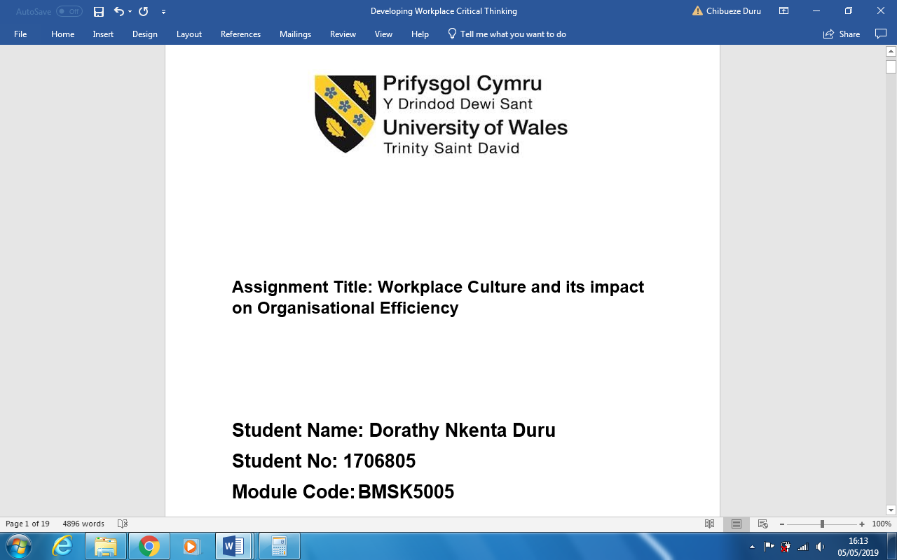

Abstract

FedEx is among the main operators of the international courier and delivery industry established in 1973 by Frederick W. Smith a Yale University graduate. The strategy of its business subsidiaries competing collectively and being operated independently and managed collaboratively has consistently made FedEx to be admired as one the most successful brands and a place to work. FedEx started as an idea championed by an individual and now has become an innovative company that is connecting people with possibilities.
In this paper, the author used some environmental and organisational analysis techniques to evaluate the courier and delivery industry. As a case study, the author used the organisational culture of FedEx that earned the brand a worldwide reputation of having a strong customer service, high customer satisfaction and a loyal workforce.
FedEx achieved competitive advantage through innovation and an organisational culture that is people centred that earned the brand a worldwide reputation of having a strong customer service, high customer satisfaction and a loyal workforce. It is important for an organisation to have a well-defined direction because it enables the employees to have a clear understanding of the aims and objectives of the organisation and where the organisation is headed.

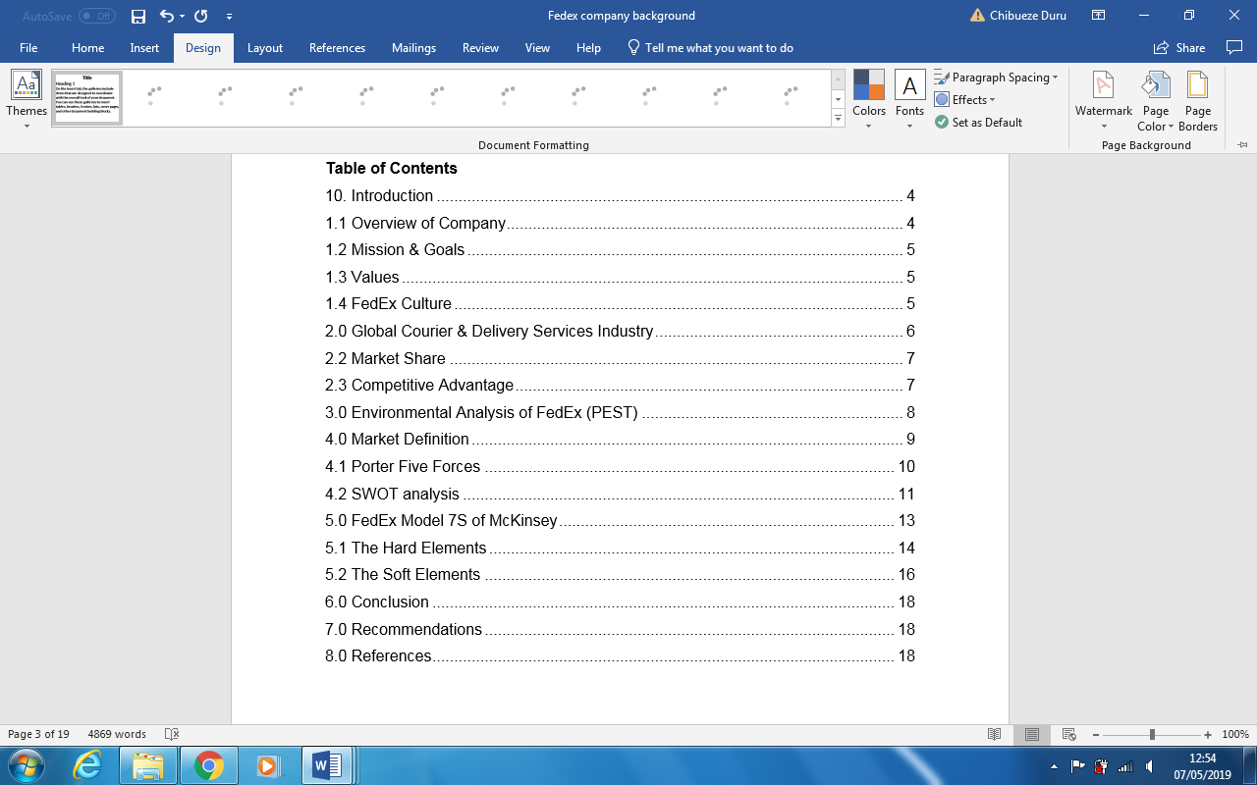

Introduction
FedEx is among the main operators of the international courier and delivery industry established in 1973 by Frederick W. Smith a Yale University graduate. The strategy of its business subsidiaries competing collectively and being operated independently and managed collaboratively has consistently made FedEx to be admired as one the most successful brands and a place to work. FedEx started as an idea championed by an individual and now has become an innovative company that is connecting people with possibilities.
In this paper, the author will use some environmental and organisational analysis techniques to evaluate the courier and delivery industry. As a case study, the author will use FedEx’s organisational culture that earned the brand a worldwide reputation of having a good customer service, high customer satisfaction and a loyal workforce.

1.1 FedEx Company Overview
The strategy of FedEx making its business subsidiaries competing collectively and at the time operate independently has enabled the organisation to gain a competitive advantage over other players of the sector. The organisation is capable of meeting their customers using the broad portfolio of the services the offer to their customer. Competing collectively and operating independently has the advantage of attracting most of their customer to use two or more of their operating companies.
Since the inception of FedEx in 1973, the organisation has tremendously both financially and organically. In 2018, FedEx generated an income of about $65.5 billion. FedEx renders its services in more than 220 countries of the world and continually offering innovative products and service globally with a workforce of about 450,000 people.
FedEx Corp. (NYSE: FDX) uses business differentiation such as “transportation, e-commerce to provide business services to its worldwide customer”. The organisation offers to its customers integrated business solutions using different companies that are collaboratively managed under the umbrella of FedEx brand. FedEx has an organisational culture that inspires employees to focus on the highest ethical and professional standards in providing services to their customers and the safety of the communities where the operate.

1.2 Mission & Goals
The mission statement is “FedEx Corporation will produce superior financial returns for its share owners by providing high value-added logistics, transportation and related business services through focused operating companies. Customer requirements will be met in the highest quality manner appropriate to each market segment served. FedEx will strive to develop mutually rewarding relationships with its team members, partners and suppliers. Safety will be the first consideration in all operations. Corporate activities will be conducted to the highest ethical and professional standards” (FedEx.com, 2019).

1.3 Values
“People: value for their employees and promotion of diversity in our workplace.
Service: FedEx is customer centric.
Innovation: We invent and inspire the service and technologies that improve the way we work and live.
Integrity: efficient management of operations, finances, and services with honesty and reliability.
Responsibility: We champion safe and healthy environments for the communities in which we live and work.
Loyalty: We earn the respect and confidence of our FedEx people, customers, and investors every day, in everyday and everything we do.
Safety: We operate safely to product our team members, customers, infrastructure and equipment” (FedEx.com, 2019).

1.4 FedEx Organisational Culture
According toIvancevich et al (2011) an organisation’s culture defines the personality and character of its employees. An organisation’s culture is constituted by shared values, beliefs of the employees based on their perception of the organisation and the expectations of the organisation on how employees should behave and interact including how organisational decision and work activities should be done. The history of the organisation and environment including the people who lead and work it are the main important factors of organisational culture.
The organisational culture of FedEx is centred on the customers and the welfare of their employees. FedEx’s leadership policies encourage employees to be customer-focused. The idea of an organisation to be customer-focused must start from the leadership and then filter through the rest of the organisation encouraging employees to make conscious decision that aligns with the established culture of the organisation (Morrow, 2003). The “FedEx Way” is a management communication on how employees should remain in compliance with the organisation’s cultures transmitted via television mounted on the various corridors of the organisation. As regards to FedEx’s culture, reinforcement has been recognised to play a very significant role. The theory is, if in a culture the quality of customer is important, then FedEx employees are highly expected to adopt his behaviour, recognised and rewarded (Ivancevich et al; 2011). When an employee exhibits “FedEx Attitude”, the management of FedEx uses rewards and recognition system to encourage them (Morrow, 2003). The culture of the organisation recognises people to be the foundation for success and key of the organisation’s future. This type of organisational culture has led FedEx employees to develop the can-do spirit that made the organisation to achieve a very admirable success worldwide and become one of the most desirable workplaces. The empowerment of employees to create innovative solutions for their customers is the common culture that makes FedEx uncommon among other competitors of the industry. The organisational culture of FedEx encourages employees to work smarter and sustainably support the communities where they operate.

2.0 Global Courier & Delivery Services Industry
This industry is segmented into smaller local delivery companies and the larger couriers such as FedEx, UPS, TNT, and DHL. These two segments provide the express courier delivery services of cargo and documents delivery via air and land of parcels to a wide range of customer worldwide. The service request for each category differs according to the services offered. For example, local delivery is derived from the local market such as households, while downstream demand stems is derived from manufacturers and retailers across the globe. Even if the demand for both segments differ, their demand both fluctuate based on the global consumer spending power, internet usage and the total value of world trade (IBIS, 2019).
This industry, in 2018 generated a revenue of about $272bn and over the past five years has grown by 2.0% and in the same timeframe the business has grown by 4.4% and the workforce has grown by 1.5% amounting to 2,819,798 people in 2018 (IBIS, 2019).

2.2 Market Share
The main competitors of the industry with the largest shares are “FedEx, UPS, TNT and Deutsche Post DHL group” (IBIS, 2019).
The industry is very capital and labour intensive. The main elements of the labour expenses include wage and salaries paid to employees such as delivery drivers, pilots, drop-off locations, operators of the call centres, loading and off-loading crews including the administrative staff.

2.3 Competitive Advantage
FedEx used information technological infrastructures that created a very notable synergistic force, for example, its website and client-provided software to gain competitive advantage in the industry. Information technology infrastructure serves as an umbrella between all the various operations, in combination with the organisation’s customer service that is driving the organisation forward. In the attempt to substitute inventory with information, IT has always been a critical success factor to the organisation. The organisation with the help of IT created a hard to imitate intimate technology links.
FedEx is the pioneer of Web based package tracking that was later copied by competitors such as UPS and DHL. FedEx created a system such as Virtual Order to enable customers to create an online catalogue, an integrated e-commerce backbone that enables the customers to figure out the product offering. FedEx allows customers to build a catalogue and use the backbone that incorporates their traditional services such as online tracking (FedEx.com, 2019).
The most important logistics KPI’s of FedEx are its On-Time delivery service, the most step because it customer satisfaction. On-Time shipping services, an interna indicators that shows how the internal operation is efficiently working properly. Its inventory method and order accuracy.

3.0 Environmental Analysis of FedEx (PEST)
For an organisation to survive and to be competitive in the current turbulent business environment, the need to constantly analysis the business environment in which they operate. FedEx operates in the logistics industry, to be able to provide best services in profitable and comfortable way, they need to understand the environment in which they operate so as to effective serve their customers.
Political Factors
FedEx operation involves the transportation of goods and documents from one county to another by air and sea, they must observe relevant government rules and regulations of each country. Each country’s political instability has direct effect to performance of the organisation; therefore, the management should monitor the political situation of the countries where they operate. It is important for FedEx before entering any market to analyse the following factors: political instability in the county’s economy, Anti-trust laws related to Air Delivery & Freight Services, trade regulations & tariffs related to Services, tax rates including legal frameworks for contract enforcement and wage legislation.

Economic Factors
As a multi-national organisation, economic factors can be devastating to the organisation if not well checked. FedEx contributes greatly economically to every nation where they operate as business success leads to high taxation that ultimately results to economic growth. FedEx should consider in their economic business environmental analysis the type of economic system in their host countries, exchange rates and stability of the host countries currency, the efficiency of local financial markets and infrastructure quality in Air Delivery and Freight services.
Social Factors
The demographics of a nation and the level of skill is important in the logistics and delivery industry because the higher the population rate of a country the more FedEx will have more potential customers. A more society with more educated people knows more the importance of time management and more people will demand the services of FedEx’s on time courier delivery services. The management of the organisation should consider the local culture of their host countries in making business policies and support the society that encourages the spirit of entrepreneurship.
Technological Factors
The transportation industry has seen a rapid technological transformation in the last five years and FedEx is a good case to illustrate this point. FedEx has emerged the technological concept to track the couriers thereby, keeping a proper update system, in the industry market. FedEx has increased its economy through the increasing trend of online shopping. Customer can now keep track of their packages through the technological advancement and the exact time their packages will be delivered. FedEx uses innovative technology to interact with their customers directly, for queries and feedbacks.

4.0 Market Definition
“FedEx is defined under code 4921 by the North American Industry Classification System (NAICS) and the FedEx’s Standard Industrial Classification (SIC) is under Air Courier Services, code 4513” (FedEx.com, 2019). Even though FedEx started business operations only, the organisation has expanded business operations globally into freight, ground and less-than-truck load (LTL) shipping both nationally and internationally.

4.1 Porter Five Forces
Existing Rivals: There is a very intensive competition among the existing players in the courier and delivery services sector. The industry is capital intensive, consumers are very price sensitive because of the little margin of differentiation between the organisations is very low. The consumers of this sector have a very low switching costs and these factors contribute to high intensity of the competition among existing rivals in the industry.
The major rival of FedEx domestically is UPS, although, “UPS offers lower prices due to government subsidies…both firms spend heavily on advertising and often match each other when it comes to fuel surcharges, increases/decreases in pricing, and even acquisitions (UPS purchased Mailboxes Etc.; FedEx followed suit with its purchase of Kinko’s)” (Amsler et al, 2010). In the global market, DHL is the major rival of FedEx’s, particularly, after the withdrawal of DHL from the US market (Amsler et al., 2010).
Supplier’s Power: Due to the sheer volume FedEx trades, suppliers exercise low power over them. FedEx has a bulk purchase power that enables good deals with its suppliers. For example, FedEx order big quantities of packaging materials, planes and vehicles, every supplier wants to be on their supplier list. IT infrastructures has weakened the power of their employees, the business process of FedEx is highly automated, and they use contract drivers. In any case, the only workforce that has union are the pilots with some bargaining power. “The Federal Aviation Administration (FAA) does exercise bargaining power over FedEx since it’s got the right to grant or restrict access to airspace and landing rights” (Amsler et al., 2010). These factors make the supplier bargaining power low.
Buyer’s Power: Due to the price sensitivity and the lack of differentiation among the competitors, the transportation sector exhibits high demand elasticity. For example, during the period financial crisis in 2008, most consumers needed to cut cost, thereby, switching other providers with lower prices but slower shipping services causing FedEx to restructure its Express division (Adler, 2012).
Threat of New Entrants: The main barrier to new entry entrants to this industry is due to the starting capital required to acquire vehicles, ships and airplanes. For example, some companies that have the potential to compete with FedEx are DHL, TNT and UPS. Another major barrier to entry is experience is knowledge and expertise. These factors make the barrier to entry very high.
Substitute Products: The fact that goods must move from the manufacturer to the consumer make transportation very difficult to substitute. There is substitute of goods transportation. However, some technological innovations in delivering documents such as the internet with e-mails and fax machines including other innovation like the 3D printers and the iCloud can affect the financial performance of FedEx’s (Roberson, 2012). All these factors make the strength product substitution very low.

4.2 SWOT analysis
Company strength
Globalisation: FedEx is a global company operating in 220 countries and territories around the world. The service of FedEx appeal to most of the world market from which they realise a huge revenue.
Innovation: FedEx has first mover advantage of using airplane and trucks differently than other competitors. The organisation with the help of IT created a hard to imitate intimate technological links
Technology and Communication: FedEx spends about 10%, around $1 billion of its revenue annually to search for new 10% of total revenues for new information technology that will enhance its performance. The excellent communication channel FedEx opened with its customers makes their customers not to switch to other providers. Customers can track their shipment through FedEx’s user friendly website.

Company Weaknesses
The major weakness of FedEx is its pilots that have the power industrial action because they have formed the FedEx Pilots Association that constantly demand changes in the pilot’s salaries, retirement benefits. The association wants is against FedEx outsourcing some foreign flights instead of giving their own pilots the job. For example, the association nearly grounded the operations of FedEx during a busy Christmas seasons in the past.
Another weakness of FedEx is the rising cost of services, if the customers do not perceive a price difference, they will switch to other competitors that offer the same service.

Company Opportunities:
Internal and Global Expansion: FedEx has the opportunity of expanding into new areas or technologies through the acquisition of more companies.
Joint-Ventures: FedEx can enjoy the growth of integrating their customer bases through joint venture with Netscap and American Express.
Contracts with Big Establishments: For fedEx to maintain their leadership in the industry, they need to go into alliance with organisation that will add cost-saving or value-adding benefits to their operational services.
Running all Subsidiaries Together: FedEx will save more money if they run their subsidiaries together integrating their operators to achieve better synergies and economies of scale.
E-commerce Expansion: FedEx should find more internet companies to increase their online presence since the e-commerce is rapidly increasing.

Company Threats
Foreign Countries Laws and Regulations: Due to the global nature of their services, FedEx is subject to laws and regulation in the nations where they operate. The operations might be affected by political instability or local trade protections. For example, the United Kingdom laws do not allow fedEx to fly their own planes or use ground transportation and this affects negatively the efficiency of FedEx’s performance in the British market.
Economic and Political Conditions: As a global player, many world’s economic and political factors such as fuel prices and employments laws affect FedEx. The organisation is subject to more risks than those that operate locally.

5.0 FedEx Model 7S of McKinsey
McKinsey 7S model highlights the method in which an organisation can increase effectiveness aligning the seven elements of businesses. Based on the 7S model of McKinsey “the hard elements are represented by ‘strategy, structure and systems’. While the soft elements are represented by ‘shared values, skills, style and staff” (McKinsey.com, 2019). The model emphasises how the elements are strongly linked together, a change in one of the elements leads to an automatic change of the other elements. According to the figure below, shared values is positioned as the heartbeat, the core of FedEx McKinsey 7S model because employee behaviour is guided by shared values which influences their performance.

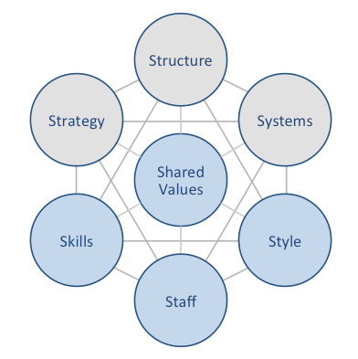

FedEx McKinsey 7S Model

5.1 The Hard Elements

1. Strategy
FedEx adopted the business strategy of “competing collectively, operating independently, and managing collaboratively” (FedEx, 2011). A business differentiation strategy that focused mainly on the quality of products and services offered to customers. Moreover, the global courier & delivery services giant meticulously positioned itself as a link between organisations and their customers, an indispensable partner that guarantees customers fast receipt of their packages and documents in time and intact.
FedEx in its business strategy used technological innovations and intensively integrated technology into various business processes. FedEx has gained competitive advantage through its information technology infrastructure, website and client-provided software. There is very notable synergistic force created by this innovative technological infrastructure that serves as an umbrella between all the various operations, combined with the organisation’s customer service that is driving the organisation forward. In the attempt to substitute inventory with information, information technology has always been a critical success factor to FedEx. The organisation with the help of IT created a hard to imitate intimate technology links.
FedEx is the pioneer of Web based package tracking that was later copied by competitors such as UPS and DHL. FedEx created system that enable its customers up for their services such as Virtual Order to create an online catalogue. The idea of the online catalogues is to give the customers the possibility of figuring out product offering. FedEx allows customers to build a catalogue and use the backbone that incorporates their traditional services such as online tracking. FedEx customers can link their web sites to FedEx Application Programming Interface (API) giving the customers the possibility of tracking their packages directly from the site using the interface. Examples of beneficiaries of FedEx services are Unique photo that sells photographic materials and a barbecue ribs seller, Carson Ribs (FedEx.com, 2019).
The most important logistics KPI’s of FedEx are its On-Time delivery service, the most step because it customer satisfaction. On-Time shipping services, an internal indicator that shows how the internal operation is efficiently working properly. Its inventory method and order accuracy.

2. Structure
The design of an organisation pertinent to its general well-being. According to Ivancevich et al (2011), an organisational design is made up of decisions and all the actions of management in determining goals such as mission, operational plans including salary and job functions that result in an organisational structure. FedEx has an organisational structure that is made up of seven subsidiary organisations as follows: “FedEx Corporation, FedEx Services, FedEx Express, FedEx Ground, FedEx Freight, FedEx Custom Critical, and FedEx Trade Networks” (FedEx, 2011). The management of each subsidiary is organised in a way they have their respective values and ideas representing the whole organisation. In any case, every subsidiary has the objective of ensuring that its function is consistent with the value of the organisation and its strategy. In addition, all subsidiaries have the duties: to invent and inspire innovation, encourage employee motivation to improve workgroup performance. For FedEx to encourage employee motivation and engagement, they select and promote best employees (FedEx, 2011)

3. Systems
The innovation objective of FedEx aims at inventing and inspiring operational innovation. “Creativity produces innovation and innovation is the lifeblood of a growing number of organizations” (Ivancevich et al; 2011). In order to stay achieve a competitive advantage, FedEx was able to align effectively innovation with their organisation and through innovation the organisation gained top rating worldwide.
FedEx’s innovative technologies enable the organisation to avoid inventing business solutions that already are in existence. Reinventing of existing solutions for FedEx a waste of time and money. According to the believe of FedEx in order to be the best; employees must put in the best in every phase of their service to the customer.

5.2 The Soft Elements
4. Staff
FedEx invests much in the training and development of its employees to acquire judgment and decision making skills. For example, FedEx created the F.A.D.E process to help employees when faced with difficult situations. F represents focus. In F stage, employees are asked to identify the issue. A - analyse the situation to identify root cause of the problem. D -using the information obtained from your situation analysis, make a sound decision. E -execute the process applying good judgment to implement the solution.
Employees satisfaction is one of the important worries of FedEx, always in search of how to make their employees happier. The management understands the main objective of employees satisfaction, an opportunity to hear the voice of the employees. The employees of FedEx have the opportunity to let the management know whether they are satisfied or unsatisfied with the way they are treated in the organisation and this ultimately is one of the key factors that aids retaining employees. FedEx understands that employee satisfaction is an important in encouraging employee psychological contract that enhances employee and organisation performance.
“Psychological contracts refer to employer and employee expectations of the employment relationship, i. e. mutual obligations, values, expectations and aspirations that operate over and above the formal contract of employment” (Smithson, & Lewis, 2003). In ascertaining how their employees are satisfied, FedEx uses surveys to identify where they are doing it right and the area to improve. Through the survey and feedback, the leadership is aware of employees concern and act swiftly in providing avenues for improvement.
5. Skills
Selecting and promoting employees aids organisations in cultivating and maintaining talent. FedEx use internal sourcing system; this strategy allows the employees of FedEx to apply on jobs before the organisation considers outside talents through a programme called ASPIRE to management, (“Assessment of Skills, Performance and Interest Required for Entry into Management”). This training is mandatory for all employees inspiring to go to management level (FedEx, 2011). There are ten important stages that an employee must complete in the ASPIRE programme. The first four stages are comprised of only management training classes that includes peer leadership, writing with intention and diversity. In stage five, an employee workgroup meeting of 15-20 minutes and feedback given to the employees from the management and peers after the meeting. In stage six, the employee will act as a manager for a whole shift carrying out all tasks a real manager does including conferences calls and meetings, etc. in stage seven, completion of individual development plan (IDP) outlining the goals the employee wish to accomplish in the future and the necessary steps to achieve them (FedEx, 2001). In stage eight, is competence assessment. Stage nine is “print all screens that provide proof all of the previous steps have been completed, which leads to step ten where the employee can apply for an open manager position. Certain jobs on the open position board are catered just for ASPIRE candidates” (FedEx, 2011)
6. Style
Organisation direction is the compass that an organisation uses to navigate into the future. Organisation direction is important because it enables the employees to have a clear understanding of the aims and objectives of the organisation and where the organisation is headed. FedEx has a creative thinking process called Analysing the Gaps, a procedure that serves to identify existing major gaps between the future state of the organisation and the current reality of the organisation (FedEx, 2011). This process is made of four steps. Step 1, reflection on the organisation’s current state and the future state. Step two, identification and how to close major present and future operation gaps. Step three, employee focus on big pictures and step four, development of a list ten top areas of Gaps that include services, technology, skills and processes (FedEx, 2001).

7. Shared Values
The objective of FedEx values/strategy is to guide the organisation in all economic situations. FedEx is known for aligning value and strategy with its operational process and has a proves background of an organisation that is dedicated to its values and strategy. The organisation is famous in its industry because of its values that are the major contributors of the organisation’s global goal. FedEx values most their relationship with people, services, integrity, responsibility and loyalty.

6.0 Conclusion
In conclusion the author has analysed the business environment of FedEx to ascertain the impact of organisational culture and the business environment of their host nations have on the performance of the organisation. FedEx achieved competitive advantage through innovation and an organisational culture that is people centred that earned the brand a worldwide reputation of having a strong customer service, high customer satisfaction and a loyal workforce. It is important for an organisation to have a well-defined direction because it enables the employees to have a clear understanding of the aims and objectives of the organisation and where the organisation is headed.

7.0 Recommendations
Although, FedEx has performed extraordinarily well since its inception in the 1970s, the organisation should continue investing on advertising. They should make people to cultivate the idea of saying we want to “FedEx it” when they need a package or documents delivered quickly, safely and on-time. FedEx can achieve this by benefiting from the positive synergy created by its subsidiaries working together. FedEx need to improve its business strategy of competing collectively and operating independently to avoid being overtaken by other big players like DHL. For FedEx to subtract more shares domestically from UPS, they need to have a controlling stake in the express delivery market and can achieve this through manipulation in consumer perception.

8.0 References
Adler, L. (2012). FedEx risks losing $1 billion-plus Post Office contract to UPS. Reuters. Retrieved from: http://www.reuters.com/article/2012/07/17/us-fedex-postalcontract-idUSBRE86G12820120717. (Retrieved on 24/04/2019).
Amsler M., Cullen J., Erdmenger JC., (2010). Strategic Report for FedEx Corporation. Vector strategy group. Retrieved from: http://economics-files.pomona.edu/jlikens/SeniorSeminars/vector2010/pdf/fdx.pdf. (Accessed on 29/04/2019)
Anon, (2019). [online] Available at: http://hr online. corp. fedex. com/training development/quality [Accessed 6 May 2019].
About FedEx. (2019). History - About FedEx. [online] Available at: https://about.van.fedex.com/our-story/history-timeline/history/ [Accessed 6 May 2019].
Ibisworld.com. (2019). IBISWorld - Industry Market Research, Reports, and Statistics. [online] Available at: https://www.ibisworld.com/industry-trends/global-industry-reports/transport-post-storage/courier-delivery-services.html [Accessed 6 May 2019].
Investors.fedex.com. (2019). FedEx - FedEx - Mission & Goals. [online] Available at: http://investors.fedex.com/company-overview/mission-and-goals/default.aspx [Accessed 6 May 2019].
Ivancevich J, Konopaske R, and Matteson M. (2011). Organizational culture. Organizational behaviour and management (9th ed. p. 40-48). Boston: McGraw-Hill Companies.
Morrow, P. (2003). Values of a customer service culture, from http://hronline. corp. fedex. com/trainingdevelopment/qualityu/recent_news_3955. shtml CNNMoney. com.
Roberson, C. (2012). Google moving into the delivery space with BufferBox acquisition. TI.Retrieved from: http://www.transportintelligence.com/briefs/google-moving-into-the-delivery-space-with-bufferbox-acquisition/2514/. (Retrieved on 24/04/2019).
Smithson, J., & Lewis, S. (2003). Psychological contract. Sloan work and family research network., from http://wfnetwork. bc. edu/encyclopedia_entry. php? id=250 Kozlowski, SWJ, & Ilgen,

