

Evidence-Based Policing and Decision Making
BMPL 4001

Table of Content
Introduction 3
Discussion 3
Classical Criminology Theories 3
Criminality and Crime 5
Models of Evidence-Based Policing 5
Reduction of Crime Activity by Classical Criminology 7
Strengths & Weaknesses of Evidence-based Policing 7
Strengths & Weaknesses of Classical Criminology 8
Conclusion 9
References 10

Introduction

Evidence-based policing is highly significant as it allows it to determine the impact of different interventions with different crimes while also understanding how they work (Braga et al. 2019). Under this consideration, this essay will focus upon classical criminology theories. An overview of criminality will also be provided. The models of evidence-based policing will be reflected in terms of drug crime. Further, different ways in which drug crime can be reduced by classical criminology will also be discussed. Lastly, the strengths and weaknesses linked to classical criminology and evidence-based policing will be provided in this essay.

Discussion

Classical Criminology Theories

Classical criminology explains any kind of crime to be a free decision for making a criminal choice activity. Moreover, this choice can be made by inducing the different principles of pain pleasure whereby individuals act in a number of ways that might maximize the pleasure but minimize the pain. It has also been suggested by Mitchell (2019) that there are three elements of classical criminology such as rationality, deterrence, and hedonism. Therefore, with respect to drug-related crime, this crime is related to possessing, manufacturing, and distributing drugs that are observed to be harmful to individuals. Further, drugs are a criminal activity as there is a huge link between expensive drugs and their chronic use in the United Kingdom and this problem has been worsening throughout the past years.

The different theories associated with a drug crime in classical criminology are:

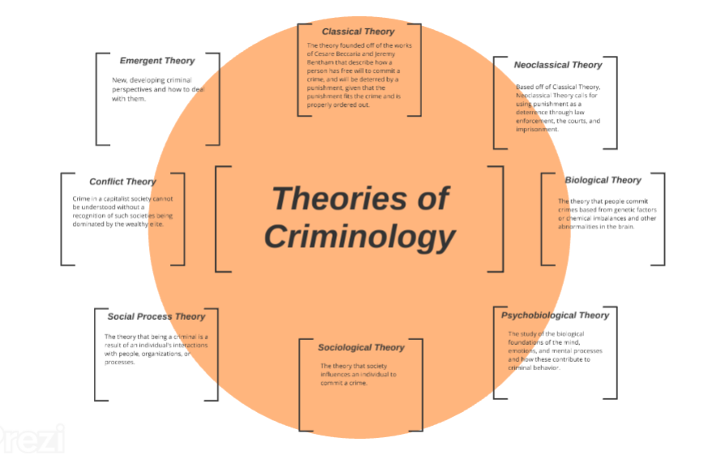
Figure 1: Different Theories of Criminology
Source: Zhao et al. 2021

Deterrence Theory: The deterrence theory of criminology reflects how the criminal is induced to commit any crime while abiding by the law of policing and punishment. However, Zhao et al. (2021) also opined that every criminal gets some benefits out of the crime, they would commit which is not worth punishment. Then they might drop the plan of abiding by the law and move forward to commit the crime.

Rational Choice Theory: This is linked to the neoclassical theory and suggests that the criminal commits the crime after all the benefits and opportunities of that particular crime. It is also believed that the criminal is fully in their senses while committing the crime (Khan et al. 2022).

Classical Theory: This is a logical theory of criminology linked to rationality of the people who are involved in the crime. This further reflects that the person can distinguish between what is correct and what is wrong yet does the crime even after the outcome and pleasure that would be derived from committing the crime. A number of crimes under this theory are punishable by death (Severson, Kodatt and Burruss, 2019).

Criminality and Crime

Criminality is the propensity for being involved in criminal activities such as drug crime. In simpler words, criminality is nothing, but the participation of an individual in a specific event which is criminal in nature. On the other hand, crime is an act of omission or commission, contrary to the law (Abramovaite et al. 2022). Considering this fact, possession of drugs in the UK is an illegal crime and individuals might be charged if they were caught with drugs whether or not they are theirs. Additionally, if an individual is under 18, then the evidence-based policing theory suggests that a police officer will inform the guardian of the parent about the individual having the drug and the penalty of this crime will depend upon the quantity in a class of the drug. In this regard, the primary factors related to criminality and crime under criminology are, crime is the result of conflict wear as criminal is the subject or an individual who is caught doing the crime (Tharshini et al. 2021). Moreover, a criminal act can not be stated as a crime without the legal and social identities that places the individual within the conflict where the crime has taken place.

Drug or cannabis cultivation and possession is referred to as a criminal activity as it is a source of risk and nuisance for the community and public members. There is a huge risk with drug crime of antisocial behaviour reflected by the criminals. Drug offenses are a crime in the UK and are associated with the possession, importation, supply, and production of illegal drugs (Khan et al. 2022). In case of drug possession of class A drugs, they can go to prison for up to 7 years or an unlimited fine or both. Therefore, it can be evidently suggested that drug possession is a huge crime with respect to classical criminology.

Models of Evidence-Based Policing

Evidence-based policing is referred to as the availability of the best evidence which can be a list for challenging and informing the policing practices, policies, and decisions. The evidence-based policing practice can be used by everyone who is involved in police activities and can be supported by the collaboration of different partners and academics (Staller and Koerner, 2021). Further, evidence-based policing in drug crime, the best possible evidence and interventions are provided for reducing drug offenses and the police forces also utilize this evidence for making informed decisions about different approaches to tackling drug crimes.

In this regard, there are different kinds of models of evidence-based policing such as the POP model, SARA model, etc. However, with respect to the drug offense crime, the HotSpot model of evidence-based policing can be most effective (Boulton et al. 2021).

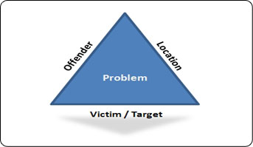
Figure 2: HotSpot Model of EBP
Source: Boulton et al. 2021

The above depicted HotSpot model of evidence-based policing is generally focused upon smaller geographical places or areas usually in the Urban Settings where drug crime is mainly concentrated. Moreover, with the help of the hotspot evidence-based policing model, the law of criminology enforces agencies that can focus on the restricted resources in those areas where the crime is occurring regularly. This practice is highly beneficial for reducing the overall drug crime. Besides, Koziarski and Lee (2020) also observed that the hotspot model of evidence-based policing and its analyses might vary in size because the hotspot area can include either small units such as buildings or block faces, or bigger units such as street segments. In this model, there are a number of prime mapping techniques that can be used for identifying and determining the drug crime hotspots such as ArcGIS. Therefore, it is evident that this model utilizes a combination of police officers and technology for analyzing the targeting process of the drug crime issue.

Conversely, a few theoretical perspectives linked to the HotSpot model of evidence-based policing in regard to drug offenses are place-based crime, routine activity theory, and rational choice theory. With respect to all these theories in drug crime, it is suggested that the drug crime offender is self-interested in committing the crime even after knowing all the consequences of the crime. Lastly, Palmer, Kirby and Coleman (2019) opined that the HotSpot model of criminology and evidence-based policing is generally dependent upon traditional law enforcement practices and strategies while ensuring control of the crime in the problem area while enforcing drug crackdowns and order maintenance.

Reduction of Crime Activity by Classical Criminology

Classic criminology can significantly reduce drug crime by increasing the most tough punishments for the crime doers as the criminals will never again involve themselves in these crimes because of the punishments. Classic criminology with respect to drugs offenses in the UK can reduce this crime activity because the punishment is harsh because it is highly illegal to import or export drugs and allow its usage on the premises. There is a lifetime sentence for drug offenses for each class of drugs, A, B, and C. Furthermore, this prime activity can be reduced because the Home Secretary of the nation has introduced different punishments for each level of drug (Mesko, 2020). Additionally, classical criminology tends to reduce the crime of drug offenses by making several improvements and enhancement over the official judicial system, including the fast responses to the crime, while cheating both the victims such as the public and the criminal self for making advancements in the tactics of policing. Besides, classical criminology with respect to drug crime also pertains to different evidence-based policing tricks like community-building programs such as drug action teams, and crime-prevention committees for the management of youth in public places while creating awareness of the ill impacts of drug usage and the penalties associated with it. Further, Yan (2019) also opined that classical criminology can also reduce the implications of a drug crime as evidence-based police officers can conduct audits of the current drug activities while comparing it with the strategies for identifying the areas of need. Further funding can also be made available for research, monitoring, and dissemination of police policies and practices on harm minimization of drug crime among the community members.

Strengths & Weaknesses of Evidence-based Policing

One of the most vital strengths of evidence-based policing in terms of drug crime is that it induces the police officers to seek evidence related to the crime while taking up immediate action. Further, evidence-based policing practice is based upon the decisions that are to be taken for the investigation of the crime. Another major strength with respect to the evidence-based policing approach is that this practice makes use of the best available evidence and resources for informing the challenges related to the policing policies in terms of the crime that has been committed (Schreck and Berg, 2021). Moreover, this approach can be utilized by everyone who is involved in the police judicial system and the evidence is used for creating innovations and strategies for curbing crime based on the experiences of both the community members and the police officers.

On the flip side, some weaknesses of evidence-based policing that cannot be overlooked are there might be a shortage of evidence with respect to the crimes which might make it difficult for the police personnel to reach the criminal while making any conclusion. Additionally, another weakness linked to evidence-based policing is that not all the police-officers associated with the case might have knowledge of the evidence which might make it difficult for them to implement changes with respect to drug crime (Mesko, 2020). This might lead them to be irritated and guilty as they cannot wholly contribute to the case while lowering its adverse impact on the community and its members.

Strengths & Limitations of Classical Criminology

One of the major benefits and strengths of classical criminology is that criminology deals with the understanding of the upbringing of the criminals who commit the drug crime. Further, another vital strength linked to classical criminology is that it reduces criminal activities because the police officers can take quick actions for curbing the spread of this crime in local geographical areas. Besides, Yan (2019) observed that classical criminology also reduces the crime rate by over 75% as deterrence is provided in the crimes in such a manner so that the police officers can effectively secure the public members while mitigating these crimes. Additionally, the different theories associated with classical criminology also determine the different mindset’s of the criminals by thinking their way and then devising mitigation strategies for reducing drug offenses. Another strength of classical criminology is that the punishments are made while proportioning them with the crime carried out such as drug crime.

Adversely, the weakness of classical criminology is that there might be a lack of interpretation of the crime sometimes. Further, classical criminology also believes that not all the individuals are rational which might be difficult for the police officers to identify the crime while apprehending the perpetrators (Chapman et al. 2022). Besides, classical criminology is a tiring task to carry out as it involves a lot of research, evidence gathering and report writings which further takes up a lot of time and efforts which might imbibe the feelings of frustration among the people who are involved in finding out about the crime case.

Conclusion

In summation, it can evidently be stated that evidence based policing is significantly vital for curbing the whole crime case. This essay provided a brief insight on the different theories associated with criminology such as HotSpot. Further, an overview of crime and criminality was also included. Lastly, the strengths and weaknesses of both evidence-based policing and criminology were provided while reflecting how evidence-based policing can reduce drug crime.

References
Abramovaite, J., Bandyopadhyay, S., Bhattacharya, S. and Cowen, N., 2022. Classical deterrence theory revisited: An empirical analysis of Police Force Areas in England and Wales. European Journal of Criminology, p.14773708211072415. Available at: https://journals.sagepub.com/doi/abs/10.1177/14773708211072415 [Accessed on 24 February 2023]
Boulton, L., Phythian, R., Kirby, S. and Dawson, I., 2021. Taking an evidence-based approach to evidence-based policing research. Policing: A Journal of Policy and Practice, 15(2), pp.1290-1305. Available at: https://academic.oup.com/policing/article-abstract/15/2/1290/5965403 [Accessed on 24 February 2023]
Braga, A.A., Turchan, B., Papachristos, A.V. and Hureau, D.M., 2019. Hot spots policing of small geographic areas effects on crime. Campbell Systematic Reviews, 15(3), p.e1046.Available at: https://onlinelibrary.wiley.com/doi/abs/10.1002/cl2.1046 [Accessed on 24 February 2023]
Chapman, A., Grylls, P., Ugwudike, P., Gammack, D. and Ayling, J., 2022, June. A Data-driven analysis of the interplay between Criminological theory and predictive policing algorithms. In 2022 ACM Conference on Fairness, Accountability, and Transparency (pp. 36-45). Available at: https://dl.acm.org/doi/abs/10.1145/3531146.3533071 [Accessed on 24 February 2023]
Khan, W., Khan, J., Humayun, M. and Naz, A., 2022. Is Criminality a Matter of Choice? Sociological Analysis of Violently Committed Robberies: A Critique of the Pakistani Legal-Administrative System’s Failure in Pakhtun Society. Journal of Policy Research, 8(2), pp.119-123. Available at: https://jprpk.com/index.php/jpr/article/view/166 [Accessed on 24 February 2023]
Koziarski, J. and Lee, J.R., 2020. Connecting evidence-based policing and cybercrime. Policing: An International Journal. Available at: https://www.emerald.com/insight/content/doi/10.1108/PIJPSM-07-2019-0107/full/html [Accessed on 24 February 2023]
Meško, G., 2020. Rural criminology–A challenge for the future. European journal of crime, criminal law and criminal justice, 28(1), pp.3-13. Available at: https://brill.com/view/journals/eccl/28/1/article-p3_3.xml [Accessed on 24 February 2023]
Mitchell, R.J., 2019. A light introduction to evidence based policing. Evidence based policing: An introduction, pp.3-14. Available at: https://books.google.com/books?hl=en&lr=&id=BAZ6DwAAQBAJ&oi=fnd&pg=PA3&dq=evidence+based+policing+crime+reduction&ots=BYgX7E9dAC&sig=JFg8KIIT4XF6wOMl2sMg3kgXTno [Accessed on 24 February 2023]
Palmer, I., Kirby, S. and Coleman, R., 2019. Assessing the appetite for evidence based policing: A UK based study. International Journal of Police Science & Management, 21(2[Accessed on 24 February 2023]), pp.91-100. Available at: https://journals.sagepub.com/doi/pdf/10.1177/1461355719838930 [Accessed on 24 February 2023]
Schreck, C.J. and Berg, M.T., 2021. What Ideas of Victimization and Vulnerability Mean for Criminological Theory: A Logical Appraisal 1. In Revitalizing Victimization Theory (pp. 15-55). Routledge. Available at: https://www.taylorfrancis.com/chapters/edit/10.4324/9781003159629-3/ideas-victimization-vulnerability-mean-criminological-theory-christopher-schreck-mark-berg [Accessed on 24 February 2023]
Severson, R.E., Kodatt, Z.H. and Burruss, G.W., 2019. Explaining white‐collar crime: Individual‐level theories. The handbook of white‐collar crime, pp.159-174. Available at: https://onlinelibrary.wiley.com/doi/abs/10.1002/9781118775004.ch11 [Accessed on 24 February 2023]
Staller, M.S. and Koerner, S., 2021. Evidence-based policing or reflexive policing: a commentary on Koziarski and Huey. International journal of comparative and applied criminal justice, 45(4), pp.423-426. Available at: https://www.tandfonline.com/doi/abs/10.1080/01924036.2021.1949619 [Accessed on 24 February 2023]
Tharshini, N.K., Ibrahim, F., Kamaluddin, M.R., Rathakrishnan, B. and Che Mohd Nasir, N., 2021. The link between individual personality traits and criminality: a systematic review. International journal of environmental research and public health, 18(16), p.8663. Available at: https://www.mdpi.com/1231234 [Accessed on 24 February 2023]
Yan, Y., 2019, October. A Summary of Ferri's Social Defense Theory from the Perspective of Positivism Philosophy. In 2nd International Conference on Contemporary Education, Social Sciences and Ecological Studies (CESSES 2019) (pp. 543-547). Atlantis Press. Available at: https://www.atlantis-press.com/proceedings/cesses-19/125920301 [Accessed on 24 February 2023]
Zhao, J., Wang, X., Zhang, H. and Zhao, R., 2021. Rational choice theory applied to an explanation of juvenile offender decision making in the Chinese setting. International Journal of Offender Therapy and Comparative Criminology, 65(4), pp.434-457. Available at: https://journals.sagepub.com/doi/pdf/10.1177/0306624X20931429 [Accessed on 24 February 2023]

