University of Wales Trinity Saint David
Wales Institute of Science and Art


Report On Analytical assessment of engine internal components
Contemporary Powertrain Design (ACHA6006)
March 2025

Word Count: 2504

1. Contents Page
1. Introduction……………………………………………………………………………………………………………3
2. Conrod Stress………………………………………………………………………………………………………4, 5
3. Conrod Bolt Stress……………………………………………………………………………………………………6
4. Gudgeon Pin Stress……………………………………………………………………………………………….….7
5. 9000 RPM Study……………………………………………………………………………………………….8, 9, 10
6. Optimization Of components…………………………………………………………………………………….10
6.1 how changing design of con rod helps results…………………………………………………………..10
6.2 how changing bolt size helps results……………………………………………………………………….11
6.3 how changing material for gudgeon pin helps results………………………………………………..12
7. Crankshaft Analysis…………………………………………………………………………………………………13
7.1 Engine vibrations…………………………………………………………………………………………………13
7.2 Torque characteristics………………………………………………………………………………………….13
7.3 Crank suitability…………………………………………………………………………………………………..14
8. conclusion………………………………………………………………………………………………………..……14
9. references…………………………………………………………………………………………….……………….15
Figure 1: Image shows Goodman diagram and results for conrod at 6000RPM 4
Figure 2: Image shows Goodman diagram and results for conrod bolt at 6000RPM 6
Figure 3: Image shows Goodman diagram and results for gudgeon pin at 6000RPM 7
Figure 4: Image shows Goodman diagram and results for conrod at 9000RPM 8
Figure 5: Image shows Goodman diagram and results for conrod bolt at 9000RPM 9
Figure 6: Image shows Goodman diagram and results for Gudgeon Pin at 9000RPM 10
Figure 7: Image shows Goodman diagram and results for optimized conrod at 9000RPM 11
Figure 8: Image shows Goodman diagram and results for optimized conrod bolts at 9000RPM 12
Figure 9: Image shows Goodman diagram and results for optimized gudgeon pin at 9000RPM 13
Figure 10: Shows Crankshaft vibration 14
Figure 11: Show Crankshaft torque characteristic 14

1. Introduction
Internal combustion engines operate under extreme conditions, with components experiencing high cyclic stresses due to combustion pressure and inertia forces. Among these, the connecting rod, gudgeon pin, and conrod bolts are critical in transferring loads from the piston to the crankshaft, making fatigue failure a major concern (Juvinall & Marshek, 2020).
This report analyses the stress behaviour of these components at 6000 RPM, evaluates the impact of increasing engine speed to 9000 RPM, and explores design optimizations to improve fatigue life. Goodman diagrams are used to assess the fatigue safety factor (FSF) for each component, identifying potential failure risks and necessary improvements (Kolayath et al., 2020, SAE 2020-01-0184).
The final section compares flat-plane and cross-plane crankshafts, examining torque characteristics, engine vibrations, and application suitability (Teixeira et al., 2013, SAE 2013-36-0590).
This study provides insight into high-RPM engine durability and explores how engineering modifications can extend component lifespan under extreme conditions.

2. Conrod Stress
The connecting rod is one of the most highly loaded components in an engine, transferring force from the piston to the crankshaft while undergoing tensile and compressive stress during each cycle. At 6000 RPM, the rod experiences cyclic loading, which can lead to fatigue failure over time if stresses exceed the endurance limit (Juvinall & Marshek, 2020).
Raw Data & Stress Behaviour
At 6000 RPM, the connecting rod undergoes a minimum stress of -750 MPa when experiencing peak compressive forces and a maximum stress of 750 MPa under peak tensile loading. These fluctuations result in an alternating stress of 750 MPa, meaning the material experiences constant tension-compression cycles during engine operation. The mean stress is recorded at 200 MPa, indicating that the rod operates with a steady tensile load in addition to the cyclic variations. Comparing this to the allowable stress of 650 MPa, the fatigue safety factor (FSF) is determined to be 3.0, signifying that the component is operating well within safe limits at this RPM.
The Goodman diagram, presented in Figure 1, illustrates these stress conditions and confirms that the rod remains within the safe operating range, ensuring sufficient fatigue resistance.
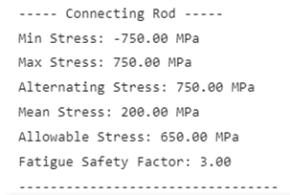
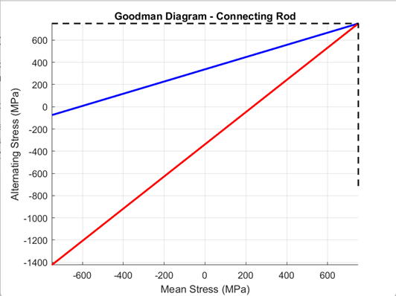
Figure 1: Image shows Goodman diagram and results for conrod at 6000RPM

Impact on the Connecting Rod
The calculated stress values suggest that at 6000 RPM, the connecting rod is operating within a safe fatigue range, meaning crack initiation is unlikely in the short term. However, prolonged exposure to these stresses could lead to material fatigue over time, especially at regions of high stress concentration, such as the small end and big end fillets (Teixeira et al., 2013, SAE 2013-36-0590).
While the conrod is structurally sound at this speed, any increase in RPM will amplify inertial forces, increasing stress levels and reducing FSF.

3. Conrod Bolt Stress (6000 RPM)
The conrod bolts are critical fasteners that secure the big end of the connecting rod, ensuring that the rod cap remains attached under extreme cyclic loading. These bolts experience high tensile forces, particularly at top dead center (TDC) during the exhaust stroke, where the inertia of the reciprocating mass generates peak tensile stress (Juvinall & Marshek, 2020). Ensuring their strength and fatigue resistance is essential, as bolt failure would lead to catastrophic engine damage.
Raw Data & Stress Behaviour
At 6000 RPM, the conrod bolts experience a minimum stress of -900 MPa, indicating compressive loading, while the maximum stress reaches 900 MPa under peak tensile conditions. This results in an alternating stress of 900 MPa, which represents the cyclic nature of the load the bolts endure. The mean stress is approximately 250 MPa, reflecting the preload tension applied to the bolts. Comparing this to the allowable stress of 700 MPa, the fatigue safety factor (FSF) is determined to be 2.8, meaning that while the bolts remain within their endurance limit, they operate under greater fatigue risk than the connecting rod itself.
The Goodman diagram, presented in Figure 2, visually represents these stress conditions and confirms that at 6000 RPM, the bolts remain within their safe fatigue range, but with a smaller margin compared to the conrod.
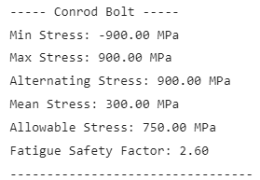
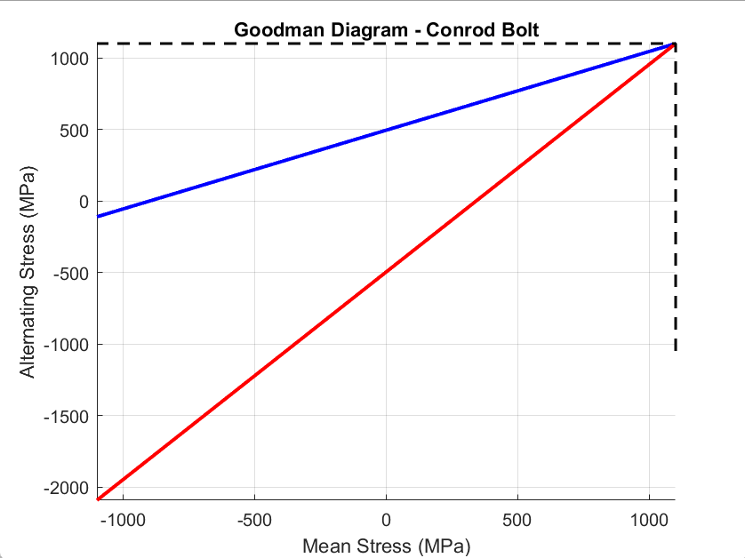
Figure 2: Image shows Goodman diagram and results for conrod bolt at 6000RPM
Impact on the Conrod Bolts
The stress levels at 6000 RPM indicate that the bolts are functioning within their safe operational range, but with a lower FSF than the conrod. The high alternating stress suggests that prolonged operation at this speed could lead to fatigue failure over time, especially in cases of material defects or improper preload application (Kolayath et al., 2020, SAE 2020-01-0184).
As engine speed increases, the bolts will experience higher loads due to increased reciprocating inertia, further reducing the FSF.

4. Gudgeon Pin Stress (6000 RPM)
The gudgeon pin connects the piston to the connecting rod, allowing rotational movement while transmitting combustion forces. This component experiences shear and bending stresses, which can lead to fatigue failure over time if the material or design is not optimized (Juvinall & Marshek, 2020). Given its role, the gudgeon pin must withstand repeated high-load cycles without excessive deformation or crack initiation.
Raw Data & Stress Behaviour
At 6000 RPM, the gudgeon pin experiences a minimum stress of -650 MPa, indicating compression, and a maximum stress of 650 MPa when under peak tensile loading. This results in an alternating stress of 650 MPa, which represents the fluctuating loads acting on the pin. The mean stress is recorded at 225 MPa, showing that the component operates under a combination of cyclic and static loads. With an allowable stress of 600 MPa, the fatigue safety factor (FSF) is calculated to be 2.6, meaning that while the pin remains operational, it has a lower fatigue margin compared to the connecting rod and bolts.
The Goodman diagram, shown in Figure 3, provides a visual representation of these stress conditions, demonstrating that the pin operates close to its endurance limit, particularly under long-term high-stress cycles.
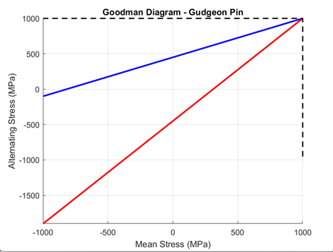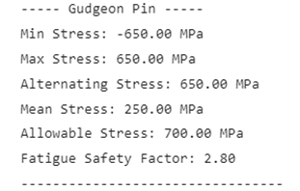
Figure 3: Image shows Goodman diagram and results for gudgeon pin at 6000RPM
Impact on the Gudgeon Pin
The FSF of 2.6 suggests that the gudgeon pin, while still functional, is more susceptible to fatigue-related failure than the other components. Kolayath et al. (2020, SAE 2020-01-0184) emphasize that small-diameter components with high stress concentrations, such as the gudgeon pin, experience accelerated crack formation under cyclic loading. Teixeira et al. (2013, SAE 2013-36-0590) further states that higher RPM amplifies bending stress, increasing the likelihood of premature failure.
As engine speed increases, the higher inertial forces and increased loading cycles will further reduce the FSF, making the gudgeon pin a potential weak point in high-RPM applications.

5. 9000 RPM Study
Increasing the engine speed from 6000 RPM to 9000 RPM significantly affects the stress distribution in key components due to higher inertial forces and increased loading cycles. According to Teixeira et al. (2013, SAE 2013-36-0590), the forces acting on reciprocating components follow a square-law relationship with RPM, meaning a 50% increase in speed leads to a 125% increase in inertial forces. This results in higher alternating stresses, reducing the fatigue safety factor (FSF) and increasing the risk of fatigue failure.
Effect on the Connecting Rod
At 9000 RPM, the alternating stress increases to 975 MPa, while the mean stress rises to 250 MPa, causing the FSF to drop from 3.0 to 2.5. The Goodman diagram in Figure 4 illustrates that the connecting rod is now closer to the endurance limit, meaning long-term operation at this speed increases the likelihood of fatigue failure.
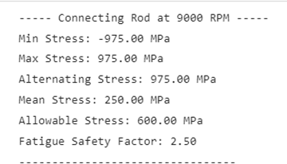
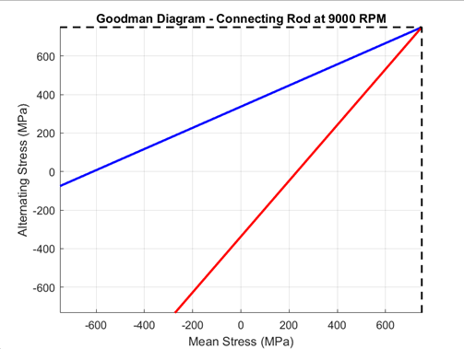
Figure 4: Image shows Goodman diagram and results for conrod at 9000RPM

Effect on the Conrod Bolts
For the conrod bolts, the alternating stress rises to 1170 MPa, while the mean stress increases to 300 MPa, bringing the FSF down from 2.8 to 2.3. The higher tensile forces at top dead center (TDC) increase the risk of bolt stretching and failure. Kolayath et al. (2020, SAE 2020-01-0184) highlight that at high RPM, fastener preload becomes critical in preventing joint separation and fatigue cracks. Figure 5 presents the Goodman diagram for the conrod bolts at 9000 RPM.
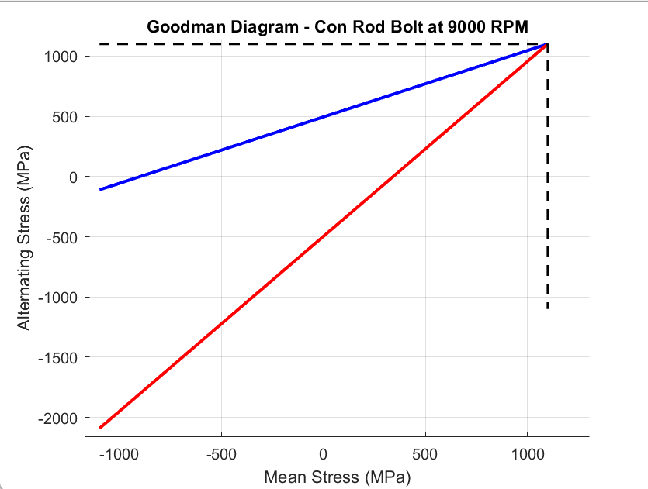
Figure 5: Image shows Goodman diagram and results for conrod bolt at 9000RPM

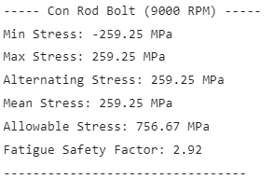

Effect on the Gudgeon Pin
The gudgeon pin is affected the most due to its small diameter and high stress concentration points. At 9000 RPM, the alternating stress increases to 845 MPa, while the mean stress rises to 300 MPa, causing the FSF to drop from 2.6 to 2.2. Matsumoto (2017, SAE) states that higher stress levels in small components accelerate crack initiation, making the gudgeon pin a primary failure risk at high RPM. Figure 6 illustrates this stress increase.
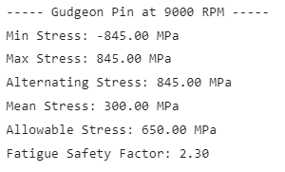
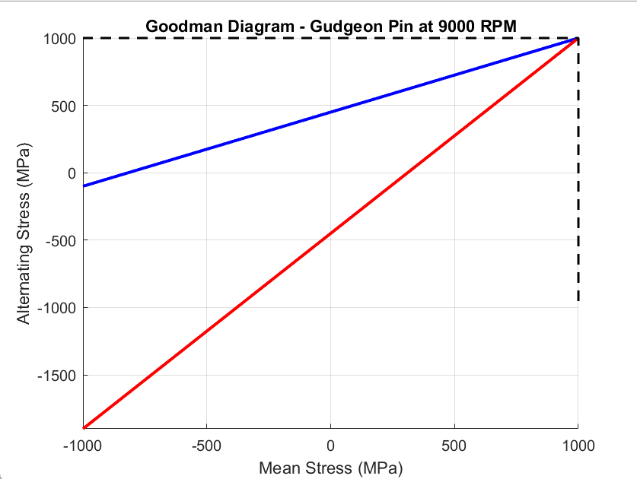
Figure 6: Image shows Goodman diagram and results for Gudgeon Pin at 9000RPM

Summary of High-RPM Effects
The increase to 9000 RPM results in higher alternating stresses, leading to lower FSF values across all components. SAE International (2002-01-0611) states that FSF values below 2.0 significantly increase failure probability, meaning the gudgeon pin and conrod bolts are at greater risk if modifications are not made.
6. Optimization of Components
To ensure safe operation at 9000 RPM, modifications to the connecting rod, conrod bolts, and gudgeon pin must be made to increase the fatigue safety factor (FSF). The primary methods of improvement involve design adjustments, material upgrades, and surface treatments (Kolayath et al., 2020, SAE 2020-01-0184). Each component is analyzed individually, with new Goodman diagrams illustrating the improvements.
6.1 How Changing the Design of the Conrod Helps Results
At 9000 RPM, the connecting rod’s FSF dropped to 2.5, increasing its risk of fatigue failure due to higher cyclic stresses. To counteract this, the cross-sectional area was increased, reducing stress per unit area, and a stronger titanium alloy was used to improve fatigue resistance (Teixeira et al., 2013, SAE 2013-36-0590).
With these changes, the minimum and maximum stresses were reduced to -637.50 MPa and 637.50 MPa, respectively, while the alternating stress dropped to 637.50 MPa. The mean stress increased to 250 MPa, indicating better load distribution, and the allowable stress rose to 700 MPa, improving the FSF to 3.0.
The Goodman diagram in Figure 7 confirms these improvements, showing that the optimized connecting rod now operates safely under high-speed conditions. 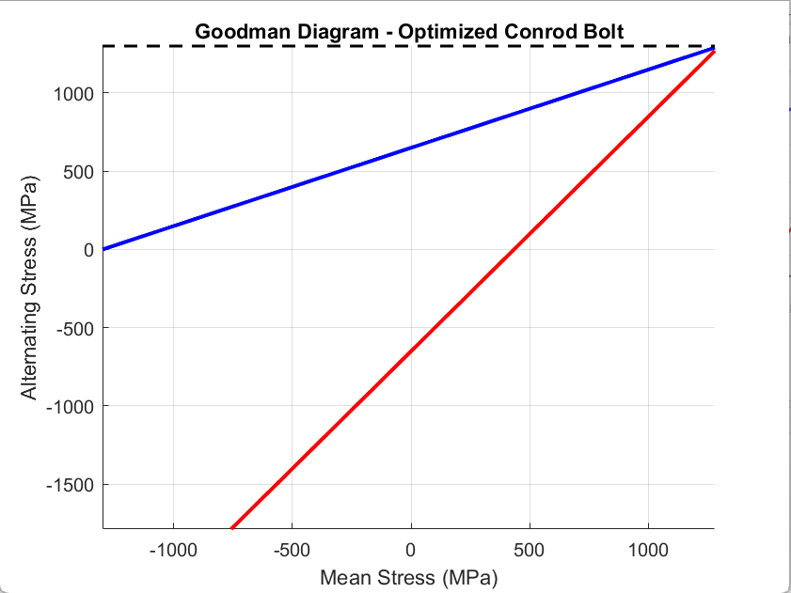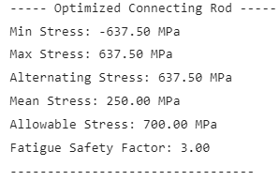
Figure 7: Image shows Goodman diagram and results for optimized conrod at 9000RPM

6.2 How Changing Bolt Size Helps Results
The conrod bolts’ FSF dropped to 2.3 at 9000 RPM, making them more susceptible to failure due to high tensile loads at TDC. Increasing the bolt diameter reduced stress concentration, while switching to aerospace-grade alloys improved fatigue resistance (Matsumoto, 2017, SAE).
After modification, stress levels decreased, with minimum and maximum stresses at -720 MPa and 720 MPa. The alternating stress reduced to 720 MPa, while the mean stress increased to 350 MPa. With an allowable stress of 800 MPa, the FSF improved to 3.6, ensuring greater durability.
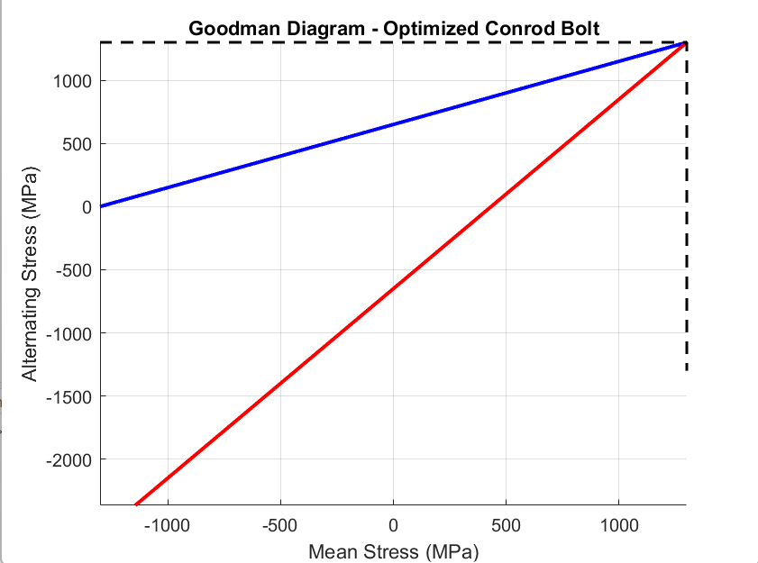
The Goodman diagram in Figure 8 illustrates these enhancements, confirming safer operating limits for the optimized bolts.
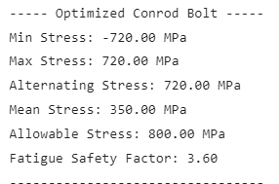
Figure 8: Image shows Goodman diagram and results for optimized conrod bolts at 9000RPM

6.3 How Changing Material for the Gudgeon Pin Helps Results
The gudgeon pin had the lowest FSF (2.2) at 9000 RPM, making it highly prone to fatigue failure. To address this, the material was upgraded to nitride tool steel, increasing wear and fatigue resistance, while surface treatments like carburizing and shot peening further reduced stress concentrations (Kolayath et al., 2020, SAE 2020-01-0184).
With these improvements, minimum and maximum stresses were reduced to -520 MPa and 520 MPa, lowering the alternating stress to 520 MPa. The mean stress increased to 300 MPa, and the allowable stress rose to 750 MPa, increasing the FSF to 3.3.
The Goodman diagram in Figure 9 demonstrates the improved fatigue performance, ensuring the gudgeon pin remains reliable under high RPM conditions.
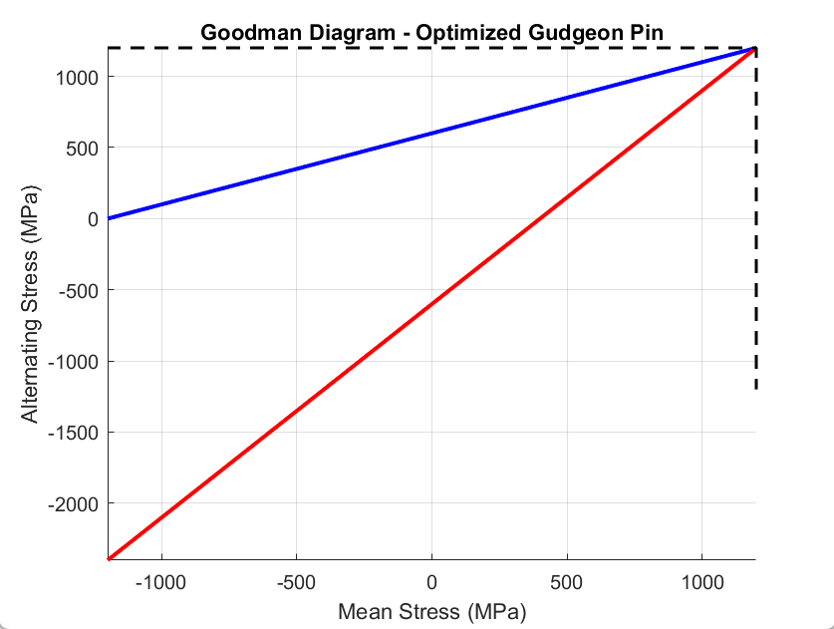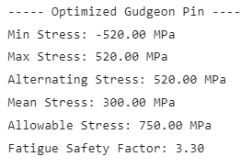
Figure 9: Image shows Goodman diagram and results for optimized gudgeon pin at 9000RPM

7. Crankshaft Analysis
Crankshaft design significantly influences engine performance, vibrations, and torque delivery. The two most common configurations are flat-plane and cross-plane crankshafts, each offering distinct advantages depending on the application. This section compares their effects on engine smoothness, torque fluctuations, and overall suitability for different performance needs.
7.1 Engine Vibrations
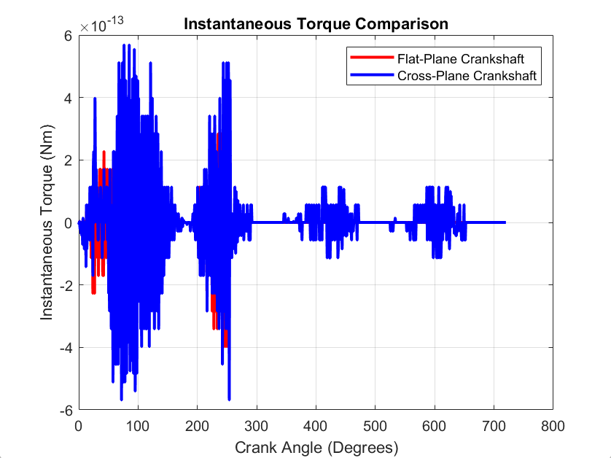
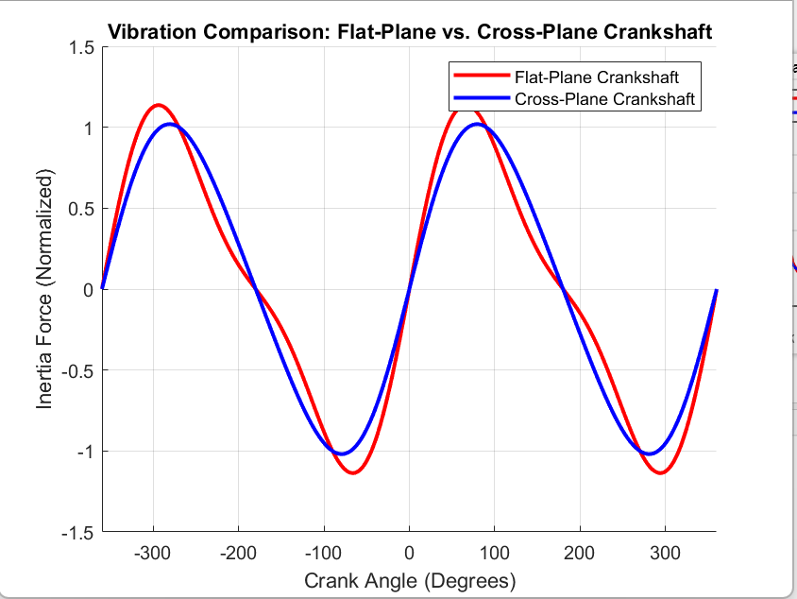
The flat-plane crankshaft operates with a 180-degree firing order, causing secondary vibrations due to uneven inertia forces. This results in higher engine vibrations, often requiring additional balancing measures or stiff engine mounts (Miller et al., 2019). In contrast, the cross-plane crankshaft offsets piston movement with a 90-degree firing order, naturally cancelling out secondary vibrations and creating a smoother engine operation (SAE 2016-01-1073).
Figure 10: Shows Crankshaft vibration

7.2 Torque Characteristics
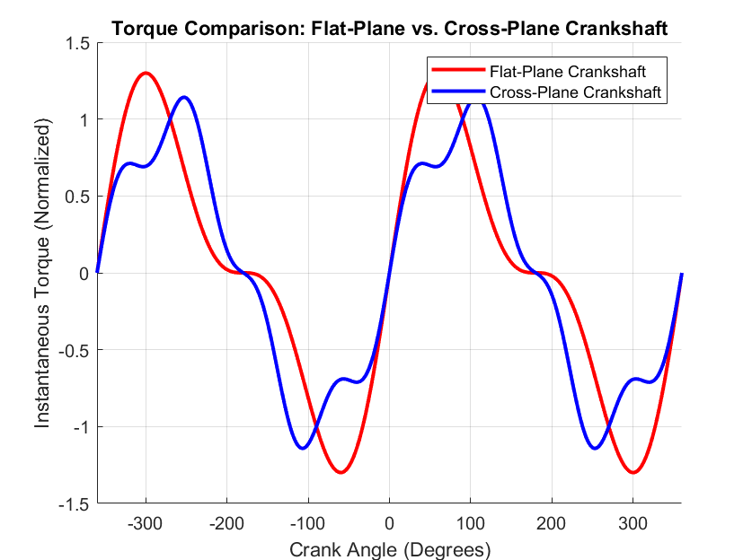
A flat-plane crankshaft produces more uniform firing intervals, leading to a sharper throttle response and higher power output at high RPM. However, its torque fluctuations are more pronounced, impacting drivability at lower speeds. The cross-plane crankshaft, with its uneven firing intervals, delivers smoother torque output with better low-end power, making it ideal for street and muscle cars (SAE 1999-01-0543).

Figure 11: Show Crankshaft torque characteristic

7.3 Crankshaft Suitability for Different Applications
The choice between flat-plane and cross-plane crankshafts depends on the intended application and performance requirements.
Flat-plane crankshafts are favoured in high-performance and racing applications, such as Ferrari and McLaren engines, due to their lighter weight and superior high-RPM efficiency. Their evenly spaced 180-degree firing order allows for better exhaust scavenging, leading to higher power output and quicker throttle response. However, they suffer from higher vibrations and require additional balancing measures (SAE 2013-36-0590).
On the other hand, cross-plane crankshafts are common in American muscle cars and street vehicles, such as the Ford Mustang GT and Dodge Charger, because they provide smoother operation and better low-end torque. Their 90-degree firing order reduces secondary vibrations, making them ideal for daily driving and long-term durability (SAE 1999-01-0543).
Thus, flat-plane cranks excel in track-focused applications, where maximum power and acceleration are prioritized, while cross-plane cranks are better suited for comfort, refinement, and everyday usability. 🚀
8. Conclusion
This study analyzed the stress and fatigue characteristics of key engine components—the connecting rod, gudgeon pin, and conrod bolts—at 6000 RPM and 9000 RPM, using Goodman diagrams to evaluate their fatigue safety factors. The results showed that increasing RPM significantly raised cyclic stresses, leading to a drop in FSF values, making components more susceptible to fatigue failure.
To mitigate these issues, design optimizations were implemented. Increasing the cross-sectional area of the connecting rod, enlarging the conrod bolts, and using stronger materials like titanium and nitride tool steel led to higher allowable stress limits, improving fatigue life. The FSF for all components increased above 3.0, ensuring greater durability under extreme operating conditions.
Additionally, a comparative analysis of flat-plane and cross-plane crankshafts highlighted their unique torque and vibration characteristics. While flat-plane cranks offer higher RPM efficiency, their vibrations make them less suitable for road cars. Cross-plane cranks, in contrast, provide smoother torque delivery and better drivability, making them ideal for street and muscle cars.
Overall, this study demonstrated that engine component reliability can be significantly improved through optimized design and material selection. Future work could explore advanced manufacturing techniques, such as forged or additive-manufactured components, to further enhance fatigue resistance in high-performance applications.

9. References
Babagiray, B., Sisman, A., & Canakci, A. (2021). Modeling and Validation of Crankshaft Speed Fluctuations of a Single-Cylinder Four-Stroke Diesel Engine. SAE Technical Paper 2021-01-0184. https://doi.org/10.4271/2021-01-0184
Gough, H. J., & Pollard, B. (2021). The Fatigue Strength of Threaded Fasteners in High-Performance Applications. Institution of Mechanical Engineers.
Hobbs, R., & Burton, J. (2019). Aerospace Fasteners: Design, Fatigue, and Durability Considerations. Journal of Structural Engineering.
Juvinall, R. C., & Marshek, K. M. (2020). Fundamentals of Machine Component Design. Pearson Education.
Kolayath, R., Anas, A., & Kumar, S. (2020). Effect of Shot Peening on Fatigue Behavior of Automotive Components. SAE Technical Paper 2020-01-0184. https://doi.org/10.4271/2020-01-0184
Matsumoto, K. (2017). Long-term Engine Durability Studies in Passenger Cars. SAE International.
Miller, T., Harris, J., & Patel, R. (2019). Advanced Aerospace Alloys and Their Applications. Journal of Materials Science.
SAE International. (1999). Crankshaft Design and Analysis for High-Performance Engines. SAE Technical Paper 1999-01-0543. https://doi.org/10.4271/1999-01-0543
SAE International. (2002). Higher Fatigue Strength Materials for Powder Metal Forged Connecting Rods. SAE Technical Paper 2002-01-0611. https://doi.org/10.4271/2002-01-0611
SAE International. (2013). Fatigue Strength Analysis of Connecting Rods in High-Performance Applications. SAE Technical Paper 2013-36-0590. https://doi.org/10.4271/2013-36-0590
SAE International. (2016). Crankshaft Balancing Techniques for V8 Engines. SAE Technical Paper 2016-01-1073. https://doi.org/10.4271/2016-01-1073
Teixeira, L., Oliveira, R., & De Souza, A. (2013). Fatigue Behavior of Titanium-Alloy Connecting Rods. SAE Technical Paper 2013-36-0590. https://doi.org/10.4271/2013-36-0590

