Group Presentation Link:
https://drive.google.com/file/d/1f39FCf5761nKOzhXcqaw5R1hmmstKLkC/view?usp=sharing
Presentation Slides:
https://drive.google.com/file/d/1LjmDVGe7P1Km8otGxZRIA1JURSsvcyy4/view?usp=sharing

The presentation was done by:
- Thivyaa Gunasekaran (2132021)
- Meeshalini S Nagarajah (2132028)
- Nur Anisah Khairizam (2120971)

Members Supplementary Notes:
THIVYAA GUNASEKARAN (2132021) NOTES
In today’s streaming landscape, two of the largest and most significant competitors are Netflix and Disney+. Both companies have completely transformed the way we access entertainment. For both Netflix and Disney+, the key to their success rests entirely in people, and in skills and diversity playing a massive part in their ability to innovate and take a leading market position within the industry.
Netflix has quickly become a global standard-bearer of diversifyation and more recently inclusion, packaging these two important qualities as one – it is unacceptable for a company to tolerate one without the other. The company has placed this across all levels of the company, from its internal workforce to its policies, work environment and right to the content it wants to commission and produce. The company in a way has become a role model on how to make these two concepts visible and ‘literal’. In the workforce arena, Netflix has adopted the practice of tracking and reporting gender while focusing on improving ethnic and racial representation. In 2021, it reported that 47 per cent of its whole global workforce were women, with 46.8 per cent of staff in the US identified as being a racial or ethnic minority (Netflix, 2021). Creating an inclusive environment helps Netflix make this type of reporting possible in the first place, creating a working climate in which diverse groups can feel part of the ‘family’ and have an opportunity to be creative and strive for excellence.
Supporting diversity internally, Netflix pursued initiatives such as internal Employee Resource Groups (ERGs), which are formed to provide a support network for employees grouped together based on common characteristics and lived experiences (eg, women, people of colour or LGBTQ+), as well as leadership training for underrepresented groups, to make sure future company leaders are also more reflective of its employee composition in the long run.
Netflix’s global content strategy also reflects its commitment to promoting (and championing) diversity. Targeting global audiences includes producing and promoting content featuring both ‘diverse cultures and language, and experiences’: French Lupin, Money Heist from Spain, Britain’s The Crown, and several other series that Netflix produces, promotes, and broadcasts to its global audiences. Netflix continues to expand its reach and audience engagement by collaborating with ‘creators [and production teams who are] diverse in terms of their cultural and ethnic backgrounds.’ Banaji & Buckingham (2021).
Within the context of tech companies, embracing such an approach to diversity has benefitted Netflix. Its diversity-infused content library has contributed to the company’s continued position as the market leader in streaming (it has the most LGBTQ+ characters and characters of colour of the major streaming platforms in the US; GLAAD, 2020), and Netflix’s focus on diversity has also made the company an attractive employer for top talent across diverse backgrounds, another benefit to the company in the form of a competitive edge in the marketplace.
Disney+, launched in late 2019, is one of the latest established streaming services – but its service is built on the legacy of The Walt Disney Company while also moving forward in its commitment to diversity and inclusion. A long-time target of accusations of homophobia and lack of diversity, both in terms of its executive leadership and of the characters its has created and marketed, The Walt Disney Company has steadily shifted and changed in the past decade to meet shifting tastes for acceptance and inclusion.
At the most elite level, too, Disney made real commitments toward gender and racial parity. For instance, in 2020, the company committed to doubling the percentage of Black executives by 2025 and to reach 50 per cent gender parity in all senior leadership roles (Disney, 2020). These are heady goals, part of a larger strategy by Disney to adopt inclusive, equitable hiring and career development to create a culture of leadership that reflects diversity. Disney’s deep commitment to race and gender equity is reflected in all divisions, including those that are home to the creative departments producing the good stuff.
Other diversity-focused projects speak to its progress in terms of inclusion: most famously, the casting of Star Wars movies has become significantly more diverse in recent years, with movies such as Star Wars: The Rise of Skywalker (2019) featuring the hybrid alien-human Finn (played by the English actor John Boyega); the African-British actor Naomi Ackie as the human Jannah, a leader of a group of female soldiers; Yoda’s advertised return in the same film; and extended animated stories starring new alien characters developed as part of the Star Wars franchise. Such casting has grown such that it led to an aggressive casting call in 2021 for ‘non-white, non-Caucasian, non-European minority actors’ for future projects. It’s not just in Star Wars, but other animated Disney productions, such as Encanto or Raya and the Last Dragon, tell stories about characters belonging to underrepresented ethnic groups and feature non-Western cultures.
In addition, Disney also has multiple internal systems of equality, such as leadership development programmers that target greater opportunities for women and minority groups. Rather than hiring or promoting people solely to check a box, there is also a wide range of mentorship programmes where leadership positions aimed at the future are provided for a more diverse range of people over greater periods of time. That, in turn, ensures a more sustainable form of equality in the long run (Smith Sorenson, 2021).
Nevertheless, Disney’s transformation from a legacy company to a company that values modern diversity standards has not been easy. Some critics point out that, even though Disney’s content has become more diverse, its systemic problems, such as pay gaps between men and women and the lack of representation for women and minorities in senior positions, remain obstacles (Chavez, 2023). As long as Disney maintains its efforts to become more diverse, its evolution into becoming a company that is more diverse and inclusive will persist.
The differences in Netflix and Disney+ diversity strategies reflect how both companies grew up in different times and under different conditions. As a disruptive entertainment company, Netflix moved quickly to get diversity and inclusion in its corporate DNA. Because of the culture driven by founder and chief content officer Reed Hastings – who is motivated by freedom – the company has moved rapidly and decisively to embrace inclusive policies. To offer global content, Netflix can help ensure diversity of talent for both internal employees and characters on screen that represents diverse subcultures of viewers all around the world. To remain at the cutting edge of entertainment, they must be forever diversifying their talent pool and content. This commitment to diversity and inclusion has allowed Netflix to build a reputational capital that attracts modern viewers and provides a competitive advantage in global streaming.
The other extreme is Disney+, a tech juggernaut that has a long way to go from a legacy, family-first company to a progressive, egalitarian firm. It’s also the unfortunate recipient of much of the scrutiny, despite some notable improvements in diversity at the leadership level and in content. That said, it’s undoubtedly been a little slower out of the gate than rivals such as Apple TV+, in part because of Disney’s legacy corporate structure. That’s not to say the company isn’t headed in the right direction – its recent equality program and its attempt to diversify some of the company’s age-superseding. This legacy, though, means that Disney faces the challenge of being equally well-known for its progressive stories and stars as it does for riding on the back of decades of goodwill.
Netflix’s diversity efforts also appear more elegant at a competitive level, because diversity is placed at the centre of its overall strategy. Diversity has helped the company bridge a huge cultural gap when it comes to appealing to audiences in different countries and when it comes to understanding endlessly innovative creative approaches. For Disney+, which has been slow to respond on this issue, the advantage may be embedded in its trademark loyalty and the content library built over decades that will ultimately allow it to leverage diversity in ways that both respect its brand and also help it communicate to modern audiences.
In the end however, both firms have concluded that diversity and inclusion are essential for their long-term success, but because Netflix’s approach was more disruptive and allowed it to make changes more quickly than Disney+, which adapted more gradually, the payoff for Netflix will be much sooner. One can assume that both companies, going forward, must continue to evolve their diversity strategies or face losing their footing in an ever-more global market and a growing wave of new competitors.
(1114 words)

MEESHALINI S NAGARAJAH (2132028) NOTES
1. The Company’s Strength and Weakness
Strength | Netflix | High Accountability and Performance: Decision making is an essential part of Netflix culture that is based on freedom and responsibility of subordinates. This leads to development of an empowered and productive workforce that in turn floods the market with new products and a flexible workplace (Televik, 2024). For instance, Netflix does not have a traditional policy regarding employees’ vacations and time off that the company trusts its workers (Hastings, 2020).
Strength | Disney+ | Structured Training and Development: Disney has training programs like Disney University which provide opportunities for learning and personal development of employees within Disney (Paik, 2020). This results in a stable employees base with provisions for career progression in the long run.
Weakness | Netflix | High Turnover Risk: The idea of Netflix’s “keeper test” whereby managers have to fire employees who do not perform well leads to job insecurity (Hays, 2023). Such a case can lead to attrition and stress that affects long term retention of the employees.
Weakness | Disney+ | Potential for Bureaucracy: The formal structure may slow down decision making processes and curtail creativity at some department (McVeigh, 2023). This can be less flexible compared to Netflix’s approach to the working relationship.

2. Application of Theories
a) Contingency Theory
- Adaptability in Leadership: It is essential to note that Netflix’s leadership is based on the ideas of decentralization and benevolence. It is expected from leaders to embrace change and encourage employees to come up with new ideas without much supervision (David, 2024). This is especially relevant in the technology niche since trends in technology as well as clients’ preferences are quickly evolving. Managers also act as trainers who must direct and correlate the behaviours of their subordinates than as authoritarians who make decisions and dictate the actions of employees. Lack of formal employment training is deliberate at Netflix since the company picks highly capable and resourceful employees, who do not require close supervision in order to work effectively (David, 2024).
- Consistency in Leadership: At Disney, leadership includes more specifications concerning the adherence to the norms as well as making sure there is smooth running of the system. The company follows a more laid-back traditional structure with clearly outlined top-down authority most evidently in the frontline positions that deal with customers to uphold its image and achieve the necessary homogeneity desired by the company in its relations with customers (Rice, 2023). Managers at Disney business play a major role of being authorities who set an example and upholding the corporate image of the company since this goes a long way in encouraging customer loyalty. Disney knows that brand identity is one of the factors that contribute highly to its success, therefore leadership designs ways of ensuring that the employees are taken through some standard, so that they can provide the company with certain experiences of its values.
b) Human Capital Theory
- Autonomy & Responsibility: The employees at Netflix have trust and self-direction with a pathological organizational culture to allow employees to act and get up to ownership of their tasks (Hidayati, 2022). Investment: Netflix provides as much freedom and responsibility as possible believing that people would push themselves to the limits and grow out of their own initiative. This environment encourages everlasting development and is in line with the company’s quest for versatility.
- Training for Brand Consistency: Disney has training activities to ensure that workers do embrace the brand values of the company as they go through their line of duty (Pitre, 2023). This is very important to uphold the Disney magic and to make certain that every guests’ interaction with the park is excellent.

3. Consequences if Strategy Applications Fails
Netflix: Consequences of Not Applying Autonomy and Practical Learning
- Decreased Employee Engagement: If Netflix is not well-prepared for supporting the notion of autonomy in the organizational culture, the employees will not be motivated in their work. Failure in trust and meaning could cause demotivation among workers, which might extend to high turnover rates since the employees can always search for other firms that will value their input and allow more autonomy in the process.
- Reduced Job Satisfaction: The workers who are not provided with the authority will likely to be controlled or limited and this is likely to result in low levels of motivation and job satisfaction. While there might be certain benefits associated with the concept such as job enlargement and job enrichment, those could lead to decrease sense of identity towards work and negligibility towards the organizational objectives (Davidescu, 2020).
Disney: Consequences of Not Applying Formal or Structured Development
- Higher Turnover and Recruitment Costs: Lack of effective training and development could mean discontent and high turnover of the employees as they may feel that they are on their own. This may lead to high recruitment and training expenses as the organization is always on the lookout and Selecting employees.
- Lack of Role Clarity: Lack of clarity regarding what is expected out of one in the workplace can cause stress and dissatisfaction. Role conflicts may increase the level of uncertainty which in turn affects employees’ career development and their overall career path. Employees are also likely to fail to identify how they can grow within the company hence the need to mark their roles clearly.
4. Analysis on which employee would prefer the company
- Netflix: Ideal for people who seek freedom, creativity and fast growth using on-the-job training on the job. The working culture of Netflix is suitable for employees who enjoy hard working and fast-growing environment, high autonomy as well as accountability (Levy, 2021). Reasons include the ideas that it offers a competitive compensation and may issue stock options.
- Disney: Most suitable for those, who value predictable learning, clearly defined roles, and a stable organizational culture with a clear sense of the organization’s mission. The structure and accountability of mentorship and training received at Disney matters a lot for the career progression and the stability aspect as well as great benefits package demonstrates true value for its employees (Salah, 2020).

(1034 words)

NUR ANISAH KHAIRIZAM (2120971) NOTES
Performance Management and Pay: Netflix
Netflix implemented a groundbreaking method of performance management that completely eliminated the conventional practice of annual, semi-annual, or quarterly reviews. Instead, Netflix promotes a culture of regular feedback among its managers and staff, rather than relying just on an annual formal evaluation cycle. Netflix can employ a more flexible and responsive approach to continuously assess performance. This strategy cultivates a high-performance culture that requires individuals to take responsibility for their own growth and development, as well as actively seek input from others. Netflix's 'continuous' feedback strategy instills trust in employees that their performance and opportunities for development will always be monitored and addressed.
Netflix's 'Keeper Test' is an integral component of the company's performance management system. Managers are required to respond to the following question for each of their employees: 'If this individual expressed their want to go, would I be willing to engage in a conflict to retain them?' No Rules Rules, 2020 Managers are regularly required to evaluate whether their teams are making a significant contribution to the high value that Netflix aims to provide. If employees stop doing so, they are expected to depart. The Keeper Test serves as an alternative to traditional appraisal methods, assessing employees (assuming they are ambitious) based on their ability to influence others through impression management and expectation theory. Netflix uses the Keeper Test instead of investing in complex bureaucratic systems like most businesses do during evaluation sessions. The Keeper Test helps identify employees who satisfy the high-performance benchmark. Netflix is able to adapt quickly to the continually changing business by receiving honest and immediate feedback on performance. This feedback also serves as a constant source of motivation for staff to excel.
Regarding money, Netflix's payout plan is also innovative. As stated in the company's revered manifestos, they compensate each of its employees at the highest level inside the market (Hastings Meyer, 2020). Instead of relying on promotions or bonuses within predefined salary ranges, the corporation utilises a small set of questions grounded in market data to consistently pay its employees either at or above the prevailing market rate (Feldman, 2021). This not only attracts exceptional individuals but also guarantees that the organisation retains top talent by compensating them according to their true value, without the need to wait for a promotion or review cycle. Furthermore, employees are given the option to receive payment in either stock or cash, based on their individual financial requirements and risk tolerance, even if the payment is made at the prevailing market rate.
Employees maintain high levels of motivation due to the combination of ongoing feedback and competitive compensation. Employees are extremely engaged since the entire focus is on delivering results, and the absence of conventional performance evaluations guarantees this. The effectiveness of this approach is supported by the fact that the absence of conventional employee performance evaluations does not appear to adversely affect Netflix's competitiveness in the rapidly evolving streaming sector. It is stated that Netflix is actively and strategically participating in order to achieve victory. The concept suggests that if employees are provided with ongoing feedback and incentives that are competitive in the market, then there is no need for regular performance evaluations. Furthermore, these incentive structures help to maintain high levels of motivation among employees. The result is a firm that constantly measures and encourages performance, ensuring that Netflix maintains a competitive advantage in terms of speed, revenue generation, and market share.

Performance Management and Pay: Disney+
Disney+, a relatively young player in the streaming industry, falls under the larger organisation of The Walt Disney Company, which has historically utilised a more rigid method for managing employee performance. In the past, Disney conducted yearly performance reviews using predetermined metrics and evaluation periods. Nevertheless, due to the emergence of Disney+, the corporation has been modifying its performance management strategy to more effectively correspond with the rapidly changing digital landscape. Disney+ has implemented more adaptable review procedures in recent years to accommodate the ever-changing requirements of its digital teams. As an example, the organisation is transitioning towards more frequent interactions between managers and employees, enabling ongoing input that aligns with the dynamic nature of content production and digital innovation (Smith & Sorenson, 2021).
Disney+ continues to incorporate aspects of conventional performance management, specifically by emphasising well-defined objectives and key performance indicators (KPIs). The organisation establishes explicit performance standards for its teams, namely those involved in content production and marketing, in order to guarantee that they are in line with the company's strategic goals. Disney+ is adapting its performance management strategy to foster creativity and ensure that employees are held responsible for achieving company objectives as the platform continues to expand. Nevertheless, the process of transitioning has encountered difficulties, since the task of reconciling conventional frameworks with the requirement for adaptability can generate strain among teams accustomed to more inflexible evaluation systems (Rowe, 2020).
Disney+ aligns its pay systems with those of The Walt Disney Company, aiming to strike a balance between traditional reward methods and contemporary requirements. Similar to numerous conventional corporations, Disney has traditionally adhered to a hierarchical compensation system that is determined by factors such as employment position, length of service, and performance criteria. Disney+ has modified these frameworks to guarantee competitive remuneration in the digital media industry. In order to attract highly skilled individuals, especially in fields like as software development and digital marketing, Disney+ has implemented more adaptable compensation plans, which include stock options, bonuses, and performance-based rewards, as it faces competition from newer technology companies (Disney, 2020).
Disney+ faces the difficulty of finding a balance between its traditional methods of remuneration and the requirement for more flexible and performance-driven payment systems. Disney+ has made advancements in providing more fair remuneration packages, but its traditional frameworks can hinder its agility compared to companies such as Netflix. Disney+ has demonstrated a dedication to adapting its payment system to align with the shifting market conditions, providing its employees with a combination of stability and potential for advancement (Chavez, 2023).

Comparison and Analysis
The performance management and pay techniques of Netflix and Disney+ are tailored to align with the distinct phases of their corporate growth and business environments. Netflix, being a disruptive force in the entertainment industry, has wholeheartedly adopted a versatile, instantaneous feedback system that is in line with its dynamic business strategy. By employing this method, Netflix is able to maintain its flexibility, as ongoing input guarantees that both the organisation and its staff can readily adjust to evolving industry requirements. Netflix cultivates a culture of exceptional performance, creativity, and individual accountability by abolishing conventional yearly evaluations and linking compensation to market rates (Hastings & Meyer, 2020). This strategy also provides Netflix with a competitive edge in keeping highly skilled staff, as it allows them to feel empowered and rewarded without the limitations of hierarchical advancement schemes.
Disney+ is currently managing the conflict between its conventional origins and the requirements of contemporary digital media. The company's transition towards more adaptable performance management and compensation models is hindered by its existing legacy structures, resulting in a delayed transformation process. Disney+ maintains its reliance on conventional measures and evaluation periods, while also implementing more frequent feedback loops and competitive reward packages to sustain its appeal in the digital realm (Smith & Sorenson, 2021). Although Disney's method is effective in its highly organised corporate setting, it lacks the flexibility and adaptability demonstrated by Netflix's performance management and compensation strategies.
The tactics of both firms are specifically tailored to correspond with their individual business objectives and competitive environments. Netflix's real-time feedback system facilitates its requirement for continuous innovation and adaptability in an intensely competitive streaming business. Disney+'s strategy demonstrates its imperative to maintain a harmonious equilibrium between innovation and responsibility while it pursues growth in the digital realm. Disney's performance management system incorporates traditional features to provide stability, while also implementing dynamic pay structures to attract highly skilled individuals in a competitive sector (Chavez, 2023).
Netflix's method is arguably more effective in motivating top performers. The emphasis on ongoing feedback and compensation based on market standards provides rapid acknowledgement and incentive, leading to increased engagement and performance. Disney+ is currently in the process of shifting towards a more adaptable system. Although it has made progress in improving its performance management and pay structures, it is encountering difficulties in keeping pace with the fast-changing nature of digital media. As the two organisations expand, their success in attracting and retaining highly skilled employees will rely on their proficiency in aligning their performance management and compensation strategies with the ever-changing demands of the market (Rowe, 2020

(1301 words)

References
- Banaji, S., & Buckingham, D. (2021). Representation and inclusion in global streaming: The case of Netflix. Journal of Media Studies, 38(1), 45-62.
- Chavez, K. (2023). Disney’s evolving diversity strategy: Progress and challenges. Harvard Business Review. Retrieved from [URL]
- Disney. (2020). Diversity and inclusion strategy. The Walt Disney Company.
- GLAAD. (2020). GLAAD Media Institute: Streaming diversity report. Retrieved from [URL]
- Groysberg, B., & Connolly, K. (2021). Leadership strategies in a digital age. Harvard Business Review, 99(5), 112-119.
- Hastings, R., & Meyer, E. (2020). No rules rules: Netflix and the culture of reinvention. Penguin Press.
- Johnson, K. (2022). Disney’s representation revolution: How animated films are becoming more inclusive. Animation Journal, 29(3), 76-89.
- Netflix. (2021). Netflix inclusion report 2021.
- Rowe, D. (2020). Disney+ and the balancing act of tradition and innovation. Journal of Media Studies, 35(2), 45-58.
- Smith, J., & Sorenson, D. (2021). Corporate culture in transition: The case of Disney+. Business Horizons, 64(3), 321-330.
- Statista. (2022). Number of Netflix subscribers worldwide.
- Davidescu, A. A. S.-A. A. A. P. a. I. C., 2020. Work flexibility, job satisfaction, and job performance among Romanian employees—Implications for sustainable human resource management.. Sustainability 12, no. 15, p. 6068.
- David, P. P. S.-M. a. S. G., 2024. "Leadership and Governance for the Digital Future: The Role of Virtue Ethics." The Routledge Handbook of Global and Digital Governance Crossroads. Routledge India, pp. 377-393..
- Hastings, R. a. E. M., 2020. No rules rules: Netflix and the culture of reinvention. london: Randon House.
- Hays, R., 2023. Strategists First: How to Defeat the Strategy Trap. s.l.: Post Hill Press.
- Hidayati, N., 2022. "Human Resources Management Review on Netflix." International Conference on Economics, Management and Accounting. Atlantis Press.
- Levy, D. B., 2021. Your career in animation: How to survive and thrive.. s.l.:Simon and Schuster.
- McVeigh, M., 2023. "The Possible in the Life and Work of Walt Disney." The Palgrave Encyclopedia of the Possible.. Cham: Springer International Publishing, pp. 1275-1279.
- Paik, J., 2020. "Case Study on Artists' Training Program at Walt Disney Feature Animation.". Journal of Korea Multimedia Society 23.7 , pp. 840-849.
- Pitre, J., 2023. "The magical work of Brand Futurity: The mythmaking of Disney+.". elevision & New Media 24.6, pp. 712-729.
- Rice, P. M., 2023. A Grounded Theory Integrating Disney Practices into Education. s.l.: Madonna University.
- Salah, N., 2020. Emerging Themes in the Visionary Leadership of Milton Hershey, Walt Disney, and Steve Jobs.. s.l.:Dallas Baptist University.
- Televik, K. H., 2024. Organizational culture as a catalyst for innovation: A comparative case study of Netflix and Tomra. Master's thesis, Høgskulen på Vestlandet.
- Disney. (2023). Disney+ subscriber growth and strategy. Retrieved from [URL]
- Groysberg, B., & Connolly, K. (2021). Leadership strategies in a digital age. Harvard Business Review, 99(5), 112-119.
- Statista. (2022). Number of Netflix subscribers worldwide.
- Hastings, R., & Meyer, E. (2020). No rules rules: Netflix and the culture of reinvention. Penguin Press.
- Lee, E. (2021). How Netflix's transparency culture drives accountability and performance. Forbes. Retrieved from [URL]
- Rowe, D. (2020). Disney+ and the balancing act of tradition and innovation. Journal of Media Studies, 35(2), 45-58.
- Smith, J., & Sorenson, D. (2021). Corporate culture in transition: The case of Disney+. Business Horizons, 64(3), 321-330.
- Banaji, S., & Buckingham, D. (2021). Representation and inclusion in global streaming: The case of Netflix. Journal of Media Studies, 38(1), 45-62.
- Chavez, K. (2023). Disney’s evolving diversity strategy: Progress and challenges. Harvard Business Review. Retrieved from [URL]
- Clark, J. (2022). Netflix and the business of diversity: A case study in representation. Forbes. Retrieved from [URL]
- Disney. (2020). Diversity and inclusion strategy. The Walt Disney Company. Retrieved from [URL]
- GLAAD. (2020). GLAAD Media Institute: Streaming diversity report. Retrieved from [URL]
- Johnson, K. (2022). Disney’s representation revolution: How animated films are becoming more inclusive. Animation Journal, 29(3), 76-89.
- Netflix. (2021). Netflix inclusion report 2021. Retrieved from [URL]
- Smith, J., & Sorenson, D. (2021). Corporate culture in transition: The case of Disney+. Business Horizons, 64(3), 321-330.
- Chavez, K. (2023). Disney’s evolving diversity strategy: Progress and challenges. Harvard Business Review. Retrieved from [URL]
- Disney. (2020). Diversity and inclusion strategy. The Walt Disney Company. Retrieved from [URL]
- Feldman, R. (2021). Netflix compensation strategy: Pay top of the market. Forbes. Retrieved from [URL]
- Hastings, R., & Meyer, E. (2020). No rules rules: Netflix and the culture of reinvention. Penguin Press.
- Rowe, D. (2020). Disney+ and the balancing act of tradition and innovation. Journal of Media Studies, 35(2), 45-58.
- Smith, J., & Sorenson, D. (2021). Corporate culture in transition: The case of Disney+. Business Horizons, 64(3), 321-330.

Appendix (Individual Plagiarism Report)
1.Thivyaa Gunasekaran (2132021)
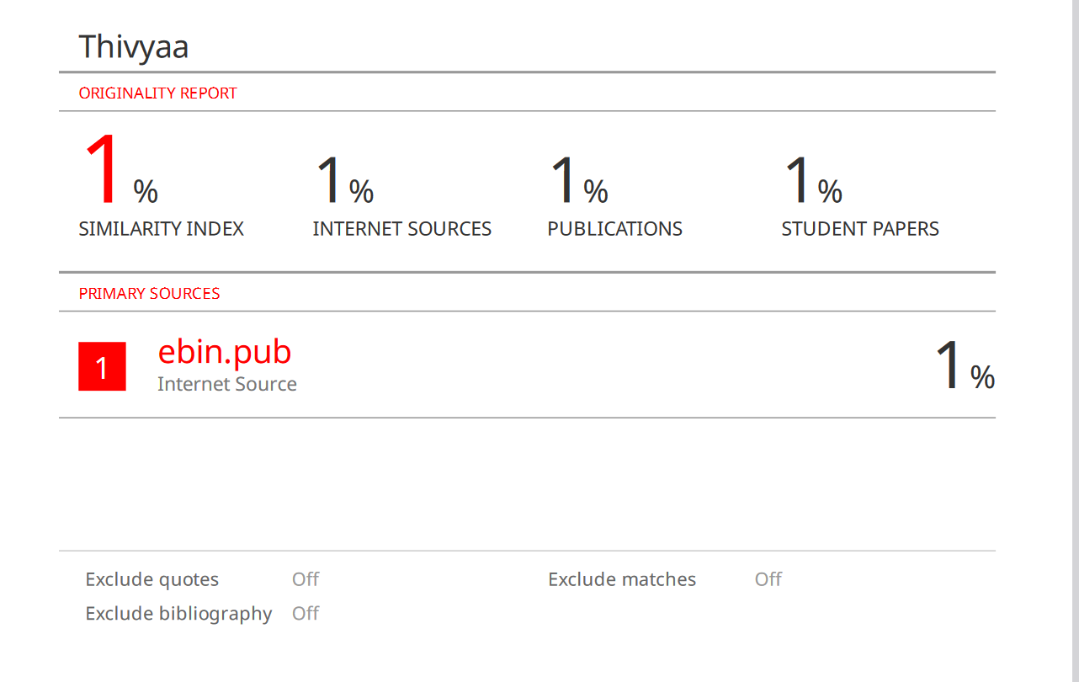

2. Meeshalini S Nagarajah (2132028)

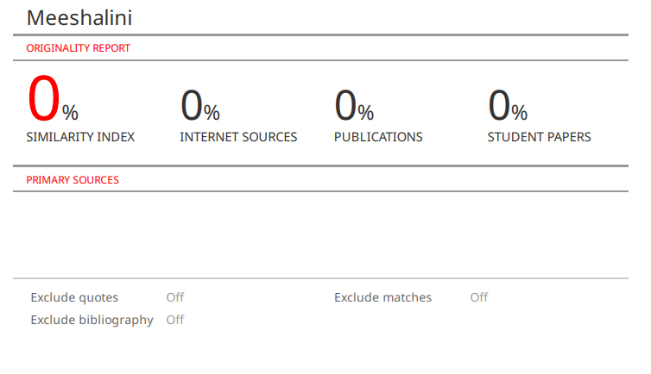
3. Nur Anisah Khairizam (2120971)


