
APPENDIX GA36a

LEVEL 4 ASSESSMENT SPECIFICATION
Assessment 1

Student name: | - EZRANUR BINTI YAACOB | Student ID number: | 2527787
Programme: | Bachelor In Accounting (Honours)
Module: | Contemporary Challenges: Making a Difference
Module code: | MWBA4000 | Contribution to Overall Module Assessment (%): | 100%
Lecturer: | Emma Roberts | Internal Verifier: | Vic Saunders
Assignment Title: | Group Presentation with supporting material (max 4 in a group) | Word count (or equivalent): | 5 mins each plus 1,500 words supporting material
Submission deadline: | Monday 24th August 2026 (23.55/ 11.55pm British Summer Time BST) | Return date of provisional marks & written feedback: | 21st September 2026

TABLE OF CONTENT
No. | Title | Page
1. | Section 1 | 3-4
2. | Section 2 | 5-6
3. | Section 3 | 7
4. | Section 4 | 8-9
5. | Reference List | 10-11

Section 1
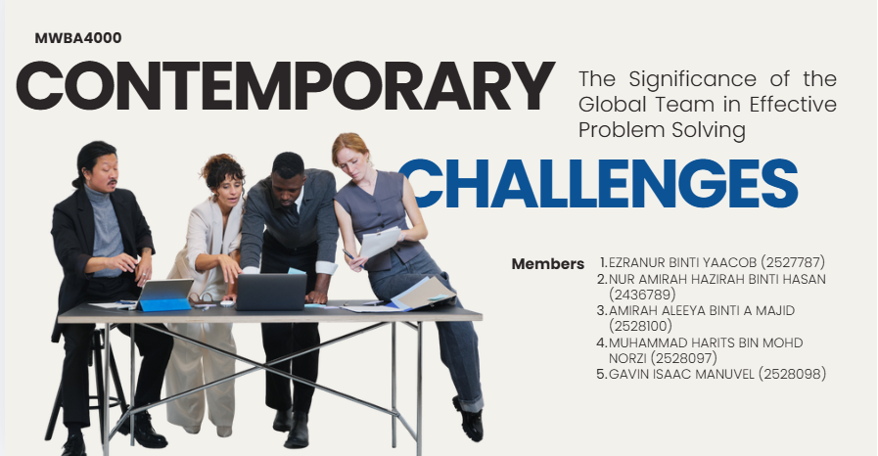

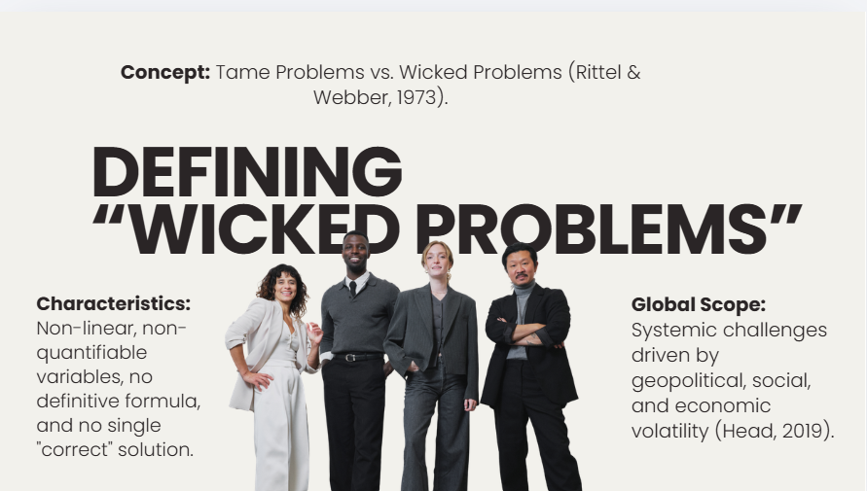

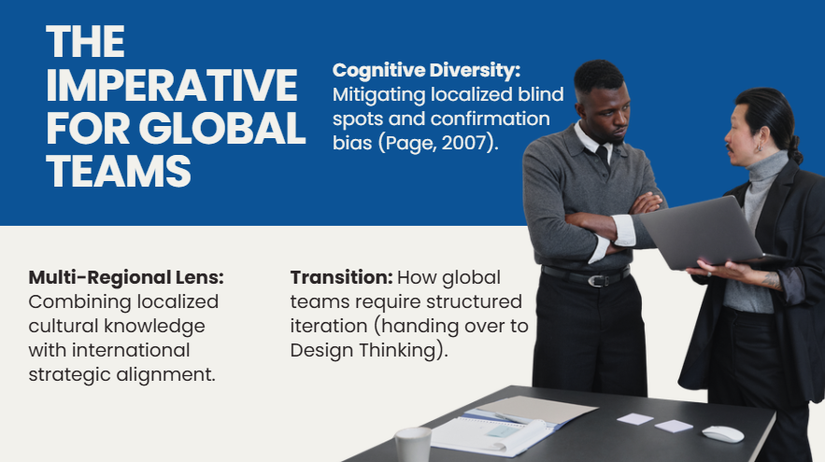

Section 2
The group presentation was designed in 4 logical parts, focusing on how team performance and leadership need to be accomplished in the world if a problem is going to be solved in a complex and modern world. The group consisted of four participants for each with a unique sub-topic, all of which ultimately helped to tell the story. The first student started the presentation by describing global team dynamics and the concept of wicked problems (Rittel and Webber, 1973) – a non-linear and unstructured problem that has many variables, solutions with which are not always clear, and are often difficult to solve. Student 2 (the author) furthered this by investigating how DT and inter-disciplinary working could offer a structured approach to tackling these wicked problems. Student 3 examined interpersonal, which involved looking at individual differences, emotional intelligence (EQ), and conflict management strategies in culturally diverse virtual teams (Goleman, 1995; Meyer, 2014). Lastly, Student 4 related these ideas in a PEST (Political, Economic, Social, Technological) analysis, assessing the macroeconomic consequences of new technologies such as Artificial Intelligence (AI), and explained the ethical issues that are essential to today's global leaders (Aguilar, 1967; Floridi et al., 2018).
The key takeaways from the group presentation were that global teams offer a unique competitive edge when addressing contemporary issues in organisations – but only when they actively tap into cognitive diversity in a structured manner and through empathetic leadership. The group found that diversity is not enough to ensure performance; it is necessary to have organizational mechanisms that are deliberately designed to make it possible to use the diversity to lead to innovative, actionable results, such as a Design Thinking framework, high emotional intelligence and ethical technology adoption (Page, 2007; West, 2012).
The individual contribution of the author (Student 2) was on the use of Design Thinking and the incorporation of the expertise of different disciplines. This content was the essential conceptual link between the wicked problems defined by Student 1 and the team dynamics focus by Student 3. Student 1 has proven the non-quantifiable nature of wicked problems makes them difficult to formulate into a definitive problem (Head, 2019), while the author has demonstrated a human-centered, iterative process of Design Thinking (Empathize, Define, Ideate, Prototype, Test) breaks down ambiguity into manageable feedback loops (Plattner et al., 2011).
Additionally, the author's section was the one that related directly with the discussion on emotional intelligence made by Student 3. Within the global context, executing the "Empathize" stage requires high levels of EQ and psychological safety in the team, as members need to listen across cultural and functional boundaries and understand the complex needs of the users (Edmondson, 1999; Mayer et al., 2004). The author's study of interdisciplinary synergy, the synergy of the combination of legal, financial and technical knowledge, also directly helped Student 4 when evaluating technology. In particular, the author emphasized the importance of interdisciplinary oversight for evaluating the systemic risks, data privacy concerns, and societal impacts identified in Student 4's PEST and ethical analysis (Jobin et al., 2019; Tsamados et al., 2021), and how advanced technologies like AI can aid in ideation and prototyping processes (Davenport and Ronanki, 2018).
Finally, the author's individual content directly supported the group's overall conclusion that successful multidisciplinary global teamwork is essential to tackling complex international problems and relies upon formal and people-driven workflows. The author illustrated how Design Thinking addresses the cognitive bias (Kahneman, 2011) and how it captures interdisciplinary strengths (Martin, 2009), bringing together the problems, how they were handled with others, and ethical technological execution in a cohesive group argument.

Section 3
Despite being widely promoted in theoretical literature as the best approach to complex problem-solving, Design Thinking and interdisciplinary global teams have a number of potential conflicts of practice.Although Design Thinking and interdisciplinary global teams are hailed as the solution to complex problem-solving in much of the theoretical literature, there are some serious friction points. However, when a global team lacks cognitive and functional diversity, it can create significant decision latency, communication hurdles and domain-based intellectual silos (Edmondson, 2012; Haas and Mortensen, 2016). Although the academic models suggest perfect interdisciplinary synthesis, members of the team often exhibit professional parochialism, tend to favor their own field methodologies over integrated ones (De Dreu and Weingart, 2003).
Moreover, although new technologies like Artificial Intelligence are touted as boosting data processing and ideation (Davenport and Ronanki, 2018), relying too heavily on automated synthesis is fraught with ethical and operational dangers. Automated tools often share the same systemic biases that are present in the training sets they are based on, which can obscure important regional, social, and political nuances that are needed for making decisions on a global scale (Floridi et al., 2018; Tsamados et al., 2021).
Perspectives on these issues are somewhat different from the overly positive literature on leadership that is found in introductions. In practice, diversity has been found to be a source of process friction, as well as innovation, in this group task. It was necessary to develop critical thinking skills and to be engaged in persuasion (Paul and Elder, 2006; Yukl, 2013) to align differing viewpoints. Instead of abstract design frameworks, for success, it was necessary to engage in conscious conflict management and rubrics for decision making that could transform cognitive disagreement into constructive critique.
Balancing theory and practice was key to critical reflection in a group task. Understanding that such approaches as Design Thinking are not magic bullets, the group also employed critical thinking to challenge assumptions, to consider the ethical boundaries of emerging technologies and to intentionally leverage interpersonal tensions to maximize group effectiveness.

Section 4
Description
This is a four-member group that was established to create a written supporting document and a video presentation. We had presentation areas based on each academic's expertise, used Microsoft Teams as a base for asynchronous work and held weekly synchronous video check-ins to discuss progress and contributions from both members (Gibbs, 1988).
Feelings
At the beginning of the project, I had some noticeable anxieties about how to distribute tasks, coordinate time-zone differences, and how to avoid some of the same content being reviewed by the two theoretical sections. Initial topics being discussed included some room for ambiguity of topic boundaries, which added some tension. Progressively, though, as we walked through our presentation sequence and discussed each border individually, my anxiety turned to confidence and trust (Tuckman, 1965).
Evaluation
The overall collaborative process was fairly successful, and the presentation and the integration of the written submission was coherent and based on current literature. The key issue we faced was ensuring that the timelines for decisions around technology tools such as AI were managed effectively when such a critical discussion was taking place. Let's see the positive side, our open lines of communication enabled us to discuss differing opinions in a positive way, without compromising team cohesiveness or unity.
Evaluation
Collaborative skills introduced in Unit 2 were essential to the success of working collaboratively throughout this project. Structured communication and active listening were key for setting boundaries on tasks (Katzenbach and Smith, 1993). As opinions disagreed about how to structure our academic critique, we relied on the critical thinking and influencing tools to analyze arguments in terms of evidence, not on authority (Paul & Elder, 2006; Yukl, 2013).
Analysis
My role was a personal one, in synthesizing the various ideas into a coherent narrative and keeping our presentation slides (and the written sections) in sync. Other group members proved to be very effective in their task-oriented leadership, such as in keeping track of the meetings' agenda and the timelines of the drafts' completion (Belbin, 2010). Disagreements were resolved in a way that involved the use of interest-based conflict resolution: alternative viewpoints were compared to our main research question instead of trying to reach a quick consensus (De Dreu and Weingart, 2003). This experience confirmed my knowledge that with high emotional intelligence and psychological safety, constructive task conflict will have an impact on the quality of team output (Edmondson, 1999; Goleman, 1995).
Conclusion
In conclusion, this group project has offered many insights into the complexities of working on a team internationally. I understood that it is necessary to have explicit structures, and to have a proper way of managing people to get them moving in the same direction in order to ensure effective alignment across different perspectives. I discovered that I am a strong person at creating a critical synthesis and using a framework in the initial phase of negotiation.
Action Plan
In future international or cross-functional project teams I will create a clear team charter and a team decision-making guideline at the forming stage (Tuckman, 1965). This will make the resolution of conflicts more efficient, reduce latency of decisions, and make the shift from allocation of tasks to the execution of critical tasks more efficient.

Reference List
- Aguilar, F.J. (1967) Scanning the Business Environment. New York: Macmillan.
- Belbin, R.M. (2010) Management Teams: Why They Succeed or Fail. 3rd edn. London: Routledge.
- Brown, T. (2008) 'Design Thinking', Harvard Business Review, 86(6), pp. 84–92.
- De Dreu, C.K. and Weingart, L.R. (2003) 'Task versus relationship conflict, team performance, and team member satisfaction: A meta-analysis', Journal of Applied Psychology, 88(4), pp. 741–749.
- Davenport, T.H. and Ronanki, R. (2018) 'Artificial Intelligence for the Real World', Harvard Business Review, 96(1), pp. 108–116.
- Edmondson, A.C. (1999) 'Psychological Safety and Learning Behavior in Work Teams', Administrative Science Quarterly, 44(2), pp. 350–383.
- Edmondson, A.C. (2012) Teaming: How Organizations Learn, Innovate, and Compete in the Knowledge Economy. San Francisco: Jossey-Bass.
- Floridi, L., Cowls, J., Beltrametti, M., Chatila, R., Chazerand, P., Dignum, V., Luetge, C., Madelin, R., Pagallo, U., Rossi, F. and Schafer, B. (2018) 'AI4People—An Ethical Framework for a Good AI Society: Opportunities, Risks, Principles, and Recommendations', Minds and Machines, 28(4), pp. 689–707.
- Gibbs, G. (1988) Learning by Doing: A Guide to Teaching and Learning Methods. Further Education Unit. Oxford: Oxford Polytechnic.
- Goleman, D. (1995) Emotional Intelligence: Why It Can Matter More Than IQ. New York: Bantam Books.
- Haas, M. and Mortensen, M. (2016) 'The Secrets of Great Teamwork', Harvard Business Review, 94(6), pp. 70–76.
- Head, B.W. (2019) 'Forty years of wicked problems: Policy failure and policy change in the 21st century', Policy and Society, 38(2), pp. 180–197.
- Janis, I.L. (1982) Groupthink: Psychological Studies of Policy Decisions and Fiascoes. 2nd edn. Boston: Houghton Mifflin.
- Jobin, A., Ienca, M. and Vayena, E. (2019) 'The global landscape of AI ethics guidelines', Nature Machine Intelligence, 1(9), pp. 389–399.
- Kahneman, D. (2011) Thinking, Fast and Slow. New York: Farrar, Straus and Giroux.
- Katzenbach, J.R. and Smith, D.K. (1993) The Wisdom of Teams: Creating the High-Performance Organization. Boston: Harvard Business School Press.
- Martin, R.L. (2009) The Design of Business: Why Design Thinking is the Next Competitive Advantage. Boston: Harvard Business Press.
- Mayer, J.D., Salovey, P. and Caruso, D.R. (2004) 'Emotional intelligence: Theory, findings, and implications', Psychological Inquiry, 15(3), pp. 197–215.
- Meyer, E. (2014) The Culture Map: Breaking Through the Invisible Boundaries of Global Business. New York: PublicAffairs.
- Page, S.E. (2007) The Difference: How the Power of Diversity Creates Better Groups, Firms, Schools, and Societies. Princeton: Princeton University Press.
- Paul, R. and Elder, L. (2006) The Miniature Guide to Critical Thinking Concepts and Tools. Dillon Beach: Foundation for Critical Thinking.
- Plattner, H., Meinel, C. and Leifer, L. (eds.) (2011) Design Thinking: Understand – Improve – Apply. Berlin: Springer.
- Rittel, H.W. and Webber, M.M. (1973) 'Dilemmas in a general theory of planning', Policy Sciences, 4(2), pp. 155–169.
- Tsamados, P., Aggarwal, N., Cowls, J., Morley, J., Roberts, H., Taddeo, M. and Floridi, L. (2021) 'The ethics of algorithms: Key problems and solutions', AI & SOCIETY, 37(1), pp. 215–230.
- Tuckman, B.W. (1965) 'Developmental sequence in small groups', Psychological Bulletin, 63(6), pp. 384–399.
- West, M.A. (2012) Effective Teamwork: Practical Lessons from Organizational Research. 3rd edn. Chichester: Wiley-Blackwell.
- Yukl, G. (2013) Leadership in Organizations. 8th edn. Boston: Pearson.

