line launcher project
Designs and calculations
Robin Williasmson-Gillie-1800974
Greig Western-1804348
Aiden Scriven-1803502
Iestyn Webber-
Contents
Greig Western 1804348 2
Energy Release (Trigger) and Safety System. 2
Trigger/safety system 2
Air lines and fixings 2
Blowby reduction 2
Bibliography 3
Robin Williamson-Gillie 1800974 4
Barrel and squash ball 4
Squash ball 4
Squash ball specs and calculations: 4
Barrel designs 5
Design 1 5
Design 2 6
Final design reasoning 6
Bibliography 7
Aiden Scriven 1803502 8
Energy Storage and Firing 8
Bibliography 9

Greig Western 1804348

Energy Release (Trigger) and Safety System.

There are 3 things to consider for this part of the project:
- Trigger/Safety system
- Pressurised air lines and fixings
- Reduction of blowby within the cylinder to increase range and repeatability of the launcher

Trigger/safety system
The safety system will comprise of 2 switches, one toggle switch with a guard to arm the system and a second push button switch to fire the system such as the one found at Gearhead Enterprises (Gearheadworld.com, 2020) . The actual switches to be used will be appropriated from cheaper local sources and will include a guard made by the team to reduce the overall cost of the unit. The switches will be mounted on a piece of aluminium from the scrap bin of a local university. This reduces the ability of the operator to accidentally fire the system. In fact, the guarded toggle switch was first designed to prevent pilots from accidentally arming systems in flight (Msp-aviation.com, 2020). The system, once armed, will be connected to a pneumatic valve operated electronically by the push button switch. After extensive research, it would seem that any purpose-built pneumatic valve rated for the pressures quoted for a tyre would far exceed the total cost allowed in this project, therefore, an alternative in the guise of a sprinkler valve has been chosen (U-buy.co.uk, 2020). This type of valve has been proven to work previously for a similar set up (Instructables, 2020) meaning that it can be used with some degree of confidence here.

Air lines and fixings
The team decided to use a vehicle tyre for the compressed air for the launcher, which is rated to a normal pressure value in use of 2.2-2.7 bar (Oponeo, 2020), therefore the lines and fittings to be used will be repurposed air lines (sgs-engineering. 2020) and a hollowed-out Schrader valve (bikerbargains, 2020) to connect the barrel to the air line. It will be hollowed out as the trigger release will incorporate its own valve, so a one-way valve will be redundant. All of the fittings will be rated to a minimum pressure rating of the maximum pressure rating of the tyre, reducing the possibility of failure.

Blowby reduction
Although it could be contested that this is part of the barrel, the reduction of blowby within the cylinder is in fact in keeping with the other air-lines and fittings of the pneumatic system, in that the purpose of both is to keep the pressurised air in the system for the entire duration of the required firing cycle. For this, it has been decided not to go down the route of the more expensive piston and piston ring composition, such as that found in a common internal combustion engine, which would involve not only extra cost in parts and materials, but also time to manufacture. A more basic, musket type solution will be used instead in the form of wadding for the squash ball, which will be tethered inside the barrel via a length of fishing line so that only one piece of wadding is required. Seeing as the equipment provided will already include a length of fishing line, it is safe to presume that the wadding can be attached to this. Wadding is typically a piece of paper or cloth wrapped around the projectile (Gun Wiki, 2020) which keeps the expanding gasses behind the projectile until it has left the barrel. The fishing line attachment point will be the length of the barrel plus 10% to make reloading easier and to ensure it ejects fully from the barrel. The actual wadding itself will in this case be made of a thin lint free cloth (furnitureclinic, 2020) due to its cost, ease of availability, the ability to change its size quickly and easily via cutting or tearing and the fact that there are no explosives being used means that it does not need to be resistant to heat or flame.

Bibliography
Gun Wiki. (2020). Wadding. [online] Available at: https://guns.fandom.com/wiki/Wadding [Accessed 3 Feb. 2020].
Oponeo. (2020). Tyre Pressure for Toyota Celica 1.80 141.00 » Oponeo.co.uk. [online] Oponeo.co.uk. Available at: https://www.oponeo.co.uk/advice-and-tips/tyre-pressure/for-toyota/celicavii/1-8/141 [Accessed 3 Feb. 2020].
Furnitureclinic. (2020). Lint Free Cotton Cloth. [online] Furniture Clinic. Available at: https://www.furnitureclinic.co.uk/Link_Free_Cotton_Cloth?si=0.1&utm_source=bing&utm_medium=cpc&utm_campaign=%5Bb.%5D%20Shopping%20Catch%20All&utm_term=1100701593008&utm_content=All%20Products [Accessed 3 Feb. 2020].
bikerbargains. (2020). SCHRADER VALVE 1/8 BSP - NZ$14.90 : Biker Bargains, Deals for your 2 Wheels!. [online] Bikerbargains.co.nz. Available at: http://www.bikerbargains.co.nz/index.php?main_page=product_info&products_id=1177 [Accessed 3 Feb. 2020].
sgs-engineering. (2020). How to Choose the Perfect Air Compressor Hose. [online] Available at: https://www.sgs-engineering.com/help-advice/choose-perfect-compressor-air-hose/# [Accessed 3 Feb. 2020].
Gearheadworld.com. (2020). Racing Switch Panel Push Button Start Aircraft Type Toggle Switch w Cover - Gearhead Enterprises. [online] Available at: https://www.gearheadworld.com/store/Ignition/Racing-Switch-Panel-Push-Button-Start-Aircraft-Type-Toggle-Switch-w-Cover-P10824C134.aspx [Accessed 3 Feb. 2020].
U-buy.co.uk. (2020). Orbit Sprinkler System 1-Inch Male NPT Jar Top Valve 57467 | Buy Products Online with Ubuy UK in Affordable Prices. B0013I62XC. [online] Available at: https://www.u-buy.co.uk/catalog/product/view/id/5925204/s/orbit-sprinkler-system-1-inch-male-npt-jar-top-valve-57467 [Accessed 3 Feb. 2020].
Instructables. (2020). How to Build an Air Cannon With a Sprinkler Valve. [online] Available at: https://www.instructables.com/id/How-to-build-an-air-cannon-with-a-sprinkler-valve/ [Accessed 3 Feb. 2020].
Msp-aviation.com. (2020). Switch Guards | MSP Aviation. [online] Available at: https://msp-aviation.com/product-category/switch-guards/ [Accessed 3 Feb. 2020].

Robin Williamson-Gillie 1800974

Barrel and squash ball

Squash ball
An important aspect of the design of the whole project is understanding the specs and parameters of the object that is being fired. In this situation it is a single yellow dot squash ball attached to a fishing line.

Squash ball specs and calculations:
The squash ball has a diameter of 40 mm and a mass of 0.024Kg (company, 2016). The diameter of the squash ball will later affect the diameter of the barrel design. The mass will affect the power that is needed in firing the ball.
One of the aspects of the squash ball that is important to consider is the drag of the ball. This requires multiple calculations to get to the final answer. These are;
- The first is to work out the area of the ball. The equation is $A=4π{\left(\frac{d}{2}\right)}^{2}$ (G.Z., 2017)l.
The d in the equation stands for the diameter of the sphere in this case 40mm or 0.04m. So, after all the correct data was input into the equation, the area of the squash ball was $5.03×{10}^{-3}m^{2}$.
- The next needed part to work out the drag is the drag coefficient of the ball. The equation for this is $F=ρv^{2}ACd$. The F stands for the force acting on the ball. $ρ$ stands for density, in the case of this calculation the density of air. The density of air varies with temperature but, the test and final firing will happen in a room at room temperature which is $20℃$, at this temperature the density of air is $1.2042 KG/m^{3}$ (student.com, 2019). V is the velocity if the squash ball, this was calculated by the team member working on the power train of the project, and the results was 3m/s.
A stand for the area of the squash ball which was previously calculated above. Cd stands for the drag coefficient which is what is trying to be found in this calculation.
So, after inputting all the data values, the drag coefficient is ‘ ‘
- The final equation is the same as the previous as the drag is the reactant to the force being applied to by the powertrain. So, the final drag force is

Barrel designs
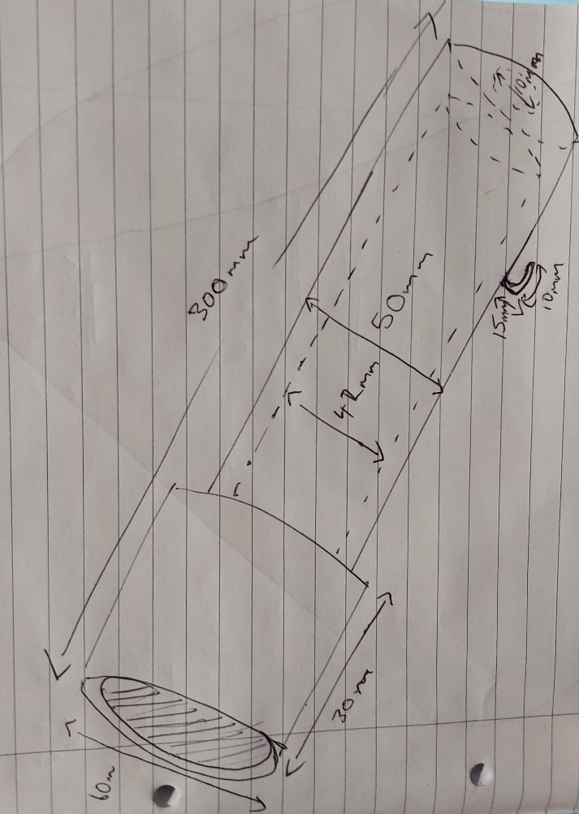
Due to the barrel being made of PVC tubing, mainly looking at plumbing tubing, there is a limit on the sizes that can be found in these components, so this had to be considered when coming up with designs for the barrel. There had to also be a way to attach the string to the launcher.

Design 1

This is the first design thought up. The length of the barrel is short as the limits of height and length are 0.6m, so this short design means that no matter the angle and the position on the baseplate it will not exceed the limit.
The inner width is 42mm, this leaves enough width for the squash ball to move but not so much that there will be a loss in pressure.
The hook on the side of the barrel is where the fishing line will be connected. This is curved away from the firing end of the barrel, to reduce the chances of the wire to come of mid-flight. The larger end to the barrel is to reduce the chances of the squash ball catching and dragging on exit.

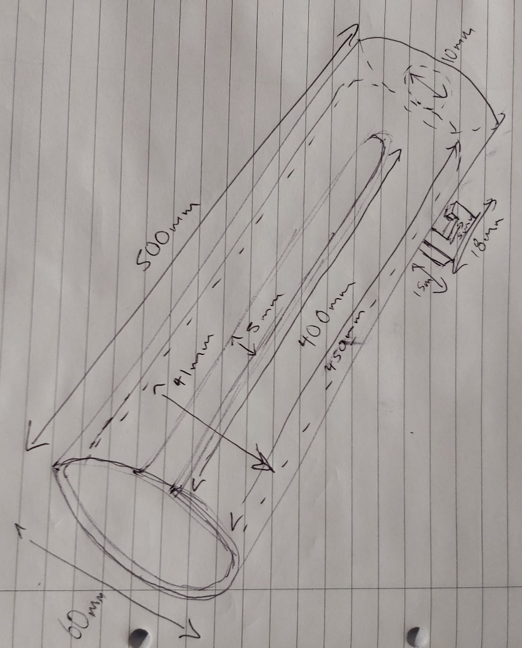
Design 2

The second design is very similar to the first, this is mainly due to the limited parameters in given in the IMEC E design spec, it also since a barrel is a very consistent shape.
This design has slight difference in its features and dimensions. It is a lot longer than the first design, this may increase range of fire, however, could increases the risk of it being longer that the limit of 0.6m high.
Another feature that it has is the cut into the side of the barrel, this was mentioned in part one of the project and was supposed to allow for the fishing wire attached to the squash ball to hang out of, and to stop in getting tangled during flight.
This design still has the hook on the side of it, similar to that of the one in the first design. There had to be a hook on both designs as it is the way the line is being attached to the launcher. This version of it however is slightly different, it has a squarer design. This squarer design is both easier to dimensions and produce.
The main in and outer diameter of the design is also larger. This was taken into consideration after looking at the options available for the PVC tubing.

Final design reasoning
The final design created on solid works was an amalgamation of design 1 and 2. The main body of the design was similar to design to, simpler and lacking the larger end piece that can be seen in design 1. This was mainly because this was not entirely needed and merely added to both the costs and time of production.
Most of the dimensions used in the final design were taken from design 1. This is because the smaller more compact design would reduce the risk of the barrel breaking the height regulation as well as keeping the whole system lighter and more cost effective.
The cut out of the side of the barrel (shown in design 2), was not used in the final design. This was because it was decided that the line could sit outside the barrel so there would be less chance of it dragging or catching on the barrel.

Bibliography
company, T. S. (2016). Squash balles explained: what do the dots mean. Retrieved from The Squash company : https://thesquashcompany.com/squash-balls-what-are-the-coloured-dots/
G.Z., G. (2017). Surface area calculator. Retrieved from GIGA calculator.com: https://www.gigacalculator.com/calculators/surface-area-calculator.php
student.com, E. (2019). Engineering student. Retrieved from www.Engineering student.co.uk: http://www.engineerstudent.co.uk/density_of_air.php

Aiden Scriven 1803502

Energy Storage and Firing

The pressure stored in the system is going to be used to propel the squash ball. Therefore, the velocity that the ball is propelled at needs to be determined for a given pressure. In order to determine this velocity, a few calculations must be made. The maximum possible velocity of the ball is a good start. This is done by using the maximum pressure, this is 20 bar. From here there are a few equations that need to be used and these are shown below.

Using the method below, the approximate maximum velocity can be determined from the system. The system will be using the storage device of a Toyota Celica tyre.

The maximum pressure to be used for the assignment as outlined in the brief is 20 bar. Therefore, the theoretical maximum velocity that the squash ball can be propelled at can be calculated. This is done using the equation:

$P= \frac{F}{A}$(Khan Academy, 2020)

Where P is pressure, F is force and A is area. This equation states that the pressure in a system is equivalent to force per unit of area. There is a well-known equation for force:

$$F=ma$$

Where m is mass and a is acceleration which equals velocity/time.

This means that an equation can be derived in order to determine the maximum possible velocity that the squash ball can be fired at. This is done by rearranging the equation given by substituting the previous two equations into the first:

$$P= \frac{mv}{tA}$$

Now that there is an equation that can be used, the equation can be rearranged to give:

$$v= \frac{tAP}{m}$$

Where: v is the velocity; t is the time; A is the surface area of the piston pushing the ball; P is the pressure in the system; and m is the mass of the squash ball and piston.

It is now possible to calculate the approximate velocity that the squash ball would have when using the maximum pressure of 20 bar. In order to calculate this velocity, the equation above will be used. The values should be substituted into the equation. It is assumed that the piston will be acting on the ball for a total of one second in this example and the average mass of a squash ball will be used of 24 grams (Robert Wood, 2008). When the equation is filled with values, this equation is formed:

$$v= \frac{\left(1\right)\left(\frac{{\left(0.045\right)}^{2}}{4}*π\right)(20)}{0.024}$$

By inputting this equation into the calculator, the result for the theoretical maximum possible velocity of the squash ball from the barrel which is 1.33 m/s. Although this value has been calculated, it is most likely not entirely accurate. This could be down to the fact that this calculation relies on all of the force exerted by the air pressure on the piston being transferred to the squash ball; this would most likely not be the case due to the effect of friction between the barrel and the piston. This friction may be reduced as much as possible through the use of lubricants but never completely eliminated. Further to this, the equation assumes that the ball is solid. A squash ball is not solid and has an elasticated surface. This means that the ball will absorb some of the force and it will dissipate in directions other than the forward direction. This combined with the inevitable bouncing along the barrel that will cause the ball to exit the barrel with a smaller velocity than was calculated using this method.

Despite the obvious inaccuracies in the calculation, there is no obvious way to accurately determine the velocity of the squash ball without specialist equipment and hours of experimental procedures. Therefore, this is the method chosen to determine a rough value for the velocity of the ball.

Bibliography

- Robert Wood, "Sports Ball Weight Comparison." Topend Sports Website, 2008, https://www.topendsports.com/resources/equipment-ball-weight.htm, Accessed 03/02/2020
- Khan Academy, "What is pressure?" Khan Academy, 2020, https://www.khanacademy.org/science/physics/fluids/density-and-pressure/a/pressure-article, accessed on 03/02/2020

