
MA Bilingualism and Multilingualism:
Andrea Folland

Local Welsh Medium Education in the Realisation of Cymraeg 2050: A Million Welsh Speakers

How evident is the implementation of the Welsh Government's strategy, Cymraeg 2050: A Million Welsh Speakers in the development of Welsh-medium education in Port Talbot?

ECGE7002Q

30th April 2022
Yr Athrofa: Education and Humanities

Name of the Programme of Study:
MA Bilingualism and Multilingualism
Name of Student (Capital Letters): ANDREA FOLLAND
DECLARATION
I certify that the whole of this work is the result of my individual effort, and that all sources have been acknowledged.
Signed: ANDREA FOLLAND
Date: April 30, 2022

DECLARATION
I am satisfied that this work is the result of the student’s effort.
Signed:
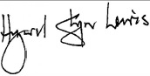
Dr Hywel Glyn Lewis
(Lecturer)
Date: 30-04-22
Acknowledgements:

I am very grateful to everyone who contributed to my research, either via their support, or by facilitating or undertaking questionnaires and interviews.

My thanks go to:

The Headteacher of Ysgol Gynradd Gymraeg Rhosafan for agreeing the participation of the school and their administering the questionnaire process on my behalf. I am very grateful to both the Headteacher and the school administration team for this.

The teachers and governors of Ysgol Gynradd Gymraeg Rhosafan who responded to questionnaires and those who also volunteered for interviews.

The parents and guardians of the pupils of Nursery and Year 4 at the school who participated enthusiastically and responded in their tens.

The Neath Port Talbot Local Education Authority representative and the representative of the Senedd who, very knowledgably and willingly, participated in the process.

Without all these people, there would have been no basis for my dissertation. Their participation and support made the research process thoroughly enjoyable and manageable; essential in pushing me to see it through.

I have also appreciated the practical and straight-forward guidance of my tutor, Dr H. G. Lewis, an immeasurable amount. He provided a voice of calm and reason whenever panic raised its head and made the most daunting tasks seem doable throughout the whole of the MA course. He is, undoubtedly, in his vocation not ‘just a job.’

Thank you to Becca and Emma for the informal intel on local schools from parents’ perspectives and for their honest feedback in piloting my questionnaires, also for publicising my questionnaires among their parenting circles.

Thanks millions to Julie, Mike and Martha for all of their help and support and for the treats. Their humour has provided an, at times, much-needed tonic and the natural intelligence of all three of them is a source of inspiration.

I am thankful for the never-ending care of my parents, who are relieved to see an end to my studies and profess to be that little bit thinner and greyer on top because of them! They never understand why I ‘get myself into these things’ but never waver in believing that I will succeed. They are the best people I know.

I am especially grateful to my Cariad Mawr, Tom, and Rusty the dog for being understanding and patient. You have dried the tears, doled out encouragement and picked up the slack when I was unavoidably detained. The way you intuit what is needed, at any given point, is sweetly surprising. Legends.

This paper is for all of you.

(And in honour of Wednesdays with Gran, who always kept it real.)

Table of Contents

Abstract 1
Table of Figures 4
Abbreviations and Acronyms 6
Chapter 1 8
Introduction 8
1.1 Cymraeg 2050: One ambition, two targets, three principles 8
1.2 A captive audience 11
1.3 Educating Cymru 11
1.4 National policy, local focus 13
1.5 Contribution of this study 16
Chapter 2 20
Literature Review 20
2.1 Attitudes to bilingualism 20
2.2 Influencing factors 25
2.3 Acquisition Planning 28
2.4 Local context 30
Chapter 3 33
Methodology 33
3.1 Scope and aims 33
3.2 Data collection 35
3.3 Framework for Data Analysis 42
3.4 Justification of a Research Strategy 44
3.5 Ethics 46
3.6 Limitations, Potential Issues and Pre-emptive Troubleshooting: 47
3.7 Other Considerations: 51
Chapter 4 52
Presentation and Analysis of Data 52
4.1 Introduction 52
4.2 Question 1: In which school year is your child, Nursery or Year 4? 53
4.3 Question 2: What were your reasons for choosing a Welsh-medium education for your child? 53
4.4. Point of interest with potential to affect implementation of Cymraeg 2050 60
4.5 Question 3: Did you take guidance / request information from any of the following authorities / services to inform your decision making on Welsh-medium education? 64
4.6 Questions 4 and 5: Did you have any reservations about sending your child to Welsh-medium education? If you answered ‘Yes’ or ‘Maybe’ to Question 4, please elaborate. 69
4.7 Question 6: Do you speak Welsh? 74
4.8 Question 7: Do you speak two or more languages? 75
4.9 Question 8: What is the main language of your home? 78
4.10 Question 9: If you are in employment, have you been asked to use/learn Welsh in your place of work? 79
4.11 Questions 10 and 11: Have you heard about Welsh Government’s ‘A Million Speakers’ strategy? If you answered ‘Yes’ or ‘Maybe’ to Question 10, please state what bearing, if any, this had on your decision to choose a Welsh-medium education for your child. 82
4.12 Question 12: If there is any other information you would like to include to expand on your answers given above, or in relation to any other aspect of your choice of Welsh medium education for your child, please include it here. 84
4.13 Question 13. What is your nationality? 85
4.14 Question 14: What is your gender? 87
4.15 Question 15: In which age group are you? 88
Chapter 5 90
Conclusion: 90
5.1 Key findings and recommendations 90
5.2 Theme 2: Availability of learning opportunities 92
5.3 Theme 3: Domains of usage 94
5.4 Theme 4: Confidence: 95
5.5 Theme 5: Collaboration 95
5.6 Looking ahead 97
5.7 Summation 100
References 101
Appendix A(i): Survey for the Parents / Guardians of Rhosafan Pupils: Language Choice Motivations 114
Appendix A(ii) : Arolwg i Rhieni / Gwarcheidwaid Disgyblion Rhosafan: 118
Appendix B(ii): Arolwg: Cymhellion Dewis Iaith Rhieni / Gwarcheidwaid Disgyblion Ysgol Rhosafan (Ar gael yma: Holiadur Pobl Broffesiynol) 130
Appendix C: Nursery parent 1 semi-structured interview - set questions 140
Appendix D: Code of Ethics: Language Choice Motivations Research / Côd Moeseg: Ymchwil Cymhellion Dewis Iaith 144
Appendix E: Parent Participant Letter 147
Appendix F: Professional Participant Letter 151

Abstract

In 2017, the Welsh Government (WG) launched Cymraeg 2050: A million Welsh speakers (the strategy), its latest Welsh language strategy. The ambition of the strategy is based around two overarching targets: increasing the number of Welsh speakers to one million by 2050 and increasing the percentage of the population who speak Welsh daily from 10% to 20%.

The approach of the strategy toward realising these targets is based around well-regarded language revitalisation models and pathways, including those championed by Fishman (1991), Grin and Moring (2002), Darquennes (2007) and Strubell (2001).

The strategy has been well-received across political parties with most debate in relation to it being centred around how best to realise the challenging targets than any sense of opposition to the strategy itself.

Intergenerational transmission in families is recognised by the WG as an important method by which the language could be developed. WG also recognises the possible difficulty in affecting sufficient influence over the home domain to keep this method of transmission operating at a level which would realise the strategy’s targets.

Consequently, Welsh-medium immersion education has been put as the principal method for ensuring that children can develop their Welsh language skills, and for creating new Welsh speakers.

The strategy states that areas with a high density of Welsh speakers will remain central to its vision as they “create the most favourable circumstances from which to foster Welsh speakers” (2017: 16). The following study, therefore, aims to uncover how the first five years of the strategy have played out in an area which would not be subject to this level of focus from the WG; Port Talbot.

Positioned on a conceptual border between south east and south west Wales, Port Talbot has a semi-anglicised feel about it.

As an early measure of the extent to which the implementation of Cymraeg 2050 is evident in the development of Welsh-medium education in Port Talbot, the research investigated parents’ reasons for selecting Welsh-medium education, and any changes occurring in these since the publication of the strategy.

A survey, comprising questionnaires and interviews, was undertaken with the parents of pupils in Nursery and Year 4 at Ysgol Gynradd Gymraeg Rhosafan. This enabled comparison of the viewpoints of those who had newly selected Welsh medium education with those whose children’s education commenced in the year prior to the strategy becoming live.
Setting these comparisons along a contextual timeline to take account of surrounding influences allowed consideration of how far any changes in reasons between year groups could be attributed to implementation of the strategy.

In the style of a case study, the research has established new means of utilising mixed methods in educational research to incorporate those who set, administer and implement policy. Triangulation of the results returned by these participants enabled further analysis of factors influencing parental choices.

Key words: Welsh-medium education; Welsh Government; Cymraeg 2050: A million Welsh speakers; policy; parental choice; awareness; availability; domains; collaboration; confidence; primary; attitudes; motivations; Port Talbot

Table of Figures

Figure Title | Page No.
Figure 1.1: Conceptual bases for the overarching principles of the Cymraeg 2050 strategy aligned with UNESCO’s factors affecting LR | 10
Figure 1.2: Percentage change in Welsh speakers (2001 – 2011) in the most predominantly Welsh-speaking areas of NPT | 14
Figure 1.3: Comparison of proportion of Welsh speakers by electoral ward in Port Talbot against county average (2011 Census data) | 15
Figure 3.1: Value in validity, as described by Sapsford and Evans (1979) | 45
Figure 4.1: Comparison of frequency of selection of reasons for choosing Welsh-medium education across parent year groups and related key | 54
Figure 4.2: Divergence in outcomes of YGGR research from that of Hodges (2012) | 57
Figure 4.3: Reasons of Nursery parents for choosing Welsh-medium education in rank order and by theme and motivation | 58
Figure 4.4: Reasons of Year 4 parents for choosing Welsh-medium education in rank order and by theme and motivation | 59
Figure 4.5: Comparison of the top five reasons of Nursery parents for choosing Welsh-medium education against predictive responses of professional participants | 61
Figure 4.6: Comparison of the top five reasons of Year 4 parents for choosing Welsh-medium education against predictive responses of professional participants | 62
Figure 4.7: Comparison of services accessed by parents across year groups to inform their decision-making regarding Welsh-medium education | 64
Figure 4.8: Additional sources of information sought by parents to inform decision-making | 65
Figure 4.9: Comparison of reservations held across year group respondents in relation to Welsh-medium education | 69
Figure 4.10: Rationale of Nursery parents for their responses to Question 4 | 70
Figure 4.11: Rationale of Year 4 parents for their responses to Question 4 | 71
Figure 4.12: Comparison of proportion of Welsh speakers across parent year groups | 74
Figure 4.13: Comparison of percentage of speakers of two or more languages by parent year group | 75
Figure 4.14: Comparison of main home language across parent year groups | 78
Figure 4.15: Comparison of proportion of respondents who have been asked to use / learn Welsh for work by parent year group | 79
Figure 4.16: Comparison of proportions of awareness of Cymraeg 2050 between year groups | 82
Figure 4.17: Additional viewpoints submitted by all participants in answer to Question 12 | 84
Figure 4.18: Comparison of nationality of respondent year groups | 87
Figure 4.19: Comparison of distribution of gender across year group respondents | 87
Figure 4.20: Comparison of age groups among respondent year groups | 88
Figure 5.1: Continuum of political factors affecting bilingualism | 98

Abbreviations and Acronyms

Abbreviation / Acronym: | Meaning:
AGM | Annual General Meeting
BBC | British Broadcasting Corporation
FIS | Family Information Service
FL | Foreign language
L1 | First language
L2 | Second language
LEA | Local Education Authority
LR | Language revitalisation
MICNPT | Menter Iaith Castell-nedd Port Talbot
MS | Member of the Senedd
NPT | Neath Port Talbot
NPTCBC | Neath Port Talbot County Borough Council
PLASC | Pupil Level Annual School Census
RAG | Red, Amber, Green
Rep. | Representative
RLS | Reverse language shift
SEP | Strategic Equality Plan
Cymraeg 2050 or ‘the strategy’ | Cymraeg 2050: A Million Welsh Speakers
UNESCO | United Nations Educational, Scientific and Cultural Organisation
UWTSD | University of Wales Trinity Saint David
WESP | Welsh in Education Strategic Plan
WIMD | Welsh Index of Multiple Deprivation
WG | Welsh Government
YGGR | Ysgol Gynradd Gymraeg Rhosafan

Chapter 1

Introduction

  - Cymraeg 2050: One ambition, two targets, three principles
In 2017, the Welsh Government (WG) launched Cymraeg 2050: A million Welsh speakers, its latest Welsh language strategy. In a departure from the formats of the strategies preceding it, Cymraeg 2050 (the strategy) is set over a much longer term and with a far larger target at its core. The strategy is based on an ambition by the WG to “see the number of people able to enjoy speaking and using Welsh reach one million by 2050” (2017: 2). In possible recognition of UNESCO’s assertion that “No single factor alone can be used to assess a language’s vitality or its need for documentation” (2003: 7), the WG has centred the strategy around two overarching targets:

- An increase in the number of Welsh speakers to one million by 2050

- An increase in the percentage of the population who speak Welsh daily (more than just a few words of Welsh) from 10%, as was the case from 2013 – 2015, to 20% by 2050.

These targets align with two of the nine factors UNESCO identifies as being evaluative of language vitality (Baker, 2011: 55): absolute number of speakers and proportion of speakers within the total population. Further alignment of the strategy, and the position of the Welsh language in Wales, with UNESCO factors affecting language revitalisation (LR) is noted during the chapter as a means of outlining the status of the language in the country.

Associations are made in the strategy between the approaches the WG aims to implement to reach its target and various well-regarded LR models and pathways. The work of Joshua Fishman (1991), Grin and Moring (2002), Darquennes (2007) and Miquel Strubell (2001) are cited among influences and the hallmarks of these specialists are evident in the three themes and principles the WG states will form its framework for the way ahead.

Figure 1.1 below, considers the themes and principles of the strategy against some of the specific elements of the LR concepts of Strubell (2001) and Grin and Moring (2002). It also aligns them with UNESCO’s factors affecting LR, which, although not directly referenced in the strategy, are evident in its content:

Figure 1.1: Conceptual bases for the overarching principles of the Cymraeg 2050 strategy aligned with UNESCO’s factors affecting LR

 | Cymraeg 2050 theme / principle: | Strubell’s Catherine Wheel Model (2001) | Grin and Moring’s Policy-to-outcome Path (2002) | UNESCO’s factors affecting LR (Baker, 2011)
1. | Increasing the number of Welsh speakers | More language learning | Capacity to use language | Factor 2: Absolute number of speakers
2. | Increasing the use of Welsh by widening opportunities which enable use of language skills | More informal social use of language = more demand for goods and services in language = more supply and consumption in language | Opportunities to use language | Factor 4: Shifts in domains of language use
3. | Creating favourable conditions, infrastructure and context by facilitating an environment in which everyone will want to use the Welsh language | Perception of greater need for language = more motivation to learn and use it | Desire to use language | Factor 5: Response to new domains and media

There is little doubt, therefore, that the broad intentions of the strategy are grounded in valued theory which may account for the reported cross-party support it has received. Such political concord, a rarity in relation to most subject matters, could prove to be a factor in aiding the eventual success of the strategy (UNESCO factors affecting LR, number 7: Governmental and institutional language attitudes and policies, including official status and use (Baker, 2011: 55). There is also reported support for the strategy, and the Welsh language more generally, in quarters beyond the WG.

A captive audience

In a measure of the level of support which exists among the Welsh public for the language and the Cymraeg 2050 strategy, a recent YouGov poll of 1086 adults in Wales suggested “…widespread acceptance and support for revitalising the language” with “only 18% of people opposing the target of reaching one million Welsh speakers by 2050.” Only 18% Oppose the Welsh Government’s One Million Welsh Speakers Target (Nation.Cymru 2022)

This evidence of appetite for the language (UNESCO factors affecting LR, number 8: Community members’ attitudes towards their own language (Baker, 2011: 55) sparks optimism in relation to the likelihood that principles two and three in Figure 1.1 above, could be realised. This begs the question, then, how does the WG intend to achieve principle one, an increase in speakers?

1.3 Educating Cymru

Despite Strubell’s (2001) Catherine Wheel model operating as a repeating cycle of interdependent variables, the element of “more language learning” appears to be the pivotal starting point of the concept. Without any speakers of a language, there would be nobody to which the other elements of the model could be applied. On this basis, the WG outlines two main methods it is to employ in reaching its ambition (2017: 31):

- Intergenerational transmission in families (UNESCO factors affecting LR, number 1 (Baker 2011: 55)

- Developing and sustaining skills through education and training, from the early years to Welsh language provision for adults.

In acknowledgement of the limitations to interventions which the WG may be able to apply in family settings, it pits Welsh-medium immersion education as the principal method of the strategy for ensuring that children can develop their Welsh language skills, and for creating new speakers.
In consideration of current and projected school data, the WG reports the following (2017: 21):

- In 2015/16, of the 35,000 learners in Year 2, 22% (7,700) were assessed in Welsh as a first language
- If this percentage were to rise to 30% by 2031, this would be approximately 10,500 learners (based on the size of the cohort of learners in Year 2 in 2015), approximately 2,800 additional children
- If this percentage were to rise to 40% by 2050, this would be approximately 14,000 learners (based on the size of the cohort of learners in Year 2 in 2015), approximately 6,300 additional children
- Administrative data from Mudiad Meithrin (2015/16) shows that 86% of children who attend Mudiad Meithrin groups progress to Welsh-medium primary education.
The elevated level of these figures highlights the importance of engaging the education sector to realise the one million speakers target. It also underlines the significance of the early years sector as a point of entry to immersion education, and to increasing demand for Welsh-medium education.

1.4 National policy, local focus

The strategy states a desire to grow the Welsh language across Wales and acknowledges a need to tailor the approach to this in line with the linguistic profiles of individual areas to achieve it. Whilst noting that there is potential to grow the language in areas with high density populations but lower percentages of Welsh speakers (2017: 7), the strategy also states that areas with a high density of Welsh speakers will remain central to its vision as they “create the most favourable circumstances from which to foster Welsh speakers” (2017: 16). It is worth considering, then, whether the focuses of the strategy leave room for those areas on a linguistic middle ground to fall through the cracks.

Further investigation of this highlighted Neath Port Talbot (NPT) as an area of interest. The 2011 census found that 15.3% of the county’s population can speak Welsh, putting the area 3.7% below the national average of 19%.

The vast majority of the 15.3%, or 20,698 Welsh speakers of the county, live to the north of Cwmtawe and in the Amman Valley. Menter Iaith Castell-nedd Port Talbot (MICNP) states that “communities such as Gwaun Cae Gurwen, Cwmllynfell and Lower Brynamman are among the most prominent Welsh language areas in Wales as a whole.” About Us. (Menter Iaith Castell-nedd Port Talbot, 2022) Figure 1.2 below, shows that the areas which Menter Iaith notes constitute the “most important in the county in terms of linguistic significance”, or its “linguistic axis”, experienced the biggest percentage decline in Welsh speakers between the last two census returns.

Figure 1.2: Percentage change in Welsh speakers (2001 – 2011) in the most predominantly Welsh-speaking areas of NPT

Community: | % Welsh speakers (Census 2001) | % Welsh speakers (Census 2011) | % change
Cwmllynfell | 68.2 | 58.8 | -9.4
Brynaman Isaf | 68.1 | 60.8 | -7.3
Gwaun-Cae-Gurwen | 67.9 | 55.8 | -12.1
Ystalyfera | 54.6 | 46.0 | -8.6
Trebanos | 42.4 | 33.6 | -8.8
Godre’r Graig | 41.5 | 30.1 | -11.4
Pontardawe | 37.4 | 31.0 | -6.4
Alltwen | 35.9 | 29.5 | -6.4
Rhos | 28.6 | 24.7 | -3.9

Source: 2011 Census via MICNPT Geographical & Linguistic Background

As a means of avoiding a complete language shift in these areas and beginning a process of early reversal, MICNPT caters specifically for them in its Strategic Plan. This conforms with the sentiment of Cymraeg 2050 in terms of keeping a focus on areas with a high density of Welsh speakers.

The somewhat quizzical point posed by the data in Figure 2 is the huge disparity between the county average proportion of Welsh speakers, 15.3%, and the proportions of Welsh speakers attributed to the “linguistic axis” areas of the county, even post-2011 decline. This can be accounted for by an exponentially lower percentage of Welsh speakers being present in Port Talbot, the town contributing some of the remaining portion of data for the county. Figure 1.3 below, shows that all but one of the areas located within Port Talbot fall well below the county average percentage of Welsh speakers (highlighted in red.) The only area to exceed the county average of 15.3% is that of the town’s peripheral villages, Bryn and Cwmafan, with the percentage of Welsh speakers there, 16.2%, still coming in significantly lower than the lowest of the Welsh language stronghold areas in Neath, which is Rhos where 28.6% of the population is reported to speak Welsh.

Figure 1.3: Comparison of proportion of Welsh speakers by electoral ward in Port Talbot against county average (2011 Census data)

Electoral ward: | Number of people of 3 years and over: | Number of Welsh speakers of 3 years and over: | Percentage:
Neath Port Talbot | 135,281 | 20,698 | 15.3
Aberafan | 5,232 | 411 | 7.9
Baglan | 6,627 | 557 | 8.4
Bryn and Cwmafan | 6,330 | 1,024 | 16.2
Margam | 2,908 | 295 | 10.1
Port Talbot | 5,457 | 518 | 9.5
Sandfields East | 6,692 | 504 | 7.5
Sandfields West | 6,495 | 524 | 8.1
Taibach | 4,634 | 354 | 7.6

Source: 2011 Census via MICNPT Geographical & Linguistic Background

Regarding the future of the Welsh language in Port Talbot, there are two crucial factors at play and these relate to its positioning within NPT:

- It shares the county with several areas which fit the mould for focus by the WG and MICNPT owing to their already high proportion of Welsh speakers.
- The usual means of considering percentage of Welsh speakers on a county basis masks the true linguistic profile of Port Talbot as an area in its own right.
In light of these facts, there is a possibility that Port Talbot could be an area fated to be overshadowed and left fighting for Welsh education resources.

1.5 Contribution of this study

The potential for oversight in terms of Port Talbot’s Welsh language future suggests it is prudent to take stock of current positioning. This will enable future comparisons to measure whether Cymraeg 2050 has instigated positive change in the area. It will also enable early intervention should progress appear to be limited over the course of the first five years of the strategy, with enough time left ahead of the 2050 target to make adjustments.

Given its infancy, the strategy assumes that “…the current pattern in terms of the percentage of learners in Welsh-medium education… will remain fairly constant” between the years 2017 and 2021 (2017: 26). In light of this, the current research will not seek to measure an increase in demand for Welsh-medium education. As there is only one Welsh primary school and one, very new, Welsh comprehensive school in the area, there is currently very little capacity to satisfy a great deal of additional demand.
Instead, as an early measure of the extent to which the implementation of Cymraeg 2050 is evident in the development of Welsh-medium education in Port Talbot, the research will investigate parental attitudes towards Welsh-medium education, and any changes occurring in these since the publication of the strategy.
Surveying the parents of pupils in Nursery and Year 4 will enable comparison of the viewpoints of those who have newly selected Welsh medium education with those whose children’s education commenced in the year prior to the strategy becoming live. Setting the research around the structure of a case study will enable consideration of surrounding influences on parental reasoning as a means of determining how far any changes in attitude are specifically attributable to the strategy on a localised level. The viewpoints of those involved in setting and administering policy and strategy will also be sought, to this end.
A combination of mixed-methods, questionnaires, interviews and consideration of primary and secondary information sources, will enable realisation of the case study objectives:

Objectives
- Ascertain parents’ reasons for selecting Welsh medium education.
- Consider potential influencing factors on the findings of objective one, including policy-based aspects.
- In the context of the research findings, consider the likely success of the strategy given the degree to which it states its reliance on the education system for attainment of the target.
- Identify areas for improvement in performance against Cymraeg 2050 to form a set of recommendations which will assist local and national realisation of the strategy targets.

There is also a timeliness to this study in that it will provide baseline data from which to measure the effects of several other local and national policy and research developments which are imminent, namely:

- Roll-out of the new curriculum across primary years in Wales from September 2022.
- Publication of the NPT Welsh in Education Strategic Plan (WESP) 2022 – 2032.
- Publication of the 2021 census results.

Gitlin, Siegel and Boru (1989) suggested that educational research should be conducted in the pursuit of political goals with the aim of instigating change for the people involved. This will be borne in mind throughout the process.

Chapter 2

Literature Review

As a means of establishing a context specific to this research on which to build planning and frame findings, the key aspects in relation to the three objectives of the study are discussed below. They are discussed in the order in which the corresponding objective will be taken forward as part of the research process, however, it should be borne in mind that they are often depicted as discussed in Chapter 1; forming part of a cyclical RLS process such as Strubell’s Catherine Wheel (Baker, 2011: 426).

2.1 Attitudes to bilingualism

In order to make sense of parental attitudes toward minority language education, consideration of its course to the present day may prove illustrative. Baker (2011) considers this course to be set across three defined periods:

- the period of detrimental effects
- the period of neutral effects
- the period of additive effects

As implied by the increasingly positive naming of these periods, attitudes towards bilingual education progressed for the better as research in the field developed. Peal and Lambert led the way on this front with their (1962) research in Montreal, Canada. This research marked the start of a new trend which, rather than report detrimental effects of bilingualism, would note the potential that bilinguals could be reaping cognitive benefits from their dual language status.

Baker notes the following:

“There is one piece of advice that parents sometimes
receive from well-meaning teachers, doctors, speech
therapists, school psychologists and other professionals:
Don’t raise your child bilingually or problems will result.”
(2011: 132)

This line of thinking has been common over the years and still continues in some arenas today; thus, it is no small wonder that parents are left needing to deliberate, sometimes extensively, on the best means of educating their children.

Chin and Wigglesworth note a geographical aspect to attitudes :

“Despite the fact that bilingualism is the way of life for
the majority of the world’s population, the question
of whether or not bilingualism should be encouraged is
often asked in countries where the population is
predominantly monolingual. Where countries which are
multilingual are concerned, the question is sometimes
asked when the second or third languages involved are
those that do not enjoy official patronage.” (2007: 53)

There are suggestions of diglossia in this statement and a resulting nod to a theme of politics, the exercising of power over whether or not to promote language. This highlights the complex situation which surrounds language and education, as referenced in Chapter 3. Of the various disciplines which Hoffman (1991) claims to contribute to our understanding of the field, Baetens Beardsmore notes them to each approach the “phenomenon” of bilingualism “…from their own particular vantage point…” (1991: 3)

This, again, hints at an agenda and potential for influence. An example of the like can be seen in the idea of “internal colonialism” (Blauner, 1969), which references colonial attitudes towards internally annexed territories. For example, this “ethnocentric Anglo-British attitude towards the Welsh language” was famously demonstrated by Matthew Arnold in his role as an inspector of schools in 1852:

“It must always be the desire of a government to
render its dominions, as far as possible, homogenous.
sooner or later, the difference between Welsh and
English will probable be effaced…an event which is
socially and politically so desirable.”
(Cited in Jones & Thomas, 1973: 127)

The saving grace for Wales in relation to Chin and Wigglesworth’s (2007) statement above is that its sentiment applies to languages which “…do not enjoy official patronage.” Since the passing of the Welsh Language Act of 1993, Welsh has had equal status with English in public life and since 7th October 2010 and the passing of the Welsh Language (Wales) Measure, Welsh has had official language status in Wales.

These pieces of legislation have been accompanied, over the years, by a series of policies and strategies, including Welsh education strategies, which have been aimed at improving access to and standards of Welsh language. Cymraeg 2050 is one of the latest such policies.

Further, the WG integrates Welsh language requirements throughout the full scope of its policy-setting meaning that key legislation and strategies such as the Future Generations Act (Wales) and Taking Wales Forward keep a consistent focus on Welsh language activity.

The political ideology supported by these policies is outlined in Figure 5.1 of Chapter 5 where it is also discussed. Figure 5 depicts the WG’s pluralistic stance in relation to bilingualism. Stubbs (1991) issues a warning in relation to such overtly positive stances; a disparity in policy promotion of which to be aware, whereby overt rhetoric might conceal covert expectations.

A means by which to measure the authenticity of strategy is to consider the domains which are made available for the use of a language. Availability of language domains is classed as a vitality factor by many frameworks of measure, including that of UNESCO, as referenced in Chapter 1. On a level of representation, domains indicate that a bilingual is being provided for. On a practical level, they provide arenas in which for a language to be restored or maintained. This may provide an element of measure in terms of analysing the responses of survey participants.

A suggestion which aligns with Stubbs’ idea of a covert alternative is featured in a review of the book “Brittle with Relics: A History of Wales, 1962-97”. Florence Sutcliffe Braithwaite, author of the article, says of a Welsh academic who is interviewed in the book, “Like many…, she imagines a Welsh identity that is not based on ‘land, language, lineage’ but is progressive, open and diverse.” (2022: 10) Sutcliffe Braithwaite relates this idea to a “less oppositional, more experimental way of governing” exercised by the WG.

This take on the WG’s approach is supported by Morgan and Sabel (2019) who have deemed the WG an “experimentalist polity in the making” stating that their style of governing “involves a more iterative and equitable relationship between the Welsh Government and its interlocutors in local government and civil society, a relationship hitherto based on a command-and-control style of governance.” (2019: 5)

This openness to collaborative working might better facilitate the integration of policy, including Cymraeg 2050, on a local level. What is interesting, however, is that the academic referenced in Sutcliffe Braithwaite’s article sees this “forward-thinking Wales” as one which could be set apart from its language, despite its promotional approach to language planning. She also disregards the language as a factor of progression, openness and diversity.

This evidences an important point about interpretation. The way in which people perceive their surroundings, politics, government actions, etc. and relate them to their own situations; potentially even making them fit a desired outcome. Several of the more recent research pieces considered refer to Bordieusian theory as an analysis framework, that of Dallimore and Cunnington-Wynn (2017) and Jones (2017), for example, consider habitus and the effects of this on parent choices of education.

2.2 Influencing factors

In relation to factors influencing choice of Welsh-medium education, Campbell and Packer state the following:
“As long as Welsh-medium schools are considered in
terms of social-mobility by one group of parents, as
institutions which offer a traditional standard of education
by another group, are a stream of cultural maintenance to
Welsh-speakers, and an expression of elitism to others,
their future as a significant phenomenon in modern Wales
will be secure for a very long time."
(Campbell & Packer, undated: 33, translated from Welsh)

The message in this aligns with Hodges (2012) noting complex combinations of reasons in the incentives of the parents in the Rhymni Valley for choosing Welsh-medium education. This also aligns with interpretations Hodges (2012) and O’Hanlon (2015) make in relation to themes in reasoning.

With reference to the issue of social mobility mentioned above, in their study, “I Heard It on the Grapevine: ‘Hot’ Knowledge and School Choice”, Ball and Vincent state that:

“The skilled/privileged have high inclination to and
capacity for choice; the semi-skilled, high inclination
and low capacity; the disconnected, low inclination
and low capacity…” (1998: 378)

This may provide partial explanation for the perception of Welsh-medium education as an elitist endeavour. As one interviewee noted in Hodges’ (2012) study:

“It’s almost like having a public-school education in
the national system . . . the discipline of the children
and the pride and expectations of the teachers.”

Given that Welsh-medium education facilities are fewer, they are also further between, meaning that attendance there requires travel and modes of transport which may be inaccessible to those with lower inclinations and capacity for choice. Conversely, this has also meant that Welsh-medium education transcends the boundaries of catchment areas which shape the attendance profiles of English-medium schools.

With this in mind, it is relevant to note that the NPTCBC SEP states the Welsh Index of Multiple Deprivation (WIMD) 2019 to have identified that: “15.4% of local super output areas (areas with a population of 1000) in Neath Port Talbot are in the top 10% of the most deprived areas in Wales. (2020: 4) The purpose of the WIMD is to identify small areas with the highest concentrations of several different types of deprivation.

There is potential that such indications may manifest as low numbers of parents citing reasons of convenience for their choices at survey.

In terms of Ruiz’s (1984) political dimensions underpinning bilingualism, these matters pre-determine the groups for whom the concept of ‘language as a right’ is a reality and actually makes it a problem which could breed resentment and stunt RLS efforts. This, potentially, leads back to the idea of overt policies being undermined by covert actions, or in this case, a lack thereof. One must bear in mind, also, that not all covert actions may be ill-intended. Particularly with regard to widescale provision of education, economic factors come heavily into play.

2.3 Acquisition Planning

The exceptionally high target of the strategy calls for an increase by 10% in the number of people in Wales able to speak more than just a few words of the language by 2050. The means for reaching language planning targets relating to an increase in the number of speakers are, more often than not, centred around two main methods (Lewis, 2014):
- intergenerational transmission within families
- effective language teaching in school.
Cymraeg 2050 is no different in these terms, however, it also states that “…there is a limit to the additional number of Welsh speakers that can be created by transmitting the language from one generation to the next.” (2017:21)
It is on this basis that the strategy states Welsh-medium immersion education, deemed to be a strong model of bilingual education by Baker (2011:210), to be the principle method for ensuring that children can develop their Welsh language skills and by which for new speakers to be created.
Over the years, much research has been undertaken with regard to the use of the education system as the primary tool in increasing the numbers of speakers of a language. The general consensus is that this approach lacks efficacy. In relation to his study of the contribution of the education sector to restoring and maintaining the Welsh language, Jones states:
“Language maintenance and restoration cannot rely on
Education alone. The achievement of such goals must
involve a partnership of schools, families and the wider
society. Schools are doing their bit. We have now reached
a point where other partners in this process must lend a
helping hand.” (1995: 105)

There is a sense to this statement that the level of reliance on Welsh-medium education for RLS purposes is not only ineffectual but onerous.

It is pertinent to note here, that there are few supporting means by which to reduce this burden given that alternative forms of delivering Welsh language education in Wales have been deemed poor. The FL “drip-feed” methods of Welsh language teaching in English-medium schools, among Baker’s weak models of education (2011:210), are well-documented as exacerbating such factors as interlanguaging and fossilisation, leading to a debate regarding the sacrifice of quality in language for quantity of speakers. A scenario which does not, necessarily, stabilise the LS situation:

“If the education system is now the primary means of Welsh
Language transmission, the issue of the maintenance of
ability becomes even more important than previously, as the
ability of those who have become second language (L2)
speakers through the influence of the education system may
well not be as firmly established as the ability of the home
language speakers.” (Jones, 2008)

The above discussion relates to the two models of Welsh language teaching which are available in Port Talbot: one strong, one weak but both with their drawbacks in terms of instigating RLS.

2.4 Local context
There are some notable developments occurring in terms of Welsh language education in Port Talbot, currently. With plans afoot to increase activity further still: NPTCBC Welsh in Education Strategic Plan (2022)

- The NPTCBC WESP 2022 – 2032 has been published.

- The objectives of the county’s WESP and the Welsh Promotion Strategy have been synergised for the first time, aligning targets and actions.

- The first Welsh comprehensive school for the area, Ysgol Bro Dur, opened in September 2018 stimulating interest and growth in Welsh-medium primary provision in Port Talbot, Neath, Llandarcy, Briton Ferry and Cwmafan.

- As part of a grant toward reducing infant class sizes, a new build 4 block extension has been provided at YGGR.

- A new Welsh medium school is planned for the east of the county borough.

- Immersion hubs are planned across the county with an immersion centre intended for location at YGGR.

- There are plans in place to replace YGGR with a new build school with increased capacity to allow for anticipated growth as well as enabling childcare and community provision on site. This will facilitate development of Welsh language skills during pre-school years.

Nind (2014: 532) references a paper from the Europe-wide ‘INCLUD-ED’ project in which it is stated that ‘educational research needs to employ methodologies that invite the contributions of all educational agents (i.e. teachers, students, parents, administrators, and policy makers) in order to generate meaningful analyses of social reality and produce usable knowledge’. (Puigvert, Christou, and Holford 2012: 513) Nind (2014) further states this to be a response to traditional research methodologies, “which may disregard or marginalise the views of such agents, and which fail to influence practice”, noting the solution of Puigvert, Christou, and Holford to be Critical Communicative Methodology, which ‘aims to analyse social reality in order to help transform it’ (2012: 514).

The present study is unique among existing research for three reasons:
- It is centred in Port Talbot
- It considers Cymraeg 2050: A million Welsh speakers
- It includes policy makers, administrators and educators in the scope of its survey.
Much recent research considered is based on situations

Chapter 3

Methodology

3.1 Scope and aims

As a means of measuring the extent to which implementation of the Welsh Government’s Strategy, Cymraeg 2050: A Million Welsh Speakers is evident in the development of Welsh-medium education in Port Talbot, the research set out to investigate whether policy-based factors are apparent among the influences on the reasons of parents at YGGR for selecting Welsh-medium education.
To determine this, a sequence of objectives was set:

- Ascertain parents’ reasons for selecting Welsh-medium education.
- Consider potential influencing factors on the findings of Objective 1, including policy-based aspects.
- In the context of the research findings, consider the likely success of the strategy given the degree to which it states its reliance on the education system for attainment of the target.
- Identify areas for improvement in performance against Cymraeg 2050 to form a set of recommendations which will assist local and national realisation of the strategy targets.

The research is centred around a question rather than a hypothesis and some of the methods required to fulfil the above objectives, thus answer this question, will generate qualitative findings. These will have potential to shape the direction of the study in the fluid manner enabled by a case study methodology.

The thinking of Adelman et al. (1977: 139-150) that a case study may be defined as “an umbrella term for a family of research methods having in common the decision to focus an inquiry round an instance” further highlights the suitability of the methodology as a framework for the current research; a mixed methods inquiry into the success of Cymraeg 2050 and how this is playing out ‘on the ground’ in a localised area, an instance.

The flexibility of the case study in allowing hypotheses to develop organically has enabled cultivation of a set of recommendations (Chapter 6) which are steeped in reality and fit for practical use. There is real potential for these to be taken forward to drive improvement in the way in which Langeveld (1965) described educational studies should strive to do, a measure of positive consequential validity.

There are degrees of separation between policy makers and policy-setting environments, and those on the ground, who are subject to the effects of the policy, and the environments in which they reside. This leaves a gap which, without exception, becomes filled with extraneous variables. That is, by the time the policy reaches those for whom it is intended to improve or change a situation it is, arguably, weakened in its power to do so as the influencing factors, referred to in Objective 2, come into play. Hoffman (1991: 6) notes those variables inextricably linked to language and education to include “sociology, ethnology, anthropology, education, psychology and most branches of linguistics, including pragmatics”. Lewis (2014) also cites socio-economic, political, religious, familial, and occupational factors. The approach to data collection described below provides finer detail on the means used to fulfil the research objectives, including the mitigations these enabled to account for the potential confounding of variables.

3.2 Data collection

As aforenoted, the variables at play in social science are so multifarious that it would not have been possible, or ethical, to sufficiently control them all in a manner which enabled sole reliance on quantitative data collection methods for the purposes of this study. It was noted beforehand that this layered societal complexity could also make it difficult to establish causal relationships between specific variables required to realise the purpose of the study; namely, whether the selection of Welsh-medium education by the parents/guardians of the pupils of YGGR has, specifically, been influenced by policy implementation.

As a means of establishing both internal validity and reliability, therefore, several factors were carefully considered to build mitigation against such difficulties. The first of these considerations resulted in the employment of two out of four of what Denzin (1973) deems are the basic types of triangulation:

- Methodological triangulation
The survey tradition, comprising two out of four of what Lewis (2014) deems to be the “main sources of research data”, questionnaire and interview, provides the starting point for investigations.

The first of these methods engaged toward the realisation of Objectives 1 and 2 was a questionnaire (Appendix Ai and Aii). This was issued bilingually to the parents of Nursery (61 households) and Year 4 (37 households) pupils at YGGR, in hard copy and digitally, to ascertain their reasons for selecting a Welsh-medium education for their children and whether there were any specific influencing factors which led them to their decision.

The theoretical sampling (Glaser and Strauss, 1967) or focused sampling (Hakim, 2000) of these cohorts from the school population related to a need to target input from those who made education choices four years post-launch of the WG’s strategy, allowing sufficient time for it to have, potentially, taken effect, and those who commenced school in the year immediately prior to the strategy becoming live. This was to allow for a comparative analysis, as outlined below. Dallimore and Cunnington-Wynn (2017) sampled participants in this way, although, their filter was based on geography rather than chronology.

The specific targeting of Year 4 parents pitted them as a ‘control’ against which to measure any change in patterns of parental reasoning post-publication of the strategy, in the vein of methods more often associated with the experimental research tradition. The introduction of this scientific element aimed to strengthen the determining of causal relationships between variables.

Within the participating year groups, a census approach to involvement was applied, meaning that a power analysis was not required. This would, theoretically, constitute an opportunity sample and maximise the chance of receipt of responses from a mix of English language, Welsh language and linguistically mixed background families. This accounted for the fact that linguistic profile could, potentially, influence degrees of likely exposure to the policy under consideration. Demographic questions, relating to this and the factors of nationality, gender and age were included to identify any patterns of political reach via a multivariate analysis. The census approach also provided a sample which would be representative in terms of the whole school.

A short pilot period of the questionnaire took place to test its fitness for purpose in relation to themes, potential ambiguities in questioning, structure and accessibility. All feedback received was actioned prior to release of the live questionnaire.

The following considerations were made in the design of the tool itself:

- Inclusion of a mix of open and closed questions ensuring return of quantitative and qualitative data which made for richer feedback and enabled triangulation of response within each return, mitigating potential respondent bias and the fact that returns were made on a self-electing basis.
- Themes were predicated and ordered, in the main, on those identified in previous research; cultural, educational, economic and personal (Hodges, 2012) or heritage, benefits of bilingualism, education quality and employment (O’Hanlon, 2015).
- The themed questions were presented in multiple choice style with participants asked to select however many responses applied to their situation. This was based on findings of Hodges (2012), Packer and Campbell (1997, 2000) and Thomas (2007) that reasons would, likely, include complex combinations. It also made for an interesting basis for multivariate analysis.
- Returns could remain anonymous, if desired, ensuring openness in response.
- Questions of demography were included at the end of the questionnaire with an option to be left blank, if preferred.
- Tried and tested question formats were used such as a ratio scale with equal class intervals to depict age ranges, for example.

The questionnaires were also issued to the teachers and governors of YGGR (Appendix Bi and Bii), a representative of the LEA and a Senedd representative. A census approach was taken in relation to the inclusion of these parties. Despite response rate being fairly low from the governor and teacher groups, sufficient responses were received to constitute a proportionate representation. The basis of involvement of these participants is described further below.

Following on from questionnaires, audio-visual, semi-structured interviews (Appendix C) were conducted to obtain supplementary qualitative data from respondents toward the realisation of Objectives 1 and 2. A sub-set of representative participants for this round of data collection was selected based on responses given at questionnaire stage, similar to the procedures followed by Hodges (2012) and O’Hanlon (2015).

This amounted to interviews being held with:
- Two governors who were also parents and were asked to answer questions in a compartmentalised way.
- Two parents of Year 4 pupils.
- Two parents of Nursery pupils.
- A representative of the LEA.
Use of secure online audio-visual media (Microsoft Teams) to conduct interviews enabled recordings, non-verbal behavioural analysis and remote participation. The latter may have lent an element of ecological validity, or naturalistic value, to interview responses owing to participants having been able to select their own location in which the interview could take place.

Seeking qualitative data from professional respondents in specific relation to their roles, in particular the LEA representative, introduced potential for interviewer bias and response effect. This was planned for by careful scrutiny of the questionnaire completed by this participant, as well as a thorough review of documents relating to their role, such as the NPT WESP and the Rapid Review of Welsh in Education Strategic Plans 2017 – 2020, conducted by Aled Roberts as a consultant and former Education Spokesperson for the Welsh Liberal Democrats. A pertinent set of questions was drawn up for interview based on the data reviewed, although the interview style remained one of semi-structure so as not to restrict flow and the possible unearthing of, as yet undiscovered hypotheses.

Permission to record interviews was requested at the start of each interaction and participants were reminded of their rights in relation to this recording and all other aspects of participation. Microsoft Teams enabled this and provided a transcript of the conversation for later reference.

The third of the “main sources of data collection” referred to by Lewis (2014) and implemented in this study, was the examination of documents. These included both primary and secondary sources from a range of arenas. They were considered as valuable quantitative and qualitative currency both in their own right and for triangulation purposes. Consideration of this data was used to fulfil Objectives 2 and 3.

- Data triangulation
In order to satisfy ethical commitments, instruments for data collection were implemented in a spirit of openness, by direct methods and with overtly stated aims. The benefits of avoiding the intrusiveness of indirect, covert methods (Garrett, 2010) left research findings exposed to direct nature biases which were counteracted by triangulation of findings. The following discussion outlines the sources which enabled this process of quality assurance.

Chapter 2 notes extensive reference across academic study to the part which government policy plays in structuring education practices, particularly in terms of minority language schooling. Several of the studies considered in that chapter refer to such policies for the provision of background information as well as for triangulation of research data. This study makes use of such sources.

In acknowledgement of the frequent absence of those involved in forming and administering education policy from the process of education research, identified in Chapter 2, a questionnaire was issued to teachers and governors at YGGR, to a representative of the LEA and to a representative of the Senedd, as noted above. The questionnaire presented to these participants required them to make informed predictions on the outcome of the parent questionnaires. The logic to this approach was that triangulation of parent questionnaire results against the predictions of professionals would determine whether the different groups are “on the same page” in terms of their understanding of the roles of each other in the education process and, subsequently, whether each is ‘using’ the other to the fullest possible effect to maximise opportunities for Welsh language learning in education.

This inclusive approach to survey participants in education research is based on Critical Communicative Methodology which Nind (2014: 532) associates with a statement made in a paper from the European INCLUDE-ED Project. In that paper, Puigvert, Christou, and Holford note that “educational research needs to employ methodologies that invite the contributions of all educational agents (i.e. teachers, students, parents, administrators, and policy makers) in order to generate meaningful analyses of social reality and produce usable knowledge.’ (2012: 513)

3.3 Framework for Data Analysis

Digital access to the questionnaire was facilitated by Microsoft Forms, which also provided a data collation and presentation function. Hard copy responses received were also input into the program by the researcher in order that they were included in the collation.

Data was analysed and presented using descriptive statistics, including frequency counts and averages, in absolute and proportionate terms. A multivariate analysis of data also identified patterns of independence and co-occurrence between variables, allowing comparison between response groups, and also, for the discerning of patterns and divergences.

There was little repetition in qualitative answers given at questionnaire and interview stages. It, therefore, provided greater insight to include verbatim quotations from these interactions rather than to code responses for the purposes of producing quantitative descriptors of them.

The framework of a thematic context analysis was applied in describing the findings related to Objectives 1 and 2. O’Hanlon (2015) takes this approach and cites Spencer, Ritchie and O’Connor’s (2000: 200) method of linking analysis to ‘outside variables’ for further exploration. In the case of the present research, the external factors were brought by consideration of the national and local context surrounding Welsh-medium education.

In addition to the analysis of themes, findings were considered in terms of chronology. Implementation of a conceptual timeline aided in comparing the reasons of those parents who had newly selected Welsh-medium education for their children with those whose children’s primary education commenced in the year prior to the strategy becoming live. The surrounding context provided by analysis of primary and secondary sources was considered along the same timeline. Analysing findings in this way illustrated whether any change in themes of reasoning could be attributed to policy development and implementation, thus supporting fulfilment of Objectives 2 and 3.

The above analyses enabled the plotting of the standpoint of each participant group, parents and professionals, along a continuum of political and educational ideologies (Figure 5.1, Chapter 5) In terms of attitude to policy implementation, this assisted in exposing the disparity between overt rhetoric and covert actions / expectations (Stubbs, 1991.) Ultimately, this also enabled prediction of the likely success of the strategy (Objective 3) on both a local and national level, highlighting potential areas for change which would improve this likelihood (Objective 4.)

3.4 Justification of a Research Strategy

There is scepticism in some quarters regarding the soundness of the case study as a methodology. Rumination on this uncertainty in terms of aspects of validity, as described by Sapsford and Evans (1979: 259–261), with the above outline of the style and structure of the present research in mind, works to quell this doubt, see Figure 3.1 below. A well-grounded, detailed perspective of the idiosyncrasies of the situation at hand is depicted, and this has value:

Figure 3.1: Value in validity, as described by Sapsford and Evans (1979)

Classification: | Present? | Commentary:
Face validity | Yes | The research has enabled consideration of the originally stated aims.
Predictive validity | Future potential | There is potential for high predictive validity from this research. In fact, one of the research objectives is based on the premise that findings be applied to predict the success, or otherwise, of the strategy in question. The degree of accuracy of prediction will become evident, either as 2050 approaches and it becomes apparent whether the target will be met or by comparison with similar future studies. That is, unless recommendations are heeded to such an extent that trajectory to target is altered.
Concurrent validity | Future potential | It is wholly possible that successive studies be held in the same vein as this one, for comparison of findings.
Internal validity  (Campbell (1969) | Yes | Consideration of competing developing hypotheses in analysing data offered a process of elimination on which to base final causal conclusions. Although an element of confounding is inevitable in social study, this has been navigated, as far as possible, in the careful design and modification of data collection methods. This included applying principles of methods more commonly used in experimental and critical communicative methodologies to create optimum conditions for the most effective realisation of the research objectives. Use of multivariate analysis of data and scrutiny of variables within the surrounding context offered further rationale for findings.
External validity  (Campbell (1969)  (population validity)  Bracht & Glass (1968) | Yes | The research, although not generalisable to all populations, has contextual relevance, i.e. despite its low population validity on a widespread scale, locally and in other communities with a similar linguistic profile, the principles of the objectives and findings could be applied in a general manner, ostensibly, observing effects in context (Nisbet & Watt, 1977.) Given that generalisability would be localised, it might better be described as relatable, Bassey (1981) or illuminative, Goulding (1979.) Whatever its description, it is, certainly, additive.
Inclusiveness | Yes | Applied in relevant arenas, the research has contextual inclusiveness.

3.5 Ethics

Approval to conduct this research was granted by the Ethics Panel at the University of Wales Trinity Saint David (UWTSD) based on a commitment to adhere to recognised codes of ethical practice.

This commitment was upheld throughout every stage of the research, with the planning phase considering such factors as anonymity vs. confidentiality, freedom to participate, principles surrounding the final report and data protection. Key decisions and actions were taken in relation to these issues:

- Consent for participation of the school was obtained from the headteacher at the earliest opportunity, including permission to name the school in reporting.
- Full disclosure of the aim of the study was provided beforehand.
- Questionnaires were distributed by YGGR as a means of minimising data transfer and of evidencing the legitimacy of the study to potential participants.
- No children were required to participate; all respondents were over the age of eighteen at the time of data collection.
- Questionnaire responses remained anonymous unless the participant agreed to a follow-up interview, in which case, provision of contact details was required. In these instances, responses were kept confidential, however, anonymity was ensured in the presentation of data and outcomes.
- Completion and submission of the questionnaire and provision of contact details for interview, both of which were voluntary, constituted consent for participation.
- Participants were within their rights to withdraw this consent at any point during the research process.
- Additional ethical considerations relating to interviews, such as consent to record, were discussed prior to the interview taking place and were repeated on film post-receipt of consent to evidence regard for due process.
- Data was managed and stored in line with GDPR (2016).
- A code of ethics and an explanation of the basis of the research were issued to all potential participants outlining the matters above, as well as several other points of principle, in order that they could make an informed decision on their willingness to participate (Appendix D, E and F).

3.6 Limitations, Potential Issues and Pre-emptive Troubleshooting:

The reliance on voluntary, self-administered participation in both questionnaires and interviews posed some concern in relation to anticipated response rates, initially. Having been alerted by the Headteacher of YGGR that the response rate of parents to circulations was historically poor, a plan of strategic, yet informal, marketing of the questionnaire was developed and seemed to work well in eliciting responses.

The potential for confounding to occur in responses of those who hold two roles within the school environment was also identified. For example, responses from parents who are also governors or teachers presenting conflicting perspectives within one questionnaire. To avoid this and ensure reliability in returns, guidance was provided requesting that, in this situation, a separate questionnaire be completed for each role held, with the participant being mindful to convey the knowledge and standpoints applicable to the separate roles in the relevant questionnaire. This was reiterated, where applicable, at interview stage.

Ensuring accessibility to participation in the research was of utmost importance. This encouraged inclusion of the widest range of participants possible and provided the richest range of viewpoints for analysis and a resultant element of content validity. It was also the most ethically sound approach, ensuring that anyone who wanted to participate had the opportunity. As Nind (2014) discusses, accessibility is important in terms of social justice and the democratisation of the research process.

To ensure that no personal data was transferred to the researcher prior to consent for participation being obtained, it was agreed that YGGR would distribute the questionnaire initially. This required the production of a hard copy for distribution to parents via their children. In recognition of the potential challenges of relying on questionnaires being passed to parents, and the increasing digital landscape, Microsoft Forms was utilised to enable a digital option to respond. Offering dual methods by which participants could respond seemed specifically prudent given that the research ran concurrently with the tail end of the COVID-19 pandemic which drove people online even more so than ever to access information and communication services remotely. It was felt that this approach would meet a ‘digital expectation’ whilst also aligning with NPTCBC’s Strategic Equality Plan (SEP) 2020 – 2024. The SEP recognises a need for digital progression whilst still providing for the digitally excluded, of whom it reports there to be a substantial number within the locality of the research.

The benefits of Microsoft Teams, in terms of improved accessibility, for both participant and researcher included:
- Access to the digital questionnaire via production of both a QR Code and a URL link in formats suitable with both computer and mobile telephone. Once both means of accessing the questionnaire were in the public domain, those with access to parent groups on social media were asked to upload them and share. The school also promoted the questionnaire via social media, including links to online copies.
- An ‘Immersive Reader’ facility. This is a text-to-speak function which ensures accessibility for those who may have literacy difficulties or reduced vision.
- Guidance on the amount of time required to complete the questionnaire. Informing participants upfront of the time commitment required to participate is said to increase response rate.

Ensuring that copies of the questionnaire were available bilingually and that follow-up interviews were held in the language choice of the participant elicited a reliability of response. It also circumvented a limitation identified of O’Hanlon’s (2015) research in which no language choice was presented to participants at interview. O’Hanlon claimed that the pertaining of this limitation equally across Scottish and Welsh respondents should not have affected the comparability of findings. This assertion would be difficult to measure, however, given the varying degrees to which this would presumably have effected participants, particularly given the nuances in diglossic situation likely to be at play in the different nations. The personal and complex nature of language choices such as this is described in the analyses of Pavlenko (2006) and Barnie (1992). Furthermore, given the subject matter of the research, providing the means by which to participate bilingually simply constituted good practice.

Time and cost constraints mean that the case study is predominantly exploratory (Biggam, 2015: 153) in its function. Each aspect of the research is borne out to conclusion, however, and its aim is centred around realistic objectives. These objectives enable sufficient in-depth contemplation within the confines of the study whilst also providing indicative future research themes which it could pay dividends to study further.

3.7 Other Considerations:

It was necessary to consider the potential impact of the COVID-19 pandemic on the undertaking of face-to-face research methods as restrictions were reviewed.
Every effort was made to make necessary interactions as safe as possible. This meant observing national COVID-19 guidelines.

Chapter 4

Presentation and Analysis of Data

4.1 Introduction

The salient findings from the data collected are presented below. The findings for individual questions are explored with particular reference to potential links between patterns of responses, and the likelihood of these being attributable to implementation of Cymraeg 2050.

The following considerations may prove useful:
- As the data are rounded to the nearest integer for ease of reporting, some response totals exceed 100%.
- Data is depicted using percentages throughout this analysis for consistency. As it is recognised that these can be misleading in instances of low returns, absolute figures are provided alongside proportions.
- Although pie charts are generally used to depict proportions of choice, bar charts are used in this analysis to allow comparison between year groups.
- Some participant comments have been paraphrased and/or translated from Welsh.

Compared with previous response rates experienced by the school to surveys, there was a good response rate to the questionnaire issued, which provided substantial data for analysis.

  - Question 1: In which school year is your child, Nursery or Year 4?
Of the 61 Nursery parents presented with a questionnaire, 46% (n = 28) responded. Of the 37 Year 4 parents presented with a questionnaire, 68% (n = 25) responded. This willingness to interact in relation to the issue of the Welsh language and the Cymraeg 2050 strategy was positive. Whether this may be an indicator of strong feeling toward the strategy is explored below.

  - Question 2: What were your reasons for choosing a Welsh-medium education for your child?
Parents were asked to select as many of the multiple-choice responses as applicable, and results are summarised in Figure 4.1 below. The chart below shows the frequency of selection of each option by the parents of each year group. For ease of presentation, multiple choice options are represented by a number, with a key provided. This numbering is continued in the discussion.

Key: Reasons for choosing a Welsh-medium education included in Figure 4.1 above
1 | Recommendation from friend / relative
2 | You attended Welsh education yourself and want the same experience for your child
3 | Rhosafan is the nearest school to your home
4 | The timings and wrap around care at the school better suit your needs than those of other schools in the area
5 | The school has a better reputation than English-medium schools
6 | The school has a better-designed curriculum than other schools in the area
7 | You wanted your child to continue into Welsh-medium education following attendance at Cylch Chwarae
8 | There are excellent Welsh-medium services and activities in your area to which you would like your child to have access
9 | You feel passionate about the future of Welsh language and culture
10 | You are aware of the potential health and economic benefits of being bilingual
11 | You were attracted by campaigns / advertising about Welsh-medium education

The multiple-choice responses to the questionnaire can be grouped into themes, which align broadly with the top line themes identified in the research of Hodges (2012), including cultural, educational, economic and personal reasons. The option “other” was also included to allow participants to record other reasons.
Analysis of the top five responses occurring in terms of themes across both parent groups uncovered the following:

Well over half of the participants in both years selected a cultural reason (reason 9) as one which affected their choice of schooling, making it the most frequently occurring answer. 61% (n=17) of Nursery respondents selected this reason, as did 60% (n=15) of Year 4 respondents. Second to this, and with only marginally less popularity, was a choice of economy (reason 10) selected by 54% (n=15) and 56% (n=14) of Nursery and Year 4 respondents respectively. In a slight departure from this concord in reasoning between year groups, the third most popular reason among Nursery parents was based on a theme of education (reason 5) and was selected by 40% (n=11) of respondents in that group. The same education-based reason ranked fourth among Year 4 parents, chosen by 28% (n=7) of them. The third most popular choice of reason among Year 4 parents was on a personal theme (reason 2) and was selected by 36% (n=9) of respondents. This same reason ranked fourth with Nursery parents who selected it at a rate of 32% (n=9). Finally, in a return to the pattern of union in themes, and indeed reasons, selected across year groups, both Nursery and Year 4 parents cited a personal motive (reason 1) as their fifth most popular reason for selecting Welsh-medium education. This was selected by 21% (n=6) of Nursery parents and 24% (n=4) of Year 4 parents.

As indicated above, there was consistency in the five most frequent responses to Question 2 across both year groups. The only disparity was the placement of reasons 2 and five. The 12% difference in the rate of selection of reason 5 between year groups is the largest in all eleven choices presented in Question 2. There was little difference in the percentage of those selecting the other three top-five reasons between year groups.

In further consideration of the disparity in selection of reason five between year groups, it was noted that the reasons most popularly selected along with it were reason 9 at a rate of 82% (n=9) among Nursery parents and 86% (n=6) among Year 4 parents as well as reason ten at a rate of 73% (n=8) among Nursery parents and 57% (n=4) among Year 4 parents. These are reasons of culture and economy respectively. The next most popular reasons to accompany reason 5 in Nursery responses were ones of education, then personal reasons.

In reflection of the overall trend in responses, there was a wider variety of accompanying reasons selected by Year 4 parents and these emphasised personal themes ahead of education.

Figure 4.2 depicts the divergence in the outcomes above from the broad results of Hodges’ (2012) research in terms of priority order of themes:

Figure 4.2: Divergence in outcomes of YGGR research from that of Hodges (2012)

 | Hodges: | Nursery Parents YGGR: | Year 4 Parents:
1. | Cultural | Cultural | Cultural
2. | Education | Economy | Economy
3. | Economic / Personal | Education | Personal
4. |  | Personal | Education

A reversal in the ranking of education and economy themes is evidenced between Hodges’ findings and the data of YGGR parents. Arguably, good standards of education and enhanced economic prospects are linked in that the former often enables the latter. From this viewpoint, these themes could be interchangeable, placing less significance on their comparable placings. However, there may be something to draw from the fact that the “sub-categories” of work-based and health benefits are superseding school-based factors in the priorities of YGGR parents. The current cost of living crisis may be a consideration in the minds of YGGR participants, however, Hodges also references a difficult economic context at the time of her study (2012). An alternative explanation is that publicisation of Cymraeg 2050 has put the health and financial benefits of bilingualism at the forefront of minds.

Potentially more significant is the difference in ranking of reason 5 by Nursery and Year 4 parents in the present study. With reference to Gardner and Lambert’s (1972) factors of integrative and instrumental motivation, the top three responses of Nursery parents would be considered integrative, instrumental, instrumental (see Figure 4.3 below), while those of Year 4 parents are integrative, instrumental, integrative (see Figure 4.4 below.) The prioritisation of instrumental incentives by Nursery parents could also have stemmed from publicisation of the strategy in terms of the instrumental benefits it brings.

The figures below show the full set of returns across both years ranked in order of frequency of selection and matched against themes of reasoning and Gardner and Lambert’s (1972) integrative and instrumental motivations.

Figure 4.3: Reasons of Nursery parents for choosing Welsh-medium education in rank order and by theme and motivation

Number: | Reason: | Theme: | Motivation:
9 | You feel passionate about the future of Welsh language and culture | Culture | Integrative
10 | You are aware of the potential health and economic benefits of being bilingual | Economy | Instrumental
5 | The school has a better reputation than English-medium schools | Education | Instrumental
2 | You attended Welsh education yourself and want the same experience for your child | Personal | Integrative
1 | Recommendation from friend / relative | Personal | Integrative
6 | The school has a better-designed curriculum than other schools in the area | Education | Instrumental
7 | You wanted your child to continue into Welsh-medium education following attendance at Cylch Chwarae | Personal / Education | Instrumental
3 | Rhosafan is the nearest school to your home | Personal (Convenience) | Instrumental
11 | You were attracted by campaigns / advertising about Welsh-medium education | External Influence | Integrative
4 | The timings and wrap around care at the school better suit your needs than those of other schools in the area | Personal (Convenience) | Instrumental
8 | There are excellent Welsh-medium services and activities in your area to which you would like your child to have access | Culture | Integrative

Figure 4.4: Reasons of Year 4 parents for choosing Welsh-medium education in rank order and by theme and motivation

Number: | Reason: | Theme: | Motivation:
9 | You feel passionate about the future of Welsh language and culture | Culture | Integrative
10 | You are aware of the potential health and economic benefits of being bilingual | Economy | Instrumental
2 | You attended Welsh education yourself and want the same experience for your child | Personal | Integrative
5 | The school has a better reputation than English-medium schools | Education | Instrumental
1 | Recommendation from friend / relative | Personal | Integrative
8 | There are excellent Welsh-medium services and activities in your area to which you would like your child to have access | Culture | Integrative
7 | You wanted your child to continue into Welsh-medium education following attendance at Cylch Chwarae | Personal / Education | Instrumental
6 | The school has a better-designed curriculum than other schools in the area | Education | Instrumental
11 | You were attracted by campaigns / advertising about Welsh-medium education | Outside Influence | Integrative
3 | Rhosafan is the nearest school to your home | Personal (Convenience) | Instrumental
4 | The timings and wrap around care at the school better suit your needs than those of other schools in the area | Personal (Convenience) | Instrumental

The way in which the above reasons are depicted to be scattered among themes and motives and with less common ground in the rankings of parents’ reasons beyond their top five choices, hints at levels of nuance and complexity which it is difficult to measure.

4.4. Point of interest with potential to affect implementation of Cymraeg 2050

Only 6% (n=3) of respondents across both year groups cited reason 8 as one of their top five for choosing Welsh medium education for their children. These parents were all part of the Year 4 cohort. This low rate suggests limited domains in which children are likely to have contact with the language outside of school, or a lack of knowledge on the part of the parents about what may be available.
The n=4 parents who were interviewed knew of Welsh-medium activities taking place in the area and of the school’s involvement in arranging these. These parents also noted disruption to activities over recent months due to the COVID-19 pandemic which may account for the low selection rate of reason 8. This disruption was also noted in relation to parents’ Welsh lessons. Despite the assertions of Baker and Wright (2017) that restricted availability of domains in which to use a language is likely to stunt proficiency, this has not affected the popularity of Rhosafan School in Port Talbot.

In relation to Question 2, a group of professional participants (one Senedd representative, one LEA representative, two governors and four teachers) were asked to make informed predictions on which of the multiple-choice options listed above would be most frequently selected by responding parents. They were asked this in relation to both year groups separately.

The results of this exercise in relation to Nursery responses are depicted in Figure 4.5 below. The multiple-choice options are represented by the same key as that used in Figure 4.1. The five options most frequently selected by Nursery parents are included in the left-hand column in rank order. There is no order to the predictions of the professionals. They were asked to predict the five most popular responses without ranking them. The green blocks indicate correct predictions against the parent responses. Incorrect predictions are indicated by inclusion of the number of the option which the professionals placed in their top five selection instead of the correct response.

Figure 4.5: Comparison of the top five reasons of Nursery parents for choosing Welsh-medium education against predictive responses of professional participants

Top 5 responses: | Senedd  Rep. | LEA  Rep. | Governor 1 | Governor  2 | Teacher  1 | Teacher  2 | Teacher  3 | Teacher  4
9 |  | 3 |  | Blank | 4 | 3 |  | 3
10 |  | 4 |  |  |  |  | 6 | 4
5 | 3 |  | Blank | 4 | 7
2 |  | 7 |  | 7
1 | 7 |  |  |  | 11 | 7 | 8

Of the 40 possible reasons predicted by the professional respondents, 55% (n=22) were predicted correctly, 40% (n=16) were predicted incorrectly and 5% (n=2) of the opportunities to respond were left blank. The modal average correct response rate among the professionals was 3/5 with 50% (n=4) of them achieving this rate.
Of the correct predictions made, reason 2, was that on which the professionals were most accurate. 75% (n=6) predicted this correctly.

Of the reasons omitted from the professional responses, number 9, was the most frequently overlooked with only 38% (n=3) of professional respondents including this as a likely top-five response.

The most frequently included erroneous prediction was reason 7. 63% (n=5) of the professionals included this response in their predictions. This was followed by the erroneous inclusion of both reasons 3 and 4 at a rate of 50% (n=4).

Figure 4.6 below depicts the predictions of the professional participants in relation to the actual responses of Year 4 parents.

Figure 4.6: Comparison of the top five reasons of Year 4 parents for choosing Welsh-medium education against predictive responses of professional participants

Top 5 responses: | Senedd  Rep. | LEA  Rep. | Governor 1 | Governor  2 | Teacher  1 | Teacher  2 | Teacher  3 | Teacher  4
9 |  | 3 |  | Blank | 3 | 7 |  | 3
10 |  | 7 | 7 |  |  |  | 6 | 4
2 |  |  | Blank
5 | 7 |  |  | Blank | 7
1 | Blank |  |  |  |  |  | 8

Of the 40 possible reasons predicted by the professional respondents, 63% (n=25) were predicted correctly, 28% (n=11) were predicted incorrectly and 10% (n=4) of the opportunities to respond were left blank. The modal average correct response rate among the professionals was, again, 3/5 with 88% (n=7) of them achieving this rate.
The professionals most accurately predicted reason two in relation to Year 4 returns. (88% (n=7)).

Of the reasons omitted from the professional responses, number nine was the most frequently overlooked with only 38% (n=3) of professional respondents including this as a likely top-five response.

The most frequently included erroneous prediction was reason 7. 63% (n=5) of the professionals included this response in their predictions. This was followed by the incorrect inclusion of reason 3 at a rate of 38% (n=3). Each of reasons 4, 6 and 8, are incorrectly stated at a rate of 13% (n=1).

The omission of reason 9, a cultural reason of integration, coupled with the incorrect inclusion of reasons 3 and 4, both personal reasons of convenience, suggests that the professionals underestimate the cultural value which YGGR parents place on a Welsh-medium education for their children. This is especially so given that reason 9 was the most frequently selected option by all parents, with reason 4 not having been selected at all by Nursery parents and ranking last with Year 4 parents, and reason 3 ranking eighth out of the eleven available reasons with Nursery parents and tenth among the Year 4 parent group.

  - Question 3: Did you take guidance / request information from any of the following authorities / services to inform your decision making on Welsh-medium education?

Parents were asked to select as many multiple-choice options as applicable and these figures are presented in Figure 4.7 below.

Large percentages of both year group respondents either did not respond to this question or stated that they did not seek any guidance or information to inform their decision making.

Of those who did, the vast majority among Year 4 (32%, (n=8)) sought this from YGGR, and 25% (n=7) of Nursery parents also sought information from the school. In addition, 4% of Year 4 parents (n=1) sought information from both Estyn and NPTCBC. Findings show that Nursery parents sought information from a wider range of sources than Year 4 parents. One possible source of information, the Family Information Service (FIS), was not accessed by either set of parents.
A larger number of Nursery respondents, 21% (n=6), also included details of “other” sources of information they had accessed, compared with 8% (n=2) of Year 4 parents who offered additional information. This information, is shown below:

Figure 4.8: Additional sources of information sought by parents to inform decision-making

Respondent Group: | Additional source of information | Additional source of information | Additional source of information | Additional source of information | Additional source of information | Additional source of information
Nursery | Family / friends | Word of mouth | Word of mouth | BBC documentary | BBC attended maternity classes to promote the Welsh language | Teachers at Cylch Ti a Fi
Year 4 | Other family members | Word of mouth

It is possible that the efforts of Nursery parents to research Welsh-medium education prior to making their choice could have resulted from an awareness of Cymraeg 2050. Of the 46% (n=13) of Nursery parents who provided an answer to this question, 54% (n=7) had, or had maybe, heard of the strategy. Of the 54% who did not answer the question or stated that they did not seek information in their decision-making process, only 13% (n=2) had heard of the strategy. This is a point which would require further investigation by interview or additional questionnaire in order to state it with a greater degree of certainty, however, there is potential that the data here evidence the instigation of a greater curiosity emerging in parents about Welsh-medium education.

It is notable that 15% (n=2) of Nursery parents attributed their decision, in part, to resources and information provided by the BBC. At interview, the parent who saw the BBC documentary, referenced in Figure X above, stated that they “couldn’t recommend it highly enough” and deemed the documentary to have provided the deciding factors in their decision-making process.

Also of note is that of the 51% (n=27) who provided a response across both year groups, 19% (n=5) included means of acquiring information which related to what Ball and Vincent’s (1998) study refers to as “the grapevine”, evidencing the value placed on opinion solicited from family, friends and connections in the community.
Forry et al. (2013) found parents who obtain information on childcare options from social networks, rather than from professionals, tend to be those of lower incomes. Although no questions of economy were asked in the present research in order to avoid limitation of responses by effects of prestige bias, Port Talbot is generally reported to have a fairly low socio-economic status. An indicator of this is the slightly higher rate of free school meals (FSM) allocated at YGGR, 21.1%, than the national average, 19.3%.

None of the 21% (n=11) who selected “Recommendation from a friend / relative” among their answers to Question 2 classed themselves as a Welsh speaker. This is a finding consistent with the research of Hodges (2012). 55% (n=6) of the n=11 who made this selection stated that they “speak a little Welsh” in answer to Question 6 but this did not convert to them stating that they speak two or more languages in answer to Question 7.

In relation to Question 3, the professional respondents were, again, asked to make informed predictions on the responses selected by the parents of each year group. There was no limit to the number of responses which could be chosen. It is possible that any discrepancies identified between responses of parents and professionals might highlight that changes are required to the way in which professionals are engaging with parents about the strategy.

Professional participant responses showed that they did not expect Nursery parents to have accessed as wide a range of information sources as they had. In relation to Nursery responses, 75% (n=6) of the professionals expected that parents would have accessed information from the school. Notably, the 25% (n=2) who didn’t propose YGGR to have been a likely source of information to parents were teachers.

Estyn was the most frequently omitted potential provider of information from professional responses with only 25% (n=2) having included the inspectorate. In addition, 63% (n=5) of professional respondents omitted NPTCBC, WG and NPT LEA as potential sources of information likely to have been accessed by Nursery parents. The only erroneous inclusion among the predictions of the professional respondents was one inclusion of the FIS.
Governor 2 correctly predicted the additional inclusion of Cylch Meithrin as a provider of information to Nursery parents. This Governor also stated health visitors / NHS to be a source of information which may have been accessed, although this was not stated by any Nursery parents. The suggestion aligns, however, with comments made by the LEA representative at interview in which they stated that the new WESP for the county aspires to reach prospective parents to provide information on the Welsh language and Welsh-medium education during pre-child bearing years.

There predictions of professional respondents were less accurate in relation to Year 4 than they were to Nursery parent responses. This is partly explained by the narrower range of information sources accessed by year 4 parents, and the assumption by professional participants that the sources accessed across year groups would broadly be the same. This omitted to show consideration on the part of the professionals of any effect the publication of the strategy may have had on the actions of parent groups. Consequently, 38% (n=3) of the professional respondents incorrectly included the LEA among their predictions, 25% (n=2) incorrectly included WG and 13% (n=1) incorrectly included the FIS.

Estyn was, again, the most frequently incorrectly omitted potential source of information with only 25% (n=2) of professional respondents including it in their returns. Both NPTCBC and YGGR were also wrongly omitted by 38% (n=3) of professional respondents.
Governor 2 correctly predicted the additional inclusion of “word of mouth” by Year 4 parents in the open responses.

  - Questions 4 and 5: Did you have any reservations about sending your child to Welsh-medium education? If you answered ‘Yes’ or ‘Maybe’ to Question 4, please elaborate.
Figure 4.9 below shows almost identical patterns of distribution in response to this question.

An overwhelming majority of parents, 79% (n=22) from Nursery and 80% (n=20) from Year 4, stated that they did not have any reservations about sending their child to Welsh-medium education.

The 21% (n=6) of Nursery parents and the 20% (n=5) of Year 4 parents who responded “maybe” and “yes” to this question provided reasons for their responses. These are included in the figures 4.10 and 4.11 below:

Figure 4.10: Rationale of Nursery parents for their responses to Question 4

Nursery Parents:
Yes: | Maybe:
It’s not the same school as some of her friends, and I don’t speak Welsh; hubby does, but I have started learning. | We, as parents are not Welsh speakers, however, we were reassured that children with English speaking parents do well in Welsh education and were well supported.
Concerned about our daughter's English / grammar being affected. Felt restricted as there was only one option of a Welsh school in our local area | We made the decision to send our daughter to Rhosafan. I, myself, had concerns that her English may be delayed or suffer slightly, but I'm sure the benefits of a bilingual education / growing up bilingual will outweigh this.
Whether he would struggle managing homework and reading as non-Welsh speaking parents. | We were worried we would not be able to help with her Welsh at home. We have Welsh speakers in the family.

There are six themes arising from the rationales given above:
- Different schools than those of friendship groups
- Mixed language family dynamics
- Concern that English language skills will suffer
- Non-Welsh speaking parents being unable to help with school work
- Lack of choice of Welsh-medium schools
- Parents learning Welsh as a result of placement of child in Welsh-medium education
Themes ii – v are among those reported fairly widely.
Theme v likely accounts for the low occurrence of reasons 3 and 4 (reasons of convenience relating to location and timing of the school) in response to Question 2. Given that there is only one Welsh-medium primary school in Port Talbot, those who have chosen to send their children to YGGR may have to travel quite a distance. At interview, two parents noted that the provision of breakfast club had enabled their child to attend YGGR as otherwise, the timing of travel to the school didn’t fit with work. Another parent interviewed had been able to move their child to YGGR from Derbyn year onwards as a bus is available for older children.

In relation to theme vi, several parents surveyed reported to be learning Welsh in a bid to support their children. Further to this, Governor 1, who was interviewed, noted the scheduling of Welsh for Adults classes to be awkward, with lessons taking place during the working day and at times which clash with after school activities.

Figure 4.11: Rationale of Year 4 parents for their responses to Question 4

Year 4 Parents:
Yes: | Maybe:
Unsure if I'd be able to assist with homework etc being a non-Welsh speaker myself however, most correspondence is bilingual. | Husband speaks Welsh; however, I do not so I felt a little apprehensive; however, Rhosafan has been fabulous and given a good mix of English and Welsh for parents to be involved.
My only reservation is that there was no Welsh comprehensive in Port Talbot when I was choosing schools; however, once Bro Dur was built, I had no reason not to send my children to Welsh school. | Being able to help my children with their school work/homework.
I wasn’t sure how to support them with my second language. After thinking about one million speakers by 2050, I had to do my bit to continue our language with my children.

There are four themes arising from the rationales given above:
- Non-Welsh speaking parents being unable to help with school work
- Cymraeg 2050
- Historic absence of Welsh-medium secondary education in the area
- General concerns relating to being a non-Welsh speaker
Themes ii – iv are not as widely reported as any of those cited by Nursery parents.
The only theme occurring among Year 4 parents which also occurred among Nursery parents relates to concerns by non-Welsh speaking parents about being unable to help with school work.

Of the n=11 parents across both year groups who responded “yes” or “maybe” in relation to having concerns about Welsh-medium education, 73% (n=8) selected reason 9 (cultural motivation) in response to Question 2 and 55% (n=6) selected reason 10 (economic motivation.) These were the two most frequently occurring answers in response to Question 2 among this group of parents. This might also suggest that these motivations were sufficiently strong so as to have eased reservations.

Professional participants were, again, asked to make informed predictions on the likely responses of parents to this question. Their predictions were fairly accurate, acknowledging concern regarding inability to assist with school work as the most likely factor of concern. They did not raise Cymraeg 2050, lack of choice of schools nor separation from friends as predicted concerns, however. They did accurately cover all of the means of overcoming reservations listed by parents.

Included below are the factors of concern and strategies for overcoming these listed by professionals as potential responses but which did not feature in parents’ returns:
Reservations:
- Non-Welsh speaking parents concerned that they would not be able to be a part of the Welsh-speaking school community.
- Non-Welsh speaking parents concerned that their children would not be able to cope with the standard of Welsh language in secondary school.

Resolutions:
- Meeting other parents
- Visiting the school for a chance to ask questions
- Meeting staff and viewing the facilities
- Advertising Cymraeg 2050 to encourage interest based on its importance to future generations.
- Advertising the lower likelihood of behavioural issues arising in Welsh-medium settings.
- Seeing the success of all children at the school, including children from non-Welsh speaking families.
- Realising that a large number of parents of existing pupils aren’t bilingual.

Of the professional respondence, 25% (n=2) stated “no” in answer to this question, indicating that they did not think that parents would have had reservations about Welsh-medium education. Both of these respondents were teachers. Given that the vast majority of parent respondents did state “no” in answer to this question, this prediction is a valid one, however, the matter is not as unidimensional as is implied by a straightforward “no.”

  - Question 6: Do you speak Welsh?
Figure 4.12 below shows a comparison of the number of Welsh speaking respondents by year group:

Of the 32% (n = 9) of Nursery parents who reported to be able to speak Welsh, only 11% (n = 1) completed the questionnaire in Welsh. Similarly of the 32% (n = 8) of Year 4 parents who reported to speak Welsh, only 38% (n = 3) completed the questionnaire in Welsh.

The most likely reason for this relates to a lack of confidence, either in using Welsh in general, or more specifically, in using written Welsh, evidence of functional bilingualism. Another possibility is that the Welsh speaking parent completed the questionnaire in collaboration with a partner who is not a Welsh speaker. Either way, there is potential for this pattern of Welsh language usage to transmit to the children of the home as evidenced by the findings of the Welsh Language Use Survey 2013 – 15. The strategy states the survey to have found that there is a 37% lower transmission rate of Welsh to children in families in which only one adult speaks Welsh, as opposed to two. (2017: 34)

  - Question 7: Do you speak two or more languages?

As depicted in Figure 4.13, 36% (n=10) of Nursery parents reported that they speak a little Welsh. Of these, however, 90% (n=9) stated that they do not speak two or more languages. At interview, it was clarified that the one person from this group who had stated that they speak two or more languages classed French as their second language, effectively meaning that none of the parents from this year group reporting to speak “a little Welsh” deemed it enough to constitute a second language.

A similar situation was noted with Year 4 parents, where of the 28% (n=7) who reported being able to speak a little Welsh, only (n=2) 28% stated that they speak two or more languages. Of this 28%, half (n=1) noted that they are of German nationality, possibly meaning that their second language is likely to be German, not Welsh.

At odds with Diebold’s (1964) theory of incipient bilingualism, the line of thinking evidenced by the above data corresponds with the second of the WG’s strategy targets which is that the increase to 20% of the population able to speak Welsh by 2050 should be able to do so with “more than just a few words.” (2017: 11)

It is pertinent to acknowledge here that if the 32% (n=17) of parents across both year groups reporting that they speak a little Welsh learnt it in English-medium education in Wales, this is likely to have been via foreign language, “drip-feed” methods. The efficacy of such methods is widely regarded as being poor with Baker categorising this system of teaching among the “weak forms of bilingual education” owing to the resultant limited proficiency in the second language (L2) (2011: 210).

The new curriculum for Wales which is to be rolled out across primary schools from September 2022, seeks for a language continuum to be introduced to all learners within which Welsh language skills will be embedded across the full spectrum of subjects. This may be an attempt by the WG to address current inefficiencies in L2 teaching. In specific relation to this, Governor 2, who is a teacher at an English-medium school, raised concerns during interview at the poor standard of Welsh held by those in English-medium schools who are, currently, expected to teach Welsh as an L2 and will be expected to embed the linguistic approach of the new curriculum. There is danger that this will (continue to) perpetuate a cycle of poor language standards. Governor 2 stated a huge lack of sufficient experience among staff in English-medium schools to deliver the expectations of the new curriculum, acknowledging the potential benefits in actively ensuring that L1 Welsh speakers be recruited/transferred to teach in English-medium schools.

An important point was raised by one respondent with regard to the wording of this question. They crossed out the word ‘speak’ and replaced it with the word ‘use’ on their questionnaire in order to describe them being a fluent user of British Sign Language. This serves as a lesson of which to be mindful in future research endeavours and in general use of the phrase, ‘to speak a language.’

  - Question 8: What is the main language of your home?
As is evident from figure 4.14 below, English is the language of the vast majority of the homes of all parent respondents. Only 4% (n=2) of all respondents stated Welsh to be the language of their home. 9% of respondents (n=5) reported varying degrees of bilingualism to be at play in their home environments.

This data highlight a disparity between the number of homes making use of the Welsh language and the number of parents reporting to be able to speak Welsh (see Question 6 above.) Across all of the parents surveyed, 32% (n=17) stated that they could speak Welsh. Of these, only 18% (n=3) reported Welsh to be in use within their homes. It is possible that this data highlights a specific difficulty which occurs in mixed-language households. This is not a new phenomenon. In fact, it is an issue which there have been attempts to address via schemes such as Twf, launched by the Welsh Language Board in 2002. Concerns regarding mixed-language households relate to the wider, well-documented issue of language transmission in the home as mentioned in relation to Question 6.

4.10 Question 9: If you are in employment, have you been asked to use/learn Welsh in your place of work?
This question aimed to gauge how likely it is that the workplace may influence parents’ interest about Welsh-medium education for their children. Figure 4.15 below shows the proportion of parents in each year group who had been asked to consider Welsh in the workplace.

Of the full YGGR cohort surveyed, 42% (n=22) had been asked to use or learn Welsh for work.

Of these, only 32% (n=7) had heard of the strategy. It seems likely, therefore, that workplaces may be championing the need to speak Welsh without explanation to their staff of the strategy behind the request. This could work either way in terms of engendering support. Some people resent having to toe the policy line and strive to work against it, while others appreciate a context. This is, possibly, because as Edwards (1994: 88) states:

“A socially-engineered policy…must ultimately, it seems,
Be reconciled with widespread, popular perceptions of
social reality and self-interest.”

For those working in the public sector, this would be a moot point as they would be expected to learn a standard level of Welsh over time, regardless, in line with the Welsh Language (Wales) Measure 2011.

In terms of the questionnaire, the 32% who had been asked to consider Welsh in the workplace and who were aware of the strategy constituted only 13% (n=7) of the full group surveyed. This small cohort didn’t enable the discerning of any patterns in reasoning.

More specifically, however, one questionnaire respondent stated that she had been asked to use Welsh in the workplace as a teaching assistant and that despite having attended Welsh-medium education, she lacked confidence to do so. This hadn’t deterred the respondent from seeking a Welsh education for their child, potentially correlating with reason 2 being selected most often as the sole reason for seeking Welsh-medium education.

During interview, the LEA representative acknowledged the significance of low confidence levels on rates of usage of Welsh, stating that unless Welsh-medium school leavers enter ‘academic’ careers, they tend to lose the Welsh they have gained due to a lack of domains in which to use the language post-16 years of age. The representative suggested that more Welsh-medium opportunities to learn vocationally might enable continuity in usage.

Only 13% (n=1) of the professional participants correctly predicted that between 26% and 50% of parent respondents would have been asked to consider Welsh in the workplace. In addition, 75% (n=6) of the professionals predicted that less than 25% of parents would have been approached about this and 13% (n=1) thought that between 51% and 75% would have been asked. If the professional participants had placed an emphasis on thinking that high percentages of parents had been asked to consider Welsh in the workplace, it might have suggested an over-reliance on workplaces to spread the word regarding the strategy. This is not the case, however, suggesting that the professionals may have realised that the responsibility to promote Cymraeg 2050 is incumbent on everyone. The LEA representative noted during interview that the focus of the new NPT WESP has been adjusted to share responsibility in this way, making the language a consideration for all.

4.11 Questions 10 and 11: Have you heard about Welsh Government’s ‘A Million Speakers’ strategy? If you answered ‘Yes’ or ‘Maybe’ to Question 10, please state what bearing, if any, this had on your decision to choose a Welsh-medium education for your child.
Figure 4.16 summarises the responses to this question with 23% (n=12) of parents across both year groups having heard about it.

Of the 18% (n=5) of Nursery parents who had heard about the strategy, 80% (n=4) stated it had no influence on their Welsh-medium education choice. The remaining respondent in this group left the second part of the question blank. n=1 of this group stated that the strategy had encouraged them to learn Welsh.

Of the 28% (n=7) of Year 4 parents who had heard about the strategy, 86% (n=6) stated it had no influence on their decision to select Welsh-medium education. The remaining respondent in this group also left the second part of the question blank. One respondent commented that “we heard about this strategy after we decided to send our children to a Welsh medium school.” This is consistent with the date of publication of the strategy occurring post-commencement of Year 4 pupils’ education.

Year 4 respondents expressed polarised opinions about the strategy, with one stating that it is a “complete and utter waste of public money that could be used to better fund schools and make funding fairer in schools”. Despite this parent’s reaction to the strategy, they gave only one reason in answer to Question 2 and that was that they feel passionate about the future of Welsh language and culture suggesting that they don’t view the strategy as a route to secure that future. Another parent, a Welsh learner, stated the following, however: “The Million Speakers strategy is very important, if we want to contribute, we need to use every opportunity to speak Welsh, or to encourage more speakers, we should be responsible for doing our bit.”

Of the professional participants, 38% (n=3) accurately predicted the percentage bracket (less than 25%) into which the proportion of parents who had heard about the strategy fell. The remaining 62% (n=5) overestimated. This suggests that there is more to do in marketing the strategy than those in administration had realised.

In terms of the influence which knowledge of the strategy had on parent decision-making regarding Welsh-medium education, 62% (n=5) accurately guessed the percentage bracket (less than 25%) which applied to the parent responses and 38% (n=3) overestimated. This 38% comprised both participating governors and a teacher suggesting that school-based administrators assumed that parents would place more stock in the strategy than the reality.

4.12 Question 12: If there is any other information you would like to include to expand on your answers given above, or in relation to any other aspect of your choice of Welsh medium education for your child, please include it here.
In response to the above question, and during interviews, participants provided the following comments. These support the response themes observed and add rich insight on which to base policy developments and promotional efforts in a more targeted way:

Figure 4.17: Additional viewpoints submitted by all participants in answer to Question 12

Nursery:
In relation to Q6, Zoom classes...learning via Dysgu Cymru. I speak Welsh with my daughter every day to the best of my ability.

I would like to learn Welsh.

We feel that a Welsh education would give our daughter a better start and facilitate the learning of other languages as she gets older, giving her more opportunities in the future.

To continue Welsh through family, help kids in future opportunities.

Bilingual education has all-round benefits for children and it is for this reason we chose Welsh language education. We are keen to learn the language ourselves and are doing so alongside the children.

Not following through with Welsh during my own education has been a massive regret of mine. I went to an English education school. I do know of children who had full Welsh education and the career opportunities they have had is outstanding. One now reports for sport and S4C.

Encouraged by speakers of other minority languages learning Welsh and using it interchangeably in family life.

Year 4:
I feel it gives the children more opportunities, e.g. Urdd, Llangrannog and helps with career options, too.

I feel that it is important for a child to have access to more than one language whilst growing up, even if their parents only use one!

Help my child in future.

I have taken back my language and given my children the opportunity which my mother was too scared to give me.

Welsh schools put more emphasis on history/culture and Welsh stories. I feel I missed out on an incredible experience when I was young – I want to do better for my children. I didn’t fully understand the meaning of my Welsh identity until adulthood. 'Cymreictod' is more important to me now and I want my children to understand that.

Professional Participants:
Senedd rep: A greater belief in our nation and its future (whether people see an independent Wales or not) allows parents/guardians to have confidence that the language has a stronger future.

Governor 2: After one term of a yearlong teacher sabbatical, I moved my children to Welsh language education in Years 1 and 3…I did this because I realised being immersed in Welsh on a daily basis helps with developing oracy skills and language knowledge. I improved by 100% in six weeks, if they could be immersed in Welsh every day, they would become more competent users of the language. I really believe that the ability to communicate through Welsh will have a positive impact on their future careers, should they remain in Wales.

The opportunity to attend the sabbatical course should be extended to more people – it is incredible.
LEA rep: There is a focus on a lot of the information considered in the questionnaire in the new NPTCBC WESP which is in draft awaiting WG approval.

  - Question 13. What is your nationality?
There are several observations to be made about the data depicted in Figure X below.

Firstly, the categories of nationality shown were written by respondents as the question enabled a free text response. They, potentially, give an insight into feelings of national identity, therefore.

Secondly, there was n=1 respondent of German nationality. The fact that this person had chosen to give their child a minority language education aligns with the idea that people who are already bilingual (which this person was, as stated in answer to Question 7) are open to the language and culture of others.

Thirdly, the fact that the vast majority of Nursery parents stated their nationality to be Welsh, more so than any other nationality and more so than any nationality expressed by Year 4 parents, may evidence the rising tide of positivity uncovered by the YouGov poll discussed in Chapter 1. As only 20% (n=3) of the Nursery parents stating their nationality to be Welsh said they had heard of Cymraeg 2050, it may be the stirring of a national identity which makes them, seemingly, more open to the principles of the strategy (as discussed in analysis of Nursery parents’ responses to Questions 2 and 3) rather than the strategy itself, although it could be a subconscious contributing factor.

4.14 Question 14: What is your gender?

As depicted by figure 4.19 below, the gender of participants isn’t sufficiently distributed to allow reliable deduction of patterns in reasoning.

4.15 Question 15: In which age group are you?

There is seemingly little correlation between the distribution of Nursery and Year 4 parents between age groups, as depicted in Figure 4.20 below, and the reasons parents gave for selecting Welsh-medium education.

A difference in reasoning between age groups may have been accounted for by differing legislation being in place at the time of the participants being in education themselves, introduction of L2 Welsh as a compulsory subject, for example, however, there were no discernible patterns in this regard.

Future analysis of the demographic data produced by the last three questions in the questionnaire may prove useful in providing patterns of knowledge about the strategy and its reach. Varying levels of awareness among demographic groupings could give insight into the most efficient ways/places/tones to use in promoting policy and delivering information.

Chapter 5

Conclusion:

5.1 Key findings and recommendations

The key findings of the research are presented thematically. Recommendations relating to each theme are made at the end of each section. These recommendations are for the attention of the WG in the first instance. Should they be adopted for action, collaboration across all education-based stakeholders will be required for their realisation.

Some of the recommendations included have arisen from incidental findings the basis of which may not have been within the intended scope of the study. In instances where these are thought to be too important to omit owing to their potential to effect fulfilment of strategy targets, they have been included for further investigation by relevant parties.

Theme 1: Awareness of Cymraeg 2050: A million Welsh speakers
At 23%, awareness of the strategy among those surveyed was fairly low. There were also extreme opinions expressed for and against it. Despite this, parents were hyper-aware of the cultural and economic benefits of bilingualism and made education choices on the basis of this knowledge. This was true across both year groups surveyed suggesting that effective promotion of these benefits pre-dates publication of the strategy and continues still.
There was some evidence of prioritisation of instrumental motives in education decision-making by Nursery parents. This was to a greater extent than in Year 4 parents.

Professional participants underestimated the value parents placed on the cultural benefits of a Welsh-medium education and overestimated parents’ regard for factors of convenience.

Nursery parents carried out a greater degree of research to aid decision-making on Welsh-medium education across a wider range of sources. This was to a degree which was not anticipated by the professional participants. Although this curiosity could not be directly attributed to release of the strategy, as mentioned in Chapter 4, it may be accounted for by a subconscious awareness of it stemming from incidental exposure to related publicity. This warrants investigation further than was enabled by the scope of this study.

Survey responses suggest there could be a central role for Wales-based English-medium media to play in publicising Welsh-medium education. Its wide reach and accessibility may succeed in connecting with those who are not inclined to seek information proactively, as was the case for a large proportion in this study, 49%.

Recommendations:
- Improve administrators’ awareness of factors motivating parents’ Welsh-medium education decisions to ensure realistic engagement and demand-based initiatives.
- Develop empirical-rational (Chin & Benne, 1976) promotion strategies aligned with parent motivations and for transmission via varied media.
- Provide standardised information packs to all services with a remit to distribute information on Welsh-medium education to ensure consistency and equity in what is delivered.
- Advertise the FIS as a resource of education-based information (this service was not accessed by any surveyed parents to inform their decision-making.)

5.2 Theme 2: Availability of learning opportunities

Although reasons of convenience were not cited as strong influences on the education choices of the parents surveyed, several parents mentioned restricted geographical access to Welsh-medium education as an issue they had overcome. It is possible that this is stunting growth in demand for Welsh-medium education in the area, in general. The NPT WESP proposes plans to build a second Welsh-medium primary school to the east of the town. This is much needed.

Parents who are adult Welsh learners referred to the impact of the COVID-19 pandemic on their learning with some stating disappointment at digital learning continuing to replace face-to-face methods. The issue of inconvenient class times was also raised. These issues need to be addressed in order to maintain and increase the number of adult Welsh learners in the system.

Lost ground due to COVID-19 could hinder realisation of the strategy’s interim targets, particularly in relation to children in Welsh schools who are from English speaking families, 89% of the YGGR study. Early measuring of the effect of the pandemic on parents’ intentions to progress children to primary / secondary education may highlight areas for intervention.

Concerns were raised regarding standards of Welsh language teaching in English-medium schools, particularly given the integrative approach to language championed by the soon-to-be-implemented new curriculum.

Recommendations:
- Ensure realisation of plans to increase Welsh-medium education provision in the Port Talbot area.
- Ensure optimum conditions for adult Welsh learning.
- Extend availability of the teachers’ sabbatical programme to wider professions.
- Investigate effects of COVID-19 on the linguistic development of children in Welsh-medium education, specifically those from English language and mixed-language households.
- Investigate ways by which to improve Welsh language standards in English-medium schools in Wales.

5.3 Theme 3: Domains of usage

The findings of the present study suggest that domains, or awareness of domains, in which to use Welsh in Port Talbot are limited with only 6% (n=3) of survey respondents citing excellent Welsh-medium services and activities in the area as a reason for selecting Welsh-medium education.

On further scrutiny of this matter during interviews, parents knew of some Welsh-medium activities which had been available but, again, referenced COVID-19 as having disrupted these.

Crystal (2000) suggests increasing the number of domains in which a language is used to be one of the solutions towards its revitalisation.

Recommendations:
i. Work with local community hubs to support development of new Welsh-medium activities.
ii. Better publicise availability of existing Welsh-medium opportunities.
ii. Ensure fulfilment of recommendations relating to WG’s Social Research Report on the effects of COVID-19 on Welsh language community groups.

5.4 Theme 4: Confidence:

As evidenced in Chapter 4, the existence of confidence issues in relation to Welsh-language learning exist twofold, in:
- English speaking parents’ doubt at being able to support a child through Welsh-medium education
- Welsh speaking parents’ reluctance to use the language.
In relation to this point of confidence, the strategy’s target to increase the percentage of the population who can speak “more than just a few words of Welsh”, although, crucial in terms of increasing usage, thus enabling the other elements of RLS cycles to come into play, needs careful messaging. A sentiment such as this could damage confidence further if pushed without context.

Recommendations:
- Work with Welsh-medium schools to market their approach to supporting English speaking parents
- Extend the scope of the Twf project to work with mixed language families of older children to foster confidence in the use of Welsh in the home.

5.5 Theme 5: Collaboration

In RLS terms, the terms in which WG is reliant on the education system for realising its target of one million Welsh speakers, Fishman (2001: 471) warns that there is a danger of schools becoming “sheltered workshops, a world apart and unto themselves.” This could result in failure to affect the desired direction of language shift. There is a message in this for those in administration; failure to consider schools in a wider, community context could lead to failure to realise targets.
What Fishman describes, and to what such heavy reliance on one sector could lead, is an ethos of working in silos, prioritising self-activities over collaborative results. This internalised approach is likely to restrict awareness of the bigger picture, limit the sharing of good practice and resources and result in, at least some, duplication of effort across sectors Wales-wide.

An example of this on a more individual level became apparent during the research process. The response rate by teachers to the survey of professionals was fairly low, n=4. This raises questions around the way in which they view their role in the promotion of Welsh-medium education. It suggests that they see their function in the practice of influencing language choice in education as a passive one; ready and willing to provide a service once a choice has already been made. In reality, teachers likely hold some of the most valuable standpoints from which to engage parents at the earliest possible stages. This also highlights a need to ensure awareness among key players as to what part they can play toward achievement of the strategy.

Recommendations:
- Establish an Annual General Meeting (AGM) on progress toward the strategy. This should be attended by representatives of all sectors from all of Wales for development of integrated approaches.
- Establish regional working groups consisting of cross-sector representatives to monitor and implement progress on AGM actions.
- Consider replicating the approach of Cylchoedd Meithrin toward language promotion, praised in the strategy, in other sectors.
- Set proportionate interim targets, by region, against the aims of the strategy enabling purposeful actions.

5.6 Looking ahead

It is apparent that in both local and national terms, there is much to be done in order to realise the ambitious Cymraeg 2050 target. The benefit of the long-term timeframe affords opportunities to review and reconfigure along the way. As has been discussed, there is reported increasing good will toward the proposal of one million Welsh speakers among the public, as well as an appetite to pursue the target in the education sector. Despite this, as is evidenced by the findings of the study and the resulting recommendations, integrated collaboration is required across sectors and across the nation to ensure success; rudderless good intentions will not translate into progress.

Figure 5.1 below aligns Baker’s perspectives of bilingual education with numerous political ideologies relating to factors affecting bilingualism. These are placed across a RAG (red, amber, green) rated continuum which depicts negative perspectives to positive perspectives from red to green. It is heartening to note that, in terms of the present study, participants, policy and education practice have aligned along the green scale, suggesting that all of the components necessary to assume successful bilingualism in the environment considered are in place.

Figure 5.1: Continuum of political factors affecting bilingualism
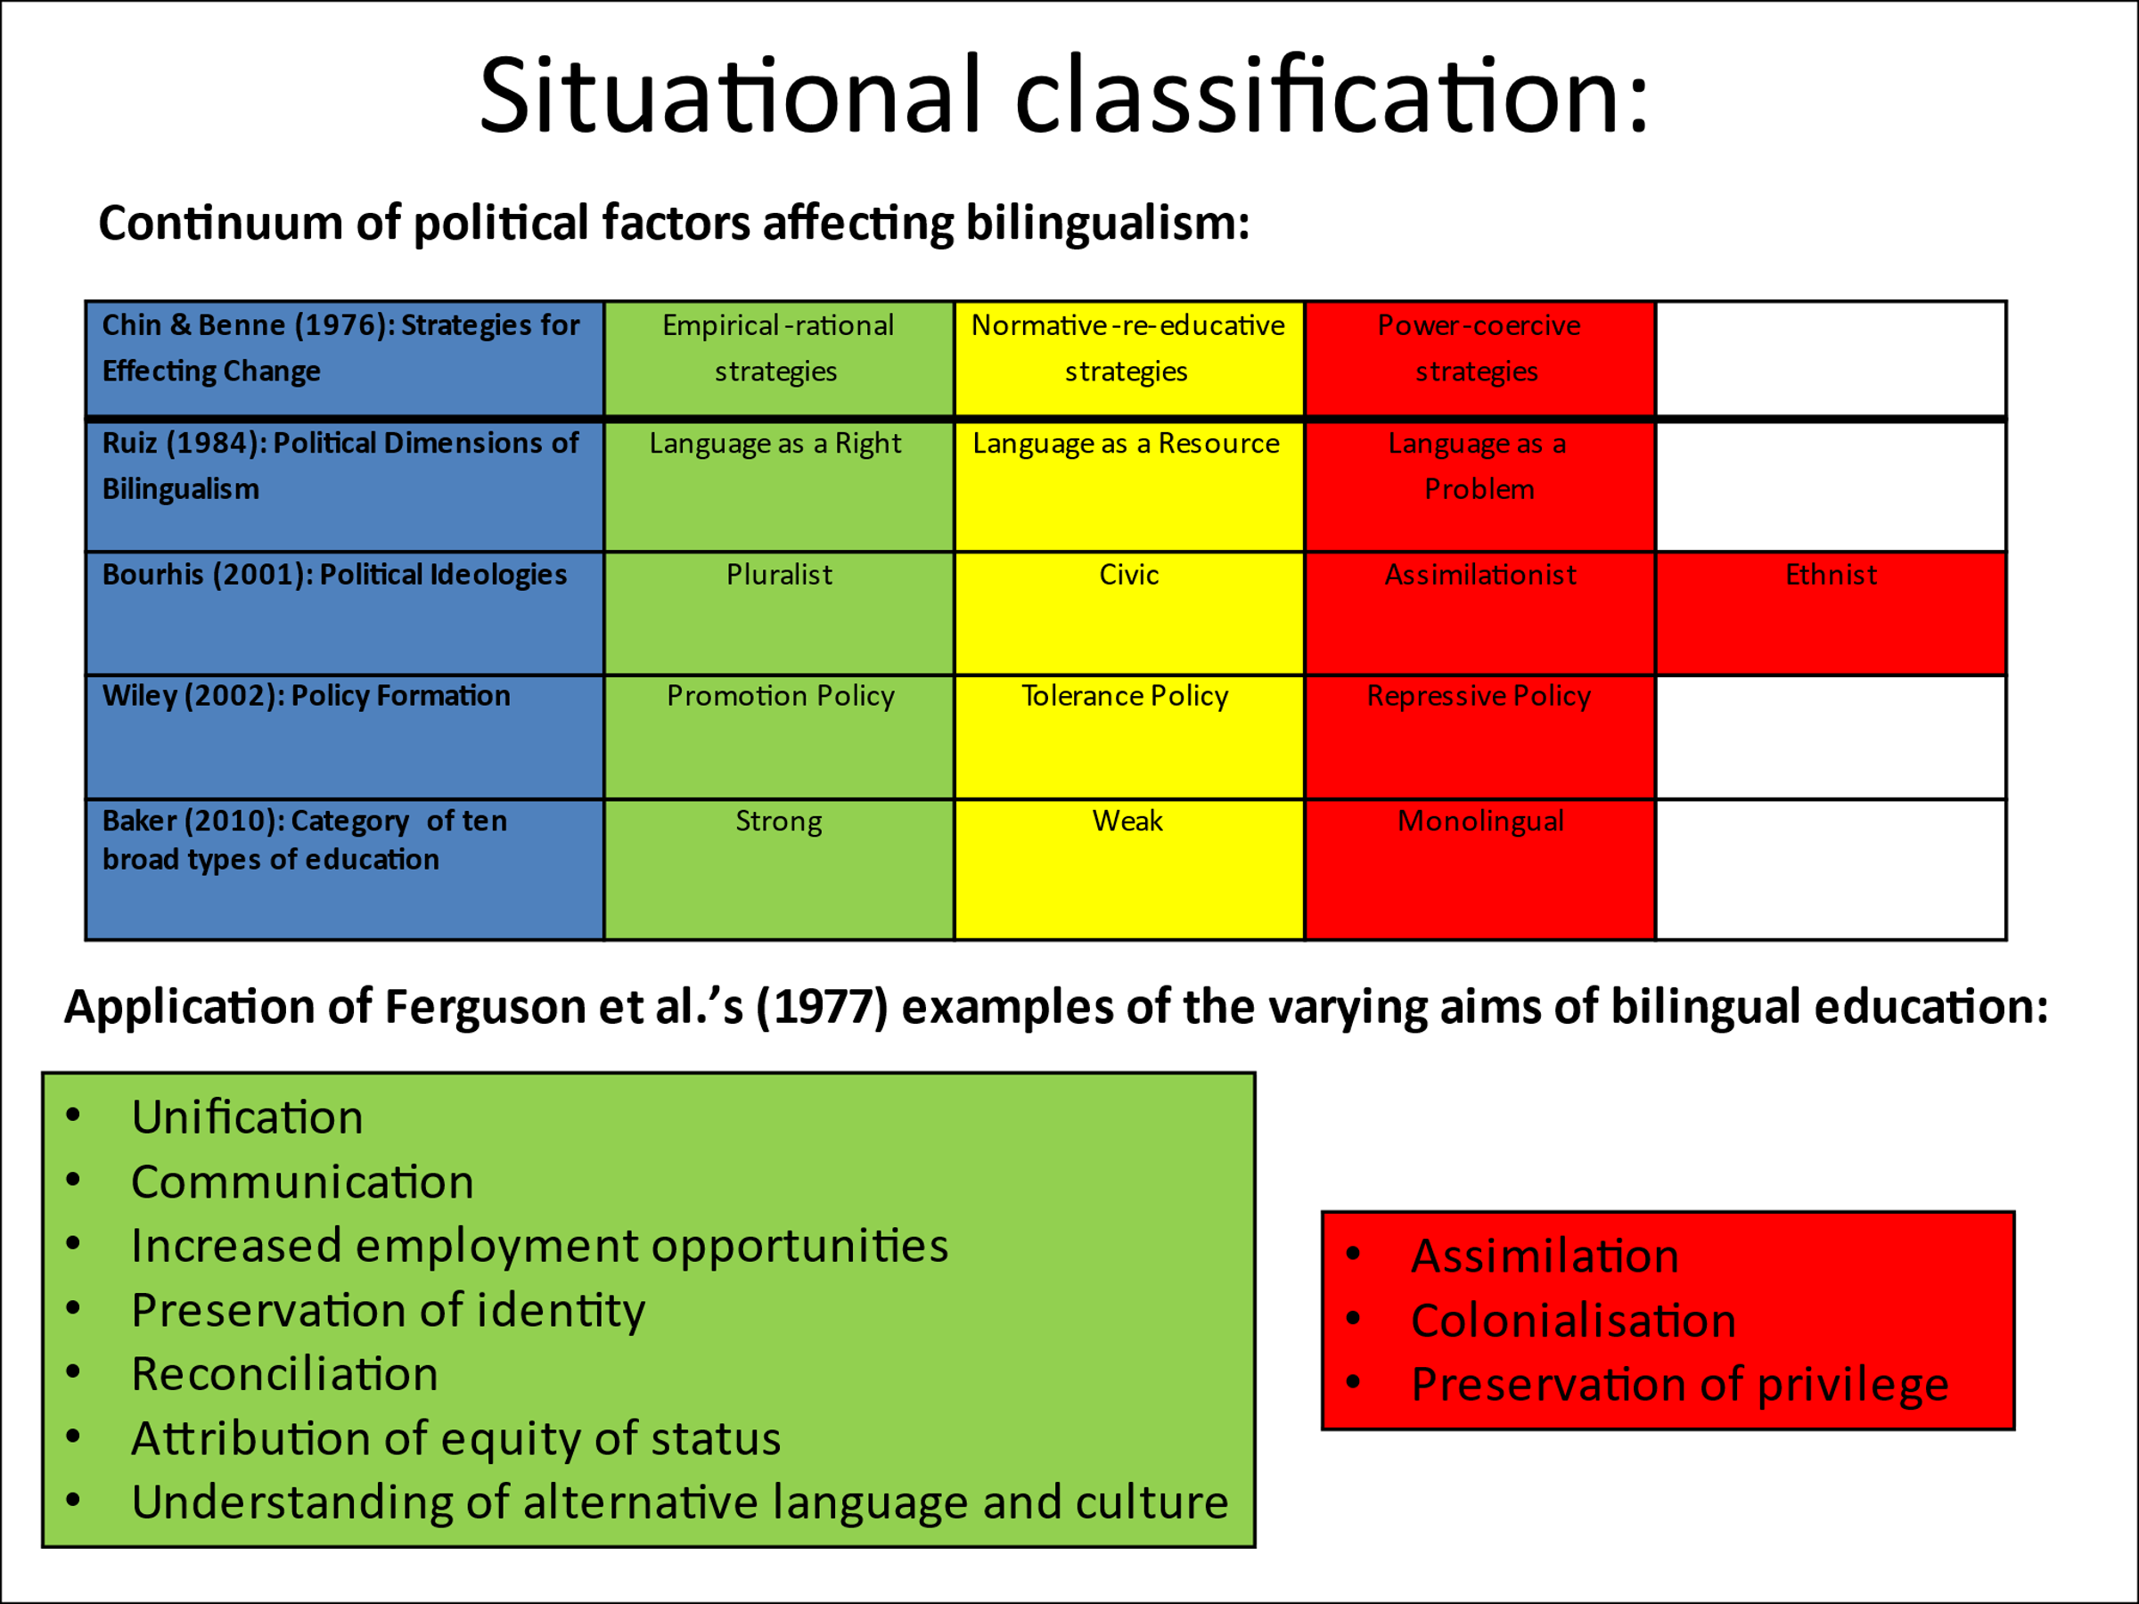

The study has established new means of utilising mixed methods in educational research to incorporate those who set, administer and operate in line with policy. This framework could be used again to conduct further investigations:

- Some small signs of early success of the strategy may be evident in findings, as mentioned above and discussed more fully in Chapter 4. Further investigations would be required to confirm this.
- There would be worth in conducting the same research in another five years’ time to evaluate progress.
- Studies measuring the effects of imminent policy and research developments, discussed in Chapter 1, would be valuable.
- The nuances of implementing Cymraeg 2050 in the Port Talbot area might be considered further by looking at the reasons of parents in English-medium schools for not choosing a Welsh-medium education; consideration of how the pluralist ideals of language policy in Wales play out in the English-medium settings of a semi-anglicised area.

As stated in Chapter 3, the research, although not generalisable to all populations, has contextual relevance. It is for this reason that the above recommendations are put forward such that they could be applied in the local interest, or in other, specific settings nationally.

Despite the low population validity of the study on a widespread scale, locally and in other communities with a similar linguistic profile, the principles of the objectives and findings could be applied in a general manner; localised generalisability, described as relatable by Bassey (1981) and illuminative by Goulding (1979.)

5.7 Summation

Langeveld (1965) stated the following:

“Educational studies … are a ‘practical science’ in the sense
that we do not only want to know facts and to understand
relations for the sake of knowledge, we want to know and
understand in order to be able to act and act ‘better’ than
we did before.” (2005: 29)

This is the principle around which the current research has been built.

References

Adelman, G. Jenkins, D. & Kemmis, S. (1977) Re-thinking case study: notes from the second Cambridge conference. Cambridge Journal of Education, Vol 6, 139-150.

Baetens-Beardsmore, H. (1986) Bi-Lingualism: Basic Principles 2nd Edn. Clevedon: Multilingual Matters.

Baetens Beardsmore, H. Bilingualism: Basic Principles. Clevedon: Multilingual Matters, 1991.

Baker, C. Foundations of Bilingualism and Bilingual Education. Clevedon: Multilingual Matters, 2011.

Baker, C. & Wright, W. (2017) Foundations of Bilingual Education and Bilingualism. Clevedon: Multilingual Matters.

Ball, Stephen J. & Vincent, C. ‘I Heard It on the Grapevine': 'Hot' Knowledge and School Choice British Journal of Sociology of Education, Vol 19, No. 3, 377-400.

Barnie, J., ‘Foreigners’ in O. Davies & F. Bowie (eds), Discovering Welshness. Llandysul: Gomer, 1992.

Bassey, M. Pedagogic Research. Oxford Review of Education, Vol. 7, No.1, 73-88, 1981.

BERA (2018) Ethical Guidelines for Educational Research, fourth edition. Available at: https://www.bera.ac.uk/publication/ethical-guidelines-for-educational-research-2018 (Accessed: 1st October 2021).

Biggam, J. Succeeding with your Master’s Dissertation: A step-by-step handbook. New York: USA, 2015.

Blauner, R., 1969. Internal Colonisation and ghetto revolt. Social Problems 16, 393-408.

Bourhis, R.Y. Acculturation, language maintenance, and language shift. In J. Klatter-Folmer & P. Vanavermaet (eds), Theories on Maintenance and Loss of Minority Languages. Münster: Waxman, 2001.

Campbell, C. & Packer, A. (1992) Cymhellion Rhieni Di-Gymraeg Dros Ddewis Addysg Gymraeg i’w Plant. The Welsh Journal of Education, Volume 3, No.1.

Chin, R. & Benne, K., 1976. General strategies for effecting changes in human systems. In Bennis, W.G., Benne, K.D., Chin, R. & Corey, K.E. (eds) The Planning of Change, New York: Holt, Rinehart & Wilson

Chin, N.B. & Wigglesworth, G. Bilingualism: an advanced resource book. London: Routledge, 2007.

Crystal, D. Language Death. Cambridge: Cambridge University Press, 2000.

Cymraeg 2050: A million Welsh speakers (2017) Available at: Cymraeg 2050: A million Welsh speakers (gov.wales) (Accessed: 15th April 2022)

Dallimore, D., & Cunnington-Wynn, L. (2017) Language Learning and Childcare Choice in Wales. Wales Journal of Education, Vol 19, No.2, 51 – 77.

Darquennes, J. (2007) Paths to Language Revitalization, Contact Linguistics and Language Minorities. [Plurilingua], Vol XXX, 61–76.

Denzin, Norman K. (1973) The research act: A theoretical introduction to sociological methods. New Jersey: Transaction Publishers.

Diebold, A.R. Incipient Bilingualism. In D. Hymes (ed.), Language in Culture and Society. New York: Harper & Row, 1964.

Drew, C.J. Introduction to Designing and Conducting Research. Missouri: Mosby, 1980.

Edwards, J. Multilingualism. London: Routledge, 1994.

Ferguson, C.A. Houghton, C. & Wells, M.H. Bilingual Education: An international perspective. In B. Spolsky & R. Cooper (eds) Frontiers of Bilingual Education. Rowley, MA: Newbury House, 1977.

Fishman, J.A. Reversing Language Shift. Clevedon: Multilingual Matters, 1991.

Fishman, J. A. Reversing language shift: Theoretical and empirical foundations of assistance to threatened languages. Clevedon: Multilingual Matters, 1991, 2001.

Forry, N. D., Tout, K., Rothenberg, L., Sandstrom, H & Vesely, C. (2013) Child Care Decision-Making Literature Review. OPRE Brief 2013-45. Office of Planning, Research and Evaluation, Administration for Children and Families, U.S. Department of Health and Human Services: Washington, DC.

Gardner, R.C. & Lambert, W.E. Attitudes and motivation: Second language learning. Newbury House, 1972.

Garrett, P. Attitudes to Language. Cambridge: Cambridge University Press, 2010.

Gitlin, A., Siegul, m. & Boru, K. (1989) The politics of method: From leftist ethnography to educative research. Qualitative Studies in Education, Vol 2, 237-253.

Glaser, B. G. & Strauss, A. L. (1967) The discovery of grounded research: strategies for qualitative research. London: Aldine Transaction.

Goulding, S. in Bell, J. (1989). Conducting small scale investigations in educational management. Open University: Paul Chapman in association with Open University, pp.230 - 251.

Grin, F. & Moring, T. (2002) Support for Minority Languages in Europe. Report for DG Education and Culture, European Commission. http://europa.eu.int/comm/education/policies/lang/languages/langmin/ files/support.pdf

Hakim, C. (2000) Research design: Successful designs for social and economic research. London: Routledge.

Hodges, R.S. (2012) Welsh-medium education and parental incentives – the case of the Rhymni Valley, Caerffili, International Journal of Bilingual Education and Bilingualism, Vol 15, No. 3, 355-373.

Hoffmann, C. An Introduction to Bilingualism. Harrow: Longman, 1991.

Jones, A. & Thomas, G. (eds), 1973. Presenting Saunders Lewis. Cardiff: University of Wales Press.

Jones, B.M., ‘Schools and Speech Communication in a Bilingual Setting’. Yn B.M. Jones & P.A.S. Ghuman (eds.) Bilingualism, Education and Identity, Cardiff: University of Wales Pres, 1995.

Jones, H. The Changing Social Context of Welsh: ‘A Review of Statistical Trends’. The International Journal of Bilingual Education and Bilingualism. 11, 5, 541-557, 2008.

Jones, S.L. (2017) ‘What Do We Know and Not Know about Choice of Medium of Education in South-East Wales?’ Wales Journal of Education 19(2). DOI: https://doi.org/10.16922/wje.19.2.8

Langeveld, M.J. In search of research. In Paedagogica Eoropea: the European yearbook of educational research, Vol 1. Amsterdam: Elsevier / Council for Cultural Co-operation of the Council of Europe, 1965.

Lewis, H.G. Aspects of Blingualism. Carmarthen: Yr Athrofa, Prifysgol Cymru y Drindod Dewi Sant, 2014.

Lewis, H.G. Models for Bilingual Teaching. Carmarthen: Yr Athrofa, Prifysgol Cymru y Drindod Dewi Sant, 2014.

Lewis, H.G. Research Methodology. Carmarthen: Yr Athrofa, Prifysgol Cymru y Drindod Dewi Sant, 2014.

Lewis, H.G. Societal Bilingualism. Carmarthen: Yr Athrofa, Prifysgol Cymru y Drindod Dewi Sant, 2014.

Menter Iaith Castell-nedd Port Talbot (2022) About Us. Available at: Menter Iaith Castell-nedd Port Talbot (Accessed: 21st April 2022).

Mhic Mhathúna, Máire & Nic Fhionnlaoich, Fiona (2021) Why parents chose to
send their children to Irish-medium immersion preschools: learning from parental choice strategies in Celtic countries, European Early Childhood Education Research Journal, Vol 29, No.3, 441-454.

Morgan, K. & Sabel, C. (2019) The experimentalist polity. Available at: Kevin_Morgan_and_Charles_Sabel.pdf (nesta.org.uk) (Accessed 21st April 2022).

Nation.Cymru (2022) ‘Only 18% oppose the Welsh Government’s one million Welsh speakers target’, Nation.Cymru, 11th March. Available at: Only 18% oppose the Welsh Government's one million Welsh speakers target (nation.cymru) (Accessed: 11th March 2022).

Nind, M. (2014) Inclusive research and inclusive education: why connecting them makes sense for teachers’ and learners’ democratic development of education, Cambridge Journal of Education, Vol 44, No.4, 525-540.

Nisbet, J. & Watt, J. Rediguide 26: Guides in Educational Research. M.B. Youngman (ed.) Nottingham University School of Education. Oxford: England

NPTCBC Strategic Equality Plan (2020 – 2024) Available at: Strategic Equality Plan – Neath Port Talbot Council (npt.gov.uk) (Accessed: 22nd March 2022)

NPTCBC Welsh in Education Strategic Plan (2022-2032) Available at: Welsh in Education Strategic Plan 2022-2032 – Neath Port Talbot Council (npt.gov.uk) (Accessed: 22nd March 2022)

O'Hanlon, F. (2015) Choice of Scottish Gaelic-medium and Welsh-medium education at the primary and secondary school stages: parent and pupil perspectives, International Journal of Bilingual Education and Bilingualism, Vol 18, No.2, 242-259.

Open University, Research Methods in Education. Milton Keynes: Open University, 2001.

Packer, A. & Campbell, C. (1997) Pam for Rhieni yn dewis Addysg Gymraeg i’w Plant? Astudiaeth Ansoddol o Agweddau Rhieni, wedi ei chynnal o fewn Dalgylch Ysgol Gymraeg ei Chyfrwng, mewn Ardal Seisnigedig [Parental choice in the selection of Welsh-medium education]. Aberystwyth: Undeb Cenedlaethol Athrawon Cymru.

Packer, A. & Campbell, C. (2000). Parental choice in the selection of Welsh-medium education. In Developing minority languages: The Proceedings of the Fifth International Conference on Minority Languages, July 1993, Cardiff, Wales, ed. P.T. Thomas and J. Mathias, Vol 578, No. 95, Llandysul: Gwasg Gomer.

Pavlenko, A. ‘Bilingual Selves’ in A. Pavlenko (ed.), Bilingual Minds – Emotional Experience, Expression and Representation. Clevedon: Multilingual Matters, 2006.

Puigvert, L., Christou, M., & Holford, J. (2012) Critical communicative methodology: Including vulnerable voices in research through dialogue. Cambridge Journal of Education, Vol 42, 513–526.

Peal, E. & Lambert, W.E. 1962 The relation of bilingualism to intelligence, Psychological Monographs 76 (27), 1-23.

Ruiz, R., 1984. Orientations in language planning. NABE Journal 8(2), 15-34

Sapsford, R.J. & Evans J. in Bell, J. (1989). Conducting small scale investigations in educational management. Open University: Paul Chapman in association with Open University, pp.258 - 273.

Spencer, L., Ritchie, J. & O’Connor, W. (2003) ‘Analysis: Practices, Principles and Processes. In Qualitative Research Practice’: A Guide for Social Science Students and Researchers, edited by J. Ritchie and J. Lewis, 199–218. London: SAGE.

Strubell, M. (2001) ‘Catalan A Decade Later’, In J. A. Fishman (ed.) Can Threatened Languages be Saved? Reversing Language Shift, Revisited: A 21st Century Perspective. Clevedon: Multilingual Matters.

Stubbs, M. 1991. Educational language planning in England and Wales; Multicultural rhetoris and assimilationist assumptions. In F. Coulmas (ed.) A Language Policy for the European Community. New York: Mouton de Gruyter.

Sutcliffe-Braithwaite, F (2002) ‘Bring out the lemonade’, London Review of Books, 44(7), pp. 8-11 Available at: Florence Sutcliffe-Braithwaite · Bring out the lemonade: What the Welsh got right · LRB 7 April 2022

Thomas, H. (2007) Brwydr i Baradwys? Y Dylanwadau ar dwf Ysgolion Cymraeg De-Ddwyrain Cymru [Factors influencing the growth of Welsh-medium schools in South-East Wales]. Unpublished PhD thesis, Cardiff University.

UNESCO Ad Hoc Expert Group on Endangered Languages. Language Vitality and Endangerment. Document submitted to the International Expert Meeting on UNESCO Programme Safeguarding of Endangered Languages, Paris, 10-12 March, 2003.

Well-being of Future Generations (Wales) Act 2015, c. 2. Available at: 42329 WBFG Essentials Guide (gov.wales) (Accessed 15th April 2022)

Wiley, T.G. & Wright, W.E. Against the undertow: Language-minority education policy and politics in the ‘age of accountability’. Educational Policy 18 (1), 142-168, 2004.

Appendix A(i): Survey for the Parents / Guardians of Rhosafan Pupils: Language Choice Motivations

MA Research: Andrea Folland Phone: 07976830949 Email: 1603176@student.uwtsd.ac.uk

Available here: Questionnaire for Parents / Guardians

This survey will take approximately 4 minutes to complete. Thank you for your time and consideration in completing it. For more information and to view a code of ethics which explains how your answers will be used, please, refer to the accompanying documents.
Please return the survey by Monday, 21st March 2022.

- In which school year is your child?
☐ Nursery ☐ Year 4

- What were your reasons for choosing a Welsh medium education for your child? (Please mark all which apply)
☐ Recommendation from friend / relative

☐ You attended Welsh education yourself and want the same experience for your child

☐ Rhosafan is the nearest school to your home
☐ The timings and wrap around care at the school better suit your needs than those of other schools in the area
☐ The school has a better reputation than English medium schools

☐ The school has a better-designed curriculum than other schools in the area

☐ You wanted your child to continue into Welsh medium education following attendance at Cylch Chwarae

☐ There are excellent Welsh medium services and activities in your area to which you would like your child to have access

☐ You feel passionate about the future of Welsh language and culture

☐ You are aware of the potential health and economic benefits of being bilingual
☐ You were attracted by campaigns/advertising about Welsh medium education

☐ Other
( P l e a s e s p e c i f y )

- Did you take guidance / request information from any of the following authorities / services to inform your decision making on Welsh medium education? (Please mark all which apply)

☐ Welsh Government
☐ Neath Port Talbot Council
☐ Neath Port Talbot Local Education Authority
☐ Rhosafan School
☐ Estyn
☐ The Family Information Service
☐ Other

( P l e a s e s p e c I f y )

- Did you have any reservations about sending your child to Welsh medium education?
☐ Yes ☐ No ☐ Maybe

- If you answered ‘Yes’ or ‘Maybe’ to Question 4, please elaborate below. Please also explain what helped you to overcome your reservations.

- Do you speak Welsh?
☐ Yes ☐ No ☐ A little

- Do you speak two or more languages?
☐ Yes ☐ No

- What is the main language of your home?
( P l e a s e s p e c I f y )
☐ Welsh ☐ English ☐ Other

- If you are in employment, have you been asked to use/learn Welsh in your place of work?
☐ Yes ☐ No

- Have you heard about Welsh Government’s ‘A Million Speakers’ strategy?
☐ Yes ☐ No ☐ Maybe

- If you answered ‘Yes’ or ‘Maybe’ to Question 10, please state below what bearing, if any, this had on your decision to choose a Welsh medium education

- If there is any other information you would like to include to expand on your answers given above, or in relation to any other aspect of your choice of Welsh medium education for your child, please include it in the box below:

- What is your nationality? (Leave blank if you would prefer not to say)

- What is your gender?
☐ Woman ☐ Man ☐ Non-binary ☐ Prefer not to say

- In which of the following age groups are you?
☐ 18 – 24 ☐ 25 – 34 ☐ 35 – 44 ☐ 45 – 54 ☐ 55 – 64 ☐ 65+
☐ Prefer not to say

If you are willing for the researcher to contact you for a follow-up conversation, please leave your name and contact details (either telephone number and/or email address) below. Please refer to the accompanying code of ethics for information on how your details will be kept and used.
Name:
Telephone no:
Email address:

Please return completed hard copy questionnaires to the school office in the envelope provided.

Thank you for your time in completing this survey. It is very much appreciated.

Appendix A(ii) : Arolwg i Rhieni / Gwarcheidwaid Disgyblion Rhosafan:
Cymhellion Dewis Iaith
Ar gael yma: Holiadur i Rieni / Gwarcheidwaid
Ymwchil MA: Andrea Folland Ffôn: 07976830949 E-bost: 603176@student.uwtsd.ac.uk

Bydd yr arolwg hwn yn cymryd tua 4 munud i'w gwblhau. Diolch am gymryd amser i ystyried y cwestiynau sydd ynddo. I gael mwy o wybodaeth ac i weld côd moeseg sy'n esbonio sut y bydd eich atebion yn cael eu defnyddio, cyfeiriwch at y dogfennau cysylltiedig a gynhwysir. Gofynnir i chi ddychwelyd yr arolwg erbyn dydd Llun, 21ain Mawrth 2022.

- Ym mha flwyddyn ysgol yw’ch plentyn?
☐ Meithrin ☐ Blwyddyn 4

2 Beth oedd eich rhesymau dros ddewis addysg Gymraeg i’ch plentyn? (Marciwch bob ateb sy’n berthnasol)
☐ Argymhelliad gan ffrind / aelod o’r teulu

☐ Aethoch chi i'r ysgol Gymraeg ac rydych eisiau i'ch plentyn gael yr un brofiad

☐ Rhosafan yw’r ysgol agosaf i’ch cartref

☐ Mae amseroedd yr ysgol a'r gofal cofleidiol sydd ar gael yno'n gweddu i'ch anghenion yn well na'r rheiny a gynigir gan ysgolion eraill
☐ Mae gan yr ysgol enw da; gwell nag ysgolion cyfrwng Saesneg
☐ Mae gan yr ysgol gwricwlwm a ddyluniwyd yn well na'r rheiny sydd gan ysgolion Saesneg yr ardal

☐ Roeddech eisiau i'ch plentyn barhau mewn addysg Gymraeg ar ôl mynychu Cylch Chwarae
☐ Mae gwasanaethau a gweithgareddau cyfrwng Cymraeg ardderchog yn eich ardal yr hoffech i'ch plentyn gael mynediad iddynt

☐ Rydych yn teimlo'n angerddol am ddyfodol iaith a diwylliant Cymru

☐ Rydych yn ymwybodol o'r buddiannau iechyd ac economaidd posib sy'n dod o fod yn ddwyieithog

☐ Cawsoch eich denu gan ymgyrchoedd/hysbysebion am addysg Gymraeg
( E s b o n i w c h o s g w e l w c h y n d d a )
☐ Arall

3 A wnaethoch chi gymryd arweiniad / gofyn am wybodaeth gan unrhyw un o'r awdurdodau / gwasanaethau canlynol i'ch helpu i wneud penderfyniad am addysg Gymraeg? (Marciwch bob ateb sy'n berthnasol)

☐ Llywodraeth Cymru
☐ Cyngor Castell-nedd Port Talbot
☐ Awdurdod Addysg Lleol (AALl) Castell-nedd Port Talbot
☐ Ysgol Rhosafan
☐ Estyn
☐ Y Gwasanaeth Gwybodaeth i Deuluoedd
☐ Arall
( E s b o n i w c h o s g w e l w c h y n d d a )

- A oedd gennych unrhyw amheuon am anfon eich plentyn i’r ysgol Gymraeg?
☐ Oedd ☐ Nac oedd ☐ Efallai

- Os ateboch 'Oedd' neu 'Efallai' mewn ymateb i Gwestiwn 4, esboniwch pam isod. Esboniwch hefyd, beth oedd yn eich helpu i oresgyn eich amheuon.

- Ydych chi’n siarad Cymraeg?
☐ Ydw ☐ Nac ydw ☐ Ychydig bach

- Ydych chi’n siarad dwy iaith, neu fwy?
☐ Ydw ☐ Nac ydw

- Beth yw prif iaith eich tŷ?
( E s b o n i w c h o s g w e l w c h y n d d a )
☐ Cymraeg ☐ Saesneg ☐ Arall

- Os ydych yn gweithio, oes gofyn i chi ddefnyddio neu ddysgu’r Gymraeg yn eich gweithle?
☐ Oes ☐ Nac oes

- Ydych chi wedi clywed am strategaeth ‘Miliwn o Siaradwyr’ Llywodraeth Cymru?
☐ Ydw ☐ Nac ydw ☐ Efallai

- Os ateboch 'Ydw' neu 'Efallai' mewn ymateb i Gwestiwn 10, dywedwch isod pa effaith, os o gwbl, y cafodd hwn ar eich penderfyniad i ddewis addysg Gymraeg i'ch plentyn.

- Os oes unrhyw wybodaeth arall yr hoffech ei chynnwys i ehangu ar yr atebion a roddoch chi uchod, neu mewn perthynas ag unrhyw beth arall sy'n ymwneud â'ch dewis i roi addysg Gymraeg i'ch plentyn, gofynnir i chi ei chynnwys yn y blwch isod:

- Beth yw eich cenedligrwydd? (Gadewch yn wag os byddai’n well gennych beidio â dweud)

- Beth yw eich rhyw?
☐ Menyw ☐ Dyn ☐ Anneuaidd
☐ Byddai’n well gennyf beidio â dweud

- Ym mha un o’r grwpiau oedran canlynol ydych chi?
☐ 18 – 24 ☐ 25 – 34 ☐ 35 – 44 ☐ 45 – 54 ☐ 55 – 64 ☐ 65+
☐ Byddai’n well gennyf beidio â dweud

Os ydych yn fodlon i'r ymchwilydd gysylltu â chi i gael trafodaeth ddilynol, gadewch eich enw a manylion cyswllt (naill ai rhif ffôn a/neu gyfeiriad e-bost) isod os gwelwch yn dda. Cyfeiriwch at y côd moeseg cysylltiedig i gael gwybodaeth am sut y bydd eich manylion yn cael eu cadw a'u defnyddio.
Enw:
Rhif ffôn:
Cyfeiriad e-bost:

Dychwelwch gopïau caled o’r arolwg sydd wedi’u cwblhau i swyddfa’r ysgol yn yr amlen a ddarperir.

Diolch am roi eich amser i gwblhau’r arolwg hwn. Gwerthfawrogir hynny’n fawr.

Appendix B(i): Survey: Language Choice Motivations of Parents / Guardians of Rhosafan Pupils (Available here: Questionnaire for Professionals)

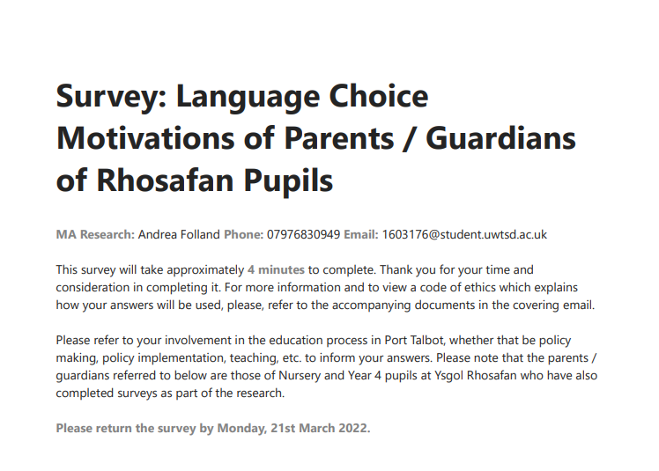

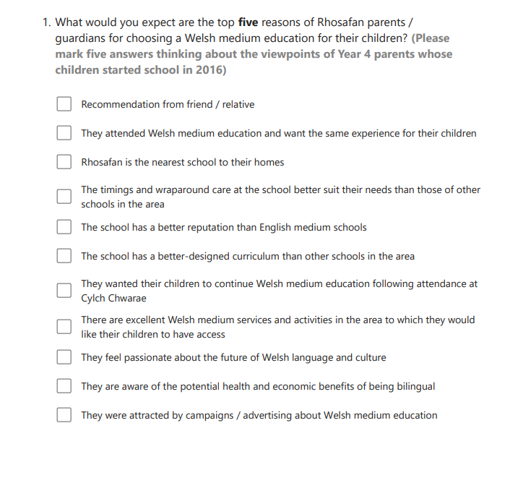
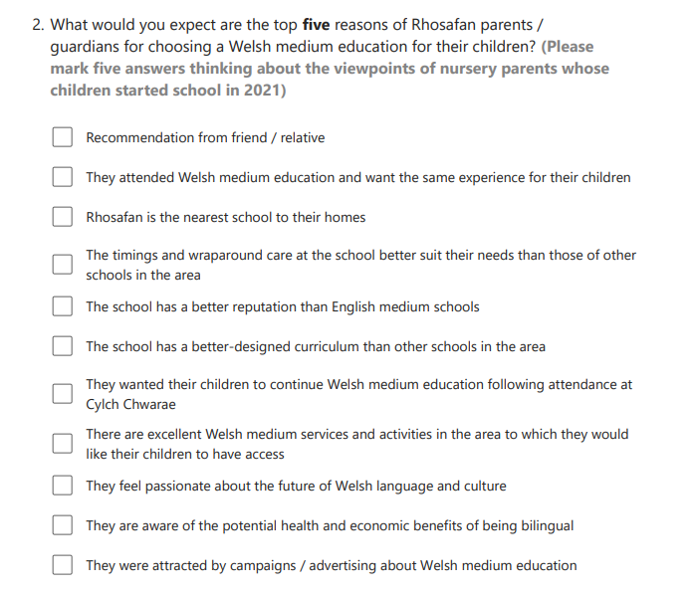

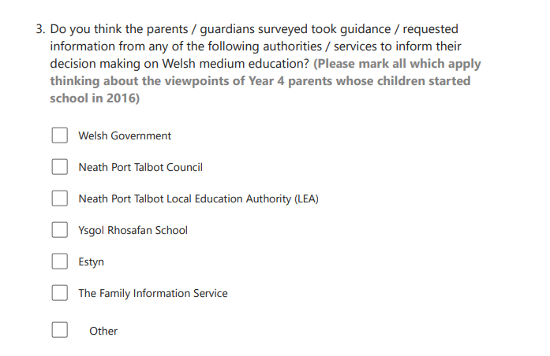

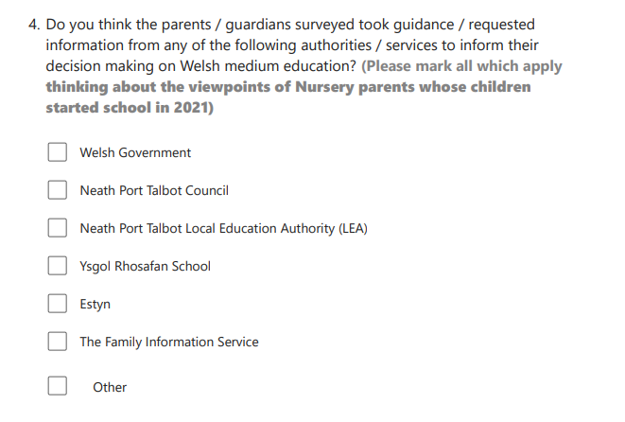

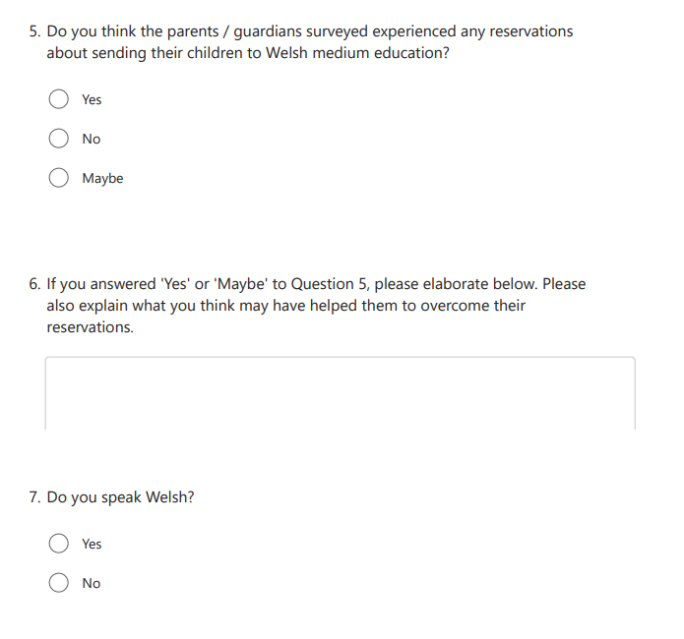

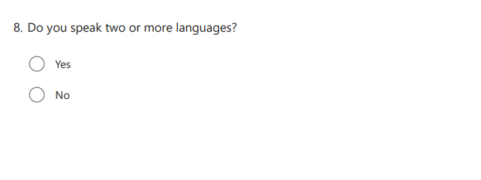

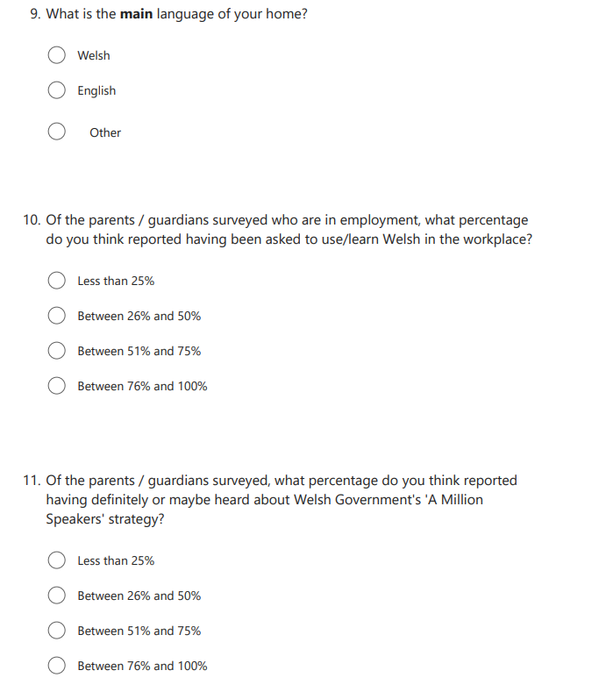

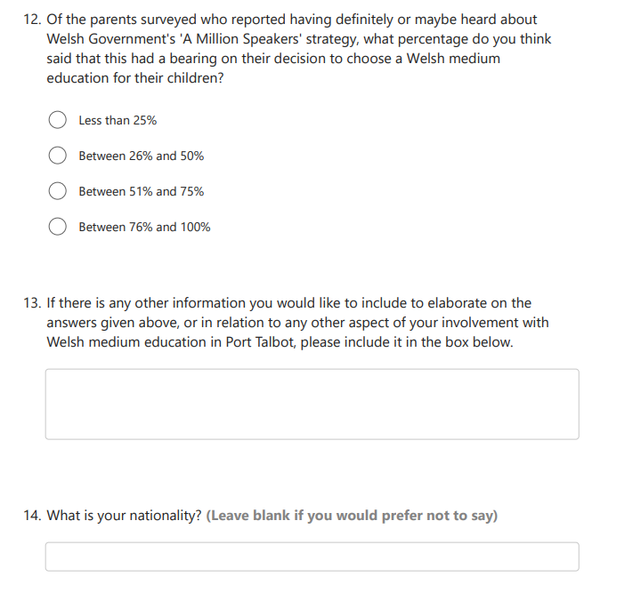

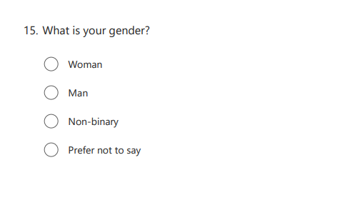
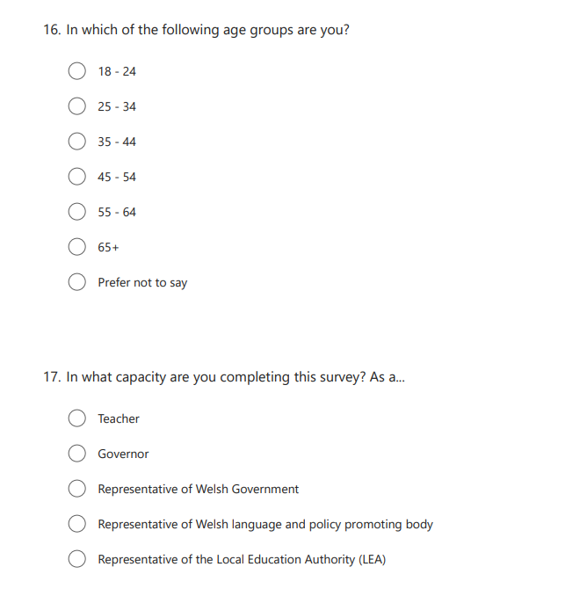

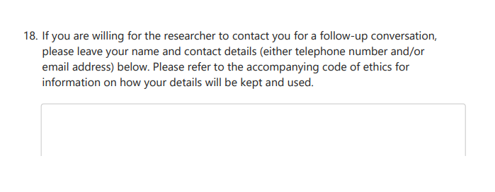

Appendix B(ii): Arolwg: Cymhellion Dewis Iaith Rhieni / Gwarcheidwaid Disgyblion Ysgol Rhosafan (Ar gael yma: Holiadur Pobl Broffesiynol)
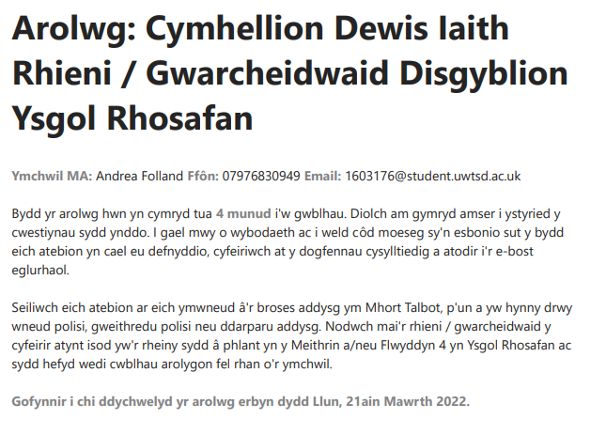

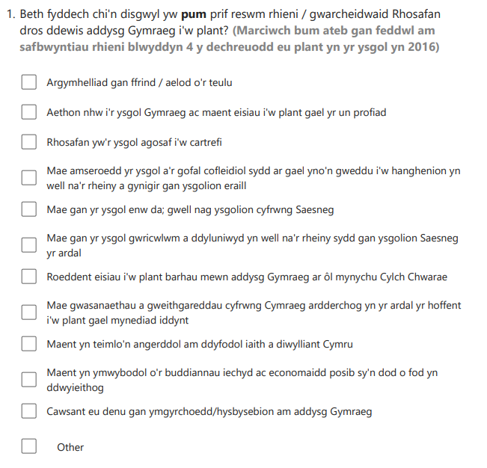

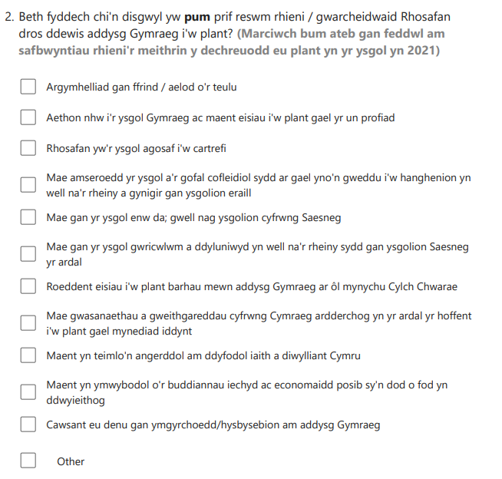

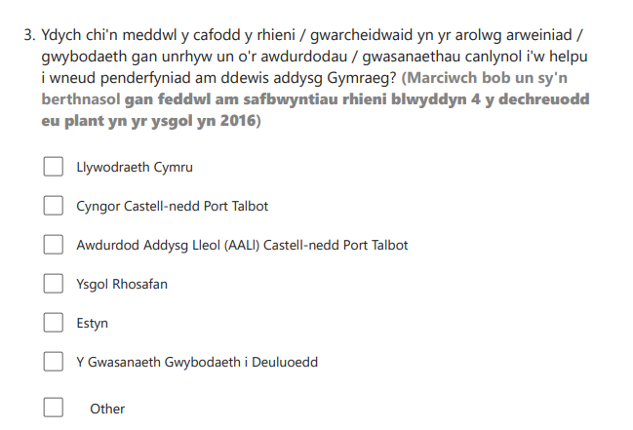

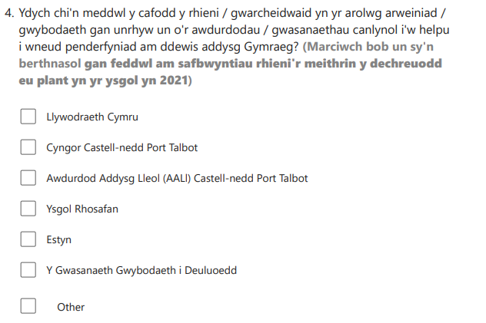

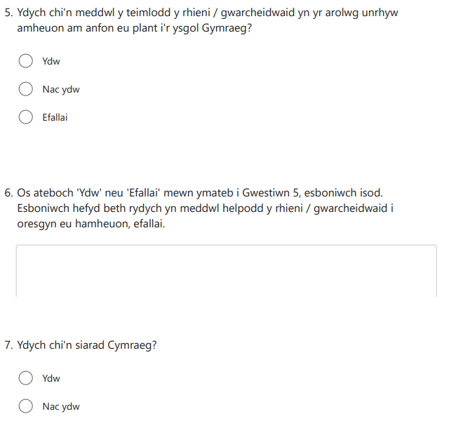

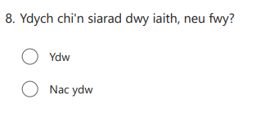
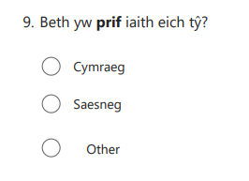

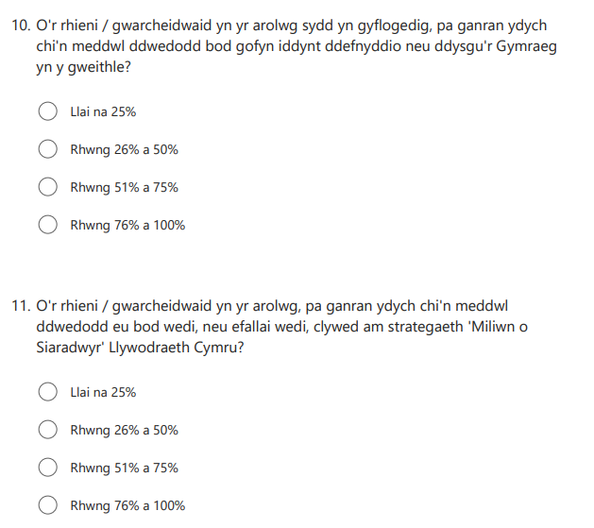

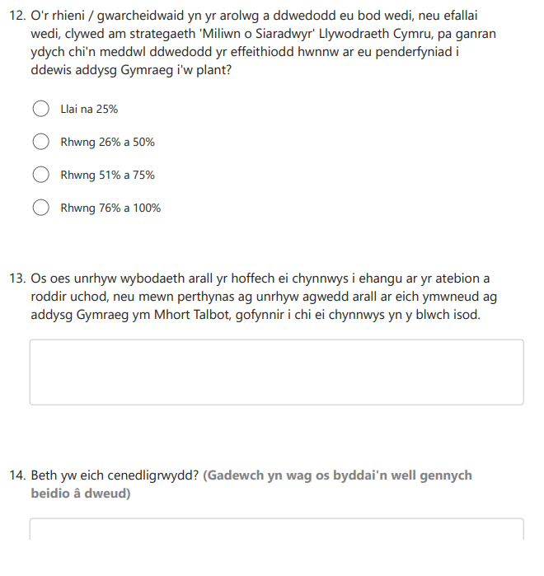

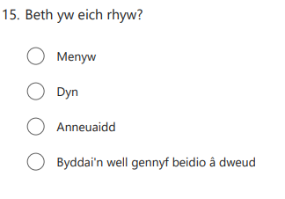
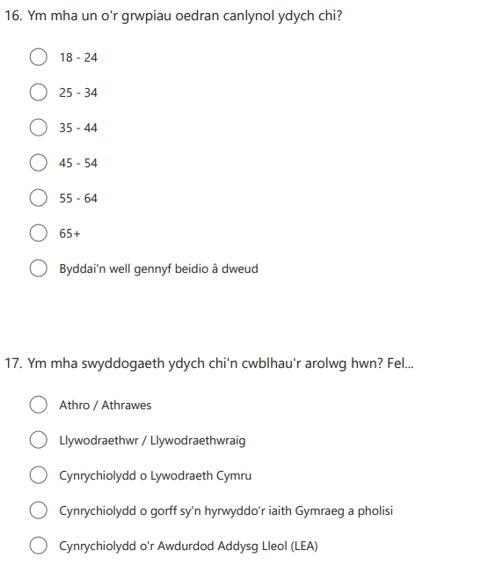

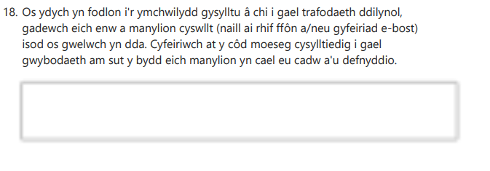

Appendix C: Nursery parent 1 semi-structured interview - set questions

- Was there anyone / anything which helped to put your mind at rest with regard to reservations held about sending your child to Welsh-medium education?

- In your questionnaire response, you have referenced the benefits of bilingualism, noting increased opportunities for bilinguals and that it is easier for them to learn other languages. How do you know of these benefits?

- You have noted that you liaised with Cylch Ti a Fi to inform your decision about choosing Welsh-medium education. How did they help with this?

Nursery parent 2 semi-structured interview - set questions:

- Are you aware of any links between the school and local bilingual programmes / activities? If so, do you make use of them?

- You have noted that you liaised with NPTCBC and NPT LEA to inform your decision about choosing Welsh-medium education, did you reach out or did they?

- In your questionnaire, you mentioned that a BBC documentary aided your decision on Welsh-medium education. Could you tell me more about it?

- Did the fact that you speak two or more languages have any bearing on your decision to choose Welsh-medium education?

- In your questionnaire, you note the all-round benefits of being bilingual. What are these to you and where did you hear about them?

- In your questionnaire, you note that you are learning Welsh. Is this since your child joined the Welsh school? Has being able to speak a little Welsh opened any opportunities to you? Do you use Welsh widely now or in some settings in particular?

Year 4 parent 1 semi-structured interview - set questions:

- In your questionnaire, you note that you had concerns about being unable to help with homework as a non-Welsh speaker. Have you had any difficulty with this or have you found ways to cope?

- In your questionnaire, you note that you have been asked to learn Welsh for work. Do you work in the public sector? Have you taken up the opportunity?

- In your questionnaire, you note that you had heard about the Cymraeg 2050 strategy. Where did you hear about it?

- Are you aware of any links between the school and local bilingual programmes / activities? If so, do you make use of them?

- What prompted you to liaise with Estyn to inform your decision making on Welsh-medium education?

Year 4 parent 2 semi-structured interview - set questions: (Welsh language interview)

- Are you aware of any links between the school and local bilingual programmes / activities? If so, do you make use of them?

- In your questionnaire, you note the benefits of being bilingual. What are these to you and where did you hear about them?

- In your questionnaire, you note that you went on the Welsh sabbatical course. Was this in conjunction with WG?

- In your questionnaire, you note that you had heard about the Cymraeg 2050 strategy. Where did you hear about it?

- In your questionnaire, you note that your sense of Welsh identity didn’t strike you until you became an adult. What restricted this when you were younger and developed it as you grew?

Governor 1 semi-structured interview - set questions: (Welsh language interview)
- In your questionnaire, you note the benefits of being bilingual as factors likely to attract parents to Welsh-medium education. From where do you think they would be likely to hear about these?

- Are you aware of any strategy which the school has in place aimed at increasing awareness about Welsh medium education? If so, has this been established with Cymraeg 2050 in
mind?

Governor 2 semi-structured interview - set questions: (Welsh language interview)
- In your questionnaire, you note that the look and feel of the school, its ethos, might provide a reason for parents to choose Welsh-medium education. Could you explain this at all?

- In your questionnaire, you note the benefits of being bilingual as factors likely to attract parents to Welsh-medium education. From where do you think they would be likely to hear about these?

- Are you aware of any strategy which the school has in place aimed at increasing awareness about Welsh medium education? If so, has this been established with Cymraeg 2050 in mind?

LEA representative semi-structured interview - set questions: (Welsh language interview)
- In terms of Cymraeg 2050, have you received any direction for change in approach to the way Welsh medium education is planned and handled since its publication?

- Has there been discussion with WG regarding the development of proportionate targets for NPT in the wider context of the strategy target?

- Aled Roberts’ review of WESPS 2017 – 2021 noted a lack of assessment of actuals against targets. At the time of his report, trends were monitored rather that active target-setting taking place to increase demand. Has this changed?
- Do you find there to be an issue with ensuring that teachers are engaged in work/discussion relating to policy?

- Do you think there are strong enough links with Mentrau Iaith and other Welsh language organisations to ensure provision of enough domains for use of Welsh outside of education?

Appendix D: Code of Ethics: Language Choice Motivations Research / Côd Moeseg: Ymchwil Cymhellion Dewis Iaith

Anonymity / Confidentiality  - Survey responses will be treated anonymously unless participants give their contact details to be involved in a follow-up discussion with the researcher (phase two of the research.)  - If participants provide their contact details to facilitate a follow-up discussion, these will be kept securely, as detailed below. In this instance, survey responses will remain confidential, meaning that data will not be identifiable as relating to individuals.  Freedom to participate  - Participation in the research is voluntary and refusal to participate will not result in any adverse treatment of individuals.  - Completion and return of the survey will constitute consent for participation in phase one of the research (survey.)  - Participants may leave blank any questions they do not wish to answer.  - Participants have the right to withdraw from the research at any point.  - Surveys will be provided in Welsh and English.  The final report  - Participants will receive feedback at the end of the period of research (shortly after 30.04.2022.)  - Participants can see the final report should they wish.  - A copy of the report will be given to the school for use as required.  - A summary of the report can be provided on demand.  Data protection / GDPR agreement  - Distribution of the survey via the school will ensure that no parent/guardian data are transferred to the researcher without prior consent.  - Should participants consent to taking part in the second phase of the research (a follow-up discussion with the researcher), provision of contact details in response to the survey will be taken as consent for this.  - Participants should only provide contact details should they wish to participate in phase two of the research. Contact details will not be required otherwise.  - Contact details given will only be used for the purpose outlined and only by the researcher.  - Completed hard copy surveys should be placed in the envelope provided and sealed before being returned to the school office. This is to ensure confidentiality.  - Hard copy survey responses / data will be stored securely under lock and key.  - Hard copy survey responses / data will be disposed of securely as soon as they are no longer required by the researcher.  - Electronic responses and contact will be made only via reputable, secure platforms (Teams, Microsoft Forms, University email system, etc.)  - Electronic data will be coded and stored only on firewall-secured devices, under password and lock and key.  - Data will not be shared with, or accessible to, any third parties.  - Participants will have the right to retract consent for use of their contact details at any point during the research process.  If you have any questions, please contact the researcher:  Email: 1603176@student.uwtsd.ac.uk  Telephone: 07976830949  Should you wish to receive a more detailed code of ethics, this can be provided on request. | Anhysbysrwydd / Cyfrinachedd  - Bydd ymatebion i’r arolwg yn cael eu trin yn anhysbys oni bai bod cyfranogwyr yn rhoi eu manylion cyswllt fel eu bod yn gallu cael trafodaeth ddilynol â’r ymchwilydd (cyfnod dau yr ymchwil.)  - Os bydd cyfranogwyr yn darparu eu manylion cyswllt, bydd y rhain yn cael eu cadw’n ddiogel, fel yr amlinellir isod. Yn yr achos hwn, bydd ymatebion yn cael eu trin yn gyfrinachol, sy’n golygu na ellir eu cysylltu ag unigolion.  Rhyddid i gyfranogi  - Mae cyfranogi i’r arolwg yn gwbl wirfoddol ac ni fydd unigolion yn cael eu trin yn wahanol o ganlyniad i wrthod cyfranogi.  - Bydd cwblhau a dychwelyd yr arolwg yn ffurfio caniatâd cyfranogi i gyfnod un yr ymchwil (yr arolwg.)  - Gall cyfranogwyr adael unrhyw gwestiynau’n wag os nad ydynt eisiau eu hateb.  - Mae gan gyfranogwyr yr hawl i dynnu yn ôl o’r ymchwil ar unryw adeg.  - Darperir arolygon yn y Gymraeg a’r Saesneg.  Yr adroddiad terfynol  - Bydd cyfranogwyr yn derbyn adborth ar ddiwedd cyfnod yr ymchwil (yn fuan ar ôl 30.04.2022.)  - Gall cyfranogwyr weld yr adroddiad terfynol os ydynt eisiau.  - Rhoddir copi o’r adroddiad i’r ysgol i’w ddefnyddio fel y bo gofyn.  - Gellir darparu crynodeb o’r adroddiad os gofynnir.  Diogelu data / Cytundeb GDPR  - Bydd yr arolwg yn cael ei ddosbarthu gan yr ysgol i sicrhau na throsglwyddir unrhyw ddata rhieni/gwarcheidwaid i’r ymchwilydd heb ganiatâd blaenorol.  - Os bydd cyfranogwyr yn rhoi caniatâd i gymryd rhan yng nghyfnod dau yr ymchwil (trafodaeth ddilynol â’r ymchilydd), bydd darparu manylion cyswllt mewn ymateb i’r arolwg yn ffurfio caniatâd ar gyfer hwn.  - Dylai cyfranogwyr ddarparu manylion cyswllt dim ond os byddant eisiau cyfranogi i gyfnod dau yr ymchwil. Nid oes gofyn am fanylion cyswllt fel arall.  - Bydd manylion cyswllt a roddir yn cael eu defnyddio ond at y diben a amlinellir, a dim ond gan yr ymchwilydd.  - Dylid rhoi copïau caled o’r arolwg sydd wedi’u cwblhau yn yr amlen a ddarperir a’i selio cyn ei dychwelyd i swyddfa’r ysgol. Bydd hwn yn sicrhau cyfrinachedd.  - Bydd ymatebion / data copi caled yn cael eu storio’n ddiogel, dan glo ac allwedd.  - Gwaredir ar ymatebion / data copi caled yn ddiogel unwaith nad yw eu hangen ar yr ymchwilydd bellach.  - Gwneir ymatebion a chyswllt electronig dim ond trwy lwyfannau dibynadwy, diogel (Teams, Microsoft Forms, system e-bost y Brifysgol, ayyb.)  - Bydd data electronig ond yn cael ei godio a’i storio ar ddyfeisiadau a ddiogelir gan wal dân, dan gyfrinair a chlo ac allwedd.  - Ni fydd data’n cael eu rhannu, nac ar gael i unrhyw drydydd partïon.  - Bydd gan gyfranogwyr yr hawl i dynnu caniatâd i ddefnyddio’u manylion cyswllt yn ôl ar unrhyw adeg yn ystod y broses ymchwil.  Os oes gennych unrhyw gwestiynau, cysylltwch â’r ymchwilydd:  E-bost: 1603176@student.uwtsd.ac.uk  Ffôn: 07976830949  Os ydych eisiau derbyn côd moeseg mwy manwl, gellir ei ddarparu os gofynnir.

Appendix E: Parent Participant Letter
Dear Parent / Guardian,  I’m Andrea Folland, a final year Master’s student at the University of Wales Trinity Saint David. As part of my studies, I am undertaking a piece of research to look at the reasons why parents / guardians of Nursery and Year 4 pupils select Welsh medium education for their children.  I will be considering whether these reasons have been influenced by those who make and implement policy, with Welsh Government’s strategy, Cymraeg 2050: A Million Welsh Speakers, specifically in mind.  To this end, I am also requesting that the teachers and governors of Ysgol Rhosafan, a representative of Neath Port Talbot Local Education Authority (LEA), a representative of the Welsh Language Commissioner’s office and a representative of Welsh Government also participate in the research.  In order that this research can been conducted, your support is required. I would be extremely grateful if you could complete a survey of your reasons for selecting Welsh medium education for your child. It should take around four minutes to complete, and responses will be treated in the strictest confidence.  Please note that participation in the survey is voluntary, and that individual questions can be left blank, should you not wish to answer them.  I hope that the final report, which will be available to all participants, will prove to be a useful tool for future Welsh language planning in Port Talbot, in the education arena and more widely.  If you are a teacher / governor at the school, as well as being a parent / guardian of a child in Nursery or Year 4, I would be grateful if you could also complete the survey for teachers / governors (to be circulated separately in an email from the school), being careful to convey the knowledge and standpoints you hold in these separate roles.  A hard copy of the parent / guardian survey is enclosed in this envelope. It is included in English and in Welsh. You may complete either language version in English or in Welsh, or in a mixture of both languages, if that is how you are most comfortable in communicating.  If you complete the hard copy, please place the completed survey back in the envelope provided, sealing it for confidentiality, and return it to the school office.  Should you have access to a mobile phone and wish to complete the survey online, you can access an electronic copy by scanning the code below. The survey should then be submitted directly by using the ‘Submit’ button which follows the questions:  QR Code:    The school will also circulate a text message containing a link to the survey for completion online should you be unable to scan the above code.  Please return the survey by Monday, 21st March 2022.  If you have a child in Nursery and another in Year 4, it would be ideal if you could please complete the survey twice, stating your differing reasons for deciding on Welsh education for each child if they have changed over time (but keeping them the same if they haven’t.) I appreciate that this requires double your time however, so, if you are only able to complete one survey, please do so with one of your children in mind and answer based on the reasons specific to that child at the time of commencing education.  For further information on how responses will be stored and used securely and confidentially / anonymously, please see the accompanying code of ethics.  If you would like to ask any questions beforehand, please contact me using the details below:  Telephone: 07976830949  Email: 1603176@student.uwtsd.ac.uk  Many thanks for your time,  Andrea Folland. | Annwyl Riant / Gwarcheidwad,  Andrea Folland ydw i, myfyrwraig radd Meistr flwyddyn olaf ym Mhrifysgol Cymru y Drindod Dewi Sant. Fel rhan o’m hastudiaethau, rwyf yn ymgymryd ag ymchwil i ystyried rhesymau rhieni / gwarcheidwaid disgyblion Meithrin a Blwyddyn 4 dros ddewis addysg cyfrwng Cymraeg i’w plant.  Byddaf yn ystyried a ddylanwadwyd ar y rhesymau hynny gan y rhai sy’n gwneud a gweithredu polisi, gan ystyried strategaeth Llywodraeth Cymru, Cymraeg 2050: Miliwn o Siaradwyr, yn benodol.  I’r perwyl hwn, rwyf hefyd yn gofyn i athrawon a llywodraethwyr Ysgol Rhosafan, cynrychiolydd o Awdurdod Addysg Lleol (AALl) Castell-nedd Port Talbot, cynrychiolydd o swyddfa Comisiynydd y Gymraeg a chynrychiolydd o Lywodraeth Cymru gymryd rhan yn yr ymchwil.  Fel y gall yr ymchil hwn gael ei gynnal, mae angen eich cefnogaeth. Byddwn yn ddiolchgar dros ben pe gallech gwblhau arolwg am eich rhesymau dros ddewis addysg Gymraeg i’ch plentyn. Dylai’r arolwg gymryd tua 4 munud i’w gwblhau, a bydd ymatebion yn cael eu trin yn gwbl gyfrinachol.  Nodwch fod eich cyfranogiad yn yr arolwg yn gwbl wirfoddol, a gallwch adael cwestiynau unigol yn wag, os nad ydych eisiau eu hateb.  Gobeithiaf y bydd yr adroddiad terfynol, a fydd ar gael i bob cyfranogwr, o fudd fel offeryn cynllunio ieithyddol ar gyfer y Gymraeg ym Mhort Talbot yn y dyfodol, yn y sector addysg ac yn ehangach.  Os ydych yn athro / athrawes / llywodraethwr / llywodraethwraig yn yr ysgol, yn ogystal â bod yn rhiant / gwarcheidwad i blentyn Meithrin neu Flwyddyn 4, byddwn yn ddiolchgar pe gallech hefyd gwblhau’r arolwg i athrawon / llywodraethwyr (i’w ddosbarthu ar wahân mewn e-bost gan yr ysgol), gan fod yn ofalus i gyfleu’r wybodaeth a safbwyntiau rydych yn eu cynnal yn y swyddogaethau gwahanol hynny.  Amgaeir copi caled o’r arolwg i rieni / gwarcheidwaid yn yr amlen hon. Mae wedi’i gynnwys yn y Gymraeg a’r Saesneg. Gallwch gwblhau’r naill fersiwn neu’r llall yn y Saesneg neu’r Gymraeg, neu gymysgedd o’r ddwy iaith, os mai dyna sut rydych yn teimlo’n fwyaf cyfforddus wrth gyfathrebu.  Os ydych yn cwblhau’r copi caled, rhowch yr arolwg wedi’i gwblhau yn ôl yn yr amlen a ddarperir, gan ei selio i sicrhau cyfrinachedd, a’i ddychwelyd i swyddfa’r ysgol.  Os oes ffôn symudol gennych a rydych eisiau cwblhau’r arolwg ar-lein, gallwch ddod o hyd i gopi electronig drwy sganio’r côd isod. Dylid, wedyn, gyflwyno’r arolwg yn uniongyrchol gan ddefnyddio’r botwm ‘Submit’ sy’n dilyn y cwestiynau.  Côd QR:    Bydd yr ysgol hefyd yn anfon neges destun a fydd yn cynnwys dolen i’r arolwg i’w gwlbhau ar-lein os nad ydych yn gallu sganio’r côd uchod.  Gofynnir i chi ddychwelyd yr arolwg erbyn dydd Llun, 21ain Mawrth 2022.  Os oes gennych blentyn yn y Meithrin a phlentyn arall ym Mlwyddyn 4, byddai’n ddelfrydol pe gallech gwblhau’r arolwg ddwywaith, gan roi’ch rhesymau gwahanol dros benderfynu ar addysg Gymraeg ar gyfer pob plentyn os yw’ch rhesymau wedi newid gyda threigl amser (ond gan eu cadw’n gyson os nad ydynt wedi newid.) Rwyf yn ymwybodol y bydd angen dwywaith eich amser i wneud hyn, felly, os ydych chi am gwblhau un arolwg yn unig, gwnewch hynny drwy ystyried un o’ch plant yn unig gan ateb yn seiliedig ar y rhesymau a oedd yn benodol i’r plentyn hwnnw wrth iddo/iddi ddechrau yn yr ysgol.  I gael gwybodaeth bellach am sut y bydd ymatebion yn cael eu storio a’u defnyddio’n ddiogel ac yn gyfrinachol / anhysbys, gwelwch y côd moeseg cysylltiedig.  Os hoffech ofyn unrhyw gwestiynau ymlaen llaw, cysylltwch â fi gan ddefnyddio’r manylion isod:  Ffôn: 07976830949  E-bost: 1603176@student.uwtsd.ac.uk  Diolch yn fawr am eich amser,  Andrea Folland.

Appendix F: Professional Participant Letter
Dear Participant,  I’m Andrea Folland, a final year Master’s student at the University of Wales Trinity Saint David. As part of my studies, I am undertaking a piece of research to look at the reasons why parents / guardians of Nursery and Year 4 pupils of Ysgol Rhosafan in Port Talbot select Welsh medium education for their children.  I will be considering how likely it is that these reasons have been influenced by those who make and implement policy, with Welsh Government’s strategy, Cymraeg 2050: A Million Welsh Speakers, specifically in mind.  To this end, I am requesting participation from: parents/guardians, teachers and governors at Ysgol Rhosafan, a representative of Neath Port Talbot Local Education Authority (LEA), a representative of the Welsh Language Commissioner’s office and a representative of Welsh Government.  In order that this research can been conducted, your support is required. I would be extremely grateful if you could complete a survey, referring to the knowledge and information you hold in your capacity as an education provider or maker/implementor of policy. It should take around 4 minutes to complete the survey, and responses will be treated in the strictest confidence.  Please note that participation in the survey is voluntary and that individual questions can be left blank, should you not wish to answer them.  I hope that the final report, which will be available to all participants, will prove to be a useful tool for future Welsh language planning in Port Talbot, in the education arena and more widely.  There is one survey for parents / guardians and another for the other participants mentioned above. If you happen to be a parent, as well as holding one of the other roles mentioned (governor, for example), I would be grateful if you could complete both surveys, being careful to convey the knowledge and standpoints you hold in these separate roles in each different version of the survey. The link to the survey for parents / guardians will be circulated in a letter from the school.  The survey for teachers, governors, policy makers and implementors can be accessed via the link or QR code below and should be submitted directly by using the ‘Submit’ button which follows the questions.  Please complete the survey by Monday, 21st March 2022.  Link to survey: Survey: Language Choice Motivations of Parents / Guardians of Rhosafan Pupils  QR Code:    The survey is available in English and in Welsh. You may complete either language version in English or in Welsh, or in a mixture of both languages, if that is how you are most comfortable in communicating.  For further information on how responses will be stored and used securely and confidentially or anonymously, please see the accompanying code of ethics.  If you would like to ask any questions beforehand, please contact me by phone or email on:  E-mail: 1603176@student.uwtsd.ac.uk  Telephone: 07976830949  Many thanks for your time,  Andrea Folland. | Annwyl Gyfranogwr,  Andrea Folland ydw i, myfyrwraig radd Meistr flwyddyn olaf ym Mhrifysgol Cymru y Drindod Dewi Sant. Fel rhan o’m hastudiaethau, rwyf yn ymgymryd ag ymchwil i ystyried rhesymau rhieni / gwarcheidwaid disgyblion Meithrin a Blwyddyn 4 Ysgol Rhosafan ym Mhort Talbot dros ddewis addysg cyfrwng Cymraeg i’w plant.  Byddaf yn ystyried a ddylanwadwyd ar y rhesymau hynny gan y rhai sy’n gwneud a gweithredu polisi, gan ystyried strategaeth Llywodraeth Cymru, Cymraeg 2050: Miliwn o Siaradwyr, yn benodol.  I’r perwyl hwn, rwyf yn gofyn i’r bobl ganlynol gymryd rhan: rhieni / gwarcheidwaid, athrawon a llywodraethwyr Ysgol Rhosafan, cynrychiolydd o Awdurdod Addysg Lleol (AALl) Castell-nedd Port Talbot, cynrychiolydd o swyddfa Comisiynydd y Gymraeg a chynrychiolydd o Lywodraeth Cymru.  Fel y gall yr ymchwil hwn gael ei gynnal, mae angen eich cefnogaeth. Byddwn yn ddiolchgar dros ben pe gallech gwblhau arolwg gan gyfeirio at yr wybodaeth sydd gennych o ganlyniad i’ch rôl fel darparwr addysg neu wneuthurwr/weithredwr polisi. Dylai’r arolwg gymryd tua 4 munud i’w gwblhau a bydd ymatebion yn cael eu trin yn gwbl gyfrinachol.  Nodwch fod eich cyfranogiad yn yr arolwg yn gwbl wirfoddol, a gallwch adael cwestiynau unigol yn wag, pe byddai’n well gennych beidio â’u hateb.  Gobeithiaf y bydd yr adroddiad terfynol, a fydd ar gael i bob cyfranogwr, o fudd fel offeryn cynllunio ieithyddol ar gyfer y Gymraeg ym Mhort Talbot yn y dyfodol, yn y sector addysg ac yn ehangach.  Mae un arolwg ar gyfer rhieni / gwarcheidwaid ac arolwg arall ar gyfer y cyfranogwyr eraill y sonnir amdanynt uchod. Os rydych yn digwydd bod yn rhiant, yn ogystal â chael un o’r swyddogaethau eraill (llywodraethwr, er enghraifft), byddwn yn ddiolchgar pe gallech gwblhau’r ddau arolwg, gan fod yn ofalus i gyfleu’r wybodaeth a safbwyntiau rydych yn eu cynnal yn y swyddogaethau gwahanol hynny yn y fersiynau gwahanol o’r arolwg. Bydd y ddolen i’r arolwg i rieni / gwarcheidwaid yn cael ei hanfon mewn llythyr o’r ysgol.  Gellir dod o hyd i’r arolwg i athrawon, llywodraethwyr, a gwneuthurwyr a gweithredwyr polisi drwy’r ddolen neu’r côd QR isod a dylid ei gyflwyno yn uniongyrchol gan ddefnyddio’r botwm ‘Submit’ sy’n dilyn y cwestiynau.  Gofynnir i chi gwblhau’r arolwg erbyn dydd Llun, 21ain Mawrth 2022.  Dolen i’r arolwg: Arolwg: Cymhellion Dewis Iaith Rhieni / Gwarcheidwaid Disgyblion Ysgol Rhosafan  Côd QR:    Mae’r arolwg ar gael yn y Saesneg a’r Gymraeg. Gallwch gwblhau’r naill fersiwn neu’r llall yn y Saesneg neu’r Gymraeg, neu gymysgedd o’r ddwy iaith, os mai dyna sut rydych yn teimlo’n fwyaf cyfforddus wrth gyfathrebu.  I gael gwybodaeth bellach am sut y bydd ymatebion yn cael eu storio a’u defnyddio’n ddiogel ac yn gyfrinachol neu’n anhysbys, gwelwch y côd moeseg cysylltiedig.  Os hoffech ofyn unrhyw gwestiynau ymlaen llaw, cysylltwch â fi ar y ffôn neu drwy e-bost:  E-bost: 1603176@student.uwtsd.ac.uk  Ffôn: 07976830949  Diolch yn fawr am eich amser,  Andrea Folland.

