

Course: International Meetings Management for the Hotel Industry (BMIH6007)

Report: Strategic Planning and Delivery of “Croeso Digital”: Promoting Welsh Heritage Through Smart Tourism Innovation
Lecture’s Name: Kathryn Flynn
Name of student: Syed Maksum Zabid (id: 2245066)

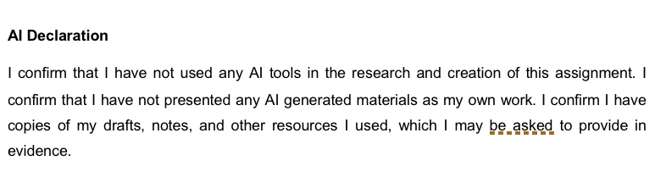

Table of Contents
1 Introduction 4
2 Application of the Event Cycle and Design Models 4
2.1 Bladen’s Three-Stage Event Design Model (2012) 4
2.2 EMBOK Model Application 5
3 Event Concept and Unique Selling Point 6
3.1 Event overview 6
3.2 Unique Selling Point 7
4 Aim and SMART Objectives 7
5 Strategic Event Management Plan 8
5.1 Operational Planning 8
5.2 Resource Allocation 8
6 Financial Feasibility and Budget 9
6.1 Budget Breakdown 9
6.2 Revenue Generation 9
7 Industry Trends and Market Demand 10
8 Situational and Cultural Considerations 10
8.1 SWOT Analysis 11
8.1.1 Strengths 11
8.1.2 Weaknesses 11
8.1.3 Opportunities 11
8.1.4 Threats 11
8.2 PESTLE Analysis 12
9 Risk Management and Sustainability 12
9.1 Risk Mitigation Strategies 12
9.2 Sustainability Practices 13
10 Recommendations 14
11 Conclusion 14
12 References 16

Introduction
The Croeso Digital Smart Tourism and Tech Conference aims to host MICE (Meetings, Incentives, Conferences and Exhibitions) as an international event that positions Wales as a center for innovative tourism. The event is part of the Visit Wales “Year of Croeso 2025” campaign which focuses on the friendly hospitality and interesting cultural traditions found in Wales. At the conference, it will be shown how artificial intelligence, virtual reality and technology in tourism can improve the visitor experience and keep Welsh heritage intact.
The Swansea Arena Conference Suite is located in a modern venue and is accessible to both regional and overseas participants. The goal is to bring together professionals from tourism, hospitality and technology who are interested in digital transformation and cultural tourism (Kshetri & Dwivedi, 2024).
This paper explains the detailed planning and implementation of the event, focusing on organisational, financial and marketing elements. To examine the event’s feasibility, it relies on the Bladen (2012) three-stage model and the EMBOK framework. Moreover, the latest tourism trends and green activities will guide the event’s organisation to meet today’s standards (Fan et al., 2022; Kusumastuti et al., 2024).

Application of the Event Cycle and Design Models

Bladen’s Three-Stage Event Design Model (2012)
Bladen’s model divides event planning into three phases: Concept, Design and Logistics (Bladen & Callinan, 2022). By using this model, all parts of the event can be managed one step at a time and each part remains connected to the overall goals.
- The focus in the Concept stage on developing the key theme and idea for the screenplay. The Year of Croeso 2025 campaign from Visit Wales inspired the creation of Croeso Digital which works to link Welsh culture and the latest trends in tourism. It is unlike ITB Berlin or Arrival 360, since the former are more international and lack a cultural perspective on the host country. Using technologies such as AI and VR to promote cultural activities is original and makes Croeso Digital stand out (Kshetri & Dwivedi, 2024).
- It is in the Design stage that the whole event experience is sketched out. There are speaker sessions, immersive areas and live events at these events. Making the restaurant bilingual, using traditional food and sustainable branding will help visitors have a positive experience (Fan et al., 2022). There are things about these venues that create a memorable experience and make the event special globally.
- In the Logistics stage, preparations happen for venue, food, workers and registration. Swansea Arena is picked because it is modern, easy to get to and equipped with the latest technology. For an event to be smooth and professional, these steps are necessary (Seyitoğlu et al., 2023).
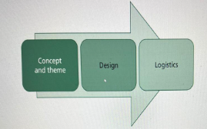
Figure 1: The three-stage event design model
Source: (Bladen & Callinan, 2022).

EMBOK Model Application
The EMBOK Model provides an overall perspective by including the important areas of Design, Administration, Marketing, Operations and Risk (O’Toole et al. 1999; Lekgau and Tichaawa, 2023).
- Design: Ensuring guests have a memorable time by combining technology and Welsh elements.
- Administering: Overseeing the money, employees and timelines of the event.
- Marketing: Promoting the event by using digital tools and teaming up with industry members (Morrison, 2022).
- Operations involve planning the physical area and assigning movement to team members.
- Risk: Overseeing safety, legal challenges and how private data is used (Bowdin et al., 2023).
These models help the event stay original, well-organised, and secure for everyone involved.
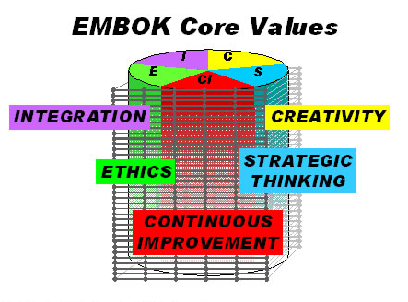
Figure 2: EMBOK event management framework
Source: (Lekgau & Tichaawa, 2023).

Event Concept and Unique Selling Point

Event overview
This conference called “Croeso Digital: Smart Tourism & Tech Conference” will be held at Swansea Arena from 25–26 September 2025. It will assemble specialists from the tourism, hospitality and technology industries to discuss smart tourism and new innovations. There are keynote speeches, live showcases of technology and group discussions at the event. Participants will learn immersive technologies in the tourism industry. Since it focuses on Welsh tradition and the latest in tech worldwide, it brings great opportunities to meet and cooperate with others. The conference contributes to Wales’ Year of Croeso 2025 by underlining Wales’ status as a strategically positioned smart travel destination (Cooke, 2024; Fan et al., 2022).
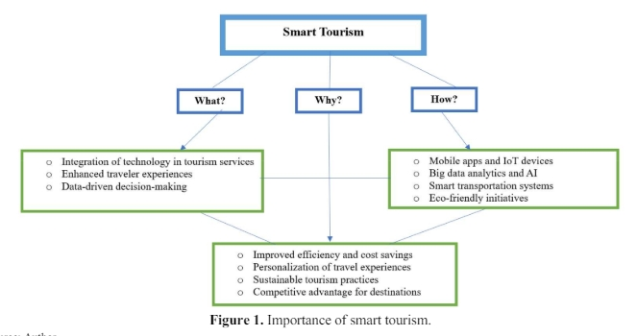
Figure 3: The smart Tourism Technology
Source: Buhalis, (2020)

Unique Selling Point
The Croeso Digital stands out because it merges culture with technological solutions. Unlike international events ITB Berlin or World Travel Market, Croeso Digital focuses only on Wales and its cultural and digital change (Getz and Page, 2024; Morrison, 2022). The conference supports advancements in technology, highlighting immersive experiences and demonstrating how AI, VR and AR are used on the spot. Using eco-friendly options like digital brochures, local food and a sustainable setting greatly adds to the uniqueness of the event (Mair and Smith, 2022). Since participants can join online or in person, the hybrid design ensures fairness and brings together more experts globally (Santos et al., 2024). This allows the event to support the development of smart tourism in Wales and bring attention from international audiences.

Aim and SMART Objectives
The aims to support the national strategies of Visit Wales as well as the bid’s detailed plans. The Croeso Digital is to present Wales as a leading smart tourism place through examples of digital adoption in travel and hospitality. Setting SMART Objectives is necessary
- Ensure that there are 300 people in total and at least 100 are from other countries.
- Reach a minimum profit of £53,000 after the event is held.
- Attainable: With the use of targeted marketing, partnering with organisations and providing both online and offline options.
- It supports Wales’ national plans for innovation and tourism, as laid out in the 2025 goal (Cooke, 2024).
- The planned activities are due to be finished by September 2025.
These aims are in line with what people and organisations want in digital and sustainable tourism. The organisers have designed the event to be interesting, enlightening and effective, aiming to boost the long-term success of Welsh tourism and connect Wales to more global markets (Bowdin et al., 2023).

Strategic Event Management Plan

Operational Planning
According to O’Toole, (2011) that feasibility assessments need to involve an analysis of operations, strategy, and finances and all of this should be completed during the planning phase To look after attendees was important, ensuring physical and emotional safety, comfort, and giving more opportunities for groups to interact and establish self-esteem. Designing according to hierarchy helped increase guests’ satisfaction and made them wish to return. The Swansea Arena features equipment for audio-visual presentations, fast internet and features for accessibility. Being central, simple to get to and perfect for any international or local visitor, it is an ideal choice (Luger, 2025). In the planning phase, important responsibilities are already: sending invitations to presenters, arranging tech, promoting the event and handling ticket sales early. The digital way for registration, wayfinding signage, catering centers and assistance for AR/VR technologies will form part of the venue logistics. Those staffing the event will ensure that logistics, guest needs and technology work correctly. By training before the event, staff members will be aware of the health and safety guidelines (Moorman, 2020). A schedule of six-month preparation will guide the operations process. The project manager will guide the team so that all activities run smoothly. In the last two weeks, there will be coordination meetings and tech trials to minimise problems (Oton and Marshall, 2021).

Resource Allocation
The conference provided space for people to build relationships within the company as well as opportunities to develop themselves, ensuring every need was met within Maslow’s hierarchy (Maslow, 2000). It is planned that resources will favour technical, personnel, marketing and green options. Some of the main people in an event are managers, technology teams, workers from catering and guards (Seyitoğlu et al., 2023). You will find technology at work for communicating with presentations, being available online and demoing features in a unique way. Money will be used for renting virtual and augmented reality equipment, hiring people to speak and making sure everyone can attend the event at home, at the office or in the venue itself. We will have local caterers offer Welsh food to the audience which will help local businesses and save the environment (Carter, 2024). Caring about the environment will involve digital menus, eco-friendly cutlery and trash bins for recyclables (Mair and Smith, 2022). Marketing related stakeholders and event management firms will be used to promote the event among potential guests (Putra and Law, 2024). The tasks will be allocated to teams and all those working on the event will get a thorough briefing about the event’s brand and objectives. The plan ensures the event runs smoothly, cares for the environment and delivers a lot of value for the audience.

Financial Feasibility and Budget

Budget Breakdown
Expense Item | Cost (£)
Venue | 10,000
Technology setup and rental | 8,000
Catering and hospitality | 7,000
Staffing | 6,000
Marketing | 4,000
Contingency Fund for MYC | 2,000
Total Estimated Cost | 37,000

The calculated expenses guarantee that the event is of good quality and stays within its budget (Connock, 2024). Proper advance preparation helps you avoid purchasing too much and won’t waste money. Instead of printing, using digital brochures will save money and help preserve the environment. Making early bookings and working with local partners will help reduce costs in catering and equipment rentals. To choose suppliers and contractors, attention will be given to both their cost-effectiveness and their dependability. Insurance, having an emergency plan and offering additional bonus features are part of proper budgeting (Bladen and Callinan, 2022).

Revenue Generation
Revenue Source | Amount (£)
Ticket Sales (Early Bird + Standard) | 70,000
Sponsorship from Tourism & Tech Companies | 15,000
Government Grants (Cultural Promotion) | 5,000
Total Expected Revenue | 90,000

Tickets will be similar to other venues and discounts will be available for groups to increase bookings. So that the event fills quickly, marketing campaigns will take place three months ahead of time. The event will sell sponsorship packages that give companies branding and chance to speak, helping to bring local firms and top tech companies on board (Kshetri and Dwivedi, 2024). The government backs tourism innovation and traditional heritage through its funding. The event being feasiKling and leaving a template for future smart tourism events in Wales requires a net profit of at least £53,000 (Bowdin et al., 2023).

Industry Trends and Market Demand
These past few years, tourism has shifted from simply providing services to also addressing people’s emotions and mental health. A good illustration of this change can be seen in Maslow’s Hierarchy of Needs, which lists Five progressively higher levels of human drive: bodily requirements, protection, affection and belonging, respect, and self-realisation. (Zajda, 2023). These days, people who travel want more than just comfortable and safe experiences; they also look for activities that fit their identity and future goals. To put the foundation into practice at Croeso Digital. Through the use of hybrid formats, the basic needs of event attendees for comfort and safety after the pandemic are considered (Rogers and Wynn-Moylan, 2022). They meet their higher-level goals by exploring community-focused parts of the tour, using guides in their language, and experiencing cultural events that strengthen their link to Welsh culture (Santos et al., 2024). By using advanced visual technology, individuals can develop a sense of belonging and show more respect for others in society (Fan et al., 2022). At the last step in Maslow’s pyramid, people are led towards self-actualisation by being involved in learning, art projects, and receiving expert advice and networking. All of them clearly line up with McClelland’s main ideas regarding achievement and affiliation in motivation. Also, by using QR brochures, serving sustainable food, and choosing eco-friendly travel, people today are meeting their needs for acceptance and bettering themselves, which Maslow’s theory says is possible as people move up through his hierarchy (Mair and Smith, 2022). Unlike big international events, Croeso Digital offers an experience that is always fresh and makes use of local values, giving participants a unique and rewarding cultural experience. Therefore, it is based on worldwide patterns and theories of motivation, which make Wales an innovative and empathetic travel destination.

Situational and Cultural Considerations
It is certain that understanding the situational and cultural landscape is vital for the success of “Croeso Digital.” The event is strategically positioned during Visit Wales’ Year of Croeso 2025, aligning with national objectives to enhance the visibility of Welsh culture through innovation (Fox et al., 2014).

SWOT Analysis
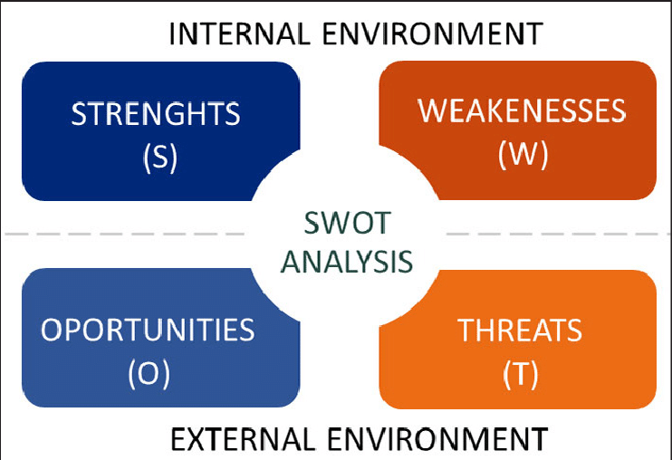
Figure 4 SWOT Analysis
Source: Cañizares & Bourotte (2021)

Strengths
Croeso Digital uniquely combines smart tourism with Welsh identity, capitalising on the £5.2 billion Welsh tourism sector. The use of AI and AR offers a modern lens for global visitors to engage with Wales.

Weaknesses
As a new event, there is low brand recognition and limited historical performance data. Its reliance on sponsorship projected to cover 40% of costs may introduce financial vulnerability if funding targets are unmet (Mair and Smith, 2022).

Opportunities
The global smart tourism market is expected to reach $24.1 billion by 2027, creating scope for Wales to assert leadership. Collaborating with tech hubs and tourism boards enhances local engagement and investment.

Threats
Competition from established events like WTM London or ITB Berlin may overshadow smaller-scale conferences. Additionally, ongoing economic inflation in the UK (4.3% in 2024) may deter international delegate attendance (Doğan et al., 2023).

PESTLE Analysis
Table 1 PESTLE Analysis
Factor | Analysis
Political | The Welsh Government tourism grants; support for digital innovation and SMEs
Economic | Moreover, post-COVID growth, but inflation pressures may impact delegate budgets
Social | The increasing demand for cultural-tech fusion experiences among Gen Z and Gen Y
Technological | Furthermore, rapid growth in AR/VR, IoT; Wales lags in tech adoption in tourism sector
Legal | It is essential to comply with GDPR, accessibility laws, and health & safety standards
Environmental | It is certain that low-carbon venue, use of local food, and digital materials reduce footprint

Risk Management and Sustainability

Risk Mitigation Strategies
Risk planning is essential for ensuring the success of Croeso Digital. Key risks include technology failures, low attendance, and financial shortfalls. Since 74% of attendees at tech events expect seamless digital experiences, the event will employ on-site technical support and conduct pre-event AR/AI system testing (Getz and Page, 2019). To address attendance uncertainty amid ongoing economic pressures, hybrid participation options will be offered. Early marketing will target over 5,000 prospective delegates globally to ensure at least 800 in-person participants. Financial risks due to 40% reliance on sponsorship will be mitigated through confirmed agreements with Welsh tech firms and contingency budget allocations (Moorman, 2020).
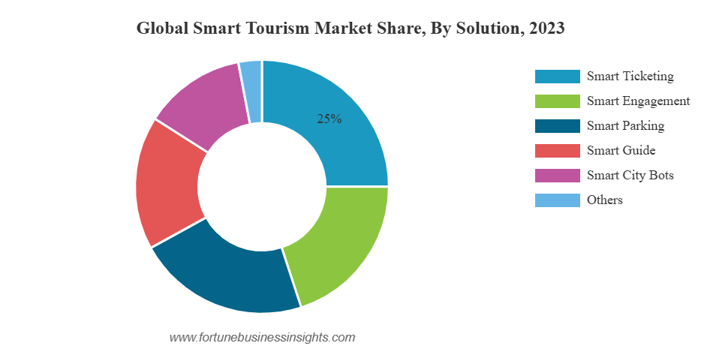
Figure 5 Global Smart Tourism Maarket share, by Solution
Source: Fortune Business Insights (2025)

Sustainability Practices
Sustainability is embedded across event planning. With 78% of travellers preferring eco-conscious events, Croeso Digital will eliminate printed materials by using digital brochures and QR signage. Catering will focus on locally sourced Welsh produce, reducing food miles by up to 60% (Mair and Smith, 2022). The venue, Swansea Arena, operates with energy-efficient systems and waste recycling. Compostable cutlery, recycling stations, and minimal plastic use will reduce landfill impact. These practices align with Visit Wales’ Green Key accreditation goals, positioning the event as a benchmark for responsible tourism in the UK (Getz and Page, 2019).
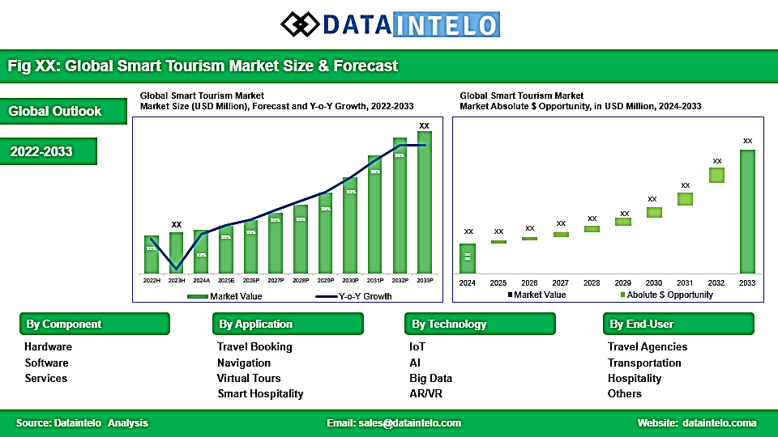
Figure 6 Global Smart Tourism Market
Source: DataIntelo (2025)

Recommendations
Key areas of focus for organisers to improve Croeso Digital include:
- Join forces with both local and worldwide technology companies to earn more sponsorship and increase your visibility online.
- Initiate early marketing activities on both social media and popular tourism channels to encourage more students to join the program (Putra and Law, 2024).
- It is important to fully test all equipment for immersive experiences to ensure there are no disruptions during presentations (Posse, 2025).
These strategies, events can better engage guests, be more successful and offer a hassle-free experience to attendees. Combined, they help ensure that the event endures and contributes to Wales’s role as a prominent leader in smart tourism.

Conclusion
If the conference is properly organised, follows the scenario format of the bid, and the people involved make good use of their resources, the results can be stronger. The Croeso Digital: Smart Tourism & Tech Conference creates a new chance for Wales to present itself as an international leader in smart tourism. Because the event celebrates technology, culture and sustainability, it attracts many people and leaves a lasting effect. Because of its clear plan, reliable finance system and in line with current industry patterns, the event is proven to be solid and important. It aims to fulfil a main requirement: helping Welsh tourism use current technology and develop new skills. Organising events in a hybrid way, offering environmentally friendly options and partnering with locals helps reach more people and benefits the community (Seyitoğlu et al., 2023). If the conference is planned well, resources are used wisely and marketing is successful, it is expected to reach its targets and motivate additional events. Croeso Digital is already set to be a success, putting Welsh tourism innovation on the map (Mair and Smith, 2022).

References
Ahmed, S. (2025). Tourism Today: Trends, Challenges, and Opportunities. Journal of Educational Studies, 3(1), 42-56. DOI:10.58218/jes.v3i1.1263
Bladen, C. and Callinan, C. (2022) ‘Destination recovery: Recovery of the post-pandemic tourism destination economy’, in Crisis management, destination recovery and sustainability. 1st edn. London: Routledge. Available at: https://doi.org/10.4324/9781003295839 (Accessed: 10 June 2025).
Bowdin, G.A.J., McDonnell, I., Harris, R., O'Toole, W., Allen, J. and Jago, L. (2023) Events management. 4th edn. London: Routledge. Available at: https://doi.org/10.4324/9781003044963 (Accessed: 10 June 2025).
Buhalis, D. (2020). Technology in tourism-from information communication technologies to eTourism and smart tourism towards ambient intelligence tourism: a perspective article. Tourism Review, 75(1), pp.267-272.
Canizares, A. and Bourotte, C.L.M. (2021) ‘Strategic diagnosis of geocommunication using SWOT analysis in the Varvite Geological Park, São Paulo, Brazil’, Journal of the Geological Survey of Brazil, 4(1) [Issue in progress]. Available at: https://doi.org/10.29396/jgsb.2021.v4.SI1.1 (Accessed: 10 June 2025).
Carter, A.R.L. (2024) Cocreation InContext: An evaluation of interactive technology design for enhancing community engagement with public spaces. Unpublished PhD thesis. [Swansea University]. DOI: 10.23889/SUthesis.66236
Connock, A. (2024) Media management and live experience: Sports, culture, entertainment and events. 1st edn. London: Routledge. DOI: 10.4324/9781003435167.
Cooke, P. (2024). The regional innovation system in Wales: evolution or eclipse?. In Regional innovation systems (pp. 214-233). Routledge.
Dogan, G., Taskin, Z., Kulczycki, E. and Szadkowski, K. (2023) ‘How inclusive are the international conferences? Attending conferences in an unequal world’, Lecture Notes in Computer Science, iConference 2023, Virtual Conference. DOI: 10.1007/978-3-031-28035-1_37.
Fan, X., Jiang, X., and Deng, N. (2022). ‘Immersive technology: A meta-analysis of augmented/virtual reality applications and their impact on tourism experience’. Tourism Management, 91, 104534. Doi: 10.1016/j.tourman.2022.104534
Fortune Business Insights. (2025). Smart Tourism Market Size, Industry Share & Forecast [2032].
Fox, D., Gouthro, M. B., Morakabati, Y., and Brackstone, J. (2014). Doing events research: From theory to practice. Routledge.
Getz, D. and Page, S. (2019) Event studies: theory, research and policy for planned events. 3rd Edition.Oxford: Routledge.
Getz, D., and Page, S. J. (2024). Event studies: Theory and management for planned events. Taylor & Francis.
Kshetri, N., and Dwivedi, Y. K. (2024). How can virtual and augmented reality facilitate international business?. Thunderbird International Business Review, 66(2), 201-210.
Kusumastuti, H., Pranita, D., Viendyasari, M., Rasul, M. S., and Sarjana, S. (2024). Leveraging local value in a post-smart tourism village to encourage sustainable tourism. Sustainability, 16(2), 873.
Lekgau, R. J., and Tichaawa, T. M. (2023). Dynamic Changes and Recovery in Event Venues: Perspectives from MICE Event Planners and Venue Managers. Studia Periegetica, 44(4), 139-158.
Luger, K. (2025). Tourism as a Development Perspective. In Tourism-About Traveling and Vacationing in our Time (pp. 179-203). Wiesbaden: Springer Fachmedien Wiesbaden.
Mair, J., and Smith, A. (2022). Events and sustainability: why making events more sustainable is not enough. In Events and sustainability (pp. 1-17). Routledge.
Maslow, A.H. (2000). The Maslow business reader. John Wiley & Sons.
Moorman, A. M. (2020). Planning and Accessibility Issues in Venue/Event Operations. In Sport Law (pp. 542-580). Routledge
Moorman, A. M. (2020). Planning and Accessibility Issues in Venue/Event Operations. In Sport Law (pp. 542-580). Routledge.
Morrison, A. M. (2022). Hospitality and travel marketing. Routledge.
O’Toole, W., Silvers, J. R., & Landey, J. (1999). History of EMBOK. In Event Management Body of Knowledge. Retrieved June 9, 2025, from https://www.embok.org/index.php/history-of-embok
O’Toole, W. (2011). Events Feasibility and Development: From Strategy to Operations. Elsevier: oxford
Otan, S. and Marshall, J. (2021). Event Planning for Sustainable Tourism. CABI Publishing.
Posse, A. (2025). Your AI Ally: A Beginner's Guide to Mastering AI Tools and Transforming Your Productivity (Vol. 1). eBookIt. com.
Putra, F. K. K., and Law, R. (2024). Critical success factors for virtual hotel operator partnership with small-and medium-sized hotels: perspectives of owners and operators. Journal of Hospitality and Tourism Insights, 7(3), 1391-1411.
Rogers, T., and Wynn-Moylan, P. (2022). Conferences and conventions: A global industry. Routledge
Santos, J. A. C., Fernández-Gámez, M. A., Puig-Cabrera, M., and Santos, M. C. (2024). Sustainability in business events: How hybrid formats shape attendee decision-making. Journal of Tourism and Services, 15(29), 320-348.
Seyitoğlu, F., Costa, C., Martins, M., and Malta, A. M. (2023). The future of tourism and hospitality labour: challenges, requirements, trends, skills and the impact of technology. Current Issues in Tourism, 1-15.
Zajda, J. (2023). Humanistic Approaches for Creating Effective Motivational Environments. In Globalisation and Dominant Models of Motivation Theories in Education (pp. 81-97). Cham: Springer Nature Switzerland. DataIntelo. (2025). Smart Tourism Market Report: Global Forecast from 2025 to 2033.

