Construction Materials
The focus of this essay will be to discuss two different habitable buildings from different parts of the world, providing information on the original design planning, the impact of the construction in its environment and the builds sustainability. The first being constructed with a concrete frame and the other made from a steel frame. I will then consider the materials used to build the frame of each building, whilst comparing both. It is vital to consider and discuss the durability and climate resistance, the process of the materials production, impact on the environment and the ease of assembling the material used for the constructions.
I have chosen the 432 Park Avenue building in New York for the concrete frame structure, for the steel frame structure I have picked the Willis/Sears Tower in Chicago. These buildings were chosen as they are both in the top ten for height for the respective frame materials used.
432 Park avenue
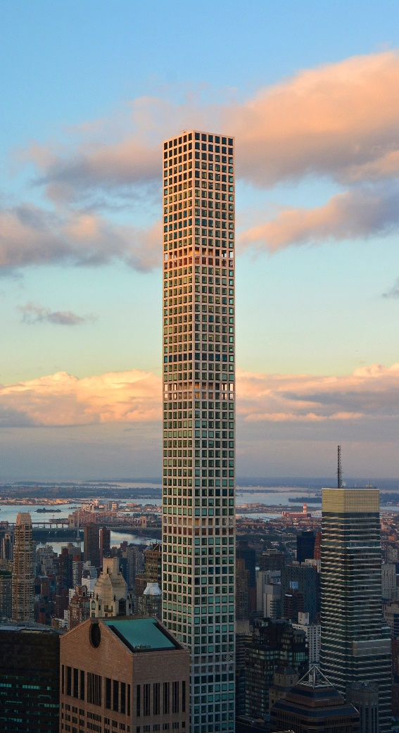
432 Park avenue is a residential skyscraper located in Manhattan. It was designed by architect Rafael Vinoly and completed in December 2015. The building is located on Billionaires’ Row where the most expensive residential buildings are in the city. The skyscraper has 86 residential floors overlooking midtown Manhattan
The building is 93.5 feet in width and length and 1396 feet (425.5 m) high putting it in the top ten for tallest buildings using a concrete frame. 70 000 cubic yards of concrete and 12500 tons of reinforcing bars were used for the frame of this structure. Two 660-ton mass dampers were included in the top portion of the building, the purpose of a tuned mass damper is s to reduce the amplitude of vibration to a satisfactory level, this can protect the building when exposed to high winds or an earthquake (Irschik, Krommer, Watanabe, Furukawa, 2009). Due to its slender structure high winds and earthquakes pose a threat, to withstand these, suitable measures have been put in place. In the lower portion of the building reinforced steel was used in the columns, thus providing the structure with more compressive strength. The concrete cast used during the construction was designed to have enhanced durability, lessening the water to cement ratio to as low as 0.25 (Structuremag.org). This ratio may benefit the durability, strength and sustainability of the structure but can make the mix difficult to form and work with, to improve the workability plasticizers should be added to the mix.
Photo showing 432 Park Avenue, https://www.google.com/search?q=432+park+avenue&rlz=1C1CHBF_enGB845GB847&sxsrf=ACYBGNSbmwCYLvWkBaDC6p9T3lIT1OomNw:1579036483680&source=lnms&tbm=isch&sa=X&ved=2ahUKEwjJxcmlgYTnAhVRQUEAHdCBAAkQ_AUoAXoECBAQAw&biw=1536&bih=722#imgrc=2aU-rgMznHV5TM:
The building has a slenderness ratio of 1:15. This was dictated by the demands of the site as the designer had a limited amount of land for the skyscraper and there are several high-rise buildings neighbouring. The structure has 99 square feet of windows symmetrically located from the bottom to the top. These gridded windows form the exoskeleton of the building and helps bear with structural loads. Several two-story void levels were constructed, meaning 432 park avenue can be considered as 6 independent buildings stacked on top as each other with the void levels. These void levels allow air to pass through giving the building a lot more stability when exposed to high winds (Wood, Henry, 2016).
Different types of cement were used for this structure. The concrete cast used was designed to have low heat of hydration, self-consolidating and to be pumpable. Having these attributes meant that the cement had low internal temperatures leading to minimal shrinkage and shorter casting periods. This gave the benefits of two-hour workability periods which allowed workers access to newly cast horizontal surfaces within five hours of laying fresh concrete (Structuremag.org). For the exposed structural elements white Portland cement was used. This would provide the building with an aesthetically pleasing look compared to other cements available. 12500 tons of reinforcing steel were used in the columns of this building providing more compressive strength. The low water to cement ratio of the cement would help preserve the steel from rust. It also reduces the risk of the concrete cracking under pressure (Structuremag.org).
The skyscraper is located on 57th street and Park Avenue in Midtown Manhattan. This location means that traffic congestion is an issue that the designers had to take this into consideration. The transportation of materials and equipment to and from a site can cause major problems with traffic. To eliminate the use of several cranes a super climber was used which climbs with the structure as it’s being built, allowing materials and equipment such as a crane being carried as the building gains height. A Table lifting system (TLS) is a support added to the side of the building which lifted materials up 3-4 floors at a time. Using these techniques meant the contractors did not have to rely on a crane to lift materials when experiencing high. This again minimised the transportation of materials back and forth to the site easing traffic. The structure took just over 4 years to build so these careful considerations to the congestion were taken.

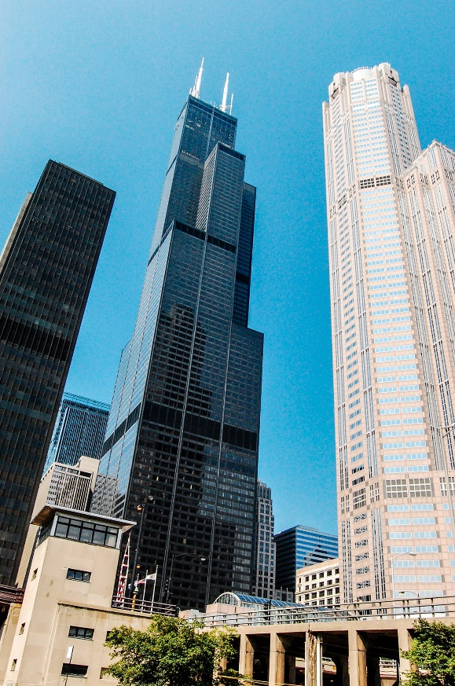
Willis/Sears Tower
The Willis Tower is a 110-story skyscraper located in Chicago, Illinois. It is the second tallest building in Chicago making it very visible in the skyline over the city. The tower is 1450 feet (412 m) in height and homes the tallest public viewing area in the United states being 1353 feet above the ground. The building is neighboured to several other high-rise buildings in the centre of Chicago (willistower.com). Willis tower was designed by architectural firm Skidmore, Owings and Merrill, the project was started in 1970 and finished in 1974 taking just over three years to complete.
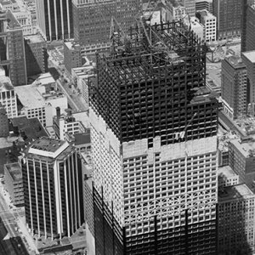
The skyscraper has a surface area of 4,400,000 sq. ft, 76 000 tons of steel were used for this construction with black anodized aluminium also being used. Anodising aluminium protects it from corrosion, helps maintain its appearance and increases its resistance (comhan.com). The building has a combined weight of 222,500 tons, the tower has 104 elevator shafts which provide more tensile strength and stability (aviewoncities.com). Average sway of the building is approximately 6 inches from centre, the building was built to withstand up to three feet of sway. The number of elevators in the building provides the building with more tensile strength to withstand this sway (theskydeck.com).
Photo showing Willis Tower, https://architecture.org

The designer of the building had 3 acres of land to work with. The land is in a highly populated area of Chicago. The site is located between Adams and Franklin streets, Jackson Boulevard and Wacker drive, all these streets have high-rise buildings, skyscrapers and hotels (Pridmore, 2002). Having the structure and building the structure in a populated area like this means traffic congestion would have been a huge issue they had to overcome. The tower was constructed using a steel frame that was pre-assembled in sections. Once pre-assembled it was delivered to the site and bolted into place. The structure relies on the use of bundled tube construction, it has 9 bundled structural tubes which rest on reinforced caissons that start at the bedrock beneath the earth’s surface (som.com).
Image showing the Willis Tower frame, https://www.SOM.com
I will now focus at the framing materials used for the constructions mentioned. To compare the materials, we must look at their durability, climatic resistance, the original production process and its environmental impact. I will then look at the materials ease of assembly and its ease of adaptation to different shapes.

Concrete
Concrete consists of three major compounds, water; aggregate; and Portland cement (concretenetwork.com). Concrete structures have a lower tensile strength compared to steel framed buildings. Due to its low tensile strength, high winds pose an issue for any skyscraper made from concrete. A concrete frame does not allow for as much sway as a steeled framed structure. 432 Park Avenue utilise 2 level voids and mass dampers to combat this issue and provide the building. The voids allow air to pass through the building instead of pushing and swaying the building.
The production of concrete firstly involves mining the earth for materials such as limestone and other potential aggregates so it could be argued that before the mix is even made it has an impact on the environment. Limestone and clay or shale is then burned in a kiln at a temperature ranged between 1400 – 1500 c. This process produces a vast amount of carbon dioxide that enter the earths atmosphere again having a negative effect on the environment (sciencedirect.com). The production of concrete requires a lot of energy and water. When mixing concrete there can be a lot of waste. If concrete hardens too quickly and if there’s not enough time to lay the concrete before it hardens, a lot of contractors will dispose of this (bautexsystems.com).
There are many different types of concrete that are designed for different structures and environments. If you require your mix to have a high workability you can use a concrete with a high water to cement ratio, allowing the concrete to be pumpable and easily transported to a site. Having a high water to cement ratio does mean that the concrete will take longer to set which can slow the down the build of a construction. As previously mentioned, the concrete used for 432 Park Avenue was designed to have enhanced durability so they used a concrete with a low water to cement ratio, workability of this concrete would have been lower than other mixes available (structuremag.org). As previously mentioned, concrete can be mixed on site, so enhancing a buildings shape or design a lot easier and cheaper than steel.

Steel
Steel compared to concrete has a higher tensile strength, meaning steel can withstand higher elastic pressure providing more stability to skyscrapers exposed to high winds and earthquakes. Chicago is located near the New Madrid fault line, this means that the Willis Tower would require a high tensile strength if exposed to an earthquake so using a steel frame for this structure would be beneficial.
To produce steel the first step is to mine iron ore mining degrades the earth’s surface, natural landscapes and effects the ground water. Water quality is degraded as a result of surface run off. Iron ore and other bearing materials, coke and limestone are poured into the furnace from the top, the furnace removes the oxygen from the iron ore. Once correctly heated the iron ore is found at the bottom of the furnace and the slag is removed off the top (Bugayev, Tretyakov,2001). Using a furnace to produce materials puts huge amounts of green house gasses into the earth’s environment. Structures made of steel require more pre-fabricated components than a concrete frame, this requires more transportation as concrete can be mixed on site. Transportation requires the use of trucks and lorries producing more green house gasses.
Steel for structures in predominantly pre-fabricated off site and then complete components can be delivered and bolted together on site. Using this method typically means steel structured building are built quicker than a concrete frame. Steel is more expensive to use for a frame rather than concrete so having specific pre-fabricated steel parts made. There are several companies who construct these fabrications, so enhancing the buildings shape is a possibility but is down to the stakeholder’s price range. Steel is recyclable so it can be used in future constructions.

References
- A View on Cities, Sears Tower, viewed 11/01/2020
<https://www.aviewoncities.com/buildings/chicago/searstower.htm>
- Bautex, Why Concrete Can be Considered Environmentally Unfriendly, viewed 11/01/202
<https://www.bautexsystems.com/blog/concrete-not-ecofriendly>
- Bugayev K, Tretyakov E, 2001, Iron and Steel Production, Books For Business, New York-Hong Kong
- Comhan, 2018, What is Aluminium Anodising and What are the Benefits?, viewed 12/01/2020
<https://www.comhan.com/en/blog/news/what-aluminium-anodising-and-what-are-benefits>
- ConcreteNetwork, What is Concrete: Concrete & Cement Defined, viewed 12/01/2020
<https://www.concretenetwork.com/concrete.html>
- Irsichik H, Krommer M, Watanabe K, Furukawa T, 2009, Mechanics and Model-based Control of Smart Materials and Structures, SpringerWienNewYork, Germany
- Pridmore J, 2002, Sears Tower: A BuildingBook from the Chicago Architecture Foundation, Pomegranate Communications Inc, Oregon USA
- ScienceDirect, Concrete Production, viewed 11/01/2020
<https://www.sciencedirect.com/topics/engineering/concrete-production>
- SOM, Willis Tower – Structural Engineering, viewed 11/01/2020
<https://www.som.com/projects/willis_tower_formerly_sears_tower__structural_engineering>
- Structuremag, 2018, Marcus S, 432 Park Avenue, viewed 11/01/2019
<https://www.structuremag.org/?p=13350>
- Skydeck, What do you know about the Willis Tower?, viewed 12/01/2020
<https://theskydeck.com/for-kids/fun-facts/>
- Willis Tower, History & Facts, viewed 12/01/2020
<https://www.willistower.com/history-and-facts>
- Wood A, Henry S, 2016, Best Tall Buildings: A b Overview of 2916 Skyscrapers, Images Publishing, Australia

