
Communication skills and models



Student: Evelina Gajauskyte (2125731)
Lecturer: Anita Nan
Module: BMSW4002
Contents
Introduction 2
Models of communication: 2
Shannon and Weaver’s model of communication 2
Berlo’s model of communication 3
Schram’s model of communication 3
Communication skills: 4
Verbal 4
Non-verbal 5
Listening 5
Active listening 5
Empathetic listening 5
Advantages and disadvantages: 6
Conclusion 6
Reference 7

Introduction
‘Communication is simply the act of transferring information from one place, person or group to another’ (Skills you need, 2021). Shannon and Weaver, Berlo, and Schram have developed three different communication cycles, which include sender, encoding, message, receiver, decoding, and in some cases feedback. The main idea is that the sender has a coded message to send, and the receiver has to encode it. There are a few different communication skills to be used: verbal, non-verbal, and listening. Verbal and non-verbal communication happens together. Despite this, listening is one of the most important skills to learn. This report aims to show the importance of the right communication. Below will be shown a lot more in-depth about each model of communication and examples of how it could be used to avoid misinterpretation.

Models of communication:

Shannon and Weaver’s model of communication

Shannon and Weaver is a model, which explains how the message is sent and received. It uses basic elements, such as message, encoding, noise, decoding, and receiver (Drew, 2022) This model of communication was applied to the example of Pedro and his wife’s conversation. The sender, in which case, it was Pedro’s wife, was asking to get a chicken on the way home, but because of the noise at work, he couldn’t receive the clear message. All he heard was – when you get back home, get to the kitchen. The sender has used a mobile phone as a channel, their communication would have been better by sending a text message, so they could understand each other clearly. Probably most of us have experienced it in our lives. I have had a similar situation at work, where I was communicating with the supplier to send me some dairy-free milk, but because of a bad connection, he could not hear me saying `dairy-free`, and he brought me regular milk instead. We could have avoided this simply by sending a message rather than talking on the phone or asking for confirmation.

Berlo’s model of communication
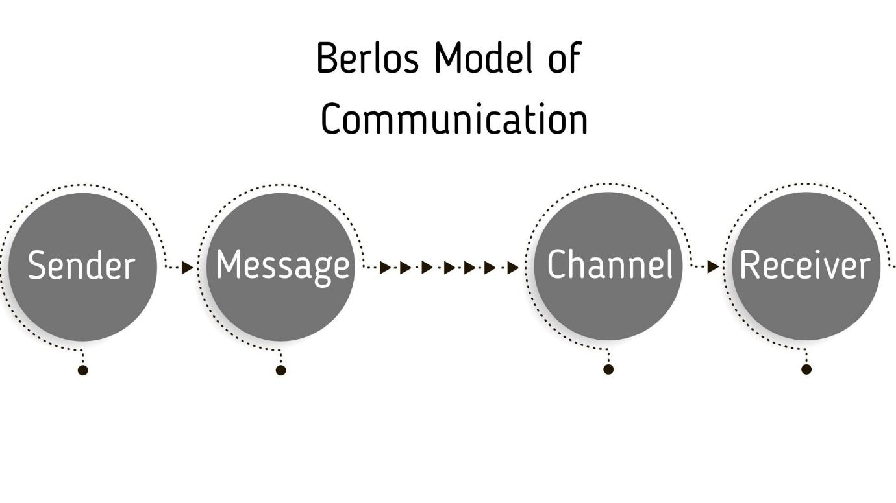
Berlo’s model of communication is divided into four elements – source, message, channel, and receiver (communication theory, n.d.). This model usually is used to translate the message to a bigger audience, as you are not waiting to get feedback from them. The main difference between Berlo’s model and the others is – that Berlo is not using noise and feedback. It was a good example when a professor’s house was on fire, and he went to the village asking for help from the village people, but they could not understand what he was asking for, because a professor was using a language they could not understand. It could be easily changed if the professor would have spoken with the village people the language they know. In that case, they would have helped him to stop the fire and he would have saved his house. It also happens in daily life when a higher-educated person is trying to talk with someone who is not graduated and does not understand an academic language. We always have to notice at what level this person is, and what language is best to use.

Schram’s model of communication
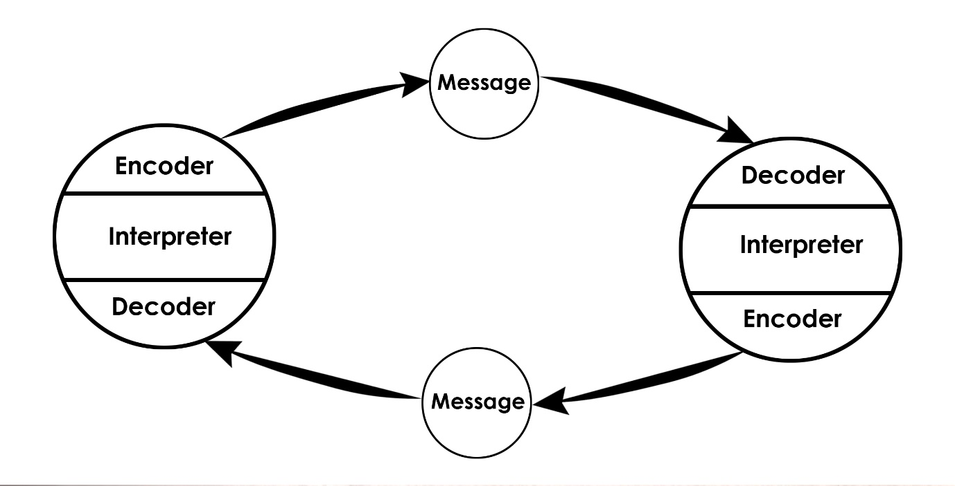

According to Shram’s model of communication, the most essential things in a conversation are coding and decoding (Management study guide, 2022). If the message was coded or decoded incorrectly, this could lead to misunderstanding each other. According to Schram, giving feedback at the end of the conversation helps to keep the discussion going, and to complete the communication. In the example of a professor and the village people, it could have been a different story if the professor has used simple language to talk to the village people, making sure, that they understand what he is asking for, so they could help him stop the fire. In addition, if the village people have asked a professor to repeat his thought, but differently, that would be helpful as well. To conclude, in relation to Schramm’s model, the key idea is, to make sure that your recipient gets the correct message from you.

Communication skills:
There are three types of communication: verbal, non-verbal, and listening. All have a huge role in how we translate the message, and it can be easily identified if we are lying or saying the truth. Sometimes people are trying to hide the truth and verbally say things, that are not genuine. We cannot hide non-verbal communication, our facial expressions, body language, and tone shows how we feel. Therefore, there are other important skills to learn – active listening – when you listen to what another person is saying, and you can respond to them. That shows that you are a hundred percent engaged. Empathetic listening is where you listen to verbal and non-verbal cues and can reflect on them.

Verbal
Research shows, that there are a few different verbal communication skills. Some include – intrapersonal communication – which would be mostly when people are discussing with themselves. Second, interpersonal is when two or more people are having a conversation. Third, is small group communication. Here usually we have a group of three or four. That mostly would be when you have a specific goal to reach or talk with a group of friends. Fourth, is public communication. We have all seen at least once, a president giving a speech. This type of communication does not require feedback from the audience. It can be just translated message to a group of people (Communication theory, n.d.).
Furthermore, there are two types of verbal communication – oral and written. Oral communication is based on speaking. It can be by face-to-face discussion, or by talking on an electronic device (Study, 2022) This communication is one of the most effective ones, as by having an oral conversation with another person, there is likely less confusion and misinterpretations because you are also using body language, which can help translate the correct message. Whereas written communication is more official way. We use written communication when we have to contact someone via email or to send a text message. It could be still beneficial, as sometimes we meet some disruptions talking on the phone, and it causes confusion about what was the person trying to say to you.
Written communication can be formal and informal. In other words, if we want to send a letter regarding our job, we have to make sure, that we use the correct language and words, alternatively, informal letters can be sent to your friends, family, and colleagues, by using casual and personal language.

Non-verbal
Non-verbal language can be used to support verbal communication or to substitute it (Phutela, 2015, p.43-49). This technique is used to express our feelings. There are many different ways to show what exactly you are saying, it can be explained with facial mimics, body expressions, gestures, posture, and so on. Almost all cultures are using the same signs for non-verbal language. By using this method, we add meaning to our point, and our emotions can speak more than our words can say.
We have had an example from ‘A Day with the chief’. It explained how verbal and non-verbal communication is important in our day-to-day life. It was talking about Mark, the top salesman, meeting Alana Brown, the Chief Executive Officer. Before Mark went to meet Alana, his co-workers said, that she is a rough person, who does not smile and does not make eye contact. At the time he went to see her, she seemed such a kind person, smiling, and making him feel comfortable. At this point, Mark has relaxed way too much, he crossed his legs and started complaining about the team he is working with. Mrs. Brown looked at him, stood up, and asked him to leave. If Mark was acting the same way as he did at the time he arrived, he would have left a good impression on Mrs. Brown, and he could have been promoted. This case shows that we have to control our attitude and body language, as we can miss opportunities and a chance on achieving our life goals.

Listening
Listening is an important skill to have. Everyone can listen, but not everyone can hear the message. There are two main types of listening: active and empathetic. Both are different, but they are important in their way. This skill helps to get the information needed and gives the ability to learn, communicate and understand better.

Active listening
During active listening, we make an effort to not only listen but to pay attention to the person and what the individual is trying to say. Research has shown that we receive only twenty-five to fifty percent of the message. (Mind tools, 2022) This means, that if we give all our attention to the speaker, we will get a clearer idea of what has been said. Otherwise, we might miss the most important point. There are different ways to develop this skill. Some include – asking questions, paying attention, show that you are engaged and actively listening.

Empathetic listening
Empathetic listening is when someone trusts you enough to open up and say how they feel (Wilson, S. R., 2021). There is a good example of ‘Multi-tasking Max’. In that case study, it was talking about Max, the event’s organiser. He has agreed to arrange an event for Tamaras parent’s 50th wedding anniversary with a hundred and fifty people. Max has mentioned to Tamara, that his mother has some illness, and all the money earned goes to her nursing home, resulting, that he cannot hire someone to help him. After a while, Tamara phoned Max asking on bringing the party one week forward, but the organiser was on another call with another client and did not pay full attention to Tamara. As result, he did not coordinate the party for her close relatives. In this situation, both parties are wrong, as Tamara could just send a message asking for a confirmation of the changes, and Max could say to Tamara, that he will call her back after a couple of minutes.

Advantages and disadvantages:
Nowadays students are facing many benefits and drawbacks to having the access to the internet. There were times when we had to leave our house to talk to our friends, colleagues, or lecturers, but now we can easily contact them by sending a message, calling on the phone, or sending an email. We do not need to wait for another class, to communicate with our classmates or teachers doing our group assignments. This can also be a negative thing because it means, that we reduce face-to-face communication, and we might need to wait longer for a response when we need it here and now. Some other advantages are easy access to the information needed. Most of us have the internet and can find information in seconds, although some time ago, we had to go to the library to get a book and find the relevant material ourselves, which takes so much longer. There are disadvantages as well as advantages – hacking the information from your device and online bullying too. You cannot trust everyone, as there are so many hackers out there, who are trying to use your information for a bad purpose. Another disadvantage is, that people got so brave, they use their anger and attack others online without showing who they are. We need to make sure that we know whom we are talking to and avoid the wrong people. Another good thing about the internet is, that we can entertain ourselves. We can play some games online or use social media. As we can see, access to cyberspace has many advantages and disadvantages, we just need to be mindful of choosing how to use it.

Conclusion
To conclude all the above, it is important to pay full attention to the person you are trying to communicate with. Not only verbal but also non-verbal cues, because they are giving the most information to you. The best way is by using one of the models of communication. They help you to learn skills needed, such as active and empathetic listening. Once you improve these abilities, it will give you wider knowledge about another person. While trying to talk to someone, it is really important to use the right channel, to avoid disagreement.

Reference
Communication theory (n.d.) Berlo’s SMCR model of communication. Available at: https://www.communicationtheory.org/berlos-smcr-model-of-communication/ (Accessed: ^{2n} November 2022)
Communication theory (n.d.) Types of verbal communication. Available at: https://www.communicationtheory.org/types-of-verbal-communication/ (Accessed: 16th November 2022)
Drew, C. (2022) Shannon Weaver model of communication – 7 key concepts. Available at: https://helpfulprofessor.com/shannon-weaver-model/#:~:text=The%20Shannon%20and%20Weaver%20model%20is%20a%20linear%20model%20of,sending%20and%20receiving%20the%20message. (Accessed: 16th November 2022)
Management study guide (2022) Schramm’s model of communication. Available at: https://www.managementstudyguide.com/schramm-model-of-communication.htm (Accessed: 16th November 2022)
Mind tools (2022) Active listening. Available at: https://www.mindtools.com/CommSkll/ActiveListening.htm (Accessed: 22nd November 2022)
Phutela, D. (2015) ‘IUP journal of soft skills’ The importance of non-verbal communication. 9(4), pp. (43-49). Available at: https://www.proquest.com/docview/1759007009?pq-origsite=gscholar&fromopenview=true (Accessed: 22nd November 2022)
Skills you need (2021) What is communication? Available at: https://www.skillsyouneed.com/ips/what-is-communication.html (Accessed: 9th November 2022)
Study (2022) Oral communication: Definition, types & advantages. Available at: https://study.com/academy/lesson/oral-communication-definition-types-advantages.html (Accessed: 16th November 2022)
Wilson, S. R. (2021) How to improve your empathetic listening skills: 7 techniques. Available at: https://positivepsychology.com/empathic-listening/ (Accessed: 22nd November 2022)

