Student name: Cosmina Lemnariu
Student number: 2119068
Module title: Problem Solving and Decision Making
Module code: BMSW 4004
Lecturer name: Zahra Mohammadnazari

“Addressing the problem of staff shortage in Proper Care, UK”

Executive summary
A shortage of staff is already impacting patient care and staff experience directly in England's NHS. The purpose of this report is to develop and propose strategies for developing a way to reduce the staff shortage problem in the UK National Health Service. In this report, we discuss these strategies in detail. The need for additional financing will need to be met by £900 million for Health Education England per year by 2023/24.

Table of Contents
Task 2....................................................................................................................................2
2.1. Introduction.....................................................................................................................4
2.2. “Discussion on the nature and impact of the complex problem (Staff Shortage) on employees and their organizations”......................................................................................4
2.3. “PESTLE analysis of the macro-environmental factors contributing to the complex problem (Staff Shortage)”......................................................................................................5
2.4. “Cause-and-effect analysis, using Fishbone Diagram, of the complex problem (Staff Shortage)”.............................................................................................................................6
2.5. “An evaluation of staff shortage".....................................................................................8
2.6. Conclusion......................................................................................................................9
Reference List ......................................................................................................................10
Appendices 15

2.1. Introduction
The workforce implementation plan to be published later this year presents a pivotal opportunity to avoid a vicious cycle of growing shortages and declining quality. To avoid this vicious cycle, urgent action is needed now. The evidence suggests that the workforce implementation plan should include a series of policy actions, which are laid out in this report. Specifically, the aim is to address workforce problems in nursing and general practice. This is not a silver bullet, but it is a series of high-impact policy actions that would over time help to eliminate nursing shortages and create a sustainable model of general practice within the NHS if properly funded and implemented.
2.2. “Discussion on the nature and impact of the complex problem (Staff Shortage) on employees and their organizations”
Nature- Across all disciplines, there are widespread shortages of staff in the NHS. With too few “nurses”, “midwives”, “doctors at hospitals”, and “psychiatrists”, the NHS is in danger of failing. Recruitment and retention continue to be problems as staff leave the service due to low job satisfaction (Nuffieldtrust, 2022). There are still challenges to ensuring “completion”, “recruitment” and “retention” of “medical graduates” in the NHS, despite an increase in people taking medical courses. The Covid-19 pandemic has intensified the pressure and working hours of NHS jobs, which has intensified these challenges. According to one estimate, only 58 adult nurses are hired as full-time equivalents from 100 nursing training places commissioned. The author Drennan and Ross, (2019) has said that the increased shortage of staff in the NHS has also been due to the lack of employment facilities provided to them. As per the author, nurses in the NHS have to work for 8-12 hours and they are not paid sufficient wage for the same. Other than this, additional facilities such as occasional holidays and timely increment have also not been provided to the nurses that have also resulted in lacking the staff in the NHS (Bourgault, 2022). Additionally, the author Buchan et al., (2019) have identified the core nature of the staff shortages in the NHS as the overwork pressure on them. It has been further argued by the author that the overwork pressure on the staff has led to a rise in the percentage of the lack of job satisfaction and thus has resulted in the scope of staff retention. A decrease in staff retention has resulted in the rise in the percentage of staff shortages in the NHS of the UK. Furthermore, Buchan, Seccombe and Smith, (2018) have argued that staff retention in the NHS needs to be developed and this has decreased drastically in the past two years due to the outbreak of the covid-19. The increased pressure on the staff of the health care centre has resulted in the fall in the staff retention percentage and thus has resulted in the lack of staff shortages. Recruitment and retention of nurses are major issues. Although there are more nurses in the workforce, the demand for nurses has increased. There has been an increase in pressure on the workforce, resulting in a growing retention issue (Glasper, 2019). Nurses and health visitors are leaving their jobs in hospitals and community settings at a higher rate than ever before. According to a King's Fund study, in the first three years of employment, 28% of nurses and health visitors are leaving their jobs (Glasper, 2019).
Impact-A survey of health executives finds that staff shortages in the NHS will make it difficult for the government to tackle major backlogs and improve access to services because it will hinder efforts to address such problems as per the author (Bimpong et al., 2020). Therefore, an amendment to the health and care bill must be accepted to strengthen workforce planning, according to the survey. Almost all trust leaders (97%) say current workforce shortages are having a serious and detrimental effect on services, according to a survey by NHS Providers, which represents all NHS hospitals, mental health, and community trusts in England. A majority of respondents (98%) believe that shortages will slow progress toward tackling the growing backlog of care (Buchan, Charlesworth, A., Gershlick and Seccombe, 2019).
2.3. “PESTLE analysis of the macro-environmental factors contributing to the complex problem (Staff Shortage)”
As per the author Williams, (2022) the macro trend analysis says the external environment impacts the NHS due to the staff shortage. Macro-environmental analysis (PESTLE) has been performed for the staff shortages in the NHS in the below bullets-
Political-In the current British political climate, Brexit is the biggest question mark. There is no question that England's decision to withdraw from the European Union will have far-reaching effects on society, including public institutions such as the NHS. It is possible that staffing conditions could be worsened if Brexit ultimately leads to stricter or less favourable living conditions for foreigners (Marć et al., 2019). The UK has a large number of medical professionals who originated from other European countries. This has also had a drastic impact on the rise of the staff shortening in the NHS of UK.
Economical-A global economic slowdown followed the 2008 financial crisis. As a consequence of the economic setback, the NHS suffered as well. NHS officials say they have faced financial challenges for over ten years (as much a result of economics as it is of regulatory reasons) (Scogin, 2022). The NHS, as a result, cannot provide high-quality treatment to its patients. Lack of qualified staff is the most obvious way in which this has manifested itself. Because of NHS salaries, clinical professionals have never been particularly attracted to the NHS.
Social- One of the most common phenomena in the world is the ageing population. People are living longer due to improved healthcare. The older population tends to have more health problems even though this is a good thing. It is often more costly and difficult to treat or manage conditions like diabetes and cancer in later stages of life (Schuurmans et al., 2020). The ageing population in the UK is stressing the NHS as a result. With the fall in the staff percentage of the NHS, the high expectation of the population cannot be met by the UK's NHS and this has resulted in a fall in the revenue position too.
Technological-Technology can also be used to improve healthcare education, which is an important step forward. Both clinical professionals and their patients can benefit from “smartwatches”, “free content sources”, and “high-quality”, “free content” (Schuurmans et al., 2020). The ease with which technology allows the masses to access information makes it a tool yet to be fully utilized. Nevertheless, the NHS should have an easier time finding qualified recruits and providing high-quality healthcare if clinical professionals are better educated.
Legal- Litigation is becoming increasingly prevalent across the globe - under various circumstances. As a result, patients (or family members) who are dissatisfied with their healthcare are taken to court for retribution more than ever. The NHS is no stranger to this phenomenon: litigation related to healthcare is on the rise in the UK, and it is not expected to slow down (Jazieh, 2020). Healthcare organizations will be forced to pay out numerous settlements and invest in expensive legal defences as a result of this. One such impact of this is on staff retention which includes fulfilment of the ethical and legal standards by the NHS. Wage law has been made mandatory in the NHS of the UK for increasing staff retention in an organization.
Environmental-There is possible no environmental effect that has been caused by the NHS except the spread of the wastes that may be caused due to the medicines (Jazieh, 2020). This can also be mitigated by enhancing staff retention which will help in waste management.
2.4. “Cause-and-effect analysis, using Fishbone Diagram, of the complex problem (Staff Shortage)”
The author Coccia, (2020) has defined the fishbone analysis as an analysis of cause-and-effect conducted using a fishbone diagram. Identifying real and potential causes enables teams to investigate the root cause in depth. Managers can use it when they want to determine the root cause of a problem. Supervisors attempt to identify the contributing factors when a system or process fails. Problem-solving in teams requires teamwork. The process is of discovering processes that are holding up a workflow. This leads to increased output quality (Sharma et al., 2019). For the staff shortage in the NHS, “cause-and-effect analysis” using the fishbone diagram has been presented below-
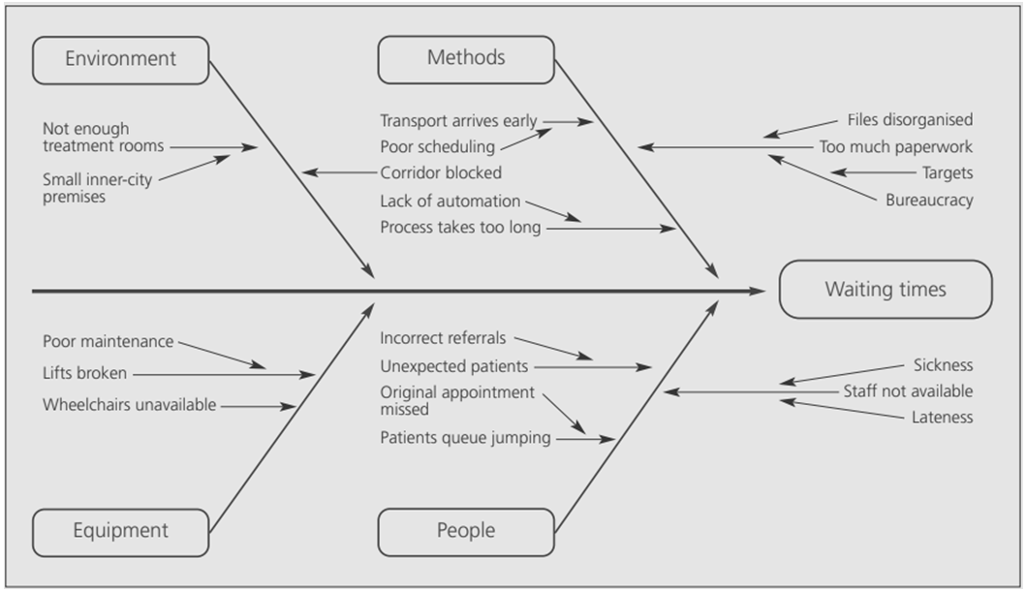
Fishbone Diagram of Staff Shortage in NHS
(Source: Self-Made)
In the above diagram, it can be seen that the major factors are the environment, methods, equipment and people that have resulted in the rise in the waiting times. This can be further explained by saying that due to the lack of treatment rooms and required premises in the NHS, the patient does not get satisfactory treatment. This also says that the environment can be increased with the rise in the staff in the NHS as this will help in attaining more patients. Other than this, the above diagram also says that the transportation problem and the blocked corridors have also resulted in the rise in the waiting time of the patients. This has also been caused due to unorganized patient queue that needed to be done by the staff. Due to a lack of staff in the NHS of UK, the methods of treatment are delayed and the waiting time for the patient increases. Additionally, the diagram also says that too much paperwork and disarrangement of the information has also resulted due to the lack of staff in the NHS. This has resulted in the rise in the waiting time for patients in the NHS. Due to a lack of organization of the equipment and the poor maintenance of the same the treatment procedures have been delayed. This can also be solved with the help of the availability of the staff in the NHS. Overload of people crowd in the NHS due to lack of patient management by the limited available staff has resulted in the rise in the waiting time for the patient.
2.5. “An evaluation of staff shortage"
The NHS may be unable to retain staff due to uncertainty regarding workforce supply, according to almost all (97%) respondents. Concerns also persist regarding the lack of certainty regarding the supply of healthcare staff over the next five to ten years, which is likely to increase employee burnout and negatively affect staff morale (Buchan, Charlesworth, A., Gershlick and Seccombe, 2019). There will be a negative impact on the quality of care if this uncertainty persists, as a significant majority of the respondents indicated it will take longer to meet stretching backlog recovery targets and reduce patient waiting times.
The identified problems related to the staff shortages can be overcome with the help of the following bullets-
Recruitment Strategy- NHS can increase the recruitment strategy while recruiting the staff. It can use the contract method to hire temporary staff in the peak season by giving them work experience and also decreasing the scope of staff scarcity in the peak times in the NHS (Achour et al., 2018).
Job redesign-Re-scheduling the work hours and the employment facilities like the terms of holidays as per the fulfilment of the job satisfaction of the staff will help in the fulfilment of the staff retention in the NHS (Zihindulai, MacGregor and Ross, 2018).
Job Satisfaction-This is another crucial factor that is needed to be fulfilled by the NHS to fulfil the employee retention strategy (Shang et al., 2019). It can be done with the help of developing the human resource management of the NHS that will be helpful for the decrease of the scope of lack of staff availability in the NHS.
Justification-Job satisfaction and job redesign are the two possible solutions for overcoming the staff shortage problem. It can be said that both these choices are interconnected with each as the fulfilment of the job redesigning will be helpful for job satisfaction fulfilment. The redesigning of the decrease in the excessive pressure on the staff at the peak timing will be helpful for staff retention in the NHS. Other than this, the rise in the staff facilities in terms of wage hikes and scheduled holidays will also help in the retention of the staff. This will also be helpful in the job satisfaction of the staff and thus will be helpful for the decrease of the staff shortage in the NHS.

Decision | Implementation | Effectiveness
Job Redesign | Re-scheduling duty hours  Re-scheduling holiday | High
Job Satisfaction | Wage hike  Promotion | High

2.6. Conclusion
This report is focused on the use of the job redesigning strategy and the job satisfaction strategy to decrease the staff shortage problem in the NHS of UK. Complete discussion based on the same has been provided here. By 2023/24, Health Education England will have to invest £900 million more per year to meet their needs.

Reference List
Achour, N., Munokaran, S., Barker, F. and Soetanto, R., 2018. Staff stress: the sleeping cell of healthcare failure. Procedia engineering, 212, pp.459-466.
Bimpong, K.A.A., Khan, A., Slight, R., Tolley, C.L. and Slight, S.P., 2020. Relationship between labour force satisfaction, wages and retention within the UK National Health Service: a systematic review of the literature. BMJ open, 10(7), p.e034919.
Bourgault, A.M., 2022. The nursing shortage and work expectations are in critical condition: is anyone listening?. Critical Care Nurse, 42(2), pp.8-11.
Buchan, J., Charlesworth, A., Gershlick, B. and Seccombe, I., 2019. A critical moment: NHS staffing trends, retention and attrition. London: The Health Foundation.
Buchan, J., Seccombe, I. and Smith, G., 2018. Nurses work: an analysis of the UK nursing labour market. Routledge.
Coccia, M., 2020. Fishbone diagram for technological analysis and foresight. Int. J. Foresight and Innovation Policy, 14(2/3), p.4.
Drennan, V.M. and Ross, F., 2019. Global nurse shortages: The facts, the impact and action for change. British medical bulletin, 130(1), pp.25-37.
Glasper, A., 2019. Will the NHS Improvement interim plan help solve the nursing staff crisis?. British Journal of Nursing, 28(14), pp.950-951.
Gray, K., Wilde, R. and Shutes, K., 2018. Enhancing nurse satisfaction: an exploration of specialty nurse shortage in a region of NHS England. Nursing Management, 25(1).
Jazieh, A.R., 2020. Managing healthcare workers during the COVID-19 pandemic and beyond. Global Journal on Quality and Safety in Healthcare, 3(2), pp.33-35.
Marć, M., Bartosiewicz, A., Burzyńska, J., Chmiel, Z. and Januszewicz, P., 2019. A nursing shortage–a prospect of global and local policies. International nursing review, 66(1), pp.9-16.
Nuffieldtrust, H., 2022. Key areas for action on the health and care workforce. [online] Nuffieldtrust.org.uk. Available at: https://www.nuffieldtrust.org.uk/files/2019-03/1553101044_heaj6918-workforce-briefing-190320-web.pdf [Accessed 4 July 2022].
Schuurmans, J.J., van Pijkeren, N., Bal, R. and Wallenburg, I., 2020. Regionalization in elderly care: what makes up a healthcare region?. Journal of Health Organization and Management.
Scogin, A., 2022. Nursing Staff Shortage and Patient Outcomes.
Shang, J., Needleman, J., Liu, J., Larson, E. and Stone, P.W., 2019. Nurse Staffing and Healthcare Associated Infection, Unit-level Analysis. The Journal of nursing administration, 49(5), p.260.
Sharma, S., Gautam, P.L., Sharma, S., Kaur, A., Bhatia, N., Singh, G., Kaur, P. and Kumar, A., 2019. Questionnaire-based evaluation of factors leading to patient-physician distrust and violence against healthcare workers. Indian journal of critical care medicine: peer-reviewed, official publication of Indian Society of Critical Care Medicine, 23(7), p.302.
Williams, M.N., 2022. Diversity as an independent driver of change in the NHS. British Journal of Healthcare Management, 28(6), pp.1-6.
Zihindulai, G., MacGregor, R.G. and Ross, A.J., 2018. A rural scholarship model addressing the shortage of healthcare workers in rural areas. South African Health Review, 2018(1), pp.51-57.

