Learner Name: Gareth Wyn Thomas
Course: HNC Instrumentation Engineering Year 2
Module Code: PCEE4009
Module Name: Instrumentation, Automation and Control
Lecturer: Jason Pointer

Contents
Task 1 Temperature Sensor Research Page 3

Task 2 Testing the sensors Page 10

Task 3 Temperature Circuit Design Page 16

Task 4 Signal Transmission Page 19

References Page 20

Appendix Tabulated data for Task 2 Page 21

Task 1 – Temperature Sensor Research
The two temperature sensors to be investigated are the Platinum RTD (Resistance Temperature Detector) and NTC Thermistor (Negative Temperature Coefficient). Both rely on the physical principle of the variation of resistance with temperature and are classified according to whether the material used in their construction is a metal or semiconductor.

- Platinum RTD.

Temperature sensor relies on the principle that resistance of a metal increases with temperature. This relationship can be represented by the non-linear equation: -

R_{T} = R₀ (1 + α₁T + α₂T² +…… α_{n}T^{n})

However, resistance of some metals increases in a reasonably linear way over a limited temperature range (e.g., platinum, copper, nickel and tungsten) as shown in Figure1.

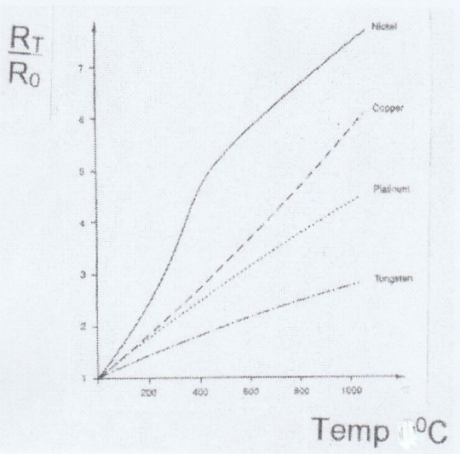

Figure 1. Typical resistance – temperature characteristic of metals (Morris, 2006).

Therefore, the non-linear equation above may now be represented by the equation: -

R_{T} = R₀ (1 + αT) where R_{T} is resistance at T⁰C
R₀ is resistance at 0⁰C
α is constant for the metal and called the
coefficient of resistance
Figure 1 indicates that platinum has the most linear resistance-temperature characteristic making it the preferred metal to use for a RTD for most applications. Research shows that its resistance-temperature relationship is linear within + 0.4% over a temperature range -200⁰C and +40⁰C. Even at 100⁰C its accuracy is approx. + 1.2%.

The construction of a platinum RTD can take two forms. The first type called a thin-film RTD. It consists of a thin film of platinum paste deposited on a white ceramic substrate as shown in Figure 2.

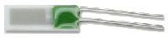

Figure 2. A Resistive Temperature Detector (Morris, 2006).

The second type of design makes use of a platinum wire coil wound on a simple former (Figure 3).

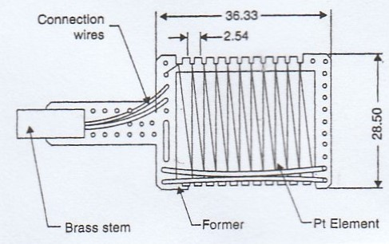

Figure 3. Construction of a fine wire platinum resistance thermometer using fine (25µm diameter) platinum wire. Dimensions in mm (Harrison, 2015).

This former is housed in a protective case as shown in Figure 4.

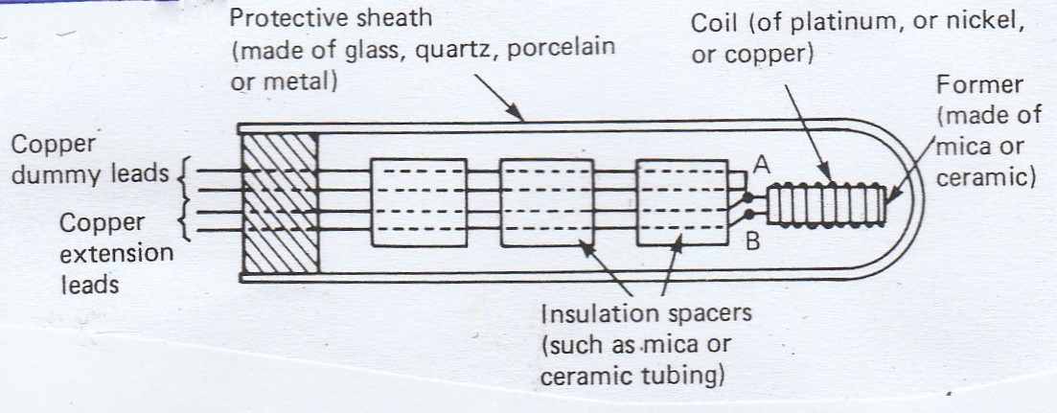

Figure 4. Showing the former housed in protective case (Bird, May 1983).

Figure 4 illustrates a typical platinum RTD having a platinum wire coil wound on a simple former which can be made of metal, plastic, mica or ceramic housed in a metal (glass or porcelain) protective case or sheath. The platinum coil leads are connected to copper extension leads at points A and B. (Copper is used as platinum is a more expensive metal). Insulation spacers are included in the design to prevent the copper leads interfering with the housing. Dummy copper leads are sometimes introduced (especially if the copper extension leads B is too close to the heating source being measured) to eliminate errors. The copper extension leads (and dummy copper leads if included) are connected to an electrical circuit usually a Wheatstone Bridge or a potential divider circuit that will convert resistance to a voltage which is then calibrated to a temperature scale (Morris, 2006).

- NTC Thermistor.

This temperature sensor relies on the principle that as temperature is increased its resistance rapidly decreases in a non-linear manner. This is illustrated when comparing Figure 1 with Figure 5 which shows typical resistance – temperature characteristics of thermistors of different materials (nickel, copper and platinum).

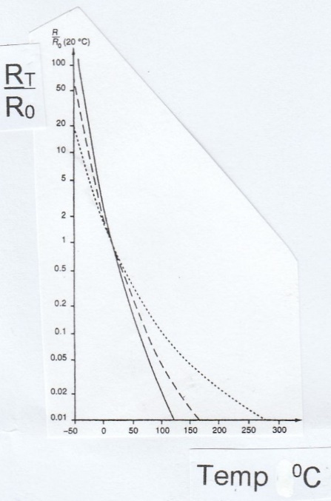
Key: Nickel ---- Copper - - - - Platinum ……..
Figure 5. Typical resistance -temperature characteristics of thermistor materials (Morris, 2006).

As shown in Figure 5 each curve has a negative gradient. The gradient value between two temperature points represents the constant or coefficient value denoted by Beta (B) (as shown in the equation below) and depends on the metal from which the thermometer is made. Such thermistors are known as Negative Temperature Coefficient Thermistors (NTC). The value of B may range from approximately 3000 to 5000 and can be obtained from manufacturers data sheets. The nominated equation for such thermistors is shown below.

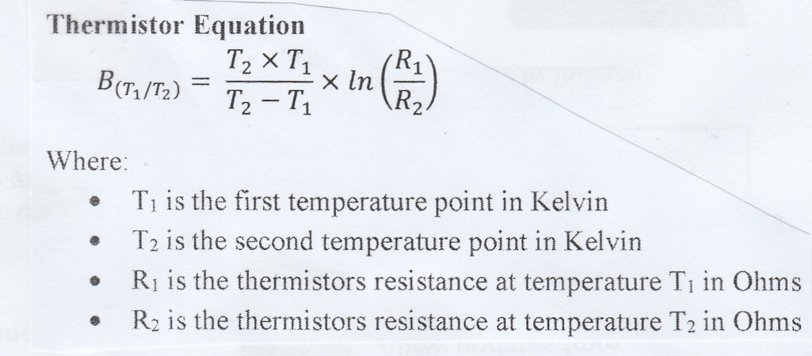

Figure 6. Thermistor Equation (Morris, 2006).

The construction of a NTC thermistor takes the form of a solid temperature sensor, consisting of a mixture of sensitive semi-conductor-based metal oxides such as chromium, cobalt, copper, manganese and nickel etc. These sensors can be formed into small ceramic shapes each connected to two leads. Figure 7 shows a rod, disc and bead shaped thermistor.

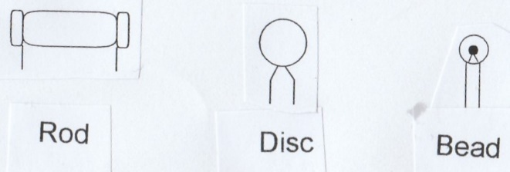

Figure 7. Showing a rod, disc and bead shaped thermistor (Bolton, 2015).

The principle of operation of a Platinum RTD and NTC Thermistor rely on the principle that their electrical resistance changes with temperature variation. Since resistance can be measured accurately it enables the sensor device to be used to measure temperature. As both devices are resistive, then according to Ohm’s Law, when a current passes through the device a voltage drop will occur which can be measured and then converted to a temperature (Morris, 2006).

One method of converting a resistance change into voltage change is use of a Wheatstone Bridge circuit as shown in figure 8. This signal conditioning is widely used as it can measure accurately a small change in temperature. It is often referred to as a Null Type Bridge and is used for calibration purposes (Morris, 2006).

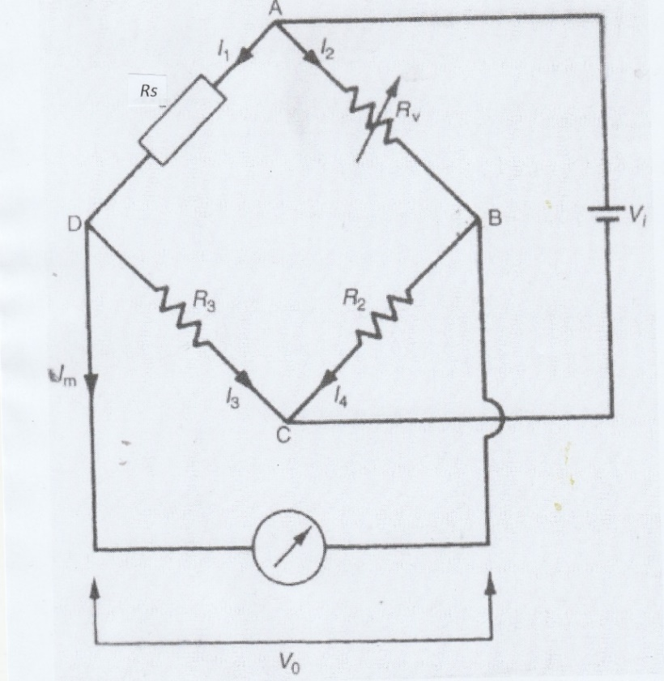

Figure 8. Wheatstone Bridge Circuit (Morris, 2006).

With reference to figure 8
- The circuit comprises of 4 resistors and a galvanometer which is a sensitive zero micro ammeter.
- Resistor Rs (sensor) is the value to be measured and compared with other resistors of known value
- Resistors R₂ and R₃ have fixed and known values and Rv is a variable resistor
- A DC voltage V₁ is applied across points A and C and the variable resistor R_{V} is adjusted until the voltage measured across points B and D is zero (known as the null point).
- It can be shown using Ohm’s Law:-

V₀ = V₁Rs - V₁R_{v}
(Rs + R₃) (R_{V} + R₂)

V₀ = V₁ X Rs - R_{v}
(Rs + R₃) (R_{V} + R₂)

At null point V₀ = 0

Rs = R_{v}
(Rs + R₃) (R_{V} + R₂)

Inverted becomes
(Rs + R₃) = (R_{V} + R₂)
Rs R_{v}

R₃ = R₂
Rs R_{v}

R_{s} = R₃ R_{v}
R₂
But R₂ = R₃
So Rs = R_{v}

Thus, the value of the resistor Rs equals value of the known variable resistor.
So, if Rs represents a PRTD sensor its resistance at any temperature may be measured.

A deflection Type Bridge is sometimes used and differs from a Wheatstone Bridge in that the variable resistor Rv (Figure 8) is replaced by a fixed resistor R₁ (Figure 9) of the same value as the normal value of the unknown resistor Rs.
As the resistance Rs changes then the output voltage V₀ changes and the relationship between V₀ and Rs must be calculated.

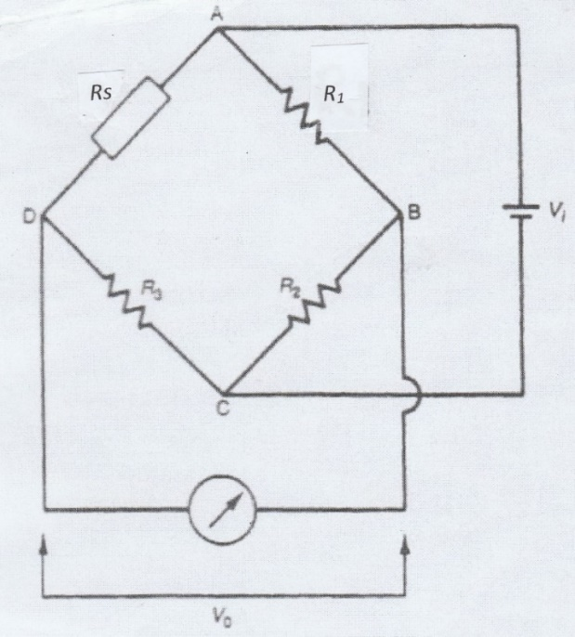

Figure 9. Analysis of Wheatstone Bridge (Morris, 2006).

The relationship between Vo and Rs is given by the equation

Vo = V₁ x Rs - R₁
Rs ₊ R₃ R₁ ₊ R₂

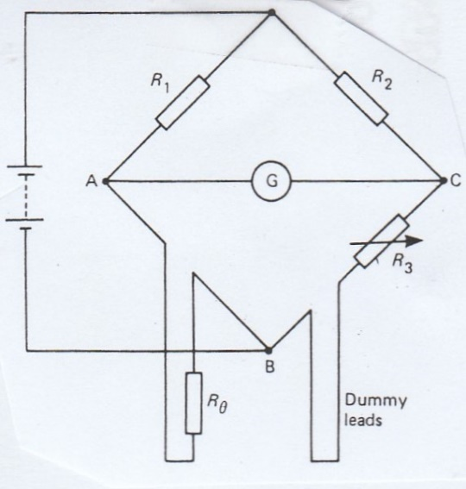

Figure 10. Wheatstone Bridge including dummy leads (Bird, May, 1983).

Figure 10 shows a Wheatstone Bridge including dummy leads. The dummy leads are included in the arm B and C to eliminate errors caused by the extension leads which are normally necessary in PRTD sensors. R_{Ɵ} represents the sensor.

In the case of thermistors, use is sometimes made of a potential divider circuit to convert the resistance change into voltage change then to a meter related to the temperature. Figure 11 illustrates a typical Potential Divider Circuit.
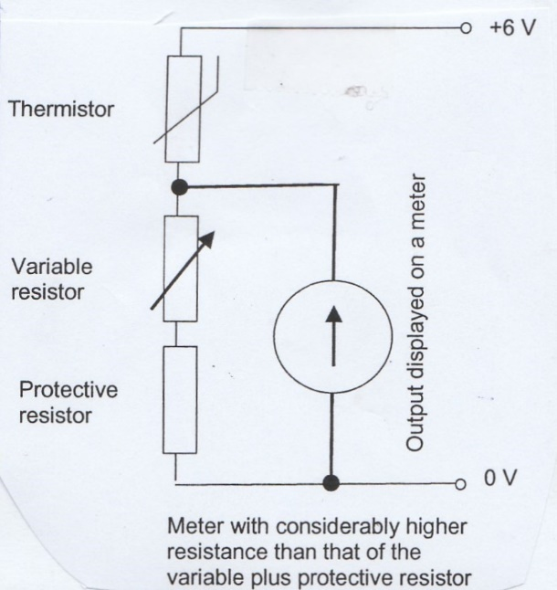

Figure 11. Potential divider circuit (Bird, May 1983).
Operational Amplification

When the signal output level of a measurement sensor is considered to be too low the signal needs to be amplified. This is achieved by an optical amplifier (op-amp). A simple op-amp is shown in Figure 12.

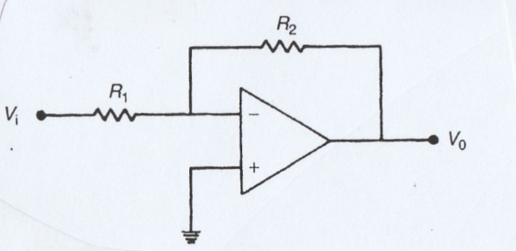

Figure 12. Simple op-amp circuit (Morris, 2006).

With reference to Figure 12.

- This is an electronic device that has two input terminals and one output terminal. The two input terminals are known as an inverting input (-) and non-inverting input (+).
- The input signal V₁ is connected to the inverting input through the resistor R₁ and the non-inverting input connects to ground.
- A feedback path is provided from output terminal through a resistor R₂ to the inverting input terminal.
- The processed signal V₀ at output is related to V₁ (input) by the equation below.

V₀ = R₂ x V_{in}
R₁
This signal amplification is defined by values of resistors R₁ and R₂ and the ratio R₂/R₁ is
known as amplification gain (or closed loop gain). The sign of the output signal V₀ is set up as shown in Figure 12 is inverted if necessary. This can be corrected by feeding this signal through a further set up for unity gain (i.e., R₁ = R₂) this inverts the signal returning it to its original sign.

Task 2 – Testing the Sensors
To translate temperature into a measurable signal the most commonly used sensors are the Resistive Temperature Detector (RTD) and Thermistor. Each has its own operating principles, benefits, considerations, and drawbacks. In addition to the characteristics of the sensors themselves - operating range, sensitivity, linearity, response time - consideration must be given to the requirements each sensor type imposes on the measurement hardware.
The successive comparison of one instrument with another ultimately leads to the need for a datum instrument (Morris, 2006), which in this experiment is the IC temperature sensor which is that currently used by the company. The company required myself to investigate accuracy of the other two temperature sensors (RTD and Thermistor) against the IC datum instrument.

The values tabulated (see appendix) were used to plot the graph (Graph 1) of the RTD temperature sensor and the IC temperature sensor of Temperature (⁰C) against Time (secs) are calculated using the formulae below.

T_{RTD} = V_{RTD} – 100 where T_{RTD} = temperature of RTD sensor in ⁰C
α V_{RTD} = voltage of RTD sensor in mV
α = constant coefficient for platinum (0.385)

T_{IC} = V_{IC} x 100 -273 where T_{IC} = temperature of IC sensor in ⁰C
V_{IC} = voltage of IC sensor in volts

% error = T_{IC} – T_{RTD} x 100
T_{IC}

Example of calculations at time 5 seconds V_{RTD} = 108.11 mV and α= 0.385
T_{RTD} = V_{RTD} - 100
α
= 108.1 -100
0.385
T_{RTD} = 21.03896 ⁰C

T_{IC} = V_{IC} x 100 – 273
= 2.9863 x100 – 273
T_{IC} =25.63 ⁰C

% error = T_{IC} -T_{RD} X 100
T_{IC}
= 25.63 -21.04 X 100
25.63
% error = 17.91%

The values tabulated (see appendix) were used to plot the graph (Graph 2) of the Thermistor temperature sensor and the IC temperature sensor of Temperature (⁰C) against Time (secs) are calculated using the formulae below.

R₂ = ( 5314 x 5) - 5314
V_{T}
T₂ = - 4050 /( ln (5314/R₂) – (4050/298.15) ) - 273.15

T_{IC} = V_{IC} X 100 – 273

% error = T_{IC} – T₂ x 100
T_{IC}

Example of calculations at time 5 seconds V_{T} = 2.499V
R₂ = ( 5314 x 5) - 5314
V_{T}
= 5314 x 5 - 5314
2.499
R₂ = 5318.25 Ω

T₂ = - 4050 /( ln (5314/R₂) – (4050/298.15) ) - 273.15

= - 4050/ (ln(5314/5318.25) – (4050/298.15)) - 273.15

= - 4050/ (-0.000799 – 13.5838) - 273.15
= - 4050/(-13.58499) -273.15
= 298.132 -273.15
T₂ = 24.98 ⁰C

T_{IC} = V_{IC} x 100 – 273 where V_{IC} = 2.997 V
= 2.997 x 100 – 273
= 299.7 - 273
T_{IC} = 26.7 ⁰C

% error = T_{IC} – T₂ X 100
T_{IC}
= 26.7 – 24.982 X 100
26.7

= 0.06434 x 100

% error = 6.434%

Data was gathered for the temperature recorded by a platinum Resistive Temperature Detector (RTD) as a low-level heating element over a period of 600 seconds in 1 second intervals using a Pico Scope and a PC as shown in the photographs below.

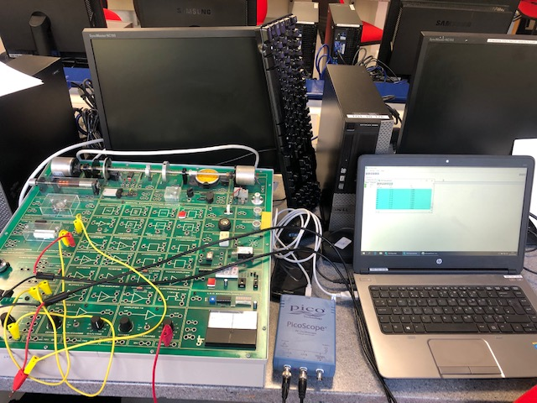
Photograph 1. Showing the experiment setup using a Pico Scope to record logged values on PC.

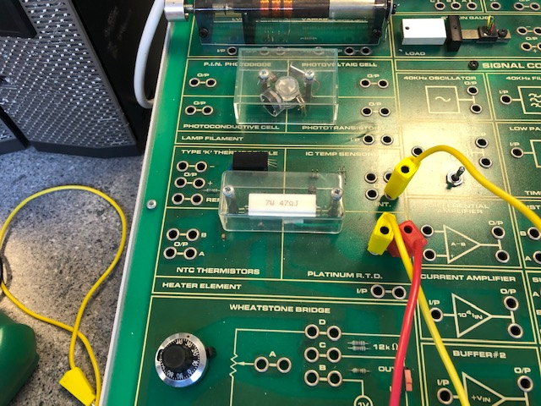
Photograph 2. Showing a close up of the NTC Thermistor and Platinum RTD.
A graph of the recorded temperature (⁰C) against time (seconds) was plotted and is shown by the blue coloured line on Graph 1. On the same sheet a graph of temperature, measured in ⁰C, by an IC temperature sensor (which is that currently used by the company) was also plotted against time (seconds) over the same period of 600 seconds in 1 second intervals. This data is represented by the red coloured line on Graph 1.

Graph 1. IC temperature Sensor (Red), Platinum RTD Temperature Sensor (blue)
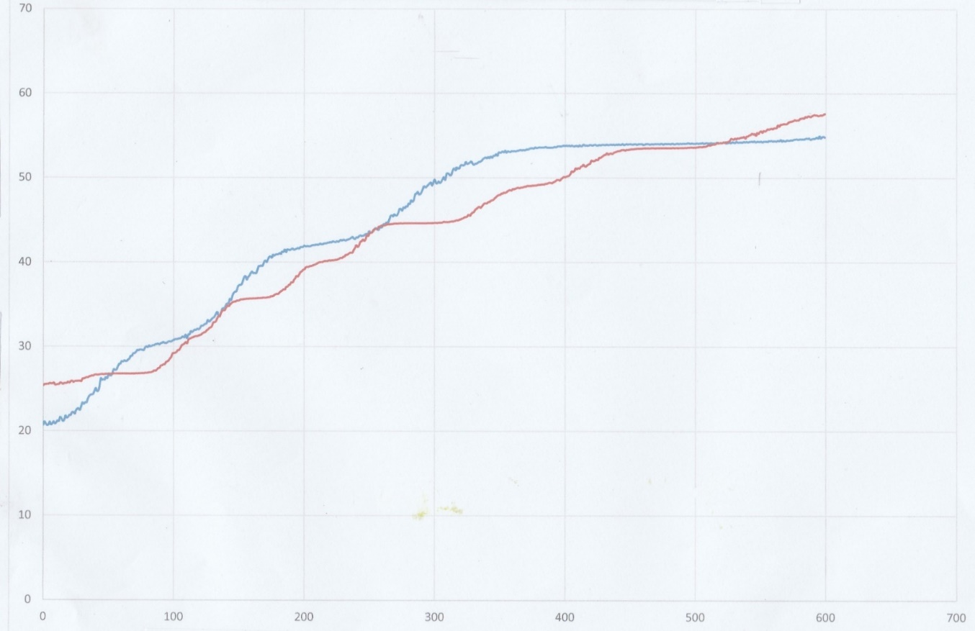
Temperature (⁰C)
Time (seconds)

A second set of data was collected using the NTC Thermistor in 1 second intervals over a period of 600 seconds. The data gathered of temperature (⁰C) against time (seconds) is shown graphically as the blue coloured graph on Graph 2. The temperature (⁰C) against time in seconds recorded by the IC temperature sensor gathered in 1 second intervals over the same period of 600 secs is plotted as the red coloured graph on Graph 2.

Details of the individual readings are given in the Appendix of this Assignment.

Graph 2. IC Temperature Sensor (red), NTC Thermistor Temperature Sensor (blue)

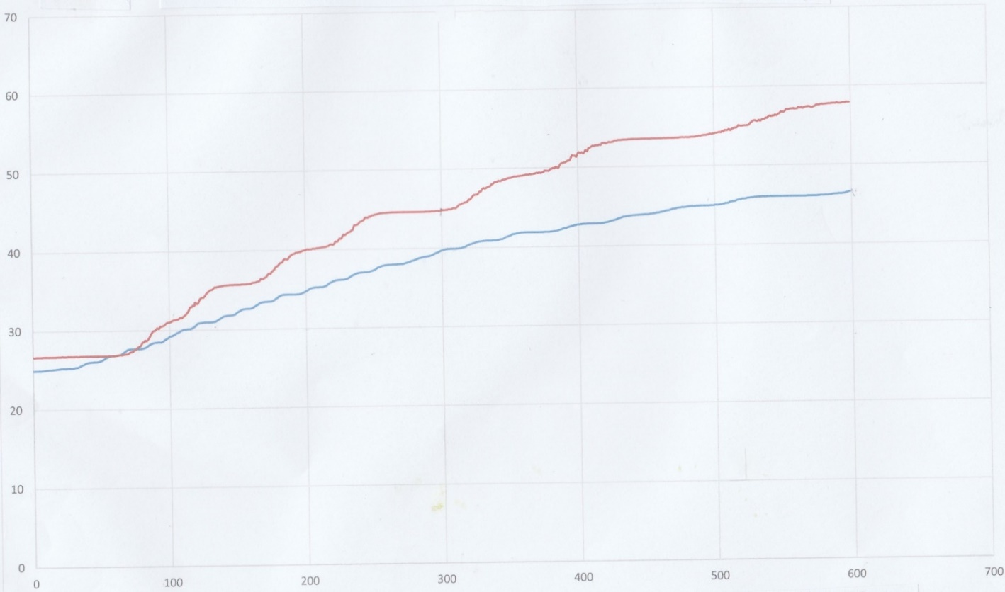
Temperature (⁰C)
Time (seconds)

The response of an instrument to the parameter sensed, in this case temperature, can be characterized in several ways, how large the actual response is, how quickly the instrument responds, how reliable the readings obtained are and over what range of the input parameter the instrument functions reliably (Harrison, 2015).

The most fundamental use of any sensor or instrument as a detector is to determine the presence or absence of a change in a parameter and also the resolution which describes this smallest detectable change (Harrison, 2015). The quantitative response to the change is its sensitivity which is an absolute quantity and is the smallest absolute amount of change that can be detected by a measurement. It is the ratio of the response in the instrument to a unit change in the parameter sensed. i.e., the gradient of the graph.

Graph 1 shows that the two instruments follow broadly the same path and there is little difference between their gradients as time is increased during the 525 seconds. After this the IC graph appears to continue in an upward path whilst the RTD graph peaks after 375 seconds to follow a flatter path.

The graphs of the RTD and IC against time (Graph 1) have little difference between the readings at each interval of time. Errors in the range 19% to 10% over the first 30 seconds but becoming fairly consistent in the range 10% to 0.2% for the remaining 550 seconds.

The stability of a temperature sensor is an indication of its ability to maintain a consistent output at a given temperature. Material plays a key role in the stability of a given sensor. RTDs are often constructed of platinum for this reason as well as to ensure low reactivity (Harrison, 2015).
The graphs of data measured using the Thermistor and IC Temperature sensor are plotted on Graph 2. The red graph being that for the IC thermometer and the blue graph being that for the Thermistor. The two curves on Graph 2 show a fairly consistent gradient along the interval of time considered and this suggests consistent sensitivity. However there appears to be an increasing error between the readings from an initial 6.5% to a gradually regular increase in percentage error to almost 20% at the end of the time interval considered.
The instrument selected must be such that the range (i.e., the maximum and minimum values of a quantity that the instrument is designed to measure (Harrison, 2015)) is appropriate to the spread of values being measured in order that the best possible accuracy is maintained in instrument readings. Usually, the inaccuracy measurement rather than the accuracy figure is quoted to provide detail to the extent to which a reading might be wrong. This is quoted as a plus + or a minus - percentage of the full scale reading of the instrument (Morris, 2006). The error readings are noted in the previous paragraph.
A further important consideration is that of reliability of the measurement of the temperature reading and that the measuring equipment will operate to an agreed level of performance. That is that the system gives a particular accuracy for a specified period. The reliability of a measurement system is likely to change with time resulting from wear on contacts and general damage due to environmental conditions (Bolton, 2015).

Thus, it would be better for the company to adopt the RTD thermometer rather than the Thermistor to ensure a more consistent result. RTD thermometers tend to be fragile and can be easily damaged but the use of platinum, which is a very stable metal and chemically inert (even though its sensitivity is not as high as other metals), provides reproducible results and so is often used as a calibrating device. The main advantage of the thermistor over the platinum RTD is its high sensitivity and smaller size.

The following table lists the advantages, limitations and disadvantages of both types of temperature measuring instruments.

Advantages of the Platinum RTD  - The temperature v resistor relationship is linear within +0.4% over the temp.  range -200⁰C to 40⁰C. At 1000⁰C the  inaccuracy is only + 1.2%  - The metal used for the coil (platinum) is very stable and provides reproducible results even though metals such as copper and nickel have a higher sensitivity.  - The metal is chemically inert i.e., Unreactive and resists corrosion and oxidation.  - Platinum has a high melting point of 1769⁰C  - The instrument can be used to measure low temperature differences and has most linear resistance-temperature characteristic. | Advantages of the Thermistor  - The equipment is small in size and has a high sensitivity.  - It is a relatively cheep method of detecting and measuring small changes in temperature.  - It provides a fast output response to temperature changes because of its small size.  - Its small size enables the temperature to be recorded at any point.  - Small changes in temperature can cause large changes in resistances -gives accurate temperature measurement control.  - Semi-conductor only have limited measurement range from -500C to 1500C inaccuracy is typically + 3%  Limits their range of application
Limitations of the Platinum RTD  - Nickel coil used mainly in the range -100⁰C to 300⁰C  - The PRTD has greater accuracy when measuring temperature in the range -200⁰C to 800⁰C and best ratio price to performance for temperature range.  - The upper range may be extended to 1500⁰C if high melting materials used for the housing and coil construction  - Measurement accuracy of + 0.5% or better.  - Sensitivity approx.. 0.4 Ω per ºC for 100 Ω | Limitations of Thermistor  - The resistance of a typical Thermistor can vary from 400Ω at 0⁰C to 100 Ω at 140⁰C  - Temperature range is -100⁰C to 300⁰C  - Gives large changes in resistor per degree changes in temperature giving accuracy + 0.1⁰C but only possible over small range of temperature.
Disadvantages of the Platinum RTD  - Platinum sensitivity is not as high as other metals such as copper and nickel  - Expensive (cheaper resistors use platinum film deposited on ceramic substate  - Slow response to temperature variation  - This RTD tend to be fragile and easily damaged when subjected to excessive vibration or shock. | Disadvantages of Thermistor  - Small sizes decrease its heat dissipation capability as self-heating effect becomes greater  - Need to operate at low current levels when compared to the RTD  - Have non linearity  - Measurement range is limited  - Measure and sensitivity are less than the RTD.

Task 3 - Temperature Circuit Design

Having considered the data obtained during research (Task 1) and testing (Task 2) of the two sensors the platinum RTD sensor was selected. The selection was based on device range, accuracy, linearity reliability sensitivity and cost which are recorded in the table of advantages, limitations and disadvantages of each sensor in Task 2.

A measuring circuit to convert the resistance of the sensor to a comparative voltage was then designed for the given specification of the measuring device.

Specification: Input range 0 ⁰C to 100 ⁰C and Output range 0 to 100 volts

Multi Sim Software was used to develop the circuit.

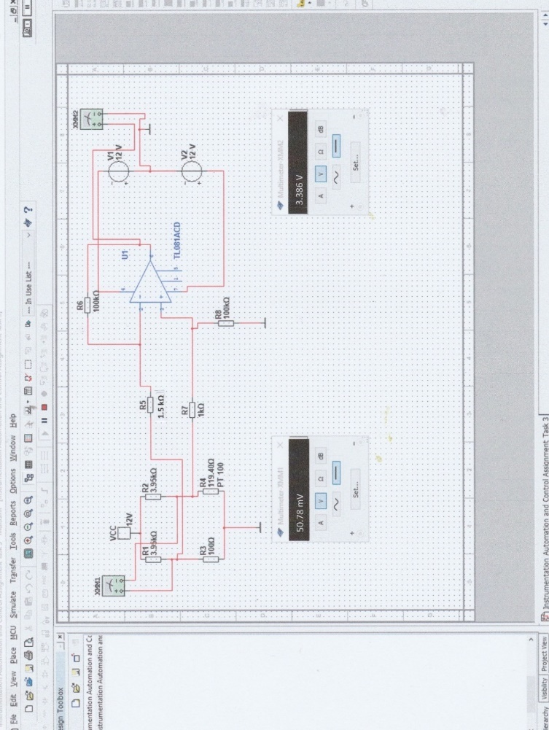

Figure 13. Screen shot of Multisim software package used to develop a signal conditioning circuit.

- The RTD sensor was connected to one arm of a Wheatstone bridge circuit, which converts its electrical resistance to a comparable output voltage.
- An amplifier (op amp) is included to amplify the bridge output voltage calibrated to give temperature.
- A spread sheet (Table 1) was created to obtain bridge output and amplifier output values for each of the platinum RTD (PT100) sensor resistance values listed.
- The resistance values were obtained from a standard reference chart for the temperature range 0⁰C to 100⁰C in increments of 10⁰C for a RTD (PT100) sensor.

Temperature  (⁰C ) | PT 100  ( Ω ) | Bridge Output  ( mV) | Amplifier Output  Voltage (V )
0 | 100 | 0.00 | 0.00
10 | 103.9 | 11.13 | 0.74
20 | 107.79 | 22.20 | 1.48
30 | 111.67 | 33.23 | 2.22
40 | 115.54 | 44.21 | 2.95
50 | 119.4 | 55.13 | 3.68
60 | 123.24 | 65.99 | 4.40
70 | 127.07 | 76.79 | 5.12
80 | 130.89 | 87.55 | 5.84
90 | 134.7 | 98.25 | 6.55
100 | 138.5 | 108.91 | 7.26

Table 1. Giving bridge output and Op Amp output voltages

The equations used to calculate the bridge and amplifier outputs are given below together with an example showing calculations for a platinum RTD (PT100) sensor at a temperature of 50⁰C and a resistance of 119.4Ω.

Example

- Calculation for Bridge output

R2 PT100

Vin

R1 R3

- RTD (PT100) Temperature 50 ⁰C from Table 1
- Resistance 119.4 Ω from Table 1
- R1 = 4000 Ω = 4 KΩ
- R2 = 4000 Ω = 4 KΩ
- PT100 = 119.4 Ω
- Vin = 12v supply

Bridge out V₀ (mV)

V0 = PT100 - R3 X Vin
PT100 +R2 R3 + R1

= 119.4 - 100 X 12
119.4 + 4000 100 + 4000

= [ 0.029 – 0.0244] X 12

= 12 X 4.6 x 10⁻³

= 55.2 mV

Bridge output is 55.2 mV

- Calculation for amplifier output

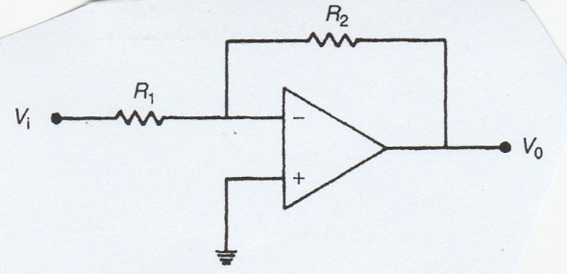

R1 = Rin = 1.5 KΩ
R2 = R _{feedback =} 100 KΩ
V1 = Vin = 55.2 mV from (i) calcs.
Vo = Vout

Vout = Gain (voltage) x Vin

= R2 x Vin
R1

= 100 x 55.2 x 10⁻³
1.5

= 66.67 x 55.2 x 10⁻³

= 3.68 V

Amplifier output = 3.68 V

The above calculated values compared favourably with those listed in Table 1.

The two meters shown on the Multi Sim screen shot (figure 13) measure the output voltage of the Bridge and Op amp respectively for a RTD (PT100) sensor at 50⁰C. On comparing the Multisim value with the corresponding results in Table 1 a discrepancy was noted. There is a difference of 4.35mV on the bridge output and 0.294V on the Op Amp output.

On investigation it was noted that Resistors R1 and R2 used on the bridge circuit should have read 4 KΩ not 3.95 KΩ and the inclusion of resistor R7 connecting the bridge output and Op amp non - inverting (+) terminal is a possible error and should have been omitted. These could possibly have caused the discrepancy noted.

Having developed the circuit on the Multisim package the circuit was built and tested. Unfortunately, it could not be amended due to lack of time and this facility was not available out of college hours because of the current “lockdown arrangements” regarding the COVID 19 pandemic. However, the assignment proved to be a valuable experience for future studies.

Task 4 - Signal Transmission
There is a need in many measuring systems to transmit measurement signals over quite large distances from the point of measurement to the place where the signals are recorded (Morris, 2006). This can create many problems for which a solution must be found. Of the many difficulties associated with long distance signal transmission, contamination of the measurement signal by noise is the most serious. Many sources of noise exist in industrial environments, such as electromagnetic fields from electrical machinery and power cables to spikes on the a.c power supply. Signals can be transmitted electrically, pneumatically, optically or by telemetry, in either analogue or digital format. There are various options for signal transmission ranging from electrical transmission to digital protocols transmission (Morris, 2006).
Digital transmission has very significant advantages compared with analogue transmission because the possibility of signal corruption during transmission is greatly reduced. The aim over many years has been to use intelligent devices to their full potential by making all communications, including the measured signal, entirely digital. Many different protocols exist for digital signal transmission such as Profibus being in widespread use. Due to the need to maintain compatibility with vast current investment in analogue instrumentation systems, a number of part analogue/part digital communication protocols have been developed as an interim measure. Prominent amongst these is a protocol called HART (Highway Addressable Remote Transducer) (Morris, 2006).
HART is a manufacturer – independent protocol that provides for analogue measurement signal transmission as well as sending command/status information digitally. In a process plant there are likely to be a large number of smart sensors, each providing information which has to be fed back to a control panel. To avoid using separate cables for each sensor to transmit their data, a bus system can be used. A bus is a common highway for signals which is used to link components. Each sensor would put its information onto the common highway for transmission to the control panel. The HART communication protocol is widely used for such transmissions (Bolton, 2015). This involves the digital signal from a smart sensor being superimposed on an analogue 4-20mA current loop signal. With this protocol, a 0 is represented by a 2200Hz frequency and a 1 by a 1200Hz frequency and these are superimposed on the d.c. signal to give simultaneous digital and analogue transmission (Petruzella, 2017). The digital data transfer rate is 1200 bits/s. The arrangement is that a master, such as a display terminal, sends a message with a request for data to a device, the device interprets the request and replies with the data (Bolton, 2015).

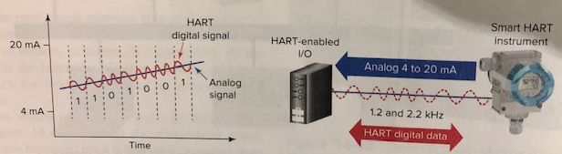
Figure 14. The HART communication protocol (Petruzella, 2017).
The HART system supports two modes of use, a hybrid mode and fully digital mode.
In hybrid mode status/command signals are digital but data transmission takes place in analogue form (usually 4-20mA format). However, in this mode is not possible to transmit multiple measurement signals on a single bus since the analogue signals would corrupt each other. To overcome this the network must be arranged in a star configuration using a separate line for each field device rather than a common bus.
In fully digital mode data transmission is digital as well as status/command signals. This enables one cable to carry signals for up to fifteen intelligent devices (. Using this mode, the data transmission speed is very low. Thus, the main application of the HART protocol has been to provide a communication capability with intelligent devices when existing analogue measurement signal transmission has to be retained because conversion to fully digital operation would be too expensive.

References
Petruzella, F. D. (2017). Programmable Logic Controllers. 5th ed. New York: Mc Graw Hill.
Morris, A. S. (2006). Measurement & Instrumentation Principles. 1st ed. Oxford: Elsevier Butterworth-Heinemann.
Bolton, W. (2015). Instrumentation & Control Systems. 2nd ed. Oxford: Newnes
Harrison, R. G. (2015). Meteorolgical Measurements and Instrumentation. 1st ed. London: John Wiley and Sons.
Bird, J. O. May, A. J. C. (1983). Engineering Science 3 Checkbook. 1st ed. London: Butterworth.

Appendix

Time | RTD | IC | RTD Temp | IC Temp | % Error
Seconds | mV | V
0 | 107.96 | 2.9839 | 20.67532 | 25.39 | 18.56902
1 | 108.11 | 2.985 | 21.06494 | 25.5 | 17.39241
2 | 108.02 | 2.9851 | 20.83117 | 25.51 | 18.34116
3 | 107.95 | 2.9855 | 20.64935 | 25.55 | 19.18062
4 | 107.98 | 2.9855 | 20.72727 | 25.55 | 18.87564
5 | 108.1 | 2.9863 | 21.03896 | 25.63 | 17.91275
6 | 107.98 | 2.9861 | 20.72727 | 25.61 | 19.06571
7 | 108.03 | 2.9861 | 20.85714 | 25.61 | 18.5586
8 | 108.12 | 2.9869 | 21.09091 | 25.69 | 17.90226
9 | 108.02 | 2.9846 | 20.83117 | 25.46 | 18.1808
10 | 108.08 | 2.9847 | 20.98701 | 25.47 | 17.60105
11 | 108.16 | 2.9851 | 21.19481 | 25.51 | 16.9157
12 | 108.13 | 2.9853 | 21.11688 | 25.53 | 17.286
13 | 108.31 | 2.9869 | 21.58442 | 25.69 | 15.98126
14 | 108.25 | 2.9864 | 21.42857 | 25.64 | 16.42523
15 | 108.14 | 2.9855 | 21.14286 | 25.55 | 17.24909
16 | 108.17 | 2.9865 | 21.22078 | 25.65 | 17.26792
17 | 108.38 | 2.9865 | 21.76623 | 25.65 | 15.14139
18 | 108.29 | 2.9867 | 21.53247 | 25.67 | 16.11816
19 | 108.32 | 2.9879 | 21.61039 | 25.79 | 16.20632
20 | 108.41 | 2.9868 | 21.84416 | 25.68 | 14.93709
21 | 108.41 | 2.9884 | 21.84416 | 25.84 | 15.46379
22 | 108.53 | 2.9892 | 22.15584 | 25.92 | 14.52221
23 | 108.54 | 2.9876 | 22.18182 | 25.76 | 13.89046
24 | 108.47 | 2.9885 | 22 | 25.85 | 14.89362
25 | 108.61 | 2.989 | 22.36364 | 25.9 | 13.65391
26 | 108.7 | 2.989 | 22.5974 | 25.9 | 12.75134
27 | 108.71 | 2.9891 | 22.62338 | 25.91 | 12.68477
28 | 108.64 | 2.9891 | 22.44156 | 25.91 | 13.3865
29 | 108.81 | 2.9887 | 22.88312 | 25.87 | 11.54574
30 | 108.98 | 2.9916 | 23.32468 | 26.16 | 10.8384
31 | 108.92 | 2.992 | 23.16883 | 26.2 | 11.56935
32 | 108.99 | 2.9925 | 23.35065 | 26.25 | 11.04515
33 | 108.98 | 2.9934 | 23.32468 | 26.34 | 11.4477
34 | 109.15 | 2.9933 | 23.76623 | 26.33 | 9.737054
35 | 109.27 | 2.9943 | 24.07792 | 26.43 | 8.899273
36 | 109.33 | 2.9947 | 24.23377 | 26.47 | 8.448182
37 | 109.36 | 2.9954 | 24.31169 | 26.54 | 8.39605
38 | 109.37 | 2.9953 | 24.33766 | 26.53 | 8.263617
39 | 109.5 | 2.9962 | 24.67532 | 26.62 | 7.305317
40 | 109.65 | 2.9966 | 25.06494 | 26.66 | 5.982989
41 | 109.51 | 2.9965 | 24.7013 | 26.65 | 7.3122
42 | 109.53 | 2.9965 | 24.75325 | 26.65 | 7.117273
43 | 109.72 | 2.9968 | 25.24675 | 26.68 | 5.371989
44 | 110.09 | 2.9971 | 26.20779 | 26.71 | 1.880224
45 | 110.02 | 2.9972 | 26.02597 | 26.72 | 2.597403
46 | 110.05 | 2.997 | 26.1039 | 26.7 | 2.232599
47 | 110.03 | 2.9972 | 26.05195 | 26.72 | 2.500194
48 | 110.15 | 2.9975 | 26.36364 | 26.75 | 1.44435
49 | 110.1 | 2.9975 | 26.23377 | 26.75 | 1.929846
50 | 110.31 | 2.9975 | 26.77922 | 26.75 | -0.10924
51 | 110.23 | 2.9975 | 26.57143 | 26.75 | 0.667557
52 | 110.23 | 2.9976 | 26.57143 | 26.76 | 0.704676
53 | 110.35 | 2.9976 | 26.88312 | 26.76 | -0.46008
54 | 110.51 | 2.9978 | 27.2987 | 26.78 | -1.9369
55 | 110.48 | 2.9978 | 27.22078 | 26.78 | -1.64593
56 | 110.49 | 2.9978 | 27.24675 | 26.78 | -1.74292
57 | 110.61 | 2.9978 | 27.55844 | 26.78 | -2.9068
58 | 110.74 | 2.9978 | 27.8961 | 26.78 | -4.16768
59 | 110.76 | 2.9978 | 27.94805 | 26.78 | -4.36166
60 | 110.87 | 2.9978 | 28.23377 | 26.78 | -5.42855
61 | 110.85 | 2.9978 | 28.18182 | 26.78 | -5.23457
62 | 110.9 | 2.9978 | 28.31169 | 26.78 | -5.71952
63 | 110.88 | 2.9978 | 28.25974 | 26.78 | -5.52554
64 | 110.89 | 2.9978 | 28.28571 | 26.78 | -5.62253
65 | 110.95 | 2.9978 | 28.44156 | 26.78 | -6.20448
66 | 110.99 | 2.9978 | 28.54545 | 26.78 | -6.59244
67 | 111.11 | 2.9978 | 28.85714 | 26.78 | -7.75632
68 | 111.12 | 2.9978 | 28.88312 | 26.78 | -7.85331
69 | 111.23 | 2.9978 | 29.16883 | 26.78 | -8.92021
70 | 111.24 | 2.9979 | 29.19481 | 26.79 | -8.9765
71 | 111.29 | 2.998 | 29.32468 | 26.8 | -9.42043
72 | 111.38 | 2.9979 | 29.55844 | 26.79 | -10.3339
73 | 111.37 | 2.998 | 29.53247 | 26.8 | -10.1958
74 | 111.4 | 2.9981 | 29.61039 | 26.81 | -10.4453
75 | 111.4 | 2.9982 | 29.61039 | 26.82 | -10.4041
76 | 111.39 | 2.9982 | 29.58442 | 26.82 | -10.3073
77 | 111.38 | 2.9983 | 29.55844 | 26.83 | -10.1694
78 | 111.5 | 2.9986 | 29.87013 | 26.86 | -11.2067
79 | 111.54 | 2.9987 | 29.97403 | 26.87 | -11.552
80 | 111.52 | 2.9989 | 29.92208 | 26.89 | -11.2759
81 | 111.58 | 2.9992 | 30.07792 | 26.92 | -11.7308
82 | 111.55 | 2.9993 | 30 | 26.93 | -11.3999
83 | 111.57 | 2.9997 | 30.05195 | 26.97 | -11.4273
84 | 111.6 | 3.0004 | 30.12987 | 27.04 | -11.427
85 | 111.61 | 3.0014 | 30.15584 | 27.14 | -11.1122
86 | 111.65 | 3.0013 | 30.25974 | 27.13 | -11.5361
87 | 111.66 | 3.0025 | 30.28571 | 27.25 | -11.1402
88 | 111.67 | 3.0041 | 30.31169 | 27.41 | -10.5862
89 | 111.64 | 3.0045 | 30.23377 | 27.45 | -10.1412
90 | 111.69 | 3.0071 | 30.36364 | 27.71 | -9.57646
91 | 111.71 | 3.0076 | 30.41558 | 27.76 | -9.56623
92 | 111.74 | 3.0087 | 30.49351 | 27.87 | -9.41337
93 | 111.71 | 3.0089 | 30.41558 | 27.89 | -9.05552
94 | 111.7 | 3.0113 | 30.38961 | 28.13 | -8.03274
95 | 111.73 | 3.0122 | 30.46753 | 28.22 | -7.96432
96 | 111.77 | 3.0133 | 30.57143 | 28.33 | -7.91186
97 | 111.78 | 3.0155 | 30.5974 | 28.55 | -7.17129
98 | 111.77 | 3.0175 | 30.57143 | 28.75 | -6.3354
99 | 111.81 | 3.0215 | 30.67532 | 29.15 | -5.23267
100 | 111.84 | 3.022 | 30.75325 | 29.2 | -5.31934
101 | 111.87 | 3.0225 | 30.83117 | 29.25 | -5.40571
102 | 111.88 | 3.0234 | 30.85714 | 29.34 | -5.1709
103 | 111.89 | 3.0254 | 30.88312 | 29.54 | -4.54677
104 | 111.91 | 3.0258 | 30.93506 | 29.58 | -4.58102
105 | 111.92 | 3.0282 | 30.96104 | 29.82 | -3.82642
106 | 111.95 | 3.0312 | 31.03896 | 30.12 | -3.051
107 | 112 | 3.0322 | 31.16883 | 30.22 | -3.13975
108 | 111.96 | 3.0332 | 31.06494 | 30.32 | -2.45691
109 | 112.08 | 3.0349 | 31.37662 | 30.49 | -2.90792
110 | 111.93 | 3.0335 | 30.98701 | 30.35 | -2.09889
111 | 112.08 | 3.0376 | 31.37662 | 30.76 | -2.00463
112 | 112.1 | 3.0391 | 31.42857 | 30.91 | -1.67768
113 | 112.24 | 3.0397 | 31.79221 | 30.97 | -2.65485
114 | 112.2 | 3.0404 | 31.68831 | 31.04 | -2.08863
115 | 112.26 | 3.0411 | 31.84416 | 31.11 | -2.35987
116 | 112.3 | 3.0419 | 31.94805 | 31.19 | -2.43043
117 | 112.3 | 3.0421 | 31.94805 | 31.21 | -2.36479
118 | 112.35 | 3.0423 | 32.07792 | 31.23 | -2.71509
119 | 112.33 | 3.0429 | 32.02597 | 31.29 | -2.35211
120 | 112.39 | 3.0435 | 32.18182 | 31.35 | -2.65333
121 | 112.5 | 3.0443 | 32.46753 | 31.43 | -3.30109
122 | 112.49 | 3.0456 | 32.44156 | 31.56 | -2.79328
123 | 112.54 | 3.0465 | 32.57143 | 31.65 | -2.91131
124 | 112.58 | 3.0472 | 32.67532 | 31.72 | -3.01174
125 | 112.61 | 3.0488 | 32.75325 | 31.88 | -2.73917
126 | 112.76 | 3.05 | 33.14286 | 32 | -3.57143
127 | 112.69 | 3.0519 | 32.96104 | 32.19 | -2.39527
128 | 112.74 | 3.0525 | 33.09091 | 32.25 | -2.60747
129 | 112.81 | 3.0542 | 33.27273 | 32.42 | -2.63025
130 | 112.86 | 3.0583 | 33.4026 | 32.83 | -1.74413
131 | 112.91 | 3.0589 | 33.53247 | 32.89 | -1.95338
132 | 113.02 | 3.0597 | 33.81818 | 32.97 | -2.57259
133 | 113.12 | 3.063 | 34.07792 | 33.3 | -2.3361
134 | 112.99 | 3.0656 | 33.74026 | 33.56 | -0.53713
135 | 112.97 | 3.0656 | 33.68831 | 33.56 | -0.38234
136 | 113.09 | 3.0693 | 34 | 33.93 | -0.20631
137 | 113.26 | 3.0727 | 34.44156 | 34.27 | -0.50061
138 | 113.3 | 3.0728 | 34.54545 | 34.28 | -0.77437
139 | 113.32 | 3.0734 | 34.5974 | 34.34 | -0.74957
140 | 113.46 | 3.0762 | 34.96104 | 34.62 | -0.98509
141 | 113.51 | 3.0784 | 35.09091 | 34.84 | -0.72018
142 | 113.54 | 3.0779 | 35.16883 | 34.79 | -1.08891
143 | 113.72 | 3.0799 | 35.63636 | 34.99 | -1.84728
144 | 113.67 | 3.0811 | 35.50649 | 35.11 | -1.12929
145 | 113.89 | 3.0825 | 36.07792 | 35.25 | -2.34872
146 | 114 | 3.0831 | 36.36364 | 35.31 | -2.98396
147 | 114.05 | 3.0833 | 36.49351 | 35.33 | -3.29325
148 | 114.07 | 3.0841 | 36.54545 | 35.41 | -3.20659
149 | 114.26 | 3.0844 | 37.03896 | 35.44 | -4.51174
150 | 114.35 | 3.0847 | 37.27273 | 35.47 | -5.0824
151 | 114.36 | 3.0856 | 37.2987 | 35.56 | -4.88949
152 | 114.39 | 3.0858 | 37.37662 | 35.58 | -5.04953
153 | 114.55 | 3.086 | 37.79221 | 35.6 | -6.15789
154 | 114.73 | 3.0863 | 38.25974 | 35.63 | -7.38069
155 | 114.75 | 3.0865 | 38.31169 | 35.65 | -7.46617
156 | 114.6 | 3.0866 | 37.92208 | 35.66 | -6.34346
157 | 114.72 | 3.0867 | 38.23377 | 35.67 | -7.18746
158 | 114.79 | 3.0868 | 38.41558 | 35.68 | -7.667
159 | 114.9 | 3.0868 | 38.7013 | 35.68 | -8.46777
160 | 114.96 | 3.0869 | 38.85714 | 35.69 | -8.87403
161 | 114.9 | 3.087 | 38.7013 | 35.7 | -8.407
162 | 114.9 | 3.0871 | 38.7013 | 35.71 | -8.37664
163 | 114.89 | 3.0871 | 38.67532 | 35.71 | -8.30391
164 | 115.02 | 3.0873 | 39.01299 | 35.73 | -9.18832
165 | 115.21 | 3.0874 | 39.50649 | 35.74 | -10.5386
166 | 115.21 | 3.0874 | 39.50649 | 35.74 | -10.5386
167 | 115.24 | 3.0876 | 39.58442 | 35.76 | -10.6947
168 | 115.22 | 3.0878 | 39.53247 | 35.78 | -10.4876
169 | 115.38 | 3.0881 | 39.94805 | 35.81 | -11.5556
170 | 115.46 | 3.0879 | 40.15584 | 35.79 | -12.1985
171 | 115.4 | 3.0881 | 40 | 35.81 | -11.7006
172 | 115.51 | 3.0884 | 40.28571 | 35.84 | -12.4043
173 | 115.63 | 3.0884 | 40.5974 | 35.84 | -13.274
174 | 115.65 | 3.0893 | 40.64935 | 35.93 | -13.1348
175 | 115.6 | 3.0896 | 40.51948 | 35.96 | -12.6793
176 | 115.73 | 3.0899 | 40.85714 | 35.99 | -13.5236
177 | 115.69 | 3.0911 | 40.75325 | 36.11 | -12.8586
178 | 115.74 | 3.092 | 40.88312 | 36.2 | -12.9368
179 | 115.75 | 3.0924 | 40.90909 | 36.24 | -12.8838
180 | 115.76 | 3.0924 | 40.93506 | 36.24 | -12.9555
181 | 115.81 | 3.0941 | 41.06494 | 36.41 | -12.7848
182 | 115.77 | 3.0954 | 40.96104 | 36.54 | -12.0992
183 | 115.88 | 3.0965 | 41.24675 | 36.65 | -12.5423
184 | 115.87 | 3.0979 | 41.22078 | 36.79 | -12.0434
185 | 115.97 | 3.0977 | 41.48052 | 36.77 | -12.8108
186 | 115.86 | 3.1005 | 41.19481 | 37.05 | -11.1871
187 | 115.98 | 3.1009 | 41.50649 | 37.09 | -11.9075
188 | 115.97 | 3.103 | 41.48052 | 37.3 | -11.2078
189 | 115.96 | 3.1035 | 41.45455 | 37.35 | -10.9894
190 | 115.99 | 3.1061 | 41.53247 | 37.61 | -10.4293
191 | 116.02 | 3.1059 | 41.61039 | 37.59 | -10.6954
192 | 115.97 | 3.109 | 41.48052 | 37.9 | -9.44728
193 | 115.99 | 3.1108 | 41.53247 | 38.08 | -9.06635
194 | 116.01 | 3.1134 | 41.58442 | 38.34 | -8.46222
195 | 116.04 | 3.113 | 41.66234 | 38.3 | -8.77895
196 | 116.02 | 3.1154 | 41.61039 | 38.54 | -7.96676
197 | 116.08 | 3.1181 | 41.76623 | 38.81 | -7.6172
198 | 116.09 | 3.119 | 41.79221 | 38.9 | -7.43498
199 | 116.1 | 3.1208 | 41.81818 | 39.08 | -7.00661
200 | 116.15 | 3.1215 | 41.94805 | 39.15 | -7.147
201 | 116.12 | 3.1234 | 41.87013 | 39.34 | -6.43144
202 | 116.13 | 3.1244 | 41.8961 | 39.44 | -6.22744
203 | 116.13 | 3.1242 | 41.8961 | 39.42 | -6.28134
204 | 116.12 | 3.125 | 41.87013 | 39.5 | -6.00033
205 | 116.14 | 3.1253 | 41.92208 | 39.53 | -6.0513
206 | 116.17 | 3.1257 | 42 | 39.57 | -6.14102
207 | 116.18 | 3.1266 | 42.02597 | 39.66 | -5.96564
208 | 116.18 | 3.127 | 42.02597 | 39.7 | -5.85888
209 | 116.2 | 3.1277 | 42.07792 | 39.77 | -5.80317
210 | 116.2 | 3.1285 | 42.07792 | 39.85 | -5.59077
211 | 116.2 | 3.1296 | 42.07792 | 39.96 | -5.30011
212 | 116.24 | 3.1299 | 42.18182 | 39.99 | -5.48092
213 | 116.22 | 3.13 | 42.12987 | 40 | -5.32468
214 | 116.22 | 3.1303 | 42.12987 | 40.03 | -5.24574
215 | 116.25 | 3.1309 | 42.20779 | 40.09 | -5.28259
216 | 116.26 | 3.1312 | 42.23377 | 40.12 | -5.26861
217 | 116.26 | 3.1312 | 42.23377 | 40.12 | -5.26861
218 | 116.29 | 3.1314 | 42.31169 | 40.14 | -5.41028
219 | 116.29 | 3.132 | 42.31169 | 40.2 | -5.25296
220 | 116.32 | 3.1319 | 42.38961 | 40.19 | -5.47303
221 | 116.31 | 3.1322 | 42.36364 | 40.22 | -5.32978
222 | 116.35 | 3.1323 | 42.46753 | 40.23 | -5.56185
223 | 116.33 | 3.1324 | 42.41558 | 40.24 | -5.40652
224 | 116.32 | 3.1328 | 42.38961 | 40.28 | -5.23736
225 | 116.36 | 3.1329 | 42.49351 | 40.29 | -5.46912
226 | 116.33 | 3.1335 | 42.41558 | 40.35 | -5.11917
227 | 116.37 | 3.1342 | 42.51948 | 40.42 | -5.19416
228 | 116.41 | 3.1349 | 42.62338 | 40.49 | -5.2689
229 | 116.39 | 3.1348 | 42.57143 | 40.48 | -5.16657
230 | 116.42 | 3.1362 | 42.64935 | 40.62 | -4.99594
231 | 116.41 | 3.1367 | 42.62338 | 40.67 | -4.80299
232 | 116.39 | 3.1386 | 42.57143 | 40.86 | -4.18852
233 | 116.43 | 3.1388 | 42.67532 | 40.88 | -4.39169
234 | 116.44 | 3.14 | 42.7013 | 41 | -4.14951
235 | 116.47 | 3.141 | 42.77922 | 41.1 | -4.0857
236 | 116.51 | 3.1411 | 42.88312 | 41.11 | -4.3131
237 | 116.55 | 3.1416 | 42.98701 | 41.16 | -4.43881
238 | 116.48 | 3.1448 | 42.80519 | 41.48 | -3.19478
239 | 116.46 | 3.147 | 42.75325 | 41.7 | -2.52577
240 | 116.53 | 3.15 | 42.93506 | 42 | -2.22635
241 | 116.53 | 3.1482 | 42.93506 | 41.82 | -2.66634
242 | 116.58 | 3.15 | 43.06494 | 42 | -2.53556
243 | 116.62 | 3.1541 | 43.16883 | 42.41 | -1.78927
244 | 116.6 | 3.1551 | 43.11688 | 42.51 | -1.42762
245 | 116.61 | 3.1569 | 43.14286 | 42.69 | -1.0608
246 | 116.62 | 3.1554 | 43.16883 | 42.54 | -1.47821
247 | 116.68 | 3.1568 | 43.32468 | 42.68 | -1.51049
248 | 116.69 | 3.1618 | 43.35065 | 43.18 | -0.3952
249 | 116.71 | 3.1612 | 43.4026 | 43.12 | -0.65537
250 | 116.81 | 3.1643 | 43.66234 | 43.43 | -0.53497
251 | 116.74 | 3.1649 | 43.48052 | 43.49 | 0.021799
252 | 116.78 | 3.1655 | 43.58442 | 43.55 | -0.07903
253 | 116.82 | 3.1682 | 43.68831 | 43.82 | 0.300521
254 | 116.93 | 3.1691 | 43.97403 | 43.91 | -0.14581
255 | 116.95 | 3.1694 | 44.02597 | 43.94 | -0.19566
256 | 116.89 | 3.1696 | 43.87013 | 43.96 | 0.204436
257 | 116.88 | 3.1719 | 43.84416 | 44.19 | 0.78263
258 | 117 | 3.1723 | 44.15584 | 44.23 | 0.16766
259 | 116.98 | 3.1734 | 44.1039 | 44.34 | 0.532485
260 | 117.09 | 3.1731 | 44.38961 | 44.31 | -0.17967
261 | 117.14 | 3.1736 | 44.51948 | 44.36 | -0.35951
262 | 117.15 | 3.1738 | 44.54545 | 44.38 | -0.37281
263 | 117.21 | 3.1749 | 44.7013 | 44.49 | -0.47494
264 | 117.18 | 3.1749 | 44.62338 | 44.49 | -0.29979
265 | 117.33 | 3.175 | 45.01299 | 44.5 | -1.15278
266 | 117.49 | 3.1751 | 45.42857 | 44.51 | -2.06374
267 | 117.54 | 3.1753 | 45.55844 | 44.53 | -2.30955
268 | 117.49 | 3.1755 | 45.42857 | 44.55 | -1.9721
269 | 117.58 | 3.1758 | 45.66234 | 44.58 | -2.42785
270 | 117.53 | 3.1758 | 45.53247 | 44.58 | -2.13654
271 | 117.54 | 3.1758 | 45.55844 | 44.58 | -2.1948
272 | 117.64 | 3.1759 | 45.81818 | 44.59 | -2.75439
273 | 117.82 | 3.176 | 46.28571 | 44.6 | -3.77963
274 | 117.82 | 3.1762 | 46.28571 | 44.62 | -3.73311
275 | 117.75 | 3.1761 | 46.1039 | 44.61 | -3.34879
276 | 117.9 | 3.1761 | 46.49351 | 44.61 | -4.22216
277 | 117.87 | 3.1762 | 46.41558 | 44.62 | -4.02417
278 | 117.95 | 3.1762 | 46.62338 | 44.62 | -4.48986
279 | 117.94 | 3.1762 | 46.5974 | 44.62 | -4.43165
280 | 118.07 | 3.1762 | 46.93506 | 44.62 | -5.1884
281 | 118.06 | 3.1762 | 46.90909 | 44.62 | -5.13019
282 | 118.22 | 3.1762 | 47.32468 | 44.62 | -6.06158
283 | 118.16 | 3.1762 | 47.16883 | 44.62 | -5.71231
284 | 118.24 | 3.1762 | 47.37662 | 44.62 | -6.178
285 | 118.48 | 3.1762 | 48 | 44.62 | -7.57508
286 | 118.53 | 3.1762 | 48.12987 | 44.62 | -7.86614
287 | 118.61 | 3.1762 | 48.33766 | 44.62 | -8.33183
288 | 118.49 | 3.1762 | 48.02597 | 44.62 | -7.63329
289 | 118.51 | 3.1762 | 48.07792 | 44.62 | -7.74971
290 | 118.61 | 3.1762 | 48.33766 | 44.62 | -8.33183
291 | 118.75 | 3.1763 | 48.7013 | 44.63 | -9.12234
292 | 118.86 | 3.1762 | 48.98701 | 44.62 | -9.78712
293 | 118.81 | 3.1763 | 48.85714 | 44.63 | -9.47153
294 | 118.86 | 3.1763 | 48.98701 | 44.63 | -9.76252
295 | 118.92 | 3.1764 | 49.14286 | 44.64 | -10.087
296 | 118.98 | 3.1764 | 49.2987 | 44.64 | -10.4362
297 | 119.03 | 3.1764 | 49.42857 | 44.64 | -10.7271
298 | 118.9 | 3.1765 | 49.09091 | 44.65 | -9.94604
299 | 119.03 | 3.1765 | 49.42857 | 44.65 | -10.7023
300 | 119.17 | 3.1766 | 49.79221 | 44.66 | -11.4917
301 | 119.01 | 3.1766 | 49.37662 | 44.66 | -10.5612
302 | 119 | 3.1765 | 49.35065 | 44.65 | -10.5278
303 | 119.08 | 3.1768 | 49.55844 | 44.68 | -10.9186
304 | 119.01 | 3.1768 | 49.37662 | 44.68 | -10.5117
305 | 119.06 | 3.1768 | 49.50649 | 44.68 | -10.8024
306 | 119.19 | 3.1772 | 49.84416 | 44.72 | -11.4583
307 | 119.28 | 3.1779 | 50.07792 | 44.79 | -11.806
308 | 119.15 | 3.1776 | 49.74026 | 44.76 | -11.1266
309 | 119.41 | 3.1776 | 50.41558 | 44.76 | -12.6354
310 | 119.45 | 3.1776 | 50.51948 | 44.76 | -12.8675
311 | 119.42 | 3.1778 | 50.44156 | 44.78 | -12.6431
312 | 119.37 | 3.1782 | 50.31169 | 44.82 | -12.2528
313 | 119.42 | 3.1784 | 50.44156 | 44.84 | -12.4923
314 | 119.62 | 3.1784 | 50.96104 | 44.84 | -13.6508
315 | 119.67 | 3.1788 | 51.09091 | 44.88 | -13.8389
316 | 119.6 | 3.1793 | 50.90909 | 44.93 | -13.3076
317 | 119.72 | 3.1797 | 51.22078 | 44.97 | -13.8999
318 | 119.67 | 3.1797 | 51.09091 | 44.97 | -13.6111
319 | 119.69 | 3.1804 | 51.14286 | 45.04 | -13.5499
320 | 119.82 | 3.181 | 51.48052 | 45.1 | -14.1475
321 | 119.83 | 3.1817 | 51.50649 | 45.17 | -14.0281
322 | 119.82 | 3.1823 | 51.48052 | 45.23 | -13.8194
323 | 119.85 | 3.1833 | 51.55844 | 45.33 | -13.7402
324 | 119.97 | 3.1835 | 51.87013 | 45.35 | -14.3774
325 | 119.88 | 3.1846 | 51.63636 | 45.46 | -13.5864
326 | 119.91 | 3.1861 | 51.71429 | 45.61 | -13.3837
327 | 119.95 | 3.1852 | 51.81818 | 45.52 | -13.8361
328 | 119.99 | 3.1874 | 51.92208 | 45.74 | -13.5157
329 | 119.91 | 3.1889 | 51.71429 | 45.89 | -12.6918
330 | 119.85 | 3.1896 | 51.55844 | 45.96 | -12.1811
331 | 119.89 | 3.1922 | 51.66234 | 46.22 | -11.7749
332 | 119.9 | 3.1933 | 51.68831 | 46.33 | -11.5655
333 | 119.94 | 3.1947 | 51.79221 | 46.47 | -11.453
334 | 119.98 | 3.1955 | 51.8961 | 46.55 | -11.4846
335 | 119.99 | 3.1945 | 51.92208 | 46.45 | -11.7806
336 | 120.03 | 3.1959 | 52.02597 | 46.59 | -11.6677
337 | 120.1 | 3.1979 | 52.20779 | 46.79 | -11.579
338 | 120.15 | 3.1995 | 52.33766 | 46.95 | -11.4753
339 | 120.17 | 3.1998 | 52.38961 | 46.98 | -11.5147
340 | 120.15 | 3.1998 | 52.33766 | 46.98 | -11.4041
341 | 120.2 | 3.2013 | 52.46753 | 47.13 | -11.3251
342 | 120.15 | 3.2014 | 52.33766 | 47.14 | -11.026
343 | 120.22 | 3.2028 | 52.51948 | 47.28 | -11.0818
344 | 120.17 | 3.2035 | 52.38961 | 47.35 | -10.6433
345 | 120.25 | 3.2042 | 52.5974 | 47.42 | -10.9182
346 | 120.26 | 3.2059 | 52.62338 | 47.59 | -10.5765
347 | 120.32 | 3.2073 | 52.77922 | 47.73 | -10.5787
348 | 120.26 | 3.2086 | 52.62338 | 47.86 | -9.95273
349 | 120.4 | 3.2096 | 52.98701 | 47.96 | -10.4817
350 | 120.4 | 3.2099 | 52.98701 | 47.99 | -10.4126
351 | 120.41 | 3.2112 | 53.01299 | 48.12 | -10.1683
352 | 120.45 | 3.2115 | 53.11688 | 48.15 | -10.3154
353 | 120.42 | 3.2124 | 53.03896 | 48.24 | -9.9481
354 | 120.49 | 3.2123 | 53.22078 | 48.23 | -10.3479
355 | 120.4 | 3.213 | 52.98701 | 48.3 | -9.70396
356 | 120.46 | 3.2142 | 53.14286 | 48.42 | -9.75394
357 | 120.44 | 3.2153 | 53.09091 | 48.53 | -9.39812
358 | 120.43 | 3.2154 | 53.06494 | 48.54 | -9.32207
359 | 120.47 | 3.2152 | 53.16883 | 48.52 | -9.58127
360 | 120.46 | 3.2167 | 53.14286 | 48.67 | -9.19017
361 | 120.47 | 3.2166 | 53.16883 | 48.66 | -9.26599
362 | 120.46 | 3.2173 | 53.14286 | 48.73 | -9.05573
363 | 120.48 | 3.218 | 53.19481 | 48.8 | -9.00575
364 | 120.49 | 3.2183 | 53.22078 | 48.83 | -8.99197
365 | 120.51 | 3.218 | 53.27273 | 48.8 | -9.16542
366 | 120.52 | 3.2184 | 53.2987 | 48.84 | -9.1292
367 | 120.5 | 3.2186 | 53.24675 | 48.86 | -8.97821
368 | 120.52 | 3.219 | 53.2987 | 48.9 | -8.9953
369 | 120.51 | 3.2195 | 53.27273 | 48.95 | -8.8309
370 | 120.53 | 3.2196 | 53.32468 | 48.96 | -8.91478
371 | 120.55 | 3.2203 | 53.37662 | 49.03 | -8.86523
372 | 120.55 | 3.2204 | 53.37662 | 49.04 | -8.84303
373 | 120.59 | 3.2205 | 53.48052 | 49.05 | -9.03266
374 | 120.6 | 3.2204 | 53.50649 | 49.04 | -9.10786
375 | 120.6 | 3.2208 | 53.50649 | 49.08 | -9.01894
376 | 120.59 | 3.2208 | 53.48052 | 49.08 | -8.96601
377 | 120.64 | 3.221 | 53.61039 | 49.1 | -9.18613
378 | 120.61 | 3.2211 | 53.53247 | 49.11 | -9.00523
379 | 120.62 | 3.2216 | 53.55844 | 49.16 | -8.9472
380 | 120.64 | 3.2218 | 53.61039 | 49.18 | -9.00852
381 | 120.64 | 3.2219 | 53.61039 | 49.19 | -8.98636
382 | 120.64 | 3.2221 | 53.61039 | 49.21 | -8.94206
383 | 120.64 | 3.2222 | 53.61039 | 49.22 | -8.91993
384 | 120.64 | 3.2222 | 53.61039 | 49.22 | -8.91993
385 | 120.66 | 3.223 | 53.66234 | 49.3 | -8.84856
386 | 120.63 | 3.223 | 53.58442 | 49.3 | -8.6905
387 | 120.63 | 3.2236 | 53.58442 | 49.36 | -8.55838
388 | 120.63 | 3.2242 | 53.58442 | 49.42 | -8.42658
389 | 120.63 | 3.2241 | 53.58442 | 49.41 | -8.44852
390 | 120.63 | 3.2238 | 53.58442 | 49.38 | -8.51441
391 | 120.64 | 3.2248 | 53.61039 | 49.48 | -8.34759
392 | 120.66 | 3.2254 | 53.66234 | 49.54 | -8.32123
393 | 120.65 | 3.2267 | 53.63636 | 49.67 | -7.98543
394 | 120.68 | 3.2278 | 53.71429 | 49.78 | -7.90335
395 | 120.69 | 3.2276 | 53.74026 | 49.76 | -7.99891
396 | 120.69 | 3.2271 | 53.74026 | 49.71 | -8.10754
397 | 120.68 | 3.2289 | 53.71429 | 49.89 | -7.66544
398 | 120.71 | 3.2302 | 53.79221 | 50.02 | -7.5414
399 | 120.72 | 3.2314 | 53.81818 | 50.14 | -7.33582
400 | 120.71 | 3.231 | 53.79221 | 50.1 | -7.36968
401 | 120.72 | 3.2319 | 53.81818 | 50.19 | -7.22889
402 | 120.71 | 3.2322 | 53.79221 | 50.22 | -7.11312
403 | 120.72 | 3.2329 | 53.81818 | 50.29 | -7.01567
404 | 120.7 | 3.2349 | 53.76623 | 50.49 | -6.48888
405 | 120.72 | 3.2379 | 53.81818 | 50.79 | -5.96216
406 | 120.7 | 3.2371 | 53.76623 | 50.71 | -6.02689
407 | 120.69 | 3.2385 | 53.74026 | 50.85 | -5.68389
408 | 120.71 | 3.2413 | 53.79221 | 51.13 | -5.20674
409 | 120.71 | 3.2405 | 53.79221 | 51.05 | -5.37161
410 | 120.69 | 3.2415 | 53.74026 | 51.15 | -5.06405
411 | 120.73 | 3.2412 | 53.84416 | 51.12 | -5.32894
412 | 120.7 | 3.2435 | 53.76623 | 51.35 | -4.70542
413 | 120.71 | 3.244 | 53.79221 | 51.4 | -4.6541
414 | 120.76 | 3.2457 | 53.92208 | 51.57 | -4.56094
415 | 120.73 | 3.2439 | 53.84416 | 51.39 | -4.77555
416 | 120.73 | 3.2437 | 53.84416 | 51.37 | -4.81634
417 | 120.72 | 3.2453 | 53.81818 | 51.53 | -4.44048
418 | 120.73 | 3.2464 | 53.84416 | 51.64 | -4.26831
419 | 120.75 | 3.2469 | 53.8961 | 51.69 | -4.26795
420 | 120.74 | 3.2505 | 53.87013 | 52.05 | -3.49689
421 | 120.73 | 3.2501 | 53.84416 | 52.01 | -3.52654
422 | 120.75 | 3.25 | 53.8961 | 52 | -3.64635
423 | 120.76 | 3.2506 | 53.92208 | 52.06 | -3.57679
424 | 120.73 | 3.2516 | 53.84416 | 52.16 | -3.22883
425 | 120.73 | 3.2514 | 53.84416 | 52.14 | -3.26842
426 | 120.75 | 3.2538 | 53.8961 | 52.38 | -2.89443
427 | 120.74 | 3.254 | 53.87013 | 52.4 | -2.80559
428 | 120.75 | 3.255 | 53.8961 | 52.5 | -2.65925
429 | 120.76 | 3.2561 | 53.92208 | 52.61 | -2.49397
430 | 120.75 | 3.2573 | 53.8961 | 52.73 | -2.21146
431 | 120.75 | 3.2577 | 53.8961 | 52.77 | -2.13399
432 | 120.77 | 3.2593 | 53.94805 | 52.93 | -1.92339
433 | 120.75 | 3.2579 | 53.8961 | 52.79 | -2.09529
434 | 120.76 | 3.2587 | 53.92208 | 52.87 | -1.98993
435 | 120.77 | 3.259 | 53.94805 | 52.9 | -1.98119
436 | 120.76 | 3.2585 | 53.92208 | 52.85 | -2.02853
437 | 120.77 | 3.2597 | 53.94805 | 52.97 | -1.84643
438 | 120.75 | 3.2605 | 53.8961 | 53.05 | -1.59492
439 | 120.77 | 3.261 | 53.94805 | 53.1 | -1.59708
440 | 120.76 | 3.2617 | 53.92208 | 53.17 | -1.41448
441 | 120.78 | 3.2619 | 53.97403 | 53.19 | -1.47401
442 | 120.76 | 3.2621 | 53.92208 | 53.21 | -1.33824
443 | 120.77 | 3.263 | 53.94805 | 53.3 | -1.21586
444 | 120.79 | 3.2632 | 54 | 53.32 | -1.27532
445 | 120.76 | 3.2631 | 53.92208 | 53.31 | -1.14815
446 | 120.77 | 3.2626 | 53.94805 | 53.26 | -1.29187
447 | 120.79 | 3.2633 | 54 | 53.33 | -1.25633
448 | 120.78 | 3.2634 | 53.97403 | 53.34 | -1.18865
449 | 120.79 | 3.2636 | 54 | 53.36 | -1.1994
450 | 120.79 | 3.2639 | 54 | 53.39 | -1.14254
451 | 120.78 | 3.2642 | 53.97403 | 53.42 | -1.03711
452 | 120.78 | 3.2642 | 53.97403 | 53.42 | -1.03711
453 | 120.79 | 3.2644 | 54 | 53.44 | -1.0479
454 | 120.79 | 3.2646 | 54 | 53.46 | -1.0101
455 | 120.77 | 3.2647 | 53.94805 | 53.47 | -0.89406
456 | 120.79 | 3.2647 | 54 | 53.47 | -0.99121
457 | 120.79 | 3.2648 | 54 | 53.48 | -0.97233
458 | 120.79 | 3.2648 | 54 | 53.48 | -0.97233
459 | 120.79 | 3.2649 | 54 | 53.49 | -0.95345
460 | 120.76 | 3.2651 | 53.92208 | 53.51 | -0.7701
461 | 120.78 | 3.2651 | 53.97403 | 53.51 | -0.86718
462 | 120.8 | 3.2651 | 54.02597 | 53.51 | -0.96426
463 | 120.8 | 3.2652 | 54.02597 | 53.52 | -0.94539
464 | 120.79 | 3.2651 | 54 | 53.51 | -0.91572
465 | 120.78 | 3.2651 | 53.97403 | 53.51 | -0.86718
466 | 120.79 | 3.2653 | 54 | 53.53 | -0.87801
467 | 120.79 | 3.2653 | 54 | 53.53 | -0.87801
468 | 120.79 | 3.2653 | 54 | 53.53 | -0.87801
469 | 120.8 | 3.2652 | 54.02597 | 53.52 | -0.94539
470 | 120.8 | 3.2653 | 54.02597 | 53.53 | -0.92653
471 | 120.8 | 3.2653 | 54.02597 | 53.53 | -0.92653
472 | 120.79 | 3.2653 | 54 | 53.53 | -0.87801
473 | 120.8 | 3.2654 | 54.02597 | 53.54 | -0.90768
474 | 120.81 | 3.2654 | 54.05195 | 53.54 | -0.9562
475 | 120.78 | 3.2654 | 53.97403 | 53.54 | -0.81066
476 | 120.8 | 3.2654 | 54.02597 | 53.54 | -0.90768
477 | 120.81 | 3.2654 | 54.05195 | 53.54 | -0.9562
478 | 120.8 | 3.2654 | 54.02597 | 53.54 | -0.90768
479 | 120.81 | 3.2654 | 54.05195 | 53.54 | -0.9562
480 | 120.8 | 3.2654 | 54.02597 | 53.54 | -0.90768
481 | 120.8 | 3.2654 | 54.02597 | 53.54 | -0.90768
482 | 120.82 | 3.2655 | 54.07792 | 53.55 | -0.98585
483 | 120.8 | 3.2655 | 54.02597 | 53.55 | -0.88884
484 | 120.79 | 3.2654 | 54 | 53.54 | -0.85917
485 | 120.81 | 3.2656 | 54.05195 | 53.56 | -0.9185
486 | 120.82 | 3.2655 | 54.07792 | 53.55 | -0.98585
487 | 120.8 | 3.2655 | 54.02597 | 53.55 | -0.88884
488 | 120.82 | 3.2656 | 54.07792 | 53.56 | -0.96699
489 | 120.81 | 3.2657 | 54.05195 | 53.57 | -0.89966
490 | 120.82 | 3.2657 | 54.07792 | 53.57 | -0.94815
491 | 120.82 | 3.2657 | 54.07792 | 53.57 | -0.94815
492 | 120.82 | 3.2658 | 54.07792 | 53.58 | -0.92931
493 | 120.82 | 3.2657 | 54.07792 | 53.57 | -0.94815
494 | 120.84 | 3.266 | 54.12987 | 53.6 | -0.98856
495 | 120.83 | 3.2661 | 54.1039 | 53.61 | -0.92128
496 | 120.82 | 3.2662 | 54.07792 | 53.62 | -0.85401
497 | 120.83 | 3.2662 | 54.1039 | 53.62 | -0.90245
498 | 120.82 | 3.2661 | 54.07792 | 53.61 | -0.87283
499 | 120.82 | 3.2662 | 54.07792 | 53.62 | -0.85401
500 | 120.82 | 3.2661 | 54.07792 | 53.61 | -0.87283
501 | 120.83 | 3.2665 | 54.1039 | 53.65 | -0.84603
502 | 120.82 | 3.2666 | 54.07792 | 53.66 | -0.77883
503 | 120.83 | 3.267 | 54.1039 | 53.7 | -0.75213
504 | 120.83 | 3.2668 | 54.1039 | 53.68 | -0.78967
505 | 120.85 | 3.2669 | 54.15584 | 53.69 | -0.86766
506 | 120.82 | 3.2672 | 54.07792 | 53.72 | -0.66627
507 | 120.83 | 3.2672 | 54.1039 | 53.72 | -0.71462
508 | 120.85 | 3.2677 | 54.15584 | 53.77 | -0.71758
509 | 120.84 | 3.2685 | 54.12987 | 53.85 | -0.51972
510 | 120.83 | 3.269 | 54.1039 | 53.9 | -0.37829
511 | 120.84 | 3.2686 | 54.12987 | 53.86 | -0.50106
512 | 120.85 | 3.2692 | 54.15584 | 53.92 | -0.4374
513 | 120.83 | 3.2699 | 54.1039 | 53.99 | -0.21096
514 | 120.84 | 3.2698 | 54.12987 | 53.98 | -0.27764
515 | 120.82 | 3.2701 | 54.07792 | 54.01 | -0.12576
516 | 120.86 | 3.2714 | 54.18182 | 54.14 | -0.07724
517 | 120.86 | 3.2712 | 54.18182 | 54.12 | -0.11422
518 | 120.85 | 3.2713 | 54.15584 | 54.13 | -0.04774
519 | 120.85 | 3.2717 | 54.15584 | 54.17 | 0.026132
520 | 120.85 | 3.2716 | 54.15584 | 54.16 | 0.007673
521 | 120.88 | 3.2719 | 54.23377 | 54.19 | -0.08076
522 | 120.88 | 3.272 | 54.23377 | 54.2 | -0.0623
523 | 120.84 | 3.2726 | 54.12987 | 54.26 | 0.239827
524 | 120.84 | 3.2725 | 54.12987 | 54.25 | 0.221438
525 | 120.86 | 3.2732 | 54.18182 | 54.32 | 0.254385
526 | 120.86 | 3.2742 | 54.18182 | 54.42 | 0.437673
527 | 120.85 | 3.2765 | 54.15584 | 54.65 | 0.904219
528 | 120.88 | 3.2762 | 54.23377 | 54.62 | 0.707129
529 | 120.87 | 3.2757 | 54.20779 | 54.57 | 0.663749
530 | 120.86 | 3.2771 | 54.18182 | 54.71 | 0.965421
531 | 120.9 | 3.2759 | 54.28571 | 54.59 | 0.557402
532 | 120.88 | 3.2772 | 54.23377 | 54.72 | 0.888585
533 | 120.87 | 3.277 | 54.20779 | 54.7 | 0.899831
534 | 120.88 | 3.2776 | 54.23377 | 54.76 | 0.960982
535 | 120.87 | 3.278 | 54.20779 | 54.8 | 1.080671
536 | 120.88 | 3.2783 | 54.23377 | 54.83 | 1.087423
537 | 120.9 | 3.2786 | 54.28571 | 54.86 | 1.04682
538 | 120.89 | 3.277 | 54.25974 | 54.7 | 0.804862
539 | 120.9 | 3.2793 | 54.28571 | 54.93 | 1.172921
540 | 120.89 | 3.2796 | 54.25974 | 54.96 | 1.274126
541 | 120.9 | 3.2807 | 54.28571 | 55.07 | 1.424161
542 | 120.91 | 3.2812 | 54.31169 | 55.12 | 1.466458
543 | 120.92 | 3.2827 | 54.33766 | 55.27 | 1.686878
544 | 120.9 | 3.2819 | 54.28571 | 55.19 | 1.638496
545 | 120.93 | 3.2822 | 54.36364 | 55.22 | 1.550822
546 | 120.89 | 3.2804 | 54.25974 | 55.04 | 1.417623
547 | 120.91 | 3.2835 | 54.31169 | 55.35 | 1.875902
548 | 120.91 | 3.2826 | 54.31169 | 55.26 | 1.716091
549 | 120.9 | 3.2845 | 54.28571 | 55.45 | 2.099704
550 | 120.92 | 3.2856 | 54.33766 | 55.56 | 2.200032
551 | 120.89 | 3.2839 | 54.25974 | 55.39 | 2.040548
552 | 120.91 | 3.286 | 54.31169 | 55.6 | 2.317107
553 | 120.92 | 3.2855 | 54.33766 | 55.55 | 2.182426
554 | 120.92 | 3.2864 | 54.33766 | 55.64 | 2.34065
555 | 120.91 | 3.2878 | 54.31169 | 55.78 | 2.632326
556 | 120.94 | 3.2876 | 54.38961 | 55.76 | 2.457657
557 | 120.94 | 3.2882 | 54.38961 | 55.82 | 2.562504
558 | 120.95 | 3.2886 | 54.41558 | 55.86 | 2.585778
559 | 120.93 | 3.2882 | 54.36364 | 55.82 | 2.609036
560 | 120.94 | 3.2892 | 54.38961 | 55.92 | 2.736748
561 | 120.93 | 3.2892 | 54.36364 | 55.92 | 2.783197
562 | 120.93 | 3.2897 | 54.36364 | 55.97 | 2.870044
563 | 120.95 | 3.2925 | 54.41558 | 56.25 | 3.261183
564 | 120.94 | 3.2913 | 54.38961 | 56.13 | 3.100641
565 | 120.98 | 3.2932 | 54.49351 | 56.32 | 3.243064
566 | 120.93 | 3.2934 | 54.36364 | 56.34 | 3.507923
567 | 120.96 | 3.294 | 54.44156 | 56.4 | 3.472414
568 | 120.94 | 3.2942 | 54.38961 | 56.42 | 3.598705
569 | 120.94 | 3.294 | 54.38961 | 56.4 | 3.564521
570 | 120.97 | 3.2944 | 54.46753 | 56.44 | 3.494804
571 | 120.96 | 3.2958 | 54.44156 | 56.58 | 3.779501
572 | 120.96 | 3.2966 | 54.44156 | 56.66 | 3.915357
573 | 120.98 | 3.297 | 54.49351 | 56.7 | 3.891523
574 | 120.97 | 3.2974 | 54.46753 | 56.74 | 4.005054
575 | 121 | 3.298 | 54.54545 | 56.8 | 3.96927
576 | 121.01 | 3.2988 | 54.57143 | 56.88 | 4.05867
577 | 121.02 | 3.2982 | 54.5974 | 56.82 | 3.911646
578 | 121.01 | 3.2986 | 54.57143 | 56.86 | 4.024923
579 | 121.01 | 3.2987 | 54.57143 | 56.87 | 4.0418
580 | 121.02 | 3.3004 | 54.5974 | 57.04 | 4.282254
581 | 121.02 | 3.3006 | 54.5974 | 57.06 | 4.315803
582 | 121.02 | 3.301 | 54.5974 | 57.1 | 4.382833
583 | 121.02 | 3.3008 | 54.5974 | 57.08 | 4.34933
584 | 121.04 | 3.3025 | 54.64935 | 57.25 | 4.542619
585 | 121.06 | 3.302 | 54.7013 | 57.2 | 4.368359
586 | 121.05 | 3.303 | 54.67532 | 57.3 | 4.580585
587 | 121.07 | 3.3031 | 54.72727 | 57.31 | 4.506591
588 | 121.01 | 3.3024 | 54.57143 | 57.24 | 4.662074
589 | 121.03 | 3.3034 | 54.62338 | 57.34 | 4.737746
590 | 121.05 | 3.3042 | 54.67532 | 57.42 | 4.779999
591 | 121.05 | 3.3048 | 54.67532 | 57.48 | 4.879393
592 | 121.07 | 3.3045 | 54.72727 | 57.45 | 4.739299
593 | 121.1 | 3.3043 | 54.80519 | 57.43 | 4.570443
594 | 121.07 | 3.3037 | 54.72727 | 57.37 | 4.606462
595 | 121.16 | 3.3041 | 54.96104 | 57.41 | 4.265739
596 | 121.07 | 3.3045 | 54.72727 | 57.45 | 4.739299
597 | 121.12 | 3.3043 | 54.85714 | 57.43 | 4.479988
598 | 121.14 | 3.3052 | 54.90909 | 57.52 | 4.539133
599 | 121.11 | 3.306 | 54.83117 | 57.6 | 4.806999

Time | Therm | IC | Thermistor |  | IC Temp | % Error
Seconds | V | V | R2 | T2
0 | 2.4975 | 2.9969 | 5324.639 | 24.95611 | 26.69 | 6.50
1 | 2.498 | 2.9968 | 5322.509 | 24.96489 | 26.68 | 6.43
2 | 2.4987 | 2.9969 | 5319.529 | 24.97717 | 26.69 | 6.42
3 | 2.4982 | 2.997 | 5321.658 | 24.9684 | 26.7 | 6.49
4 | 2.4986 | 2.9969 | 5319.955 | 24.97542 | 26.69 | 6.42
5 | 2.499 | 2.997 | 5318.253 | 24.98244 | 26.7 | 6.43
6 | 2.4988 | 2.997 | 5319.104 | 24.97893 | 26.7 | 6.45
7 | 2.5006 | 2.9971 | 5311.45 | 25.01054 | 26.71 | 6.36
8 | 2.501 | 2.9971 | 5309.75 | 25.01756 | 26.71 | 6.34
9 | 2.5027 | 2.9972 | 5302.534 | 25.04742 | 26.72 | 6.26
10 | 2.503 | 2.9972 | 5301.262 | 25.05269 | 26.72 | 6.24
11 | 2.5048 | 2.9971 | 5293.633 | 25.08431 | 26.71 | 6.09
12 | 2.5052 | 2.9971 | 5291.94 | 25.09134 | 26.71 | 6.06
13 | 2.5058 | 2.9973 | 5289.4 | 25.10188 | 26.73 | 6.09
14 | 2.507 | 2.9972 | 5284.325 | 25.12297 | 26.72 | 5.98
15 | 2.5085 | 2.9972 | 5277.987 | 25.14933 | 26.72 | 5.88
16 | 2.5089 | 2.9971 | 5276.299 | 25.15636 | 26.71 | 5.82
17 | 2.5107 | 2.9973 | 5268.706 | 25.188 | 26.73 | 5.77
18 | 2.511 | 2.9974 | 5267.442 | 25.19328 | 26.74 | 5.78
19 | 2.5122 | 2.9975 | 5262.387 | 25.21438 | 26.75 | 5.74
20 | 2.5131 | 2.9974 | 5258.6 | 25.23021 | 26.74 | 5.65
21 | 2.5134 | 2.9976 | 5257.338 | 25.23548 | 26.76 | 5.70
22 | 2.5138 | 2.9976 | 5255.656 | 25.24252 | 26.76 | 5.67
23 | 2.5142 | 2.9975 | 5253.974 | 25.24955 | 26.75 | 5.61
24 | 2.5143 | 2.9975 | 5253.554 | 25.25131 | 26.75 | 5.60
25 | 2.5145 | 2.9976 | 5252.713 | 25.25483 | 26.76 | 5.62
26 | 2.5147 | 2.9976 | 5251.873 | 25.25835 | 26.76 | 5.61
27 | 2.5149 | 2.9976 | 5251.032 | 25.26186 | 26.76 | 5.60
28 | 2.5154 | 2.9977 | 5248.932 | 25.27066 | 26.77 | 5.60
29 | 2.5162 | 2.9977 | 5245.574 | 25.28473 | 26.77 | 5.55
30 | 2.5176 | 2.9977 | 5239.702 | 25.30937 | 26.77 | 5.46
31 | 2.521 | 2.9978 | 5225.468 | 25.36921 | 26.78 | 5.27
32 | 2.5219 | 2.9978 | 5221.707 | 25.38505 | 26.78 | 5.21
33 | 2.5246 | 2.9977 | 5210.44 | 25.4326 | 26.77 | 5.00
34 | 2.5284 | 2.9978 | 5194.622 | 25.49954 | 26.78 | 4.78
35 | 2.5347 | 2.9978 | 5168.503 | 25.61059 | 26.78 | 4.37
36 | 2.5399 | 2.9978 | 5147.042 | 25.70232 | 26.78 | 4.02
37 | 2.5429 | 2.9978 | 5134.7 | 25.75527 | 26.78 | 3.83
38 | 2.5475 | 2.9978 | 5115.833 | 25.8365 | 26.78 | 3.52
39 | 2.5514 | 2.9978 | 5099.89 | 25.90541 | 26.78 | 3.27
40 | 2.555 | 2.9978 | 5085.217 | 25.96905 | 26.78 | 3.03
41 | 2.5571 | 2.9978 | 5076.677 | 26.00619 | 26.78 | 2.89
42 | 2.558 | 2.9978 | 5073.021 | 26.02211 | 26.78 | 2.83
43 | 2.5586 | 2.9978 | 5070.585 | 26.03272 | 26.78 | 2.79
44 | 2.5593 | 2.9978 | 5067.745 | 26.04511 | 26.78 | 2.74
45 | 2.5597 | 2.9978 | 5066.123 | 26.05218 | 26.78 | 2.72
46 | 2.56 | 2.9978 | 5064.906 | 26.05749 | 26.78 | 2.70
47 | 2.5611 | 2.9978 | 5060.448 | 26.07696 | 26.78 | 2.63
48 | 2.5623 | 2.9978 | 5055.59 | 26.09819 | 26.78 | 2.55
49 | 2.5655 | 2.9978 | 5042.656 | 26.15485 | 26.78 | 2.33
50 | 2.5693 | 2.9978 | 5027.338 | 26.22215 | 26.78 | 2.08
51 | 2.5753 | 2.9978 | 5003.245 | 26.3285 | 26.78 | 1.69
52 | 2.5814 | 2.9979 | 4978.864 | 26.43671 | 26.79 | 1.32
53 | 2.5875 | 2.9979 | 4954.599 | 26.54502 | 26.79 | 0.91
54 | 2.5921 | 2.9979 | 4936.376 | 26.62676 | 26.79 | 0.61
55 | 2.5979 | 2.998 | 4913.491 | 26.7299 | 26.8 | 0.26
56 | 2.6008 | 2.998 | 4902.087 | 26.78151 | 26.8 | 0.07
57 | 2.6022 | 2.9981 | 4896.591 | 26.80643 | 26.81 | 0.01
58 | 2.6036 | 2.9981 | 4891.101 | 26.83136 | 26.81 | -0.08
59 | 2.6042 | 2.9981 | 4888.749 | 26.84204 | 26.81 | -0.12
60 | 2.6045 | 2.9983 | 4887.574 | 26.84738 | 26.83 | -0.06
61 | 2.605 | 2.9984 | 4885.616 | 26.85629 | 26.84 | -0.06
62 | 2.6058 | 2.9989 | 4882.485 | 26.87054 | 26.89 | 0.07
63 | 2.607 | 2.9992 | 4877.791 | 26.89191 | 26.92 | 0.10
64 | 2.6106 | 2.9992 | 4863.737 | 26.95606 | 26.92 | -0.13
65 | 2.6166 | 2.9991 | 4840.399 | 27.06307 | 26.91 | -0.57
66 | 2.6239 | 2.9996 | 4812.148 | 27.19339 | 26.96 | -0.87
67 | 2.6298 | 2.9999 | 4789.43 | 27.29882 | 26.99 | -1.14
68 | 2.6376 | 3.0002 | 4759.552 | 27.43837 | 27.02 | -1.55
69 | 2.6442 | 3.0003 | 4734.408 | 27.55659 | 27.03 | -1.95
70 | 2.6473 | 3.0014 | 4722.641 | 27.61216 | 27.14 | -1.74
71 | 2.6484 | 3.0028 | 4718.472 | 27.63188 | 27.28 | -1.29
72 | 2.649 | 3.0029 | 4716.2 | 27.64264 | 27.29 | -1.29
73 | 2.6494 | 3.0035 | 4714.686 | 27.64982 | 27.35 | -1.10
74 | 2.6495 | 3.0051 | 4714.307 | 27.65161 | 27.51 | -0.51
75 | 2.6495 | 3.0057 | 4714.307 | 27.65161 | 27.57 | -0.30
76 | 2.6495 | 3.0076 | 4714.307 | 27.65161 | 27.76 | 0.39
77 | 2.6496 | 3.0092 | 4713.929 | 27.6534 | 27.92 | 0.95
78 | 2.6498 | 3.0098 | 4713.172 | 27.65699 | 27.98 | 1.15
79 | 2.6506 | 3.0116 | 4710.145 | 27.67134 | 28.16 | 1.74
80 | 2.6529 | 3.0148 | 4701.455 | 27.71261 | 28.48 | 2.69
81 | 2.6549 | 3.0153 | 4693.91 | 27.74851 | 28.53 | 2.74
82 | 2.6586 | 3.0172 | 4679.982 | 27.81496 | 28.72 | 3.15
83 | 2.663 | 3.0167 | 4663.469 | 27.89404 | 28.67 | 2.71
84 | 2.6702 | 3.0185 | 4636.566 | 28.02356 | 28.85 | 2.86
85 | 2.6776 | 3.0212 | 4609.065 | 28.15685 | 29.12 | 3.31
86 | 2.6834 | 3.0243 | 4587.617 | 28.26144 | 29.43 | 3.97
87 | 2.6877 | 3.0275 | 4571.776 | 28.33906 | 29.75 | 4.74
88 | 2.6909 | 3.0292 | 4560.02 | 28.39685 | 29.92 | 5.09
89 | 2.6932 | 3.0298 | 4551.587 | 28.43842 | 29.98 | 5.14
90 | 2.6942 | 3.0312 | 4547.926 | 28.45649 | 30.12 | 5.52
91 | 2.6945 | 3.0328 | 4546.828 | 28.46192 | 30.28 | 6.00
92 | 2.6948 | 3.0322 | 4545.73 | 28.46734 | 30.22 | 5.80
93 | 2.6953 | 3.0348 | 4543.901 | 28.47638 | 30.48 | 6.57
94 | 2.6964 | 3.0348 | 4539.879 | 28.49627 | 30.48 | 6.51
95 | 2.701 | 3.0358 | 4523.097 | 28.5795 | 30.58 | 6.54
96 | 2.7079 | 3.0362 | 4498.031 | 28.70447 | 30.62 | 6.26
97 | 2.7142 | 3.038 | 4475.257 | 28.81872 | 30.8 | 6.43
98 | 2.7199 | 3.0394 | 4454.741 | 28.9222 | 30.94 | 6.52
99 | 2.727 | 3.0398 | 4429.308 | 29.05126 | 30.98 | 6.23
100 | 2.7341 | 3.04 | 4404.006 | 29.18049 | 31 | 5.87
101 | 2.7375 | 3.0408 | 4391.936 | 29.24244 | 31.08 | 5.91
102 | 2.7413 | 3.0419 | 4378.482 | 29.31173 | 31.19 | 6.02
103 | 2.7451 | 3.0427 | 4365.065 | 29.38107 | 31.27 | 6.04
104 | 2.7503 | 3.043 | 4346.764 | 29.47604 | 31.3 | 5.83
105 | 2.7568 | 3.0433 | 4323.986 | 29.5949 | 31.33 | 5.54
106 | 2.7617 | 3.0438 | 4306.886 | 29.6846 | 31.38 | 5.40
107 | 2.7659 | 3.0448 | 4292.276 | 29.76156 | 31.48 | 5.46
108 | 2.7724 | 3.0459 | 4269.754 | 29.8808 | 31.59 | 5.41
109 | 2.7768 | 3.0455 | 4254.568 | 29.96161 | 31.55 | 5.03
110 | 2.7808 | 3.0471 | 4240.804 | 30.03514 | 31.71 | 5.28
111 | 2.7828 | 3.0483 | 4233.937 | 30.07192 | 31.83 | 5.52
112 | 2.7835 | 3.05 | 4231.536 | 30.0848 | 32 | 5.98
113 | 2.7845 | 3.0522 | 4228.108 | 30.1032 | 32.22 | 6.57
114 | 2.7852 | 3.0548 | 4225.71 | 30.11609 | 32.48 | 7.28
115 | 2.7865 | 3.059 | 4221.259 | 30.14002 | 32.9 | 8.39
116 | 2.789 | 3.0594 | 4212.712 | 30.18606 | 32.94 | 8.36
117 | 2.7946 | 3.0613 | 4193.622 | 30.28928 | 33.13 | 8.57
118 | 2.8001 | 3.0609 | 4174.947 | 30.39078 | 33.09 | 8.16
119 | 2.8079 | 3.0652 | 4148.588 | 30.53494 | 33.52 | 8.91
120 | 2.8168 | 3.0633 | 4118.69 | 30.69974 | 33.33 | 7.89
121 | 2.8234 | 3.0643 | 4096.64 | 30.82216 | 33.43 | 7.80
122 | 2.8263 | 3.0688 | 4086.984 | 30.876 | 33.88 | 8.87
123 | 2.8277 | 3.0705 | 4082.329 | 30.90201 | 34.05 | 9.25
124 | 2.8289 | 3.0714 | 4078.343 | 30.92431 | 34.14 | 9.42
125 | 2.8294 | 3.0715 | 4076.684 | 30.93361 | 34.15 | 9.42
126 | 2.8295 | 3.0736 | 4076.352 | 30.93546 | 34.36 | 9.97
127 | 2.8295 | 3.076 | 4076.352 | 30.93546 | 34.6 | 10.59
128 | 2.8295 | 3.0779 | 4076.352 | 30.93546 | 34.79 | 11.08
129 | 2.8295 | 3.0794 | 4076.352 | 30.93546 | 34.94 | 11.46
130 | 2.8297 | 3.0807 | 4075.688 | 30.93918 | 35.07 | 11.78
131 | 2.8302 | 3.0809 | 4074.029 | 30.94848 | 35.09 | 11.80
132 | 2.8317 | 3.0824 | 4069.056 | 30.97637 | 35.24 | 12.10
133 | 2.8329 | 3.0838 | 4065.082 | 30.99869 | 35.38 | 12.38
134 | 2.8375 | 3.0838 | 4049.877 | 31.08431 | 35.38 | 12.14
135 | 2.8428 | 3.0845 | 4032.419 | 31.18307 | 35.45 | 12.04
136 | 2.849 | 3.0849 | 4012.079 | 31.29876 | 35.49 | 11.81
137 | 2.8541 | 3.0854 | 3995.415 | 31.39404 | 35.54 | 11.67
138 | 2.86 | 3.0855 | 3976.21 | 31.50443 | 35.55 | 11.38
139 | 2.8665 | 3.0858 | 3955.144 | 31.62621 | 35.58 | 11.11
140 | 2.8703 | 3.0862 | 3942.872 | 31.6975 | 35.62 | 11.01
141 | 2.872 | 3.0863 | 3937.393 | 31.72941 | 35.63 | 10.95
142 | 2.8736 | 3.0865 | 3932.242 | 31.75946 | 35.65 | 10.91
143 | 2.8743 | 3.0865 | 3929.99 | 31.77261 | 35.65 | 10.88
144 | 2.8747 | 3.0866 | 3928.704 | 31.78013 | 35.66 | 10.88
145 | 2.8751 | 3.0867 | 3927.418 | 31.78764 | 35.67 | 10.88
146 | 2.8764 | 3.0868 | 3923.241 | 31.81208 | 35.68 | 10.84
147 | 2.8789 | 3.0868 | 3915.219 | 31.85908 | 35.68 | 10.71
148 | 2.882 | 3.0869 | 3905.292 | 31.91741 | 35.69 | 10.57
149 | 2.89 | 3.0869 | 3879.772 | 32.06814 | 35.69 | 10.15
150 | 2.8978 | 3.087 | 3855.025 | 32.2154 | 35.7 | 9.76
151 | 2.9032 | 3.087 | 3837.97 | 32.31752 | 35.7 | 9.47
152 | 2.9087 | 3.0872 | 3820.665 | 32.42168 | 35.72 | 9.23
153 | 2.913 | 3.0873 | 3807.181 | 32.50321 | 35.73 | 9.03
154 | 2.9167 | 3.0873 | 3795.61 | 32.57344 | 35.73 | 8.83
155 | 2.918 | 3.0874 | 3791.552 | 32.59813 | 35.74 | 8.79
156 | 2.919 | 3.0876 | 3788.432 | 32.61713 | 35.76 | 8.79
157 | 2.9196 | 3.0878 | 3786.562 | 32.62853 | 35.78 | 8.81
158 | 2.9199 | 3.0879 | 3785.627 | 32.63423 | 35.79 | 8.82
159 | 2.9206 | 3.0881 | 3783.446 | 32.64754 | 35.81 | 8.83
160 | 2.9224 | 3.0884 | 3777.842 | 32.68176 | 35.84 | 8.81
161 | 2.9251 | 3.0893 | 3769.45 | 32.73313 | 35.93 | 8.90
162 | 2.9313 | 3.0894 | 3750.238 | 32.85123 | 35.94 | 8.59
163 | 2.9369 | 3.0896 | 3732.954 | 32.95807 | 35.96 | 8.35
164 | 2.9431 | 3.0904 | 3713.896 | 33.07654 | 36.04 | 8.22
165 | 2.9481 | 3.0909 | 3698.584 | 33.17222 | 36.09 | 8.08
166 | 2.955 | 3.0914 | 3677.54 | 33.30448 | 36.14 | 7.85
167 | 2.9591 | 3.0938 | 3665.081 | 33.38319 | 36.38 | 8.24
168 | 2.9619 | 3.0939 | 3656.593 | 33.437 | 36.39 | 8.11
169 | 2.9632 | 3.0942 | 3652.658 | 33.46199 | 36.42 | 8.12
170 | 2.964 | 3.0954 | 3650.238 | 33.47738 | 36.54 | 8.38
171 | 2.9643 | 3.0963 | 3649.33 | 33.48315 | 36.63 | 8.59
172 | 2.9647 | 3.0988 | 3648.121 | 33.49084 | 36.88 | 9.19
173 | 2.9654 | 3.1006 | 3646.005 | 33.50431 | 37.06 | 9.59
174 | 2.966 | 3.1003 | 3644.193 | 33.51586 | 37.03 | 9.49
175 | 2.9678 | 3.1025 | 3638.76 | 33.55051 | 37.25 | 9.93
176 | 2.9712 | 3.1041 | 3628.515 | 33.61601 | 37.41 | 10.14
177 | 2.977 | 3.1059 | 3611.092 | 33.72788 | 37.59 | 10.27
178 | 2.9845 | 3.1086 | 3588.664 | 33.87283 | 37.86 | 10.53
179 | 2.9895 | 3.1095 | 3573.774 | 33.96963 | 37.95 | 10.49
180 | 2.9972 | 3.1111 | 3550.941 | 34.11898 | 38.11 | 10.47
181 | 3.0012 | 3.1134 | 3539.125 | 34.19669 | 38.34 | 10.81
182 | 3.0054 | 3.114 | 3526.753 | 34.27839 | 38.4 | 10.73
183 | 3.0078 | 3.1149 | 3519.699 | 34.32513 | 38.49 | 10.82
184 | 3.0087 | 3.1179 | 3517.057 | 34.34266 | 38.79 | 11.47
185 | 3.0093 | 3.1186 | 3515.296 | 34.35435 | 38.86 | 11.59
186 | 3.0094 | 3.118 | 3515.002 | 34.3563 | 38.8 | 11.45
187 | 3.0095 | 3.1186 | 3514.709 | 34.35825 | 38.86 | 11.58
188 | 3.0096 | 3.1211 | 3514.416 | 34.3602 | 39.11 | 12.14
189 | 3.0096 | 3.123 | 3514.416 | 34.3602 | 39.3 | 12.57
190 | 3.0096 | 3.1242 | 3514.416 | 34.3602 | 39.42 | 12.84
191 | 3.0096 | 3.125 | 3514.416 | 34.3602 | 39.5 | 13.01
192 | 3.0098 | 3.1256 | 3513.829 | 34.36409 | 39.56 | 13.13
193 | 3.0101 | 3.1267 | 3512.949 | 34.36994 | 39.67 | 13.36
194 | 3.0108 | 3.1268 | 3510.897 | 34.38359 | 39.68 | 13.35
195 | 3.012 | 3.1273 | 3507.381 | 34.40699 | 39.73 | 13.40
196 | 3.0135 | 3.1275 | 3502.99 | 34.43625 | 39.75 | 13.37
197 | 3.0166 | 3.1282 | 3493.929 | 34.49676 | 39.82 | 13.37
198 | 3.0197 | 3.129 | 3484.887 | 34.55733 | 39.9 | 13.39
199 | 3.0242 | 3.1294 | 3471.795 | 34.64535 | 39.94 | 13.26
200 | 3.0292 | 3.1298 | 3457.293 | 34.7433 | 39.98 | 13.10
201 | 3.0341 | 3.1305 | 3443.127 | 34.83943 | 40.05 | 13.01
202 | 3.0393 | 3.1305 | 3428.145 | 34.94161 | 40.05 | 12.76
203 | 3.0456 | 3.1304 | 3410.061 | 35.06562 | 40.04 | 12.42
204 | 3.0484 | 3.1306 | 3402.048 | 35.12081 | 40.06 | 12.33
205 | 3.0506 | 3.1311 | 3395.762 | 35.16421 | 40.11 | 12.33
206 | 3.0525 | 3.1312 | 3390.341 | 35.20171 | 40.12 | 12.26
207 | 3.0536 | 3.1314 | 3387.205 | 35.22344 | 40.14 | 12.25
208 | 3.0543 | 3.1318 | 3385.211 | 35.23727 | 40.18 | 12.30
209 | 3.0544 | 3.1321 | 3384.926 | 35.23924 | 40.21 | 12.36
210 | 3.0546 | 3.1322 | 3384.357 | 35.24319 | 40.22 | 12.37
211 | 3.0549 | 3.1326 | 3383.502 | 35.24912 | 40.26 | 12.45
212 | 3.0556 | 3.1328 | 3381.51 | 35.26296 | 40.28 | 12.46
213 | 3.0569 | 3.133 | 3377.812 | 35.28866 | 40.3 | 12.44
214 | 3.0605 | 3.1333 | 3367.588 | 35.35988 | 40.33 | 12.32
215 | 3.063 | 3.1335 | 3360.502 | 35.40939 | 40.35 | 12.24
216 | 3.0702 | 3.1342 | 3340.159 | 35.5522 | 40.42 | 12.04
217 | 3.0769 | 3.1349 | 3321.315 | 35.68538 | 40.49 | 11.87
218 | 3.0822 | 3.1363 | 3306.466 | 35.79094 | 40.63 | 11.91
219 | 3.0856 | 3.1364 | 3296.967 | 35.85876 | 40.64 | 11.76
220 | 3.0907 | 3.1359 | 3282.758 | 35.96062 | 40.59 | 11.41
221 | 3.0934 | 3.137 | 3275.255 | 36.01462 | 40.7 | 11.51
222 | 3.0969 | 3.14 | 3265.547 | 36.08468 | 41 | 11.99
223 | 3.098 | 3.1398 | 3262.501 | 36.10672 | 40.98 | 11.89
224 | 3.0988 | 3.1409 | 3260.287 | 36.12276 | 41.09 | 12.09
225 | 3.0994 | 3.1436 | 3258.627 | 36.13478 | 41.36 | 12.63
226 | 3.1 | 3.1434 | 3256.968 | 36.14681 | 41.34 | 12.56
227 | 3.1005 | 3.1455 | 3255.586 | 36.15684 | 41.55 | 12.98
228 | 3.1014 | 3.1484 | 3253.099 | 36.17489 | 41.84 | 13.54
229 | 3.1032 | 3.1481 | 3248.129 | 36.21101 | 41.81 | 13.39
230 | 3.1051 | 3.1494 | 3242.89 | 36.24916 | 41.94 | 13.57
231 | 3.1084 | 3.1508 | 3233.806 | 36.31548 | 42.08 | 13.70
232 | 3.1141 | 3.1518 | 3218.16 | 36.43021 | 42.18 | 13.63
233 | 3.119 | 3.1525 | 3204.756 | 36.52901 | 42.25 | 13.54
234 | 3.1248 | 3.1541 | 3188.944 | 36.64618 | 42.41 | 13.59
235 | 3.1292 | 3.1553 | 3176.988 | 36.73522 | 42.53 | 13.63
236 | 3.1318 | 3.1602 | 3169.939 | 36.78789 | 43.02 | 14.49
237 | 3.1366 | 3.1606 | 3156.956 | 36.88527 | 43.06 | 14.34
238 | 3.1391 | 3.1611 | 3150.209 | 36.93605 | 43.11 | 14.32
239 | 3.1411 | 3.1623 | 3144.82 | 36.97671 | 43.23 | 14.47
240 | 3.1425 | 3.1644 | 3141.052 | 37.00518 | 43.44 | 14.81
241 | 3.1433 | 3.1652 | 3138.9 | 37.02146 | 43.52 | 14.93
242 | 3.1442 | 3.1661 | 3136.48 | 37.03978 | 43.61 | 15.07
243 | 3.1447 | 3.1672 | 3135.137 | 37.04996 | 43.72 | 15.26
244 | 3.1449 | 3.1698 | 3134.599 | 37.05403 | 43.98 | 15.75
245 | 3.1455 | 3.17 | 3132.988 | 37.06625 | 44 | 15.76
246 | 3.1464 | 3.1699 | 3130.572 | 37.08459 | 43.99 | 15.70
247 | 3.1487 | 3.1714 | 3124.403 | 37.13146 | 44.14 | 15.88
248 | 3.1517 | 3.1714 | 3116.371 | 37.19267 | 44.14 | 15.74
249 | 3.1543 | 3.1727 | 3109.422 | 37.24576 | 44.27 | 15.87
250 | 3.1574 | 3.1728 | 3101.152 | 37.30913 | 44.28 | 15.74
251 | 3.1609 | 3.1736 | 3091.834 | 37.38076 | 44.36 | 15.73
252 | 3.1669 | 3.1739 | 3075.908 | 37.50377 | 44.39 | 15.51
253 | 3.1725 | 3.1744 | 3061.099 | 37.61882 | 44.44 | 15.35
254 | 3.1756 | 3.1748 | 3052.923 | 37.68261 | 44.48 | 15.28
255 | 3.1788 | 3.1753 | 3044.5 | 37.74853 | 44.53 | 15.23
256 | 3.1816 | 3.1753 | 3037.144 | 37.80627 | 44.53 | 15.10
257 | 3.1847 | 3.1755 | 3029.015 | 37.87027 | 44.55 | 14.99
258 | 3.1859 | 3.1755 | 3025.873 | 37.89507 | 44.55 | 14.94
259 | 3.1874 | 3.1758 | 3021.948 | 37.92608 | 44.58 | 14.93
260 | 3.1883 | 3.1758 | 3019.595 | 37.94469 | 44.58 | 14.88
261 | 3.1888 | 3.176 | 3018.288 | 37.95503 | 44.6 | 14.90
262 | 3.1891 | 3.176 | 3017.504 | 37.96124 | 44.6 | 14.89
263 | 3.1895 | 3.1761 | 3016.459 | 37.96952 | 44.61 | 14.89
264 | 3.1897 | 3.1761 | 3015.937 | 37.97366 | 44.61 | 14.88
265 | 3.1899 | 3.1762 | 3015.415 | 37.97779 | 44.62 | 14.89
266 | 3.1901 | 3.1762 | 3014.893 | 37.98193 | 44.62 | 14.88
267 | 3.1904 | 3.1762 | 3014.109 | 37.98814 | 44.62 | 14.86
268 | 3.1912 | 3.1762 | 3012.022 | 38.00471 | 44.62 | 14.83
269 | 3.192 | 3.1762 | 3009.935 | 38.02128 | 44.62 | 14.79
270 | 3.1925 | 3.1762 | 3008.631 | 38.03163 | 44.62 | 14.77
271 | 3.1933 | 3.1762 | 3006.546 | 38.04821 | 44.62 | 14.73
272 | 3.1946 | 3.1762 | 3003.16 | 38.07516 | 44.62 | 14.67
273 | 3.1976 | 3.1762 | 2995.357 | 38.13739 | 44.62 | 14.53
274 | 3.2003 | 3.1762 | 2988.347 | 38.19346 | 44.62 | 14.40
275 | 3.2023 | 3.1762 | 2983.161 | 38.23504 | 44.62 | 14.31
276 | 3.2043 | 3.1762 | 2977.983 | 38.27664 | 44.62 | 14.22
277 | 3.2086 | 3.1762 | 2966.87 | 38.36619 | 44.62 | 14.02
278 | 3.2111 | 3.1762 | 2960.423 | 38.41833 | 44.62 | 13.90
279 | 3.2134 | 3.1763 | 2954.501 | 38.46633 | 44.63 | 13.81
280 | 3.2164 | 3.1762 | 2946.788 | 38.52901 | 44.62 | 13.65
281 | 3.2197 | 3.1762 | 2938.322 | 38.59805 | 44.62 | 13.50
282 | 3.2229 | 3.1763 | 2930.128 | 38.66507 | 44.63 | 13.37
283 | 3.2262 | 3.1762 | 2921.695 | 38.73428 | 44.62 | 13.19
284 | 3.2283 | 3.1763 | 2916.338 | 38.77836 | 44.63 | 13.11
285 | 3.2301 | 3.1764 | 2911.752 | 38.81618 | 44.64 | 13.05
286 | 3.2323 | 3.1763 | 2906.153 | 38.86244 | 44.63 | 12.92
287 | 3.2344 | 3.1762 | 2900.816 | 38.90663 | 44.62 | 12.80
288 | 3.2352 | 3.1764 | 2898.784 | 38.92347 | 44.64 | 12.81
289 | 3.236 | 3.1764 | 2896.754 | 38.94032 | 44.64 | 12.77
290 | 3.2371 | 3.1764 | 2893.964 | 38.9635 | 44.64 | 12.72
291 | 3.2392 | 3.1765 | 2888.643 | 39.00777 | 44.65 | 12.64
292 | 3.242 | 3.1766 | 2881.558 | 39.06686 | 44.66 | 12.52
293 | 3.245 | 3.1767 | 2873.982 | 39.13025 | 44.67 | 12.40
294 | 3.2494 | 3.1767 | 2862.894 | 39.22334 | 44.67 | 12.19
295 | 3.2539 | 3.1768 | 2851.586 | 39.31873 | 44.68 | 12.00
296 | 3.2576 | 3.1771 | 2842.311 | 39.39728 | 44.71 | 11.88
297 | 3.26 | 3.1771 | 2836.307 | 39.4483 | 44.71 | 11.77
298 | 3.2645 | 3.1772 | 2825.072 | 39.54409 | 44.72 | 11.57
299 | 3.2691 | 3.1774 | 2813.619 | 39.6422 | 44.74 | 11.39
300 | 3.2712 | 3.1776 | 2808.402 | 39.68704 | 44.76 | 11.33
301 | 3.2739 | 3.1782 | 2801.703 | 39.74476 | 44.82 | 11.32
302 | 3.2757 | 3.178 | 2797.243 | 39.78327 | 44.8 | 11.20
303 | 3.2774 | 3.1784 | 2793.036 | 39.81967 | 44.84 | 11.20
304 | 3.2786 | 3.1783 | 2790.069 | 39.84538 | 44.83 | 11.12
305 | 3.2789 | 3.1791 | 2789.327 | 39.85181 | 44.91 | 11.26
306 | 3.2792 | 3.179 | 2788.586 | 39.85824 | 44.9 | 11.23
307 | 3.2794 | 3.1792 | 2788.092 | 39.86253 | 44.92 | 11.26
308 | 3.2797 | 3.1802 | 2787.351 | 39.86896 | 45.02 | 11.44
309 | 3.28 | 3.1806 | 2786.61 | 39.87539 | 45.06 | 11.51
310 | 3.2805 | 3.1804 | 2785.375 | 39.88612 | 45.04 | 11.44
311 | 3.281 | 3.1812 | 2784.141 | 39.89684 | 45.12 | 11.58
312 | 3.2819 | 3.183 | 2781.92 | 39.91615 | 45.3 | 11.88
313 | 3.2826 | 3.1847 | 2780.194 | 39.93117 | 45.47 | 12.18
314 | 3.2841 | 3.1851 | 2776.497 | 39.96338 | 45.51 | 12.19
315 | 3.2862 | 3.1862 | 2771.327 | 40.00851 | 45.62 | 12.30
316 | 3.2881 | 3.1866 | 2766.654 | 40.04937 | 45.66 | 12.29
317 | 3.2911 | 3.1875 | 2759.289 | 40.11395 | 45.75 | 12.32
318 | 3.2953 | 3.1877 | 2748.999 | 40.20451 | 45.77 | 12.16
319 | 3.2989 | 3.1886 | 2740.2 | 40.28225 | 45.86 | 12.16
320 | 3.3027 | 3.1909 | 2730.933 | 40.36445 | 46.09 | 12.42
321 | 3.3051 | 3.1911 | 2725.091 | 40.41643 | 46.11 | 12.35
322 | 3.3078 | 3.1928 | 2718.529 | 40.47497 | 46.28 | 12.54
323 | 3.311 | 3.1953 | 2710.766 | 40.54444 | 46.53 | 12.86
324 | 3.313 | 3.1967 | 2705.922 | 40.5879 | 46.67 | 13.03
325 | 3.3163 | 3.1971 | 2697.941 | 40.6597 | 46.71 | 12.95
326 | 3.3182 | 3.1971 | 2693.353 | 40.70109 | 46.71 | 12.86
327 | 3.32 | 3.1984 | 2689.012 | 40.74033 | 46.84 | 13.02
328 | 3.3209 | 3.2009 | 2686.843 | 40.75996 | 47.09 | 13.44
329 | 3.3219 | 3.2011 | 2684.435 | 40.78178 | 47.11 | 13.43
330 | 3.323 | 3.2037 | 2681.787 | 40.8058 | 47.37 | 13.86
331 | 3.3236 | 3.2053 | 2680.343 | 40.8189 | 47.53 | 14.12
332 | 3.3239 | 3.2047 | 2679.622 | 40.82546 | 47.47 | 14.00
333 | 3.3244 | 3.2056 | 2678.42 | 40.83638 | 47.56 | 14.14
334 | 3.3245 | 3.2067 | 2678.179 | 40.83856 | 47.67 | 14.33
335 | 3.3246 | 3.207 | 2677.939 | 40.84075 | 47.7 | 14.38
336 | 3.3247 | 3.208 | 2677.698 | 40.84294 | 47.8 | 14.55
337 | 3.3252 | 3.21 | 2676.497 | 40.85386 | 48 | 14.89
338 | 3.3253 | 3.2106 | 2676.257 | 40.85605 | 48.06 | 14.99
339 | 3.3258 | 3.2125 | 2675.055 | 40.86698 | 48.25 | 15.30
340 | 3.3263 | 3.2128 | 2673.854 | 40.87791 | 48.28 | 15.33
341 | 3.3273 | 3.2129 | 2671.454 | 40.89979 | 48.29 | 15.30
342 | 3.3289 | 3.2142 | 2667.616 | 40.9348 | 48.42 | 15.46
343 | 3.3313 | 3.2138 | 2661.865 | 40.98737 | 48.38 | 15.28
344 | 3.3321 | 3.2142 | 2659.95 | 41.00491 | 48.42 | 15.31
345 | 3.3348 | 3.2153 | 2653.494 | 41.06414 | 48.53 | 15.38
346 | 3.3396 | 3.2155 | 2642.043 | 41.16961 | 48.55 | 15.20
347 | 3.3445 | 3.2162 | 2630.386 | 41.27751 | 48.62 | 15.10
348 | 3.3467 | 3.2168 | 2625.164 | 41.32603 | 48.68 | 15.11
349 | 3.3494 | 3.2174 | 2618.764 | 41.38564 | 48.74 | 15.09
350 | 3.352 | 3.2177 | 2612.611 | 41.44312 | 48.77 | 15.02
351 | 3.3562 | 3.2178 | 2602.691 | 41.5361 | 48.78 | 14.85
352 | 3.3604 | 3.2184 | 2592.797 | 41.62926 | 48.84 | 14.76
353 | 3.361 | 3.2192 | 2591.385 | 41.64259 | 48.92 | 14.88
354 | 3.363 | 3.2196 | 2586.684 | 41.68702 | 48.96 | 14.85
355 | 3.364 | 3.2194 | 2584.335 | 41.70926 | 48.94 | 14.77
356 | 3.3655 | 3.2198 | 2580.815 | 41.74263 | 48.98 | 14.78
357 | 3.3667 | 3.2199 | 2578.001 | 41.76934 | 48.99 | 14.74
358 | 3.3678 | 3.2202 | 2575.423 | 41.79384 | 49.02 | 14.74
359 | 3.3684 | 3.2203 | 2574.018 | 41.8072 | 49.03 | 14.73
360 | 3.369 | 3.2207 | 2572.613 | 41.82058 | 49.07 | 14.77
361 | 3.369 | 3.2209 | 2572.613 | 41.82058 | 49.09 | 14.81
362 | 3.3693 | 3.2216 | 2571.911 | 41.82726 | 49.16 | 14.92
363 | 3.3693 | 3.2215 | 2571.911 | 41.82726 | 49.15 | 14.90
364 | 3.3694 | 3.2216 | 2571.677 | 41.82949 | 49.16 | 14.91
365 | 3.3695 | 3.2221 | 2571.443 | 41.83172 | 49.21 | 14.99
366 | 3.3695 | 3.222 | 2571.443 | 41.83172 | 49.2 | 14.98
367 | 3.3695 | 3.2224 | 2571.443 | 41.83172 | 49.24 | 15.05
368 | 3.3695 | 3.2227 | 2571.443 | 41.83172 | 49.27 | 15.10
369 | 3.3695 | 3.223 | 2571.443 | 41.83172 | 49.3 | 15.15
370 | 3.3695 | 3.2238 | 2571.443 | 41.83172 | 49.38 | 15.29
371 | 3.3695 | 3.2234 | 2571.443 | 41.83172 | 49.34 | 15.22
372 | 3.3696 | 3.224 | 2571.209 | 41.83395 | 49.4 | 15.32
373 | 3.3698 | 3.2234 | 2570.741 | 41.83841 | 49.34 | 15.20
374 | 3.3698 | 3.2242 | 2570.741 | 41.83841 | 49.42 | 15.34
375 | 3.37 | 3.2245 | 2570.273 | 41.84287 | 49.45 | 15.38
376 | 3.3702 | 3.2263 | 2569.805 | 41.84733 | 49.63 | 15.68
377 | 3.3705 | 3.226 | 2569.103 | 41.85402 | 49.6 | 15.62
378 | 3.3708 | 3.2262 | 2568.402 | 41.86071 | 49.62 | 15.64
379 | 3.3713 | 3.2262 | 2567.233 | 41.87187 | 49.62 | 15.61
380 | 3.3723 | 3.2281 | 2564.896 | 41.89419 | 49.81 | 15.89
381 | 3.3733 | 3.2286 | 2562.56 | 41.91652 | 49.86 | 15.93
382 | 3.3744 | 3.2295 | 2559.992 | 41.94109 | 49.95 | 16.03
383 | 3.3756 | 3.2293 | 2557.193 | 41.96791 | 49.93 | 15.95
384 | 3.377 | 3.2308 | 2553.93 | 41.99922 | 50.08 | 16.14
385 | 3.3777 | 3.23 | 2552.3 | 42.01488 | 50 | 15.97
386 | 3.3816 | 3.2299 | 2543.227 | 42.10224 | 49.99 | 15.78
387 | 3.3826 | 3.233 | 2540.905 | 42.12466 | 50.3 | 16.25
388 | 3.3857 | 3.2352 | 2533.712 | 42.19425 | 50.52 | 16.48
389 | 3.3902 | 3.2356 | 2523.296 | 42.29543 | 50.56 | 16.35
390 | 3.3912 | 3.2361 | 2520.985 | 42.31795 | 50.61 | 16.38
391 | 3.3912 | 3.2366 | 2520.985 | 42.31795 | 50.66 | 16.47
392 | 3.3952 | 3.2376 | 2511.754 | 42.40811 | 50.76 | 16.45
393 | 3.3975 | 3.2386 | 2506.456 | 42.46003 | 50.86 | 16.52
394 | 3.4001 | 3.2387 | 2500.476 | 42.5188 | 50.87 | 16.42
395 | 3.4023 | 3.2412 | 2495.423 | 42.56858 | 51.12 | 16.73
396 | 3.4029 | 3.2451 | 2494.046 | 42.58216 | 51.51 | 17.33
397 | 3.4062 | 3.2446 | 2486.481 | 42.65695 | 51.46 | 17.11
398 | 3.4077 | 3.2447 | 2483.048 | 42.69098 | 51.47 | 17.06
399 | 3.4101 | 3.2434 | 2477.56 | 42.74548 | 51.34 | 16.74
400 | 3.4107 | 3.247 | 2476.19 | 42.75912 | 51.7 | 17.29
401 | 3.4114 | 3.2494 | 2474.591 | 42.77503 | 51.94 | 17.65
402 | 3.4124 | 3.2477 | 2472.309 | 42.79778 | 51.77 | 17.33
403 | 3.4129 | 3.2491 | 2471.168 | 42.80915 | 51.91 | 17.53
404 | 3.4137 | 3.2476 | 2469.344 | 42.82736 | 51.76 | 17.26
405 | 3.4138 | 3.2494 | 2469.116 | 42.82963 | 51.94 | 17.54
406 | 3.4141 | 3.2518 | 2468.432 | 42.83646 | 52.18 | 17.91
407 | 3.4141 | 3.2503 | 2468.432 | 42.83646 | 52.03 | 17.67
408 | 3.4143 | 3.254 | 2467.976 | 42.84102 | 52.4 | 18.24
409 | 3.4145 | 3.2548 | 2467.52 | 42.84557 | 52.48 | 18.36
410 | 3.4147 | 3.2559 | 2467.064 | 42.85013 | 52.59 | 18.52
411 | 3.4146 | 3.2572 | 2467.292 | 42.84785 | 52.72 | 18.73
412 | 3.4147 | 3.2569 | 2467.064 | 42.85013 | 52.69 | 18.68
413 | 3.4148 | 3.2578 | 2466.836 | 42.8524 | 52.78 | 18.81
414 | 3.4152 | 3.2577 | 2465.925 | 42.86151 | 52.77 | 18.78
415 | 3.4153 | 3.2577 | 2465.697 | 42.86379 | 52.77 | 18.77
416 | 3.4157 | 3.2584 | 2464.786 | 42.8729 | 52.84 | 18.86
417 | 3.4168 | 3.2582 | 2462.282 | 42.89797 | 52.82 | 18.78
418 | 3.4176 | 3.2603 | 2460.462 | 42.91621 | 53.03 | 19.07
419 | 3.4188 | 3.2604 | 2457.733 | 42.94359 | 53.04 | 19.04
420 | 3.4207 | 3.2607 | 2453.416 | 42.98696 | 53.07 | 19.00
421 | 3.4217 | 3.2599 | 2451.146 | 43.00981 | 52.99 | 18.83
422 | 3.4231 | 3.261 | 2447.97 | 43.04181 | 53.1 | 18.94
423 | 3.4266 | 3.2617 | 2440.042 | 43.12191 | 53.17 | 18.90
424 | 3.4281 | 3.2614 | 2436.649 | 43.15628 | 53.14 | 18.79
425 | 3.4301 | 3.2617 | 2432.13 | 43.20215 | 53.17 | 18.75
426 | 3.4322 | 3.262 | 2427.39 | 43.25036 | 53.2 | 18.70
427 | 3.4341 | 3.2633 | 2423.107 | 43.29402 | 53.33 | 18.82
428 | 3.4364 | 3.2635 | 2417.929 | 43.34692 | 53.35 | 18.75
429 | 3.4405 | 3.2636 | 2408.715 | 43.44138 | 53.36 | 18.59
430 | 3.4424 | 3.2641 | 2404.452 | 43.48522 | 53.41 | 18.58
431 | 3.445 | 3.2638 | 2398.627 | 43.54528 | 53.38 | 18.42
432 | 3.4477 | 3.2642 | 2392.587 | 43.60773 | 53.42 | 18.37
433 | 3.4501 | 3.2644 | 2387.226 | 43.66331 | 53.44 | 18.29
434 | 3.451 | 3.2643 | 2385.218 | 43.68417 | 53.43 | 18.24
435 | 3.4521 | 3.2645 | 2382.764 | 43.70968 | 53.45 | 18.22
436 | 3.4532 | 3.2644 | 2380.313 | 43.7352 | 53.44 | 18.16
437 | 3.455 | 3.2648 | 2376.304 | 43.777 | 53.48 | 18.14
438 | 3.4554 | 3.2648 | 2375.414 | 43.78629 | 53.48 | 18.13
439 | 3.4565 | 3.2649 | 2372.967 | 43.81186 | 53.49 | 18.09
440 | 3.4575 | 3.265 | 2370.743 | 43.83511 | 53.5 | 18.07
441 | 3.4578 | 3.265 | 2370.077 | 43.84209 | 53.5 | 18.05
442 | 3.4585 | 3.265 | 2368.521 | 43.85838 | 53.5 | 18.02
443 | 3.4589 | 3.265 | 2367.633 | 43.86769 | 53.5 | 18.00
444 | 3.4593 | 3.2651 | 2366.745 | 43.877 | 53.51 | 18.00
445 | 3.4596 | 3.2651 | 2366.079 | 43.88398 | 53.51 | 17.99
446 | 3.4604 | 3.2653 | 2364.303 | 43.90262 | 53.53 | 17.99
447 | 3.4607 | 3.2653 | 2363.637 | 43.9096 | 53.53 | 17.97
448 | 3.461 | 3.2652 | 2362.972 | 43.91659 | 53.52 | 17.94
449 | 3.4614 | 3.2653 | 2362.085 | 43.92592 | 53.53 | 17.94
450 | 3.4618 | 3.2652 | 2361.198 | 43.93524 | 53.52 | 17.91
451 | 3.4627 | 3.2653 | 2359.203 | 43.95622 | 53.53 | 17.88
452 | 3.4633 | 3.2653 | 2357.874 | 43.97022 | 53.53 | 17.86
453 | 3.4651 | 3.2653 | 2353.888 | 44.01223 | 53.53 | 17.78
454 | 3.465 | 3.2654 | 2354.11 | 44.00989 | 53.54 | 17.80
455 | 3.4668 | 3.2654 | 2350.128 | 44.05194 | 53.54 | 17.72
456 | 3.4674 | 3.2654 | 2348.802 | 44.06596 | 53.54 | 17.70
457 | 3.4689 | 3.2655 | 2345.489 | 44.10104 | 53.55 | 17.65
458 | 3.4704 | 3.2655 | 2342.178 | 44.13615 | 53.55 | 17.58
459 | 3.4705 | 3.2654 | 2341.957 | 44.13849 | 53.54 | 17.56
460 | 3.4728 | 3.2654 | 2336.887 | 44.19238 | 53.54 | 17.46
461 | 3.4742 | 3.2655 | 2333.804 | 44.22521 | 53.55 | 17.41
462 | 3.4766 | 3.2655 | 2328.524 | 44.28154 | 53.55 | 17.31
463 | 3.477 | 3.2657 | 2327.645 | 44.29094 | 53.57 | 17.32
464 | 3.4798 | 3.2657 | 2321.496 | 44.35677 | 53.57 | 17.20
465 | 3.4808 | 3.2656 | 2319.303 | 44.3803 | 53.56 | 17.14
466 | 3.4814 | 3.2658 | 2317.987 | 44.39443 | 53.58 | 17.14
467 | 3.4844 | 3.2658 | 2311.416 | 44.46512 | 53.58 | 17.01
468 | 3.4866 | 3.2657 | 2306.605 | 44.51703 | 53.57 | 16.90
469 | 3.489 | 3.2657 | 2301.363 | 44.57373 | 53.57 | 16.79
470 | 3.4897 | 3.2658 | 2299.835 | 44.59029 | 53.58 | 16.78
471 | 3.4909 | 3.266 | 2297.218 | 44.61867 | 53.6 | 16.76
472 | 3.4933 | 3.2659 | 2291.989 | 44.6755 | 53.59 | 16.63
473 | 3.4948 | 3.266 | 2288.724 | 44.71106 | 53.6 | 16.58
474 | 3.4956 | 3.2661 | 2286.984 | 44.73003 | 53.61 | 16.56
475 | 3.4961 | 3.2664 | 2285.897 | 44.74189 | 53.64 | 16.59
476 | 3.4986 | 3.2667 | 2280.466 | 44.80125 | 53.67 | 16.52
477 | 3.4977 | 3.2667 | 2282.421 | 44.77987 | 53.67 | 16.56
478 | 3.4991 | 3.2664 | 2279.381 | 44.81313 | 53.64 | 16.46
479 | 3.4998 | 3.2667 | 2277.862 | 44.82977 | 53.67 | 16.47
480 | 3.5008 | 3.2667 | 2275.694 | 44.85356 | 53.67 | 16.43
481 | 3.5014 | 3.2665 | 2274.393 | 44.86783 | 53.65 | 16.37
482 | 3.5021 | 3.2664 | 2272.876 | 44.88449 | 53.64 | 16.32
483 | 3.5025 | 3.267 | 2272.01 | 44.89401 | 53.7 | 16.40
484 | 3.5028 | 3.2669 | 2271.36 | 44.90116 | 53.69 | 16.37
485 | 3.5029 | 3.2669 | 2271.144 | 44.90354 | 53.69 | 16.37
486 | 3.5035 | 3.2672 | 2269.845 | 44.91783 | 53.72 | 16.39
487 | 3.5038 | 3.2677 | 2269.195 | 44.92498 | 53.77 | 16.45
488 | 3.504 | 3.2677 | 2268.763 | 44.92974 | 53.77 | 16.44
489 | 3.5041 | 3.2682 | 2268.546 | 44.93212 | 53.82 | 16.51
490 | 3.5045 | 3.2679 | 2267.681 | 44.94166 | 53.79 | 16.45
491 | 3.5046 | 3.2686 | 2267.464 | 44.94404 | 53.86 | 16.55
492 | 3.5046 | 3.269 | 2267.464 | 44.94404 | 53.9 | 16.62
493 | 3.5047 | 3.2692 | 2267.248 | 44.94642 | 53.92 | 16.64
494 | 3.5047 | 3.269 | 2267.248 | 44.94642 | 53.9 | 16.61
495 | 3.5049 | 3.2697 | 2266.815 | 44.95119 | 53.97 | 16.71
496 | 3.5054 | 3.2697 | 2265.734 | 44.96311 | 53.97 | 16.69
497 | 3.5054 | 3.2705 | 2265.734 | 44.96311 | 54.05 | 16.81
498 | 3.5059 | 3.2701 | 2264.653 | 44.97504 | 54.01 | 16.73
499 | 3.5069 | 3.2707 | 2262.492 | 44.9989 | 54.07 | 16.78
500 | 3.508 | 3.2708 | 2260.116 | 45.02516 | 54.08 | 16.74
501 | 3.5081 | 3.2715 | 2259.9 | 45.02754 | 54.15 | 16.85
502 | 3.5083 | 3.2716 | 2259.469 | 45.03232 | 54.16 | 16.85
503 | 3.5092 | 3.2721 | 2257.526 | 45.05382 | 54.21 | 16.89
504 | 3.5105 | 3.2726 | 2254.722 | 45.08489 | 54.26 | 16.91
505 | 3.5116 | 3.2722 | 2252.352 | 45.1112 | 54.22 | 16.80
506 | 3.5134 | 3.2737 | 2248.475 | 45.15429 | 54.37 | 16.95
507 | 3.5143 | 3.2731 | 2246.538 | 45.17585 | 54.31 | 16.82
508 | 3.5171 | 3.275 | 2240.519 | 45.24299 | 54.5 | 16.99
509 | 3.5167 | 3.2747 | 2241.379 | 45.23339 | 54.47 | 16.96
510 | 3.5181 | 3.2751 | 2238.372 | 45.26699 | 54.51 | 16.96
511 | 3.5226 | 3.2761 | 2228.724 | 45.37516 | 54.61 | 16.91
512 | 3.5243 | 3.2747 | 2225.086 | 45.4161 | 54.47 | 16.62
513 | 3.5261 | 3.2763 | 2221.237 | 45.45948 | 54.63 | 16.79
514 | 3.5271 | 3.2769 | 2219.101 | 45.4836 | 54.69 | 16.83
515 | 3.5278 | 3.2776 | 2217.606 | 45.5005 | 54.76 | 16.91
516 | 3.5313 | 3.2778 | 2210.141 | 45.58505 | 54.78 | 16.79
517 | 3.5337 | 3.2785 | 2205.031 | 45.64313 | 54.85 | 16.79
518 | 3.5352 | 3.2807 | 2201.841 | 45.67947 | 55.07 | 17.05
519 | 3.536 | 3.2803 | 2200.14 | 45.69886 | 55.03 | 16.96
520 | 3.5381 | 3.2801 | 2195.68 | 45.74981 | 55.01 | 16.83
521 | 3.5379 | 3.2803 | 2196.105 | 45.74495 | 55.03 | 16.87
522 | 3.5393 | 3.2804 | 2193.134 | 45.77894 | 55.04 | 16.83
523 | 3.5404 | 3.2805 | 2190.802 | 45.80567 | 55.05 | 16.79
524 | 3.5424 | 3.2807 | 2186.565 | 45.85431 | 55.07 | 16.73
525 | 3.5431 | 3.281 | 2185.083 | 45.87134 | 55.1 | 16.75
526 | 3.5443 | 3.282 | 2182.544 | 45.90056 | 55.2 | 16.85
527 | 3.5451 | 3.2842 | 2180.852 | 45.92005 | 55.42 | 17.14
528 | 3.5458 | 3.2853 | 2179.372 | 45.93711 | 55.53 | 17.28
529 | 3.5466 | 3.2867 | 2177.682 | 45.95662 | 55.67 | 17.45
530 | 3.5469 | 3.2869 | 2177.049 | 45.96394 | 55.69 | 17.46
531 | 3.5476 | 3.286 | 2175.57 | 45.98102 | 55.6 | 17.30
532 | 3.5476 | 3.2861 | 2175.57 | 45.98102 | 55.61 | 17.32
533 | 3.5481 | 3.2874 | 2174.515 | 45.99322 | 55.74 | 17.49
534 | 3.5481 | 3.286 | 2174.515 | 45.99322 | 55.6 | 17.28
535 | 3.5486 | 3.2876 | 2173.46 | 46.00542 | 55.76 | 17.49
536 | 3.5488 | 3.2884 | 2173.038 | 46.01031 | 55.84 | 17.60
537 | 3.5489 | 3.2886 | 2172.827 | 46.01275 | 55.86 | 17.63
538 | 3.549 | 3.2898 | 2172.616 | 46.01519 | 55.98 | 17.80
539 | 3.5491 | 3.29 | 2172.405 | 46.01763 | 56 | 17.83
540 | 3.5492 | 3.2916 | 2172.194 | 46.02008 | 56.16 | 18.06
541 | 3.5493 | 3.2925 | 2171.983 | 46.02252 | 56.25 | 18.18
542 | 3.5493 | 3.2918 | 2171.983 | 46.02252 | 56.18 | 18.08
543 | 3.5494 | 3.2927 | 2171.772 | 46.02496 | 56.27 | 18.21
544 | 3.5494 | 3.2926 | 2171.772 | 46.02496 | 56.26 | 18.19
545 | 3.5495 | 3.2936 | 2171.561 | 46.0274 | 56.36 | 18.33
546 | 3.5495 | 3.2931 | 2171.561 | 46.0274 | 56.31 | 18.26
547 | 3.5495 | 3.2945 | 2171.561 | 46.0274 | 56.45 | 18.46
548 | 3.5495 | 3.2955 | 2171.561 | 46.0274 | 56.55 | 18.61
549 | 3.5495 | 3.2975 | 2171.561 | 46.0274 | 56.75 | 18.89
550 | 3.5495 | 3.2974 | 2171.561 | 46.0274 | 56.74 | 18.88
551 | 3.5495 | 3.2972 | 2171.561 | 46.0274 | 56.72 | 18.85
552 | 3.5495 | 3.2985 | 2171.561 | 46.0274 | 56.85 | 19.04
553 | 3.5495 | 3.3003 | 2171.561 | 46.0274 | 57.03 | 19.29
554 | 3.5495 | 3.3002 | 2171.561 | 46.0274 | 57.02 | 19.28
555 | 3.5495 | 3.3005 | 2171.561 | 46.0274 | 57.05 | 19.32
556 | 3.5495 | 3.301 | 2171.561 | 46.0274 | 57.1 | 19.39
557 | 3.5495 | 3.301 | 2171.561 | 46.0274 | 57.1 | 19.39
558 | 3.5496 | 3.3014 | 2171.35 | 46.02985 | 57.14 | 19.44
559 | 3.5495 | 3.3008 | 2171.561 | 46.0274 | 57.08 | 19.36
560 | 3.5497 | 3.301 | 2171.14 | 46.03229 | 57.1 | 19.38
561 | 3.5496 | 3.3013 | 2171.35 | 46.02985 | 57.13 | 19.43
562 | 3.5497 | 3.3028 | 2171.14 | 46.03229 | 57.28 | 19.64
563 | 3.5498 | 3.3022 | 2170.929 | 46.03473 | 57.22 | 19.55
564 | 3.5498 | 3.3026 | 2170.929 | 46.03473 | 57.26 | 19.60
565 | 3.5499 | 3.3018 | 2170.718 | 46.03718 | 57.18 | 19.49
566 | 3.5499 | 3.3027 | 2170.718 | 46.03718 | 57.27 | 19.61
567 | 3.5501 | 3.3032 | 2170.296 | 46.04206 | 57.32 | 19.68
568 | 3.55 | 3.3035 | 2170.507 | 46.03962 | 57.35 | 19.72
569 | 3.5501 | 3.3038 | 2170.296 | 46.04206 | 57.38 | 19.76
570 | 3.5502 | 3.3036 | 2170.085 | 46.04451 | 57.36 | 19.73
571 | 3.5507 | 3.3029 | 2169.032 | 46.05673 | 57.29 | 19.61
572 | 3.5509 | 3.3028 | 2168.61 | 46.06162 | 57.28 | 19.59
573 | 3.5507 | 3.3035 | 2169.032 | 46.05673 | 57.35 | 19.69
574 | 3.5507 | 3.3042 | 2169.032 | 46.05673 | 57.42 | 19.79
575 | 3.5514 | 3.3056 | 2167.557 | 46.07384 | 57.56 | 19.96
576 | 3.5511 | 3.3057 | 2168.189 | 46.06651 | 57.57 | 19.98
577 | 3.552 | 3.3057 | 2166.293 | 46.08852 | 57.57 | 19.94
578 | 3.5521 | 3.3063 | 2166.082 | 46.09096 | 57.63 | 20.02
579 | 3.5522 | 3.3063 | 2165.872 | 46.09341 | 57.63 | 20.02
580 | 3.5528 | 3.3063 | 2164.608 | 46.10809 | 57.63 | 19.99
581 | 3.5535 | 3.3066 | 2163.135 | 46.12523 | 57.66 | 20.00
582 | 3.5531 | 3.3067 | 2163.977 | 46.11544 | 57.67 | 20.04
583 | 3.5546 | 3.3069 | 2160.821 | 46.15217 | 57.69 | 20.00
584 | 3.5554 | 3.3073 | 2159.139 | 46.17177 | 57.73 | 20.02
585 | 3.5555 | 3.307 | 2158.929 | 46.17422 | 57.7 | 19.98
586 | 3.5571 | 3.3076 | 2155.568 | 46.21346 | 57.76 | 19.99
587 | 3.5576 | 3.3075 | 2154.518 | 46.22573 | 57.75 | 19.96
588 | 3.558 | 3.3075 | 2153.678 | 46.23554 | 57.75 | 19.94
589 | 3.5592 | 3.3075 | 2151.161 | 46.26501 | 57.75 | 19.89
590 | 3.5593 | 3.3082 | 2150.951 | 46.26746 | 57.82 | 19.98
591 | 3.5608 | 3.3077 | 2147.806 | 46.30433 | 57.77 | 19.85
592 | 3.5601 | 3.3075 | 2149.274 | 46.28712 | 57.75 | 19.85
593 | 3.561 | 3.3077 | 2147.387 | 46.30924 | 57.77 | 19.84
594 | 3.5617 | 3.3082 | 2145.921 | 46.32646 | 57.82 | 19.88
595 | 3.563 | 3.3081 | 2143.199 | 46.35845 | 57.81 | 19.81
596 | 3.5652 | 3.3083 | 2138.597 | 46.41263 | 57.83 | 19.74
597 | 3.5662 | 3.3088 | 2136.508 | 46.43729 | 57.88 | 19.77
598 | 3.5691 | 3.3087 | 2130.454 | 46.50886 | 57.87 | 19.63
599 | 3.5713 | 3.3086 | 2125.868 | 46.56324 | 57.86 | 19.52

