
Student Name – Vrunda Natvarbhai Parmar
Student Number - 2418330
Module Name: - International Business Concepts
Module Code: - LCMB7034
Lecture Name: - Jean Wang
Assignment Title: Emerging Market
Company: - H&M
Term 2

TABLE OF CONTENTS
1. Introduction 3
2. Benefits and Challenges of International Operations 3
2a. Why H&M is an MNC/TNC 3
2b. Nature of H&M’s Global Operations (Value Chain) 4
2c. Entry Modes in Different Markets 5
2d. Key Benefits from Internationalisation 6
3. OLI (Ownership–Location–Internalisation) Factors & Impact on H&M’s Entry Mode 7
3.1 Ownership Advantages (O) 7
3.2 Location Advantages (L) 8
3.3 Internalisation Advantages (I) 9
3.4 Impact on Entry Mode 10
4. Cultural Differences & Impact on H&M’s Market Entry Success 11
4.1 Key Cultural Differences 11
4.2 Impact on Market Entry Strategy 12
4.3 Impact on Potential Market Success 13
5. Recommendations 14
6. Conclusion 16
References 18

1. Introduction
Hennes & Mauritz AB, H&M is a fast fashion retailer with its headquarters in H&M, Stockholm, Sweden that has managed to position itself as a major fashion force all over the world (Miettinen, 2024). With a workforce of about 155,000 employees in 4300 stores spread across about 80 markets in the world, H&M is now the second largest clothes retailer in the world in terms of revenue after Zara (Expertise Accelerated, 2025).
The business model of the company focuses on providing high fashion at low prices, based on economies of scale, ethical behaviours and high brand awareness to retain competitive advantage in the dynamic fashion retailing business (H&M Group, 2025). The report will discuss the international operations of H&M by applying the multinational corporation theory, which will study its entry strategies, competitive advantages, cultural adaptation mechanisms, and strategic recommendations to remain successful in emerging markets, especially Brazil as one of the critical expansion case studies.

2. Benefits and Challenges of International Operations

2a. Why H&M is an MNC/TNC
H&M is classified under Multinational Corporation (MNC) and Transnational Corporation (TNC) on the basis of a number of pertinent factors (Akther, 2025). The firm has production and retailing operations in various continents with manufacturing relationships in Asia (especially Bangladesh, China, India), and Europe, and at the same time retails in 79 store markets and online stores in 61 markets. The foreign sales are a good percentage of the total revenue and the company has various ownership structures in various markets and high foreign employment of about 155,000 employees worldwide (Expertise Accelerated, 2025). The hierarchical decentralization of H&M is where the strategic decision-making power is vested in Swedish head offices and the operational management is decentralized in regional centres is characteristic of the TNC with its balancing of the globalization with local sensitivity.
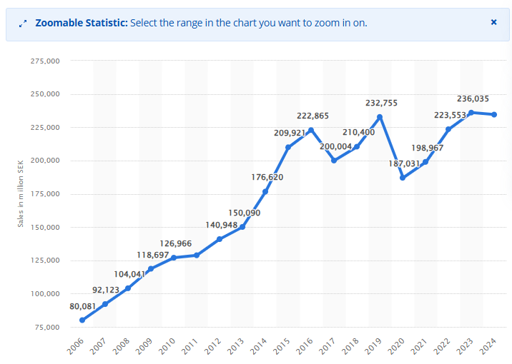
Figure 1: Total sales of the H&M
(Source: Statista, 2025)

2b. Nature of H&M’s Global Operations (Value Chain)
H&M global value chain has elaborate operations of the complete lifecycle of fashion products. The inbound logistics in the company entails a lot of research and communication by the central procurement office in Stockholm to the worldwide production centres (Kukkonen, 2021). H&M has around 15 local production offices with a workforce of over 1,600 colleagues that deal directly with suppliers every day, and which will guarantee quality control and standards of compliance (H&M Group, 2025). The operations stage consists of lean-agile dual integrated supply chain system with 80 percent of lean production having emphasis on efficiency and cost-cutting and 20 percent is agile manufacturing with its emphasis on quick reaction to market tendencies. This step enables H&M to cut its lead times to no more than 20 days between design and retail.
Outbound logistics of the company are handled in a complex network of distribution with a warehouse located in Hamburg, Germany that is the centre of all activities and receives about 160 million pieces a day (Landegren and Flognman, 2023). H&M has its own logistics organization, H&M International Transportation, Inc., and uses numerous transportation methods (railways, waterways, roadways) to ensure a cost minimization and keep the speed of delivery. Marketing and sales operations are synchronized on a global scale and localized at the regional level, with the advertising campaigns of the region, languages, and the influencers are adapted to the region. The service aspects comprise a new in-store experience in the form of Scan and Buy technology, multi-pay and customer loyalty programs adopted in major markets. The supply chain of H&M has about 800 suppliers and 30 production distribution centres across the world with production being concentrated in Bangladesh, China, India, Vietnam, Pakistan and Turkey where there are low costs of labour and manufacturing expertise (Rathore et al., 2019).

2c. Entry Modes in Different Markets
H&M uses various modes of market entry based on the peculiarities of a market and the regulatory conditions. Foreign direct investment (FDI) with wholly owned subsidiaries has proven to be the most popular entry mode being used by H&M in major markets such as the United States and India where the company has invested in 100 percent owned establishments after the regulatory board granted foreign direct investment (Nyambuto, 2021). This strategy gives the greatest degree of control over brand norms, consumer experience, and business processes and meets the needs of H&M whose mono-brand store operations cannot support multi-brand distribution patterns. Contract manufacturing is an important type of entry mode and H&M is outsourcing virtually all manufacturing processes to overseas manufacturers instead of setting up manufacturing plants (Rana et al., 2021). This plan will lower capital needs and enable the company to concentrate on its core competencies in designing, retailing and supply chain management and enjoy low-cost production in the developing economies.
Franchising is also a significant additional entry mode especially in markets where entry barriers due to high investments or regulatory complications are high. H&M in Europe and Middle East H&M works together with local franchisees who pay royalties and open brand stores under H&M supervision, reducing the need to invest much but offering medium-level operational control (Jamal, A2023). It is worth noting that franchising has not been the universal expansion model even though conversations of this model have been observed in countries such as India where H&M has continued to possess complete ownership of the company through wholly owned subsidiary model.
H&M took a hybrid entry strategy which involved fully owned retailing as well as local partnering agreements in Brazil. The company has partnered with Dorben Group, taking advantage of their knowledge of the region as well as existing infrastructure but retained ownership of stores and strategic direction (Fashion Network, 2025). Such a mix model will help H&M to overcome Brazil complicated regulatory environment (with customs duty more than 30 percent on apparel) and to take advantage of the local market experience and distribution channels.

2d. Key Benefits from Internationalisation
The global operation of H&M provides great strategic and financial advantage. The most obvious benefits are market growth and revenue diversification, and in this case, the emerging markets such as Brazil have populations above 200 million and the increasing disposable income of the growing middle classes (Hadjikhani et al., 2019). The company clearly aims at entering into the emerging markets in order to decrease the dependency on the mature North American and European markets that are facing poor consumer spending.
Economies of scale are a very essential advantage and the huge global sourcing system of the company allows it to source raw material and labour at favourable prices. The standardized supply chain model developed over 800 suppliers has helped H&M achieve bulk purchasing power and production efficiency and thus H&M is able to maintain its competitive high fashion at low prices positioning (H&M Group, 2025).
Portfolio diversification geographic risk reduction is used to protect against regional economic crashes. H&M focuses on the concentration risk of any market by keeping its presence in the various economic regions, which are at different levels of development (Sandberg and Abrahamsson, 2022). The penetration of the company into Brazil and India among other emerging markets is particularly a strategic move that seeks to eliminate the reliance on the developed Western markets.
Availability of cheaper resources is still inherent in the profitability model of H&M. The emerging markets have inexpensive labour, manufacturing prowess and in some instances, raw materials. The particular entry into Brazil involves local manufacture of footwear, beachwear, and jeans, which will decrease the dependency on imports and exploit local textile manufacturing potentials (Pérez Hincapié, 2022).
The brand prestige and worldwide recognition will boost the power of the company to get the high-end customers and demand price positioning power. Its presence in 80 markets confirms the position of H&M as a global fashion authority and augers well in the brand being positioned as a luxury brand in certain markets even as it retains its budget friendly attributes in others.

3. OLI (Ownership–Location–Internalisation) Factors & Impact on H&M’s Entry Mode

3.1 Ownership Advantages (O)
H&M has unique ownership specific competitive advantages which make its foreign direct investment instead of licensing and other asset light models (Ly, 2021). This firm has a well-established global brand, which is one of its main ownership benefits, achieved by years of brand building investment and consumer confidence in the high fashion at low prices positioning. This intellectual property is difficult to copy or move with a license and internal ownership is better to maintain brand integrity and guarantee the same customer experience worldwide. Ali, (2025) stated that other ownership advantages are technological and operational expertise. Complex supply chain management software, such as AI-based demand forecasting based on Google Cloud platform architecture, is proprietary knowledge that gives H&M competitive edge over other competitors. The supply chain model of company is combining lean and agile production in the company shows that the company has operational expertise that its competitors will find difficult to replicate.

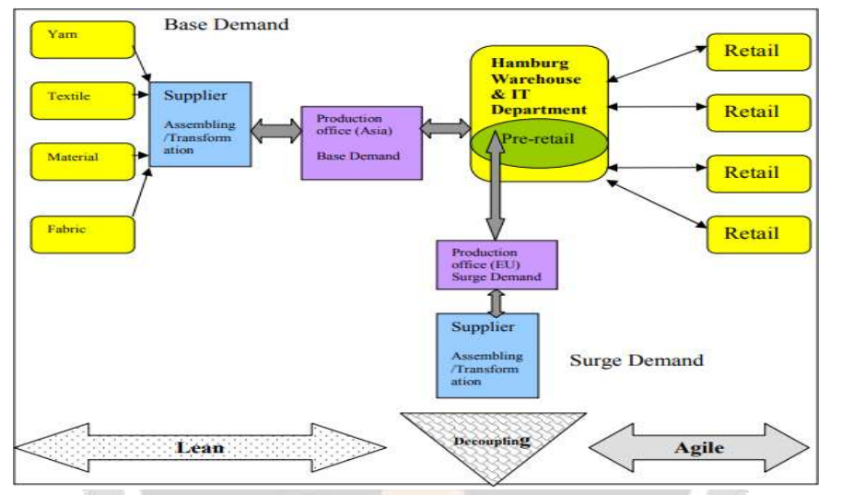
Figure 2: Model of H&M (Agile + Lean)
(Source: Rathor et al., 2019)
There are design and trend-forecasting services embedded into the Stockholm design centre of H&M commonly referred to as the White Room which grants H&M unique creative benefits. H&M has 80+ pattern makers and proprietary design processes that combine both long-term collection and real-time market response advertising in the design process, resulting in products that not only capture emerging trends but also offer quality products. The expertise in the supply chain coordination that includes the control of 800 suppliers, 15 production offices, and complicated logistical networks is a major ownership strength (Hugos, 2024). The ability to manage the production process in several countries and retain the same quality of production and delivery time is not easily passed on to the external partners. The money and access to capital allows H&M to invest in infrastructure, technology and brand building initiatives that the smaller competitors are not able to afford. This ownership benefit helps it to enter capital intensive emerging markets and helps it to achieve quick geographic expansion.

3.2 Location Advantages (L)
The geographical benefits of H&M should explain its entry mode targeting the market with unique geographical and economic factors and that correspond with the strategic goals of the company. The consumer demographics within the emerging markets can be recognized as vital location benefits in Brazil where the population numbers are over 200 million with growing middle classes that are exhibiting an ever-growing disposable income and rising demand of affordable fashion (Bezuidenhout et al., 2021). The emerging markets have favourable labour market conditions that give high location advantages. Bangladesh, China, India, Vietnam, and Pakistan have much lower wage rates than the developed markets and still possess manufacturing knowledge (Rahman and Moazzem, 2022). The sourcing of these areas by H&M takes advantage of this location disadvantage and helps in sustainable employment of developing economies.
Auskalnis (2025) stated that cost efficiency and availability of raw materials is also one of the critical location advantages and this can be seen in the textile producing regions. Textile manufacturing skills are also available in Turkey, India and Pakistan together with access to raw materials at reasonable fees. The availability of markets and alignment of consumer behaviour in the emerging markets are favourable to the expansion strategy of H&M. The Brazilian market of e-commerce is worth USD 59.07 billion in 2025 and is forecast to advance to USD 147.25 billion by 2030, reflecting a rapid 20.04% CAGR. 60% of people shop online and in-store using the omnichannel retailing model that perfectly matches the digital-first abilities of H&M.
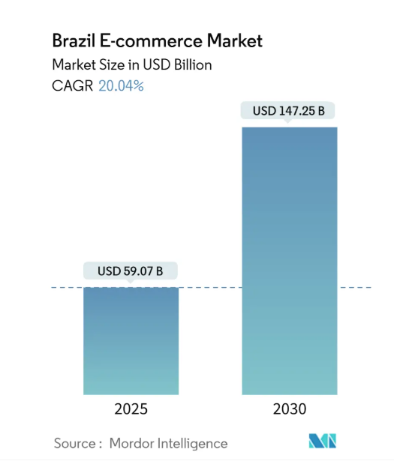
Figure 3: E-commerce market Brazil
(Source: Mordor Intelligence, 2025)
Other than this, the development of the regulatory environment offers location benefits in the particular markets. The location-specific advantage that triggered the entry decision by H&M was created by the acceptance of 100 percent foreign direct investment by India (McFerson, 2022). The government digitalization efforts by Brazil to increase the uptake of MSMEs equally generate location advantages to existing Omni channel players. The structure of tax and import duty is different at different places, which has an impact on the production and entry choices of H&M. The H&M entry into Brazil has also taken the form of local production in order to reduce the customs fees of more than 30 percent on imported apparel, and turning the location into cost-optimal.

3.3 Internalisation Advantages (I)
The internalisation benefits of H&M heavily lean towards complete ownership and internal control of the business retail operations as opposed to a licensing or franchising agreement (Nyambuto, 2021). Proprietary supply chain knowledge should be internalised so that the knowledge spill to competitors is avoided. The integrated systems of demand forecasting, inventory optimization and logistics coordination that H&M utilizes are competitive secrets that cannot be entrusted to the external franchisees safely.
The control of the brand and quality assurance requires the internalisation of the major markets. H&M brand promise of the use of constant quality, design, and customer experience needs to be under direct control of store operations, staff training, and merging standards that may be undermined by franchisees to boost their profitability in the short term.
The fast-paced adjustment to the new trends requires the unified operations that allow making the decisions quickly and ensuring the effective communication (Igwe-Nmaju, 2024). The competitive position of the company is based on the ability to translate design concepts to the retail shelves within a time span of around 20 days, lead time that cannot be sustained under licensing or franchising systems that impose communication lag and coordination drag.
It is argued by Heshmati-Kim et.al (2025) that The high value markets justify internalisation due to investment protection against opportunistic behaviour in franchisee. The strong brand equity that H&M gives a temptation to franchisees to alter the standardized operating procedures or to undermine brand positioning by reducing costs.
Market knowledge development demands concerted activities through which headquarters gets to know local consumer preferences, competition, and regulatory conditions. Franchisees do not give much feedback mechanism as wholly owned subsidiaries that directly report market intelligence to central management (Alon et al., 2021). Systems ownership is needed in technology integration in the supply chain, store and customer interfaces. The demand prediction, live inventory and customized merchandising systems employed by H&M require integrated data streams that cannot support the independence of the franchisees.

3.4 Impact on Entry Mode
The wholly owned subsidiary entry mode is highly motivated by the cumulative impact of the H&M ownership, location and internalisation advantages in the major markets such as Brazil, India and the United States (Ly, 2021). The ownership advantages (brand, design, supply chain mastery) and the internalisation advantages (knowledge defense, quality control, quick adjustment) of H&M generate strong basis to think that it should maintain the full operational control instead of licensing the rights to external players.
The location benefits in new markets augment subsidiary ownership as the best method of entry. The location conditions with the established integrated retailers favourable over the decentralized franchising arrangements include the regulatory approval of FDI and the fragmented Brazilian retail environment and state efforts in digitalization of the business (Vansvik and Friskytt, 2024).
Combinations of local joint ventures (as in Brazil with Dorben Group) are a moderate solution that recognises the particular weaknesses of location (regulatory complexity, lack of distribution infrastructure) without entirely losing the advantages of internalisation associated with H&M owning and controlling retail business (Fashion Network, 2025).
Franchising becomes a secondary mode of entry in European and Middle Eastern markets that are already developed, location benefit is less strong, capital requirements are stiffer and regulatory conditions favour local relationships. Nevertheless, the level of ownership and operational control that H&M has in these areas is still substantial in contrast to the traditional franchise relationships.

4. Cultural Differences & Impact on H&M’s Market Entry Success

4.1 Key Cultural Differences
Brazil and Sweden are two countries which have a huge difference in their cultures that influence the market entry strategy of H&M as well as the needs of the country in relation to its operations. Consumer tastes in fashion also vary significantly, where Brazilian consumers are showing tastes in bright colours, loud designs and tight body shapes as part of the influence of tropical climate and beach culture (de Medeiros Dantas et al., 2025). The traditions of Swedish designs are cantering minimalism, neutral colours, and utilitarianism—disciplines of design that are essentially opposed to Brazilian tastes in fashion. This difference is clearly dealt with by H&M entry strategy, which involved local manufacturing of beachwear according to the local weather and style variations, as the standardized Swedish designs were not enough to attract local consumers with their wide tastes.
The cultural differences in the pattern of business interactions are indicated in communication styles and directness. The Swedish business culture has stressed a direct and efficient communication and egalitarian hierarchies unlike the Brazilian business culture which has stressed on relationship-building, personal association and hierarchical respect (Heshmati-Kim et al., 2025). These disparities influence H&M recruitment, the management communication and customer service training in Brazil. Hofstede’s cultural dimension is most suitable model that helps to manage and measure the differences between the cultures of the different countries based on different indicators (Lundmark, 2023)
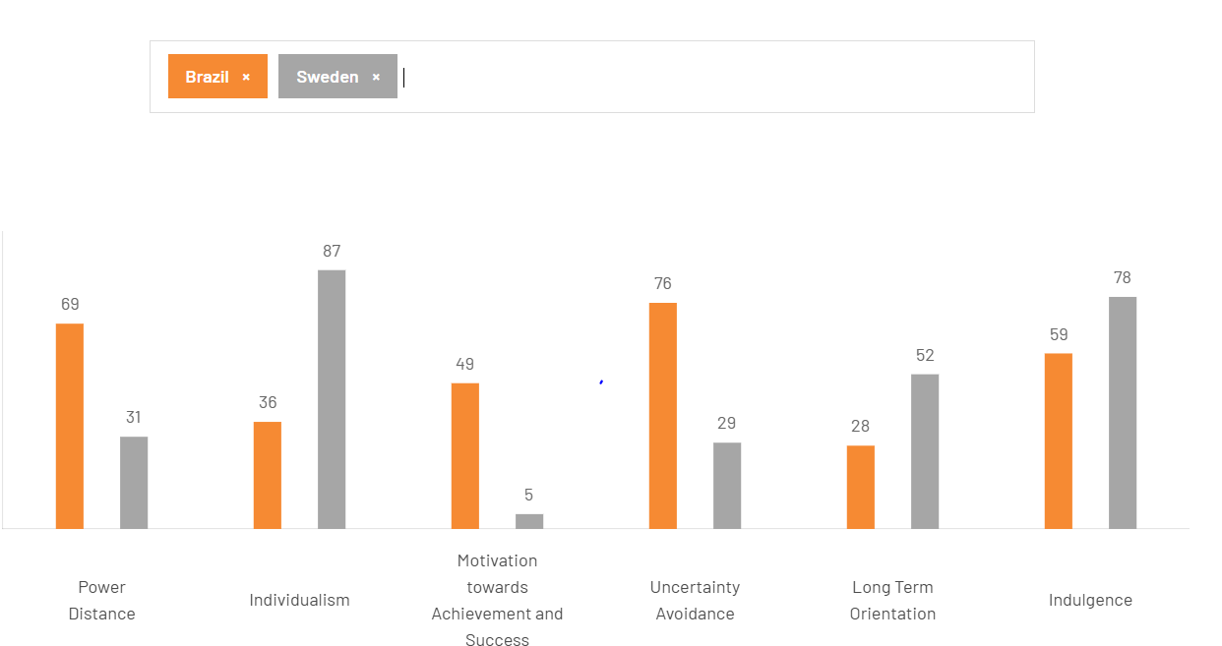
Figure 4: Hofstede cultural dimensions
(Source: The culture factor, 2025)
The chart above reflects the differences in culture of Sweden and the Brazil based on different indicators. It can be found that there is significant difference between Sweden and Brazil based on indicators such as power distance, motivation towards achievement and success, and uncertainty avoidance. Sweden and Brazil have different attitude towards sustainability and labour practices. H&M have a corporate positioning of being a sustainable and ethical fashion store based on the strong environmental awareness and tradition of labour rights in Sweden. Brazilian consumers are becoming more aware of the concept of sustainability, but affordability and instant pay is still important to them more than environmental standards (Chard et al., 2024). This cultural aspect will require shifting the marketing focus of H&M towards sustainability leadership (the first positioning in Scandinavia) and affordability and value presentation in Brazil.
Brazil has a higher level of consumer income stratification and social class consciousness, which influences the brand positioning strategy than Sweden (Villa O'Dogherty, 2023). Brazil has a sharp wealth inequality so the consumer groups (lower-middle class, upper-middle, affluent), have very different buying power and brand attitude. The positioning of H&M as an affordable fashion can fit the lower and lower-middle classes, which needs Brazil-focused marketing with a focus on price accessibility and not premium positioning.
It can be identified that the brand majorly focuses on following SOP for ensuring that the similar process and procedure is followed in every market irrespective of differences in the culture. Using this adaptation approach, the brand maintains its brand image accordingly in the different international markets.

4.2 Impact on Market Entry Strategy
The entry strategy used by H&M to enter Brazil has explicit cultural adaptation mechanisms that accommodate the cultural differences identified. Local product development will change the market entry strategy of mere simple standardized replication of the stores to a more culturally-driven product curation. H&M has locally produced beachwear’s, footwear and jeans in Brazil, which is explicit acknowledgment that the Swedish and European designed collections were not enough to meet the local preferences (Bergamo de Carvalho and Zhumagaliyeva, 2025). The company also has a plan of seasonally changing collections with those in the Southern Hemisphere, unlike uniform global collections.
Localized marketing, and brand positioning respond to differences in communication style and consumers preference. The H&M market approach is a valuable case study, as it uses the region-specific advertising messages with references to regional languages, culturally appropriate visuals, and festive event-related messages (Diwali campaigns, e.g.). Brazil entry strategy will equally localize the marketing focus of sustainability leadership to affordability, value demonstration and fashion trends to the Brazilian aesthetic preferences.
Local expertise partnership strategy helps to reduce the challenge of cultural integration. The collaboration of H&M with Dorben Group, a Brazilian-based retail conglomerate with extensive local market expertise and local connections that the Swedish headquarters was unable to duplicate because of the distance factor (Fashion Network, 2025). This structure of partnership helps in transfer of culture knowledge that would help the company adapt better in the market.
Localizing store format and experience deals with cultural variations in demands of the retail setting. Instead of using standardized white box store designs used in European market, H&M Brazil expansion uses warmer designs, interactive merchandising and using local relevant designs that mirror the Brazilian design preferences and provide culturally suitable retailing settings.
Adaptation of the staffing and organizational culture identifies differences between communicating styles of the Swedish corporate headquarters and the Brazilian operational teams. The employment of local Brazilian managers by H&M (a typical example being Joaquim Pereira hired as Country Manager) will guarantee the cultural knowledge and cultural style of communication in the local management systems.

4.3 Impact on Potential Market Success
The mechanisms of cultural adjustment contribute substantially to the chance of H&M becoming successful on the Brazilian market and adding long-term management issues. When the products being offered and advertising messages appeal to the values and aesthetic preferences of the local culture, the levels of consumer acceptability and brand loyalty are significantly enhanced. The localized strategy with cultural sensitivity in designing products and marketing campaign that H&M used in Brazil led to 56 percent consumer satisfaction despite cultural difficulties (KeyMyHome, 2025).
Nevertheless, at the same time, cultural differences present complexity of execution and risk of management. Study reports that 48 percent of H&M shoppers worldwide believe that the marketing campaigns used by the company do not align with their cultural values, which highlights the current issue in the process of attaining cultural alignment despite the cultural adjustments (H&M Group, 2023). A failure to complete cultural adaptation can lead to brand dilution by losing the interest of target customers who want genuine local brands and the global customers who appreciate the consistency of H&M brand across the world.
H&M is susceptible to competition with local-based competitors whenever it enters culturally diverse markets. The developed domestic fashion companies in Brazil (C&A, Renner) have the inherent cultural benefits and the formed consumer relationship that cannot be overpower by any localization (Vansvik and Friskytt, 2024). The result of this cultural identity by consumers is often preference of brands that seem to be authentic and local as opposed to foreign brands that are trying cultural adjustments.
The potential of the cultural oversimplification occurs in cases of the companies trying to adapt to two or more cultural dimensions at once. The standardization of H&M into 80 markets inevitably has an element of cultural averaging in it, in design selection, marketing messages and operational processes which would hardly be optimally reflective of local culture.
The culturally sensitive entry strategy may be faster than the standardized entry strategy in terms of market penetration rate; however, the market size capture will be affected by various non-cultural drivers such as price competitiveness, retail convenience, and supply chain efficiency. The rivalry between H&M and Zara and SHEIN in Brazil is based on the ultimate value proposition and not solely on the cultural factors (Auskalnis, 2025).
The formation of brand loyalty is stronger in the long-term when customers feel that H&M appreciates their culture and learns about it. On the other hand, the perception of cultural insensitivity (as was the case with the boycott campaigns in certain markets) generates reputational losses that are hard to undo.

5. Recommendations
Recommendation 1: Establish Dedicated Emerging Market Standard Operating Procedures (SOPs) With Cultural Flexibility Frameworks
Although the global brand should be consistent, H&M ought to design emerging market specific SOPs with standard procedures with specified cultural flexibility areas (Lanzer, 2025). Instead of using standardized global processes, H&M needs to exist with core non-negotiable norms (supply chain security, quality assurance, financial controls) and developing explicit flexibility in product mix, marketing communication, store design and staffing patterns.
Machineries to implement are: (1) the establishment of core-flex-structures whereby documentations on which operations should be globalized and those which may be localized are done; (2) the establishment of local design councils in key emerging markets that have authority to select 15-20 percent of store assortment of products that are locally-designed within architectural templates; (3) the establishment of regional marketing councils with authority to select message of campaigns and creative direction within globally-based brand formats; (4) decentralization of store environment design decisions to regional This will retain the brand integrity and effectiveness of H&M and adapt to the cultural preferences that will lead to greater acceptance of the brand in the market (Makhdoom et al., 2022).
Machinery | Description | Purpose/Outcome
Core–Flex Structures | Documentation to identify which operations/processes should remain global and which may be localized. | Ensures brand consistency while allowing cultural adaptation.
Local Design Councils (Emerging Markets) | Councils empowered to select 15–20% of store assortment as locally designed within global architectural templates. | Enhances local cultural relevance of product offerings.
Regional Marketing Councils | Councils with authority to customize campaign messages and creative direction within global brand guidelines. | Ensures culturally appropriate communication while maintaining brand identity.
Decentralized Store Environment Design | Store layout and environment design decisions delegated to regional teams. | Improves local market fit while retaining H&M’s core brand aesthetics.

Among the expected results are the fact that consumer satisfaction in emerging markets will increase with the boycotts being lowered by increasing cultural awareness, and competitive positioning will be strengthened against the locally-based competitors. Specific to Brazil: allow regional design council to include 20-30 percent beachwear collections with Brazilian seasonal trends with aesthetics, allow marketing teams to focus on affordability and values over sustainability leadership and flexibility in store design to feature warmer colour palettes and interactive displays to meet Brazilian retail expectations.
Recommendation 2: Expand Local Production and Supply Chain Diversification in Key Emerging Markets
H&M ought to also pursue faster localized productions beyond the existing pilot projects in Brazil, and also develop manufacturing hubs in India, Mexico, and other emerging markets with high potential (Vansvik and Friskytt, 2024). The Brazil model that currently manufactures footwear, beachwear, and jeans within the country and imports other products to Asia/Europe is the most balanced-with the expansion being done to this successful hybrid model will allow reducing the tariff exposure, lead time, and creating a robust relationship in the local market.
Mechanisms to be implemented are: (1) 35-40 percent locally-sourced inventory in Brazil by 2027 (compared to current 10-15 percent) via projects to work with Brazilian textile manufacturers; (2) similar hybrid sourcing models in India where the target is 30 percent locally-sourced (vs. 10-15 percent currently); (3) building robust local supplier capabilities to enhance quality and ethical standards, so as to be able to enter into local partnerships; (4) negotiating preferential tariff treatment
Mechanism | Target/Action | Expected Impact
Locally Sourced Inventory – Brazil | Increase to 35–40% local sourcing by 2027 (from current 10–15%). | Faster responsiveness, lower costs, higher local acceptance.
Hybrid Sourcing Model – India | Achieve 30% local sourcing (vs. current 10–15%). | Strengthens market integration and supply agility.
Local Supplier Capability Building | Improve quality, ethics, and reliability to enable long-term partnerships. | Ensures sustainable, ethical supply chains aligned with H&M standards.
Preferential Tariff Negotiations | Secure favourable tariff structures in key markets. | Reduces landed costs and enhances price competitiveness.

Overall the probable results are the reduction of costs by 15-20 percent of the emerging market inventory by removing tariffs and lowering logistics expenses, quicker response to local fashion trends by producing locally, and improved relationships with the community that will support political stability and market position. Brazil-specific deliverables: develop manufacturing plant in Minas Gerais state and produce 40,000+ units per month of locally-relevant products, cut delivery times of products in the country by 40 percent with regional production, and establish 500-plus local manufacturing positions to boost corporate image.
Recommendation 3: Implement AI-Enabled Personalization and Culturally-Adapted Inventory Management
H&M needs to implement artificial intelligence, which allows the store-by-store adjustment of inventory, depending on the local customer behaviour, cultural inclinations, and local trends (Bhalerao et al., 2024). Existing AI applications focus on demand prediction and supply chain optimization; there is an upcoming opportunity in the front-end personalization that develops locally-relevant shopping experiences on top of standardized operational structures.
The implementation mechanisms encompass: (1) the deployment of machine learning algorithms that examine the local purchasing patterns, seasonal preferences, and cultural aspects to create store-specific recommended inventory assortment; (2) the deployment of smart shelf systems that place products in culturally-relevant groupings and combinations that reflect the purchasing power and purchase intensity of a particular locality whilst preserving brand consistency; (3) the deployment of AI-driven personal shopping assistants that make culturally-specific style recommendations; and (4) the deployment of dynamic pricing algorithms that increase or decrease the intensity of promotions based on the purchasing
The anticipated results will see an improvement in inventory turnover 15-25 percent, stock out by 40 percent, a 20 percent increase in conversion rates and significantly improved customer satisfaction due to relevant product availability emphasizing personalization of availability. Brazil specific implementation: install regional machine learning models that study local social media trends, local cultural preferences and local competitive moves to tailor monthly product assortment to 15-20 local flagship stores; install smart mirrors that allow virtual try-on of styling combinations appropriate to the local culture and develop Portuguese-language AI styling assistants that offer culturally-appropriate fashion advice.

6. Conclusion
The fact that H&M has succeeded in changing the Swedish fast fashion icon into an international multinational with 80 operating markets has proven that the complex international business environments can be negotiated through a balance between the cost-effective implementation of the strategic use of core competitive advantages and the pragmatic cultural adaptation. The ownership benefits of the company, which include high brand equity, design quality, supply chain proficiency and financial strength give a good reason why the firm should consider foreign direct investment using wholly owned subsidiaries as opposed to asset-light models such as franchising. The potential to create attractive opportunities in emerging markets with location benefits, especially Brazil and India with their scale of population, increasing disposable income, and growing middle classes justifies the continued geographic expansion of H&M despite the consumer spending weakness in the mature European markets.
To meet this objective, H&M must implement a core-flex global approach, which standardizes brand defining factors and gives local design and marketing councils the power to localise product assortments, campaigns and in-store environment to cultural demands. Meanwhile, the company must increase local sourcing in Brazil and India with hybrid sourcing models, supplier capability building, and tariff dealings to cut down on costs, and enhance responsiveness to the market. Lastly, H&M must adopt the latest technologies in retailing such as machine learning to predict demand, smart shelves, AI style understanding, and dynamic pricing to provide individualized customer experiences, optimize assortments, and increase competitiveness without losing the international brand identity.

References
Akther, R. (2025). The Corporate Social Responsibility Strategies in Fashion Industry: Case Company H&M. https://www.theseus.fi/bitstream/handle/10024/894025/Akther_Rehana.pdf?sequence=2
Ali, Q. (2025). Application of Artificial Intelligence in Supply Chain Management (Doctoral dissertation, Dublin, National College of Ireland). https://norma.ncirl.ie/7980/1/qasimali.pdf
Alon, I., Apriliyanti, I. D., and Henríquez Parodi, M. C. (2021). A systematic review of international franchising. Multinational Business Review, 29(1), 43-69. https://www.emerald.com/insight/content/doi/10.1108/mbr-01-2020-0019/full/pdf
Auskalnis, J. T. (2025). Ethical Elegance: Navigating Consumer Morality and Production Practices in Fashion Through Analyzing Shein, Zara, & Vivienne Westwood. https://research.library.fordham.edu/cgi/viewcontent.cgi?article=1207&context=environ_ssss2015
Bergamo de Carvalho, J., and Zhumagaliyeva, A. (2025). Sustainability and Profit in Fashion: Insights from Born-Sustainable SMEs in Brazil and Scandinavia. https://lup.lub.lu.se/luur/download?func=downloadFile&recordOId=9206690&fileOId=9206698
Bezuidenhout, H., Mhonyera, G., Van Rensburg, J., Sheng, H. H., Carrera Jr, J. M., and Cui, X. (2021). Emerging market global players: the case of Brazil, China and South Africa. Sustainability, 13(21), 12234. https://www.mdpi.com/2071-1050/13/21/12234
Bhalerao, K., Rroy, A. D., and More, R. (2024). Artificial Intelligence Technologies Usage Decides the Success or Failure of Garment Industry Ecosystem. International Management Review, 20(1). https://americanscholarspress.us/journals/IMR/pdf/IMR-0-2024/imr2024SpringSp-art11.pdf
Chard, E., Bergstad, C. J., Steentjes, K., Poortinga, W., and Demski, C. (2024). Gender and cross-country differences in the determinants of sustainable diet intentions: a multigroup analysis of the UK, China, Sweden, and Brazil. Frontiers in Psychology, 15, 1355969. https://www.frontiersin.org/journals/psychology/articles/10.3389/fpsyg.2024.1355969/pdf
de Medeiros Dantas, Í. J., Curth, M., Teixeira, D. P., Júnior, G. S., and Batista, F. E. A. (2025). Is there a color for sustainability in fashion products? A case study with Brazilian slow fashion footwear. Cultura e Scienza del Colore-Color Culture and Science, 17(01), 45-56. https://jcolore.gruppodelcolore.it/ojs/index.php/CCSJ/article/download/408/308
Expertise Accelerated. (2025) Successful Businesses and Their Inventory Management Strategies. [Online]. Available at: https://expertiseaccelerated.com/inventory-management-strategies/#:~:text=H&M:%20Maximizing%20Price%20Economy%20and%20Minimizing%20Lead [Accessed on: 02/12/2025].
Fashion Network. (2025) H&M to enter Brazil in 2025 in partnership with Dorben Group. [Online]. Available at: https://ww.fashionnetwork.com/news/H-m-to-enter-brazil-in-2025-in-partnership-with-dorben-group,1537238.html [Accessed on: 02/12/2025].
H&M Group. (2023) Annual and Sustainability Report 2023. [Online PDF]. Available at: https://hmgroup.com/wp-content/uploads/2024/03/HM-Group-Annual-and-Sustainability-Report-2023.pdf [Accessed on: 02/12/2025].
H&M Group. (2025) Business idea. [Online]. Available at: https://hmgroup.com/about-us/business-idea/ [Accessed on: 02/12/2025].
H&M Group. (2025) Supply chain. [Online]. Available at: https://hmgroup.com/sustainability/leading-the-change/transparency/supply-chain/ [Accessed on: 02/12/2025].
Hadjikhani, A., Leite, E., and Pahlberg, C. (2019). Business and socio-political interaction in international service projects: The case of Brazil. Management International Review, 59(1), 171-200. https://link.springer.com/content/pdf/10.1007/s11575-018-0368-9.pdf
Heshmati-Kim, J., Ida Ayu Nyoman, D. I., and Stenlund, M. E. (2025). Cultural Adaptation in the Swedish Work Culture: Experiences of Immigrant Employees in Sweden. https://www.diva-portal.org/smash/get/diva2:1967612/FULLTEXT01.pdf
Hugos, M. H. (2024). Essentials of supply chain management. John Wiley & Sons. https://www.researchgate.net/profile/Michael-Hugos/publication/319321782_Key_Concepts_of_Supply_Chain_Management/links/619ec4f1f1d6244571694a61/Key-Concepts-of-Supply-Chain-Management.pdf
Igwe-Nmaju, C. (2024). Organizational communication in the age of APIs: integrating data streams across departments for unified messaging and decision-making. International Journal of Research Publication and Reviews, 5(12), 2792-2809. https://www.researchgate.net/profile/Chibogwu-Igwe-Nmaju/publication/392472264_Organizational_Communication_in_the_Age_of_APIs_Integrating_Data_Streams_Across_Departments_for_Unified_Messaging_and_Decision-_Making/links/68439f5e6b5a287c3049b315/Organizational-Communication-in-the-Age-of-APIs-Integrating-Data-Streams-Across-Departments-for-Unified-Messaging-and-Decision-Making.pdf
Jamal, A. N. (2023). Business plan for a clothing and artificial jewellery business in Central Ostrobothnia, Finland. https://www.theseus.fi/bitstream/handle/10024/816813/Jamal_Abdul.pdf?sequence=2
KeyMyHome. (2025) H&M targets Brazil and India as spending slows in the US and Europe. [Online]. Available at: https://keymyhome.com/news/hm-targets-brazil-and-india-as-spending-slows-in-the-us-and-europe#:~:text=H&M's%20entry%20into%20these%20markets,resonate%20more%20deeply%20with%20customers. [Accessed on: 02/12/2025].
Kukkonen, V. (2021). Cooperation within the supply chain: Inbound process development. https://osuva.uwasa.fi/server/api/core/bitstreams/4f36664a-cd50-4ea6-aa01-83676ba122eb/content
Landegren, E., and Flognman, E. (2023). Expanding warehouse operations as a fashion brand: a case study about the motivating factors and challenges. https://www.diva-portal.org/smash/get/diva2:1774530/FULLTEXT01.pdf
Lanzer, L. (2025). The future of sustainable supply chain management: blockchain and smart contracts in the fashion industry-a case study of a european denim brand. https://www.diva-portal.org/smash/get/diva2:1979859/FULLTEXT01.pdf
Lundmark, E. (2023). Banal and nostalgic: Memories of Swedishness in the Christmas calendar. Temenos-Nordic Journal for the Study of Religion, 59(1), 29-51. https://journal.fi/temenos/article/view/112453/80013
Ly, B. (2021). Competitive advantage and internationalization of a circular economy model in apparel multinationals. Cogent Business & Management, 8(1), 1944012. https://www.tandfonline.com/doi/pdf/10.1080/23311975.2021.1944012
Ly, B. (2021). Competitive advantage and internationalization of a circular economy model in apparel multinationals. Cogent Business & Management, 8(1), 1944012. https://www.tandfonline.com/doi/pdf/10.1080/23311975.2021.1944012
Makhdoom, I., Lipman, J., Abolhasan, M., and Challen, D. (2022). Science and Technology Parks: A futuristic approach. IEEE Access, 10, 31981-32021. https://ieeexplore.ieee.org/iel7/6287639/6514899/09737029.pdf
McFerson, T. (2022). Why are Companies Moving Back Home? An investigation into the drivers of location choice in the European apparel industry (Master's thesis). https://studenttheses.uu.nl/bitstream/handle/20.500.12932/42488/McFerson_Final_Thesis.pdf?sequence=1&isAllowed=y
Miettinen, S. (2024). Examining corporate social responsibility reporting and accountability: a case study of H&M’s practices in fast fashion. https://www.theseus.fi/bitstream/handle/10024/869362/Miettinen_Silja.pdf?sequence=2
Mordor Intelligence. (2025) Brazil E-commerce Market Size, Share Analysis, Forecast to 2030. [Online]. Available at: https://www.mordorintelligence.com/industry-reports/brazil-ecommerce-market#:~:text=Brazil%20E%2Dcommerce%20Market%20Analysis [Accessed on: 02/12/2025].
Nyambuto, F. K. (2021). Market Entry Strategies and Performance of Multinational Fashion Retailers in Nairobi (Doctoral dissertation, University of Nairobi). https://erepository.uonbi.ac.ke/bitstream/handle/11295/157157/Nyabuto%20F_Market%20Entry%20Strategies%20and%20Performance%20of%20Multinational%20Fashion%20Retailers%20in%20Nairobi.pdf?sequence=1
Nyambuto, F. K. (2021). Market Entry Strategies and Performance of Multinational Fashion Retailers in Nairobi (Doctoral dissertation, University of Nairobi). https://erepository.uonbi.ac.ke/bitstream/handle/11295/157157/Nyabuto%20F_Market%20Entry%20Strategies%20and%20Performance%20of%20Multinational%20Fashion%20Retailers%20in%20Nairobi.pdf?sequence=1
Pérez Hincapié, W. C. (2022). Nearshoring in Latin America: a new home for American textile and apparel companies based in China?. https://repository.eafit.edu.co/bitstreams/bbf1aeb3-af13-421b-ba2f-bf46edfb8ddb/download
Rahman, M., and Moazzem, K. G. (2022). Enhancing global market competitiveness of textile and garment exports of South Asia. https://repository.unescap.org/bitstream/handle/20.500.12870/4420/ESCAP-2022-WP-Enhancing-global-market-competitiveness-textile-garment-exports.pdf?sequence=1&isAllowed=y
Rana, M. B., Allen, M. M., and Servais, P. (2021). Supplier internationalization in the global apparel value chain from Bangladesh to Ethiopia: the buyers business model, institutions and entrepreneurial capability. In Upgrading the Global Garment Industry (pp. 13-45). Edward Elgar Publishing. https://www.researchgate.net/profile/Mohammad-Rana-3/publication/351943183_Supplier_Internationalization_in_the_Global_Apparel_Value_Chain_from_Bangladesh_to_Ethiopia_The_Buyer's_Business_Model_Institutions_and_Entrepreneurial_Capability/links/60b115f845851557baa6a883/Supplier-Internationalization-in-the-Global-Apparel-Value-Chain-from-Bangladesh-to-Ethiopia-The-Buyers-Business-Model-Institutions-and-Entrepreneurial-Capability.pdf
Rathore, M. S., Maheswari, K., and Jain, S. (2019). Fast moving H&M: An analysis of supply chain management. International Journal of Advance Research and Innovative Ideas in Education, 5(4), 1557-1568. https://ijariie.com/AdminUploadPdf/Fast_Moving_H_M__An_Analysis_Of_Supply_Chain_Management_ijariie10784.pdf
Sandberg, E., and Abrahamsson, M. (2022). Exploring organizational learning and experimental logistics development at the global fashion retailer H&M. Global Business and Organizational Excellence, 41(2), 6-20. https://onlinelibrary.wiley.com/doi/pdf/10.1002/joe.22143
Statista. (2025) Sales of the H&M Group by country. [Online]. Available at: https://www.statista.com/statistics/252187/sales-of-the-hundm-group-by-country/ [Accessed on: 02/12/2025].
The culture factor. (2025) Cultural dimensions. [Online]. Available at: https://www.theculturefactor.com/country-comparison-tool?countries=brazil%2Csweden [Accessed on: 02/12/2025].
Vansvik, S., and Friskytt, I. (2024). How to succeed with a large retail expansion into an emerging market.“How can multinational retail companies concur the challenges presented by a Brazilian venture and what strategies lead to long-term success?”. https://gupea.ub.gu.se/bitstream/handle/2077/81916/24-21.pdf?sequence=1
Villa O'Dogherty, G. (2023). Analyzing the challenges of advertising in culturally polarizing countries: Brazil and Finland comparison. https://www.theseus.fi/bitstream/handle/10024/801645/Villa%20ODogherty_Gabino.pdf?sequence=2

