PROJECT MANAGEMENT IN CONSTRUCTION
Name: NELSON OIGBOCHIE
STUDENT NO ; 2122737

Table of Contents
Introduction 2
Characteristics of a project manager in the construction project 2
Principles of project management in the construction industry 4
Risk management 5
Engagement in the construction industry 7
Stakeholders in the construction industry 8
Gantt chart for scheduling and resource planning 9
Conclusion 9
References 11

Introduction
Project management in the construction industry helps individuals to keep the overall process of construction on the right track and efficiently. Project management in the construction industry involves organizing along with directing all parts of the lifecycle of a project, from completion to ideation. It is the holistic approach having the goal to deliver projects under budget and on time. Project management in the construction industry is the complex structure which needs addressing crucial concerns that include risk assessment (Owusu-Manu et al. 2020). Procurement, scheduling, and cost control. Every project manager interacts with every team member involved within a project of construction, from contractors to owners and architects.
Project management in the construction industry includes team members from ground crew members, engineers, financial planners, contractors, and others. However, a project manager has the most important role of all. The goal of a project manager is ensuring the overall process of construction goes efficiently and as per the plan. A project manager is responsible to maintain a tight schedule, allocate resources, ensure quality, stay in the budget and avoid scoop creep (Levy 2018). This paper will discuss the characteristics of a project manager and present the work for the intended audience. This paper will also discuss the overall characteristics of all other stakeholders within the construction industry.

Characteristics of a project manager in the construction project
It is the responsibility of the project manager to plan, organize and direct certain projects. A project manager ensures that every project is on budget and on time. In addition, a project manager is responsible for managing the project team and if all things get done. A project manager is an individual who coordinates as well as directs material along with human resources (Adekunle et al. 2022). The job of a project manager is ensuring that the project’s objectives, such as scope, time, quality and cost, are met. A project manager’s role is quite crucial to the success of the project. A project manager is responsible to handle this project, from completion to planning. However, the role of a project manager within the construction industry could differ from every other type of project management. Construction management is much more based on missions. It means that the organization of the project finished with the project build’s end (Mardiani 2018). As a result, the project manager requires certain knowledge of techniques of construction along with having efficient leadership skills.
Every construction project is full of endeavours of a high structure. In construction, there exist different moving parts which should arrive in the appropriate place. In addition, there exist numerous people having different roles along with responsibilities to play along with needing coordination. An efficient project manager within the construction industry can manage different projects. There exist numerous job roles as well as responsibilities from architects to contracts and engineers. It is also the responsibility of the project to ensure that different phases of the project run smoothly (Yap and Chow 2020). From planning to design, an efficient project manager should be able in solving issues quickly. An efficient project manager should have different skills. From focus, flexibility, loyalty, integrity and honesty, the project manager is responsible to set all standards for the remaining project team.
In construction management, it is crucial to manage the team efficiently due to all risks involved within the project. With effective negotiation skills, a project manager could resolve conflicts for ensuring the success of the project. A good negotiation also minimizes every risk to the objectives of the project. An efficient project manager should be confident as well as optimistic that a project could be successful while leading the project team. In addition, accountability is a concept that an efficient project manager should understand. It could make the difference between struggling in meeting project deadlines constantly and finishing projects within the deadline (Kim, Chang and Castro-Lacouture 2020). Effective project management is accountable for all their contributions and works ethics. It helps create a culture of projects where every deadline is respected, and excellence can be achieved.

Principles of project management in the construction industry
The primary objective is supporting all objectives of the project through efficient management of equipment, time, labour and capital. An efficient project manager should be following different principles of project management for making the project successful.
- Outline project goals: Goals can be established that could be likened for laying down the project’s foundations. The project manager should establish certain targets for the project team. If every target is not defined, the project manager is at risk to build faulty foundations. When all goals aren’t met on the project, it could lead to some huge delays throughout the project’s lifecycle, causing massive costs for the client (Vipin and Rahima Shabeen 2019). When there is the implementation of SMART goals, the project manager can gain a better picture of the performance of the project team and then decide what can be improved.
- Manage risks: The approach of risk management is used to determine all risks present within the project, along with evaluating all procedures for minimizing their impacts on the project. This process includes controlling, monitoring, and planning risk’s instances. As this process’s centre is the plan of risk management that details all risks along with processes to address them. A plan of risk management helps to manage all risks of the project efficiently.
- Define responsibilities of the team: Defining all responsibilities of all team members within the project team that includes engineers, cost managers, schedulers and project planners, is one type of risk management as this ensures all individuals understand what is actually expected of them and also saves confusion during the execution phase. One efficient way for defining it is using the RACI chart that is the responsibility assignment matrix breaking all tasks down (Farler and Haan 2021). There might be a stellar team and properly defined goals; however, confusion would creep into this project if such is not clear who all are responsible at this task level.
- Tailor the project methodology: There is not any one-size-fits-all when this is about project methodology, as all projects would differ in complexity, size and type. The project manager can have the most appropriate methodology of project management; however, if the project manager does not begin by considering all needs of this project, he or she runs this risk to apply unsuitable processes (Pheng and Hou 2019). A tailored methodology of project management is the iterative approach that will take effort as well as time for finding the templates, tools and processes that work, and the project manager will achieve better results for the projects.

Risk management
Risk management within the construction projects to evaluate as well as implement procedures for reducing risks’ impact on the project. This process of risk management includes thorough planning for creating a plan of risk management which allows the project manager in identifying, monitoring and mitigating every risk as it arises. A plan of risk management is created in the early phases of the planning process of the project. It also details what risks could take place and the response plan for resolving them. It includes designating anyone within the team to own that issue along with address it (Wu, Hu and Zheng 2019). The process to mitigate risks of the project is managing different steps, such as identification, assessment, mitigation, monitoring and reporting.
- Identification: A list of all possible issues is made that can arise. This identification list can be updated and edited as needed.
- Assessment: This list of risks’ can be assessed using a matrix of risk assessment that charts each risk’s likelihood along with the impact’s size this could have on the project (Yury and Dmytro 2019). Creating the matrix of risk assessment helps while addressing those risks if these appear.
- Mitigation: A contingency plan can be implemented, which would reduce the impact as well as the likelihood of all risks identified earlier. There must be given owners who would be responsible to identify these risks along with manage their resolution.
- Monitoring: Monitoring must be ongoing always, as all risks are identified when they appear. All major stakeholders must be consulted as well as kept updated on all project risks (Zuo et al. 2018). The leaders of other departments should also be engaged for help, along with empowering the project team for responding to all risks.
- Reporting: The reports upon risk mitigation allow the project manager in evaluating the contingency plan’s effectiveness. Dashboards can be created for illustrating progress and generating reports which are distributed easily.

Engagement in the construction industry
Construction employees are moving along with adapting to issues constantly on the frontline. The conditions of construction are changing constantly. Without reliable communication and regular updates, construction employees could feel to be left out of this loop. Hence, having dependable communication between employees equips all workers using tools for making necessary changes along with demonstrating their importance to all. Regular communication could help in cutting through any confusion along with enabling an engaging, productive and safe work environment (Nguyen et al. 2018). From negotiating a contract agreement to regular physical labour, construction workers are physically as well as mentally exhausted. For encouraging the engagement of employees in the project, there is a need for enthusiastic as well as proactive leadership for inspiring and motivating the success of long-term.
In addition, construction work involves dangerous activities or hazardous environments regularly. Helping all employees staying aware of all work procedures as well as policies would create a much safer environment for working and improve engagement as well as the attitude of employees onsite. Construction works are fast-paced, hands-on and do not leave much time to check messages or review files. Employees should know that all their contributions are essential and valuable (Hussain et al. 2018). By providing reliable, simple, and fast access to all resources, all employees feel engaged, supported and understood. Unique environments of construction work could create interesting concerns for this industry; however, employee engagement is not one of those concerns.

Stakeholders in the construction industry
Stakeholders have along with will be available consistently inside all construction projects. Every stakeholder is explicit to every individual project; hence, the commitment of stakeholders is crucial for decreasing the effect of adverse impacts they could have. There exist different stakeholders within the construction industry who are crucial for these projects.
- Quantity surveyor (QS): The QS analyzes the specifications as well as the drawing of a new infrastructure that engineers or architects provide. The QS calculates the materials’ quantity used within the infrastructure. They should calculate the actual labour or work cost. During the infrastructure’s whole construction, the QS keeps eye upon the cost. Quantity surveying depends on the tools of technical measurement for appropriate cost results (Arsanjani and Ershadi 2021). The QS plays a vital role to manage all finances for the construction project along with making them cost-efficient.
- Architects: Architects play an essential role within the construction as they are liable for all infrastructures’ visual appearance before designing the final structure. Architects are hired for creating the detailed design of the idea or concept of the clients. Architects could render different drawings that include 3D views, 3D models, structural drawings, elevations, site plans and floor plans. The overall infrastructure is visualized by architects, bringing together some creative designs as well as ideas for this industry.
- Civil engineers: Civil engineers’ primary role is to construct buildings along with other structures that aren’t harming the environment. Civil engineers design all projects considering every need of the owners, along with the availability of labour skills, money, manpower, material and machinery (Kukah, Owusu-Manu and Edwards 2022). Civil engineers also prepare the tenders that become the contracts’ part, along with calculating the number of different items needed for the projects.

Gantt chart for scheduling and resource planning
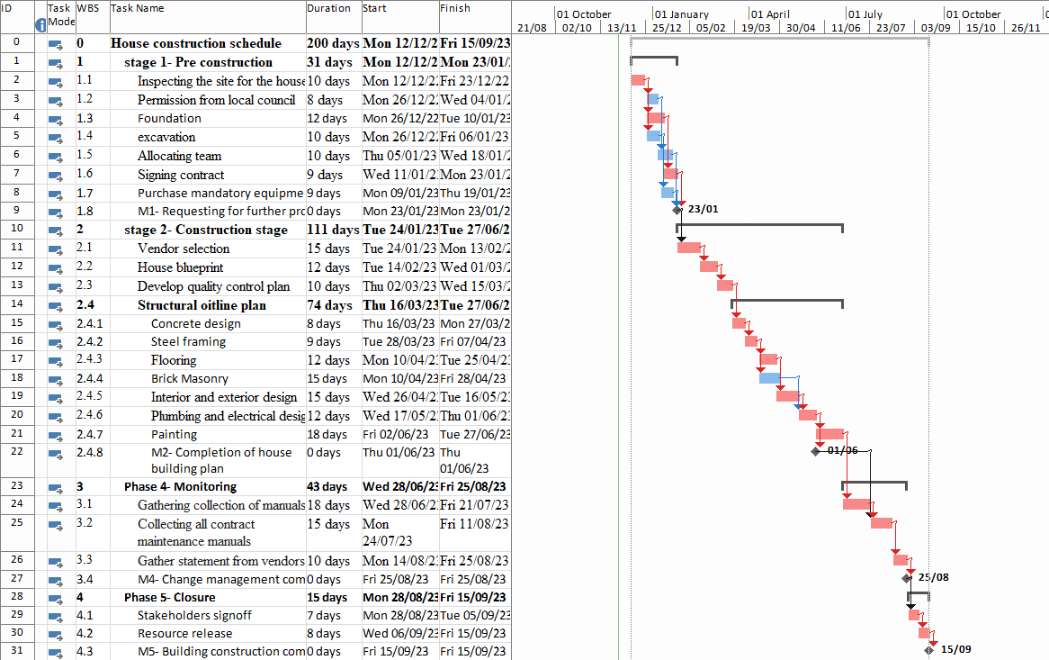

Conclusion
Project management in the construction industry is the multifaceted subject which includes addressing different crucial matters. A project manager interacts along with liaises with every team member involved in this project. Project management in the construction industry keeps all teams aligned along with, leads to success. The solutions of project management for this project help improve forecasting, keep all costs low, centralize information and boost efficiency. The solutions of project management include the process to manage the project of construction. The solutions of project management include a broader type of constraints for considering which are specific to this design along with the build of all construction projects.
The solutions of project management could interact with different disciplines in this project’s lifeline, from public works to engineering and architecture. Software of project management in this construction industry also organizes the reporting, resources, building, scheduling and planning associated with this construction project. It also improves productivity and streamlines all processes by maintaining a tight budget as well as schedule. These solutions are utilized for controlling all phases of the project by organizing all disparate parts along with automating routines for adding efficiencies. A tool of project management also keeps all stakeholders up-to-date by sharing reports containing crucial data related to the project.

References
Adekunle, P., Aigbavboa, C., Akinradewo, O., Oke, A. and Aghimien, D., 2022. Construction Information Management: Benefits to the Construction Industry. Sustainability, 14(18), p.11366.
Arsanjani, M.A. and Ershadi, M., 2021. Avenues to improving the effectiveness of project portfolio management in the construction industry. International Journal of Management Science and Engineering Management, pp.1-10.
Farler, D.W. and Haan, P., 2021. Effective Leadership in the Engineering, Technology, and Construction Industry. Journal of Construction Materials, 2, pp.4-8.
Hussain, A.M.A., Othman, A.A., Gabr, H.S. and Aziz, T.A., 2018, December. Causes and impacts of poor communication in the construction industry. In 2nd International conference: sustainable construction and project management-sustainable infrastructure and transportation for future cities, Egypt (pp. 16-18).
Kim, S., Chang, S. and Castro-Lacouture, D., 2020. Dynamic modeling for analyzing impacts of skilled labor shortage on construction project management. Journal of Management in Engineering, 36(1), p.04019035.
Kukah, A.S.K., Owusu-Manu, D.G. and Edwards, D., 2022. Critical review of emotional intelligence research studies in the construction industry. Journal of Engineering, Design and Technology.
Levy, S.M., 2018. Project management in construction. McGraw-Hill Education.
Mardiani, G.T., 2018, August. Construction industry project planning information system. In IOP Conference Series: Materials Science and Engineering (Vol. 407, No. 1, p. 012093). IOP Publishing.
Nguyen, P.T., Nguyen, V.N., Pham, L.H., Nguyen, T.A., Nguyen, Q.L.H.T.T. and Huynh, V.D.B., 2018. Application of supply chain management in construction industry. Advances in Science and Technology. Research Journal, 12(2).
Owusu-Manu, D.G., Debrah, C., Amissah, L., Edwards, D.J. and Chileshe, N., 2020. Exploring the linkages between project managers' mindset behaviour and project leadership style in the Ghanaian construction industry. Engineering, Construction and Architectural Management.
Pheng, L.S. and Hou, L.S., 2019. The economy and the construction industry. In Construction quality and the economy (pp. 21-54). Springer, Singapore.
Vipin, V.P. and Rahima Shabeen, S., 2019. Factors affecting material management in construction industry. International Journal of Recent Technology and Engineering, 8(3), pp.8445-8448.
Wu, G., Hu, Z. and Zheng, J., 2019. Role stress, job burnout, and job performance in construction project managers: the moderating role of career calling. International journal of environmental research and public health, 16(13), p.2394.
Yap, J.B.H. and Chow, I.N., 2020. Investigating the managerial ‘‘nuts and bolts’’for the construction industry. Built Environment Project and Asset Management, 10(3), pp.331-348.
Yury, P. and Dmytro, L., 2019. Transfer of project management technologies from information technology to construction industry. In CEUR Workshop Proceedings (pp. 47-51).
Zuo, J., Zhao, X., Nguyen, Q.B.M., Ma, T. and Gao, S., 2018. Soft skills of construction project management professionals and project success factors: A structural equation model. Engineering, Construction and Architectural Management.

Quantity Surveyor (QS)
QS plays a crucial role within contract administration along with other areas indirectly or directly related to construction projects. Considering every stakeholder, such as engineers, architects, contractors and owners, QS plays an independent role. Contract documents’ interpretation, as well as drafting, are valuable when this is about ensuring a project’s effective progress. It is the responsibility of a QS to estimate costs along with maintain a budget for the construction firm. A QS ensures that every structure under construction meets all needed quality as well as legal standards. A QS is involved in every phase of the project.


Project Manager
The most vital duty of the construction project manager is the process of bidding. The project manager builds a dedicated team for managing bids along with driving them for strategically crafting bid proposals depending on all details research of all requirements and clients. The project manager organizes the process of construction scheduling by employing techniques of construction scheduling, like setting some achievable deadlines and creating work breakdowns with the use of Gantt charts. A project manager also tracks the finances of a project while making some quick adjustments for accommodating all project risks that could cause overruns in the budget. A project manager also ensures transparency within every contractual agreement by performing this legwork to vet the information of the subcontractor before hiring.


Architect
Architects work with all other professionals, like engineers, for delivering qualified designs. There are different responsibilities of architects during every phase of a construction project. Every architect is appointed by the clients, along with the architects have the responsibility to gather information as well as ideas needed for creating the functional space which meets all needs of the clients. Architects create detailed designs of the ideas of the clients. It is also the responsibility of the architects to create detailed drawings along with testing the feasibility of a project. Architects also visualize the overall structure of infrastructure, bringing creative ideas to this construction industry.


Civil Engineer
A civil engineer manages, designs, develops, creates and maintains construction projects. It is the responsibility of a civil engineer to check structures’ strength before concrete is used on them for creating columns, slabs and beams. A civil engineer carries out roles which are required for making a construction project successful, such as leadership, planning and inspection. The overall work at the site of a construction project is supervised by a civil engineer, such that there aren’t any problems or faults within the structure.


