BA Business Management

Module: Data Handling & Business Inteligence

Module code: LCBB5000
Student Name: Peter Gottschling
Student ID:2030897
Lecturer: Anupam Mazumdar

Executive Summary
Business Intelligence has become a need of the hour in the contemporary era for businesses to sustain competitive growth in the market. The current report has focused on the current an future trends of business intelligence and highlighted the key areas of BI that will be extensively used by global businesses in the near future.

Table of Contents
Introduction 4
Recent trends in business intelligence 4
1. Artificial Intelligence (AI) 4
2. Predictive analysis tools 5
3. Natural Language Processing (NLP) 7
4. Collaborative Business Intelligence 7
5. Embedded Analytics 8
Conclusion 9
References 10

Introduction
“Business Intelligence” (BI) entails a combined approach to facilitate data-driven decision-making for competitive growth through advanced analytics, data mining, business analytics and infrastructure development. In the highly competitive market, the need for BI has become a priority for organisations to acquire a competitive edge and sustain long-term productivity and agility. Through the continuous evolution of the BI landscape, businesses are no longer contemplating the use of BI to improve market insights but rather focusing on the most effective approaches to communicate each data story in the coming years. The current report explores the key BI trends in the contemporary era that have a huge potential for growth in the long run.

Recent trends in business intelligence

Artificial Intelligence (AI)
AI is one of the most widely used tools in business intelligence that can exponentially boost productivity and facilitate well-informed decision-making. In the contemporary digital era, AI is being extensively used to aid businesses in deriving unique market traits and fostering better connections with customers through 24/7 helpline services (Satheesh, Samala and Rodriguez, 2020). From advanced customer management to automated talent sourcing and recruitment, AI has the potential to exponentially drive informed decision-making and improve market performance.
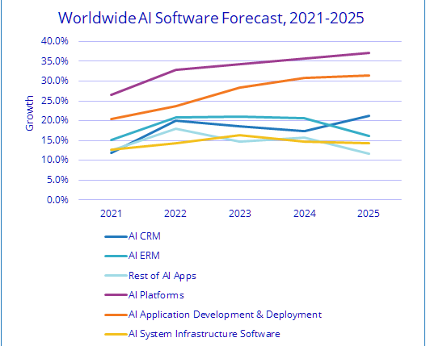
Figure 1: Forecast of AI software worldwide (2021-2025)
(Source: IDC, 2021)
The International Data Corporation (IDC) estimates the worldwide revenue for the AI market to show an 18.8% year-on-year growth by 2024, breaking the $500 billion milestone (IDC, 2021). Presently, AI software dominates nearly 88% of the AI market, however, AI hardware is predicted to show rapid growth in the coming years, with AI services expanding at the highest rate from 2023 onwards (IDC, 2021). Likewise, modern businesses are extensively using this technology to automate their routine operations, develop informed decisions through bulk data, improve productivity through automated solutions and use AI-powered talent sourcing and recruitment to effectively reach out to the most suitable candidates (Weitzman, 2022). In addition, E-Commerce platforms are using voice commands and automated chatbots to provide 24/7 customer service even in the absence of human customer support executives.

Predictive analysis tools
“Predictive analysis” is the process of obtaining data from pre-existing data sets to forecast the future of a business through probabilities. It is a data mining practice that helps businesses generate insights and predict the future of a business with the help of historical data, machine learning and statistical modelling (Gupta et al. 2020). Over the years, with technological advances, the usage of predictive analysis tools has increased exponentially and was forecasted to reach the US$11 billion milestone in the global market by 2022 (Vailshery, 2022).
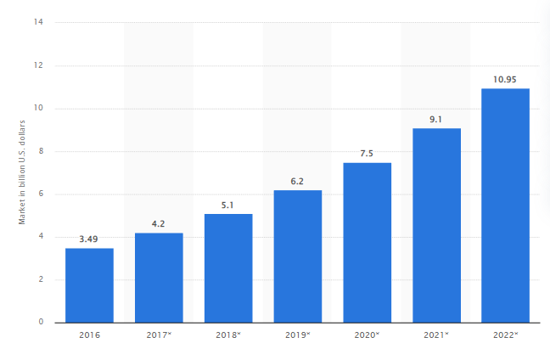
Figure 2: Worldwide market forecast of predictive analytics (2016-2022)
(Source: Vailshery, 2022)
Predictive analysis has grown as a reliable BI tool and is currently used by more than 80% of large enterprises all across the globe making it one of the most commonly used automatic intelligent technologies in the world. Through the help of big data analytics (BDA), predictive analysis tools generate massive volumes of information through different business interactions and analyse them to provide a better understanding of the underlying trends and dynamics of the target market. In the retail industry, Tesco is one of the major corporate giants known to use BDA to predict customer demands and generate market forecasts through historic data (Marr, 2016). In the hospitality sector, predictive analysis is being used to offer personalised experiences to customers, setting up perfect room prices for existing customers by analysing their historic behaviour and forecast demands in peak seasons to avoid overbooking. Similarly, several other industrial areas are using predictive analysis and BDA to facilitate effective growth and stay ahead in the market.

Natural Language Processing (NLP)
NLP is one of the most recent developments in artificial intelligence that enables computerised devices to comprehend, analyse, and modify the human language. The technology is developed to bridge gaps between machine comprehension and human communication by drawing on a variety of fields. Researchers identify NLP as one of the most potent forms of artificial intelligence that can enable computers and robots to interpret human language in spoken or written form and comprehend information (Kang et al. 2020). Some of the common trends of NLP that are relevant in the current and future market scenario are as follows:
- Speech recognition: accurately converting voice commands to text.
- Grammatical tagging: determining the part of speech from a particular test
- Word sense disambiguation: deriving the most appropriate meaning of words with multiple meanings according to the context.
- Sentient analysis: extracting subjective qualities from a piece of text, such as confusion, anger, sarcasm, suspicion and emotions.
- Natural language generation: converting "structured information" into the human language (IBM, 2022).
In the upcoming future, NLP is going to be extensively used in different industries to replace manual labour through digital assistance, speech-to-text software, voice-operated GPS, customer service chatbots and other areas of convenience. The NLP industry is expected to grow from about 3 billion US dollars in 2017 to more than $43 billion in 2025 (Thormundsson, 2022). The technology will play an accelerating role in different corporate solutions to enable better streamlining of corporate operations in the international market by simplifying business processes and encouraging workplace productivity. Through NLP, businesses will be able to identify the tone of different customer reviews without having to manually read large chunks of reviews.

Collaborative Business Intelligence
Modern business intelligence solutions are focused on collaborative approaches to enhance information and the decision-making process. Accordingly, collaborative BI tools are developed by combining 2.0 technologies with online collaborative instruments such as social media. Collaborative solutions are extensively used by modern businesses to improve industrial collaboration and bring a fresh outlook to market challenges with the help of advanced data and information technology. In the upcoming years, the global business intelligence market is expected to grow to more than 18 billion US dollars in 2025, rising from 15.2 billion in 2020 (Vailshery, 2022). Collaborative software is going to play a significant role in the future business run to facilitate better interactions with industrial groups and enable effective engagement with global industrial giants. These software applications will extensively assist corporations and businesses to expand their market dynamics and achieve futuristic objectives through enhanced customer interaction, supply chain and human resource management.

Embedded Analytics
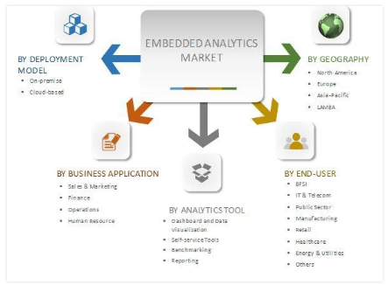
Figure 3: Global market segmentation of embedded analysis
(Source: Allied Market Research, 2017)
Gartner defines embedded analytics as a digital workplace capability in which the normal workflow of users is embedded with data analytics "without the need to toggle to another application" (Gartner, 2022). This technology is frequently used in specific applications such as demand forecasts, inventory planning, financial budgeting, optimisation of marketing campaigns and converting sales leads. Through the help of embedded analysis companies no longer have to rely on traditional spreadsheets for data and rather have learnt to use integrated dashboards to enable better value generation within applications. The embedded analytics market is forecasted to reach about 77.5 to million US dollars by 2026 with a CAGR of 13.6% from 2017 (Allied Market Research, 2017). Researches highlight that embedded analytics will have the fastest rate of growth in the contemporary market to facilitate valuable collaboration among stakeholders and give employees and customers the option to alter data and information in a recognisable environment for effectively deriving organisation and market insights.

Conclusion
In the 21st-century era, businesses are essentially focusing on automated technology and advanced solutions to accelerate corporate productivity and improve market efficiency. The trend has been significantly observed in the post-pandemic era as businesses all across the globe started focusing on digital growth and prioritising advanced logistics and supply chain management. The current report has highlighted some of the main BI trends that have significant potential in the future market scenario.

References
Allied Market Research, 2017. Embedded Analytics Market - Global Opportunity Analysis and Industry Forecast, 2016-2023. Available at:https://www.alliedmarketresearch.com/embedded-analytics-market (Accessed December 23, 2022).
Gartner, 2022. Embedded Analytics. Available at:https://www.gartner.com/en/information-technology/glossary/embedded-analytics (Accessed December 23, 2022).
Gupta, S., Drave, V.A., Dwivedi, Y.K., Baabdullah, A.M. and Ismagilova, E., 2020. Achieving superior organizational performance via big data predictive analytics: A dynamic capability view. Industrial Marketing Management, 90, pp.581-592.
IBM, 2022 What is natural language processing?, IBM. Available at: https://www.ibm.com/uk-en/topics/natural-language-processing (Accessed: December 22, 2022).
IDC, 2021. IDC Forecasts Companies to Spend Almost $342 Billion on AI Solutions in 2021. Available at:https://www.idc.com/getdoc.jsp?containerId=prUS48127321 (Accessed December 23, 2022).
Kang, Y., Cai, Z., Tan, C.W., Huang, Q. and Liu, H., 2020. Natural language processing (NLP) in management research: A literature review. Journal of Management Analytics, 7(2), pp.139-172.
Marr, B., 2016. Big Data At Tesco: Real Time Analytics At The UK Grocery Retail Giant. Available at:https://www.forbes.com/sites/bernardmarr/2016/11/17/big-data-at-tesco-real-time-analytics-at-the-uk-grocery-retail-giant/?sh=260f2ada61cf (Accessed December 23, 2022).
Satheesh, M.K., Samala, N. and Rodriguez, R.V., 2020. Role Of Ai-induced Chatbot in Enhancing Customer Relationship Management in the Banking Industry. ICTACT Journal on Management Studies, 6(4), pp.1320-1323. Availale at: https://ictactjournals.in/paper/IJMS_V6_I4_Paper_5_1320_1323.pdf (Accessed December 22, 2022).
Thormundsson, B., 2022. Natural language processing market revenue worldwide 2017-2025, Statista. Available at:https://www.statista.com/statistics/607891/worldwide-natural-language-processing-market-revenues/ (Accessed December 23, 2022).
Vailshery, L., S., 2022. Predictive analytics market forecast worldwide 2016-2022, Statista. Available at: https://www.statista.com/statistics/819415/worldwide-predictive-analytics-market-size/ (Accessed December 23, 2022).
Weitzman, T., 2022. The Top Five Ways AI Is Transforming Business. Available at:https://www.forbes.com/sites/forbesbusinesscouncil/2022/11/21/the-top-five-ways-ai-is-transforming-business/?sh=4b2407078e7f (Accessed December 23, 2022).

