IMPACT OF VIRTUAL LEARNING ENVIRONMENT

Table of Contents
Introduction 2
Data analysis 2
Primary data analysis 2
Secondary data analysis 8
Conclusion 12
References 13

Introduction
In the era of globalization, resource transfer has become a common thing. The importance of VLE can be mentioned in this context. The demand from learners is changing because the demand in the job market has changed. It can be expected that it will be changed dramatically within some years. In order to deal with the situation, VLE is extremely important. Considering this fact, the study will analyze both primary and secondary data on various aspects of VLE. The impacts, the issues related to using VLE, and the probable solutions to these problems will be an integral part of the study.

Data analysis

Primary data analysis
In order to conduct primary data analysis total of 20 respondents are chosen. A total of six questions are constructed regarding various aspects of VLE and the questions are as follows.
Question 1: Do you think that a major section of colleges will accept VLE in the future time?
Yes | 14
No | 5
May be | 1

Figure 1: Possibility of adoption of VLE in the near future
(Source: Created by self through excel)
While asking questions about the possibility of adopting VLE, in the near future, it is understood that most of the respondents think that the major colleges will adopt this in the near future. There is a very small section of respondent who does not have any idea about the probability of adoption of VLE in the near future. Some people think that colleges will not adopt VLE in the future. They may think that the issues related to VLE will not be possible to overcome in the near future. Changes in learning preferences can be mentioned in this context (Carter et al. 2020). There are many learners who want to gain knowledge on subjects which may not be available in the domestic country. In that respect, the importance of VLE can be mentioned. The expectation in the job market can also be mentioned in this context. Through VLE, a learner can improve their technical knowledge and it may be the reason for which a large section of respondents thinks that its importance will be increased and colleges will adopt it.
Question 2: What are the positive impacts of VLE?
Completion of syllabus within time | 11
Gaining more knowledge | 6
Cost effectiveness | 3

Figure 2: Positive impacts of VLE
(Source: Created by self through excel)
Based on the above figure, it can be said that a total of three kinds of answers are got from this question. Most of the respondents think that with the help of VLE, the syllabus can be completed within a specific time. Time saving is the factor which can be considered in this context. The percentages of people who think that cost-effectiveness is a positive impact are very less in percentage. Apart from that, there are other answers as well and this is gaining more knowledge.
There are many sources which are free to use in the recent time. Some of the sources are good as well and therefore some respondents think that it is gaining knowledge is its positive impact. There are many learners who faced the problem of time consumption because the distance between the house and university was very long (Fandiño et al. 2019). VLE is helpful to overcome the problem. According to the respondents, many learners has got the advantage of VLE and therefore they have said that.
Question 3: What are the negative impacts of VLE?
Loneliness problems | 10
Lack of understanding | 8
Reduction of eyesight power | 2

Figure 3: Negative impacts of VLE
(Source: Created by self through excel)
Along with positive impacts, there are negative impacts of using VLE as well. In this case, also three kinds of answers are got. Considering the above figure, it can be said that most of the learners think that the loneliness problem is one of the worst consequences of the adoption of a Virtual learning environment. A small percentage of respondents think that it can reduce eyesight. Furthermore, the other answer is a lack of understanding. Loneliness problems can create serious mental health issues and this is not good for a Lerner in the long term perspectives (Huang et al. 2019). The eyesight problem probability is higher for those who have already eye problems.

Question 4: What are the problems faced to adopt VLE?
Internet issues | 15
Lack of technological skill | 4
Lack of trust in VLE | 1

Figure 4: Problems faced while adopting VLE
(Source: Created by self through excel)
The above figure is regarding problems faced while adopting VLE. According to most of the respondents, the internet issue is the main thing and this is very much applicable for the learners who are from a rural section of the country. The percentage is lowest for lack of trust in VLE. Along with that, another answer is also got and this is a lack of technological skill. Due to the present pandemic situation, colleges and other institutions were forced to continue working from their home culture (Gunasinghe et al. 2020). Therefore learners had to come back to their homes and during this time, they faced an internet issue.
Question 5: What can be probable intuitive to overcome the problem?
Infrastructural development | 12
Increasing awareness | 3
Giving training on technological skill | 5

Figure 5: Probable initiative to overcome problems
(Source: Created by self through excel)
Under the consideration of the above figure, it can be said that infrastructural development can be the most effective solution to the problem. This is due to the fact that the internet issues are faced in rural sections because of having improper infrastructure. Apart from that, two more answers are got and these are increasing awareness as well as giving training on technological skills (Chui et al. 2020). The lowest percentage is for increasing awareness. It implies that most of the learners do not think that increasing awareness of VLE can be the main issue in the era of digitalization.
Question 6: Which type of VLE is used in most of the institutions?
Distance Learning Degree Programs | 8
Google classroom | 8
Professional Certification Courses. | 4

Figure 6: Type of VLE used in most of the institutions
(Source: Created by self through excel)
From the above figure, it can be said that different kinds of VLEs are used in different institutors. There are no answers which get the maximum percentage. In other words, it can be said that the number of respondents who think Distance Learning Degree Programs is followed in the most institution and the number who think that Google classroom is used by institutors is the same. Personal certification courses are another answer which can is also seen in the above figure. The importance of these examples can be understood during the pandemic situation. Otherwise, it was quite problematic to continue the studies (Bogusevschi et al. 2020).

Secondary data analysis
Considering the present times, it can be said that all the things are becoming digitalized. The learning process is not an exceptional case in this context. The present pandemic situation is helpful to understand the importance of VLE. With the help of VLE, it was possible for the schools and colleges to continue the study process. The importance of different kinds of mobile applications can be mentioned in this context (Herrador-Alcaide, et al. 2020). Due to the situation, many learners were forced to come to the home and for some learners, they had to come back home as they are associated with a foreign university. In this case, also they did not face problems and VLE can be mentioned as a reason.
There are differences in opinion about the impact of VLE. According to some people, there are positive impacts of VLE but there are some persons who think that VLE has both positive and negative impacts on the learning process. VLE helps in saving time and this is really beneficial for the learners whose home is far from college. Therefore the possibility of completing the task is high within a specific time period (caw.ac.uk, 2022). In the future, the skill of technology will be high in demand. A virtual learning environment is helpful to bring improvement to this skill within learners. The availability of sources can also be mentioned under the benefits of VLE. The following figure is presented with respect to this point
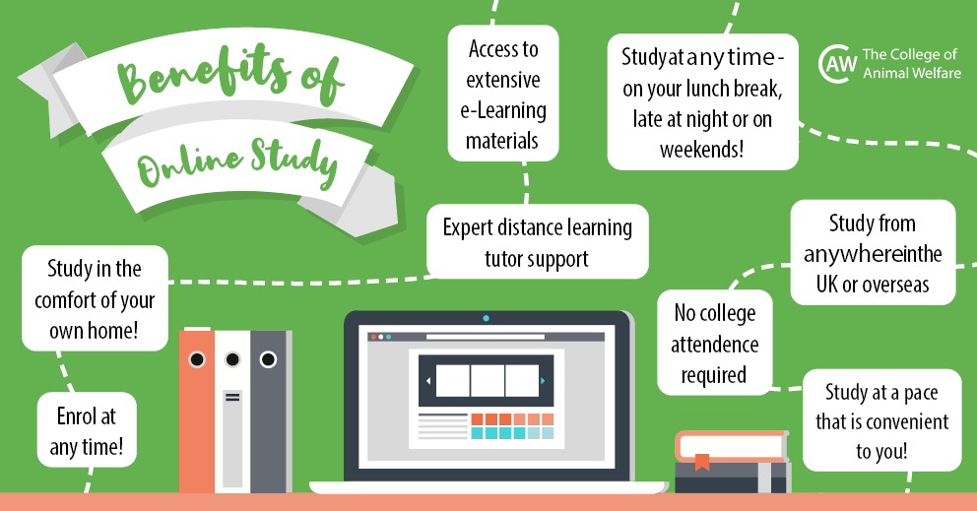
Figure 7: Benefits of VLE
(Source: caw.ac.uk, 2022)
The above figure denotes the benefits of enrollment at any time from any place. However, there are negative impacts of it as well. Based on the evidence, it can be said that physical health is hampered due to using mobile and computers for a longer period of time. Concentration problem is another thing which is also identified. There are many studies in which it can be said that learners have become much lonely and it has an indirect negative impact on the learning process (Sharadgah and Sa'di, 2020). During the pandemic period, some learners had to go for counseling. It has been observed that the percentage of this kind of learner is increasing with time.
It is not possible for all the learners to get the maximum advantage from VLE. This is because of lack in internet facility. There are some areas both in urban and rural, especially in the rustic area in which there is no proper infrastructure or internet. Therefore some learners could not get the advantage of VLE. They could not attain the classes properly. There are different kinds of sources through which information can be collected. However, before the collection of data checking authenticity is very important. Many learners do not know the way of identifying authenticity (Torres Martín et al. 2021). In this way, they can be misguided about information. Some important skills are required to be mentioned. Research skills, as well as technical skills, are something which is needed most. Some learners cannot get the advantage because of not being proficient in these skills. Lack of awareness of the benefits of VLE can also be mentioned in this regard.
The usefulness of VLE can be understood based on some determinates. The following figure is presented in this respect.
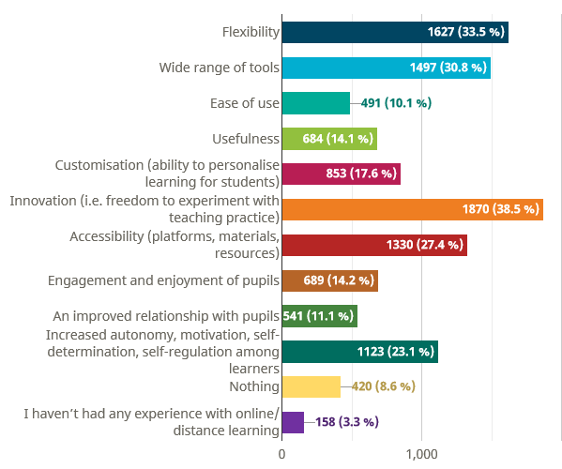
Figure 8: usefulness of VLE
(Source: schooleducationgateway.eu, 2022)
This figure is got based on a recent survey. The most important thing is that innovation can be adopted under VLE which will be helpful for the learners to get more facilities under learning preferences. The percentage of "ease of use" is low and this percentage needs to be changed within a very short span of time.
The internet facility in all the places should be improved. The role of the Government should not be ignored. It will be better if any private organization takes part in it. The college authority should have a look at this matter as well. It is important to take proper initiative so that learners can be improved in technological skills and research skills. The situation of the pandemic is quite controlled now and therefore training can be provided to improve these skills. Arrangement of the campaign can also be the probable solution through which the learners and guardians can understand the importance of VLE (Borba et al. 2018). Some guardian thinks that VLE is not useful for the future of learners.

Conclusion
The overall elaboration helps in understanding that the number of benefits of adoption of VLE is higher than its negative impacts. The discussion indicates different kinds of problems related to the adoption of VLE. It is not opposable to use and get the benefit of VLE for all kinds of learners. Therefore initiative should be taken in such a way so that VLE can be accepted by all kinds of learners. The intervention of the Government can be mentioned. There are different kinds of distance education courses on which the demand for learners has increased. The pandemic situation is a great example to understand the actual importance of VLE. The context of learning preference change should also not be ignored in this regard.

References
Bogusevschi, D., Muntean, C., and Muntean, G. M. (2020). Teaching and learning physics using 3D virtual learning environment: A case study of combined virtual reality and virtual laboratory in secondary school. Journal of Computers in Mathematics and Science Teaching, 39(1), 5-18.
Borba, M. C., Chiari, A. S. D. S., and de Almeida, H. R. F. L. (2018). Interactions in virtual learning environments: new roles for digital technology. Educational Studies in Mathematics, 98(3), 269-286.
Carter Jr, R. A., Rice, M., Yang, S., and Jackson, H. A. (2020). Self-regulated learning in online learning environments: strategies for remote learning. Information and Learning Sciences.
caw.ac.uk, 2022. Why Study Online? 10 Benefits of Online Learning - CAW Blog. [online] CAW Blog. Available at: <https://blog.caw.ac.uk/index.php/caw-news/benefits-of-online-learning/> [Accessed 4 May 2022].
Chui, K. T., Fung, D. C. L., Lytras, M. D., and Lam, T. M. (2020). Predicting at-risk university students in a virtual learning environment via a machine learning algorithm. Computers in Human Behavior, 107, 105584.
Fandiño, F. G. E., Muñoz, L. D., and Velandia, A. J. S. (2019). Motivation and E-Learning English as a foreign language: A qualitative study. Heliyon, 5(9), e02394.
Gunasinghe, A., Hamid, J. A., Khatibi, A., and Azam, S. F. (2020). The viability of UTAUT-3 in understanding the lecturer's acceptance and use of virtual learning environments. International Journal of Technology Enhanced Learning, 12(4), 458-481.
Herrador-Alcaide, T. C., Hernández-Solís, M., and Galván, R. S. (2019). Feelings of satisfaction in mature students of financial accounting in a virtual learning environment: an experience of measurement in higher education. International Journal of Educational Technology in Higher Education, 16(1), 1-19.
Huang, Y. C., Backman, S. J., Backman, K. F., McGuire, F. A., and Moore, D. (2019). An investigation of motivation and experience in virtual learning environments: a self-determination theory. Education and Information Technologies, 24(1), 591-611.
schooleducationgateway.eu, 2022. Survey on online and distance learning – Results. [online] SchoolEducationGateway. Available at: <https://www.schooleducationgateway.eu/en/pub/viewpoints/surveys/survey-on-online-teaching.htm> [Accessed 4 May 2022].
Sharadgah, T. A., and Sa'di, R. A. (2020). Preparedness of institutions of higher education for assessment in virtual learning environments during the Covid-19 lockdown: Evidence of bona fide challenges and pragmatic solutions. Journal of Information Technology Education. Research, 19, 755.
Torres Martín, C., Acal, C., El Honrani, M., and Mingorance Estrada, Á. C. (2021). Impact on the virtual learning environment due to COVID-19. Sustainability, 13(2), 582.

