Suspect Interview Theft Task Sheet
Scenario 12 Vehicle Interference-Suspect brief

Suspect Brief
Suspect details: (use your own name)
Suspect address: (use your own address)
Location: Kingsway industrial estate carpark, BRIDGEND
Time of the incident: Approx 1 hour before the time the initial statement was taken

!! Watch the film clip !!

You are a drug user with a significant criminal record who has to raise significant funds to feed your drug habit, at the time specified, you attended Kingsway industrial estate carpark, BRIDGEND. You took an old flat headed screwdriver with you in order to break into vehicles on the site and steal items from within the vehicles. You are under the impression that there is no cctv on the site.

You have started to attack a vehicle when a person has challenged you, you have told them that you own the van but they have revealed that they are in fact the owner and you have decided to run away from them out of the industrial unit.
You dropped the screwdriver as you run but decided not to stop and pick it up as you thought other people were nearby and you didn’t want to get caught.
You do not know the victim of the theft, you have no reason for targeting this van other than its location.
You were arrested this morning, your reply to caution was “I HAD TO GET SOME MONEY BECAUSE I NEEDED SOME DRUGS”

Interview Information-
You agree that you used to own the screwdriver but you will repeatedly state that the screwdriver was stolen from your garage and that you had nothing to do with the theft.

Deny that you were at the scene.
Deny having anything to do with the incident.
Dispute the caution reply on the statement if asked, say the police officer made that up

Aims of the Scenario

- The aim of investigative interviewing is to obtain accurate and reliable accounts from victims, witnesses or suspects about matters under police investigation.
- Investigators must act fairly when questioning victims, witnesses or suspects. Vulnerable people must be treated with particular consideration at all times.
- Investigative interviewing should be approached with an investigative mind-set. Accounts obtained from the person who is being interviewed should always be tested against what the interviewer already knows or what can reasonably be established.
- When conducting an interview, investigators are free to ask a wide range of questions in order to obtain material which may assist an investigation.
- Investigators should recognise the positive impact of an early admission in the context of the criminal justice system.
- Investigators are not bound to accept the first answer given. Questioning is not unfair merely because it is persistent.
- Even when the right of silence is exercised by a suspect, investigators have a responsibility to put questions to them.

Outcome of the Scenario

- Aim: To Provide interviewers with the competence to prepare and plan interviews with suspects.
- Objectives
- Assess information gathered about suspect(s)
- Assess the type and current condition of the suspect to inform the approach to the interview in accordance with legal requirements.
- Establish the correct interview approach utilising the engage and explain phase aide memoir
- Identify the nature of the allegation and identify investigative important information
- Produce a written interview plan that takes account of the suspect assessment , the needs of the investigation and legal requirements
- Select and set up the necessary interview location, resources and personnel.

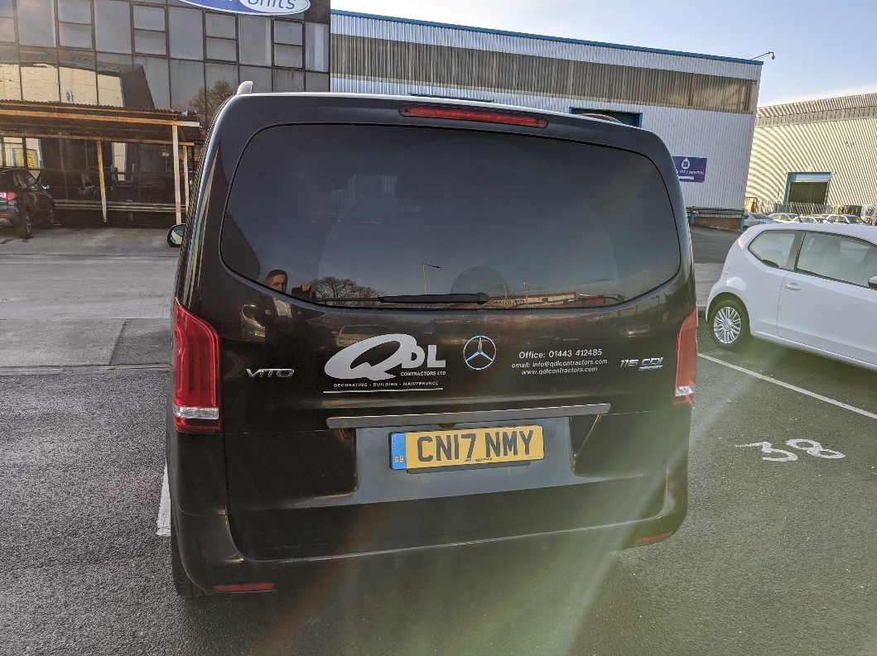

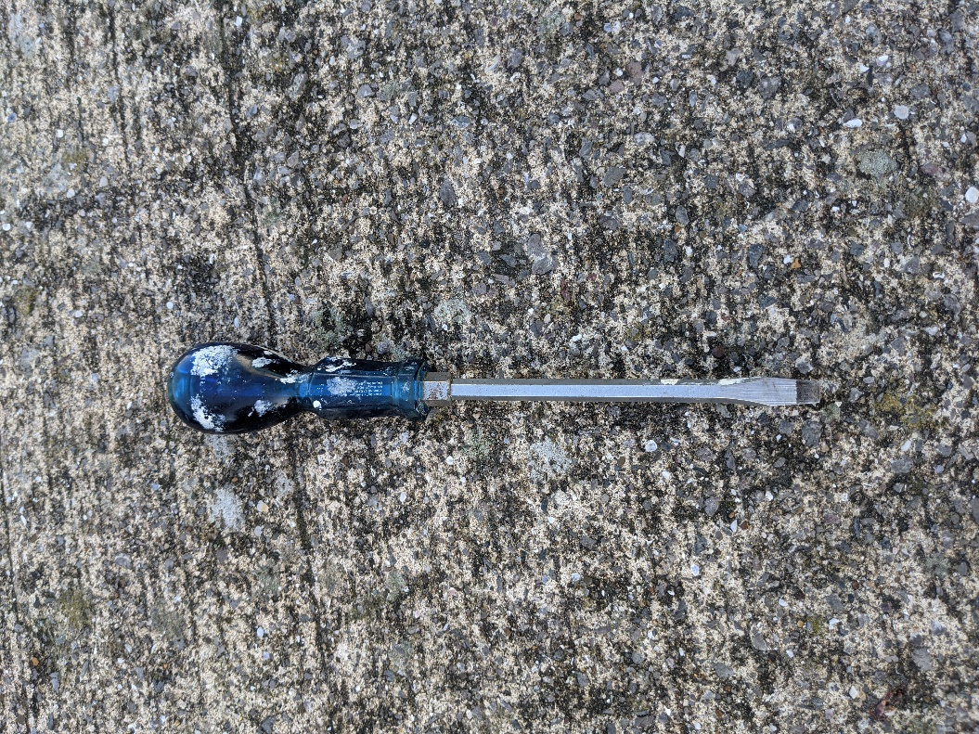

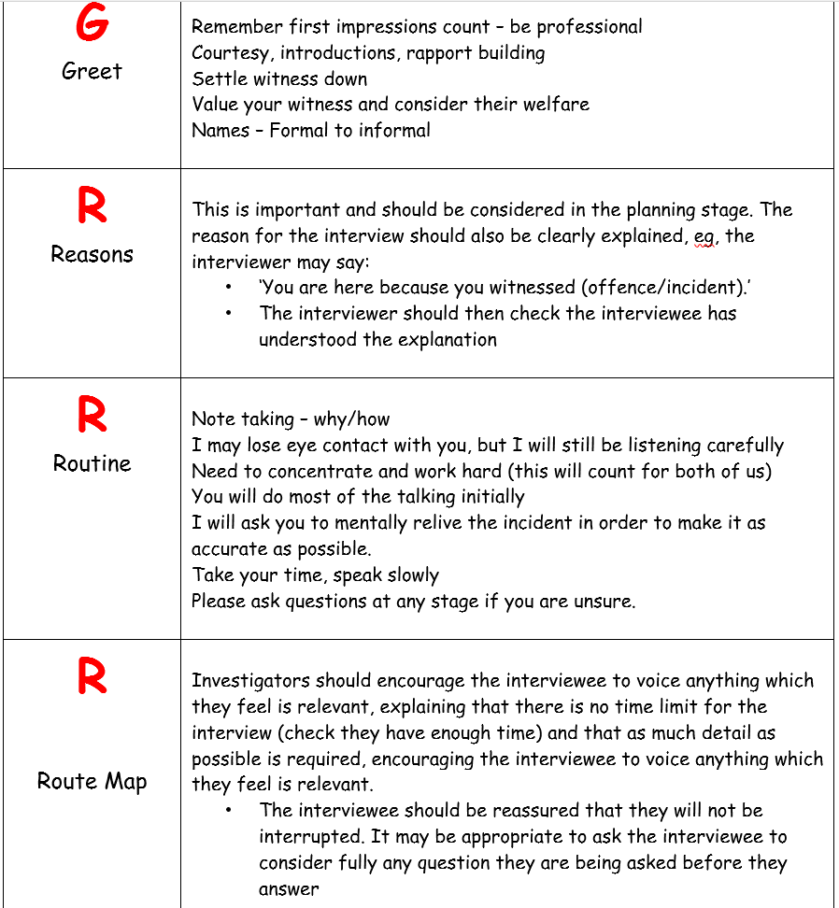

S9 Criminal attempts act 1981

Interference with vehicles.
(1)A person is guilty of the offence of vehicle interference if he interferes with a motor vehicle or trailer or with anything carried in or on a motor vehicle or trailer with the intention that an offence specified in subsection (2) below shall be committed by himself or some other person.
(2)The offences mentioned in subsection (1) above are—
(a)theft of the motor vehicle or trailer or part of it;
(b)theft of anything carried in or on the motor vehicle or trailer; and
(c)an offence under section 12(1) of the M1Theft Act 1968 (taking and driving away without consent);
and, if it is shown that a person accused of an offence under this section intended that one of those offences should be committed, it is immaterial that it cannot be shown which it was.
(3)A person guilty of an offence under this section shall be liable on summary conviction to imprisonment for a term not exceeding three months or to a fine not exceeding [F1level 4 on the standard scale] or to both.
(4). . . . . . . . . . . . . . . . . . . . . . . . . . . . . . . . F2
(5)In this section “motor vehicle” and “trailer” have the meanings assigned to them by [F3section 185(1) of the Road Traffic Act 1988].

