3. Gas Exchange Worksheet
This is a diagram of an alveoli. The blood going in is blue and leaving is red. Can you colour the blood vessels to show this.

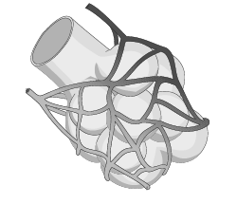

There is a huge amount of surface area in the lungs. If the whole inside surface was laid out flat, it would easily cover a tennis court!!!
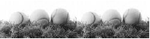

This is a diagram of the inside of an alveoli.
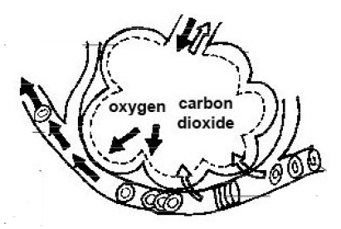
On this diagram:
- Colour the blood cells either blue or red.
- Add the labels to the diagram using the words below.

deoxygenated blood oxygenated blood alveoli oxygen carbon dioxide
blood capillary
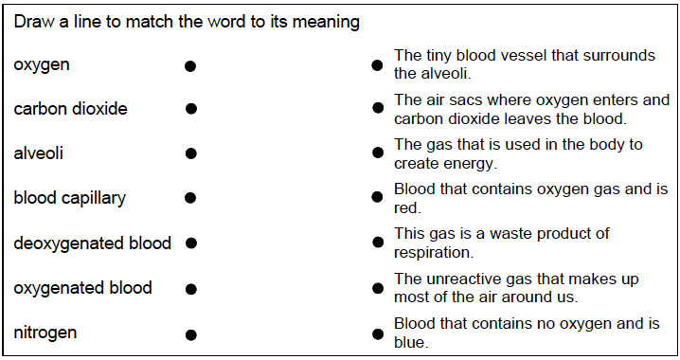

How thick are the walls of the alveoli?

…………………………………………………………………………………………………………………………………………..

Which two gases diffuse in the alveoli?

1. …………………………………………………….

2. …………………………………………………….

Where does the oxygen go once it is in the blood?

…………………………………………………………………………………………………………………………………………..

…………………………………………………………………………………………………………………………………………..

…………………………………………………………………………………………………………………………………………..

