Development of future Marketing Strategies of the Virgin Group

Module: Marketing Management
Course: Masters of Business Administration

Report by: Rudra Pankaj Bhai Patel
Student no. 2229997

Table of Contents
Executive Summary 3
1. Introduction 4
2. Task 01: Findings 4
2.1 Concept and Importance of Marketing 4
2.2 Macro and Micro Marketing Environment 6
2.2.1 Macroenvironment Factors 6
2.2.2 Microenvironmental Elements 7
2.3 Target Market Identification and Marketing Material Effectiveness 8
2.3.1 Identification Of The Target Market 8
2.3.2 Process/Indicators for Determining the Target Market: 8
2.4 Evaluation of the Success of Marketing Material 9
2.5 Selection of Media Channels/Communication Methods: 9
2.5.1 Media Outlets and Communication Techniques 9
2.5.2 Effectiveness and Suitability of Media Channels 10
2.6 Key Performance Indicators (KPIs) for Effectiveness in Marketing 11
3. TASK 02: Conclusion on the Shortcomings of Virgin Group's Marketing Strategy 12
4. Task 3: Recommendations for Improving Virgin Group's Marketing Strategy 14
4.1 Create a Consistent Framework for Brand Messaging 14
4.2 Refine Target Market Segmentation 14
4.3 Utilize Data-Driven Channel Selection 14
4.4 Enhance Measurement and Analysis 15
4.5 Foster Integration and Collaboration 15
4.6 Enhance the customer experience 15
References 17

Executive Summary
This study offers recommendations for enhancing the Virgin Group's marketing strategy while critically assessing the function and operations of the marketing division. Analysis of the macro and micro marketing environments, target market identification, effectiveness testing of marketing collateral, and media channel analysis were all part of the evaluation process. According to the findings, a number of issues were found, including inconsistent brand message, a lack of target market segmentation, a poor choice of media channels, inadequate measuring procedures, and a lack of connectivity between business units.
There have been given specific ideas on how to fix these flaws. These suggestions include creating a unified framework for brand messaging, enhancing target market segmentation, using data-driven channel selection, improving measurement and analysis practices, fostering integration and collaboration, embracing innovation and experimentation, enhancing customer experience, and encouraging continuous learning and adaptation.
By putting these suggestions into practice, the Virgin Group will be able to improve their marketing efficiency, raise customer engagement and brand awareness, boost sales growth, and get a better return on investment. It is vital to take into account whether these recommendations can be implemented given the organization's financial and resource constraints. The Virgin Group may boost their marketing strategy, build a strong brand presence, and successfully service their target markets by addressing the found weaknesses and putting the suggested improvements into practice. Overall, this will help the Virgin Group thrive and expand in the cutthroat commercial environment.

Introduction
Within organizations, particularly the well-known Virgin Group, the marketing division is crucial. The marketing department's position and operations within the Virgin Group are critically assessed in this study, along with plans for future growth in response to problems that have been found. The Virgin Group's marketing investments will be highlighted as the idea and value of marketing are examined. To comprehend how outside influences affect the organization's marketing strategy, a macro and micro analysis of the marketing environment will be done.
The analysis will also look at how to identify target markets, how effective marketing materials are, and how to choose communication media. Based on the examination that was done, the study will also evaluate the Virgin Group's marketing strategy's flaws. There will be suggestions made to improve the approach while taking into account its viability given the available funds and resources. This research seeks to offer insights into enhancing marketing effectiveness and propelling future growth within the company by critically assessing the marketing initiatives of the Virgin Group and making insightful recommendations.

Task 01: Findings

Concept and Importance of Marketing
Creating, communicating, providing, and exchanging value with consumers, clients, partners, and society at large are all part of the fundamental concept of marketing in business. Understanding client needs and wants, creating goods or services to meet those needs, and successfully marketing and distributing them to specific markets are all part of it. It is impossible to exaggerate the value of marketing in business. Marketing is essential in determining the wants, preferences, and pain areas of the client. Businesses can create goods and services that add value and address customers' problems by comprehending their needs and motivations. Marketing aids in differentiating offerings, strategically placing them, and developing a distinctive value proposition that draws in and keeps customers.
According to Kotler and Armstrong (2001), the marketing notion is essential for increasing customer value and boosting sales. Businesses rely on marketing to increase sales and revenue. Advertising, sales promotions, and lead generation are just a few examples of the different marketing techniques that businesses can use to boost their brand recognition, connect with more people, and ultimately enhance client acquisition. Sales, market share, and profitability can all rise as a result of efficient marketing initiatives. Marketing is crucial in building and enhancing brand equity. A solid brand identity developed through efficient marketing strategies aids in setting a business apart from rivals, encourages client loyalty, and establishes favorable brand connotations. Increased client trust, higher perceived value, and the capacity to demand premium prices are all influenced by brand equity.
Conducting market research and obtaining customer insights are both important aspects of marketing. This aids companies in comprehending consumer preferences, market trends, and evolving consumer behavior. Companies can adjust their offers, make informed judgements, and create powerful marketing plans to target particular customer categories by using this information. The Virgin Group is renowned for its marketing expertise and large financial commitments to marketing initiatives. To raise brand awareness and engage consumers, it devotes significant financial resources to advertising campaigns, promotions, and sponsorships. The Virgin Group devotes a significant amount of financial resources to marketing initiatives and advertisements (Virgin Group, 2021). The business also makes human resource investments, hiring qualified marketers who can create and implement successful marketing plans. The Virgin Group's marketing initiatives place a lot of emphasis on technological infrastructure, which includes digital marketing platforms and customer analytics tools.
The Virgin Group can reach and engage its target markets, create brand equity, and promote commercial success by utilizing these tools. Investments in marketing by the corporation are in line with its overarching goal of providing innovative and customer-focused experiences throughout its varied range of enterprises.

Macro and Micro Marketing Environment

Macroenvironment Factors
- Economic Conditions: The Virgin Group's marketing approach is highly impacted by economic factors like GDP growth, inflation rates, and customer purchasing power. Economic downturns can have an impact on consumer spending and the demand for particular goods or services, necessitating changes to marketing strategies, promotions, and pricing.
- Socio-cultural Trends: The Virgin Group's marketing choices are influenced by changing societal attitudes, values, and cultural conventions. The marketing strategy of the Virgin Group is influenced by macroenvironmental factors like economic conditions and sociocultural trends (Johnson & Scholes, 2008). For instance, the corporation has incorporated CSR activities into its marketing communications to appeal to customers who are socially and environmentally conscious due to the growing interest in sustainability.

- Rapid technical advancements have a significant impact on the marketing strategy of the Virgin Group. To effectively reach and engage customers, it must adapt to shifting digital environments, take advantage of innovative technologies, and make use of a variety of digital marketing channels. Innovation in products as well as the inclusion of digital experiences in the marketing mix are influenced by technological improvements.
- Legal and Regulatory Factors: The Virgin Group's marketing strategies are influenced by legal and regulatory frameworks such consumer protection laws, advertising rules, and data privacy requirements. These laws' observance guarantees moral marketing behavior and guards against reputational threats.
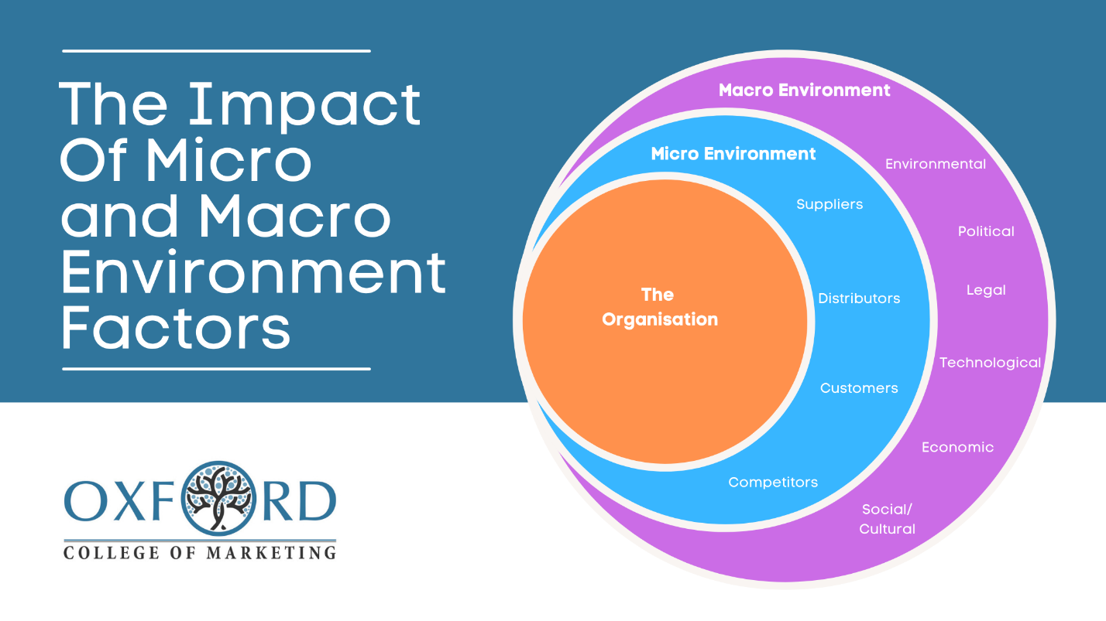
- Competitive Landscape: The Virgin Group's marketing choices are heavily influenced by the competitive climate in which it works. The Virgin Group's capacity to stand out from the competition and draw clients is impacted by the marketing tactics, product offers, price, and positioning of rivals. For an organization to remain relevant in the market, it is crucial to monitor and react to competitive dynamics.
Figure 1: Macro and Micro Marketing Environment

Microenvironmental Elements
- Customers: Virgin Group's marketing plan must take into account the demands, tastes, and behaviors of its target market. Market research, audience segmentation, and the creation of customer personas all aid in the customization of marketing messages and the provision of individualized experiences.
- Suppliers: The Virgin Group's marketing choices are influenced by its connections with suppliers since these factors affect the accessibility, value, and price of the inputs needed to deliver goods and services. Collaboration with suppliers can help with value generation and successful marketing initiatives.
- Distributors, retailers, and online platforms all function as intermediaries in the distribution and marketing of the Virgin Group's goods and services. Effective marketing and achieving target markets depend on forming trusting relationships with intermediaries and being aware of their strengths and weaknesses.
- Competitors: The Virgin Group uses competitor analysis to spot market trends, compare its offers to those of rivals, and set itself apart. Success depends on keeping an eye on marketing tactics used by rival companies and strategically responding to preserve a competitive advantage.
A combination of macro and microenvironmental elements affect the marketing choices and plans of The Virgin Group. The organization can negotiate market dynamics, anticipate client wants, and maintain competitiveness in the industries it works in by understanding and adjusting to these elements.

Target Market Identification and Marketing Material Effectiveness

Identification Of The Target Market
Each company within the Virgin corporation may have a varied target market because the corporation works in a variety of industries. When identifying a target market, demographic, psychographic, and geographic aspects must be taken into account (Kotler & Keller, 2016). The Virgin Group probably uses a combination of market research, segmentation analysis, and consumer profiling to determine their target market(s). They can better identify their target market(s) if they are aware of the traits, requirements, and preferences of various consumer categories.

Process/Indicators for Determining the Target Market:
When deciding on their target market or markets, The Virgin Group may take into account a number of criteria, such as:
- Age, gender, income, education, occupation, and other demographic factors can be used to identify and segment the target market for particular goods and services.
- Lifestyle, beliefs, attitudes, interests, and behavior patterns all play a part in determining the target market by helping us understand customer motivations and preferences.
- Geographics: When defining target markets, The Virgin Group may take into account geographic considerations like location, urban/rural locations, or regional preferences.
- Benefits and Usage: Analyzing customer benefits preferences and product usage trends might assist in focusing marketing efforts on particular market segments.

Evaluation of the Success of Marketing Material
Based on brand memory and customer involvement, marketing materials' efficacy can be assessed (Kotler et al., 2020). Consider the following when assessing the Virgin Group's marketing efforts, including its advertising, campaigns, and promotional content:
- Examine whether the marketing materials are consistent with the Virgin Group's core beliefs, values, and positioning. Consistency contributes to increased customer trust and brand awareness.
- Clarity and Relevance of the Marketing communications: Consider the clarity and relevance of the marketing communications. A clear value proposition, a focus on important advantages, and a resonance with the wants and desires of the target market are all characteristics of effective marketing collateral.
- Consider the marketing material's originality, ingenuity, and aesthetic appeal. Effectiveness can be increased by using memorable and attention-grabbing images, gripping narrative, and interesting material.
- Call to Action: Assess the marketing materials' success in inspiring the target market to take the intended activities. An effective call to action can be measured by promoting purchases, inquiries, subscriptions, or social media activity.
- Measurable Results: Seek proof of measurable results, such as higher brand recognition, website traffic, lead generation, or conversion rates. Understanding the effectiveness of the marketing materials can be gained by analyzing the available data and analytics.

Selection of Media Channels/Communication Methods:

Media Outlets and Communication Techniques
The Virgin Group engages with clients directly through social media channels including Facebook and Twitter (Kaplan & Hoenlein, 2010). These may consist of:
- Facebook, Twitter, Instagram, LinkedIn, and YouTube are just a few of the social media channels where The Virgin Group regularly interacts with its target audience. Direct communication, content sharing, brand storytelling, and the advertising of goods and services are all made possible by these platforms.
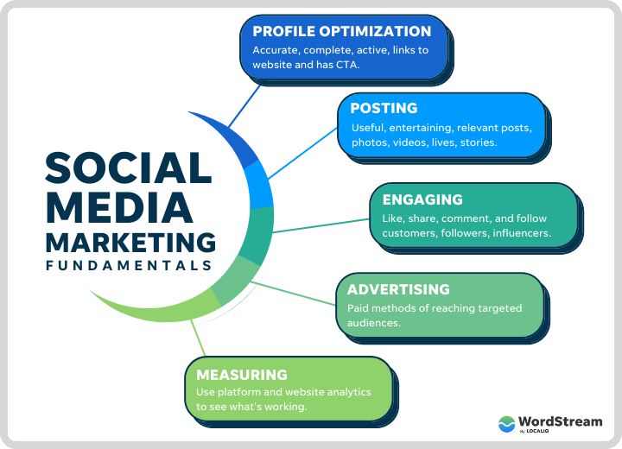
- Email marketing is a popular strategy employed by the Virgin Group to contact customers, give updates, and make tailored offers. They probably use targeted email campaigns to speak to particular client base segments.
Figure 2: Social Media Marketing for Businesses, Source: Word stream
- The Virgin Group understands the value of being found in search engines through search engine optimization (SEO). They may boost organic traffic and enhance their online visibility by making their websites and content search engine friendly.
In order to engage and inform its target audience, The Virgin Group produces and distributes informative content, such as blog entries, articles, videos, and podcasts. Building trust with customers and thought leadership are two benefits of content marketing.
e. Traditional Advertising: To reach a larger audience and strengthen their brand visibility, The Virgin Group may continue to use traditional advertising channels like print media, television, radio, and outdoor billboards.

Effectiveness and Suitability of Media Channels
The features of the target market(s), the nature of the products/services being promoted, and the overall marketing objectives all affect how relevant and effective the media channels utilized by the Virgin Group are. Here are some things to think about:
- Platforms for social media: Social media is useful for reaching a wide audience, interacting with clients directly, and utilizing user-generated material. These platforms are an efficient way to communicate with The Virgin Group's target market, which may include tech-savvy and socially connected individuals.
- Email marketing: Email marketing enables targeted client segmentation and personalized communication. It works well for fostering relationships with customers, promoting offers, and increasing conversions. The client database and segmentation techniques used by Virgin Group can improve the efficacy of email campaigns.
- Search Engine Optimization (SEO): According to Strauss and Frost (2020), SEO increases the Virgin Group website's online presence. They may draw organic traffic and make sure that their brand and offerings are discoverable by optimizing their website and content.
- Content Marketing: According to Pulizzi (2017), Virgin Group uses content marketing to develop thought leadership and brand loyalty. The quality and relevancy of the information created, as well as the distribution channels used, all affect how effective content marketing is.
- Advertising through conventional media: These channels may have a wider audience, but their performance varies according to the target audience and the particular goals of the campaign.
The Virgin Group continues to use conventional advertising platforms including television and print media to reach a bigger audience (Fill, 2019). The Virgin Group may use conventional advertising to promote its brand and strengthen its reputation.
It is crucial for the Virgin Group to regularly evaluate the suitability and efficacy of various media outlets and communication strategies by keeping an eye on statistics like engagement rates, click-through rates, conversion rates, and consumer feedback. This makes it possible to modify and improve marketing plans in order to reach the target market(s) and spread the brand message as effectively as possible.

Key Performance Indicators (KPIs) for Effectiveness in Marketing
The Virgin Group may monitor a number of key performance metrics to assess how well their marketing plan is working. Typical KPIs can include:
- Conversion Rates: Analyzing conversion rates at various points in the customer journey, such as from website visits to purchases, can assist determine how well marketing is working to motivate desired behavior. Marketing effectiveness is measured using metrics like conversion rates and client lifetime value (Kaplan & Norton, 2004; Reibstein, 2010).
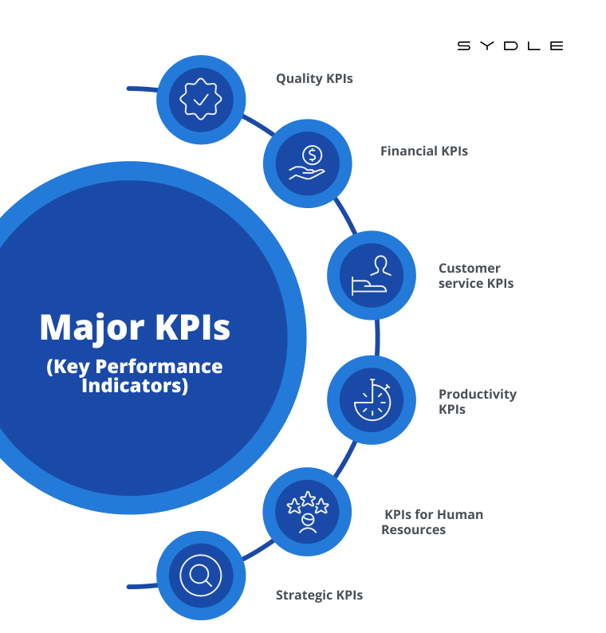
- Customer Lifetime Value (CLTV): CLTV sheds light on the value earned over the long term by clients attracted through marketing activities. A higher CLTV shows that marketing is effective in luring worthwhile and devoted clients.
Figure 3: KPI's for Effectiveness in Marketing
- Customer Retention Rate: The Virgin Group can evaluate the success of marketing in nurturing customer loyalty and lowering turnover by tracking the percentage of customers who remain over time.
- Customer Satisfaction and Net Promoter Score (NPS): By conducting customer satisfaction surveys and calculating NPS, businesses can gauge how well their marketing efforts are influencing the happiness and loyalty of their customers. Insights into customer perception can be found in customer satisfaction surveys and Net Promoter Score (NPS) calculations (Reichheld, 2003).

TASK 02: Conclusion on the Shortcomings of Virgin Group's Marketing Strategy
The Virgin Group may have difficulties when incorporating corporate social responsibility (CSR) into promotional materials (Lindgreen & Swaen, 2010). Several significant conclusions and flaws in the Virgin Group's marketing plan can be made in light of the data and analysis used in Task 1. These consist of:
The Virgin Group has identified target markets for its goods and services, but there may be potential for improvement in terms of segmentation and personalization of marketing messaging. The relevance and efficiency of marketing initiatives can be increased by further honing the targeting of particular client segments. Although the Virgin Group makes use of a variety of media outlets and communication techniques, there may be space for improvement in the channel selection and resource allocation. Marketing results could be improved by taking a more data-driven approach to media planning and choosing the best channels for reaching target audiences.
- Insufficient Measurement of Marketing Effectiveness: The Virgin Group probably uses a variety of measures and KPIs to gauge marketing effectiveness, but more, more standardized measurement techniques may be required. Virgin Group's marketing research is challenged by ethical marketing factors such consumer privacy and openness (Smith & Murphy, 2012). More precise information on the results of marketing initiatives can be obtained through improving measurement of marketing campaigns, monitoring customer engagement, and setting up distinct ROI standards.
- Limited Integration Across Business Units: The Virgin Group manages a number of companies under its wing, and there might be room to enhance integration and synergy in marketing operations. Customer image and brand loyalty can be improved by ensuring a unified and consistent brand experience across all business units.
- Lack of Consistent Brand message: The Virgin Group works in a variety of industries; therefore, brand message may fluctuate amongst company divisions. This may weaken the overall brand identity and affect how well marketing initiatives work.
The Virgin Group's marketing strategy has some drawbacks, including inconsistent brand messaging, a lack of target market segmentation, a poor choice of media outlets, inadequate measurement of marketing effectiveness, and weak cross-business unit integration. The Virgin Group may strengthen their marketing strategy and increase overall efficacy in reaching and engaging their target markets by addressing these areas for improvement.

Task 3: Recommendations for Improving Virgin Group's Marketing Strategy
Here are practical suggestions for enhancing the Virgin Group's marketing strategy based on the findings from Task 2, taking into consideration their viability given the available funds and resources:

Create a Consistent Framework for Brand Messaging
- Create a framework for brand messaging that is consistent and in line with the overarching identity and values of the Virgin Group.
- Virgin Group's marketing initiatives in the constantly changing social media landscape can benefit from leveraging social media influencers and user-generated content (Kaplan & Heinlein, 2010).
- To establish a unified brand experience, make sure the brand messaging is consistent across all business units, goods, and services.

Refine Target Market Segmentation
- To more accurately identify and segment target markets, do in-depth market research.
- Address the particular wants, preferences, and pain points of targeted customer segments in marketing communications and campaigns.

Utilize Data-Driven Channel Selection
- Spend money on data analytics and research to determine the best communication channels and platforms for reaching and engaging target audiences.
- Allocate resources to channels that show a higher return on investment and modify marketing budgets, as necessary.
- Concerns about ethics in marketing research for the Virgin Group can be addressed by following ethical norms and gaining informed permission (American Marketing Association, 2020).

Enhance Measurement and Analysis
- Implement a thorough framework for measuring marketing performance that is in line with organizational goals.
- Consistently monitor and evaluate important indicators, such as ROI, conversion rates, customer lifetime value, and brand recognition.
- Utilize technologies and techniques for marketing analytics to obtain deeper understanding and guide data-driven decision-making.

Foster Integration and Collaboration
- Encourage information sharing and cross-functional cooperation amongst various Virgin Group business units.
- Establish centralized marketing policies, procedures, and best practices to guarantee consistent brand messaging and representation.

Enhance the customer experience
- Delivering outstanding client experiences at all touchpoints should be your main priority.
- Utilize client feedback, surveys, and analytics to pinpoint problems and areas where the customer journey may be made better. The Virgin Group should make sure that its CSR actions are transparent and genuine in order to solve the issues with CSR in advertising material (Maignan & Ferrell, 2001).
- Personalize marketing initiatives to increase client loyalty and pleasure.

References
Aaker, D. A. (1996). Building strong brands. Free Press.
Baines, P., Fill, C., & Rosengren, S. (2017). Marketing. Oxford University Press.
Chaffey, D., & Smith, P. R. (2017). Digital marketing excellence: Planning, optimizing, and integrating online marketing. Routledge.
Direct Marketing Association. (2018). GDPR for Direct Marketers: Essential Guides. Retrieved from https://dma.org.uk/gdpr/dma-guidance
European Commission. (2018). General Data Protection Regulation (GDPR). Retrieved from https://ec.europa.eu/info/law/law-topic/data-protection_en
Fill, C. (2019). Marketing communications: Engagement, strategies, and practice. Pearson.
Johnson, G., & Scholes, K. (2008). Exploring corporate strategy: Text and cases. Prentice Hall.
Kaplan, A. M., & Haenlein, M. (2010). Users of the world, unite! The challenges and opportunities of Social Media. Business Horizons, 53(1), 59-68.
Kaplan, R. S., & Norton, D. P. (2004). Strategy maps: Converting intangible assets into tangible outcomes. Harvard Business School Press.
Keller, K. L. (1993). Conceptualizing, measuring, and managing customer-based brand equity. Journal of Marketing, 57(1), 1-22.
Hanna, R., Rohm, A., & Crittenden, V. L. (2011). We're all connected: The power of the social media ecosystem. Business Horizons, 54(3), 265-273.
Kaplan, A. M., & Haenlein, M. (2010). Users of the world, unite! The challenges and opportunities of social media. Business Horizons, 53(1), 59-68.
Kotler, P., & Armstrong, G. (2021). Principles of marketing. Pearson.
Kotler, P., Keller, K. L., Brady, M., Goodman, M., & Hansen, T. (2020). Marketing management. Pearson.
Lindgreen, A., & Swaen, V. (2010). Corporate social responsibility. International Journal of Management Reviews, 12(1), 1-7.
Maignan, I., & Ferrell, O. C. (2001). Corporate citizenship as a marketing instrument: Concepts, evidence, and research directions. European Journal of Marketing, 35(3/4), 457-484.
Porter, M. E. (1980). Competitive strategy: Techniques for analyzing industries and competitors. Free Press.
Pulizzi, J. (2017). Content Inc.: How entrepreneurs use content to build massive audiences and create radically successful businesses. McGraw-Hill Education.
Reibstein, D. J. (2010). Marketing metrics: The definitive guide to measuring marketing performance. Wharton School Press.
Reichheld, F. F. (2003). The one number you need to grow. Harvard Business Review, 81(12), 46-54.
Schultz, D. E., Patti, C. H., & Kitchen, P. J. (2018). Integrated marketing communications: Strategic planning perspectives. Routledge.
Strauss, J., & Frost, R. (2020). E-marketing. Routledge.
Virgin Group. (2021). Virgin Group. Retrieved from https://www.virgin.com/
Labbe, M. (2020). Databricks AI in next-generation transportation | TechTarget. [online] Enterprise AI. Available at: https://www.techtarget.com/searchenterpriseai/news/252485051/Databricks-AI-in-next-generation-transportation [Accessed 22 Jun. 2023].
Phrasee (2023). Virgin Atlantic Takes Email Marketing to New Heights With AI-Optimized Content - Phrasee | WP. [online] Phrasee | WP. Available at: https://phrasee.co/resources/virgin-atlantic-takes-email-marketing-to-new-heights/. [Accessed 22 Jun. 2023].
Reding, M. (2021). What is a PESTLE analysis? [online] CPD Online College. Available at: https://cpdonline.co.uk/knowledge-base/business/pestle-analysis/#:~:text=The%20PESTLE%20analysis%20was%20invented. [Accessed 21 Jun. 2023].
Sadq, Z.M. (2016). Virgin Group Success Businesses: Diversification, and Key Strengths. Research Gate. Account and Financial Management Journal. Available at: https://www.researchgate.net/publication/318727329_Virgin_Group_Success_Businesses_Diversification_and_Key_Strengths [Accessed 21 Jun. 2023].
Verdict AI (2019). All Aboard the AI Train: How Trainline and Virgin Trains are Using Artificial Intelligence to Automate their Operations - Verdict AI | Issue 6 | November 2018. verdict-ai.nridigital.com. Available at: https://verdict-ai.nridigital.com/verdict_ai_nov18/all_aboard_the_ai_train_how_trainline_and_virgin_trains_are_using_artificial_intelligence_to_automate_their_operations [Accessed 22 Jun. 2023].
Virgin (2023). The Virgin History | from 1970 to Today | Virgin.com. Available at: https://www.virgin.com/about-virgin/timeline [Accessed 22 Jun. 2023].
Virgin Pulse (2023). How to Use AI in Healthcare - Tips From the Experts. Virgin Pulse. Available at: https://www.virginpulse.com/learning/how-to-use-ai-in-healthcare/ [Accessed 22 Jun. 2023].
Wayve (2023). Asda and Wayve launch UK’s largest self-driving grocery home delivery trial. Wayve. Available at: https://wayve.ai/press/asda-and-wayve-launch-grocery-delivery-trial/ [Accessed 22 Jun. 2023].

