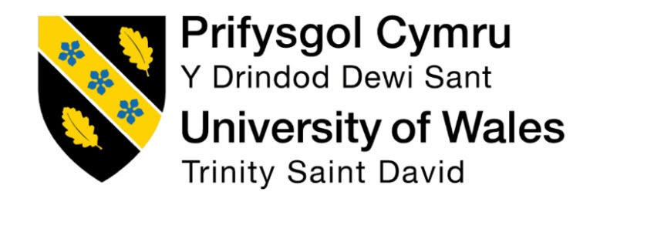

Module Name: Professional Career Development

Module Code: BMBS4005

Student Name: Karolina Cervenakova

Student Number: 2521756

Lecturer: Antoinette Milne

Deadline: Monday 26th October 2026 23.59PM

I confirm that I have not presented any ai-generated text as my own work. I confirm that I have retained copies of drafts, notes, and resources used before and after the use of AI tools.

Element 1: Career Sector Investigation – Accounting

Introduction
I am interested in accounting because I want to learn more about how businesses operate and manage their finances. I would like to develop my business knowledge at university and eventually work as a business accountant.
What Does an Accountant Do?
An accountant has many different jobs within a business. For example, they prepare financial reports, record transactions and monitor income and expenses.
In the UK, accountants can work in different organisations, including accounting firms, banks, private companies and government departments. Some accountants work directly for one business, while others work for accounting firms that provide financial services to different customers.

Skills and Qualities Employers Want
Employers look for people who are organised, reliable and good at communicating (CIPD, 2024). Teamwork is also important because accountants may work with other employees and customers. Paying attention to detail helps avoid mistakes, while problem solving can help when dealing with financial information.
Accountants need to understand financial statements, including balance sheets and profit and loss statements, as well as budgeting and bookkeeping. Some accounting roles may require professional qualifications, depending on the employer and level of responsibility.
In the UK, there are several professional bodies within the accounting sector (CIMA, 2026), Including the association of Chartered Certified Accountants (ACCA, 2025) the Institute of Chartered Accountants in England and Wales (ICAEW, 2025) and the Chartered Institute of Management Accountants. These organisations offer professional qualifications and support people who want to develop a career in accounting. Having relevant qualifications can help accountants progress in their careers.
Current Trends in Accounting
Artificial intelligence (AI) is becoming more common in accounting. (ACCA, 2026) AI can help accountants with repetitive tasks such as organising financial information and checking data. This can save time and allow accountants to focus on other parts of their work.
Data analysis is also becoming important in accounting (ACCA, 2026). Accountants can use data to understand how a business is performing, identify improvements and help them make good decisions. This means accountants need to be comfortable using technology and working with data.
There are also skills shortages in some areas of accounting, particularly among people with strong digital and data analysis skills (CAEW, 2025). This means businesses can find it difficult to recruit people with the right skills. For students like me developing these skills could create more career opportunities and help me prepare for a future in accounting. (UCAS, 2026)

How it fits my career goals
Accounting fits my goals because I want to build my career in business and become an accountant in the next five years. I want to gain more experience and improve my problem-solving skills and teamwork. After graduating, I want to apply my skills and gain experience. I could also investigate accounting qualifications and certifications, such as AAT or ACCA, to understand what I might need to become an accountant in the future (AAT, 2026). These qualifications could help me develop accounting skills and understand different routes into the profession. Overall, my main goal is to have a stable career in accounting that I can enjoy and build my future around.

Element 2: Skills Audit and Professional Development Plan

My career goal is to graduate from university and gain a job in the accounting industry. To achieve this, I need to understand my current strengths and identify the skills I need. my personal SWOT analysis, emotional intelligence, professional behaviour and a SMART goal for my future development. (The Open University, 2026).
Strengths
One of my strengths is that I am very determined, hardworking and reliable. My previous work experience has helped me gain professional skills (CIPD, 2024). When I am given a task, I try my best to complete it properly and I am not afraid to ask questions when I do not understand something. Asking for clarification supports professional growth (The Open University, 2026)
Weaknesses/ Areas for Development
An area I’d like to improve on is my confidence in Excel, I found using Excel difficult at first, especially when learning new formulas. However, with time and lots of practice, it became easier and I felt more confident. Developing skills such as Excel is increasingly important in modern accounting (ACCA, 2020). I also struggled with referencing. I was unsure how to correctly use sources in my work also working on improving that skill.

Opportunities
Starting university has given me opportunities to build a future that I can be proud of. My biggest opportunity would be to graduate and gain experience in accounting environment or find a placement in an office. Work experience and placements are key routes into accounting profession (AAT, 2026).
Threats
One threat I may face at university is managing my workload and making sure I keep up with deadlines while balancing my studies with my personal life and other responsibilities. Managing several deadlines can be challenging and may affect my motivation. Workload supports self-awareness (The Open University, 2026). I also used Gibbs’ Reflective cycle (Gibbs, 1988) describing situations analysing what went well or not and planning how to do better next time.
Strengths and Areas for Development
My work experience has helped me become responsible and adaptable.
I would like to improve my confidence, especially when sharing ideas, and become better at managing my time during university.
Reflection on Emotional Intelligence and Professional Behaviour
Emotional intelligence helps me understand my emotions and how they can affect me and how I handle them. The Johari Window has helped me recognise that feedback from others can help me notice things that I may not notice.
(The Open University, 2026) Developing self-awareness will help me become more professional and work effectively with others.
I also used Gibbs ‘Reflective Cycle (Gibbs, 1988) describing situations, analysing what went well or not and planning how to do better next time. This helps me learn from my experiences and improve from them.
SMART Goal – Supporting My Future Development
My smart goal is to improve my accounting knowledge by researching topics from my university modules and making short notes on what I learn in my modules using them to improve, I will make notes on one accounting topic each week and review them regularly to help me improve. This goal is realistic because I can use my lectures notes, university resources and reliable websites. (UCAS, 2026) I will follow this plan throughout my studies and review my progress (UCAS, 2026)

Element 3: Recruitment Application Pack
Job Title | Trainee Accountant
Organisation | BPU chartered accountants
Location | Cardiff Gate Business Park, Cardiff
Where the vacancy was found | BPU official careers website
Job Role URL | www.bpuaccountants.co.uk/careers

Karolina Cervenakova
Cardiff Wales
07411915120
2521756@student.uwtsd.ac.uk

I am a motivated student interested in developing a career in accounting. I am determined, reliable, and able to work under pressure. My previous experience in customer service, cleaning, and office environment has helped me to develop strong communication skills and loads of teamwork. I am motivated to build my accountancy knowledge, gain practical experience, and develop professionally in that career.

Experience
2022–2023
Dessert shop• customer service assistant • coco gelato.
- Served customers and handled orders correctly
- Used a till and handled payments
- Worked well under pressure during busy periods
2024-2026
• cleaning company• Abby lee cleaning services.
- Worked independently and as part of a team.
- Worked to deadlines
- Followed work procedures and health and safety requirements

Education
University of Wales Trinity Saint David
Business skills 2026
present
Developing business skills and professional skills
Developing digital skills, including excel and Microsoft word

Key Skills
- Communication and customer service
- Teamwork
- Reliable
- Problem solving
- Organization and time management

Professional Development
- Improving my knowledge of the business industry
- Developing more knowledge by using digital skills such as Microsoft Excel
- Determined to gain practical experience

Cover Letter

Dear hiring manager,
I am writing to apply for the accountant’s role. I am currently studying and I am interested in gaining more skills and experience in the business and accounting industry. I am a very determined and hardworking individual who is willing to learn and improve.
Through my previous experience, I have developed strong communication skills and teamwork. I have worked in different environments, which has helped me become more confident, reliable and able to work under pressure.
I am also improving my skills through my studies, including Excel and working with business and accounting tasks. Although some areas were difficult at times, I have progressed with practice, and I am always eager to learn new things.
I am a motivated and responsible person who takes pride in completing my work to a high standard. I work well with others, can manage my time effectively and stay focused when under a lot of pressure. I would be happy to bring these qualities to your company and become a reliable member of the team.

Thank you for taking the time to consider my application. I look forward to hearing from you.
Yours faithfully,
Karolina Cervenakova

LinkedIn Profile
business student, aspiring business accountant customer service & teamwork experience.
https://www.linkedin.com/in/karolina-cervenakova-054358441?utm_source=share_via&utm_content=profile&utm_medium=member_ios
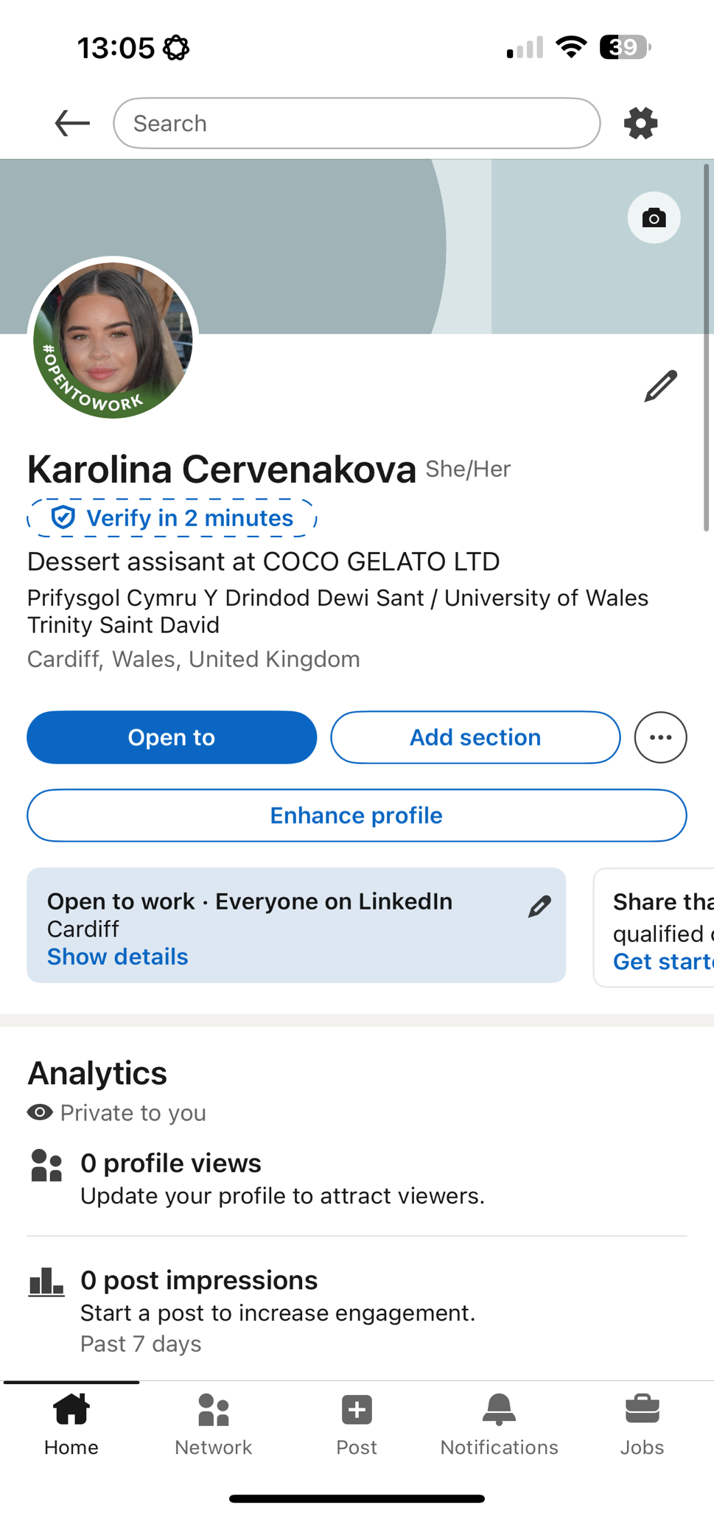

Application Rationale
I chose to apply for a trainee accountant role because building a career in accounting is my clear, long-term goal. Every part of my application has been tailored to show I have the right attitude, existing strengths, and willingness to learn the qualities employers value most in this sector. (CIPD, 2024).
On my cv, I highlighted my reliability to work under pressure, and experience working with people from different backgrounds. I listed customer service, handling payments accurately, and following procedures. Skills that transfer directly to accounting, such as attention to detail, integrity, and trustworthiness- all key values in accounting (ACCA, 2025). I also included teamwork and communication because these are essential for working with colleagues and clients in finance roles.
My cover letter reinforces these points while adding my current studies. I focused on the skills I am developing, particularly Excel and financial tasks and honestly noted that some areas are challenging at first, but I am determined to improve. This shows self-awareness and a growth mindset, which are key skills accounting firms look for (UCAS, 2026). I kept the tone professional but genuine, matching the committed style expected in the industry.

or my LinkedIn profile, I wrote a clear headline stating I am an accounting student and added my education, work history and key skills. This makes me easily to be found by recruiters and shows I am actively building a professional profile. It shows my personality alongside my qualifications.
All three pieces work together to show exactly who I am. I am very consistent, honest, and ready to put in effort. I’m not just looking for a job. I’m building my future and I want to do it the right way by learning, growing, and proving that I can become the best accountant I know I could become.

AAT (2026) starts your career in accounting: qualifications and routes. Available at: https://www.aat.org.uk (Accessed: 23 October 2026)

ACCA (2020) Digital skills and technology in the accounting profession. Available at: https://www.accaglobal.com https://www.aat.org.uk (Accessed: 23 October 2026)

ACCA (2025) The future of accountancy: Ai, automation and evolving roles. Available at: https://accaglobal.com/future-accountancy https://www.aat.org.uk (Accessed: 23 October 2026)

ACCA (2026). The role and responsibilities of the modern accountant. Available at: https://www.accaglobal.com https://www.aat.org.uk (Accessed: 23 October 2026)

CIMA (2026) what is management accounting? Roles and career paths. Available at: https://www.cimaglobal.com/abouts-us/what-is-management-accounting/ ( Accessed: 25 October 2026).

CIPD (2024) Employer skills requirements in finance and business sectors. Available at: https://www.cipd.co.uk
(Accessed: 25 October 2026).

Gibbs, G. (1988) Learning by doing the reflective Cycle. Available at: https://www.open.edu (Accessed: 25 October 2026).

ICAEW (2025) Five in-demand skills for accountants in 2025. Available at: https://www.icaew.com/insights/viewpoints-on-the-news/2025/feb-2025/five-indemand-skills-for-accountants-in- 2025 (Accessed: 25 October 2026).

The Open University (2026) Professional development and reflective practice. Available at: https://www.open.edu (Accessed: 25 October 2026).

UCAS (2026) applying for jobs in accounting: CVS, cover letters and interviews. Available at: https://www.ucas.com/careers-advice/applying-for-jobs/accounting-and-finance (Accessed: 25 October 2026).

