
Intercultural Competence Report


Student Name: Alina Adriana Badea
Student ID: 2234830
module title: foreign languages & cultural awareness
module code: bmih5003
lecturer: lisa bassler
word count: 1009

Executive Summary
In the globalised world we live in now, it is important for leaders to understand how different cultures work. In jobs like service, where people from all walks of life work together all the time, this is especially true. English and Thai culture are different, and this study looks at how those differences affect people who run a hotel business. The GLOBE Project's study on leadership and culture is used to look at how these differences show up in different parts of daily life and in the way businesses work. At the end of the study, ideas are given to the Inclusivity Hotel & Spa Management Team in London, England, on how to make the hotel friendlier and more culturally aware so that a Thai team can stay there.
The study finds some areas where they are alike, even though they are different. One such area is how they handle success. Motivating people to do their best is not too important in either culture, which makes it easy to send messages across as a group. Different thoughts about loyalty, language barriers, and different views on laws and rules at work need to be dealt with, but they need to be done on purpose.
The study tells the Inclusivity Hotel & Spa Management Team a few things they can do to deal with these issues and get the most out of having a varied staff:
Back a job growth plan that is open and lets people reach their goals at their own pace.
If your staff speaks English, teach them basic Thai. To help them converse better, focus on the differences in tone.
Use a consistent style of performance management that is based on helping people learn and grow.
These ideas can help the Inclusivity Hotel & Spa make the workplace a place where people from different cultures are valued and honoured. People will be able to work together, understand each other better, and finally do well in the growing global hospitality business.

Table of Contents
Introduction 3
Main Body 4
Conclusion 7
Recommendations 8
References 9

Introduction
In the globalised world we live in now, leaders need to know how to deal with and understand cultural differences (Anurag, 2023). This is especially important in fields like hospitality where you often work with people from different backgrounds. The main point of this study is to look at how the cultures, traditions, and social rules of England and Thailand are different from each other. It will also talk about how hard it is to be a leader in the hotel business when working with people from different backgrounds. This report will use data gathered from the GLOBE Project's study on leadership and culture to look at how the cultures of these two countries are different. Finally, helpful ideas will be given to the Inclusivity Hotel & Spa in London, England Management Team to help them deal with these issues and make the place friendlier and more understanding of other cultures so that when the team joining us from Thailand arrives, they will be aware not only of the challenges lying ahead but also will know how to tackle these challenges.

Main Body
Religion, politics, and social norms in England and Thailand make their nations very different from one another. As a Western country part of the Anglo cluster, England values individualism, a performance driven motivation, equal treatment, and pragmatism. Thailand, on the other hand, as a country part of the South Asia cluster, places more value on collectivism, clearer distinctions between male and female roles, and social systems that are set up in a hierarchy (The Culture Factor, 2024). This is because of the Buddhist and native ways of life there (Sajjad, 2023). Differences like these affect many parts of daily life, like how people eat, how they talk to each other, and how they follow their religion.
The following two images reflect GLOBE Project’s findings related to cultural practices and values in England and Thailand.
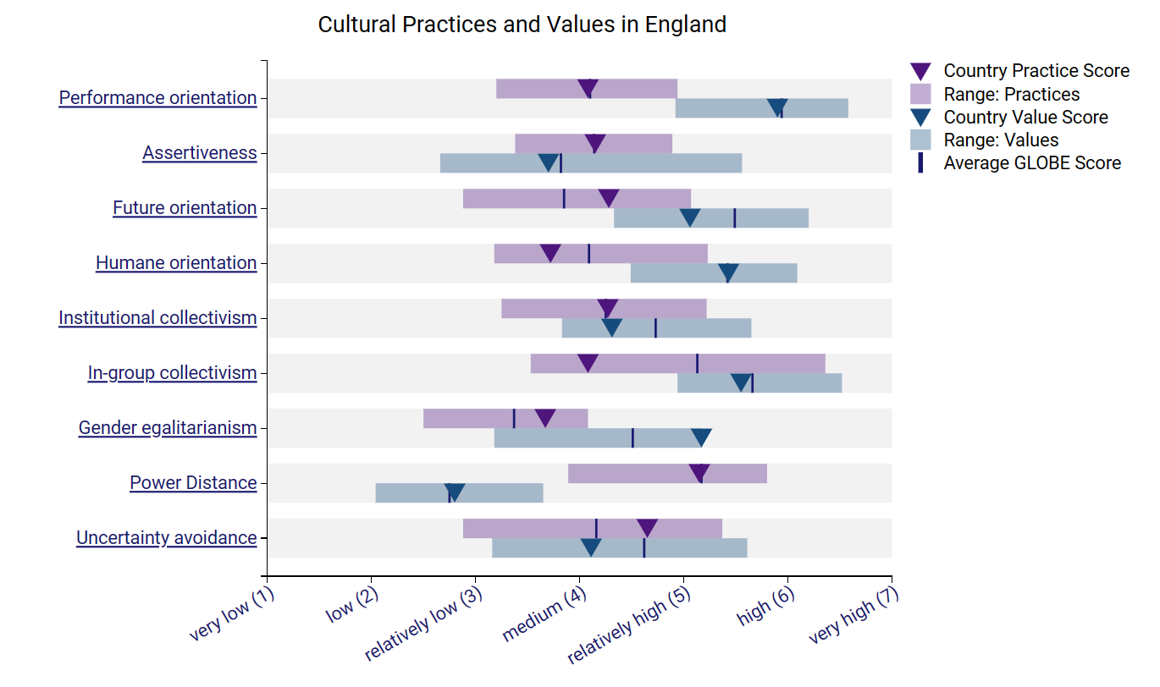
Cultural Practices and Values in England (GLOBE, 2020)
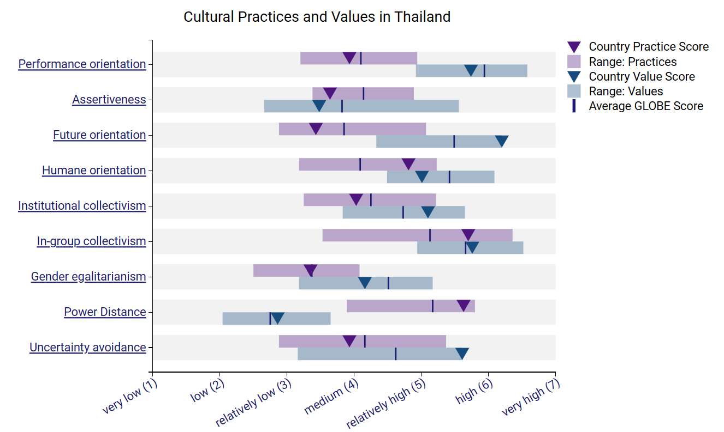
Cultural Practices and Values in Thailand (GLOBE, 2020)
When considering the ‘Performance orientation’ indicator, it can be seen that both countries have scored similar on both the Value metric as well as on the Practice one. With England having a score of 4.8 and Thailand 3.93. This indicates that both cultures place a medium emphasis on encouraging individuals to perform and achieve greatness.
The ‘Future Orientation’ indicator shows that in England, individuals prefer to take a steadier approach when it comes to their careers, being willing to patiently wait while they work towards their plans leading to the final reward, which can be a promotion. On the other hand, in Thailand, they would rather have more immediate results, not being as willing to take the ‘baby-step’ approach.
When it comes to the ‘In-group collectivism’ metric, English culture puts less of an emphasis on loyalty towards the organisation and finds it easier to detach itself from it than those coming from Thailand, where the sense of loyalty and belonging to the organisation is more important.
The ‘Uncertainty Avoidance’ indicator shows that English people prefer clearer rules and guidance to help them through the expectations imposed by the organisation, whereas those from Thailand are less bothered by unpredictability and prefer a more relaxed environment, without strict rules and regulations.
From the above comparison it can be noted that whilst performance management is a relatively new concept when it comes to human resources management, especially when focusing on linking the organisations targets of ones goals and strengths, the similar views both cultures have on this aspect makes it easier for managers to find a more unified approach in delivering the message, since landing the message the organisation tries to send depends on how employees react to it (Selden and Sowa, 2011, p.252).
Whilst it might be believed that having a longer-term career plan can be more beneficial, as it can help alleviate the stress related to one’s career development and help focus on personal development while working to achieve one’s plan (McNevin, 2023), it can be understood, why someone coming from Thailand might be more willing to guide their career based on their societies and family’s expectations (Akosah-Twumasi et al, 2018).
One challenge can be identified from the fact that those coming from Thailand will be more inclined towards loyalty for their organisation, more precisely, the Inclusivity Hotel & Spa, and might find it difficult to understand why English employees do not demonstrate the same attachment and commitment to the brand. According to Kholis and Astuti, loyalty refers to one’s ability to remain dedicated to the organisation by demonstrating devotion, honesty, and obedience (Kholis and Astuti, 2023).
One of the biggest challenges our hotel might encounter is the language barrier, which can lead to misunderstandings and difficulties in relaying the message evenly and fairly for all employees.
A final challenge identified is the reduced need Thailand nationals have for clear rules and regulations when it comes to the work place. Having to work in a country where these are clearly defined by law, for example the Health and Safety at Work guidance (HSE, 2024), they might feel more restricted and limited in their actions.

Conclusion
In conclusion, whilst the two cultures have differences in their approaches to work life and progression, the report has also found similarities in their views on how performance management can be conducted and delivered.
It has also been highlighted that management needs to focusing on how address each other’s cultures, as well as how to lead to solve these problems. Groups like the Inclusivity Hotel & Spa can avoid these issues and make the most of having a diverse staff by promoting cross-cultural training, setting up language assistance programmes, and making a place where everyone values and respects differences.

Recommendations
Based on the above findings I propose the following recommendations to enable a smooth and productive cooperation between Thailand national employees and English ones:
- Management is to encourage a more relaxed approach towards career development and enable each individual to follow their goals at their own pace.
- Basic Thai language lessons to be given to English employees, with emphasis on the variations in the tonality, as in Thai language, depending on the tonality a word can change its meaning (Sully, 2022).
- Management to use a consistent and employee drive style of performance management, characterised by encouraging self-development.

References
Akosah-Twumasi, P., Emeto, TI., Lindsay, D., Tsey, K. and Malau-Aduli, B. (2018) ‘A Systematic Review of Factors That Influence Youths Career Choices – the Role of Culture’ Systematic Review, 3 (July), Article 58. DOI: 10.3389/feduc.2018.00058 (accessed: 23rd February 2024).
Anurag, P. (2023) ‘Global Leadership: Navigating Cultural Differences in a Connected World’ Open Growth. Available at: https://www.opengrowth.com/resources/global-leadership-navigating-cultural-differences-in-a-connected-world (accessed: 23rd February 2024).
GLOBE, 2020, Vizualizations of the 2004 Study. Available at: https://globeproject.com/results%3Fpage_id=country.html#country (accessed: 23rd February 2024).
Health and Safety Executive (2024) Legislation. Available at: https://www.hse.gov.uk/legislation/ . (accessed: 23rd February 2024).
Kholis, N. and Astuti, HPP. (2023) ‘Strengthening Loyalty and Performance of Government Office Employees: Exploring Leadership Strategies’ SAR Journal, 6 (Issue 3, September). DOI: 10.18421/SAR63-03
McNevin, M. (2023) ‘How to Develop a 5-Year Career Plan’ Harvard Business Review, 27 September. Available at: https://hbr.org/2023/09/how-to-develop-a-5-year-career-plan (accessed: 23rd February 2024).
Sajjad, M. (2023) ‘Ultimate Guide To Buddhism In Thailand’ Clever Thai. Available at: https://www.cleverthai.com/buddhism-in-thailand/ (accessed: 23rd February 2024).
Selden, S. and Sowa, JE. (2011) ‘Performance Management and Appraisal in Human Service Organizations: Management and Staff Perspectives’ Public Personnel Management, 40 (Issue 3, Fall).
Sully, J. (2022) ‘What Language Do They Speak in Thailand (4 Clear Dialects)’ Thai Guider. Available at: https://thaiguider.com/what-language-do-they-speak-in-thailand/ (accessed: 24th February 2024).
The Culture Factor, 2024, Hofstede Insights. Available at: https://www.hofstede-insights.com/country-comparison-tool?countries=thailand%2Cunited+kingdom (accessed: 23rd February 2024).

