

Data Analysis
Student ID: 2515581
Word Count: 1,623

Assessment brief and AI Declaration

Table of content

Executive statement……………………………………………………………….

Introduction………………………………………………………………………….

Literature Review ………………………………………………………………….

Data Collection……………………………………………………………………..

Data Analysis………………………………………………………………………..

Discussion……………………………………………………………………………

Conclusion…………………………………………………………………………..

References…………………………………………………………………………..

Appendix……………………………………………………………………………..

Executive Summary

Safran Seats UK are part of the wider France Safran Group. They specialize in the design and production of premium first class and business aircraft seating systems. The aerospace sector presents unique operational challenges due to high levels of product customization, strict regulatory requirements, and complex global supply chains. As evidenced by Ivanov, & Dolgui., (2021. Pp-780) “The aerospace manufacturing industry operates in a highly complex and regulated environment where production reliability and supplier coordination are critical”. Maintaining effective inventory management and data-driven decision-making are therefore critical for ensuring operational efficiency and customer satisfaction.
Safran Seats UK operates within an environment characterized by high product complexity, high quality and large volume delivery requirements. Recently, the organization faced significant operational challenges related to inventory management, data accuracy, and decision-making effectiveness. These issues arose from reliance on an ERP system supported by manual, spreadsheet-based reporting, which resulted in low inventory accuracy, excessive stockholding, material shortages, and customer delivery delays of up to six months.

Introduction

This report examines how Safran Seats UK addressed these challenges through the adoption of a data-driven inventory analytics solution. Initial attempts to address the problem through gradual enhancements to current systems proved ineffective, prompting the organization to pursue a more transformational, analytics-based approach. Safran Seats UK implemented LeanDNA, which is a specialist inventory analytics platform integrated with its existing ERP system to provide real-time visibility, automated analysis, and prioritized decision-making support.
The report will investigate the following key operational issues faced by Safran:
Part One
- Analyse how it addresses the challenge
- Evaluate the solutions considered with emphasis on the role of data-based approaches
- Assesses the benefits achieved
Part Two
- Analyse annual financial data of Safran Seats UK from 2020 to 2024, focusing on Sales, Cost of Sales, Administrative Expenses and the importance of Managerial Oversight
This report will discuss the importance of descriptive statistics, correlation and regression analysis, and the Gorry and Scott Morton (1971) decision-making framework to evaluate business performance and managerial control.

Literature Review
Inventory management serves as a fundamental operational function, especially within intricate manufacturing sectors like aerospace. Slack et al, (2022. Pp-485) argues “that poor inventory control leads to increased costs, inefficiencies, and reduced service levels”. When assembling a complete set of first-class and business seats, challenges often arise due to the substantial variety of components required to finalise the seat i.e. ship set. This is supported by M, Christopher. (2016. Pp-100) who states, “Aerospace manufacturers face additional difficulties due to long lead times, large numbers of components and high levels of engineering complexity”.
Although, ERP systems are extensively utilised for inventory management, research as evidenced by Monczka et al., (2020. Pp-455) suggests that “they are primarily transactional and often lack advanced analytical capabilities”. As a result, organisations frequently supplement ERP data with manual spreadsheets, increasing the likelihood of data inaccuracies and fragmented decision-making. This evidences the need to implement LeanDNA together with their ERP systems.

Data Collection
Due to Safran’s dependence on an outdated system, Safran Seats UK faced a considerable operational challenge stemming from inefficient inventory management and ineffective data visibility. The organisation depended on an ERP system supported by manually generated spreadsheets to track inventory levels and material availability. LeanDNA states “These systems were fragmented and failed to provide accurate, real-time data”. This resulted in major problems within the business.
Quantitative Variables
Inventory Accuracy
Previously as low as 10%
Delayed by 3 – 6 months
Reduced by approx. 36% post implementation
Excess Inventory Levels
Delivery Lead Time
10-15 hours spent manually generating reports
Supply Planner Reporting Hours

Qualitive Variables
Decision Structure
Data Visibility and Transparency
Managerial Confidence in Data
Cross Functional Collaboration

Inventory accuracy was estimated to be as low as 10 per cent, and according to LeanDNA, (2019) “Supply planners spent 10–15 hours per week manually creating Excel reports”. This led to excess stock of some components, shortages of others, and frequent production disruptions. Customer deliveries were consequently delayed between 3 to 6 months, directly impacting productivity and as evidenced by CaseStudies.com (2019) that “This is negatively affecting performance and customer satisfaction”.
Safran investigated different solutions before selecting data-driven approach. As shown in the table below:
Solution | Benefit | Limitation
Supplier diversification | Reduced reliance on single suppliers | High qualification and coordination costs
Increased inventory buffers | Protection against shortages | High holding costs and inefficiency
Data-based approach | Better forecasting and control | Initial investment and training required
The data-based approach was chosen because it addressed the roots cause of supply chain issues rather than only managing their effects. Ivanov and Dolgui (2021, pp777) emphasise that “supply chain resilience increasingly depends on data-driven responsiveness rather than static planning models”. Therefore, improvement was required not only in measurable performance outcomes but also in organisational decision maturity.

Data Analysis
Safran Seats UK conducted an internal review to identify the root causes of its operational difficulties. This analysis revealed that the core issue was not workforce capability but the absence of reliable, real-time, decision-ready data. Initial attempts to simplify ERP output and improve manual reporting processes were unsuccessful, as they failed to overcome the limitations of the legacy system. Davenport, (1998, p. 121) explains that “Companies have built information systems that were designed to support specific business functions. The result is a patchwork of incompatible systems that cannot communicate with one another”. Recognizing the need for a more fundamental solution, the organisation shifted its focus towards adopting a data-driven approach that prioritised analytics, visibility, and actionable insights.
Safran Seats UK adopted a data-based approach by replacing manual spreadsheet analysis with a real-time analytics platform. This enabled accurate inventory visibility, prioritised decision-making, and predictive insights that were not possible using traditional ERP systems alone. By basing decisions on reliable, centralised data rather than intuition or delayed reports, Safran reduced excess inventory, improved delivery performance, and strengthened operational efficiency.
The pictures below show a visual example of the old system using Baan with excel sheets and the new system of M3 and LeanDNA.

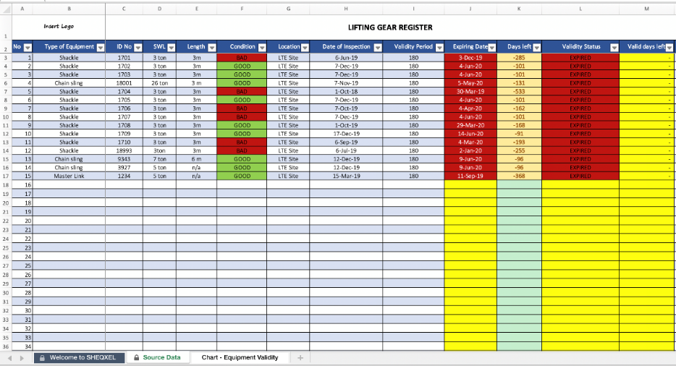
Before Data Based Approach
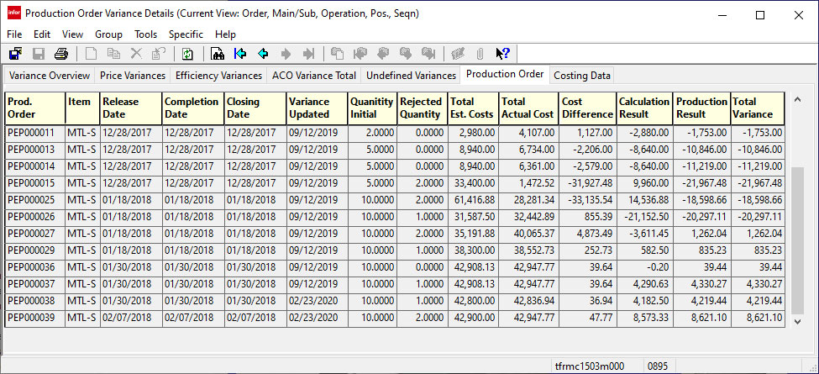
After Data-Based Approach
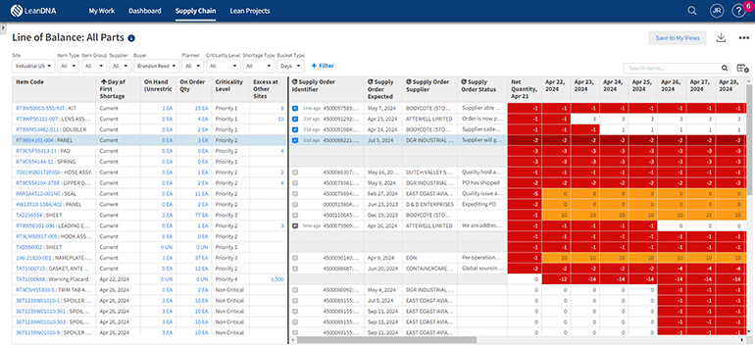
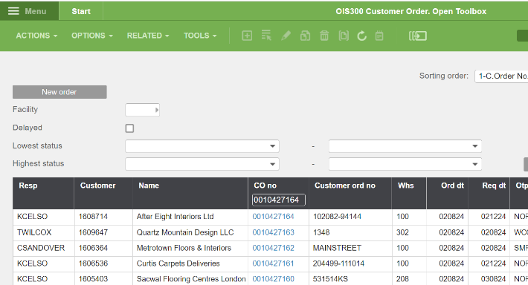
All Picture taken from google images for security reason

Discussion
Several solutions were considered, including maintaining the existing ERP system with stricter reporting controls and expanding spreadsheet-based analysis. However, CaseStudies.com (2019) states, “These options were rejected due to their lack of scalability and continued reliance on manual processes”. Safran selected LeanDNA, a specialist inventory analytics platform capable of integrating with the existing ERP system. LeanDNA, (2019) explains “The platform automatically extracted, cleansed, and analyzed inventory and demand data, providing prioritized insights rather than static reports”. This data-based approach allowed the organisation to shift from reactive, intuition-based decision-making to a structured, analytics-orientated framework. Algorithms detected surplus inventory, shortages, and fluctuations in demand, enabling planners to concentrate on actions with significant impact on the business.
The benefits of the data-driven solution were significant and measurable. Within three months, According to CaseStudies.com (2019) “Quantitative results show Safran Seats UK reduced excess inventory by approximately 36 per cent, releasing substantial working capital. Inventory accuracy improved, reducing shortages and production delays”. This then meant time spent on manual reporting was significantly reduced, allowing employees to focus on value-adding activities. Delivery performance improved, enhancing customer confidence. Qualitative benefits included improved cross-functional collaboration and a cultural shift towards evidence-based decision-making.
The incorporation of data analytics has greatly enhanced decision-making process in Safran UK. Managers now possess access to real-time dashboards and key performance indicators (KPIs) concerning production, supplier performance, and inventory levels. This advancement has led to improved forecasting accuracy and facilitated the earlier detection of supply chain risks. Hair et al., (2019. Pp 35) argues that “Descriptive statistics summarize large datasets into meaningful measures… enabling managers to understand historical performance patterns”.

The graph below shows Safran’s KPI.

The table below compares the before and after approach for the new data design.
After
Before
ERP (M3)
ERP (Baan)
Lean DNA analytics platform
Raw Data Exports
Clean, unified, real-time data
Multiple Excel Spreadsheets
Dashboards and prioritized actions
Manul analysis
Faster, aligned decisions
Delayed / inconsistent decisions
Optimized inventory levels
Overstock and shortages
Improved delivery and cost control
Late deliveries & high costs

Key Strengths
Key weaknesses
Real time visibility

Low Data accuracy

Cross team alignment

High human error

Predictive alerts
No predictive insight

As shown in the table above by implementing LeanDNA into M3 it allows all departments to align from aftermarket orders to ship set orders. This also allows teams across our multiple buildings to communicate in a much clearer and effective way as the visibility is in real time.

Conclusion
Safran’s transition from BANN to LeanDNA represents a successful data-driven transformation. By addressing the limitations of outdated systems, embracing advanced analytics, and executing structured change management. Safran significantly improved operational efficiency and financial outcomes. This enabled accurate inventory visibility, prioritised decision-making, and predictive insights that were not possible using traditional ERP systems alone. Overall, LeanDNA has empowered Safran to integrate its manufacturing principles with modern, data-based decision-making resulting in reduced excess inventory, improved delivery performance, and strengthened operational efficiency within Safran’s complex aerospace environment.

Part 2
The following table indicate sales, cost of sale and the administrative expenses that Safran have faced from 2020 – 2024.
Year | Sales | Cost of Sales | Administrative expenses
2020 | 121,797 | 120,826 | 32,772
2021 | 125,961 | 109,588 | 27,169
2022 | 115,866 | 96,518 | 21,780
2023 | 106,408 | 105,208 | 20,557
2024 | 196,394 | 173,833 | 32,646

A year-by-year analysis indicates that sales decreased from 2020 to 2023, with the pandemic significantly influencing this trend. Additionally, it highlights the impact of the outdated Bann system. In 2024, there was a notable increase in sales, which implies a growth in operations and enhanced demand which was improved by data-informed planning. Administrative costs remained consistent, reflecting efficient management of overhead expenses. As evidenced by (Safran, 2024) “In 2024, the organization transitioned toward a growth-oriented strategy, reflected in significantly higher sales and increased administrative expenditure. This shift indicates a strategic reallocation of resources to capture rising market demand”. The sharp increase in sales in 2024 indicates post-transformation performance improvements and potential market recovery.
Sales data show a mean of approximately 133,285 and a median of 121,797, with high standard deviation reflects instability, particularly the substantial increase in 2024. Cost of Sales follows a similar distribution, indicating a strong relationship between production activity and revenue. Administrative expenses show lower variance, suggesting controlled overhead management. Laudon and Laudon (2022, p.33) emphasise that “Descriptive statistics are essential for identifying financial patterns that inform managerial oversight”. Regression analysis indicates a positive relationship between Cost of Sales and Sales revenue. Wooldridge (2013, p.129) explains that a “Statistically significant regression coefficient confirms a meaningful relationship between independent and dependent variables”. In this context, higher production activity (Cost of Sales) significantly influences revenue generation.

 | Sales | Cost of Sales | Administrative Expenses
Mean | 133,285 | 121,595 | 27,385
Median | 121,797 | 109,588 | 27,169
Mode | 0 | 0 | 0
Standard Deviation | 34,000 | 30,000 | 5,500
As shown in the table and graphs below.

Gorry and Scott Morton developed a framework for management information systems that categorizes organisational decision-making along two dimensions:
- Management level (strategic, tactical and operational)
- Degree of decision structure (structured, semi-structured and unstructured).
The Gorry and Scott Morton (1971. Pp-55) framework classifies “decisions based on managerial level and degree of structuredness. This model is widely used in Management Information Systems to assess how information supports different types of decisions”. The framework allows us to examine how information systems support decision-making at different hierarchical levels within organisations. As shown below.
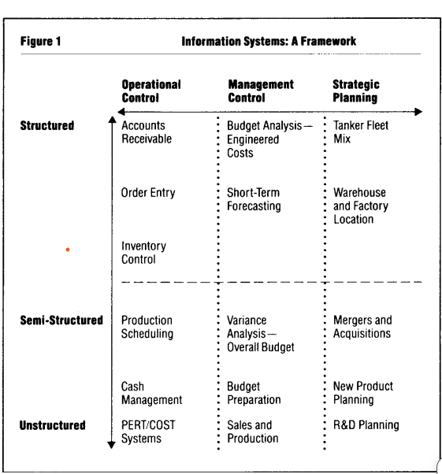

Gorry & Morton (1989. Pp-49) demonstrates the above table. Additionally, the below table depicts how Safran Seats UK align their matrix with Gorry and Morton.
Safran’s Matrix

Management Level |  | Structured Decisions | Semi-Structured Decisions | Unstructured Decisions
Strategic |  | Long-term financial planning and program profitability analysis; capacity utilization reporting across UK operations | Investment decisions relating to automation and tooling; make-or-buy analysis for seat components; supplier base rationalisation | Decisions regarding participation in new aircraft programs
Tactical (Managerial) | Master production scheduling using MRP systems; supplier performance monitoring |  | Planning aligned with program demand; inventory buffer decisions for long-lead materials; prioritisation of engineering change requests | Mitigation of supply chain disruptions; negotiation of delivery recovery plans
Operational | Work order release and sequencing; execution of quality inspection routines; time and attendance recording |  | Resolution of production bottlenecks; adjustment of assembly sequences due to late or non-conforming parts; handling of minor non-conformances | Real-time problem solving on the shop floor; response to urgent Aircraft-on-Ground (AOG) requests; implementation of last-minute engineering deviations
Safran now work at the structured level of decision making – whereas two years ago they were following the unstructured decisions. Safran implements the information in the matrix primarily through integrated transactional systems that effectively support structured operational and compliance decisions. Therefore, as the decision structure decreases, managerial judgement plays a greater role. Safran recognise that decisions rely heavily on interpretation of combined data, reducing consistency and predictive capability. This highlights a key limitation identified by Gorry and Scott Morton, whereby information systems support, but do not replace managerial decision-making under uncertainty.

References
CaseStudies.com (2019) Available at: https://www.casestudies.com/company/leandna/case-study/safran-seats-gb-reduces-excess-inventory-36-percent-in-3-months (Accessed: 13 January 2026).
Christopher, M. (2016) Logistics and supply chain management. 5th edn. Harlow: Pearson Education. Pp – 100.
Davenport, T.H. (1998) ‘Putting the enterprise into the enterprise system’, Harvard Business Review, 76(4), pp. 121–131.
Gorry, G.A. and Scott Morton, M.S. (1971) ‘A Framework for Management Information Systems’, Sloan Management Review, 13, pp. 55–70.
Gorry, G. A., & Morton, M. S. S. (1989). A Framework For Management Information Systems. MIT Sloan Management Review, 30(3), pp. - 49.
Hair, J.F., Black, W.C., Babin, B.J. and Anderson, R.E. (2019) Multivariate Data Analysis. 8th edn. Hampshire, UK: Cengage Learning. pp. 35.
Ivanov, D. and Dolgui, A. (2021) ‘A digital supply chain twin for managing the disruption risks and resilience in the era of Industry 4.0’, Production Planning & Control, 32(9), pp. 775–788.
LeanDNA (2019) Safran Seats GB customer case study. Available at: https://media.trustradius.com/product-downloadables/52/SJ/4IXVWK6RJ1P7.pdf (Accessed: 13 January 2026).
Laudon, K.C. and Laudon, J.P. (2022) Management Information Systems: Managing the Digital Firm. 17th edn. Harlow, UK: Pearson Education Ltd. Pp -33.
Monczka, R.M., Handfield, R.B., Giunipero, L.C. and Patterson, J.L. (2020) Purchasing and supply chain management. 7th edn. Boston: Cengage Learning. Pp – 455.
Safran Group (2023) Safran Seats: aircraft interiors and seating systems. Available at: https://www.safran-group.com (Accessed: 13 January 2026).
Safran (2021). Universal Registration Document – 2020 Results.
Safran (2022). Universal Registration Document – 2021 Results.
Safran (2023). Universal Registration Document – 2022 Results.
Safran (2024). Universal Registration Document – 2023/2024 Results.
Slack, N., Brandon-Jones, A. and Burgess, N. (2022) Operations management. 10th edn. Harlow: Pearson Education. Pp – 485-500.
Wooldridge, J.M. (2013) Introductory econometrics: A modern approach. 5th edn. Mason, OH: South-Western Cengage Learning. pp. – 129-130.

Appendix

. Mean (Average): $\text{Mean}=\frac{\text{Sum of Sales}}{n}$
Sum of Sales:
121,797 + 125,961 + 115,866 + 106,408 + 196,394
- 121,797 + 125,961 = 247,758
- 247,758 + 115,866 = 363,624
- 363,624 + 106,408 = 470,032
- 470,032 + 196,394 = 666,426
$$\text{Mean Sales}=\frac{666,426}{5}=133,285.2$$
Mean Sales = 133,285.2
Median
: 106,408, 115,866, 121,797, 125,961, 196,394
Middle value = 121,797
Median Sales = 121,797

