
Module Name: International Marketing: Principles and Practices
Module Code: LCMB7026
Assessment component 1: Individual report
Title: International Marketing Strategy of Cadbury: A Comparative Analysis of India and the United Kingdom
Student Name: Vishal Sapkal
Student ID: 2521152

Table of Contents
Section 1: International Market Entry Strategy and Marketing Mix 3
1. Introduction 3
2. Company Overview 3
3. Comparative Market Analysis (PESTEL) 4
4. Hofstede Cultural Analysis 7
5. STP Analysis 9
6. International Marketing Mix (7Ps) 13
7. Market Entry method in India 19
8. Ethical Issues 21
9. Recommendations 22
Section 2: Reflective Account (Gibbs' Reflective Cycle) 25
1. Description 25
2. Feelings 26
3. Evaluation 26
4. Analysis 27
5. Conclusion 28
6. Action Plan 28
Reference 29

Section 1: International Market Entry Strategy and Marketing Mix

1. Introduction
International marketing is an approach that enables brands in accessing the global marketplace and broaden their consumer base through expanding operations. Under this process, brands adapt their products, pricing, promotion, and distribution strategies to meet the evolving needs of consumers. The purpose of this report is to critically examine the international marketing strategy of Cadbury in the UK (home market) and India (host market). Comprehensive insights into the international marketing approach at Cadbury show how it adapts to varied regulatory, environmental, economic and cultural dimensions. In order to achieve this objective, frameworks like PESTLE, Hofstede's Cultural Dimensions, STP, and the 7Ps marketing mix have been used here. Lastly, based on the findings, strategic recommendations have been provided to Cadbury that support it for its future international growth.

2. Company Overview
Cadbury is a prominent global manufacturer of chocolate and confectionery products that is known for its delicious offerings. John Cadbury founded this British multinational brand in 1824 as a grocery shop (Cadbury, 2026). Over time, it has become a well-known confectionery manufacturer that offers a diverse product portfolio that includes Dairy Milk, 5 Star, Silk, Bournville, Gems and other products. The operation and market presence of Cadbury have strengthened after its joining Mondelez International in 2010. Cadbury’s mission is to create delicious, premium chocolate made responsibly with purpose (Cadbury, 2026). Cadbury, as a subsidiary of Mondelez, focuses on offering the right snack, making it the right way at the right time (Mondelezinternational, 2026). Millions of consumers receive products from Cadbury through its extensive international distribution network, with a presence in more than 50 countries.
Multi-billion-dollar global revenue received by Mondelez International from Cadbury’s operation. For instance, approximately $36 billion in net revenue was added in 2024 at Mondelez through Cadbury’s operational activities (Mondelezinternational, 2026). Despite intense competition from firms like Nestlé, Ferrero, Mars and Hershey, Cadbury has maintained a strong market position with a well balance in between local adaptation and global consistency. Thus, the selection of Cadbury is appropriate to understand international marketing adaptation across varied macro-environmental conditions.

3. Comparative Market Analysis (PESTEL)
Macro-environmental factors impacting Cadbury’s operations have been analysed using the PESTLE framework based on the UK’s and India's business environment.
Political Environment
Cadbury’s international operation is influenced significantly by government policies and political stability. India(Favourable): Under a stable political environment, the Indian government offers a 100% FDI permit to multinational firms. Favourable conditions for operation are built with an automatic route for food manufacturing (PIB, 2026). Production costs for chocolates for foreign firms increase with import duties and 18% GST (John, 2025). Local manufacturing at Cadbury is facilitated in the context of a reduction in operational costs.
UK(Favourable): In a politically stable environment, transparent governance and a robust regulatory system are supportive for firms like Cadbury to operate efficiently (Shaba, 2024). However, operational complexity and administrative cost enhanced following the Brexit condition. Well-established regulations, a business-friendly environment and stronger consumer protection provide a favourable condition for Cadbury’s operation.
Comparing both these countries' political business environment, it can be stated that the predictable, transparent and strong policy framework of the UK provides a better regulatory environment for Cadbury’s operation. In contrast, Cadbury has the opportunity to achieve long-term business objectives and maintain a resilient market position in India with pro-investment policies and a wider marketplace.
Economic Environment
India(Favourable): Government data shows that in FY 2025-2026, India’s GDP recorded growth of 7.4% (MoSPI, 2026). Despite such growth, India’s inflation increased to 4.38% in May 2026 (Tradingeconomics, 2026). Consumers have become price-sensitive with rising inflation. In response to such a challenge, Cadbury has adopted a value-based pricing approach for maintaining market relevance and attracting middle-income consumers into its operations. Despite Inflation current sales of Cadbury in India is $1.5 billion supported by increasing chocolate consumption and festival-driven demand (Brandequity.economictimes, 2026). India is thus one of fastest growing international markets for its operation.
UK(Favourable): ONS data shows that the UK’s GDP growth is 1.4% in 2025 in comparison to the previous year (ONS, 2026). While the BBC reported that in May 2025 its inflation was recorded at 3.4% (BBC, 2026). It resulted in higher operational and distribution costs at Cadbury’s operations, which have changed consumers’ pricing patterns. As a result, rather than focusing on competitive pricing, Cadbury has shown a higher focus on quality, premium packaging and innovative offerings. UK sales remained stable at around £64 million in 2023, 2024 (Uk.news.yahoo, 2025).
This comparison reflects that affordable pricing is required in India for a high amount of sales. In contrast, in the UK, it can support premium pricing and focus on differentiation due to strong purchasing power.
Social Environment
India(Favourable): Chocolate purchases in India are enhanced during festive seasons like Holi, Raksha Bandhan and Diwali. Symbols of celebration and gifting at Cadbury support its enhanced sales. “Kuchh Meetha Ho Jaaqye” is a well-known campaign of Cadbury that encouraged consumers to celebrate special occasions (Brandequity.economictimes.indiatimes, 2026). However, growing health awareness decreases their interest of consuming sugar-based products, which have to carefully consider by Cadbury.
UK(Favourable): Individualistic buying behaviour is seen across UK consumers (Hoque et al., 2025). Consumers make higher consumption of chocolates during festivals like Easter and Christmas. However, growing environmental concern and health awareness have generated their interest in sustainable, healthier products. Responsible cocoa sourcing and low sugar content in Cadbury’s products help it in maintaining positive brand position and increased sales.
Therefore, a culturally responsive marketing approach adaptation is required for Cadbury to fulfil consumers' requirements and maintain a resilient market position.
Technological Environment
India(Favourable): Rapid digitalisation and widespread smartphone adoption among Indian consumers provide a favourable digital business environment for Cadbury’s operation (Pramodini, et al., 2026). Delivery of products becomes easier with the growth of e-commerce platforms like Blinkit, Flipkart and Amazon. Personalised marketing and consumers’ active engagement are supported with the use of technologies like AI and data analytics.
UK(Favourable): Cadbury’s operation has become highly efficient in the UK with advanced manufacturing and growth of digital tools like AI and automation (Dureja, 2024). Operational efficiency and supply become better with the use of AI and other tools.
Both these countries give favourable digital environmental conditions for Cadbury’s efficiency and operational growth.
Environmental Factors
India(Favourable): Aligning with UN sustainable development goals, there is greater emphasis on plastic waste and carbon emission reduction in India (EY, 2026). Thus, it has become essential for Cadbury for prioritising sustainable packaging and responsible business practices.
UK(Favourable): The UK’s target is to achieve net-zero by 2050 and reduce plastic waste; for this, it has made strict policies (Parliament.uk, 2026). Greener operational practices have become strategic for Cadbury’s operation.
Cocoa Life programme supports it in making responsible sourcing and other approaches like eco-friendly packaging (Cocoalife, 2026). In both countries, its responsible practices support it in achieving a higher level of growth in operation.
Legal Environment
India(Favourable): Food safety in India is overseen by the Food Safety and Standards Authority of India (FSSAI). Following strict laws, Cadbury must engage in responsible business and marketing practices.
UK(Favourable): Safety level for products in the UK is checked by the Food Standards Agency (FSA), and the Advertising Standards Authority (ASA) looks over advertising approach. Strict laws following thus becoming important for Cadbury.
In both countries, Cadbury's stringent adherence helps it in maintaining a positive brand image and achieving significant business growth.
Both India and the UK provide favourable market for Cadbury’s growth, though there are differences. Higher consumer base support potential growth in India, though localisation requirement arises due to inflation and price sensitivity. In contrast, premium positioning is supported in the UK with regulatory stability. However, continuous innovation and product differentiation require for resilient position in this mature market.

4. Hofstede Cultural Analysis
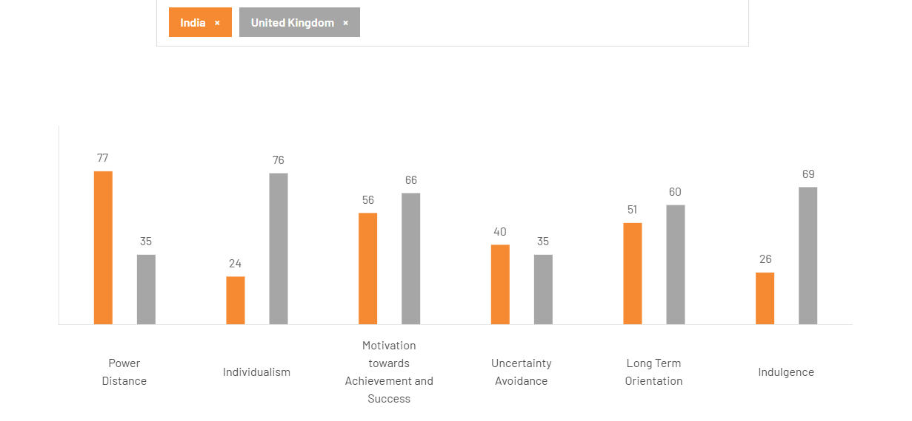
Figure 1: Hofstede Cultural Analysis
(Source: Theculturefactor, 2026)
Cultural differences between the UK and India have been explored using Hofstede’s cultural dimension framework that influences the marketing approach at Cadbury’s operation.
Power Distance: The power distance score of India is 77, and that of the UK is 35. This value reflects that hierarchy and power of authority are prioritised highly in India. In the Indian market, there is a requirement for Cadbury to make advertisements by focusing on family values and respect culture (Chattopadhyay et al., 2023). In contrast, equity-based communication must be prioritised in the UK’s operation.
Individualism: This score level in the UK is 76 and for India is 24. Personal preference is a priority for British consumers, whereas family and collective relationships are highly valued in India. Considering these differences in the Indian market, a family-oriented campaign during Diwali and other festivals increases its adoption rate. In contrast, personalised marketing must be a priority in the UK market.
Masculinity: This score in the context of India is 56, and that of the UK is 66. From this value, it has been indicated that achievement and success are a higher level of priority for British consumers. Therefore, there is a requirement for quality in products as well as rewards and discounts for repetitive purchases for maintaining market relevance in the UK (Al-Adwan et al., 2025). Whereas emotional storytelling in the Indian market.
Uncertainty Avoidance: New innovative products are highly favoured in both the Indian and UK markets, which is reflected through the avoidance score of 35 in the UK and 40 in India. Thus, Cadbury offering new flavours and low-sugar content can increase its market share.
Long-term Orientation: 60 is the value in the UK and 51 in the context of India. From this value, it has been seen that there is a higher priority for UK consumers towards sustainability and long-term planning. Thus, better planning and a sustainable approach emphasised in marketing helps it achieve notable growth.
Indulgence: This value for the UK is 69, and for India is 26; thus, Cadbury must focus on personal pleasure for British consumers. While, festivals, gifting, and family celebration quality offerings are effective for better growth.
Based on cultural differences, there is a requirement of adapting advertising to support Cadbury’s business growth.
Collectivist, family-oriented values and strong festival-driven demand in India give Cadbury greater cultural advantages. It supports in making emotional marketing and increasing active engagement level of consumers. In contrast premium position is favoured in the UK with its mature and individualistic market. Here, ongoing innovation require for achieving long-term growth. Thus localisation need to be priority in India and innovation-driven business in the UK.

5. STP Analysis
STP stands for segmentation, targeting, and positioning, which assist the businesses in figuring out who their most important customers are (GeeksforGeeks, 2025). It assists the business from wasting money on broad, generic ads and instead helps in concentrating on the buyers most likely to buy.
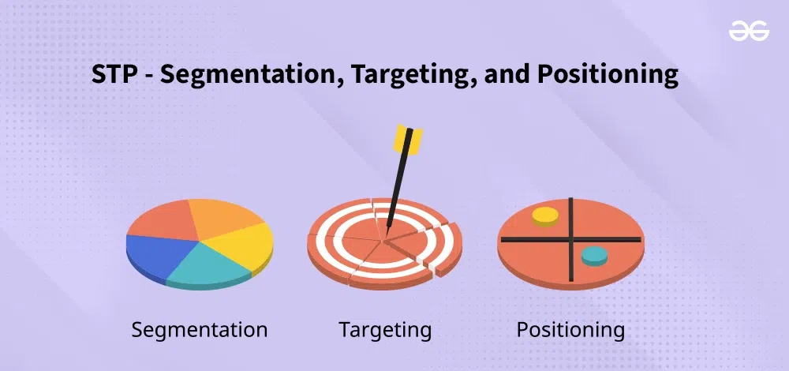

Figure 2: STP analysis
(Source: GeeksforGeeks, 2025)
Segmentation
Demographic Segmentation
Cadbury targets the children, teenagers, adults and the families through the help of differentiated products. India basically highlights affordable chocolates for the middle-income consumers, while the UK focuses on targeting the premium, seasonal and family-oriented chocolate purchases.
Geographic Segmentation
Cadbury adapts distribution as well as marketing geographically through serving the urban and rural consumers within India through the help of diverse retail channels, while the UK showcases supermarkets, convenience stores, online retail and ultimately seasonal demand.
Psychographic Segmentation (VALS)
This company targets the Experiencers, Achievers, Believers and Thinkers through the help, of its innovative products, premium gifting, emotional storytelling and sustainable initiatives which showcase the consumers' lifestyles, values, aspirations and finally the purchasing motivations across markets.
Critical evaluation
Cadbury adopts differentiated market segmentation to showcase the contrasting customer characteristics of India and the United Kingdom. With respect to India, this brand has expanded beyond children to target the growing middle-class segment of the nation. This segment is projected to surpass 1 billion people by the end of 2047, while sustaining a strong appeal among both families and festival gift purchasers (SCAI, 2026). Moreover, different campaigns like "Kuch Meetha Ho Jaaye" as well as "Shubh Aarambh" position the chocolates as part of the conventional celebrations, particularly during both the Diwali and Raksha Bandhan (Markhub24, 2026). On the flip side, with respect to the UK, Cadbury segments the customers through lifestyle and premium consumption preferences, targeting families, young professionals, and finally the ethically conscious buyers through products like Cadbury Dairy Milk, Bourneville, as well as lower-sugar variants. Compared with the UK, where purchasing is driven largely by everyday indulgence as well as seasonal occasions like Easter and Christmas, Indian demand is more strongly influenced through the cultural festivals, which requires Cadbury to adopt locally responsive segmentation strategies.
Targeting
Cadbury prioritises the high-potential customer groups on the basis of both market maturity as well as purchasing behaviours within India and the United Kingdom. Within India, this company embrace a differentiated targeting strategy through providing distinct product ranges for the children’s, adults, families and ultimately the rural customers through the help of affordable packs, premium chocolates and festive gift collections as well. Basically, Mondelez has strategically expanded its focus from children to adults, with adults now accounting for a substantial share of the chocolate consumption. Not only this, but the company also targets the rural customers through the help of low-unit-price packs, and thus supports wider market penetration beyond metropolitan areas (Janwal, 2025).
On the other hand, Cadbury UK concentrates on the customers who seek premium as well as seasonal confectionery and thus fortifies the demand through different products like Cadbury Dairy Milk, Cadbury Heroes and Cadbury Roses, specifically during Easter and Christmas (Mynewsdesk, 2024). This means that in this nation, Cadbury follows a differentiated targeting strategy within the United Kingdom through catering the premium chocolate consumers, families as well as the seasonal shoppers through the help of tailored product portfolios. Compared with India, where increasing household penetration tends to drive volume growth, the UK strategy basically revolves around maximising value through the help of category innovation, which reveals the exclusive ability of Cadbury to closely align the targeting with differing market dynamics.
Positioning

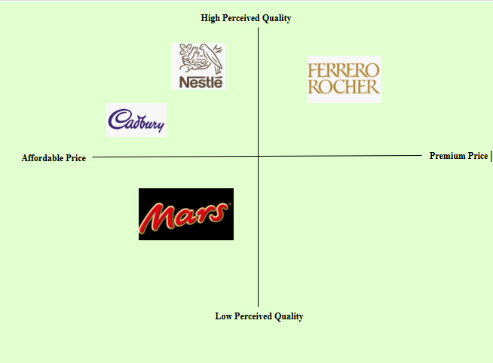

Figure 3: Positioning Map
(Source: Self-developed)
This company adopts different positioning strategies to highlight customers' varied expectations within both India and the United Kingdom. In India, the brand is positioned as a crucial part of the celebrations and emotional moments. This helps to successfully transform chocolate into a culturally accepted gifting option along with the traditional sweets. On the flip side, Cadbury UK positions itself around a sense of heritage, quality and everyday indulgence and thus strengthening its long-standing business reputation across mature confectionery markets (Kounougakis, 2022). Compared with India, the UK positioning of the Cadbury company places greater emphasis on brand heritage as well as premium value and thus highlights the differences across both customer preferences and market maturity.

6. International Marketing Mix (7Ps)
The marketing mix presents a structured framework for critically analysing how Cadbury adapts its international business marketing strategy across India and the United Kingdom. Through comparing and contrasting the seven elements of the 7Ps, this section profoundly examines how the brand closely aligns its offerings with varied preferences of the customers, market conditions and finally the volatile business environments.
Marketing Mix element 1: Product
India
In India, the company provides affordable packs (₹5–₹20), Cadbury Silk, 5 Star, Gems and Cadbury Celebrations gift boxes, which are tailored for different festivals (Janwal, 2025).
UK
With respect to the UK, Cadbury mainly focuses on Dairy Milk, Bournville, Heroes, Roses and finally seasonal products for Easter and Christmas, with greater emphasis on both premium and sharing formats (Mynewsdesk, 2024).

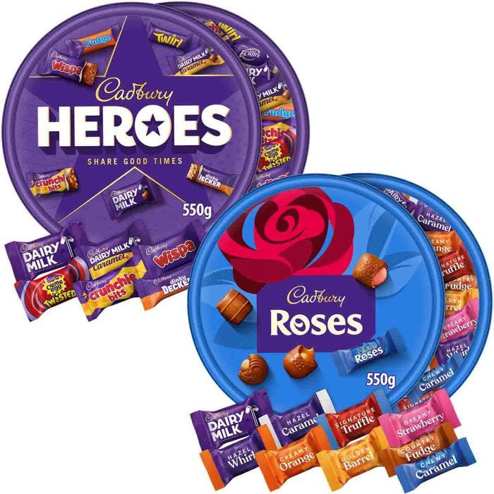

Figure 4: Product variety in India and UK
(Source: Amazon, 2026; CadburyGiftsDirect, 2026)
Marketing Mix element 2: Price
India
It offers value-based pricing, which is supported by low-unit-price packs in order to enhance affordability along with the market penetration.
UK
In the UK, the company uses a premium pricing strategy which is supported by the larger pack sizes, gifting products and higher disposable incomes.

Figure 5: Different distribution Channel in India and UK
(Source: Self-developed)
Marketing Mix element 3: Place
India
The products of the brand are distributed through over six million retail outlets, incorporating the kirana stores, supermarkets and quick-commerce platforms like Blinkit and Zepto (Janwal, 2025).
UK
The product available through Tesco, Sainsbury's, ASDA, Morrison’s, convenience stores and other major online retailers (Shufflebotham, 2023).
Marketing Mix element 4: Promotion
India
Emotional campaigns incorporating the Kuch Meetha Ho Jaaye, festival advertising and finally the celebrity endorsements help the brand to strengthen its cultural relevance within India. Cadbury also adopts an Integrated Marketing Communications (IMC) approach through the help of different social media platforms like Instagram, Facebook, YouTube, influencer collaborations and festive digital campaigns in order to maximise the consumer engagement.
UK
Advertising basically focuses on generosity, heritage and everyday moments through the help of television, digital media and seasonal campaigns. Cadbury further implements an Integrated Marketing Communications (IMC) strategy through leveraging the Instagram, TikTok, YouTube, supermarket promotions and sustainability-focused campaigns to strengthen brand engagement.
Marketing Mix element 5: People
India
Local sales teams and distributors support the relationships across diverse urban as well as rural markets. Mondelez India employs over 3500 people within different area like the manufacturing, sales and distribution (Ambitionbox, 2026). Besides that, the employees also receive proper training on continuous product, sales and customer relationship, while the performance incentives encourage the motivation as well as market expansion.
UK
Employees prioritise customer service, merchandising and retail execution within the organised supermarket channels. Cadbury's Bournville and UK operations employ approximately 3000 people. Moreover, the staff receive proper training on aspects like regular customer service, food safety and merchandising supported through the career development opportunities as well as performance-based reward programmes in order to enhance the motivation and service quality.
Marketing Mix element 6: Process
India
Local manufacturing in combination with an extensive distribution network helps in enhancing product availability across diverse regions of the nation. However, within India, customers can submit their complaints through website, email, helpline and social media and thus ensures prompt resolution as well as satisfaction
UK
Advanced supply chain systems within the UK not only support efficient inventory management but also timely seasonal product distribution. Whether customers face dissatisfaction with the process they can report their concerns through website, contact form, email, helpline and social media for timely resolution.
Marketing Mix element 7: Physical Evidence
India
Bright, festive packaging along with the locally relevant gift boxes reinforce the emotional and celebratory occasions of India.
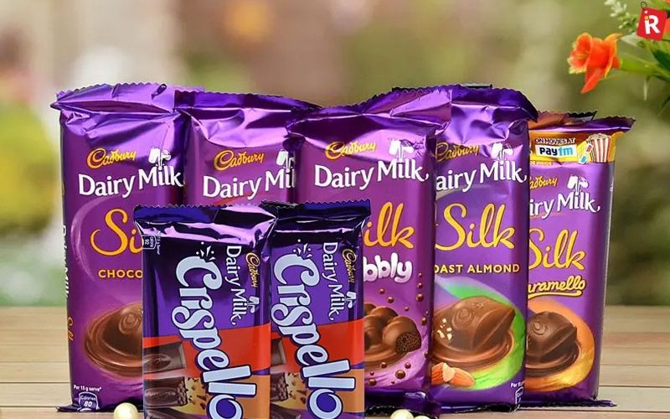

Figure 6: Cadbury packaging in India
(Source: Sharma, 2026)
UK
Premium packaging, sustainable design initiatives in combination with the attractive in-store displays help to fortify the perceptions of quality.
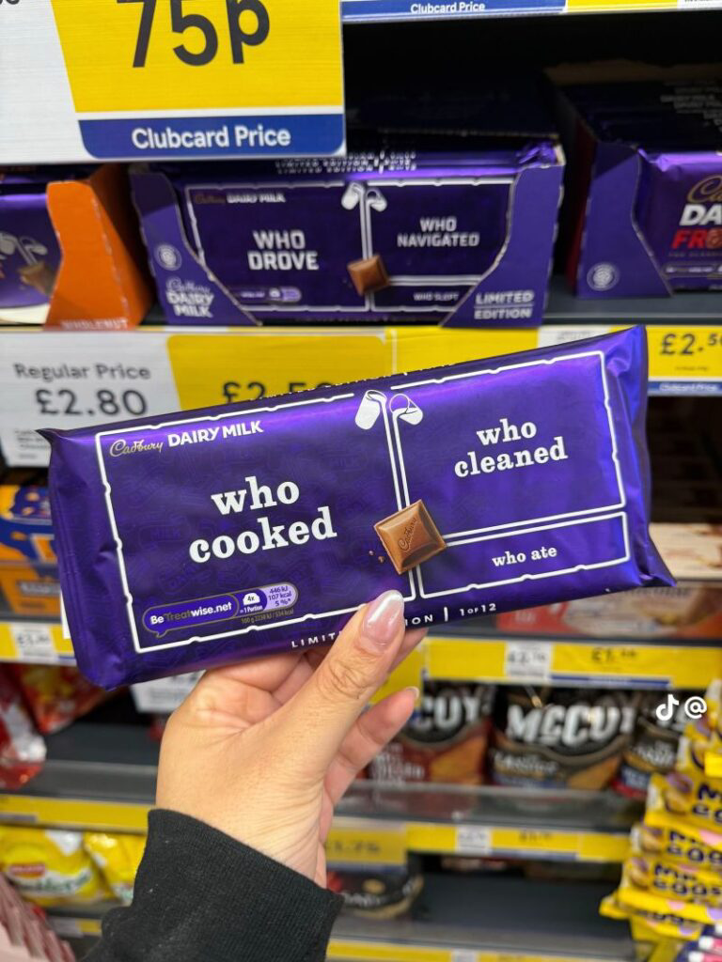

Figure 7: Cadbury packaging in UK
(Source: Herring, 2025)
Critical Evaluation
The comparison of the 7Ps of the Cadbury company reveals that the success of international marketing is driven through strategic adaptation rather than standardisation. Compared with the United Kingdom, the diverse income levels of India and stronger price sensitivity require smaller pack sizes, affordable pricing and ultimately extensive distribution through both traditional and retail channels, and thus allow the company to maximise its market penetration. On the flip side, the mature UK confectionery market encourages premium product portfolios with a sense of value-based pricing and organised retail partnerships which help boost profitability rather than volume growth (Hossain et al., 2024).
Cultural differences also remarkably influence the marketing decisions of Cadbury. Though the promotional activities within India are closely aligned with different festivals and gifting traditions, the UK-based campaigns basically highlight a sense of heritage, generosity and finally everyday indulgence. This means that Cadbury profoundly localises the brand communication without compromising its global brand identity. In a similar way, physical evidence differs across markets, as festive packaging as well as gift assortments develop a sense of emotional value within India while the sustainable as well as premium packaging closely integrates with the growing environmental awareness within the UK.
However, not all elements require substantial adaptation. Core quality of the products, standards of customer service, along with supply chain effectiveness remain globally consistent, which ensures a unified brand experience across both business markets (Moshood, 2025). Nevertheless, the marketing effectiveness of this brand highly depends on effectively balancing the global brand consistency with local market adaptation. Compared with the UK, the complicated distribution networks of India require a sense of profound operational flexibility, while the rising health as well as sustainability expectations in both markets emphasise the need for continued innovation in products, packaging and ultimately responsible sourcing.

7. Market Entry method in India
A market entry method is a process utilised by firms to operate and penetrate the international market. The common market entry methods involve wholly owned subsidiaries, strategic alliances, joint ventures, franchising, and licensing. After Indian independence, Cadbury enter within India illustrate in which way choosing an accurate market entry strategy contributes to sustainable business success.
Within India, Cadbury operates in franchising service industries like hotels and restaurants. Cadbury's Indian strategies' major element is its investments in local manufacturing (Lubis and Muniapan, 2024). Though this firm developed production facilities in Thane (Maharashtra), it helps the firm to reduce dependence on imports, increase supply chain efficiency, and reduce transport costs (Lubis and Muniapan, 2024). On the other hand, Cadbury is a consumer goods company, and its franchising offer minimum advantages and has not aided major control over production activities (Aujla, 2022). Apart from that, Joint Ventures, though they offer local market knowledge, it sometime develops conflicts about profit sharing, strategic objectives and management decisions within the company. On the other hand, a Wholly Owned Subsidiary (WOS) strategy helps to handle 100% company’s operations within a new-entering country, though this technique needs major investments and offers maximum control over strategic decisions, product quality and business activity.
Cadbury's Entry into India
Therefore, instead of depending solely on international products, they step by step developed a local presence and decreased costs, that help to fulfil customers' growing requirements (Ibrahim, 2024). With the help of Mondelez India Foods Private Limited, Cadbury operates in India and selects the Wholly Owned Subsidiary (WOS) strategy to operate within India. As a result, gradual growth helps them to hold the leadership position within the Indian chocolate confectionery market, where the Bournville, Perk, Gems, 5 Star, and Dairy Milk-like flagship brands are included. Therefore, adopting this strategy helps to offer maximum control over business operations, brand image and product quality.
The local manufacturing facilities development also allows the firm to manufacture the product in smaller quantities and with smaller packaging, which is suitable for the Indian market with its price-conscious consumers (Ibrahim, 2024). As a result, these meet the local customers' preferences, raise supply chain efficiency, and empower Cadbury to decrease transportation costs. On the other hand, this strategy also brings issues for profit generation, as smaller packs generate less revenue per unit sold and contribute less to the company’s profitability, as it needs higher packing and production costs relative to product volume (Gupta et al., 2024).
Advantages of the Wholly Owned Subsidiary
- Complete control over distribution activities, marketing, and production.
- Strong protection of intellectual property and brand reputation (Ventura, 2025).
- Through local manufacturing, improved operational efficiency
- Capability to manage continuous quality standards.
Disadvantages of the Wholly Owned Subsidiary
- Requires substantial capital investment.
- For financial and operational performance, greater responsibility.
- Increased costs related to handling the workforce and managing manufacturing facilities
- From regulatory changes and supply chain disruptions, potential challenges arise.

8. Ethical Issues
Ethical issues
Ethical Cocoa Sourcing and Farmer Welfare
Through Mondelez International’s Cocoa Life programme, this brand invests US$1 billion in sustainable cocoa farming as well as community development (Cocoalife, 2026). This showcases the progress towards ethical sourcing. However, compared with the increasing expectations of the stakeholders for complete supply chain transparency and farmer income protection, concerns regarding the long-term sustainability as well as independent verification remains very significant.
Sustainable Packaging and Environmental Responsibility
Cadbury has committed to lowering the packaging waste while maximising the recyclability of its packaging materials (Deshmukh and Tare, 2023). Nevertheless, compared with the stronger environmental expectation across the UK, progress remains gradual. Therefore, continued investment within recyclable, reduced plastic and circular packaging solutions is necessary to fortify the environmental creditability across both business markets of UK and India.
Unethical issues
Sugar Consumption and Public Health
Rising obesity as well as diabetes in both countries have maximised pressures on the confectionery companies. Cadbury has introduced portion-controlled products and cleaner multinational labelling (Myers, 2020). A significant example is the Cadbury Freddo and Dairy Milk promotions which both the customers and the public health organisations criticised for encouraging the high-sugar consumption among the young audiences. However, compared with the growing expectations of health-conscious customers, its portfolio remains largely focused on indulgence, which further requires strong development of lower-sugar as well as healthier product alternatives.
Cadbury Worm Controversy:
Cadbury faced widespread criticism after worms has been found within the Dairy Milk chocolate bars which sold in Maharashtra, India (The IRM India, 2021). Despite the poor retailer storage has been identified as the primary cause of the incident, the incident damaged the consumer trust and also prompted enhanced tamper-proof packaging along with stricter quality controls within the nation.

9. Recommendations
Expand healthier chocolate products
Due to the rising incidence of obesity, diabetes and healthy lifestyles in the UK, the requirement for lower sugar content, more cocoa, and plant-based chocolates in the existing variety of Cadbury should be met within 12 to 18 months. It can invest more in R&D and offer healthier varieties of products, while showing nutrition facts on the packaging. For example, Nestle’s reduced sugar KitKat and Mondelez's Cadbury Dairy Milk 30% Less Sugar in certain markets (Jethwa, 2019). The expected benefits are going to be a better reputation, popularity among health-conscious consumers, and presence in premium markets (Tuigunov et al., 2025). However, product redesigning can entail higher manufacturing expenses, and taste might change.
Increase sustainable packaging
The environmental regulations and consumer demands show that Cadbury needs to hasten efforts in moving towards using recyclable, biodegradable, and low-plastic packaging (MUIGAI, 2013). Cadbury would need to work together with packaging suppliers and retailers in developing a sustainable approach to packaging within 18 to 24 months to comply with UK environmental regulations. For instance, Mondelez has promised to come up with packaging that is recyclable for most of their products by 2025 around the world (Mondelēz International, 2018). Some of the advantages include better ESG ratings, good corporate reputation, and meeting the regulations. However, sustainable materials have relatively high initial costs.
Implement AI-driven personalised digital marketing
Cadbury needs to use AI-based personalized digital marketing to engage customers better and boost online sales in the UK. AI will be able to analyze consumer data and provide personalized suggestions for products, advertisements, and festival-based promotions (Kumar et al., 2025). For instance, Amazon’s AI recommendation system is successful in providing a good customer experience via personalized suggestions. It will take 6 to 12 months to execute this initiative by integrating AI into CRM and e-commerce systems. The advantages are increased brand loyalty and marketing efficiency. The disadvantages are high costs of implementation and data protection issues.
Launch more India-specific festival campaigns
India has a collectivist culture and follows festival buying behaviour by considering festival campaigns. In India, Cadbury should further localize its campaigns for festivals like Diwali, Raksha Bandhan, and Holi through regional languages, packaging, and storytelling through digital channels. The example of the well-known “Kuch Meetha Ho Jaaye” campaign of Cadbury shows that such alignment of chocolates with Indian festivals helps to generate more sales and build emotional connection and loyalty to the brand (Fernandes et al., 2016). But an excessive focus on seasonal campaigns may result in unstable demand in non-festive seasons.
Strengthen omnichannel retail and quick-commerce partnerships
The firm needs to build partnerships with more supermarkets and rapid commerce retailers like Blinkit, Zepto, and Instamart in India within 6 to 12 months. Within the India's rapidly growing online grocery market, the company also needs to develop collaboration with retail organizations through omnichannel distribution strategies. This is because Mars has made products more accessible through omnichannel distribution systems to cater to changing shopper trends (Mars United, 2026). The negative aspect of the same is increased dependency on third-party retailers.
Improve transparency in cocoa sourcing and sustainability communication
Cadbury India needs to improve visibility in its supply chain through developing responsible cocoa sourcing programs, reporting its sustainability achievements, and using QR codes for tracking the source of its products within 24 to 36 months (Martins et al., 2023). Mondelez International’s Cocoa Life program is an excellent model for investing in farmers’ welfare and sustainable farming practices that help to build consumer confidence and brand differentiation (Mondelēz International, 2022). However, traceability systems are costly and difficult to maintain due to implication in India.

10. Conclusion
In conclusion it can be asserted that, Cadbury profoundly adapts its STP strategy along with the 7Ps marketing mix to the contrasting cultural as well as economic conditions within India and the UK while managing global brand consistency. However, strengthening healthier product innovation, ethical sourcing of cocoa, sustainable packaging and finally responsible marketing practices remains crucial in order to boost long-term competitiveness and customer trust. From the marketing entry strategy, it has illustrated that slow growth enables them to occupy the leadership position in the Indian chocolate confectionery market segment, and Dairy Milk feature prominently among their flagship brands. The report suggests Cadbury to diversify healthier products, use sustainable packaging, develop personalized marketing using artificial intelligence, improve India-specific festival promotions, improve omnichannel and quick commerce collaborations, and increase transparency in cocoa sourcing. Overall, these strategies will help in becoming more competitive, increasing customer engagement, achieving sustainability goals, and promoting growth in the UK and Indian markets.

Section 2: Reflective Account (Gibbs' Reflective Cycle)
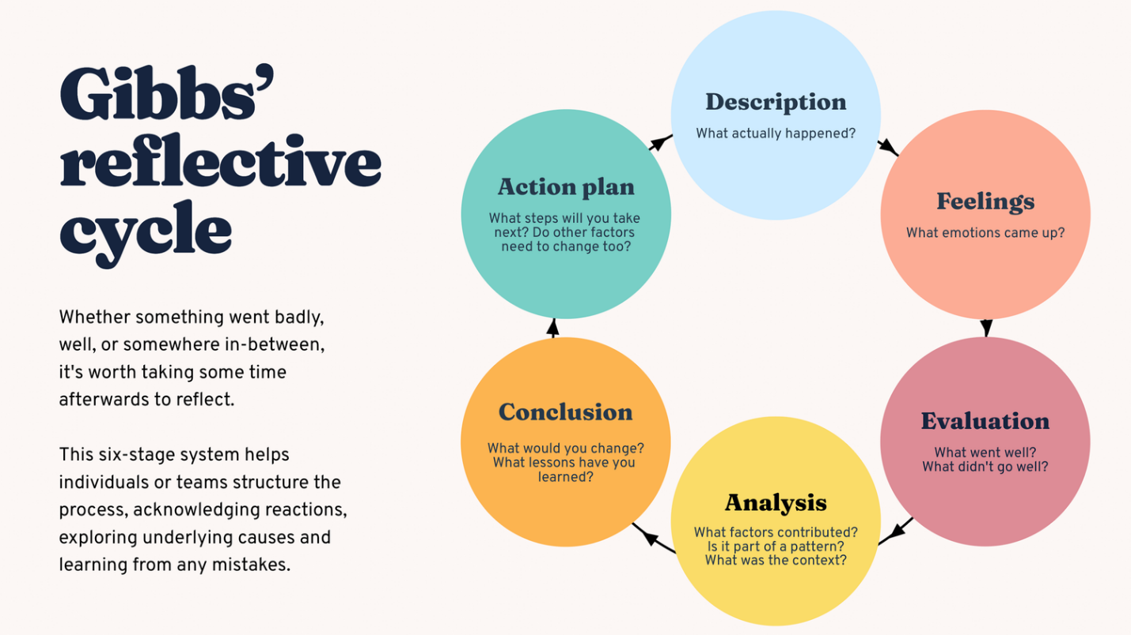
Figure 1: Gibbs' Reflective Cycle
(Source: Bitesizelearning, 2025).

1. Description
This study needs to analyse critically the international marketing strategy of Cadbury through comparing the UK and Indian operations. Therefore, this study includes employing different global marketing models such as STP, Hofstede's Cultural Dimensions, PESTEL analysis, and the 7Ps of the marketing mix. Besides that, I assessed Cadbury's market entry strategy and analysed ethical challenges impacting the firm and offered innovative approaches to raise their future international marketing performance.
Therefore, Cadbury has been chosen as it is an internationally recognised company which has a powerful presence in emerging and developing markets. Besides the comparison among the UK and India, offer an opportunity to gain knowledge on which way a multinational firm adapts its marketing strategies to create differentiation in consumers, cultural, political and economic environments. (inspired by De Prada et al. 2022) This study will empower me to combine real business practices with theoretical marketing concepts and raise comprehensive knowledge about global marketing management.

2. Feelings
From the start of the study, I feel confident enough about selecting Cadbury as it is an international company and has minimal knowledge about the strategic decisions engaged in global marketing. Primarily, I believed that these successful MNC companies would have developed uniform marketing approaches in various countries. On the other hand, throughout my course of research, I feel there is generally a trade-off between localisation and standardisation strategies. I encountered my first problem locating contemporary academic as well as corporate information, industry publications, company reports, and academic journals. Therefore, I realised that it is critical to compare the UK and India critically instead of emphasising every market separately. Other issues emerge when employing the theoretical models accurately while managing a logical flow within this research; in spite of the issues, I feel confident step by step as my knowledge about the international marketing concepts has been raised with the help of constant analysis and reading.

3. Evaluation
With the progression of the report, I realise that this study is important and offers valuable learning. One important aspect that went well is including various global marketing frameworks to assess Cadbury's business strategies. Utilising the PESTLE analysis assisted me in gaining knowledge about how legal, environmental, technological, social, and economic factors impact business decisions. Hofstede's Cultural Dimensions empower me to appreciate in which way cultural differences impact product positioning, advertising and consumer behaviour.
Besides that, the comparison between the UK and India raises my capability to find out the differences and similarities in marketing strategies. Therefore, I become able to raise my research skills through utilising credible industry sources, company reports and academic literature to aid my arguments.
On the other hand, I mitigated different complexities in the time of the writing assignment. Multiple data associated with Cadbury's sustainability initiatives and Cadbury's market entry strategy have spread across different sources, making it problematic to find the most relevant evidence (inspired by Zamiri and Esmaeili, 2024). Besides, I understand that criticism means something more than writing that this worked or didn't work, but is about the underlying analysis as to how a strategy succeeds in some markets, and others will inevitably fail. As a result, these experiences outline the significance of balancing analytical discussion with descriptive information to produce a large academic report.

4. Analysis
Finishing the study helps me to raise my knowledge about global marketing and illustrates in which way theoretical models aided strategic decision-making in the MNC. Therefore, external environmental factors are shown through the PESTLE analysis for the UK and India. For instance, India's price-sensitive consumers and large emerging economy need extensive distribution networks and affordable products, though the UK's mature market places illustrate health-conscious consumption, sustainability, and premium products.
Besides that, Hofstede's Cultural Dimensions emphasised the significance of culture in structuring marketing decisions. I gained knowledge about the differences in purchasing behaviour, promotional messages, indulgence, influence, consumer expectations, long-term orientation, individualism and power distance. This analysis why the company utilises festival-related advertising while concentrating on seasonal promotions and premium gifting in the UK.
Besides that, the STP model raised my knowledge about targeting and marketing segmentation by illustrating how the firm finds out particularly users groups and positions their products as per local requirements. Here I acquired the most significant perspectives and understood that global marketing strategies need a careful balance among the local adaptation and global standardisation. Besides, the company manages a continuous international brand identity, though it redesigns marketing strategy in multiple aspects to suit diverse market and cultural conditions. As a result, these this flexibility has commit to Cadbury's long-term competitive edge and illustrates the international marketing theories' practical applications.

5. Conclusion
With the progression of the report, it has stated that this report has widened my knowledge about international marketing through preparing, analysing a researching on the particular topic. These experiences illustrated the significance of evidence-based analysis, critical evaluation and careful planning when comparing the business strategies within diverse regions. Employing the recognised marketing models assisted me to raise more designing and analytical approach to solving problems, while the research procedure of the research raised my confidence in assessing and locating credible data (inspired by Zhao et al. 2024). In the end, this study has broadened my writing skills and academic skills and my knowledge about how MNCs integrate their marketing strategies in various international markets.

6. Action Plan
This reflection helps to find out the different areas for development in future. Basically, I will raise my critical analysis by concentrating on analysing business strategies' effectiveness instead of describing them. Therefore, I want to try to raise my research skills through evaluating a broader range of recent industry reports a peer reviewed journals and permit me to efficiently handle future assignments with real evidence. On the other hand, I will raise my referencing skills through giving accuracy accurately within the entire writing. Thirdly, to raise my report writing capability. I will start future assignments previously and establish a comprehensive, detailed outline before revision, which permits sufficient time for proofreading.

Reference
Al-Adwan, A.S., Yaseen, H., Alkhwaldi, A.F., Jafar, R.M.S., Fauzi, M.A. and Abdullah, A.,( 2025). ‘Treasure hunting for brands: metaverse marketing gamification effects on purchase intention, WOM, and loyalty’. Journal of Global Marketing, 38(4), pp.392-416. https://www.tandfonline.com/doi/pdf/10.1080/08911762.2025.2463897. (Accessed 28 July, 2026)
Amazon (2026). Cadbury Celebrations Assorted Chocolate Bar Gift. Available from:https://www.amazon.in/Cadbury-Celebrations-Assorted-Chocolate-70-2g/dp/B014KKL8EC. (Accessed 28 July, 2026)
Ambitionbox (2026). Working at Cadbury. Available from: https://www.ambitionbox.com/overview/cadbury-overview. (Accessed 28 July, 2026)
Aujla, D.S., (2022). ‘an Analysis of the Marketing Strategies of Cadbury’. Marketing Mastery: Strategies for Captivating Audiences, p.43. https://books.google.co.in/books?hl=en&lr=&id=RgEJEQAAQBAJ&oi=fnd&pg=PA43&dq=+Cadbury%27s++and+Market+Entry+Strategy&ots=06UzkhqAql&sig=xYDe00-YeKO-bD_57yRf_NKH5t4&redir_esc=y#v=onepage&q=Cadbury's%20%20and%20Market%20Entry%20Strategy&f=false . (Accessed 28 July, 2026)
BBC (2026). What is happening to UK prices?. Available from: https://www.bbc.com/news/articles/c17rgd8e9gjo (Accessed 28 July, 2026)
Bitesizelearning (2025). The Gibbs Reflective Cycle, explained. Available from:https://www.bitesizelearning.co.uk/resources/gibbs-reflective-cycle-explained-diagram-examples (Accessed on 30th July, 2026)
Brandequity.economictimes (2026).Mondelez India FY 25 Revenue Available from: https://brandequity.economictimes.indiatimes.com/news/business-of-brands/mondelez-india-fy25-revenue-slips-2-pc-to-rs-12503-cr/126561415 (Accessed 31 July, 2026)
Brandequity.economictimes.indiatimes (2026). Cadbury Dairy Milk's 'Kuchh Meetha Ho Jaaye' campaign shifts focus to 'Acchai'.Available from: https://brandequity.economictimes.indiatimes.com/news/research/advertising/cadbury-dairy-milks-kuchh-meetha-ho-jaaye-campaign-shifts-focus-to-acchai/65063775 (Accessed 28 July, 2026)
Cadbury (2026). The Cadbury Story. Available from: https://www.cadbury.co.uk/about/history/our-story/ (Accessed 28 July, 2026)
CadburyGiftsDirect (2026). Cadbury Heroes & Roses. Available from: https://www.cadburygiftsdirect.co.uk/cadbury-heroes-roses-chocolate-tubs-550g-bundle-of-2.html. (Accessed 28 July, 2026)
Chattopadhyay, A., Ali, S.S., Chakraborty, S., Acharjee, S., Roy, A., Pal, S. and Chittilapilly, S.V., (2023). ‘Cultural Adoption Through Advertisements: International and Indian Scenarios’. Journal homepage: www. ijrpr. com ISSN, 2582, p.7421. https://www.researchgate.net/profile/Aaratrika-Chattopadhyay/publication/368464780_Cultural_Adoption_Through_Advertisements_International_and_Indian_Scenarios/links/63ea56274dcb750da7570468/Cultural-Adoption-Through-Advertisements-International-and-Indian-Scenarios.pdf. (Accessed 28 July, 2026)
Cocoalife (2026). SUPPORTING SUSTAINABLY SOURCED COCOA. Available from: https://www.cocoalife.org/en/brands/cadbury/ (Accessed 28 July, 2026)
Cocoalife (2026). Why Cocoa Life?. Available from: https://www.cocoalife.org/en/. (Accessed on 28 July, 2026)
De Prada, E., Mareque, M. and Pino-Juste, M., (2022). ‘Teamwork skills in higher education: is university training contributing to their mastery?’. Psicologia: Reflexao e critica, 35(1), p.5. https://link.springer.com/content/pdf/10.1186/s41155-022-00207-1.pdf. (Accessed 28 July, 2026)
Deshmukh, P. and Tare, H., (2023). ‘Green marketing and corporate social responsibility: A review of business practices’. Multidisciplinary Reviews, 7(3), pp.1-9. https://pdfs.semanticscholar.org/9378/a207efa8e3122792b9364f0ba31c9d80cd76.pdf. (Accessed 28 July, 2026)
Dureja, V., (2024). ‘Emerging Technologies and Their Impact on Business Transformation in the United Kingdom’. Available at SSRN 6111026. https://papers.ssrn.com/sol3/Delivery.cfm?abstractid=6111026. (Accessed 28 July, 2026)
EY (2026). India’s Green Resolve: Reducing Plastic Waste. Available from: https://www.ey.com/en_in/insights/sustainability/india-s-green-resolve-reduce-plastics-and-power-a-sustainable-future (Accessed 28 July, 2026)
Fernandes, S.F., Gupta, P. and Vidyasagar, A., (2016). ‘Cadbury India–Sweet Turning Sour.’ Ushus Journal of Business Management, 15(4), pp.37-54. https://journals.christuniversity.in/index.php/ushus/article/download/1641/1370. (Accessed 28 July, 2026)
GeeksforGeeks (2025). STP Marketing - Segmentation, Targeting, and Positioning. Available from: https://www.geeksforgeeks.org/marketing/stp-segmentation-targeting-and-positioning/. (Accessed on 28 July, 2026)
Gupta, V., Godavale, D. and Vidani, J., (2024). ‘Comparative Analysis Between Hersey’s Chocolate VS Dairy Milk Chocolate (Cadbury) with Reference to Taste in Ahmedabad City’. https://www.academia.edu/download/122955062/90.pdf. (Accessed 28 July, 2026)
Herring. J., (2025). New packaging from Cadbury Dairy Milk rewards cooks and drivers. Available from:https://www.famouscampaigns.com/2025/01/new-packaging-from-cadbury-dairy-milk-rewards-cooks-and-drivers/. (Accessed 28 July, 2026)
Hoque, A., Kabir, M.A. and Tahseen, S., (2025). ‘Online Retail: Purchasing Occasional Gifts through Online Channels is a Prevalent Trend in the United Kingdom’. Mohammad Anowarul and Tahseen, Salsabil. https://papers.ssrn.com/sol3/Delivery.cfm?abstractid=5403243. (Accessed 28 July, 2026)
Hossain, M.I., Akter, N. and Muzareba, A.M., (2024). ‘Pricing Strategies’. In Marketing in a Transition Economy: New Realities, Challenges, and Prospects (pp. 273-297). Singapore: Springer Nature Singapore. https://link.springer.com/chapter/10.1007/978-981-97-3553-2_8. (Accessed 28 July, 2026)
Ibrahim, A.A., (2024). ‘THE EFFECT OF ADVERTISING ON SALES OF FAST-MOVING CONSUMER GOODS: A STUDY OF CADBURY NIGERIA PLC’. International Journal of Sales, Retailing & Marketing, 12(1). https://www.circleinternational.co.uk/wp-content/uploads/2025/01/IJSRM-Vol-12-No-1-December-2024.pdf#page=18. (Accessed 28 July, 2026)
Janwal. S., (2025). Cadbury Case Study: Marketing Strategy, Campaigns & More. Available from: https://www.youngurbanproject.com/cadbury-case-study/. (Accessed on 28 July, 2026)
Jethwa, P., (2019), Dairy Milk 30% Less Sugar was introduced by Cadbury. Available from https://www.betterretailing.com/cadbury-dairy-milk-less-sugar/ (Accessed 28 July, 2026)
John, M., (2025). ‘Implications of Next-Generation GST Reforms on Agriculture, Agri-Value Chains and Rural Livelihoods in India: A Conceptual Analysis’. https://gem.sgcaruvithura.ac.in/assets/vol5-issue1/vol5-issue1-paper8.pdf. (Accessed 28 July, 2026)
Kounougakis. A., (2022). CHOCSTALGIA”: UK’S FONDNESS FOR NOSTALGIC CHOCOLATE TREATS IS UNWRAPPED IN CHOCOLATE TRENDS REPORT MARKING 200 YEARS OF CADBURY. Available from: https://savanta.com/knowledge-centre/view/the-sweet-success-of-cadbury/. (Accessed on 28 July, 2026)
Kumar, L., Dutt, R. and Gaikwad, K.K., (2025). ‘Packaging 4.0: Artificial intelligence and machine learning applications in the food packaging industry.’ Current Food Science and Technology Reports, 3(1), p.19. https://www.researchgate.net/profile/Kirtiraj-Gaikwad/publication/392654941_Packaging_40_Artificial_Intelligence_and_Machine_Learning_Applications_in_the_Food_Packaging_Industry/links/684c088c69e22a0aa9d5f2db/Packaging-40-Artificial-Intelligence-and-Machine-Learning-Applications-in-the-Food-Packaging-Industry.pdf . (Accessed 28 July, 2026)
Lubis, M. and Muniapan, B., (2024). ‘International market development Strategies for enhancing global expansion in the export industry’. Involvement International Journal of Business, 1(1), pp.14-28. https://ejournal.agungmediapublisher.com/index.php/iijb/article/download/3/6. (Accessed 28 July, 2026)
Markhub24 (2026). Cadbury Dairy Milk's Celebration-Led Communication in India. Available from: https://www.markhub24.com/post/cadbury-dairy-milk-s-celebration-led-communication-in-india. (Accessed on 28 July, 2026)
Mars United, (2026), Store Growth Meets Omnichannel Innovation. Available from https://www.marsunited.com/store-growth-meets-omnichannel-innovation/ (Accessed 28 July, 2026)
Martins, F.P., Batalhão, A.C., Ahokas, M., Liboni Amui, L.B. and Cezarino, L.O., (2023). ‘Rethinking sustainability in cocoa supply chain in light of SDG disclosure.’ Sustainability Accounting, Management and Policy Journal, 14(7), pp.258-286. https://www.emerald.com/sampj/article-pdf/14/7/258/2182875/sampj-03-2022-0132.pdf. (Accessed 28 July, 2026)
Mondelēz International, (2018), Mondelēz International Commits to Making All Packaging Recyclable by 2025. Available from https://ir.mondelezinternational.com/news-releases/news-release-details/mondelez-international-commits-making-all-packaging-recyclable#:~:text=(GLOBE%20NEWSWIRE)%20%2D%2D%20Mondel%C4%93z%20International,provide%20recycling%20information%20by%202025. (Accessed 28 July, 2026)Mondelēz International, (2022), Mondelēz International Doubles Down on Cocoa Life Program with Total Investment of $1 Billion by 2030; Calls for More Sector-Wide Action. Available from https://ir.mondelezinternational.com/news-releases/news-release-details/mondelez-international-doubles-down-cocoa-life-program-total#:~:text=By%202030%2C%20Cocoa%20Life%20aims,on%20Cocoa%20Life%20farms%20globally. Accessed 28 July, 2026.
Mondelezinternational (2026). Mondelēz International Reports Q4 and FY 2024 Results. Available from: https://ir.mondelezinternational.com/news-releases/news-release-details/mondelez-international-reports-q4-and-fy-2024-results/ (Accessed 28 July, 2026)
Mondelezinternational (2026). SNACKING MADE RIGHT. Available from: https://www.mondelezinternational.com/snacking-made-right/ (Accessed 28 July, 2026)
Moshood, M., (2025). ‘Assessing brand-driven supply chain customization and its role in enhancing operational efficiency and sustained market expansion for global enterprises’. Int J Adv Res Publ Rev, 2(8), pp.32-50. https://www.researchgate.net/profile/Modinat-Moshood/publication/394406659_Assessing_Brand-Driven_Supply_Chain_Customization_and_its_Role_in_Enhancing_Operational_Efficiency_and_Sustained_Market_Expansion_for_Global_Enterprises/links/68962f5b37ccad61380433cb/Assessing-Brand-Driven-Supply-Chain-Customization-and-Its-Role-in-Enhancing-Operational-Efficiency-and-Sustained-Market-Expansion-for-Global-Enterprises.pdf. (Accessed 28 July, 2026)
MoSPI (2026). FIRST ADVANCE ESTIMATES OF GROSS DOMESTIC PRODUCT FOR 2025-26.Available from: https://www.mospi.gov.in/uploads/latestReleases/latest_release_1767781372753_1380ce82-f5a5-440d-99e6-e6b35af0deb5_GDP_Press_Note_on_FAE_2025-26.pdf (Accessed 28 July, 2026)
MUIGAI, S.M., (2013). ‘Strategies employed by Cadbury Kenya Limited to gain sustainable competitive Advantage.’ Unpublished MBA Project, University of Nairobi. https://www.academia.edu/download/101979262/Muigai_Sustainable_20competitive_20advantage.pdf. (Accessed 28 July, 2026)
Myers. A., (2020). Cadbury doubles down on portion control with new chocolate multipacks. Available from: https://www.confectionerynews.com/Article/2020/07/17/Cadbury-doubles-down-on-portion-control-with-new-chocolate-multipacks/. (Accessed on 28 July, 2026)
Mynewsdesk (2024). CHOCSTALGIA”: UK’S FONDNESS FOR NOSTALGIC CHOCOLATE TREATS IS UNWRAPPED IN CHOCOLATE TRENDS REPORT MARKING 200 YEARS OF CADBURY. Available from: https://www.mynewsdesk.com/uk/mondelez-uk/pressreleases/chocstalgia-uks-fondness-for-nostalgic-chocolate-treats-is-unwrapped-in-chocolate-trends-report-marking-200-years-of-cadbury-3312967. (Accessed on 28 July, 2026)
ONS (2026). GDP first quarterly estimate, UK: January to March 2026. Available from: https://www.ons.gov.uk/economy/grossdomesticproductgdp/bulletins/gdpfirstquarterlyestimateuk/januarytomarch2026 (Accessed 28 July, 2026)
Parliament.uk, (2026). Targets and performance. Available from: https://www.parliament.uk/about/sustainability/targets-and-performance/. (Accessed 28 July, 2026)
PIB (2022). POLICY MEASURES TO SUPPORT FOOD PROCESSING SECTOR. Available from: https://www.pib.gov.in/PressReleasePage.aspx?PRID=1848845&reg=48&lang=2 (Accessed 28 July, 2026)
Pramodini, S., Prajna, M. and Aithal, P.S., (2026). ‘The Sweet Revolution: The Rise of the Chocolate Industry in India’. Poornaprajna International Journal of Teaching & Research Case Studies (PIJTRCS), 3(1), pp.59-102. https://www.poornaprajnapublication.com/index.php/pijtrcs/article/download/42/38. (Accessed 28 July, 2026)
SCAI (2026). INDUSTRY NEWS. Available from: https://www.scai.in/industry-news/. (Accessed on 28 July, 2026)
Shaba, Y., (2024). ‘Corporate Governance: Exploring Key Concepts, Mechanisms, and Historical Evolution’. Asian Research Journal of Arts & Social Sciences, 22(11), pp.10-9734. https://papers.ssrn.com/sol3/Delivery.cfm?abstractid=5005652. (Accessed 28 July, 2026)
Sharma. R., (2026). Top 5 Chocolate Brands in India Winning Consumer Preference. Available from:https://www.indianretailer.com/article/retail-business/consumer-trends/top-5-chocolate-brands-india-winning-consumer-preference. (Accessed 28 July, 2026)
Shugfflebotham. B., (2023). Cadbury and Fry's launch King's Coronation chocolate bars available at Tesco, Sainsbury's, Morrisons and Asda. Available from: https://www.manchestereveningnews.co.uk/whats-on/shopping/cadbury-frys-launch-kings-coronation-26699125. (Accessed on 28 July, 2026)
The IRM India (2021). When crisis led to consumer safety:the story of cadbury. Available from:https://www.theirmindia.org/blog/when-crisis-led-to-consumer-safety-the-story-of-cadbury/. (Accessed 28 July, 2026)
Theculturefactor (2026). Hofstede Cultural Analysis. Available from: https://www.theculturefactor.com/country-comparison-tool?countries=india%2Cunited+kingdom.(Accessed 28 July, 2026)
Tradingeconomics (2026). India Inflation Rate. Available from: https://tradingeconomics.com/india/inflation-cpi (Accessed 28 July, 2026)
Tuigunov, D., Smagul, G., Sinyavskiy, Y., Omarov, Y. and Barmak, S., (2025). ‘Functionalization of chocolate: current trends and approaches to health-oriented nutrition.’ Processes, 13(5), p.1431. https://www.mdpi.com/2227-9717/13/5/1431. (Accessed 28 July, 2026)
Uk.news.yahoo (2025). Cadbury's sales surge after losing royal warrant for first time in 170 years .Available from: https://uk.news.yahoo.com/cadburys-sales-surge-losing-royal-093833210.html (Accessed 31 July, 2026)
Ventura, I.C.C., (2025). ‘The cadbury takeover: an analysis of kraft foods’ capital structure decisions’. https://run.unl.pt/bitstreams/d75b58e1-9cc2-43de-83e6-855850cc7d9d/download. (Accessed 28 July, 2026)
Zamiri, M. and Esmaeili, A., (2024). ‘Strategies, methods, and supports for developing skills within learning communities: A systematic review of the literature’. Administrative Sciences, 14(9), p.231. https://www.mdpi.com/2076-3387/14/9/231. (Accessed 28 July, 2026)
Zhao, Y., Zhang, Y., Zhang, Y., Zhao, X., Wang, J., Shao, Z., Turkay, C. and Chen, S., (2024). ‘Leva: Using large language models to enhance visual analytics’. IEEE transactions on visualization and computer graphics, 31(3), pp.1830-1847. https://arxiv.org/pdf/2403.05816. (Accessed 28 July, 2026)

