

Programme: Master of Business Administration
Module: Marketing Management
Assessment Component 1
Pioneers vs Followers: Evaluating Strategic Market Entry and Pro duct Life Cycle Strategies for Sustained Competitive Advantage

Student Name: Prit Vasantbhai Patel
Student ID:2427108

Table of Contents
1. Introduction 3
2. Main Body 3
2.1 Strategic Benefits of Pioneer and Follower Firms 3
2.2 Product Life Cycle Strategies of Pioneers and Followers 7
3. Conclusion 10
References 12

1. Introduction
One of the most significant choices business leaders must make throughout the strategic marketing process in the competitive and rapidly changing global marketplace today is deciding when to bring new products or technologies to the market. Such a choice tends to be a strategic one: whether to pioneer to come into the market first or follower, coming in after but perhaps better equipped (Giachetti, and Pira, 2022). Each of the two methods presents unique strengths and inherent dangers, thus it remains a fundamental argument in marketing strategy and innovation management.
Several companies have succeeded with either of the two strategies over the years. Companies such as Apple and Tesla have achieved solid early mover advantages by innovation and leadership in brand names, whereas companies such as Samsung and PepsiCo have employed late entry to develop existing products and take control of markets. The strategic direction adopted not only determines market positioning but also the manner in which companies address growth and sustainability in terms of phases of the Product Life Cycle (PLC). A pioneer firm is one which first launches an innovative product or idea to a market, whereas a follower firm enters the market after seeing the response from the market and learning from the experiences of the pioneer. Product Life Cycle model presents phases a product passes through, growth, maturity, and decline, each necessitating distinct strategies (Gray, 2024).
This essay will initially critically evaluate the main strengths of both pioneer and follower strategies, with supporting real-world examples and academic works. It will then discuss how each type of business implements growth and maturity stage PLC strategies to ensure a strong competitive edge.
Thesis Statement
Although both follower and pioneer companies can attain competitive advantage, ultimate success is contingent on how well they execute growth and maturity stage strategies in the Product Life Cycle.

2. Main Body

2.1 Strategic Benefits of Pioneer and Follower Firms
One of the longest-running debates in strategic marketing is whether companies are more likely to benefit by entering a market early as pioneers or entering later as followers. Timing of market entry is seen as critical, but is not always a successful guarantee. While pioneers can achieve initial dominance via innovation and brand loyalty, followers can take advantage of advanced strategies, cost-effectiveness, and learned market conduct. This section critically assesses the benefits of both roles, based on scholarly views and actual company experience.
Advantages of Pioneer Companies
Early movers or pioneers tend to receive credit for earning the highly mentioned First-Mover Advantage (FMA), which Lieberman and Montgomery (1988) conceived. According to this, to be first gives firms the chance to gain technological dominance, frame customers' expectations, and win access to scarce assets, such as good sites or patents. Early advantages tend to lead to sustained market dominance when complemented with ongoing innovation (Hayat, and Qingyu, 2024).
For example, Apple's 2007 iPhone revolutionized the cell phone industry with a touch-driven, application-focused user experience (Park, and Kim, 2021). While there were smartphones prior, Apple became the standard-bearer for smartphone aesthetics and interface design. Through 2023, Apple owns 52% of the American smartphone market, showing the extent to which path-forging innovation can establish dominance over a brand (Statista, 2024). Yet, according to some authors, it is debatable if this dominance results from early entry or from Apple's ecosystem approach and ongoing product development. So, simply being first is not sufficient and strategic follow-up is required. Another compelling case is Tesla, which established the contemporary electric vehicle (EV) industry. Tesla's early entry into EVs, as well as its investment in battery technology and charging infrastructure, enabled it to hold over 49% of the U.S. EV market by 2023 (Ewing, 2024). The company's position is widely regarded as a textbook example of Lieberman and Montgomery's theory, especially with regards to technological leadership and customer switching costs.
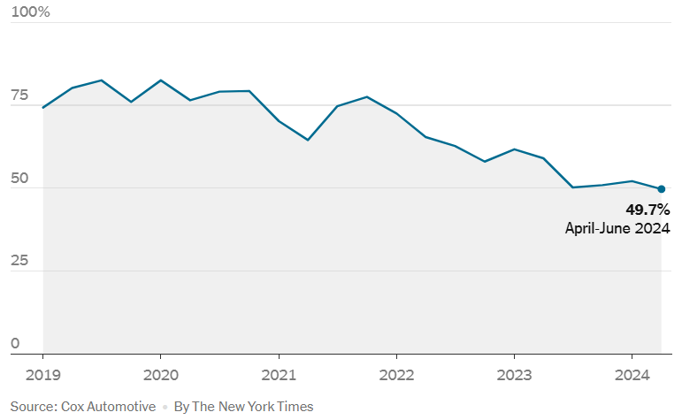
Figure 1: Tesla EV Market in the US
(Source: Ewing, 2024)
However, according to Lehmhus, (2022), early movers enjoy such advantages but such are short-term in nature, particularly in very changing markets. Higher R&D costs, unclear demands, and being the teacher with an inconsiderate student apply as well, which was also Sony's case in its Betamax where being the first also resulted in it losing out on the later-coming VHS format due to unsuccessful licensing deals and customer realignment (Tang, 2022).
Benefits of Follower Companies
Conversely, follower companies intentionally wait to enter the market to adopt the lessons learned from pioneers' successes and failures. It has strategic benefits like lower development costs, improved market insight, and quicker responsiveness to customers' tastes. The late-mover of followers get advantage from the FMA concept by proposing that copying and strategic improvement can surpass innovation, particularly in competitive or mature markets.
The ultimate example is Samsung, which arrived in the smartphone space after Apple but rapidly expanded by providing differentiated price points, bigger screens, and quick feature development. Samsung's approach helped it become the world's largest smartphone manufacturer with 19.4% worldwide market share in 2024 (Laricchia, 2024).
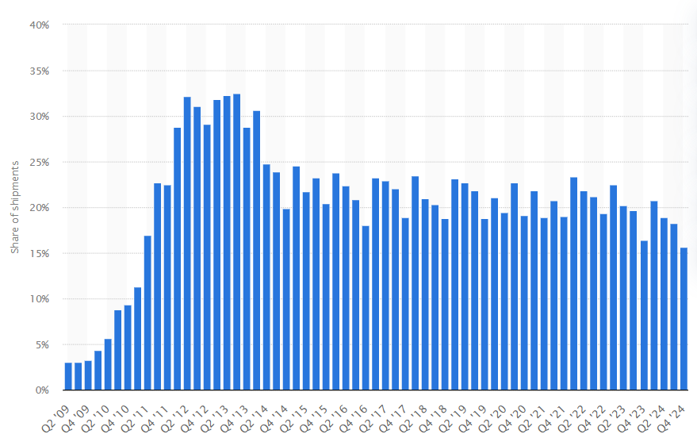
Figure 2: Samsung's share of global smartphone
(Source: Laricchia, 2024)
In contrast to Apple's focus on high-end users, Samsung focused on a wider user base, demonstrating that follower tactics can lead to worldwide leadership by means of quick adaptation. Facebook's emergence following MySpace's fall is also a case of follower success (Daza-Ramírez, 2025). Through streamlining the social media formula, adding a real-name requirement, and overall improved design, Facebook surpassed its predecessor. Its parent company, Meta, now has more than 3.6 billion monthly active users, illustrating how follower companies can reign supreme when they innovate beyond the pioneering leader (Wernerfelt et al., 2022). From a scholarly perspective, Gómez et al., (2022) contend that market leadership tends to go not to pioneers, but to companies that enter later and perform better. This contradicts the determinism of FMA and confirms that the quality of execution, rather than the timing of entry, tends to drive sustained success.
In addition, followers are spared the effort of educating the market — a drawback for pioneers. PepsiCo, which entered the soft drink market after Coca-Cola, effectively differentiated its taste profile and branding. While Coca-Cola holds the global lead, PepsiCo has established a formidable portfolio with $91.5 billion in 2023 net revenue, much of which comes from beverage sales (Team, 2024). The growth of Pepsi serves as an example of how good branding, focused marketing, and diversification of products can enable followers to succeed.
Critical Analysis and Final Argument
The comparative study shows that pioneers and followers can be successful, but under different circumstances. First-mover advantage, as Lieberman and Montgomery (1988) have suggested, works best when companies are able to maintain technological leadership, build high switching costs, and have slow-changing markets with strong brand loyalty. This theory fails to consider industries with fast innovation cycles, where followers are able to jumpfrog through nimble strategies.
In addition, a pioneer's achievement relies not only on being first. Lacking ongoing innovation and customer interaction, pioneers become susceptible to obsolescence. Nokia, for instance, was an earlier pioneer in cellular technology but lost its competitive advantage as a result of strategic stiffness and not being able to adapt. This is in accordance with the argument of Ma (2023), who highlighted that pioneers tend to be displaced by more adaptive, efficient entrants. In contrast, follower firms enjoy strategic hindsight, lower risk, and rapid learning and adaptability. Their performance improves in dynamic markets with rapidly changing consumer tastes and low entry barriers. Yet, they have to face challenges of brand differentiation and the possibility of being labeled as imitators instead of innovators.
Finally, the decision to be a pioneer or a follower must not be seen as an either-or proposition. Rather, it must be seen as part of a larger strategic context that includes internal capabilities, market preparedness, and resource allocation. Pioneering can provide early market dominance, but followers can thrive, and even surpass when they match strategic timing with operational excellence and customer orientation.

2.2 Product Life Cycle Strategies of Pioneers and Followers
With a competitive and rapidly changing market environment, businesses are required to constantly adjust their strategies in order to grow and maintain a competitive edge. The Product Life Cycle (PLC) framework, coined by Levitt (1965) is a prime strategic instrument to assist firms to navigate through market conditions. The model also delineates four separate phases—introduction, growth, maturity, and decline—each demanding a response commensurate with it (Stark, 2022). The growth and maturity phases are both key to defining long-term success for both pioneer and follower companies. Yet they implement these in dissimilar fashion based on entry timing, strategy of innovation, and competitive setting.
Growth and Maturity Stage Strategies for Pioneer Companies
Pioneers enter first into a market with a new product or idea, and in the growth stage, they have to expand rapidly to support their leadership position. As stipulated by Levitt (1965), this stage calls for product improvement, stimulating demand, and increased distribution. Tesla is a pioneer company that took advantage of growth-stage strategies by introducing various models, advancing battery efficiency, and spending money on charging infrastructure. By 2023, Tesla had sold more than 1.8 million vehicles and held more than 49% U.S. EV market share (Hopkins, and Lazonick, 2024; Ewing, 2024).
The second example is Apple, which created the contemporary smartphone market with the iPhone. In its growth phase, Apple centered on app ecosystem development and ongoing product innovation. As competition grew, Apple moved to the maturity phase by tying users to its ecosystem with ancillary services. Apple's services revenue hit $85.2 billion in 2023, which indicates its approach of deepening customer connections to protect market share (Kindig, 2023).
Pioneers also apply brand equity strategies in establishing their leadership. Following Keller's (2001) Customer-Based Brand Equity model, constructing meaningful connections and emotional affinity during initial phases assures long-term allegiance. This can be seen with Apple's upscale branding and styling, which assists in maintaining top margins despite saturation in the marketplace. Yet, pioneers have constraints. Cirik and Makadok, (2023) maintain that first-mover advantage in itself does not necessarily lead to long-term success. Without ongoing innovation, first movers can fall into complacency. Nokia, for example, was the first to introduce mobile phones but lost its position as the industry moved towards smartphones. Therefore, pioneers need to ensure strategic flexibility during growth and maturity phases to prevent market decline.
Growth and Maturity Stage Strategies for Follower Companies
Follower companies enter the market following pioneers and use unique strategies based on observations in the market and lowered uncertainty. In the growth stage, followers concentrate on penetration pricing, cost-cutting, and selective differentiation. These strategies enable followers to expand quickly while satisfying value-sensitive customers.
A good example is Xiaomi, which joined the smartphone industry subsequent to Apple and Samsung. Instead of competing on brand status, Xiaomi provided low-cost feature-filled phones, which appealed to budget-conscious segments. It leveraged online sales and customer feedback and became India's leading smartphone brand with 18% market share in 2023 (The Hindu, 2025). Xiaomi's success in the growth stage reiterates the strength of learning from pioneer errors and riding operational efficiency.
Another model that can be used for followers is the Blue Ocean Strategy of Kim and Mauborgne (2005), which urges companies to develop new demand in an untapped area. Spotify, for instance, trailed iTunes but offered a differentiated business model through music streaming subscriptions. Spotify had reached over 600 million worldwide users by 2024, as opposed to Apple Music's estimated 93 million (Mehta, 2024; Leu, 2024). This is an indication of the possibility of followers innovating not in technology but in delivery and consumption patterns.
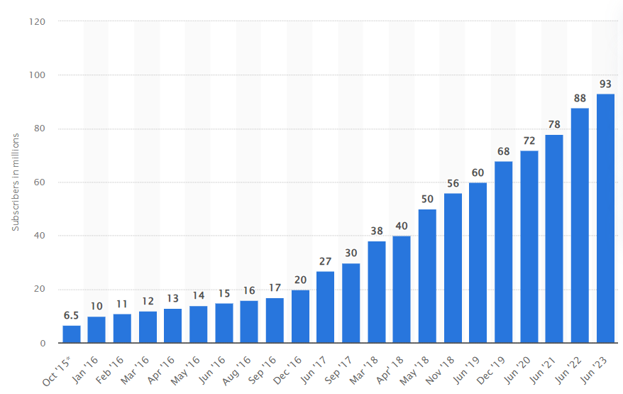
Figure 3: Apple Music Subscribers
(Source: Leu, 2024)
During the maturity phase, follower firms tend to adopt product diversification, brand repositioning, and geographic extension. PepsiCo, for example, joined the soft drink sector following Coca-Cola but became formidable through acquisitions, health-oriented product lines, and youth-oriented branding. PepsiCo's 2023 revenue of $91.5 billion exemplifies how maturity-phase strategies can prolong life cycle profitability (Team, 2024).
However, followers themselves are not trouble-free. Success for followers relies on differentiation, as argued by Gómez et al., (2022). Followers who just copy without offering value tend not to be able to maintain growth in maturity. Additionally, for industries with high switching costs or emotional brand connection, follower strategies do not work as well. Even with numerous competitors, Apple maintains its dedicated user base because of brand equity and bundled services hurdles that are difficult for followers to breach.
Critical Evaluation and Comparison
Although the PLC model offers a systematic approach, its success relies on how effectively companies match strategies with market situations. Pioneers, in growth, seek to lead through innovation, product improvement, and educating customers. Followers, however, capitalize on available demand to grow fast in the growth stage. By lowering prices and building on pioneer products, they can capture a large share, as is the case with Xiaomi and Spotify. In maturity, they sustain momentum through diversification in markets and lifestyle branding, as is the case with PepsiCo. While Levitt (1965) had stressed the necessity of lifecycle-based marketing strategies, Kim and Mauborgne (2005) suggested that successful companies forge new demand curves entirely—quite a strategy utilized by innovative imitators. In the meantime, Keller's brand equity framework supports the pioneer's advantage in the event emotional bonds and perceived distinctiveness are maintained.
Some researchers, such as Huang et al., (2022), highlighted that the PLC model is too linear and less effective in dynamic markets such as technology. Products would be launched and extended time and again in these settings, eliminating the classic PLC boundaries. It implies that both pioneers and imitators would need to employ strategic flexibility as opposed to rigid-stage reactions.
Pioneers and followers can both sustain competitive advantage in the growth and maturity phases by aligning strategies with market conditions. While pioneers concentrate on innovation and building an ecosystem, followers use efficiency and differentiation. Success then really hinges on agility, timing, and how well firms manage to service customers and changing life cycle needs.

3. Conclusion
This essay critically analyzed the strategic benefits provided to pioneer and follower firms and explored the product life cycle strategies employed by pioneer and follower firms at the growth and maturity phases to develop and maintain competitive advantage. For instance, Apple and Tesla are the pioneer firms which establish early mover advantages on the basis of brand leadership as well as technological breakthroughs and the creation of customer loyalty. Market understanding, lower development costs, faster adaptation, and obtaining competitive advantages through low development costs and quick adoption in cost constraining and fast changing markets are benefits for follower firms like Samsung, Xiaomi, and Spotify.
Looking at the time during which the market might need the Product at the level of growth and maturity phases of the Product Life Cycle model, the time of the entry of the Product is so important, whatever it be earlier or later.
Finally, although choice of pioneer or follower is important, it is long run success that depends mostly on adaptive strategies in managing key PLC phases. Quality of execution, customer involvement, adaptability are all as critical as strategic timing when competing successfully in fast changing global markets.

References
- Cirik, K. and Makadok, R., (2023). First-mover advantages versus first-mover benefits: What’s the difference and why does it matter?. Academy of Management Review, 48(3), pp.409-431.
- Daza-Ramírez, M.T., (2025). Metamorphosis: Facebook's strategic transformation into Meta. In Strategic Response to Turbulence (pp. 13-30). Edward Elgar Publishing.
- Ewing, J. (2024). Tesla’s Share of U.S. Electric Car Market Falls Below 50%. The New York Times. [online] 9 Jul. Available at: https://www.nytimes.com/2024/07/09/business/tesla-electric-vehicles-market-share.html [Accessed 21 Mar. 2025].
- Giachetti, C. and Pira, S.L., (2022). Catching up with the market leader: Does it pay to rapidly imitate its innovations?. Research Policy, 51(5), p.104505.
- Gómez, J., Perez-Aradros, B. and Salazar, I., (2022). How to beat early movers: The role of competitive strategy and industry dynamism on followers’ performance in the telecommunications industry. Long Range Planning, 55(5), p.102244.
- Gómez, J., Perez-Aradros, B. and Salazar, I., (2022). How to beat early movers: The role of competitive strategy and industry dynamism on followers’ performance in the telecommunications industry. Long Range Planning, 55(5), p.102244.
- Gray, J., (2024). The life cycle of international cooperation: Introduction to the special issue. The Review of International Organizations, 19(4), pp.641-664.
- Hayat, K. and Qingyu, Z., (2024). The synergistic effects of green innovation strategies on sustainable innovative performance with the mediation of green innovative competitive advantage. Corporate Social Responsibility and Environmental Management, 31(5), pp.4172-4189.
- Hopkins, M. and Lazonick, W., (2024). Tesla as a Global Competitor: Strategic Control in the EV Transition. Institute for New Economic Thinking Working Paper Series, (225).
- Huang, Y., Li, R., Zou, F., Jiang, L., Porter, A.L. and Zhang, L., (2022). Technology life cycle analysis: From the dynamic perspective of patent citation networks. Technological Forecasting and Social Change, 181, p.121760.
- Keller, K.L. (2001) Building Customer-Based Brand Equity. Marketing Management, 10, 14-21.
- Kim, W. C., and Mauborgne, R. (2005). Blue Ocean Strategy: How to Create Uncontested Market Space and Make the Competition Irrelevant. Boston, MA: Harvard Business School.
- Kindig, B. (2023). Apple’s Services Growth Flywheel Continues To Strengthen. [online] Forbes. Available at: https://www.forbes.com/sites/bethkindig/2023/11/16/apples-services-growth-flywheel-continues-to-strengthen/ [Accessed 21 Mar. 2025].
- Laricchia, F. (2024). Samsung Smartphone Market Share Worldwide | Statista. [online] Statista. Available at: https://www.statista.com/statistics/276477/global-market-share-held-by-samsung-smartphones/ [Accessed 21 Mar. 2025].
- Lehmhus, D., (2022). Advances in metal casting technology: A review of state of the art, challenges and trends—Part I: changing markets, changing products. Metals, 12(11), p.1959.
- Leu, P. (2024). Number of Apple Music subscribers worldwide 2015-2023. [online] Statista. Available at: https://www.statista.com/statistics/604959/number-of-apple-music-subscribers/ [Accessed 21 Mar. 2025].
- Levitt, T. (1965) Exploit the Product Life Cycle. Harvard Business Review, 43, 81-94.
- Lieberman, M.B. and Montgomery, D.B. (1988). First-Mover Advantages. Strategic Management Journal, 9, 41-58.
- Ma, H., (2023). Revolutionary innovation and the incumbent business: Patterns of relationship and coping strategies. Organizational Dynamics, 52(1), p.100925.
- Mehta, I. (2024). Spotify crosses the 600M monthly active users mark. [online] TechCrunch. Available at: https://techcrunch.com/2024/02/06/spotify-crosses-the-600m-monthly-active-users-mark/ [Accessed 21 Mar. 2025].
- Park, B.J. and Kim, D., (2021). Coopetition dynamics between giant entrants and incumbents in a new convergent segment: a case in the smartphone industry. Asian Journal of Technology Innovation, 29(3), pp.455-476.
- Stark, J., (2022). Product lifecycle management (PLM). In Product lifecycle management (volume 1) 21st Century paradigm for product realisation (pp. 1-32). Cham: Springer International Publishing.
- Statista (2024). Quarterly market share of smartphone vendors in the U.S. 2016-2024 | Statista. [online] Statista. Available at: https://www.statista.com/statistics/620805/smartphone-sales-market-share-in-the-us-by-vendor/ [Accessed 21 Mar. 2025].
- Tang, X., (2022). The class action as licensing and reform device. Columbia Law Review, 122(6), pp.1627-1690.
- Team, T. (2024). Pick Pepsi Stock Over Coca-Cola? Forbes. [online] 4 Sep. Available at: https://www.forbes.com/sites/greatspeculations/2024/09/04/pick-pepsi-stock-over-coca-cola/ [Accessed 21 Mar. 2025].
- The Hindu (2025). Vivo leads Q4 2024 India smartphone market, Apple breaks into top five brands. [online] The Hindu. Available at: https://www.thehindu.com/sci-tech/technology/vivo-leads-q4-2024-india-smartphone-market-apple-breaks-into-top-five-brands/article69179619.ece [Accessed 21 Mar. 2025].
- Wernerfelt, N., Tuchman, A., Shapiro, B. and Moakler, R., (2022). Estimating the value of offsite data to advertisers on meta. University of Chicago, Becker Friedman Institute for Economics Working Paper, (114).

