EFFICIENT TEAM WORKING

EWT1

Elena Daniela Marcu 2119677
Certificate for Higher education
Lecturer
Soban Sadiq

- Introduction
- Models of communication
- Communication skills
- The advantages and disadvantages of technology in communication
- Conclusion
- References

INTRODUCTION

Success is depending on communication, regardless of business or private life, and the cost of having poor communication skills can be severe or even life-threatening.
All forms of life communicate. Animals use their bodies to communicate, humans use verbal and non-verbal communication (body language, facial expressions, gestures, voice tone, etc.)
Communication is giving, receiving, or exchanging ideas, information, signals, or messages through appropriate media, enabling individuals or groups to persuade, seek information, give information, or express emotions.
Efficient communication means delivering the message clearly and making sure this is comprehended, in the shortest amount of time.
Communication is a two-way process, where all participants should perform to their responsibility, to insure this is done efficiently. The sender must understand the receiver, well enough to build the message to suit the receiver, not only to make it easier to understand but also to make it easy to remember. In other words, the sender should tailor the message to suit the receiver (or multiple receivers)
Receivers on the other hand should take full responsibility to listen to the message, and not simply to hear it, to decode and interpret the message, and pay attention to the non-verbal part of the delivery. Clarification is a great habit of ensuring correct understanding and ensuring the sender that you understand and follow the line of thought.

MODELS OF COMMUNICATION

According to Denis McQuail, “a model is a selective representation in verbal or diagrammatic form of some aspect of the dynamic process of mass communication.”
To put it another way, communication models give us a visual picture of the various components of a communication situation.

There are 3 categories of communication:
- Linear – One-way communication
- Interactive - two-way communication
- Transactional communication – two-way communication, where the message gets more complex

The Shannon-Weaver model

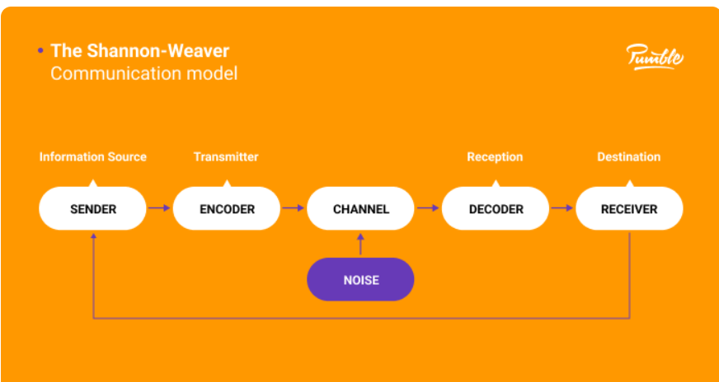

The Shannon-Weaver model of communication may be the most well-known.
Strangely enough, Shannon and Weaver were mathematicians who created their work in the Bell Telephone Laboratories during the Second World War. They sought to identify the most efficient communication channels.
The components of this model of communication:
- Sender
- Encoder
- Channel
- Decoder
- Receiver
The first to discuss the significance of noise in communication was Shannon and Weaver. John Fiske defines noise in his book Introduction to Communication Studies: “anything that is added to the signal between its transmission and reception that is not intended by the source.”
The Shannon-Weaver Model example:
Pedro works on a building site and Maria is his wife. One day Maria phoned Pedro.
‘Hello, Pedro, when you’re coming home, see if you can get me a chicken.
’‘Okay,’ replied Pedro.
When he got home, Pedro took off his boots and coat and went into the kitchen.
‘Maria, where are you?’ He said.
‘Here – in the sitting room,’ she said
Maria is the sender, her mouth is the encoder, the phone is the channel, Pedro’s ears, and brain are the decoder and Pedro is the receiver.
The problem in this process is the lack of feedback, as Pedro was working in a noisy environment, the message got altered, she never asked for feedback, and he did not make sure he comprehended the message
Feedback is just the transmission of the recipient's response back to the sender.
It lets the speaker adapt their message to the audience's response.
The fact that feedback makes the recipient feel involved in the communication process may be its most significant purpose.
Because they feel their perspective is being taken into consideration, this makes the recipient more open to the message.

Berlo’s S-M-C-R model
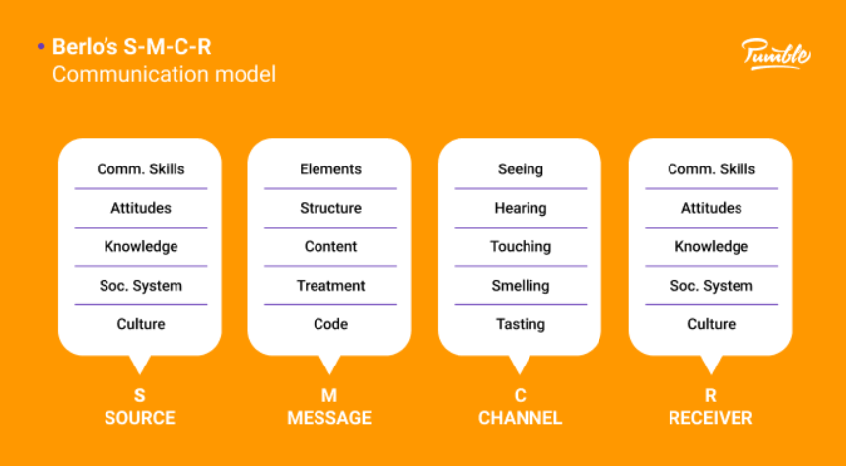

The distinctive aspect of Berlo's communication model is that it provides a thorough explanation of each step's essential components.
Four steps are used to explain communication in this model:
Source
Message
Channel
Receiver
Source: Let's consider the critical elements that affect how successfully the message is communicated, starting with the source.
The source, or sender, carefully crafts the message before communicating it to the recipient.
Considering this, how does the sender communicate with the recipient?
With the help of:
Communication skills – The source must have excellent communication skills in order for the communication to be successful. When to pause, what to repeat, how to pronounce words, and other such considerations must all be known by the speaker.
Second, the source must have the proper mindset. Even the best speakers wouldn't be able to engage listeners and leave a lasting impression without it.
Knowledge is the third component, which doesn't necessarily entail education but rather the sender's intention to convey information that is clear.
The sender must be aware of the social system in which the communication takes place, and watch out that nobody is offended by what you say.
It is crucial for cross-cultural communication that the sender is familiar with the culture where the process is taking place in order to achieve effective communication.

Message
- Content.
- Elements — addition to the words (content): gestures, body language, facial expressions, etc. must be considered
- Treatment —The source must be aware of the importance of the message.
- Structure — The source must properly structure the message to ensure the receiver will understand it correctly.
- Code — All the elements, verbal and nonverbal, need to be accurate if you do not want your message to get altered and misunderstood.

The Channel
How the message is delivered to the recipient. All our senses function as communication tools. Each of our five senses—hearing, smelling, seeing, tasting, and touching—serves as a channel of communication, depending on the kind of information we wish to convey.
The receiver
The receiver of a message delivered by a source is the person the source is speaking to.
The receiver must infer the same elements as the source in order to comprehend the message. They should have similar knowledge, attitudes, and communication abilities as well as be familiar with the social structure and cultural context in which they interact.
Although communication models can't fully capture the complexities of real-life communication, they can allow us to look at the various stages of the process and gain a better understanding of how we communicate both inside and outside of the workplace.
Linear models — consider communication to be a one-way street. These are primarily employed in customer communications in marketing, sales, and public relations.
Interactive models — Used in internet-based and mediated communication, they refer to two-way communication with indirect feedback.
Transactional models — They refer to two-way communication with indirect feedback when used in internet-based and mediated communication.
Although none of these models accurately captures our communication, they can nevertheless be used to identify possible issues, find solutions, and enhance communication in general.

THE ADVANTAGES AND DISADVANTAGES OF TECHNOLOGY IN COMMUNICATION

It’s common sense these days that communication was revolutionized, and technology replaced personal contact. Mobile phones, emails, and social media are at hand for everybody to be used to communicate to send/receive messages instantly. It made life easier and people from all over the world can interact and exchange information, pictures, music etc. Distance is not an issue anymore. Businesses thrive with the help of ICT (information communication technology). Video conferences replaced travel, as business or team meetings can be held online. People can work remotely, so there’s no need to commute or relocate to find a better job.
ICT has united people and countries, trades and businesses transforming the world into an independent system.
Students can enroll in international schools and universities and attend courses over the internet or access learning materials via e-learning platforms or e-libraries.
As with anything, the development of technological communication has also downsides. People lost the human touch and personal contact. We cannot read body language, facial expressions, or hear voice tones, this translates into making room for misinterpretation since most of the communication is actually non-verbal.
Another downside is security. Information (message) can be hacked, and this can bring loss or tainted reputation.
Social media can cause addiction, and it is uncontrollable in terms of the quality of the material accessible online, and individuals have a tendency to believe anything they read, which can lead to addiction and a general lack of education.

CONCLUSION

The word Communication comes from the Latin: communicare which means “to share” or “to be in relation with”. As mentioned at the beginning all forms of life communicate, they share information. Animal communication can be defined as any behaviour of one animal that affects the current or future behaviour of another animal.
Plants and fungi communicate, Recent research has shown that most of the microorganism plant communication processes are neuron-like.
Fungi communicate to coordinate and organize their growth and development such as the formation.
Humans are studying communication as a complex process. Communication is probably the most important aspect of our existence (human or non-human). If water is essential for life to continue to exist, communication is as important.
Aristotle, the Greek philosopher said “Man is, by nature a social animal”, and what would it be without communication

REFERENCES

https://study.com/academy copyright 2003-2022 Study.com 28 August
9 Types of Nonverbal Communication (verywellmind.com) 2022 Dotdash Media, Inc.
Efficient Communication | HWAO Consulting 2013 - 2022 HWAO Consulting.
Harold D. Lasswell
McQuail′s Mass Communication Theory by Denis McQuail (goodreads.com)
Introduction to Communication Studies, John Fiske
Walton, Andy. Advantages & Disadvantages of Information & Communication Technology. The Houston Chronicle. 2013.
Web. https://smallbusiness.chron.com/advantages-disadvantages-information-communication-technology-66948.html
Ian T. Baldwin; Jack C. Schultz (1983). "Rapid Changes in Tree Leaf Chemistry Induced by Damage: Evidence for Communication Between Plants". Science. 221 (4607): 277–279.
Cobley, Paul (2008-06-05), "Communication: Definitions and Concepts", in Donsbach, Wolfgang (ed.), The International Encyclopedia of Communication, Chichester, UK: John Wiley & Sons, Ltd, pp. wbiecc071,
Jones, R. G. (2018). Communication in the real world. Flat World Knowledge
McQuail, D., & Windahl, S. (2016). Communication models: For the study of Mass Communications. Routledge.
Definitions of Communication (communicationtheory.org)

