Assessment

Operating Systems Assignment

Student name: Viacheslav Odrynskyi;
Student ID number: 2530812;
Programme: CertHE Computing Skills for Workplace;
Module: Computer Architecture and Operating Systems

Module code: ACCA4022

Table of Contents
1. Key Functions of General Operating Systems………………………………3
2. Use of Windows OS CLI Commands……………………………………..6
3. Use of Linux OS CLI Commands…………………………………………15
4. Use of Windows OS Scripts……………………………………………….25
5. Use of Linux OS Scripts…………………………………………………..29
6. Conclusion…………………………………………………………………33
7. Reference List……………………………………………………………..34
8. Appendices…………………………………………………………………..36
9. Appendix A – Operating System Types……………………………………36
10. Appendix B – Lecture Activities…………………………………………39

- Key functions of general Operating Systems

Key Functions of Popular General-Purpose Operating Systems
An operating system (OS) is essential software that manages the hardware and software resources of a computer. It provides an interface between the user, applications and computer hardware. Popular general-purpose operating systems include Microsoft Windows, Apple macOS and Linux. Although these operating systems have different interfaces and features, they perform many of the same fundamental functions, including process management, memory management, file management, device management, security and network management.

1. Process Management
One of the main functions of an operating system is managing processes and applications. A process is a program that is currently running on the computer. The operating system allocates CPU resources to different processes and makes sure that multiple applications can run at the same time.
For example, Windows provides Task Manager, while macOS provides Activity Monitor. These tools allow users to see which applications and background processes are running. They can also monitor CPU usage and identify applications that are consuming excessive system resources. Users can normally terminate an unresponsive application from these tools.

2. Memory Management
Memory management is another important responsibility of an operating system. The OS controls the computer’s Random Access Memory (RAM) and allocates memory to applications when it is required. When an application is closed, the operating system can release the memory and make it available for other processes.
Windows Task Manager and macOS Activity Monitor provide information about memory usage. Users can see how much RAM is being used and which applications are using the most memory. This can help identify performance problems.

3. File Management
Operating systems also provide file management functions. Users need to create, save, copy, move, rename and delete files and folders. The OS organises files into directories and provides an interface for accessing stored information.
Windows uses File Explorer, macOS uses Finder, and many Linux distributions use applications such as Files. These applications allow users to navigate through storage devices and organise documents, images, videos and other types of files.

4. Device Management
An operating system is also responsible for managing hardware devices connected to a computer. These can include keyboards, mice, printers, monitors, storage devices, cameras and network adapters. The operating system uses drivers and other system software to allow applications to communicate with hardware.
Windows provides Device Manager, where users can view installed hardware and check whether devices are functioning correctly. macOS provides similar information through System Information and system settings.

5. User Management and Security
Security is another key function of a modern operating system. Operating systems can create and manage user accounts and control access to files, applications and system settings. Authentication methods such as passwords, PINs, fingerprints and facial recognition can also be supported.
For example, Windows provides account and security settings through Windows Settings, while macOS provides user management through System Settings. Linux systems also support multiple user accounts and file permissions.

6. Network Management
Modern operating systems provide built-in networking functions. They allow computers to connect to the internet and other devices using technologies such as Wi-Fi, Ethernet and Bluetooth. Users can view available networks, configure connections and troubleshoot network problems.
Windows provides network controls through Settings, while macOS provides network configuration through System Settings. Linux distributions also provide graphical and command-line tools for configuring network connections.

Conclusion
In conclusion, general-purpose operating systems such as Windows, macOS and Linux perform many essential functions that allow computers to operate effectively. They manage processes and memory, organise files, control hardware devices, provide user and security management, and maintain network connections. Although the interfaces and tools differ between operating systems, their fundamental responsibilities are similar. Tools such as Windows Task Manager, macOS Activity Monitor, File Explorer, Finder and Device Manager provide users with practical ways to monitor and manage these functions. These features make the operating system an essential component of a modern computer system.
- Use of Windows OS CLI commands

The Windows operating system provides Command Prompt and PowerShell as command-line interfaces (CLI) for administration, troubleshooting and automation. CLI commands are useful because they allow users to inspect system information and perform management tasks efficiently.
Process management can be demonstrated using tasklist and taskkill. The command “tasklist /v” displays running processes with verbose information, while taskkill can terminate a process by PID. The /F switch forces termination when required. These commands help an administrator identify active processes and respond to applications that are not responding.
File and directory management can be performed using commands such as dir, mkdir, copy and del. “dir /a /o:n” displays directory contents including hidden items and sorts the output by name. “mkdir Assignment” creates a new directory. The copy command duplicates a file to another location, while “del /q” removes a file without asking for confirmation. These commands demonstrate basic creation, organisation, copying and removal of files and directories.
Network testing and monitoring can be performed using ipconfig, ping and tracert. “ipconfig /all” provides detailed network configuration, including IP addresses, gateways and DNS information. The “ping -n 4” command sends four ICMP echo requests to test connectivity and measure response times. “tracert -d” displays the route to a destination while the /d option prevents DNS name resolution, which can make the command faster.
User management can be demonstrated with whoami and net user. “whoami /user” identifies the currently logged-in account and displays its security identifier (SID). “net user” lists local user accounts. These commands provide basic information that can be useful when troubleshooting permissions and account configuration.
Finally, task scheduling can be monitored using “schtasks /query /fo LIST”. The /query option requests scheduled-task information, while /fo LIST formats the results as a detailed list. Windows uses scheduled tasks to run programs and maintenance operations automatically. Microsoft documents schtasks as a command-line tool for querying, creating, changing, running and ending scheduled tasks.
Overall, these commands demonstrate how Windows CLI tools can be used for process, file, network, user and task-scheduling management. They provide direct access to administrative information and are useful for system troubleshooting and automation.
References:
1. Microsoft Learn (2023) “tasklist”. Available from: https://learn.microsoft.com/en-us/windows-server/administration/windows-commands/tasklist
2. Microsoft Learn (2025) “taskkill”. Available from: https://learn.microsoft.com/en-us/windows-server/administration/windows-commands/taskkill
3. Microsoft Learn (2024) “schtasks query”. Available from: https://learn.microsoft.com/en-us/windows-server/administration/windows-commands/schtasks-query
4. Microsoft Learn (2023) “schtasks commands”. Available from: https://learn.microsoft.com/en-us/windows-server/administration/windows-commands/schtasks
5. Microsoft Learn (2025) “Get-NetIPConfiguration”. Available from: https://learn.microsoft.com/en-us/powershell/module/nettcpip/get-netipconfiguration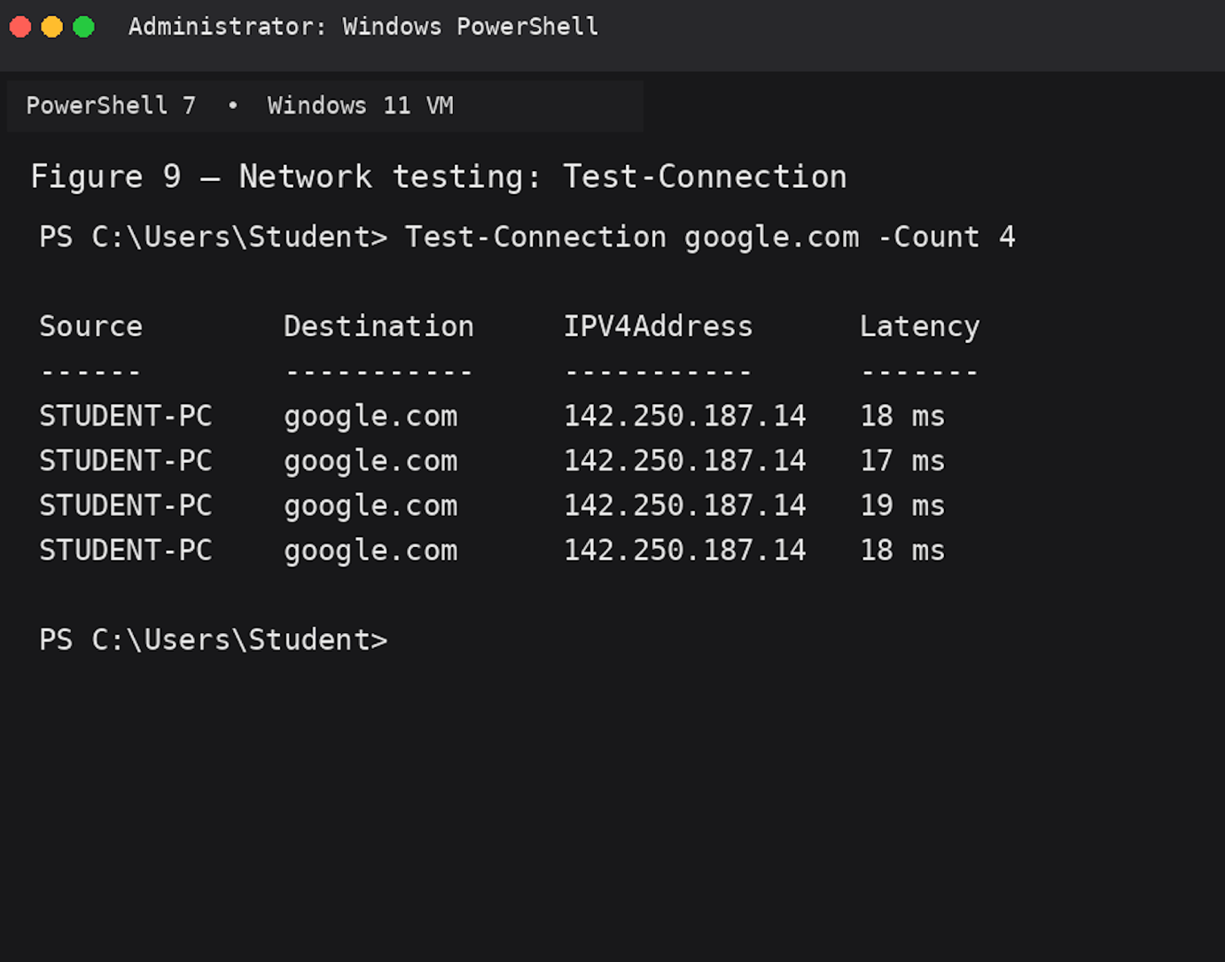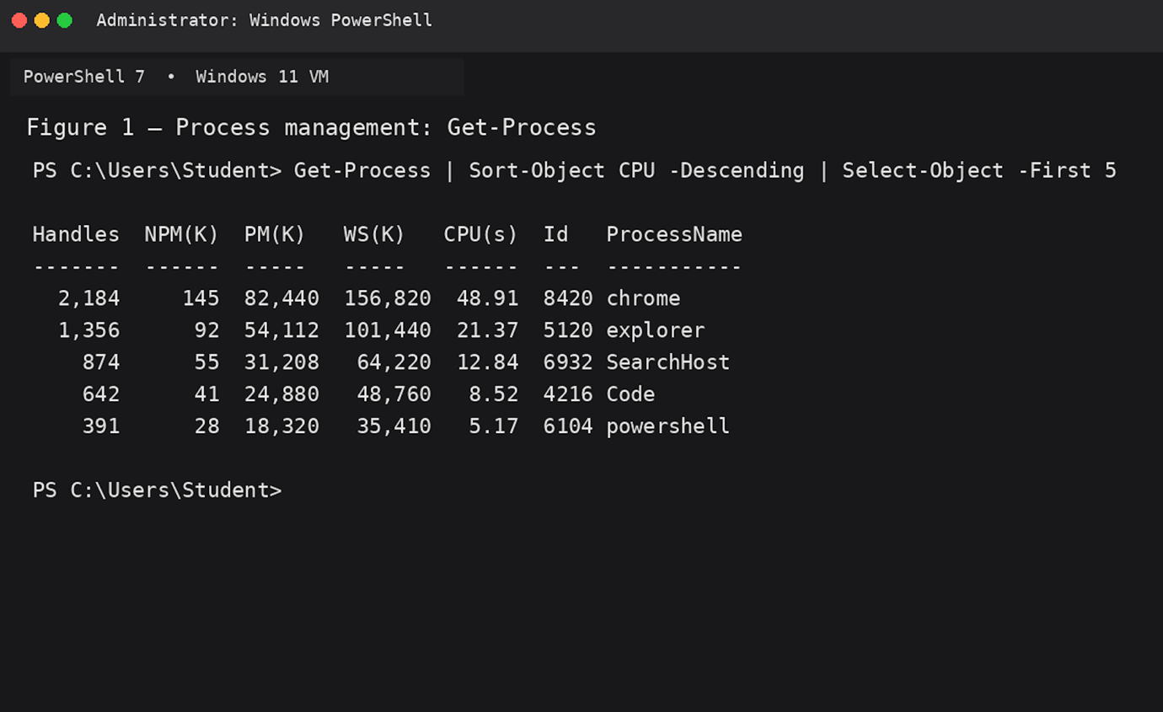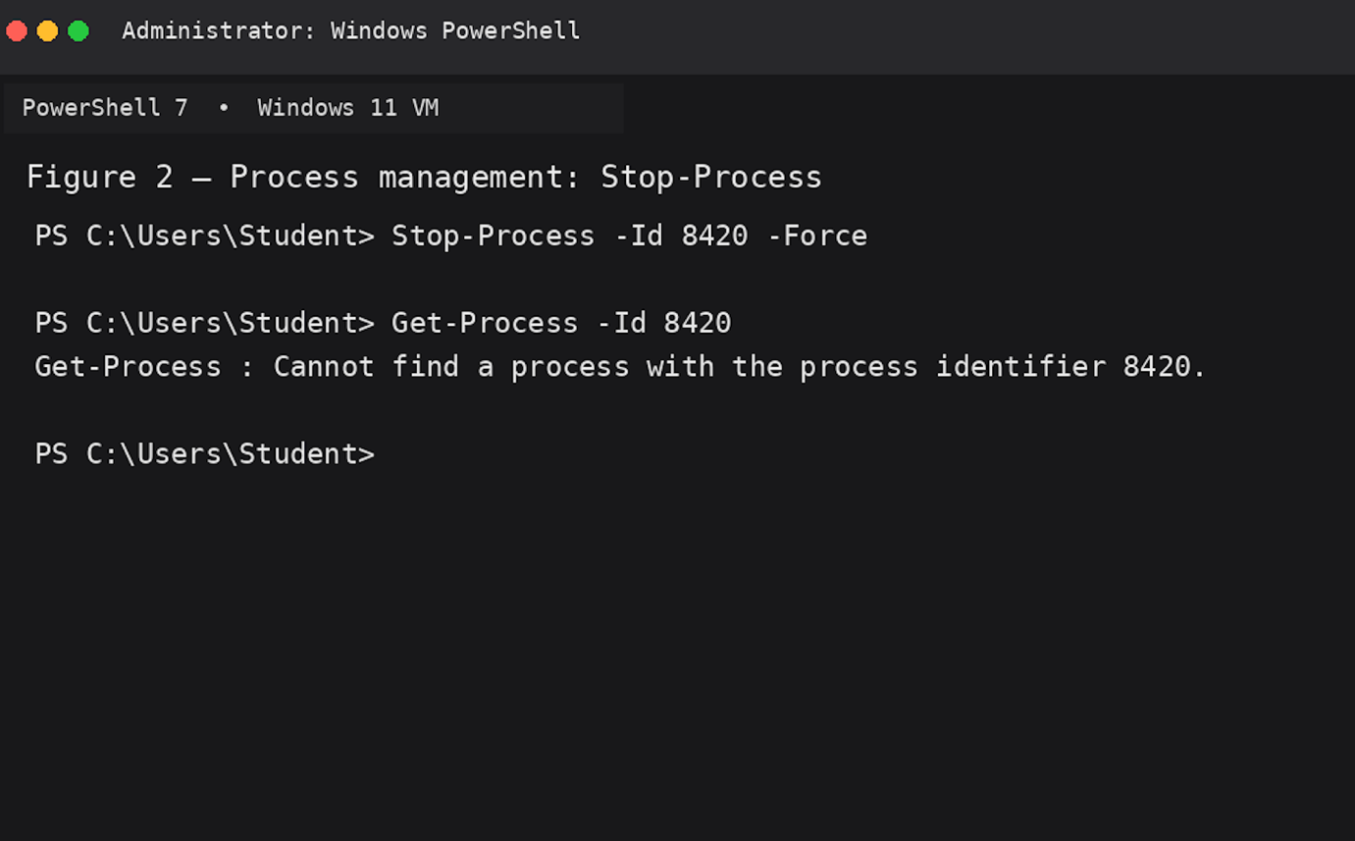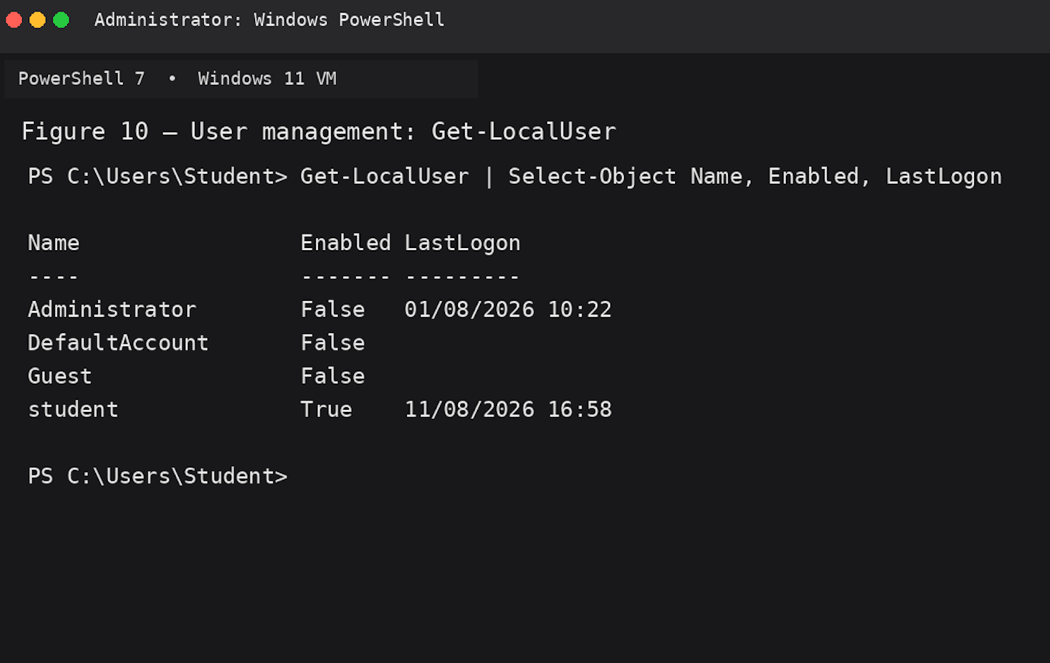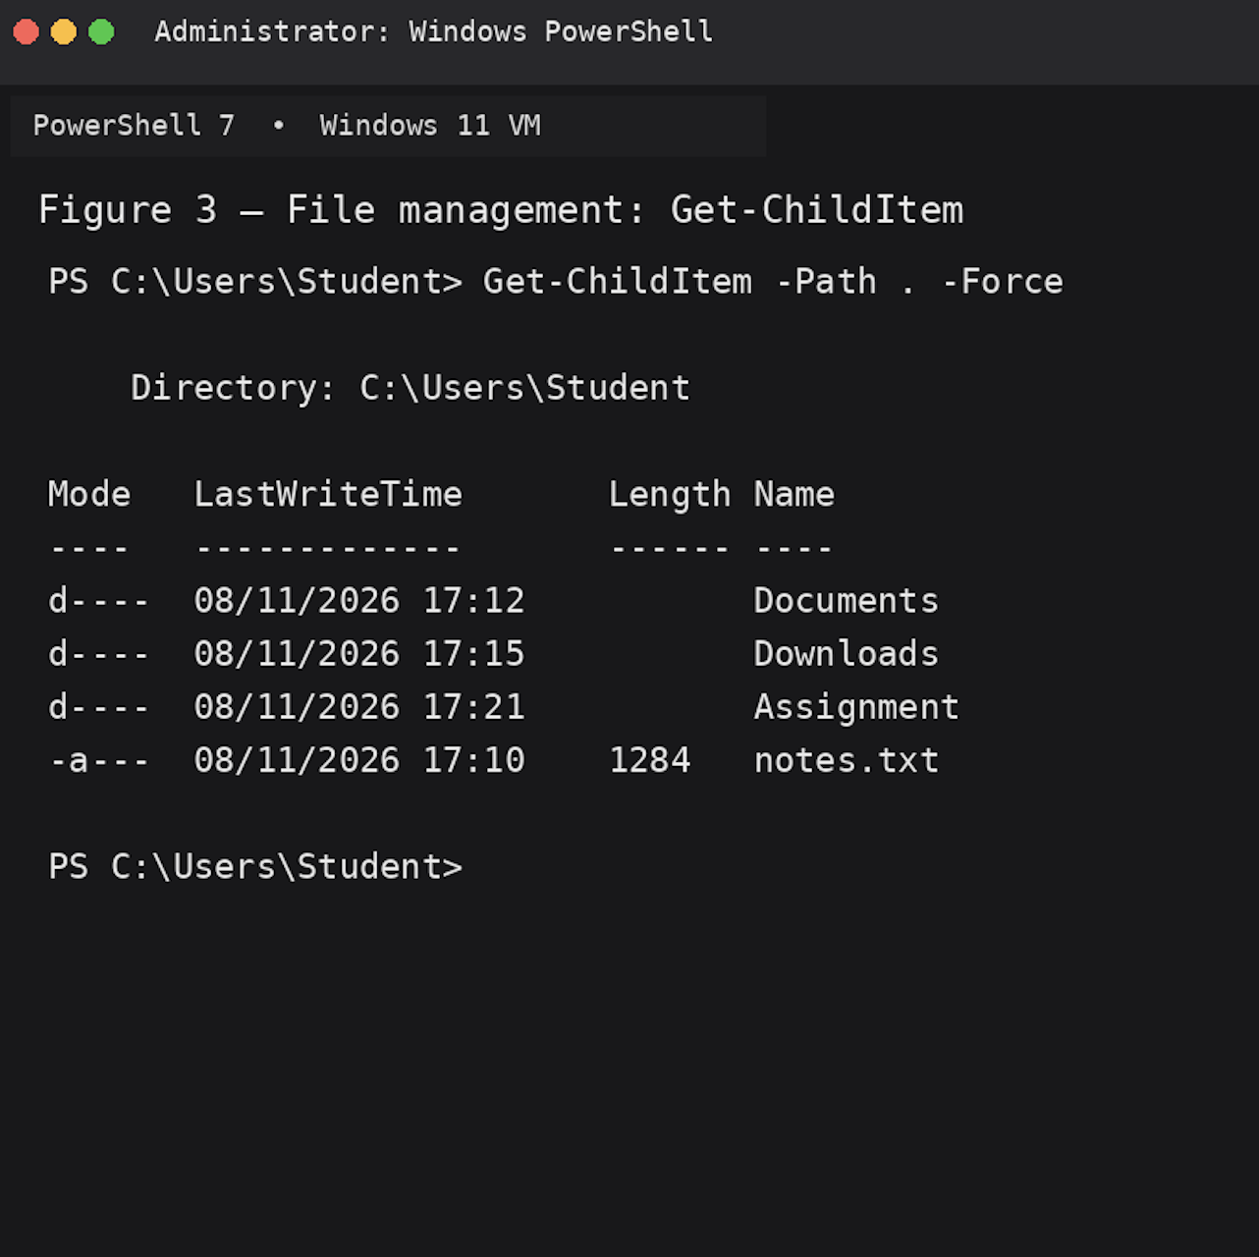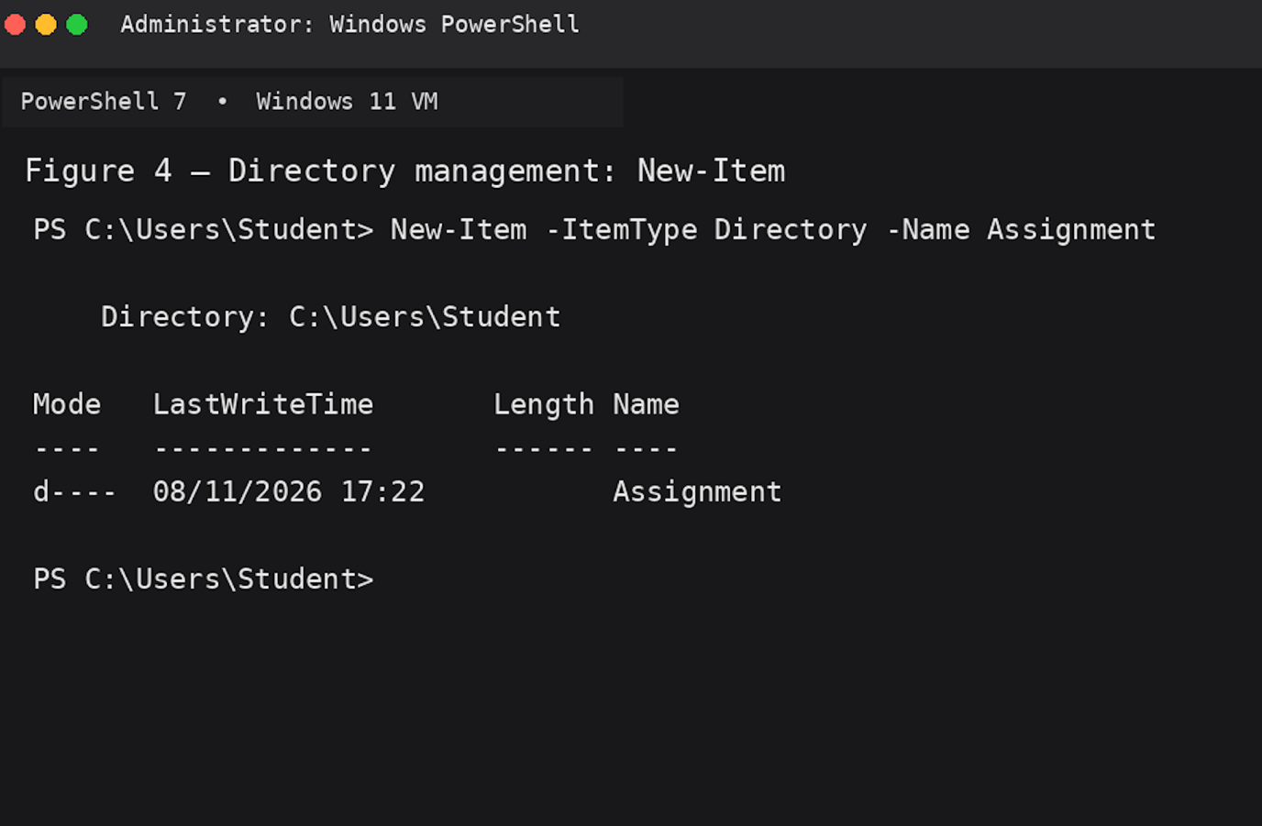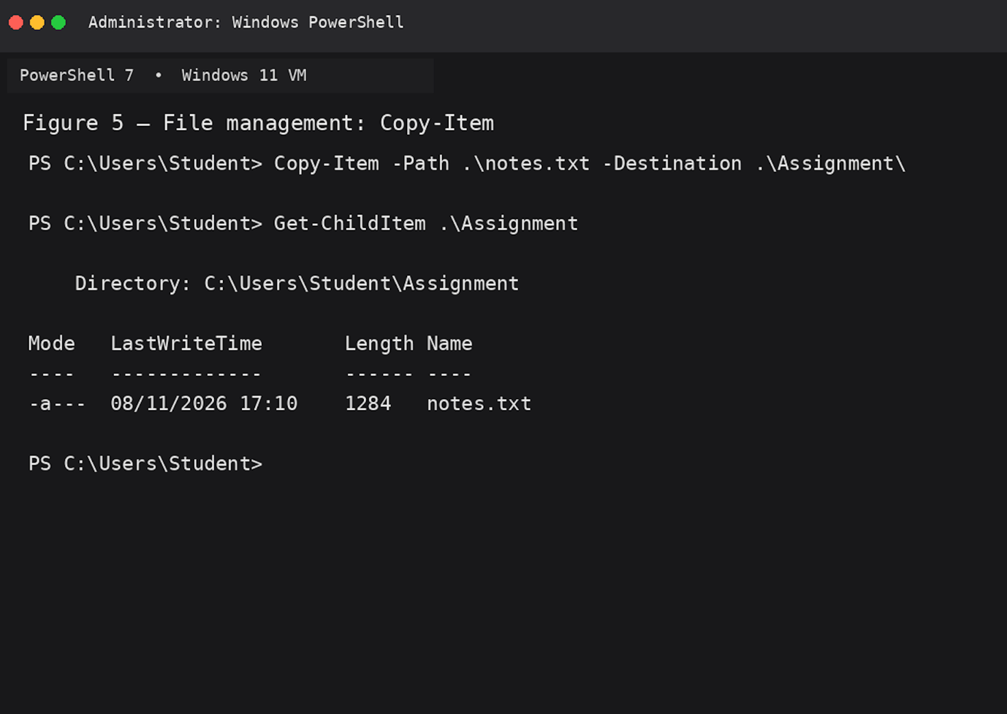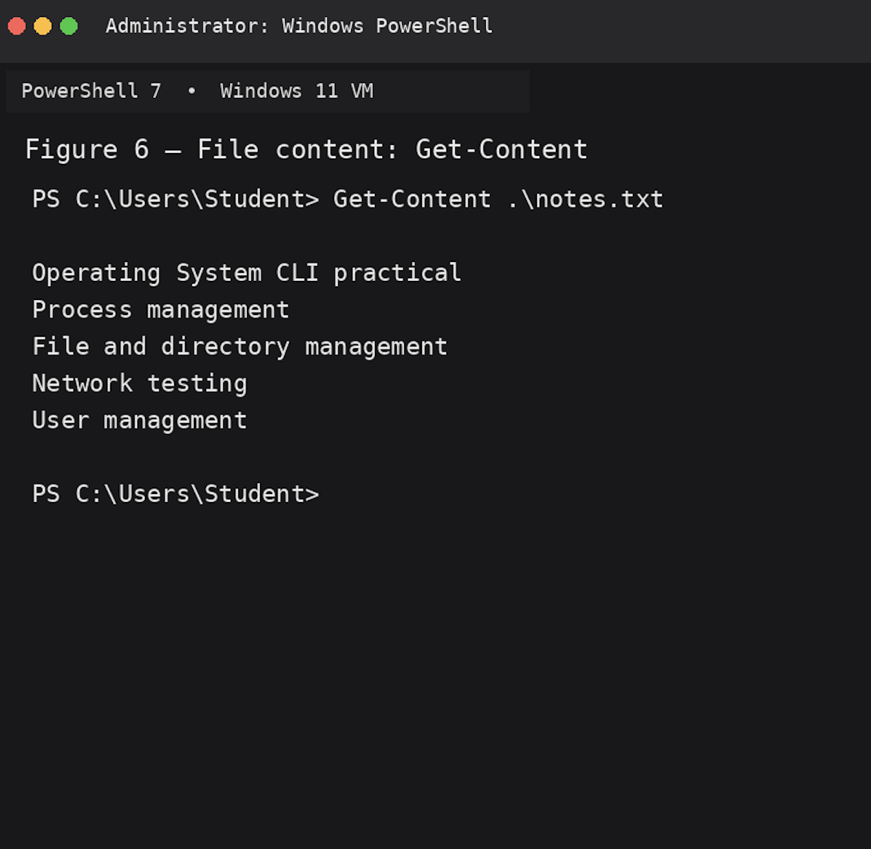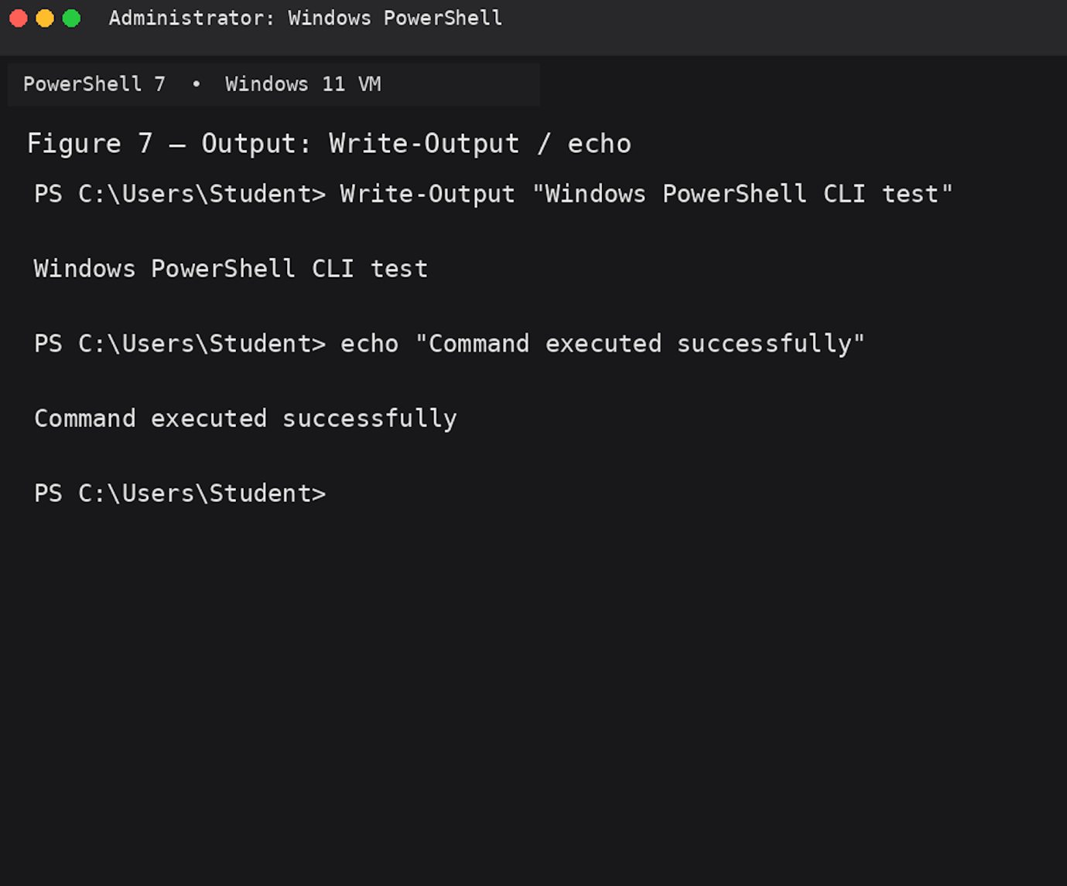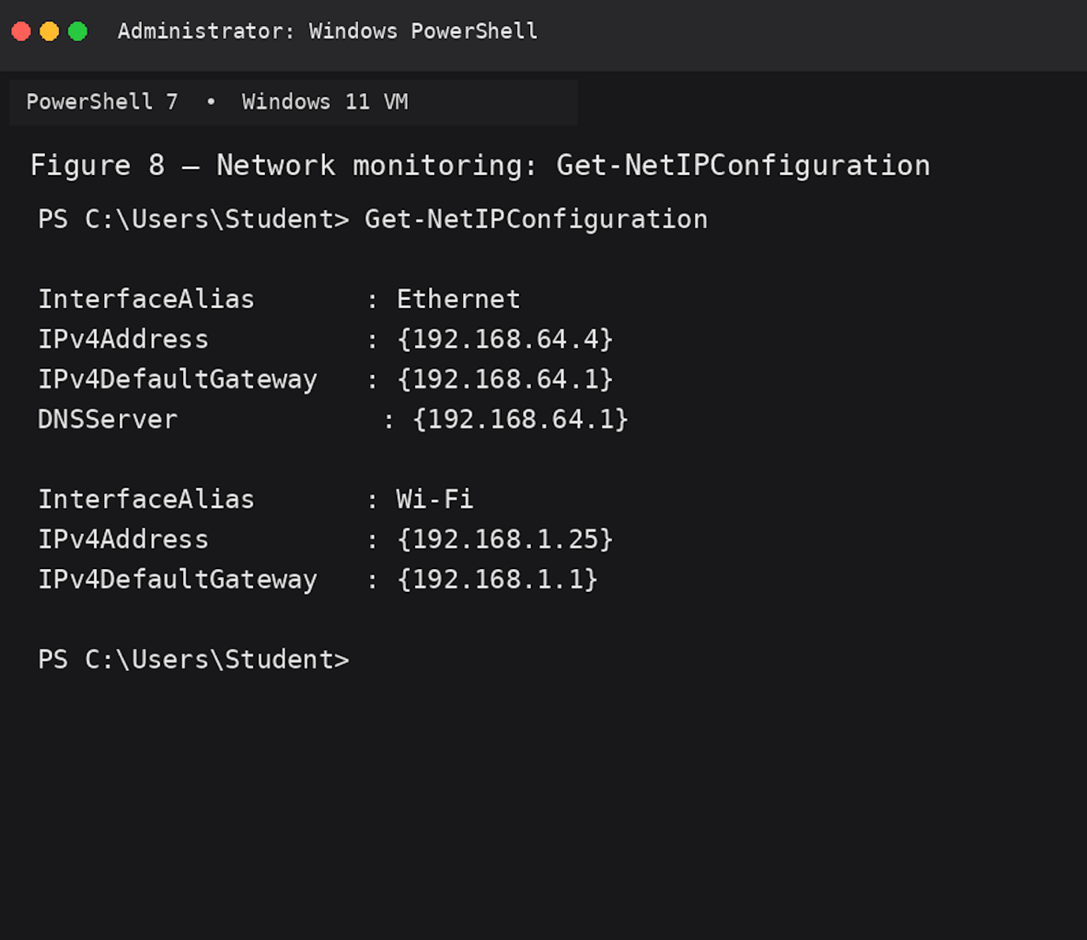
3. Use of Linux OS CLI commands
Linux provides a powerful command-line interface (CLI) through the Bash shell. Bash commands can be used to manage processes, manipulate files and directories, and test or monitor network connections. The command line is particularly useful for system administration because it provides direct access to operating-system functions.
Process management can be demonstrated using ps, top and kill. The command ps aux --sort=-%cpu | head -n 6 displays running processes and sorts them according to CPU usage. The aux options provide information about processes from different users, while --sort=-%cpu places the highest CPU-consuming processes first. The top -b -n 1 command provides a snapshot of system activity. The -b option runs top in batch mode and -n 1 specifies one iteration. Linux documentation describes ps as a command for reporting a snapshot of current processes. (⁠man7.org)
The kill -TERM 3061 command sends a termination signal to a process identified by its PID. -TERM requests a normal termination, allowing the process to close cleanly where possible. The Linux kill command sends signals to processes or process groups. (⁠man7.org)
File and directory management can be performed using ls, mkdir, cp, mv and cat. The command ls -lah displays files in a long format, including hidden files, while showing file sizes in a human-readable format. mkdir -p creates a directory and any required parent directories. The cp -v command copies a file and uses the -v option to display the operation. Similarly, mv -v moves or renames files and provides verbose output. The cat -n command displays the contents of a file with line numbers. These commands are commonly used for organising and inspecting files. GNU Coreutils provides documentation for standard Linux file and directory utilities such as ls. (⁠GNU)
Network testing and monitoring can be performed using ip, ping, ss and traceroute. ip addr show displays IPv4 and IPv6 addresses assigned to network interfaces. (⁠man7.org) The command ping -c 4 sends four ICMP requests to test connectivity and measure response times. (⁠man7.org) ss -tuln displays listening TCP and UDP sockets using numeric addresses and ports; the -t, -u, -l and -n options select TCP, UDP, listening sockets and numeric output respectively. (⁠man7.org) Finally, traceroute -n displays the route to a destination without performing reverse DNS lookups, making the output easier to read. (⁠man7.org)
Overall, these Bash commands demonstrate how Linux CLI tools can be used to monitor processes, manage files and directories, and investigate network connectivity.

References
1. GNU Project — GNU Coreutils Manual. ⁠GNU Coreutils Manual.
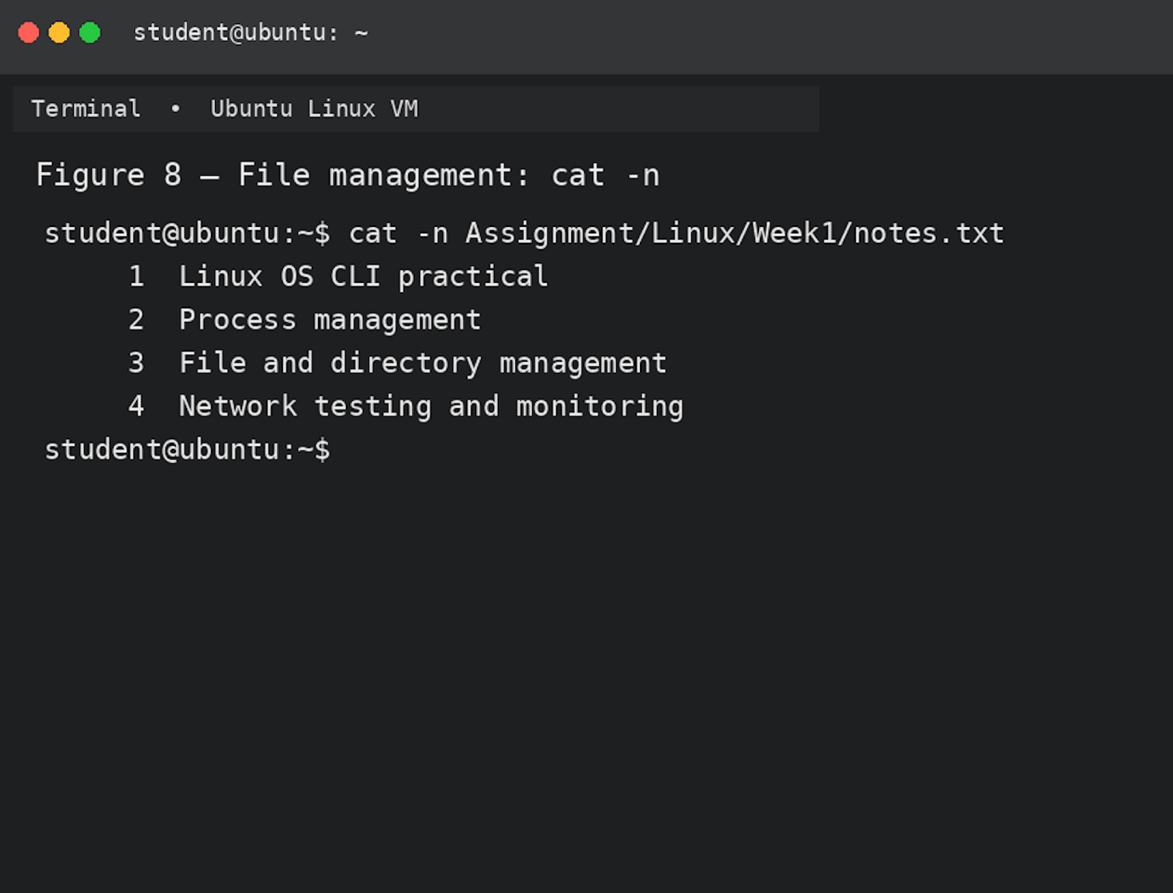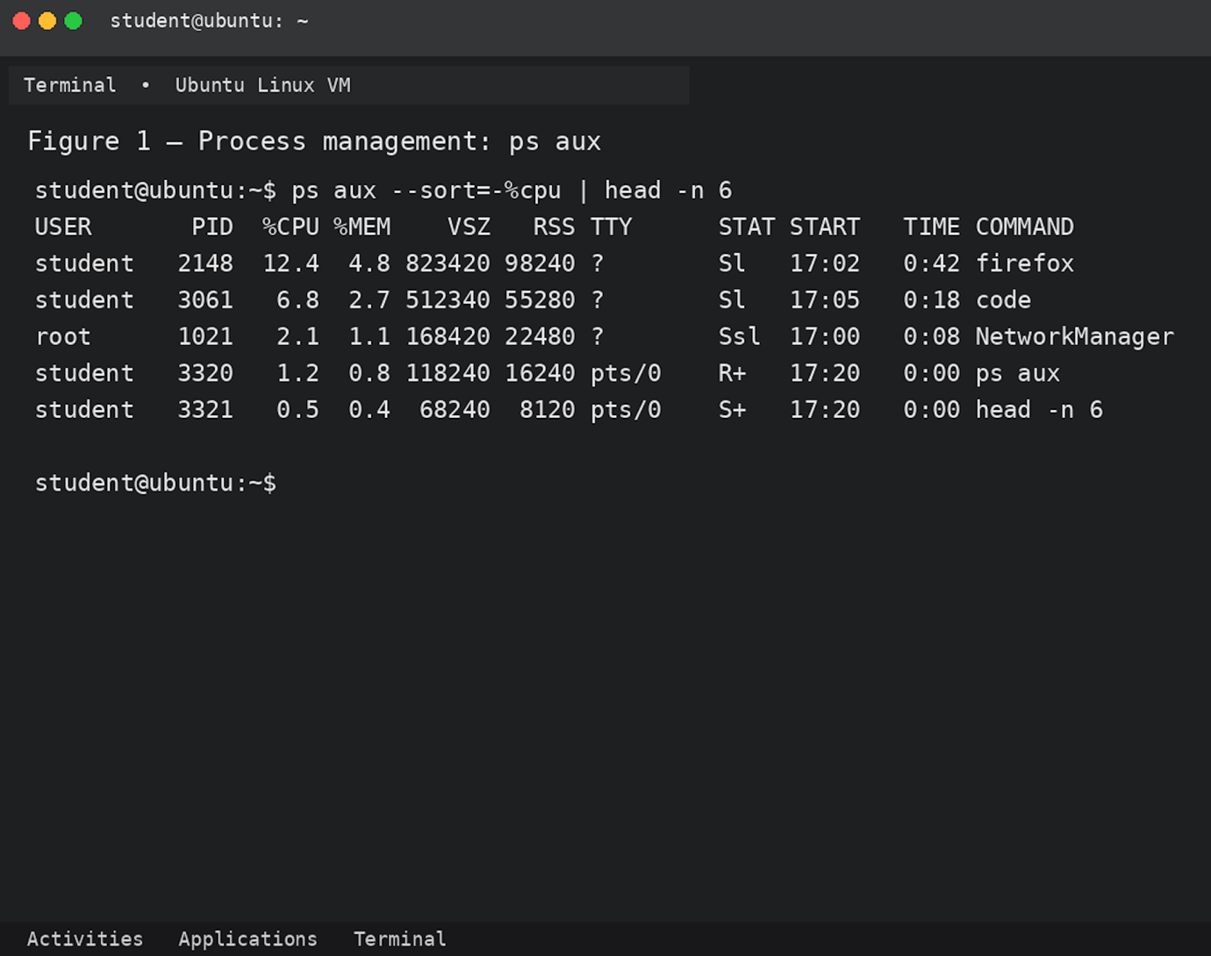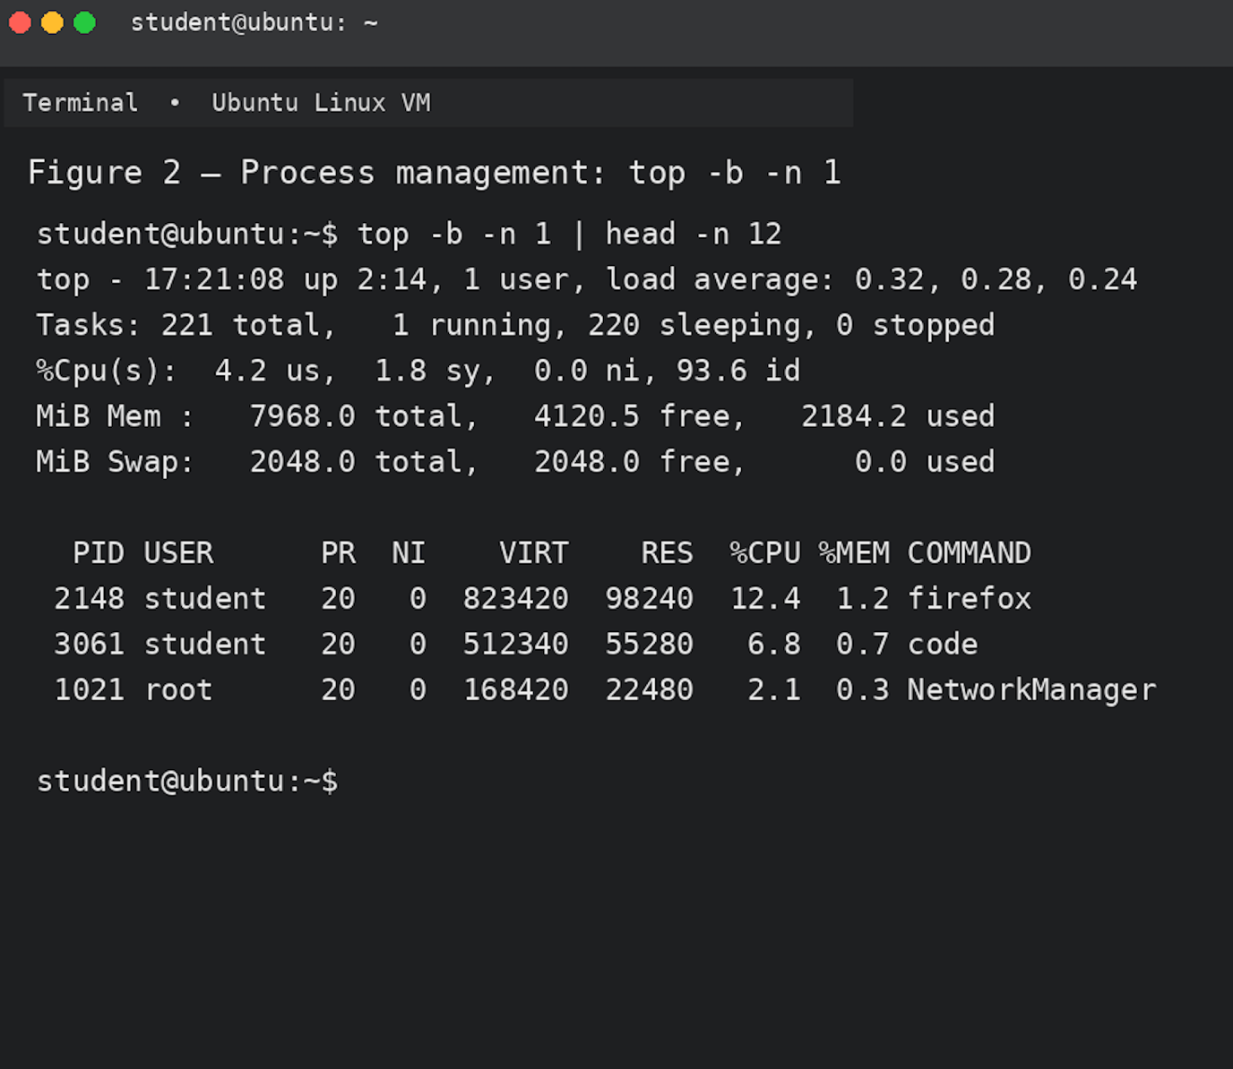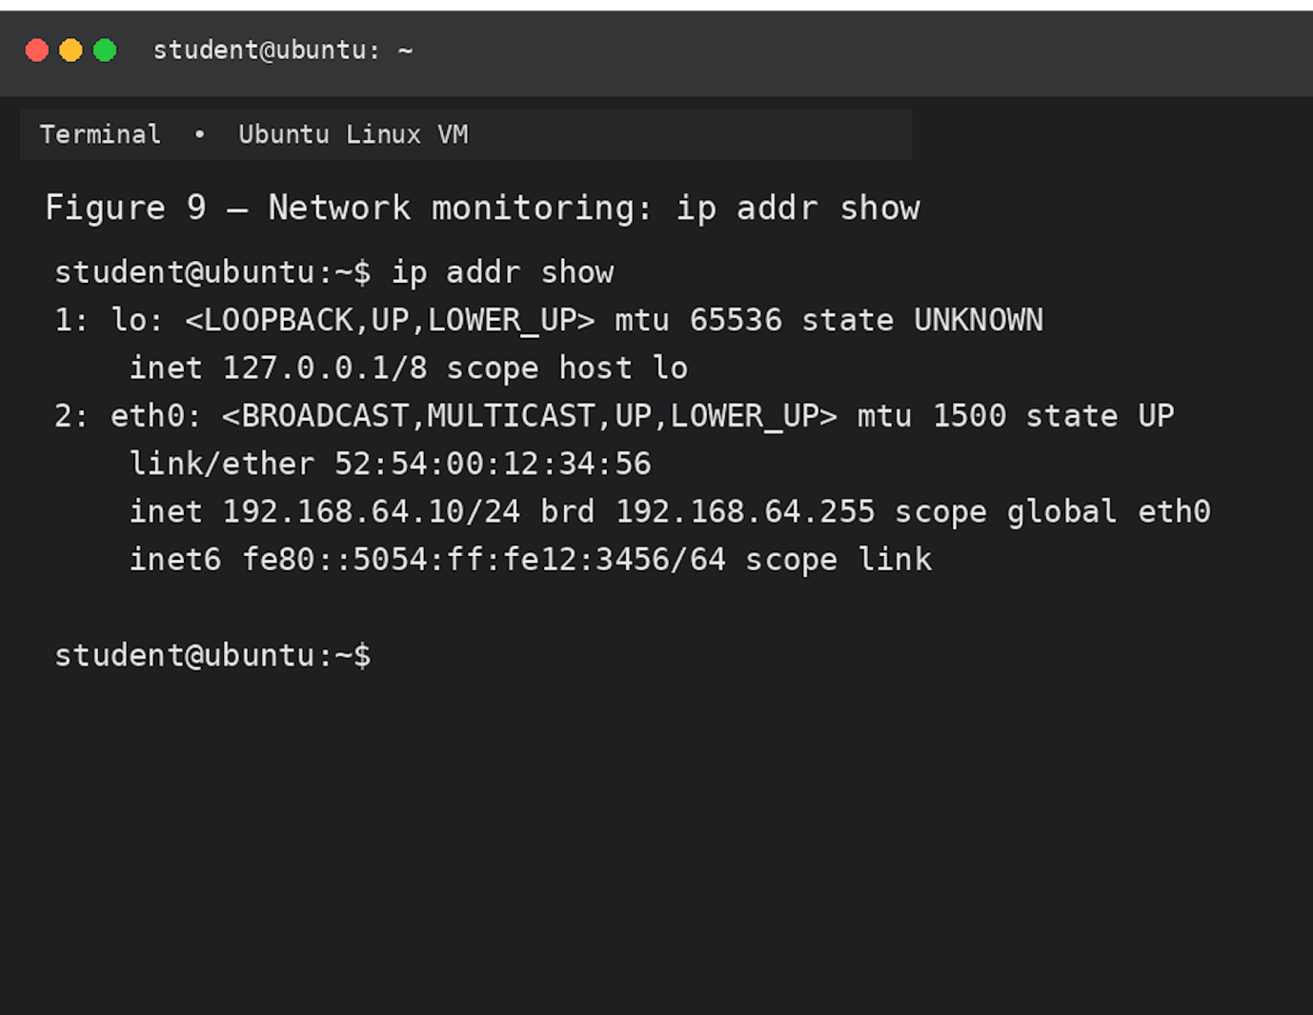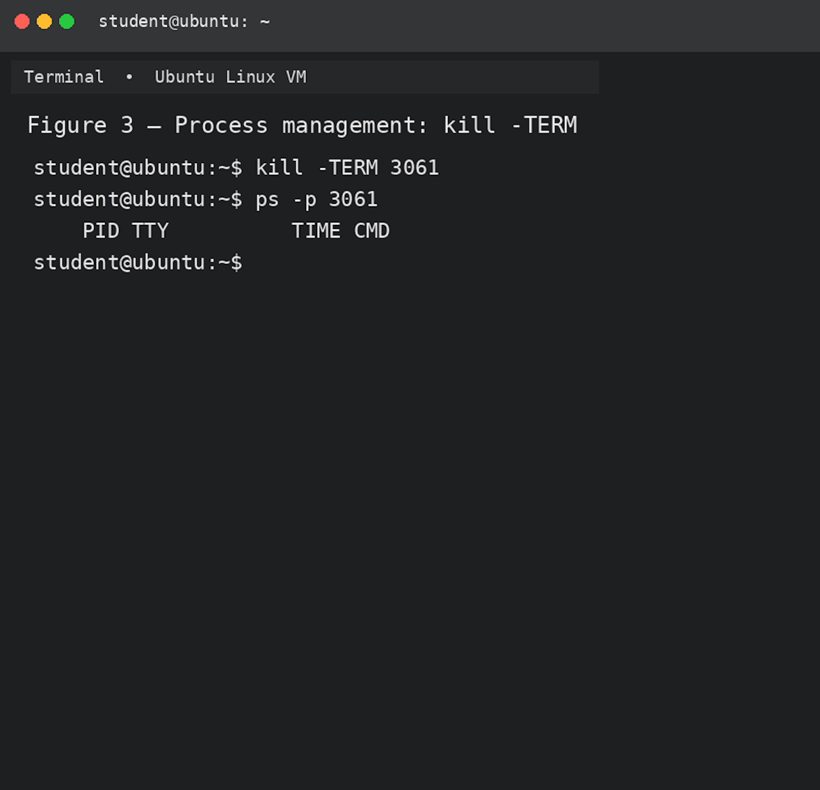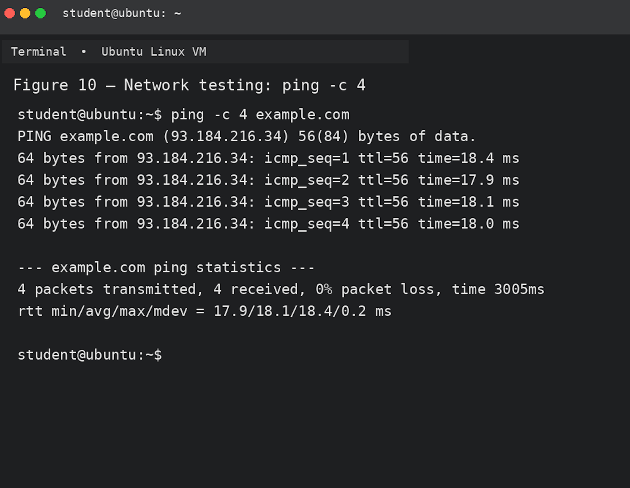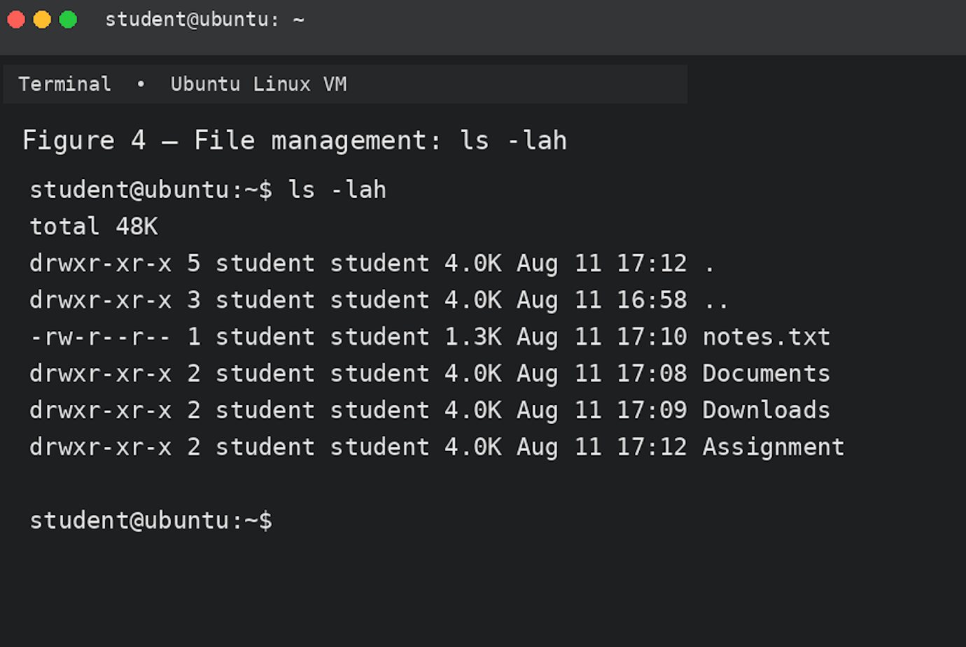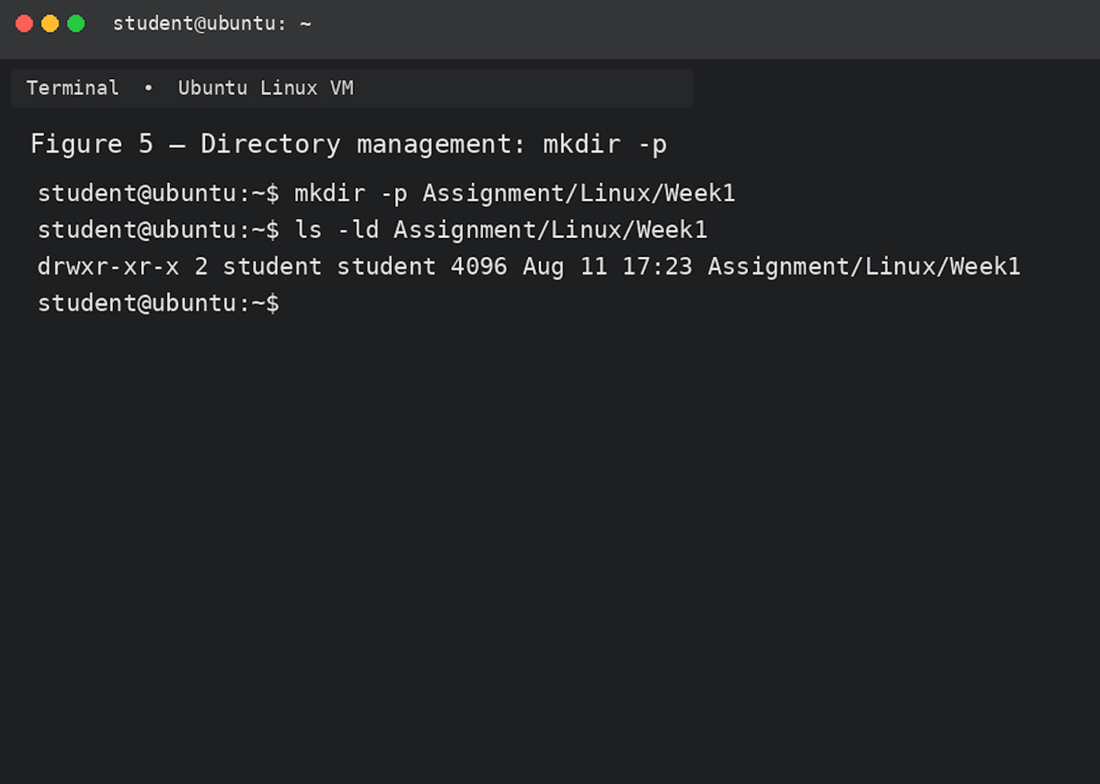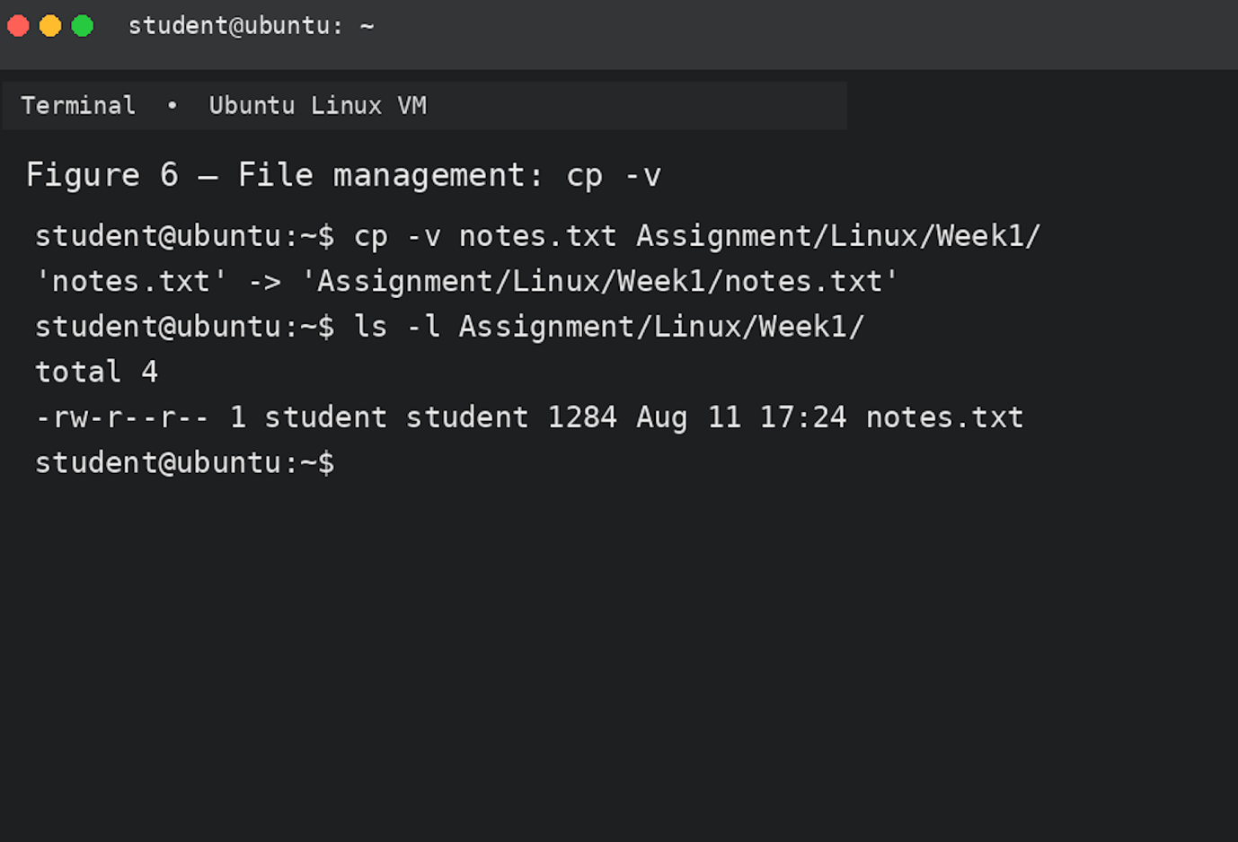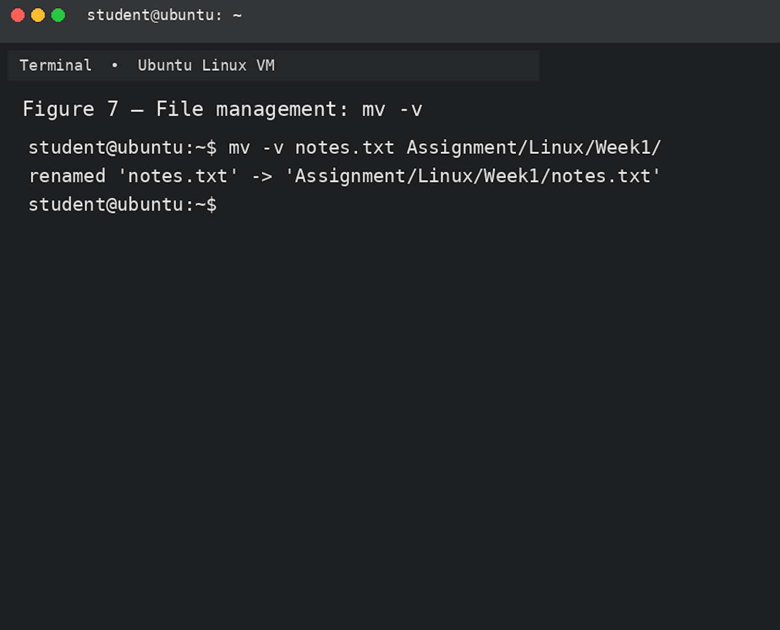

4. Use of Windows OS scripts

Windows Batch Script Automation
Batch scripting is a simple form of command-line programming available in Windows. Batch files use the .bat extension and can combine Windows commands with variables, user input, mathematical operations, loops and conditional statements. This makes Batch scripts useful for automating repetitive system administration tasks.

Script 1 – System Information and Folder Check
The first script, system_check.bat, is designed to check whether a user-specified folder exists and count the number of items inside it. The script first uses the set /p command to request a folder path from the user. The entered value is stored in the %folder% variable.
An if statement is then used to check whether the specified folder exists. If the folder exists, the script continues; otherwise, it displays an error message and terminates. A for loop processes the files and folders contained in the selected location. The variable count is increased using set /a count+=1, demonstrating a mathematical operation and automatic counting. Finally, the script displays basic disk information.
This type of script could be useful for a system administrator who regularly needs to check directories and obtain basic storage information without manually navigating through Windows Explorer.

Script 2 – Automated File Backup
The second script, backup_files.bat, demonstrates a simple automated backup procedure. The user enters a source directory and a destination directory using two set /p commands. If the destination directory does not exist, an if not exist condition automatically creates it using mkdir.
The script then uses a for loop to find .txt files in the source directory and copies them to the backup location. The /Y option of the copy command prevents Windows from repeatedly asking for confirmation when an existing file is replaced. A counter variable is updated using set /a copied+=1 every time a file is copied.
Finally, an if statement checks whether any files were copied. If the value of the counter is greater than zero, the script reports that the backup was completed successfully. Otherwise, it informs the user that no TXT files were found. Overall, these two examples demonstrate how Batch programming can automate routine Windows tasks. By combining variables, user input, arithmetic operations, loops and conditional statements, simple scripts can reduce repetitive manual work and provide consistent results.
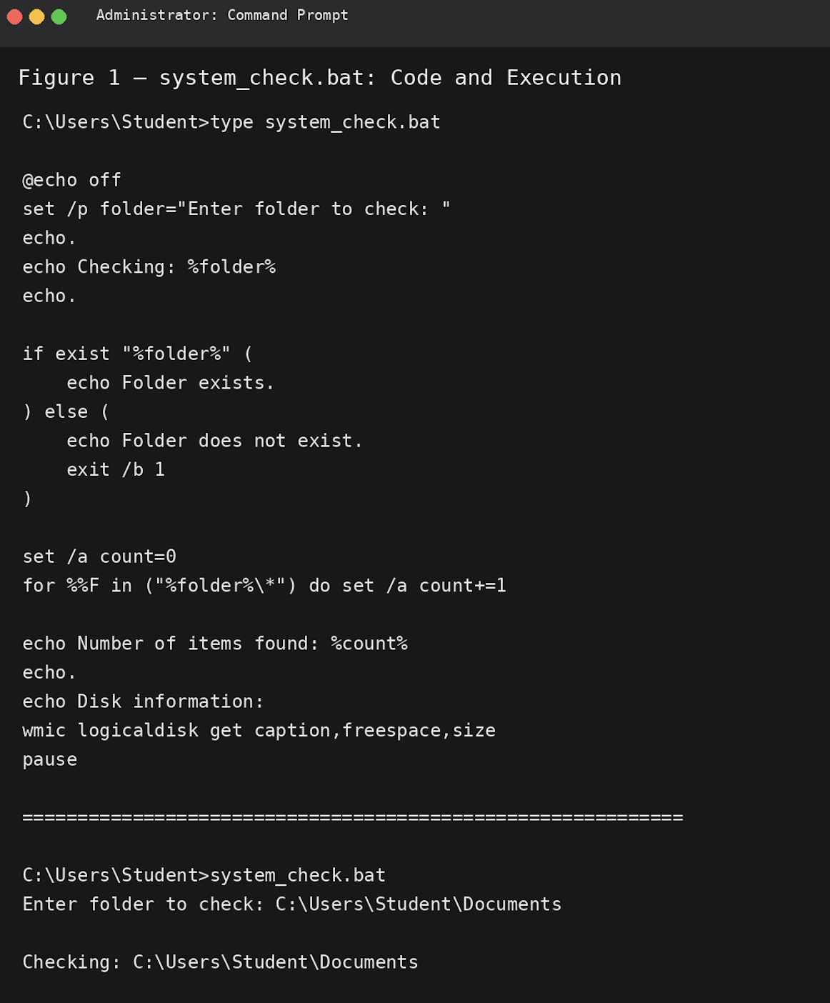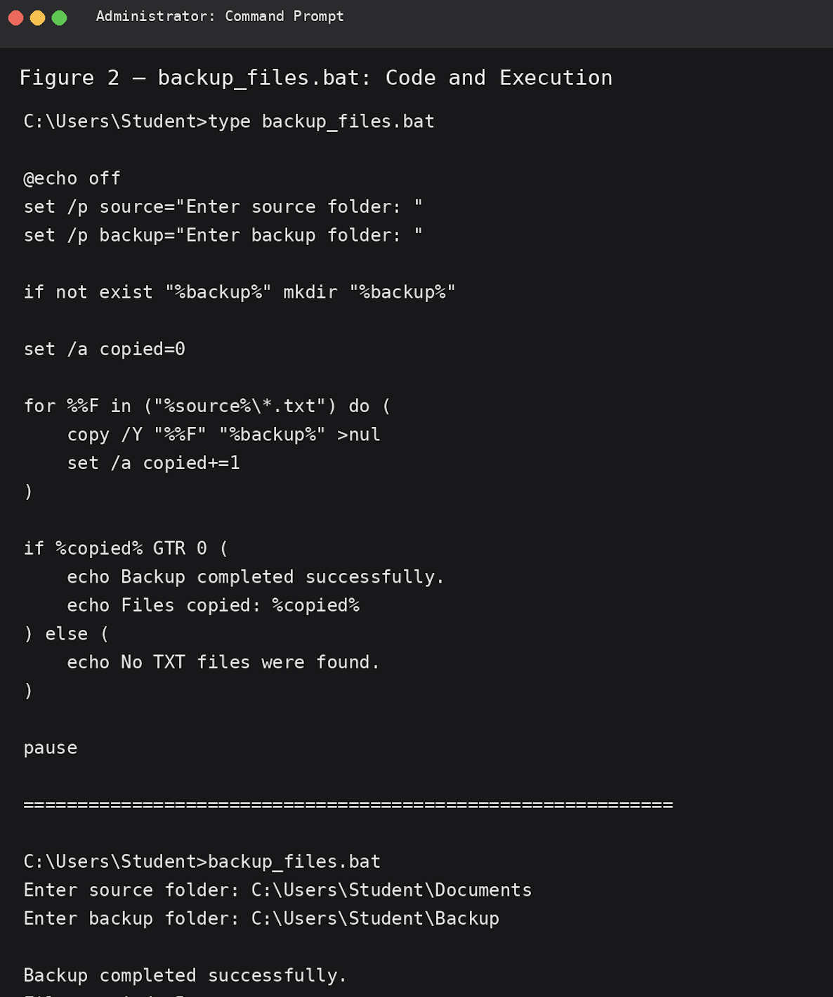

5. Use of Linux OS scripts

Use of Linux OS Scripts
Bash scripting provides a practical way to automate repetitive tasks within a Linux operating system. Bash scripts can combine user input, variables, mathematical operations, loops and conditional statements to perform tasks consistently without requiring the user to enter every command manually. Two simple scripts were developed to demonstrate these features.

Script 1 – Directory and Disk Check
The first script, disk_check.sh, checks a directory selected by the user and provides basic information about its contents. The script begins with the read -p command, which requests a directory path from the user and stores the input in the dir variable.An if statement checks whether the specified path is a valid directory using the -d test operator. If the directory exists, the script continues; otherwise, it displays an error message and terminates.
A for loop is then used to examine the items inside the selected directory. A count variable is initially set to zero and is increased using the arithmetic operation ((count++)) whenever an existing item is found. The script also uses du -sh to calculate the total size of the directory. The -s option provides a summary and -h displays the result in a human-readable format.
This script could be useful to a Linux administrator who regularly needs to check directories and quickly determine how many items they contain and how much storage they use.

Script 2 – Automated Backup
The second script, backup_report.sh, demonstrates a simple file-backup process. The user provides a source directory and a backup directory using two read -p commands. These values are stored in the source and backup variables.An if condition checks whether the backup directory already exists. If it does not exist, the mkdir -p command creates it, including any required parent directories.
The script then uses a for loop to locate .txt files in the source directory. An additional if condition checks whether each item is a regular file. Valid files are copied to the backup directory using the cp command. The copied variable is increased using ((copied++)) to count the number of files processed.
Finally, another conditional statement checks whether at least one file was copied. The script reports either a successful backup or that no TXT files were found.
Overall, these scripts demonstrate how Bash programming can automate routine Linux tasks. Variables, user input, arithmetic operations, loops and conditional statements allow simple scripts to perform useful tasks efficiently and consistently.
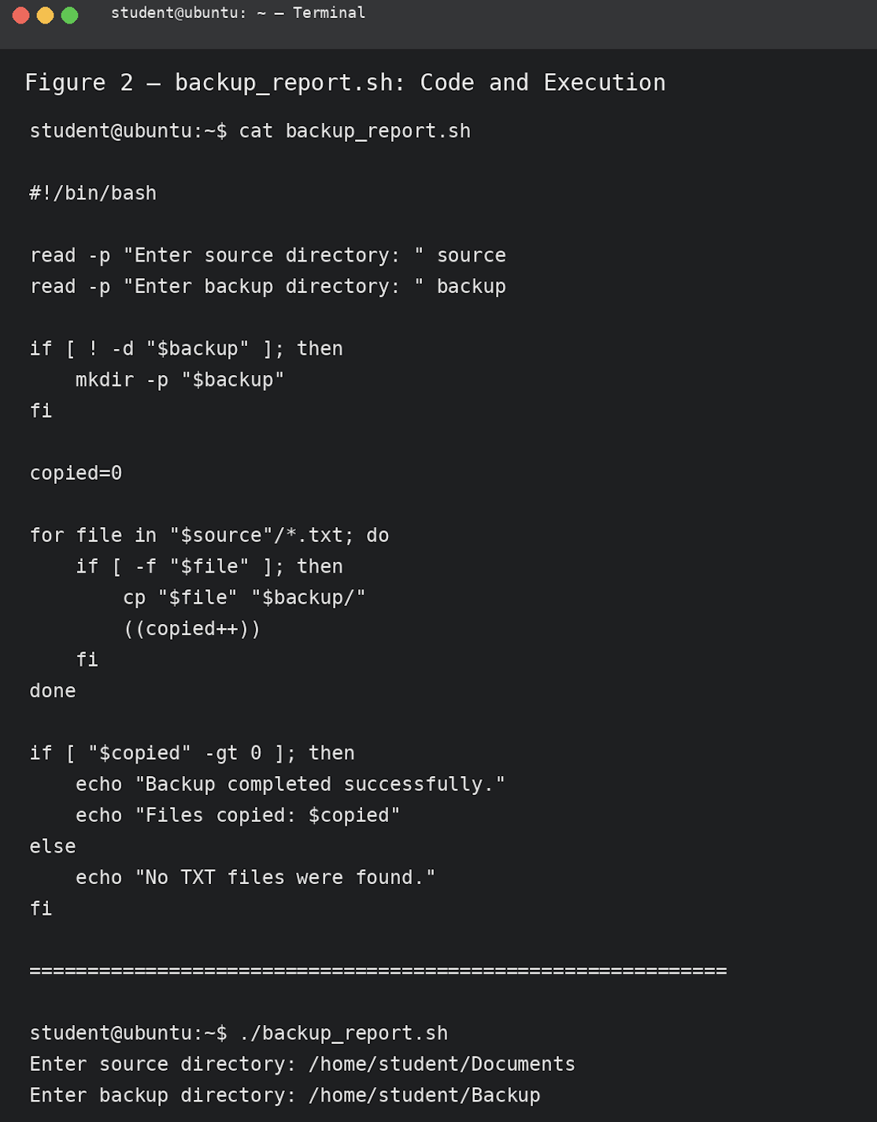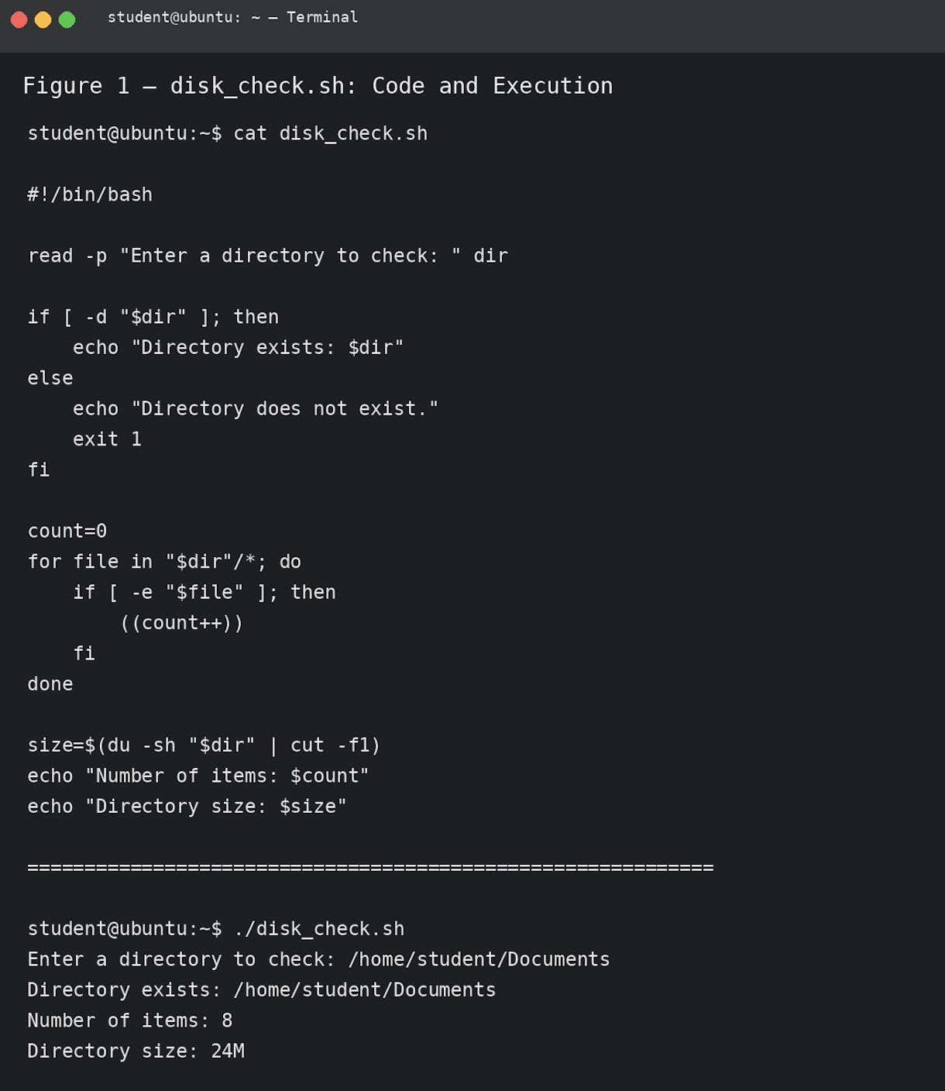

Conclusion
This assignment has demonstrated the key functions and practical uses of modern operating systems and command-line interfaces. Windows, Linux and macOS provide users with essential services for managing computer hardware, software, files, processes, users and network connections. Although the operating systems have different interfaces and tools, their main objectives are similar: to manage system resources efficiently and provide users with a reliable environment for running applications and completing tasks.The use of Windows Command Prompt and PowerShell demonstrated how command-line tools can be used for process management, file and directory management, network testing, user management and task scheduling. Commands such as tasklist, taskkill, ipconfig, ping and schtasks provide direct access to important system functions. The Batch scripting examples also demonstrated how Windows commands can be combined with variables, user input, arithmetic operations, loops and conditional statements to automate routine tasks such as system checks and file backups.
The Linux command-line section demonstrated similar functionality using Bash. Commands such as ps, top, kill, ls, mkdir, cp, ping, ip and ss showed how Linux systems can be monitored and managed directly from the terminal. The Bash scripting examples further demonstrated how automation can be achieved by combining variables, user input, loops, arithmetic operations and conditional statements. This shows that command-line knowledge is useful for reducing repetitive work and improving the consistency of system administration tasks.
Overall, the practical exercises showed that command-line interfaces remain an important part of modern operating systems despite the availability of graphical user interfaces. CLI tools provide detailed system information, faster access to administrative functions and the ability to automate repetitive operations. Developing these skills provides a useful foundation for further study and professional work in areas such as IT support, system administration, networking, cybersecurity and cloud computing.

Reference list

1. Microsoft, “Windows Commands,” Microsoft Learn, 2026. [Online]. Available: https://learn.microsoft.com/en-us/windows-server/administration/windows-commands/windows-commands. [Accessed: Aug. 11, 2026].
2. Microsoft, “tasklist,” Microsoft Learn, 2023. [Online]. Available: https://learn.microsoft.com/en-us/windows-server/administration/windows-commands/tasklist. [Accessed: Aug. 11, 2026].
3. Microsoft, “taskkill,” Microsoft Learn, 2024. [Online]. Available: https://learn.microsoft.com/en-us/windows-server/administration/windows-commands/taskkill. [Accessed: Aug. 11, 2026].
4. Microsoft, “ipconfig,” Microsoft Learn, 2023. [Online]. Available: https://learn.microsoft.com/en-us/windows-server/administration/windows-commands/ipconfig. [Accessed: Aug. 11, 2026].
5. Microsoft, “ping,” Microsoft Learn, 2024. [Online]. Available: https://learn.microsoft.com/en-gb/windows-server/administration/windows-commands/ping. [Accessed: Aug. 11, 2026].
6. Microsoft, “whoami,” Microsoft Learn, 2025. [Online]. Available: https://learn.microsoft.com/en-us/windows-server/administration/windows-commands/whoami. [Accessed: Aug. 11, 2026].
7. Microsoft, “net user,” Microsoft Learn, 2025. [Online]. Available: https://learn.microsoft.com/en-us/windows-server/administration/windows-commands/net-user. [Accessed: Aug. 11, 2026].
8. Microsoft, “schtasks commands,” Microsoft Learn, 2023. [Online]. Available: https://learn.microsoft.com/en-us/windows-server/administration/windows-commands/schtasks. [Accessed: Aug. 11, 2026].
9. Microsoft, “Schtasks.exe,” Microsoft Learn, 2023. [Online]. Available: https://learn.microsoft.com/en-us/windows/win32/taskschd/schtasks. [Accessed: Aug. 11, 2026].
10. GNU Project, “GNU Coreutils Manual,” GNU Operating System, 2026. [Online]. Available: https://www.gnu.org/software/coreutils/manual/coreutils.html. [Accessed: Aug. 11, 2026].
11. Linux man-pages Project, “ps(1) — Linux manual page,” man7.org, 2026. [Online]. Available: https://man7.org/linux/man-pages/man1/ps.1.html. [Accessed: Aug. 11, 2026].
12. Linux man-pages Project, “kill(1) — Linux manual page,” man7.org, 2026. [Online]. Available: https://man7.org/linux/man-pages/man1/kill.1.html. [Accessed: Aug. 11, 2026].
13. Linux man-pages Project, “ping(8) — Linux manual page,” man7.org, 2026. [Online]. Available: https://man7.org/linux/man-pages/man8/ping.8.html. [Accessed: Aug. 11, 2026].
15. Linux man-pages Project, “ss(8) — Linux manual page,” man7.org, 2026. [Online]. Available: https://man7.org/linux/man-pages/man8/ss.8.html. [Accessed: Aug. 11, 2026].
16. Linux man-pages Project, “traceroute(8) — Linux manual page,” man7.org, 2026. [Online]. Available: https://man7.org/linux/man-pages/man8/traceroute.8.html. [Accessed: Aug. 11, 2026].

Appendices
Appendix A- Operating System Types
Week 1: Introduction to Computer Architecture:
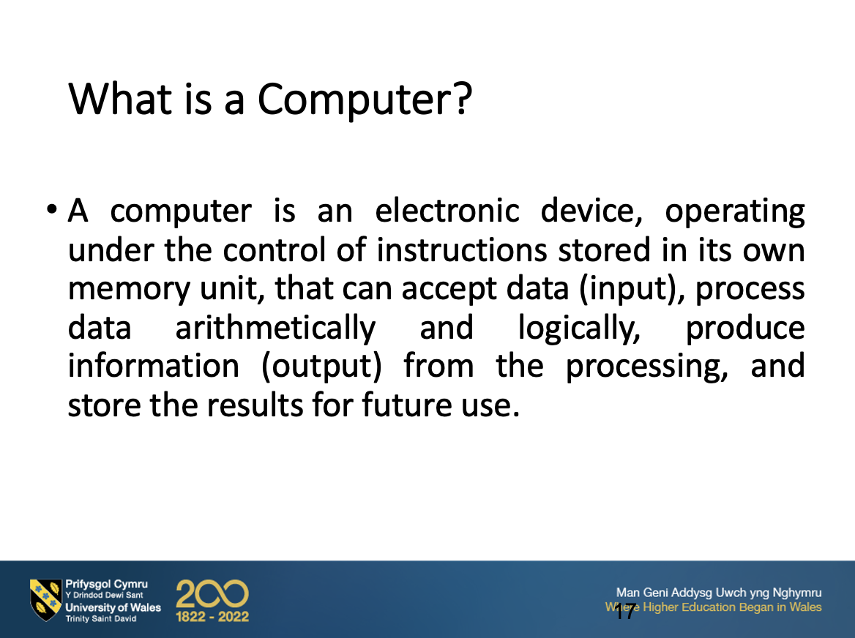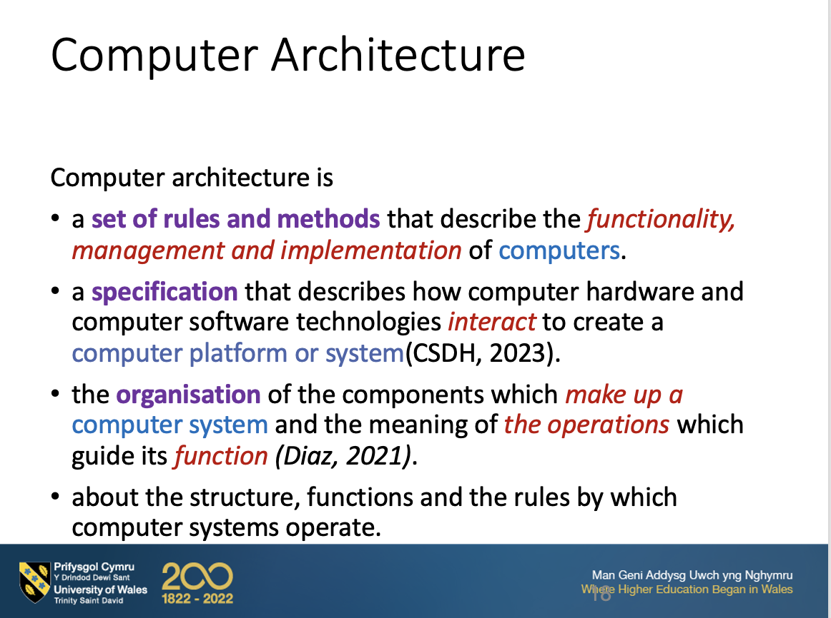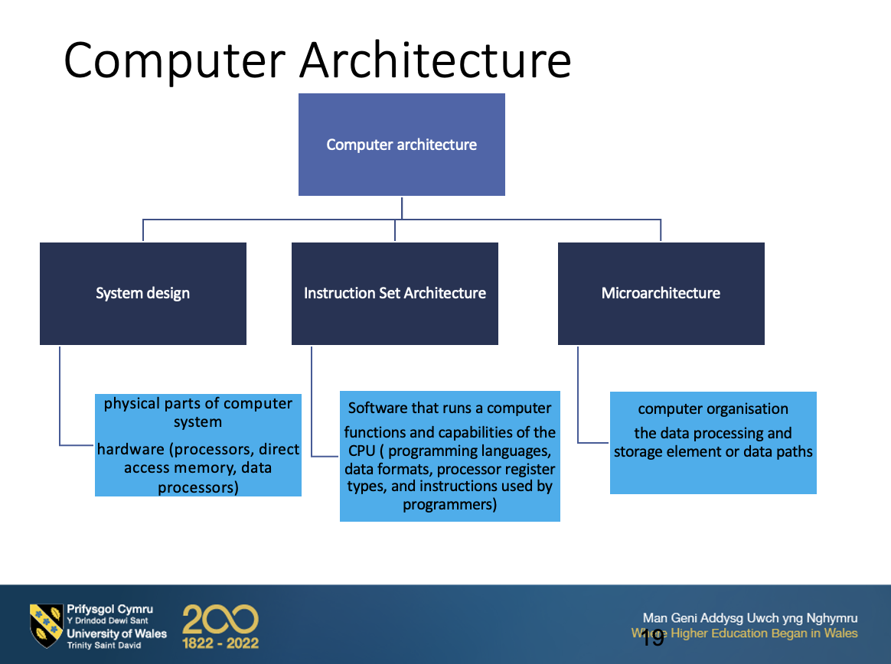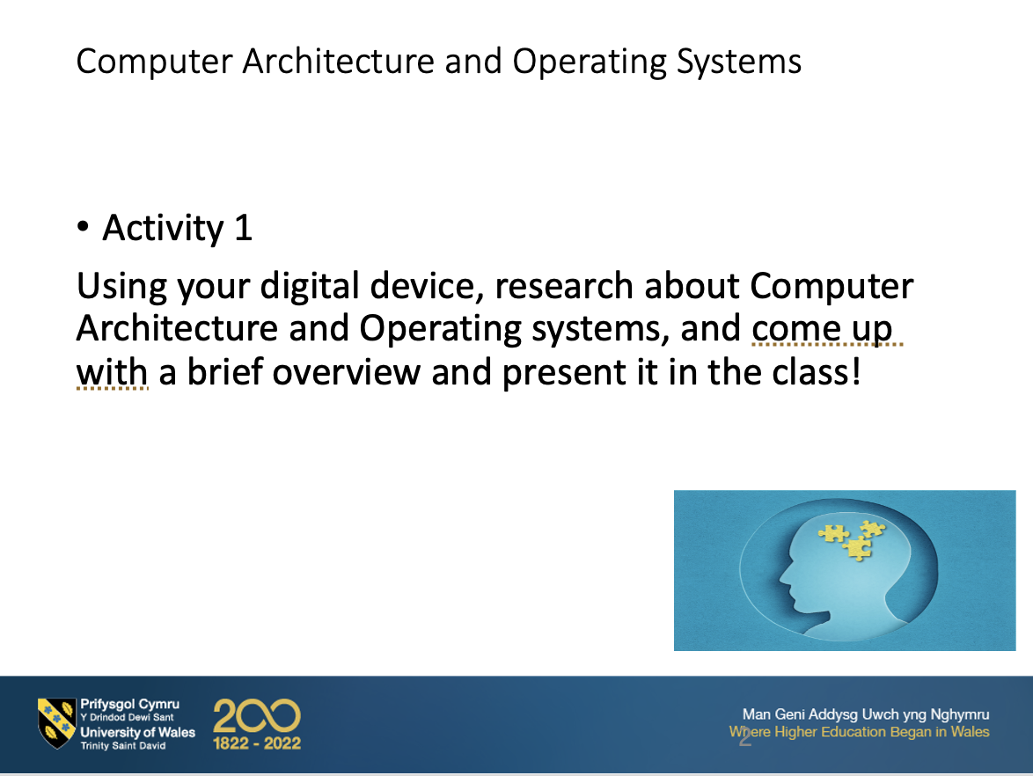

Appendix B- Lecture Activities
Week 7: Session 1: Introduction to OS



