Programs in C and documentation assignment (Part C) by Gareth Evans

Author - Gareth Evans
Student Number – 1810612
Course - Cyber Security & Networks (Part Time)
Module – Software Development (ACCA4017)

Implementing C to create a game of pairs

This report accompanies part A & B of the assignment already uploaded. It covers how a game of pairs can be created using the programming language C. The problem is broken down below, followed by the code itself with relevant comments and screenshots of the output.

Breaking down the problem

This game of pairs involves twelve numbers, the player selects two numbers at a time until all six pairs have been reached. To do this, the code must do the following:
- Create an array that holds twelve values
- Ask the player to select two of these values, each representing a number that they will try and match
- If the player gets a pair, these cards are removed from the game and they cannot select these cards again
- Once the player gets all six pairs, it must tell them how many incorrect attempts they had
- The player must have the option to play again and beat their previous “score”

See the next section for the code. Relevant comments are highlighted in green.

1.2 Code and comments

#include <stdio.h>

int pairs[12] = { 1,1,2,2,3,3,4,4,5,5,6,6 }; // Array holds numbers 1-6 twice to represent the pairs available

void main()

{
int card1;
int results[12] = { 6,5,4,3,2,1,6,5,4,3,2,1 }; // if the user opts to play again, this will be the new array with re arranged numbers
int i = 0; //this is used in the for loop at the end of the game

int card2;

int point = 0; // stores the number of points the user has

int correct = 0; //stores the number of correct attempts the user has

int wrong = 0; //stores the number of incorrect attempts the user has
char response; //stores the response from the user if they want to play

printf("Press Y if you want to play pairs!\n"); //asks player if they want to play

scanf(" %c", &response);

while (response == 'y') // if they enter ‘y’, the game begins

{

while (point != 6) // as long as the variable ‘point’ does not equal six, the game will ask the player to pick cards

{

printf("Pick a Card (0-11):");

scanf("%d", &card1); //user picks a card and it is stored

if (pairs[card1] == -1) // when a pair is found, the cards value is changed to -1, this is seen below

{

printf("You cannot use the same card again\n"); //this prevents the any card that has been taken out of the game being selected again due to the value being set to -1

wrong = wrong + 1; //adds to the incorrect attempts total

}

printf("Pick a different card (0-11):");

scanf("%d", &card2); //player picks second card and is stored

if (card1 == card2)

{

printf("You must pick different cards!\n"); // this prevents the user from picking the same ‘card’
}

else if (pairs[card1] == pairs[card2]) //if the player selects the same numbers from the array, they find a pair
{

printf("That's a match!\n");
pairs[card1] = -1;
pairs[card2] = -1; //this sets card1 & card2 to -1 so the player cannot pick them again as mentioned earlier
point = point + 1; //adds one to the point total

}

else

{
printf("Sorry no luck!\n"); //if the user does not find a match, this message is printed
wrong = wrong + 1; // adds one to the wrong attempts total

}

if (point == 6) //as the user needs to find six pairs, once they have six points, the game is finished

{

printf("Congrats, you did it!\n", correct);

printf(" You had %d incorrect attempts", wrong); //tells the user how many wrong attempts they had by taking the value from the variable ‘wrong’

printf(" Do you think you can do better? \n Press y to play again!");

scanf(" %c", &response); //gives the user the option to play again
}

}
point = 0;
correct = 0;
wrong = 0;
card1 = 99;
card2 = 555; //if the user wants to play again, the values for the variables used in the previous game are all reset or set to numbers not used before to prevent the game from thinking they have used the numbers before

for (i = 0; i < 12; i++)
{
pairs[i] = results[i]; // this changes the values in the array from the first game to rearrange the the order seen in the array ‘results’
}
}
if (response != 'y')
{
printf("Ok maybe another time!\n"); //if the user enters anything other than ‘y’, it is assumed they do not wish to play again and the program closes
}
}

1.3Screenshots

Below are screenshots of all possible outcomes from the program that allow it to run.
Figure 1 Player chooses not to play
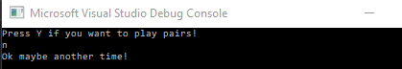

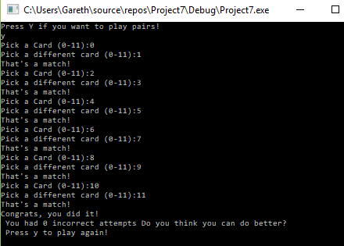
Figure 2 User wins the game with no incorrect attempts

Figure 3 Player chooses to play again after having 2 incorrect attempts
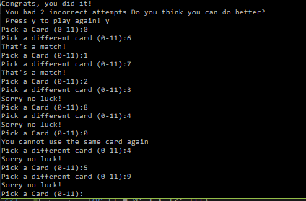

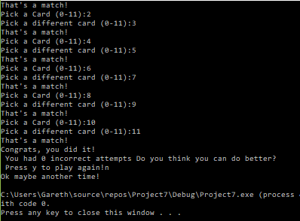
Figure 4 Player wins the game and decides not to play again

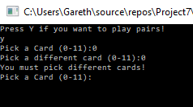
Figure 5 User tries to pick the same card, program stops this

The following screenshots show problems that occur within the program when the player inputs characters not recognised.

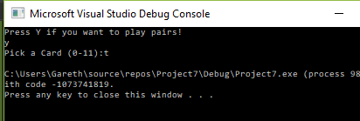
Figure 6 Player inputs a letter when picking a card, causing the program to stop

Figure 7 Player selects a number out of range. The program still runs. However, the player will not find any pairs. The program gives the player the range to pick from so this should prevent it.
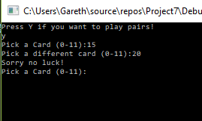

Figure 8 If the player goes out of range and selects two numbers that have the same digits when swapped (e.g 35 and 53), it finds a pair
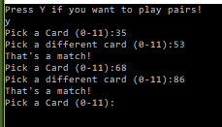

1.4 Changes made to initial design

The program above is a simple game of pairs, using only loops and if / else if statements. It is possible to make a more complex version, one that could include the following:
- A function – the initial design included a function. However, it would now allow the program to run correctly and removing it seemed to be the only way to get the program to run. The function was designed to ask the player to play again and return the response to the start of the program
- Random number generator – It would have been preferred that the values of the array would randomise with each game. This would not work; the numbers would not store in the array. Because of this, the value of the array was manually changed after the user opted to play again. If the user was to play a third time, the values of the array would stay the same.

