Introduction to Innovation Management
Assessment B
MSc Industry 4.0 Advanced Manufacturing
Module Code: ACPA7005
Supervisor: Alan Mumby

Analysis of Innovation within Hanson UK in relation to CEM II/A-LL – Innovation in Cement

27th May 2022
Student: Christopher O’Connor 1351620
Email: christopher.oconnor@hanson.biz

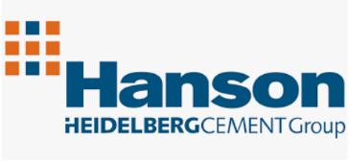

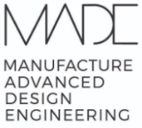

Contents
Introduction 3
How is Cement Produced? 4
What is CEM I? 4
What is CEM II/A-LL? 5
Review of Innovation Process of CEM II 5
The Principal Drivers for the Innovation 5
Barriers and Risks faced by the company in developing this innovation 6
The key determinants of committing to develop the innovation 7
Processes and Technologies which the company used to carry this development forward 7
Extent to which the development relied on resources external to the company 8
How was management overview of the development maintained? 8
Extent to which this innovation process represents best practice 9
How well is the problem and domain defined? 10
Priorities for Innovation Policies 10
The Three Horizon Framework (3H) 11
Conclusion 12
Bibliography 14
Appendices 16

Introduction
Hanson UK are a leading building materials manufacturer and supplier of the United Kingdom. They have over 3500 employees occupying over 300 sites around the country, consisting of three large cement plants, three REGEN production plants and numerous quarries, concrete and asphalt plants.
As with all businesses in the current climate they have significant challenges operationally when it comes to sustainability and its carbon footprint. This is particularly the case for its Cement business line and its three cement manufacturing plants, Padeswood, Ketton and Ribblesdale. It is estimated that between 4-8% of global CO2 emissions are a result of cement production. (Britannica, 2022)
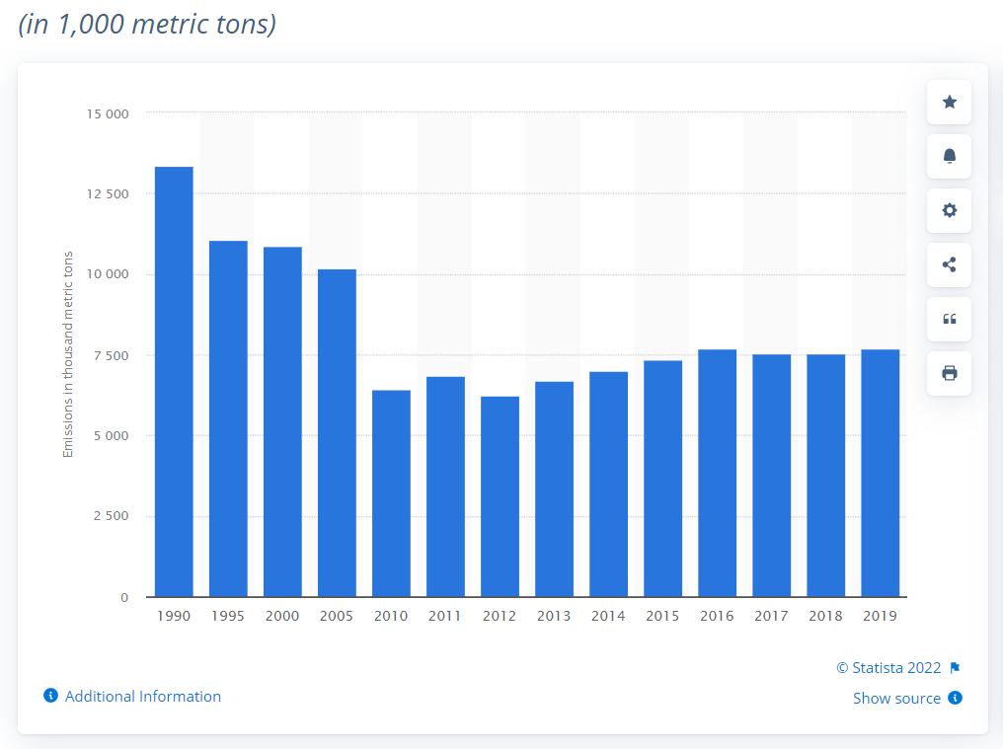
Figure 1 - UK CO2 Cement production emissions data 1990 – 2019 (Statista, 2022)
In 2019 for example, UK cement manufacturing was responsible for 7.7 MT of CO2 emissions. Although this figure is small in comparison to Chinas figure of 827 MT for the same period, it is clear that both legally in line with the UK governments 2050 NETZERO roadmap, but perhaps most importantly morally, when you consider that impact that global warming is already having on the planet, that businesses and organisations must do all they can to reduce and where possible eliminate their CO2 production.
To mitigate the CO2 problem in cement production, Hanson Cement have developed an alternative to the standard CEM I cement that is typically high in embodied CO2. Their alternative product has been named CEM II/A-LL and offers a reduction in CO2 by replacing clinker with limestone and a grinding aid during production process.
The report will outline the development of this new product with focus on how the business assessed, planned, and executed the innovation process that was required to successfully realise the idea of a CEM I alternative.

How is Cement Produced?
There are four main stages in the production of cement, they are:
- Crushing and grinding of raw materials (Limestone and clay)
- Correctly blending raw materials together
- Burning the mixture to form “clinker”
- Grinding the clinker along with gypsum
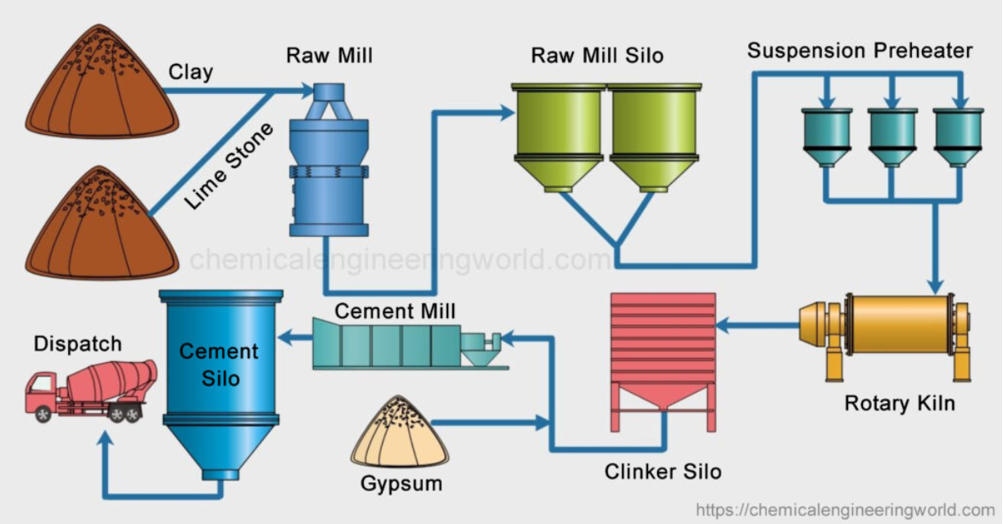
Figure 2 - Overview of cement production process (Chemical Engineering World, 2022)
It is at step three in this process where we see the most significant impact on CO2 emissions in the production of clinker, this is since the primary fuel used to burn the mixture and turn it into clinker is natural gas. Also, during the calcification of Limestone to produce clinker, CO2 is given off as a by-product which is typically then vented to atmosphere.
It is reasonable to suggest then that targeting the reduction of clinker in the cement making process and replacing it with a more sustainable alternative would reduce the CO2 footprint that is left behind from clinker production.
Cement is sold in two forms, in bulk using tankers that can carry up to 30 tonnes at a time (industrial customers), or as a packed product (usually for the public) and come in bags up to 25kg in weight. Bulk cement usually accounts for 80% of cement production, however in Hanson the volumes are evenly split between bulk and packed products. Typical sectors that consume the cement product are ready-mix concrete suppliers, builders’ merchants, and concrete manufacturing plants. (Hanson UK, 2021)

What is CEM I?
CEM I, which is also referred to as Ordinary Portland Cement (OPC) is comprised of mainly ground clinker and up to 5%. In line with current cement and British Standard BS EN 197-5:2021 (European Standards, 2021), and is the primary cement product manufactured by Hanson UK. CEM I accounts for 79% of manufactured cement in the UK, which totals 10 million tonnes per year (HUB 4, 2022). Currently the concrete standard BS 8500 only allows OPC to a be a mixture of clinker with one other mixer, whether that be fly ash, ground limestone or blast furnace slag. In July 2018 a joint project by the Mineral Products Association, supported by its members and cement manufacturers such as Hanson, Tarmac and Breedon looked at utilising limestone as a replacement for clinker to make a ternary cement product of clinker/limestone and one other additive (fly ash/blast furnace slag). The MPA proposed that this replacement of a proportion of the clinker for limestone could potentially reduce the embodied CO2 by 40% (Mineral Product Association, 2019). A key metric to achieve BS 8500 is that the concrete 28-day strengths must achieve a result of 52 N/mm², this is an important point that must be addresses before any new material is given British Standard approval.

What is CEM II/A-LL?
CEM II/A-LL is a low carbon ternary cement product that has been developed by Hanson UK. Instead of the typical OPC binary blend, the addition of limestone as a proportional replacement for clinker at around 10/11% ratio has many significant benefits. They can be categorised as:
- Lower cost of production: Limestone is cheaper to produce than clinker
- Positive effect on sustainability: Limestone cements offer up to 40% savings on embodied CO2
- Comparable product strengths: Limestone introduction coupled with grinding aids have proven to replicate the inherent product strengths typically found in CEM I

Review of Innovation Process of CEM II

The Principal Drivers for the Innovation
According to Nina Cardinal, National Technical Manager for Hanson Cement, the principal driver was the challenge to reduce the amount of embodied CO2 in the cement manufacturing to align to the business’s commitment of a 50% reduction by 2030.
On top of this, a review of the British Standard BS EN 197-5:2021 cement standard meant that there would be an opportunity to develop a cement which could include more limestone in it, thus potentially reducing the embodied CO2.
The two aforementioned drivers were then supported and perhaps accelerated by Hanson UK commercial department when they realised that they could offer customers a more sustainable product, with the same qualities that was also cheaper to make. Therefore, although initially the project was conceptualised by the technical department, it was pushed forward by the commercial team to ensure there was a market ready for the product once it had been technically proven,

Barriers and Risks faced by the company in developing this innovation

Barrier | Risk | Mitigation
Reduced concrete strengths due to increased limestone which is less reactive than clinker | Substandard cement that would fail strength tests | Introduction of grinding aid called Mapei Grinding Aid/C (see technical document in appendices) in the manufacturing process. These grinding aids were found to activate some of the dormant clinker in the process which was able to substitute for the reduction in clinker volume and increase in limestone, which is less reactive due to its hydraulic properties.
Concrete standard BS 8500 limits the amount of LS cement that can be added to concrete mix | Customers would not want a product that does not meet BS8500 | Hanson along with other members of the Minerals Product Association (MPA) which is the trade association, such as Tarmac/Breedon etc collaborated to prove that high limestone cement would suitably meet the concrete standard strength and chemical requirements at no detriment. The collaboration of the organisations meant a greater voice, which was inevitably heard with the standard anticipated to change at the end of 2022
Not enough testing resource at Scunthorpe lab | Unable to carry out sufficient testing to achieve UK Conformity Assessed (UKCA) Mark. Therefore, would not be able to sell product | Resource levels assessed and extra hired where necessary
Customers adverse to change due to concerns around quality/strengths | Unable to sell product to market | Concrete market is very conservative and prefers a more trusted and proven product due to obvious concerns with security and integrity. Therefore, Hanson set out a rigorous testing programme that would prove the quality and strength of CEM II/A-LL. On top of this, Hanson offered their customers the use of their labs to allow them to carry out their own product testing for reassurance. They also went further by reaching out to the customers and helping them look for applications where the use of CEM II would be suited.
CEM II/A-LL production capacity | Reduced CEM I product availability for market  CEM I and CEM II/A-LL cross contamination | As CEM II/A-LL is produced in the same cement mills as CEM I, production of CEM II meant that CEM I production was halted. Commercial had to ensure market demand in place for all CEM II/A-LL produced  With only a limited amount of storage capacity in the cement plant silos, current CEM I silos would need to store CEM II/A-LL when required. To avoid contamination, silos would be run empty and checked before each product change

The barriers faced by Hanson during the CEM II project can be categorised into technical, commercial and production challenges. These are typical when considering any innovation and often require the collaboration of all entities to find a suitable solution.

The key determinants of committing to develop the innovation
Nina Cardinal explained that it was well known within the industry that a cement could be made with an increased proportion of limestone to clinker, so the business knew that providing they had customers to supply the material to, and that the standards and quality controls that they must adhere to could be achieved, they could proceed with full scale CEM II/A-LL production. The reduced production costs associated with CEM II production coupled with the proven sustainability benefits meant that is Hanson UK could be the first company to successfully produce CEM II at scale they would have a significant edge in the cement markets.

Processes and Technologies which the company used to carry this development forward
With the general cement production process essentially remaining the same, and the quality checks only increasing in frequency rather than technicality the only new process/technology that was used during the implementation of CEM II was the use of the described grinding aids. Grinding aids have a rich history of use in cement manufacturing as they are known to have positive effects on cement chemistries, strengths and can also reduce the kiln temperature in which it is produced, thus reducing fuels and therefore CO2 emissions (Grinding aids for high performance cements, 2022).
The key to the success of the use of the grinding aid was the proportion at which it was added to the grniding process. Tests conclulded that the grinding aid proportion and type differed between each cement production plant, this was down to the different operting parameters in each mill, coupled with the differing raw materials used at each site. Nick Sharpe, Technical Manager for Cement described how the trials were carried by adding different volumes of grinding aid into different cement mixes of limestone proportions, with each sample undergoing rigurours 7 day and 28 day strength testing XRF machines that use laser difraction to analyse the materials instrinsic strength. An example of such testing can be seen below. Note the red, blue and green marks highlighted on the image. Red highlights the different grinding aid weights and limestone proportions, green circles highlight the 28 strength figure with no grinding aid added, the blue lines indicated 28 day strengths with grinding aid added. You will note a stregth improvement in all cases where grinding aid has been added, further more on each occasion the 28 strength is above the 52N/mm² result as required to achieve BS 8500.
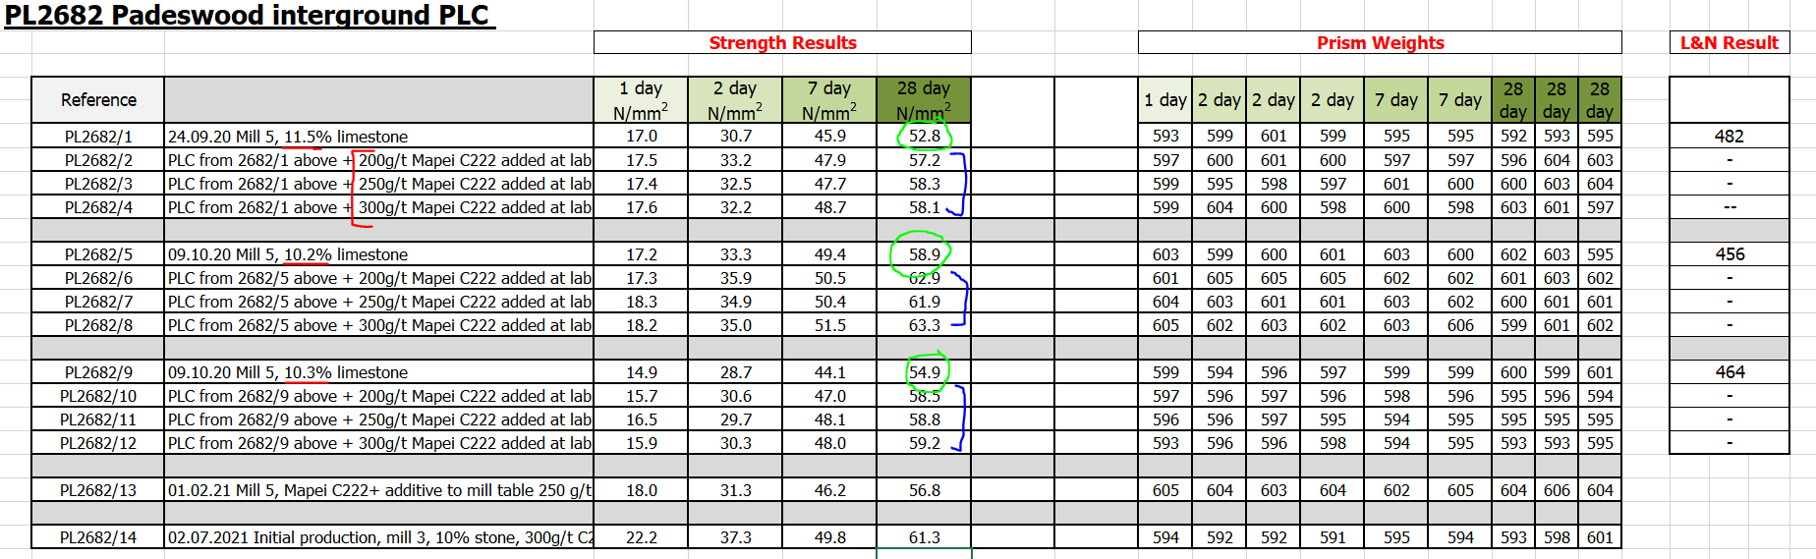
Figure 3 - Data from Padeswood cement plant on grinding aid trials (Hanson UK, 2021)
The grinding aids best suited for Ribblesdale, Padeswood and Ketton were found to be Mapei C209, C222 and C333 respectively.

Extent to which the development relied on resources external to the company
If not for the collaboration between cement manufacturing organisations in lobbying to change the current concrete standard, then this innovation would not have succeeded. Although Hanson did not have direct control on resource of the other organisations, through open collaboration and sharing of results it enabled a strong case to be put forward for the change in the concrete standard.
Secondly, there was a reliance on the ability of the grinding aid manufacturer to have suitable production capacity to meet the increase in the grinding aid usage. Failure to secure sufficient and consistent supplies would mean that CEM II production could not be carried out.
The vast majority of work for this development was carried out by internal resource spanning the technical, commercial, and manufacturing teams.

How was management overview of the development maintained?
The management overview of this project was led by Mark Hickingbottom, National Commercial Manager for Cement and a senior team consisting of Mr Hickingbottom, Nina Cardinal and Nick Sharpe, Technical Manager for Cement. From the project’s conception, a weekly meeting was set up where project content such as ideas, risks, challenges, production, and development were discussed with relevant actions taken. Each action was recorded on an action list and given an owner and completion date. Each meeting, actions that were due were discussed and fed back on.
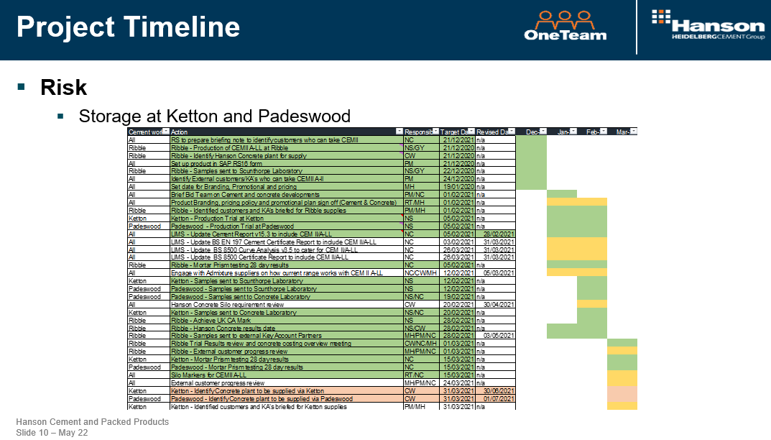
Figure 4 - Project timeline tracker example (CEM II Project Timeline, 2021)
The success of the project was measured by sales per KT of product, with targets set out for an incremental progression of sales as per below image.
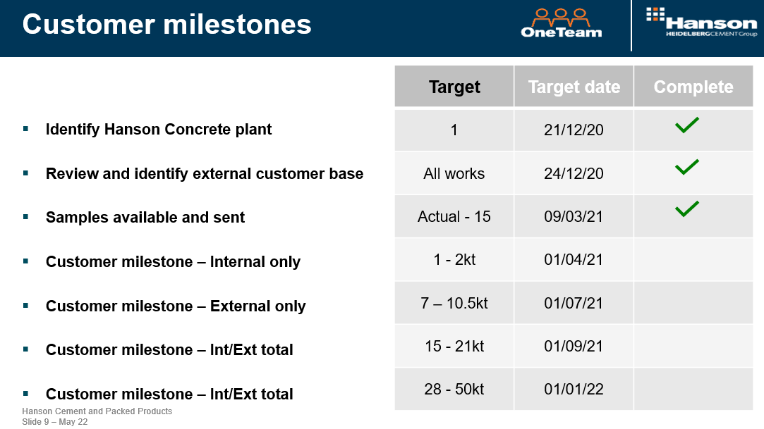
Figure 5 - Incremental sales target tracker (CEM II Project Timeline, 2021)

Extent to which this innovation process represents best practice
To review how this innovation process compares to what may be considered as best practice, lets first categorise key components of any innovation process and juxtapose Hanson UKs approach against them.

How well is the problem and domain defined?
As per (Satell, 2017), these are the two most important questions that must be asked at the start of any innovative idea. The reason for this is that the answers can give you a direction as to which innovation type you may find the most success, according to Satell’s Innovation Matrix.
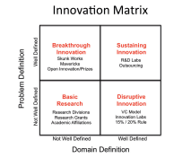
Figure 6 - Greg Satell's Innovation Matrix (Kadar, et al., 2014)
It is fair to say that the problem in question is both well defined (reduce CO2 in cement production) and resided within a domain that is also well defined (cement production). Therefore, one can suggest that the innovation problem falls within the “Sustaining Innovation” category. This suggestion is supported well by (Digital Tonto, 2017) who says the following about Sustaining Innovation:
“Most of the time, we’re trying to get better at what we’re already doing. We want to improve existing capabilities in existing markets, and we have a pretty clear idea of what problems need to be solved and what skill domains are required to solve them.”
The Sustaining Innovation category is synonymous with tools such as strategic road mapping and research and development teams. These are both prevalent in Hanson UK innovation process with a clear strategic outline being put forward by the technical and commercial departments, with both departments carrying out R&D tasks in the technical and commercial domains respectively.

Priorities for Innovation Policies
A paper by (Kadar, et al., 2014) highlights the main priorities for innovation policy as part of an innovation strategy as, these are listed below with comments aside relating to if and how these are applicable to the innovation process that has taken place at Hanson UK for the during the development of CEM II/A-LL:
- Empowering people to innovate: It is clear from the conversations held with Nina Cardinal and Nick Sharpe that they were given the power and freedom to pursue a solution to the problem of CO2 emissions in cement by the business. Not only were they supported theoretically, but they were also supported in the form of cash expenditure and time/resource commitments. This suggests that Hanson UK are aligned to best practice when it comes to empowering its people for them to be innovative.
- Unleashing innovations: As outlined in figures 4 and 5 of this document as soon as the product was deemed viable there was an unrelenting eagerness pushed forth by the commercial department to get the product in service and out to its customers.
- Creating and applying knowledge: This point is clearly demonstrated in the significant trials that took place in the CEMII/A-LL development where new knowledge on how effective griding aids were in cement production with increased limestone, with the knowledge then being applied successfully to a point where the product was produced at mass and sold to customers to be used in real world applications.
- Applying innovation to address global and social challenges: This innovation project is an excellent example of how innovative ideas can address, in this case, global challenges. The potential benefits of this product on CO2 emissions may have an enormous effect on the cement industry’s ability to align with its, and the respective global governments plant to be NetZero in carbon emissions by 2050.

The Three Horizon Framework (3H)
Featured in the 2009 publishing of The Alchemy of Growth (Baghai, et al., 2000), the Three Horizon Framework was a system that intended to provide companies with a structure that can assess potential opportunities for growth but without detriment to the current business performance. The three horizons were labelled as:
- The Core Business (Horizon 1)
- Adjacent Markets and Capabilities (Horizon 2)
- Long-Term Bets (Horizon 3)
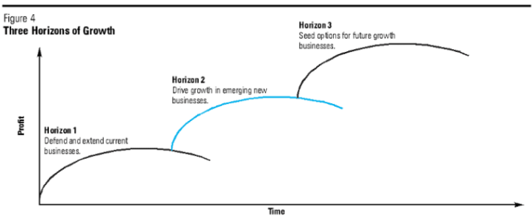
Figure 7 - Representation of The Three Horizon Framework (Investment Moats, 2018)
It was proposed that each horizon must be allocated resource not equally, but proportionately to risk and opportunity. The quote (Satell, 2017), “you invest the bulk of your resources in capabilities and markets you know well, a much smaller proportion to adjacencies, and an even smaller proportion to future opportunities that don’t even exist yet.”
From this logic surfaced the 70/20/10 rule, which meant that 70% of your resource should be dedicated to your Core Business, 20% to your Adjacent Markets and Capabilities and the remaining 10% on Long-Term bets.
The CEM II/A-LL development arguably sits on the boundary between Horizon 1 and 2 when you consider the previous illustration, as it satisfies the current core markets of the cement business whilst also looking to expand into more sustainable cement markets.

Conclusion
From conversations held with senior figures within Hanson UK in relation to this and other innovative projects that are ongoing on site, it is fair to conclude that there is no clear innovation strategy in place that is directly communicated to different teams and employees within the business. Nobody I spoke with were acutely aware of Satell’s Innovation Matrix, or The Three Horizon Framework for which much literature suggest must be implemented to successfully innovate. Despite this however, throughout the CEM II/A-LL development, and in other innovative ideas that are ongoing within the business such as the cement carbon capture initiatives, there is much evidence that all of them somehow adopt ideas from the strategies and models that have been mentioned in this report. From basic R&D to long term strategical planning in the form of limestone cement and CO2 capture, these tools for innovation are prevalent throughout the business and at all levels.
The CEM II/A-LL development started with clearly defined goals and ideas how to achieve them, with excellent cooperation and collaboration between team from the technical, commercial, and manufacturing sectors each leveraging their own expertise to achieve the end goal. This is a key determinant in the success of innovations and highlighted beautifully by (Satell, 2017) with the line, “Innovation, more than anything, is combination.”
The project was also managed well with regular meetings that outlined clear paths forward on how to maintain the progression of the innovation from concept to sellable product. Clear ownership was given so at each stage of the project which allowed for accountability to be held through the development.
The success of the development can be quantified by the CEM II/A-LL sales achieved to date against the original plan of 28-50KT by January 2022. The current sales data shows 5000T of sales per month, increasing, with anticipated year-end sales of 300KT of CEM II/A-LL. Inevitably however, Hanson UK want CEM II/A-LL to become its primary cement product and replace CEM I. To do this it needs to be responsible for 80% of Hanson UK cement sales which now stand at around 5 million tonnes. This will only be achieved however if the proposed changes to the concrete standard BS 8500 go ahead which will allow the sale of CEM II/A-LL in bulk by road tanker.
The excellent collaboration between not only the teams within Hanson UK, but the coming together of the competing organisations under the umbrella of the MPA to lobby for BS 8500 to be modified to include limestone cements, can be considered a huge success as it has set in motion a change on an industrial scale that may have a significant impact on global CO2 emissions and inevitably the problem that is climate change.

Bibliography
Baghai, M., Coley, S. & White, D., 2000. The Alchemy Of Growth: Practical Insights for Building the Enduring Enterprise. s.l.:Basic Books.
Britannica, 2022. Cement. [Online]
Available at: https://www.britannica.com/technology/cement-building-material/Extraction-and-processing
[Accessed 23 May 2022].
CEM II Project Timeline (2021) Hanson UK.
Chemical Engineering World, 2022. Chemical Engineering World. [Online]
Available at: https://chemicalengineeringworld.com/cement-manufacturing-process/
[Accessed 23 May 2022].
Digital Tonto, 2017. No Innovation Strategy fits every problem, so you need to work with a full toolbox, s.l.: Digital Tonto.
European Standards, 2021. BS Standards. [Online]
Available at: https://www.en-standard.eu/bs-en-197-5-2021-cement-portland-composite-cement-cem-ii-c-m-and-composite-cement-cem-vi/
[Accessed 25 May 2022].
Grinding aids for high performance cements (2022) MAPEI.
Hanson UK, 2021. Hanson UK Packed Products. [Online]
Available at: https://www.google.com/search?q=hanson+cement+production+volume&oq=hanson+cement+production+volume&aqs=edge..69i57j69i64.5764j0j1&sourceid=chrome&ie=UTF-8
[Accessed 26 May 2022].
Hanson UK, 2021. Padeswood Cement Plant - Grinding Aid Trial Data. Padeswood: Hanson UK.
HUB 4, 2022. Hub 4 News. [Online]
Available at: https://hub-4.com/news/government-backed-cement-research-sets-out-potential-to-cut-direct-co2-emissions-by-up-to-four-million-tonnes-a-year
[Accessed 16 May 2022].
Investment Moats, 2018. McKinsey's Three Horizons of Growth Business Framework Explained. [Online]
Available at: https://investmentmoats.com/uncategorized/mckinseys-three-horizons-of-growth-business-framework-explained/
[Accessed 26 May 2022].
Kadar, M., Moise, I. & Coloba, C., 2014. Innovation Management in the Global Digital Scoiety. Science Direct, Volume 143, pp. 1083-89.
Mineral Product Association, 2019. This is UK Concrete. [Online]
Available at: https://thisisukconcrete.co.uk/Perspectives/Innovation-cementing-a-more-sustainable-future.aspx
[Accessed 20 May 2022].
Satell, G., 2017. Mapping Innovation. New York: McGraw-Hill.
Statista, 2022. Carbon dioxide (CO2) emissions from the manufacture of cement in the United Kingdom (UK) from 1990 to 2019. [Online]
Available at: https://www.statista.com/statistics/485967/co2-emissions-from-the-manufacture-of-cement-uk/#:~:text=CO2%20emissions%20from%20cement%20manufacturing,Kingdom%20(UK)%201990%2D2019&text=The%20manufacture%20of%20cement%20in,have%20fallen%20by%2043%20percent.
[Accessed 22 May 2022].

Appendices
Appendix 1) Mapei Grinding Aid Information sheet


