Investigate and Critically Analyse Process Changes to Improve Data Collection from Explosive Cylinder Tests
Research Proposal
Alexander Dand - 1810440

Contents
Figures 3
1. Introduction 4
1.1 The Cylinder Test 4
2. Background to the Proposed Research 7
2.1 Cylinder Wall Motion 7
2.2 3-D Printing 8
2.3 Experiment Set-up 8
3. Aims & Objectives 10
3.1 Aim 10
3.2 Objectives 10
3.3 Expected Outcomes 10
4. Project Design 11
4.1 Outline of Potential Improvements 11
4.1.1 3D Printing Improvements 11
4.1.2 Tooling and Metrology Improvements 11
4.1.3 Laser Cutting Solution 11
4.2 Criteria for Improvements Evaluation 11
4.3 Risks & Limitations 11
6. Resources & Planning 13
6.1 Resources Required 13
6.1.1 Physical Resources 13
6.1.2 Human Resources 13
6.1.3 Other Resources 13
6.2 Gantt Chart [29] - With Public Link to chart - https://sharing.clickup.com/g/h/4-8930778-7/5b8eb1821a53a95 14
7. References 15

Figures
Figure 1 - Full Motion Experiment Cylinder test (PCB probes) [14] 4
Figure 2 - Wave Shape Experiment cylinder test configuration (HetV probes) [3] 5
Figure 3 - Example of the detonation angle effect as a result of detonation from one end of a cylinder of explosives [17] 6
Figure 4 - Detonation Wave Propagation in Hydrodynamic Theory [18] 7
Figure 5 - Overview image of the Technical Drawing of the Probe Holder 8

1. Introduction

1.1 The Cylinder Test
The Cylinder Test (CT) is a tried and tested experiment used in the field of Explosives research and is used to assess performance of formulations [1] [2]. The test consists of a cylinder of High Explosives (HE) enclosed in a metal case and detonated at one end. Upon detonation, the expansion of the detonation products produces movement of the case, which is then measured using various diagnostic techniques [3] [4] [5]. Historically, the techniques included time-of-arrival probe boards [6], but has moved on to Heterodyne Velocimetry (HetV, UK), or Photonic Doppler Velocimetry (PDV, USA) [7] [8]. Whilst the measurement of direct radial expansion is easier with PCB probes as it is a direct measurement, however the measurements are made at discrete points. With HetV, the data measured is continuous and therefore shows a more complete picture in real time. The purpose of these tests is to generate an equation of state (EoS) for the detonation products that is unique to the formulation [9] [10]. When combined with hydrocode calculations [11] [12], analysing the steady-state expansion of the case will grant constants to satisfy the Jones-Wilkins-Lee (JWL) EoS equation [13].
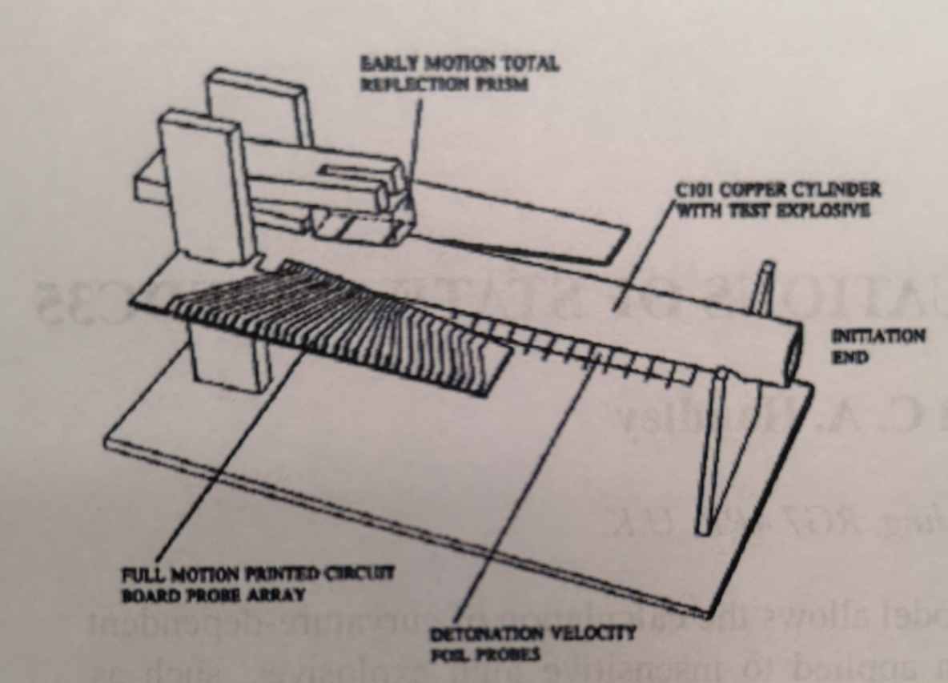
Figure 1 - Full Motion Experiment Cylinder test (PCB probes) [14]
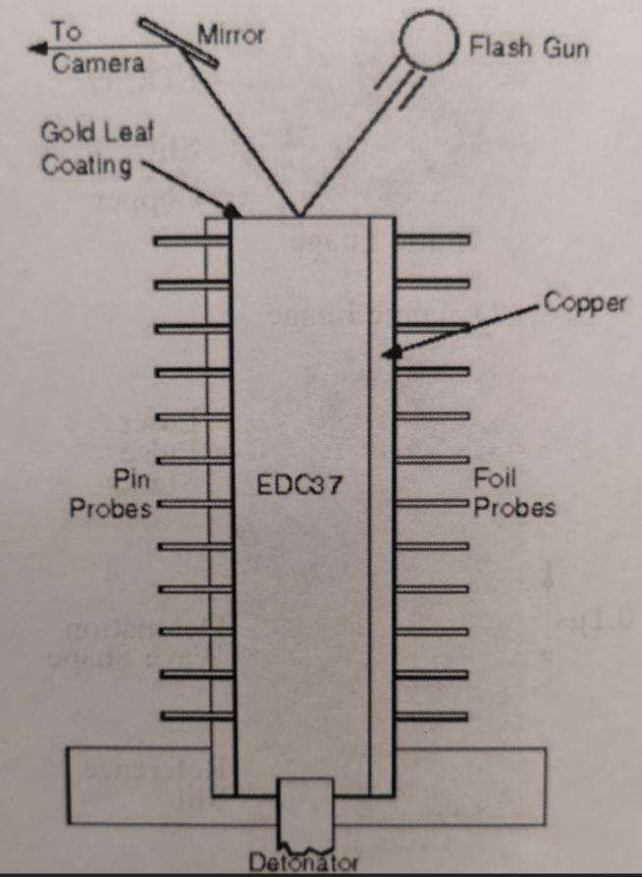
Figure 2 - Wave Shape Experiment cylinder test configuration (HetV probes) [3]
Currently, the experiment is held static on a 3D printed rapid prototyped polycarbonate frame, with probes set into the frame. Some labs perform CTs using probes set to normal (90°), but the current standard for AWE is to set 3 probes at 20˚, 30˚ and 40˚ angles in order to account for the angle of incidence of a particle of copper case travelling as a result of the detonation travelling from one end of the CT as shown in Figure 3. This known angle of incidence is approximately 15°, and the various probe angles can be used to calculate multiple one-dimensional measurements (proportional velocity, depending on the angle of the probe), and from those calculate a hypotenuse to create a two-dimensional measurement (expansion of the copper wall) [15]. Due to the speed of the experiment, it is incredibly important to know exactly what angle the probes are held at in order to take into account the proportion of velocity measured by what angle the case expansion hits at. This requires a high degree of metrology accuracy, and the also the angle that they are fixed at [16]. This in order to take these factors into account and accurately calculate the velocity and behaviour of the detonation products to properly characterise the HE performance.
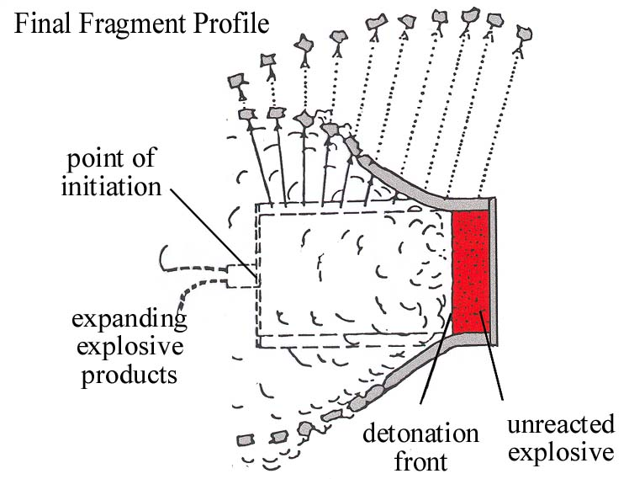
Figure 3 - Example of the detonation angle effect as a result of detonation from one end of a cylinder of explosives [17]
Currently the angled probes are nominally set (see Figure 5) at 20˚and 30˚ and 40˚ with a tolerance of ±0.3˚. As the angular velocity of the detonation is only approximately 5˚, a potential variance of 0.6˚ is quite a large proportion. The probes set normal to the CT copper wall have a positional tolerance of ±0.5mm. These tolerances are due to a number of factors:
- The accuracy of the 3D printing equipment
- Guide holes are formed as part of the 3D printing process, and are manually drilled to size as part of the experiment set-up
- The measurement of the angle of the probes is measured by using laser measurement for the hypotenuse, and a ruler to measure the opposite of the triangle

As such, the purpose of this study is to attempt to optimise this experiment, where the probe head positional tolerances can be more accurately stated in order to provide more consistent and repeatable data.

2. Background to the Proposed Research

2.1 Cylinder Wall Motion
- Once the detonation wave passes, the detonation products expand and push the cylinder wall outwards.
- If it were possible for all of the HE to detonate simultaneously, the wall would expand exactly radially outwards, but in reality, it expands at a small angle to the wall normal. This is due to the lateral motion of the detonation wave, i.e. because the detonation wave is travelling along the axis.
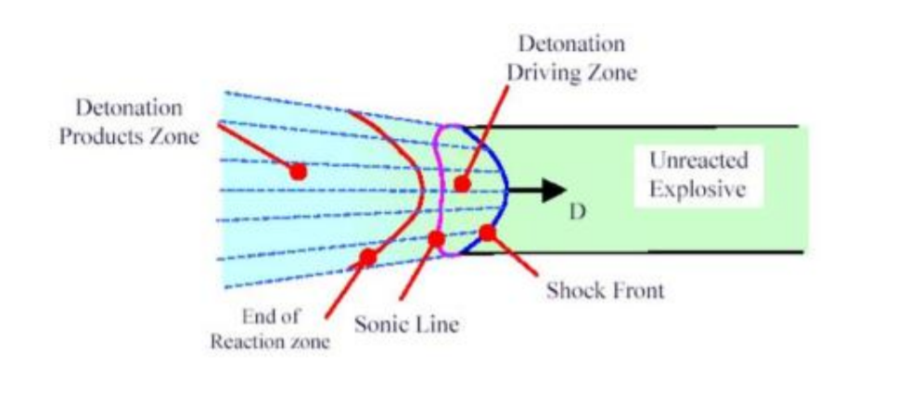
Figure 4 - Detonation Wave Propagation in Hydrodynamic Theory [18]
- Due to the copper case, this angle is exacerbated by the change in velocity of the detonation products at the boundary of the HE and case. Much like the refraction of a light beam, a change in density of material that a detonation is travelling through cause the particles involved to change velocity and therefore angle of travel [9]. The new angle of travel can be calculated depending on the thickness of the case [19] [20].

2.2 3-D Printing
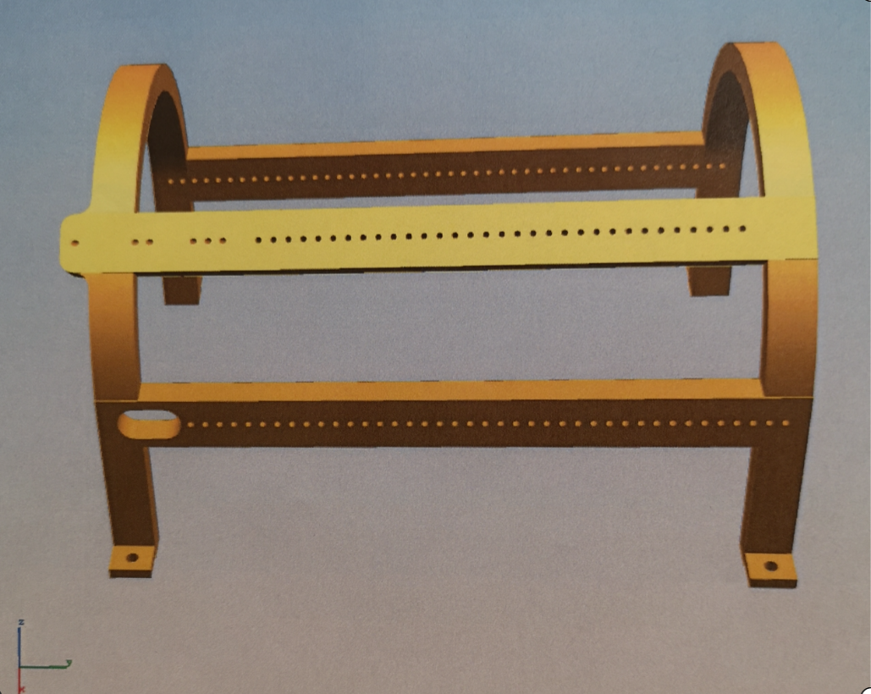
Direction of detonation
Angled probe guides
Figure 5 - Overview image of the Technical Drawing of the Probe Holder
As with all manufacturing and engineering techniques, 3D printing possesses some margin of error at the point of manufacture, with varying degrees of acceptability. As previously stated, the model is printed from polycarbonate, but other materials are possible to use, such as metals (steel, aluminium, copper), or other composite plastics [21]. Accuracy of printing can be affected by multiple factors, such as maintenance of the equipment, material selection, shrinkage, warping, size of printed object, effects of post-processing or even just the underlying quality of the equipment [22] [23] [24] [25]. These factors should be investigated in order to assess where improvements can be made, and also if the polycarbonate is the best material for the job. Any potential improvements should also take into account material properties.
Another consideration should be the method of 3D printing. The current method is that of Fused Deposition Modeling, with a tolerance of ±0.2mm, however Stereolithography printing has a lower limit of ±0.01mm [22]. There are pros and cons to the various methods, but these will be considered fully in the study.

2.3 Experiment Set-up
A further consideration to be made for this project will be that of the set-up process. As part of the set-up, the probe guides are manually drilled out by the Trial Technician, which is most likely why the positional tolerance is quoted as ±0.5mm rather than the 0.2mm stated by the manufacturing method specification. If a method was devised to improve this process (laser-cutting, for example, has a tolerance down to 15µm), the tolerance would be reduced, however some methods may not be suitable (laser cutting may be prohibitively expensive, or the heat of the laser may warp the plastic frame).
The other aspect of experimental set-up with a possible improvement is that of measuring the actual angle the probes sit at after set-up. Should the tolerances be suitably reduced with previously discussed improvements, and the probe heads are consistently where they are expected to be, this would be less important however should it be proved that the probe location uncertainty cannot be reduced sufficiently, the metrology required to measure accurately what angle the probes sit at will be essential [26]. Currently part of the measurement solution involves a ruler, which suggests there is most likely a more precise measurement option available.
One thing that must be noted at the point of set-up, is that whilst the angle of the probe needs to be known to a high degree of accuracy, the distance from the CT to the probe head is not as important. Whilst some consideration must be made for this as if the probe is too close, the probe will be destroyed before it has had the chance to obtain the required data, but the window of utility is very easily hit by manual set up so this parameter will not be investigated as a part of this study.

3. Aims & Objectives

3.1 Aim
The aim of the project is to obtain a method of more accurately positioning HetV probes within a Cylinder Test in order to gather better or more accurate data from said tests. [29]

3.2 Objectives
The objectives are:
- Investigate the 3-D modelling process of the CT bracket with regard to enhancing repeatability of probe positioning.
- Investigate and implement process and tooling improvements for the same.
- Investigate and devise improvements to the current method of measuring the probe angles after experiment set-up.
- Test and evaluate improvements with a view to future research.

3.3 Expected Outcomes
One expected outcome of this project will be a more robust experimental process for the CT series of experiments. Should the research and application of such be successful, this will result in a CT bracket design that allows for more repeatable positioning of the HetV probes, for a more consistent data set from each experiment. There will be a more efficient set-up process for the experiment, and a more comprehensive analysis of the performance of the HE detonation products. As various formulations of HE perform differently, it will form the basis for analysing optimised probe angles for the different formulations, and the measurements of such.
It will also grant information required for future work for the purposes of continuous improvement activities, as technology in manufacturing, experimental process and measurement, and knowledge capture improves.

4. Project Design

4.1 Outline of Potential Improvements

4.1.1 3D Printing Improvements
The proposal is to analyse the currently employed 3D Printing process by interrogating the specifications of the equipment, and the program used to create the frame. The regular maintenance and inspection of printer components can affect accuracy [23], as can the material used in the printing process. Another consideration could be replacing the printer for a higher spec model or replacing the printing technique with a more intrinsically accurate process.

4.1.2 Tooling and Metrology Improvements
The main focus of this project is to ensure the repeatability of the probe angle positioning. A way of physically ensuring this would be to manufacture a standard set of jigs that the probe bracket could be set static on. Once set, a calibrated to vertical pillar drill could be used to ensure that the same path of the drill was followed every time which would reduce the uncertainty brought in by hand drilling. This method could be used for all probe guide holes which would tighten both positional and angular tolerances.
There are many precision metrology techniques used in engineering, and available within the company. A meeting with an experienced Quality representative would ensure further solutions could be considered. As previously stated, this step would perhaps not be required if a solution could be found to ensure repeatability of the angular positioning of the guide holes.

4.1.3 Laser Cutting Solution
Another potential avenue of research could be that of Laser Cutting the probe guides. A previous study by the author included a discussion with an SME for laser cutting on site [27], who advised the laser cutter he used was accurate to 10-20µm. However, it would need to be investigated whether the heat from the laser would warp the frame during this process before any serious research goes into this option.

4.2 Criteria for Improvements Evaluation
The evaluation of these improvements can be done without the need of explosives. Any change to the 3D Print process can be proved out by manufacturing multiple brackets, feeding probes (or probe simulants) into the bracket and measuring the position of them. Should the variance be reduced across a good representative sample, it can be deemed a success and used in live experiments. The jig solution can be checked in the same way, by trialling the solution across multiple brackets and measuring the probe positions.

4.3 Risks & Limitations
The first and foremost consideration with regard to risk in an explosive process is safety. The principles of ALARP (As Low As Reasonably Practicable) apply when considering workplace risk [28], and as such, any activities should be covered by a suitable and sufficient Risk Assessment. Any work not required to be done in the presence of explosives should not be done in the presence of explosives, and any supplemental activities (set-up, etc.) should take safety into account. This has the potential to limit efficiency, materials or tooling used, and any activities during the experiment.
Time is another consideration as a risk. Due to the precision nature of this work, any design and manufacturing process will take time, and due diligence takes resource. Also, big companies are not known for their brevity, and work of this kind will necessarily have multiple stakeholders, all needing to review documentation and design before any improvements are implemented.
Availability should be considered, both in the raw materials and equipment required for any manufacture, and in knowledge. Are there sufficiently trained and knowledgeable people to consult? Are they available or are they busy on other priorities? These questions should be answered before proceeding with any work.
Cost is another factor that will need to be looked at. There will need to be a cost/benefit analysis done on any improvement to ask the question ‘Is it worth it?’ The company will expect the benefits of obtaining this knowledge should give benefits in turn, be they in pure profit, technological advancement, or an increase in safety.

6. Resources & Planning

6.1 Resources Required
Until a full consultation with relevant SMEs (Subject Matter Experts) has taken place, the precise list of resources will not be finalised. However, some resources can be listed as required before initial consultation as follows, but it will not be exhaustive:

6.1.1 Physical Resources
- 3D printer/printing material
- Tooling raw material
- Machining plant (calibrated pillar drill or similar)
- Metrology equipment
- CT Assembly (including HE and detonator)
- Probes/diagnostic setup

6.1.2 Human Resources
- Trials technician team
- Quality technician
- Firing officer/Trials Conducting Officer (TCO
- Clean up team
- Tooling engineer
- 3D Print operator/programmer

6.1.3 Other Resources
- Facilities suitable for manufacture/set up/firing
- Tooling Design software
- 3D Print Design software

6.2 Gantt Chart [29] - With Public Link to chart - https://sharing.clickup.com/g/h/4-8930778-7/5b8eb1821a53a95
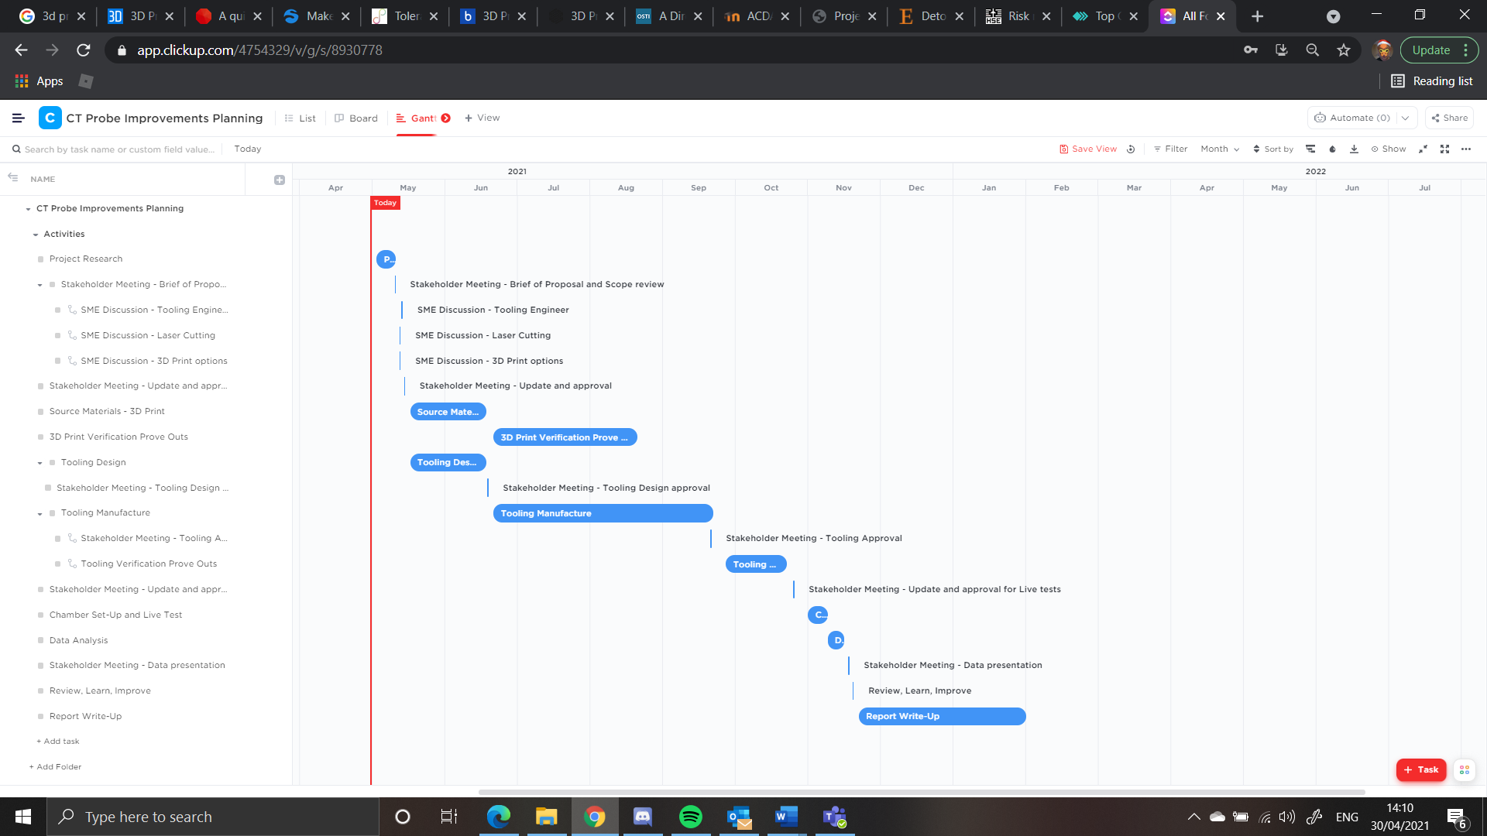

7.

References

[1] | M. A. Zocher and T. D. Aslam, “Modeling a High Explosive Cylinder Experiment,” in AIP Conference Proceedings 1979, 030008, Los Alamos, 2018.
[2] | W. Trzciński, “Application of a cylinder test for determining energetic characteristics of explosives,” Journal of Technical Physics, vol. 42, no. 2, pp. 165-179, 2001.
[3] | P. Merchant, S. White and A. Collyer, “A WBL-Consistent JWL Equation of State for the HMX-Based Explosive EDC37 from Cylinder Tests,” AWE - British Crown Copyright, Reading, 2002.
[4] | M. Suceska, Test Methods for Explosives, Zagreb: Springer, 1995.
[5] | M. A. Cook, The Science of High Explosives, New York: Reinhold Publishing Corporation, 1958.
[6] | W. A. Bailey, R. A. Belcher, D. K. Chilvers and G. Eden, “Explosive Equation of State Determination by the AWRE Method,” AWRE - Copyright Controller HMSO, London, 1981.
[7] | P. Mercier, J. Bénier, P. A. Frugier, G. Contencin, J. Veaux, S. Lauriot-Basseuil and D. M., “Heterodyne velocimetry and detonics experiments,” in SPIE 7126, 28th International Congress on High-Speed Imaging and Photonics, Canberra, 2009.
[8] | D. H. Dolan, “Extreme measurements with Photonic Doppler Velocimetry (PDV),” Review of Scientific Instruments, vol. 91, no. 5, 2020.
[9] | W. Fickett and W. C. Davis, Detonation, Los Angeles: University of California Press, 1979.
[10] | G. I. Kerley, “Prediction of Explosive Cylinder Tests Using Equations of State from the PANDA Code,” Sandia National Laboratories, Albuquerque, 1993.
[11] | G. S. Collins, “An Introduction to Hydrocode Modelling,” Arizona, 2002.
[12] | C. E. Anderson Jr., “An overview of the theory of hydrocodes,” International Journal of Impact Engineering, vol. 5, no. 1-4, pp. 33-59, 1987.
[13] | R. Menikoff, “JWL Equation of State,” Los Alamos National Laboratory, Los Alamos, 2016.
[14] | A. N. Hodgson and C. A. Handley, “DSD/WBL-Consistent JWL Equations of State for EDC35,” in American Institute of Physics 1426, 2011.
[15] | A. N. Hodgson, J. W. Ferguson and B. D. Sutton, “Reconstruction of Cylinder Test Wall Expansion from Velocimetry Data,” British Crown Copyright - AWE, Reading, 2015.
[16] | S. Jackson, “The Detonation Cylinder Test: Determination of Full Wall Velocity and Shape from a Single Velocimetry Probe with an Arbitrary Angle,” in American Institue of Physics 1793, 2015.
[17] | N. Davies, OME Explosive Munitions Lecture, Swansea: UWTSD, 2019.
[18] | E. Topkaraoğlu, “DESIGN AND DEVELOPMENT OF A CYLINDER EXPANSION TEST SETUP FOR DETERMINATION OF EQUATION OF STATE PARAMETERS OF VARIOUS EXPLOSIVES,” Topkaraoğlu, Emir, Ankara, 2014.
[19] | J. E. Kennedy, “Gurney Energy of Explosives: Estimation of the Velocity and Impulse Inparted to Driven Metal,” Sandia Laboratories, Albuquerque, 1970.
[20] | E. K. Anderson, M. Short and S. I. Jackson, “Cylinder test wall velocity profiles and product energy for an ammonium nitrate and aluminum explosive,” in AIP Conference Proceedings 1793 030018, 2017.
[21] | Markforged, “3D Printing Materials,” Markforged, [Online]. Available: https://markforged.com/materials/?utm_source=google&utm_medium=cpc&utm_campaign=12762815233&utm_content=126589449048&utm_term=3d%20print%20material&gclid=CjwKCAjwj6SEBhAOEiwAvFRuKDSjcAnAMx85k8anvxNvh2kDLhgAxCjZv2hql0vuk-N__sZcXT7K5BoCxTcQAvD_BwE. [Accessed 28 04 2021].
[22] | M. Nutma, “A quick guide to dimensional accuracy for 3D printing,” 3D Printing Media Network, 04 09 2019. [Online]. Available: https://www.3dprintingmedia.network/quick-guide-dimensional-accuracy-3d-printing/. [Accessed 28 04 2021].
[23] | ALL3DP, “3D PRINTER TOLERANCES: HOW TO TEST AND IMPROVE THEM,” ALL3DP, [Online]. Available: https://all3dp.com/2/3d-printer-tolerance-test-and-improve-your-3d-printer-s-tolerances/. [Accessed 28 04 2021].
[24] | 3D Learning Hub, “3D printing tolerances: All you need to know about the Accuracy of Additive Manufacturing,” Sculpteo, [Online]. Available: https://www.sculpteo.com/en/3d-learning-hub/design-guidelines/3d-printing-tolerances/. [Accessed 28 04 2021].
[25] | 3D People, “Tolerance and Accuracy,” 3D People, [Online]. Available: https://www.3dpeople.uk/tolerance-accuracy. [Accessed 28 04 2021].
[26] | C. R. Johnson, J. P. Borg and C. S. Alexander, “A Direct Comparison of Transverse Velocimetry Techniques Using Photon Doppler Velocimetry (PDV) in Oblique Impact Experiments,” Sandia National Laboratories, Albuquerque, 2019.
[27] | A. M. Dand, “Development and Evaluation of a Test, Trial, Project using Systems Engineering Approaches - The Problem with 'Wonky' SD4s,” UWTSD, Reading, 2020.
[28] | HM Government, “Health and Saftey at Work Act 1974,” HM Government, London, 1974.
[29] | ClickUp, “ClickUp - One App to Replace Them All,” ClickUp, [Online]. Available: https://app.clickup.com/4754329/v/l/li/57236387. [Accessed 30 04 2021].

