ACADEMIC DISCIPLINE OF HOSPITALITY AND TOURISM MANAGEMENT

MODULE HANDBOOK WINTER TERM 2024

BMIH4006
Table of Contents
Component one: Learning Log 3
Component two: Assessment of practical task Scenario 7
Importance of health and safety factors in the hotel industry 7
Relevance of the housekeeping department in the hotel sectors 7
Challenges and regulations associated with the housekeeping departments 7
Precautions taken to prevent accidents and injuries 8
Equipment and tools that should be used by the staff during room cleaning 8
Essential procedures for cleaning the rooms incorporated as safety measures 9
Component three: Presentation 10
Introduction 10
Current trends in the hotel industry 10
The importance of health and safety in the hotel industry 10
Challenges the housekeeping staff faces facing maintaining safety procedures 11
Importance of training and development for the housekeeping department 11
Different types of training are given to the housekeeping staff 11
Different types of training are given to the housekeeping staff (cont.) 12
Essential precautions required for the staff 12
Elements that need to be implemented in the housekeeping safety training 12
Conclusion 13
References 14

Component one: Learning Log
In this section of the study, my reflective journey regarding my placement experiences will be going to be represented through Gibb’s reflective model. This section will explain all of my experiences and evaluations during my working experiences. Gibb’s Reflective Model consists of six different stages which help to explain different analyses (Adeani et al., 2020).
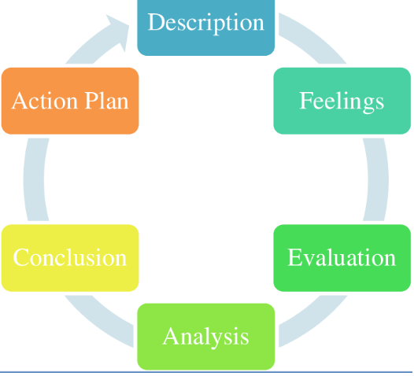
Figure 1: Gibb’s Reflective Model
(Source: Adeani et al., 2020)
Description
During my learning time at the University, I have tried to focus more on practical knowledge to enhance my career advancement opportunities in professional life and this has helped me with my placement process at Ashford International Hotel in the housekeeping department. Soft and practical skills are essential parts of this department because the staff need to always work in practical fields and may face sudden complexities while managing all the activities (Raghubalan and Raghubalan, 2016). Some of my inherited skills have helped to get advantages compared to other job aspirants and helped me to acquire this position. During my training process, I tried to follow the instructions of my supervisor to understand the roles and responsibilities of my position at my workplace which guided me to get accustomed to my surroundings and my co-workers.
Feelings
The chance I got to work at Ashford International was a great opportunity for me. I have always had a passion for working in the housekeeping department of a renowned hotel and serving customers effectively. I have gathered a lot of knowledge about tourism management and hospitality management. This knowledge and skills have helped me a lot to work efficiently in the workplace. After the placement, I was a little bit nervous at first, but later, when I applied my skills and strengths I succeeded in ensuring the growth of my career. The experience of working in this particular hotel has helped me a lot to become more confident and gather the skills to adapt to new situations and manage the situations very successfully.
Evaluation
Maintaining health and safety in the housekeeping department of a hotel helps to avoid hazards and challenges. Several staff and visitors come from different cultural and religious backgrounds and in this situation, my strong communication skills have helped me to communicate with the staff very effectively. However, I realised that some challenges occurred in the group and due to the lack of problem-solving skills, I faced some difficulties in mitigating the issues. Without my problem-solving ability, I would never be able to make effective decisions for the company. Moreover, my leadership skills and team-building skills have helped me to build a positive relationship with the other members and staff. And lastly for the overall development of problem-solving and decision-making skills, firstly the enhancement of critical thinking or logical thinking ability is highly essential.
Analysis
I have identified from my supervisor that leadership means not only building a team and guiding them but also a proper leadership style that can influence the team members easily. During my placement time in the housekeeping department, my supervisor gave me the responsibility to lead a group of ground staff during the safety and hygiene training process. I have applied the principles of the transformational leadership style to guide the employees and motivate them towards the common vision and this has guided me to make effective collaboration and communication with the team members and achieve the purpose of my activities. As per the theory, leaders who achieve empathy, trust, genuineness and risk resolution power can achieve success in their roles (Bush, 2018). This was a great experience and lesson learning for me which can help me to be a leader in my professional life in the hotel industry.
Conclusion
The working experience has helped me to identify the areas that I have to enhance for determining future growth and development. Those areas and skills are problem-solving skills, decision-making skills and critical thinking skills. These skills are highly essential for housekeeping staff and also for a successful manager. Adapting some procedures and training programs can help me to improve these skills in future.
Action plan
Objectives | Improvement Way | Analysis | Time Bound
To revamp my problem-solving | I will try to understand the depth and reason behind the issues which will help me to develop specific and effective solutions for the problems and will improve my ability in this section. | By acquiring this skill, the employees in this department can handle difficult situations and avoid the risk of delaying issues (Mullins and Dossor, 2013). | 3 months
To improve my Interpersonal Skills | I will try to approach other people with an assertive and friendly approach and will try to give value to others which will help me with this process. | The employees of the housekeeping department directly communicate with the clients and this skill helps them with their interaction process and satisfies the clients through their friendly and personalised services (Leiter and Bakker, 2010). | 3 months
To enhance my critical thinking skills | To enhance this skill, I will try to improve my active listening and formulate questions after gathering information will help me to reduce my knowledge gap and will help me to explore my points of view. | Critical thinking helps the staff to develop step-by-step procedures from targeting the issues to developing solutions (Kleinig, 2020). | 4 months
Table 1: Action Plan
(Source: Self-creation)

Component two: Assessment of practical task Scenario
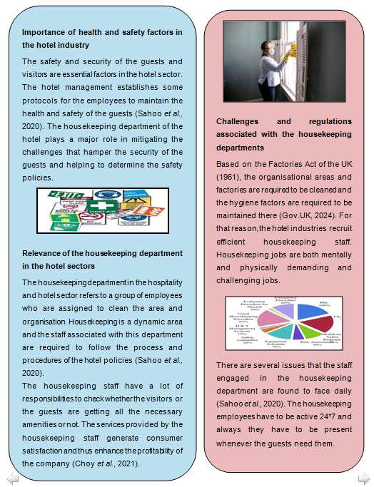
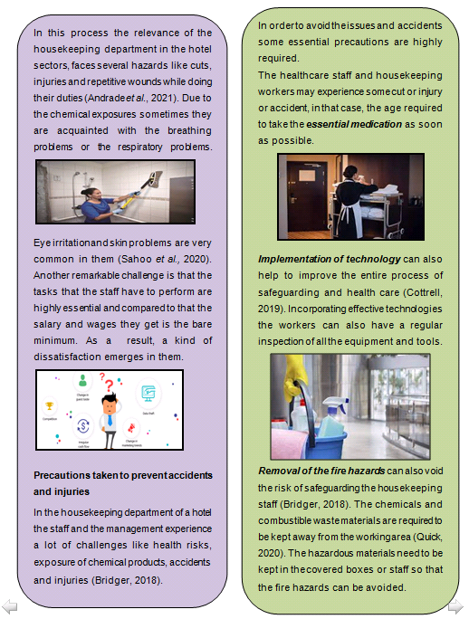
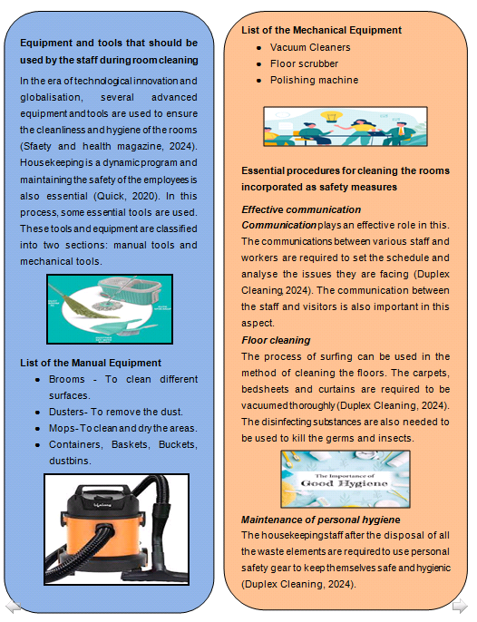

Importance of health and safety factors in the hotel industry
The safety and security of the guests and visitors are essential factors in the hotel sector. The hotel management establishes some protocols for the employees to maintain the health and safety of the guests (Sahoo et al., 2020). The housekeeping department of the hotel plays a major role in mitigating the challenges that hamper the security of the guests and helping to determine the safety policies.

Relevance of the housekeeping department in the hotel sectors
The housekeeping department in the hospitality and hotel sector refers to a group of employees who are assigned to clean the area and organisation. Housekeeping is a dynamic area and the staff associated with this department are required to follow the process and procedures of the hotel policies (Sahoo et al., 2020). The housekeeping staff have a lot of responsibilities to check whether the visitors or the guests are getting all the necessary amenities or not. The services provided by the housekeeping staff generate consumer satisfaction and thus enhance the profitability of the company (Choy et al., 2021).

Challenges and regulations associated with the housekeeping departments
Based on the Factories Act of the UK (1961), the organisational areas and factories are required to be cleaned and the hygiene factors are required to be maintained there (Gov.UK, 2024). For that reason, the hotel industries recruit efficient housekeeping staff. Housekeeping jobs are both mentally and physically demanding and challenging jobs. There are several issues that the staff engaged in the housekeeping department are found to face daily (Sahoo et al., 2020). The housekeeping employees have to be active 24*7 and always they have to be present whenever the guests need them. In this process the relevance of the housekeeping department in the hotel sectors, faces several hazards like cuts, injuries and repetitive wounds while doing their duties (Andrade et al., 2021). Due to the chemical exposures sometimes they are acquainted with the breathing problems or the respiratory problems. Eye irritation and skin problems are very common in them (Sahoo et al., 2020). Another remarkable challenge is that the tasks that the staff have to perform are highly essential and compared to that the salary and wages they get is the bare minimum. As a result, a kind of dissatisfaction emerges in them.

Precautions taken to prevent accidents and injuries
In the housekeeping department of a hotel the staff and the management experience a lot of challenges like health risks, exposure of chemical products, accidents and injuries (Bridger, 2018). In order to avoid the issues and accidents some essential precautions are highly required.
The healthcare staff and housekeeping workers may experience some cut or injury or accident, in that case, the age required to take the essential medication as soon as possible.
Implementation of technology can also help to improve the entire process of safeguarding and health care (Cottrell, 2019). Incorporating effective technologies the workers can also have a regular inspection of all the equipment and tools.
Removal of the fire hazards can also void the risk of safeguarding the housekeeping staff (Bridger, 2018). The chemicals and combustible waste materials are required to be kept away from the working area (Quick, 2020). The hazardous materials need to be kept in the covered boxes or staff so that the fire hazards can be avoided.

Equipment and tools that should be used by the staff during room cleaning
In the era of technological innovation and globalisation, several advanced equipment and tools are used to ensure the cleanliness and hygiene of the rooms (Sfaety and health magazine, 2024). Housekeeping is a dynamic program and maintaining the safety of the employees is also essential (Quick, 2020). In this process, some essential tools are used. These tools and equipment are classified into two sections: manual tools and mechanical tools.
List of the Manual Equipment
- Brooms - To clean different surfaces.
- Dusters- To remove the dust.
- Mops- To clean and dry the areas.
- Containers, Baskets, Buckets, dustbins.
List of the Mechanical Equipment
- Vacuum Cleaners
- Floor scrubber
- Polishing machine

Essential procedures for cleaning the rooms incorporated as safety measures
Effective communication
Communication plays an effective role in this. The communications between various staff and workers are required to set the schedule and analyse the issues they are facing (Duplex Cleaning, 2024). The communication between the staff and visitors is also important in this aspect.
Floor cleaning
The process of surfing can be used in the method of cleaning the floors. The carpets, bedsheets and curtains are required to be vacuumed thoroughly (Duplex Cleaning, 2024). The disinfecting substances are also needed to be used to kill the germs and insects.
Maintenance of personal hygiene
The housekeeping staff after the disposal of all the waste elements are required to use personal safety gear to keep themselves safe and hygienic (Duplex Cleaning, 2024).

Component three: Presentation

Introduction
The health and safety policy helps set out common approaches to protect the general rules of well-being and safety and this guides the employers to manage health and safety within the business operation possess (Hu et al., 2021). In the case of the housekeeping department, this policy helps to define the activities which need to be considered to maintain a safe working environment and reduce workplace hazards.

Current trends in the hotel industry
- The hospitality industry can become vulnerable due to internal and external factors due to health threats
- The rise of touch less amenities to reduce physical contact points (Hospitality Insights, 2024)
- Healthcare services for the visiting guests
- Health and safety measurement guidance for redefining the safety standards and ensuring the well-being of the guests (The Economic Times, 2021)
After the pandemic, the hotel industry is prioritising safety measures to avoid the threats related to this matter and the implementation of these additional steps helps to guide the housekeeping segment to maintain comprehensive health and safety measurements beyond predicted expectations.

The importance of health and safety in the hotel industry
- Health and safety practices help in avoiding the possibility of risky events (Goh and Lee, 2018)
- The housekeeping department tries to follow these guidelines to avoid the risks of hazards such as fire, falls, use of toxic chemicals
- The safety protocols guide the housekeepers to ensure a safe environment and practices within the department.
The safety protocols and best practices guide the employees in handling chemicals during cleaning purposes, and material handling and assist them in avoiding complexities and maintaining the well-being of themselves and others.

Challenges the housekeeping staff faces facing maintaining safety procedures
- High expectations from guests and hotels are putting additional workloads on the employees
- They have to face the daily hurdles and maintain the safety practices leading to increased safety and well-being risks among them
- Lack of proper guidance and support to stay aligned with the current trends in the hotel sector
The staffs in the housekeeping section needs to handle the expectations of the customers and employers and unrealistic expectations increase the workload on them leading to well-being risks. Lack of training also made the situation difficult for them.

Importance of training and development for the housekeeping department
- Training programme improves the ability of the members to perform their roles in proper time and guidance
- Helps in improving practical knowledge and improves their performance of customer satisfaction (Khalimova, 2020)
- Effective training programme in health and safety elements guides the employees to cultivate a culture of a safe environment
The training and development process empowers the employees and guides them in their skills development process improves the motivation of the employees to keep up the good work at their workplace and improves their mental well-being.

Different types of training are given to the housekeeping staff
- The manager can utilise the Standard Operating Procedures (SOP) framework for training staff housekeeping (Sari et al., 2020)
- The use of this training framework helps in cleanliness and orderliness and helps in maintaining a concrete experience for customers
SOP is an effective training method for new hires in the hotel sector because this allows them to learn quickly the necessary tasks activities and guidelines related to safety and health issues.

Different types of training are given to the housekeeping staff (cont.)
- Health and safety training helps in maintaining the best practices and well-being paramount at the workplace (Rosemberg, 2020)
- This training enhances the knowledge of hazardous handling knowledge and helps in preventing common injury issues.
This training strategy guides the staff in handling chemicals and using personal programme equipment (PPE) which is very important for protecting the health conditions of the members during handling the cleaning activities.

Essential precautions required for the staff
- Use of the PPE kit helps in managing the health and safety measurement of staff
- Removing various fire hazardous substances helps to avoid the risk of emerging risks (Link, 2019)
- Implementing technology for the communication process helps to monitor regular inspection
The housekeepers are facing issues due to communication, health risks, accidents and injuries and the implementation of these strategies will help to avoid risks.

Elements that need to be implemented in the housekeeping safety training
- Cleaning skills are a basic part of the responsibilities of housekeeping members and help in creating common ground
- Demonstrating the proper method of using equipment and other cleaning materials (Mejia et al., 2021)
- Understanding the proper guest etiquette and interaction process to satisfy guests
- Implementation of the fire and safety protocols to make them informed regarding the situation
The training programme for the workers of this department needs to cover a broader area and prospects to ensure the continuity of the process and confidence among the employees. Cleaning skills are the common ground practice of housekeeping members and implementation of this process can help in evolving the working procedures of members and employees can apply this during their activities. In addition, the use of proper equipment knowledge can reduce the workload pressures and maintain the quality of performance of the employees. Guest interaction process helps them to stay engaged with them and deliver effective services. Safety and Fire Protocol can be implemented in a more fun and interactive way to keep the employees regularly updated and refreshed.

Conclusion
This section of the study has helped to explain the current trends of housekeeping departments in the hotel industry regarding safety issues and the importance of following these trends to avoid the risks of emerging issues. Moreover, the basic elements that need to be incorporated into the training programme have also been analysed.

References
Component 1
Adeani, I.S., Febriani, R.B. and Syafryadin, S., (2020). Using GIBBS’reflective cycle in making reflections of literary analysis. Indonesian EFL Journal, 6(2), pp.139-148.
Bush, T., (2018). Transformational leadership: Exploring common conceptions. Educational Management Administration & Leadership, 46(6), pp.883-887.
Kleinig, J., (2020). Trust and critical thinking. In Trust and Schooling (pp. 15-25). Routledge.
Leiter, M. P. and Bakker, A. B. (2010) Work Engagement : A Handbook of Essential Theory and Research. Hove [England]: Psychology Press.
Mullins, L. and Dossor, P. (2013) Hospitality Management and Organisational Behaviour. 5th ed. Harlow: Pearson.
Raghubalan, G. and Raghubalan, S. (2016) Hotel Housekeeping - Operations And Management. 3rd ed. India: Oxford University Press.
Component 2
Andrade, M.S., Miller, D. and Westover, J.H., (2021). Job satisfaction factors for housekeepers in the hotel industry: a global comparative analysis. International Hospitality Review, 35(1), pp.90-108.
Bridger, E. (2018) Employee engagement: a practical introduction. 2nd ed. HR Fundamentals. London: CIPD and Kogan Page.
Choy, M., Cheng, J. and Yu, K., (2021). Evaluating the environmental sustainability strategies of the housekeeping department: the case of an international hotel chain in Hong Kong, China. Tourism Critiques: Practice and Theory, 2(1), pp.115-132.
Cottrell, S. (2019) The Study Skills Handbook. 5th ed. London: Red Globe Press.
Duplex Cleaning, (2024). Tips for effective cleanliness [Online] Available at:<https://www.safetyandhealthmagazine.com/articles/12470-tips-for-effective-workplace-housekeeping> [Accessed on 8 February 2024]
Quick, L. (2020) Managing Events. Real Challenges, Real Outcomes. London: SAGE Publications Ltd.
Safety and Health magazine, (2024). List of cleaning equipments [Online] Available at:<https://www.duplexcleaning.com.au/blog/list-of-cleaning-equipment-used-for-housekeeping.html> [Accessed on 8 February 2024]
Sahoo, S., Singh, G., Bhogal, R.P., Mehra, A., Aggarwal, A.K., Goel, K., Dutta, U., Bhalla, A., Lakshmi, P.V.M., Puri10, G.D. and Grover11, S., (2020). Psychosocial issues among the “faceless corona warriors”-the hospital housekeeping staff and sanitary workers on COVID-19 duty: an exploratory survey from a tertiary health care center from North India. J Postgrad Med Educ Res, 54, pp.94-9.
Component 3
Goh, E. and Lee, C., (2018). A workforce to be reckoned with: The emerging pivotal Generation Z hospitality workforce. International Journal of Hospitality Management, 73, pp.20-28.
Hospitality Insights, (2024). Top 10 Trends in the Hospitality Industry in 2024. [Online] Available at:<https://hospitalityinsights.ehl.edu/hospitality-industry-trends\> [Accessed on 8th February 2024]
Hu, X., Yan, H., Casey, T. and Wu, C.H., (2021). Creating a safe haven during the crisis: How organizations can achieve deep compliance with COVID-19 safety measures in the hospitality industry. International Journal of Hospitality Management, 92, p.102662.
Khalimova, N.J., (2020). Analysis of foreign experience in hotel career enhancement programs. Central Asian Problems of Modern Science and Education, 2020(2), pp.3-14.
Link, T., (2019). Guideline Implementation: Transmission‐Based Precautions. AORN journal, 110(6), pp.637-649.
Mejia, C., Ciarlante, K. and Chheda, K., (2021). A wearable technology solution and research agenda for housekeeper safety and health. International Journal of Contemporary Hospitality Management, 33(10), pp.3223-3255.
Rosemberg, M.A.S., (2020). Health and safety considerations for hotel cleaners during Covid-19. Occupational Medicine, 70(5), pp.382-383.
Sari, N.K.C., Susyarini, N.P.W.A., Suarja, I.K. and Sudiarta, M., (2020). Check-in Handling by Receptionist to Improve Service Quality. International Journal of Glocal Tourism, 1(2), pp.99-108.
The Economic Times, (2021) Emerging trends of the industry.[Online] Available at:<https://m.economictimes.com/small-biz/sme-sector/trends-for-the-hospitality-and-travel-industry-in-2022/articleshow/88586428.cms> [Accessed on 8th February 2024]

