Name: Connor Johnson

Student Number: 2517511
__________________________________________________________

WORKSHEET 1 – TESTING (Using Variables)

- Original code:
#define _CRT_SECURE_NO_WARNINGS
#include <stdio.h>
#include <string.h>
#include <math.h>

void main()
{
char surname[16];
int age;
float hoursPerWeek;
char nationalInsuranceNum[12];

printf("Please enter your Age: ");
scanf("%d", &age);

while (age < 16 || age > 67)
{
printf("invalid age entered\n");
printf("Please enter your Age again: ");
scanf("%d", &age);
}

printf("Please enter the amount of hours you worked this week: ");
scanf("%f", &hoursPerWeek);

printf("Please enter your Surname: ");
scanf("%s", &surname);

printf("Please enter your National Insurance Number: ");
scanf("%s", &nationalInsuranceNum);

if (strlen(nationalInsuranceNum) < 9 || strlen(nationalInsuranceNum) > 9)
{
printf("Please try again\n");
printf("Please enter your National Insurance Number: ");
scanf("%s", &nationalInsuranceNum);
}

}
- Code Testing

For each test below, run your code and enter the values provided. Present a screenshot of the programme running. Did the programme behave correctly, or did it do something unexpected, and if so, why?

Surname:
- Enter JONES
- Leave blank
- Enter A
- Enter 123

National Insurance Number:
- Enter PE534121B
- Leave blank
- Enter AB11223344556677 (ie too long for National Insurance number format)

Age
- Enter 34
- Enter 150
- Enter -4
- Enter a letter

Number of working hours per week:
- Enter 37.5
- Enter 105
- Enter 0
- Enter -2

Fill in a box for each test above. You should present 15 separate boxes, 1 for each test. (Note: the two boxes are provided as a template)

Test:
Surname i. Enter JONES

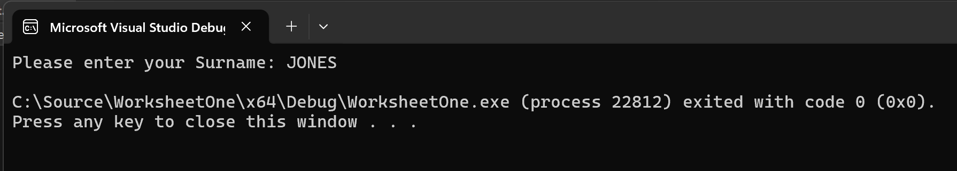
Screenshot(s) of output:
Result: Did the programme behave as expected ie syntactically and logically correct?
YES
Programme behaved as expected allowed me to enter the surname JONES.

Test:
Surname ii Leave blank
Screenshot(s) of output:
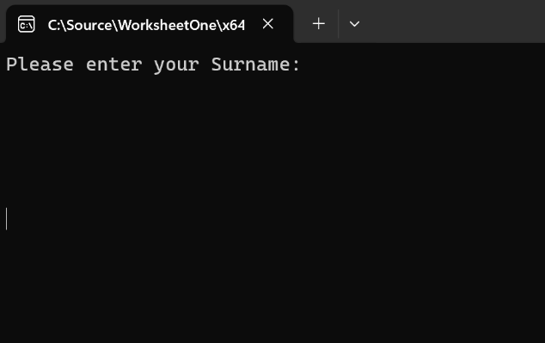
Result: Did the programme behave as expected ie syntactically and logically correct?
NO
Didn’t allow me to leave it blank only added extra lines.

Test:
Surname iii Enter A
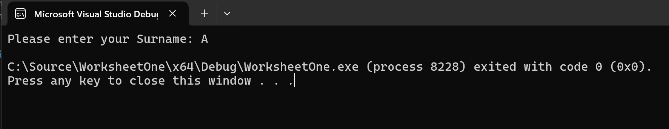
Screenshot(s) of output:

Result: Did the programme behave as expected ie syntactically and logically correct?
NO
It allowed me to enter ‘A’ which shouldn’t really be allowed as surnames are generally longer than a single letter.

Test:
Surname iii Enter A
Screenshot(s) of output:
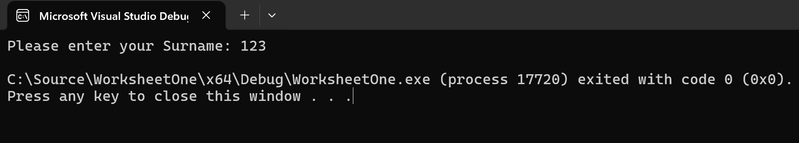
Result: Did the programme behave as expected ie syntactically and logically correct?
NO
This shouldn’t have worked as ‘123’ isn’t a surname.

Test:
National insurance i enter PE534121B
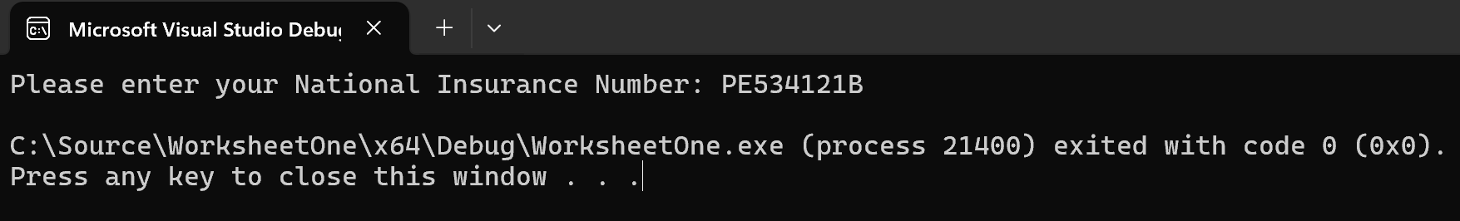
Screenshot(s) of output:

Result: Did the programme behave as expected ie syntactically and logically correct?
YES
The programme allowed me to enter the national insurance number ‘PE534121B’ in the correct format.
Test:
National insurance ii Leave blank
Screenshot(s) of output:
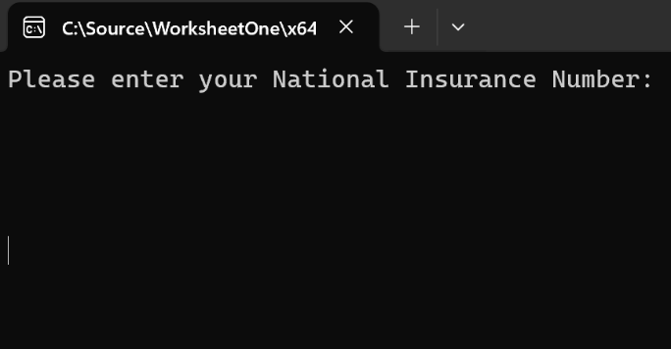
Result: Did the programme behave as expected ie syntactically and logically correct?
NO
The programme didn’t allow me to enter blank as it only added spaces or extra lines.
Test:
National insurance iii Enter AB11223344556677
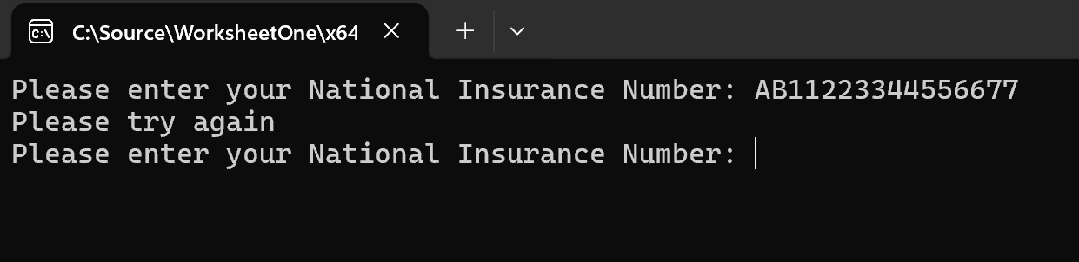
Screenshot(s) of output:

Result: Did the programme behave as expected ie syntactically and logically correct?
YES
When I entered the national insurance number ‘AB11223344556677’ its asked me to try again as it was an incorrect format.

Test:
Age i Enter 34
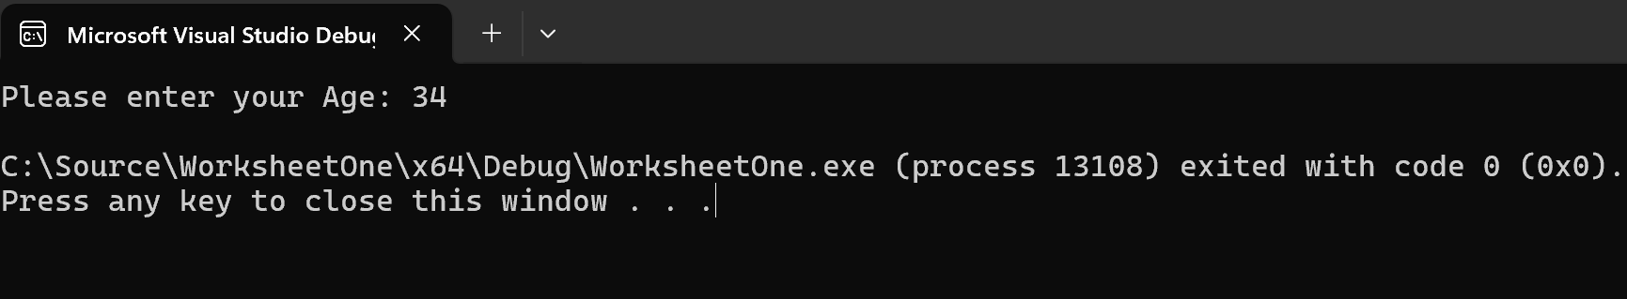
Screenshot(s) of output:

Result: Did the programme behave as expected ie syntactically and logically correct?
YES
The programme allowed me to enter the age ‘34’ as it falls within validation.
Test:
Age ii Enter 150
Screenshot(s) of output:
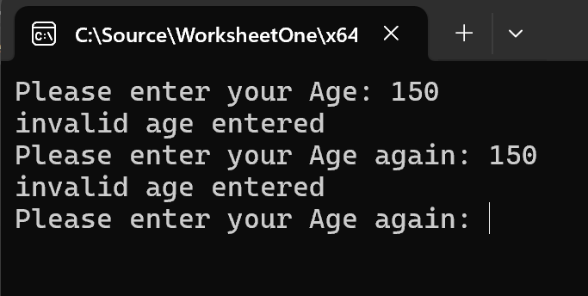

Result: Did the programme behave as expected ie syntactically and logically correct?
YES
The age ‘150’ is too high and outside of the validation for acceptable ages therefore the programme will show ‘invalid age entered’.
Test:
Age iii Enter -4
Screenshot(s) of output:
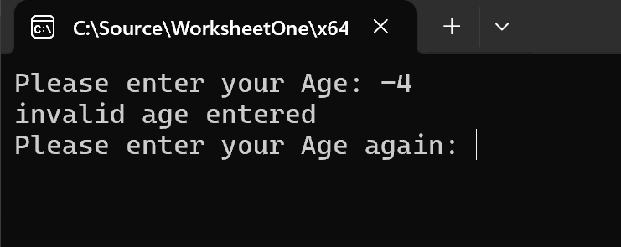
Result: Did the programme behave as expected ie syntactically and logically correct?
YES
The programme didn’t allow the age ‘-4’ to be entered as its too low and outside of the validation.
Test:
Age iv Enter a letter

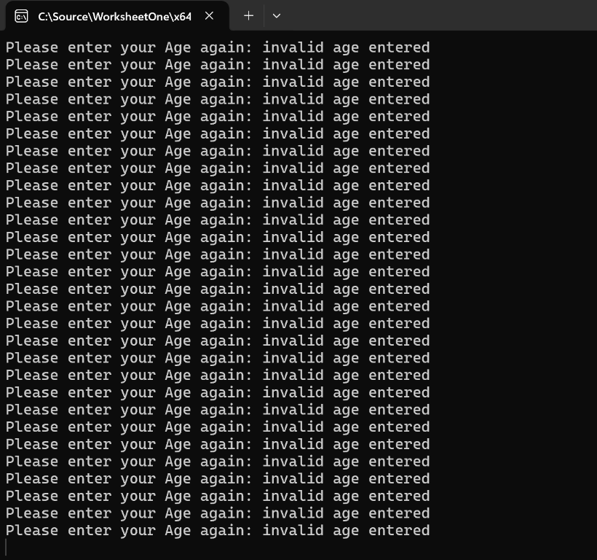
Screenshot(s) of output:

Result: Did the programme behave as expected ie syntactically and logically correct?
NO
The programme has gotten stuck in an infinite loop which isn’t correct at all.

Test:
Hours worked i Enter 37.5
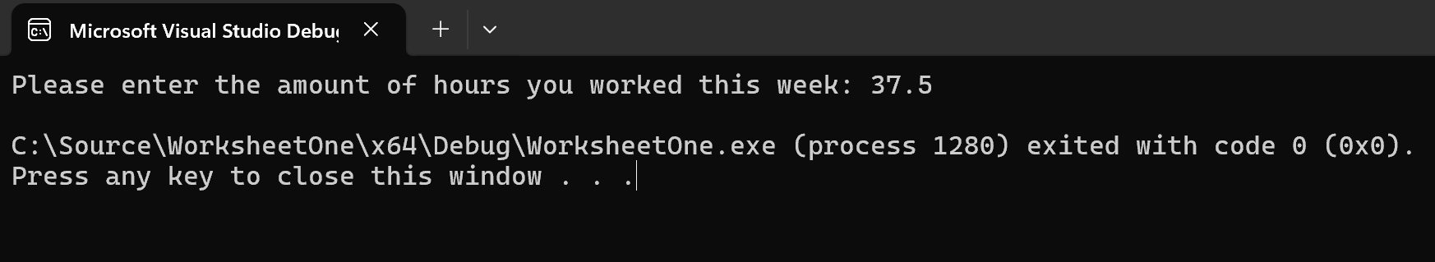
Screenshot(s) of output:

Result: Did the programme behave as expected ie syntactically and logically correct?
YES
The programme functioned as intended it allowed me to enter the hours worked.

Test:
Hours worked ii Enter 105
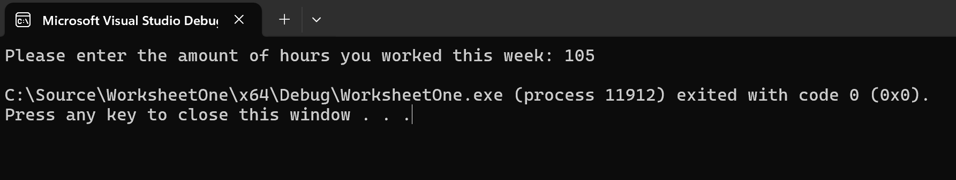
Screenshot(s) of output:

Result: Did the programme behave as expected ie syntactically and logically correct?
NO
The programme shouldn’t have allowed ‘105’ to be entered as it unrealistic to work 105 hours per week

Test:
Hours worked iii Enter 0
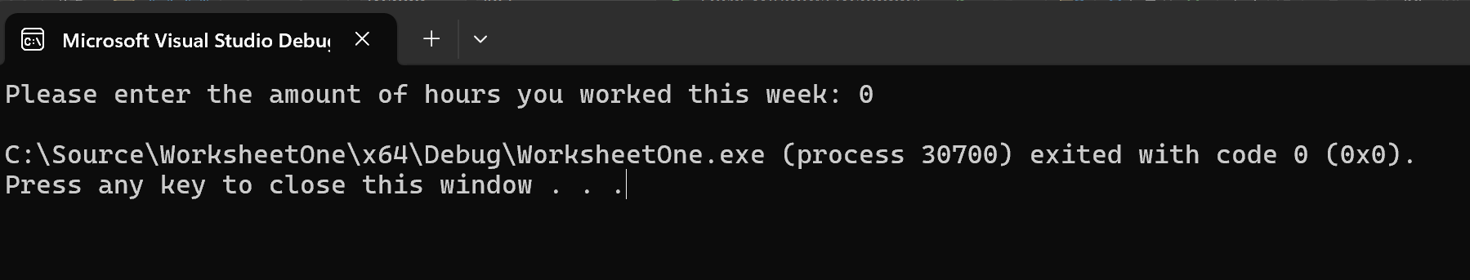
Screenshot(s) of output:

Result: Did the programme behave as expected ie syntactically and logically correct?
YES
The programme has worked as intended here as its possible to not work any hours in a week due to holidays or sickness etc.

Test:
Hours worked iv Enter -2
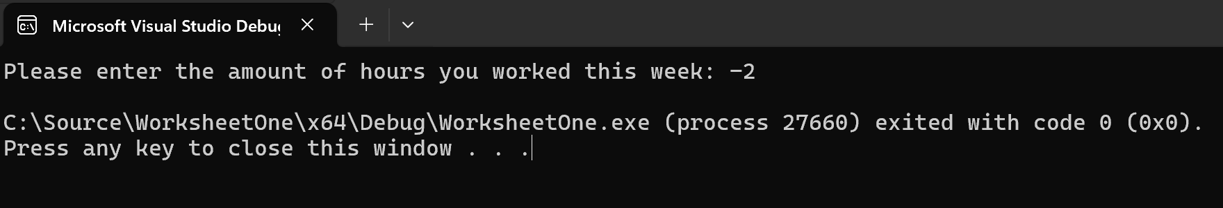
Screenshot(s) of output:

Result: Did the programme behave as expected ie syntactically and logically correct?
NO
As its impossible to work -2 hours in a week this input should be outside of validation parameters.

- Consider the results of the above tests and revisit your code in order to solve the problems. (Note: you may not be able to solve all of them, but solve as many as you can.)

Paste your revised code here:

#define _CRT_SECURE_NO_WARNINGS
#include <stdio.h>
#include <string.h>
#include <math.h>

int isAlphabetic(char str[])
{
int i = 0;
while (str[i] != '\0')
{
if ((str[i] < 'A' || str[i] > 'Z') && (str[i] < 'a' || str[i] > 'z'))
{
return 0;
}
i++;
}
return 1;
}

void main()
{

char surname[16];
int age;
float hoursPerWeek;
char nationalInsuranceNum[10];

printf("Please enter your Age: ");
scanf("%d", &age);

while (age < 16 || age > 67 )
{
printf("Invalid age entered. Must be between 16 and 67\n");
printf("Please enter your Age again: ");
scanf("%d", &age);
}

printf("Please enter the amount of hours you worked this week: ");
scanf("%f", &hoursPerWeek);

while (hoursPerWeek < 0 || hoursPerWeek > 70)
{
printf("invalid hours entered\n");
printf("please try again\n");
printf("Please enter the amount of hours you worked this week: ");
scanf("%f", &hoursPerWeek);
}

printf("Please enter your Surname: ");
scanf("%s", &surname);

while (strlen(surname) < 2 || strlen(surname) > 16 || !isAlphabetic(surname))
{
printf("surname entered is invalid. must be between 2 and 16 letter only\n");
printf("Try again\n");
printf("Please enter your Surname: ");
scanf("%s", &surname);
}

printf("Please enter your National Insurance Number: ");
scanf("%s", &nationalInsuranceNum);

while (strlen(nationalInsuranceNum) != 9)
{
printf("invalid. National insurance number must be 9 characters.\n");
printf("Please enter your National Insurance Number: ");
scanf("%s", &nationalInsuranceNum);
}

}

