Pathway Project 1
Student Name: Nadira Chowdhury
Student ID: 1605 413

Individual reflective submission

The academic period is the ideal time for an individual to develop personal skills, knowledge, and employability that will be helping in the development of the career in future. This group presentation brought a good opportunity to me to enhance my skills and knowledge. In this presentation, I had worked with a group and successfully performed my part. This reflection paper will explain the whole activities and learn from the assigned group presentation.

Collaborative working is always challenging for every person because the different individual has a different perception so that working together is complex in many cases. Hence, personal skill-set like time management, interpersonal communication and networking were playing important role in my group presentation work.
Time management
A very important personal skill is time management. This skill is not only necessary to work individually but also important while working in the group. Time management in the presentation was very important because late submission of the presentation brought big penalty in the course and eventually the academic result will be affected badly. Time management is the process of developing a work schedule and tactical application to meet the time of works (Wilson, 2015). Good time management skill increases the efficiency of the work and helps to complete assigned work successfully and timely. For effective time management, I had taken the help of different time management models in the presentation.
Pickle Jar theory is a concept of time management that explains there has the limitation of time so that people should focus on prime task first and then people should focus on supplementary tasks in their daily life (Limocelli, 2006). Pickle jar theory metaphorically demonstrates the prime task as big rocks in the jar and pebbles in the jar denotes supplementary tasks. This time management theory worked very well in performing my group presentation. For instance, I had first identified my prime task in the presentation and made time frame to complete those and then I focused on the small tasks. As a result, I had not missed any important task in my part of the presentation. This model supported me to create daily work schedule of my part in the presentation given by my group and I contributed my part successfully and efficiently.
POSEC is another important time management model that assisted me a lot in the development of the group presentation. POSEC time management refers prioritises, organise, streamline, economise and contribute the tasks (Satyenra, 2013). Theses model helped me in different ways in my presentation for instance; prioritise helped me to determine top priority activities and least priority activities. Organise helped me collect the necessary resources and information for the presentation in a systematic manner. Streamline supported me to complete less essential task e.g. alignment, design the slide, font size, and style etc. that often ignored by the students. Economise supported me identifying the less urgent activities in the presentation. Contribute helped me focus on few remaining things like grammar check, spelling check, reference check that make a difference in the presentation slides.
Time management is a vital personal skill that is necessary for the daily life including the academic period. In this group presentation, time management models supported me to focus first on the essential tasks and then focus on least essential tasks. So, I did not miss any complementary tasks in the presentation that may affect my group personation. Moreover, in the schedule development of each task in the presentation of my part, time management skill supported me efficiently complete my presentation.
Interpersonal communication
In the group work, communication is an essential issue hence; interpersonal communication skill is playing a big role to perform group activities efficiently. Interpersonal communication is the process of communicating between two individuals in the most suitable methods (Vraithwaite and Schrodt, 2014). Interpersonal communication was an essential personal skill of mine while I had participated in the group presentation. In this aspect, I had taken the concepts of different interpersonal communication models to make my communication skill effective.
Social exchange theory of interpersonal communication focuses on the developing and maintaining the relationships with people (Burgess and Huston, 2013). While working in the group, all group members do not equally hold similar perception or behaviour. So, it is very important to develop interpersonal relationships first that will communicate properly in the group activities. While I was joined in my group for performing the group presentation, at first I had focused on the developing interpersonal relationship with the other group members. As a result, interpersonal communication became easier and I was able to get support from my group members to complete my part properly. In addition, this communication skill was also helped me support my other group members to make the group presentation successful.
Another interpersonal communication theory is systems perspectives that explain various types of interrelationships in the group which is supportive in the network building communication in the group (Kwal, 2013). In the group presentation, this theory assisted me to conduct communication effectively through telephone, online messaging apps, and face-to-face communication. The outcome of the interpersonal communication skill was significant. Our group has gotten the synergic outcome in the development of the group presentation. We solved our problems in preparing the presentation instantly and shared our knowledge with us effectively.
Interpersonal communication is another vital personal skill that is required very frequently while working in the group. This personal skill helped me to maintain relationships with other group members. I had asked the group member that I faced complex and the group members have solved the complexity. On the other hand, my group members were also taken support from me where interpersonal communication skill plays a significant role.
Networking
In the group presentation, my networking skill was also played a significant role. Without networking between group members, collaborative work cannot be performed properly. Networking makes a favourable atmosphere in the group that generates new ideas and a positive result (Misner, 2011). Online messaging apps like Whatsapp played the key role in the networking skill in our group presentation activities. This app connected all group members and removed the distance and time barriers. When I faced any problem, I simply sent a message to my group members through the app and got a reply quickly and solved my problems effectively.
Working in the group is always challenging for a person because each member of the group comes from various background and holds different perception. This group presentation was also challenging for me because it was a new experience to me and the ability of each member to perform work was different. So, to achieve a favourable result from our group activities, leadership awareness was played a significant role. Leadership encourages people to work according to specific direction. Awareness in leadership is very significant in the group work like our group presentation. For instance, we applied participative leadership style for developing a good outline of the presentation (Adewale, 2007). This consultative leadership approach helped to identify prime activities and supplementary that increased the weight in the presentation. On the other hand, when any group member was not cooperated to perform their given task, autocratic leadership practice bounded them to complete their tasks. So, the awareness in the leadership supported to bring favourable outcome in the group presentation.
The presentation topic was sustainability and global citizenship. My group selected the tourism sector to conduct the presentation and Travelodge hotel was taken in from this sector. In the development of the presentation, I have founded that community is an important determinant of the sustainability of the tourism sector. International, national and local communities are directly related to the globalisation of the tourism sector. For instance, I experienced that the involvement of the local and domestic community increases the reputation of the tourism and hospitality of Welsh (Maiden, 2008). As a result, the number of inbound visitors has increased that provides stability in the business of Travelodge hotel and other local businesses have also benefitted.
In the tourism sector, sustainability is a vital issue because the long-term positive result can be achieved through sustainability. The information I had gathered to conduct the presentation, I observed that the environmental impact on the tourism is very high. Approximately 140 million cubic gallon water and 15% energy of the total energy production has been used by the hotels in the tourism industry of the country (DCMS, 2009). So, hotels like Travelodge have taken initiatives of using renewable energy and recycling the rainwater for use that provides continuous green energy supply and sustainability in the tourism sector of the Welsh.
Global citizenship is an essential component in the current globalised world. Global citizenship indicates the persons who are the conscious different context of the wider world and their actions have an impact on the industry (Ronald, 2012). Travelodge hotel achieves global citizenship through initiating eco-friendly operations, charity fundraising programme and the value of the hotel is practicing in its every hotel throughout the country.
Another important issue I founded in the presentation was employment skill. In the globalised world, from academic life to professional career employment skill plays the vital role. Employment skill indicates the skills of an individual that can be transferable and make the person capable to do work (Scales and Kelly, 2012). Employment skill helped me in this presentation in different ways. For instance, I used my brainstorming capacity to make the presentation unique and resourceful. I communicated with the group members properly, researched many journals, internet articles, and books with patience and my problem-solving ability were properly applied that proved my employment skill in formulating the presentation.
I got a new experience in this group presentation because I had not any previous experience of working in a group. So, I took this opportunity to learn and increase my knowledge and ability. I have learned many things from this group presentation work. For instance, communication is a complimentary issue in the group work. At previous, I had some problems of communication. This group presentation helped me overcome the communication barrier and I had learned how to conduct interpersonal communication. The exchange of information between the group members increases the knowledge and understanding. In addition, my technical skill has also been increased from the group presentation. At previous, I wasn’t familiar with the creating powerpoint slides. But, one of my group members helped me to learn the powerpoint slides and design in a professional manner. Learning the time management was one of my big achievements. This presentation required to be submitted in a specific deadline. Different time management models helped me to develop a proper time management plan for each activity in the presentation.
In addition, the topic of the presentation was on the up-to-date issue. The sustainability and globalisation in the tourism sector is a concerned issue nowadays. From this presentation, I have learned the importance of sustainability of tourism for a hotel company in the current globalised world. The global citizenship issue, relationships between leadership and entrepreneurship, community participation and other relevant issues enhanced my knowledge about the current and future prospects of the tourism sector. I had also prepared a learning log that supported me to assess and monitor my presentation activities according to my plan. So, it can be said that my overall achievement from the group presentation is satisfactory.

References
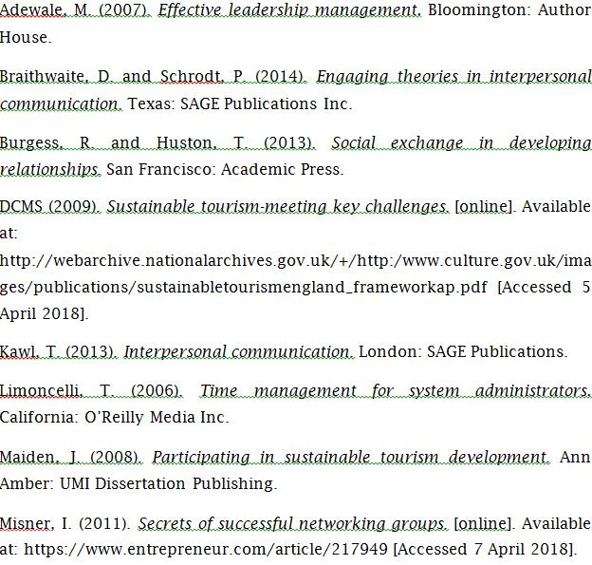

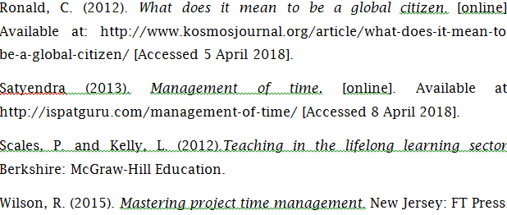

Learning Log
- How did you work together?
I along with my team work together at first research the assignment brief, then broke down the issues that included in the presentation, collect relevant data and conduct the presentation.
- Who did what?
In the presentation, I performed the examples of sustainable project in tourism sector, environmental sustainability and examples of environmental sustainability.
- What went wrong?
At first I did not understand what information could be used in my parts. But, by consulting with the group members, I had overcome the barrier.
What went well?
I had completed the assigned part with the most appropriate information and submit my part on time so that it contributed a lot in the presentation.
- Did you meet often enough?
- Did you use Skype or other online meeting platform?
Yes, we were connected Whatsapp for online meeting because it is available and easy to communicate.
- Did that work well?
- Did you have technical problems in meeting online?
No, I did not face any problem in the online meeting and our online group meeting was effective.
Did some group members refuse to meet online?
No, every group members were cooperative and did not refuse to communicate on whatsapp because it was more comfortable than face-to-face meeting.
- How did you overcome this?
- Did someone not pull their weight?
Nobody pull their weight because all members were committed to render their best effort.
- Did you discuss this with them as a group?
- Did you resolve this problem satisfactorily?
- How did you divide the work between you?
The topic primarily scrutinized and we identified the issues that required to be covered. Then each member selected the topic they were confident to do well.
- Was it fairly shared out?
Definitely distribution of work was fair.
- What have you learned by doing this?
I have learnt about development of power point slides, environmental sustainability in the tourism sector, interpersonal communication ways and effective time management techniques.
- Did you enjoy the process?

- Why did you enjoy it?
- Did you dislike the process?
- Why did you dislike it?
- How could it have been improved?
Every group members were so collaborative and gave their best effort for maximum favourable outcome.

