Synthesize a solution to a potential real-life scenario
Author: Robert Cook (2015030)

L4 - Network and Cybersecurity Essentials (ACCA4024)
School of Applied Computing
Wales Institute of Science and Art
Date and Time of submission: 07/01/2021 20:30

Abstract

This document is going to discuss potential cyber security flaws in a company called Che-Si who are a global construction company. It will look at their policies and infrastructure for network security. The document is also going to design and recommend a better framework for Che-si to follow to improve their network security.
Cyber security is one of the most important things these days for businesses. [1]
Table of Contents

- Introduction……………………………………………………………………Page4.
- Devices being used at Che-si……………………………………….…………Page7.
- Threats and attacks……………………………………………………………. Page 8.
- Mitigation……………………………………………………………………...Page 9
- Weak Points/ Vulnerabilities - Attack scenario………………………………. Page 11
- Outcome of scenario…………………………………………………………. Page 17
- Digital signatures and digital encryption methods…………………………Page 17
- Conclusion and recommendations…………………………………………Page 17
- References………………………………………………………………… Page 19
- Wordcount……………………………………………….…………………Page 20

Introduction
A network is essentially things connected together.
Networks are used by pretty much everyone these days. Businesses can really improve their productivity by using a network effectively – it gives a variety of functions to a business; it can mean people can stay in touch easier and information can be shared across locations in a matter of minutes.
In computing when we talk about a “network” we usually think of computers, computer systems and other devices (servers, firewalls, printers, switches) being able to communicate to each other to allow the sharing data from one place to another.
For example, this could be a PC in one room, needing to talk with a server hundreds of metres away, to get data for an admin clerk to help a customer.
Most network connections from “client devices” such as PCs or laptops – will either be wired with a standard cat5 cable or will have a wireless connection to the nearest wireless access point.
There are lots of different types of networks. Two that are covered in basic networking are LAN (local Area network – so this is usually for a small geographical area.) and WAN (this is Wide area network – so this is for a large geographical area). [2]
Over the years there have been various types of network topologies, these are essentially model designs for networks. These come with various advantages and disadvantages a few to mention would be BUS, STAR, RING, MESH and TREE.
They each come with their own advantages and disadvantages. [3]

A very basic network (Star topology) with limited security would look like:
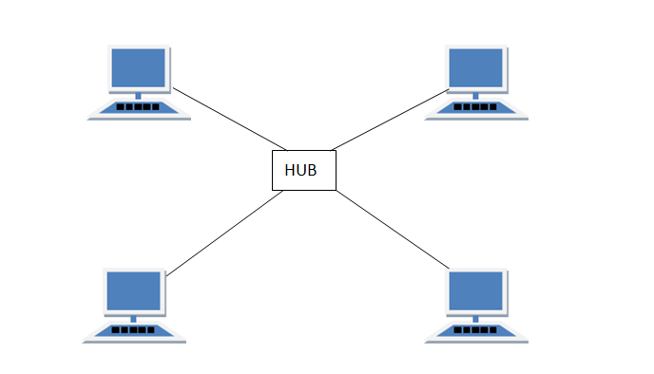

People and companies use networks to store and access information, some security problems can arise due to this.
Sensitive data like medical records or financial information could be stored on devices such as servers and pc’s which are networked. Over the years of networks being developed to enhance businesses, some parties around the world would try to infiltrate or hack networks to obtain this sensitive data for their own personal use.
This would allow said party to then use that information for their own personal advantage. Some parties do this “just for fun” or to “show off their knowledge or skills” most do it for some sort of financial gain.
Therefore, security in a network is so important. There are measures we can put in place to enforce what is known as cyber security.
If security in a network is taken to lightly, then companies will become prone to cyber-attacks. If sensitive information is lost by a company, as they do not have sufficient security measures to prevent this, or take cyber security to lightly, it can seriously harm the company’s reputation and can even cost them more time and money.
Throughout this document I will outline some good practises for Che-Si to follow to maintain better cyber security on their network.

Devices being used at Che-si
Che-si is a global construction company. They have sites all over the world. Therefore, their network you could consider to be quite large.
The staff and customers there make use of a variety of devices, but the main ones are:
Laptops – to keep staff mobile when on construction sites.
Pcs – located at Che-si bases used by admin staff.
Personal Mobile devices utilised by all staff to work around the clock.
They upload their files to an FTP server at one of their sites.
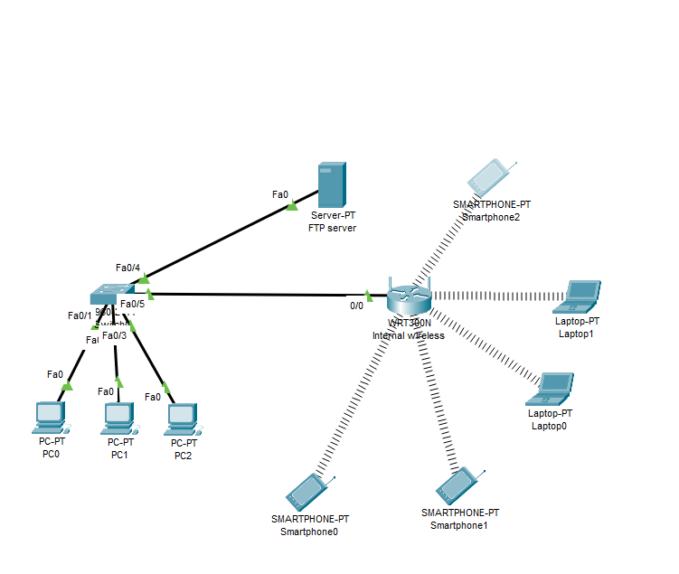
The company operate 24/7 and make use of other storage facilities like Cloud Storage and also video Conference facilities.

Threats and attacks
Any personal Devices (mobile phones) connected to external networks e.g., 4G to connect to resources that are used by Che-si can provide a potential threat to the security of your network. The connection you may use may not be secure or encrypted if public Wi-Fi is used. [4]
A potential attack that could take place on Che-si is a man in the middle attack as wireless devices are being used such as mobiles or laptops. If the TLS protocol is not utilised when data is being sent between the Che-si sites. This could leave them open to this type of attack.
TLS typically uses port 443 on any standard firewall- this should be enforced. [5]
The hacker could target the wireless devices at Che-si. He could potentially setup his own Wi-Fi-hotspot SSID e.g., CHE-SI Guest.
A network sniffer can then be used to inspect any traffic that passes through his hotspot and then intercepted. Any site that is visited that does not use HTTPS is viewable to the hacker. Sensitive data such as logon credentials could be leaked to the hacker.
Another potential attack that can occur is a Phishing attack – mostly done through email. This type of attack could trick staff and customers into clicking on hyperlinks in email which can ask them to provide sensitive data. It could take them to websites or get them to download an attachment that is not legitimate. Attackers would disguise themselves as a trustworthy source. [6]
You need to also consider Physical security on site and how to stop hackers / unwanted people just physically walking into areas where your network equipment / server environment is stored. [7]

Mitigation
How to mitigate against sniffer and man in the middle attacks.
Advise staff not to use free public Wi-Fi networks when accessing Che-si resources – such as documents in cloud storage, use only internal networks where possible as TLS will be enabled. If a website is not using TLS it will be automatically blocked by proxy server, or only use if connection such resources in encrypted.
Be sure to always use HTTPS when sending any type of sensitive data. This makes use of the TLS protocol.
Make sure internal wireless network points at Che-si have a very strong password policy such as having them change every 30 days.
For video conferencing facilities – I would recommend that Che-si use either Microsoft teams or Polycom. These video conference software’s are deemed “safer” by cyber security experts. Use of facilities like “zoom” should not be permitted. [8]
Microsoft authenticator should be used on personal devices when accessing cloud storage or emails. The authenticator app can be downloaded onto users’ smartphones or other devices if preferred. It allows the user to permit connections to access emails or other apps remotely. It is an extra layer of security that most large organisations are now making use of e.g., NHS. [9]
How to mitigate Phishing – Staff awareness and training is key to mitigate this. Safe senders’ lists can be setup on email servers to stop some unwanted emails, but some can still get through the net. [10]
There should be a password policy – Passwords should have to meet a criteria to be accepted for use. A capital letter, a number, a special character and must be between 8-20 characters long. This can help mitigate Brute force attacks. [11]
All workstations owned by Che-si should have anti-virus protection installed. I would recommend Kaspersky Agent and endpoint anti-virus. [12]
This anti-virus can be managed remotely from a server by an administrator, in terms of updating and quarantining viruses.
Salto locks, badge swipe access, surveillance cameras and any other suitable physical security should be put in place to mitigate any unwanted people getting into areas they should not. e.g., Server rooms, switch rooms.
Cyber security patching – this would be key for Che-si. Ensuring that their server and client environment is patched with the latest Microsoft updates. This should be scheduled on a regular basis.

Weak Points/ Vulnerabilities - Attack scenario
The major weak point in Che-si, is laptops being used on a public Wi-Fi networks when staff members are out in public, and they need to FTP/upload files into the network or cloud storage. In this example I will demonstrate how hackers could use a packet sniffer to intercept credentials/confidential files which are used within Che-si.
The Type of attack I am going to demonstrate is a sniffer attack. The sniffer technique can be used to monitor communication between network devices to see what packets are being sent. I am going to in this example show how a sniffer could be used to target a staff member at che-si
For this scenario there are construction engineers who have gone to a public café for their lunchtime break. During their break they have decided to send on some reports via FTP to che-si FTP server.
In the cafe there is free public Wi-Fi which the staff member connects to.
The SSID of the Wi-Fi is called “Café-Wi-Fi”.
However, in this café there is a hacker who wants to obtain information about some work Che-si are doing. The hacker decides to connect to the public Wi-Fi also and use a network sniffer too see what is going on, targeting FTP packets.
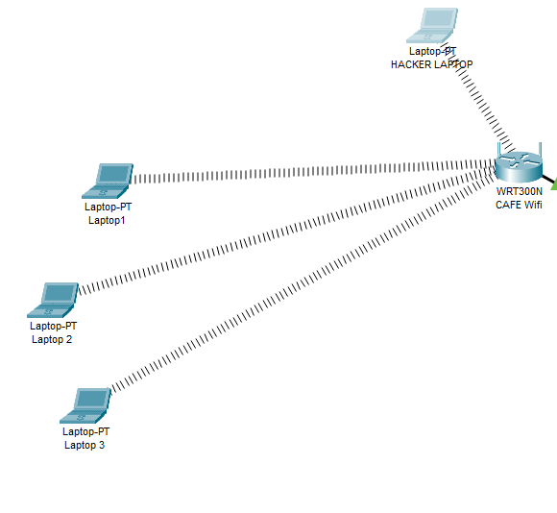
The hacker connects his network sniffer to the access point and sets it to monitor FTP. A software sniffer could be used such as Wireshark.

Or the hacker could have a sniffer monitoring FTP commands to the FTP server.

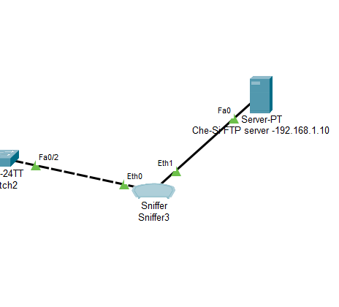
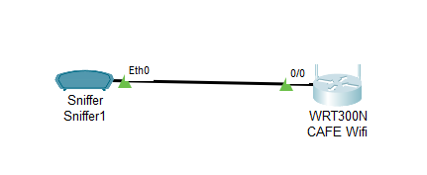
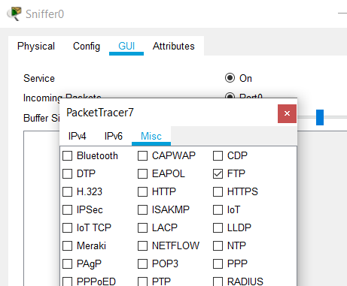
He filters his sniffer to only look for FTP packets.

From laptop one – the user then accesses the FTP server at Che-si and uploads a document. A document I created for this scenario called CHESI.txt

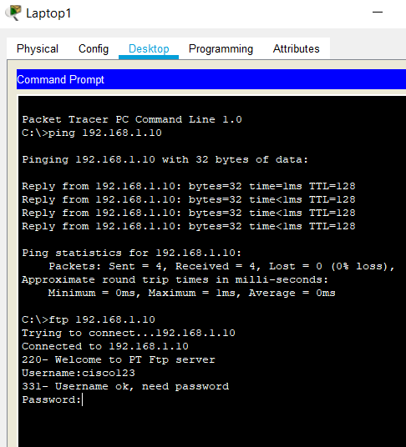
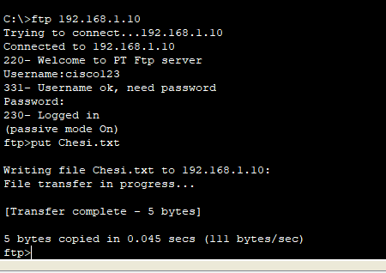

We can see the file is now on the FTP Server
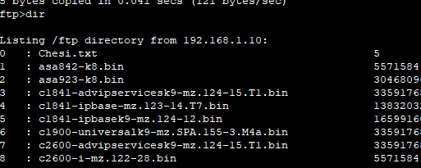

When the hacker the checks the sniffer – he can see all the FTP packets. On checking these packets through his sniffer, he could obtain the users, username and password. Which is at the bottom of the below screenshot.

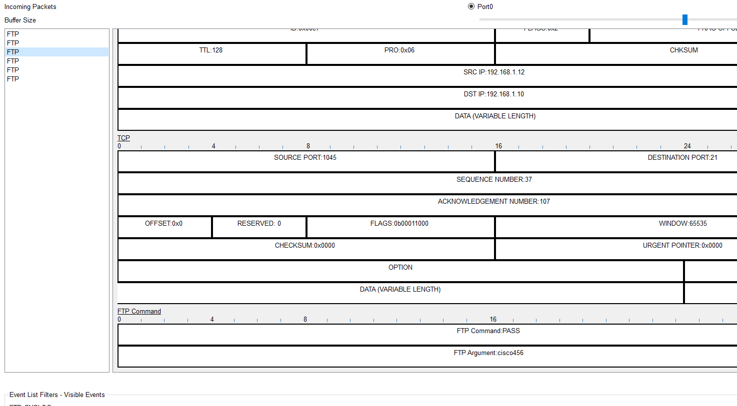

This would then mean – username and passwords would be compromised – leaking all Che-si client information.

Outcome of scenario
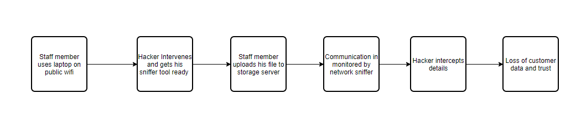
The outcome of the above scenario would mean that the hackers would obtain login information to Che-si file storage area. Which means all files stored there would be compromised and therefore the confidential information of Che-si clients.

Digital Signatures and Data Encryption methods
There are various methods and techniques to make sure data is not tampered with between the source and destination.
Data encryption – we can use data encryption keys (private and public) to encrypt and secure data between source and destination. The asymmetric method is more of a tougher security method when sending packets over the internet as the data in encrypted.
We can make use of digital signatures to ensure the integrity of data when sending from one place to another. They add a good layer of security and Che-si would benefit from this if they are using non secure channels such as public Wi-fi. Using this type of method would secure the “CIA” or confidentiality, integrity, and availability of the data.
It would allow Che-si to verify that the sender of the document is the sender, and that the data has not been tampered with in any way.
The type of encryption that would be used here would be good to stop other types of attacks like man in the middle attacks.

Conclusion and recommendations
I would advise Che-si to look at the possible attacks and mitigations outlined in this document and adapt it into their own infrastructure with immediate effect.
This would ensure that their network security is more in line with modern day businesses and that they would be less prone to cyber security attacks and loss of their customer’s trust. The current structure of Che-si is quite open and confidential documents are easy to obtain as shown in example attack above.
To enforce cyber security within Che-si it would be appropriate if possible, to employ cyber security officers or a cyber security team. This would allow Che si to evolve their cyber security to keep up with the constant threats. Cyber threats are constantly evolving, and hackers are using new ways to find exploits in technologies every day.
Che-si could also benefit from putting other tools into their network infrastructure to manage security. They mostly use a window 10 and Windows 7 environment, using group policy editor and active directory would also be beneficial for them. This would allow them to manage and implement user accounts and manage computers and laptops much better.
Group policy will allow them to modify, how much a “standard user” can do when they are logged on. Active directory will allow fast management of user accounts and devices as well as enforcing security on a global level for the company.
Firewalls should also be added to the Che-si network infrastructure. Blocking any necessary outbound and inbound ports. This would stop any wanted packets being sent into Che-si and would seriously enhance their cyber security – I would recommend one firewall at each of their sites across the globe. Any 3rd parties that may need to dial into the Che-si network to provide support or to set something up should have a code of connection document in place. Every 3rd party should be assessed for the latest cyber security patches and under what they wish to securely dial in e.g., RDP.
A mixture of putting in these measures and mitigations with appropriate staff and teams to manage them would really help secure the Che-si network.

References

[1] | Annie Button, “Five reasons cyber security is more important than ever,” 30 August 2018. [Online]. Available: https://www.consultancy.uk/news/18435/five-reasons-cyber-security-is-more-important-than-ever.
[2] | H. Andrea, “Networks Training,” Networks Training, 8 September 2020. [Online]. Available: https://www.networkstraining.com/different-types-of-networks/#:~:text=10%20Different%20Types%20of%20Networks%201%20Personal%20Area,9%20Campus%20Area%20Network%2010%20System%20Area%20Network. [Accessed 28 December 2020].
[3] | “StudyTonight,” StudyTonight, [Online]. Available: https://www.studytonight.com/computer-networks/network-topology-types#. [Accessed 28 December 2020].
[4] | C. HOFFMAN, “Howtogeek,” Howtogeek, 12 July 2017. [Online]. Available: https://www.howtogeek.com/178696/why-using-a-public-wi-fi-network-can-be-dangerous-even-when-accessing-encrypted-websites/.
[5] | “Wikipedia,” 04 January 2021. [Online]. Available: https://en.wikipedia.org/wiki/Transport_Layer_Security.
[6] | “imperva,” 04 January 2021. [Online]. Available: https://www.imperva.com/learn/application-security/phishing-attack-scam/#:~:text=What%20is%20a%20phishing%20attack.%20Phishing%20is%20a,opening%20an%20email%2C%20instant%20message%2C%20or%20text%20message..
[7] | P. Goldstein, “BizTech,” 04 January 2021. [Online]. Available: https://biztechmagazine.com/article/2016/10/why-physical-security-should-be-important-cybersecurity.
[8] | L. Irwin, “IT governance,” 18 June 2020. [Online]. Available: https://www.itgovernance.co.uk/blog/is-zoom-safe-to-use#:~:text=There%20are%20plenty%20of%20justifiable,into%20the%20webcam%20and%20microphone..
[9] | “GreenData,” 04 January 2021. [Online]. Available: https://www.greendatait.com.au/why-use-multi-factor-authentication-mfa-for-office-365-and-azure/#:~:text=Why%20use%20Multi-Factor%20Authentication%20%28MFA%29%20for%20Office%20365,numbers%20are%20susceptible%20to%20hackers%20forcing%20logins%2C%20.
[10] | S. Gombar, “NwajTech,” 20 January 2020. [Online]. Available: https://www.nwajtech.com/11-steps-to-mitigate-the-risk-of-phishing-attacks/#:~:text=11%20Steps%20to%20Mitigate%20the%20Risk%20of%20Phishing,Before%20You%20Click%20%7BIMG%7D.%20...%20More%20items...%20.
[11] | D. Markiewicz, “Information Security Office,” Carnegie Mellon University, 12 January 2007. [Online]. Available: https://www.cmu.edu/iso/governance/guidelines/password-management.html.
[12] | S. Opperman, “Neo Technologies,” 21 April 2020. [Online]. Available: https://www.neo.co.za/8-reasons-why-you-should-use-kaspersky-for-your-computer/.

Word Count: 2178

