Research Proposal

Submission date: 29-Nov-2020
Submission ID: 2001427
Name: YuKang Tian

AN ANALYSIS OF THE IMPACT OF E-COMMERCE ON CORPORATE MARKETING STRATEGY DECISIONS DURING COVID-19 – A CASE STUDY OF CHINA

Introduction
An Analysis of the impact of e-commerce on corporate marketing strategy decisions during COVID-19 -- A case study of China

This proposal is mainly about some suggestions and plans for the thesis writing. First of all, the main possible research problems in the thesis will be put forward for discussion, and this part will prove the feasibility of the thesis. Secondly, the research background of this report is a period after the outbreak of COVID-19. The researcher intentionally narrowed the research time range, so as to better understand the positive relationship or negative contradiction between the two territories. The researcher will then present the main objectives of the study and the relevant details. A brief literature review will also be included in the proposal, which will mainly describe the practicality of the research scope. Finally, the researcher will list some research methods and analytical techniques that may be used, and use the Gantt chart reasonably as a time planning tool. Obviously, some possible difficulties in the research will also become obstacles to the completion of this academic paper.

Research process

2.1 Research questions
In this section, it is important to determine the relationship between e-commerce and enterprise marketing strategy decisions, as this will directly affect the success of the paper. Su and Li (2020) proposed that the rapid development of e-commerce would affect the external situation, strategic performance and strategic evaluation of enterprises, which undoubtedly requires enterprises to formulate reasonable marketing strategies to ensure their survival and development. The second possible research question is whether there is enough primary data, secondary data and some data to support the thesis under the time of COVID-19. From the end of last year to the end of this year, the COVID-19 is approaching a year. Some academic writers have made preliminary judgments or conducted more in-depth studies on the impact of COVID-19 on various aspects. These literatures can be used as references for researchers to write this paper. In addition, some media reports on COVID-19 on the Internet can also serve as real-time research evidence.

2.1 Background
The COVID-19 crisis has provided a suitable opportunity for some enterprises to develop in this aspect of e-commerce. The study shows that during COVID-19, "industries that produce and provide information products and services continue to play a role, while industries that produce physical products, especially labor-intensive ones, are forced to reduce operations or temporarily shut down."(Seetharaman and Priya, 2020).In China, from January to March, 2020, people hardly go out of their homes. At this time, the demand of customers for online shopping increases greatly, and the role of e-commerce for some domestic enterprises is reflected, especially for those small and medium-sized enterprises, whose income comes from customers' online shopping and electronic shopping. Enterprise website information and website services to drive the growth of sales can not be ignored.(MacGregor and Vrazalic, 2007)

2.2 Objectives and Aims
Actually, the main purpose of this article is to take China's small and medium-sized enterprises as an example, to change the marketing direction and strategy through their use of e-commerce during the epidemic, so as to give some advice and inspiration to those enterprises in other countries who still trapped by the epidemic. Because some companies in western countries still choose the traditional methods to operate entities or even stay closed for a long time due to the constant pressure of the epidemic.
In addition, the researchers will use some Chinese enterprises and customers used in Internet marketing as research targets as examples to substantiate their thesis. Firstly, investigate companies that use online media and sell software during the epidemic and find out what they think of their current marketing strategies. Secondly, to investigate customers' demands for products during the epidemic, and a questionnaire was made to determine what kind of daily necessities customers needed during the epidemic. Thirdly, according to the survey results, the researcher will provide reasonable suggestions for Chinese small and medium-sized enterprises to change their marketing strategies by using e-commerce.

2.3 Mini literature review
If we want to conduct academic research on this field, we must first understand the research carried out by some writers or experts in this field. The most important role of these studies is to guide the thoughts and further inspire. As the subject background of the upcoming study is the COVID-19 period, the researcher hopes that the small and medium-sized enterprises limited by the epidemic in the world can correctly change their marketing ideas and make reasonable strategic decisions based on the development of contemporary e-commerce. Online marketing can help enterprises to adjust high efficiency, save costs, expand the market scope, and can establish a good relationship with customers. (Good and David, 2002)

Research techniques
Primary Data and Secondary Data
First of all, the collection of primary and secondary data will be used in the paper. The original data is the original research data in the original form without any analysis and processing. The data provided researchers with a wealth of information. Depending on the nature of a study, the raw data may be provided with a report and analysis so that the reader can see it directly, or it may be confidential. This data will be valuable for those who want to learn more about research methods, anomalies that occur during research, and other topics. (McMahon, 2020) In this paper, researchers may use questionnaires to investigate which Chinese enterprises make use of e-commerce to develop marketing strategies. Secondary data analysis refers to the use of data collected by others for other purposes. In this case, the questions raised by the researchers are addressed by analyzing the data sets they were not involved in collecting. The purpose of data collection is not to answer researchers' specific research questions, but for another purpose. This means that the same data set is actually a primary data set for one researcher and a secondary data set for another researcher.(Crossman, 2019) In this paper, researchers will read a large number of literatures on market and e-commerce to explore the connection between the two, including books on e-commerce and marketing, and the latest media reports on the impact of coVID-19 on this aspect.

Research Onion
Secondly, The Research Onion, which is created by Saunders et al. (2007), can also become a Research technique used by researchers. Studying Onions can provide researchers with an effective way forward and a clear understanding of their plans. And studying Onions can be adapted to almost any type of research method, and can be used in a wide variety of situations. (Bryman, 2012) In this paper, the researcher will collect and compare the data on the use of e-commerce in marketing by Chinese enterprises before and after the coVID-19 outbreak, so as to prove that the development of e-commerce will have an impact on the marketing decisions of enterprises.
Figure 1: The Research Onion
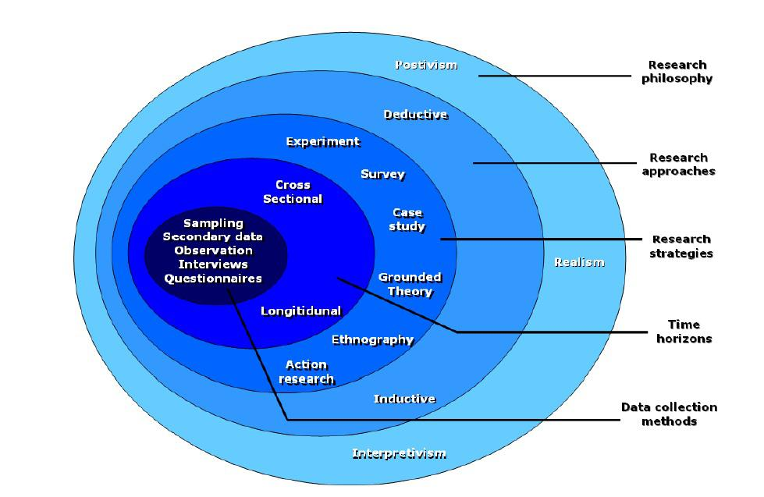

Research rationale
In the last year of my undergraduate study, the researcher will be able to complete an independent project by writing a paper. In fact, many factors have influenced the topic selection and thinking of this paper. Under certain background conditions, it is undoubtedly challenging for researchers to combine e-commerce with marketing. However, keen interest motivates researchers to study and study this field.
Commercial tools are needed for marketing decisions and management pricing, and the accurate use of electronic services is also an important aspect (Rajagopal, 2013). Under the coVID-19 outbreak, people's demand for electronic services reached a peak. Some customers even need to buy daily necessities online every day because they can hardly go out during the epidemic. Many enterprises seize this opportunity to use the online sales channel for high profits.

3.0 Time Arrangement
The following table mainly shows the researcher's following research arrangement and time planning. The production of Gantt chart can help the researcher to plan the research paper topic without being disturbed by external factors.

Figure 2: Time management

4.0 Reference
Bryman, A. (2012). Social research methods (5th ed.). Oxford: Oxford University Press.

Crossman, A., (2019), Pro and Cons of Secondary Data Analysis [online], Available at: https://www.thoughtco.com/secondary-data-analysis-3026536 [Accessed on 28 November, 2020]

Good, David J., 2002. e-Commerce Strategies for Business-to-Business Service Firms in the Global Environment. American Business Review, 20(2), pp.111–119.

MacGregor, R.C. & Vrazalic, L., 2007. E-commerce in regional small to medium enterprises, Hershey, PA: Idea Group Pub.

McMahon, M., (2020), What is Primary Data? [online], Available at: https://www.wise-geek.com/what-is-primary-data.htm [Accessed on 28 November, 2020]

Rajagopal, 2013. Marketing decision making and the management of pricing successful business tools, Hershey, PA: Business Science Reference.

Saunders, M., Lewis, P., & Thornhill, A. (2007). Research Methods for Business Students, (6th ed.) London: Pearson.

Seetharaman, P., 2020. Business models shifts: Impact of Covid-19. International journal of information management, 54, p.102173.

Su Liqin & Li Hongmei, 2011. Management of enterprises' marketing strategy under e-commerce environment. 2011 International Conference on Computer Science and Service System (CSSS), pp.1370–1372.

