University of Wales Trinity Saint David
Mr Leighton Fernandes (1915091)
Lecturer: Brynach Heffernan
24th March 2023
BMSW6105

Coaching and mentoring
Individual and Organisational Benefits of Coaching and Mentoring

EXECUTIVE SUMMARY
This Paper highlights the credibility of coaching depends on being able to help achieve set outcomes made in the coaching process. The value of the coaching process will be determined by the effective methods and evaluation techniques used to assess the impact of coaching and mentoring. Coaching and mentoring has proven to inspire and benefit individuals in the workplace to achieve better wellbeing, reach personal/organisational goals, boost productivity, and assist organisations in building resilience. This paper provides a review of the relationship between leadership and employee engagement and finds that line managers as coaches and mentors can be very beneficial to organisations. However, power kinetics may limit a line managers creativity to fully resolve the issue. Therefore, conflicts of interest may play a major factor in line managers acting as a coach or a mentor within an organisational context.

Table of Contents
1.0 INTRODUCTION 3
2.0 MAIN FINDINGS 4
2.1 What is Coaching 4
2.3 What is Mentoring 5
2.4 Similarities and Differences between Coaching and Mentoring 6
2.5 Line Manager as a Coach/Mentor 7
2.6 Coaching/Mentoring in Building Resilience and Dealing with Change 8
2.7 Personal Performance in Peer Coaching 9
3.0 CONCLUSION 10
4.0 APPENDICES 11
5.0 REFERENCES 12

INTRODUCTION
This report was requested by the president of the International Coach Federation (ICF) on the 16^{th of} January 2023, and was submitted on the 24th of March 2023. This report was compiled by the vice president of the (IFC) to analyse the impacts and benefits of coaching and mentoring in an organisational context. The focus being on organisations utilising coaching/mentoring to develop individuals in the workplace and the benefits to the organisation and the employee. To gain a better understanding of the nature of the coaching process, this paper will explore models and theories associated with coaching and to consider the benefits to the organisation of developing individuals in the workplace. This paper will provide a critical evaluation on the purpose of coaching and mentoring within an organisational context, analysing the skills, behaviours, attitudes, beliefs and values of an effective coach or mentor. Also, the similarities and differences between coaching and mentoring, Advantages, and disadvantages of coaching/mentoring to organisations concerning return on investment, the line manager as a coach/mentor, including an assessment of the necessary skills and behaviours, the role of coaching and mentoring in building resilience and dealing with change. The writer will provide a critical refection on his own performance in the peer coaching exercise, using Gibbs reflective Cycle and Landsberg’s Instant Pay-off Coaching Model. Finally, this paper will provide a personal development plan (PDP).

2.0 MAIN FINDINGS

2.1 What is Coaching
Coaching can be defined by Clutterbuck, (2006) as a form of personal development. It is a process that enables individuals through guided questioning and discussion to achieve goals, improve their personal performance and learn about themselves to make better decisions. A coach also refers to a person who acts as a facilitator that provides guidance and clear actions plans to help individuals reach specific organisational goals and reach their full potential, Megginson, (1999). The coach will not usually share their own personal experiences with the coachee throughout these sessions, Burton, (2022). Indicating that learning is structured and focused. Coaching helps by developing employees performance in the workplace by unlocking their potential capabilities via the utilisation of using coaching models, conversation, and action plans. Coaching models help to provide a framework to explore the topic or issue with a coachee in a logical, structured, and clear developed way, Landsberg, (2015). There are numerous well-known models for coaching in the workplace, which include: GROW, OSCAR and the Instant Pay-off coaching model.
GROW stands for Goal, Reality, Options and Will, which is a four-step structure, Whitmore, (1993). The key benefits of the grow model are that managers do not need to be a coaching expert. For example, the model provides a framework that uses general questioning to obtain information to help solve problems. However, this model primarily focuses on solutions rather than analysing problems. Typically, the coach will use ‘ask’ and ‘tell’ within each step of the process. An example of the GROW coaching model can be seen in (appendix 1)

OSCAR stands for Outcome, Situation, Choices, Actions and Review, Whittleworth, (2002). The key benefits of the OSCAR model are its shared approach towards progress and positive achievement, allowing individuals to focus on success and moving forward, Whittleworth, (2002). The disadvantage to this model is that it is based on the idea that coaching should focus on results and not the causes of the problems. The OSCAR Coaching Model can be seen in (appendix 2)

The benefits of Landsberg Instant Pay-off Coaching Model are it helps individuals find personal blocks in their current situation in a short period of time Landsberg, (2015). These blocks take into consideration an individual personal circumstances. This model does not allow a one-way flow of telling and instructing, Landsberg, (2015). An example of a written script (workplace scenario in practice) structured using Landsberg’s model can be seen in (appendix 3).

2.3 What is Mentoring
Megginson, (1999) defines a mentor as a person who has significant knowledge and experience in a particular area of work, who can act as an adviser to a mentee who requires knowledge in the desired or same field. The mentors goal is to help individuals extend their knowledge which helps the mentee grow and develop as professionals by offering personal advice based on their advanced knowledge and experience Indeed, (2022). The mentor and mentee relationships can be built through personal connections, networking or via formal executive mentorship programs Fiona, (2021). Mentors can be used to assist individuals in becoming better people, boost performance levels and encouraging professional/personal development by setting goals, giving honest feedback, and providing learners with assistance in expanding their networks. As a result, organisations who want to develop employee skills, knowledge and understanding often create mentoring programs, Drahosz, (2021). According to Kram, (2007) the mentors tacit knowledge and personal understanding of a subject, when shared directly via one-to-one consultations with mentees can help train and create high performance individuals resulting in a productive workplace environment. Whitmore, (1993) states when employee development is encouraged in the workplace it demonstrates to the workforce that they are valued as their employer wants to assist them grow as individuals. Mentors can assist individual and organisations by instructing people who are just starting their careers with guidance on professional expectations regarding the priorities of the job role and workplace behaviours - assisting to establish appropriate work habits that allow them to focus and perform in their job roles effectively, Birt, (2022). Mentors can motivate individuals to take calculated risks based on the lessons learnt negative impacts and mistakes the mentors have made along their journeys - conveying successes and failures for mentee to use as example so they do not have to suffer the consequences themselves. These learning experiences will assist and prepare individuals for challenges that they will expect to face and provide valuable advice on how to potentially overcome them, Kirsten. (2014). For the sustainability of talent, mentoring is a very important key element to an organisational succession plan for effective approaches to developing employees when introducing a new system or programs for change management. Although, a relatively high degree is placed on directiveness and one-way learning, CIPD, (2021).

2.4 Similarities and Differences between Coaching and Mentoring
Coaching and mentoring are both development techniques centred around one-to-one sessions to increase an individuals skill set, knowledge/understanding and work performance. These sessions and development activities are structured around a person’s individual needs, Institute of Coaching, (2023). Both coaching and mentoring can be most effective for organisations when used for supporting training and the development of its employees to ensure the knowledge, skills and behaviours are transferred into the workplace Landsberg, (2015). The skills needed and similarities between coaching and mentoring are they both focus on career development, unlocking potential, skill progression, uncovering new ways of thinking, discussion of goals, knowledge sharing and an overall desire to develop people. Although, coaching is ‘non-directive’ which means the coach will usually not share personal experiences to the coachee. Whereas mentoring can be viewed as ‘directive’ meaning giving advice, making suggestions, or simply telling it how it is. Although coaching is directed towards the individuals current needs. Mentoring focuses in on the future goals of individuals people Megginson, (1999). For example, if an employee has been recruited to a new management position within a company that delivers leadership programs, a coach may be required to adjust the required leadership style to best suit the organisational culture. The coach will identifying what management style they currently have, what change in style is needed and the current blocks for future improvement. The coach will facilitate the discussion by asking open, closed, and probing questioning techniques to assist the learners thinking and the exploration of options - helping them with learning rather than teaching them, Lee, (2022).
Mentors on the other hand, in the same leadership scenario an organisation may use internal sources as mentors. A line manager for instance, who can advise the employee how thing should be done at the company, help, guide, support them on the expected behaviour of managers at senior level and providing feedback on the progress into the new leadership role Kaufmann. (2021). According to the Institute of Coaching, (2009) 80% of individuals in organisations who receive coaching report better wellbeing and increased confidence. 70% of individuals report increased work performance, more effective communication, and better relationships with 86% of companies suggesting they have regained their return on investment (ROI) on coaching and more. For example, studies have proven that individuals who work with coaches, experience the true benefit of coaching and mentoring in the workplace. Compared to others, they tend to reach their goals much faster in their roles, and responsibilities. The international coach federation (ICF) and the health coaches institution (HCI) jointly conducted a study to evaluate the benefits of a coaching culture and found that 60% of organisations that participated in the study who adopt a coaching culture reported above average revenue for their companies, Coaching Federation, (2022). The value of the coaching process will be determined by the effective methods and evaluation techniques used to assess the impact of coaching and mentoring – which has proven to inspire and benefit individuals in the workplace to achieve better wellbeing, reach personal/organisational goals and boost productivity Kram, (2007).
However, Clutterbuck, (2006) identifies and outlines the issues involved with coaching, and states there is a certain requirement and a need to demonstrate the skills, knowledge, experience and understanding of the coaches and models used to evaluate individual needs before hired as coaches, via the coaches outcomes achieved, level of learning gained as a coach, organisationally or individually. For example, a less established form of training and development may not have an impact on employee engagement and performance.

2.5 Line Manager as a Coach/Mentor
According to Richardson, (2021) having line managers as coaches and mentors can be very beneficial to organisations. These are some of the positive facts found in research. According to Harvard Business Review, (2019) having line managers as coaches has been appraised as the second most successful learning and development practice. It is said to be three times more effective than external coaching programs. A good line manager with a desirable leadership style and positive personality traits will know the effects that leadership has on organisational culture and will fully understand diversity and the value of individuals in the workplace Parsloe, (1999). Therefore, a good line manager will understand and has already developed positive/warm relationships with the employees, and they trust one another. However, line managers who do not understand this methodology do not usually support employees and are unfamiliar with the benefits and the potential barriers to effectiveness Forbes. (2018). Therefore, personal characteristics will need to be taken into consideration regarding personality and relationships for a line manager to be a successful coach within an organisational context. For example, if an organisation has not got the in-house expertise with the knowledge and understanding of managing complex issues, external coaching is more efficient in terms of taking the burden off these line managers who require further training and development around leadership and coaching/mentoring to achieve the organisational objective of developing individuals in the workplace to reach higher levels of performance. Although as external coaching can be expensive Forbes. (2018).
CIPD, (2023) suggests the disadvantages of line managers as coaches are they may lack the skills required which often limits them as coaches. Important key attributes of a coach concerning skills, attitudes, values, beliefs, and behaviours include listening skills and questioning technics. For example, a combination of open, closed, and probing questioning. Other important key skills of a coach include Leadership, communication, assertiveness, ethical awareness, time management, an understanding of the business world in general and is totally compliant to rules and regulations in terms of professional standards. According to HBR, (2019) line managers may not have the social skills, personality traits and leadership style to engage employees. Also, power kinetics may limit a line managers creativity to fully resolve the issue. McCarthy, (2015) argues conflicts of interest may have an influence over a line manager as a coach which may hinder the role of a human development enabler to enhance performance. Also, a line manager could use coaching and mentoring sessions to monitor performance and to act on any employees resisting change.

.

2.6 Coaching/Mentoring in Building Resilience and Dealing with Change
Resilience is a term used for the ability to handle and recover from setbacks in life. For example, a ‘resilient person’ is one who has powerful coping skills and can manage their available resources and can identify when help is needed by finding ways to manage the situation and adapt to change Hurley, (2022). Change management is referred to as the application of a structured process which involves a move from its current condition to a future desired condition – a business modification that requires a change in business strategy, corporate culture, business practices, policies, practices, operation, structure or infrastructure Pratt, (2023). The main factors, influences and drivers of organisational change will depend on the internal and external environment of the organisation. However, organisations are driven by several different forces. These include technological, new market growth opportunities, a shift in the organisations objectives, learning new organisational behaviours/skills, change in corporate culture, government legislation initiatives, economic down turns and challenging trading conditions. Whatever the change might be or the reasons for the change, employees will find it difficult to adapt Lyndhurst, (2016). Therefore, poorly managed change will have a huge impact on the workforce as employees will fail to engage, resulting in a loss of productivity, loss of loyalty and increased employee turnover. Also, change resistors will spread doubt and fear to other employees reducing further engagement and employee satisfaction Wickford. (2019). Although, organisations can build resilience, through coaching and mentoring to help the workforce deal with change. For example, coaches can help employees develop skills in self-management and learning increasing resilience and self-awareness Corporate, (2021). Coaching/Mentoring can bring resilience into focus by asking the coachee/mentee to share current challenges and addressing how they are dealing with these issues. Both coaching and mentoring act as support systems for employees – with these emotional support structures in place will help with productivity, retention, mental wellbeing of employees and it shows that the organisation care about them, improving employee development Drahosz, (2021).

2.7 Personal Performance in Peer Coaching
I think it is important to note that as the coach, i wrote the script. The script was written and structured using Landsberg’s Instant Pay-off Coaching Model, based around a situation in my personal and professional life to raise awareness amongst my peers about this particular issue that could potentially be affecting their performance and personal wellbeing. I set the scene and covered personal issues and stresses at the workplace. Further developed through viewing the potential barriers faced by the coachee both personal management related and connected with resources.
I felt like i stuck to the 4 components of the Model well. I would frame things as a question rather than me tell the coachee what to do. I gave the coachee the opportunity to speak from his perspective, teasing out sensitive issues by asking questions to get a response and not telling. I think that people feel more comfortable doing what they want to do rather than if i suggested something. Due to the personal nature of sensitivity involved within the coaching session, i was sympathetic and empathetic.
I used the appropriate Open, Probing and Closed Questions, appropriate use of pauses, asked permission to make suggestions to the coachee when the coachee was struggling with solutions. I think there was a good use of probing closed an open questioning throughout. The aim was to help and support the coachee to improve performance and look at the situation as it is now and help towards improved performance in the future. I made use of stoic philosophy during the exchanges. It was clear that myself as a coach, and Ben as the coachee remained focused throughout the session as i used encouraging language, warm and open body language, nods of the head, murmurs of encouragement, appropriate energy levels to match and mirror the coachee.
In conclusion as a coach, i remained calm and controlled throughout the session and i was supportive and encouraging particularly when the coachee expressed concerns about personal well-being. I used encouraging language and supportive terms to overcome these concerns. This interaction enabled the coachee to feel more comfortable and increase positivity during the session. I think there was good conversation management with the coachee doing most of the talking. The coachee came up with their own solutions to problems. However, due to the complexity of the skills, knowledge, experience and understanding of coaching models used to evaluate individual needs, i would need further development in these areas. The instant payoff model was effective in establishing personal blocks within the coachee. The benefits of Landsberg model are, it helped me address the personal blocks in the coachee which led to his overall wellbeing and not just toward the aims and objectives of the organisation. My action plan (PDP) is provided in (appendix 4).

3.0 CONCLUSION
This study highlights the credibility of coaching depends on being able to help achieve set outcomes made in the coaching process. The value of the coaching process will be determined by the effective methods and evaluation techniques used to assess the impact of coaching and mentoring – which has proven to inspire and benefit individuals in the workplace to achieve better wellbeing, reach personal/organisational goals, boost productivity, and assist organisations in building resilience to help the workforce deal with change. These learning experiences can assist and prepare individuals for challenges and provide valuable advice on how to potentially overcome them. However, there is a certain requirement and a need to demonstrate the skills, knowledge, experience and understanding of the coach and models used to evaluate individual needs before hired as coaches. For example, a less established form of training and development may not have an impact on employee engagement and performance. Therefore, coaches will need to have the necessary skills for the organisation to get the maximum return on their investment (ROI). Therefore, line managers as coaches and mentors can be very beneficial to organisations. A good line manager with a desirable leadership style and positive personality traits will know the effects that leadership has on organisational culture and will fully understand diversity and the value of individuals in the workplace. Therefore, would have already developed positive/warm relationships with the employees, and they trust one another. However, line managers who do not understand this methodology do not usually support employees and are unfamiliar with the benefits and the potential barriers to effectiveness and they will require further training and development to act as coaches. A line Manager may lack the skills required which often limits them as coaches. For example, line managers may not have the social skills, personality traits and leadership style to engage employees. Also, power kinetics may limit a line managers creativity to fully resolve the issue. Therefore, conflicts of interest may play a major factor in line managers acting as a coach or a mentor within an organisational context.
.

4.0 APPENDICES

Appendix 1 – GROW Model

Whitmore, (1993)

Appendix 2 – OSCAR Coaching Model
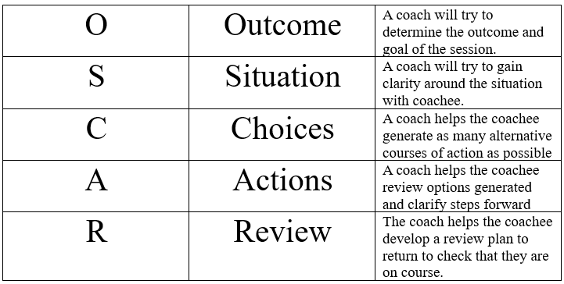
Whittleworth. (2002)

Appendix 3 - Landsberg’s Instant Pay-off Coaching Model (Script)

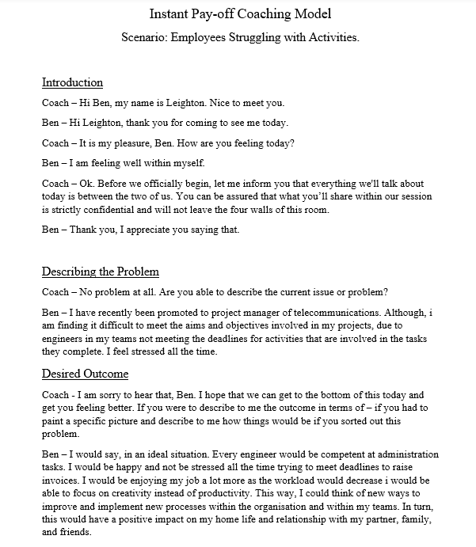

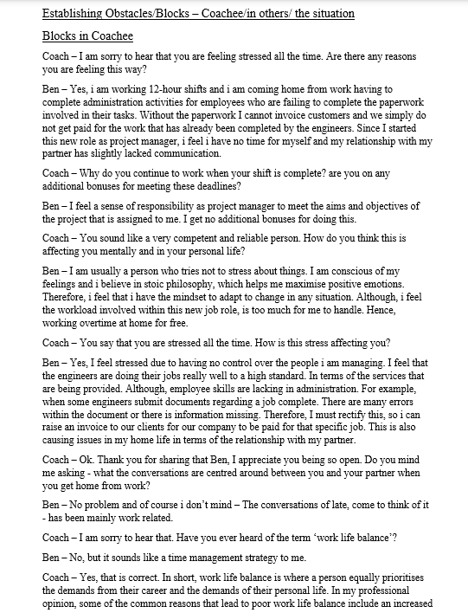
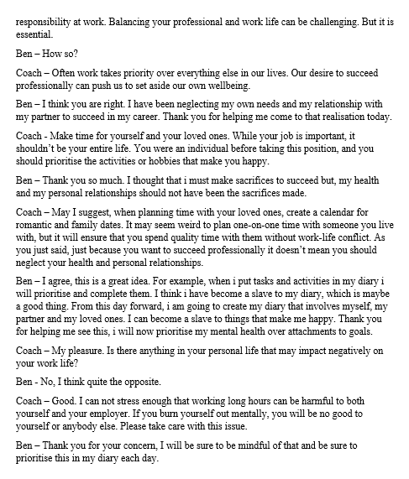

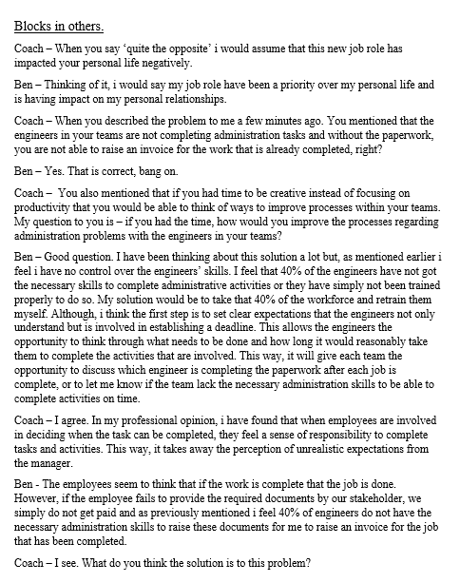
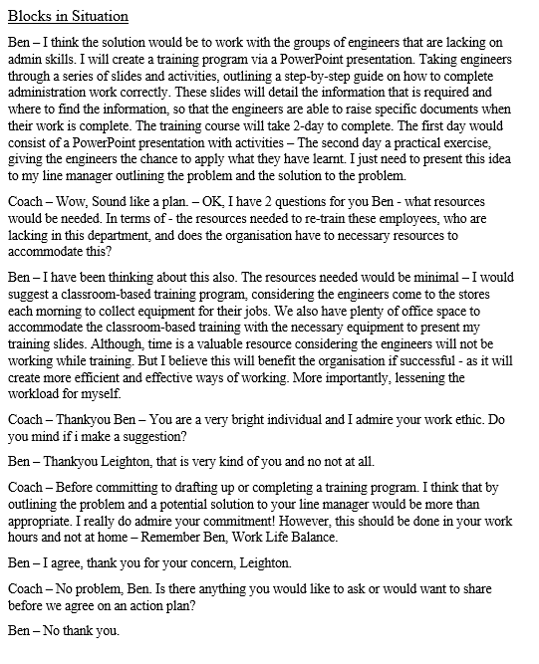

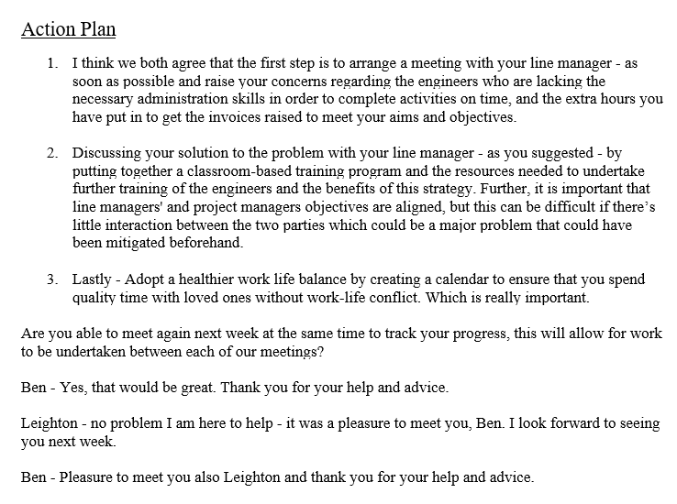
Landsberg, (2015)

Appendix 4 – Personal Development Plan (PDP)
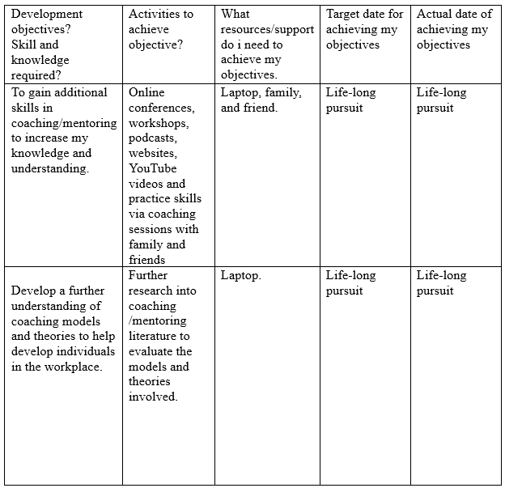

5.0 REFERENCES

Birt. (2022). 24 Reasons Why Mentorship Is Important for Mentee and Mentor. [Online]. www.indeed.com. Last Updated: 1 October 2022. Available at: https://www.indeed.com/career-advice/career-development/why-is-a-mentor-important [Accessed 22 February 2023].
Burton. (2022). How To Improve Your Coaching Skills: 6 Proven Methods. [Online]. thinkific.com. Last Updated: 8 March 2022. Available at: https://www.thinkific.com/blog/how-to-improve-your-coaching-skills/ [Accessed 07 February 2023].
Carter. (2006). Practical Methods for Evaluating Coaching. [Online]. INSTITUTE FOR EMPLOYMENT STUDIES. Available at: https://www.employment-studies.co.uk/system/files/resources/files/430.pdf [Accessed 02 February 2023].
CIPD. (2021). Coaching and mentoring Identify ways to apply coaching and mentoring principles as part of an overall learning and devel. [Online]. cipd.co.uk. Last Updated: 14 June 2021. Available at: https://www.cipd.co.uk/knowledge/fundamentals/people/development/coaching-mentoring-factsheet#gref [Accessed 24 February 2023].
CIPD. (2023). Line managers' role in supporting the people profession. [Online]. www.cipd.co.uk. Last Updated: 17 February 2023. Available at: https://www.cipd.co.uk/knowledge/fundamentals/people/hr/line-managers-factsheet#gref [Accessed 16 March 2023].
Clutterbuck. (2006). Creating a coaching culture. m Clutterbuck and Megginson, Making Coaching Work: Creating a Coaching Culture. 38(5), pp.233-235. [Online]. Available at: https://globalioc.com/wp-content/uploads/2019/01/Coaching-Culture-Clutterbuck-and-Megginson.pdf [Accessed 05 February 2023].
Coaching Federation. (2022). Building a Coaching Culture. [Online]. Coachingfederation.org. Last Updated: 2014. Available at: https://coachingfederation.org/research/building-a-coaching-culture [Accessed 02 March 2023].
Corporate. (2021). Invest and retain in 2021 – 5 reasons coaching & mentoring is more important than ever. [Online]. gbscorporate.com. Last Updated: 2021. Available at: https://www.gbscorporate.com/blog/invest-and-retain-in-2021-5-reasons-coaching-mentoring-is-more-imp [Accessed 20 March 2023].
Drahosz. (2021). Building resilience into your Mentoring Plan By: Kim Wheeler. [Online]. Linkedin.com. Last Updated: 23 April 2021. Available at: https://www.linkedin.com/pulse/building-resilience-your-mentoring-plan-kim-wheeler-kathy [Accessed 15 Feb 2023].
Fiona. (2021). What are the similarities and differences between Coaching and Mentoring? [Online]. fptrainingltd.co.uk. Last Updated: 26 March 2021. Available at: https://fptrainingltd.co.uk/what-are-the-similarities-and-differences-between-coaching-and-mentoring [Accessed 15 Feb 2023].
Forbes. (2018). Culture, Leadership, Performance: How Are They Linked? Rodger Dean Duncan Contributor I cover leadership issues that mak. [Online]. Forbes.com. Last Updated: 30 October 2018. Available at: https://www.forbes.com/sites/rodgerdeanduncan/2018/10/30/culture-leadership-performance-how-are-they [Accessed 14 March 2023].
Harvard Business Review. (2019). The Leader as Coach. [Online]. hbr.org. Last Updated: November 2019. Available at: https://hbr.org/2019/11/the-leader-as-coach [Accessed 15 March 2023].
Hurley. (2022). What Is Resilience? Your Guide to Facing Life’s Challenges, Adversities, and Crises. [Online]. Everydayhealth.com. Last Updated: 14 July 2022. Available at: https://www.everydayhealth.com/wellness/resilience/#:~:text=Resilience%20is%20the%20ability%20to,thr [Accessed 19 March 2023].
Indeed. (2022). 11 Coaching in the Workplace Examples. [Online]. www.indeed.com. Last Updated: 28 October 2022. Available at: https://www.indeed.com/career-advice/career-development/coaching-scenario-examples [Accessed 15 Feb 2023].
Institute of Coaching. (2009). Benefits of Coaching the Personal Benefits of Coaching. [Online]. Instituteofcoaching.org. Last Updated: 2009. Available at: https://instituteofcoaching.org/coaching-overview/coaching-benefits [Accessed 28 February 2023].
Institute of Coaching. (2023). Benefits of Coaching. [Online]. instituteofcoaching.org. Last Updated: 04 September 2023. Available at: https://instituteofcoaching.org/coaching-overview/coaching-benefits [Accessed 04 February 2023].
Kaufmann. (2021). The Dual Role of Manager and Mentor. [Online]. Labmanager.com. Last Updated: 3 February 2021. Available at: https://www.labmanager.com/leadership-and-staffing/the-dual-role-of-manager-and-mentor-24999 [Accessed 28 February 2023].
Kirsten. (2014). A New Way of Seeing Mentoring - benefits for mentors. [Online]. kmpplus.com. Last Updated: 2014. Available at: https://kmpplus.com/en/a-new-way-of-seeing-mentoring-benefits-for-mentors/ [Accessed 24 February 2023].
Kram. (2007). The Handbook of Mentoring at Work Theory, Research, and Practice. United States: SAGE Publications. pp.21-51.
Landsberg. (2015). The Tao of Coaching Boost Your Effectiveness at Work by Inspiring and Developing. 3rd ed. London: Profile Books. pp.32-47.
Landsberg. (2015). The Tao of Coaching Boost Your Effectiveness at Work by Inspiring and Developing. 3rd ed. London: Profile Books. pp.51-67.
Lee. (2022). Knowledge Base » Business » Effective Questioning Effective Questioning. [Online]. cpdonline.co.uk. Last Updated: 27 May 2022. Available at: https://cpdonline.co.uk/knowledge-base/business/effective-questioning/ [Accessed 28 February 2023].
Lyndhurst. (2016). Understanding the Behavioural Drivers of Organisational Decision-Making. [Online]. assets.publishing.service.gov.uk. Last Updated: March 2016. Available at: https://assets.publishing.service.gov.uk/government/uploads/system/uploads/attachment_data/file/5083 [Accessed 19 March 2023].
McCarthy. (2015). Coachable Moments: Identifying Factors that Influence Managers to take Advantage of Coachable Moments in Day-to-Day Ma. [Online]. Radar.brookes.ac.uk. Last Updated: 1 Feb 2015. Available at: https://radar.brookes.ac.uk/radar/file/13da4487-218b-4571-bb48-c08ec918e46b/1/vol13issue1-paper-01.p [Accessed 18 March 2023].
Megginson. (1999). Making Coaching Work Creating a Coaching Culture. London: Chartered Institute of Personnel and Development. pp.42-69.
Megginson. (1999). Making Coaching Work Creating a Coaching Culture. London: Chartered Institute of Personnel and Development. pp.77-91.
Parsloe. (1999). The Manager as Coach and Mentor. 2nd ed. United Kingdom: Institute of Personnel and Development. pp.41-59.
Pratt. (2023). What is change management? [Online]. Techtarget.com. Last Updated: 2023. Available at: https://www.techtarget.com/searchcio/definition/change-management [Accessed 19 March 2023].
Richardson. (2021). The Role of Line Managers In Coaching & Development. [Online]. Development-academy.co.uk. Last Updated: 2 July 2021. Available at: https://development-academy.co.uk/news-tips/role-of-line-managers-in-coaching-development/ [Accessed 7 March 2023].
Whitmore. (1993). Coaching for Performance a Practical Guide to Growing Your Own Skills. United Kingdom: John Wiley & Sons, Incorporated. pp.22-34.
Whittleworth. (2002). The OSCAR Coaching Model. United Kingdom: Worth Consulting Ltd. pp.38-54.
Wickford. (2019). Negative Impact of Organizational Change on Employees. [Online]. smallbusiness.chron.com. Last Updated: 31 January 2019. Available at: https://smallbusiness.chron.com/negative-impact-organizational-change-employees-25171.html [Accessed 19 March 2023].

