DS1 Assessment My Digital Life
Student ID: 2438385

Screenshot 1: Phone Home Screen
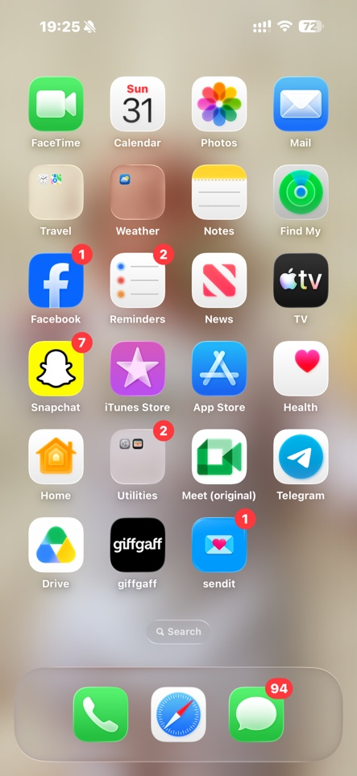
This screenshot shows part of my digital life and the apps I use regularly on my phone. I use Snapchat and Facebook to communicate with friends and family and stay connected with others. I use the Mail app to receive important messages and information related to my studies and personal life. I also use the App Store to download and update apps that help me with everyday tasks. This shows that digital technology is an important part of how I communicate, access information, and manage daily activities.

Screenshot/Photo 2: Calender App
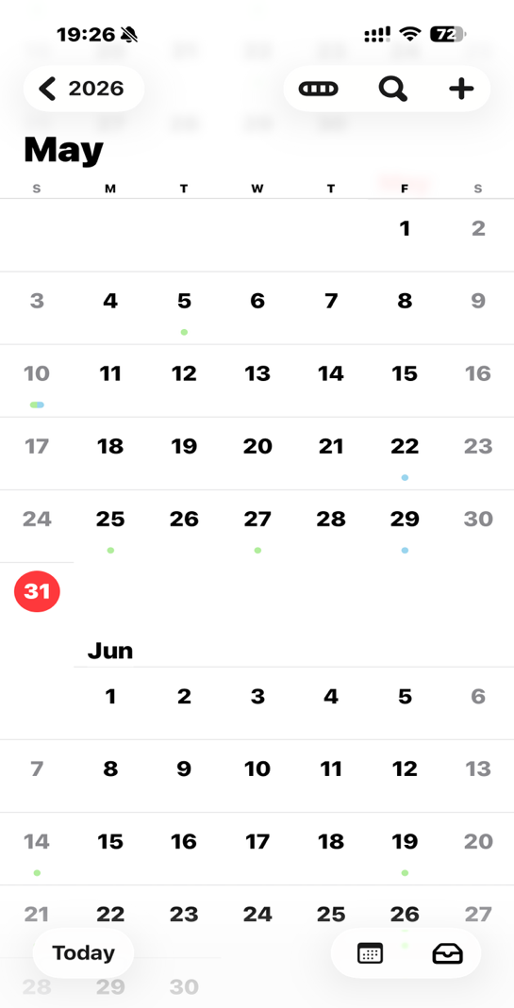
This screenshot shows the calendar app that I use regularly to organise my schedule. I use the calendar to keep track of important dates, appointments, study deadlines, and personal events. I am confident in using the calendar to manage my time and set reminders for important tasks. I would like to improve my time management skills by planning my schedule more effectively and using more of the calendar's features. These skills are important because they help me stay organised, meet deadlines, and balance my studies with other responsibilities.

Screenshot/Photo 3- Youtube
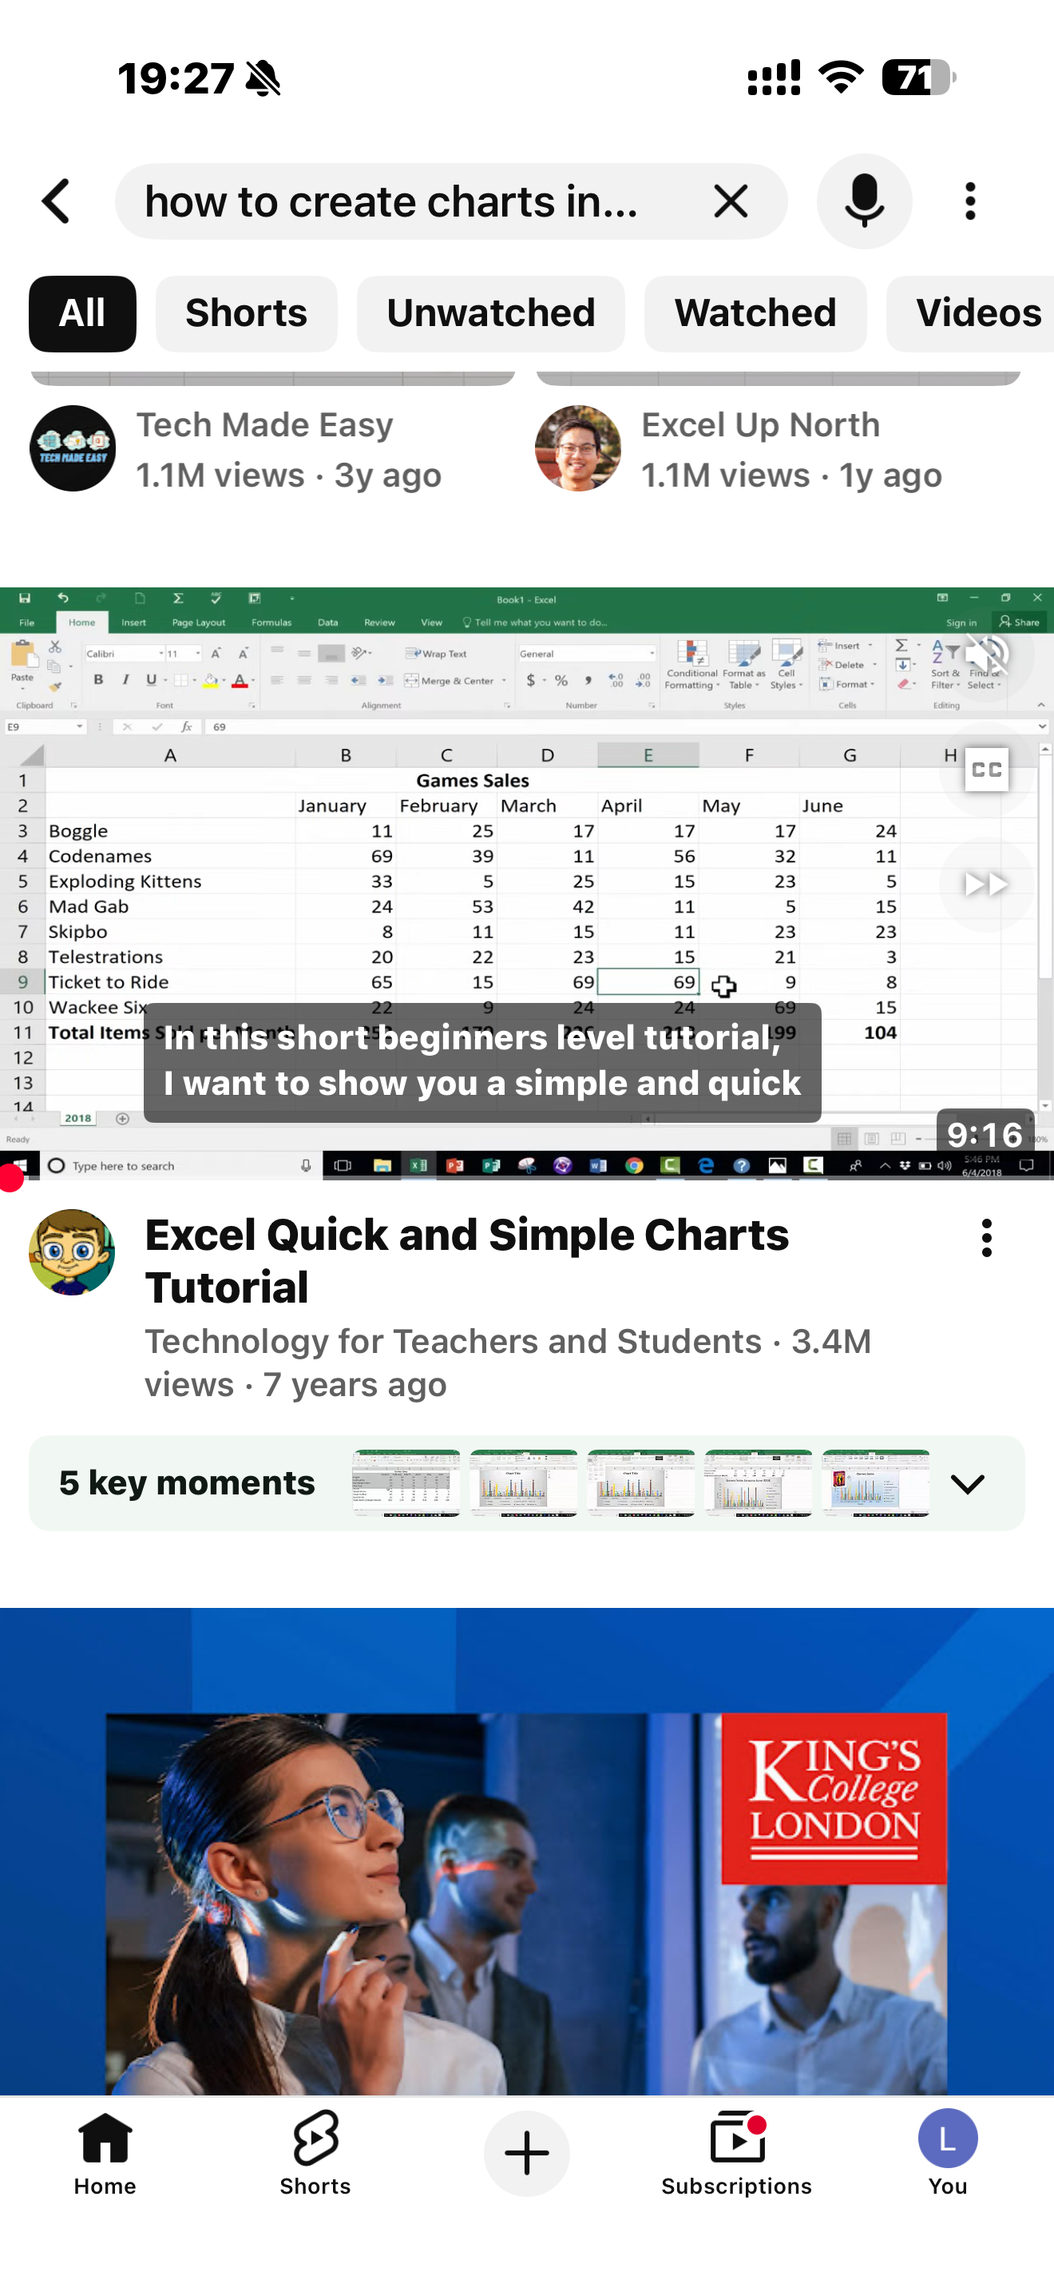
This screenshot shows how I use YouTube as part of my digital life to learn new skills. In this case, I was using a video tutorial to understand how to create charts in Excel. It shows that I use digital platforms not only for entertainment but also for learning and improving my academic skills. This helps me develop my knowledge of software tools and supports my studies by allowing me to follow step-by-step guidance at my own pace.

Screenshot/Photo 4 – Laptop showing Email
[Insert Photo/Screenshot below]
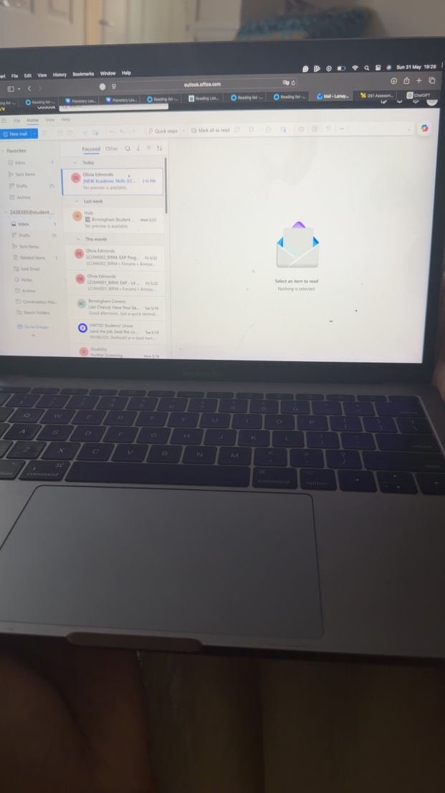
This screenshot shows my laptop with my email open, which is part of my digital life. It shows that I use email as an important tool for communication, especially for my studies. I use it to receive and send messages, stay updated with important information, and communicate with tutors and classmates. This demonstrates that I rely on digital tools to stay organised, informed, and connected in both my education and daily life.

My Short Reflection

My digital life involves using a range of tools every day on my phone and laptop. I use apps like Snapchat and Facebook to communicate with friends and family. I use email to send and receive important messages for my studies. I also use my calendar to organise my time and keep track of deadlines and appointments. I use YouTube to learn new skills, such as how to use Excel and create charts. I also use online platforms like Moodle to access my course materials and submit my assignments. I use my phone and laptop every day to complete both personal and academic tasks. These digital tools help me stay connected, organised, and informed. They also make it easier for me to manage my studies and daily responsibilities. I feel confident using basic digital tools, but I would like to improve my skills in using software like Excel and managing my digital work more efficiently. I also want to become more confident in using advanced features of different applications.
Digital skills help me with my studies by making it easier to access learning materials, complete assignments, and communicate with tutors. In business or work, digital skills are important for communication, organisation, and completing tasks efficiently using different software. Improving my digital skills is important to me because it will help me become more confident, perform better in my studies, and prepare for future job opportunities.

Submission Checklist
Before you submit, please check:
​​​ ☒ I added 4–6 screenshots
☒ I wrote short sentences for each screenshot
☒ I wrote my short reflection
☒ My work is my own
☒ My file opens correctly
​​☒ My file opens correctly

