
Student name | Md Akramul Haque Nayeem Sarker
Student ID | 2436020
Programme name | Master of Business Administration
Module | Strategic Management
Module Code | LCMB7003
Assignment title | Assessment: Individual Report - Decathlon
Lecturer’s name | Amare Desta
Word count | 5433
Submission date | 13.12.2025

Table of Contents
Introduction 3
Section 1: Selection of Organisation and Target Market 4
1.1 Introduction to Decathlon 4
1.2 Justification for Target Market: Bangladesh 5
1.3 Rational for the Decision 6
Section 2: Comprehensive Strategic Analysis 7
2.1 Macro-Environmental Analysis (PESTLE) 7
2.2 Industry/Competitive Analysis (Porter’s Five Forces) 10
2.3 Performance Analysis (SWOT Analysis) 12
2.4 Insights and Strategic Implications 13
Section 3: Strategy Development and Formulation 15
3.1 Strategic Direction and Rationale 15
3.2 Entry Strategy Options 15
3.3 Market Entry Mode Recommendation 16
3.4 Competitive Positioning (Porter’s Generic Strategies) 18
3.5 Strategic Fit and Capability Assessment (VRIO Analysis) 19
3.6 Strategy Implementation Components 21
3.7 Risk Analysis and Mitigation 23
Section 4: Performance Evaluation Framework 24
4.1 The Balanced Scorecard Framework 24
4.2 Triple Bottom Line (TBL) Integration 25
4.3 Monitoring and Mechanisms of Governance 26
Conclusion 28
References 29

Introduction
Decathlon, a sports-goods retailer with a global lead, is interested in expanding its business in Bangladesh, the country where the number of people with middle-income and promising future grows, where the young population starts to pay more and more attention to sport and fitness (Decathlon, 2025). In this report, an analytical framework is provided that can be used to lead the entry of Decathlon. It employs PESTEL, Porter's Five Forces, SWOT, and the Balanced Scorecard to evaluate competition, institutional and market forces. The report also provides an evidence-based expansion plan, which is a combination of financial, operational and sustainability to ensure that Decathlon can realise long-term growth and a competitive edge in Bangladesh.

Section 1: Selection of Organisation and Target Market

Introduction to Decathlon
Decathlon S.A. is one of the world’s largest integrated sports retailers, founded in France in 1976 (GlobalData Plc, 2021). It has more than 1700 stores in over 70 countries (Decathlon, 2024). It has successfully combined product design, logistics, and retail based on its commitment to making sports accessible to everyone (Decathlon, 2025). It ensures affordability and quality through its broad product portfolio and executes a vertical integration model to conduct an effective supply chain.

Figure 01: Decathlon
Source: (Decathlon, 2025)
Decathlon follows a democratization strategy to make sports accessible to the many by removing sports participation barriers (DataReportal, 2025). Hence, its vision is to ensure sustainability, inclusivity, and promote the well-being of both physical and mental, as well as innovation (Decathlon, 2023).
Decathlon implements its internationalization strategy based on deliberate intention and thorough research (Prakash, 2025). At first, it expanded and established the business in European markets. Afterwards, it focused on India and China because these countries have large youth populations and increasing disposable incomes (GlobalData Plc, 2021).

Justification for Target Market: Bangladesh
Bangladesh, being a strategically aligned and high-growth opportunity, is a new target market for Decathlon to achieve its mission of making sport accessible to the many.
Economic and Demographic Potential
Bangladesh is showing a robust economic performance and favourable demographic trends, gradually, for the international expansion of a business like Decathlon. Over the past few decades, the country’s average growth rate of GDP has been 6-7% (Chauhan, 2025). More than 60% of its total population, which is approximately over 170 million, is under the age of 35 (DECATHLON, 2021). Hence, Decathlon will have a customer base who are interested in fitness, sports, and recreation.
Emerging Sports and Fitness Culture
The youth in Bangladesh is shifting towards health consciousness and sports participation. Hence, cricket, badminton, cycling, football, and so on, all kinds of sports are getting popular day by day (Decathlon, 2024). In addition, the government also initiated the National Sports Policy 2020. Hence, it would be an ideal opportunity for Decathlon (New Age BD, 2025).
Market Gap and Competitive Advantage
Local retailers and small-scale importers are mainly dominating markets, which leaves the sporting goods retail market underdeveloped and fragmented. Though Nike, Puma, and Adidas products are shown to an extent in the market, they target high-income customers (PowerCommerce, 2024). Therefore, Decathlon can grasp this significant market gap where it can offer its mid-range, affordable, and high-quality products with a renowned brand image.
Favourable Business Environment
Bangladesh’s government has introduced Vision 2041, which is focused on retail sector expansion, digitalization, and industrial growth (Prakash, 2025). Hence, it has favourable trade liberalization policies along with continuous improvement in infrastructure to attract foreign investment.

1.3 Rational for the Decision
This is an almost unestablished sports retail market, but expanding rapidly- primarily due to a larger proportion of youth desiring to participate in sport and remain physically active. It is large with a market size approaching $600M and a forecasted growth rate of 7-8% per year (New Age BD, 2025). Cities such as Dhaka, Chittagong, and Sylhet have the majority of the demand, as the middle class is seeking branded equipment. Nevertheless, the market is extremely fragmented, with informal retailers and small importers controlling sales channels, which provides strong opportunities for structure, quality-oriented international entrants, such as Decathlon (PCMI, 2024).
Exiting competitors and market segmentation
Domestic companies like Bata and Apex footwear have good brand recognition in the sports and casual footwear market, but do not have a wide line of equipment (Goswam, 2024). A few premium global brands, Nike, Adidas, and Puma serve up-end consumers through distributors or franchises in several cities (DataReportal, 2025).
Decathlon’s competitive advantage
The all-in-one model, design, make, sell, which Decathlon has chosen, allows them to maintain a low cost and high quality, which distinguishes them among the poser brands and the low-cost locals (Feldman, 2020). They encompass more than 70 sports, thus they can satisfy an enormous array of different tastes (Decathlon, 2024a). Besides, their community-spotlight strategy, conducting workshops and events, might result in a significant increase in loyalty and resonance with Bangladeshi youth.

Section 2: Comprehensive Strategic Analysis

2.1 Macro-Environmental Analysis (PESTLE)
PESTLE analysis will assist Decathlon to analyse the external macro-environmental factors in the Bangladesh sports retail market, hence identifying potential opportunities and threats and making strategic decisions.
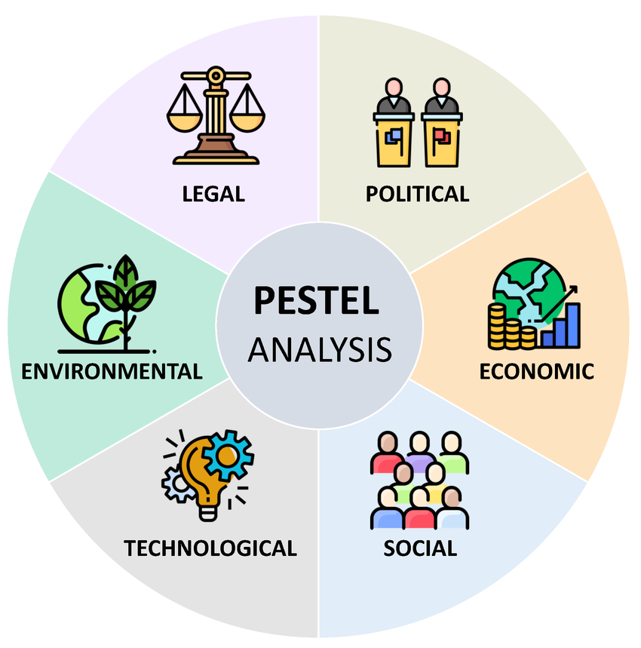
Figure 02: PESTLE analysis
Source: (PCMI, 2024)
Political
Bangladesh is currently vulnerable to political instability, emulating the 2024 student-led demonstrations that toppled the long-standing ruling regime and saw the formation of a government of transition (PCMI, 2024). This interim government has promised electoral and governance reforms, and national elections are to be held in 2026; however, episodic unrest and demonstrations remain on the increase and create a short-term lack of predictability in business operations (DataReportal, 2025). Political volatility enhances operational risk by impacting it, interim curfews and transport disruption, and could negatively affect investor sentiment, regulatory continuity, and consumer confidence in the short run (Reuters, 2025a).
Economical
Bangladesh remains a high-growth emerging economy that has moderated growth. Predictions of the 2024-25 growth in the gross domestic product of the countries are multilateral, within the mid-single-digit range, as ADB projections are at about 3.9% in FY2025, with a predicted recovery of FY2026-27 (Research and Markets, 2025). According to the IMF and World Bank updates, a heterogeneous recovery is taking place, where inflationary pressure continues to exist, and challenges exist in outside financing (World Bank, 2015). The GDP per capita is low in comparison with the world standards, around US$2.5-2.6K in 2024 (PCMI, 2024). These macro trends indicate the rise of a larger middle-class consumer market of cheap branded products, though in the short term, consumer purchasing power is vulnerable to inflation and currency fluctuations (Witcher, 2019).
Social
One of the strategic resources that Bangladesh possesses is that of demographics. It is estimated that there are about 175-176mm people in the country and a highly youthful population, as the census data released in 2022 shows that around 28% of the population is 15- 29 (Invest Bangladesh, 2022). The high number of young people is a rich group of consumers within the sports, active-lifestyle consumer and brand adoption sectors. The pace of urbanisation is increasing, with Dhaka and Chattogram becoming large consumer centres (Reuters, 2025a). At the same time, there is growing awareness of health and fitness, through growing involvement in organised sport, and growing focus by governments on sport development in youth (David and David, 2019).
Technological
Digital infrastructure has been growing very fast. There are about 44-45% or 77-78million users in early-2025 internet penetration, and tens of millions of mobile-internet subscriptions today (Reuters, 2025a). This has developed large-scale e-commerce and cross-channel prospects. Digital transactions and mobile payments have increased significantly in 2024-25 (Makadok et al., 2018). Such signalling opens opportunities to mobile-first retail and verifies the need to facilitate cash-on-delivery, local payments, and solid last-mile logistics.
Environmental
The issue of urban heat and environmental degradation in major urban centres is becoming a significant problem that affects consumer behaviour, such as outdoor sporting activities and the resilience of infrastructure, as well as that of supply chains, especially at ports and transport nodes (Reuters, 2025b). As a result, in the case of Decathlon, the environmental risk will necessitate the creation of climate-resistance sourcing and logistics, sustainable store formulation, and corporate social responsibility programmes like recycling programmes, thus aligning with the local focus and reducing reputational risk (Daniels and Radebaugh, 2016).
Legal
The regulatory environment is evolving positively in areas like investment promotion. Such as Vision 2041 and BIDA initiatives; however, the current political transition increases the level of short-term regulatory uncertainty (Invest Bangladesh, 2022). The rules of importation, tariffs, and labour standards are relevant to sourcing to retail and local manufacturing relationships, such as the recent minimum-wage changes in the garment industry. The flows of foreign direct investment faltered in 2024 and 2025 as it stem from macroeconomic stress and political uncertainty that can, or might, affect new entry incentives and the conditions of new entry sources of finance (Unifab, 2025).

2.2 Industry/Competitive Analysis (Porter’s Five Forces)
According to the Five Forces framework, the market environment within Bangladesh is advantageous in terms of size and growth opportunities, but is also competitive regarding price and customer bargaining power (World Bank, 2015).
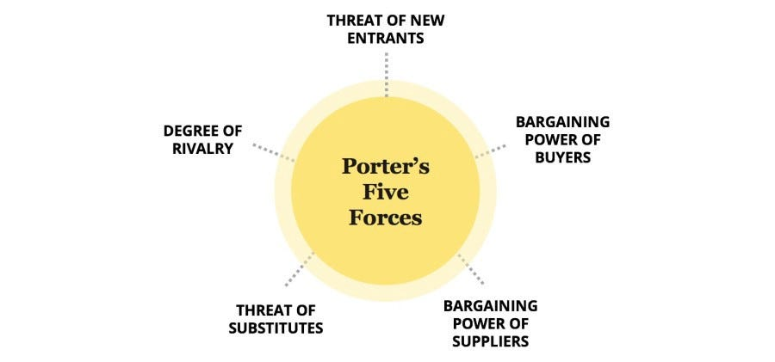
Figure 03: Porter’s Five Forces model
Source: (Grant, 2021)
Industry Rivalry
The sports goods market in Bangladesh is currently fragmented, but it is experiencing intense competition, especially (Grant, 2021). Local manufacturers and retailers, including Bata and Apex, Walkar/PRAN-RFL group and smaller importers, constitute the market structure. Besides, a small number of premium international brands, namely Nike, Adidas and Puma, are distributed selectively via third parties, and informal market channels offering low-cost alternatives (Rabetino et al., 2021). This fragmented structure generates severe price rivalry in the mass-market segments as it creates differentiation contests in the luxury segments, giving the overall competition such high to moderate intensity of rivalry (Worldometer, 2025).
Threat of New Entrants
Capital spending of large-format stores and omnichannel logistics is moderate, but the greatest obstacles are positions in building solid supplier networks, achieving economies of scale, and earning customer confidence (Prakash, 2025). However, regulatory compliance, importation charges, locale choice in flood-prone areas, and the need to have a subtle grasp of regional market dynamics combine to increase the cost risk profile of potential entrants (Rabetino et al., 2021).
Bargaining Power of Suppliers
The supplier power in Bangladesh is also relatively low for a global retailer like Decathlon. The vertically integrated model of Decathlon, combined with its growing sourcing obligations in the region, particularly increased sourcing goals in India, enables the vertical to negotiate favourable terms and sourcing to switch suppliers when required (Decathlon, 2023). Local supplier quality and compliance variability also cause extra expenses, such as quality control and audit costs that need to be well-planned (PowerCommerce, 2024).
Bargaining Power of Buyers
In Bangladesh, buyers are highly price-sensitive and increasingly becoming digitally fluent. The mass market segment improves buyer power because there are more informal marketplaces with significantly lower prices (Lynch, 2021). In parallel, the fast growth of e-commerce and mobile penetration, with widespread cellular coverage and a large population with access to the internet, means that consumers with increased choices and increased price transparency, thus increasing their bargaining power through the online medium (GlobalData Plc, 2021). Therefore, buyer power is high, especially on commodified products like basic clothing and footwear.
Threat of Substitutes
Alternatives in the sporting goods industry are created due to a combination of many different sources, including generic clothing and treadmills distributed by the traditional shops, second-hand or counterfeit products sold at informal locations, sport-related services, like gymnasium memberships including equipment use, and lower-cost products of a local nature (Lynch, 2021). Although substitute products do not fully replace the product range of Decathlon, they bring constraints to pricing and margin potential, especially among lower-income groups (Chauhan, 2025). The threat of substitutes poses an intermediate threat because consumers can use alternatives informally or access the services rather than owning them.

2.3 Performance Analysis (SWOT Analysis)
Strengths
The core competitive strength of Decathlon is the vertically integrated business model that enables the execution of cost-effective pricing based on the large-scale procurement worldwide and proprietary brands (Amason and Ward, 2020). Its multi-sport brand portfolio fabric with more than 70 sports, gives good differentiation compared to the fragmented local retailers that generally specialise in footwear or cricket gear. Decathlon has another strategic strength of advanced international logistics and omnichannel capability (Reuters Staff, 2025). Besides, the company already has South Asian manufacturing presence, and the Bangladeshi textile and clothing industry already supplies 85‛% of export revenues, thus presenting local production opportunities that will optimise the costline and strengthen the brand name Made in Bangladesh (DataReportal, 2025).
Weaknesses
In spite of such advantages, Decathlon has some internal challenges. First, it is an inexperienced brand in the mass market in Bangladesh, where informal purchasing patterns and local retail relations of trust prevail (Lynch, 2021). Second, the pricing model of the company is considered as premium by the lower-income groups, and approximately 18.7% of the people in Bangladesh live below the country's poverty line (DataReportal, 2025). Another weakness is dependence on large-format stores. Within cities, particularly Dhaka, business rent rates are increasing, and roads are congested, which increases the cost of doing business and complicates moving inventory (Adekola and Sergi, 2016).
Opportunities
Bangladesh provides good growth opportunities due to good macroeconomic and demographic trends. According to ADB Outlook, GDP will recover 5.7% in FY2025 due to urbanisation and the increased consumption of the middle classes (New Age BD, 2025). The trend of wellness, fitness apps and gym subscriptions opens business chances for Decathlon to introduce sports community, events and training workshops. Local sourcing through the strong apparel industry in Bangladesh can reduce importation taxes and transportation expenses, enhance ESG positioning, and provide Decathlon with an advantage over imported brands (Sharma et al., 2020).
Threats
There are formal and informal competitors as external threats. Informal markets such as Bangabazar and New Market offer extremely cheap goods, which are becoming more buyer-powerful and are tightening the margins of Decathlon (Decathlon, 2025). There is also a high prevalence of counterfeit sportswear, with 20-25% of branded items in circulation being imitations (Research and Markets, 2025). International brands like Adidas and Nike have fewer stores, but high aspirational value enables them to effectively compete in the high-end markets.

2.4 Insights and Strategic Implications
This part summarises the reports of the PESTEL, Porter's Five Forces, and the SWOT analyses with an aim of pointing out the most crucial strategic recommendations determining the future market penetration of Decathlon in Bangladesh.
Key Insights from the External Environment
Bangladesh is a high-growth but structurally complex environment. Such macroeconomic factors as a forecasted GDP growth of 5.7% in FY2025 and a young demographic composition, 61% under the age of 35 years, imply huge long-term market opportunities for sports retail (Reuters, 2025a). Increasing urbanisation and the spread of the middle class increase the demand of cheap sportswear even more, which coincides with the value offer of Decathlon (New Age BD, 2025).
Nonetheless, the PESTEL analysis indicates certain challenges, such as 9% inflation, high importation levies on finished products, between 30 and 60%, and infrastructural limitations as far as logistics and overcrowding in major cities are concerned (Statista, 2025b). The Porter's Five Forces give a moderate level of competitive force, with informal markets and fake goods having intense negative pressure on pricing (PCMI, 2024). According to the SWOT analysis, despite the high cost-leadership potential that Decathlon has, brand weakness and the massive store format also need to be adjusted (Alcácer et al., 2016).
Market Entry Strategy Implications
Firstly, a hybrid sourcing model, where Decathlon buys imported goods and partners with a local regional manufacturing sector within the Bangladesh textile industry, one of the most available globally, will reduce its sourcing costs by 20 to 30% or cut costs completely to counter importation duties and economic fluctuations (Shenkar et al., 2021).
Secondly, community-based retailing, by providing sports events, coaching clinics, and partnerships with schools, should be adopted by Decathlon to attain trust and visibility (Decathlon, 2025). The integration of the channels is particularly important due to the increasing adoption of digital tools in Bangladesh, where the number of e-commerce users is expected to reach 46 million by 2025 (The Daily Star, 2025).
Lastly, infrastructure constraints suggest that Decathlon will need to change its store footprint, adding medium stores, click-and-collect hubs, and digital kiosks, to guarantee an efficient operation (Chauhan, 2025).

Section 3: Strategy Development and Formulation

3.1 Strategic Direction and Rationale
The strategic orientation taken by Decathlon of Bangladesh is based on the market-development dimension of the Growthmatrix of Ansoff, whereby the organisation projects its established multi-sport retail model into a young international market (Henry, 2021). The main emphasis lies in getting a strong first-mover edge in the affordable international sporting goods market, exploiting the growing middle class in Bangladesh, rising sports participation, and the lack of structured retail (ECDB, 2017).
Strategic Objectives
The strategy of expansion will be supported with the set of SMART (Specific, Measurable, Achievable, Relevant, Time-bound) goals:
Market Penetration Objective: Within the first three years of market entry, it will achieve a 5% market share in the urban sporting goods retail segment by expansion of stores and omnichannel retailing (Chauhan, 2025).
Operational Objective: Within 24 months, it will have a local distribution centre to reduce logistics by at least 20% versus complete import dependency (The Daily Star, 2025).
Brand Development Objective: It can build strong brand awareness and involvement with the community by hosting more than 100 sporting events each year, and establishing links with schools, gyms, and sports organisations (Decathlon, 2024a).
Financial objective: It will achieve break-even within the fourth year due to effective management of inventory, sourcing locally, and minimising format stores (PCMI, 2024).
Sustainability Goal: It will procure at least 30% of apparel quite locally by the third year to offload import taxes and strengthen the ESG position (Decathlon, 2025).

3.2 Entry Strategy Options
Below, some options are discussed to detect a suitable entry strategy for Decathlon.
Wholly Owned Subsidiary
High commercial real estate costs, importation fees of about 30-60% on finished sportswear, and the bureaucratic nature of Bangladesh make a pure direct entry strategy a costly decision with great risks (Statista, 2025a). Such a strategy may be viable in the long term, but it may slow down initial penetration of the market.
Joint Venture (JV) with a Local Partner
This business approach is marketed favourably along with the informal-based retail leading and trust-based buying culture in Bangladesh (Boon et al., 2018). The joint-venture (JV) model also allows Decathlon to leverage local sourcing relationships in the USD 47 billion textile and apparel industry, hence reducing reliance on imports and aggregate product prices (The Daily Star, 2025).
Franchise Model
The franchise model has a simple entry requirement and easy expansion to more cities. However, franchisees are unlikely to recreate the community-oriented store atmosphere, in-store testing paradigm, or the technical skill essential to Decathlon, thus risking brand dilution in the new environment (Hayes, 2022).
Considering the risk-reward trade-offs, institutional aspects, and the cost-leadership status of Decathlon, the joint-venture model is the most suitable entry strategy, offering a concession between strategic control, local market adaptability and moderated regulatory barriers (Reese, 2020).

3.3 Market Entry Mode Recommendation
This part discusses the entry mode of Decathlon into the Bangladesh market based on Dunning's OLI Paradigm.
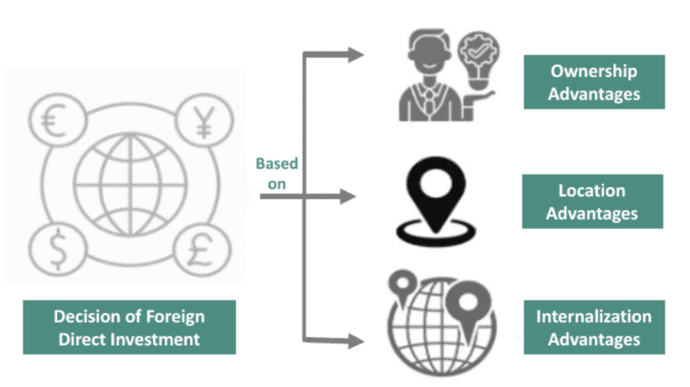
Figure 05: Dunning's OLI Paradigm
Source: (Reese, 2020)
Ownership Advantages
Decathlon has strong ownership-specific strengths, namely, its vertically-integrated business model, in-house brands, such as Quechua, Kipsta, and Domyos, developed R&D, and global supply-chain effectiveness (The Daily Star, 2025). These strengths allow Decathlon to maintain price levels that are 30-40% lower than the competing international brands in emerging markets (Statista, 2025b). Its integration into e-commerce networks and strong digital platform offers it an ownership edge, given that the e-commerce customer base in Bangladesh should surpass 50million users by 2026 (The Daily Star, 2025).
Location Advantages
Bangladesh has some such attractive location factors, including a rapidly expanding middle class that is projected to grow to 25 million by 2030, a young population of more than 61% below the age of 35 that drives sporting and fitness demand, an already competitive global textile and apparel sector capable of supporting local sourcing, and urban retail growth in Dhaka and Chattogram, where modern shopping malls and mixed-use developments are rapidly expanding (Research and Markets, 2025). Nevertheless, expensive import taxes on sporting equipment, usually 30-60%, infrastructure overload, and policy instability increase operational risks, which favour an entry mode where a domestic partner can make it through bureaucracy (Prakash, 2025).
Internalization Advantages
According to internalisation theory, Decathlon must maintain control over branding, pricing, training and supply-chain systems to protect product quality and prevent imitations (Narula et al., 2019). The lack of unity in the retail market and the high level of counterfeiting in Bangladesh also support the argument of internalising core functions over licensing (Reese, 2020).
Recommendation
According to OLI, a joint venture (JV) is the best entry mode. The JV is able to operate flagship stores and an omnichannel platform, and Decathlon internalises important design, supply-chain, and merchandising (Batschauer da Cruz et al., 2022). This hybrid structure reduces the institutional risk, accelerates the market penetration and preconditions the further wholly owned development in case market stasis and brand awareness increase (Engert et al., 2016).

3.4 Competitive Positioning (Porter’s Generic Strategies)
Porter’s Generic Strategy: Cost Leadership with Differentiation
The cost leadership approach will work best in Bangladesh, where more than 56% of consumers consider affordability the most prominent buying argument (GlobalData Plc, 2021). By offering high-quality products at affordable prices, Decathlon can contrast with non-institutional cheap sellers and high-quality global brands like Nike and Adidas, who currently operate mainly via distributors (Batschauer da Cruz et al., 2022).
Nevertheless, Decathlon also embraces various aspects of differentiation, including experience zones of retail outlets, sports workshops, and multi-sport options (Decathlon, 2023). Those experiential aspects lack in the fragmented retail environment of Bangladesh and allow Decathlon to create a unique value offer that combines affordability and innovation.
Resource-Based View: Leveraging Core Capabilities
According to the resource-based perspective, Decathlon has strong tangible and intangible resources that can be utilised to achieve sustainable benefits (Engert et al., 2016). Its international research and development network, advanced supply chain solutions, and own brands, such as Quechua, Kipsta, Kalenji, are valuable, rare, inimitable, and non-substitutable (VRIN) capabilities (The Daily Star, 2025). Incorporating local sourcing in Bangladesh's USD 47 billion textile and apparel sector can mitigate the impact of import duties, improve cost competitiveness, and improve the ESG positioning due to local employment (Mintzberg et al., 2020).
Strategic Outcome
Cost leadership combined with experiential differentiation and the resources enabled by VRIN can enable Decathlon to achieve a long-lasting competitive advantage that both informal markets and premium brands can hardly copy (Kraus et al., 2020). This twofold approach makes the company the most convenient and reliable multi-sport retailer in Bangladesh.

3.5 Strategic Fit and Capability Assessment (VRIO Analysis)
This part assesses the fundamental resources and capabilities of Decathlon through the VRIO framework to decide whether they can be used to continue achieving a competitive advantage in the Bangladeshi market.
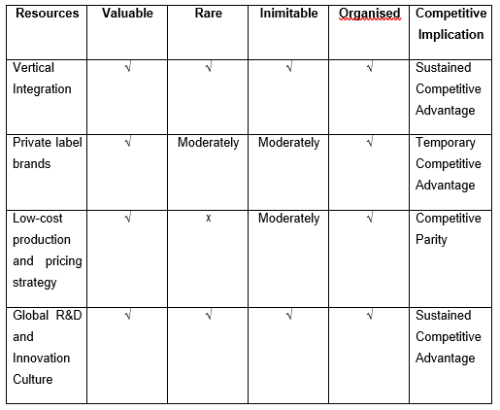
Figure 04: VRIO analysis for Decathlon
Source: (Decathlon, 2025)
Decathlon has a number of priced and unique abilities, which strongly position it to grow in Bangladesh (Feldman, 2020). Its business model is vertically entity-based as the product design, manufacturing, logistics, and stores come under one umbrella, and this provides cost efficiency and facilitates low pricing that is essential in a price-conscious market (Decathlon, 2025).
Besides, the high brand equity that Decathlon has through its own-label products, such as Kalenji, Quechua, and Kipsta, helps in the differentiation and maintains a cost advantage (Baumgartner and Rauter, 2017). Together with its innovation culture and customer-oriented culture, one of which is in-store product testing, these strengths will give Decathlon a sustainable competitive edge as it transitions into the Bangladeshi market (Feldman, 2020).

3.6 Strategy Implementation Components
This section outlines the systematic, stage-based operationalisation of the market entry and competitive strategy that Decathlon will use in Bangladesh.
 | Initiatives | Description | Time period
Phase 1 | Market penetration and Partnerships | The initial phase focuses on the legal, strategic and operational basis. Decathlon will institutionalise a joint venture with a respected Bangladeshi firm to capitalise on regulatory savvy, land procurement connections and cultural understanding (Goswam, 2024). A feasibility test will be undertaken during this period to establish the best sites in Dhaka, Chattogram and Sylhet where purchasing power is strong, and sports participation is on the rise (The Daily Star, 2025). At the same time, Decathlon will apply to the Bangladesh Investment Development Authority (BIDA) and start negotiating with local textile and apparel producers seeking cost-effective sourcing (Shafiul, Md. Iftekharul Amin and Md. Shariful Islam, 2024). | 1-6 months
Phase 2 | Infrastructure, Supply Chain, and Store Rollout | Decathlon will set up a central distribution centre (CDC) close to Dhaka so that it can simplify the logistics, minimise last-mile delivery expenses and facilitate the activities of the omnichannel (Rabetino et al., 2021). In view of the continuous modernisation at Chattogram Port, it will adopt a hybrid import-local sourcing model to reduce reliance on high import taxes and supply chain delays (Shafiul, Md. Iftekharul Amin and Md. Shariful Islam, 2024). The rollout of the stores will start with 2 flagship stores, about 1,500-2,000 sqm, which will be complemented by a scalable e-commerce platform that can be adjusted to the rapidly growing online retail market in Bangladesh (DataReportal, 2025). Local staffing and training will be via the Decathlon Sports Leader model that will guarantee regular services and participation of the community. | 7-24 months
Phase 3 | Marketing, Brand Building, and Expansion | The community-based sports events, school partnerships, and collaboration with the local sports federations will expedite brand awareness in decathlon (Cornelissen, 2023). The aim is to undertake more than 100 sporting workshops in one year, hence building trust and visibility (Decathlon, 2025). | 24-36 months

3.7 Risk Analysis and Mitigation
Political and Regulatory Risks
Its operations can be influenced by occasional policy changes, changes in importation duties, and red tape. Business continuity may be temporarily interrupted by political swings (Rachmad, 2022). Meetings periodically with BIDA, local chambers and industry organisations assist in foreseeing regulatory changes. An emergency supply-chain redirection plan will ensure operations remain uninterrupted (Invest Bangladesh, 2022).
Economic and Financial Risks
Economic and financial risks consist of low currency and inflation. The inflation rate in 2024 was approximately 9% declining consumer buying capacity, and narrowing the margins (New Age BD, 2025). To safeguard pricing and profitability, Decathlon needs to divide local production with some imports, plus selectivity and hedge against fluctuations in currency and alleviate expenses on duties.
Supply Chain and Infrastructure Risks
The overcrowding of Chattogram Port, the inconsistency of the time needed to clear customs, and the heavy traffic jam in Dhaka all present serious obstacles to inventory movements and distribution quality (Ecdb.com., 2017). To alleviate these risks, Decathlon must form a central distribution centre nearby to Dhaka, supported by advanced warehouse management systems and a system of numerous transport partners (Cornelissen, 2023).

Section 4: Performance Evaluation Framework

4.1 The Balanced Scorecard Framework
Balanced Scorecard (BSC) provides a systematic approach to evaluating the performance of Decathlon within four key lenses, hence integrating operational plans with the strategic goals in Bangladesh (Whittington et al., 2019).
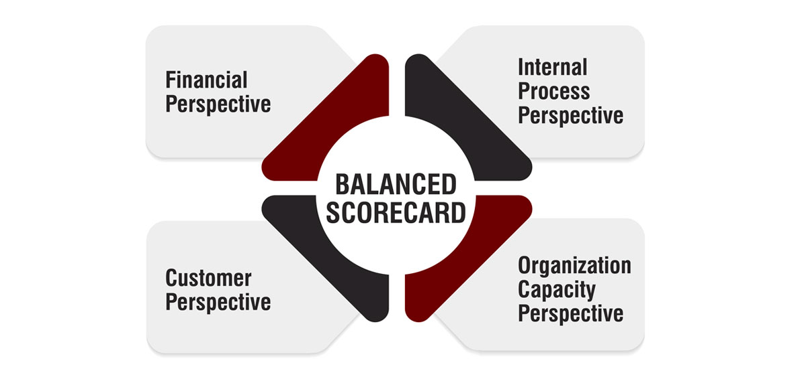
Figure 06: Balanced scoreboard
Source: (Whittington et al., 2019)
Financial Perspective
Financial goals include achieving market share and cost efficiency. The primary performance indicators (KPIs) will be revenue growth, gross margin, and breakeven in operations (Ecdb.com., 2017). As an example, Decathlon projects achieving a market share of 5% in urban sporting goods in three years and reducing logistics expenses by 20% by adopting a central distribution centre (Research and Markets, 2025). The assessment of financial sustainability and price effectiveness will be supported by observation of sales per square metre in flagship stores and the contribution of online revenues (Batschauer da Cruz et al., 2022).
Customer Perspective
Customer KPIs aim to assess brand awareness, satisfaction, and loyalty. Measures include the Net Promoter Score (NPS), the repeat purchase rates, and the rates of attendance in sporting events or workshops (Feldman, 2020). Besides, it is expected that school partnerships are expected to increase brand recognition as well (Reuters, 2025a).
Internal Process Perspective
The inventory turnover, the latency of order fulfilment and the performance of local suppliers will be monitored using key performance indicators (David and David, 2019). The introduction of an integrated sourcing model that would consolidate local production and foreign imports will be measured by provisioning on-time delivery rates and cost-cutting analysis, thus avoiding supply chain risks, including port overcrowding and delays at customs (6Wresearch, 2025).
Learning and Growth Perspective
Sustainable organisational growth is based on employee development and the transfer of knowledge. Key performance indicators will encompass the number of hours spent on staff training, retention rates, and performance measures of customer-centric service delivery (Rabetino et al., 2021). The ongoing professional growth of the programme of Sports Leader will help to maintain the high service standards of Decathlon and provide the organisation with greater organisational capacity in Bangladesh at the same time (Unifab, 2025).

4.2 Triple Bottom Line (TBL) Integration
The Triple Bottom Line (TBL) model allows Decathlon to assess its expansion plan in Bangladesh in terms of economic, social, and environmental metrics, thus facilitating the achievement of sustainable value to stakeholders (Lynch, 2021).
Economic Dimension
The economic focus of Decathlon is oriented towards profitability, market share growth, and financial sustainability. The sales in flagship stores and the sales on the Internet, gross profit, and turnover are key performance indicators (Amason and Ward, 2020). The target is a 5% market share and breakeven within four years. Decathlon will strive to be cost-competitive by sourcing locally and reducing the cost of imports and logistics, along with a more significant appearance in Bangladesh (PCMI, 2024).
Environmental Dimension
In Bangladesh, a country that is highly prone to the effects of climate change, such as frequent floods and cyclones, environmental sustainability is extremely important (Ecdb.com., 2017). Decathlon will embrace an environmentally responsible sourcing agenda, recycling and friendly materials, and streamline its supply chain to reduce carbon emissions, hence, implementing energy-efficient store design, reducing the amount of waste in packaging material, and encouraging recycling of some products (Henry, 2021).
Social Dimension
The company has to ensure the involvement of the stakeholders, community building, and staff welfare (Whittington et al., 2019). Skills transfer and providing high-quality services are supported by the employee development programme in the context of the Sports Leader programme (Shenkar et al., 2021). The involvement of local communities and the presence of jobs in retail stores and supply chains are strategies to strengthen the social legitimacy of Decathlon and to support the goals of Vision 2041 in Bangladesh to provide jobs and social inclusion (6Wresearch, 2025).
The Triple Bottom Line approach will allow Decathlon to track its sustainable performance in a holistic fashion, thus facilitating long-term competitiveness and effectively meeting the expectations of customers, employees, and policymakers in Bangladesh (Boon et al., 2018).

4.3 Monitoring and Mechanisms of Governance
Continuous monitoring and strategic agility are considered crucial to Decathlon to react well to the changing market conditions in Bangladesh to achieve sustainable growth and a competitive edge.
Performance Monitoring
Decathlon will introduce a real-time performance monitor system that will track important measures in financial, customer, internal process, and sustainability levels (6Wresearch, 2025). Monthly sales growth, inventory turnover, Net Promoter Score (NPS), and carbon footprint will be constantly measured (Hayes, 2022).
Strategic Agility
Strategic agility requires Decathlon to change its operation and marketing strategies in response to regulatory shifts, competition and changing consumer preferences (Alcácer et al., 2016). These involve updating sourcing strategies to reduce import duty changes, redistributing inventory to urban centres with high need, and modifying community engagement programmes in line with customer involvement and response (Armstrong, 2024).
Feedback Loops and Continuous Improvement
Periodic review of results with management, local partners and supply chain teams will develop coordinated feedback channels (Reese, 2020). The lessons learned in these sessions will guide further optimisation of the processes, promotion, and product mix to ensure that Decathlon remains responsive in the fast-paced sport retail market in Bangladesh.

Conclusion
The opportunity to join the expanding sports and fitness market in Bangladesh, because of urbanisation, young population and increased disposable incomes, is an opportunity reeking of new ventures by Decathlon. Although there are also troubles in terms of regulatory requirements and infrastructure constraints, they could be overcome with the help of joint ventures, a step-by-step launch of the stores, and a hybrid method of sourcing. Through the Triple Bottom Line and the Balanced Scorecard, Decathlon will be able to constantly monitor its financial, social, and environmental performance. Concisely, the expansion strategy is a decent roadmap for Decathlon for the successful realisation in the dynamic sporting goods industry in Bangladesh.

References
- 6Wresearch (2025). Bangladesh Sports Equipment and Apparel Market | Size 2031. [online] 6wresearch.com. Available at: https://www.6wresearch.com/industry-report/bangladesh-sports-equipment-and-apparel-market-outlook? [Accessed 7 Dec. 2025].
- Adekola, A., and Sergi, B. S. (2016). Global business management: A cross-cultural perspective. Routledge.
- Alcácer, J., Cantwell, J., and Piscitello, L. (2016). Internationalization in the information age: A new era for places, firms, and international business networks?. Journal of international business studies, 47(5), 499-512.
- Amason, A., and Ward, A. (2020). Strategic management: From theory to practice. Routledge.
- Armstrong, M. (2024). Armstrong's handbook of strategic human resource management: Improve business performance through strategic people management. Kogan Page Publishers.
- Batschauer da Cruz, C. B., Eliete Floriani, D., and Amal, M. (2022). The OLI Paradigm as a comprehensive model of FDI determinants: a sub-national approach. International Journal of Emerging Markets, 17(1), 145-176.
- Baumgartner, R. J., and Rauter, R. (2017). Strategic perspectives of corporate sustainability management to develop a sustainable organization. Journal of Cleaner Production, 140, 81-92.
- Boon, C., Eckardt, R., Lepak, D. P., and Boselie, P. (2018). Integrating strategic human capital and strategic human resource management. The International Journal of Human Resource Management, 29(1), 34-67.
- Chauhan, M.S. (2025). Decathlon: The Global Game-Changer in Sports Retail. [online] Culture of Internet. Available at: https://cultureofinternet.com/Decathlon-case-study.
- Cornelissen, J. P. (2023). Corporate communication: A guide to theory and practice.
- Daniels, J. D., and Radebaugh, L. H. (2016). International business environments and operations. Pearson Education Limited.
- DataReportal (2025). Digital 2025: Bangladesh. [online] DataReportal – Global Digital Insights. Available at: https://datareportal.com/reports/digital-2025-bangladesh? [Accessed 14 Nov. 2025].
- David, F., and David, F. (2019). Strategic management: A competitive advantage, concept and cases. Group, 120, 18-18.
- DECATHLON (2021). DECATHLON ANNUAL SUSTAINABLE DEVELOPMENT REPORTS. [online] sustainability.decathlon.com. Available at: https://sustainability.decathlon.com/decathlon-annual-sustainable-development-reports.
- Decathlon (2023). Decathlon Group’s 2023 Performance. [online] Decathlon-united.media. Available at: http://decathlon-united.media/pressfiles/decathlon-group-2023-performance [Accessed 13 Nov. 2025].
- Decathlon (2024a). DECATHLON 2024 NFRD. [online] Decathlon-united.media. Available at: https://www.decathlon-united.media/pressfiles/decathlon-2024-nfrd.
- Decathlon (2024b). Decathlon new brand identity and positioning. [online] Decathlon-united.media. Available at: https://www.decathlon-united.media/decathlon-new-identity.
- Decathlon (2025). Decathlon Group’s 2024 Performance. [online] Decathlon-united.media. Available at: https://www.decathlon-united.media/pressfiles/decathlon-group-2024-performance.
- ECDB (2017). eCommerce Data & Analytics Based on Billions of Transactions. [online] Ecdb.com. Available at: https://ecdb.com/resources/sample-data/market/bd/all [Accessed 15 Nov. 2025].
- Ecdb.com. (2017). eCommerce Data & Analytics Based on Billions of Transactions. [online] Available at: https://ecdb.com/resources/sample-data/market/bd/all [Accessed 7 Dec. 2025].
- Engert, S., Rauter, R., and Baumgartner, R. J. (2016). Exploring the integration of corporate sustainability into strategic management: A literature review. Journal of cleaner production, 112, 2833-2850.
- Engert, S., Rauter, R., and Baumgartner, R. J. (2016). Exploring the integration of corporate sustainability into strategic management: A literature review. Journal of cleaner production, 112, 2833-2850.
- Feldman, E. R. (2020). Corporate strategy: Past, present, and future. Strategic Management Review, 1(1), 179-206.
- Fosgel, D. (2016). Strategic sustainability: A natural environmental lens on organizations and management. Routledge.
- GlobalData Plc (2021). Decathlon SA Company Profile - Overview. [online] Globaldata.com. Available at: https://www.globaldata.com/company-profile/decathlon-sa/.
- Goswam, I. (2024). Strategic Management and Business Policy-Globalization, Innovation and Sustainability. Academic Guru Publishing House.
- Grant, R. M. (2021). Contemporary strategy analysis. John Wiley & Sons.
- Hayes, J. (2022). The theory and practice of change management. Bloomsbury Publishing.
- Henry, A. (2021). Understanding strategic management. Oxford University Press.
- Invest Bangladesh (2022). BIDA | Foreign & Joint Venture Investment in Bangladesh. [online] Investbangladesh.gov.bd. Available at: https://www.investbangladesh.gov.bd/foreign-joint-venture-projects? [Accessed 15 Nov. 2025].
- Kraus, S., Rehman, S. U., and García, F. J. S. (2020). Corporate social responsibility and environmental performance: The mediating role of environmental strategy and green innovation. Technological forecasting and social change, 160, 120262.
- Lynch, R. (2021). Strategic management. Sage.
- Makadok, R., Burton, R., and Barney, J. (2018). A practical guide for making theory contributions in strategic management. Strategic Management Journal, 39(6), 1530-1545.
- Mintzberg, H., Ahlstrand, B., and Lampel, J. B. (2020). Strategy safari: The complete guide through the wilds of strategic management. Pearson UK.
- Narula, R., Asmussen, C. G., Chi, T., and Kundu, S. K. (2019). Applying and advancing internalization theory: The multinational enterprise in the twenty-first century. Journal of International Business Studies, 50(8), 1231-1252.
- New Age BD (2025). Sports goods market in Bangladesh growing steadily. [online] Newagebd.net. Available at: https://www.newagebd.net/post/trade-commerce/263841/sports-goods-market-in-bangladesh-growing-steadily? [Accessed 14 Nov. 2025].
- PCMI (2024). Bangladesh E-commerce Market: Growth & Trends 2024-2025. [online] Payments and Commerce Market Intelligence - Global payments market research and insights. Available at: https://paymentscmi.com/insights/bangladesh-ecommerce-market-insights/? [Accessed 15 Nov. 2025].
- PowerCommerce (2024). Best Mart 360 Reports Strong Growth in Annual Sales and Profit for 2024 | PowerCommerce. Power Commerce . [online] doi:https://doi.org/10.53811.53812.53813.53814.53815.
- Prakash, P. (2025). Decathlon doesn’t do shoe boxes or big adverts. Yet the French giant has quietly become the crown jewel of the sports retail world. [online] Fortune Europe. Available at: https://fortune.com/europe/2025/01/30/decathlon-stores-france-sports-retailing/.
- Rabetino, R., Kohtamäki, M., and Federico, J. S. (2021). A (re) view of the philosophical foundations of strategic management. International Journal of Management Reviews, 23(2), 151-190.
- Rachmad, Y. E. (2022). Revolutionizing Global Business: The Impact of Management 5.0 on International Corporate Strategies.
- Reese, S. (2020). Reflecting on impacts of Peter Senge’s Fifth Discipline on learning organizations. The Learning Organization, 27(1), 75-80.
- Research and Markets (2025). Sports Market Report 2025 - Research and Markets. [online] Researchandmarkets.com. Available at: https://www.researchandmarkets.com/reports/5939106/sports-market-report?srsltid=AfmBOoow-VWoHOLzm1JNLziUgr-RQ4tDS6BPg739PSoftIoFBv0GL1Mc [Accessed 15 Nov. 2025].
- Reuters (2025a). Bangladesh, World Bank sign $850 million deal to boost jobs, trade. Reuters. [online] 24 Apr. Available at: https://www.reuters.com/markets/asia/bangladesh-world-bank-sign-850-million-deal-boost-jobs-trade-2025-04-24/.
- Reuters (2025b). French sports goods seller Decathlon to double India sourcing to $3 billion in 5 years. [online] Reuters. Available at: https://www.reuters.com/world/india/french-sports-goods-seller-decathlon-double-india-sourcing-3-billion-5-years-2025-07-29/? [Accessed 15 Nov. 2025].
- Reuters Staff (2025). Sports retailer Decathlon reports stronger 2024 sales as new CEO takes over. Reuters. [online] 31 Mar. Available at: https://www.reuters.com/business/retail-consumer/sports-retailer-decathlon-reports-stronger-2024-sales-new-ceo-takes-over-2025-03-31/.
- Senge, P. M. (2017). The leaders new work: Building learning organizations. In Leadership perspectives (pp. 51-67). Routledge.
- Shafiul, M., Md. Iftekharul Amin and Md. Shariful Islam (2024). E-COMMERCE LANDSCAPE IN BANGLADESH: A CROSS-COUNTRY ANALYSIS. Journal of Business Administration, 45(1). doi:https://doi.org/10.58964/jba45n101.
- Sharma, P., Leung, T. Y., Kingshott, R. P., Davcik, N. S., and Cardinali, S. (2020). Managing uncertainty during a global pandemic: An international business perspective. Journal of business research, 116, 188-192.
- Shenkar, O., Luo, Y., and Chi, T. (2021). International business. Routledge.
- Statista (2025a). Number of users of e-commerce Bangladesh| Statista. [online] Statista. Available at: https://www.statista.com/forecasts/1436494/number-of-users-e-commerce-e-commerce-market-bangladesh? [Accessed 15 Nov. 2025].
- Statista (2025b). Sports - Bangladesh | Statista Market Forecast. [online] Statista. Available at: https://www.statista.com/outlook/amo/sports/bangladesh? [Accessed 15 Nov. 2025].
- The Daily Star (2025). E-Commerce can be Bangladesh’s next growth engine - if policy keeps pace. [online] The Daily Star. Available at: https://www.thedailystar.net/supplements-0/news/e-commerce-can-be-bangladeshs-next-growth-engine-if-policy-keeps-pace-3971006? [Accessed 15 Nov. 2025].
- The Daily Star (2025). E-Commerce can be Bangladesh’s next growth engine - if policy keeps pace. [online] The Daily Star. Available at: https://www.thedailystar.net/supplements-0/news/e-commerce-can-be-bangladeshs-next-growth-engine-if-policy-keeps-pace-3971006? [Accessed 7 Dec. 2025].
- Unifab (2025). COUNTERFEITING & ORGANISED CRIME. [online] Available at: https://www.unifab.com/wp-content/uploads/2025/06/UNIFAB_Contrefacon-Criminalite_ENGLISH_VDEF_03062025.pdf? [Accessed 15 Nov. 2025].
- Whittington, R., Regnér, P., Johnson, G., Angwin, D., and Scholes, K. (2019). Exploring strategy. Pearson UK.
- Witcher, B. (2019). Absolute essentials of strategic management. Routledge.
- World Bank (2015). Overview. [online] World Bank. Available at: https://www.worldbank.org/en/country/bangladesh/overview?.
- Worldometer (2025). Bangladesh Population (2025) - Worldometer. [online] Worldometers.info. Available at: https://www.worldometers.info/world-population/bangladesh-population/?.

