Jack Kennedy
2003924@student.uwtsd.ac.uk

OOP programming report
ADVANCED SOFTWARE DEVELOPMENT ACCB5011

Contents
Introduction 1
Importance of OOP and this application 1
Testing 1
Conclusion 7
Video demonstration: 8
Appendix 9

Introduction
This application is a car rental program built in C++, an OOP language, this report will discuss the importance of OOP in the context of this program, as well as the implementation of this application via the concepts of OOP and the principles used withing OOPS, such as classes, methods, and inheritance.

Importance of OOP and this application
Object oriented programming allows for the creation of programs that are more efficient and require less memory. The program is broken down into smaller part, objects, and classes, this is supported by inheritance and polymorphism, reducing redundant code, allowing easier abstraction, and ultimately reducing maintenance costs. This also means systems developed using OOPs are more upgradable.
Classes are a critical part of OOPL they allow code to be broken up into sections that then facilitate many other components of that type of language, like inheritance, polymorphism, or encapsulation, for instance. The car rental application makes use of classes such as “inventory”, “user”, “vehicle” and its child class “cars”. The program is more efficient because methods in these classes are used in multiple places, where in a non-OOP language the code would need to be written out multiple times for each instance. The program is more upgradable since the parent class “vehicle” allows for other types of vehicles to be integrated into the program with relative ease, simply adding another child class to the base class “vehicle”, would allow for another type of vehicle to be implemented into the rental program, this is an example of inheritance, a key concept of OOP. The classes all interact with each other in a way that is designed to be scalable, and easy to improve upon, for instance the menu class allows the user to select from a list of options, it then, based on that input runs the relevant functions, this is done using a switch case, this case could very easily be extended, as each individual case has relatively little code, needing only some outputs to make the program user friendly, some validation, and the methods to be used.
For instance the login function is split between two classes, “user” and “menu”, two maps are used to keep track of users and users that are logged in, these are set up in the “user” class, it is designed in this way to allow easy scalability, updating the login system to support registering new users, and having multiple users logged in would not require as much work as upgrading a system built differently to this, or a system built in a non-OOPL, this is because the login system would only need to be updated in the user class, and not in other classes it is used in. In fact, the “logged_in_users” map can already support having multiple users logged in, so the program would simply need a way for another user to log in, without logging out first
Polymorphism is another concept in OOP that allows functions and classes to be overloaded, in this case, the program makes use of overloaded methods. Within the rental application there are methods that are overloaded, for instance, both “display” and “list_cars” are overloaded, allowing them to perform different tasks based on how the method is used, “display” can both display information on vehicles, and the subclass cars, whereas “list_cars” does two slightly different tasks depending on how it is called. This is made possible because of polymorphism, which is as mentioned a critical component of OOPLs.
Attributes are variables used to define the different properties of classes. The program makes use of attributes, the most notable ones being the ones used in the vehicle class, that are inherited by the cars subclass. These attributes; “make”, “model”, “year”, “seats”, “isRented”, and “renter” allow the program not only to store information on these objects, but also interact with them and manipulate the information stored in them, for instance, when a car is rented with “rent_car”, which is a method used in the “inventory” class, that car’s “isRented” attribute is changed to “true”, this attribute is then later used to verify that users are not trying to rent cars that have already been rented. This very simple to implement because of the nature of OOP languages. Other classes also use attributes, such as “usern” in the “menu” class, this attribute handles which user is logged in and is critical to the program. Most of the variables used in this application are used within classes, however, there are global variables, such as “logged” which tells the application if a user is currently logged in.

Testing
  - Login functionality:
Input | Expected Result | Actual Result | Test Success
Credentials for first account | First account is logged in | 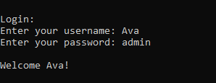 | Yes
Credentials for second account | Second account is logged in | 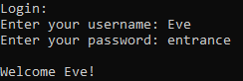 | Yes
Credentials for a non-existent account | The application outputs: “Invalid username or password. Please try again.” | 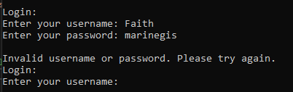 | Yes
Username for first account, password for second | The application outputs: “Invalid username or password. Please try again.” | 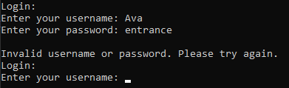 | Yes
Username for first account, unrelated password | The application outputs: “Invalid username or password. Please try again.” | 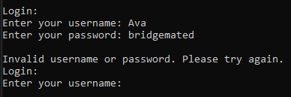 | Yes
Both inputs blank | The application outputs: “Invalid username or password. Please try again.” | 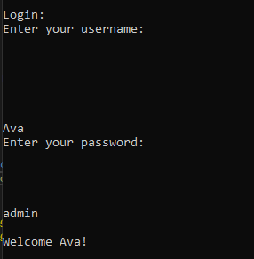  the application does not move on unless you put in actual inputs, but the inputs work, this should not cause an issue | No (action not needed)
Username for first account, password is a random integer | The application outputs: “Invalid username or password. Please try again.” | 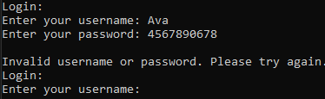 | Yes
Username for first account, password is blank | The application outputs: “Invalid username or password. Please try again.” | 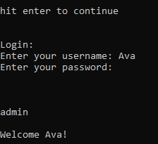  once again, the application does not let you enter nothing, instead waiting for you to enter an input | No (action not needed)

  - Renting a car:
Input | Expected Result | Actual Result | Test Success
Renting a car in the standard way | The user rents a car, the application tells the user that the car was rented successfully | 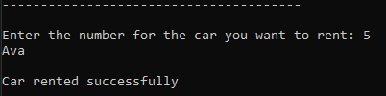 | Yes
Renting a car when all cars are rented | The application tells the user that no cars are available, and tells the user to input the number one, so they can continue using the program | 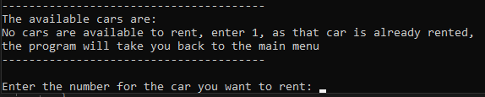 | Yes
Renting a car that is already rented by the user | The application outputs that the car is not available. It then explains why this might be the case | 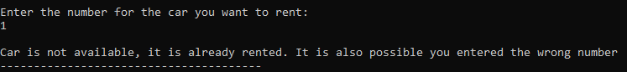 | Yes
Renting a car rented by another user | The application outputs that the car is not available. It then explains why this might be the case | 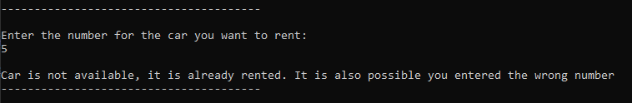 | Yes
Renting a car that does not exist | The application tells the user that the number they entered does not correspond to a car | 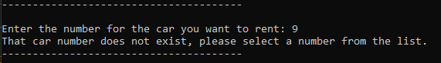 | Yes

  - Returning a car:
Input | Expected Result | Actual Result | Test Success
Returning a car that was rented | The application tells the user that the car was returned successfully | 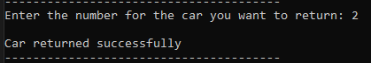
Returning a car that was rented by a different user | The application tells the user that the car was not returned, as either the car was not rented, or they did not rent the car | 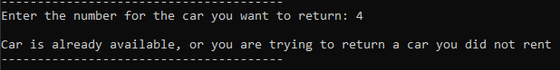
Returning a car that’s not rented | The application tells the user that the car was not returned, as either the car was not rented, or they did not rent the car | 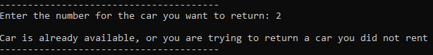
Returning a car that does not exist | The application tells the user that the number they entered does not correspond to a car | 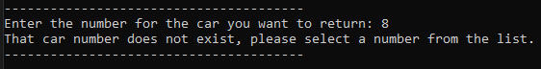

  - Check information about a car:
Input | Expected Result | Actual Result | Test Success
Check information on a car that was not rented | The application provides information on a car, and includes the fact that the car has not been rented | 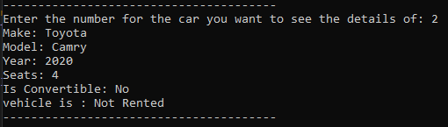 | Yes
Check information on a car that was rented | The application provides information on a car, and includes the fact that the car has been rented | 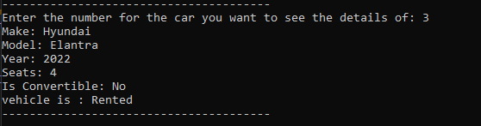 | Yes
Check information on a car that doesn’t exist | The application tells the user that the number they entered does not correspond to a car | 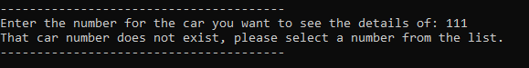 | Yes

  - Display all available cars:
Input | Expected Result | Actual Result | Test Success
When some cars are available | All available cars are displayed, but not every car is displayed | 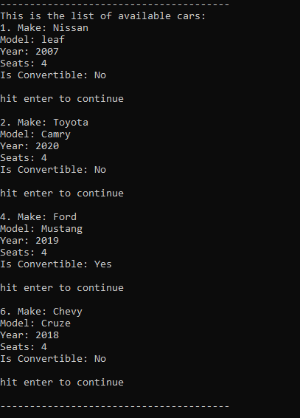 | Yes
When all cars are available | All available cars are displayed, which is all the cars, in this case we would expect to see all cars from one to six. | 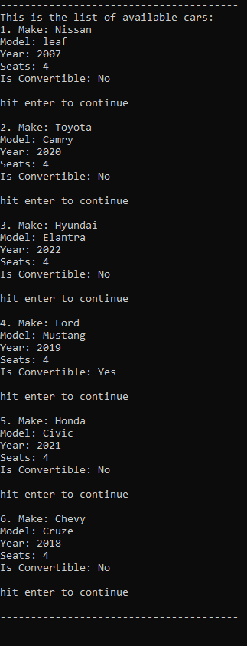 | Yes
When no cars are available | No cars are displayed, and the application tells the user that no cars are available to rent | 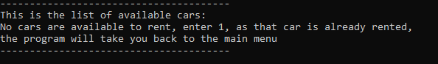  The message from the other use of display() also shows, this needs fixing. To fix this, I will edit the message to say, “No cars are available to rent, if you are renting enter 1, as that car is already rented, the program will take you back to the main menu.” There could also be a code-based solution; to change the message outputted if the method is called for available cars. This would be considered if the program was to be expanded upon | No.  edited the program to fix

  - Check the user’s rented cars:
Input | Expected Result | Actual Result | Test Success
When the user has rented a car | The car that the user has rented is displayed | 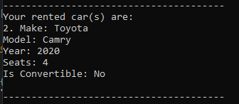 | Yes
When the user has rented multiple cars | The cars that the user has rented are shown in a list | 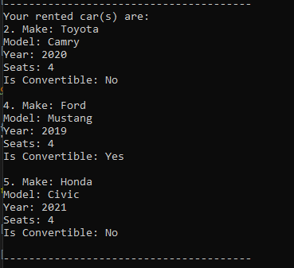 | Yes
When the user has rented no cars | No cars are displayed | 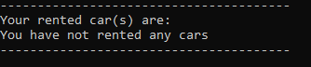 | Yes
When the user has rented a car, and another user has rented cars | Only the logged in user’s car is displayed | 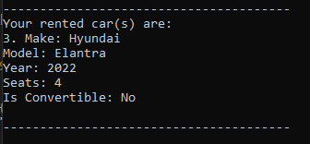 | Yes

Conclusion
In conclusion, OOPLs are incredibly useful for creating efficient and well abstracted programs, the car rental application made use of the key concepts of OOP to create a scalable program that utilised classes and methods effectively. The program was thoroughly tested, and the conclusion of those tests lead to some improvement, but mainly demonstrated that the application performed the functions it was designed to. When creating an application in an OOP it is important to consider these principles.

Video demonstration:
https://youtu.be/Fj9tx9A-3bA

Appendix

#include <iostream>
#include <string>
#include <map>
#include <vector>
#include <cstdlib>
#include <conio.h>
using namespace std;

bool logged = false; //tells the program that a user is logged in
int validation; //handles validation in various parts of the program

//user guide class
//call user guide function
class userguide {
public:
void display() {
cout << "User Guide:" << endl;
cout << "" << endl;
cout << "------------------------------------------------------------------------------" << endl;
cout << "To use this program, first login, then select from the list of options the " << endl;
cout << "action you would like to perform. When this action is complete, you will then" << endl;
cout << "be returned to the list of options where you can select another option i.e logout" << endl;
cout << "this program is designed for easy use, every option is numbered, and all a user" << endl;
cout << "ever has to do is select an option by typing its number" << endl;
cout << "On occasions where there is a large list being sent, the user will need to hit enter to" << endl;
cout << "continue after each new entry is sent" << endl;
cout << "------------------------------------------------------------------------------" << endl;
cout << "" << endl;
cout << "hit enter to continue" << endl;
_getch();
}
};

userguide guide; //creates a userguide

//user class
class user {
public:
string name;
static map<string, string> users; // static variable to store username and passwords for multiple users
static map<string, user> logged_in_users; // static variable to store the logged in users

bool login(string username, string password) {
// validate the username and password against the list of registered users

if (users.count(username) && users[username] == password) {
logged_in_users[username] = *this;
name = username;

//checks the user's password using the map
return true;
}
else {
cout << "Invalid username or password. Please try again." << endl; //tells the user if they are trying to login with an invalid username or password
return false;
}
}

static void logout(string username) { //logs out the user
logged_in_users.erase(username);
}
};
map<string, string> user::users;
map<string, user> user::logged_in_users;
user user_obj;

//vehicle class
//has the variables for the vehicles
class vehicle {
public:
string make;
string model;
string renter;
int year;
int seats;
bool isRented;

vehicle(string make, string model, int year, int seats) {
this->make = make;
this->model = model;
this->year = year;
this->seats = seats;
this->isRented = false;
this->renter = "none"; //the default value for a vehicle, this would cause an issue if there was a user called "none", if this program were to be scaled, then either none would need to be disallowed as a username, or this would need to be changed
} //sets up a constructor for vehicle

void display() {
cout << "Make: " << make << endl;
cout << "Model: " << model << endl;
cout << "Year: " << year << endl;
cout << "Seats: " << seats << endl;
} // a display method for vehicles
};

//subclass for cars (child of vehicle class)
class car : public vehicle {
public:

string transmission;
bool isConvertible;

car(string make, string model, int year, int seats, string transmission, bool isConvertible)
: vehicle(make, model, year, seats) {
this->isConvertible = isConvertible;
this->transmission = transmission;
}

void display() {
vehicle::display();
cout << "Is Convertible: " << (isConvertible ? "Yes" : "No") << endl;
}

void check_rental() {
cout << "vehicle is : " << (isRented ? "Rented" : "Not Rented") << endl;
}
};

//Inventory class
//array/list that stores the list of cars
class inventory {
public:
vector<car> cars; //stores the car objects

void list_cars() { //prints a list of the cars
int n = 0;
for (int i = 0; i < cars.size(); i++) {
if (cars[i].isRented == false) {
cout << i + 1 << ". "; // adds one to the index to make the program more user friendly
cars[i].display();
n++;
cout << " " << endl;
}
if (cars[i].isRented == false) {
cout << "hit enter to continue" << endl;
cout << " " << endl;
_getch();
}
}
if (n == 0) {
cout << "No cars are available to rent, if you are renting enter 1, as that car is already rented," << endl << "the program will take you back to the main menu" << endl;
};
}

void list_cars(string currentuser) { //prints a list of the cars that are rented by a specific user
int n = 0;
for (int i = 0; i < cars.size(); i++) {
if (cars[i].renter == currentuser) {
cout << i + 1 << ". "; // adds one to the index to make the program more user friendly
cars[i].display();
n++;
cout << " " << endl;
}
}
if (n == 0) {
cout << "You have not rented any cars" << endl;
}
}

void rent_car(int index) {
if (cars[index - 1].isRented) { //checks that the car has not already been rented, if it has then it tells the user the car is not available
cout << " " << endl;
cout << "Car is not available, it is already rented. It is also possible you entered the wrong number" << endl;
}
else {
cars[index - 1].isRented = true; //here the -1 accounts for the fact one was added one to it, helping to make the program more user friendly, it is the same wherever index is shown to be reduced by one
cars[index - 1].renter = user_obj.name;
cout << user_obj.name << endl;
cout << " " << endl;
cout << "Car rented successfully" << endl;
}
}

void return_car(int index) {
if (cars[index - 1].isRented && cars[index - 1].renter == user_obj.name) { //makes sure that the car being returned was rented, and was actually rented by the user that is trying to return it
cars[index - 1].isRented = false; //sets the cars rented status to false, signifying to the program that the car is no longer rented
cars[index - 1].renter = "none";
cout << " " << endl;
cout << "Car returned successfully" << endl;
}
else {
cout << " " << endl;
cout << "Car is already available, or you are trying to return a car you did not rent" << endl;
}
}
};
inventory inv_obj;

//menu class
class menu {
public:
string usern;

void login() {
user_obj.users.insert(pair<string, string>("Ava", "admin"));
user_obj.users.insert(pair<string, string>("Eve", "entrance")); //hard codes in the logins for two users
cout << " " << endl;
cout << " " << endl;
while (logged == false) {
string username, password;
cout << "Login: " << endl;
cout << "Enter your username: ";
cin >> username;

cout << "Enter your password: ";
cin >> password; //asks the user to input their login details
cout << " " << endl;

if (user_obj.login(username, password)) { //passes the login details to the method used for logging in
cout << "Welcome " << username << "!" << endl;
usern = username;
logged = true; //tells the program that a user is logged in
menu_show();
}
}
};

void menu_show() {
while (logged == true) {
cout << " " << endl;
cout << "---------------------------------------" << endl;
cout << "1. Rent a car" << endl;
cout << "2. Return a car" << endl;
cout << "3. Display all available cars" << endl;
cout << "4. Check information about a car" << endl;
cout << "5. Check the user's rented car(s)" << endl;
cout << "6. Exit" << endl;
cout << "---------------------------------------" << endl;
cout << " " << endl;
int option;
int index;
cin >> option;
string carchoice;

switch (option) { //a case that runs the other methods in the program
case 1:
cout << "---------------------------------------" << endl;
cout << "The available cars are: " << endl;
inv_obj.list_cars();
cout << "---------------------------------------" << endl;
cout << " " << endl;
cout << "Enter the number for the car you want to rent: ";
cin >> index;

if (index < validation + 1)
{
inv_obj.rent_car(index);
cout << "---------------------------------------" << endl;
cout << " " << endl;
}
else {
cout << "That car number does not exist, please select a number from the list." << endl; //tells the user they have entered a number for a car that does not exist
cout << "---------------------------------------" << endl;
}

break;
case 2:
cout << "---------------------------------------" << endl;
cout << "Enter the number for the car you want to return: ";
cin >> index;

if (index < validation + 1)
{
inv_obj.return_car(index);
cout << "---------------------------------------" << endl;
cout << " " << endl;
}
else {
cout << "That car number does not exist, please select a number from the list." << endl; //tells the user they have entered a number for a car that does not exist
cout << "---------------------------------------" << endl;
}

break;
case 3:
cout << "---------------------------------------" << endl;
cout << "This is the list of available cars:" << endl;
inv_obj.list_cars();
cout << "---------------------------------------" << endl;
cout << " " << endl;
break;
case 4:
cout << "---------------------------------------" << endl;
cout << "Enter the number for the car you want to see the details of: ";
cin >> index;
if (index < validation + 1)
{
inv_obj.cars[index - 1].display();
inv_obj.cars[index - 1].check_rental();
cout << "---------------------------------------" << endl;
cout << " " << endl;
}
else {
cout << "That car number does not exist, please select a number from the list." << endl; //tells the user they have entered a number for a car that does not exist
cout << "---------------------------------------" << endl;
}

break;
case 5:
cout << "---------------------------------------" << endl;
cout << "Your rented car(s) are: " << endl;
inv_obj.list_cars(user_obj.name);
cout << "---------------------------------------" << endl;
cout << " " << endl;
break;

case 6:
user_obj.logout(usern);
logged = false;
cout << " " << endl;
break;
default:
cout << "---------------------------------------" << endl;
cout << "Invalid option. Please try again." << endl;
cout << "---------------------------------------" << endl;
cout << " " << endl;
break;
}
}
}
};

int main()
{
inv_obj.cars.push_back(car("Nissan", "leaf", 2007, 4, "automatic", false));
inv_obj.cars.push_back(car("Toyota", "Camry", 2020, 4, "automatic", false));
inv_obj.cars.push_back(car("Hyundai", "Elantra", 2022, 4, "automatic", false));
inv_obj.cars.push_back(car("Ford", "Mustang", 2019, 4, "automatic", true));
inv_obj.cars.push_back(car("Honda", "Civic", 2021, 4, "automatic", false));
inv_obj.cars.push_back(car("Chevy", "Cruze", 2018, 4, "automatic", false));
validation = inv_obj.cars.size();

guide.display(); //calls the user guide

menu main_menu;
main_menu.login(); //opens the main menu
return 0;
}

