
Prepared by:
Olga Calughin – Student ID 2510354

The program: Applied Computing (Foundation)
Module name: Analysing & Solving Problems
Module code: ACCA4019
Lecturer’s name: Dr Semih Yumusak

Submission date: 26 March 2026

26th March 2026
Component 2: Written assessment
Problem Analysis and Solution Development

Table of Contents
List of Figures 2
Introduction 3
Task 1: Deconstructing the Problem and Identifying Key Requirements 3
1.1 Breaking Down the Problem 3
1.2 Key Requirements Using the MoSCoW Technique 4
1.3 Constraints 5
1.3.1 Hard Constraints (Non-Negotiable) 5
1.3.2 Soft Constraints (Optimisation Goals) 6
1.4 Relevant Variables Involved 6
Task 2: Developing a Flowchart-Based Solution for Classroom Allocation 7
Task 3: Reflecting on Problem-Solving Techniques and Justifying the Approach 11
3.1 Problem-Solving Techniques Used 11
3.2 Why this Approach is Appropriate 11
3.3 Assumptions and Limitations 12
Conclusion 12
References 13

List of Figures
Figure 1: Main Program Flowchart 8
Figure 2: Find Suitable Room Flowchart 9

Introduction
An effective classroom allocation system is essential for ensuring that college spaces are utilised efficiently and fairly, facilitating the smooth operation of the institution. This report presents a structured solution by breaking the problem into smaller components, applying the MoSCoW prioritisation technique, and clearly defining constraints. The methodology is further supported by flowcharts and explanatory notes that illustrate the logic behind the allocation process. Abstraction is used to eliminate unnecessary details and highlight the fundamental mechanisms of effective room assignment. This approach enhances transparency, reduces complexity, and supports evidence-based decision-making. The reflection section critically evaluates each technique's contribution to the development of a structured solution.

Task 1: Deconstructing the Problem and Identifying Key Requirements
The college is experiencing inefficient use of classroom space: some rooms are overcrowded, others are underused, and timetable clashes occur. These issues lead to delays, unnecessary movement across campus, and a reduced quality of the learning experience. The goal is to develop a structured solution that allocates rooms efficiently, minimises travel time, and produces accurate, conflict-free timetables. To resolve this, the problem must be broken down into smaller, manageable components.

1.1 Breaking Down the Problem
The problem can be broken into three major sub-problems:
- Classroom Allocation Issues
- Class sizes do not match with room capacities, leaving some classrooms overcrowded while others remain underused.
- Excessive Movement Time
- Consecutive classes are scheduled in distant rooms, causing staff and students to waste time transitioning between rooms and leading to late starts.
- Timetabling Conflicts
- Multiple classes are scheduled in the same room simultaneously, and staff are assigned to teach in different rooms or buildings at the same time, resulting in scheduling conflicts.
Each sub-problem involves specific requirements, constraints, and variables.

1.2 Key Requirements Using the MoSCoW Technique
The MoSCoW technique is used to prioritise requirements for the classroom allocation solution, ensuring that essential functions are addressed before secondary enhancements. This method categorises the system’s core capabilities by their importance (Must Have, Should Have, Could Have, and Won’t Have), allowing development efforts to focus on the most critical aspects of the problem [1].
MUST HAVE(Critical Requirements)
These requirements are essential and non-negotiable; failing to meet them can cause a system breakdown[1].
The system must:
- Allocate rooms based on class size and room capacity, ensuring that the number of students in a class is always less than or equal to the capacity of the assigned room.
- Assign exactly one room to every scheduled class.
- Prevent all scheduling conflicts, including:
  - staff being scheduled to teach more than one class at the same time,
  - rooms being allocated to more than one class simultaneously,
  - student groups being assigned to overlapping sessions.
SHOULD HAVE(Important but Not Critical)
These requirements are important for the system's success; however, their absence would not critically undermine the overall outcome[1].
The system should:
- Allocate nearby rooms for consecutive classes with the same student groups or staff members to minimise movement across campus.
- Support the allocation of rooms with special requirements.
- Optimise room utilisation, ensuring that large rooms are not assigned to small classes unless necessary.

COULD HAVE(Desirable Enhancements)
These requirements are desirable but not essential to the system's core operation[1].
The system may:
- Allow staff to specify room or time preferences.
- Automatically reallocate rooms when the student enrolment numbers change significantly.
- Provide mobile notifications to inform staff and students of room changes.
- Include real-time dashboards displaying current room usage and occupancy.
WON’T HAVE(For Now)
These requirements are not critical to the current system and can be considered for future development phases[1].
The system will not:
- Incorporate real-time GPS tracking of students or staff.
- Automatically resolve all last-minute disruptions, such as staff illness, emergency absences, or sudden increases in class size.

1.3 Constraints
Developing a system that optimises classroom allocation, minimises movement time for students and staff, and prevents scheduling conflicts requires careful consideration of several types of constraints. In the academic literature on timetabling, these constraints are commonly divided into hard and soft categories. Hard constraints are required to generate a feasible timetable, while soft constraints are preferred but not mandatory[2], [3], [4].

1.3.1 Hard Constraints (Non-Negotiable)
- A staff member may not be assigned to more than one group or room at the same time.
- A single course may not be scheduled in multiple rooms at the same time.
- No room shall be allocated to more than one class at a time.
- Rooms should be selected based on their capacity (number of students) and the course’s required features.
- The class size must not exceed the capacity of the assigned room.
- A staff member must have fixed teaching hours per week for a single course throughout a semester.

1.3.2 Soft Constraints (Optimisation Goals)
- The total amount of unused room capacity should be minimised.
- Student and staff movement between rooms should be kept to a minimum.
- Allocations should, where possible, align with staff preferences.

1.4 Relevant Variables Involved
Efficient classroom allocation within an educational timetabling system involves various groups of resources; each is treated as an object with specific attributes.
- timeSlot represents discrete periods during which teaching activities may be scheduled.
  - slotID: Unique identifier assigned to each time slot.
  - weekDay: Day of the week on which the slot occurs.
  - timeStart: Scheduled start time of the slot.
  - timeFinish: Scheduled end time of the slot.
- staff represents academic personnel available for teaching activities.
  - staffID: Unique identifier for each staff member.
  - staffName: Full name of the staff member.
  - staffAvailability: Available time slots for teaching.
- group represents a cohort of students enrolled in a shared programme or module.
  - groupID: Unique identifier for each student group.
  - groupName: Descriptive name of the group.
  - groupAvailability: Available study time slots.
- room represents physical teaching spaces within the institution.
  - roomID: Unique identifier for each room.
  - roomName: Descriptive name or code for the room.
  - roomLocation: Physical location of the room within the campus.
  - roomType: Classification of room type (e.g., computer labs)
  - roomCapacity: Maximum number of students the room can accommodate.
  - roomAvailability: Available time slots for room usage.
- course represents an academic module or subject offered within the timetable.
  - courseID: Unique identifier for each course.
  - courseName: Official name of the course.
  - courseHoursPerWeek: Number of teaching hours required each week.
- class represents a scheduled teaching instance associated with a course.
  - classID: Unique identifier for each class.
  - courseID: Identifier linking the class to its parent course.
  - staffID: Identifier of the staff member assigned to teach the class.
  - groupID: Identifier of the student group attending the class.
  - classRequiredFeature: Required room characteristics (e.g., computer labs).
  - classSize: Total number of students enrolled in the class.

Task 2: Developing a Flowchart-Based Solution for Classroom Allocation
Figures 1 and 2 present flowcharts outlining the logical steps for optimising the classroom allocation process.
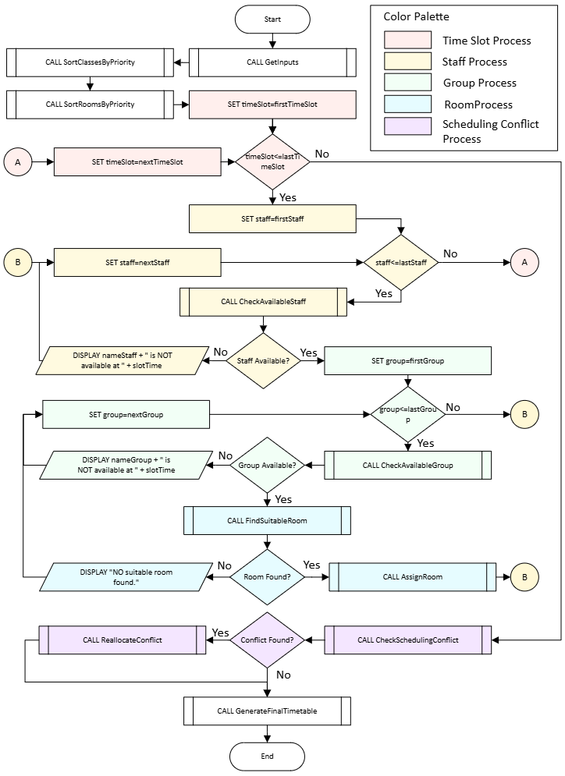

Figure 1: Main Program Flowchart
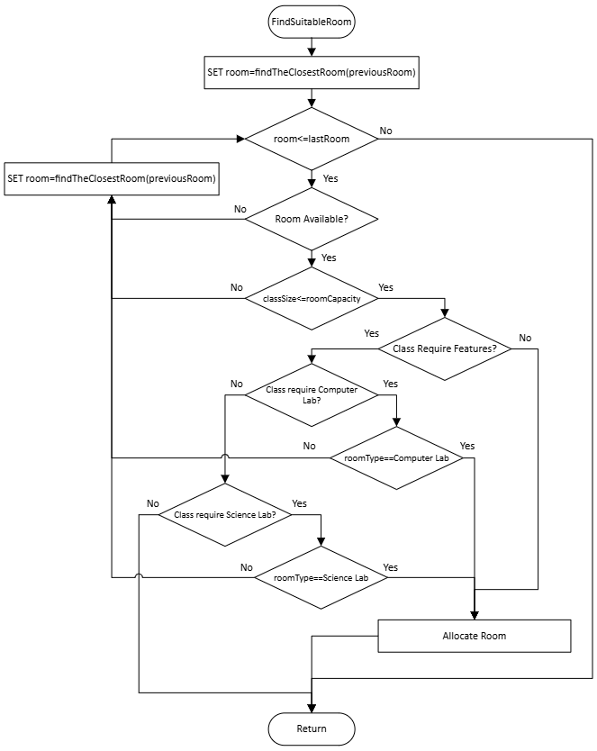

Figure 2: Find Suitable Room Flowchart

Explanation of How the Solution Works
The Main Program Flowchart in Figure 1 presents a scheduling algorithm that optimises classroom allocation by evaluating time slots, staff, groups, and rooms through a structured sequence of priority-based decisions and availability checks. The process begins by sorting classes and rooms according to predefined institutional priorities (e.g., larger student groups and rooms first), ensuring that the most important or resource-intensive sessions are addressed first.
After gathering all necessary inputs, the algorithm iterates through each time slot. For each time slot, it cycles through the list of staff members to check their availability. If a staff member is unavailable, the system displays an immediate message and moves on to the next candidate. Once an available staff member is identified, the algorithm evaluates each student group to ensure that no group is double-booked or assigned to overlapping sessions. If a group is unavailable, the system displays a message and continues searching.
When both an available staff member and a student group are found, the algorithm calls the function FindSuitableRoom, which identifies a room that meets the class's requirements. If no suitable room is available, the system displays a message and returns to the next student group to explore alternative combinations. When a room is successfully allocated, the system proceeds to the next time slot.
This iterative process continues until all time slots, staff members, groups, and rooms have been evaluated. Once all iterations are complete, the system checks for any scheduling conflicts.
The sub-process CheckSchendulingConflict verifies that no overlapping assignments or resource clashes have been introduced. If a conflict is detected, a reallocation procedure is initiated to resolve the issue without disrupting the overall timetable. If no conflict is found, the system generates the final timetable.
The Find Suitable Room Flowchart in Figure 2 presents a step-by-step process for evaluating each room’s availability, capacity, and required features before allocation. The findTheClosestRoom function is incorporated into this process to ensure that each new candidate room is chosen based on proximity to the previously used room, thereby minimising movement time between consecutive classes for both students and staff.
By combining priority sorting, sequential availability checks, and conflict resolution, the flowchart models a robust and efficient approach to timetable generation. This approach reduces manual intervention, minimises scheduling errors, and ensures fair and logical distribution of institutional resources.

Task 3: Reflecting on Problem-Solving Techniques and Justifying the Approach

3.1 Problem-Solving Techniques Used
A range of structured problem-solving techniques was applied to break down the complexity of the classroom-allocation scenario and develop a logical, optimised solution.
The first major technique was decomposition, where the large, complex problem was broken into smaller, manageable components. This made it possible to analyse each part independently before integrating them into a complete solution[6].
The MoSCoW technique helped prioritise requirements into MUST HAVE(e.g., capacity matching), SHOULD HAVE(e.g., minimising movement time), COULD HAVE(e.g., preference handling) and WON’T HAVE(e.g., real-time navigation). This ensured the solution focused on essential functionality first.
Abstract thinking was used to generalise the real-world scenario into a structured model. For example, rooms were treated as objects with attributes(name, location, type, capacity). This abstraction allowed the creation of a flowchart that focuses on logic rather than physical details. It also made it easier to identify decision points and constraints without being distracted by unnecessary complexity.

3.2 Why this Approach is Appropriate
This approach is appropriate, as it manages complexity through decomposition, abstraction, and prioritisation, enabling the problem to be addressed in a clear and structured manner. It reflects practices used in real-world scheduling and timetabling systems, making the solution realistic and scalable. Furthermore, it supports fairness and efficiency by prioritising larger classes for suitable rooms and optimising space utilisation.

3.3 Assumptions and Limitations
The solution assumes:
- All input data are correct and up to date.
- The college operates within a single building.
- The timetable is generated per week and is applicable for all weeks within a semester and remains consistent.
- Breaks between classes are 15 minutes, which allows student groups and staff to move between classes.
- The college offers three types of rooms: standard rooms, computer labs, and science labs.
The solution has limitations:
- It doesn’t handle real-time disruptions such as staff illness or sudden changes in class size.
- It may create extended gaps between scheduled classes for both student groups and staff members, reducing overall time efficiency.
- A more advanced system will be required for campuses with multiple buildings and a variety of room types.
- The optimisation is approximate rather than mathematically optimal.

Conclusion
Research on challenges in college classroom allocation has resulted in an effective, structured solution utilising established problem-solving techniques. By applying decomposition, the complex scheduling scenario was broken into manageable components, allowing each requirement to be examined in isolation before being integrated into a coherent system. The MoSCoW method further supported this process by prioritising essential needs such as capacity matching and conflict avoidance, ensuring that the solution focused on the most critical aspects of efficient timetable design. Through abstraction, the real-world environment was translated into a logical model in which rooms, groups, and staff were treated as objects with defined attributes, enabling the creation of a clear flowchart that captures the decision-making logic of the allocation process.
The main flowchart provides a structured sequence of checks and assignments that optimise room usage and prevent scheduling conflicts.
The reflection on the techniques used shows how decomposition, prioritisation, and abstraction helped manage complexity and supported the development of a transparent and justifiable solution.
Although the model operates under several assumptions and has limitations—such as single-building operation and the inability to handle real-time disruptions—it establishes a strong foundation for an efficient, conflict-free allocation system. It also highlights opportunities for future enhancement, including dynamic updates and more advanced optimisation methods.
Overall, the solution meets the assessment requirements by providing a logical, well-reasoned, and practically applicable approach to improving classroom allocation in the college.

References
[1] K. I. A. Fadlallah, M. M. Sharif and M. E. Y. Eldow, "Developing parallel requirements prioritization machine learning model integrating with MoSCoW method," vol. 1, no. 1, 2024,
[2] A. Bashab, et al., "Optimization Techniques in University Timetabling Problem: Constraints, Methodologies, Benchmarks, and Open Issues." vol. 74, no. 3, 2023,
[3] C. Maya-Padrón and N. M. Arratia-Martínez, "Educational timetabling problem with teaching load assignment using preferences and compactness," pp.1–26, 2024,
[4] M. Chen, F. Werner and M. Shokouhifar, "Mathematical modeling and exact optimizing of university course scheduling considering preferences of professors," vol. 12, no. 5, pp.498, 2023,
[5] H. W. Prabawa, R. Rosjanuardi and E. Nurlaelah, "Problem decomposition skills, mathematical maturity, and their relation to mathematics problem-solving in a computer science learning class," vol. 9, no. 3, pp.946–958, 2023.

