School of Sport, Health & Outdoor Education

Assessment Feedback Sheet

Student No./Name: 1400155/Henry Frost
Module: Landscape and Sustainable Recreation.
Module Code: SHSS6082

Personal Evaluation – to support your academic progress please complete the section below BEFORE submitting your work.
What do you consider to be the best aspects of this work? |  |  | Different uses of the three locations.
Which aspects do you consider could have been improved in this piece of work? |  |  | More in depth look to consider internal and external factors.
What have you found most satisfying whilst undertaking this submission? |  |  | Visiting different locations to look at their use.
ASSESSMENT CRITERIA | Learning  Outcomes |  | GRADE
ASSESSMENT CRITERIA |  |  | Poor  < 20% | Weak  20-29% | Unsatisfactory  30-39% |  | Satisfactory  40 – 49% | Good  50 – 59% | Very Good  60 – 69% | Excellent  70 – 84% |  | Exceptional  85– 100% | %
Your discussion of the nature of landscape within the context of the fieldwork locations | 1 |  |  |  |  |  |  |  |  |  |  |  | 20%
Your critical evaluation of external and internal influences that affect the perception, interpretation and use of landscape at the fieldwork sites. | 2 |  |  |  |  |  |  |  |  |  |  |  | 20%
Your critical discussion of the relationship between landscape and recreation and your suggestion of sustainable approaches to the interpretation and use of landscape for recreation. | 3 |  |  |  |  |  |  |  |  |  |  |  | 40%
Your identification and use of relevant academic and other material to help inform and develop your argument | 1,2,3 |  |  |  |  |  |  |  |  |  |  |  | 20%
It is expected that students will present work that is proof read, correctly referenced and adheres to the Assessment Checklist. Therefore a range of 0 – 10 marks will be deducted for non-completion of any of the points on the checklist below.
TUTOR COMMENTS:

Submission date:  via Turnitin |  | Return date:  (at least within 4 weeks) |  |  |  | Tutor: |  |  |  |  | Mark:

Uses of landscape at three different locations.

To understand what landscape means to an individual, two visits were made to two very different locations around the South of Wales. These trips were aimed at improving the knowledge of what landscape was and how place can influence the person. With each trip, a reflective account was taken to help better understand what the landscape can mean to different individuals. In addition, below in appendix 3, there is another reflective account taken at a separate location to help add breadth to this discussion around landscape and place. Furthermore, to help add context to this discussion, maps and pictures of the locations have been supplied to help add more information to this discussion to help best understand what is being stated.

Gower.

The first visit which was undertaken was to Pennard castle and Three cliffs bay (Appendix 1, 4 and 7) on the Gower in South Wales. This trip was led by Dryad Bushcraft, a local company that specialises in bushcraft skills and wilderness activities. The aim of this trip was to venture towards the Three cliffs bay and then up to Pennard castle looking at the local flora as well as considering the historical background and local history of Pennard castle. The landscape which was found at Pennard Castle and the Three Cliffs Bay is very typical of what you find on the Gower peninsular and the surrounding South Wales coast line. The beginning of the walk was largely dominated by woodland and gently rolling hills slowly giving way to the flood plain of the river Pennard Pill. Further down the flood plain the Castle comes into the view and then once the last few meanders of the river end you see the Three cliffs bay. Once at the castle you get a better view point of the surrounding landscape (Appendix 4) and the surrounding farm land and woods. As seen in Appendix 4c, the area around Pennard Castle and the Three cliffs bay is rich with flora, fauna, and beautiful landscape. However, beyond the castle is a substantial sand dune system which has a link to why the castle was led into disrepair and why very little is still visible today (Appendix 4b). This sand dune system is what links the castle to Three Cliffs Bay, aptly named due to the three prominent cliffs. The area which was explored around Three Cliffs and Pennard Castle has a very secluded feel more so than at Dinefwr Park (Appendix 2) and The Nevis Range (Appendix 3, 6 and 9). The walk started with a slight descent down into the Pennard Pill flood plain and from there you started to feel very detached from the surrounding world and made it feel very isolated and as if you were in another period of time. “Geography is a reflection of people’s curiosity about the differences between parts of the Earth’s surface.” (2008, p.16). This has helped to form the feeling of being disconnected from the surrounding area. Being disconnected from the area around the place visited meant that it helped one to forget where they were and focus on the here and now and thus focus more on the surrounding landscape and topography helping to give the sense of isolation. By being isolated it also helped to focus on what was important to the here and now especially when it came to learning about the local fauna and flora, as well as the historical landscape of Pennard Castle.

Furthermore, “Place attachment can be developed through both (1) direct experiences with place, especially long-term, frequent, and positive experiences and (2) learning about place from indirect sources rather than direct contact.” (Kudryavtsev et al, 2012). Meaning that it will be appropriate to consider the external factors that helped to form an attachment to the place in question and how it has helped to influence both the perception, interpretation and the use of the land surrounding of the Gower. Firstly, looking at the external factors of the fieldwork visit (appendix 1). An important external factor that helped to influence the perception of the landscape was the stories that were told about how the castle became a ruin. This story helped to put a fun and interesting spin onto the castle itself, helping to give a traditional folklore feel to it and helping to cement it more into the landscape. “Demonstrates how different stories of the same setting can emphasise different aspects of history, that in turn may lead to quite dissimilar representations of the place and what occurred.” (Stewart, 2008). In addition, the story about the demise of the castle was an important external factor helping to influence the interpretation of the area, it helped to show that the location of the castle had originally made it an important defensive and trade location near to the sea helping to give it a sense of importance. Additionally, an important external factor that influenced the use of the Three Cliffs Bay was it extreme nature. Although the rest of the area surrounding is fairly mundane, the Three Cliffs themselves are very popular climbing and abseiling locations (Appendix 4a). This external factor will mean that anyone visiting the area will be largely drawn to that area given because of the use. Moreover, adding on to the external factors, it will also be important to consider what where important internal factors experienced during the field trip. Also considered to be place meaning, “Place meaning refers to the symbolic meanings that people ascribe to settings.” (Kudryavtsev, 2012). An important internal factor which effected the perceptions of the day was the muddy conditions during the early stages, this intern meant more time was spent making sure no one slipped then really taking in what lay around and listening to any information given by the guide, meaning that initially the day started off badly. In addition, internal factors also played a role over the interpretation of the day. Having listen to the stories about Pennard Castle and its eventual demise due to the local fairy folk, the area now be used to tell stories and that the journey around from beginning to the end is the beginning and end of the stories of the past. Also, to be considered is the internal factors on use of the landscape, it was noted that at the beginning of the day the use of the land seemed minimal however, at the end of the day it was found that the use of the land seemed vast from a golf course or climbing and even to story-telling. Making it a go to place to explore and immerse oneself in history and folklore.

Relating this field trip to current and relevant academic sources, it has been noted that what was experienced throughout the day with the stories and the knowledge of local fauna and flora, is it helping to highlight the importance of the relationship between landscape, recreation and helping to promote its sustainable use. Firstly, what is important to consider is the landscape that surrounds Pennard Castle and the Three Cliffs Bay, this landscape has been built up predominantly by storytelling, “The areas of cultural and environmental history have much to offer outdoor environmental education in regard to learning how to ‘read’ the landscape for stories of past activities that have shaped a place.” (Stewart, 2008). This helps to formulate the relationship between landscape and recreation. Stories of past events have clearly shown to influence landscape and as in the case of Pennard Castle, were there is the story of the local Fairy Folk causing the downfall of the castle. Subsequently, the story can be used to attract walkers and nearby climbers to come and see if they are able to find the fairy folk, making use of both the stories and the local sporting attractions to help draw individuals in. Secondly, recreation has an interesting link to both landscape and how it can be used sustainably, further adding depth to Stewarts (2008) point, Van der Zee has stated that, “Like every human activity outdoor recreation influences the natural environment and can be destructive as an industry.” (1990). As seen in appendix 4c, the wildlife around the castle is incredibly pristine with many edible wild vegetation available on sight to pick during the correct seasons. Consequently, with a potential increase in people wishing to visit the area, you will begin to see the fine line between keeping the area natural to it become heavily eroded due to visitor numbers and vegetation being removed. It can easily be argued that closing the area off to large groups could provide an answer, a notable example is the Ogof Ffynnon Du National Nature Reserve in the Brecon Beacons. This area rich with flora which clings to the Limestone pavement is fenced off to visitors in an attempted to preserve the area unique to the Swansea Valley. Although it maybe an effective measure here, enforcing such rule over Pennard Castle and the Three Cliffs maybe a touch on the extreme side, it must be said it is important to take precautions now to minimise the effect. One important area to help minimise the effects of human interference is the Domestication on the land, “Domesticated nature in its simplest form means nature exploited and controlled.” (Kareiva et al, 2007). In essences, what will be important here is to allow nature to take its course and not attempt to destroy parts which we feel do not help ourselves and merely just embrace the presences of the new foothold nature can take. If the Pennard Pill changes course, then it should be left, and no further alterations should ever be made, although alterations were initially made during the castle construction it should be embraced as the new norm and left to naturally reform itself. This is the most important aspects of preservation for the Pennard Castle and Three Cliffs as it helps to persevere the magical landscape which many find themselves in.

Dinefwr park.

The next field trip undertaken was to the Dinefwr Country park (Appendix 2, 5 and 8) located outside of Llandeilo. This is a very stark contrast between the first location (Appendix 1) and very different to the other chosen location at the Nevis Range outside Fort William (Appendix 3). The Country Park itself is located outside of the Brecon Beacons meaning the terrain features are gentle rolling hills with very little in terms of notable features like the Three Cliffs or any sand dune system. However, as like the trip to the Gower it features a castle on the grounds. Although, were built at separate times, it is clear to see that they formed an impressive shadow over the surrounding land helping to upholds its significance over the indigenous population. There is a common theme however which emerges from the three locations in the sense that they use the surrounding land to gain a significant advantage whether it be tactical in defence or making use out of the substantial rise in topography which is seen at the Nevis Range, which is located on the slopes of Aonach Mor next door to Ben Nevis. Going back to the two original locations, what was noted also was the differences which are experienced at both locations in terms of sustainability issue as well as how to encourage people to use it.

Throughout the day at Dinefwr park, it was noted that a large proportion of the influences which effect perception, interpretation and use of landscape were largely external. However, it will also be important to note the internal factors effecting the three prior stated areas. As seen in Appendix 5b, there is a picture of the mill pond located along a ‘Capability’ Brown walk (National Trust, 2018). On a calm day the lake produces a near perfect reflection on the woodland surrounding it. Reflection is an important internal effect towards adding positive effects towards perception, interpretation, and the landscape use. “Reflective practice, therefore, is also an attractive idea for environmental educators as it provides a process for achieving key goals of environmental education, namely, the development of critical thinking skills and a commitment to action.” (Ferreira et al, 2013). The mill pond itself can be seen as a key to promoting reflection to aid perception, interpretation and the use of landscape. The role which reflection played was to help consider the external factors that influence the respective titles in this paragraph. Currently, the popularity of Dinefwr is causing some destruction to its current infrastructure. Not long before the visit, it had hosted an Autumn market where of up to 6000 people attend over the weekend. Due to a wrong information being passed a large coach was used to shuttle people to and from the park, due to its size, it caused havoc in the carpark and eventually destroyed the grass banks and certain speed bumps as well. “The influence of the human species on the global ecosystem has considerably in the past century.” (Langeweg et al, 2000). This is an important area of consideration towards the up keep of Dinefwr. Perceptions may change on the place if visitors are told maybe a car park is shut due to its over use, meaning people may interpret that as a sort of mild threat that they cannot park there and see its use as being diminished and potentially reducing funding to the park due to low numbers of visitors.

It was clear to see at Dinefwr Park that the relationship between landscape and recreation was in some ways fragile. As stated prior by Langeweg et al (200), we as a species have incredible influence over the ecosystem with incredible ability to change it for our good. This is similar to what is being experienced at Dinefwr. “It is important to know and understand what is happening in the world, how other people live and work and how we are all interconnected.” (Cooper, 2007). In real world scenarios, it is very hard to draw the line between people becoming more concerned with the landscape, but also encouraging people in for them to understand the issues surrounding the ecosystem, which itself has stresses and strains on the landscape through recreation. Additionally, “Outdoor Learning is also connected with questions of sustainable development and citizenship.” (Field Studies Council, 2004). This helps to further add to the conundrum of getting people to see the effect we have on the landscape but having to do it through recreation which causes damage. Dinefwr park as a vast variety of means of achieving outdoor learning, as seen in appendix 5a they have a raised boardwalk section which goes from the old abattoir and through the deer park. The walk takes visitors through ancient woodland and the old remnants of silting pools for the mill pond. The aim of the National trust ranger for Dinefwr is to reinstate the silting pools to help desilt the mill pond to encourage more wildlife, but it stuck as large machinery will have to be used to rebuild some of the sluice gates, however, even though the short-term outcome is less desired, the benefits will only be seen with time. This is important as it helps to positively impact upon Rewilding Britain, “Rewilding is the large scale restoration of ecosystems where nature can take care of itself.” (Rewilding Britain, 2018). Although, there seem to be many short-term issues, especially the cost, it is important to see the benefit to visitor’s knowledge and flora and fauna.

Having analysed and looked at the issues and positives that surround the field trip locations it is clear to see that landscape plays a big part in how the land can be used, but also, has a very large influence over how it can be used sustainably for others in years to come. Although a few issues were highlighted such as the short-term increased use and destructed of areas, it was clear to see the many positives that were seen surrounding its use and interesting stories that surround them to encourage and educate people on the past and the future.

Word Count: 2674

References:
- Cooper, G. (2007) ‘Going Global in the Outdoors – how outdoors leaders can encourage education for a fair and sustainable world’, Horizons, (40), pp. 4-7.
- Cresswell, T. (2008) Place: a short introduction. Oxford: Blackwell.
- Ferreira, J., Keliher, V., Blomfield, J. (2013) ‘Becoming a reflective environmental educator: Students’ insight on the benefits of reflective practice’, Griffith University, 14(3), pp. 368-380. doi: 10.1080/14623943.2013.767233.
- Field Studies Council (2004) A Review of Research on Outdoor Learning, Available at: https://www.field-studies-council.org/media/268859/2004_a_review_of_research_on_outdoor_learning.pdf (Accessed: 25 January 2018).
- Kareiva, P., Watts S., Mcdonald, R., Boucher, T. (2007) ‘Domesticated Nature: Shaping Landscapes and ecosystem for Human Welfare’, American Association for the Advancement of Science, (316), pp. 1866-1869. doi: 10.1126/science.1140170.
- Kudryavtsev, A., Stedman, R., Krasny, M. (2012) ‘Sense of place in environmental education’, Environmental Education Research, 18(2), pp. 229-250.
- Langeweg, F., Hilderink, H., Maas, R. (2000) ‘Urbanisation, Industrialisation and Sustainable Development’, National Institute of Public Health and the Environment, (27), pp. 2-23.
- National Trust (2018) ‘Capability’ Brown walk, Available at: https://www.nationaltrust.org.uk/dinefwr/trails/capability-brown-walk-carmarthenshire (Accessed: 25 January 2018).
- Rewilding Britain (2018) Rewilding, Available at: http://www.rewildingbritain.org.uk/rewilding/ (Accessed: 25 January 2018).
- Stewart, A. (2008) ‘Whose place, whose history? Outdoor environmental education pedagogy as ‘reading’ the landscape’, Journal of Adventure Education and Outdoor Learning, 8(2), pp. 79-98. doi: 10.1080/14729670801906125.
- Van de Zee, D. (1990) ‘The complex relationship between landscape and recreation’, Landscape Ecology, 4(4), pp. 225-236.

Appendices:
Appendix 1 – Gower:
Landscape Character:
- Gentle rolling hills.
- Give way to an open flood plain leading to the Three Cliffs bay.
- Sand dunes help to link Pennard Castle to The Three Cliffs.
Landscape Quality:
- The valley for the Pennard Pill is very isolated from the surrounding landscape. Giving it a very secluded feel.
- Rich with edible flora.
- Deep link to old folklore.
Designations:
- SSSI, AONB, SAMS (Scheduled Ancient monument).
Use:
- Climbing, Walking, Golf, natural studies.
Access:
- A4118 provided the main access to the Gower Heritage Centre, then is a 20-minute walk to the castle.
Future Potential:
- The area is used extensively to teach people how to wild forage and looking after yourself in the field. The sand dunes have no longer mobile but rising sea levels and subsequent erosion may limit use of the three cliffs for climbing and hamper operations for the gold course.

Appendix 2 – Dinefwr:
Landscape Character:
- Gentle rolling hills with little prominent features.
- At the bottom of the grounds in a large flood plain.
Landscape Quality:
- Although largely influenced by humans, the park features ancient woodland and some of the oldest tree in the United Kingdom.
- Keeps resident deer as well as a mill pond which would supply hydro-electricity to the house.
Designations:
- SSSI.
Use:
- Walking, natural education, heritage centre.
Access:
- Easy access from Carmarthen by A40 and very local to Llandeilo.
Future Potential:
- The site is currently looking into recreating some of the original past features of the house such as the silting pools and also improving car parking.

Appendix 3 – Nevis Range:
Landscape Character:
- Large landscape features such as Aonach Mor and Ben Nevis.
- Glen Nevis splits the Hills.
- Landscape as a very ancient feel to it.
- In winter, snow will cover most of the surrounding hills down to between 650m (Nevis Range ski centre).
Landscape Quality:
- Landscape has stayed untouched for a number of years.
- Little in terms of variety of landscape, predominantly large mountains and U-shaped valleys.
- Home to a number of unique species of fauna such as red deer and Golden Eagles.
Designations:
- Grampian Mountain Range.
- Holds a SSSI and SAC
Use:
- Skiing and snowboarding, mountain biking, hill walking, climbing.
Access:
- Local town of Fort William as a railway stain as well as the main road coming north from Glasgow the A82.
Future Potential:
- Snow coverage as been an issue largely due to global warming. Snow thaws frequently leading to closures and limited ski runs. Mountain biking as continued to flourish and has hosted the UCI mountain biking world cup since 2002 and also hosted the mountain biking World championship in 2007.
Cable car offers easy access to Aonach Mor most of the year except for between October and early December for maintenance
Appendix 4:
Appendix 4a:
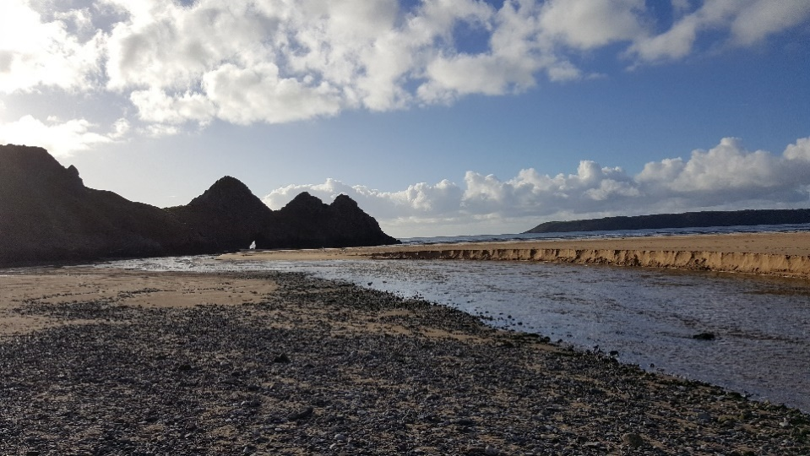

Appendix 4b:
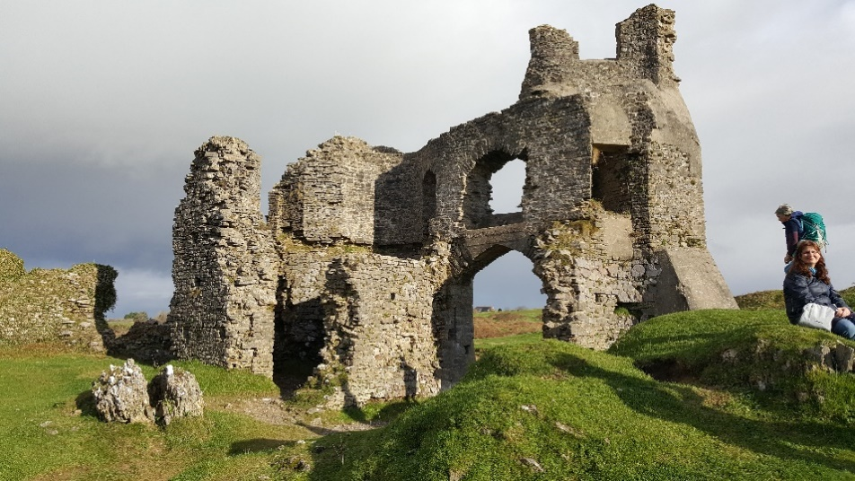

Appendix 4c:
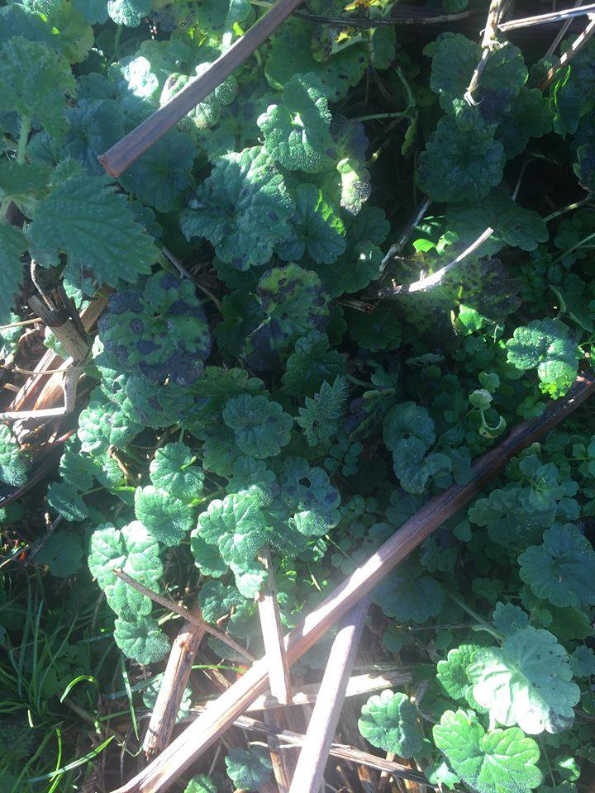

Appendix 5:
Appendix 5a:

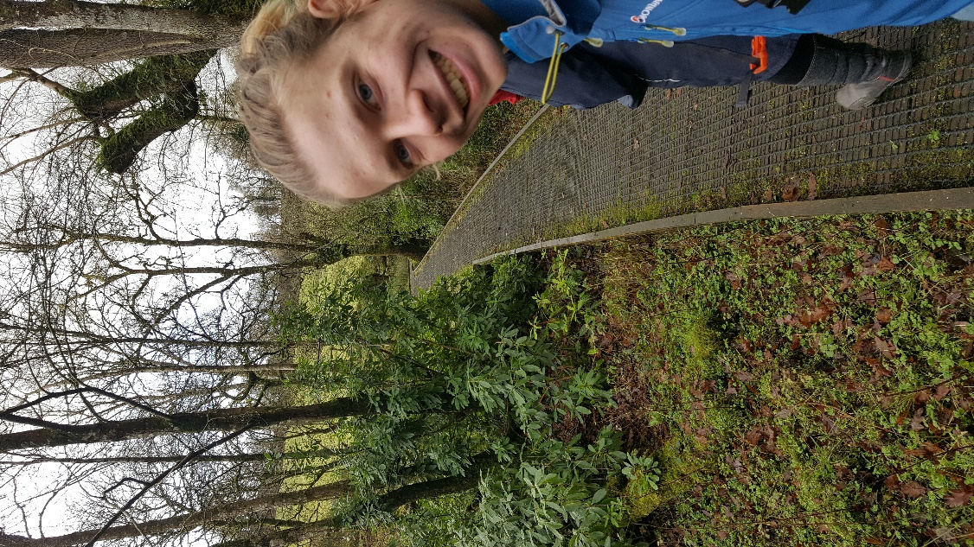

Appendix 5b:
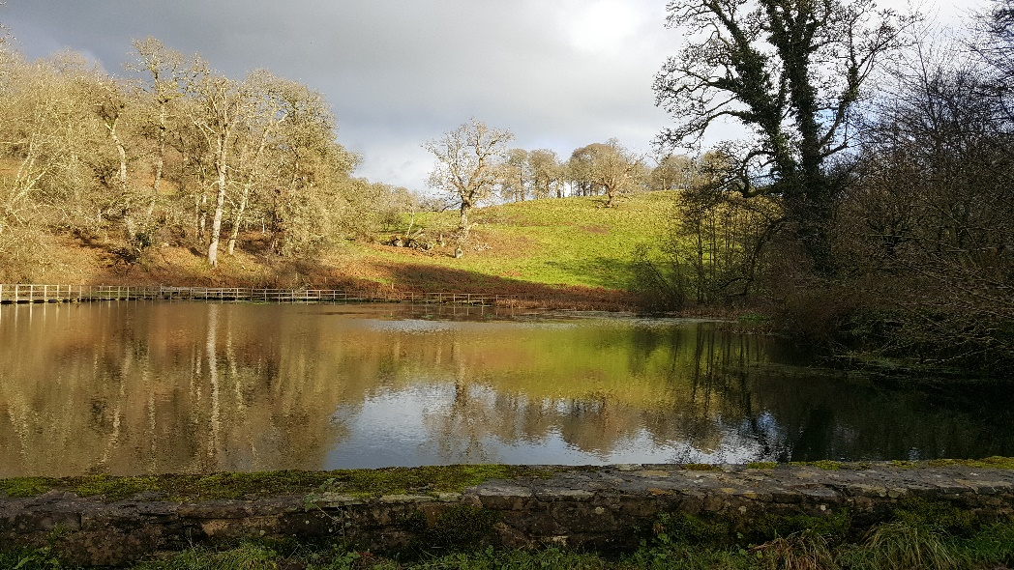

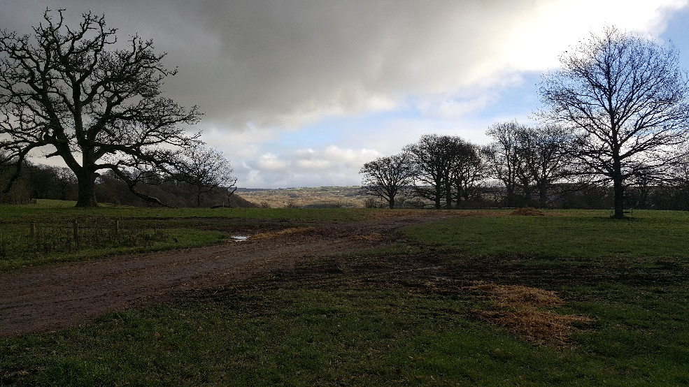
Appendix 5c:

Appendix 6:
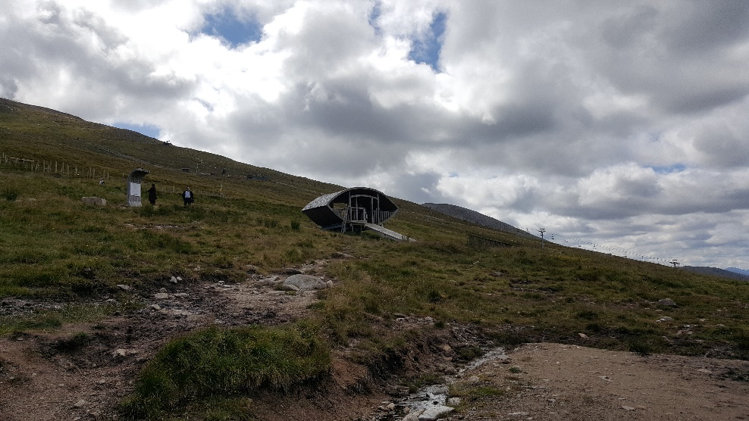
Appendix 6a:

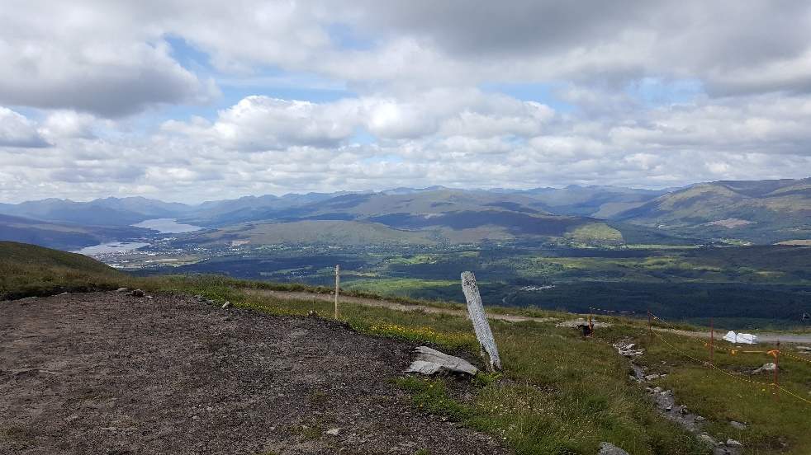
Appendix 6b:

Appendix 7:
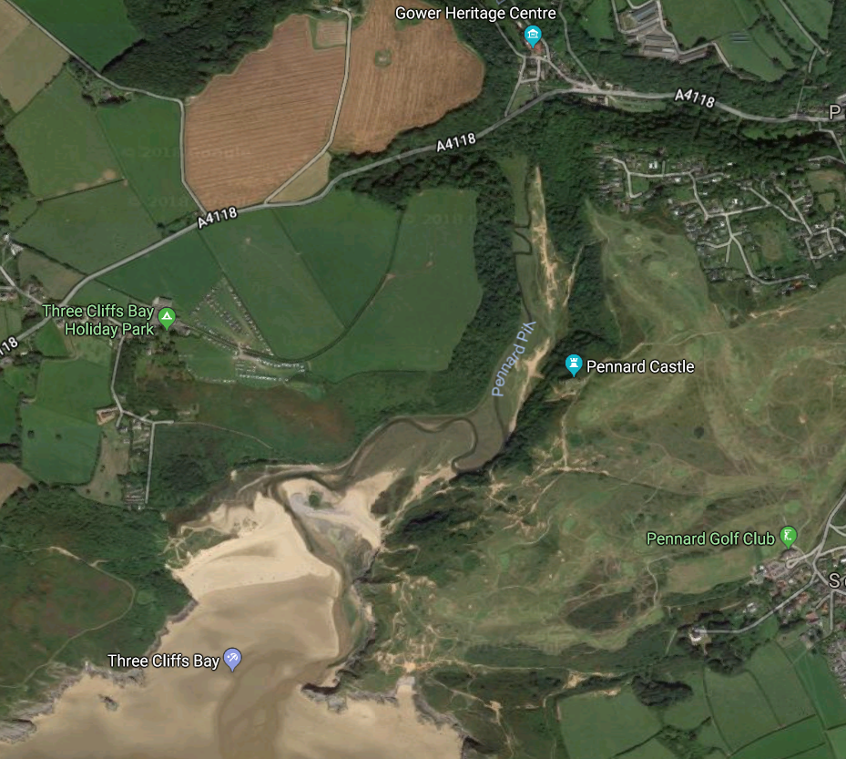

Appendix 8:
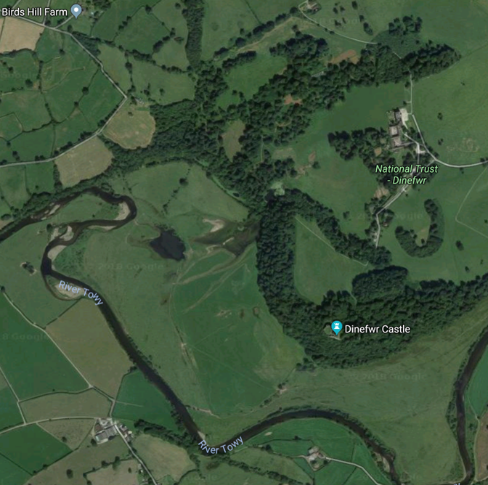

Appendix 9:


