
COURSE TITLE: DIGITAL SKILLS AND RESEARCH METHODS

COURSE CODE: BMSW4003

STUDENT NAME: IFEOMA NJOKU

STUDENT NUMBER: 1818792

Table of content Page
Introduction 3
Research background 4
Research aim 4
Research objectives 5
Research rationale 6
Literature review 8
Methodology 10
Results 11
Ethical consideration 12
Conclusion 13
Reference 15

1.0 Introduction
This research is geared towards investigating the significant of virtual learning environment (VLE) to student. The concept of VLE comes into existent about many years and it has been very useful in helping the student to do additional study of their own after regular classes. A Virtual Learning Environment (VLE) is a system which gives student tools for learning through the web (Richard, 2016). It comprises of student tracking, assessment, communication tools and collaboration (Ian, 2013). Student can get access to these whether they are in school or not, these meaning anywhere they are they can get support throughout the day and week. Lecture can be delivered to full time student and those who cannot be in school all the time. e.g. those on distance learning courses, doing evening classes, or workers studying part-time (Pete, 2016).
We have diverse types of VLE, the may differ a bit but they all carry out the same function and can produce the same study materials. Higher institution has a licence VLE which can go into any one of the categories:
- off-the-shelf, such as Blackboard
- open source (often free to use and adapt but support is charged for), such as Moodle
- bespoke (developed by institutions for their own individual needs)
This research will be using quantitative research method with survey distributed to eleven students, the outcomes from the survey will be analysed to determine the relevant of the platform to the students.
1.1 Background to research
With higher institution looking for ways to ensure that students will have learning materials easily and learn on their own, then organisation are come up with an online learning platform. According to Faden (2105), the population of students making significant use of the platform are increasing with 28% increase in the past five years. Because of the differences in the platform some schools are quite easy with the student while others a bit difficult because of the different stages. There is an 80% increase in the number of schools that are using the platform now when compare to ten years ago, with many students finding the platform very useful as it enable them to study at their time.
1.2 Research aim
To investigate the significant of virtual learning environment to the students
1.3 Research objectives
- To evaluate the impact of virtual learning environment
- To investigate the advantages and disadvantages of the platform
- To examine the different platforms and their significant to students educational capabilities
- To compare the traditional learning environment with the virtual learning environment
1.4 Research rationale
Many students argue that the virtual learning has bring about loss of contact with lecturers as will prefer to learning on their own without needing the help of the teachers. It is very obvious that this bring about convenient for the students and less work for the lecturer but the level participation of the students has dropped to 2% (Dean, 2013). As part of an investigative approach to really gain an understanding of the impact VLE has on the performance both the negatives and the positives. Research rationale according to Ahmed (2013) is the process of one identifying the reason or the motivation behind a certain research topic.

Chapter Two
2.0 literature review
2.1 Virtual learning environment concepts
The concept of virtual learning is linked with formal education that is related to the students and lecturer. The learning is common in most of the universities and colleges globally because of it easy accessibility and user friendly environment (Jones, 2013). The changes in the learning has made significant for institution to come up with a platform that allows students to study on their own and at a convenient time (Hayes, 2013). VLE is a web based educational system that is very dynamic and efficient for the students and the institution. This platform enables the students to prepare ahead of each class while also access to reading materials and sometimes guidelines on their coursework.
It is observed that the platform has helped to boost the student’s involvement in the daily activities of the school and it can be used to get lecturer feedback concerning their school work. The content is design to help the students carry out personal learning with videos, online reading articles and samples of good coursework to help the students. According to Siemens & Gašević (2012), VLE offers an interactive platform where the students can chat within themselves to gain knowledge and understanding concerning a particular task that is challenging. Dean et al (2016) argues that virtual learning environment is designed to make the students focus their research and learning based on what is available on the platform. In this way the student learning capabilities will only rely on the materials available in the platform
2.2 Learning analytics
Online education has become the easiest way of people getting advance qualification without having to be within the four walls of classroom. This is an impact of how technology is relevant in all sector of life; therefore students rely on the platform for all learning. According to Bramley (2016), learning with technology could be very could be very disruptive as reliance may lead to the students becoming lazy. Although the platform has become an engaging medium and integral part of learning in the universities and colleges but may likely become obsolete if not updated on regular bases to accommodate the needs of the students. The statistics of the number of students using the platform has increased to about 90% and it is estimated that by year 2030 many students will prefer online studies rather than traditional classroom teaching (Ahmed, 2016).
One of the main concepts behind learning analytics is the capability to take into account the number of students making use of the platform, in a way to evaluate the level of usability of the platform (Jones, 2016). The number of people using the platform is very important for the institution as this will allow them to plan and structure the content to meet with the students demands. Goff (2015) suggests that engaging learning environment may not really impact the performance of the students but the ability to engage with all the materials available.
2.3 Virtual Learning Environments and Their Relation to Students’ Performance
According to Ahmed (2016), VLE is very efficient for the students as it enables them to learn on their own and get themselves prepared for the classes ahead and this means there are better placed to learn quickly and faster. Any changes that the university will want to implement in the curricula can be effective introduce using the platform to see the reactions from the students before full implementation. Apart from using it formal education purposes the platform could also be used for informal educational purposes such as communication and sharing of knowledge. Dean et al (2016) suggests that in recent survey the positive impact that VLE has on the students is more than the negatives. Although many people still prefer the normal classroom teaching it is very imperative that times are changing and the mode of learning is changing with time and very soon the number of students that prefer online learning will increased by 26% (Ian, 2015).

Chapter Three
3.0 Methodology
This research is a quantitative analysis, with eleven students chosen selected randomly. This is quantitative research that will involve giving out questionnaire to11 participants that will fill it out depending on the applicability of the questions to them. Consent forms will be issued to the participants in compliance to the policy of the university. The survey will be handed out to the students with consent forms and is expected to be filled out within ten minutes.
Student Questionnaire: Virtual Learning Environment (VLE)
(Please tick one answer per question)
1) Are you satisfied or dissatisfied with the support that VLE Moodle offers?
A) Extremely satisfied
B) Satisfied
C) Neutral
D) Unsatisfied
E) Extremely unsatisfied
2) Does VLE help students to customise learning platform to suite local needs?
A) Extremely satisfied
B) Satisfied
C) Neutral
D) Unsatisfied
E) Extremely satisfied
3) Does VLE improve and encourage communication between teachers and students?
A) Extremely satisfied
B) Satisfied
C) Neutral
D) Unsatisfied
E) Extremely unsatisfied
4) In VLE how satisfied are you using Moodle?
A) Extremely satisfied
B) Satisfied
C) Neutral
D) Unsatisfied
E) Extremely unsatisfied
5) Would you agree that VLE is it the best system of learning from long distance?
A) Extremely satisfied
B) Satisfied
C) Neutral
D) Unsatisfied
E) Extremely unsatisfied
6) Do you think VLE encourages student feedback?
A) Extremely satisfied
B) Satisfied
C) Neutral
D) Unsatisfied
E) Extremely unsatisfied
7) Does VLE resource system deliver sufficient learning materials to student via by web?
A) Extremely satisfied
B) Satisfied
C) Neutral
D) Unsatisfied
E) Extremely unsatisfied
8) In VLE can you take part in an online course from any location where you can get a WiFi Signal?
A) Extremely satisfied
B) Satisfied
C) Neutral
D) Unsatisfied
E) Extremely unsatisfied
9) In VLE can you learn from home at your own comfort?
A) Extremely satisfied
B) Satisfied
C) Neutral
D) Unsatisfied
E) Extremely unsatisfied
10) Does VLE customise its learning materials with tests to suit the student’s needs?
A) True
B) False
11) In VLE customisable management features is used to create privates website with online course for education and trainers to achieve goals?
A) True
B) False
12) VLE can create a lesson plan using existing resources?
A) True
B) False

Chapter four
4.0 Results
This could be describing as the outcome from research that is being carried out (Bramely et al, 2016). Therefore the table below illustrate the outcomes from the research that was carried out;
Question number | Extremely satisfied | satisfied | Neutral | Unsatisfied | Extremely unsatisfied | Total
1 | 2 | 7 | 2 | 0 | 0 | 11
2 | 4 | 4 | 3 | 0 | 0 | 11
3 | 4 | 5 | 1 | 1 | 0 | 11
4 | 3 | 3 | 3 | 2 | 0 | 11
5 | 3 | 5 | 1 | 2 | 0 | 11
6 | 3 | 4 | 3 | 1 | 0 | 11
7 | 3 | 4 | 2 | 2 | 0 | 11
8 | 2 | 3 | 3 | 2 | 1 | 11
9 | 3 | 4 | 1 | 2 | 1 | 11

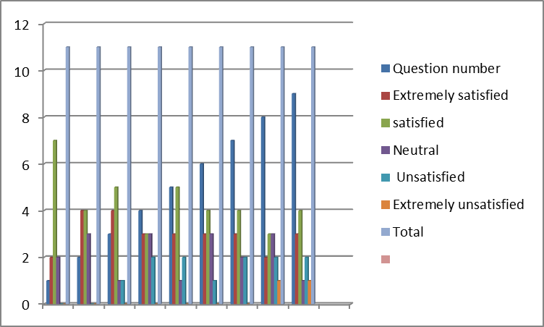
Bar chat representing the outcomes from the survey
Question number | True | False
10 | 5 | 6
11 | 7 | 4
12 | 8 | 3
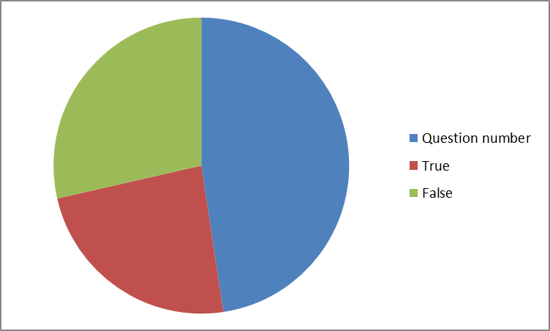
Pie chat representing the true and false section of the survey question
There is clear evidence from the eleven students that participated in the survey with 72% agreeing that the use of virtual learning environment has improved their capability to study more and get good grades from the study. 4% of the participants will prefer the traditional classroom teaching.
Conclusion
Getting result from how student are performing give us the ability to get the higher opportunity ta access the group VLE is, how high they are: how many number of course the student is to do, how many unit they have passed, unit they have pass that is linked to what they have registered, and at what percentage they have passed in the course unit. The more the group access to VLE is, the will be less percentage of failing the course unit. Huge differences was discovered between the number of course unit passed, which was very low at the rate of 0.5,these was seen between the group whose subject got higher assess to virtual environmental and the ones with a lower access. This analysis shows similarities in each group, the other variables of the research indicates that the impact of VLE is very relevant to the students learning adequately.
Ethical consideration
As the participants were given consent forms to seek their permission to take part in the survey. Ethical compliance with the university policy was followed in terms of ensuring that all details from the participants were made anonymous with the intention of destroying them after the exercise. Data protection Act 2018 was adequately adhering to during the process of carrying out the research.
The GDPR (General Data Protection Regulation) principles adopted during the research and compliance with the EU data protection were also applied to avoid compromising with the collected data.

Reference
Agudo-Peregrina, A., Iglesias-Pradas, S., Conde-González, M., & Hernández-García, A. (2014). Can we predict success from log data in VLEs? Classification of interactions for learning analytics and their relation with performance in VLE-supported F2F and online learning. Computers in Human Behaviour. 31. pp. 542–550.
Alves, P., Miranda, L., & Morais, C. (2014). Open Educational Resources: Higher Education Students’ Knowledge and use. In Rikke Ørngreen & Karin Tweddell Levinsen (Eds.), Proceedings of the 13th European Conference on e-learnig ECEL 2014. Reading, UK: Academic Conferences and Publishing International Limited. pp. 11- 18
Baker, R. and Siemens, G. (2014). Educational data mining and learning analytics R.K. Sawyer (Ed.). Cambridge handbook of the learning sciences. Cambridge University Press. Cambridge. UK.
Dahlstrom, E., Brooks, C., & Bichsel, J. (2014). The Current Ecosystem of Learning Management Systems in Higher Education: Student, Faculty, and IT Perspectives. Research report. Louisville, CO: ECAR. Available online: http://www.educause.edu/eca
Ferguson, R. (2019). The state of learning analytics in 2019: A review and future challenges. Technical report KMI-12-01. UK: Knowledge Media Institute, The Open University.
Papamitsiou, Z., & Economides, A. (2014). Learning Analytics and Educational Data Mining in Practice: A Systematic Literature Review of Empirical Evidence. Educational Technology & Society, 17 (4), 49–64. 2014
Siemens, G., & Gašević, D. (2012). Guest Editorial - Learning and Knowledge Analytics. Educational Technology & Society. 15(3). pp. 1-2

