Resonance

Saffina H - 2322601
Electrical and Electronic Principles – ACDA4006
BEng Embedded Electronic Systems

Table of Contents
Table of Figures 2
Table of Tables 3
Table of Equations 3
1. Abstract 3
2. Introduction 3
3. Simulation setups 4
3.1 Digital Simulation 4
3.2 Breadboard Circuit 6
4. Results 8
4.1 Simulation Results 9
4.2 Breadboard results 9
4.3 Plotting the results 9
5. Discussion 10
5.1 Resonant frequency 10
5.2 Q factor 11
5.3 Parasitics 12
5.4 Second simulation 14
6. Conclusion 16
7. References 18

Table of Figures
Figure 1:Bandpass filter circuit 3
Figure 2: Simulated circuit schematic 4
Figure 3: Layout of components on breadboard 6
Figure 4: Connection of oscilloscope probes to breadboard circuit 7
Figure 5: Picture illustrating the set up of the oscilloscope and signal generator 8
Figure 6:Graph of attenuation against frequency for both sets of results 10
Figure 7: Graph showing how measurements for the Q factor were taken for the simulation 11
Figure 8:Graph showing how measurements for the Q factor were taken for the breadboard 12
Figure 9:Diagram illustrating how an imperfect capacitor can be modelled 13
Figure 10:Diagram illustrating how an imperfect inductor can be modelled 13
Figure 11:Diagram illustrating how an imperfect resistor can be modelled 13
Figure 12:Second simulation of band pass filter circuit 14
Figure 13: Graph of attenuation against frequency for all sets of results 15
Figure 14:Graph showing how Q factor was calculated for the second simulation 16

Table of Tables
Table 1: Table of results for simulation, recording Vout, calculating attenuation 9
Table 2: Table of results for breadboard results, recording Vout, calculating attenuation 9
Table 3:Table of results for second simulation, recording Vout, calculating attenuation 15

Table of Equations
Equation 1:Resonant frequency 10
Equation 2: Q factor 11

1. Abstract
This lab reports sets out an experiment to analyse how the attenuation of a band-pass filter circuit varies with frequency. This was tested digitally and through building the circuit on breadboard. It was found that the results from the simulation were vastly different to the breadboard tests and further analysis determined this to be a result of parasitics in the components. The simulation was then adapted to reflect the real circuit more accurately.

2. Introduction
The circuit that will be looked at in this report is a filter. In this specific case it is a band-pass filter; it contains a capacitor and inductor and resistor, as shown in the circuit diagram below, meaning it is an ‘passive filter’ due to containing only passive components. [1]
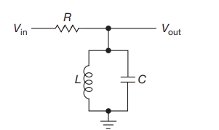 [2]
Figure 1:Bandpass filter circuit
The purpose of most filters is to transmit signals in a certain frequency range and lessen/attenuate signals outside of this range. [3] It does this by combining both a high-pass and low-pass filter in series. [4] This means that the high-pass filter has a cut-off frequency that will block all frequencies lower that the cut-off, while the low-pass filter blocks any frequencies above its cutoff frequency.
Some of the applications of band-pass filters include:
- Optics – such as LASER
- Telecommunications
- Wireless transmitters and receivers
- Audio amplifier circuits [5]
The experiment looked at in this report will measure the attenuation of the band-pass filter as frequency is increased and varied around the resonant frequency. Resonance occurs when the capacitive impedance and inductive impedance are equal as they both vary with frequency. [6] When this happens, the impedance of the circuit is at a minimum, causing circuit current to be at a maximum and a maximum attenuation. [7]
The experiment will involve both a simulated circuit and a circuit built on breadboard. The attenuation at various frequencies will be calculated and the results compared. The Q factor of each test will also be calculated and potential reasons for differences will be analysed.

3. Simulation setups

3.1 Digital Simulation
First, the circuit schematic was constructed on Proteus, following the design set out in the assignment brief. This schematic is shown below in Figure 1, it includes Proteus’ built in oscilloscope and signal generator features.
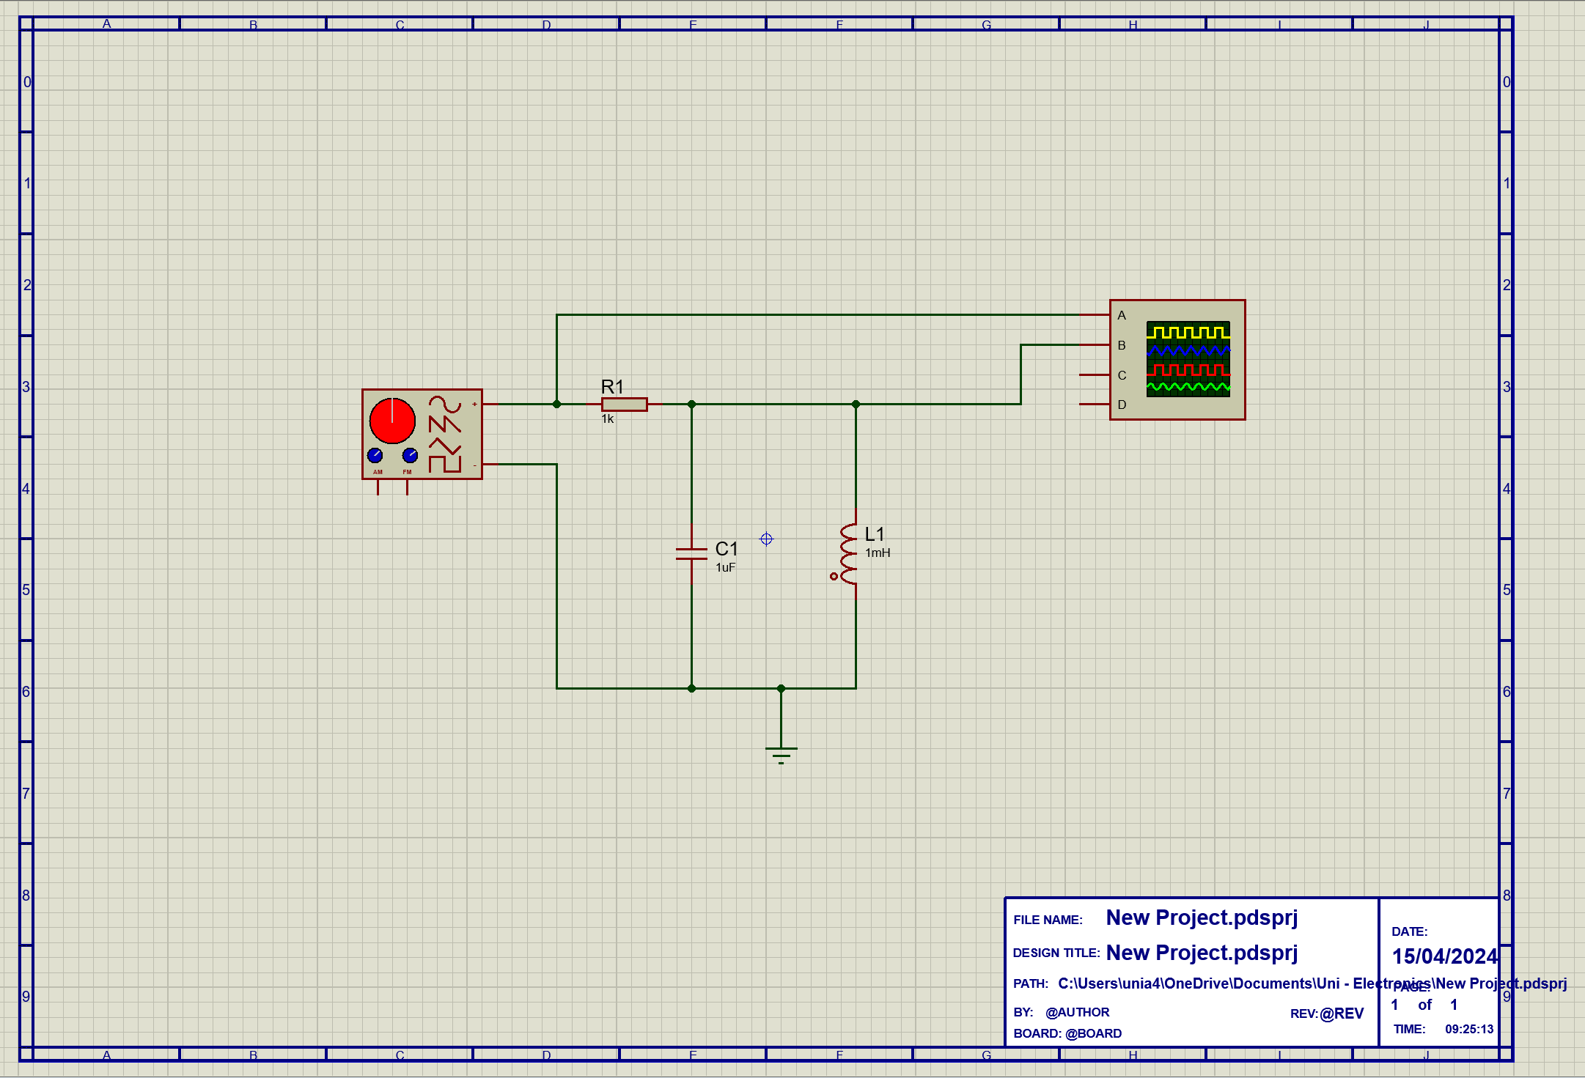
Figure 2: Simulated circuit schematic
The signal generator was set to 2V_{pk-pk} and its frequency will be varied, starting at 100Hz and ending at 20kHz. The frequencies that will be measured will then increment from 100Hz by 100-1000Hz, depending on how close the value is to the peak of the response as additional frequencies will be measured close to the peak to measure its shape more accurately. The initial setup of the signal generator can be seen below in Figure 2.

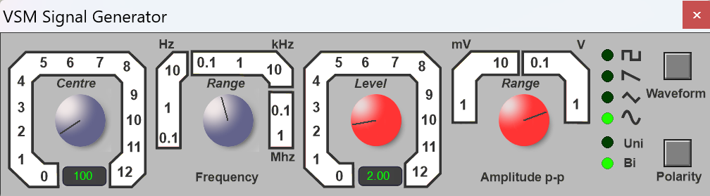
Figure 2: Digital signal generator display
Channel A of the oscilloscope was set to measure the input voltage, which is the output of the signal generator. Channel B of the oscilloscope was measuring the output of the circuit. The peak-to-peak of each channel was measured using the oscilloscope’s ‘Cursors’ function, this meant that the maximum and minimum voltage of each waveform could be measured, giving the peak-to-peak voltage of both the input and output waveforms. The oscilloscope display is shown in Figure 3.
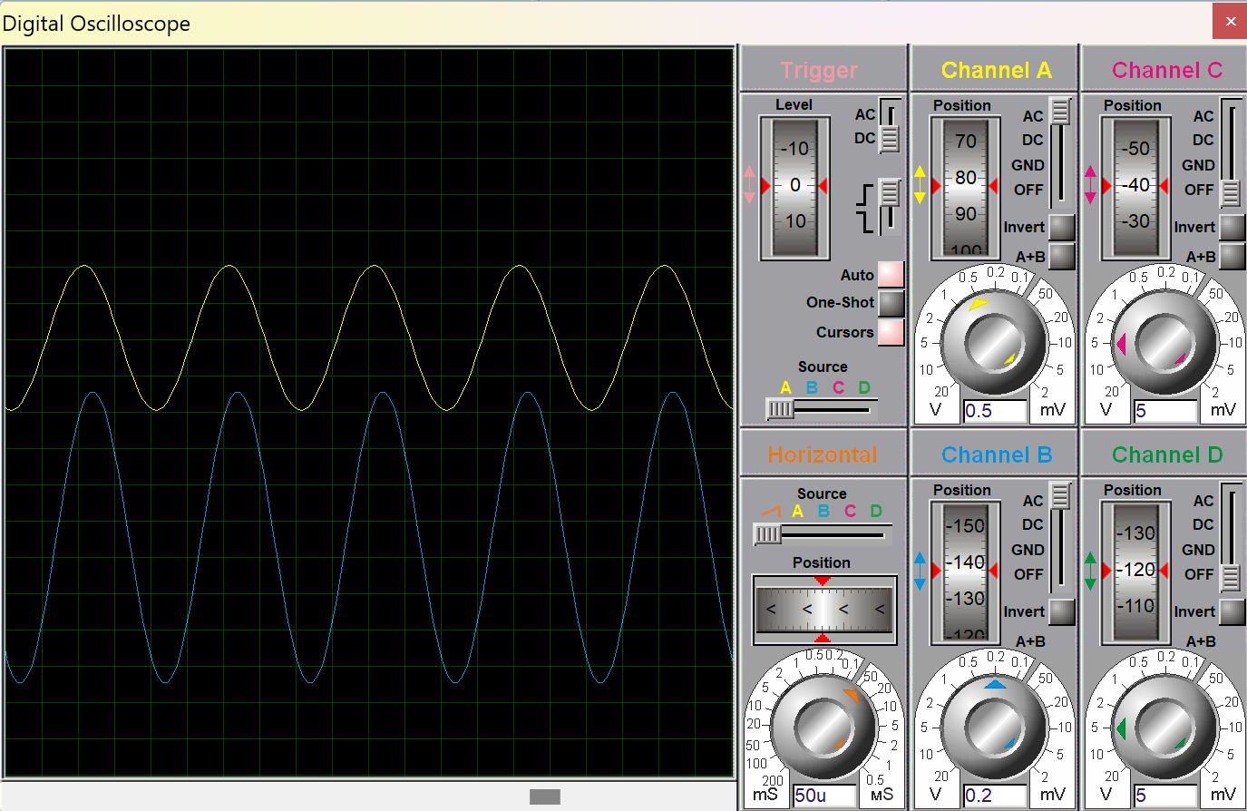
Figure 3: Digital oscilloscope display

3.2 Breadboard Circuit
After the results from the simulated schematic were recorded, the same circuit was set up on a breadboard. This circuit can be seen below in Figure 4, it includes the power rail being connected to the red wire on the left, connecting to the output of the signal generator. Similarly on the right-hand side, the negative rail will connect to the negative terminal of the signal generator.
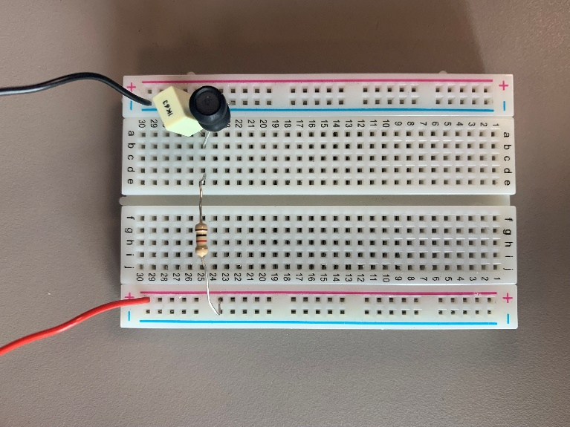
Figure 3: Layout of components on breadboard

The signal generator and oscilloscope was then connected to the circuit as shown below in Figure 5. The two osclilloscope probes were attached either side of the resistor, as one will then measure input voltage and the other output voltage, as shown in the circuit schematic. Both probes were then also connected to ground (negative terminal of signal generator) as this provides an electrically neutral reference point and provides more accurate measurements by sharing the same ground as the circuit. [8]

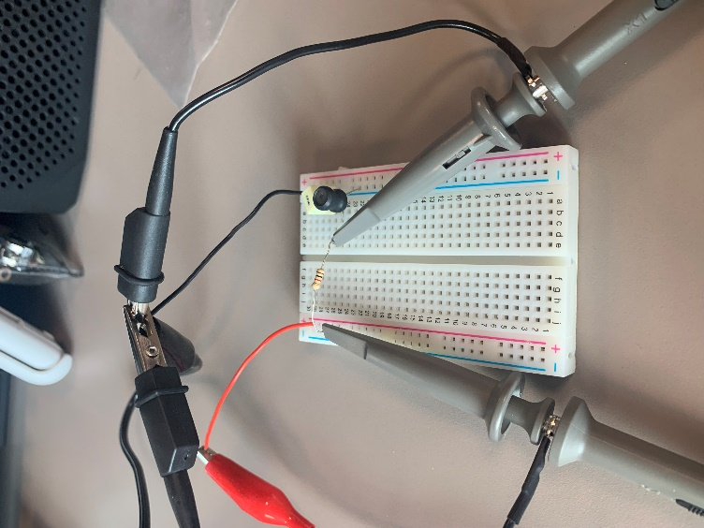
Figure 4: Connection of oscilloscope probes to breadboard circuit

Figure 5 indicates how measurements were taken. The signal generator on the bottom was set to 2V_{pk-pk} and then the frequency was varied. As the signal generator had a dial to select frequencies it was very challenging to achieve exact values, therefore values of frequency were as close as possible and then recorded to 5 significant figures. The input and output voltages are shown on the oscilloscope display. Their peak-to-peak values were read and recorded using the built-in functions of the oscilloscope. By selecting the ‘measure’ option, the oscilloscope will display the peak-to-peak voltages of channel 1 and channel 2, allowing the input and output voltages to be measured more accurately than using cursors.
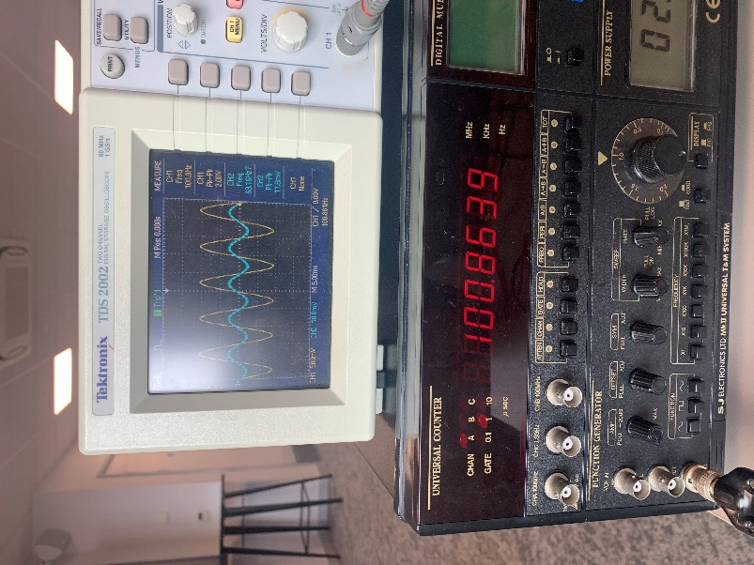
Figure 5: Picture illustrating the set-up of the oscilloscope and signal generator

4. Results
In this section, the raw measurements for frequency, input voltage (V_{in}) and output voltage (V_{out}) have been recorded for both the simulation and breadboard circuits. For both, attenuation has then been calculated using the formula:
$dB= 20\log_{10}{(\frac{Vin}{Vout})}$ [9]
The frequency, V_{in}, V_{out} and Attenuation are recorded for both the simulation and breadboard in Table 1 and Table 2.

4.1 Simulation Results
Table 1: Table of results for simulation, recording Vout, calculating attenuation
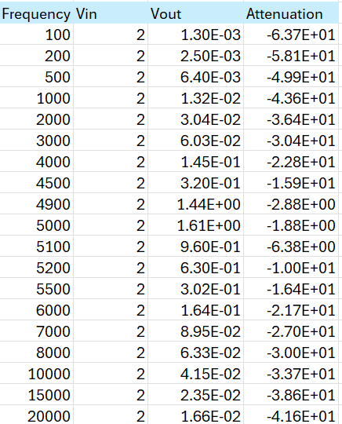

4.2 Breadboard results
Table 2: Table of results for breadboard results, recording Vout, calculating attenuation
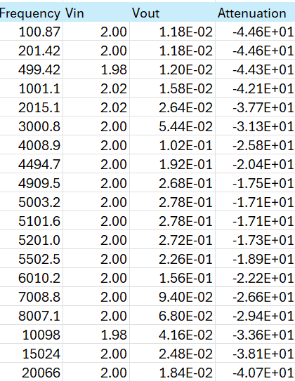

4.3 Plotting the results
The two sets of results were then plotted on the same axis in order to better compare them. This graph is shown below in Figure 9.
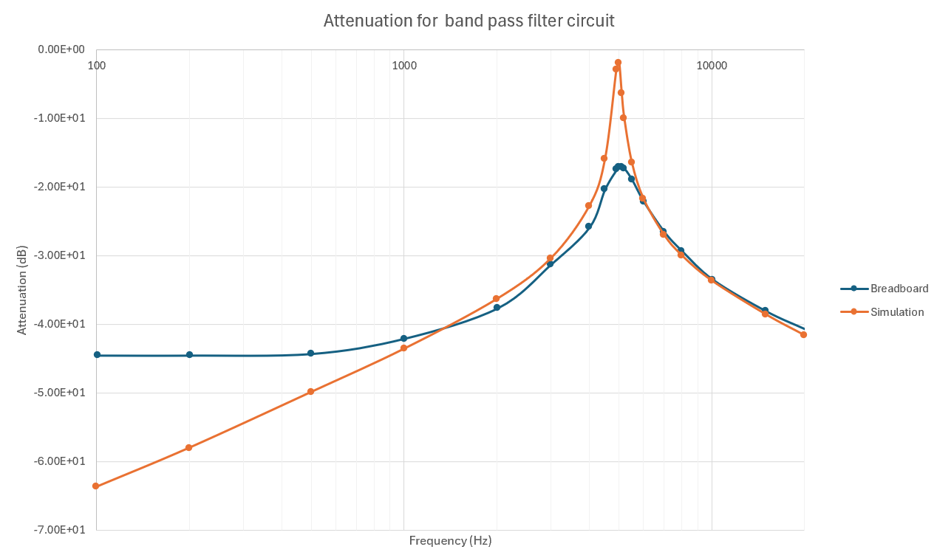
Figure 6:Graph of attenuation against frequency for both sets of results

Key points to note in this graph is the fact that both the breadboard and simulated results both have a peak at around 5000Hz. Both graphs also follow a similar curved shape.
However, the simulated results peak at a much higher value of attenuation and at a much sharper point, while the breadboard results have a much smoother peak. Additionally, between around 100-900Hz, the breadboard value for attenuation is greater than the simulated results values. The breadboard value of attenuation seems to plateau at lower values of frequency, while simulated attenuation decreases as frequency gets lower.

5. Discussion

5.1 Resonant frequency
The resonant frequency was calculated using equation 1 below:
$f_{0}= \frac{1}{2π\sqrt{LC}}$ [2]
Equation 1: Resonant frequency
The equation is derived from equating capacitive reactance and inductive reactance, then rearranging to find frequency. Substituting in the values of the capacitor and inductor from the schematic in Figure 2, the resonant frequency was calculated to be 5032.92 Hz (2dp). This aligns with the graph in Figure 6, with both tests appearing to reach maximum attenuation at around 5000Hz.

5.2 Q factor
To further compare the two tests, and work out what causes the difference between them, the Quality factor (Q factor) was also calculated for each. The Q factor measures how sharp the peak is. This is done by taking the attenuation at the resonant frequency (5033Hz), then reading the width between the points -3dB lower than that value and using the following formula:
$Q= \frac{f_{0}}{{∆f}_{-3dB}}$ [2]
Equation 2: Q factor
For both tests the graph was enlarged around the peak. The frequency axis was reduced so it covered between 4800Hz and 5300Hz and changed to a linear scale in order to read values more precisely off the axis. The graph for the simulated circuit is shown below in Figure 7.

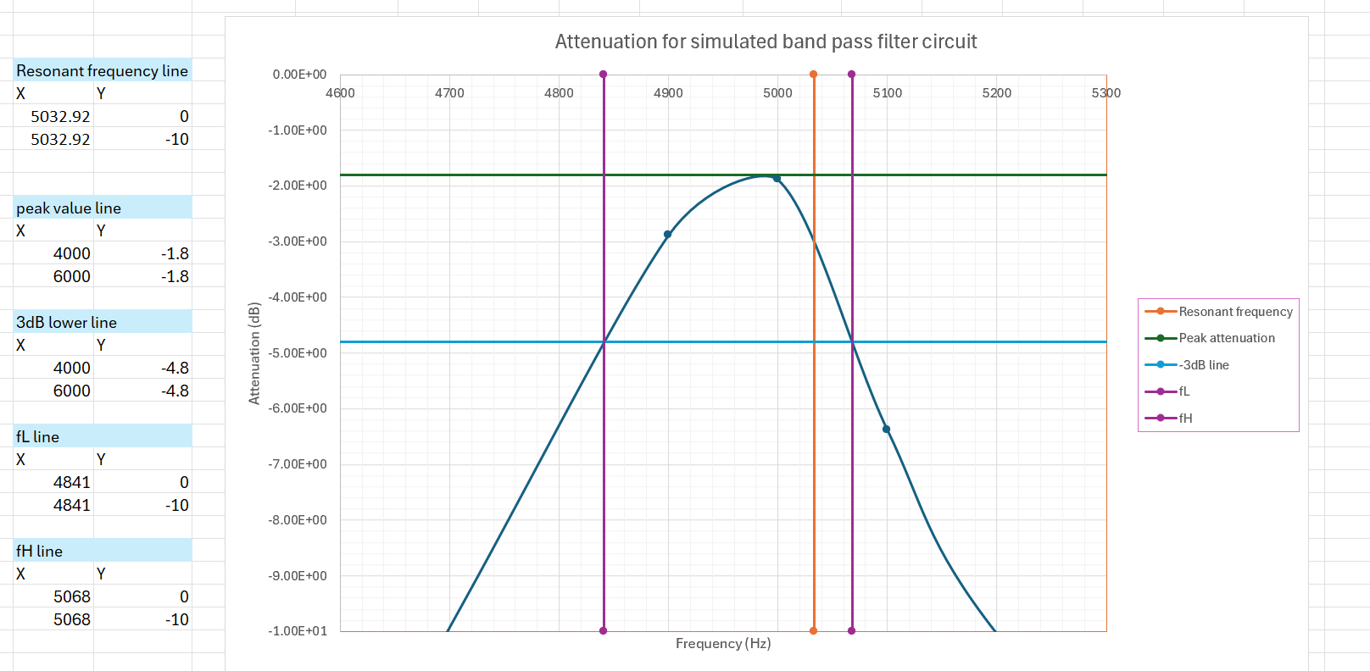
Figure 7: Graph showing how measurements for the Q factor were taken for the simulation

Initially the resonant frequency was marked on the graph, shown by the orange line as a reference point (line is not through peak as no reading was taken at resonant frequency). Then a horizontal line was plotted that would mark the peak of the graph and allow its value to be read on the vertical axis, in this case: -1.8 dB. A second horizontal line was then plotted at -4.8 dB (shown in blue) by calculating -1.8 – 3. To mark where this line intersected with the graph, two additional lines were plotted, fL and fH. Their x values were then adjusted until the exactly passed over this intersection, allowing the frequency the intersection is at to be read off the axis.
The bandwidth was then calculated as Δf = 5068 – 4841 = 227 Hz. By using the formula for Q factor, as mentioned above, the Q factor for the simulation test was then calculated:
$Q= \frac{f_{0}}{{∆f}_{-3dB}} = \frac{5032.92}{227} = 22.171 (3dp)$

The same process was then repeated for the breadboard test results; however, the graph had a different range of axis in order to make the peak fill the graph so it was easier to read (frequency ranged from 4000 to 6000Hz, attenuation ranged from -14 to -28 dB). The graph can be seen below in Figure 8.
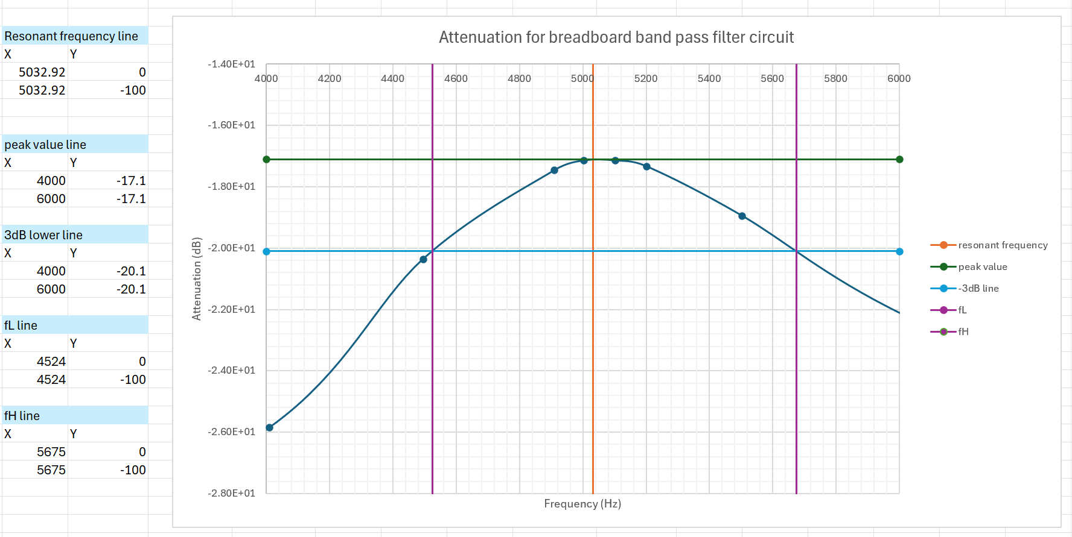
Figure 8:Graph showing how measurements for the Q factor were taken for the breadboard

The same sequence of calculations that were performed for the simulation test results were then repeated.
$∆f=5675-4524=1151$
$Q= \frac{5032.92}{1151} =4.373 (3dp)$

Comparing the two Q factor values, it is clear that the simulation has a much higher quality factor (22.171 compared to 4.373).

5.3 Parasitics
One of the main causes of the less-sharp peak in the breadboard circuit is due to losses in both the capacitor and inductor known as parasitics whereas the simulation has a sharper peak as it assumes all components are ‘perfect’. [10]
The main two parasitics of these components are ESR (effective series resistance) and ESL (effective series inductance). These parasitics cause the circuit to waste more power, reducing the power output of the circuit and thereby lowering the Q factor. [11]
Each component can be modelled more accurately by representing additional losses in series. For a resistor, it can be modelled with an inductor, representing ESL, in series. For capacitors and inductors, it can be modelled with a resistor representing their ESR in series. [12] Diagrams demonstrating each of these have been created and are shown below in Figures 9-11.

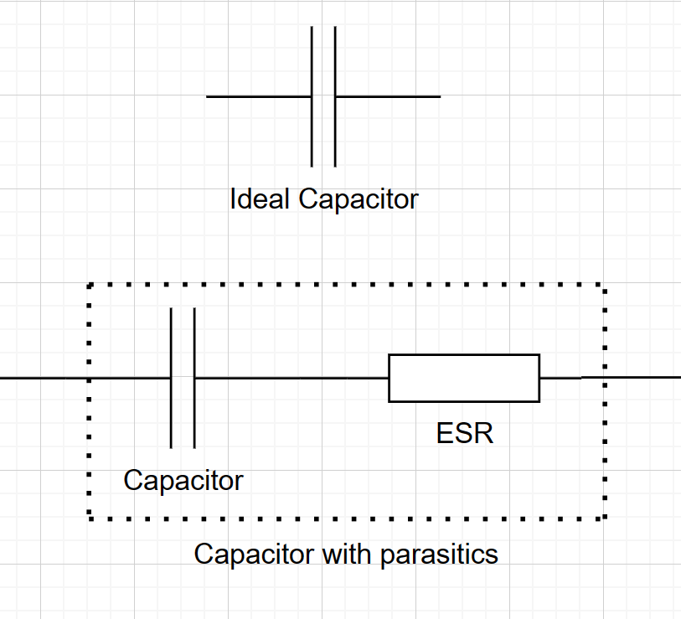
Figure 9:Diagram illustrating how an imperfect capacitor can be modelled
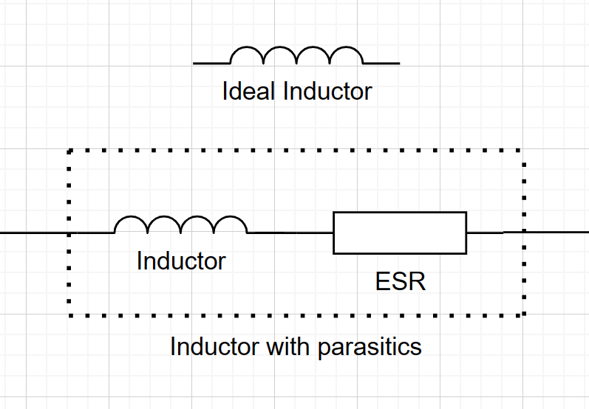
Figure 10:Diagram illustrating how an imperfect inductor can be modelled
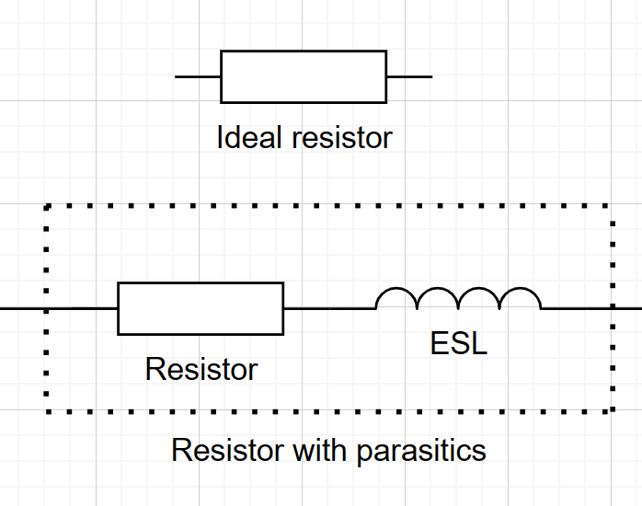
Figure 11:Diagram illustrating how an imperfect resistor can be modelled
While there are certain other elements possible to include in this model, such as capacitors ESL caused by the leads or internal plates, they are so negligible that they will not have a large impact on the overall circuit, so will therefore not be included.
In order to better represent these elements in the simulation, the exact values of the capacitor and inductor, and resistor were measured as well as their ESR or ESL respectively. These measurements produced the following results:
- Resistor: resistance = 979 Ω, inductance = 84.5 uH (resistor had tolerance of +-5%)
- Inductor: inductance = 0.994 mH, resistance = 7.32 Ω
- Capacitor: capacitance = 1.064 uF, resistance at 1kHz = 5.09189x10^-5
resistance at 10kHz = 7.63784x10^-4
As the capacitor’s ESR varied with frequency, the mean resistance of the two values was taken, as this would provide a reasonable average for the frequency closest to the resonant frequency, where it would have the most impact. The mean of the two measurements:
$ESR= \frac{5.09189x{10}^{-5}+7.63784x{10}^{-4}}{2}=4.07351x{10}^{-4}Ω$

5.4 Second simulation
The circuit was then re-simulated using proteus in an attempt to better replicate the real circuit. The schematic is shown below in Figure 12:
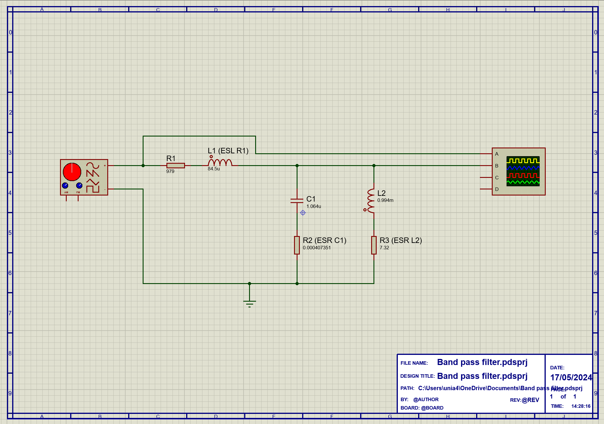
Figure 12:Second simulation of band pass filter circuit
The same set of frequencies was then measured again using the same method as the original simulation. The table of results is shown below in Table 4.
Table 3:Table of results for second simulation, recording Vout, calculating attenuation
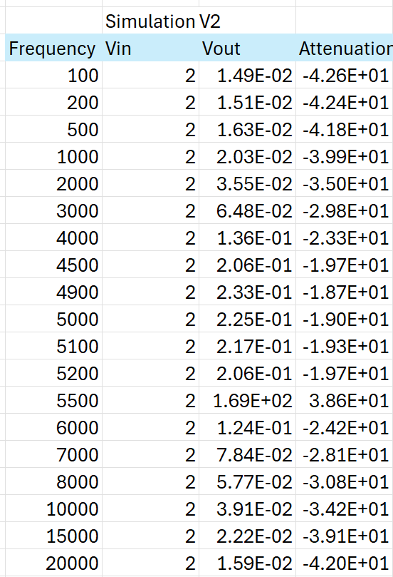

This set of results was then added to the same graph as the initial simulation and the breadboard circuit in order to compare the shapes. This graph is shown in Figure 13 below.

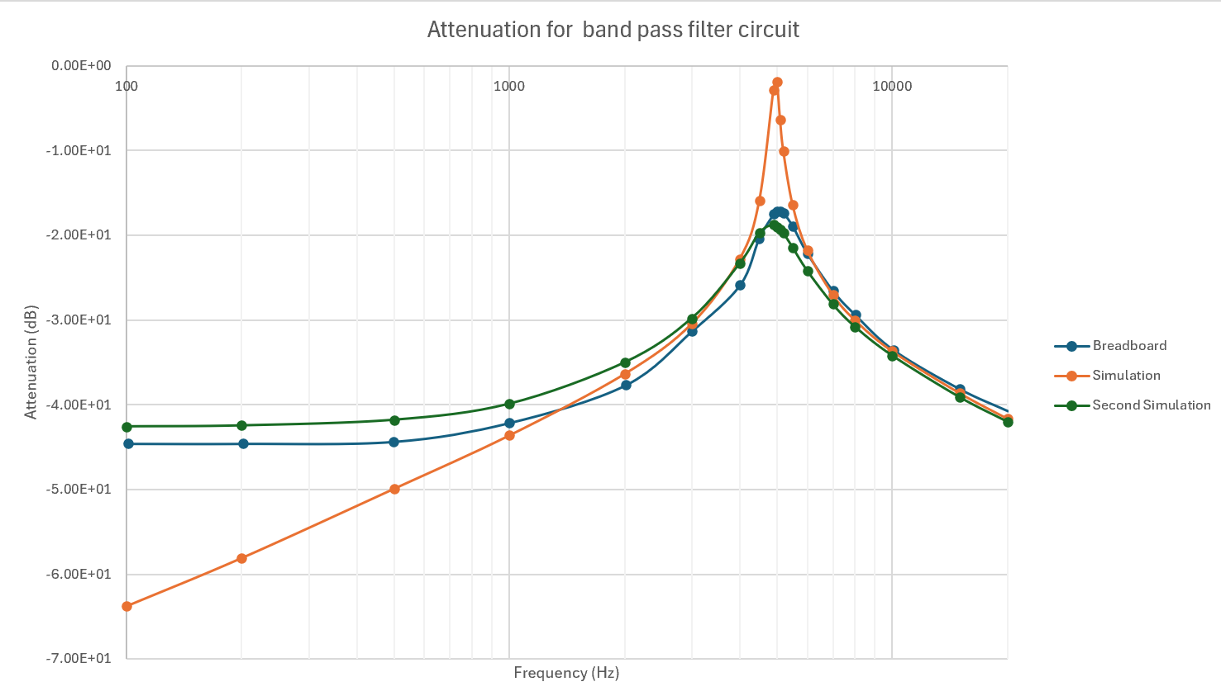
Figure 13: Graph of attenuation against frequency for all sets of results

As shown in green on the graph, the new simulation results much more closely follow the shape of the results from the breadboard circuit. It has a much smoother peak and plateaus similarly as frequency gets lower. The maximum attenuation is also much lower, and closer to the breadboard test. To further look at their similarities, the Q factor of the new simulated circuit was calculated using the same method as previously mentioned in section 5.2 and used the graph in Figure 14.

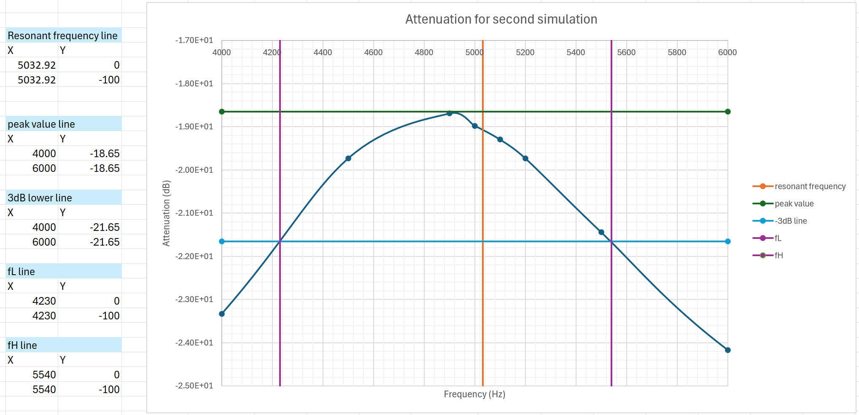
Figure 14:Graph showing how Q factor was calculated for the second simulation

Then, by using the same formular used in sections 5.1 and 5.2, the following calculations were made:
$$∆f=5540-4230=1310 Hz$$
$Q= \frac{5032.92}{1310} = 3.842 (3dp)$
This Q factor is now much closer to the Q factor calculated from the breadboard (4.372) and is significantly lower that the initial simulation (22.171). This suggests that the main factor affecting the quality of the breadboarded filter circuit if the internal parasitics of the components.

6. Conclusion
In this experiment it has been determined that losses due to the effective series resistance and effective series inductance have a significant impact on the maximum attenuation achieved in a band-pass filter. It has also been found that by including the ESL and/or ESR of components in a simulation, it will generate a much more realistic result, which is more similar to the result expected from testing the real circuit.
This experiment has also shown how the attenuation of a band-pass filter circuit is affected by frequency, and how it caused a large peak in attenuation around the resonant frequency. This allows only frequencies around that value to be passed in a circuit, demonstrating how filters may be applied in telecommunications and audio amplifiers as it can eliminate unwanted noise/frequencies. [5]

7. References

[1] | “Band-Pass Filters,” Electricity - Magnetism, [Online]. Available: https://www.electricity-magnetism.org/band-pass-filters/. [Accessed 04 05 2024].
[2] | W. H. Paul Horowitz, The Art of Electronics, 3rd ed., Cambridge University Press, 2015, pp. 52-53.
[3] | K. Lacanette, “A Basic Introduction to Filters - Active, Passive and Switched-Capacitor,” National Semiconductor Corporation, 2010.
[4] | Electrical4U, “Band Pass Filter: Circuit & Transfer Function (Active & Passive),” E4U, 19 04 2024. [Online]. Available: https://www.electrical4u.com/band-pass-filter/?utm_content=cmp-true. [Accessed 26 04 2024].
[5] | WatElectronics, “What is Band Pass Filter: Circuit & Its Working,” Wat Electronics, 26 10 2020. [Online]. Available: https://www.watelectronics.com/what-is-band-pass-filter-circuit-its-working/. [Accessed 24 04 2024].
[6] | J. Bird, “Electrical Circuit Theory and Technology,” Newnes, 2003, p. 225.
[7] | D. K. July Thomas, “Resonant circiuts,” Brilliant, [Online]. Available: https://brilliant.org/wiki/resonant-circuits/. [Accessed 15 05 2024].
[8] | Tektronix, “How to use an oscilloscope,” Tektronix, [Online]. Available: https://www.tek.com/en/documents/primer/setting-and-using-oscilloscope#C5section1. [Accessed 07 05 2024].
[9] | University of York, “What You Should Know About... Decibels,” Communications Engineering MSc - Preliminary Reading, p. 2, 23 02 2010.
[10] | W. H. Paul Horowitz, in The Art of Electronics, Cambridge University Press, 2015, p. 392.
[11] | A. Kingatua, “Determining the Equivalent Series Resistance (ESR) of Capacitors,” All About Circuits, 31 03 2017. [Online]. Available: https://www.allaboutcircuits.com/technical-articles/determining-equivalent-series-resistance-esr-of-capacitors/. [Accessed 03 05 2024].
[12] | Texas Instruments, “Understanding Basic Analog - Passive Devices,” Mixed Signal Products, 1999.

