ECAD 4008: Cycle 1 Professional and Pedagogical Studies:
Leading the learning; what, how and why am I teaching?

Introduction

According to Child Australia (2017) pedagogical principles are methods and strategies which can be implemented into teaching and education. The pedagogies influence the way that children learn and how the teacher plans and delivers lessons. It’s about how teachers teach rather than what they teach. The whole point of a pedagogical principle is to ensure that children are receiving quality education and are developing holistically, which is what makes it important. An example definition of Pedagogical principle would be, “Quality teaching is defined as pedagogical practices that facilitate for diverse children their access to knowledge, activities and opportunities to advance their skills in ways that build on previous learning, assist in learning how to learn and provide a strong foundation for further learning in relation to the goals of the early childhood curriculum …‘Te Whariki’ and cultural, community and family values.” (Farquhar, 2003, 5). The new curriculum for Wales has its own 12 pedagogical principles which we should try to follow and comply with.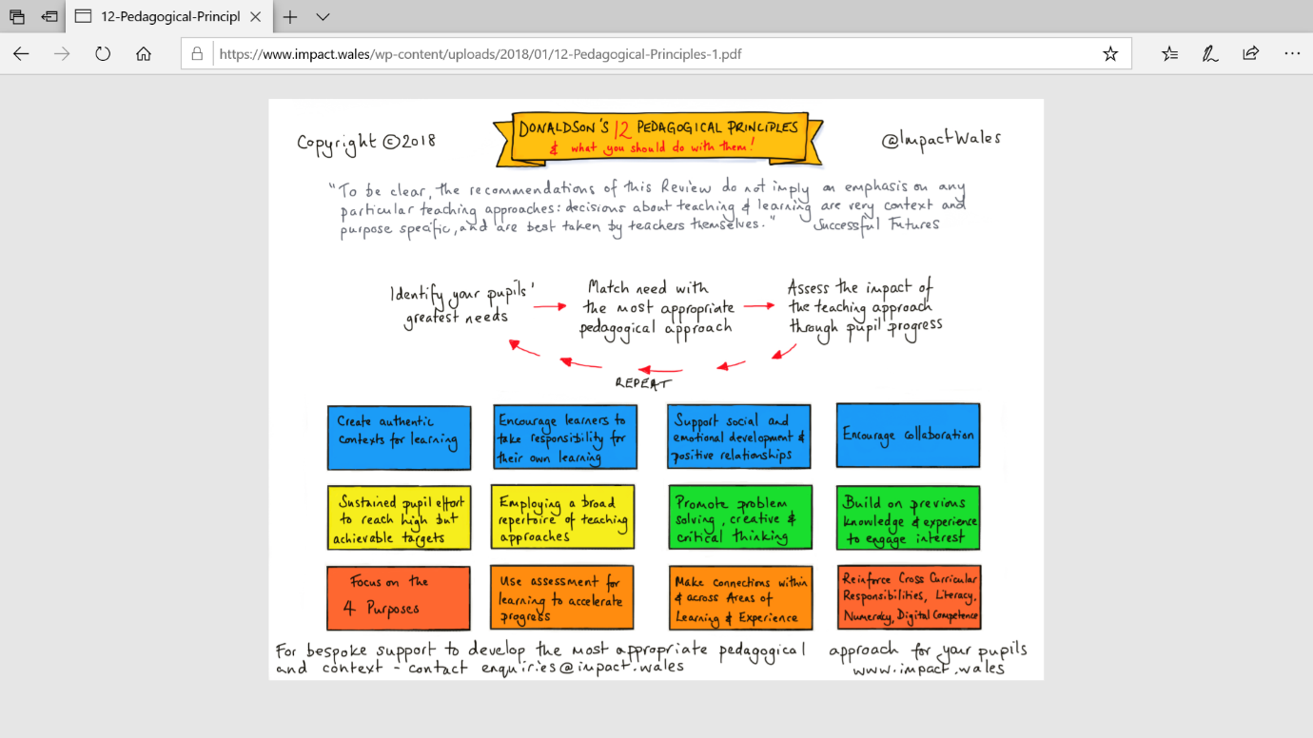
Impact Wales (2018)
The Foundation Phase – Philosophy (Curriculum)
In the Welsh Government (2015) document it mentions,
The Foundation Phase framework is a curriculum for 3-7 year olds in Wales, which was introduced in 2010. The statutory areas of learning in the Foundation Phase are:
- personal and social development, well-being and cultural diversity
- language, literacy and communication skills
- mathematical development
- Welsh language development
- knowledge and understanding of the world
- physical development
- creative development.
The foundation phase framework involves delivering lessons through practical and hands on activities, both indoors and outdoors. This framework promotes learning through play and positive partnerships with parents/carers and the community. Children are assessed against the outcomes that they achieve, which include, bronze, silver and gold the outcome 1 up to outcome 6. Children in year 2 are typically aiming to be at outcome 5 and outcome 6 is there for those who have high attainment levels.

Pedagogical Principle 1 (PP1) – “Good teaching and learning means employing a blend of approaches including direct teaching.”
Pedagogical Principle 2 (PP2) – “Good teaching and learning sets tasks and selects resources that build on previous knowledge and experience and engage interest.”
Pedagogical Principle 3 (PP3) - “Good teaching and learning ranges within and across Areas of Learning and experience.”
(Donaldson 2015:68)

Foundation Phase Pedagogy PP1/PP3 (strategies & Techniques) (cross-curricular approach)

Principle 1 and 2 involves stratergies and technuqies used in the classroom as well as the cross curicluar approach to learning. The cross curicular approach is about combining all areas of learning into 1, this means that teachers will not teach by subject, the activty planned will often cover 2 or more areas of learning. For example, children may be given a cake baking activity, this involves mathematical development due to the measuring of the ingredients, as well as creative delevopment for decorating the cakes. Physical development would also come in, in terms of gross motor skills, mixing and pouring ingredients. Approaches and techniques used in the classroom may involve how the lesson is taught, for example, small focus groups or whole class teaching. It could be hands on learning or learning where children sit and watch. Another approach may be a thematic approach. This means to base all learning around a theme. All learning and activties will link to the theme in some sort of way, this appraoch supports the cross-curicular idea as it allows you to implement all the different areas of learning under one umbrella. Other approaches may include the Montessori approach which is completey child-centred. This is where the classroom is very hands on and practical while giving children the opportunity to make creative choices. An example of using this in the classroom may be giving involving children into the planning for the class, or allowing them to help pick the class theme. A strength of these principles may be that children learn in a variety of ways. Some children learn best with practical hands on activities, where some children may work better with visual resources. Therefore, it is extremely important for a teacher to cater for all needs of the children by using a range of strategies and approaches. Children who have high attainment and children who may have any additional learning needs, both get the equal opportunity to learn and develop when the teaching approaches are differentiated. According to Education Development Trust (2013), to be an effective teacher, “teachers should cater for the needs of different learners, offer suitable feedback and, at the same time, enhance their confidence and interest in learning”. Using a blend of approaches will also help to keep the children fully engaged and enthusiastic about what they are learning as they’re less likely to lose focus as children aren’t having to repeat the same sort of task. The enhanced engagement may also be down to the fact that children feel empowered by the idea that their specific needs are being met and they’re able to understand the classroom activity or discussion. Using the different approaches will ensure that the classroom environment is always alive and exciting for the children, doing different activities using the same approach all day everyday will become draining and children will lose interest and that’s not what we want as teachers. Direct teaching is a another strategy where the teacher teaches and pupils listen, the most common and traditional strategy of teaching., According to the Education Development Trust (2013), “direct teaching and good interaction are as important in group work and paired work as they are in whole class work but organising students as a whole class for a significant proportion of a lesson helps to maximise their contact with the teacher so every student benefits from the teaching and interaction for sustained periods of time “this suggests that this strategy can be useful and we should use it where appropriate. A strength of using the cross curricular approach would be that it allows children to make links and see how all the different areas of learning can be used together in everyday life and situations. It shows how things can be used in contexts. This approach will also keep things exciting for the children, they’re never just doing literacy, they’re doing exciting and fun activities while learning new things and furthering their understanding.

During my time at placement I often used a thematic approach by planning around the topic that had been set by my class teacher. For example, the theme for one week was Mother’s Day, so I planned an activity which supported creative and mathematical development but still related to the theme. This is also the cross curricular approach. The activity was creating a necklace for a gift, the beads on the necklace needed to be put in a pattern. Another example would be where the children were looking at real life superheroes, which I then organised my uncle who is a member of the RNLI to pay a visit to the class and talk about what he does. I often used different approaches while teaching the same activity but to the different attainment groups. Children with higher attainment were given more independent tasks whereas the lowest attainment group were given the opportunity to discuss with others and have my close support and scaffolding to help complete the task. Vygotsky (1920) would support this idea as he believed that pupils should learn with his Zone of Proximal Development (ZPD) by giving children the scaffolding/support to help them complete an activity or task. He believed that children shouldn’t beat themselves up about not easily being able to do something and support should be given, Vygotsky (1920) found that this method worked and allowed children to develop their understanding and help them feel confident about knowing something.

When carrying out my lessons I mainly use focus groups as it allows the children to have the constant support if they need it, it also allows me as a teacher to ensure that the children understand and are engaged. However, before breaking off into groups I explain the task to the whole class briefly and then assign a focus group, a group for role play, a group for mojo challenges and a group for outdoor play. Learning through play is very important in my classroom, which is why children are given the opportunity for both roleplay and outdoor play. According to Susan Isaacs (1885-1948) outdoor play is extremely important and beneficial to young children.

In terms of approaches/strategies for assessment, children get to self-assess their work and check for mistakes with a purple pencil before handing in any work as I feel that they are likely to learn more from realising and noticing mistakes rather than them being corrected and being forgotten about.

In my placement we do use the cross curricular approach often and we try using different strategies as much as possible. A lesson I had planned was about 3D shapes, where children would glue and stick the shapes to their matching name. Children also had the opportunity to make the 3D shapes using our polydrons. Children were then also given a 3D shape colouring sheet. Here, I took on a practical approach, as well as allowing children to be independent.

If there were to be an area for development for PP1 and PP3, I would suggest that as teachers we need to think about is that using lots of different approaches often needs a lot of planning and thought, which can be extremely time consuming and time isn’t something teachers have a lot of. So obviously, throwing in 10 different approaches in one day is going to be difficult to plan. Children still need structure in the classroom, so it’s important to get a good balance between new and existing approaches and the structure of teaching. Too many different approaches at one time may cause chaos in the classroom, which then may make it difficult to assess the children’s attainment. Another area for development may be that these approaches may require resources that aren’t available to the school as well as the staff needing to be trained to carry out these approaches in the classroom. If the school does not have the budget, then some of these approaches may not be able to be implemented into the children’s learning.

Planning in the Foundation Phase PP2 (pupil voice/ interests)

Pedagogical Principle 2 involves the childrens intrests and giving them a pupil voice. Taking into account the childrens intrestts are extreemly important as its likley that theyre going to show a higher level of engagement if tgeyre interested and curious. To involve childrens intersests in the classroom their reward system could be themed to something they like or even music for a dance lesson could be something that they like. It will motivate them and giving them the urge to particpate. You can use the childrens intrests to decide on themes for classroom. For example if theyre intrested in superheroes, you can make it a theme. Setting mojo challeges, which are independent tasks around the classroom. You can let the children choose the mojo challenges or the topic that they link to. This moves us on to puipl voice, being intrested in their intrests and letting the children talk about what they want to learn about, giving them the opportunity to make choices and decisions. Children often feel empowered by being given choices and making decisions. Pupil voice may include having a school council for children to talk about what they’re happy with and what they’re unhappy with at school. It may include involving children with decisions on classroom rules or even the order of the day in terms of lessons. All theese things can help keep the children engaged and intersted and they would have been able to agree with the decisions. Asking children whether they want to do their maths lesson in the morning or afternoon. All theese opportunities for choice and decision making is something that the children will be grateful for and look forward too. It also involves building on the previous knowledge of the children. This means building up on what they already know, in order for them to make links and further ther understanding of what they already know. The children are more likely to grasp a concept if your building on from what they already know. Just like adults children are likely to find it difficult being thrown into the deep end so refering back to ideas and previous knowledge it can help the children further their undertsanding. Impact journal of the charted college of teaching (2018) was a useful source of infromation, they explained “Prior knowledge is one of the most influential factors in learning (Ausubel, 1968, cited in (Hattie and Yates, 2014), p. 114). Whilst most teachers are aware that new learning refines prior knowledge and adds complexity to current understanding, a science of learning perspective positions prior knowledge as central to organising and reassembling new information in order to make it meaningful. This marshalling process occurs in the prefrontal region, an area of children’s brains that is typically slow in developing. Whilst children may possess the appropriate prior knowledge, they may not make connections between this and the new content, hence the importance of prompting children to recall previous learning before the presentation of new knowledge (Howard-Jone et al., 2018).”

During my time at placement, when planning for my lessons I would always speak to the class teacher to grasp an idea of where they’re at with their topic and how I can build on that or if something isn’t topic related I would see what has been covered already with the children. When I gave a lesson on 3D shapes, as an introduction I recapped and asked them about 2D shapes they already know and if they knew any 3D shapes. I used their knowledge of objects they use in the classroom or at home to compare with the 3D shape names. For example, a football which they should already understand was able to be paired with the shape name sphere. My placement school ensure that children have lots of choices and opportunity for pupil voice. At the start of every term, the whole class talk about ideas for their new theme and they decide as a class. In terms of homework, children get to choose what homework they would like. The teacher then creates a sheet of all homework tasks that the children have come up with. At home children can complete the tasks in any order they like, giving more freedom and flexibility especially for parents.

If there were to be areas of improvement for this principle it would be that children cannot make decisions for everything, the teacher obviously oversees and directs the ideas to ensure it is appropriate for school and covers the areas of learning. Making time for pupil voice discussion may be difficult as its time consuming and there’s likely to be some debate between pupils, so it’s important that its managed efficiently. Another area would be that you would need to take time with the planning to ensure you have assessed the children enough to know what knowledge they already have. You also need to have the time to be able to recall and recap their knowledge

Current perspective – challenges/ recommendations
The new curriculum for wales is made up of 4 purposes/areas whther the curriculum will uspport learners to be:
- ambitious, capable learners, ready to learn throughout their lives
- enterprising, creative contributors, ready to play a full
part in life and work
- ethical, informed citizens of Wales and the world
- healthy, confident individuals, ready to lead fulfilling lives as valued members of society.
The 6 areas of learning for the new curriculum include:
- Expressive Arts
- Humantites
- Health and Wellbeing
- Science and Technology
- Mathematics and Numeracy
- Langauge, Literacy and Communication
The curriculm refrom seems to be very positive. Expressive Arts and dance was something i felt was very important and should be included into learning whether it was on the cuuriclum or not but forunatley this was made an area of learning. I was also pleased with health and wellbeing being a very big factor in this curriculum as mental health awareness is rising and this promotes this.
If I was to make any reccomendations, I would reccomend that although the areas of learning are a lot more broad, cross curicluar teaching should still take place.
Conclusion
Moving forward, I will develop my practice by ensuring i follow the pedagogical principles in my planning and delivery of lessons. To do this, I will always give children the opoourtunity for choice and decision through classroom themes or activties and I will always find away for their voices to be heard. In my teaching I will deffinetly implement the cross curicular approach into my teaching in order to keep the atmosphere in my class exciting for the children. I will continue to use a variety of stratergies and approaches to enhance puipls learnig and development, especially once I have carried out all of my, meet test and share activties at university. I will be able to see what Ideas work best for me and my learners. I will also be open to trying new stratergies where possible without overwhelming the children. I think its important that i always build lessons up off of the childrens prior knowldege where i can so new information can be graspe easily. Due to the new curriculum reform being put in place for 2022, the year I hopefully graduate, I will look at all 12 of the pedagogical principles and implement them in my teaching where possible.

Appendix
https://www.impact.wales/wp-content/uploads/2018/01/12-Pedagogical-Principles-1.pdf

Reference List
- The Welsh Government (2015) The Foundation Phase Framework. Available at: https://hwb.gov.wales/curriculum-for-wales-2008/foundation-phase/foundation-phase-framework/
- The Welsh Government (2019) Preparing for the new curriculum. Available at: https://gov.wales/preparing-new-curriculum
- Child Australia (2017) What is a pedagogy? How does it Influence our practice? Available at: https://childaustralia.org.au/wp-content/uploads/2017/02/CA-Statement-Pedagogy.pdf
- Ko, J. Sammons P. (2013) Effective Teaching: A Review of Research and Evidence. Available at: https://www.educationdevelopmenttrust.com/EducationDevelopmentTrust/files/98/98ad6340-0ef6-4e1d-a541-db6018afce7d.pdf
- Christopher Tay, Impact Journal of the Charted College of Teaching. (2018) A good start: The pedagogical challenge of engaging prior knowledge for all puipls. Available at : https://impact.chartered.college/article/tay-pedagogical-challenge-engaging-prior-knowledge/
- Yale Poorvu Centre for Teaching and Learning (2012) Building Upon Students’ Prior Knowledge and Skills. Available at: https://poorvucenter.yale.edu/StudentsPriorKnowledge
- Christine Sakrikas, Prep Scholar (2020) Vygotsky Scaffolding: What It Is and How to Use It. Available at: https://blog.prepscholar.com/vygotsky-scaffolding-zone-of-proximal-development

