

Student Name: | Sheila Choudhury
Student Number: | 1714030
Module No: | BMSK5002
Module Title: | Developing Relationships & Workplace Achievement
Lecturer: | Ze Zook

Table of Contents

Executive Summary Pg. 3

Introduction Pg. 3

Tesco Background Pg. 4
Tesco Organisational Structure

Human Resource Management (HRM) Pg. 5
Diagram: HR Departments
Diagram: Guest’s Model on HRM Strategy
Diagram: Tesco’s Benefit Cycle

Motivation Pg. 9

Self-Determination Theory (SDT) Pg.10
Diagram: SDT of Motivation

Taylor’s Motivational Theory Pg.11
Diagram: Tesco Rewards for Hard work

Mayo’s Theory Pg.13
Diagram: Tesco’s 360 Degree Feedback/Personal Development Tool

Abraham Maslow Pg.16
Diagram: Maslow 5 Hierarchy of Needs

Frederick Herzberg Pg.17
Diagram: Herzberg’s 2 Factor Theory of Motivation- Hygiene Factors

Employee Engagement Pg.19
The Importance of Building Workplace Relationships

Building your Career & Reaching Your Potentials Pg.21

Personal Development Plan Pg.22

Conclusion Pg.24

References Pg.25-26

Executive Summary

This Report focused on Developing Relationships and Workplace Achievements, emphasising on the Human Resource Management (HRM) and its various flexibilities in People Management, Engagement and Development. The Report provides a look into UK’s leading Supermarket Store Tesco to see how the Huge Organisation Promotes itself to the Workforce through all the incentives it offers its workers to keep a healthy and happy Workforce and Workplace.

Introduction

In the early years, when the Industrial environment was changing, it was discovered by Scholars and Theorists that Employees are an Asset to Organisations. The Business World was changing that many Organisations started focusing on Employee Retention and Development. This would make Businesses move forward, sustainable and successful. To do this, they had to employ Tools, Techniques and Strategies to stay on top of the game.
Therefore, Researchers such as Bullock mentioned in his Handbook that, Employee Engagement is pivotal in the Business World attempt to enhance the intellectual power that exists in the diverse workforce in the 21st Century (Bullock, 2011).
Business Organisations are always looking for ways to improve Employee Engagement in order to increase Productivity, instil Positivity in the Corporate Culture, and improve Organisational Reputation that exist in the Industry and the Business Community.
Research by Bullock suggested that when Employee Engagement is Effective it gives Organisations the advantage to leverage thought, innovation, creativity, leadership, in order to gain maximum returns on investments in human capital (Bullock, 2011).
Therefore, in this Assignment I will be critically analysing Tesco as an Organisation on the potential benefits it has to the organisation and employees. Wherefore, I will assess how individuals are developed within the workplace and how it would help employees to progress in the work environment. I will use tools/theories/models to demonstrate the methods used and provide appropriate frameworks which shows an individual’s personal development expectations. Futhermore, I will do a self-development plan for my own developmental needs.

Tesco Background

Tesco is the leading British Retailer; it is amongst the top Retail Outlets in the world. Tesco has a Workforce of 476,000 Employees and a Net Profit of £3.4 Billion (Tesco.com, 2019).
Jack Cohen was a Sole-Trader who worked as a Market Stallholder selling Fruits and Vegetables during 1919, ten years later in 1929 the first Tesco came into operation.
Tesco has expanded worldwide, with 2,300 Super-Stores, Tesco Express Outlets and Hypermarkets in operation today. Tesco offers different range of Products and Services (Tesco.com, 2019).
Therefore, to support the growing Organisation, Tesco require a workforce that are highly motivated, competent, trained, flexible and one that understands customer needs. Tesco in return offers its Employees support to grow and develop within the Company through motivation by enhancing Knowledge, developing new Skills, providing Job Satisfaction, which are achieved by Training & Development and Reward and Recognition.
Diagram: Shows a typical Organisational Structure for Tesco (Internet).

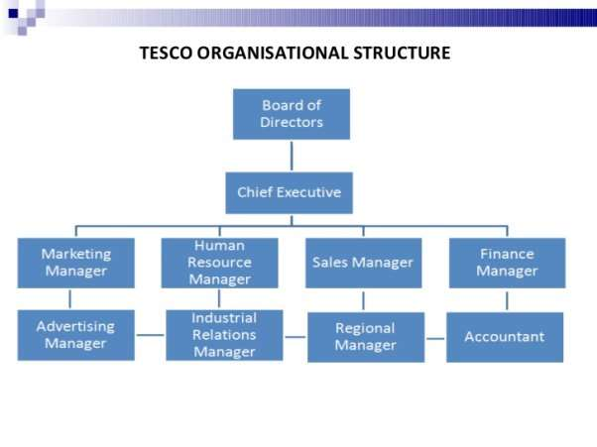

Human Resource Management (HRM)

HR Diagram: Shows typical Human Resource Department layout (Internet).

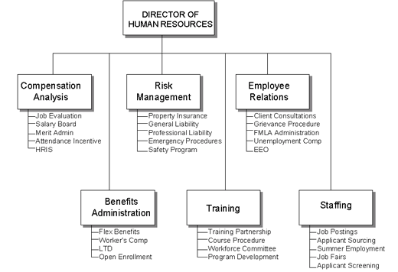

The HRM Diagram above shows the responsibility of the HR Departments. They have the responsibility of Managing Staff and Resources.
In the recent years, researches between Performance and Employee Engagement suggested that together it acts as an instrument in which the HRM Practices influence the Employee and Organisation’s Performance. Therefore, Researchers in HRM have been questioning how the link between people management can improve the Outcomes of Performance of an Organisation. However, Researchers and Practitioners have concluded that there is no actual certainty that a well-structured HRM can influence on the Performance of an Organisation. It is still faced with many underlying problems with Data, Methodology and Theory (Truss et al., 2013).
Henceforth, recent studies show that Relationship is most likely the key factor to the positive approach of HRM Systems. This may increase job satisfaction and commitment hence, improving task performance, lowering the intent to leave and reduced absences. (Truss et al., 2013).
Through the Development Process of Employee Engagement inside the HRM Department, it allows Organisations to expand researches on Psychological terms but also to further study on Engagement and Interrelationships.
Human Resource Management (HRM) is a procedure which Organisations takes in Managing the Employees. The Mangers of the HR Department oversees three areas which are the Staff, Defining/Designing Work and Composing the Employees. The HRM at Tesco’s are looking for ways to implement new managing strategies for employee retention and understanding the work flexibility, (Tesco.com.2016).
HRM Department at Tesco’s seem to follow the ‘Guest’s Model’ for their strategy process. The Process is sectioned into Five Stages:

Diagram: Guest’s Model of “HRM Strategy”

According to Guest (2011), the HRM Practices depends on five important activities:
- “Hiring Employees
- Development & Training
- Compensation
- Performance Appraisals
- Employee Relations Improvement

The HR Outcomes depends on:
- Commitment
- Quality
- Flexibility

The Behavioural Outcomes depends on:
- Motivation
- Co-operation
- Organisational Citizenship

The Performance Outcomes depends on:
- Productivity
- Positive
- Innovation Power
- Quality
- Turnover
The Financial Outcomes depends on:
- Profits
- Revenue
- Total Income”
It has been discovered through the Guest Model that Relationships between Performance and Commitment is proving challenging to establish. (Truss et al., 2013). Through the observation of the Guest’s Model it is recognised that HRM is required to establish Motivation and Development of its Employees.
Employees as we know are the backbone of every Organisations. To search for right talent makes it challenging and competitive. Therefore, Organisations such as Tesco focuses on its own Employees within the Company on Performance Management through an established link between the work efforts, diverse objectives, and the Organisation’s mission (Truss et al., 2013).
Researchers have also stated that Employee Performance based on Behaviours, Actions, and Results will help understand the different needs that is required to accomplish tasks successfully (Truss et al., 2013). The Management Process procedure saves time if it is perfectly planned and implemented within the Organisation. (Truss, et al., 2013).
Diagram: Tesco’s Benefits Cycle

The Diagram above shows how the HR Department tuned with the Employee Sector in this Benefits Cycle.

Motivation

To engage Employees, Organisations must look for ways to get them to focus. Scholars and Researchers recognise that Motivation is a Factor of Employee Engagement. They acknowledged Employees that are motivated work hard and achieve higher output which reduces Labour Costs. Therefore, requiring less Supervision which enables the Employees to demonstrate their own work, hence impacting customers positively.
Furthermore, there will be lower rates of: Mistakes, Accidents and Conflicts because concentration level is greater. Employees that feel motivated at work will look forward to coming into work which equals to less absences at work. They will also have more commitment and loyalty for the Organisation they work for. Whereby, un-motivated workforce will be the opposite; they will be less satisfied within their job roles and show signs of negativity. Consequently, affecting the quality of work.
Motivation develops from ‘Personal Interest or External Factors’ such as Promotion or Praise & Reward. There are many theories relating to Motivation. Although, ‘Pay’ is known to be the Primary Motivator, other five factors are:

- Challenge and Enjoyment
- Opportunity for Advancement
- Recognition & Achievement
- Appreciation of Hard
- Responsibility & Empowerment

STD- Self-Determination Theory

Through researches, Deci & Ryan proposed that two comprehensive patterns of Motivation. (1985).
Intrinsic Motivation: activity out of pleasure and interest.
Extrinsic Motivation: activity for serving oneself.
Extrinsic is predominant in work but takes different forms. Therefore, the Self-Determination Theory (SDT) suggests that Extrinsic motivation reflects on External Sources such as; Money, Praise & Rewards, Attainment of Self-Confidence and Personal Goal, Fame, etc. However, SDT analyses the Intrinsic Motivation relating to the Internal Sources such as: learning new skills and gaining Knowledge. Self-Determination Theory (STD) Table below shows ‘The Antecedents of Motivation’ (Miller et al., 1988; Meyer & Gagne, 2008).

STD Diagram of Motivation: (Deci & Ryan, 1985).

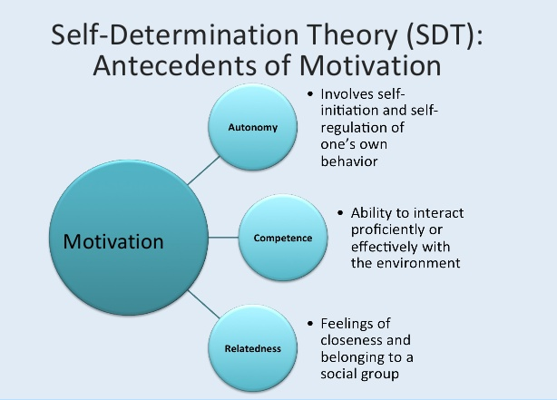
The Self-Determination Theory (STD) above explains why people feel the need of Three Motivational Factors ‘Autonomy, Competence and Relatedness’ to achieve their Psychological Growth. (Ryan & Deci, 1985).
According to Ryan and Deci, human tendency of being Proactive or Passive depends on an individual’s Social Condition. Therefore, Social Support is required which is achieved through Relationships and Interaction with others. Therefore, Tesco identified the necessity of creating Respect and Trust amongst its Employees. Therefore, setting goals, valuing employees, and providing a positive environment increases Employee Motivation. Staff that feel motivated at Tesco works in Groups to accomplish individual and team objectives. It gives individuals the opportunity to focus on: Fair Treatment, Customer Care/Relationship, and Feedbacks (Miller, et al., 1988; Meyer & Gagne 2008).
Tesco values its Employees by understanding that they have a life beyond work life. Therefore, they show their appreciation by supporting their staff in their ‘Work life Balance’ and Rewarding them with:
- Flexible Work/Hours
- Staff Discount
- Free/Discount Rates on Healthcare
- Company Share Options
- Discounted Gym Membership
- Competitive Salary
(Business Case Studies, 2019).

Taylor’s Theory of Motivation

In the year 1919, Frederick Taylor published his researches on Motivational Theories. Frederick Taylor suggested individuals only worked for ‘Money’. (Taylor, 1919).
The Industries at the time were producing work based on quantity; therefore, the work was repetitive. They paid workers in ‘Piece Rate’ which is based on Results. Therefore, meant getting paid for every product produced which worked well for the Business as they were achieving greater outcomes. However, it wasn’t good for the workers as it gave them less encouragement, opportunities, and the time to think/express their innovative ways. Hence, the development and use of the workers were limited in the Organisation (Business Case Studies, 2020).
This method is used in big Organisations such as ‘Tesco’. Tesco follows a method like ‘Taylors Theory’ in their ‘Employee Reward Programme’ by offering Staff ‘Financial Reward Packages’ which is the motivational factor. Tesco offers support to Employees such as diverse lifestyles through applicable and targeted benefits other than Financial gain.
Finance is not the only factor that motivates people, there are many Non-Financial related factors that can uplift and motivate people such as desiring to enhance personal skills, serving people, and achieving Promotions. For Example, a person may want to become a Golf Player not for the pay but for their ‘Love & Passion’ for the Sport.
Diagram: Tesco Rewards (Business Case Studies, 2019).

It is known that Employees get motivated when they are satisfied with the work they produce. This occurs when Employers of Organisations establish a healthy environment where the Employees are made to feel comfortable and valued. This is possible through Effective Communication and Feedbacks from Employees. Furthermore, by investing in Development & Training of the Employees there is a higher chance of Employee Performance and Motivation. This would improve their Skills, Knowledge and Job Satisfaction.
Tesco welcomes its Employees to engage in their annual ‘Staff Satisfaction’ Survey called ‘Viewpoint’. It gives Employees the chance to express themselves on the different conditions of their Job. Hence, with the results of the outcomes Tesco can identify the right tools and resources to offer its Workers to keep them engaged and motivated. Benefits Tesco offers are:
- “Pension Scheme (Award-Winning Scheme providing long-term Benefits)
- Lifestyle Break (4-12 weeks off work and guaranteed the job back at the end)
- Career Break (6 Months-6 Years Break with a Right to Return)” (Business Case Studies)

The Mayo Effect

Sir Elton Mayo, a Theorist (Mayo, 1930), suggested that Employees were Motivated through some of Factors (listed below) at work:

- Effective Communication
- Effective Teamwork
- Interests in others views and opinions
- Involvement of people in Decision-Making
- Ensuring Well-Being of everyone
- Creating interesting work and Non-repetitive (Business Case Studies, 2019).

Mayo’s research known as the ‘Hawthorne Theory’ was based on workers working in the Hawthorne Powerplant. Through his Research he came to the results that Workers were demotivated at work if the work was repetitive and boring. Therefore, Mayo believed that to motivate the workers they needed to feel important and valued, this was achieved by giving them the opportunity of decisions making and acknowledging their social surrounding and needs.
Mayo’s Theories is used in Tesco in all Department. Therefore, to motivate Employees Tesco uses Communication as a very important Factor within its Organisation. Communication is used in the forms of Intranet, one-one discussions with Managers, Memos, Newsletters, Emails, or structures like Appraisals. Tesco Line Managers arrange Team Meetings updating on the daily programme and presents the deserving Employees with the Value Awards, to show Appreciation by Celebrating Achievement by saying ‘Thank you’ to each other.
Tesco invests in motivation through many different sources such as Training and Development. Employees can develop their skills further through Training not only for the job requirement but to further develop their Managerial/Leadership Skills for further Growth.
One of the Developmental Tools Tesco uses is ‘Strategic Career Planning’ to help workers ‘Achieve the Extraordinary’. Tesco introduced a System of 360 Degree Feedback. The Personal Development Tool provides Employees/Employers with Feedback from all the people the employee worked with in Partnership. The Developmental Plan helps to understand the ‘Behaviour, Strength and Weaknesses’ of the individual better within the Workplace so that they can improve and get the work done efficiently. (Business Case Studies, 2019).

PDP 360 Degree Feedback Diagram: ‘Tesco Personal Development Plan’ Tool (Business Case Studies, 2019).

Tesco Presents their Employees with a Personal Development Plan that they develop using the 360 Degree Feedback. The PDP Report helps the Managers of Tesco to provide the Staff with meaningful feedback to provide more opportunities, enabling Employees to reach their full potential by the encouragement of Self-Assessment. Individuals are responsible to follow-up their Development Programme. This Approach enables a two-way relationship which assures the Value and Commitment of an Employee for the Organisation which in return improves the Business for its Organisation and Customers (Business Case Studies, 2019).

Abraham Maslow

Psychologist Abraham Maslow based his Motivational Theories on Five Essential Human Needs. These factors affected work values, because he believed workers are motivated by those five essential Human Needs and the need to fulfil those.
Diagram: “Abraham Maslow’s Hierarchy of Motivational Needs” (Maslow, 1943).

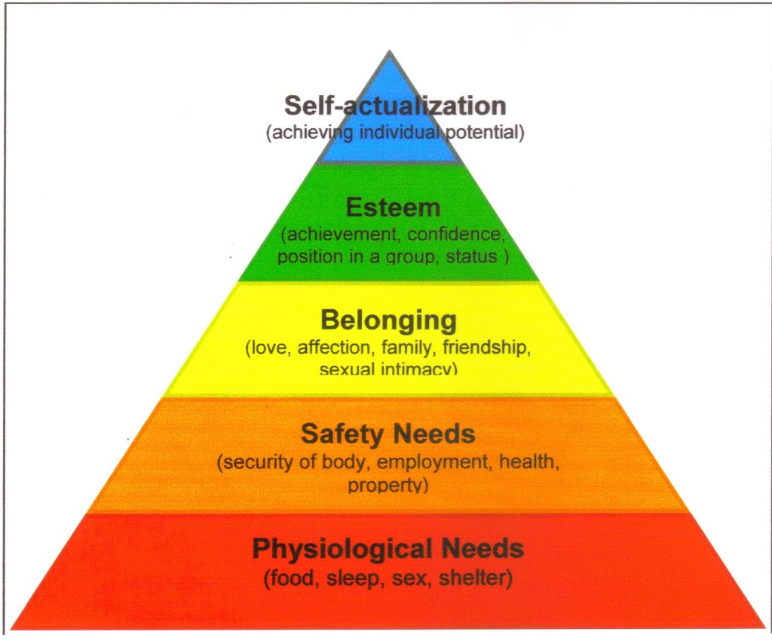

Below is the breakdown of the ‘Motivational Needs’ for Tesco Employees in the form of Maslow’s Hierarchy (Numbers 1-5 top to bottom).

- “Self-Fulfilment – Tesco offers:
- Recognition of Skills & Talents
- Opportunity for Promotion & Career Progression Programme
- Personal Development Plans

- Self-Esteem – Tesco Values:
- Recognition & Contribution Achievement Celebration
- Self-Respect & Respect for Others
- Praise for Hard-Work
- Self-Assessment
- 360 Degree Feedback & Appraisal System
- Social Needs – Tesco Promotes:
- Home-from-Home Ethos (encourages long service)
- Teamwork & Group-Work
- Working Conditions

- Security Needs – Tesco Provides:
- Safety
- Security of Formal Contracts
- Pension & Sickness Schemes
- Healthcare Benefits

- Basic Physical Needs – Tesco Facilitates:
- Canteen/Toilets/Shower Rooms
- Place of Work
- Salary
- Restaurants
- Lockers” (Business Case Studies).

Frederick Herzberg

Frederick Herzberg designed the Two-Factor Theory of Motivation (1959) called the ‘Hygiene Factor.’ His research showed ‘Factors’ that present as real motivators known as ‘Satisfiers.’ The Hygiene Factors present creates Dissatisfaction, that is if Satisfiers were not present. Therefore, this method prevents Dissatisfaction by improving the Hygiene Factors. However, these factors individually cannot provide motivation. Therefore, Herzberg was able to present how Employees were motivated through conditions where they felt fulfilled (Business Case Studies, 2019).

Diagram: Tesco 2 Factor Theory (Business Case Studies, 2019).

- Satisfiers | - Hygiene Factors
“Recognition | Company Policy and Administration
Work Itself | Relationship with Co-Workers
Responsibility | Supervision
Promotion | Status
Growth | Job Security
 | Working Conditions
 | Personal Life
Achievement | Pay and Benefits”

Tesco’s motivates its Staff by keeping a close focus on the Hygiene Factors and allowing the Satisfiers to take place. Therefore, this action Motivates the employees by Empowering them effective communication, delegation of responsibilities and employee involvement in decision making.
Tesco holds forums for staff that want to discuss pay rises and other issues. This demonstrate how Tesco recognises the work efforts of people and rewards them accordingly.
So far, we can conclude that Motivation plays a pivotal role in the Management of People and getting them to engage and partake in Responsibilities/Discussions and Decisions hence, giving Employees the opportunity to Develop and Progress in their Career choices. Taylor suggested Pay was the main motivational factor to improve Production. However, Mayo has shown that Organisations need workers to have more motivation and stake within the Company. Maslow and Herzberg Theories shows different factors can motivate employees.
Tesco provides a lot of career opportunities and Developmental Programmes in order to move forward with one’s Career Options. These incentives help satisfy and retain Employees for long-term whereby, they can use their skills and knowledge in different departments and areas of Tesco. Therefore, enabling the Managers and Staff to focus on their own interest within employment.

Employee Engagement

The Culture of an Organisation depends on the Behaviour Patterns and Relationship it develops over the years. Culture is created by the people that work for the Organisation and it is their effort that helps implement its Values, Beliefs and Perceptions and make them into reality in which they create the Dynamic Culture. This is possible when the people of the Organisation feel at ease coming into work, can trust and value each other’s views and perception and they all share the same vision (Truss et al, 2013; Bullock, 2011).
When given Responsibility an individual will know they are trusted, therefore it will motivate them more. As mentioned by Theorist in People Management that motivation comes from inside of a person, it is developed by the feelings of doing something worthwhile and the efforts are being Valued and Appreciated. Therefore, wanting to contribute to the Organisation’s Success (Business Case Studies, 2019).
Tesco does this by assigning Mentors within the Organisation that have been given the Role to help another individual reach his/her Goals. They involve themselves by making sure that the right Support and Guidance are provided to help individuals reach their full potential, hence aiding individuals to perform their best. Therefore, workers in the Organisation aims to work together and achieve their own Personal and the Organisation’s Objectives. This is achieved by everyone in the Organisation sharing the same dreams and vision therefore, creating a Culture where they can progress and take on greater Responsibility together (Business Case Studies, 2019).
Employees at Tesco’s are required to make use of their Skills, Expertise and Knowledge, by creating a 360 Degree Feedback PDP it will enable them:

- “Responsibilities in the existing job role makes work more fulfilling and rewarding
- Career Opportunities within the Organisation which gives them access to extra knowledge and skill development and wider range of Responsibilities”
- Job Enrichment – individuals are encouraged to take on extra tasks” (Business Case Studies, 2019).

Through this Staff will be more Engaged, Customers more Satisfied hence, will Benefit the Organisation. The success of an Organisation stems from High Performance. This is achieved by how an Organisation Culture reflects on its Employees. Culture that Supports and Nurtures their Employees, helps them to achieve their ambitions, will see better Performance and Engagement (Business Case Studies, 2019).

The Importance of Building Workplace Relationships

Humans require personal connection for; support, friendship, interaction and happiness, with technological advances these days human interaction is more vital. It is necessary for Organisations to get Employees connected so that they can value each other when working on Projects together as part of a Team or Personal Support. Bringing Workers together allows them to strengthen the relationship bond which each other, therefore inspiring better work and a valued work environment. (Bullock, 2011; Truss et al., 2013).

Developing Relationships that are meaningful within the Workplace is essential for the Employees. Organisations are recognising the importance of Social Dynamics are required to build a Strong Foundation to build and Successfully Engage the Workforce (Truss et al., 2013).

Components contributing towards a strong workplace relationship are Hiring the correct people, Respect, and Trust. Organisations such as Tesco recognises and rewards the right behaviour, encourages acknowledgement of one another and collaboration. Tesco has created support centre for communication whereby Staff know exactly where to go for help and support and monitors activities to identify where engagement is lacking.
Furthermore, Tesco encourages the connection of people through communication to say ‘Thank you’, post pictures, share recognition etc, because Tesco values the importance of their workers, through them Tesco are able to build a strong business hence, valued employees feel part of the Organisation making them more committed and likely to remain.

“Good plans shape good decisions”

Building your Career and Reaching your Potential

At Tesco’s everyone is made to feel welcome and valued. Tesco offers a lot of Career Opportunities to help individuals grow and follow a career path that is best suited for the individual. Tesco puts the individual in charge of their own Career Goals, but support is given all the way.
An individual is required to reach their own full potential and that is possible by ‘Developing Oneself’ by: Maximising their Strength, Gaining New Skills, Broadening their Knowledge and Experience. To Develop, one must seek out New Challenges and Experiences and take Risks.
Tesco’s follows 4 steps to guide you build your career:
- Step 1: Know yourself
An individual must know their own strength and weaknesses and be clear about their Goal. This is where one can think about their own Beliefs, Leadership and Managerial Skills and Achievements.
- Step 2: Know what Career Options there are
Everyone has their own Approach to their Career Path. Therefore, know what Opportunities and Resources are available out there for yourself to climb your Career Ladder.
- Step 3: Know how Tesco can support you
Tesco is a huge Business Corporation; it offers many opportunities for one to climb the ladder. Therefore, it is necessary to find the right support to help guide you. This is where one can discuss and make plans for the necessary steps to take forward in order to reach ones Goals.
- Step 4: Know what to do next
This is where you have had your ‘Career Discussion’ and talked about the options available to you. You will create yourself a Personal Development Plan and decide what steps to take next to follow through with your ideas and plans to reach your desired goal.

Personal Development Plan (PDP)

Tesco recognises that Employees are Assets and they are individuals that have different aspirational needs. The Review process of Personal Development Plan allow to recognise Employs Achievements and Abilities and view their potential Development. The Employee benefits by having the opportunity for Career Progression and Tesco will benefit by delivering top quality Customer Service through their skilled Workforce.

My Development Plan
The Questions below are from Tesco’s Career Development Discussion Job Aid in their PDP Plan. Although I am not an Employee within Tesco, my answers are related to my current status of reaching my goals.

- What do I need to learn in the next year?

At the current moment I am unemployed, but I am studying to go back to full-time work. Therefore, it is important for me to complete my Education and not lose the focus and desire to finish my studies by going into full-time Employment. However, I am searching for Part-time and Voluntary Work.

- What Skills, Knowledge, Abilities do I need in the next 3-5 Years?

My Short-Term aim is to focus on University Education. I am currently studying BA (Hons) Leadership & Management Skills for the Workplace. I will complete my Degree by June 2021. I have completed Level 4 and 5, therefore I return to University in June 2020 to complete level 6.
I have recently applied for the position of Administration Operator at the University of Wales Trinity Saint David but unfortunately, I was not short-listed for the Position. I also contacted the University Career Advisor for Voluntary Work within the University; I was told I will be notified in February, which I look forward to hearing from.
I am searching for part-time work to be able to put my newly gained skills I possessed through my studies of this Course such as; Speaking Confidently to large groups of people, involving myself in Team-work and presenting my, knowledge, skills, views, perceptions and beliefs. I have acquired the skill of ‘Presentations’, using PowerPoint and Slides, which I have not done before attending the University. The job I am looking for will help me use my knowledge of Managing people, Teamwork and use my Communication skills.
Once I have reached my Short-term goal which is achieving my Degree, I will look to go into Fulltime Employment that best suits my Skills and Knowledge and where I feel I would develop better for future goals.

- What Steps can I take to learn these skills
- Focus on my Education
- Attain my Degree
- Acquiring Managerial/Leadership Skills through Part-Time or Voluntary Work and Education

- Who Can I ask for Support/Mentoring?
There are lots of Opportunity and Facilities that offers help to University Undergraduate/Graduate Students. I know I can ask for help/support/guidance /advice/feedback at my own Institution. I also have the help/support/guidance from my Family, Friends and Colleagues.

Conclusion

People generally spend most of their time at work. Therefore, it is necessary to get along with the people that you spend your time with, hence making the work and workplace better.
We gathered how Relationships at work with our Colleagues and Mangers have a huge impact on the level of Job Satisfaction, Developing Skills and Knowledge, Staff Morale, Work Environment, and Quality of Life. Workplace Relationship is very important and vital for Teamwork. Respecting and understanding one another and how their differences will allow you to value a person’s opinion which helps develop a more Productive and Positive Workplace Environment.
Organisation need to keep focus on how they can maintain their Staff and get the best out of them. Employee Relations between the HR Representatives and Management can impact on the Workplace Culture. Therefore, to manage a positive Employee Relations Organisations need to Reduce Workplace Conflicts and improve their Staff Morales which in turn will Increase Productivity which are the objectives of Tesco and all other Business Organisation.

References

- Albrech, S. (2011). Handbook of Employee Engagement: Perspectives, Issues, Research and Practice, Human Resource Management International Digest.

- Ahmed, M., et al (2019). High-Commitment human resource practices and employee outcomes: The contingent role of organisational identification, Human Resource Management Journal.

- Bullock, J. (2011). Handbook of Employee Engagement: Perspectives, Issues, Research and Practice2011 Edited by Simon L. Albrecht. Handbook of Employee Engagement: Perspectives, Issues, Research and Practice. Edward-Elgar, March 2010. Leadership & Organisation Development Journal, 32(3), pp.310-311.

- Jaekwon, K., & Smith-Walker, A. (2013). The Relationship between HRM Practices and Organisational Performance in the Public Sector: Focusing on Mediating Roles of Work Attitudes, International Review of Public Administration.

- Gagne, M., & Deci, E., (2005). Self-determination theory and work motivation. Journal of Organisational Behaviour, 26, 331-362.

- Guest, D. E. (2011). Human Resource Management and Performance: still searching for some answers. Human Resource Management Journal, 21(1), pp. 3-13). DOI:10.1111/j.1748-8583.2010.00164

- Maslow, A. H. (1943), A Theory of Human Motivation, Psychological Review, Vol. 50, pp. 394-395.

- Mayo, E. (1933), The Human Problem of an Industrial Civilisation. New York: Macmillan.

- Meyer J., & Gagne, M. (2008). Employee Engagement from a Self-Determination Theory Perspective. Industrial and Organisational Psychology, 1(1), 60-62. DOI:10.1111/j.1754-9434.2007.00010

- Miller, K., Deci, E. & Ryan, R. (1988). Intrinsic Motivation and Self-Determination in Human Behaviour. Contemporary Sociology, 17(2), p.253.

- Taylor, F. W. (1911). The Principles of Scientific Management. New York: Harper & Brothers.

- Truss, C., Shantz, A., Soane, E., Alfes, K., & Delbridge, R. (2013). Employee engagement, organisational performance and individual well-being: exploring the evidence, developing the theory, The International Journal of Human Resource Management, 24:14, 2657-2669, DOI: 10.1080/09585192.2013.798921

- Business Case Studies, (2020), Creating-a-high-performance-culture-Business Case Studies [ONLINE] Available at: https://businesscasestudies-co-uk.cdn.ampproject.org/v/s/businesscasestudies.co.uk/creating-a-high-performance-culture/amp/ [Accessed: 5 Dec. 2019].

- Business Case Studies, (2020). Organisational-structure-in-an-innovative-environment – Business Case Studies [ONLINE] Available at: https://businesscasestudies.co.uk/organisational-structure-in-an-innovative-environment/ [Accessed: 5 Dec. 2019].

- Business Case Studies, (2020). Motivational-Theory-In-Practice-At-Tesco – Business Case Studies [ONLINE] Available at: https://businesscasestudies.co.uk/motivational-theory-in-practice-at-tesco/ [Accessed 5 Dec. 2019].

