Assignment Title: Computer System Component Specification
Module: Computer systems fundamentals (ACCA4028)
Program name: CertHE in Digital Skills
Student name: Adrian Dulgheru
Student ID: 2231314

Task 1
In the table below I built a computer for an elderly relative who wants a low-cost desktop PC with a small form factor but a full-size keyboard and decent-sized monitor to help with their eyesight.

For the motherboard, I opted for the MSI LGA 1700 because it’s a new-generation motherboard and you have all the ports needed for connectivity like HDMI, USB 3.2 or USB 2.0, LAN, or AUDIO. The big plus in my opinion is that on this motherboard you have support for an NVME ssd which is a high-speed ssd that will run everything you access on it instantly. Another big plus is the expansion slot where you can add an audio card for example in case the one that is onboard is failing during the time.
For the CPU I opted first of all for Intel instead of AMD because they are more stable and for normal use of a computer like working in Excel, watching videos on YouTube, or video calling this is the best option in my opinion.I opted for an I3 because 4 cores and 8 threads are enough to run Windows 11 smoothly.
For the memory, I chose Corsair because it’s one of the best companies for RAM, especially these models with the heatsinks that help the memory be cool. The amount of 16GB it’s enough for a good run in a PC considering only the operating system needs approximately 4-5GB to run its features. If you would like to multi-tasking and run an HD video on youtube and at the same time work on a document this amount will help to run without any interruption.

For storage, I chose the Samsung nvme SSD because first of all Samsung is one of the best SSDs on the market with a long warranty of 5 years because they are very good quality, and they have a write/read speed of approx 3000 Mb/s which is 6 times faster than a normal SSD and 30 times faster than a normal HDD.

For the power supply I chose the be quite! 450w Bronze because it’s very important in a computer to have all the voltages stable and this type of power supply it’s exactly what it does.

Overall I made these choices to have a fast computer that will last for a few good years without having any issues.

Name | Model | Picture | Price
Motherboard | MSI PRO Intel H610M-G DDR4 , LGA 1700 , Micro-ATX | 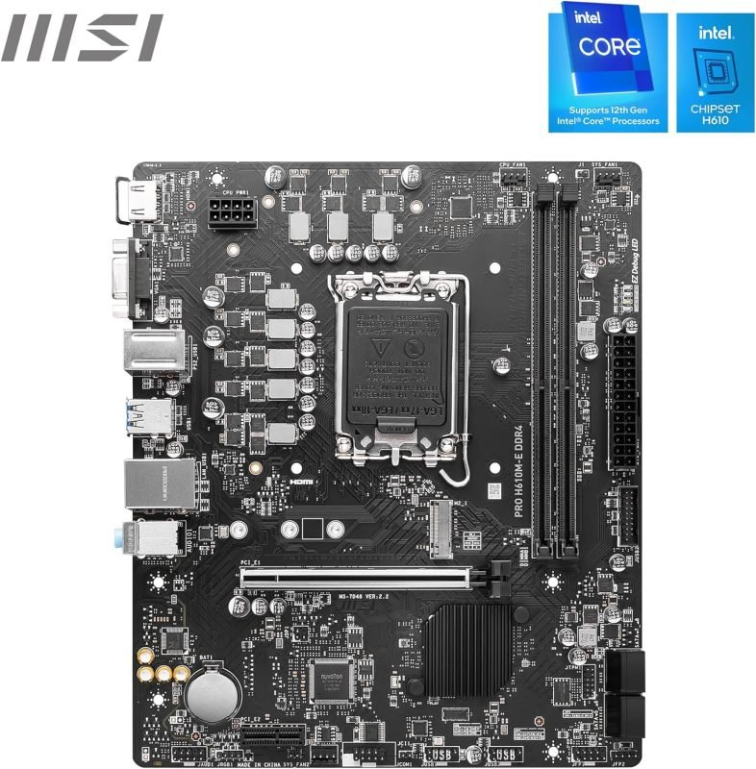 | 69.99
CPU | Intel 4 Core i3 14100 Raptor Lake Refresh , LGA 1700 | 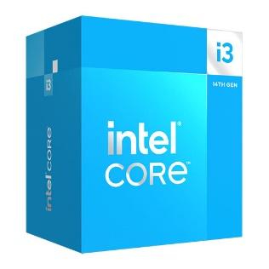 | 144.98
Memory | Corsair Vengeance LPX 16GB DDR4 3600MHz CL18 | 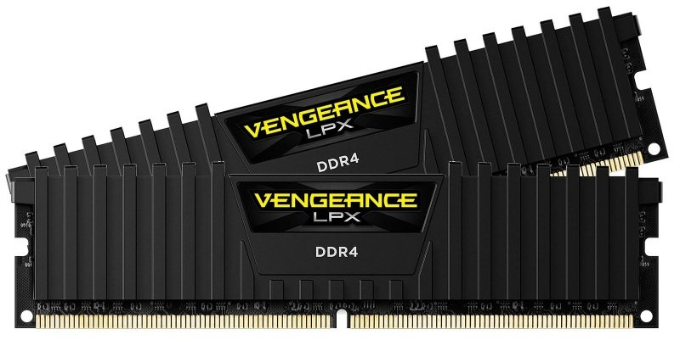 | 36.99
HDD/SSD | Samsung 980 500GB PCIe 3.0 NVMe M.2 Internal SSD (MZ-V8V500BW) | 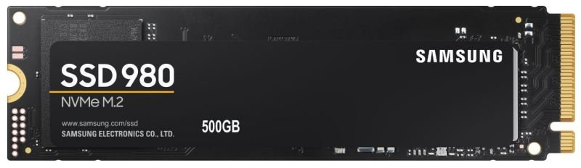 | 61.98
Video Card ( GPU ) | Onboard  Intel UHD Graphics 730 |  | 0
Case | Silverstone Sugo micro-ATX/ITX SFF Gaming Case SG11B | 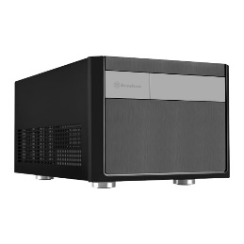 | 79.99
Power supply | be quiet! SFX Power 3 450W Bronze Wired Power Supply | 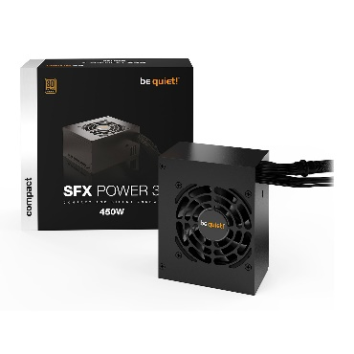 | 64.99
Mouse and keyboard | HP 320MK Wired Desktop Keyboard and Mouse Set | 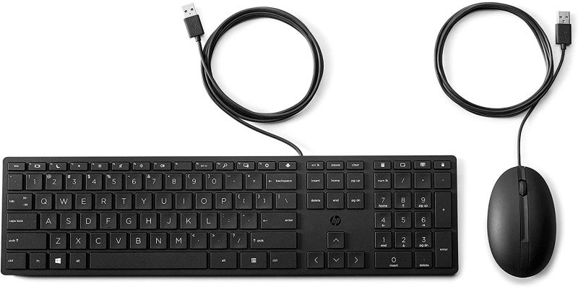 | 26.18
Monitor | LG 24MK43HP-B 24" Full HD IPS Monitor | 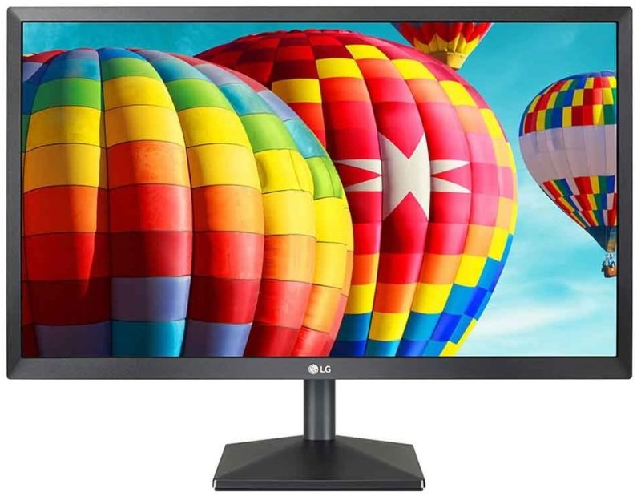 | 79.98
Microsoft Office | Microsoft 365 Personal License - 1 Year - 1 License |  | 55.49
Antivirus | McAfee Internet Security 3 Devices 1 Year Subscription |  | 21.99
Microsoft Windows | Windows 11 Home |  | 119.99
TOTAL |  |  | 762.55

Task 2

This is my computer and I am using it most of the time for university to make the projects on it , to watch videos on youtube or to chat with my friends on facebook or whatsapp.For my necessities this is enough to help me with what I need.The computer runs perfectly without any problems.

Component | Model | Picture
CPU | Intel Core i5 4590 3.30 GHz , Socket 1150 | 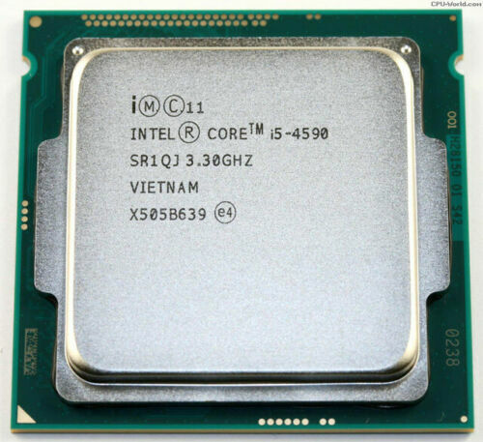
Motherboard | Dell 040DDP , Socket 1150 | 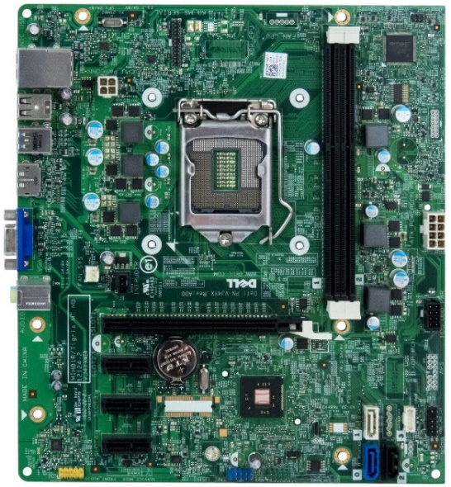
Ram | 2 x 8GB PC3-12800 1600 MHz Integral | 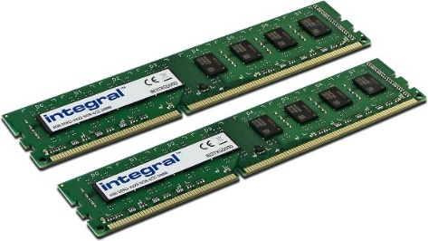
SSD | Samsung SSD 850 PRO 256GB | 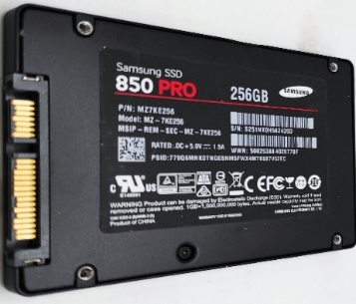
Optical unit | TSSTcorp DVD+-RW SH-216DB | 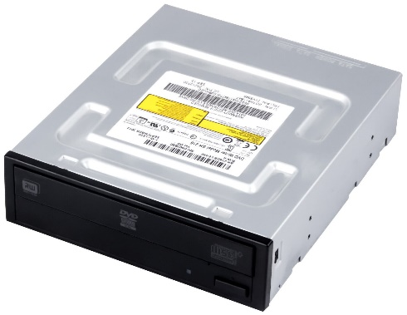
Operating system | Windows 10 Pro 64-bit
Keyboard | Dell Wired KB216 | 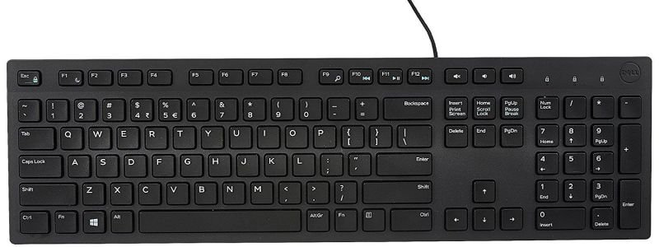
Mouse | Dell Wired 570-11147 | 
Printer | Ricoh SP201N | 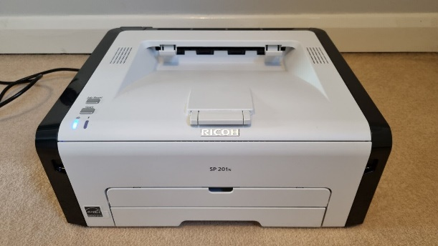

SSD Speed test
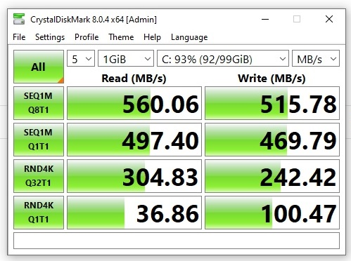

CPU Benchmark

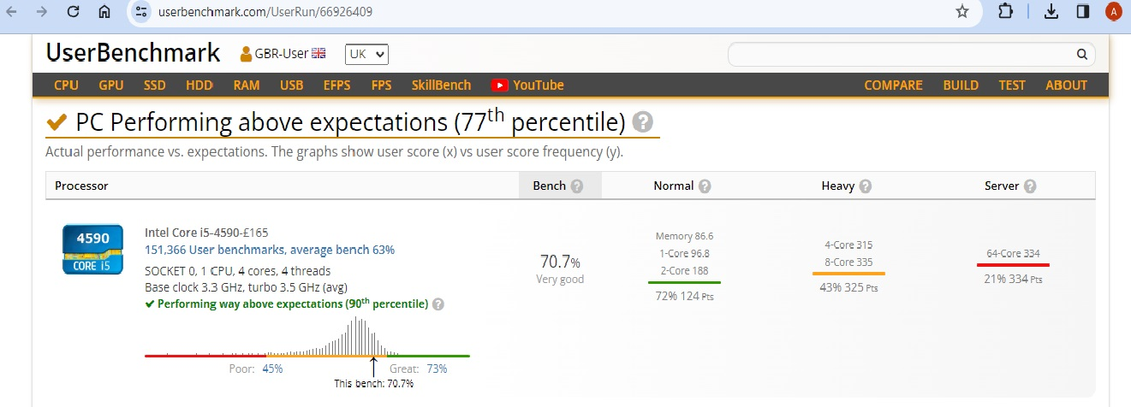

GPU Benchmark Test



