
BMMB7027and BMMB7027D
Strategic and Agile Business Management

STUDENT NAME: MINHAJUR RAHMAN KHAN MISU

STUDENT ID: 2511789
Word Count: 5052

Executive Summary
This report evaluates Amazon's strategic direction with a particular focus on enhancing customer care through strategic and agile business management practices. The report aims to thoroughly analyse Amazon's positioning, understand its challenges and opportunities, understand the expert approaches taken to customer care and give a recommendation on the best approach for Amazon to take that will help achieve sustainable competitive advantage. The analysis revealed a number of strategic points that could impact the future function of Amazon. These include new competition in e-commerce and technology industries, changing customer demands, legal requirements, data privacy, and a constant need for fresh innovations. Meanwhile, there are chances arising with artificial intelligence, predictive analytics, digital transformation, and improved customer experience management. The results reveal that Amazon has several strengths, such as a well-established brand, high-level technological capabilities, highly efficient logistics and a culture that puts customers first, which appears to be effective and successful. The organisation also exhibits a high degree of strategic agility, making innovations, experimenting and making decisions on data. However, ongoing investments in service quality and actively involving customers will be necessary to keep customers loyal. The three options evaluated, with the SAF framework, are hyper-personalisation through Artificial Intelligence, the improvement of the customer testimony by integrating an omnichannel approach and a predictive customer service system. The assessment results indicated that the customer service system with predictive capability is the best strategy as it has the highest suitability, acceptability and feasibility. This strategy expects that customer satisfaction will be enhanced, customer loyalty will be reinforced, the failure rates of services will be lower, and operational efficiency will be higher. Additionally, proactive problem solving will create Amazon's competitive advantage and aid long term organisations resilience in the growing and dynamic business landscape.

Table of Contents
Executive Summary 2
Introduction 5
Company Background 5
Purpose and Scope of the Report 6
Report Structure 7
Strategic Analysis of Amazon 7
External Environment Analysis 7
PESTLE Analysis 7
Porter's Five Forces Analysis 11
Internal Environment Analysis 12
VRIO Analysis 12
Brand Reputation 12
Support Activities 15
Strategic Position 15
Current Customer Care Evaluation 16
Strategic and Agile Business Management Evaluation 17
Strategic Agility at Amazon 17
Agile Culture 18
Innovation Capability 18
Data-Driven Decision-Making 18
Strategic Options for Enhanced Customer Care 19
Option 3: Predictive Customer Service System. 21
Evaluation of Strategic Options Using the SAF Framework 21
Wider Organisational Implications 22
Leadership Implications 23
Organisational Culture Implications 24
Technology and Innovation Implications 24
Ethical and CSR Implications 24
Financial and Operational Implications 24
Conclusions 25
Recommendations 25
References 27

Introduction

Company Background

Figure: Amazon
Source: (Das and Hassan, 2022)
Amazon is one of the largest multinationals around the world in the fields of technology and e-commerce. It was started in 1994 by Jeff Bezos, and, originally, it was an online bookstore, but over time it branched out into other products and services (Das and Hassan, 2022). Nowadays, Amazon is present in e-commerce, cloud computing, digital streaming, AI, supply chain and advertising markets. It has a presence in several global markets, including North America, Europe, Asia and other international markets and has millions of customers around the world. Amazon is positioned as a strong and competitive player in the global retail and technology sector, boasting a broad range of products, a robust logistics system, and advanced technological features. Amazon Web Services (AWS) also bolsters its presence in the market with its cloud infrastructure to help businesses around the world.
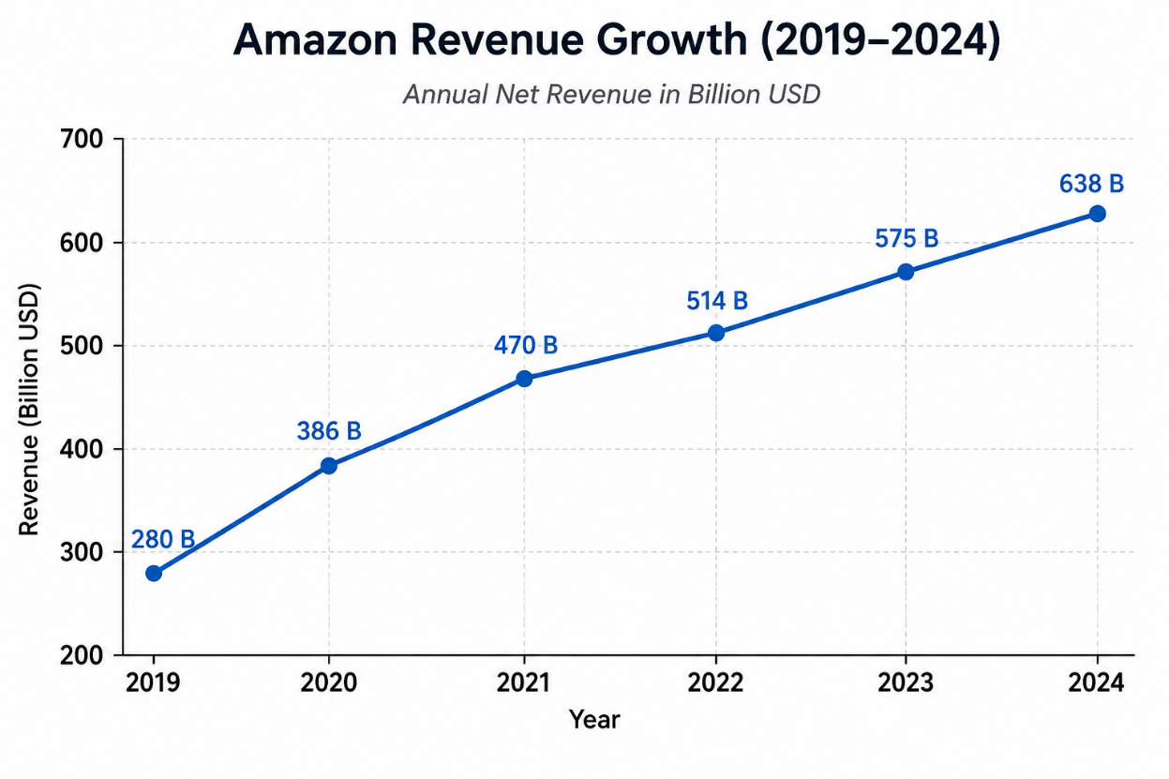
Figure: Amazon Revenue Growth
Source: (Tuncalp, 2026)
The company's innovation and operational efficiency have been key to its continued success and competitiveness. Amazon's purpose is to "be Earth's most customer-centric company. The annual revenue of Amazon has been rising steadily from 2019 to 2024 as indicated in the chart. The highest growth was between 2019 and 2021 while in the years after, revenue growth remained steady. The positive trend suggests that Amazon's business is doing well, and this strength will enable the company to fund its innovation, customer service, and future expansion strategies.

Purpose and Scope of the Report
This report aims to analyse the current strategic direction at Amazon and to see what opportunities there are to improve Amazon's customer service through strategic and agile business management practices. Organisations lie in dynamic and uncertain environments, where technological change, customer expectations and strong global competition are common. Therefore, it is crucial to conduct strategic reviews as critical to ensuring organisational sustainability and competitive advantage. Customer care is a distinct focus since customer experience is a key influencer in digital market success for the organisation. Customer service is a thing of strength for Amazon, and continuous improvement and innovation are needed to meet their expectations. Hence, the report is focused on ways of strategic approaches which can augment the customer relationship and enhance the service quality. The report also considers how crucial strategic agility is. Agile organisations are in a better position to capitalise on major changes in the market, technology and consumer emotions.

Report Structure
This report is divided into a number of sections. The main body of this introduction will be followed by a detailed strategic examination of Amazon by considering the external and internal business environment. It then investigates and critically examines strategic and agile business management practices and compares and contrasts the different strategies for improving customer care. The wider organisational implications with respect to leadership, organisational culture, technology, ethics and corporate responsibility are then explored.

Strategic Analysis of Amazon

External Environment Analysis

PESTLE Analysis
Amazon is dealing with an extremely dynamic global environment that is affected by politics, ecology, economy, technology, legality and social dynamics. It's essential to be aware of these outside factors so they can be compared to the organisation's strategic position and opportunities.
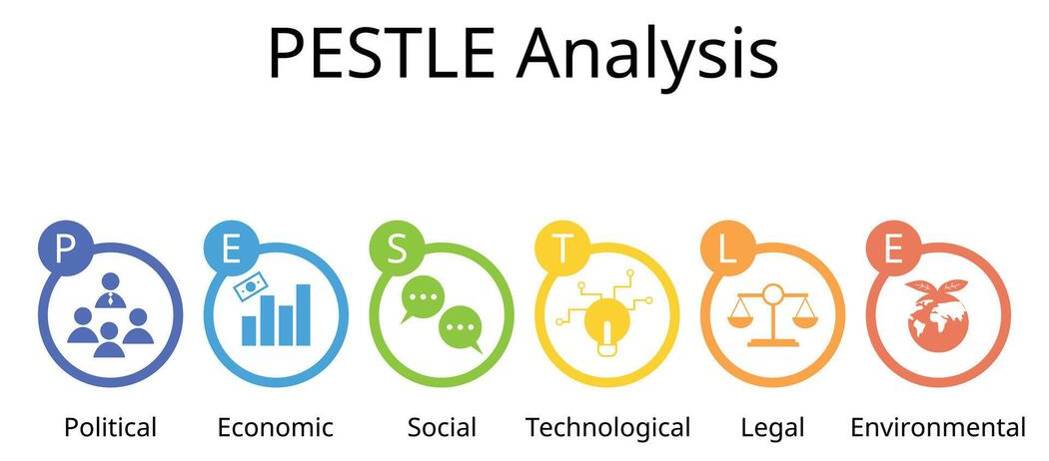
Figure: PESTLE Analysis
Source: (Mueller-Saegebrecht and Walter, 2025)
Political Factors
Amazon's business internationally is greatly affected by its political situation. The company does business in many countries and is thus impacted by laws and regulations of governments in those countries relating to trade, taxation, labour standards and digital regulations. In some markets, government regulation and antitrust action have become more stringent and intense as a result of probing and questioning of major tech firms (Haislip and Richardson, 2017). International trade changes and geopolitical risks could also impact one of Amazon's international supply chains and supply chain efficiency. As a result, Amazon needs to keep adjusting its strategies continuously to meet the evolving regulatory needs.
Economic Factors
The economic condition will directly affect the purchasing behaviour of consumers and organisational performance. Amazon's retail activities are impacted by inflation, interest rates, economic growth and consumer confidence (Coltman et al., 2011). One of the biggest potential downsides when an economy faces uncertainty is that some people will become more sensitive to price and be concerned with what they're buying. But Amazon has a diversified business model of e-commerce, cloud computing, advertising and subscription services. It manages to diversify its revenues, which helps it mitigate the risk from one source and ensure sustainability in economic declines.
Social Factors
Consumer expectations are still increasing in the digital markets. Today, increasingly, customers are expecting to get convenience, speed, customisation, and a smooth customer service experience from modern businesses (Mueller-Saegebrecht and Walter, 2025). In response to Amazon, the company has been putting money into innovations that make customers happy, like same-day delivery, individualised recommendations, and technologies that use voice commands. Amazon's long-term growth is backed by demographic changes, rising use of the internet and growing acceptance of online shopping.
Technological Factors
Technology is one of the most important assets behind Amazon's competitive advantage. Amazon's use of AI, machine learning, cloud technology, robotics, and data analytics ensures its smooth functioning and enhances customer habits (Mihardjo et al., 2019). The company is constantly pursuing innovation in order to help it hold its position in the market and enable strategic agility. New technologies also allow better customer service by using predictive analysis and automation, and customising the delivery of services.
Legal Factors
Amazon Inc. thrives in intricate legal contexts in various jurisdictions. Its organisation is subject to both consumer protection and competition law principles, in addition to requirements for participation in the employment process, data privacy and the protection of intellectual property. The recent legal challenges regarding market dominance and data treatment have led to additional compliance requirements (Arbussa et al., 2017). Noncompliance may lead to monetary fines and damage to its reputation. Hence, legal risk management is still of great strategic value.
Environmental Factors
Customers, governments and investors are now more concerned about environmental sustainability. Amazon is increasingly coming under pressure to further lower carbon emissions, increase the sustainability of its packaging and boost the sustainability of environmental responsibility in its supply chain. The company has undertaken various sustainability measures, such as investing in renewable energy and committing to carbon footprint reduction.
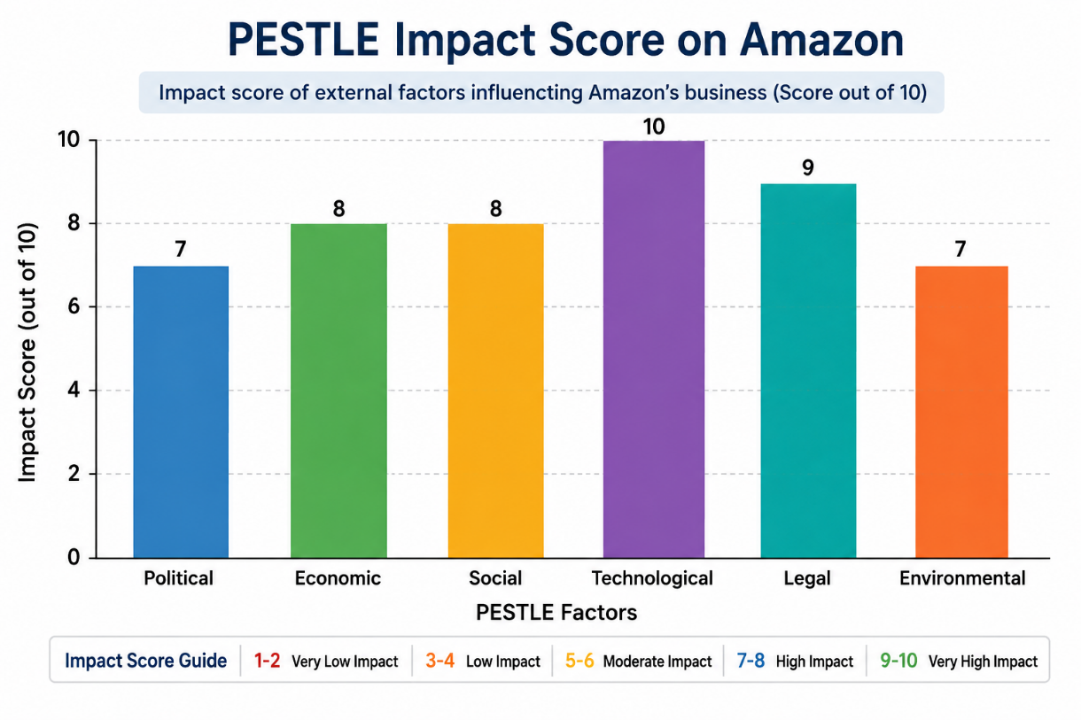
Figure: PESTLE Impact Score on Amazon
Source: (Mihardjo et al., 2019)
Amazon's business environment is analysed in relation to the other six PESTLE factors and their relative impact on it. Technological factors are the most significant, and Amazon has a strong need for innovation and regulatory adherence, followed by legal, economic, and social factors. From the figure, it is evident that Amazon has to adapt to the external environment continually to gain a competitive edge and long term growth.

Porter's Five Forces Analysis
Porter's Five Forces are used to get to an understanding of the competitive game within which Amazon operates.
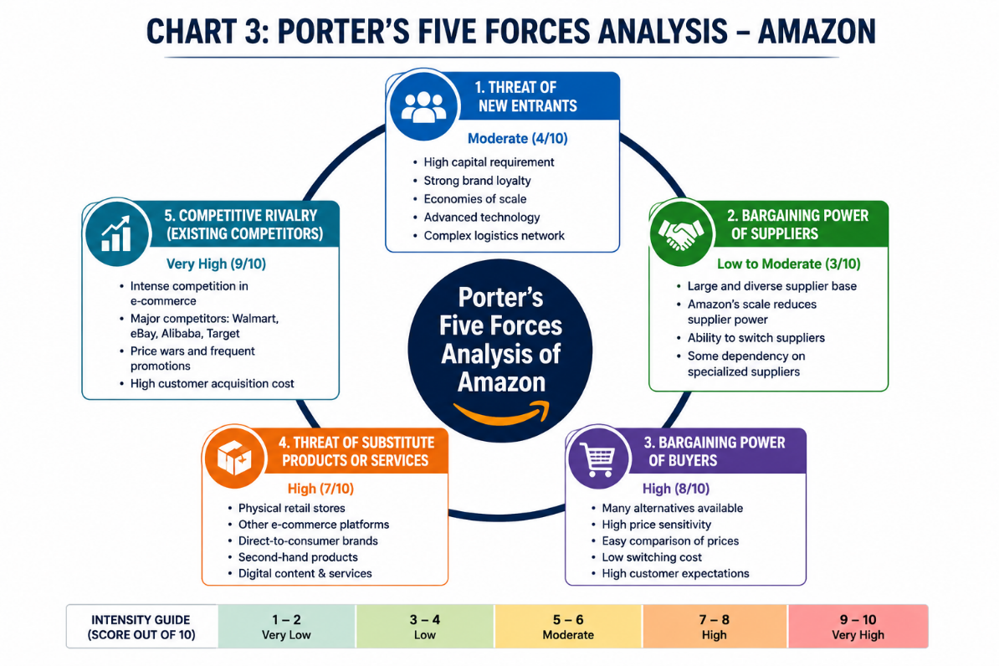
Figure: Porter's Five Forces Analysis of Amazon
Source: (Amiri and Vida, 2023)
Threat of New Entrants – Low
New entrants can be relatively small as there are significant barriers to entering the market. Amazon has several advantages, such as their vast web infrastructure, cutting-edge technology, brand recognition, and financial capabilities (Clauss et al., 2019). Any new players would need to spend a lot of money to reach the level of scale and functionality.
Bargaining Power of Suppliers – Moderate
As is commonplace, supplier power is still medium as Amazon works with many suppliers and sellers. The organisation is large and has strong negotiating leverage due to its size and purchasing muscle. But there are some technology vendors and niche suppliers that will have more power in special business areas.
Bargaining Power of Buyers – High
Switching costs and the fact that customers have lots of other online places to shop online means that customers have plenty of power to bargain. They can see and compare prices and services on various platforms easily (Wade et al., 2021). Therefore, Amazon has to continuously upgrade customer service and add value to ensure customer loyalty.
Threat of Substitutes – Moderate to High
Some alternatives are traditional brick-and-mortar retailers, niche online retailers, and distribution channels that go directly to consumers. There are many different products on the market, leading to greater competition and ongoing innovation.
Competitive Rivalry – Very High
The e-commerce/technological environment is a competitive market. Amazon is currently in a rivalry with big organisations around the world like Walmart, Alibaba, Microsoft, Google and many regional shops (Mason, 2018). Thus, the need for continuous innovation, strategic agility and customer-focused differentiation is necessary to maintain a competitive advantage.

Internal Environment Analysis

VRIO Analysis
The VRIO framework assesses characteristics of the resources and capabilities that enable the organisation to sustain a competitive advantage: Value, Rarity, Imitability and Organisational Support. Amazon has several strategic assets which help to reinforce its competitive positioning and help it in the long-term.

Brand Reputation
Amazon has developed one of the most recognised and trusted brands globally. Convenience, reliability and good customer service add to the reputation of the organisation, thus establishing value in the business. It is a relatively rare brand strength because of its long years of customer trust accumulated (Kandampully et al., 2018). However, similar brand value can be attempted by the competitors, but it takes a lot of time and investment to build customers' loyalty for the equivalent brands. Amazon is very well structured in its marketing, service and customer service policies to utilise the brand. Thus, brand reputation offers a competitive edge that is constant.
Technological Capabilities
Amazon's high-tech facilities are an asset to the company's goals. AI, machine learning, cloud computing, and data analytics are among the technologies the organisation uses to enhance both operations and customer experience (Du Plessis and De Vries, 2016). These capabilities contribute to efficiency, creativity, and strategic agility. While companies invest in technology, it is not easy for them to follow the Amazon lead in scale and expertise. The organisation has also been configured in such a way that it benefits as much as possible from technological innovations through constant investments and research. Thus, technological competence plays an important role in competitive advantage.
Logistics and Distribution Network
Amazon's logistics network is a global, critical strategic asset as well. There are many extensive fulfilment centres, transportation networks, and delivery partners that allow for quick and efficient order fulfilment. This feature provides significant value to customers and adds to operational efficiencies. It would be very expensive to duplicate such a network and would take quite a bit of investment. Organisational systems are specially structured to ensure the effort of these resources is most effective.
Amazon Web Services (AWS)
One of Amazon's most valuable strategic assets is AWS. It makes significant revenue and acts as a catalyst for innovation in the organisation. It has built up great value, broad recognition in the market, and technological sophistication within AWS (Hwang and Seo, 2016). Looking to duplicate its mass scale and capabilities is a great deal of trouble for competitors. Amazon's organisational structure is effective in fostering the development and growth of AWS. So, AWS continues to be a key enabler of sustained competitive advantage.
Value Chain Analysis
Value Chain Analysis (VCA) looks at the role of organisational activities in contributing to value creation and competitive advantage. Amazon has been very successful in integrating the primary and support functions in its value chain, thereby allowing the organisation to create superior customer experiences.
Inbound Logistics
Amazon has a wide network of suppliers and inventory management systems in various markets around the world. The use of advanced forecasting technologies and data analysis enhances inventory management and minimises inefficiencies in the operation (Homburg et al., 2017). The capabilities help in product availability and stock management effectively.
Operations
Operating at an "operational level" is at the core of Amazon's business model. Using automated fulfilment centres, robotics, artificial intelligence, and cutting-edge warehouse management systems can facilitate efficient order processing (Lemon and Verhoef, 2016). These technologies deliver productivity gains and cut the cost of operation and time to market.
Outbound Logistics
Amazon's distribution capability is one of its biggest competitive advantages. The company has large fulfilment centres and transport solutions and can guarantee faster delivery of products, thanks to its last-mile logistics skill (Verhoef et al., 2015). Prime services improve customer satisfaction and build loyalty of customers.
Marketing and Sales
Amazon uses data to help them customize their marketing efforts and enhance customers' shopping experiences. Purchasing recommendations, promotions, and reviews from customers helps make informed buying decisions. Such activities improve customer connectivity and boost sales productivity.
Service
One of the main values given is customer service. Well-designed returns processes, service and self-service play an important part in customer experiences (Das and Hassan, 2022). The ongoing program of service quality does meet the organisation's philosophy that customers are at the centre of its operations.

Support Activities
Support activities reinforce the value chain of Amazon. Organisations are continuing with continuous innovation and investing in research and development for technological development. Human Resource Management enables the maintenance of effectiveness in the operations by promoting workforce development and the acquisition of human resources. The procurement systems enrich the management of suppliers and operational effectiveness (Foltean et al., 2019). Leadership, governance and strategic planning processes are essential components of an organisation's infrastructure that support the various aspects of the business. In general, Amazon's value chain is well in line with the customer value creation process.

Strategic Position
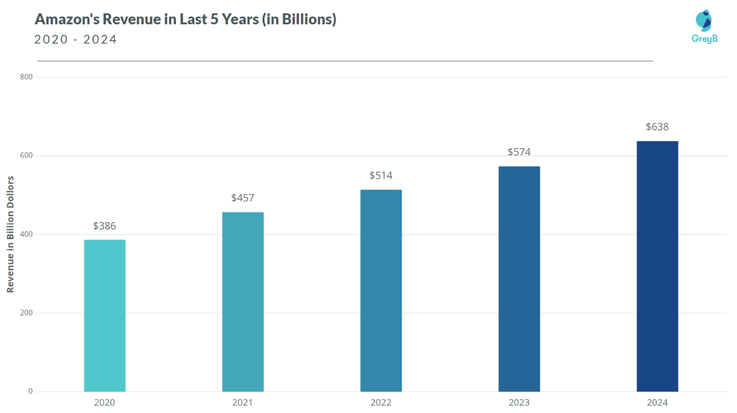
Figure: Amazon’s Revenue Last Year
Source: (Shamout et al., 2024)
As can be seen in the chart, Amazon's revenue grew steadily from $386 billion in 2020 to $638 billion in 2024. This steady growth is indicative of the company's competitive position in the market and its global operations. An increase in revenue also reflects profitable investments in technology, logistics and innovation directed towards the customer. In summary, the rise in Amazon's share price during the past week highlights the company's robust financial results and future growth prospects. Amazon's strategic analysis adds to its solid foothold in the global e-commerce and tech sectors. There are many key assets within the organisation, such as the highly recognised brand, its advanced technological resources, and the fact that it has a very sophisticated logistics network, alongside excellent financial resources. They increase operating efficiency, innovation and customer satisfaction and provide significant barriers to the competition. There are multiple avenues for Amazon to increase its ability to grow going forward (Haislip and Richardson, 2017). As AI, automation, and predictive analytics are increasingly embraced, they can also further improve customer experiences and performance. There are also risks to the expansion of digital services, the enhancement of sustainability efforts and the creation of personalised customer care solutions. In addition, there are risks associated with the expansion of digital services, the improvement of sustainability offerings and the development of personalised customer care solutions. Amazon, however, has various threats in the external environment (Ullah and Narain, 2020).

Current Customer Care Evaluation
In physical stores, customer care is a key element of the company's operations and is a key objective of the company's business strategy in this regard. The primary attributes through which Amazon will provide a convenient and reliable service experience are: competitive pricing, fast delivery, and personalised service experience. The use of advanced technologies such as AI and data analytics enables personalised product recommendations and customer interaction. There are multiple strengths that result in elevated stages of consumer satisfaction (Coltman et al., 2011). Convenience and customer loyalty are improved by fast shipping (especially Amazon Prime). Easy digital platforms make buying all easier and more convenient, and effective return and refund policies build customer confidence. The wide portfolio of offers and tailored advice enhances the customer experience even more and leads to the right repurchase behaviour. While this is a strong area, there are some areas of customer care that Amazon could do better. With increasingly high expectations of customers, there is a constant need to add value to the service. In some cases, an automated support system can restrict opportunities for human interaction when dealing with intricate issues.

Strategic and Agile Business Management Evaluation

Strategic Agility at Amazon
Strategic agility is the capacity of an organisation to swiftly and effectively adjust to shifting market conditions, customer demand, technology and competition. The company's track record of strategic manoeuvrability remains remarkable, with a customer-centric culture, groundbreaking innovations, and data analytics that guide decision-making (Khan et al., 2021). Amazon's ability to manoeuvre flexibly over the years with its customer-focused culture, constant innovations, and wide implementation of data-driven decision-making has consistently been remarkable. This allows the organisation to be flexible and retain and build a sustainable competitive advantage in a highly dynamic market.
Strategic Agility Dimension | Evidence at Amazon | Strategic Contribution
Agile Culture | Customer obsession, experimentation, and decentralised decision-making | Faster response to market changes
Innovation Capability | AWS, Alexa, Prime, AI technologies | Continuous value creation and growth
Data-Driven Decisions | Customer analytics, predictive systems, machine learning | Improved customer experiences and operational efficiency

Agile Culture
Amazon's culture is very conducive to strategic agility. Leadership standards progress foundation building, experimentation, accountability, and customer fervour. Employees are motivated by the opportunity to recognise opportunities, explore ideas and make decisions to enhance the outcomes for customers (Nurjaman and Dwipriyoko, 2021). This culture is one that is flexible and reacts quickly in the business arena. One standout trait of Amazon's agile culture is that they are willing to try things and learn from them. Many new products and services are experimented with and tuned up before being introduced on a large scale. This allows the organisation to adapt to its customers' needs and the market and makes it more responsive. The structure, where the emphasis is placed on small autonomous teams, also ensures swift decisions and flexibility around measures.

Innovation Capability
Amazon's strategic tremendous success hinges on innovation. The organisation continuously engages in research, technology development and digital transformation activities. This dedication to invention has manifested itself in several hugely successful services, including Amazon Prime, Amazon Web Services (AWS), Alexa, and advanced logistics technologies. Innovation capacity allows Amazon to see and capitalise on emerging opportunities in the market and to stay competitive (Mueller-Saegebrecht and Walter, 2025). The company is constantly innovating in products, services and business model development to create new revenue streams and value for its customers.

Data-Driven Decision-Making
Another critical component of Amazon's strategic agility is decision-making based on data. The organisation gathers and processes vast amounts of customer data, operational and market data for strategic and operational decisions. With advanced analytics and machine learning, Amazon can uncover trends, forecast customer behaviour, and fine-tune business processes. Customer info is especially crucial towards enhancing the quality of service and personalisation. Advanced analytical systems provide support for product recommendations, targeted promotions, inventory planning and forecasting demand (Shams et al., 2021). These capabilities allow Amazon to react swiftly to customer needs and the market. Moreover, data are helpful in decision-making, making organisations more efficient and better managed in terms of risk management. Decision-makers have timely data to guide with, not just their opinions based on past ideas that might not be true in the present.

Strategic Options for Enhanced Customer Care
After the strategic analysis, there are a number of strategic options that can be considered to enhance Amazon's customer care capabilities. These options are most likely around the customer experience, customer satisfaction, and strategic agility and innovations for long-term customer competitive advantage.
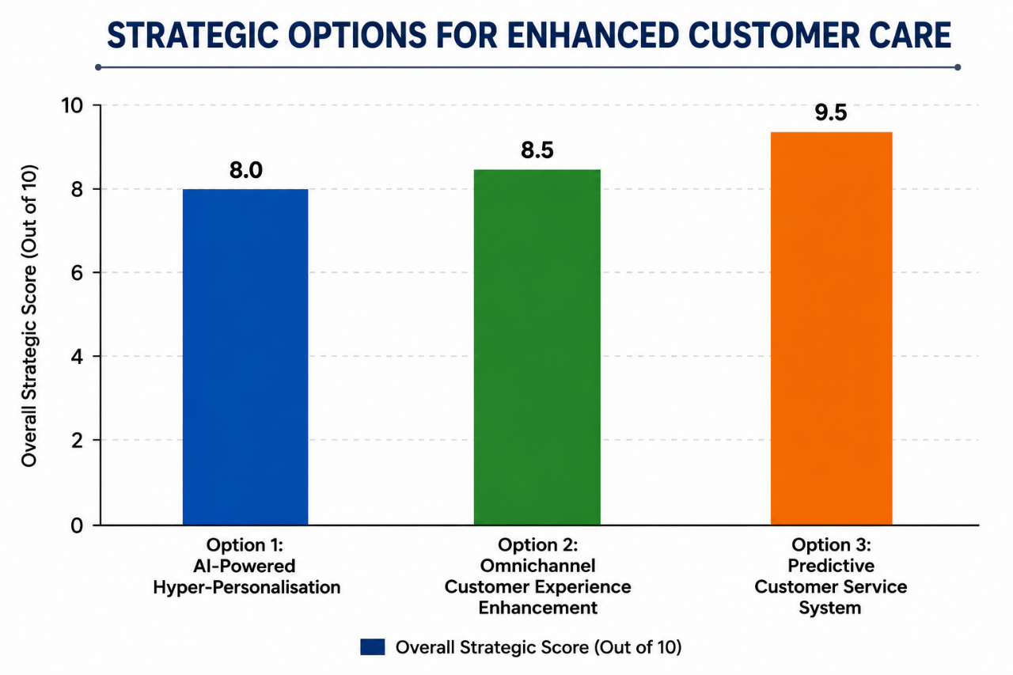
Figure: Strategic Options for Enhanced Customer Care
Source: (Hansen, 2025)
This chart is a comparison of three strategic positions that can help improve Amazon's customer care. Predictive Customer Service System is the top performer in the points column because it allows companies to resolve issues in advance and be more efficient. Omnichannel Customer Experience Enhancement is the second one, offering seamless customer interactions. AI-Powered Hyper-Personalisation also shines in the personalised recommendations and enhanced customer loyalty departments.
Option 1: AI-Powered Hyper-Personalisation
Hyper-personalisation with AI means leveraging a wide scope of artificial intelligence, machine learning and sophisticated data analysis to deliver highly individualised customer interactions. While Amazon already has a system in place to make recommendations, a more intricate personalisation scheme throughout the customer's experience would be possible with greater investments. Within this scheme, consumers' interests, shopping behaviours, page visits, socio-demographic characteristics, and behavioural trends would be studied on the spot (Mihardjo et al., 2019).
There are various promising possibilities of benefits in this strategy. Personalised experiences can lead to better customer satisfaction, build stronger loyalty and improve customer retention. Boosted recommendations also have the potential to generate extra sales revenue by prompting further purchases. More also helps to reinforce the ethos of 'the customer is king' and aids Amazon's competitive edge.
Option 2: Omnichannel Customer Experience Enhancement
Omnichannel customer experience enhancement is the process of orchestrating each customer touchpoint to make them all cohesive. Users now demand uniform customer journeys when interacting with brands, using channels such as websites, mobile apps, voice assistants, social media, customer support or retail stores. This approach would entail integrating the information and communication systems with the service processes, both within and between the channels.
This strategic option has a number of benefits. Better channel integration can provide greater convenience, customer satisfaction and build brand cohesiveness. Building a smooth customer journey might also lead to better customer interaction and foster loyalty (Tenggono et al., 2025). Plus, integrated systems can offer staff greater access to customer information, aiding in the delivery of effective services. While these benefits are apparent, significant technology investments and changes in approach and behaviours may be required to implement.

Option 3: Predictive Customer Service System.
Predictive customer service systems are truly a proactive method of customer service systems. Instead of only reacting when something goes wrong, Amazon would leverage artificial intelligence, predictive analytics and other machine learning technologies to proactively detect potential issues ahead of time.
It would review all of this information on operations, delivery, procurement and customer relations to determine potential problems with service. If there were possible delays, short run/long run production problems, payment issues, or technical problems, they could be determined before the process (Arbussa et al., 2017). This approach can provide a great amount of customer service benefits. By resolving issues proactively, one can minimise customer frustration, enhance service stability, and boost customer satisfaction. Early intervention can also help lower the number of customer complaints and support inquiries, which can help streamline operations.

Evaluation of Strategic Options Using the SAF Framework
The Suitability-Acceptability-Feasibility (SAF) Framework to Assess Strategic Options for Improving Amazon's Customer Care Model is the main tool that will be utilised for evaluating the options identified for enhancing Amazon's customer care capabilities.
Strategic Option | Suitability | Acceptability | Feasibility | Overall Assessment
AI-Powered Hyper-Personalisation | High | Medium-High | High | Strong Option
Omnichannel Customer Experience Enhancement | High | High | Medium | Strong Option
Predictive Customer Service System | Very High | High | High | Best Option
Suitability Assessment
A key question that is considered at the suitability phase is whether the proposed strategy will effectively tackle the strategic challenges and opportunities of the organisation. Hyper-personalisation, especially the AI-driven type, is ideal since it can boost customer involvement via customisation and align with Amazon's customer-centric approach. The availability is also aligned to the increase in consumer demand for personalised services (Doz and Kosonen, 2010). Omnichannel customer experience enhancement is also apt as customers have come to anticipate a seamless customer journey across channels.
Acceptability Assessment
Acceptability refers to the potential response from the stakeholder group and the potential risks and benefits of each option. Hyper-personalisation benefits are particularly substantial in increasing customers' satisfaction, loyalty, and revenues by using AI-powered personalisation. But issues on the privacy of the data and the large volume of customer data could raise concerns for stakeholders and limit acceptability (Clauss et al., 2019).
Feasibility Assessment
Feasibility addresses the ability of an organisation to implement the project, based on its resources, capabilities and competencies. Hyper-personalisation with AI is very possible due to Amazon's extensive customer information, their technological knowledge and advanced artificial intelligence (Wade et al., 2021). Enhancing the CX on all channels is moderately achievable. There are wide-ranging digital capabilities available across Amazon; however, the use of several customer service channels at a global level could be an investment, coordination and organisational change.

Wider Organisational Implications
A predictive customer service system would go beyond customer service, reaching numerous aspects of the Amazon business. These strategic decisions can impact leadership behaviour, organisational culture, technology, ethical obligations, and bottom-line profitability. Thus, the broader organisational consequence of the proposed strategy must be assessed.
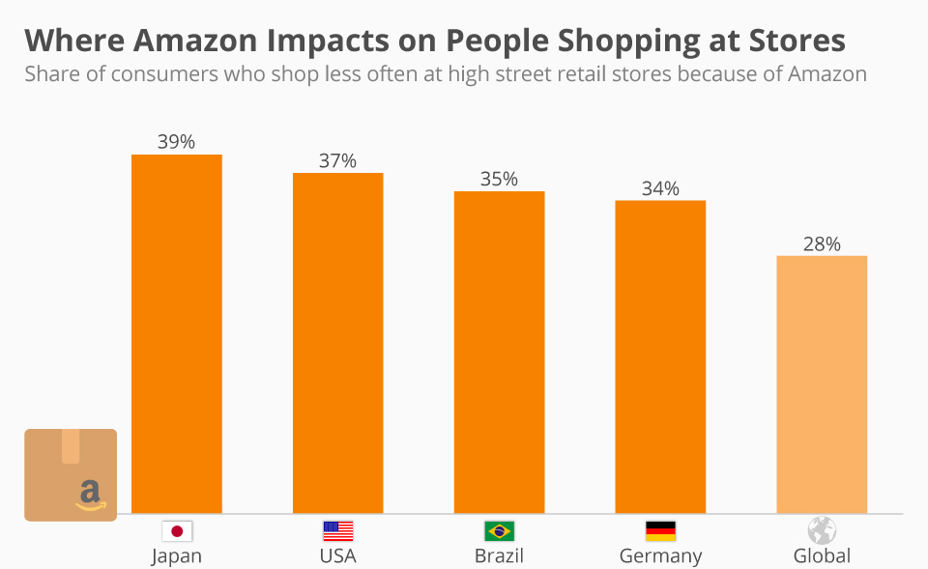
Figure: Wider Organisational Implications
Source: (Grewal et al., 2025)
The graph reflects that Amazon has already impacted the consumer shopping habits of various countries significantly. The highest impact is in Japan with 39% of consumers reporting a decrease in their shopping frequency in physical stores, followed by the USA (37%), Brazil (35%) and Germany (34%). Worldwide, 28% of consumers have decreased their visits to conventional retail stores due to Amazon. The results demonstrate the influence of Amazon on retail markets and remind companies to invest in digitalisation, optimisation of processes and innovative solutions for customers.

Leadership Implications
Continued Results would rely on effective leadership commitment and direction. Senior leaders would have to champion a customer-focused vision and help with digital transformation efforts throughout the company (Slater, 2022). Leadership teams would also be responsible for the allocation of resources, directing the process of organisational change, and advancing cross-functional working.

Organisational Culture Implications
Through the new plan, Amazon will further emphasize customer-centered culture, ultimately establishing a proactive customer service. The employees would be expected to use predictive features to anticipate customer needs and make the necessary adjustments before the customers even express discontent (Mason, 2018). This change can create a culture of being innovative, responsive and constantly improving. Initially, however, workers may be reluctant to accept new approaches to working practices.

Technology and Innovation Implications
To implement this, more investments need to be made in artificial intelligence, machine learning, predictive analytics, data integration systems, etc. Such innovations would bolster Amazon's ability to reinvent itself and improve efficiency and customer service (Kotter et al., 2021). The enhanced analytics potential also could help support future strategic initiatives in other business functions. Moreover, ongoing innovation is required to sustain an accurate system and to continue to gain a competitive edge.

Ethical and CSR Implications
Using predictive customer service systems comes with several ethical issues. Amazon would also need to create a responsible use of its customers' data, as well as be transparent about how data is collected and analysed. If the data privacy protection measures are not of good strength, then it would not be possible to ensure the customers' trust and compliance with the regulations. On a CSR (Corporate Social Responsibility) front, the organisation would also have to ensure the fair operation of artificial intelligence systems, along with avoiding discriminatory outcomes.

Financial and Operational Implications
Embarking on such a plan would demand a substantial upfront commitment in terms of technology infrastructure, software creation, training staff and integration of the systems. These costs could result in a rise in operating expenses in the interim (Kern, 2018). Long term, however, the returns to the company may be through greater customer retention, higher LTV of customers, lower cost of dealing with customer complaints and higher operational efficiency. Predictive service capabilities can also help to reduce service disruptions and optimise resources.

Conclusions
This report sought to analyse Amazon's direction and its strategic approach with emphasis on Customer Care and how it can be improved using a strategic and agile approach. The analysis, however, left no doubt about the global competitive position of Amazon with regard to e-commerce and technology markets. It has very strong assets such as a strong, global brand, sophisticated technological competence, comprehensive logistics networks and innovation capability. Having these resources, Amazon can deliver customer value and a sustainable competitive advantage (Denning, 2019). The external analysis revealed several opportunities in relation to AI, the digital transformation, customer personalisation and changing consumer expectations. But the organisation is also grappling with several new pressures - including competition, regulatory issues, data privacy concerns, and shifting economic conditions. Additionally, after analysing their internal strengths and weaknesses, Amazon has shown to have dynamic resources that are hard to replicate and contribute to their long-term strategic values. Amazon's strategic agility was assessed through its culture of customer service, collaboration across all its departments, innovation in its approach and decision-making processes based on data. Such capabilities lay a solid pathway for future strategic development and customer care improvement (De Smet et al., 2018). The three strategic scenarios evaluated through the SAF framework were the use of Artificial Intelligence (AI) for hyper-personalisation, an omnichannel approach for the optimisation of the Customer Experience (CE) and a predictive system for Customer Service (CS). All three appeared to have strategic benefits, but the predictive customer service proved to be the best viable solution. The strategy achieved the highest balance of suitability, acceptability and feasibility in direct relation to Amazon's customer-centric philosophy.

Recommendations
Several recommendations are suggested, which are formed on the basis of the findings of this report, to enhance Amazon's capacity related to customer care and to support the long-term strategic success.
Recommendation 1: Implement AI-Driven Predictive Customer Care
Amazon needs to focus on implementing a predictive customer service system for its all-around operations. AI can be leveraged to foresee your customers' problems beforehand. Drivers of proactivity in problem resolution include better customer satisfaction rate, lower number of complaints and customer loyalty (Ahlbäck et al., 2017). This is very similar to what Amazon are trying to achieve with their Customer First and Strategic Verbal Polite.
Recommendation 2: Strengthen Omnichannel Integration
Amazon should also enhance their customer support channels to make its support experience seamless across its website, mobile apps, voice-activated apps, social media, and support channels. Better coordination of channels would make services better for customers and service more uniform (Lynch, 2018).
Recommendation 3: Develop Customer Analytics Capability
The watchword for future investments in advanced customer analytics is a better understanding of customer behaviour and preferences. The improvements in analytical capability could benefit demand forecasting, delivery of personalised services, and strategic decision-making (Whittington et al., 2020). Better data use would also give Amazon the advantage of better predicting the evolution of customer expectations and market trends.
Recommendation 4: Establish Customer Experience Performance Metrics
Amazon needs to create a customer experience measurement tool that extends across the customer experience. Some metrics to track include customer satisfaction ratings, customer retention rates, response times, complaint resolution rates, and customer lifetime value. Continuous surveillance of these measurements will allow the management to assess the performance of the services, determine the areas that can be improved, and ensure that the services meet the needs and goals of the organisation.

References
Ahlbäck, K., Fahrbach, C., Murarka, M. and Salo, O. (2017) How to Create an Agile Organisation. McKinsey & Company.
Amiri, S., & Vida, V. (2023). Analysis of marketing strategic issues at Amazon. SEA: Practical Application of Science, 11(31).
Arbussa, A., Bikfalvi, A., & Marquès, P. (2017). Strategic agility-driven business model renewal: the case of an SME. Management Decision, 55(2), 271-293.
Clauss, T., Abebe, M., Tangpong, C., & Hock, M. (2019). Strategic agility, business model innovation, and firm performance: an empirical investigation. IEEE transactions on engineering management, 68(3), 767-784.
Coltman, T., Devinney, T. M., & Midgley, D. F. (2011). Customer relationship management and firm performance. Journal of Information Technology, 26(3), 205-219.
Das, S., & Hassan, H. K. (2022). Impact of sustainable supply chain management and customer relationship management on organisational performance. International Journal of Productivity and Performance Management, 71(6), 2140-2160.
De Smet, A., Lurie, M. and St. George, A. (2018) Leading Agile Transformation: The New Capabilities Leaders Need to Build 21st-Century Organisations. McKinsey & Company.
Denning, S. (2019). How Amazon Became Agile. Forbes.
Doz, Y. L., & Kosonen, M. (2010). Embedding strategic agility: A leadership agenda for accelerating business model renewal. Long-range planning, 43(2-3), 370-382.
Du Plessis, L., & De Vries, M. (2016). Towards a holistic customer experience management framework for enterprises. South African Journal of Industrial Engineering, 27(3), 23-36.
Foltean, F. S., Trif, S. M., & Tuleu, D. L. (2019). Customer relationship management capabilities and social media technology use: Consequences on firm performance. Journal of business research, 104, 563-575.
Grewal, H., Dhillon, G., Buddhavarapu, V., Verma, R. K., Munjal, R. S., Sharma, P., ... & Surani, S. (2025). Strategic insights of telehealth platforms and strengths, weaknesses, opportunities, and threats analysis of Amazon's clinical endeavors. World Journal of Methodology, 15(2), 98513.
Haislip, J. Z., & Richardson, V. J. (2017). The effect of Customer Relationship Management systems on firm performance. International Journal of Accounting Information Systems, 27, 16-29.
Hansen, T. L. (2025). Amazon Strategic Audit.
Homburg, C., Jozić, D., & Kuehnl, C. (2017). Customer experience management: toward implementing an evolving marketing concept. Journal of the Academy of Marketing Science, 45(3), 377-401.
Hwang, J., & Seo, S. (2016). A critical review of research on customer experience management: Theoretical, methodological and cultural perspectives. International Journal of Contemporary Hospitality Management, 28(10), 2218-2246.
Kandampully, J., Zhang, T., & Jaakkola, E. (2018). Customer experience management in hospitality: A literature synthesis, new understanding and research agenda. International Journal of Contemporary Hospitality Management, 30(1), 21-56.
Kern, J. (2018) Agile in the Context of a Holistic Approach. InfoQ.
Khan, S. H., Majid, A., & Yasir, M. (2021). Strategic renewal of SMEs: the impact of social capital, strategic agility and absorptive capacity. Management Decision, 59(8), 1877-1894.
Kotter, J.P., Akhtar, V. and Gupta, G. (2021) Is Your Organisation Surviving Change—or Thriving in It? Harvard Business Review.
Lemon, K. N., & Verhoef, P. C. (2016). Understanding customer experience throughout the customer journey. Journal of Marketing, 80(6), 69-96.
Lynch, R. (2018) Strategic Management. 8th edn. Harlow: Pearson.
Mason, L. (2018) Amazon Culture: Staying Agile. YouTube.
Mihardjo, L. W., Sasmoko, , & Rukmana, R. A. (2019). Customer experience and organisational agility-driven business model innovation to shape sustainable development. Polish Journal of Management Studies, 20(1), 293-304.
Mueller‐Saegebrecht, S., & Walter, A. T. (2025). Strategic agility—an urgent capability for successful business model innovation? A conceptual process model and theoretical framework. Strategic Change, 34(3), 407-428.
Nurjaman, R., & Dwipriyoko, E. (2021, March). Strategic agility on SME: A case study of the small doll industry in Bandung. In 1st Paris Van Java International Seminar on Health, Economics, Social Science and Humanities (PVJ-ISHESSH 2020) (pp. 392-395). Atlantis Press.
Shamout, M. D., Alzoubi, H. M., Elrehail, H., Itani, R., Al-Gasaymeh, A., & Farouk, M. (2024, February). Streamlining E-Commerce and Last-Mile Delivery for Enhanced Customer Satisfaction: An In-Depth Analysis of Amazon's Strategies. In 2024 2nd International Conference on Cyber Resilience (ICCR) (pp. 1-8). IEEE.
Shams, R., Vrontis, D., Belyaeva, Z., Ferraris, A., & Czinkota, M. R. (2021). Strategic agility in international business: A conceptual framework for “agile” multinationals. Journal of International Management, 27(1), 100737.
Slater, D. (2022). Leading and Innovating with Leadership Principles. Amazon Web Services Executive Insights.
Tenggono, E., Soetjipto, B. W., & Sudhartio, L. (2025). Navigating institutional pressure: Role of dynamic managerial capabilities and strategic agility in healthcare organisations’ renewal. International Journal of Healthcare Management, 18(3), 502-511.
Tuncalp, D. (2026). Amazon Corporation: Controlling for Success.
Ullah, I., & Narain, R. (2020). The impact of customer relationship management and organisational culture on mass customisation capability and firm performance. International Journal of Customer Relationship Marketing and Management (IJCRMM), 11(3), 60-81.
Verhoef, P. C., Kannan, P. K., & Inman, J. J. (2015). From multi-channel retailing to omni-channel retailing: introduction to the special issue on multi-channel retailing. Journal of Retailing, 91(2), 174-181.
Wade, M., Joshi, A. and Teracino, E.A. (2021) 6 Principles to Build Your Company's Strategic Agility. Harvard Business Review.
Whittington, R., Regnér, P., Angwin, D., Johnson, G. and Scholes, K. (2020) Exploring Strategy: Text and Cases. 12th edn. Harlow: Pearson.

