REPORT: COMMUNICATION WITHIN THE WORKPLACE

How Well Do Employers Perform at Communication - Discuss?

- Table of Contents
- Terms of Reference
- Summary
- Introduction
- Methods
- Discussion / Assessment
- Recommendations
- Conclusion
- References
- Appendices

Joanne Jarrett (1711041)

Effective Team Working and Communication (ETW) BMSK4002

Richard Smalls

Submission Date: 2nd April 2018

Table of Contents 2

Terms of Reference 3

Summary 4

Introduction 5

Methods 6

Discussion 7, 8, 9 & 10

Conclusion 11

List of References 12

Appendices 12

Terms of Reference
I am submitting this Inductive Report, as part of Course BMSK4002 (ETW) Effective Team Working and Communications for ‘Certificate of Higher Education in Skills for the Workplace’, to be read by Lecturer Richard Smalls, University of Wales Trinity Saint David.

Summary
How effective are employers in communicating with their employees and how can we actually define ‘good communication in the workplace…?’
It is evident that good employer communication skills have never been more important, in terms of creating and maintaining a contented workforce - ultimately producing successful outcomes.
Employers who adopt the new more innovative verbal and non-verbal forms of communication, for example, the more ‘emotionally intelligent’ methods, will encourage successful interactions with their employees.

Introduction
This inductive report is based upon the real-life experiences of a former colleague, who has worked for several years, as a Legal Secretary at an inner city firm of solicitors.

Scenario
The subject works for a large firm of solicitors.
There are 35 fee earners and 15 personal, legal and administrative secretaries to cover the majority of the secretarial work.
Current Workplace Concerns
- Rumours are circulating about possible redundancies
- Growing conflict among staff
- Decreased motivation
- Rise in sickness rate
- Fall in quality of output

Main Issues Around How Managers Communicate With Staff
- Managers all communicate in different ways
- No reciprocal communication with employees
- No resolutions to communications issues – when highlighted
- Managers fail to engender the trust of employees
The report will explore the ease with which employers are able, or are not able to communicate effectively with their employees within the workplace.
The aims and objectives are to examine, consider and weigh up whether employers perform well when communicating with their employees – and if they do, how well do they do this…? Recommendations to improve employer/employee communications are also given, should this be necessary.
In general, most people would imagine that employers are not great at communicating with their employees and this assertion might normally be based on their own personal experience; the personal experience of someone close to them, or even an anecdotal story.

Problem
During my investigation, I systematically evaluated this perception of communication from employer toward employees and provide some well-debated results based on my findings.

Methods
The query methods I have commenced comprise information obtained via peer-reviewed articles, documents, papers reports and also background reading of relevant literature. Information from radio, television and online broadcasts - not all of which are to be found within this report.
This report is centered on a realistic case study.

Discussion
The central argument for the development of this report – ‘How Well Do Employers Communicate with Employees In The Workplace…?’ assumes that employers know how to extract the best out of their workforce by interacting and communicating with them well.
Communicating well, rests on having the required skills, which in turn encourage an easy mutual working relationship.
Successful communication between two people for example, involves a certain amount of conscious behavior.
- Our body language (non-verbal)
- Voice tone (para-linguistic cues)
- Channels used (e.g. email / face-to-face)
Irrespective of the means by which we choose to convey our message, there is no guarantee that our message will be received in the way in which it was intended.
“Components of Effective Communication
Communication skills such as active listening and assertiveness, help make information processing more transparent. Actively trying to understand and interpret the verbal messages of others takes work. Simply asking another person to provide the evidence that led to certain conclusions can be very enlightening” Griffiths, B. A. and Dunham, E. B. (2017 p.45) A. Maund, M. Schriek and P. Tinkler, (2017)

Created in 1948 ‘The Shannon Weaver Model of Communication’ (see below). demonstrates the progression of a message from sender to receiver.

RECEIVEER
CHANNEL
ENCODER
SENDER
DECODER

NOISE

According to Shannon and Weaver, (3) things exist, which prove problematic to good communication.
The first is ‘technical problems’. The second is ‘semantic problems’ – that is, when messages are sent and received, that are very different and thirdly, ‘effectiveness problems’. In other words, how well does the message elicit a response?
New, more suitable ways of communicating can be implemented with a style chosen, to match that of the employees, who will, in all probability be one of the (4) below types of communicator.
- Analytical Communicator
- Personal Communicator
- Intuitive Communicator
- Functional Communicator

“Learning The Art of Persuasion”
Persuasion is acquiring many varied qualities.
You need to be self-assured (not overconfident and impetuous), motivated and self-possessed (and not appear an awkward fool), and be likeable and charming (and not come across like someone untrustworthy).
People want to hear balanced, honest, and reliable communications from truthful, genuine, and honourable people. If you are involved with people who see the logical approach is the best one to give.
“However, convincing people through logic isn’t the easiest thing and will require you to do a lot of research to be thoroughly prepared to present your case. Also, emotional people – those hyper individuals who are all over the place when you talk to them – can calm down and focus on your message if you are calm and can support your discussion with credible and logical evidence. Here are three key ingredients in presenting a persuasive message: Know your facts - Be able to document any claims you make with factual data and information as proof. You've researched the evidence, so tell others what it says. But, don’t come off as a “know-it-all.” Know your audience - What kinds of people are they? What is their current opinion on the issue or topic? How did they form their opinion? Where do they get their information? What are their own needs and interests? What arguments are most likely to persuade them? Know how to fit the facts to your audience – Once you have your claims backed up by proof, and you know the interests and motivations of your listeners, carefully match what you have to say to what they want and need to hear. How do you get to Carnegie Hall? Practice! The more you use rational persuasion principles the more influential you will become. “Managers Must Talk to Their Employees”
(Conrad, D. 2014)

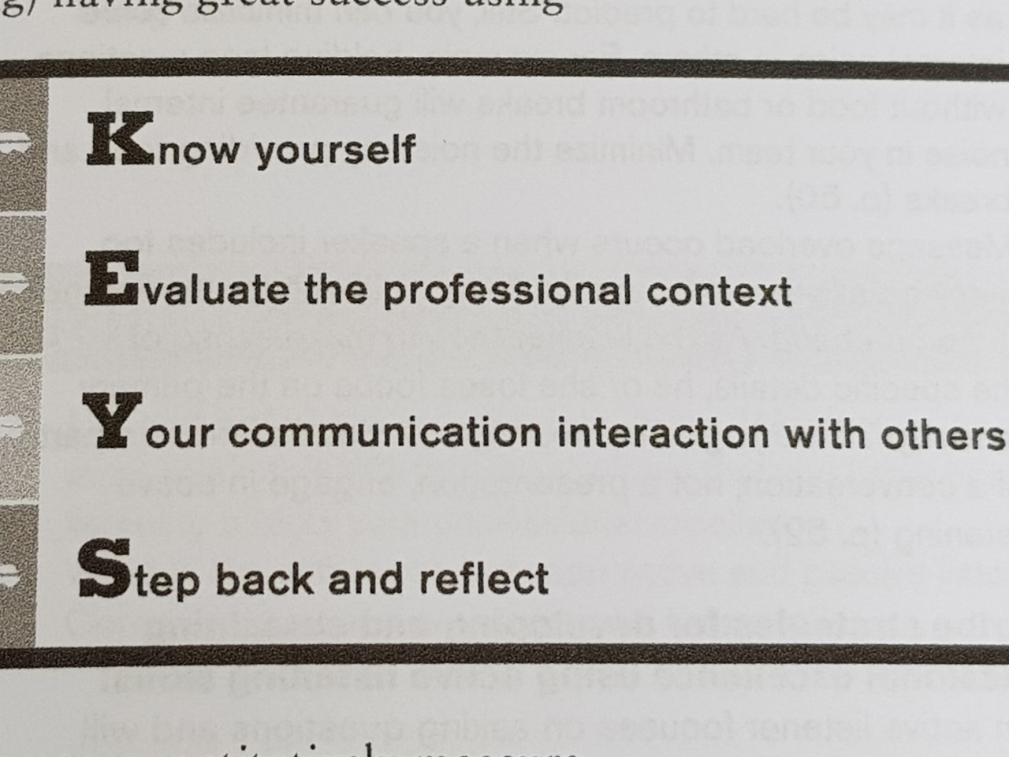
Fig. 1. (Excellence in verbal and non-verbal communications).
(Verbal and Non-Verbal Communication. Cert in Higher Education: Skills for the Workplace, 2017. P83, A. Maund, M. Schriek and P. Tinkle

Conclusion
And finally, the employer/employee relationship is one that needs to function in an harmonious manner, with employers having the skills to enable free-flowing communication between themselves and their employees – keeping workplace conflicts kept to a minimum.
Effective communication, can be improved firstly, by employers showing consideration in their choice of communication; the method and timing that is used and personalizing the message to particular employees.
A one-size-fits-all approach should not be adopted.

List of References

Conrad, D. (2014). ‘Workplace Communication Problems: Inquiries by Employees and Applicable Solutions’. Journal of Business Studies Quarterly. Vol. 5, No. 4 [Online] Available at: http://jbsq.org/wp-content/uploads/2014/06/June_2014_8.pdf (Accessed 02 May 2018)
Cottrell, S. (2013) Palgrave Study Skills, The Study Skills Handbook 4th edn. London: Palgrave Macmillan
Griffiths, B. A. and Dunham, E. B., A. Maund, M. Schriek and P. Tinkler, (2017) Cert in Higher Education: Skills for the Workplace Student Yearbook. Communication. London: Sage Publishing. P45)
(Verbal and Non-Verbal Communication. Cert in Higher Education: Skills for the Workplace, 2017. P83, A. Maund, M. Schriek and P. Tinkler)
Morgan, P. (2016) The Business Student’s Guide to Study and Employability. London: Sage Publications

Background Reading

Newspapers, relevant books, articles, etc…

