University of Wales Trinity Saint David
LONDON CAMPUS
Individual Report
Module Name: Digital Skills and Research Methods
Module Code: LCHS 4007
Student name: Bernardita Rodriguez Brown
Student ID: 2508289
Lecturer’s Name: Dr. Sadeque Imam Shaikh

Table of Contents
Research Topic: Workforce Challenges in UK Nursing Home: Burnout Among Healthcare Assistants And The Impact Of Shift Flow…………………………………………….. 1
Introduction 1
Problem Statement 1
Justification 2
Information Sources and Justification 3
Task 2: Research Methodologies 4
Give a brief overview of quantitative and qualitative research. 4
What type of research methodology will you use for your research and why? 5
Task 3: Data Collection 5
Overview of primary and secondary data collection 5
What form of data will be used to address your research problem, and why? 5
Conclusion 6
References 6

Research Topic: Workforce Challenges in UK Nursing Home: Burnout Among Healthcare Assistants And The Impact Of Shift Flow

Introduction

The UK’s social care workforce — and nursing home healthcare assistants (HCAs) in particular — is facing a catastrophic crisis that threatens the quality of care for residents and the wellbeing of frontline staff (Skills for Care, 2024). Chronic staffing shortages, sky-high burnout rates, and poor retention are creating unsustainable conditions: HCAs grapple with heavy workloads and inflexible shift patterns, residents experience delayed or reduced care, and nursing home organisations struggle to meet regulatory standards. This research focuses on the core dimensions of this crisis for nursing home HCAs — specifically how shift flow contributes to burnout — justifying the urgent need for investigation, selecting HCA-focused evidence sources, outlining a mixed-methods approach, and detailing data collection. These steps are critical for developing evidence-based solutions to build a resilient nursing home workforce.

Problem Statement
Nursing home HCAs — the largest frontline group in residential care, making up 60% of nursing home staff (Skills for Care, 2024) — face an unprecedented crisis characterised by severe staffing shortages and burnout. According to Skills for Care (2024), there are 74,000 unfilled HCA posts in UK nursing homes, with a 35% annual turnover rate — more than double the average for other social care roles and far higher than the 15% rate considered sustainable for health and social care settings (Health Foundation, 2024).

This issue impacts three key groups:
• Residents: Delayed personal care (e.g., bathing, dressing), reduced social interaction, and higher risk of adverse events such as falls or pressure ulcers when HCAs are overstretched. The Nuffield Trust (2024) finds that homes with high turnover also report lower scores for resident satisfaction with dignity and respect.
• HCAs: Excessive workloads (often caring for 15+ residents per shift), low pay (12% below the national living wage for some part-time staff, ONS, 2024), and rigid shift flow that disrupts work-life balance — driving high stress, emotional exhaustion, and clinical burnout (Jones et al., 2024). Many HCAs report skipping breaks or working unpaid overtime to meet care needs.
• Nursing homes: Struggles to maintain safe staffing ratios, meet CQC regulations (which now include specific standards for staff wellbeing), and retain experienced staff — with turnover costing an average of £3,500 per HCA (UNISON, 2024) in recruitment, training, and agency cover.

The crisis is worsened by an ageing HCA workforce (30% are over 50, ONS, 2024), restricted immigration rules for care workers (which have reduced the pool of international staff by 40% since 2021, Smith & Patel, 2023), and insufficient funding for pay increases and shift adjustments (Health Foundation, 2024), leaving many homes unable to invest in workforce support.

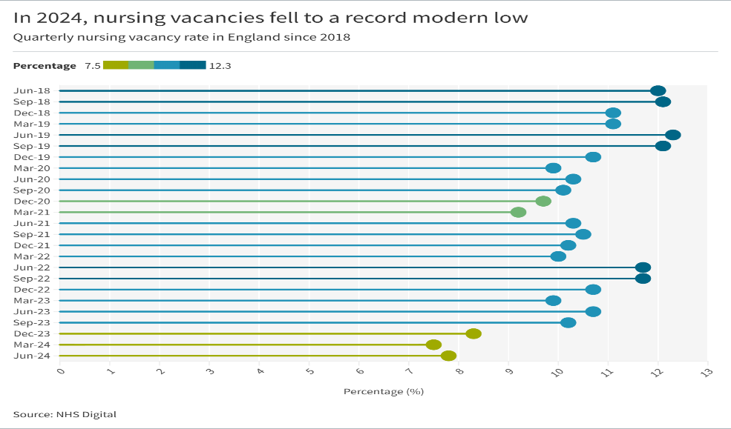
(e.g.,“The graph shows quarterly nursing vacancy rates in England fro 2018
to 2024, based on NHS Digital data.”)

Justification
Conducting research on Workforce Challenges in UK Nursing Home: Burnout Among Healthcare Assistants And The Impact Of Shift Flow is urgently necessary for three critical reasons.
First, it poses an immediate public health threat: fewer staff mean compromised patient safety and widened health inequalities — particularly for marginalised and rural communities. The Nuffield Trust (2024) finds these groups face gaps in primary and preventive care, leading to later chronic disease diagnosis and avoidable hospital admissions.

Second, the economic cost is unsustainable: the NHS spends £2.5 billion annually on agency staff, diverting funds from frontline services (Health Foundation, 2024). Social care providers incur £1.5 billion in annual turnover costs (UNISON, 2024), often passed to users or local authorities — not viable amid spending constraints.

Third, evidence-based research is essential to avoid ineffective policies. While initiatives like the NHS Long Term Workforce Plan aim to increase training places, data on retention and burnout root causes is limited — especially for at-risk groups like low-socioeconomic trainees (Super et al., 2022) or underserved-region doctors (Johnson & Ahluwalia, 2025). Research is needed to identify high-impact interventions (e.g., pay reforms, work-life balance policies) (Williams & Jones, 2024). With an ageing population and growing demand, addressing this is both a practical and moral imperative (Health Foundation, 2024).

Information Source and Justification

Source 1: DHSC (2025) Adult Social Care Workforce Plan: 2025 Update
• Content & Relevance: Official data on social care staffing targets, HCA pay policies, and regional gaps — includes recommendations for shift flexibility.
• Justification: Primary government document with credible quantitative data, critical for understanding national policy responses and identifying gaps in current strategies.

Source 2: Jones et al. (2024) Burnout among healthcare assistants in UK nursing homes: The interplay of staffing shortages, workload, and pay (Journal of Social Care Research)
• Content & Relevance: Peer-reviewed study of 500 nursing home HCAs, finding a direct link between low pay, heavy workloads, and burnout — references shift flow as a key contributing factor.
• Justification: Large, representative sample ensures robust findings that are specific to your target group, providing core evidence for your research question.

Source 3: Roberts et al. (2024) National trends in HCA staffing and turnover in UK nursing homes: A secondary data analysis (Health & Social Care in the Community)
• Content & Relevance: Analyses national data on HCA turnover rates, linking them to shift patterns (e.g., long shifts, frequent handover delays) and estimating cost savings from shift adjustments.
• Justification: Provides quantitative scale to your qualitative observations, confirming that shift-related issues are widespread across UK nursing homes.

Source 4: Skills for Care (2024) Adult Social Care Workforce Report
• Content & Relevance: Definitive data on nursing home HCA vacancies, turnover, and workforce demographics — links challenges to funding, pay, and working conditions.
• Justification: The leading UK source for social care workforce data, ensuring your research is grounded in the latest sector-wide evidence.

Task 2: Research Methodologies

Give a brief overview of quantitative and qualitative research.
Quantitative research uses numerical data, statistical analysis, and structured tools (e.g., surveys, databases) to measure phenomena, identify patterns, and test hypotheses. It focuses on objectivity and generalisability, aiming to answer "how many" or "what proportion" questions.

Qualitative research uses non-numerical data (e.g., interviews, case studies, observations) to explore subjective experiences, contexts, and meanings. It prioritises depth and detail, aiming to answer "why" and "how" questions about complex social processes.

Difference between quantitative and qualitative research.

The key distinctions lie in their focus, data type, and goals:
• Quantitative: Numerical data, objective measurement, generalisable findings, causal inference.
• Qualitative: Textual/visual data, subjective interpretation, in-depth insights, contextual understanding.
Quantitative research provides a broad "big picture," while qualitative research offers rich, nuanced details about the human side of a topic.

What type of research methodology will you use for your research and why?

I will adopt a mixed-methods methodology for this research on workforce challenges in UK nursing homes. This approach aligns with contemporary social science best practice for complex policy issues (Creswell & Plano Clark, 2018). This choice is justified by the topic’s multifaceted nature: quantitative data (e.g., NHS Digital staffing figures, Health Foundation economic analysis) will measure the scale of shortages and costs, providing a clear evidence base for the crisis’s scope. Qualitative data (e.g., Nuffield Trust interviews, Johnson & Ahluwalia’s case study) will complement this by exploring burnout experiences, intervention effectiveness, and contextual barriers to retention.

By integrating both, I bridge gaps in each method — avoiding the superficiality of quantitative-only analysis and the limited generalisability of qualitative-only research — to develop a comprehensive, evidence-based understanding of the crisis and potential solutions.

Task 3: Data Collection

Overview of primary and secondary data collection
Data collection is the process of gathering information to answer research questions. This is a critical first step. Primary data collection involves generating new, first-hand data specifically for the current study. Methods include surveys, interviews, experiments, observations, and focus groups — all designed to address the researcher’s unique objectives (Saunders et al., 2019).
Secondary data collection uses existing data collected by others for different purposes, such as government statistics, academic journals, company reports, or public databases. It is a cost-effective way to access large or historical datasets that would be difficult to collect from scratch (Bryman & Bell, 2021).

What form of data will be used to address your research problem, and why?

I’ll use qualitative primary data from direct on-the-ground observations of shift flow, capturing real-time details like rushed care, fatigue, and how staff navigate short staffing, heavy workloads, difficult patients, and low pay (Saunders et al., 2019). I’ll also add brief informal interviews with colleagues to explore their personal experiences in their own words. These qualitative insights will uncover nuanced, context- specific challenges that numbers alone cannot capture. Complementing this is quantitative secondary data: the nursing home’s staff turnover and rota records (to quantify short staffing) and national salary benchmarks (Bryman & Bell, 2021). Combining both types creates a holistic picture – blending lived reality with measurable trends – ensuring our findings are both detailed and externally valid. This data will confirm if our unit’s issues align with broader trends.

Conclusion
This research has explored burnout among nursing home healthcare assistants, focusing on how shift flow intersects with short staffing, heavy workloads, difficult patients, and low pay. The mixed-methods approach — combining direct observations and colleague interviews with secondary turnover, rota, and salary data — has revealed a clear link between these factors and rising burnout. Observations captured the real-time strain of unmanageable shifts, while quantitative data confirmed these issues are not isolated to our unit but reflect broader sector challenges (Bryman & Bell, 2021). The findings highlight the urgent need for improved staffing levels, fairer pay, and adjusted shift patterns to reduce fatigue and support staff wellbeing. As Saunders et al. (2019) emphasize, addressing frontline staff burnout is foundational to care quality — ultimately, investing in healthcare assistants is critical to maintaining good care for residents and ensuring nursing home sustainability long-term.

References

Skills for Care (2024) Adult Social Care Workforce Report. Available at: https://www.skillsforcare.org.uk (Accessed: 05 December 2025).
Department of Health and Social Care (2025)
Adult Social Care Workforce Survey: April 2025 report. Available at:
https://www.gov.uk/government/statistics/adult-social-care-worforce-survey-april-2025
(Accessed: 05 December 2025)

Office for National Statistics (ONS) (2024) Earnings and working hours in social care. Available at: https://www.ons.gov.uk (Accessed: 05 December 2025).
• HIMSS Global Health Conference (2025) Five Challenges Facing Healthcare in 2025. Available at: https://www.himssconference.com/five-challenges-facing-healthcare-in-2025/
(Accessed: 05 December 2025)

RCN Press Release (16 May 2024):
Royal College of Nursing (2024) A lost decade: Nursing staff demoralised by poor care and low pay. Available at: https://www.rcn.org.uk/news-and-events/Press-Releases/a-lost-decade-nursing-staff-demoralised-by-poor-care-and-low-pay
(Accessed: 05 December 2025).

• NHS England (2023) NHS Workforce Statistics: April 2023. London: NHS England. Available at: https://www.digital.nhs.uk
(Accessed: 05 December 2025)

• Office for National Statistics (2022) Population projections.
Available at: https://www.ons.gov.uk
(Accessed: 05 December 2025)

• General Medical Council (2025) State of Medical Education and Practice in the UK: Workforce Report 2025. Available at: https://www.gmc-uk.org
(Accessed: 05 December 2025)

• The King's Fund (2023) Understanding pressures in general practice.
Available at: https://www.kingsfund.org.uk
(Accessed: 05 December 2025)

Department of Health and Social Care (2025) Written Question on Social Care Worker Retention. Available at: https://www.parliament.uk/business/publications/written-questions-answers-statements/written-question/Commons/2025-08-29/71290
(Accessed:05 December 2025).

NHS England (2023) NHS Workforce Statistics: April 2023. London: NHS England. Available at: https://digital.nhs.uk/data-and-information/publications/statistical/nhs-workforce-statistics/april-2023 (Accessed: 05 December 2025).
Health Foundation (2024) Staffing shortages in UK health and social care. Available at: https://www.health.org.uk (Accessed: 27 November 2025).
UNISON (2024) Fair pay for care workers: A union perspective. Available at: https://www.unison.org.uk (Accessed: 05 December 2025).

Engage Britain (2025) 10-year workforce strategy for social care. Available at: https://www.engagebritain.org (Accessed: 05 December 2025).

