
BA (Hons) Leadership and Management Skills in the Workplace
INDEPENDENT PROJECT
MODULE CODE: LCLM6005

Evaluating the Role of Leadership in Estate Service Performance and Tenant Satisfaction: A Case Study of Sutton Housing Partnership

Portfolio Components:
Element 1: Independent Project/Dissertation
Element 2: Research Process Reflection
Element 3: Methodology Poster

Student: Dijana Sklancec
Student ID: 2314272
Supervisor: Muhammad Rahman
Submission Deadline: 18th August 2026- 2pm

ELEMENT 1
INDEPENDENT PROJECT / DISSERTATION

Evaluating the Role of Leadership in Estate Service Performance and Tenant Satisfaction:
A Case Study of Sutton Housing Partnership

Acknowledgements
I would like to express my sincere gratitude to my dissertation supervisor, Mr Mohammad Rahman, for his guidance, support and constructive feedback throughout the development of this research.
I would also like to thank Sutton Housing Partnership for granting permission to conduct this study and for supporting the data-collection process. I am particularly grateful to all Estate Services employees who took the time to complete the questionnaire and to the managers who participated in the interviews and generously shared their professional experiences and perspectives. Their contributions were invaluable to this research.
I would also like to acknowledge my colleagues for their support and encouragement throughout the research process.
Finally, my deepest thanks go to my family, especially my daughters, Katarina and Irina, for their patience, understanding and constant encouragement throughout my university journey. Balancing work, study, and family life has required considerable commitment, and their support has been a constant source of motivation. This achievement would not have been possible without them.
Thank you to everyone who contributed, directly or indirectly, to the completion of this research.

Abstract
Leadership is an important organisational factor influencing employee behaviour, service delivery, and performance; however, its relationship with tenant satisfaction within UK social housing remains under-researched. This study evaluated the role of leadership in Estate Service Performance (ESP) and Tenant Satisfaction (TS) within Sutton Housing Partnership (SHP), focusing specifically on Estate Services.
An explanatory sequential mixed-methods case-study design was adopted within a pragmatist philosophy. Quantitative data were collected through an anonymous questionnaire distributed to all forty-eight eligible Estate Services employees. Thirty-one questionnaires were returned, of which thirty were valid for analysis. Descriptive statistics and Pearson's Product-Moment Correlation were used to examine five leadership styles and the relationships between Effective Leadership, ESP, and employees' perceptions of TS. Four semi-structured manager interviews were subsequently analysed thematically to explain and contextualise the quantitative findings. SHP Key Performance Indicator (KPI) and Tenant Satisfaction Measure (TSM) data provided complementary organisational evidence.
The findings indicated high levels of transactional, transformational, servant and participative leadership, while laissez-faire leadership was rated very low. Effective Leadership demonstrated a statistically significant moderate positive association with ESP (r = .497, p = .005), supporting H₁. Its association with perceived TS was positive but not statistically significant (r = .343, p = .063); therefore, H₂ was not supported. ESP demonstrated a statistically significant strong positive association with perceived TS (r = .756, p < .001), providing the strongest relationship and supporting H₃. Qualitative findings indicated that effective leadership was adaptive and multidimensional, while staffing, workload, resources, and cross-service dependencies also influenced performance.
The study concludes that leadership is significantly associated with frontline service performance, while ESP is more strongly associated with perceived tenant satisfaction. Leadership should therefore be understood as one influential organisational resource within a wider service system rather than as an independent determinant of tenant outcomes. The findings support adaptive leadership, adequate frontline resources, employee participation, and performance-informed continuous improvement within Estate Services.
Table of Contents
CHAPTER 1: INTRODUCTION 1
1.1 Introduction 1
1.2 Background and Organisational Context 1
1.3 Research Problem and Rationale 2
1.4 Research Aim and Objectives 2
1.5 Research Questions and Hypotheses 3
1.6 Overview of Research Methodology 3
1.7 Significance and Scope of the Study 4
1.8 Dissertation Structure 4
1.9 Chapter Summary 5
CHAPTER 2: LITERATURE REVIEW 6
2.1 Introduction 6
2.2 Leadership Styles and Estate Service Performance 6
2.3 Leadership, Estate Service Performance and Tenant Satisfaction 9
2.4 Theoretical Foundation 11
2.4.1 Job Demands–Resources Theory (JD-R) 12
2.4.2 Social Exchange Theory (SET) 12
2.5 Chapter Summary 17
CHAPTER 3: RESEARCH METHODOLOGY 18
3.1 Introduction 18
3.2 Research Design 18
3.3 Population, Sampling and Data Collection 20
3.4 Data Analysis 22
3.5 Research Quality and Methodological Rigour 23
3.6 Ethical Considerations 24
3.7 Chapter Summary 25
CHAPTER 4: RESULTS, ANALYSIS AND DISCUSSION 26
4.1 Introduction 26
4.2 Survey Response Profile 26
4.3 Data Preparation and Composite-Score Construction 27
4.4 Descriptive Statistics 28
4.5 Research Question One: Leadership Styles Practised within Estate Services 30
4.6 Research Question Two: Effective Leadership and Estate Service Performance 32
4.7 Research Question Three: Effective Leadership and Tenant Satisfaction 35
4.8 Research Question Four: Estate Service Performance and Tenant Satisfaction 37
4.9 Cross-Interview Thematic Analysis 38
4.10 Integrated Discussion 40
4.11 Summary of Hypothesis Testing 42
4.12 Chapter Summary 42
CHAPTER 5: CONCLUSIONS AND RECOMMENDATIONS 44
5.1 Introduction 44
5.2 Conclusions in Relation to the Research Questions 44
5.3 Contribution and Practical Implications 45
5.4 Limitations and Future Research 47
5.5 Final Conclusion 47
REFERENCES 49
Appendix 1: Participant Information Sheet 54
Appendix 2: Employee Questionnaire (Microsoft Forms) 59
Appendix 3: Manager Participant Consent Form 63
Appendix 4: Manager Interview Schedule 67
Appendix 5: UWTSD Ethical Approval 71
Appendix 6: SHP Annual Report to Residents 2024/25 87
Appendix 7: SHP KPI and TSM Report 2025/26 (Quarter 1–3) 99
Appendix 8: Organisational Permission/SHP Approval 101
Appendix 9: Anonymised Interview Transcript – Manager 1 (M1) 102
Appendix 10: Anonymised Interview Transcript – Manager 2 (M2) 113
Appendix 11: Anonymised Interview Transcript – Manager 3 (M3) 118
Appendix 12: Anonymised Interview Transcript – Manager 4 (M4) 123
Appendix 13: Qualitative Coding and Theme Development 132
Appendix 14: Anonymised Example of a Completed Employee Questionnaire 135
Appendix 15: Statistical Analysis Output 138

List of tables
Table 1. Comparison of Leadership Styles 6
Table 2. Summary of Key Studies Examining Leadership and Organisational Performance 10
Table 3. Comparison of the Theoretical Frameworks 13
Table 4. Literature Synthesis and Research Gap 15
Table 5. Research Design Framework 19
Table 6. Data Collection Summary 22
Table 7. Data Analysis Procedures 23
Table 8. Measures to Ensure Research Quality 24
Table 9. Survey Response Profile 27
Table 10. Interpretation of Mean Scores 29
Table 11. Descriptive Statistics 29
Table 12. Cross-Interview Evidence: Adaptive and Combined Leadership 32
Table 13. Pearson Correlation between Effective Leadership and ESP 33
Table 14. Pearson Correlation between Effective Leadership and Perceived TS 35
Table 15. Pearson Correlation between ESP and Perceived Tenant Satisfaction 37
Table 16. Final Cross-Interview Themes 39
Table 17. Summary of Hypothesis Testing 42
Table 18. Recommendations Arising from the Study 46

List of Figures
Figure 1. Conceptual Framework 11
Figure 2. Integrated Theoretical Framework 13
Figure 3. Literature Gap Addressed by the Present Study 16
Figure 4. Research Methodology Framework for the Present Study 20
Figure 5. Quantitative Data Analysis Process 28
Figure 6. Mean Scores for Leadership Styles within Estate Services 31

List of Abbreviations
Abbreviation | Meaning
ALMO | Arms-Length Management Organisation
ESP | Estate Service Performance
JD-R | Job Demands–Resources
KPI | Key Performance Indicator
SET | Social Exchange Theory
SHP | Sutton Housing Partnership
TS | Tenant Satisfaction
TSM | Tenant Satisfaction Measure

CHAPTER 1: INTRODUCTION

Introduction
Leadership is an important organisational factor because it can influence employee motivation, service delivery and organisational performance (Yukl and Gardner, 2020; Northouse, 2025). Its importance is particularly evident within UK social housing, where landlords are expected to demonstrate accountability, effective neighbourhood management, and positive resident outcomes. The Social Housing (Regulation) Act 2023 strengthened the regulatory framework for social housing, while Tenant Satisfaction Measures (TSMs) have increased the emphasis on service quality, transparency, and tenant experience (Social Housing (Regulation) Act 2023; Regulator of Social Housing, 2023).
This study evaluates the role of leadership in Estate Service Performance (ESP) and Tenant Satisfaction (TS) within Sutton Housing Partnership (SHP). Focusing specifically on Estate Services, it examines transformational, transactional, servant, participative and laissez-faire leadership. An explanatory sequential mixed-methods case study integrates employee questionnaire data, manager interview data and organisational performance evidence.

Background and Organisational Context
Sutton Housing Partnership manages housing services on behalf of the London Borough of Sutton (Sutton Housing Partnership, 2026c). Estate Services contribute directly to frontline service delivery through communal cleaning, environmental maintenance, estate inspections, neighbourhood standards and the identification and reporting of operational issues.
These activities shape residents' everyday experiences of their neighbourhoods and contribute to organisational performance. Leadership may influence service delivery by establishing expectations, supporting employees, monitoring standards, and encouraging effective performance. However, outcomes are also affected by staffing, workload, training, equipment, budgets, and organisational policies. This is consistent with Job Demands–Resources (JD-R) Theory, which recognises that employee performance reflects the interaction between organisational resources and workplace demands (Bakker, Demerouti and Sanz-Vergel, 2023).
The regulatory context increases the significance of these relationships. TSMs provide standardised measures of tenant experience and landlord performance, including aspects of neighbourhood management, responsiveness, and service quality (Regulator of Social Housing, 2023). Examining how leadership relates to frontline performance and tenant satisfaction is therefore both academically and organisationally relevant.

Research Problem and Rationale
Leadership research demonstrates relationships with employee engagement, motivation and organisational performance (Yukl and Gardner, 2020; Northouse, 2025; Iddrisu and Mohammed, 2025). However, comparatively limited research examines these relationships within UK social housing, particularly Arms-Length Management Organisations (ALMOs).
Furthermore, leadership, organisational performance and customer or service-user satisfaction are frequently examined separately, limiting understanding of how they may interact within frontline service environments. Organisational studies also commonly rely on employee questionnaires, creating potential common-method bias where predictor and outcome variables are reported by the same respondents (Podsakoff et al., 2003; Jordan and Troth, 2020).
This study addresses these contextual and methodological gaps within SHP Estate Services by combining employee perceptions with managerial explanations and published organisational evidence. It evaluates leadership as an important organisational factor while recognising that ESP and TS are also influenced by wider operational conditions.

Research Aim and Objectives
The aim of this study is:
To evaluate the role of leadership in Estate Service Performance and Tenant Satisfaction within Sutton Housing Partnership.
The research objectives are:
- To identify the leadership styles practised within SHP Estate Services.
- To examine the association between Effective Leadership and Estate Service Performance.
- To examine the association between Effective Leadership and employees' perceptions of Tenant Satisfaction.
- To examine the association between Estate Service Performance and employees' perceptions of Tenant Satisfaction.
These objectives correspond directly with the research questions and quantitative relationships examined in the study.

Research Questions and Hypotheses
The study addresses four research questions:
RQ1: What leadership styles are practised within Sutton Housing Partnership Estate Services?
RQ2: How is Effective Leadership associated with Estate Service Performance within Sutton Housing Partnership?
RQ3: How is Effective Leadership associated with employees' perceptions of Tenant Satisfaction within Sutton Housing Partnership?
RQ4: How is Estate Service Performance associated with employees' perceptions of Tenant Satisfaction within Sutton Housing Partnership?
The quantitative component tests three hypotheses:
H₁: Effective Leadership is positively associated with Estate Service Performance.
H₂: Effective Leadership is positively associated with employees' perceptions of Tenant Satisfaction.
H₃: Estate Service Performance is positively associated with employees' perceptions of Tenant Satisfaction.
The hypotheses examine associations rather than causal effects because the study uses a cross-sectional design (Saunders, Lewis and Thornhill, 2023).

Overview of Research Methodology
The study adopts a pragmatist philosophy and primarily deductive approach within an explanatory sequential mixed-methods case study (Creswell and Creswell, 2023). All 48 eligible Estate Services employees were invited to complete an anonymous Microsoft Forms questionnaire. Thirty-one questionnaires were returned; one was excluded because informed consent had not been provided, leaving 30 valid responses. Quantitative data were analysed in Microsoft Excel using descriptive statistics and Pearson's Product-Moment Correlation.
The qualitative phase comprised four purposively selected Estate Services manager interviews designed to explain and contextualise the quantitative findings. Interview data were analysed thematically using Braun and Clarke's (2022) approach. SHP Key Performance Indicators (KPIs), Tenant Satisfaction Measures (TSMs) and other organisational data provided complementary evidence for contextual triangulation (Sutton Housing Partnership, 2026a; 2026b). Chapter 3 provides the full methodological justification.

Significance and Scope of the Study
Academically, the study addresses an under-researched organisational context by examining five leadership styles and the relationships between Effective Leadership, ESP and perceived TS within UK social housing. JD-R Theory and Social Exchange Theory (SET) provide complementary explanations of how leadership may operate through organisational resources, support and reciprocal employee behaviour (Cropanzano and Mitchell, 2005; Bakker, Demerouti and Sanz-Vergel, 2023).
Practically, the findings may help SHP identify leadership and operational practices that support frontline service improvement. The study is limited to SHP Estate Services and does not claim generalisability to all SHP departments or UK social housing providers. Importantly, TS within the employee questionnaire represents employees' perceptions of tenant satisfaction rather than direct tenant responses; published TSM evidence therefore provides a complementary resident perspective.

Dissertation Structure
The dissertation comprises five chapters. Chapter 1 introduces the context, research problem, aim, objectives, questions and methodology. Chapter 2 critically reviews the literature and develops the theoretical and conceptual framework. Chapter 3 explains and justifies the methodology. Chapter 4 presents, analyses and integrates the quantitative, qualitative and organisational findings. Chapter 5 concludes the study and presents its contribution, limitations, recommendations and directions for future research.

Chapter Summary
This chapter established the context, rationale, aim, objectives and research questions underpinning the study. It introduced the proposed relationships between Effective Leadership, Estate Service Performance and Tenant Satisfaction and outlined the explanatory sequential mixed-methods case-study design. The next chapter critically reviews the relevant literature, establishes the theoretical foundation and identifies the research gap addressed by the study.

CHAPTER 2: LITERATURE REVIEW

Introduction
Leadership effectiveness is increasingly understood as context-dependent, reflecting interactions between leadership behaviours, employee needs and organisational demands (Yukl and Gardner, 2020; Northouse, 2025). Frontline service managers must therefore balance employee support and participation with accountability and service standards.
This chapter critically evaluates five leadership styles—transformational, transactional, servant, participative and laissez-faire—and their relevance to Estate Service Performance (ESP) and Tenant Satisfaction (TS). It then examines evidence concerning the relationships between leadership, employee performance, and service outcomes. Job Demands–Resources (JD-R) Theory and Social Exchange Theory (SET) are critically evaluated as complementary explanations of these relationships. Finally, the literature is synthesised to establish the theoretical, contextual and methodological gaps addressed by the present study.

Leadership Styles and Estate Service Performance
Leadership styles differ in how managers motivate employees, exercise control, distribute decision-making authority and respond to performance. These differences are important in operational environments because effective service delivery requires both reliable standards and sufficient employee discretion to respond to day-to-day problems.
The principal characteristics, strengths, and limitations of the five leadership styles examined in this study are summarised in Table 1.
Table 1. Comparison of Leadership Styles
Leadership Style | Principal Characteristics | Strengths | Limitations | Potential Relevance to Estate Services
Transformational | Vision, inspiration and employee development | Motivation, innovation and commitment | May provide less operational control | High
Transactional | Expectations, monitoring and performance management | Consistency and accountability | May restrict initiative | High
Servant | Employee wellbeing, support and empowerment | Trust, engagement and commitment | May be difficult under operational pressure | Moderate–High
Participative | Employee involvement in decision-making | Collaboration and employee voice | May slow decisions | Moderate
Laissez-faire | Minimal managerial intervention | Employee autonomy | Weak accountability and inconsistent performance | Low
Source: Developed by the author from the reviewed literature.
Transformational leadership emphasises vision, motivation and employee development. Recent evidence associates constructive leadership with stronger employee engagement, motivation and performance (Li et al., 2025; Iddrisu and Mohammed, 2025). Transformational behaviours may encourage employees to exceed minimum requirements, identify problems proactively and contribute to service improvement. However, emphasis on inspiration may provide insufficient procedural control where consistent operational standards are required.
Transactional leadership provides clear expectations, performance monitoring and accountability, which may support defined service standards. However, excessive control may restrict employee initiative and discretionary behaviour (Yukl and Gardner, 2020; Northouse, 2025). Transformational and transactional leadership are therefore potentially complementary: the former supports motivation and improvement, while the latter reinforces consistency and accountability.
Servant leadership places greater emphasis on follower development, support and wellbeing. Eva et al. (2019) conceptualise servant leadership as a distinct follower-oriented approach, while Ekmekcioglu and Öner (2024) associate servant leadership with perceived organisational support and innovative work behaviour. Evidence from public-sector organisations further suggests that servant leadership can be associated with employee performance through public service motivation (Mishra and Hassen, 2023). Such characteristics may be valuable where trust, employee wellbeing and discretionary effort influence service quality. Nevertheless, supportive leadership cannot independently overcome persistent workload, staffing or resource constraints.
Participative leadership involves employees in work-related decisions. Collective-leadership research demonstrates the value of shared aims, coordinated contribution and diverse perspectives (Croft et al., 2022). Public-sector evidence also suggests that participative leadership can strengthen employee voice through greater organisational identification (Qing and JinHua, 2023). Participation may strengthen employee voice and problem-solving because frontline employees possess direct operational knowledge, although extensive consultation may delay urgent decisions requiring clear managerial direction.
Laissez-faire leadership differs from these approaches because it involves limited managerial intervention. Hundie and Habtewold (2024) associate laissez-faire leadership with weaker employee performance relative to more active leadership approaches. Although autonomy may benefit experienced and capable employees, prolonged managerial absence may weaken communication, accountability and operational consistency.
The literature therefore identifies an important tension between managerial control and employee autonomy. Transformational, servant and participative behaviours may strengthen motivation, trust and involvement, while transactional behaviours support standards and accountability. No single style addresses all operational requirements, and recent public-sector evidence similarly indicates that leadership–performance relationships are contingent upon organisational context rather than uniformly linear (Lu et al., 2026). This provides a conceptual basis for examining the five leadership dimensions separately for descriptive purposes while using the study's composite Effective Leadership measure to examine the principal hypothesised relationships. Negatively worded laissez-faire items were reverse-scored so that higher composite scores consistently represented more effective leadership.

Leadership, Estate Service Performance and Tenant Satisfaction
Leadership may influence organisational outcomes indirectly through employee motivation, support, engagement and discretionary effort, while service-user satisfaction may depend upon how these effects translate into frontline delivery.
Recent empirical evidence supports relationships between leadership and employee performance. Li et al. (2025) identify psychological and engagement-related pathways connecting leadership with personnel performance, while Iddrisu and Mohammed (2025) emphasise employee motivation and engagement in explaining relationships between leadership styles and organisational effectiveness. Public-sector evidence similarly indicates that transformational leadership may support employee performance through mechanisms including employee participation and public service motivation (Tran and Hoang, 2024). Ekmekcioglu and Öner (2024) further demonstrate the relevance of perceived organisational support to employee behaviour. Collectively, these studies provide a basis for expecting Effective Leadership to be positively associated with ESP, with recent public-sector research likewise linking supportive leadership behaviours with task and contextual employee performance (Arslan et al., 2026).
However, evidence from other organisational settings cannot automatically be transferred to UK social housing. JD-R Theory cautions against treating leadership as an isolated determinant because workload, staffing, training and resources may enable or constrain employee effectiveness (Bakker, Demerouti and Sanz-Vergel, 2023).
A further limitation is the frequent use of cross-sectional self-report questionnaires, where predictors and outcomes originate from the same participants. This may create common-method bias and inflate observed associations (Podsakoff et al., 2003; Jordan and Troth, 2020; Podsakoff et al., 2024). Perceived leadership–performance relationships therefore require cautious interpretation and complementary evidence.
Tenant satisfaction introduces additional complexity because residents experience organisational leadership indirectly. Within UK social housing, TSMs encompass dimensions including overall satisfaction, neighbourhood management, communication and landlord responsiveness (Regulator of Social Housing, 2023). Tenant satisfaction should consequently be regarded as a multidimensional outcome influenced by several organisational services, contextual factors and conditions (Pawson and Sosenko, 2012). Recent sector evidence indicates that tenants' experiences of landlord service delivery, particularly repairs and home maintenance, are important drivers of overall satisfaction (Regulator of Social Housing, 2024). Leadership may relate to tenant experience primarily through employee behaviour and the quality, consistency and responsiveness of frontline service delivery.
This distinction provides the literature basis for H₁–H₃. Effective Leadership is expected to be positively associated with ESP and employees' perceptions of TS, while ESP is expected to be positively associated with perceived TS. These relationships are conceptualised as associations rather than causal effects. Selected empirical evidence informing these expectations is summarised in Table 2.
Table 2. Summary of Key Studies Examining Leadership and Organisational Performance
Study | Research Focus | Principal Finding | Relevance to the Present Study
Li et al. (2025) | Leadership, environment, engagement and employee performance | Identifies psychological and engagement-related pathways connecting leadership with personnel performance | Supports the proposed Effective Leadership–ESP relationship
Iddrisu and Mohammed (2025) | Leadership styles and organisational effectiveness | Employee motivation and engagement contribute to relationships between leadership and organisational effectiveness | Supports an employee-level pathway between leadership and performance
Ekmekcioglu and Öner (2024) | Servant leadership and employee behaviour | Servant leadership is associated with organisational support and innovative work behaviour | Supports the relevance of supportive leadership to employee behaviour
Hundie and Habtewold (2024) | Transformational, transactional and laissez-faire leadership | Leadership approaches differ in their relationships with employee performance | Supports comparison between active and passive leadership approaches
Source: Developed by the author from the reviewed literature.
Overall, evidence is stronger for leadership–performance relationships than for direct leadership–tenant satisfaction relationships, reinforcing the need to examine ESP within the proposed framework.
The proposed relationships are illustrated in Figure 1.
Effective Leadership

Transformational
Transactional
Participative
Servant
Laissez-faire
Employee Motivation, Engagement
and Accountability
(Conceptual Mechanisms from the literature)
Estate Service Performance (ESP)
(Contextualised alongside SHP KPIs)
Employees’ Perceptions of Tenant Satisfaction (Perceived TS)
(Contextualised alongside TSM evidence)
Note: Employee motivation, engagement and accountability are conceptual mechanisms derived from literature and were not tested as separate variables. Arrows represent hypothesized association rather than causal relationships.

Figure 1. Conceptual Framework
Source: Developed by the author based on the approved research proposal.
Figure 1 proposes associations between Effective Leadership, ESP and employees' perceptions of TS. ESP represents a potential connection between leadership and tenant experience; however, the framework does not assume statistical mediation or causality.

Theoretical Foundation
The proposed relationships require organisational and relational explanation. JD-R Theory conceptualises leadership as a resource operating alongside workplace demands, whereas SET explains reciprocal employee responses to supportive relationships. Together, they explain how leadership may relate to ESP and, indirectly, tenant experience.

Job Demands–Resources Theory (JD-R)
JD-R Theory proposes that employee outcomes reflect the interaction between workplace demands and available organisational resources (Bakker, Demerouti and Sanz-Vergel, 2023). Leadership may function as an organisational resource by providing guidance, feedback, recognition and support that enable employees to manage operational demands.
Within frontline Estate Services, physical demands, workload and resident expectations coexist with resources such as managerial support, training and equipment. Leadership may strengthen these resources but cannot compensate fully for persistent operational constraints. JD-R therefore challenges leadership-centred explanations of performance, although its broad treatment of leadership provides limited insight into specific styles and interpersonal processes. SET addresses this limitation.

Social Exchange Theory (SET)
SET explains workplace behaviour through reciprocal relationships. Employees who perceive support, fairness and trust may respond through stronger commitment, cooperation and discretionary effort (Blau, 1964; Cropanzano and Mitchell, 2005).
Within Estate Services, such reciprocity may be reflected in proactive identification of problems, responsiveness to residents and additional effort to maintain service standards. SET therefore provides a plausible relational mechanism connecting supportive leadership with ESP and potentially with residents' experiences.
However, reciprocal effort is neither automatic nor sufficient to explain organisational performance. Employees experiencing excessive workloads or inadequate resources may be unable to translate supportive relationships into stronger service outcomes. SET consequently gives less attention than JD-R Theory to structural and operational constraints.
The complementary contributions and limitations of the two theories are summarised in Table 3.

Table 3. Comparison of the Theoretical Frameworks
Theory | Primary Focus | Contribution to the Present Study | Limitation
Job Demands–Resources (JD-R) Theory | Interaction between job demands and organisational resources | Explains leadership as one organisational resource supporting employee performance and ESP | Less emphasis on interpersonal reciprocity and specific leadership styles
Social Exchange Theory (SET) | Reciprocal workplace relationships | Explains how support, fairness and trust may encourage commitment and discretionary behaviour | Less emphasis on structural and operational constraints
Source: Developed by the author based on Bakker, Demerouti and Sanz-Vergel (2023), Blau (1964) and Cropanzano and Mitchell (2005).
The relationship between the two theories is illustrated in Figure 2.
Effective Leadership
Job Demands-Resources Theory
(Leadership as an organisational resource)
Social Exchange Theory
(Supportive leadership builds trust, commitment, and reciprocity)
Employee Motivation and Engagement
Estate Service Performance (ESP)
Employees’ Perception of TS

Figure 2. Integrated Theoretical Framework
Source: Developed by the author from the reviewed theoretical literature.
Neither theory provides a complete explanation independently. JD-R explains the organisational conditions within which employees perform, while SET explains relational mechanisms through which supportive leadership may influence behaviour. Their integration therefore supports examination of associations between Effective Leadership, ESP and perceived TS without assuming that leadership alone determines either outcome.
Critical Literature Synthesis and Research Gap
Critical synthesis of the literature identifies three gaps relevant to the present research.
Theoretical gap
Existing studies demonstrate substantial evidence concerning relationships between particular leadership approaches and employee or organisational performance (Ekmekcioglu and Öner, 2024; Hundie and Habtewold, 2024; Iddrisu and Mohammed, 2025), while comparatively less attention has been given to integrating multiple leadership dimensions, frontline service performance and service-user satisfaction within a single framework. Furthermore, the literature provides stronger evidence for leadership–employee performance relationships than for a direct relationship between leadership and tenant satisfaction.
Contextual gap
Much of the empirical evidence informing leadership and performance originates outside UK social housing, including healthcare and broader organisational and public-sector settings (Hundie and Habtewold, 2024; Iddrisu and Mohammed, 2025; Lu et al., 2026). Findings from these contexts cannot automatically be transferred to ALMOs, where neighbourhood management, regulatory accountability and resident experience create a distinctive operational context.
Methodological gap
Cross-sectional employee questionnaires are common within organisational leadership research and are vulnerable to common-method bias where predictors and outcomes originate from the same respondents (Podsakoff et al., 2003; Jordan and Troth, 2020; Podsakoff et al., 2024). Combining employee perceptions with managerial explanations and organisational evidence can provide stronger contextual interpretation, although these evidence sources measure related rather than identical phenomena.
Contribution of the Present Study
The study addresses these gaps by examining five leadership dimensions within SHP Estate Services and testing associations between Effective Leadership, ESP and employees' perceptions of TS. The conceptual framework examines the relative strength of these relationships without assuming that leadership directly determines tenant satisfaction.
The explanatory sequential mixed-methods case study also addresses the limitations of relying exclusively on one evidence source. Employee questionnaire findings provide the quantitative starting point, manager interviews explain and contextualise the observed patterns, and published KPI and TSM evidence provides an additional organisational perspective. These sources are treated as complementary rather than directly equivalent measures. The contribution of the study is summarised in Table 4.
Table 4. Literature Synthesis and Research Gap
Theme | Current Evidence | Identified Gap | Contribution of the Present Study
Leadership styles | Individual leadership approaches commonly examined | Limited integrated comparison across leadership dimensions | Examines five leadership dimensions within one organisational context
Organisational context | Evidence concentrated outside UK social housing | Limited evidence concerning leadership within ALMOs | Examines SHP Estate Services
Organisational outcomes | Leadership and employee performance more established than leadership and tenant satisfaction | Limited integration of leadership, frontline performance and tenant experience | Examines Effective Leadership, ESP and perceived TS within one framework
Research methodology | Cross-sectional self-report surveys are common | Potential common-method bias and single-source interpretation | Integrates surveys, interviews and organisational evidence
Source: Developed by the author from the reviewed literature.
The relationship between these gaps and the present research is illustrated in Figure 3.




Existing Leadership Research
Healthcare
Education
Other Sectors
Leadership
Employee Engagement
Customer Satisfaction
Research Gap
- Limited evidence from UK social housing and ALMOs
- Limited comparison of five leadership styles
- Limited integration of leadership, performance
- Limited use of multiple evidence sources
Present study
Effective Leadership
Estate Service Performance (ESP)
Employees’ perceptions of TS
Supported by:

Manager Interviews
Employee Surveys
SHP TSMs
SHP KPIs

Figure 3. Literature Gap Addressed by the Present Study

Source: Developed by the author from the reviewed literature.

The contribution therefore extends beyond applying established leadership theory to another organisation. The study examines whether relationships identified in broader leadership literature are evident within the distinctive operational setting of UK social housing and uses qualitative and organisational evidence to interpret, rather than merely reproduce, quantitative associations.

Chapter Summary
This chapter critically evaluated five leadership approaches and their potential relevance to ESP and TS. The literature indicates that operational effectiveness may require a combination of accountability, employee support, participation and appropriate autonomy rather than reliance upon one leadership style. Empirical evidence provides stronger support for relationships between leadership and employee performance than for a direct relationship with tenant satisfaction.
JD-R Theory explains how leadership operates alongside organisational demands and resources, while SET provides a relational explanation based on support, trust and reciprocity. Neither theory is sufficient independently, but together they provide a coherent foundation for the study's conceptual framework. The review identified theoretical, contextual and methodological gaps concerning the integration of leadership, frontline performance and tenant experience within UK social housing. These gaps provide the justification for the explanatory sequential mixed-methods methodology presented in Chapter 3.

CHAPTER 3: RESEARCH METHODOLOGY

Introduction
This chapter explains and justifies the methodology used to investigate relationships between Effective Leadership, Estate Service Performance (ESP) and Tenant Satisfaction (TS) within Sutton Housing Partnership (SHP). Methodological choices were aligned with the research aim, objectives and hypotheses established in Chapter 1. An explanatory sequential mixed-methods case study combined employee questionnaire data, manager interviews and organisational performance evidence (Creswell and Creswell, 2023; Saunders, Lewis and Thornhill, 2023). The chapter addresses research design, sampling, data collection and analysis, methodological rigour and ethical considerations.

Research Design
A pragmatist philosophy was adopted because the research problem required both quantitative evidence of relationships and qualitative explanation of those relationships. Pragmatism permits methods to be selected according to their usefulness in addressing the research questions rather than requiring adherence to a single methodological tradition (Creswell and Creswell, 2023; Saunders, Lewis and Thornhill, 2023).
The study was primarily deductive, as hypotheses derived from the literature and conceptual framework were evaluated quantitatively. An explanatory sequential mixed-methods design was used, whereby questionnaire findings formed the quantitative phase and subsequent manager interviews provided qualitative explanation and contextual interpretation. Published SHP Key Performance Indicators (KPIs) and Tenant Satisfaction Measures (TSMs) provided complementary organisational evidence. This sequence enabled QUAN → QUAL → integration, rather than treating the methods as independent datasets (Creswell and Creswell, 2023; Murry et al., 2023).
A single-case study strategy was appropriate because the research examined leadership and service performance within the bounded organisational context of SHP Estate Services (Yin, 2018). The study was cross-sectional because primary data were collected during one research period; consequently, identified relationships are interpreted as associations rather than evidence of causality (Saunders, Lewis and Thornhill, 2023).
The principal methodological choices and their justification are summarised in Table 5.
Table 5. Research Design Framework
Methodological Element | Selected Approach | Justification
Research philosophy | Pragmatism | Supports integration of quantitative and qualitative evidence
Research approach | Primarily deductive | Tests literature-derived hypotheses
Research design | Explanatory sequential mixed methods | Quantitative findings are subsequently explained qualitatively
Research strategy | Single case study | Examines SHP Estate Services within its organisational context
Time horizon | Cross-sectional | Data collected during one research period
Integration | Explanatory integration and contextual triangulation | Integrates quantitative findings with qualitative explanations and complementary organisational evidence
Source: Developed by the author, adapted from Saunders, Lewis and Thornhill (2023), Creswell and Creswell (2023) and Yin (2018).
Figure 4 illustrates the overall research sequence and demonstrates the QUAN → QUAL → integration process, with organisational evidence used for contextual triangulation.

Quantitative Phase: Employee Questionnaires, Microsoft Forms
Evaluate the Role of Leadership in Estate Service Performance and Tenant Satisfaction at SHP
Research Aim
Qualitative Phase: Semi-structured Interviews
Data Analysis and Integration: Descriptive statistics, Pearson correlation, Thematic analysis
Research Philosophy: Pragmatism
Research Approach: Deductive
Research Strategy: Explanatory Sequential Mixed-Method Case Study
Secondary Data: SHP Annual Report, KPIs and TSMs
Integrated Findings:
Leadership – Estate Service Performance – Tenant Satisfaction
Conclusions and Recommendations

Figure 4. Research Methodology Framework for the Present Study
Source: Developed by the author, adapted from Saunders, Lewis and Thornhill (2023), Creswell and Creswell (2023), and Yin (2018).

Population, Sampling and Data Collection
The study focused exclusively on SHP Estate Services. All forty-eight eligible employees were invited to participate, constituting a total-population invitation rather than the selection of a sample. The anonymous questionnaire was administered through Microsoft Forms (Appendix 2), with an anonymised example of a completed questionnaire provided in Appendix 14. Following communication about the study during an Estate Services team meeting, the questionnaire link was circulated to eligible employees by an SHP administrator through the organisation's internal communication system. The team meeting provided an opportunity to explain the purpose of the research and raise awareness of the questionnaire. Participation was entirely voluntary, and employees were free to decide whether to participate. The Microsoft Forms questionnaire incorporated participant information and informed consent, and no information identifying individual respondents was provided to managers.
Within the employee questionnaire, Tenant Satisfaction (TS) was operationalised as employees’ perceptions of tenant satisfaction, as tenants were not surveyed directly. Organisational KPIs and TSMs were analysed separately as secondary evidence and used alongside the survey and manager interviews to contextualise and triangulate the primary findings.
Thirty-one questionnaires were returned, representing a 64.6 per cent response rate. One response was excluded because informed consent had not been provided, leaving thirty valid responses and a 62.5 per cent usable response rate.
Four Estate Services managers were selected purposively for semi-structured interviews because their responsibilities provided relevant insight into leadership and operational performance (Saunders, Lewis and Thornhill, 2023). Managers received the Participant Information Sheet (Appendix 1) and completed a separate Interview Consent Form (Appendix 3) before participation. Interviews were conducted face-to-face or online via Microsoft Teams using the Manager Interview Schedule (Appendix 4) and, with permission, were audio-recorded for transcription and analysis.
The interviews were intended to explain and contextualise quantitative patterns rather than establish statistical representativeness or complete data saturation. Avoiding a saturation claim is appropriate because saturation should not be treated as a universal criterion for thematic-analysis sample adequacy (Braun and Clarke, 2021).
Published SHP evidence was purposively selected to provide complementary organisational context, comprising the SHP Annual Report to Residents 2024/25 (Appendix 6) and the SHP KPI and TSM Report 2025/26, Quarter 1–3 (Appendix 7). Organisational permission to conduct the primary research is provided in Appendix 8.
The evidence sources and their purposes are summarised in Table 6.
Table 6. Data Collection Summary
Data Source | Participants or Source | Sampling Technique | Purpose
Employee questionnaire | 48 invited (30 valid responses) | Total-population invitation | Measure perceived leadership, ESP and employees' perceptions of TS
Semi-structured interviews | 4 managers | Purposive sampling | Explain and contextualise survey findings
SHP KPIs | Organisational records | Purposive document selection | Contextualise performance findings
SHP TSMs | Organisational records | Purposive document selection | Provide resident-based satisfaction evidence
Source: Developed by the author.

Data Analysis
Questionnaire responses were exported from Microsoft Forms to Microsoft Excel. Data cleaning involved checking informed consent, completeness, coding accuracy and response validity. The non-consenting response was removed, and no missing responses were identified among the thirty valid cases.
Likert responses were coded from 1 to 5. Negatively worded laissez-faire items were reverse-scored before composite scores were calculated. The five leadership styles were retained for descriptive analysis, while the Effective Leadership composite was used to evaluate the hypothesised relationships with ESP and perceived TS.
Means and standard deviations summarised the variables. Pearson's Product-Moment Correlation examined the direction and strength of the relationships between Effective Leadership and ESP, Effective Leadership and perceived TS, and ESP and perceived TS. Scatterplots were inspected for linearity and influential outliers, and statistical significance was assessed at p < .05 (Field, 2024). Correlations were interpreted as associations rather than causal relationships.
Interview recordings were transcribed, anonymised and analysed using Braun and Clarke's (2022) six-phase thematic-analysis approach: familiarisation, coding, generating themes, reviewing themes, defining and naming themes, and producing the analysis. Themes were subsequently integrated with questionnaire findings and organisational evidence to identify convergence, divergence and contextual explanations.
The analytical procedures are summarised in Table 7.
Table 7. Data Analysis Procedures
Data | Analysis Technique | Software | Purpose
Questionnaire | Descriptive statistics | Microsoft Excel | Summarise responses
Questionnaire | Pearson correlation | Microsoft Excel | Evaluate H₁–H₃
Interview transcripts | Thematic analysis | Microsoft Word | Develop and interpret themes
KPIs and TSMs | Comparative analysis | Microsoft Excel | Contextualise primary findings
Source: Developed by the author.

Research Quality and Methodological Rigour
Research quality was supported through literature-informed questionnaire items, alignment with the research questions, pilot testing and standardised administration. Pilot testing assessed clarity, relevance, sequencing and completion time and resulted in minor wording revisions (Bell, Bryman and Harley, 2022).
No statistical internal-consistency coefficient was calculated. Instead, questionnaire quality was supported through literature-informed item development, pilot testing, consistent wording and standardised administration.
Credibility was further supported by comparing questionnaire findings, manager explanations and published organisational evidence (Creswell and Creswell, 2023). Importantly, employee TS items represented employees' perceptions of tenant satisfaction, whereas TSMs represented resident-based organisational evidence. The sources were therefore used for contextual triangulation rather than treated as equivalent measures.
These measures are summarised in Table 8.
Table 8. Measures to Ensure Research Quality
Quality Criterion | Measure Adopted
Questionnaire clarity | Pilot testing and wording revisions
Content relevance | Literature-informed items aligned with research questions
Consistency | Standardised instructions, scale and administration
Credibility | Comparison of questionnaire, interview and organisational evidence
Transparency | Documented cleaning, coding and analytical procedures
Source: Developed by the author.

Ethical Considerations
Ethical approval was obtained from the University of Wales Trinity Saint David before data collection (see Appendix 5). For the employee questionnaire, participant information and informed consent were incorporated into Microsoft Forms (Appendix 2). Managers received the Participant Information Sheet (see Appendix 1) and provided separate written consent (see Appendix 3) before interviews conducted using the Manager Interview Schedule (see Appendix 4).
The questionnaire collected no unnecessary demographic or personal information. Survey responses were anonymous, while managers were pseudonymised as M1–M4. Research data were stored securely in accordance with the University's data-retention requirements and applicable UK data-protection legislation, including the Data Protection Act 2018.
The researcher's employment within SHP created potential insider-researcher and perceived-coercion risks. Insider research can provide contextual understanding and facilitate participant access, but shared professional knowledge, workplace relationships and organisational hierarchies may also influence data collection and interpretation (Warner, 2024). Organisational permission was therefore obtained before recruitment (see Appendix 8), participation remained voluntary, and managers had no access to individual questionnaire responses or participant identities. These safeguards reduced potential power-related influence and supported independent participation.

Chapter Summary
This chapter justified the pragmatist, primarily deductive, explanatory sequential mixed-methods case-study design. Employee questionnaires established quantitative patterns, manager interviews provided explanatory context, and SHP KPI and TSM evidence supported contextual triangulation. Methodological rigour was strengthened through pilot testing, standardised procedures, transparent data cleaning and integration of complementary evidence. The cross-sectional, single-organisation design nevertheless constrains causal inference and wider generalisability. Chapter 4 presents and integrates the findings.

CHAPTER 4: RESULTS, ANALYSIS AND DISCUSSION

Introduction
This chapter presents, analyses and discusses the findings concerning leadership, Estate Service Performance (ESP) and employees' perceptions of Tenant Satisfaction (TS) within Sutton Housing Partnership (SHP). Evidence is integrated from thirty valid employee questionnaires, four semi-structured manager interviews (M1–M4), and SHP Key Performance Indicator (KPI) and Tenant Satisfaction Measure (TSM) data for Quarter 1–3 of 2025/26 (Sutton Housing Partnership, 2026b).
Questionnaire data were analysed using descriptive statistics and Pearson's Product-Moment Correlation, while interview data were analysed thematically following Braun and Clarke's (2022) six-phase approach. Organisational evidence was used for contextual triangulation rather than treated as directly equivalent to the primary measures (Yin, 2018; Creswell and Creswell, 2023).
The chapter first presents the survey profile and descriptive results before addressing each research question through integrated quantitative, qualitative and secondary evidence. Cross-interview themes are then consolidated and the findings interpreted through Job Demands–Resources (JD-R) Theory and Social Exchange Theory (SET).

Survey Response Profile
The questionnaire was distributed to all forty-eight eligible Estate Services employees. Thirty-one questionnaires were returned, representing a response rate of 64.6 per cent. One response was excluded because informed consent had not been provided, leaving thirty valid questionnaires and a usable response rate of 62.5 per cent. No missing responses were identified among the valid questionnaires. Table 9 summarises the final survey response profile.

Table 9. Survey Response Profile
Survey Activity | Number | Percentage
Questionnaires distributed | 48 | 100.0%
Questionnaires returned | 31 | 64.6%
Valid questionnaires analysed | 30 | 62.5%
Excluded (no consent provided) | 1 | 3.2% of returned questionnaires
Missing responses | 0 | 0.0%
Source: Author's calculation from Microsoft Forms data.
The response therefore provided substantial coverage of the eligible Estate Services population; however, the modest analytical sample (n = 30) limits statistical precision and the wider generalisability of the findings (Saunders, Lewis and Thornhill, 2023).

Data Preparation and Composite-Score Construction
Microsoft Forms responses were exported to Microsoft Excel, screened and coded from 1 (Strongly Disagree) to 5 (Strongly Agree). Composite scores were calculated for transformational, transactional, servant, participative and laissez-faire leadership, ESP and perceived TS. The negatively phrased laissez-faire items were reverse-scored when constructing the overall Effective Leadership composite so that higher scores consistently represented more effective leadership. Supporting composite-score calculations, descriptive statistical output and Pearson correlation analysis are provided in Appendix 15.
Means and standard deviations were calculated to summarise employee perceptions, followed by Pearson's product-moment correlation to examine associations between Effective Leadership, ESP and perceived TS. Statistical significance was assessed at p < .05. Because the research was cross-sectional and correlational, coefficients were interpreted as associations rather than evidence of causality (Field, 2024). Figure 5 summarises the analytical process.

Questionnaires distributed 48
Questionnaires Returned (31)
Consent Screening
(1 Response Excluded)
Valid Response (30)
Microsoft Excel Coding and Screening
Reverse Scoring and Composite Construction
Descriptive Statistics
Pearson Correlation Analysis
Integration with M1–M4 and KPI/TSM Evidence

Figure 5. Quantitative Data Analysis Process
Source: Developed by the author.

Descriptive Statistics
Descriptive statistics were calculated to establish the overall pattern of employee perceptions before examining relationships between the principal variables. Mean scores (see Table 10) were interpreted by dividing the 1–5 Likert scale into five equal intervals of 0.80 [(5 − 1) ÷ 5].

Table 10. Interpretation of Mean Scores
Mean Score | Interpretation
1.00–1.80 | Very Low
1.81–2.60 | Low
2.61–3.40 | Moderate
3.41–4.20 | High
4.21–5.00 | Very High
Source: Author's calculation based on equal intervals of the five-point Likert scale.
Using these ranges, descriptive statistics were calculated for the five leadership styles, Effective Leadership, ESP and employees' perceptions of TS. Table 11 presents the mean scores, standard deviations and corresponding interpretations.
Table 11. Descriptive Statistics
Construct | Mean Score | Standard Deviation | Interpretation
Transformational Leadership | 4.17 | 0.59 | High
Transactional Leadership | 4.20 | 0.58 | High
Servant Leadership | 4.15 | 0.59 | High
Participative Leadership | 3.77 | 0.73 | High
Laissez-faire Leadership | 1.28 | 0.68 | Very Low
Effective Leadership | 4.20 | 0.53 | High
Estate Service Performance | 4.30 | 0.51 | Very High
Employees' Perceptions of TS | 4.49 | 0.44 | Very High
Source: Author's statistical analysis using Microsoft Excel.
As shown in Table 11, transactional leadership recorded the highest leadership-style mean (M = 4.20), closely followed by transformational (M = 4.17) and servant leadership (M = 4.15). Participative leadership also fell within the high range (M = 3.77), whereas laissez-faire leadership recorded a very low mean (M = 1.28). Overall, Effective Leadership was high (M = 4.20), while ESP (M = 4.30) and employees’ perceptions of TS (M = 4.49) fell within the very high range.
The small differences between the four constructive leadership-style means are more informative when considered collectively than as a simple numerical ranking. Rather than suggesting the dominance of a single leadership approach, the pattern indicates that employees perceive a combination of accountability, support, motivation and participation within Estate Services. Conversely, the very low laissez-faire score suggests that passive or avoidant leadership behaviours are not perceived as characteristic of Estate Services.
The TS composite must nevertheless be interpreted cautiously because it represents employees' perceptions of residents' experiences rather than direct responses from tenants. Organisational TSM data were therefore treated separately as secondary resident-reported evidence for contextual triangulation. Furthermore, leadership, ESP and perceived TS were measured through the same employee questionnaire, meaning that common-method variance may have influenced the observed associations between the variables (Podsakoff et al., 2003). Manager interviews and organisational evidence therefore provide important complementary perspectives.

Research Question One: Leadership Styles Practised within Estate Services
Research Question 1: What leadership styles are practised within Sutton Housing Partnership Estate Services?
The survey indicates that constructive leadership within Estate Services is not concentrated in one style. As illustrated in Figure 6, transactional leadership recorded the highest mean (M = 4.20), closely followed by transformational (M = 4.17) and servant leadership (M = 4.15). Participative leadership was also rated high (M = 3.77), whereas laissez-faire leadership was very low (M = 1.28).

Figure 6. Mean Scores for Leadership Styles within Estate Services
Source: Author's statistical analysis using Microsoft Excel (n = 30).
The qualitative findings broadly reinforce this pattern. Across M1–M4, managers did not identify a single leadership style as universally effective; instead, they emphasised adapting leadership to individual employees, operational requirements and circumstances. M3 stated that “the most effective approach is to combine several leadership styles depending on the situation” (M3), associating servant leadership with trust and employee wellbeing, transactional leadership with expectations and accountability, and transformational leadership with service improvement and organisational change.
M4 expressed a similar perspective, explaining that managers must “pick a bit out of each of those styles” according to the employee and circumstances (M4). M1 further emphasised coaching, listening, employee participation and autonomy, cautioning against unnecessary micromanagement where employees can work independently. M2 similarly favoured a combination of transactional and servant leadership, while identifying transformational leadership as particularly relevant during organisational change.
The close quantitative scores for transactional, transformational and servant leadership reinforce this qualitative evidence. Transactional behaviours appear particularly relevant to operational standards and accountability, while servant and transformational behaviours provide complementary emphasis on employee support, trust and improvement. Participative leadership, although slightly lower, remained within the High category, indicating that employee involvement also forms part of the leadership environment. The very low laissez-faire score provides a contrasting result, suggesting that employees experience active managerial involvement rather than passive leadership.
The thematic analysis therefore generated Theme 1: Adaptive, Participative and Empowering Leadership. Table 12 summarises the cross-interview evidence and its convergence with the survey findings.
Table 12. Cross-Interview Evidence: Adaptive and Combined Leadership
Evidence | Interpretation
M1: leadership approach varies according to circumstances and individual employees | Adaptive and empowering leadership
M2: transactional and servant leadership, with transformational leadership for change | Combined leadership
M3: combination of leadership styles according to the situation | Situational flexibility
M4: “pick a bit out of each” | Individualised leadership
Survey: four constructive leadership styles rated High | Quantitative convergence with interview findings
Laissez-faire leadership: M = 1.28 | Passive leadership not characteristic of Estate Services
Source: Author's survey and thematic analysis.
The findings are consistent with literature suggesting that different leadership approaches offer complementary strengths and that leadership effectiveness depends upon organisational and situational context rather than one universally superior style (Northouse, 2025; Yukl and Gardner, 2020). RQ1 can therefore be answered by characterising leadership within SHP Estate Services as predominantly active, adaptive and context-sensitive, with managers drawing upon multiple approaches rather than relying on a single fixed style.

Research Question Two: Effective Leadership and Estate Service Performance
Research Question 2: How is Effective Leadership associated with Estate Service Performance within Sutton Housing Partnership?
Hypothesis 1 (H₁): Effective Leadership is positively associated with Estate Service Performance.
Pearson's Product-Moment Correlation was used to examine the association between Effective Leadership and ESP. As shown in Table 13, the analysis identified a statistically significant moderate positive correlation.
Table 13. Pearson Correlation between Effective Leadership and ESP
Variables | Pearson's r | p-value | Interpretation | Decision
Effective Leadership ↔ ESP | .497 | .005 | Moderate positive | H₁ Supported
Source: Author's statistical analysis using Microsoft Excel (n = 30).
Effective Leadership was moderately and positively associated with ESP (r = .497, p = .005). Employees who evaluated leadership more positively therefore also tended to report higher levels of Estate Service Performance. As the p-value was below the predefined .05 significance level, H₁ was supported within the study sample. However, the moderate strength of the coefficient indicates that leadership and performance are related but distinct organisational phenomena.
The manager interviews provide further insight into how this association may operate in practice. M2 associated effective leadership with regular supervision, estate inspections, communication, guidance, performance monitoring and prompt problem resolution. M3 similarly emphasised managerial visibility and regular inspections as mechanisms for identifying areas requiring improvement and maintaining standards. M4 highlighted training, clear instructions and accountability, emphasising that employees require both an understanding of what is expected and sufficient knowledge to perform effectively.
These findings generated Theme 2: Leadership-Enabled Performance within Organisational Constraints. Although leadership was consistently regarded as important, managers did not attribute performance solely to managerial behaviour. M2 identified staffing, workload, equipment, training and budget as significant influences. M3 similarly highlighted financial constraints and staffing pressures, particularly during periods of annual leave, while M1 emphasised staffing, equipment, workforce deployment and cross-service dependencies.
A notable area of divergence concerned managerial visibility. M2, M3 and M4 emphasised inspections and direct managerial presence as mechanisms for identifying problems, reinforcing standards and supporting employees. M1, however, cautioned that excessive observation may become micromanagement where experienced employees can work independently. Rather than representing a simple contradiction, these accounts suggest that effective supervision may depend upon employee capability, operational risk and task requirements. Greater managerial visibility may be appropriate where standards require improvement, while experienced employees may benefit from greater autonomy.
The findings are consistent with JD-R Theory. Leadership, feedback and managerial support may operate as organisational resources, whereas high workload, staffing shortages and limited resources represent demands that can constrain performance (Bakker, Demerouti and Sanz-Vergel, 2023). This interpretation is also consistent with public-service research demonstrating that leadership and leader–employee communication can be relevant to employee wellbeing, job stress and burnout (Rajesh et al., 2023). The moderate correlation is consistent with this interpretation: leadership is meaningfully associated with performance, but wider organisational conditions remain important. The findings are also broadly consistent with research connecting supportive leadership with employee engagement, motivation and organisational performance (Li et al., 2025; Iddrisu and Mohammed, 2025).
Secondary evidence provides complementary context. SHP's Q1–Q3 2025/26 data reported positive resident assessments of estate caretaking (75.9%), external sweeping and litter picking (81.6%), grounds maintenance (77.8%) and communal-area cleanliness (78.0%) (Sutton Housing Partnership, 2026b). These measures cannot be statistically equated with the employee ESP composite because they were derived from different populations and measures. Nevertheless, they indicate that positive employee perceptions occurred during a period in which relevant organisational service indicators were also favourable.
Overall, H₁ was supported within the sample. Effective Leadership was significantly associated with ESP, while the interview and organisational evidence indicate that performance remains conditioned by staffing, resources, workload and wider operational circumstances.

Research Question Three: Effective Leadership and Tenant Satisfaction
Research Question 3: How is Effective Leadership associated with employees' perceptions of Tenant Satisfaction within Sutton Housing Partnership?
Hypothesis 2 (H₂): Effective Leadership is positively associated with employees' perceptions of Tenant Satisfaction.
Pearson's Product-Moment Correlation was used to examine the association between Effective Leadership and perceived TS. Table 14 presents the results.
Table 14. Pearson Correlation between Effective Leadership and Perceived TS
Variables | Pearson's r | p-value | Interpretation | Decision
Effective Leadership ↔ Perceived TS | .343 | .063 | Positive, not statistically significant | H₂ Not Supported
Source: Author's statistical analysis using Microsoft Excel (n = 30).
Effective Leadership demonstrated a positive but statistically non-significant association with perceived TS (r = .343, p = .063). Although employees reporting more positive leadership also tended to report higher perceived tenant satisfaction, the result did not meet the predefined p < .05 significance threshold. H₂ was therefore not supported within the study sample.
This finding is analytically important because it qualifies the assumption that positive leadership perceptions necessarily translate directly into perceived tenant satisfaction. Although the coefficient was positive, the evidence did not demonstrate a statistically significant association within this sample.
The interviews provide contextual insight into this result. M2 stated that tenants may not regularly see managers but experience leadership through “cleaner estates, quicker responses to reported issues and better communication” (M2). M3 described caretakers as the organisation's “eyes and ears” on estates (M3), suggesting that managerial support may help frontline problems to be identified and addressed. M4 similarly described a “rub-off on the staff”, with leadership effects eventually “filtering down to the tenants” (M4). Together, these accounts suggest a potentially indirect operational connection rather than a simple direct leadership–satisfaction relationship.
M1 provided an additional perspective by emphasising that dissatisfaction may arise from service charges, resident expectations, property conditions and other organisational services. Cross-service dependencies involving areas such as Repairs and Assets may influence residents' overall experiences even where Estate Services leadership is effective. M4 similarly discussed situations in which residents may attribute problems to Estate Services despite resolution depending upon other service areas.
These findings generated Theme 3: Tenant Satisfaction through Service Quality, Transparency and Shared Responsibility. Tenant satisfaction was viewed as a multifactorial outcome shaped by communication, expectation management, responsiveness and frontline service quality alongside wider organisational factors. This may help explain why perceived TS represents a more distal outcome than ESP within the conceptual framework.
SHP's TSM evidence provides complementary context. During Q1–Q3 2025/26, overall tenant satisfaction was reported at 76.5 per cent, while 79.1 per cent of residents reported being treated fairly and with respect (Sutton Housing Partnership, 2026b). These organisational measures are distinct from employees' perceptions of TS and cannot statistically validate the questionnaire results. They nevertheless provide a separate resident perspective against which the employee findings can be considered.
SET offers one interpretation. Supportive and fair leadership may encourage reciprocal employee behaviours such as commitment, responsiveness and discretionary effort, which may subsequently influence residents' experiences (Cropanzano and Mitchell, 2005). However, reciprocal behaviour was not directly measured and H₂ was not statistically significant. SET therefore provides an interpretive framework rather than evidence that leadership directly produces tenant satisfaction.
The result also provides a useful qualification to research linking supportive leadership with service quality and organisational outcomes (Ekmekcioglu and Öner, 2024; Hundie and Habtewold, 2024). Within Estate Services, tenant satisfaction is influenced by multiple service and organisational factors beyond leadership alone.
Overall, H₂ was not supported within the study sample. Leadership may contribute to residents' experiences, but the quantitative evidence did not establish a statistically significant direct association between Effective Leadership and perceived TS.

Research Question Four: Estate Service Performance and Tenant Satisfaction
Research Question 4: How is Estate Service Performance associated with employees' perceptions of Tenant Satisfaction within Sutton Housing Partnership?
Hypothesis 3 (H₃): Estate Service Performance is positively associated with employees' perceptions of Tenant Satisfaction.
Pearson's Product-Moment Correlation was used to examine the association between ESP and perceived TS. Table 15 presents the results.
Table 15. Pearson Correlation between ESP and Perceived Tenant Satisfaction
Variables | Pearson's r | p-value | Interpretation | Decision
ESP ↔ Perceived TS | .756 | < .001 | Strong positive | H₃ Supported
Source: Author's statistical analysis using Microsoft Excel (n = 30).
ESP demonstrated a statistically significant strong positive association with perceived TS (r = .756, p < .001). Employees who evaluated operational performance more favourably also tended to report higher levels of perceived tenant satisfaction. H₃ was therefore supported and represented the strongest statistical association identified in the study.
The magnitude of this association is particularly notable when compared with the other correlations. Effective Leadership was moderately associated with ESP (r = .497, p = .005), while its direct association with perceived TS was weaker and not statistically significant (r = .343, p = .063). This pattern is consistent with, but does not statistically confirm, the conceptual proposition that frontline service performance may connect leadership with residents' experiences. Formal mediation analysis was not undertaken, and ESP cannot therefore be claimed to statistically mediate the relationship.
The qualitative evidence provides further context. Managers repeatedly connected residents' experiences with cleaner estates, timely problem resolution, communication and consistent frontline standards. M2 indicated that well-supported employees are more likely to provide reliable and professional services, while M3 emphasised the role of caretakers in identifying estate problems. M4 connected leadership with staff behaviour and subsequently with residents, while M1 emphasised customer-centred communication and realistic expectation management.
The strong ESP–TS association is substantively consistent with the nature of Estate Services because communal cleanliness, estate condition, environmental maintenance, responsiveness and problem resolution are services directly experienced by residents. It is also consistent with sector evidence indicating that tenants' experiences of landlord service delivery are important determinants of overall satisfaction (Regulator of Social Housing, 2024).
Nevertheless, the strength of the correlation should be interpreted cautiously because ESP and perceived TS were measured through the same employee questionnaire. Common-method variance may therefore have influenced the magnitude of the observed association (Podsakoff et al., 2003). SHP's organisational KPI and TSM evidence provides contextual triangulation but cannot eliminate this limitation because the measures were collected separately and at an aggregate organisational level.
Overall, H₃ received the strongest statistical support. Frontline service performance was closely associated with employees' perceptions of tenant satisfaction, although the correlational and cross-sectional design does not establish causality.

Cross-Interview Thematic Analysis
The four manager transcripts, provided in Appendices 9–12, were analysed using Braun and Clarke's (2022) six-phase approach to thematic analysis. Meaningful extracts were coded, related codes were grouped into candidate themes, and themes were reviewed across M1–M4 for coherence, convergence and divergence. A supporting audit trail of the coding and theme-development process is provided in Appendix 13. Four final cross-interview themes were identified, as summarised in Table 16.

Table 16. Final Cross-Interview Themes
Theme | Core Meaning | Participants
1. Adaptive, Participative and Empowering Leadership | Leadership combines approaches and adapts to individual employees, circumstances and operational requirements | M1–M4
2. Leadership-Enabled Performance within Organisational Constraints | Leadership supports performance, while staffing, workload, budget, resources and cross-service dependencies also influence outcomes | M1–M4
3. Tenant Satisfaction through Service Quality, Transparency and Shared Responsibility | Residents experience the effects of leadership primarily through frontline service outcomes, responsiveness and communication | M1–M4
4. Performance Measurement, Learning and Continuous Improvement | KPIs, TSMs, inspections, feedback, training and team learning support service improvement | M1–M4
Source: Author's thematic analysis following Braun and Clarke (2022).
The themes were interconnected rather than independent. Theme 1 concerned how managers described effective leadership; Theme 2 demonstrated that leadership operates within organisational constraints; Theme 3 connected leadership and service performance with residents' experiences; and Theme 4 identified mechanisms through which performance evidence supports learning and improvement.
The first three themes have therefore been integrated directly into the analyses of RQ1–RQ4. Theme 4, Performance Measurement, Learning and Continuous Improvement, provides additional insight into how managers use organisational evidence. M1–M4 referred to KPIs, TSMs, inspections and resident feedback as mechanisms for identifying weaker performance and informing action. M2 described using KPI and TSM information to identify trends and agree improvement actions, while M3 emphasised investigating underlying causes where targets were not achieved. M4 highlighted follow-up actions, toolbox talks, staff meetings and training.
Performance management was not described solely as a top-down process. M1 emphasised learning from frontline employees, while M4 highlighted teamwork alongside clear managerial accountability. This suggests that continuous improvement combines formal performance monitoring with practical frontline knowledge, employee development and collaborative problem-solving. Theme 4 therefore complements the quantitative findings by illustrating how leadership may translate performance information into operational action.

Integrated Discussion
Integration of the quantitative, qualitative and organisational evidence reveals three principal patterns.
First, leadership within Estate Services appears active, adaptive and multidimensional rather than dominated by one style. Transactional, transformational and servant leadership achieved similarly high means, participative leadership was also high, and laissez-faire leadership was very low. These quantitative findings converge with managers' descriptions of combining leadership approaches according to employees, operational requirements and circumstances. This is consistent with literature suggesting that leadership effectiveness is context-dependent rather than determined by one universally superior approach (Yukl and Gardner, 2020; Northouse, 2025).
Second, Effective Leadership was significantly associated with ESP (r = .497, p = .005), although managers identified staffing, workload, equipment, budgets, training and cross-service dependencies as additional influences. JD-R Theory provides a useful interpretation because leadership, feedback and managerial support may function as organisational resources, while workload, staffing shortages and resource limitations operate as demands that may constrain performance (Bakker, Demerouti and Sanz-Vergel, 2023).
SET provides a complementary perspective. Communication, recognition, trust and managerial support were prominent throughout the interviews, and supportive workplace relationships may encourage reciprocal commitment, cooperation and discretionary effort (Cropanzano and Mitchell, 2005). However, SET alone cannot fully explain the structural constraints emphasised by managers. Considered together, JD-R and SET therefore provide a more complete interpretation: JD-R highlights the interaction between resources and demands, while SET helps explain relational processes through which supportive leadership may influence employee behaviour.
Third, the association between ESP and perceived TS (r = .756, p < .001) was stronger than the direct association between Effective Leadership and perceived TS (r = .343, p = .063). Manager accounts provide a coherent contextual explanation, suggesting that residents experience the effects of leadership primarily through frontline service delivery, estate conditions, responsiveness and communication. This pattern is consistent with the conceptual pathway proposed in Chapter 2:
Effective Leadership → Estate Service Performance → Employees' Perceptions of Tenant Satisfaction
However, the pathway represents a conceptual interpretation rather than a statistically established causal sequence. Formal mediation analysis was not undertaken, and the cross-sectional design does not permit causal inference. The findings therefore do not establish that ESP mediates the relationship between leadership and perceived TS; rather, the convergence between the correlation pattern and manager accounts suggests that frontline service performance may represent an important connection between leadership and residents' experiences.
Triangulation with SHP organisational evidence provides further context. Positive employee assessments of ESP occurred during a period in which estate caretaking, sweeping, grounds maintenance and communal cleanliness indicators were also favourable. Similarly, employees' very positive perceptions of TS occurred alongside majority-positive resident TSM results (Sutton Housing Partnership, 2026b). However, convergence should not be confused with equivalence. These evidence sources involved different participants, measures and levels of analysis; their correspondence therefore provides contextual corroboration rather than statistical confirmation of the primary findings.
The integrated evidence further indicates that leadership operates within a wider organisational system. Tenant satisfaction may reflect not only Estate Services leadership and frontline performance but also resident expectations, service charges, repairs, property conditions, communication, other organisational services and resident behaviour. This is particularly relevant to the non-significant H₂ result and supports conceptualising leadership as one influential organisational resource operating alongside multiple factors affecting service delivery.
Overall, the empirical evidence provides partial rather than complete support for the conceptual framework. H₁ and H₃ were supported, whereas H₂ was not statistically supported. Rather than indicating a simple direct relationship between leadership and all outcomes, the findings provide a more differentiated account: Effective Leadership is significantly associated with frontline operational performance, while ESP is strongly associated with perceived tenant satisfaction. The direct leadership–TS association remains less certain, suggesting that the contribution of leadership to residents' experiences may be reflected principally through frontline service delivery, while remaining conditioned by wider organisational resources, demands and dependencies.

Summary of Hypothesis Testing
The hypothesis-testing results are summarised in Table 17. Two of the three proposed relationships were statistically supported.
Table 17. Summary of Hypothesis Testing
Hypothesis | Statistical Test | Result | Decision
H₁: Effective Leadership is positively associated with ESP | Pearson correlation | r = .497, p = .005 | Supported
H₂: Effective Leadership is positively associated with perceived TS | Pearson correlation | r = .343, p = .063 | Not Supported
H₃: ESP is positively associated with perceived TS | Pearson correlation | r = .756, p < .001 | Supported
Source: Author's statistical analysis using Microsoft Excel (n = 30).
As shown in Table 17, Effective Leadership demonstrated a statistically significant moderate positive association with ESP, while ESP demonstrated a statistically significant strong positive association with perceived TS. The direct association between Effective Leadership and perceived TS was positive but did not reach statistical significance. The strongest statistical association therefore occurred between ESP and perceived TS.

Chapter Summary
This chapter presented and integrated evidence from 30 valid employee questionnaires, four manager interviews and SHP organisational performance data. Employees reported high levels of Effective Leadership and very high levels of ESP and employees' perceptions of TS. Transactional, transformational, servant and participative leadership were all rated high, while laissez-faire leadership was rated very low. The manager interviews reinforced this pattern by identifying leadership as adaptive, supportive, accountable and participative rather than being characterised by one universally effective style.
The quantitative analysis supported H₁, identifying a statistically significant moderate positive association between Effective Leadership and ESP (r = .497, p = .005). H₂ was not supported because the positive association between Effective Leadership and perceived TS did not reach statistical significance (r = .343, p = .063). H₃ received the strongest statistical support, with ESP demonstrating a statistically significant strong positive association with perceived TS (r = .756, p < .001).
The thematic analysis provided further context for these statistical patterns by indicating that leadership operates alongside staffing, workload, resources, training and cross-service dependencies. Managers consistently described residents as experiencing the effects of leadership through frontline service quality, responsiveness, communication and problem resolution. Organisational KPI and TSM evidence provided complementary contextual evidence rather than statistically equivalent measures.
Overall, the evidence provides partial support for the conceptual framework. Effective Leadership was significantly associated with Estate Service Performance, while Estate Service Performance was strongly associated with employees' perceptions of Tenant Satisfaction. However, a statistically significant direct association between Effective Leadership and perceived TS was not established. These findings provide the empirical basis for Chapter 5, which presents the study's conclusions, recommendations, limitations and implications.

CHAPTER 5: CONCLUSIONS AND RECOMMENDATIONS

Introduction
This chapter concludes the study by synthesising the findings in relation to the research aim and questions. It evaluates the contribution of the research to understanding leadership within Sutton Housing Partnership (SHP) Estate Services, presents practical recommendations, acknowledges the principal limitations and identifies opportunities for future research. The study aimed to evaluate the role of leadership in Estate Service Performance (ESP) and Tenant Satisfaction (TS) through employee questionnaires, manager interviews and organisational performance evidence.

Conclusions in Relation to the Research Questions
The study provides partial support for the conceptual framework and demonstrates that leadership within Estate Services is best understood as adaptive and multidimensional rather than as one dominant leadership style.
In relation to RQ1, employees reported high levels of transactional (M = 4.20), transformational (M = 4.17), servant (M = 4.15) and participative leadership (M = 3.77), whereas laissez-faire leadership was very low (M = 1.28). Manager interviews reinforced these findings by consistently emphasising the need to adapt leadership behaviours to employees, operational circumstances and service requirements. The convergence of employee and manager evidence therefore suggests that effective leadership within Estate Services combines accountability, support, participation and flexibility rather than relying upon one universally superior approach (Yukl and Gardner, 2020; Northouse, 2025).
Regarding RQ2, Effective Leadership demonstrated a statistically significant moderate positive association with ESP (r = .497, p = .005), supporting H₁. The interviews provided further explanation by identifying communication, clear expectations, inspections, training, managerial support and accountability as mechanisms through which leadership may support operational performance. However, managers also identified staffing, workload, equipment, budgets and cross-service dependencies as important constraints. This qualifies any leadership-centred explanation of performance: leadership may operate as an organisational resource, but its contribution remains conditioned by workplace demands and available resources (Bakker, Demerouti and Sanz-Vergel, 2023).
For RQ3, the relationship between Effective Leadership and employees' perceptions of TS was positive but not statistically significant (r = .343, p = .063); consequently, H₂ was not supported. The result indicates that the study cannot establish a statistically significant leadership–perceived TS association within this sample. Manager accounts nevertheless suggested that residents may experience leadership indirectly through frontline employee behaviour, communication, responsiveness and service outcomes. SET provides a plausible interpretation whereby supportive relationships may encourage reciprocal employee commitment and discretionary effort (Cropanzano and Mitchell, 2005), although this mechanism was not directly evaluated.
The clearest result concerned RQ4. ESP demonstrated a statistically significant strong positive association with perceived TS (r = .756, p < .001), supporting H₃ and representing the strongest relationship identified. The findings therefore indicate a particularly close association between employees' perceptions of frontline service quality and their perceptions of residents' experiences. This is consistent with the regulatory importance attached to neighbourhood management, responsiveness and service quality within the TSM framework and with national TSM evidence demonstrating the continuing importance of landlord service performance to tenant experience (Regulator of Social Housing, 2023; 2025b). However, mediation was not evaluated; consequently, ESP cannot be claimed to statistically mediate the relationship between leadership and perceived TS.
Overall, leadership was most clearly associated with operational performance, while operational performance demonstrated the strongest association with perceived tenant satisfaction. Leadership should therefore be conceptualised as one influential resource within a wider service system rather than as an independent determinant of resident outcomes.

Contribution and Practical Implications
The study contributes to the literature by examining leadership within an under-researched UK social housing context and integrating five leadership dimensions, ESP and perceived TS within one organisational case study. It also contributes methodologically by combining employee perceptions, managerial explanations and organisational KPI and TSM evidence, thereby reducing dependence upon a single source of interpretation.
The findings have practical implications for SHP. Leadership development should balance accountability and clear standards with employee support, participation and appropriate autonomy. Equally, improving resident experience requires attention to the organisational conditions enabling frontline employees to perform effectively, rather than concentrating solely on managerial behaviour.
The principal evidence-based recommendations are presented in Table 18.
Table 18. Recommendations Arising from the Study
Recommendation | Evidence from the Study | Proposed Action
Develop adaptive leadership | Four constructive styles rated high; M1–M4 supported combined approaches | Strengthen managers' ability to combine accountability, support, participation and empowerment according to employees and circumstances
Protect frontline capacity | Managers identified staffing, workload and resources as constraints | Regularly review staffing, workload, equipment and operational pressures and address significant capacity gaps
Strengthen employee voice | Interviews emphasised participation, trust and frontline knowledge | Use team discussions, feedback and improvement forums to involve employees in operational decisions
Connect KPIs and TSMs with improvement | Managers used performance information to identify trends and problems | Discuss relevant KPI/TSM trends with teams and translate weaker results into specific improvement actions
Prioritise service quality and responsiveness | ESP–perceived TS produced the strongest association (r = .756) | Focus improvement activity on service consistency, estate standards, communication and timely problem resolution
Source: Developed by the author from the study findings.
These recommendations reflect the study's central finding that leadership and operational conditions should be addressed together. Consistent with the wider regulatory emphasis on using tenant satisfaction evidence to understand service outcomes, KPI and TSM information should be used not only for monitoring but also to identify areas requiring learning, resource adjustment and service improvement (Regulator of Social Housing, 2025a).

Limitations and Future Research
Key limitations should be recognised. First, the study examined one organisation and involved 30 valid employee questionnaires and four manager interviews. Although the questionnaire captured a substantial proportion of the eligible Estate Services population, the modest analytical sample limits statistical precision and external generalisability beyond SHP.
Second, the cross-sectional design identifies associations but cannot establish temporal order or causality (Saunders, Lewis and Thornhill, 2023). Longitudinal evidence would be required to determine whether changes in leadership precede changes in service performance or satisfaction.
Third, leadership, ESP and perceived TS were measured through the same employee questionnaire. This creates potential common-method bias because predictor and outcome measures originate from the same respondents (Jordan and Troth, 2020; Podsakoff et al., 2024). Importantly, TS represented employees' perceptions of tenant satisfaction rather than direct tenant responses. SHP TSM evidence provided an independent resident-based organisational perspective, but it was collected separately and could not be matched statistically to individual employee responses.
Finally, the researcher was also an SHP employee. Although anonymity, voluntary participation and standardised procedures reduced potential influence, insider positionality may have affected data interpretation or participant responses and should therefore be recognised when considering the findings (Bukamal, 2022).
Future research should examine larger samples across multiple social housing providers and collect directly linked evidence from employees, managers and residents. Longitudinal designs could assess whether changes in leadership are followed by changes in performance and resident outcomes. With larger datasets, structural equation modelling could examine whether ESP statistically mediates the relationship between Effective Leadership and tenant-related outcomes (Zyphur, Bonner and Tay, 2023), a proposition suggested by the present pattern of findings but not evaluated in this study.

Final Conclusion
This study concludes that effective leadership is important within Estate Services, but its influence is neither isolated nor uniformly related to all outcomes. Effective Leadership was significantly associated with Estate Service Performance, while ESP demonstrated the strongest association with employees' perceptions of Tenant Satisfaction. Manager interviews further showed that these relationships operate within practical constraints involving staffing, workload, resources and cross-service dependencies.
The principal contribution of the study is therefore not the claim that leadership directly determines tenant satisfaction, but the more nuanced conclusion that leadership may create organisational conditions that support frontline performance, while the quality and responsiveness of frontline services are more closely associated with perceived resident experience.
For SHP, sustainable service improvement is consequently likely to require adaptive and supportive leadership alongside adequate operational resources, employee participation, performance learning and consistent service delivery. This integrated conclusion refines the original conceptual framework and provides a context-sensitive account of leadership within UK social housing while addressing the theoretical, contextual and methodological gaps identified in Chapter 2.

REFERENCES
Arslan, A., Rezaei, M., Gündüz, S. and Alfiero, S. (2026) 'Leveraging leadership styles for ESG performance in the public sector: the role of humble leadership in enhancing employee task and contextual outcomes'. International Entrepreneurship and Management Journal, 22(1), p. 31.
Bakker, A., Demerouti, E. and Sanz-Vergel, A. (2023) 'Job demands–resources theory: Ten years later'. Annual Review of Organizational Psychology and Organizational Behavior, 10, pp. 25-53.
Bell, E., Bryman, A. and Harley, B. (2022) Business Research Methods. 6th ed. Oxford: Oxford University Press.
Blau, P. M. (1964) Exchange and Power in Social Life. New York: John Wiley & Sons.
Braun, V. and Clarke, V. (2021) ‘To saturate or not to saturate? Questioning data saturation as a useful concept for thematic analysis and sample-size rationales’. Qualitative Research in Sport, Exercise and Health, 13(2), pp. 201–216.
Braun, V. and Clarke, V. (2022) Thematic analysis : a practical guide. London: SAGE Publications.
Bukamal, H. (2022) ‘Deconstructing insider–outsider researcher positionality’. British Journal of Special Education, 49(3), pp. 327–349.
Creswell, J. W. and Creswell, J. D. (2023) Research design : qualitative, quantitative, and mixed methods approaches. 6th ed. Thousand Oaks, CA: SAGE Publications.
Croft, C., McGivern, G., Currie, G., Lockett, A. and Spyridonidis, D. (2022) 'Unified Divergence and the Development of Collective Leadership'. Journal of Management Studies, 59(2), pp. 460–488.
Cropanzano, R. and Mitchell, M. (2005) 'Social Exchange Theory: An Interdisciplinary Review'. Journal of Management, 31(6), pp. 874–900.
Data Protection Act 2018, c. 12.
Available at: https://www.legislation.gov.uk/ukpga/2018/12/enacted/data.xht?view=snippet&wrap=true
(Accessed 10 August 2026).
Ekmekcioglu, E. and Öner, K. (2024) 'Servant leadership, innovative work behavior and innovative organizational culture: The mediating role of perceived organizational support'. European Journal of Management and Business Economics, 33(3), pp. 272–288.
Eva, N., Robin, M., Sendjaya, S., van Dierendonck, D. and Liden, R.C. (2019) 'Servant Leadership: A systematic review and call for future research'. The Leadership Quarterly, 30(1), pp. 111–132.
Field, A. (2024) Discovering Statistics Using IBM SPSS Statistics. 6th ed. London: SAGE.
Hundie, Z. and Habtewold, E. (2024) ‘The effect of transformational, transactional, and laissez-faire leadership styles on employees’ level of performance: The case of hospital in Oromia Region, Ethiopia’. Journal of Healthcare Leadership, 16, pp. 67–82.
Iddrisu, I. and Mohammed, B. (2025) 'Exploring the Impact of Leadership Styles on Organizational Effectiveness: the Mediating Role of Employee Motivation and Engagement'. Public Organization Review, 25(3), pp. 1111–1133.
Jordan, P. and Troth, A. (2020) 'Common method bias in applied settings: The dilemma of researching in organizations'. Australian Journal of Management, 45(1), pp. 3-14.
Li, J., Ebabu, E.A., Yu, H., Yuan, D.P., Ning, J. and Xuanyi, X. (2025) 'Leadership, environment, and engagement: Psychological pathways to enhanced personnel performance'. Acta psychologica, 261, 105963.
Lu, Y., Lou, Z., Wang, X., Jia, X. and Zhang, C. (2026) ‘The relationship between leadership decision-making styles and employee performance in government public sector: a multi-case comparative study’. Journal of Organizational and End User Computing, 38(1), pp. 1–34.
Mishra, S. and Hassen, M. (2023) ‘Servant leadership and employee's job performance: the role of public service motivation in Ethiopian public sector organizations’. International Journal of Public Leadership, 19(1), pp. 64–80.
Murry, L., Fadare, O., Al-Khatib, A. and Witry, M. (2023) ‘Integration in mixed-methods studies: existing practices, considerations and recommendations for pharmacy research’. International Journal of Pharmacy Practice, 31(4), pp. 431–437.
Northouse, P. G. (2025) Leadership: Theory and Practice. 10th ed. Thousand Oaks, CA: SAGE Publications.
Pawson, H. and Sosenko, F. (2012) ‘Tenant satisfaction assessment in social housing in England: How reliable? How meaningful?’. International Journal of Consumer Studies, 36(1), pp. 70–79.
Podsakoff, P. M., MacKenzie, S. B., Lee, J.-Y. and Podsakoff, N. P. (2003) 'Common method bias in behavioral research: a critical review of the literature and recommended remedies'. Journal of Applied Psychology, 88(5), pp. 879–903.
Podsakoff, P.M., Podsakoff, N.P., Williams, L.J., Huang, C. and Yang, J. (2024) 'Common Method Bias: It's Bad, It's Complex, It's Widespread, and It's Not Easy to Fix'. Annual Review of Organizational Psychology and Organizational Behavior, 11, pp. 17–61.
Qing, M. and JinHua, Z. (2023) ‘The influence of participative leadership on the voice behavior of public servants’. Public Personnel Management, 52(3), pp. 291–316.
Rajesh, J., Prikshat, V., Patel, P. and Varma, A. (2023) ‘Public service leadership: follower interpersonal communication satisfaction in transformational leadership and growth satisfaction, job stress and burnout’. Journal of Asia Business Studies, 17(6), pp. 1183–1204.
Regulator of Social Housing (2023) Tenant Satisfaction Measures - Technical requirements.
Available at: https://www.gov.uk/government/publications/tenant-satisfaction-measures-technical-requirements
(Accessed 26 July 2026).
Regulator of Social Housing (2024) National Tenant Survey findings report.
Available at: https://www.gov.uk/government/publications/national-tenant-survey-findings-report
(Accessed 9 August 2026).
Regulator of Social Housing (2025a) Analysis of tenant satisfaction in the social housing sector published by RSH.
Available at: https://www.gov.uk/government/news/analysis-of-tenant-satisfaction-in-the-social-housing-sector-published-by-rsh
(Accessed 9 August 2026).
Regulator of Social Housing (2025b) Tenant Satisfaction Measures 2024/25: Headline Report.
Available at: https://www.gov.uk/government/statistics/tenant-satisfaction-measures-202425/tenant-satisfaction-measures-202425-headline-report
(Accessed 10 August 2026).
Saunders, M., Lewis, P. and Thornhill, A. (2023) Research methods for business students. 9th ed. Harlow: Pearson Education.
Social Housing (Regulation) Act 2023, c. 36.
Available at: https://www.legislation.gov.uk/ukpga/2023/36/contents
(Accessed 9 August 2026).
Sutton Housing Partnership (2026a) Annual Report to Residents 2024/25.
Available at: https://www.suttonhousingpartnership.org.uk/download/shp-annual-report-to-residents-202425-2pdf.pdf?ver=9179&doc=docm93jijm4n6552.pdf
(Accessed 1 August 2026).
Sutton Housing Partnership (2026b) SHP TSM/KPI Data 25/26 MASTER FILE.
Available at: https://www.suttonhousingpartnership.org.uk/download/shp-kpi-data-2526-master-file-kpispdf.pdf?ver=9183&doc=docm93jijm4n6554.pdf
(Accessed 1 August 2026).
Sutton Housing Partnership (2026c) About Us.
Available at: https://www.suttonhousingpartnership.org.uk/about-us/
(Accessed 9 August 2026).
Tran, Y. and Hoang, T. (2024) ‘Transformational leadership and public employee performance: The mediating roles of employee participation and public service motivation’. International Review of Administrative Sciences, 90(4), pp. 793–809.
Warner, B. (2024) ‘Clinical Colleague and Clinical Academic: A Physician’s Autoethnographical Reflexive Account of Opportunities and Challenges as an “Insider” Researcher’. International Journal of Qualitative Methods, 23.
Yin, R. (2018) Case Study Research and Applications: Design and Methods. 6th ed. Thousand Oaks, CA: SAGE Publications.
Yukl, G. and Gardner, W. (2020) Leadership in organizations. 9th ed. Harlow: Pearson Education Limited.
Zyphur, M., Bonner, C. and Tay, L. (2023) 'Structural equation modeling in organizational research: The state of our science and some proposals for its future'. Annual Review of Organizational Psychology and Organizational Behavior, 10(1), pp. 495-517.

Appendix 1: Participant Information Sheet
University of Wales Trinity Saint David (London Campus)
Canary Wharf
1 Westferry Circus
London – E14 4HA
Tel: +442071277400
Email: info.london@uwtsd.ac.uk
londonstudentservices@uwtsd.ac.uk
Participant Information Sheet
Dissertation Title
Evaluating the Role of Leadership in Estate Service Performance and Tenant Satisfaction: A Case Study of Sutton Housing Partnership
Dear Participant,
My name is Dijana Sklancec, and I am a final-year undergraduate student studying BA (Hons) Leadership and Management Skills for the Workplace at the University of Wales Trinity Saint David (London Campus).
As part of my final-year dissertation, I am undertaking this research study.
Before deciding whether to participate, please read the information below carefully. It explains the purpose of the study and what your participation will involve.

Purpose of the Study
The purpose of this research is to evaluate how different leadership styles influence Estate Service Performance (ESP) and Tenant Satisfaction (TS) within Sutton Housing Partnership. The findings will contribute to my undergraduate dissertation and may also provide valuable insights into leadership practices and opportunities for continuous service improvement.
Why Have I Been Invited?
You have been invited because you are employed within the Estate Services Department at Sutton Housing Partnership and your experience may provide valuable insights into the relationship between leadership, service performance and tenant satisfaction.

What Will Participation Involve?
Participation is entirely voluntary.
If you agree to take part, you will be asked to:
- complete an anonymous online questionnaire using Microsoft Forms, which will take between 5–7 minutes; or
- if invited as a manager or supervisor, participate in a semi-structured interview lasting between 20–30 minutes, conducted either face-to-face or online via Microsoft Teams, depending on participant availability and organisational requirements.
Please answer each question honestly based on your own experiences and professional judgement.

Do I Have to Take Part?
No.
Participation in this study is entirely voluntary.
If you decide to participate, you may withdraw from the study at any time before submitting your questionnaire or completing your interview, without giving a reason and without any adverse consequences.
Please note that once an anonymous questionnaire has been submitted, it cannot be withdrawn because responses cannot be linked to individual participants.

Confidentiality and Data Protection
Your privacy is important.
- No personal or demographic information will be collected through the employee questionnaire.
- Interview participants will not be identified by name in the dissertation, and all interview data will be anonymised during transcription.
- All information collected will be treated as strictly confidential.
- Data will be stored securely in accordance with the University's data retention policy and UK General Data Protection Regulation (UK GDPR) requirements.
- Only the researcher and the dissertation supervisor will have access to the research data.
- The results will be reported only in summary form, and no individual participant will be identifiable.
- Audio recordings of interviews will be securely stored, transcribed, anonymised and deleted after the completion of the research in accordance with the University's data retention policy.

Are There Any Risks or Benefits?
There are no anticipated risks associated with participating in this research.
Although there is no direct personal benefit from taking part, your contribution will help improve understanding of how leadership may influence Estate Service Performance and Tenant Satisfaction within Sutton Housing Partnership. The findings may also contribute to future organisational learning and service improvement.

What Will Happen to the Results?
The findings from this study will form part of an undergraduate dissertation submitted to the University of Wales Trinity Saint David in partial fulfilment of the requirements for the BA (Hons) Leadership and Management Skills for the Workplace.
The results may also be shared with Sutton Housing Partnership in summary form if requested. No individual participant will be identified in any report or publication arising from this research.

Who Is Conducting the Research?
Researcher
Dijana Sklancec
BA (Hons) Leadership and Management Skills for the Workplace
University of Wales Trinity Saint David (London Campus)
Email: 2314272@student.uwtsd.ac.uk

Dissertation Supervisor
Mr Mohammad Rahman
Lecturer and Dissertation Supervisor
University of Wales Trinity Saint David (London Campus)

Further Information
If you have any questions about this research or require further information before deciding whether to participate, please contact the researcher using the contact details provided above.

University Contact
University of Wales Trinity Saint David (London Campus)
Canary Wharf
1 Westferry Circus
London E14 4HA
Telephone: +44 (0)20 7127 7400
Email:
info.london@uwtsd.ac.uk
londonstudentservices@uwtsd.ac.uk

If you have any questions, concerns or complaints regarding this research, you may contact the University of Wales Trinity Saint David (London Campus) using the contact details above.
Thank you for taking the time to read this information and for considering participation in this research. Your time and contribution are greatly appreciated.

Appendix 2: Employee Questionnaire (Microsoft Forms)
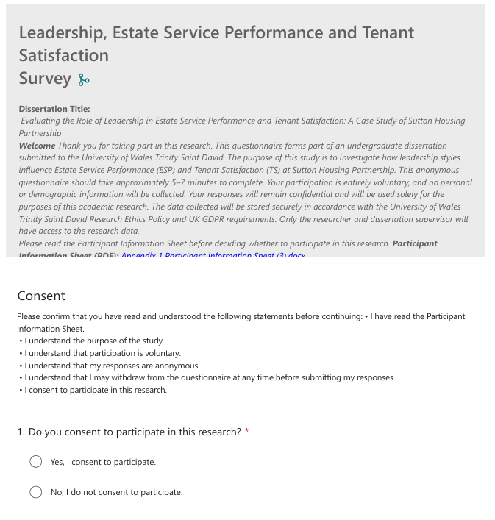

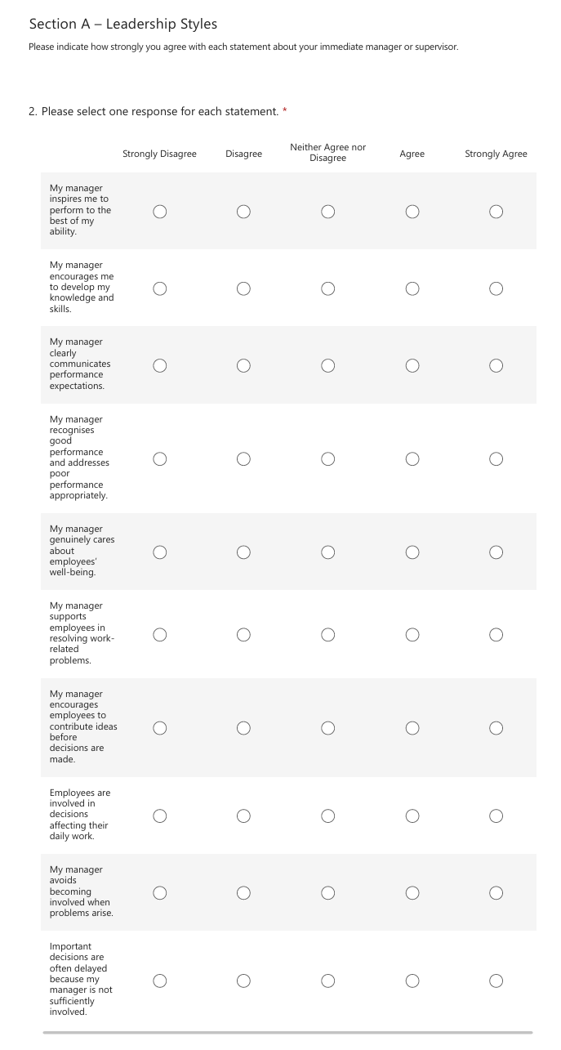
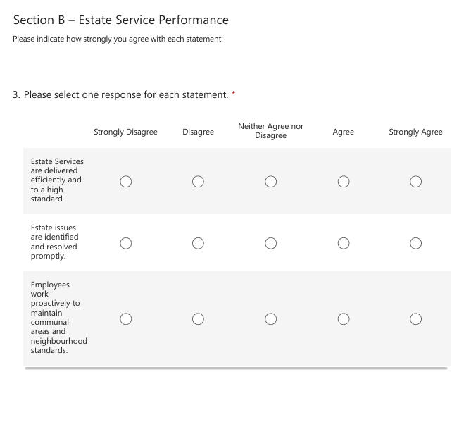
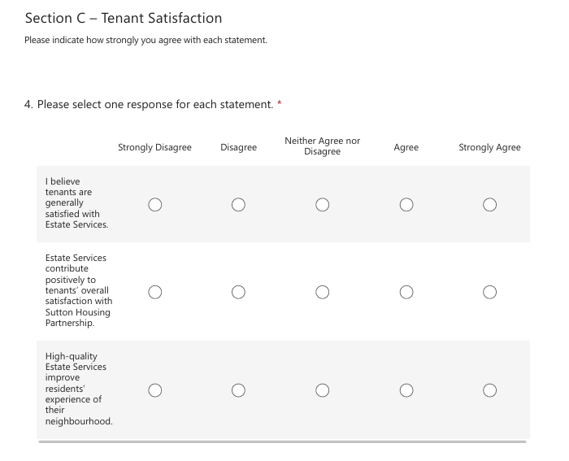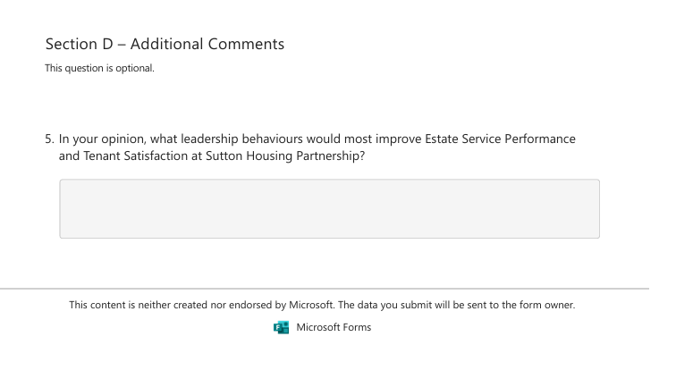
Source: Author’s own questionnaire created using Microsoft Forms.

Appendix 3: Manager Participant Consent Form
University of Wales Trinity Saint David (London Campus)
Canary Wharf
1 Westferry Circus
London – E14 4HA
Tel: +442071277400
Email: info.london@uwtsd.ac.uk
londonstudentservices@uwtsd.ac.uk
Participant Consent Form
This consent form applies to participants taking part in the semi-structured interviews. Where interviews are conducted via Microsoft Teams, participants may either return a signed electronic copy of this form before the interview or provide recorded verbal consent at the beginning of the interview.

Dissertation Title
Evaluating the Role of Leadership in Estate Service Performance and Tenant Satisfaction: A Case Study of Sutton Housing Partnership

Researcher Details
Dijana Sklancec
BA (Hons) Leadership and Management Skills for the Workplace
University of Wales Trinity Saint David (London Campus)

Please read each statement carefully and tick each box to indicate your consent before signing this form.
☐ I confirm that I have read and understood the Participant Information Sheet for this study.
☐ I have had the opportunity to ask questions about the research and have received satisfactory answers.
☐ I understand that my participation is entirely voluntary.
☐ I understand that I am free to withdraw from the study at any time before data analysis begins without giving a reason.
☐ I understand that my responses will be treated confidentially and anonymously.
☐ I understand that no personally identifiable information will appear in the dissertation or any related reports or presentations.
☐ I understand that the information I provide may be used for the purposes of this undergraduate dissertation and any related academic presentations or publications, provided that I cannot be identified.
☐ I understand that interview recordings (where applicable) will only be made with my permission and will be securely stored before being permanently deleted in accordance with the University's data retention policy.
☐ I voluntarily agree to participate in this research study.

Participant
Name: _______________________________________
Signature: ___________________________________
Date: _______________________________________
Researcher
Name: Dijana Sklancec
Signature: _________________________________
Date: _______________________________________

Confidentiality Statement
All information collected during this research will remain confidential and will be processed in accordance with the UK General Data Protection Regulation (UK GDPR), the Data Protection Act 2018 and the University of Wales Trinity Saint David Research Ethics Policy.
Participants' identities will not be disclosed in the dissertation or any related publications. Questionnaire responses will be anonymous. Interview participants will be assigned identification codes during transcription, and any personally identifiable information will be removed before analysis.
Participation or non-participation will have no effect on employment, professional relationships or performance evaluation within Sutton Housing Partnership.

Researcher Contact Details
Dijana Sklancec
BA (Hons) Leadership and Management Skills for the Workplace
University of Wales Trinity Saint David (London Campus)
Email: 2314272@student.uwtsd.ac.uk
Supervisor: Mohammad Rahman

University Contact Information
University of Wales Trinity Saint David (London Campus)
Canary Wharf
1 Westferry Circus
London E14 4HA
Tel: +44 20 7127 7400
Email: info.london@uwtsd.ac.uk
Student Services: londonstudentservices@uwtsd.ac.uk

Appendix 4: Manager Interview Schedule
Dissertation Title
Evaluating the Role of Leadership in Estate Service Performance and Tenant Satisfaction: A Case Study of Sutton Housing Partnership

Interview Information
Thank you for agreeing to participate in this interview.
This interview forms part of an undergraduate dissertation at the University of Wales Trinity Saint David.
The purpose of the interview is to explore managers' perspectives on how leadership influences Estate Service Performance (ESP) and Tenant Satisfaction (TS) within Sutton Housing Partnership.
The interview will last between 20–30 minutes and may be conducted either face-to-face or online via Microsoft Teams, depending on participant availability and organisational requirements.
Participation is entirely voluntary. All responses will remain confidential and anonymous. With your permission, the interview will be audio-recorded solely for the purposes of transcription and analysis.

Interview Questions
The questions below provide a guide for the interview. Follow-up questions may be asked, where appropriate, to clarify or explore participants' responses in greater depth.
Opening Question
- Could you briefly describe your current role and responsibilities within Sutton Housing Partnership?
Leadership Styles
- In your experience, what leadership behaviours are most effective in motivating Estate Services employees?
Prompt (if required):
- Communication
- Recognition
- Support
- Decision-making
- Performance management
- Different leadership styles (for example, transformational, transactional, servant, participative and laissez-faire) have different strengths and limitations.

Which approaches do you believe are most effective within Estate Services, and why?

Estate Service Performance
- How do leadership practices influence the quality and efficiency of Estate Services?
Prompt (if required):
- Estate inspections
- Communal cleaning
- Environmental maintenance
- Response to reported issues
- What factors, other than leadership, have the greatest influence on Estate Service Performance?
Prompt (if required):
- Staffing
- Workload
- Resources
- Training
- Budget
- Organisational policies
Tenant Satisfaction
- In your opinion, how does leadership influence tenant satisfaction?
Prompt (if required):
- Service quality
- Communication
- Responsiveness
- Estate appearance
- How do you use organisational performance information, such as Key Performance Indicators (KPIs) and Tenant Satisfaction Measures (TSMs), to manage and improve your team’s performance?
Organisational Improvement
- What leadership practices could further improve Estate Service Performance and Tenant Satisfaction within Sutton Housing Partnership?
Closing Question
- Is there anything else you would like to add regarding leadership, Estate Service Performance or Tenant Satisfaction that has not already been discussed during this interview?

Interview Completion
Thank you for your participation.
Your contribution is greatly appreciated. All information provided will be treated confidentially and used solely for the purposes of this academic research.

Appendix 5: UWTSD Ethical Approval
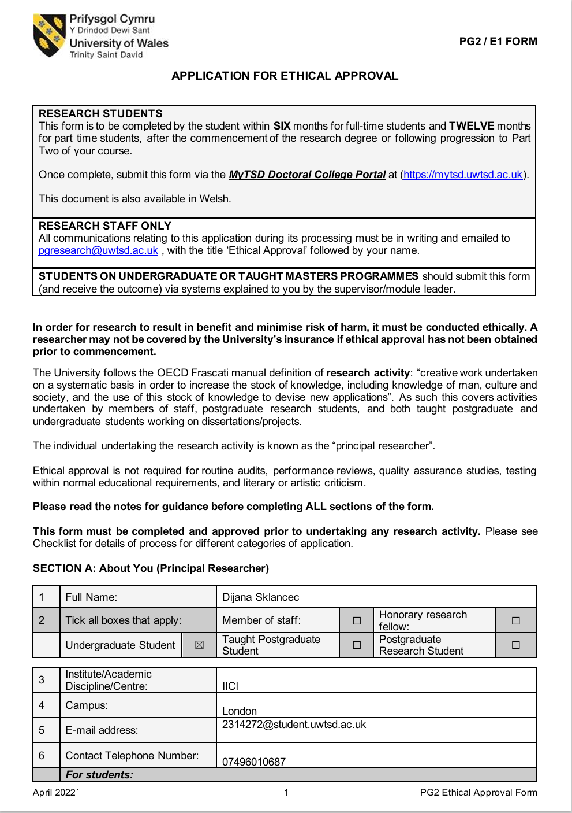
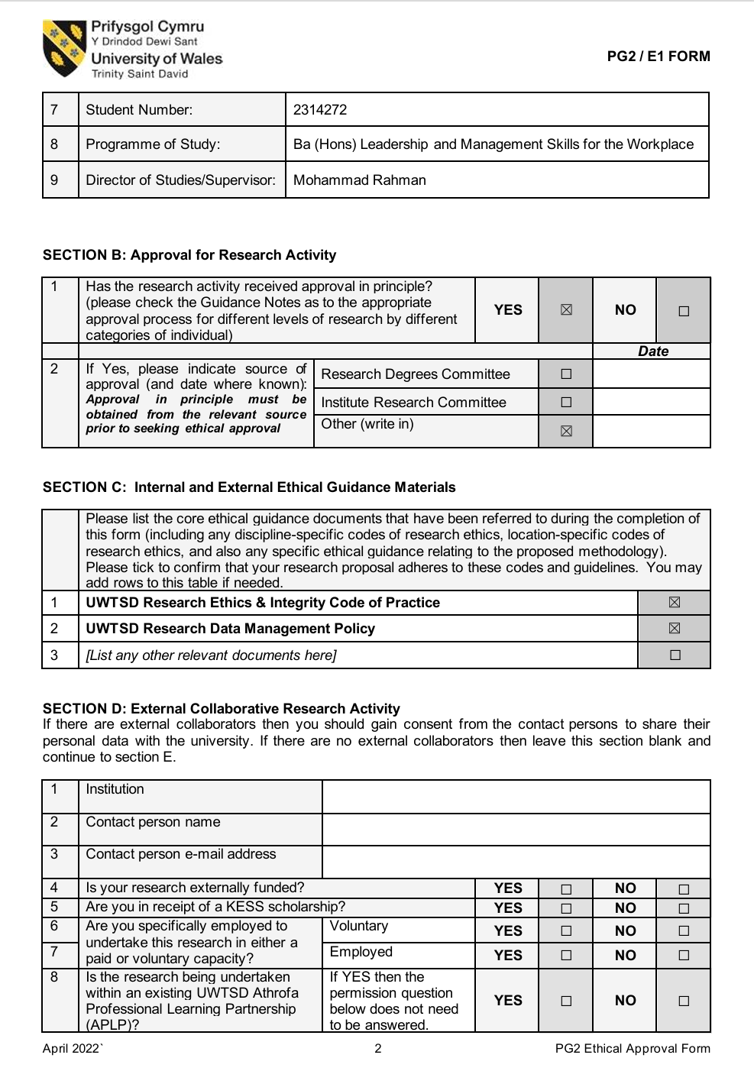

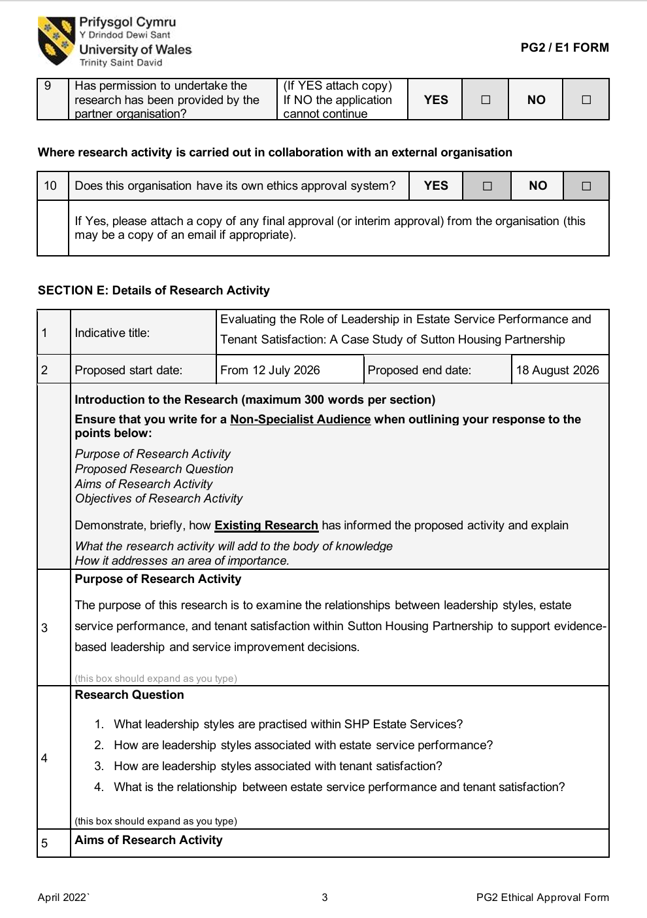

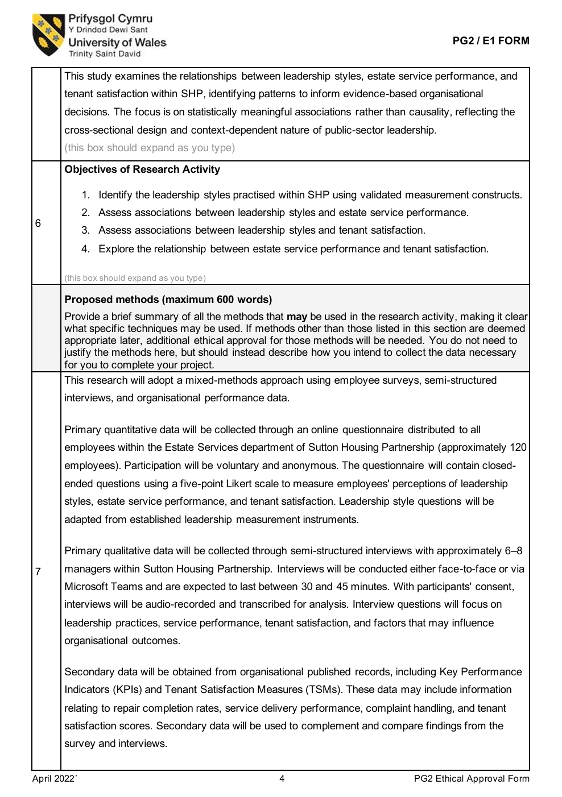

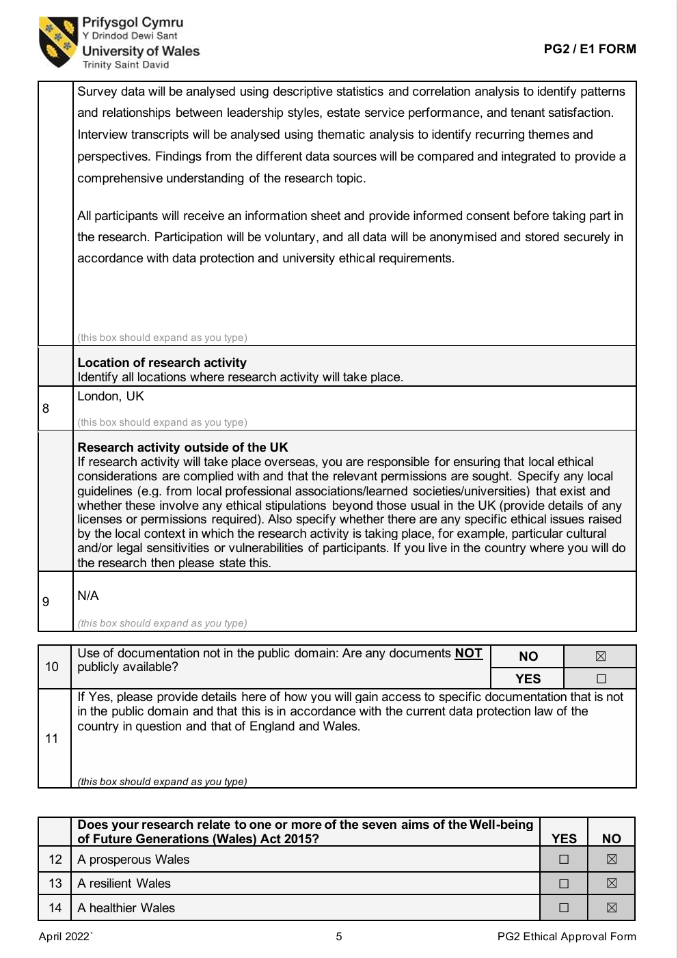

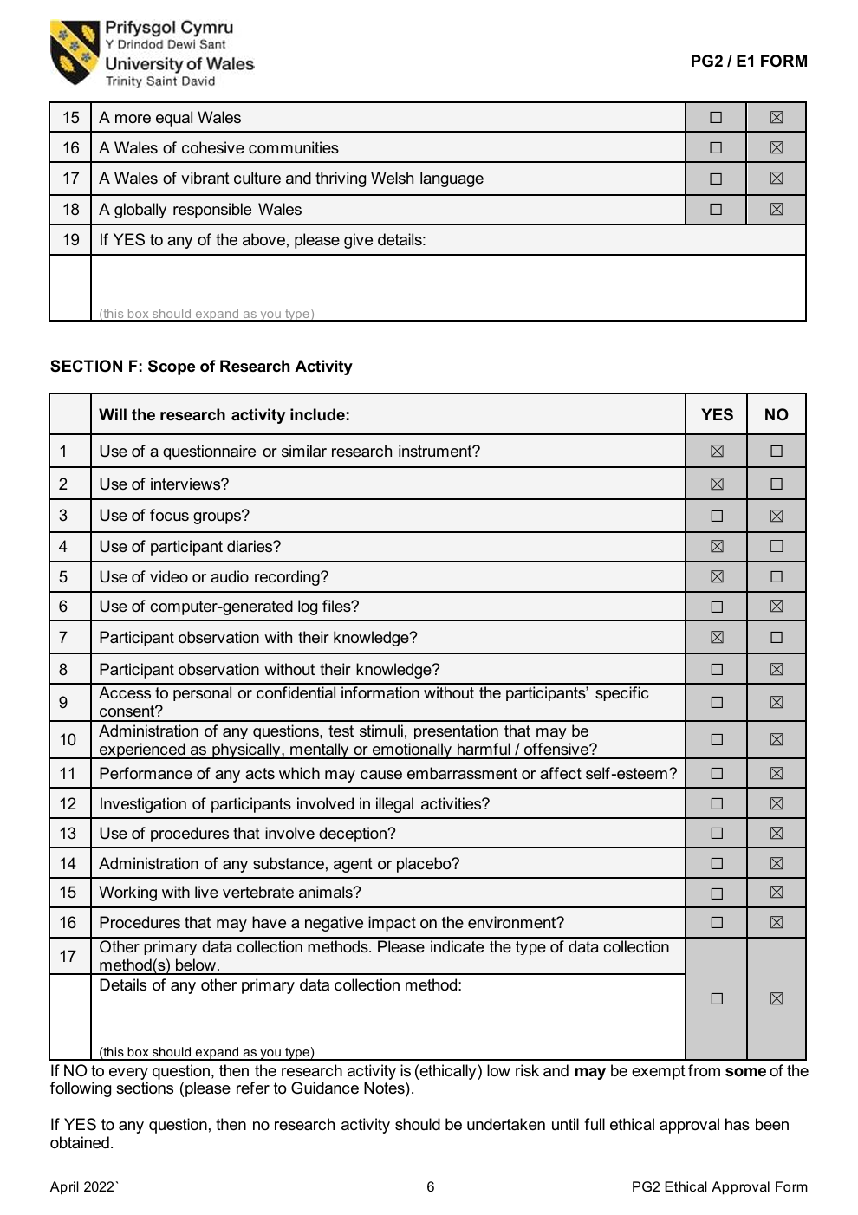

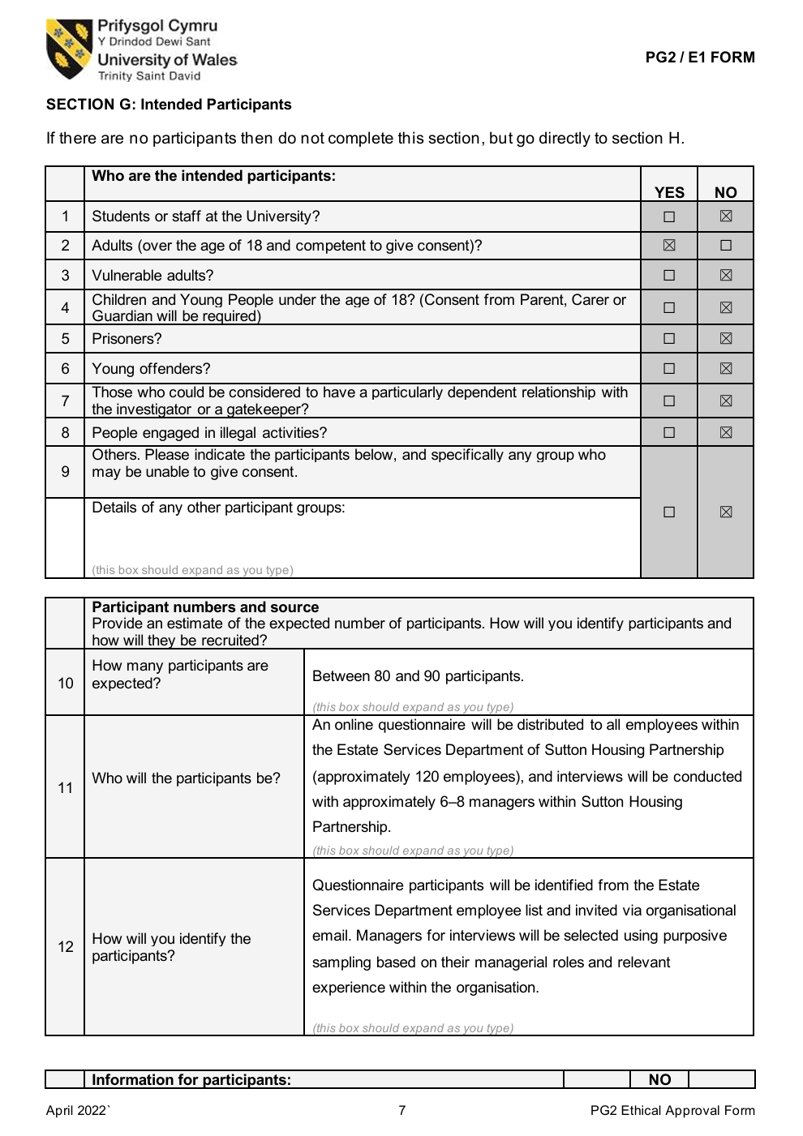

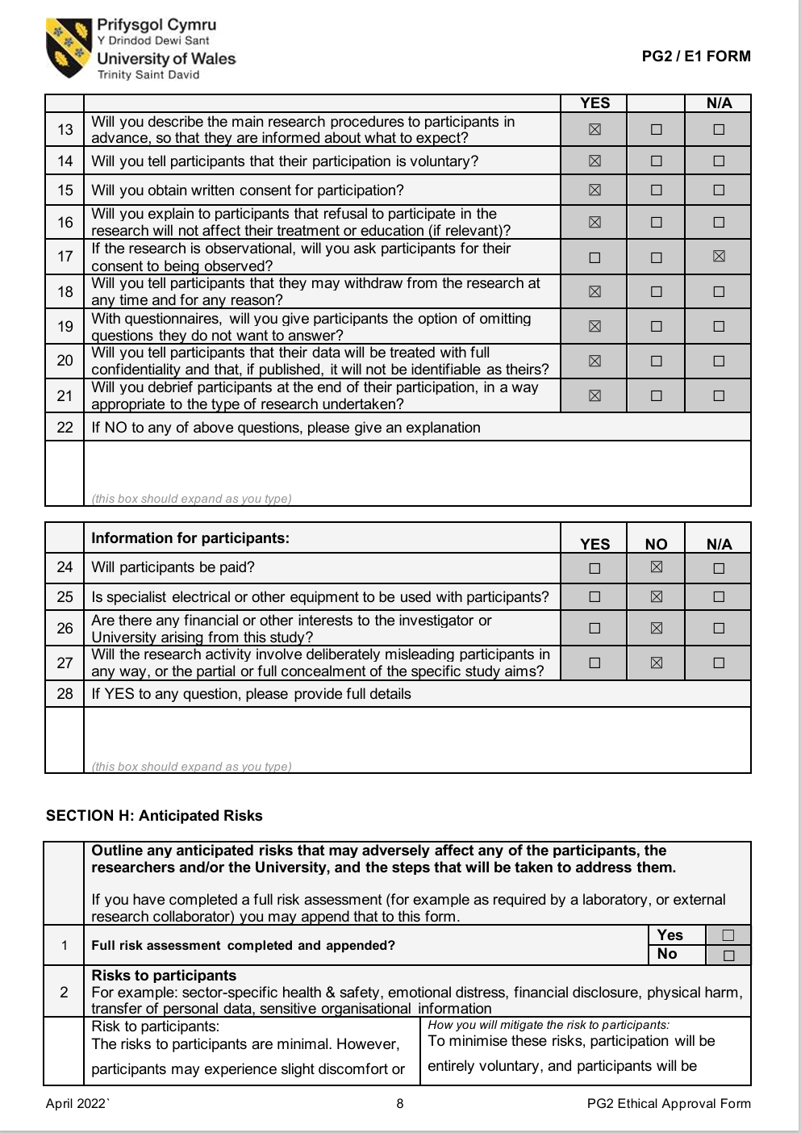

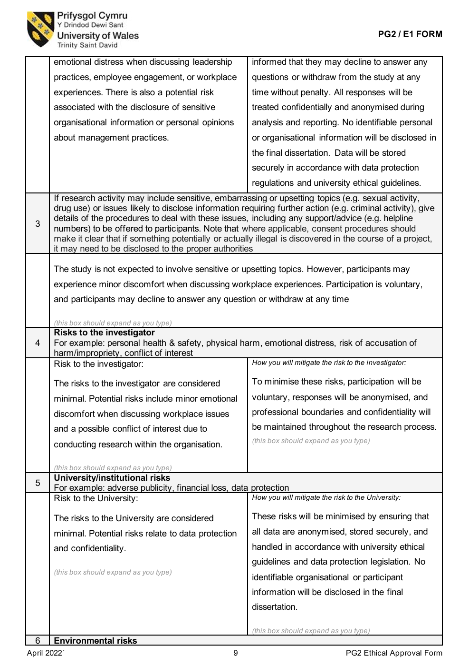

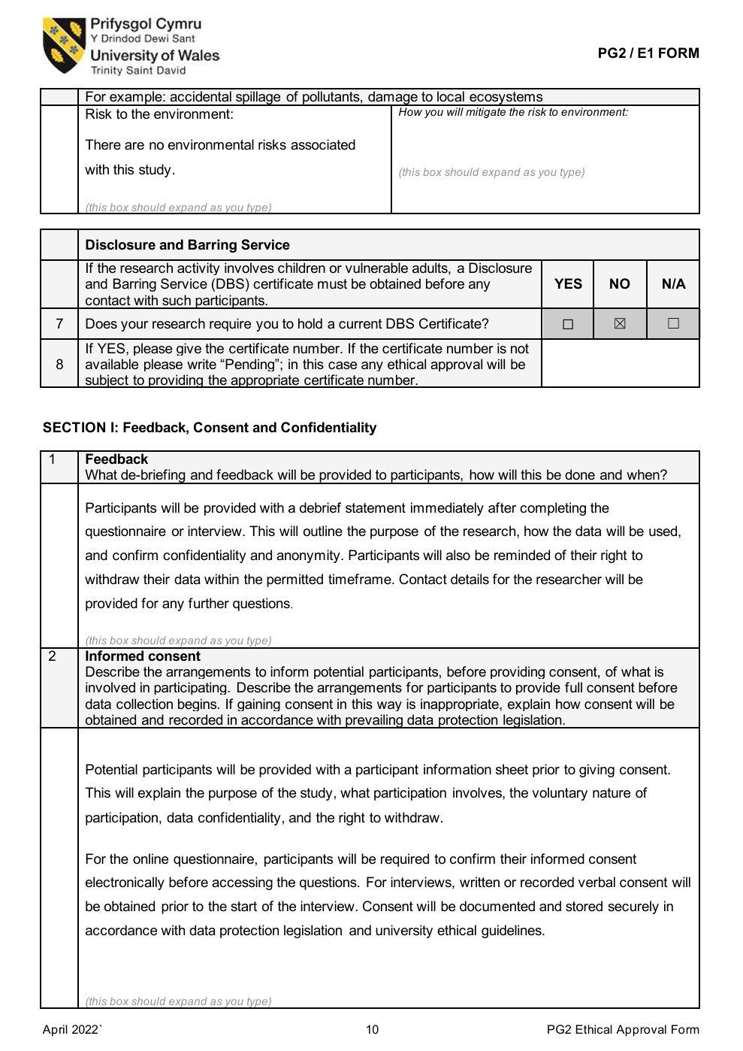

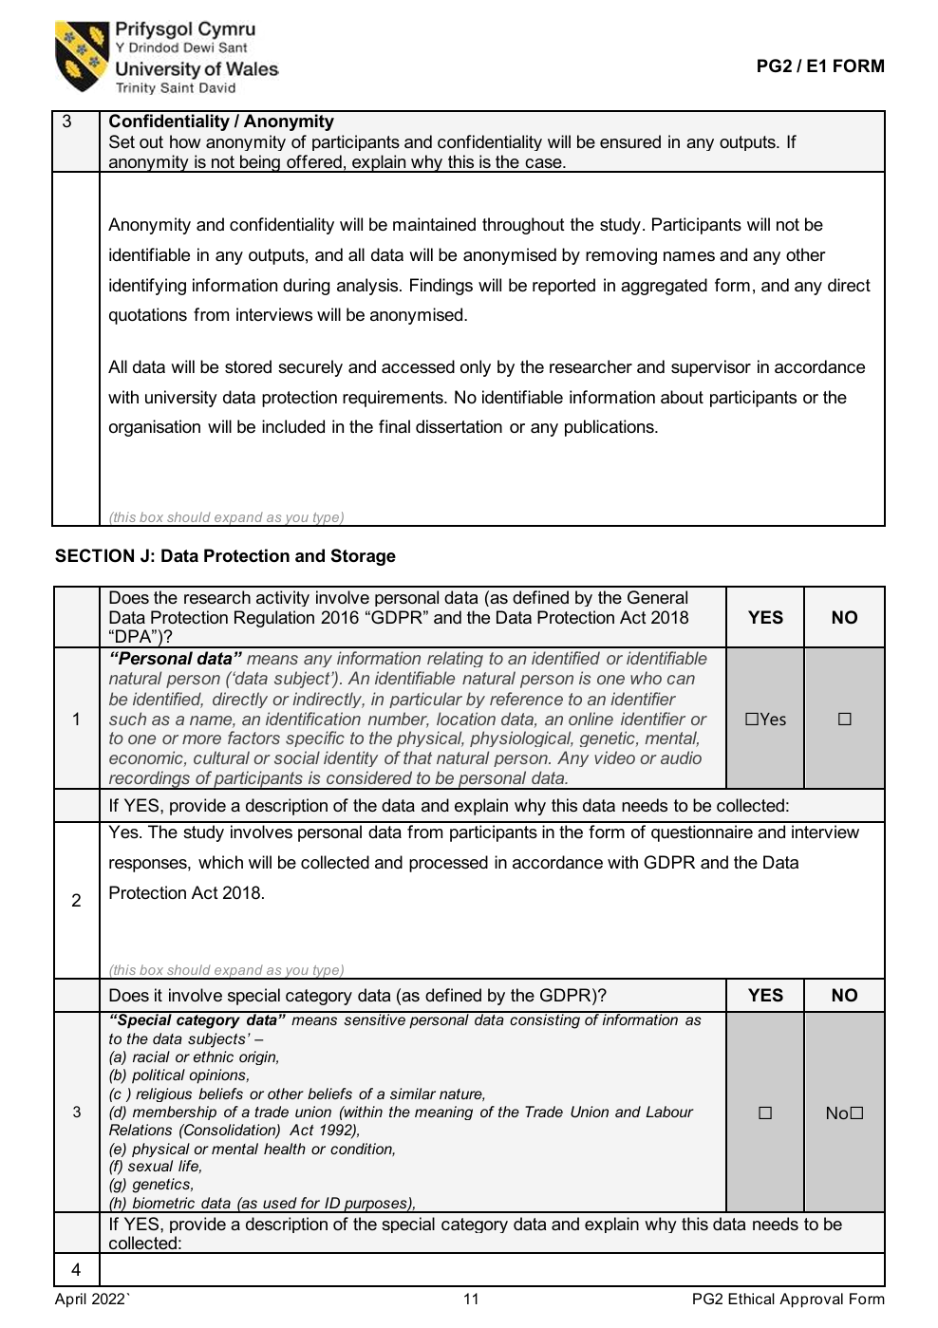

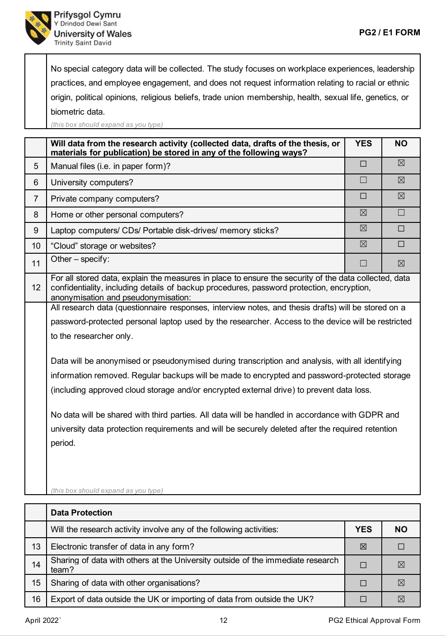

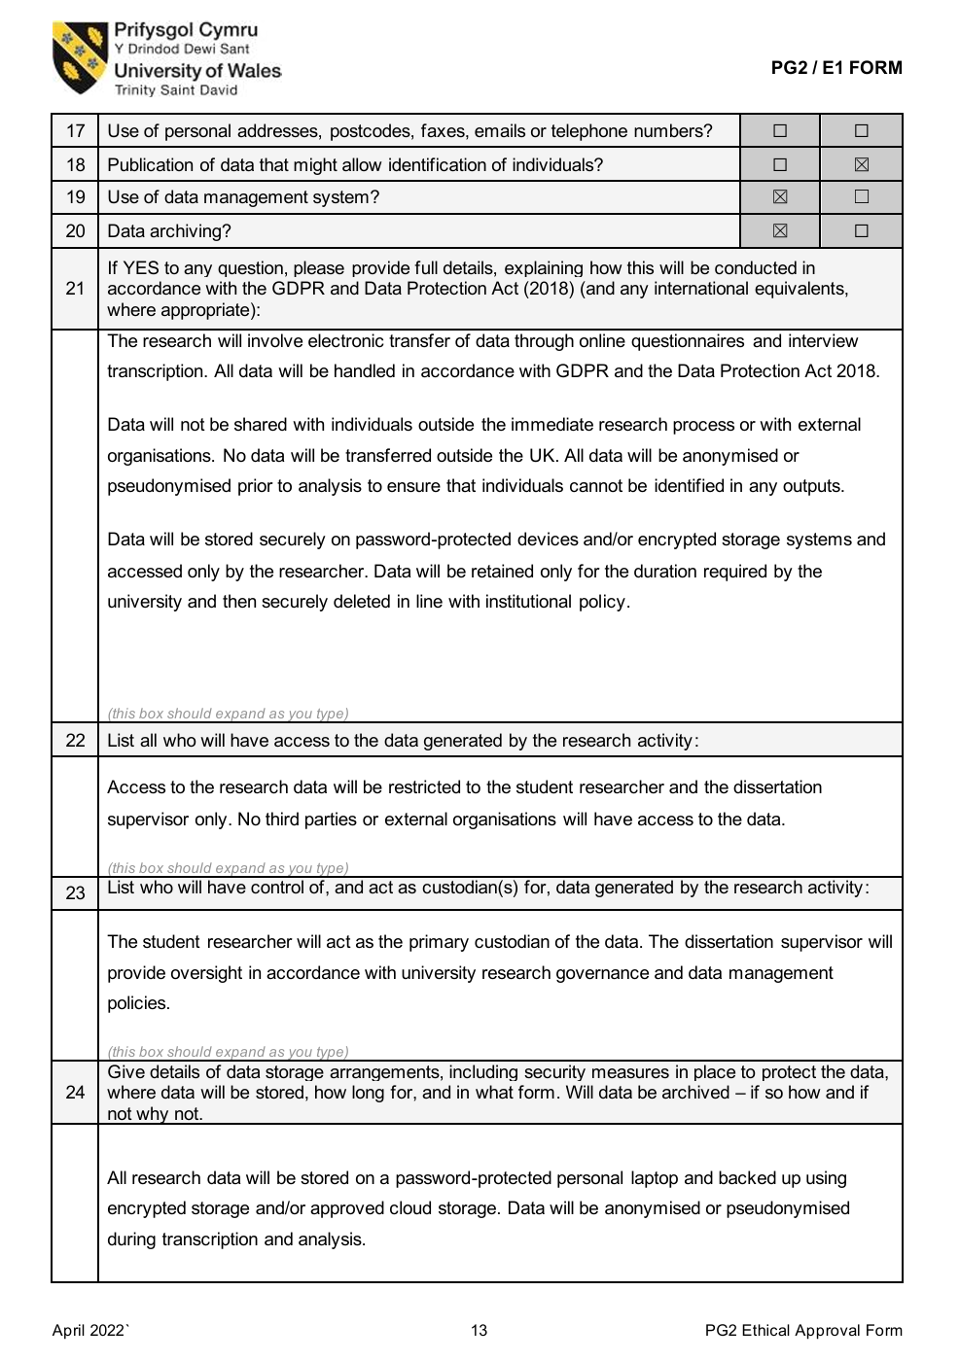

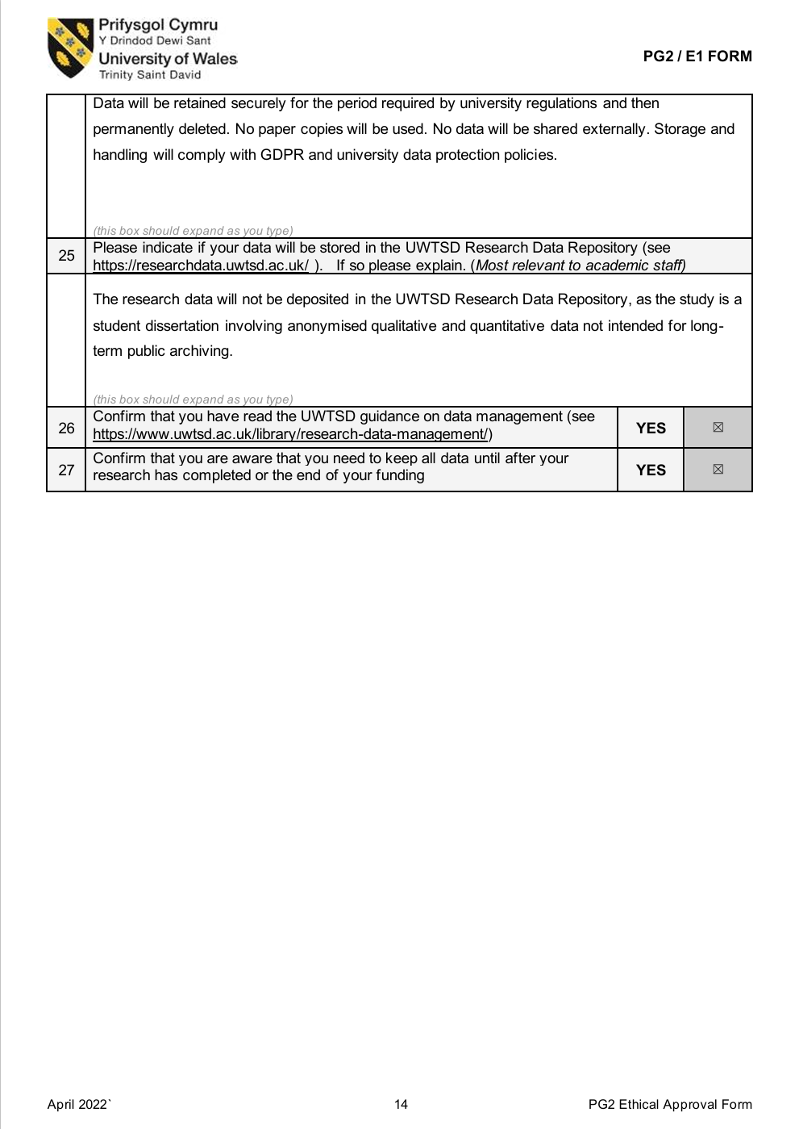

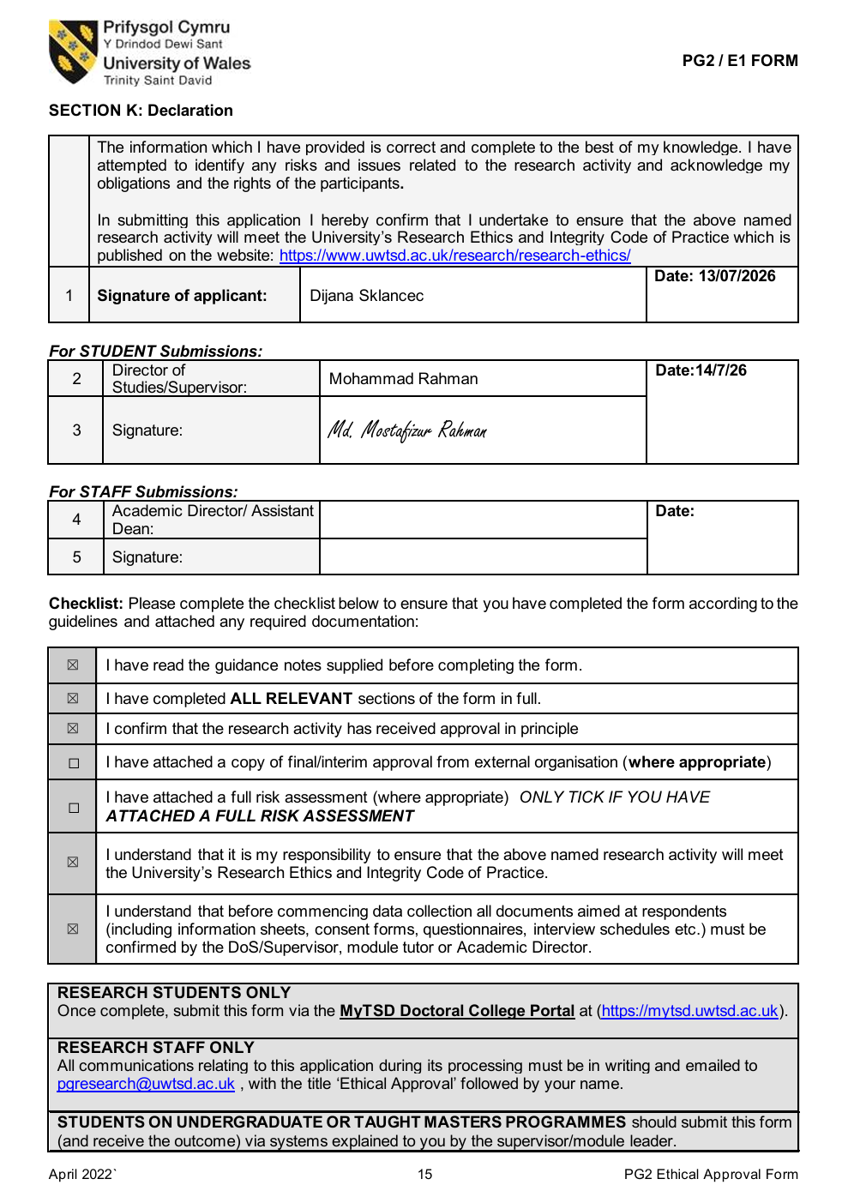



Appendix 6: SHP Annual Report to Residents 2024/25


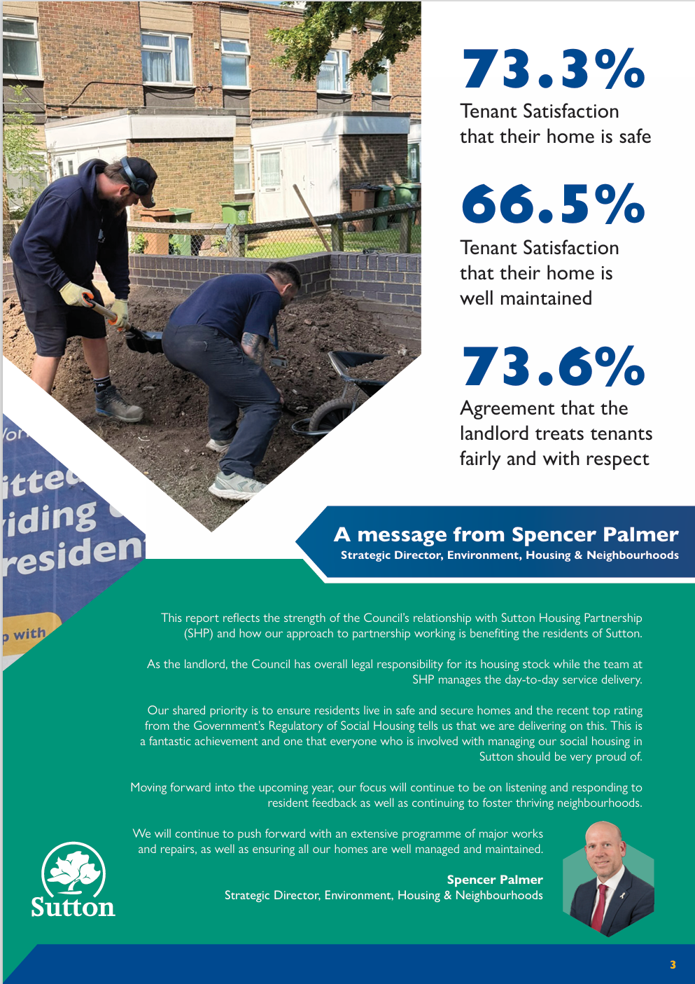


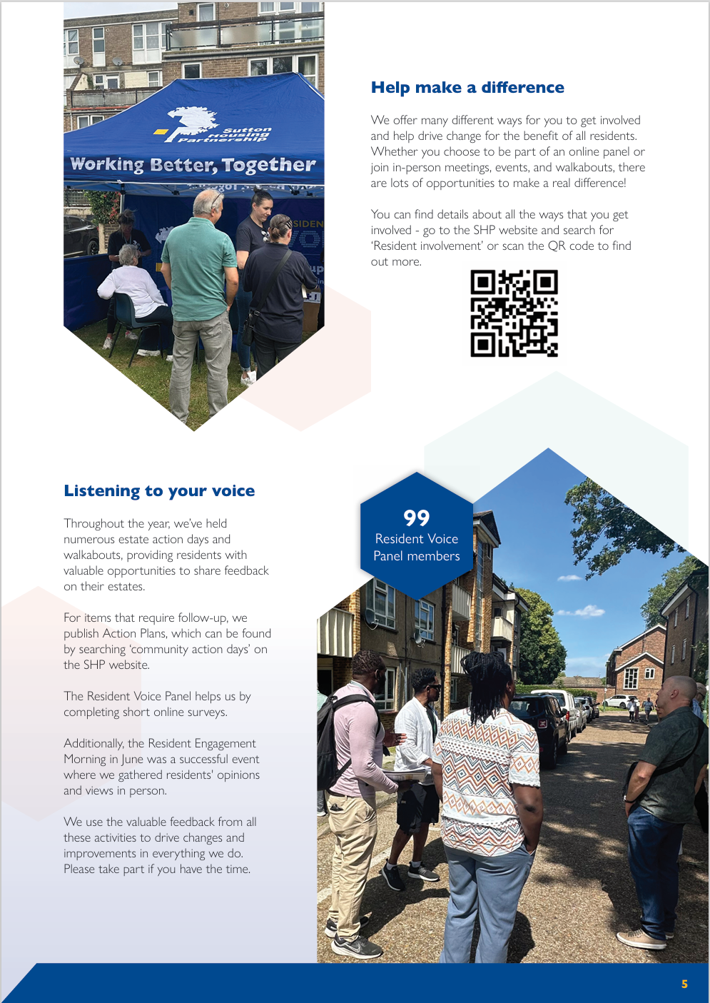

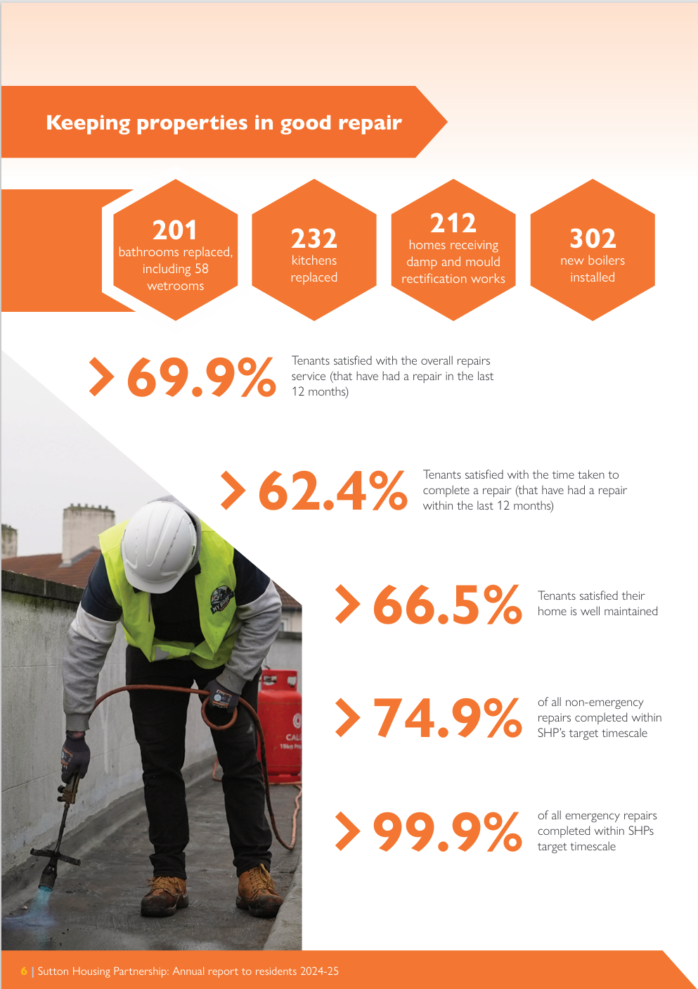



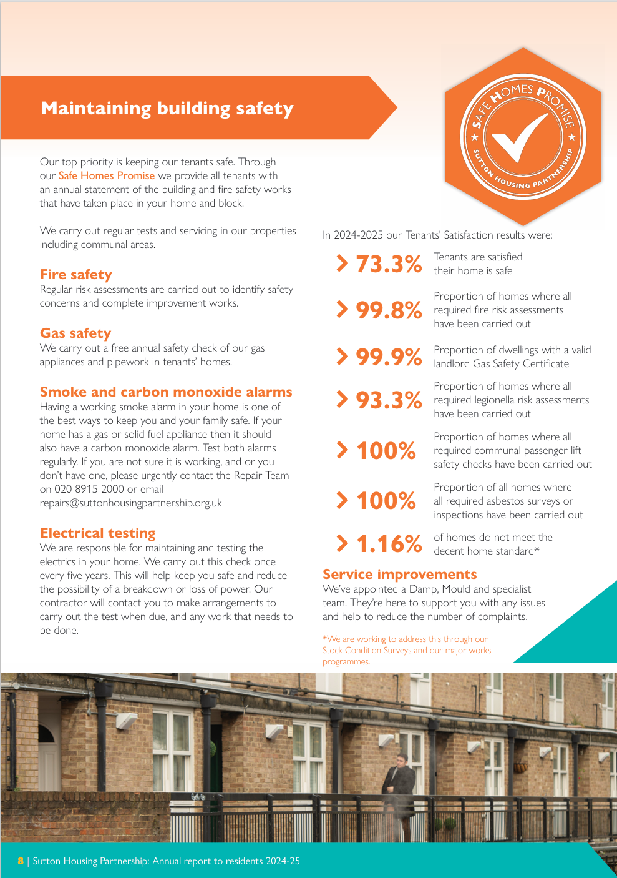

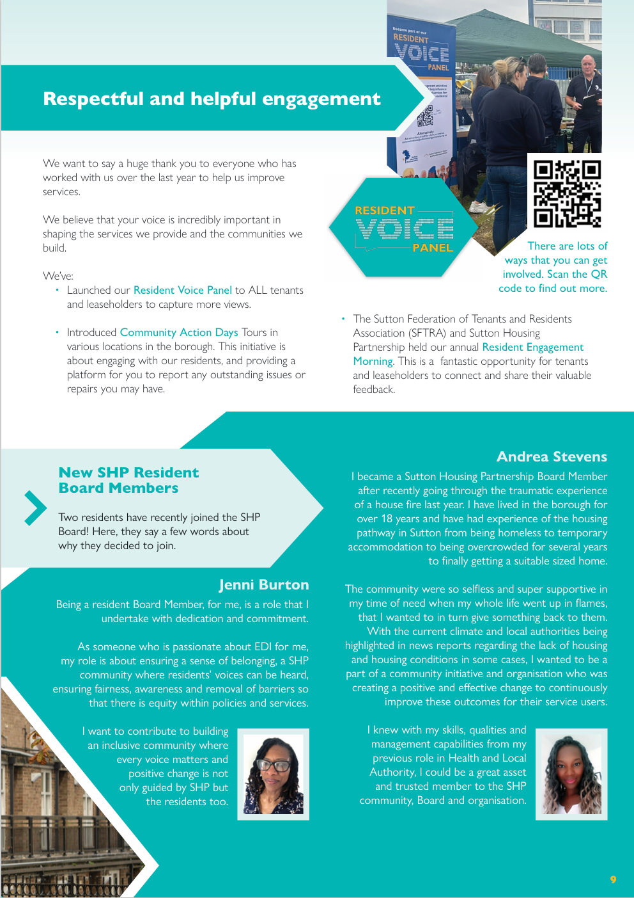

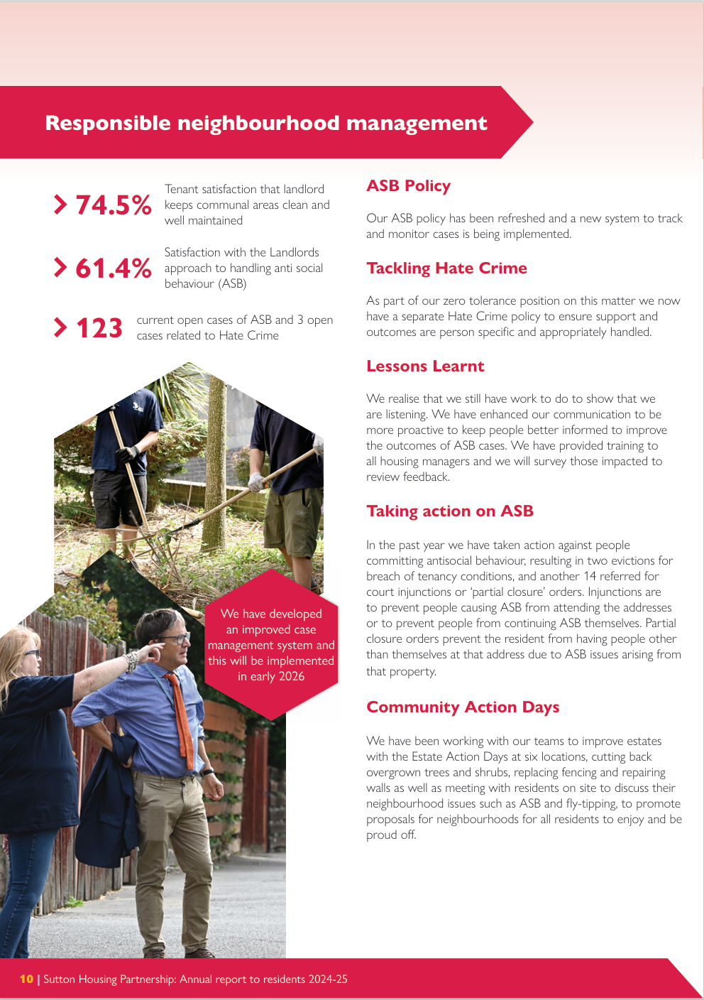

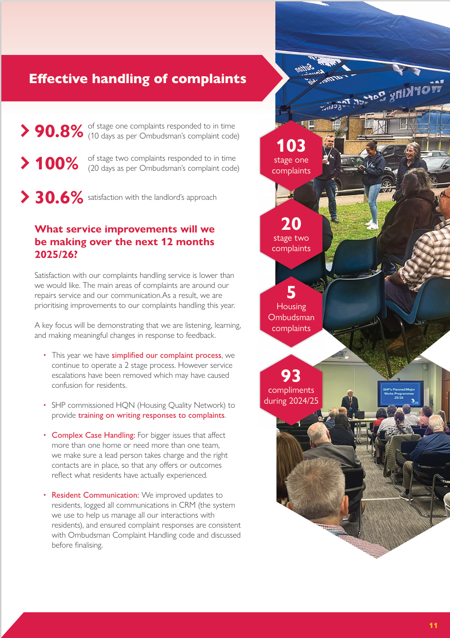

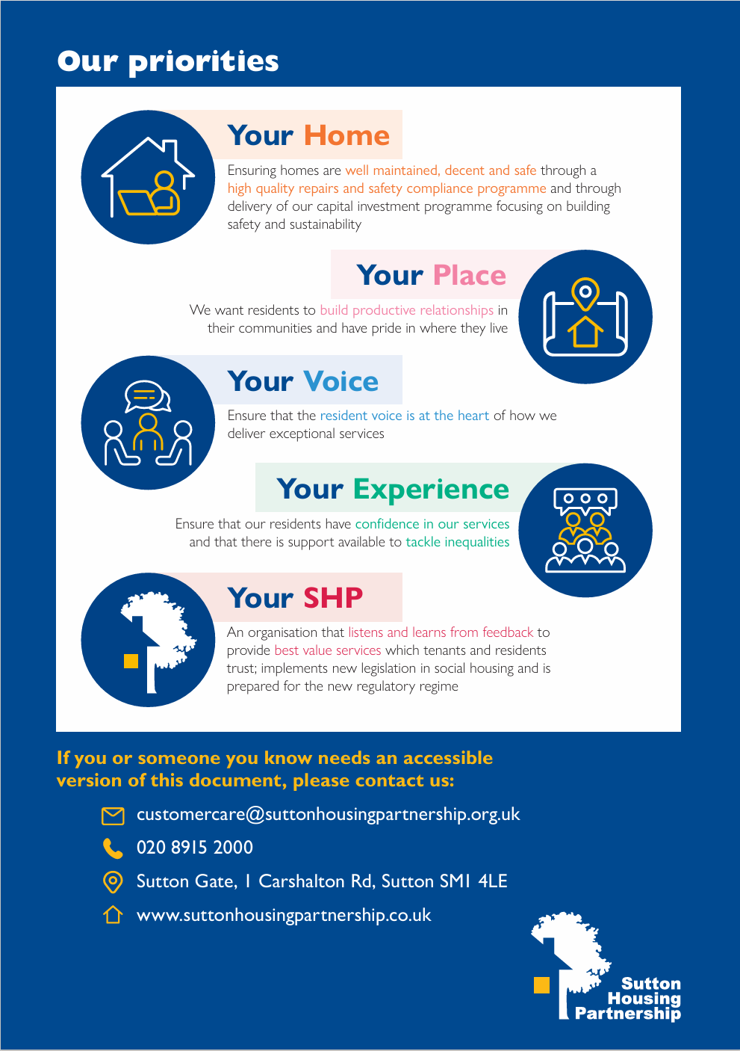
Source: Sutton Housing Partnership (2026a), Annual Report to Residents 2024/25.

Appendix 7: SHP KPI and TSM Report 2025/26 (Quarter 1–3)
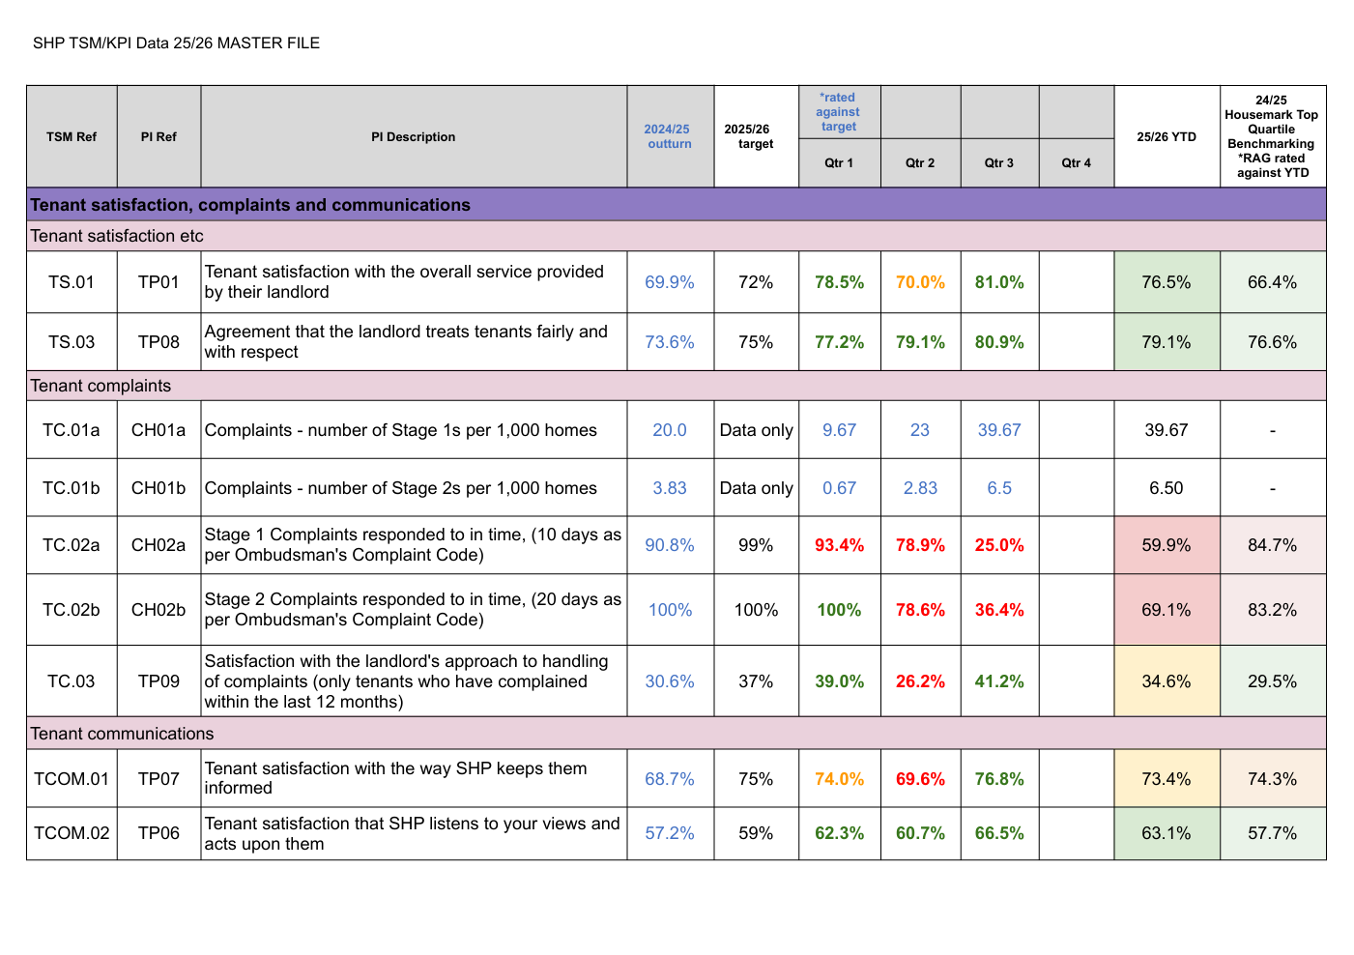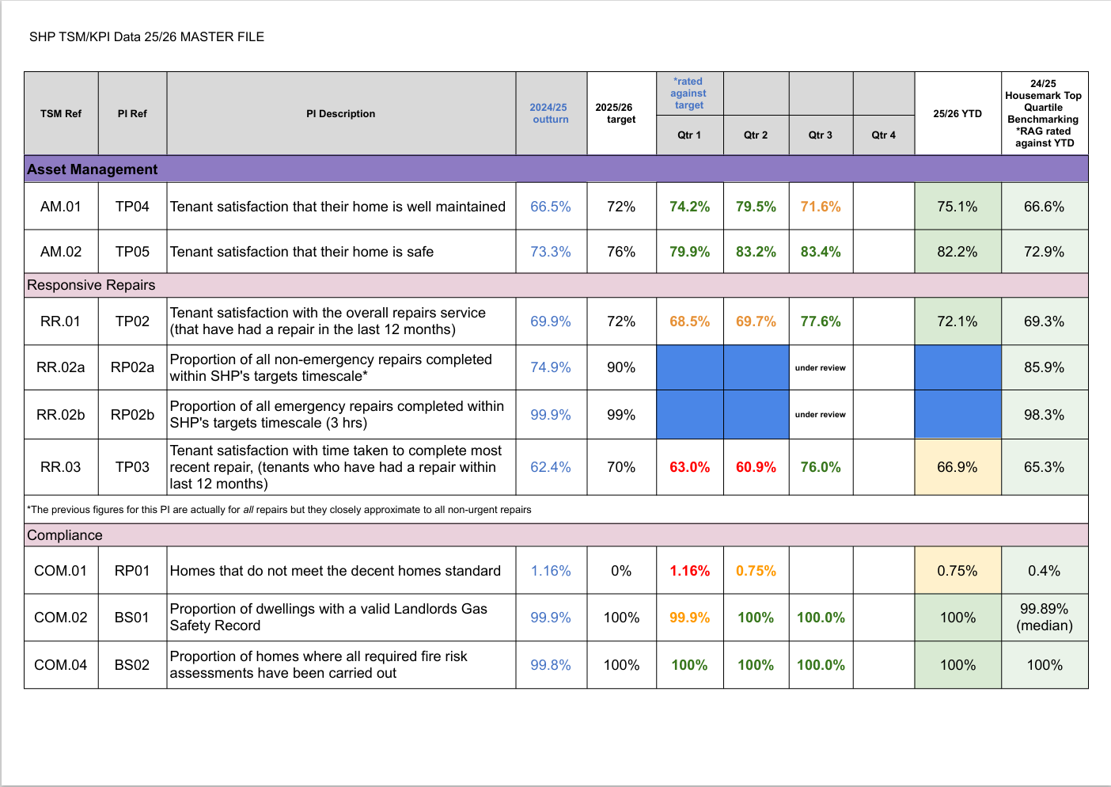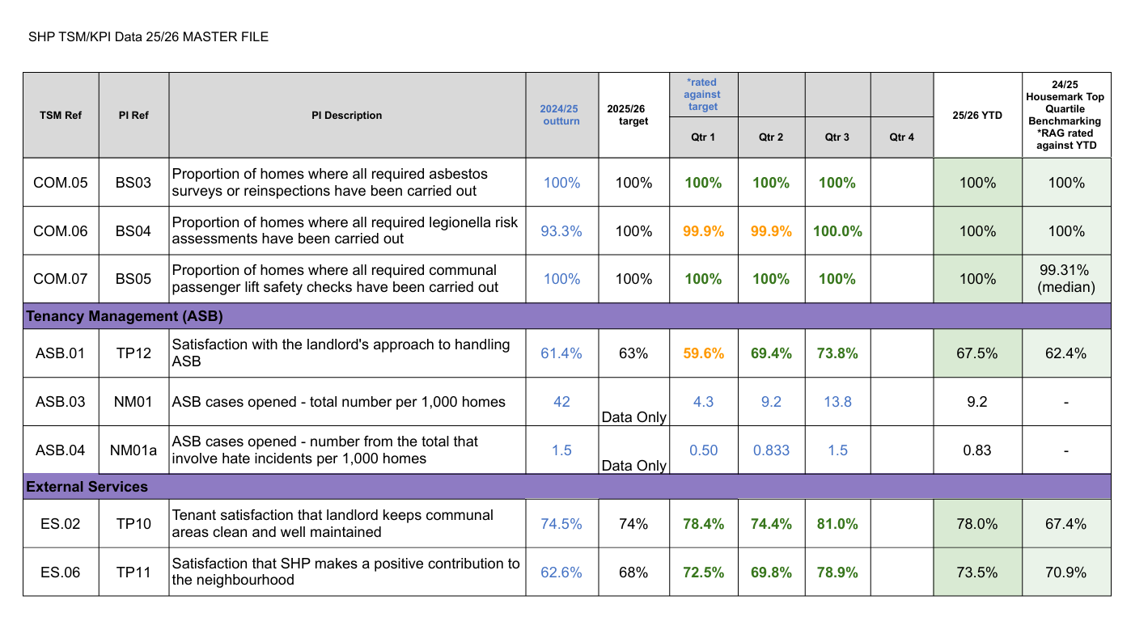Source: Sutton Housing Partnership (2026b), SHP TSM/KPI Data 25/26 MASTER FILE (Quarter 1–3).

Appendix 8: Organisational Permission/SHP Approval

Appendix 9: Anonymised Interview Transcript – Manager 1 (M1)
Dissertation Title:
Evaluating the Role of Leadership in Estate Service Performance and Tenant Satisfaction: A Case Study of Sutton Housing Partnership
Participant: M1 – Manager
Interviewer: Researcher
Interview Type: Semi-structured interview
Anonymisation Note: The participant has been assigned the identifier M1. Specific job titles, service names, organisational initiatives, events and other potentially identifying details have been removed or generalised to protect confidentiality. Minor wording edits have been made solely where necessary for anonymisation and readability, without changing the substantive meaning of the participant’s responses.

Opening
Interviewer: Thank you very much for taking the time to meet with me today. As I said earlier, the interview is part of my undergraduate dissertation at the University of Wales Trinity Saint David. It should take between 20–30 minutes and is designed to explore your views on how leadership influences Estate Service Performance and Tenant Satisfaction.
You have already completed the consent form and offered to record this interview. Thank you for that. If you are happy, I can start with the questions.
M1: Yes, please.

Question 1: Could you briefly describe your current role and responsibilities within Sutton Housing Partnership?
M1: I hold a management role within Sutton Housing Partnership and have responsibility for a number of housing and resident-facing services. My role involves overseeing service delivery, supporting operational areas and collaborating with employees and residents to ensure that services are delivered effectively. I also contribute to wider organisational initiatives and decision-making.
So, it is quite a wide spectrum.
And, yes, it is really about collaborating with residents and concentrating on delivering those services.
Interviewer: Thank you. That is quite a comprehensive role.

Question 2: In your experience, what leadership behaviours are most effective in motivating Estate Services employees?
M1: I think, in terms of leadership behaviours, the first thing I would say is what is really important is transparency.
Being honest and sharing what the scenarios are, as much as you can, so people understand why we can or cannot do certain things. That is really, really important.
It is essential that we make people aware of the circumstances, but with the balance that there is also a requirement for them to deliver services and customer service as well.
If we talk about recognition, recognition is an important one because, from my perspective, whilst we have awards to recognise exceptional work, I think the day-to-day work that we do across all of our services is challenging.
If I were looking from a leader’s perspective, I would want to make sure that people recognise that you appreciate what they do. It can be something as simple as saying thank you to recognise that they have done something.
Every now and again, you should try to find platforms where you can give people recognition as a team and build that teamwork. For instance, opportunities where teams can get together, work through challenges and share ideas, but then, at the end of that, make sure you are grateful for the fact that they are sharing those ideas.
Obviously, it is natural to think about how we support people if they have challenges or blockages, but those resolutions need to be realistic in the long term and within what is possible and within your control.
It also requires shared support. Support does not just come from a leader. Support comes from staff as well because they identify what is really needed and required. They know what is really happening on the ground.
By supporting the leader to understand the circumstances, the leader can then think about what strategies could help to support that.
If we are looking at decision-making, it sits with management, but I like to see, and try to demonstrate, that individual employees participate in part of that decision-making.
For example, a frontline employee recently showed me the operational challenges within their area. I made a comprehensive record of those issues with a view to working through them over a sustained period of time.
That shows investment in the employee by the employee investing in the organisation. Whilst we may not be able to resolve everything quickly, the fact is that those issues are being recognised. That is a really important part of support.
It is about outcomes. It is about satisfaction. Are people happy?
We can look at that across the services. For example, if I looked at our Tenant Satisfaction Measures, which are delivered to us by the Regulator of Social Housing, we can see how residents perceive our services.
One of the things that I am really pleased about is that tenant satisfaction with the overall service provided by the landlord is currently high compared with our peers. What that tells us is that residents are, in the main, satisfied with our services.
But that ties into recognising performance around how we deliver our services and gaining feedback from residents.
If we were not performing in that way, we would have to look at how we are performing in certain areas, look at our KPIs and Tenant Satisfaction Measures, and think about what we could do to improve that.
Interviewer: I would also like to ask about tenant surveys. Is it possible that residents who are unhappy with something may be more likely to submit feedback than residents who are satisfied and do not have any issues?
M1: Yes, I would agree. I think we will have a chance to talk about that when we discuss complaints and how we can be transparent in that respect because we have certainly done a work around our complaints.

Question 3: Different leadership styles, such as transformational, transactional, servant, participative and laissez-faire leadership, each have different strengths and limitations. Which approaches do you believe are most effective within Estate Services, and why?
M1: If I were looking at Estate Services, I would say, as standard, the first thing is to communicate effectively, but that is in every service. That is absolutely a given.
Provide honest feedback and make sure people understand the good bits as well as the bad bits, rather than just focusing on one area.
But if I were looking at behaviours, I would say there is definitely something around coaching methods.
It is not all about giving orders. It is about recognising the individual and their way of operating, whilst keeping the company’s business requirements clearly in focus when you are using those coaching methods.
People you might need to put an arm around; people might prefer very pragmatic, clear instruction.
Different people have different ways of absorbing instruction, and it is about recognising that across your teams and among different employees and managers, to make sure that you deliver the right message.
For example, different service areas can have very different structures and ways of working from Estate Services.
So, leadership is dependent on the circumstances that you are in.
You have got to be able to read the room. You have got to be able to understand the people that you are working with and recognise what approach is going to collaborate best with them.
Recognition is also important. If you want to motivate somebody, you need to recognise the work that they are doing.

Question 4: How do leadership practices influence the quality and efficiency of Estate Services?
M1: I do not necessarily think managers always need to be visible on site.
If you have diligent staff who understand their roles, you do not have to constantly look over somebody’s shoulder because that will not make them work any better.
It is about trust and allowing people to be involved in the decisions they make on site.
There are things that employees can resolve themselves without having to come back to a manager for every decision. If they make an appropriate decision, the manager should support them.
That autonomy is important.
At the same time, communication with customers is really important. If employees understand why they are doing something and can communicate that effectively to residents, that can prevent unnecessary complaints and dissatisfaction.
Employees also need managers who listen and respond when they raise concerns.

Question 5: What factors, other than leadership, have the greatest influence on Estate Service Performance?
M1: Staffing is obviously one.
Equipment and tools are also important. Staff need the appropriate resources to deliver the service.
Flexibility is another factor. We need to consider people’s circumstances and be flexible where we can, but the first priority has to be the business need.
We have a service that we have to deliver. So, whilst we want to be flexible and support employees, we have to balance that against what the service requires.
If you are short-staffed, for example, you have got to look at how you deploy the available staff effectively so that the disruption to residents is minimised.
It is about balancing the needs of employees with the requirements of the organisation and the residents receiving the service.

Question 6: In your opinion, how does leadership influence tenant satisfaction?
M1: Tenant satisfaction is influenced by how effectively we deliver services, but it is also about managing expectations.
If a resident expects a particular service and we are unable to deliver that, we need to communicate effectively and explain why we are not able to provide it.
That way, at least we are managing their expectation, and that is really, really important.
You do not want to damage staff satisfaction by making them responsible for something that they may not actually be able to do anything about.
There are also issues that may not relate directly to the physical quality of Estate Services. Residents may be dissatisfied because of service charges or because they do not understand what they are paying for.
So, communication and transparency with residents are very important.

Question 7: How do you use organisational performance information, such as Key Performance Indicators and Tenant Satisfaction Measures, to manage and improve performance?
M1: We look at KPIs and Tenant Satisfaction Measures to identify where we are performing well and where there may be areas that require improvement.
If the performance is good, that should be recognised.
If something is not performing as expected, then we need to understand why.
We would look at the information, look at what is happening in that particular area and try to understand what is causing the issue.
We would take lessons from that and, if we can deliver an improvement, we would look at doing that.
If we cannot deliver what residents are asking for, then we need to communicate effectively why we are not able to provide that service.
At least then we are managing their expectations because that is really important.
Question 8: What leadership practices could further improve Estate Service Performance and Tenant Satisfaction within Sutton Housing Partnership?
M1: I cannot say that I am fully alive to the whole Estate Services setup in terms of what it currently looks like and who is where.
But what I would say is that it seems like a pretty decent setup at the moment because we are getting satisfactory feedback from it.
That said, how would we further improve it?
It would be looking at the gap and asking, what are the things that we are not getting right?
But that may not be about physical service delivery.
You have got to think about things like service charges.
For example, a resident raised concerns about paying a service charge for a particular estate service without having detailed planned dates for when that service would be delivered.
It was explained that providing the service more frequently or according to a more intensive schedule would result in higher service costs.
Interviewer: That could increase the charges, couldn’t it?
M1: Yes, increase the charges.
Now, the resident may be willing to do that, or they may not. I would say they are less likely to want to do that.
But if you explain it to them so they understand the circumstances, they might say, “Do you know what? When they do come, it is a good service. We do not need any more than that.”
I would say the gap in Tenant Satisfaction Measures is probably because there are residents paying charges that they feel are unwarranted.
So, it is not just about improving a service physically. It is also about providing insight to residents so that they recognise the transparency of what the service delivery is, what they are paying for, and can say, “Okay, that seems fair enough.”
They should then be more satisfied.
Interviewer: I have experienced similar situations where residents’ expectations need to be balanced against the resources allocated to the service.
M1: And increasing the hours may not necessarily achieve the outcomes residents are expecting.
Just because you are physically there doing a little bit more for a little bit longer does not mean the same problems will not happen when you are not there. The same damage may be caused, and then people may say, “Well, I’m paying more and I’m getting less.”
That then has a knock-on effect on the employee because they may feel they are not delivering the service.
There are also situations where, as a leader, I am not able to deliver all the necessary services on my own.
Other organisational teams may need to resolve issues that fall outside Estate Services, and there are also behavioural and environmental issues affecting estates that Estate Services alone cannot resolve.
So, leadership is important, but there are dependencies across different services, and residents themselves also have a role in maintaining their estates.

Question 9: Is there anything else you would like to add regarding leadership, Estate Service Performance or Tenant Satisfaction that we have not discussed today?
M1: It is really important to say that I am really proud of what Sutton Housing Partnership’s Estate Services, including caretaking, delivers.
I am really proud.
It is one of the highest-performing services that we have. Not every housing provider can say that.
It is a really multifaceted team, and it is well led.
The managers and supervisors have a really good understanding of their staff and work with them as best as they can. And the individual caretakers that I have experienced—I’ve yet to have a bad experience.
It is really important for us to celebrate that at every opportunity because it is a good service.
If I was looking at satisfaction, this is an area where we are really good. You can see from the Tenant Satisfaction Measures that we perform strongly, and I think other registered housing providers could potentially learn lessons from that.
When I look at management, I think there’s always room for improvement.
There’s always insight. Nobody is a finished article. I am always learning.
When I spent time with a frontline employee on an estate, I gained considerable insight into operational issues that I had not previously been aware of. Further discussion and information from the employee increased my understanding of those challenges.
The fact that I am a manager does not mean I would automatically have been aware of all of that.
It comes back to my leadership style.
My style is about listening to others and learning from them.
So, my success is really their success.
I succeed through the ability of others to share that insight with me and tell me what I need to deliver at organisational level.
If a change needs to be made at organisational level that affects the service, frontline employees can provide the insight that informs that decision.
And you will notice I say across, not down, because we are all human. We are all here in a place of work to work.
It is essential that we recognise that there is no way I can deliver these services on my own just because I am the leader.
I do not need my face to be in front of everything.
For example, at an organisational event, I was asked to represent the service publicly. I preferred members of the frontline teams delivering the service to be included because they were the employees directly involved in delivering it.
I contributed to the introduction and then allowed the frontline employees to explain their work because they were the people delivering the service.
What I do not want is my face in front of everything.
That is my management style.
Other managers may prefer to be at the front, and that is fine. I would do that when appropriate as well.
But my style, over time, is that I want people to feel that they can influence organisational decisions.

Closing
Interviewer: Thank you. Thank you so much. I have finished all of my questions and received very detailed answers, which I will analyse further and include in my dissertation.
M1: That is absolutely fine. If there is anything else you need around this, you can always give me a shout.

Appendix 10: Anonymised Interview Transcript – Manager 2 (M2)
Dissertation Title:
Evaluating the Role of Leadership in Estate Service Performance and Tenant Satisfaction: A Case Study of Sutton Housing Partnership
Participant: M2 – Manager
Interviewer: Researcher
Interview Type: Semi-structured interview
Anonymisation Note: The participant has been assigned the identifier M2. Specific job titles, operational areas and other potentially identifying details have been removed or generalised to protect confidentiality. Minor wording edits have been made solely where necessary for anonymisation and readability, without changing the substantive meaning of the participant’s responses.

Opening
Interviewer: Thank you very much for taking the time to participate in this interview. As explained in the Participant Information Sheet, this interview forms part of my undergraduate dissertation at the University of Wales Trinity Saint David and explores your views on how leadership influences Estate Service Performance and Tenant Satisfaction within Sutton Housing Partnership.
You have already read the Participant Information Sheet and signed the Interview Consent Form. Before we begin, I would also like to confirm that you are happy for this interview to be audio-recorded solely for the purposes of transcription and analysis.
M2: Yes.
Interviewer: Thank you. I will begin with the first question.

Question 1: Could you briefly describe your current role and responsibilities within Sutton Housing Partnership?
M2: I have management responsibilities relating to the day-to-day delivery of Estate Services. My responsibilities include supervising employees, monitoring performance, allocating resources, conducting estate inspections, ensuring health and safety compliance, responding to operational issues, and supporting staff to achieve agreed service standards.
I also work with other departments to resolve estate-related issues and ensure residents receive a consistent level of service.

Question 2: In your experience, what leadership behaviours are most effective in motivating Estate Services employees?
M2: Clear communication is the most important. Staff need to understand what is expected of them and receive regular feedback.
Recognising good performance and providing support when problems arise also helps maintain motivation. Employees respond positively when managers are approachable, fair and willing to listen.

Question 3: Different leadership styles, such as transformational, transactional, servant, participative and laissez-faire leadership, have different strengths and limitations. Which approaches do you believe are most effective within Estate Services, and why?
M2: A combination of transactional and servant leadership works best.
Transactional leadership provides clear expectations, accountability and consistency, which are essential for maintaining service standards. Servant leadership helps build trust, supports employee wellbeing and encourages staff to feel valued.
Transformational leadership is particularly useful when introducing service improvements or organisational change because it encourages employees to embrace new ways of working.
I find that relying on just one leadership style is less effective than adapting the approach to the situation.

Question 4: How do leadership practices influence the quality and efficiency of Estate Services?
M2: Leadership has a direct impact on service quality. Regular supervision, estate inspections and prompt communication help ensure work is completed to the required standard.
Managers who provide guidance, monitor performance and resolve problems quickly usually achieve better operational performance.
Good leadership also helps maintain staff morale, which contributes to higher productivity and more consistent service delivery.

Question 5: What factors, other than leadership, have the greatest influence on Estate Service Performance?
M2: Adequate staffing levels are essential. High workloads can reduce service quality even when leadership is effective.
Budget availability, suitable equipment, training and realistic workloads also have a significant impact.

Question 6: In your opinion, how does leadership influence tenant satisfaction?
M2: Tenants may not see managers regularly, but they experience the results of good leadership through cleaner estates, quicker responses to reported issues and better communication.
When employees are well supported and understand expectations, they are more likely to provide a reliable and professional service, which improves residents’ overall satisfaction.
Question 7: How do you use organisational performance information, such as Key Performance Indicators (KPIs) and Tenant Satisfaction Measures (TSMs), to manage and improve your team’s performance?
M2: We regularly review KPIs to monitor operational performance and identify areas requiring improvement.
TSM results help us understand residents’ experiences and identify where additional attention is needed. We discuss these findings during team meetings, identify trends and agree actions to improve performance.
Using both measures helps ensure decisions are based on evidence rather than assumptions.

Question 8: What leadership practices could further improve Estate Service Performance and Tenant Satisfaction within Sutton Housing Partnership?
M2: Increasing staffing levels to reduce excessive workloads would have a significant impact.
Providing additional training, improving communication between teams and ensuring managers remain visible and accessible would also support performance.
Continued investment in equipment and resources would enable staff to work more efficiently and deliver a better service to residents.

Question 9: Is there anything else you would like to add regarding leadership, Estate Service Performance or Tenant Satisfaction that has not already been discussed during this interview?
M2: Leadership should remain visible, supportive and consistent.
Employees perform better when they feel valued, understand what is expected of them and receive recognition for good work.
Creating a positive working environment benefits both staff and residents because it leads to higher service standards and greater tenant satisfaction.
Closing
Interviewer: Thank you very much. That concludes all of my questions. Thank you for taking the time to participate and for providing such detailed responses. Your interview will be transcribed, anonymised and analysed as part of the dissertation, in accordance with the consent provided.
M2: You’re welcome.
Interviewer: Thank you again for your participation.

Appendix 11: Anonymised Interview Transcript – Manager 3 (M3)
Dissertation Title:
Evaluating the Role of Leadership in Estate Service Performance and Tenant Satisfaction: A Case Study of Sutton Housing Partnership
Participant: M3 – Manager
Interviewer: Researcher
Interview Type: Semi-structured interview
Anonymisation Note: The participant has been assigned the identifier M3. Specific job titles, operational areas and other potentially identifying details have been removed or generalised to protect confidentiality. Minor wording edits have been made solely where necessary for anonymisation and readability, without changing the substantive meaning of the participant’s responses.

Opening
Opening Note: Prior to commencement of the interview, M3 had received the Participant Information Sheet, signed the Interview Consent Form and provided permission for the interview to be audio-recorded for transcription and analysis.
Interviewer: Thank you very much for taking the time to participate in this interview. As explained in the Participant Information Sheet, this interview forms part of my undergraduate dissertation at the University of Wales Trinity Saint David and explores your views on how leadership influences Estate Service Performance and Tenant Satisfaction within Sutton Housing Partnership.
I will begin with the first question.

Question 1: Could you briefly describe your current role and responsibilities within Sutton Housing Partnership?
M3: I have management responsibility for the delivery of Estate Services and for ensuring that estates are maintained to the required standards. My responsibilities include supervising employees, monitoring performance, managing operational resources, conducting regular estate inspections, ensuring compliance with health and safety requirements, responding to operational issues and supporting staff to achieve agreed service standards.
I also work closely with other departments to resolve estate-related matters and improve service delivery.

Question 2: In your experience, what leadership behaviours are most effective in motivating Estate Services employees?
M3: Setting clear goals and maintaining open communication are essential.
Employees need to understand what is expected of them and feel comfortable raising concerns or asking for support.
Regular monitoring, recognising good performance and resolving issues promptly all help maintain motivation and encourage staff to take pride in their work.

Question 3: Different leadership styles, such as transformational, transactional, servant, participative and laissez-faire leadership, have different strengths and limitations. Which approaches do you believe are most effective within Estate Services, and why?
M3: The most effective approach is to combine leadership styles depending on the situation.
Servant leadership is particularly important because trust between managers and employees is essential. Our employees are the driving force behind delivering high-quality services, so supporting their wellbeing is a priority.
Transactional leadership is also necessary because staff need clear expectations, accountability and consistency.
Transformational leadership becomes important when implementing improvements or changes that benefit both employees and residents.
I do not believe one leadership style works in every situation, so managers need to adapt their approach.

Question 4: How do leadership practices influence the quality and efficiency of Estate Services?
M3: Leadership has a significant influence on performance.
Regular estate inspections help managers understand what is happening on site and identify areas requiring improvement.
Being visible on the estates allows managers to provide immediate guidance, maintain cleaning standards and address issues before they become larger problems.
This helps ensure services are delivered consistently and efficiently.

Question 5: What factors, other than leadership, have the greatest influence on Estate Service Performance?
M3: Budget is one of the biggest challenges.
As an organisation, we have to deliver high-quality services within allocated budgets, so there is limited flexibility.
Staffing levels can also become challenging during periods of increased absence or reduced staff availability.
Resources, equipment and workload also influence overall performance.

Question 6: In your opinion, how does leadership influence tenant satisfaction?
M3: Residents may not always see managers, but they experience the results of effective leadership.
Good communication between managers and employees leads to quicker responses and higher service standards.
Caretakers are our eyes and ears on the estates, so supporting them enables problems to be identified and resolved more quickly, which improves the service residents receive.

Question 7: How do you use organisational performance information, such as Key Performance Indicators (KPIs) and Tenant Satisfaction Measures (TSMs), to manage and improve your team’s performance?
M3: KPIs and TSMs provide valuable information about where improvements are needed.
We regularly review the performance data to identify trends and areas where targets are not being achieved.
Once we identify an issue, we investigate the root causes, discuss possible solutions with the team and implement actions to improve performance.
Using performance data helps ensure that decisions are based on evidence rather than assumptions.

Question 8: What leadership practices could further improve Estate Service Performance and Tenant Satisfaction within Sutton Housing Partnership?
M3: Additional investment in budgets, equipment and resources would make a significant difference.
Increasing staffing capacity during particularly busy periods would also help reduce workload pressures and improve the consistency of service delivery.
Continued staff development and maintaining strong communication across teams would further improve both operational performance and tenant satisfaction.

Question 9: Is there anything else you would like to add regarding leadership, Estate Service Performance or Tenant Satisfaction that has not already been discussed during this interview?
M3: Balancing workloads, providing appropriate equipment and working within budget constraints remain the biggest challenges.
Despite these limitations, maintaining visible leadership, supporting employees and focusing on continuous improvement are essential for delivering high-quality Estate Services and achieving positive outcomes for residents.

Closing
Interviewer: Thank you very much. That concludes all of my questions. Thank you for taking the time to participate and for providing detailed responses. Your interview will be transcribed, anonymised and analysed as part of the dissertation, in accordance with the consent provided.
M3: You’re welcome.
Interviewer: Thank you again for your participation.

Appendix 12: Anonymised Interview Transcript – Manager 4 (M4)
Dissertation Title:
Evaluating the Role of Leadership in Estate Service Performance and Tenant Satisfaction: A Case Study of Sutton Housing Partnership
Participant: M4 – Manager
Interviewer: Researcher
Interview Type: Semi-structured interview
Anonymisation Note: The participant has been assigned the identifier M4. Specific job titles, geographical areas, service responsibilities, locations, third-party organisations and other potentially identifying details have been removed or generalised to protect confidentiality. Minor wording edits have been made solely where necessary for anonymisation and readability, without changing the substantive meaning of the participant's responses.

Opening
Opening Note: Prior to commencement of the interview, M4 had received the Participant Information Sheet, signed the Interview Consent Form and provided permission for the interview to be audio-recorded for transcription and analysis.
Interviewer: Hello. Thank you very much for taking the time to meet with me today. I really appreciate your support and your willingness to participate in my research.
The interview forms part of my undergraduate dissertation at the University of Wales Trinity Saint David. It should take 20–30 minutes and is designed to explore your views on how leadership influences Estate Service Performance and Tenant Satisfaction within Sutton Housing Partnership.
You have agreed that we can record this interview, and you have also signed the participant consent form. Thank you for that.
There are no right or wrong answers. I am interested in hearing about your professional experience and opinion. If you are happy, I will begin with the first question.
M4: Please go ahead.

Question 1: Could you briefly describe your current role and responsibilities within Sutton Housing Partnership?
M4: I am a manager within Estate Services at Sutton Housing Partnership. My role involves managing frontline Estate Services employees across allocated areas and overseeing aspects of operational service delivery.

Question 2: In your experience, what leadership behaviours are most effective in motivating Estate Services employees?
M4: Reading through the various ideas, if you want to call it communication, recognition and support, it is always a combination of everything, really.
I feel if you focus on one particular thing, you will be losing out on the effectiveness of other ideas as well.
You have got to know your staff, number one. Before anything, know your job, know what is expected of you, but know and understand the staff. Understand their individual personalities.
Do not try and treat them all the same because people are very different. Might be very sensitive. You have got to treat them more gently and give them more information. Others can think for themselves. They are tougher. They know what is going on.
So, noticing the personality is very, very important.
Be firm about line management. I believe staff must know who their line manager is. This is to stop them being pulled in different directions. They might be getting instructions from elsewhere that I do not know about and then doing something that I have not sanctioned myself.
So, for staff to understand line management is a very important thing, and I do reiterate this to my staff. If people request something from you, run it past me first before you agree to it.
Interviewer: So, would you say communication is one of the best examples?
M4: Very, very good communication. It has got to be there according to the individual.

Question 3: Different leadership styles, such as transformational, transactional, servant, participative and laissez-faire leadership, each have different strengths and limitations. Which approaches do you believe are most effective within Estate Services, and why?
Interviewer: Just to clarify, my research includes five leadership styles. Transformational leaders inspire and encourage improvements. Transactional leaders focus more on clear expectations, monitoring and accountability. Servant leaders prioritise supporting and developing employees. Participative leaders involve employees in decision-making. Laissez-faire leadership provides employees with considerable autonomy and minimal supervision.
In your opinion, is it better to combine these leadership styles or use one particular leadership style?
M4: I think you would be failing terribly if you tried to stick to one leadership style. That is a guarantee.
If you take laissez-faire, for example, I can use it with certain experienced employees because I know they can manage it. I know I can leave the job to them. I can tell them things once and they get it and go on with it. But there are other people where that simply would not work, so I cannot use laissez-faire with them.
So once again, as I mentioned before, transformational, transactional—you have got to combine them all depending on the personality you are speaking to. And I do try to do that.
There are certain people I have just got to tell what to do and follow up to make sure they are doing it because I know they might forget. It does not mean that they are a bad staff member. That is just their personality.
I have got very reliable staff that I must tell how to do something and follow up to make sure they have done it the right way. But the attitude is there. They are good, they are loyal, they work hard. It is just a different leadership style.
So, each one of them—the autocratic, the bureaucratic—I do not believe heavily in those. Those are sort of being bossy and demanding. That can rub staff up the wrong way, and instead of gaining their trust and their working togetherness, it drives them away.
But sometimes you have to do it. If you see the person is not doing the job continuously times, then you can move a little bit towards autocratic or bureaucratic.
But absolutely, you have got to pick a bit out of each of those styles and use it on the personality that you are dealing with at the time.

Question 4: How do leadership practices influence the quality and efficiency of Estate Services?
M4: Greatly.
I think right from the beginning, if the leadership is right, you are going to be giving the right training to the staff.
I am a great believer that it is rare you have bad staff; you have just got bad leadership. If things are going wrong, blame the leader, not the staff.
You might get somebody that is deliberately not wanting to do the job. Fine. Then you have got to deal with them in the proper leadership way and proper corrective way according to company policy.
But it is because the staff have not been trained properly. They do not understand what your instructions were in the first place.
People intentionally try to do the right thing. They do not intentionally try to be bad. So, leadership is extremely important right from the beginning.
I have always said if a staff member comes in with the right attitude right from the beginning, I will give them all the other training. I will get them to do the job I want them to do, or I need them to do.
Question 5: What factors, other than leadership, have the greatest influence on Estate Service Performance?
M4: I would say number one, clear communication. That is in the previous thing, but that's always number one.
I must repeat it, but otherwise it is consistency. Show understanding. Listen to the person when they are speaking to you. Keep eye contact so that they know you are listening to them. Otherwise, I am sitting looking around dreaming and that person is already losing interest themselves.
So, show results. If you've asked them to do a certain task, let them see the results of it, if you can, obviously, so they can feel proud that it was a good result, or it didn't actually work and we need to try a different way of doing the job.
Training—extremely important—and the quality of training. Again, follow up to see that the understanding was there and that the training they received was fully understood.
And support. Make sure you support them with what they need, whether it be appropriate protective equipment, good equipment or uniforms.
Is the task workable? Can they achieve the task? If you have given them a task they cannot achieve, then they are just set up to fail, and nobody wants that.
And can they do it by themselves, or do they need the extra staffing to do it?
Interviewer: So, the budget is also an important one. Is it the most important?
M4: It is not the most important, not at all.
You can always make other plans to get around budget constraints, but it is an important thing.
You cannot just go spending money excessively and overbuy the amount of equipment you need or buy equipment that costs significantly more than an appropriate alternative. It must obviously be workable and usable.
You cannot have too little budget, but it is not the beginning and end of everything.

Question 6: In your opinion, how does leadership influence tenant satisfaction?
M4: It is going to rub off. Leadership is very important because of the rub-off on the staff, and the results eventually filter down to the tenants.
So, if I just let my staff permanently do what they felt like, and I did not do the site inspections and I did not check the quality of the training and so on, eventually it will fall apart, guaranteed.
It will just get loose. People may start coming in late, taking longer lunches, this type of thing.
Interviewer: For example, how would tenants see that kind of behaviour, in your opinion? How can they see if the leader is a good leader?
M4: They see it through communication, and the end result of whatever task has been set.
A good example is that we recently conducted resident engagement alongside an estate inspection. The feedback we received was extremely good.
The residents we spoke with were very happy with the staff and very happy with the cleanliness and results of the work they do.
So, tenant surveys are one way of actually gauging and getting a percentage of satisfaction. But more important than paper surveys and internet surveys—by far more important—is direct engagement with residents. And I have said this for years.
People that are dissatisfied will fill in the form saying they are dissatisfied. People that are satisfied often will not fill it in.
And I know for myself, I do not fill in something each time I go to a shop and say, “Oh, you were very good.” I do not. But if I was very angry with them and I did not like something, I am going to fill in the form.
So, direct contact and direct surveys are the key to finding out what the satisfaction levels are with tenants.
Interviewer: So, if I understood correctly, your opinion is that the most important thing is to engage with the tenants?
M4: Engage. In one word, engage and communicate properly.
Question 7: How do you use organisational performance information, such as Key Performance Indicators and Tenant Satisfaction Measures, to manage performance?
M4: It is just one part. The KPIs are one part of the performance-management process we normally use.
The organisation provides us with Key Performance Indicator information and discusses it with us so that we get an understanding of where we are slightly weaker and where we are stronger.
It is broken down into different service categories, including things such as how residents rate indoor and outdoor cleaning. All of those sorts of things—small but important.
During performance discussions with staff, I use the KPIs so that we can highlight where we need to increase performance.
Interviewer: And, for example, Tenant Satisfaction Measures also record tenant satisfaction or dissatisfaction. Through the Tenant Satisfaction Measures and surveys, if you see that percentages are going below a target, what could be done regarding that?
M4: Where the performance is lacking and the percentages are dropping, obviously you have got to communicate instantly with your staff.
What I normally do, if it is possible to see why somebody was dissatisfied with certain things, is trying to understand: “Why were you dissatisfied? What did you see?”
Not necessarily to change their mind, but for me to understand what made them look in that direction.
Quite often you might find something like, “Oh, the bins were overflowing.”
Then once you have investigated it, you might find that the issue resulted from a service dependency outside the direct control of the caretaking team.
But you cannot just leave it like that. You have got to show residents you are going to do something. So, you contact the appropriate service and try to get the problem resolved.
That person may then understand that it was not necessarily the caretaking service that caused the problem and that action is being taken.
There are also occasions where dissatisfaction relates to repairs or another service rather than caretaking itself. So, we have found that.
But bypassing that, speak to the tenant. If they do say, “Oh, the bin shed itself is untidy and it hasn't been cleaned,” I will immediately speak with the relevant caretakers and say, “Come on, do you need extra equipment? Do you need better cleaning materials? What is holding us back?”
And then I will increase the inspections on those sorts of sites and those areas until we have lifted up those percentages.
Interviewer: So, defining the problem and the root causes of the problem is the way to approach resolving the issue.

Question 8: What leadership practices could further improve Estate Service Performance and Tenant Satisfaction within Sutton Housing Partnership?
M4: We have covered all of it.
I find, from my side, quick communication and quick follow-up, and consulting with the residents until the problem is resolved. Then try and maintain that.
Do not just let it go because it has now been solved. One tenant's problem is often the same problem experienced by other tenants; they just have not said anything.
So, follow it up and then check other areas for the same sort of problem and keep your eye on it.
Follow it up. List down where your weakest points are and where your most problematic areas are recorded.
And then, through staff discussions, briefings and team meetings, discuss it and try and solve it together.
Interviewer: So further leadership development would help in that case?
M4: Absolutely. Always training.
Question 9: Is there anything else you would like to add regarding leadership, Estate Service Performance or Tenant Satisfaction that we have not discussed today?
M4: Just maybe things that I have seen over the years.
You have got to be a firm leader. You have got to say what you want but convince your staff why you need it.
If they understand it and they support you, then you are starting to win the battle.
If you are going to come in with bully-boy tactics and things like that, you are not going to gain the respect of your staff, and you will not get the cooperation.
So, win the respect and sort of togetherness of the staff. Show that you are all one team.
Yes, the manager must take the lead, and they must make the decisions and do the investigations and things. But at the same time, you are all one team. You have all got the same goal, working towards the same result.

Closing
Interviewer: Thank you very much. That concludes all of my questions. I really appreciate you taking the time to participate today and share your experience. Your interview will be transcribed, anonymised and analysed as part of the dissertation, in accordance with the consent provided. Thank you again for your support.
M4: Well, good luck.

Appendix 13: Qualitative Coding and Theme Development
This appendix provides an audit trail of the thematic analysis of the four anonymised manager interviews (M1–M4). Following Braun and Clarke's (2022) six-phase approach, interview data were reviewed, coded and grouped into broader categories before four final themes were developed. Coding was undertaken manually, with attention to convergence and divergence across participants.
Table A13.1. Qualitative Coding and Theme Development
Illustrative Evidence | Initial Code | Category | Final Theme
M1: leadership should adapt to individual employees and circumstances | Individualised leadership | Adaptive leadership | Theme 1: Adaptive, Participative and Empowering Leadership
M2: transactional and servant leadership work effectively in combination | Combined leadership | Adaptive leadership | Theme 1
M3: “combine several leadership styles depending on the situation” | Situational flexibility | Adaptive leadership | Theme 1
M4: managers should “pick a bit out of each of those styles” | Combined leadership | Adaptive leadership | Theme 1
M1: experienced employees should be trusted to work autonomously | Employee autonomy | Trust and empowerment | Theme 1
M1–M4: communication, support and employee involvement were emphasised | Support and participation | Employee involvement | Theme 1
M2–M4: inspections, monitoring and managerial visibility support standards | Active supervision | Performance support | Theme 2: Leadership-Enabled Performance within Organisational Constraints
M1–M4: staffing, workload, equipment and resources influence performance | Operational constraints | Resource capacity | Theme 2
M1–M3: wider organisational services may affect Estate Service outcomes | Cross-service dependencies | Organisational constraints | Theme 2
M2: tenants experience leadership through cleaner estates, quicker responses and communication | Indirect leadership effect | Frontline service experience | Theme 3: Tenant Satisfaction through Service Quality, Transparency and Shared Responsibility
M3: caretakers are the organisation's “eyes and ears” on estates | Frontline knowledge | Service responsiveness | Theme 3
M4: leadership effects “filter down to the tenants” | Indirect tenant impact | Service experience | Theme 3
M1: transparency and expectation management influence satisfaction | Resident communication | Transparency | Theme 3
M1–M4: KPIs and TSMs identify areas requiring improvement | Performance monitoring | Evidence-based management | Theme 4: Performance Measurement, Learning and Continuous Improvement
M2–M4: weaker results lead to investigation and corrective action | Root-cause analysis | Performance learning | Theme 4
M1–M4: feedback, team discussions and training support improvement | Organisational learning | Continuous improvement | Theme 4
Source: Author's thematic analysis of anonymised manager interviews M1–M4.
Table A13.2. Cross-Interview Theme Matrix
Final Theme | M1 | M2 | M3 | M4
1. Adaptive, Participative and Empowering Leadership | ✓ | ✓ | ✓ | ✓
2. Leadership-Enabled Performance within Organisational Constraints | ✓ | ✓ | ✓ | ✓
3. Tenant Satisfaction through Service Quality, Transparency and Shared Responsibility | ✓ | ✓ | ✓ | ✓
4. Performance Measurement, Learning and Continuous Improvement | ✓ | ✓ | ✓ | ✓
Source: Author's thematic analysis of M1–M4.
Note: A tick indicates that the theme was substantively represented in the participant's interview; it does not indicate frequency or quantitative weighting.
The coding demonstrated strong convergence across the four interviews while retaining areas of divergence. In particular, managers differed in the level of direct supervision considered appropriate: some emphasised inspections and managerial visibility, whereas M1 placed greater emphasis on employee autonomy and avoiding unnecessary micromanagement. The final themes were integrated with the quantitative and organisational evidence in Chapter 4.

Appendix 14: Anonymised Example of a Completed Employee Questionnaire

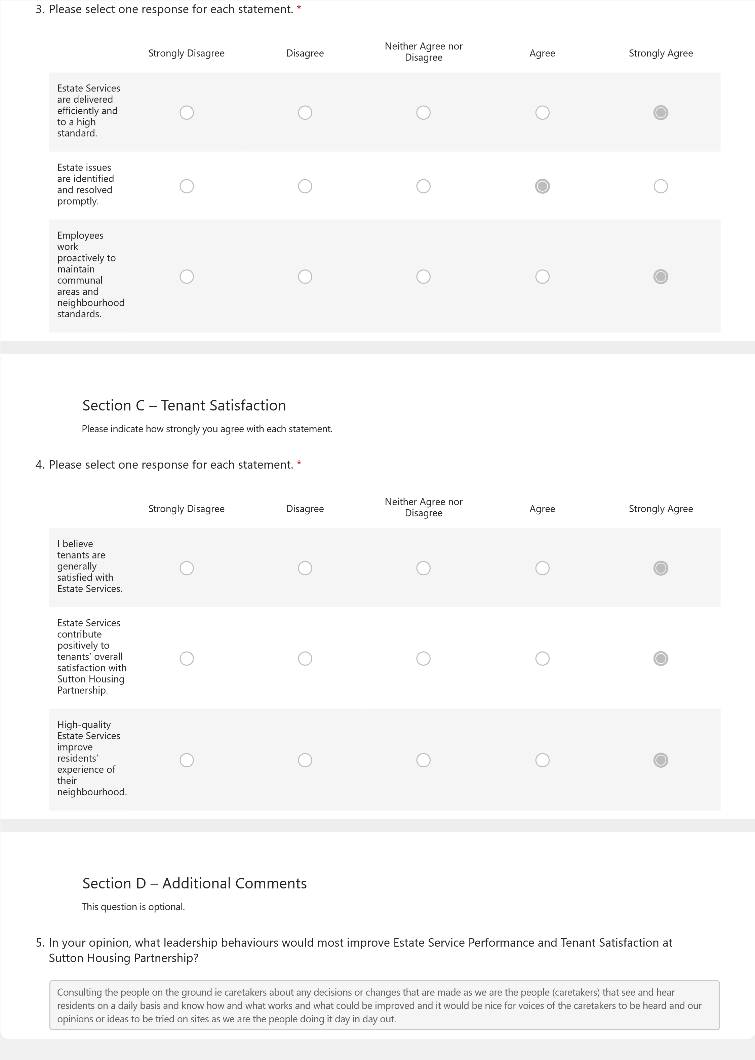
Source: Author’s own questionnaire created using Microsoft Forms.

Appendix 15: Statistical Analysis Output
This appendix provides supporting quantitative evidence for the statistical analysis presented in Chapter 4. Thirty-one questionnaires were returned; one response was excluded because informed consent had not been provided, leaving 30 valid responses (n = 30) for analysis. The anonymised composite scores used in the descriptive and correlational analyses are presented in Table A15.1.
Table A15.1. Anonymised Composite­–Score Output
Y | Z | AA | AB | AC | AF | AG | AH | AI
Transformational | Transactional | Servant | Participative | Laissez-faire Raw | Laissez-faire Reversed | Effective Leadership | ESP | Employees’ Perception of TS
4 | 4 | 4 | 4 | 1 | 5 | 4.2 | 4.0 | 4.0
3 | 3 | 2.5 | 2 | 4 | 2 | 2.5 | 3.0 | 3.7
4 | 4.5 | 3.5 | 3.5 | 1 | 5 | 4.1 | 4.0 | 4.0
5 | 5 | 4.5 | 3.5 | 1 | 5 | 4.6 | 3.7 | 4.3
4 | 4.5 | 4 | 3.5 | 2 | 4 | 4 | 4.0 | 5.0
3 | 3.5 | 3 | 2.5 | 3 | 3 | 3 | 3.7 | 4.0
4 | 4 | 3.5 | 3 | 2 | 4 | 3.7 | 4.3 | 4.7
5 | 5 | 5 | 4.5 | 1 | 5 | 4.9 | 5.0 | 5.0
4 | 4.5 | 5 | 3.5 | 1 | 5 | 4.4 | 5.0 | 5.0
4 | 3.5 | 4 | 3.5 | 1 | 5 | 4 | 4.7 | 4.7
4 | 4 | 4 | 4 | 1 | 5 | 4.2 | 4.0 | 4.0
4 | 4.5 | 4 | 3.5 | 1 | 5 | 4.2 | 4.0 | 4.0
4 | 4 | 4 | 4 | 1 | 5 | 4.2 | 4.0 | 4.0
4 | 4 | 4 | 3.5 | 1 | 5 | 4.1 | 5.0 | 4.7
4 | 4.5 | 4 | 3.5 | 1.5 | 4.5 | 4.1 | 4.7 | 4.7
3 | 4 | 4 | 3 | 1 | 5 | 3.8 | 4.7 | 4.7
4 | 4 | 4.5 | 4.5 | 1 | 5 | 4.4 | 4.0 | 4.7
4 | 4 | 4 | 3.5 | 1.5 | 4.5 | 4 | 4.3 | 5.0
4 | 4 | 4.5 | 4.5 | 1 | 5 | 4.4 | 5.0 | 4.7
4 | 4 | 4 | 4 | 1 | 5 | 4.2 | 4.0 | 4.7
4 | 3.5 | 4 | 2.5 | 1.5 | 4.5 | 3.7 | 4.7 | 5.0
5 | 5 | 5 | 5 | 1 | 5 | 5 | 5.0 | 5.0
5 | 5 | 5 | 4.5 | 1 | 5 | 4.9 | 4.0 | 4.0
5 | 5 | 5 | 5 | 1 | 5 | 5 | 4.7 | 5.0
4 | 4 | 4 | 4 | 1 | 5 | 4.2 | 4.0 | 4.0
5 | 3 | 5 | 5 | 1 | 5 | 4.6 | 5.0 | 5.0
5 | 5 | 4 | 3.5 | 1 | 5 | 4.5 | 4.7 | 4.7
4 | 4 | 4 | 4 | 1 | 5 | 4.2 | 4.0 | 4.0
5 | 5 | 4.5 | 4 | 1 | 5 | 4.7 | 4.0 | 4.0
4 | 4 | 4 | 4 | 1 | 5 | 4.2 | 4.0 | 4.7
Source: Author's statistical analysis using Microsoft Excel (n = 30).
Note: The dataset contains anonymised composite scores only. No personally identifiable information is included.
Composite-Score Calculation
Responses to the relevant questionnaire items were numerically coded and averaged to produce the five leadership-dimension composite scores. The same calculation procedure was applied to each leadership dimension.
For example, Transformational Leadership was calculated as:
Transformational Leadership = Mean of the two relevant questionnaire items
Example Excel calculation:
=AVERAGE(coded H2, coded I2)
The same averaging procedure was applied to Transactional, Servant, Participative and raw Laissez-faire Leadership, using their respective questionnaire items.
Reverse Scoring of Laissez-faire Leadership
Because higher raw laissez-faire scores represented less effective leadership behaviour, the raw laissez-faire composite was reverse-scored before its inclusion in the Effective Leadership composite:
Reverse Laissez-faire = 6 − Raw Laissez-faire
Excel formula:
=IF(AC2="","",6-AC2)
For example, a raw score of 1 became 5, while a raw score of 4 became 2.
Effective Leadership Composite
The overall Effective Leadership score was calculated as the mean of the four constructive leadership dimensions and the reversed laissez-faire score:
=IF(Y2="","",AVERAGE(Y2,Z2,AA2,AB2,AF2))
For example, for the first valid case shown in Table A15.1:
(4 + 4 + 4 + 4 + 5) ÷ 5 = 4.20
Estate Service Performance and Employees’ Perceptions of Tenant Satisfaction
The same averaging procedure was used to calculate ESP and Employees’ Perceptions of TS from the three questionnaire items representing each construct.
For example, the ESP composite was calculated as:
=AVERAGE(coded R2, coded S2, coded T2)

Descriptive Statistical Analysis
Means and sample standard deviations were calculated in Microsoft Excel for each leadership dimension and the three principal study constructs. The principal Excel functions used were:
=AVERAGE(range)
=STDEV.S(range)
The resulting descriptive statistics, including the mean, standard deviation and corresponding interpretation for each construct, are presented in Table A15.2.
Table A15.2. Descriptive Statistical Output
A | B | C | D
Construct | Mean | SD | Interpretation
Transformational Leadership | 4.17 | 0.59 | High
Transactional Leadership | 4.20 | 0.58 | High
Servant Leadership | 4.15 | 0.59 | High
Participative Leadership | 3.77 | 0.73 | High
Laissez-faire Leadership | 1.28 | 0.68 | Very Low
Effective Leadership | 4.20 | 0.53 | High
Estate Service Performance | 4.30 | 0.51 | Very High
Employees' Perceptions of Tenant Satisfaction | 4.49 | 0.44 | Very High
Source: Author’s statistical analysis using Microsoft Excel (n = 30).
Note: Laissez-faire Leadership is reported using the original (non-reversed) score; therefore, a lower mean indicates lower perceived use of laissez-faire leadership. The measure was reverse-scored only for calculation of the Effective Leadership composite.
Pearson Correlation Analysis
Pearson’s product-moment correlation was used to examine the relationships between the three principal study constructs: Effective Leadership, Estate Service Performance (ESP), and Employees’ Perceptions of Tenant Satisfaction (TS). The analysis examined the following hypothesised relationships: Effective Leadership and ESP (H₁); Effective Leadership and Employees’ Perceptions of TS (H₂); and ESP and Employees’ Perceptions of TS (H₃).
Pearson’s correlation coefficients were calculated in Microsoft Excel using the CORREL function. For example, the relationship between Effective Leadership (column AG) and Estate Service Performance (column AH) was calculated as:
=CORREL(AG2:AG31,AH2:AH31)
The same procedure was applied to the remaining hypothesised relationships using the corresponding composite-score columns. Statistical significance was assessed at p < .05. Table A15.3 presents the resulting Pearson correlation coefficients and associated p-values.
Table A15.3. Pearson Correlation Output
A | B | C
Relationship | Pearson's r | p-value
Effective Leadership ↔ ESP | 0.497 | .005
Effective Leadership ↔ Tenant Satisfaction | 0.343 | .063
ESP ↔ Tenant Satisfaction | 0.756 | p < .001
Source: Author’s statistical analysis using Microsoft Excel (n = 30).
The results show that Effective Leadership had a statistically significant moderate positive association with ESP (r = .497, p = .005). Its association with Employees’ Perceptions of Tenant Satisfaction was positive but not statistically significant (r = .343, p = .063). ESP demonstrated a statistically significant strong positive association with Employees’ Perceptions of Tenant Satisfaction (r = .756, p < .001).

ELEMENT 2
RESEARCH PROCESS REFLECTION

Gibbs’ Reflective Cycle

Research Process Reflection
Using Gibbs’ (1988) Reflective Cycle, I critically reflect on how completing this research challenged my assumptions, developed my judgement and changed how I understand evidence in professional practice.
Description
My research evaluated the role of leadership in Estate Service Performance and Tenant Satisfaction within Sutton Housing Partnership through an explanatory sequential mixed-methods case study. I combined an employee questionnaire, four manager interviews and organisational evidence. The process required adaptation: organisational permission took longer than anticipated, the research boundary was refined to Estate Services, and data collection had to be completed within a constrained timeframe while adhering to ethical requirements.
Feelings
Initially, my professional familiarity with Estate Services gave me confidence and appeared to be an advantage. However, I gradually recognised a tension within my insider position. The same experience that enabled me to understand the organisational context could also shape my expectations of what the research should reveal. I therefore became more conscious that confidence derived from professional experience should not be confused with research evidence.
Evaluation
Several decisions strengthened the research. Thirty-one of 48 eligible employees responded, and four managers contributed detailed perspectives, and integrating multiple evidence sources enabled more critical interpretation. Excluding the questionnaire response for which informed consent had not been provided was particularly important because it reinforced that ethical integrity takes precedence over maximising usable data. Conversely, I underestimated the time required to secure organisational permission. This was not simply an external difficulty; it exposed a weakness in my initial planning because organisational access should have been treated as a significant research dependency. Furthermore, employees’ perceptions of tenant satisfaction could not fully represent tenants’ own perspectives, limiting the conclusions I could legitimately draw.
Analysis
The greatest development in my thinking occurred when the findings challenged my original expectations. I anticipated that Effective Leadership would be positively associated with both performance and perceived tenant satisfaction. However, although leadership was significantly associated with Estate Service Performance, its association with perceived tenant satisfaction was not statistically significant. I learned that the purpose of research is not to validate an expected argument but to allow the evidence to refine or challenge it.
The qualitative findings extended this lesson by identifying staffing, workload, resources and cross-service dependencies as additional influences on performance. My understanding therefore shifted from a leadership-centred explanation towards viewing leadership as one organisational resource within a complex service system. I also learned to distinguish correlation from causation and contextual triangulation from statistical confirmation. Most importantly, reflexivity became practical rather than theoretical: I had to question whether interpretations arose from the data or from my existing workplace knowledge.
Conclusion
The research changed how I understand independent enquiry. I developed greater confidence not from obtaining expected results, but from being able to defend conclusions that were appropriately cautious, including findings that challenged my assumptions. I now recognise uncertainty and limitation as components of credible research rather than weaknesses to conceal.
Action Plan
In future, I would secure organisational access earlier, plan the analytical strategy in advance, allow greater recruitment time and incorporate direct service-user perspectives. I would also maintain a reflexive research diary to document assumptions and methodological decisions. Professionally, I will apply the same discipline by questioning intuitive explanations, seeking competing perspectives and distinguishing experience from evidence before making leadership or service-improvement decisions.
References
Gibbs, G. (1988) Learning by doing: A guide to teaching and learning methods. London: Further Education Unit.

ELEMENT 3
METHODOLOGY POSTER

Research Process (Methodology) and Findings (Research Output)

Poster Overview
This poster provides a visual summary of the research process and principal findings of the study, Evaluating the Role of Leadership in Estate Service Performance and Tenant Satisfaction: A Case Study of Sutton Housing Partnership. It presents the explanatory sequential mixed-methods methodology, including the research design, participants, data-collection methods, analytical procedures and ethical considerations. The poster also summarises the quantitative survey findings, qualitative themes developed from the manager interviews and the integration of these evidence sources with organisational KPI and TSM data. The findings highlight the relationship between Effective Leadership, Estate Service Performance and employees’ perceptions of Tenant Satisfaction and provide evidence-based recommendations for leadership and service improvement within Estate Services.



