

An Investigation into the Available Software Solutions for the Management of Documentation and Recordings in the Childcare Profession

By
Jonathan Thomas
241978

Supervisor: Jeanette Adams
Second Marker: John Williams

Project submitted as part of the requirements for the award of BSc (Hons) Computing and Information Systems Networks

April 2018

Declaration Form

I JONATHAN THOMAS declare that I am the sole author of this Project; that all references cited have been consulted; that I have conducted all work of which this is a record, and that the finished work lies within the prescribed word limits.

This work has not previously been accepted as part of any other degree submission.

Signed:

Date: 22/04/2018

Form of Consent

I JONATHAN THOMAS hereby consent that my Project, submitted in candidature for the B.Sc.(Hons) Computing & Information Systems degree, if successful, may be made available for inter-library loan or photocopying (subject to the law of copyright), and that the title and abstract may be made available to outside organisations.
Signed:

Date: 22/04/2018

Abstract
In the present day, where computer technology and the internet drives businesses, the challenge to modernise is one faced in all industries. Following decades of milestone events and cultural shift, the traditional family dynamic has changed resulting in an increased demand for professional childcare as more parents pursue employment. In the UK, it is a legal requirement that childcare providers create and maintain recordings pertaining to the children for whom they care and that these records be available to legal guardians and governing bodies. Although the legal requirement to create, maintain and present recordings exists, at present there appears to be no industry-standard means of doing so.

This paper focuses on the design, development and evaluation of a bespoke web application with the aim of providing childminders the functionality to create and maintain recordings and present them in a digital format. A responsive web application, accessible on a range of internet devices, will be developed using common web technologies including HTML, CSS, JavaScript and PHP and driven by a MySQL backend database.

The following methodologies will guide the progress of this project:
- Research Onion – Research will be undertaken following Saunders’ Research Onion methodology.
- Feature Driven Development – Development will be undertaken following the Feature Driven Development methodology.
Valuable features to be developed include:
- Daily diary recording.
- Accident recordings.
- Invoice creation.
- Receipt creation.
- Access to policies, procedures and other important documents.
Success of the project will be determined using the following methods:
- Criteria-based Assessment – The project will be determined successful if all of the aims, objectives and requirements have been satisfied.
- User Acceptance Testing – Testing and evaluation will be performed by the client to determine the perceived level of success.
The final solution successfully meets all of the established aims, objectives and requirements yet leaves scope for future improvements and developments.

Contents
Abstract 3
1 Introduction 6
2 Research and Review of Literature 9
2. 1 Childcare Profession in the UK 9
2.2 Early Years Education 10
2.3 Cultural Shift 10
2.3.2 Changing role of men 12
2.3.3 Family roles 13
2.4 Modern-day Childcare 15
2.4.1 Modern-day Demand 17
2.5 Benefits and Drawbacks of Childcare 18
2.6 UK Legislation 18
2.6.1 Additional legal considerations 21
2.7 Available Tools 21
2.7.1 Nursery Genie 21
2.7.2 MyMontessoriChild 22
2.7.3 iChildCare 23
2.7.4 Independent Childminder 24
Conclusion 24
2.8 Potential Methods and Technologies 25
2.8.1 Locally installed software 25
2.8.2 Mobile Application 26
2.8.3 Web-based Application 27
2.8.4 Conclusion 28
2.9 Critical Review 29
3 Research and Development Methodologies 30
3. 1 Research Methodology 30
3. 2 Evaluation and Success Criteria 32
3.2.1 Success Criteria 32
3.3 Development Methodology 33
4 Design and Implementation 35
4. 1 Website 35
4.1.1 Mood Board 35
4.1.2 Sitemap 36
4.1.3 Content Plan 36
4.1.4 Wireframes 37
4.2 Web Application 38
4.2.1 Database design 38
4.2.2 Database Design Decisions 45
4.2.3 Wireframes 45
4.2.4 Functionality 46
4.3 Implementation 50
4.3.1 Website 52
4.3.2 Web App 53
4.3.3 Responsive 60
4.4 Testing 65
4.4.1 Unit Testing 65
4.4.2 System testing 67
4.4.3 User Acceptance Testing 67
5 Evaluation 68
5.1 Criteria-based 68
5.2 User Acceptance Testing 70
5.3 Conclusion 71
6 Conclusions and Recommendations 72
6.1 Conclusions 72
6.2 Recommendations 73
7 Reflection 75
8 Reference List 78
9 Appendices 88

1 Introduction
This report will require comprehensive research to be undertaken into the historical and cultural factors behind professional childcare in UK. In Wales, professional childcare settings are regulated by Care and Social Services Inspectorate for Wales (CSSIW) and are expected to conform to local and national policies, laws and acts. As part of this agreement CSSIW issue National Minimum Standards by which they expect professional childcare settings to conform. The literature review will consider the impact of these standards of childcare settings.

This project will focus largely on Swansea-based childminding business, Little Flowers. Little Flowers conform to CSSIW’s Standards yet still rely on a paper-based method of record creation. By their own admission, this means of record keeping is inefficient and a burden on both time and resources. Little Flowers wish to digitise this aspect of their business in an attempt to increase efficiency and reduce their dependency on physical resources such as paper and printing ink. In addition, Little Flowers also wish to be able to distribute daily diary recordings, accident records and invoices to parents using a digital format.

The working hypothesis is that while CSSIW legally expect recordings to be generated, maintained and presented to the appropriate people as yet there is no industry standard means of doing so.
To achieve success in the development of a suitable solution it will be necessary to conduct the aforementioned research into the history of childcare in the UK to fully value its current position. Following a comprehensive literature review, research into currently available tools will be undertaken. In addition, research will be conducted with regards to suitable research and development methodologies. Finally, a highly detailed design, development, implementation and evaluation process will be performed and recorded culminating in a final solution.

For this project to be considered successful it must meet all of the predetermined aims, objectives and requirements set forth by the author and Little Flowers. The overarching aim of this project is to develop a solution that increases Little Flowers’ business efficiency, diminishes their dependence on physical resources and identifies a solution that allows staff to create, maintain and distribute recordings and documents while allowing parents the opportunity to easily access information about their children.

1.1 Little Flowers Childminding
Founded in January 2007 by Sarah Price, Little Flowers is a registered childminding business based in Swansea, Wales. Little Flowers founder Sarah continues to manage and co-ordinate the activities of the business alongside her husband and business partner James Price. Little Flowers operate from the Price’s family home which is well-equipped to entertain, educate and care for children in a safe and nurturing environment. Little Flowers are registered with the CSSIW and insured with Morton Michel, childcare insurance specialists. Little Flowers adopt the Welsh Government’s Foundation Phase Framework as a guideline for the educational curriculum they provide. This framework places the child at the centre of activities and promotes equality, celebrates diversity and encourages the holistic development of the child through experiential activities [1]. Little Flowers offer a multilingual learning environment, both indoor and outdoor activities, the promotion of healthy eating and lifestyle choices and much more.

In addition to adhering to and obeying the regulations and policies expected of them as a professional childminding setting, Little Flowers also set themselves high standards and observe a set of principles and values that ensure they provide high quality service, security and safety to the children in their care. In their statement of purpose Little Flowers make it clear that in all of their practices child welfare and safety is paramount. Little Flowers consider open communication with parents a fundamental factor to the success of the service they provide. Parent’s input and views are invited and welcomed, allowing them to be a vital component in the service provided to and the development of their child. The following is a condensed list of the aims and objectives of Little Flowers:
- Little Flowers’ motto is “Helping Children Grow”. Little Flowers wish to see each child in our care grow and develop and “flourish in their time with us with the view of achieving their full potential”.
- Little Flowers aim to encourage creativity, self-expression and imagination through various games and activities. Little Flowers also encourage and develop language and communication through a range of play, story-telling and other activities.
- Little Flowers aim to be positive role models, promoting social skills and encouraging polite behaviour and respect for others. Little Flowers promote and develop positive attitudes to differences of race, culture, gender, language and ability. Little Flowers wish for children to develop a strong self-image and a sense of belonging by gaining knowledge and understanding of their own culture and background.
- It is important to Little Flowers that parents are able to leave their children knowing that they are in safe hands and are having a very positive and enjoyable experience.
- Little Flowers also believe in continued professional development and actively seek opportunity to further their knowledge and skills.
At present Little Flowers operate a paper-based system to manage documentation and recordings. For example, Little Flowers complete a daily diary for each of the children in their care. The daily diary is used to give parents an account of the child’s day including their general mood, the activities they have been involved in and what they have eaten. These diaries are paper booklets that are completed by hand at the end of each day and take a considerable amount of time to complete. Little Flowers believe that diaries, along with a number of other processes, would benefit from being digitised. By digitising a number of their key processes and documents Little Flowers aim to become more efficient by reducing the time necessary to complete diaries and also reducing their carbon footprint by diminishing their reliance upon physical resources such as paper and printing ink. In addition to this increased efficiency, the opportunity to digitise the completion of daily diaries would allow Little Flowers to keep a digital record of children’s activities for future reference.

The following list includes some of the documents that are currently paper-based that Little Flowers wish to be able to complete and make available via a digital platform:
- Daily diaries.
- Photos and videos.
- Policies and procedures documentation including:
  - Risk assessments.
  - Statement of purpose.
  - Fire and escape policies.
  - First aid policies.
  - Food hygiene policies.
- Liability insurance certificate.
- Invoices and receipts.
- Accident forms.

2 Research and Review of Literature
A critical review and analysis of the available literature pertaining to childcare and related fields is expected to provide invaluable insight into the profession. Research will be undertaken with regards to the current legislation and principles to which professional childcare settings must adhere and the means, methods and technologies available and in use to meet the expectations placed upon them.

2.1 Childcare Profession in the UK
The history of childcare in the UK spans back over a great number of years and has long been a vital service to the British public. Throughout British history individuals have been employed to raise, care for and educate children in a number of different settings. For example, during Victorian times it was not uncommon for those families wealthy enough to employ a nanny to care for the children [2]. It was also not uncommon that those families wealthy enough were also able to send their children to local privately funded schools given that no publicly available system of education was made available in the UK until the 19th century [3]. For the working class of Britain however, schools and childcare were an unthinkable concept as children were instead required to join the workforce and bring home a wage. In 1821, during the height of the Industrial Revolution, 49% of the UK’s workforce was made up of individuals under the age of twenty with children as young as five working in agriculture and as chimney sweeps [4]. Entering the 19th century, the role of children (particularly in less wealthy families) was to act as a ‘little adult’ and to perform the tasks expected of an adult. This attitude slowly shifted throughout the century. Throughout the 19th century a number of initiatives sprung up signalling this change in cultural attitude towards children:
- Factory Act 1833 – In 1833, the Government passed the Factory Act which gave young children some basic rights. These rights included the protection that factories should not employ children under the age of nine, that those child employees over nine years old were limited on the number of hours they could work in a day and significantly that child workers would receive two hours of schooling each day. [5]
- Industrial Schools Act 1857 – In 1857, the Government gave magistrates the power to sentence criminal and vagrant children to a period of time in industrial school. The intention of the industrial schools was to remove children from vulnerable situations where they be drawn into crime and instead give them education and training in a particular industrial skill. [6-7].
- Education Act 1870 – Although religious privately funded and industrial schools were in operation, for the few it wasn’t until 1870 that the inaugural piece of legislation on national education was passed. The Education Act 1870 stands as the first recognised commitment by the UK Government of a national provision for education for children.
- National Society for the Prevention of Cruelty to Children (NSPCC) 1884 – After being founded in 1884 [8] the NSPCC played an integral role in campaigning for protection of children with their first major breakthrough in 1889 when the first ever UK law protecting children from abuse was passed [9].
These initiatives are just some of the key examples and milestones in the changing cultural perception of the role of children through the 19th century. Of course, the misuse and poor treatment of children did not end overnight but what followed for many years was a continued improvement in the cultural perception and the protection of children. Another major milestone in this cultural shift was the acceptance of the Declaration of the Rights of the Child by the League of Nations (including the UK) in 1924 following the World War One [10].

2.2 Early Years Education
During the 19th and 20th centuries with much of Europe undergoing similar transformation it was from the continent that some of the most influential pioneers of childcare and early years education emerged. Possibly the most influential among these was German philosopher and educator Friedrich Fröebel. Having spent a vast number of years as an educator and advocate for early years learning, Fröebel is most famous for coining the term ‘kindergarten’ (German for ‘children’s garden’) in 1840, a name he had given to his institution opened in Blakenburg in 1837 [11]. Fröebel placed a great deal of importance on the naming of his institution rejecting suggestions such as ‘infant school’ stating that his kindergarten would a be place where children were not schooled but freely developed. By supplying a range of selected toys and apparatus to the kindergarten, Fröebel established a learning through play approach to developing children [12].

Closer to home, it was the somewhat controversial Welshman Robert Owen who established the UK’s first infant’s school in New Lanark in 1816. The controversy regarding Owen related to how he profited greatly from the industrial revolution which exploited child labour [13]. Although providing a means of education to children, Owen claimed that children “will always amuse each other without useless childish toys” [14] - a belief fundamentally different to that of Fröebel who encouraged learning through play and the freedom to imagine. Fröebel’s principles of freedom and guidance continue to form the basis of many childcare settings in the modern-day.

In the years that followed World War One, with less children in the workforce and the start of World War Two in 1939, an increase in childcare provision was needed. This provision of childcare across the UK was necessary to account for the absence of fathers serving in the Armed Forces and mothers who had taken on employment to support their family and fill the gap left by those men fighting the war. It was during World War Two that the Education Act 1944 stated that local education authorities should provide provision of nursery schools for children under five years [15] marking a significant development in childcare and early years education. Following the war, the provision for childcare continued to grow but not necessarily at a rate that matched the demand. Following the war many women who had taken on employment chose to continue in their roles [16].

2.3 Cultural Shift
2.3.1 Changing role of women
World War Two brought an inevitable widespread change to the UK workforce and the role of women in society. With the British Army increasing in size from one million men in September 1939 to 3.5 million men by the end of the war, it was unavoidable that women would be so heavily relied upon to fill the gaps left by men [17]. With the war taking a major toll on Britain, women found themselves becoming a vital component in success. From 1941 women were called to fill roles as engineers, mechanics and driving emergency vehicles and by mid-1943 almost 90% of single women and 80% of married women were employed in factories, agriculture or in the Armed Forces. Women accounted for over 640,000 positions, among these included the then Princess Elizabeth [18]. Following the war, as men returned (though not as many that left) many women were forced to leave their job roles. Within a year of the war ending over a million women had left their jobs [19]. Women in employment had been expected to return to the 1930’s gender role of looking after the home and “servicing a male breadwinner as his dependent” but what was clear is that for many women the war had given them an opportunity to understand their worth in the workplace and that “the place of women after the war was not exactly what it had been in 1939” [20].

In an American study (where the attitude towards the role of women was very similar to that of Britain) found that in 1900 only 25% of women worked outside of their home. Following a sharp increase of women in the workforce during World War Two and rapid decline following the war the percentage of women in work grew from 30% in 1950 to 50% in 1980 [21]. In the UK, the Office for National Statistics (ONS) cites World War One as an initial opportunity for women to move into industry and that continued change in attitudes, particularly around the 1960s, played a large part in the increase from five million women in the workforce in 1900 to thirteen million by the year 2000. This increase saw women make up 46% of the workforce by the year 2000 [22]. Alongside the cultural shift of attitude towards the role of women in society was a number of other factors that influenced the positive incline in women in the workforce. Over a number of years, manufacture and heavy industry found itself becoming more automated and less reliant upon physical exertion making them more accessible industries for women. Another major component was the introduction of the aforementioned Education Act 1944. In 1922 female students made up just 23% of the 10,000 degrees obtained in the UK; by 1993 female students represented 45% of degree recipients [22]. This incline in female degree recipients can largely be attributed to the Education Act 1944 that afforded more girls access to education and inevitably led to the greater representation of females receiving degrees. With a greater percentage of educated females, it is natural that more women would also desire a professional career than in previous generations. In addition, the Education Act 1944 also afforded women more free time than they had previously been used to owing to children attending formal education.

Figure 1 shows the positive incline of female representation in the UK workforce between 1971 and 2017:

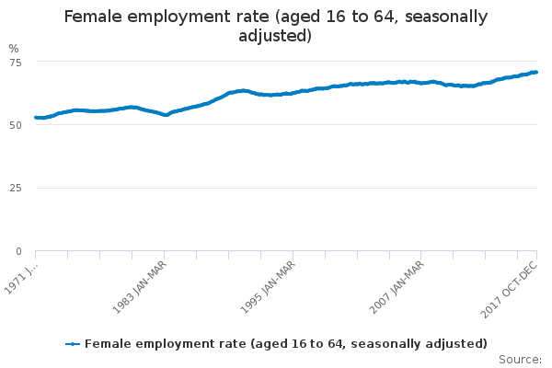
Figure 1 – Female employment rate graph. [23]

2.3.2 Changing role of men
While the 20th century as a whole brought about a dramatic change for women across the UK it was the later decades that saw a change in the cultural attitude towards the role of men. According to a British Social Attitudes survey conducted in 1984, 49% of those questioned agreed with the statement “a man’s job is to earn money; a woman’s job is to look after the home and family”. When the same statement was proposed in 2012 the findings showed a significantly lower rate of people held this view with only 13% agreeing with the statement [24]. With an increased female representation in the workforce this has also been a factor on the changing role of men and fathers. In working families, maternal breadwinning is on the rise with 33% of working mothers earning at least half of the household income [33]. Studies have found that in two-parent families where the mother is employed, weekly paternal engagement with children is substantially higher than in families with unemployed mothers. This suggestion is challenged though by the fact that working mothers spend less time with their children meaning fathers are only proportionally more engaged [25]. Although in most families the amount of time fathers spend playing with their children falls short of maternal engagement, studies suggest that a child’s play with a father is generally more stimulating and emotionally arousing due to a more boisterous nature and may make their time with children more influential [25]. Though the general perception is that mothers are more affectionate than fathers a meta-analysis of 172 studies conducted by psychologists Lytton and Romney found little or no difference in seven areas of parenting including “warmth, nurturance, responsiveness, encouragement of dependence, restrictiveness, low encouragement of independence, and disciplinary strictness” [26-27].

2.3.3 Family roles
In keeping with the apparent change of public attitude towards the role of parents, in 2015 the UK Government launched its Shared Parental Leave (SPL) initiative. The SPL initiative affords eligible parents the opportunity to share leave from employment between both mother and father equally [28] rather than the two week limitation imposed on fathers prior to its inception in 2015. One year following the initiative’s launch the UK Government commissioned a survey that found if money were no issue then 53% felt that the responsibility of looking after children should be shared equally [29]:

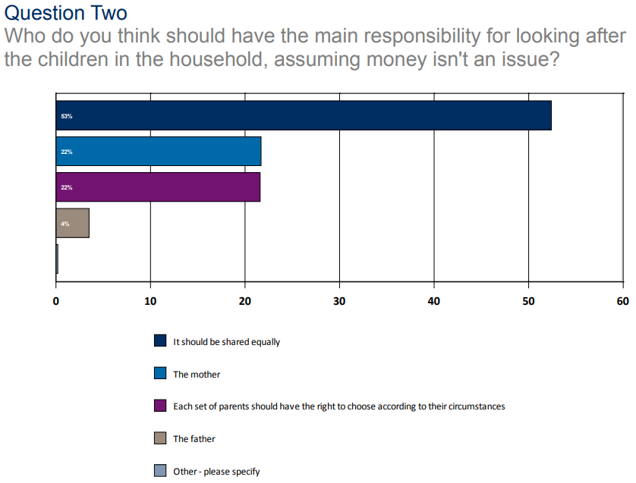
Figure 2 – UK Government SPL Survey. [29]
Although the majority of those surveyed felt that responsibility should be shared this did not reflect in the statistics of how SPL was actually allocated between parents. Of those fathers questioned, 74.8% said that if SPL had been available when they had children they would have considered it and an even greater 85.9% suggest they will consider it for future. The staggering reality though is that just 1% of men are applying for SPL according to a survey commissioned by My Family Care and the Women’s Business Council [30].

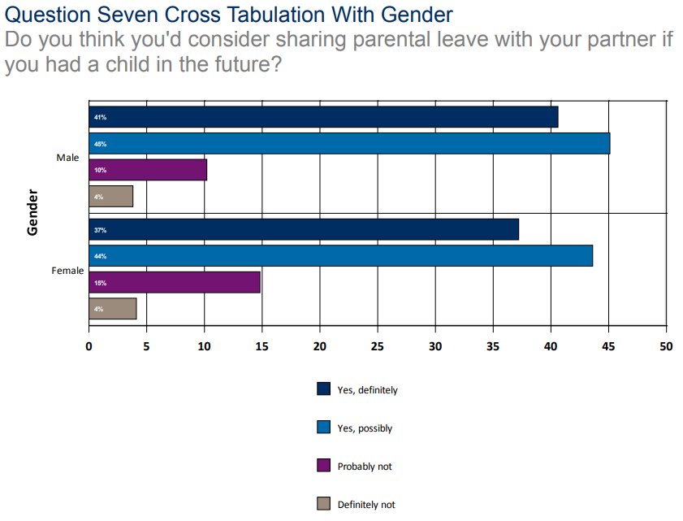
Figure 3 – UK Government SPL Survey. [29]
The astonishingly low uptake of SPL can be attributed to a number of factors though in the main it pertains to financial insecurity and the possibility of a negative effect on the father’s career. Of those fathers questioned, 38% state they would be financially worse off for taking shared parental leave.
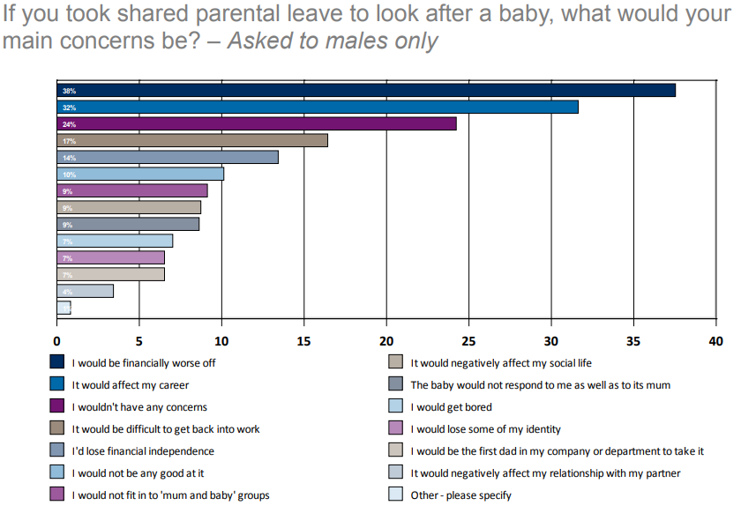
Figure 4 – UK Government SPL Survey. [29]
In addition to the financial and practical implications of fathers taking SPL there also seems to be resonating values of old. When asked why mothers should have the main responsibility of looking after a baby, 69% of participants agreed that mothers make more natural parents. When the same questioned was reversed only 3% of participants felt fathers make more natural parents.
While the statistics analysed seem to tell a rather mixed story, the truth is that they only focus on a rather specific issue. The introduction of SPL gives a clear indication that public attitudes are challenging the stereotypically assumed roles of mothers and fathers in the family. Unfortunately, it seems that although SPL is an example of a well-intended initiative many families are unable to utilise it as it would have a negative impact on their household financially. In two-parent families, 48% of parents surveyed both work full-time with 72% claiming they use evenings and weekends to catch-up on work. In addition, 47% of those questioned said that over the last two years it has become more financially challenging to raise a family [31].

In 21st century Britain there is no such thing as a typical family unit [32]. With maternal breadwinning being true for 33% of families [33], 46% of the UK workforce being made up of women [22] and the university gender gap being greater than ever with 30,000 more females attending university in this academic year than males [34] it is inevitable that the traditional view of gender roles is being challenged more than ever before [26]. As women continue to excel both academically and professionally and men continue to assume the role as a family’s primary breadwinner the unavoidable outcome is that childcare as a profession will be required to play an integral part of supporting parents to continue working.
2.4 Modern-day Childcare
Having considered key contributory factors, with a particular focus on the last 70 years, it is clear that childcare as a profession is a necessity in modern-day Britain. In Wales alone the childcare profession employs over 17,000 people and it is believed that by providing this service parents go on to generate an estimated £1.2 billion in annual income [35]. Welsh Government consider childcare to be a growing profession and recognise the role it plays in supporting economic growth and reduction of poverty in the country. This growth in childcare is exemplified by the incline of available childcare places from 76,000 in 2012 to 84,000 in 2017 [35].

The childcare profession in Wales operates in a number of formats giving parents the option to find a solution that best fits the needs of their family:
- Childminders – Registered childminders care for children in their own home and are often smaller in number than other settings.
- Day care (Sessional) – Sessional day care settings usually operate AM and PM sessions which is more suited to parents who may only require the service for a specific part of the day.
- Day care (Full days) – Full day settings provide care for the whole day. For example, 8am - 5pm.
- Out of School – These settings provide care for children of school age before or following the school day.
- Open Access Play Provision – Play provision can be located in a variety of settings and may or may not have a premises. It is staff supervised, but child-led play activities where children have a wide range of freedom to play as they wish within safety guidelines.
- Crèche – Crèche is considered occasional day care for children up to 12 years old on non-domestic premises.
[36]

In December 2016, CSSIW had 4,012 registered childcare providers. Figure 5 depicts the proportional representation of these childcare settings according to type:

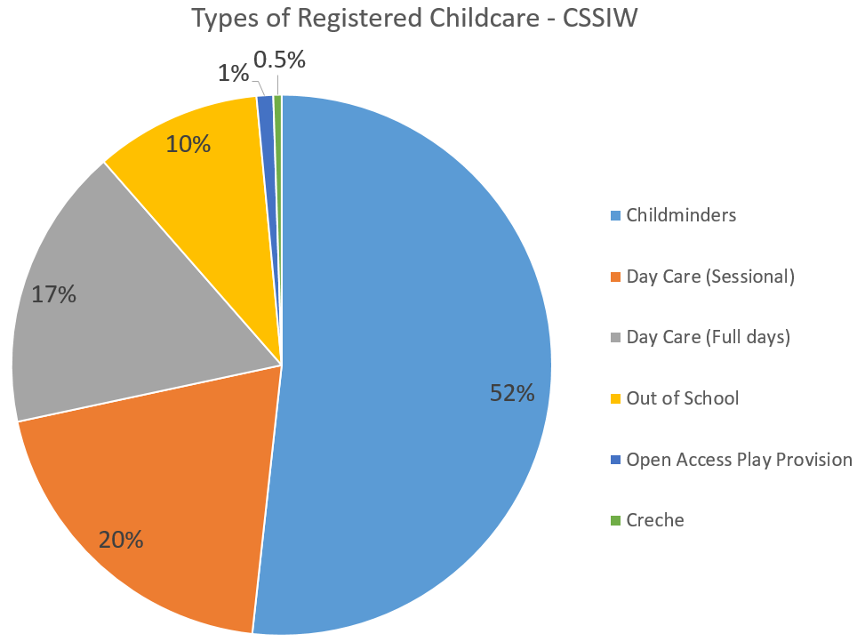
Figure 5 – Childcare Settings Chart. [35]
Registered childminders account for over half of all registered childcare providers in Wales and are significantly larger in representation than other types of childcare setting.

Figure 6 depicts the ownership of registered childcare settings in Wales:
- Private – Private childcare settings are owned privately and operate by charging parents a rate to care for children. This rate can be defined by hours, sessions, days or however the setting sees fit.
- Public – Public childcare settings are operated by local government and authorities. These settings are usually non-domestic and offer childcare to some of the most disadvantaged communities in Wales [37].
- Voluntary – These account for the majority of sessional care providers such as play groups.
- Other – Data is not provided for the ‘Other’ 5%.

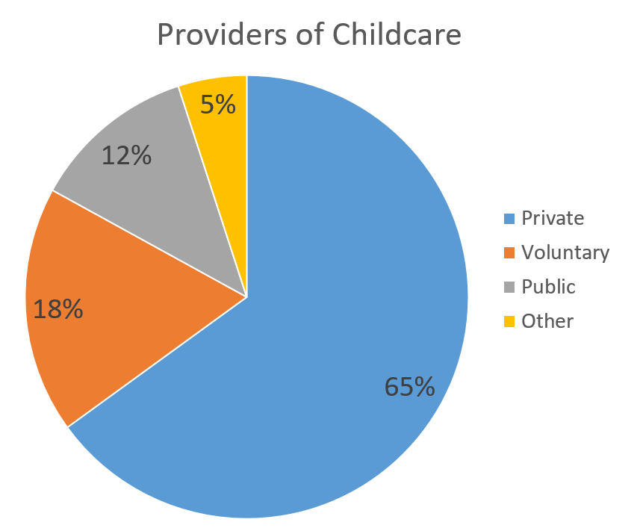
Figure 6 – Childcare Settings Chart. [35]

2.4.1 Modern-day Demand
Childcare as a profession, according to Welsh Government is growing but the question now is whether or there are enough childcare places available to meet demand. According to the Childcare Capacity report issued by Welsh Government there are approximately 175,000 children up to the age of four living in Wales and a total of just less than 80,000 childcare places available [38]. Welsh Government recognise the need for increased provision in the Childcare Capacity report stating “the childcare sector in Wales has been given priority sector status and funding has been announced for business support services for childcare providers” [39]. Welsh Government are also introducing a scheme where working parents of three and four year olds are provided thirty hours of free childcare per week for forty-eight weeks of the year [40]. The major problem faced by Welsh Government is that the Childcare Capacity report indicates that there are 46,000 children eligible for full day places yet only 45,000 spaces are available [38]. It is highly unlikely that all of those eligible would take up the offer but does give an indication of the high demand for professional childcare services in Wales with some areas of Wales having no professional childcare availability whatsoever.

Welsh Government’s proposal to offer thirty hours of free childcare to working parents is being heralded as a welcome relief. In focus groups and meetings with the public Welsh Government recognise that for many families large portions of income were being spent on childcare [41]. According to Family and Childcare Trust’s Childcare Survey 2017, parents working part-time and requiring twenty-five hours of childcare with a private childminder can expect to pay an average of £101.03 and those requiring fifty hours paying an average of £193.84 [39]. Put into the context, the median gross weekly earnings in Wales amount to £498.40, the lowest in the UK which amounts to a take-home wage of £401.98 after tax and National Insurance [42]. Based on the median gross weekly earnings above, the average childcare cost would demand a sizeable 48% of the earner’s weekly wage. Alternative childcare provisions and family support have been considered (See Appendix A).

2.5 Benefits and Drawbacks of Childcare
Having considered and analysed a number of key areas relating to childcare, the most important factor yet to be considered is the impact on the child. The impact of childcare on children is a difficult area to study and analyse in quantitative measures owing to the fact that childcare settings differ so greatly. What is generally agreed though is that both positive and negative impacts on a child’s behaviour and development are influenced greatly by the quality of care the child receives [43]. The initial theory by many scholars is that non-parental childcare could be risky for children and that separation from parents can have negative psychological and behavioural impact but research has gone a great way to debunk this misconception. The Encyclopaedia on Early Childhood Development who conducted research into the field found that good quality childcare benefits almost all children who enjoy positive relationships with childcare providers [44]. It was found that positive childcare experiences help develop a child cognitively and behaviourally by opening extended social worlds to children and that relationships with parents are not harmed by childcare experiences [44]. In addition, studies found that ideal environments combine quality, affordability and accessibility and that a setting offering these to a high standard are critical for long-term benefits [45]. Having considered a number of studies and resources it is clear that the impact of childcare hinders on the quality of care provided in much the same way that children are influenced by the quality of parenting they receive. Separation from parents has no negative impact where children are cared for in a high quality setting and is positively associated with cognitive development [46].

2.6 UK Legislation
Given the very nature of its service, it is absolutely necessary that the childminding profession is regulated by a governing body. In Wales, CSSIW all childcare professionals must register with and adhere to the standards of CSSIW in accordance with The Regulation of Child Minding and Day Care (Wales) Order 2016 [47]. Focusing on professional childminders, it is a requirement to register with CSSIW where an individual is paid to care for one of more children under the age of twelve in their own home [48]. In their most recent annual report, CSSIW indicate that there are currently 2,340 registered childminders in Wales offering a total of 16,531 childcare places [49]. These professional childminders must comply with the National Minimum Standards for Regulated Childcare provided by CSSIW. The National Minimum Standards consists of twenty-five standards covering areas such as record keeping, quality of care and the management of services. To ensure compliance with these standards, CSSIW conduct full and focused inspections of childcare settings [50].

The following is a summarised list of the National Minimum Standards for Regulated Childcare provided by CSSIW:

Information on Service
Parents should be provided with all of information they may require to make an informed decision. This should include information about the business including a Statement of Purpose.

- Information
- The Contract

Planning for individual needs and preferences
The individual needs and requirements of a child should be assessed, recorded and accounted for in the quality of care delivered by the childminding professional.
- Assessment
- Meeting individual needs
- Records

Empowering service users, encouraging lifestyle choices
Parents must be kept involved and informed about the activities, achievements and noted progress and development of their child.
- Working in partnership with parents
- Opportunities for play and learning

Quality of care
Children should feel secure, happy and comfortable with their carers and in the childcare setting. The rights of children must be upheld and respected.
- Nurture and well-being
- Behaviour
- Healthcare
- Medication
- Food and drink

Staffing
Suitably trained, qualified and experienced individuals should be employed in childcare settings to ensure that the needs of children are fully met.
- Suitable persons

Conduct and management of the services
Both parents and carers benefit from a well-organised childcare setting. Staff to child ratios should remain in accordance with best practice guidelines. It is also imperative that the business operates sound financial procedures to offer a consistent high quality service.
- Organisation
- Staffing ratios
- Equal opportunities
- Financial procedures
- Quality assurance

Complaints, protection and notifications of significant events
In the event that a parent is compelled to make a formal complaint they should feel confident that their complaint will be listened to and taken seriously. Children are respected and protected and parents are informed of anything that may impact their care.
- Complaints
- Child protection
- Notifications of significant events

The physical environment
The environment in which children are cared for should be safe, secure and suitable for the purpose and activities of children. Childminders must adhere to additional relevant legislation such as the Health and Safety at Work Act 1974.
- Environment
- Equipment
- Safety
[36]

Of the National Minimum Standards, standards five and six make specific reference to the importance and necessity of record keeping and communication. Standard five highlights the key recordings that must be kept which includes:
- Business Contact Information.
- Records of child accidents.
- Records of first aid.
- Records of children’s special dietary requirements / allergies / medical information.
- Documentation showing the procedures in the event of a child being lost or not collected.
In addition, standard five dictates that parents and CSSIW be allowed “access as appropriate to a full range of records maintained by the registered person for the smooth running of the setting” [36] to ensure that lines of communication are open and accessible.

Furthermore, standard six which is entitled “working in partnership with parents” requires that “parents are kept fully involved in and informed about their child’s activities, achievement and progress” [36]. While the regulations do not specify that a daily recording must be produced for each child, by doing so Little Flowers ensure that they are honouring their own principal of effective communication with parents, that they are meeting standard six of the regulations and also generating official recordings that can be referenced at a later date should they be required. Keeping regular recordings of the activities and progress of the children in their care is an effective means of involving parents in the development of future care for their children and bridges the gap between care in the home and care in the childminding setting.

In addition to the childcare focused policies and law, Little Flowers must also adhere to further common workplace laws identified in (See Appendix C).

2.6.1 Additional legal considerations
The primary goal of this project is to digitise a number of documents and businesses processes for Little Flowers. Subsequently, it is of the utmost importance that all investigation and development is done so well-within legal and ethical boundaries. The development of this project will at no point require the sharing of actual data or information relating to a minor nor will contact be appropriate with a minor or parent of a minor either directly or indirectly. All documentation provided by Little Flowers will be blank, completed with fictitious data or have all personally identifiable information and media redacted. These safeguards will ensure that the proposal and project do not infringe upon or contravene with the Data Protection Act 1998 [51].

In the design, development and deployment phases of this project particular consideration will be given to principle seven of the Data Protection Act that states “appropriate technical and organisational measures shall be taken against unauthorised or unlawful processing of personal data and against accidental loss or destruction of, or damage to, personal data.” [52].

2.7 Available Tools
To gain a wider understanding of currently adopted childcare record keeping tools and to identify a potential solution for Little Flowers time has been taken to contact local childcare settings. As expected, each setting was in full compliance with CSSIW’s standards but seemed to manage the responsibility of record keeping with varying approaches.

2.7.1 Nursery Genie
A senior nursery nurse at Treetops Day Nursery stated that they currently use a combination of both physical and digital recording processes. Staff at the nursery use a software package called Nursery Genie [53]. It was explained that daily diaries for children were completed by hand to make them more personal to each child. Nursery Genie is also adopted by Mes Enfants in Swansea and Pobl Bach in Carmarthenshire.
Nursery Genie is developed by software company Care Software based in Swansea. Nursery Genie boasts a number of features including checking in and checking out, meal time records, accident recording and more. Having spoken to a representative of the Nursery Genie product I was informed that Nursery Genie only works on Windows PCs and tablets and was developed in the C# programming language. The application itself is locally installed meaning the user must be on the device it is installed on to use it, but the data can be accessed remotely. The problem here is that should the device become non-operational or Little Flowers desire to complete recordings from a separate device they would not be able to do so.

Nursery Genie is designed for clients operating a nursery environment where a larger number of children are cared for. To access many of the features that Nursery Genie boasts requires the client to subscribe to the premium monthly contract. While the cost of a premium contract may be an acceptable in a larger scheme, it would be too significant an outgoing for Little Flowers. Nursery Genie is a feature rich solution with an intuitive user interface but unfortunately its limitation to a single device and relatively high monthly cost make it unsuitable for Little Flowers.
Table 1 - Advantages and disadvantages of Nursery Genie
Nursery Genie
Advantages | Disadvantages
UI is user friendly and intuitive. | NG is not available outside of a Windows environment.
Email integration allowing reports and information to be sent digitally to parents. | Parents unable to view previous recording/information relating to their child.
Integration with other tools specifically invoicing software such as ClearBooks, QuickBooks and Sage. | Pricing only allows for touch screen/tablet licenses on the premium package (£180/month).

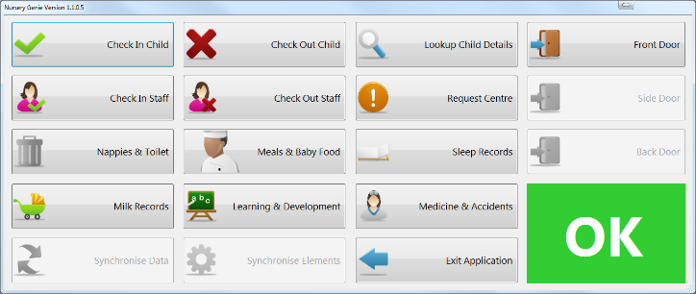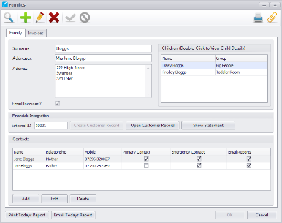
Figure 7 – Nursery Genie Screenshots.

2.7.2 MyMontessoriChild
Another similar childcare establishment in terms of size to Treetops is Montessori. Montessori take a digital approach to managing recordings and correspondence through a web-application called MyMontessoriChild (MMC) [54]. Staff and parents/carers are able to log into this web-application to create or view recordings.

MMC is a bespoke application developed for sole use by Montessori staff within a Montessori setting. Unfortunately, the MMC website provides little in the way of detail about the application itself. The website indicates that the app is able to record teachers’ observations with a view to developing teaching plans and providing reports. The website also suggests that the MMC system is “as secure as online banking”. A post on popular internet forum MumsNet made by Lucy Morrison, a partner of MMC, assured parents that MMC places a strong focus on security. Morrison states that the application utilises:
- Two factor authentication.
- Data encryption.
- System activity logging and monitoring.
- Data backups on secure servers.

While some of these terms may not be commonly understood by the average user, it does indicate that MMC are thorough with regards to the security measures they enforce and towards data protection as a whole.

As stated, MMC is a bespoke application and is available only to Montessori placements. This of course makes it an unsuitable solution for Little Flowers.

Table 2 - Advantages and disadvantages of MyMontessoriChild
MyMontessoriChild
Advantages | Disadvantages
High priority on application security and data protection. | Little information provided on the website to prospective placements or parents.
Bespoke system for Montessori placements. As a result those familiar with Montessori are likely to feel quickly comfortable with the solution. | Website and all information is contained in a single image. This makes it impossible for users with screen readers to access.

2.7.3 iChildCare
The final digital solution evaluated is iChildCare. Interestingly, iChildCare was also developed in Swansea like Nursery Genie. In comparison to Nursery Genie, iChildCare has adopted a different approach in a number of key areas most notably the application’s implementation. iChildCare utilises the server-side scripting language PHP to create a web-application that is accessed through an internet browser. As a result of this method of implementation, iChildCare instantly alleviates the limitation of using the application on a single device meaning it can be accessed from a range of devices from any internet connected location.

iChildCare offers a number of features including daily diary recording, document and policy management, accident and incident recording, child attendance calendar and more. It is a highly functional solution and with a monthly cost of £9.99 is a more feasible solution when compared to the likes of Nursery Genie. The level of detail provided about the solution on the website and accompanying screenshots will reassure prospective customers by giving them an opportunity to appreciate how the application is likely to work.

iChildCare is a solution that meets a number of the needs of Little Flowers. The primary concern however is that iChildCare is a third party application that runs entirely separately from Little Flowers and their website. This raises difficult questions with regards to data protection and what would happen in the event of iChildCare becoming non-operational or going out of business.

Table 3 - Advantages and disadvantages of iChildCare.
iChildCare
Advantages | Disadvantages
Browser based web-application available on all devices. | The login screen for staff and clients are almost identical. This can cause confusion for visitors.
Cost-effective solution in comparison to alternatives. No fixed contract lengths. | iChildCare does not integrate with existing websites. Users must operate it through the iChildCare domain.

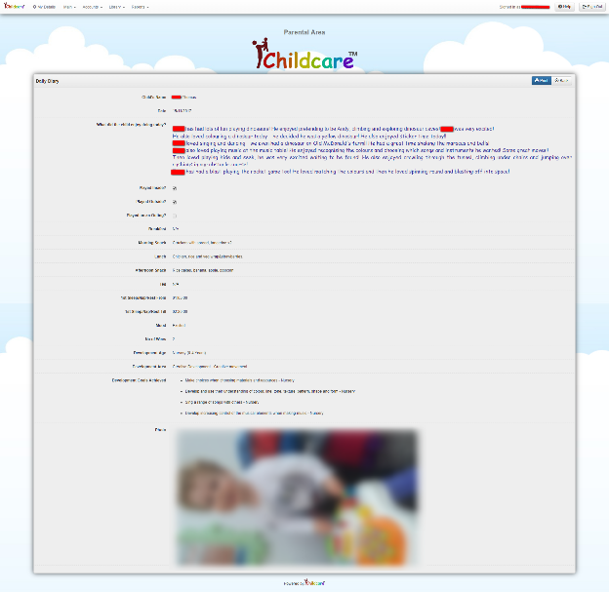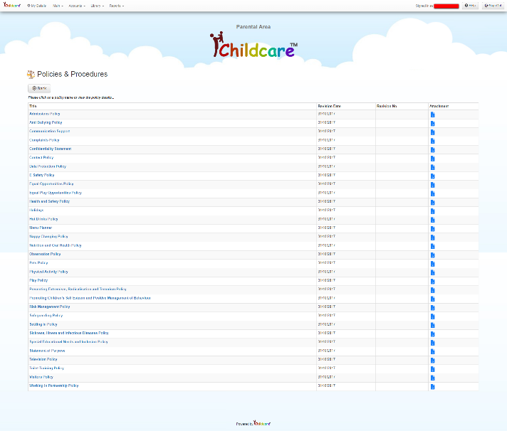
Figure 8 - Daily diary generated by iChildCare (NB Identifiable information has been redacted) and Little Flower’s policies available online.

2.7.4 Independent Childminder
Finally, to gain insight into a range of childcare settings the practices of a newly established childminding service in Swansea were considered. This childminding service currently provides care to just three children having only recently completed the CCSIW registration process. At present all records currently exist in a paper-based format and will continue to do so for the foreseeable future with the exception of invoices that are calculated using Microsoft Excel and distributed digitally via email. Given the size and youth of the business it is understandable that they are not yet prepared to take the financial risk of implementing a digital system without first gaining a steady client base.

Conclusion
This investigation into the available tools and current practices of how professional childcare settings adhere to the regulations set out by CSSIW clearly indicates that there is no industry standard means of producing and maintaining records. Each of the childcare settings analysed adopted an approach that can either be considered a manual paper-based approach or a digital approach. Smaller childcare settings, such as childminders, appear more likely to adopt a paper-based approach as opposed to larger settings such as nurseries that utilise a digital solution.

2.8 Potential Methods and Technologies
To produce a solution that is effective and meets the requirements of Little Flowers it is important to first consider the range of methods and technologies currently available to design, develop and produce the solution they require.

2.8.1 Locally installed software
The first consideration for development is a locally installed software solution, often referred to as a thick client. A thick client is software that is installed on a single device that may require periodic connection to an external network for updates and acquiring resources. A thick client is often characterised by its requirement of such computer resources as hard disk storage, RAM and CPU [55]. Thick clients are software solutions installed to a computer where most functionality is not dependent on a connection to a network or server.

.NET Framework
The .NET framework is a programming and software development framework that allows software developers and engineers to produce applications suitable for the Windows environment. The .NET framework provides an extensive class library that provides developers with a wealth of code that allows them to create applications that can easily utilise the resources of the machine on which it is installed [56]. The .NET framework allows developers to write code in programming languages such as Visual Basic, C++ and C#.

According to StatCounter, Microsoft’s Windows operating systems currently hold an incredible 82.56% market share of desktop operating systems worldwide [57]. Little Flowers currently use a Microsoft Surface laptop operating on Windows 10 which would make a solution built using the .NET framework suitable for their setting at present.

Java
An alternative development solution would be to use the Java programming language. Designed as a “general-purpose, concurrent, class-based, object-oriented language” [58] Java is a platform-independent programming language that would allow an application to be developed once and deployed successfully across operating systems. In effect, a Java application would operate as successfully in a Windows environment as an Apple OS environment. According to The Popularity of Programming Language Index (PYPL), which determines the popularity of programming languages according to the frequency on which tutorials are searched on Google; Java is the most popular programming language with a share of 22.7% [59].

Table 4 - Advantages and disadvantages of locally installed method.
Locally Installed
Advantages | Disadvantages
Microsoft’s Windows dominates Operating System market. | Only available on the device on which it is installed.
Java is platform independent. | Non-operational device may lead to data loss and damage to business operations.
Familiarity – Users are likely to be familiar with PC applications.
2.8.2 Mobile Application
Within mobile application development there are two outstanding leaders in the field; iOS and Android. In the UK, sales of Apple and Samsung devices combined control over two thirds of the smartphone market sharing 68% of all smartphone sales (34% each)[60]. In terms of tablet devices it is the same two companies who lead the way occupying 85% of the market, although in this area Apple are the significant leaders with iPad ownership accounting for a phenomenal 76% of tablet sales in the UK between 2012 and 2017 [61]. Furthermore, when considering operating systems irrespective of device, iOS and Android control a staggering 98.6% of all mobile devices in the UK and Europe [62].

iOS
iOS is the operating system designed, developed and distributed with all mobile Apple products. To develop applications for iOS devices requires the developer to be using an Apple device running Xcode, which is Apple’s Integrated Design Environment (IDE) for the development of applications in Apple’s Swift programming language [63].
Android
Alternatively, developers looking to develop for the Android platform are provided greater freedom in their choice of IDE but a leading option is the official offering of Android entitled Android Studio [64]. Android applications are largely built using the platform-independent Java programming language which affords users more freedom to develop in Windows, OS X and other operating systems with which they are comfortable.
Xamarin
Additional consideration should be given to a Windows tool called Xamarin that allows developers to create applications for iOS, Android and Windows in the Windows environment while compiling natively for each platform. Since Microsoft acquired Xamarin in 2016 [64] its popularity has grown rapidly owing to its functionality that users can develop a single code base that compiles to a native application on multiple operating systems [65].

Table 5 - Advantages and disadvantages of mobile app method.
Mobile App
Advantages | Disadvantages
Mobile app popularity continues to grow rapidly. | Recordings with large bodies of text are difficult to input on mobile/table screen.
Familiarity – Users are becoming increasingly familiar and dependent on mobile apps. | Non-operational device may lead to data loss and damage to business operations.
Portable device allows users greater freedom in where they create and retrieve data.

2.8.3 Web-based Application
The final development platform considered is a web-based application often referred to as a web app. Web apps are often a dynamic data-driven website that allows a user to perform tasks and functions where processing and computation takes place on an external server [67]. It requires little more than an internet connection and a browser for a user to access and the application’s performance is not dependent on the resources of the local machine.
PHP
PHP, as defined by its developers, is an “open source general purpose scripting language that is especially suited for web development” [68]. PHP code embedded into HTML is pre-processed by the server on which it is stored and the results are delivered to the user is plain HTML. As a result, PHP allows a developer to create a dynamic website capable of retrieving data and performing complex calculations without requiring the resources of the user’s local machine. This powerful functionality and the fact that PHP’s primary focus is the development of web apps are key reasons why it is used by 83.2% of websites that utilise server-side scripting [69].

ASP.NET
ASP.NET is the closest competitor to PHP in terms of server-side scripting language popularity among websites, but with a market share of just 13.8% it is dwarfed by PHP’s widespread use [69]. The offering of Microsoft is an open source web framework designed for the development of web apps and services [70]. ASP.NET is also server-side scripting language processed by the server on which it is stored and delivers its results in plain HTML.

HTML5 / CSS / JavaScript
Although web apps rely greatly on server-side scripting languages to perform much of the processing and calculations this alone would not produce a suitable solution. Server-side processing allows for data retrieval and computation but client-side languages and functions must also be performed to properly deliver to the content to the viewer. Client-side languages and functions are those performed on the user’s device and are most often concerned with the rendering and display of a web page. These features will be vital in delivering a successful web app and will be used in all aspects of development.

The most fundamental building block of web design is HyperText Markup Language (HTML) which defines the content and layout of a web page [71]. Web pages also make use of Cascading Style Sheets (CSS) which contain styling rules and describes how elements of a web page should be rendered in the viewer’s browser [72]. Finally, it will also be necessary to harness the power of client-side programming language JavaScript. JavaScript is a lightweight language best known for its use in web pages and is most often used to perform functions according to user enforced events such as button clicks [73].

Table 6 - Advantages and disadvantages of web app method.
Web App
Advantages | Disadvantages
A web app would be accessible from any internet connected location. | Requires internet connection.
Platform and device independent. | Web hosting companies offer security and data backup guarantees.
Web app performance is not hindered by computing resources of the viewing device.

2.8.4 Conclusion
Having considered the available platforms for development it is believed that a web-based application would be the most suitable solution to meet the requirements of Little Flowers.

While each of the development routes present their own advantages a web app would afford Little Flowers the most benefit. These benefits include:
- Access anywhere – A web app would require no more than an internet connected device with an internet browser. This would provide a level of freedom and access to their data and operations that other solutions would not. It would also negate the risk of inoperable devices resulting in irrecoverable data loss.
- Performance – The performance of the web app will not be influenced by the resources available of the device on which the web app is utilised. As a result, Little Flowers staff would be able to retrieve data as easily on a mobile or tablet as they would a computer.
- Parents – Parents, as the paying customers of Little Flowers, will immediately recognise the benefit of being able to view information pertaining to their children through a web app which allows them to view records from any internet connected device whether it be at home, in the workplace or abroad.
- Security – Web hosting business 1&1 are one of the market leaders in the UK and may be a suitable service for Little Flowers. By deploying a web app through a service supplier such as 1&1, Little Flowers will benefit from 1&1’s commitment “to ensuring the very highest levels of security and safety with all of our services” [74], practiced through the use of enhanced SSL certificates, external firewalls and data backups and recovery.
Having analysed both PHP and ASP.NET it has been decided that PHP will be the server-side programming language used to develop the Little Flowers web app. Although PHP and ASP.NET offer a great deal of similar functionality, the popularity of PHP suggests a widespread confidence in its ability. Due to its widespread use, PHP also benefits from a very loyal open source community that provide support and guidance through their official website and on popular forums such as StackOverflow. Finally, PHP is a free and open source programming language which benefits a small business such as Little Flowers as it reduces the initial cost of development and deployment [75]. All client-side, server-side and design code will be developed using the Atom IDE package and will be tested locally using XAMPP and the Google Chrome and Mozilla Firefox internet browsers.

2.9 Critical Review
The investigation into the modern childcare profession and the available methods of creating, maintaining and sharing documentation has confirmed that although it is a legal requirement to retain recordings no industry standard means of doing so is enforced. Subsequently, childcare settings adopt either a paper-based or digital method of recording information. The research undertaken has corroborated the belief that small childcare settings, such as childminders, can see immediate positive impact on efficiency by employing a digital solution.

Childcare as a profession has seen continued growth over a number of years owing largely to the changing role of women in society and cultural shift in family dynamics. As a result, women make up a larger percentage of the workforce than ever before meaning children are more likely to require the care and services of professional childcare settings.

It has been determined that no suitable tool currently exists and that a bespoke web app would satisfy the needs of Little Flowers most successfully.

3 Research and Development Methodologies

3. 1 Research Methodology
This project will follow the Research Onion methodology, a visual representation of an approach to conducting research. The Research Onion, developed by Saunders et al, consists of a number of layers where the researcher works their way from the outside layer towards the centre as they progress providing a clear and effective path for progression. Variations of the Research Onion exist but it is generally accepted that onion consists of five key layers which include: Philosophy, approach, strategy, time horizon and data collection methods [76].

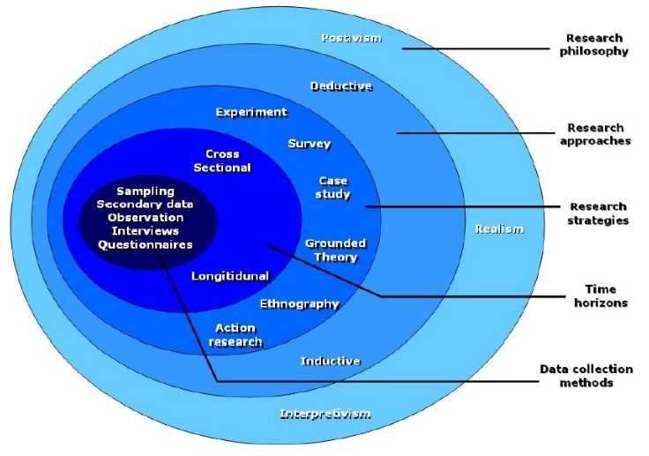
Figure 9 – Research Onion. [77]
Philosophy
According to Professor Robert M Davison, a research philosophy “is a belief about the way in which data about a phenomenon should be gathered, analysed and used” [78]. This project will largely adopt the positivism philosophy as the success of the project will be assessed by objective and measurable pointers. A number of success criteria exist, thus to be successful the criteria must be met. While the overall success of the project will be determined based on quantitative factors the degree of success may be measured by qualitative data such as the end user’s opinion, a measure more often associated with the phenomenological philosophy.

Table 7 - Advantages and disadvantages of positivism.
Philosophy
Advantages | Disadvantages
Quantitative approach provides clear and scientific measures of success. | Human behavior is not entirely objective so users are expected to perform analysis without emotional influence.
Measureable results produce valid and reliable results. | Positivism often considered inflexible by following strict rules.
Solution
Success criteria will be identified using clearly defined objective markers. Subsequently, success will be determined by functionality alone and not by the user’s perceived degree of success.

The perceived inflexibility of positivism is more commonly associated with scientific projects and is not likely to negatively impact this project. [79]
Approach
This project will follow the deductive research approach which is often associated with the positivism philosophy. The deductive approach is considered a theory-testing approach where a hypothesis is either proved or disproved as a result of deductive research. Cresswell and Clark state that deductive research is “top down from a theory to hypotheses to data to add to or contradict the theory” [80].

Table 8 - Advantages and disadvantages of deductive approach.
Approach
Advantages | Disadvantages
Proves or disproves a hypothesis. | Not a universally applicable approach.
Clearly defined start and end point indication of success.
Solution
The deductive approach is the most suitable for this project as it will attempt to prove or disprove a hypothesis and has very few weaknesses. [81-82]

Strategy
Case studies will provide the large majority of the data and information required for this project. A case study is a detailed examination of an object, event or subject either actual or fictional. The research in this project will utilise actual professional childcare settings as valuable sources of information with a particular focus on Little Flowers. Case studies produce highly detailed information of both a qualitative and quantitative nature.

Table 9 - Advantages and disadvantages of case studies.
Strategy
Advantages | Disadvantages
Produce highly detailed information (Both qualitative and quantitative). | Large amounts take great time and resources to acquire.
Allows the researcher the opportunity to gather insight into focused areas. | Benefits from an established relationship with the subject which can impact time scales.
Researcher is able to analyse a real-life environment/subject. | Criticised for generalisation and lack of scientific results.
Solution
Little Flowers and the research have an established professional relationship and a clearly defined scope of work which will reduce the impact on time taken by case studies. The researcher will make regular contact with Little Flowers to gather quantitative and qualitative feedback. [83-84]

Time Horizon
This project will employ a cross-sectional time measurement. As the project will be delivered and implemented at a single point in time there will be no continuous improvement to provide a continued measurement. The efficiency of the current paper-based system will be directly compared against the efficiency of the solution when it is implemented, effectively comparing two single moments in time [85].
Data Collection Method
As previously identified, the success of this project will be measured by both quantitative and qualitative feedback. To acquire data that will aid the development of the solution a combination of interviews and observations will be used. Questionnaires may be used following implementation to determine the perceived level of success and will be designed in such a way that quantitative feedback will be generated. Interviews will allow users to provide qualitative feedback and user observations will afford the developer first-hand insight into how the user uses the solution.

Table 10 - Advantages and disadvantages of chose data collection methods.
Data Collection Method
Advantages | Disadvantages
Interviews – Gather highly detailed answers. Researcher able to lead interview in their preferred direction. | Interviews – Interviews are time and resource consuming when used on a large scale.
Observations – Gather first-hand insight to how systems and functions are utilised by end user. | Observations – Users may not perform naturally under direct observation.
Questionnaires – Retrieve a combination of both qualitative and quantitative data. | Questionnaires – On a large scale questionnaires can return with missing data or not be returned at all. Not as detailed as other data collection methods.
Solution
Interviews, observations and questionnaires will be valuable data collection methods in this project. The project will require regular contact between the researcher and Little Flowers which will reduce the likelihood of missing data. Both parties will benefit from regular contact that will positively influence the end solution. [86]

3. 2 Evaluation and Success Criteria
The proposed bespoke web application will be platform independent and require only an internet connection and an internet browser to access its features. The development will be performed under the guidance of the Feature Driven Development methodology as outlined in greater detail in the following section.

To consider the design and implementation of this web app a success a number of criteria have been identified against which the success of the development will be judged.

3.2.1 Success Criteria
Website
- Create an attractive and professional website which must include:
  - ‘About Us’ information page.
  - ‘Services’ page.
  - Interactive image gallery.
  - Contact information and contact form.
  - Single point of login for parents and staff.
- Website should be responsive allowing for mobile, tablet and laptop/desktop viewers.
Staff functionality
- Adding records of children, parents and emergency contacts to database.
- Accessing child, parent and contact information as required.
- Amending child, parent and contact information as required.
- Deletion of child, parent and contact information as required.
- Add new staff users.
- Creation of daily diaries including photo attachment.
- Viewing historical daily diaries.
- Creation of accident records.
- Viewing historical accident records.
- Manually create invoices.
- Create automatically calculated invoices.
- Create invoices in PDF format.
- Manually create receipts.
- Upload policies and procedures documentation.
Parent functionality
- View ‘My children’ and stored information.
- View completed daily diaries.
- View completed accident records.
- View created invoices.
- View created receipts.
- View policies and procedures documentation.
Project
- Project adopts a suitable research methodology.
- Project adopts a suitable development methodology.
- Project is evaluated using appropriate methods.
- Project identifies areas for future development.

3.3 Development Methodology
In recent years a number of agile software development methodologies have grown great prominence in software development. Such agile methodologies oppose the more traditional waterfall development methodology. The waterfall methodology works on the principle that each stage of the model: Requirements analysis, design, implementation, testing and maintenance are entirely complete before moving onto the next phase. One of the main weaknesses of the traditional waterfall method is that errors in design are not often identified until deployment [87].

Of the alternative development methodologies a popular choice is Feature Driven Development (FDD). FDD is a lightweight methodology that was developed by Jeff De Luca and Peter Coad in 1997 and first published in 1999 [88]. FDD is an iterative and incremental software development process that is considered to be part of both the lightweight and agile development methodologies [89].

In FDD, a feature is considered to be a small piece of functionality that is valuable to the client [89]. FDD is based on the principle that projects are broken down into small manageable functions which are designed, developed and reviewed continually until such a point that the final solution is considered complete.

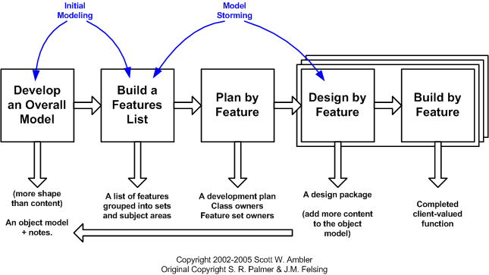
Figure 10 – FDD Methodology.
Figure 10 depicts the FDD methodology model. The FDD approach allows multiple users to work in parallel on separate features and also makes it simple to track progress. It also allows for end-user input to ensure the features that are being designed and developed are valuable. As a result, FDD is a fast-paced development method that produces tangible results at each iteration in the development process.

Table 11 - Advantages and disadvantages of FDD.
Feature Driven Development
Advantages | Disadvantages
Easily recognisable progress. | Features are not always easily broken into manageable chunks.
Results produced after each iteration. | Does not naturally produce written documentation.
Focuses on development of valuable features. | Not as powerful on small scale projects.
Easily scalable methodology.
[90-92]

4 Design and Implementation
4. 1 Website
As indicated earlier, the final solution should be attractive and professional so to reassure potential customers of the high quality service that Little Flowers provide. Following consultation with Sarah Price, it was agreed that the website should consist of a range of vivid colours and images that portray happy children to reinforce the message that the welfare and happiness of the children in their care is of utmost importance. Studies indicate that principle hues (red, yellow, green, blue and purple) are most likely to positively influence the emotional state of the viewer [93].
4.1.1 Mood Board
A mood board is a visual representation of the colours, images and general feel that may be applied to a website design.
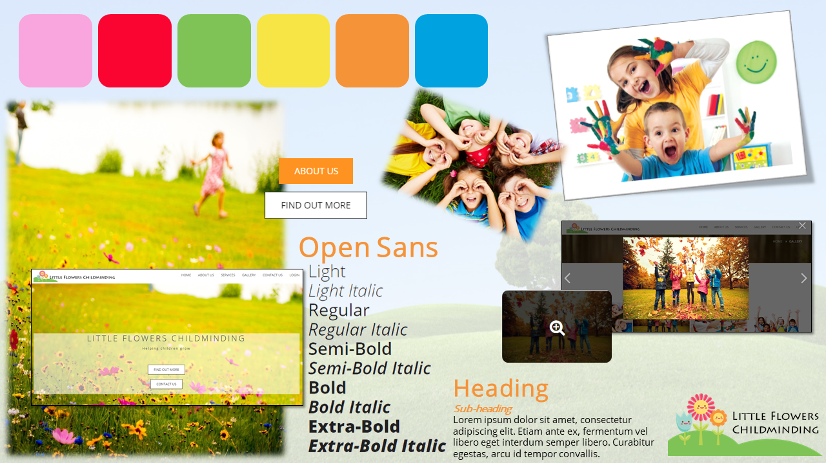
Figure 11 – Mood Board.

4.1.2 Sitemap
Figure 12 displays a sitemap of the public facing website. In this hierarchical model each entity represent a page that can be viewed with all pages directly accessible by the navigation bars that will appear consistently on each page.

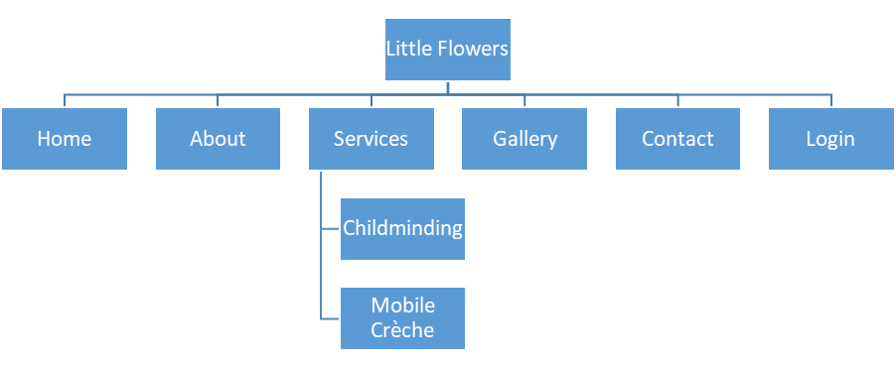
Figure 12 – Sitemap.

4.1.3 Content Plan
A content plan is a listing of the features and content to be included on each of the pages of the website. A well-structured content plan is an additional aid in ensuring that valuable features are not omitted during the design and development of the project.

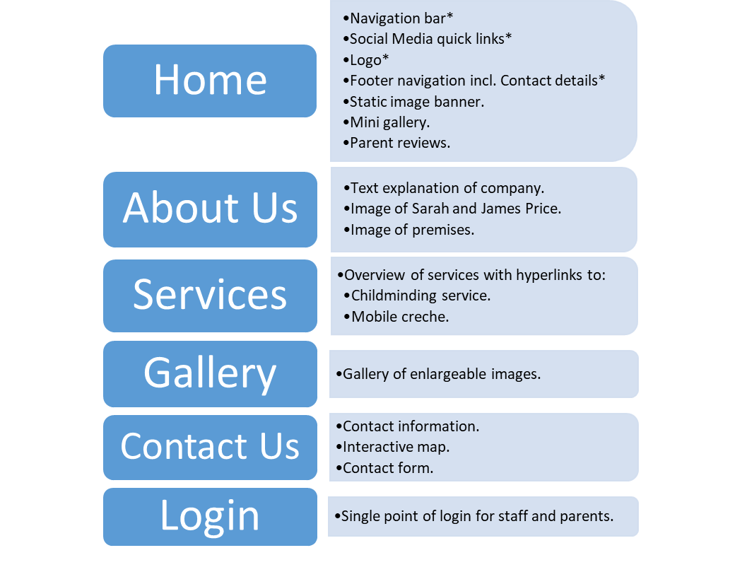
Figure 13 – Content plan.
*A number of features will appear on multiple or all pages. For example, the navigation bar will be consistently placed on each page allowing the user to navigate the website as they wish. This intentional design choice to enforce a consistently located navigation bar will provide the viewer with access to any other page regardless of the page they are currently viewing. O’Reilly states the most important factor for judging navigation success is whether a user is able to reach their intended destination [94], a consistent navigation bar practices the sixth of Jakob Nielsen’s Usability Heuristic for User Interface Design where Nielsen promotes “Recognition over recall” by minimising the user’s memory load by making objects, actions and options clearly visible [95].

4.1.4 Wireframes
A wireframe is a basic interface design that indicates the intended structure of a page or application [96]. Wireframes will aid Little Flowers in gathering an understanding of how the website is likely to appear and gives them the opportunity to raise concerns before development commences. Wireframes are intentionally colourless so that the focus is placed on the structure and layout without distraction [96].

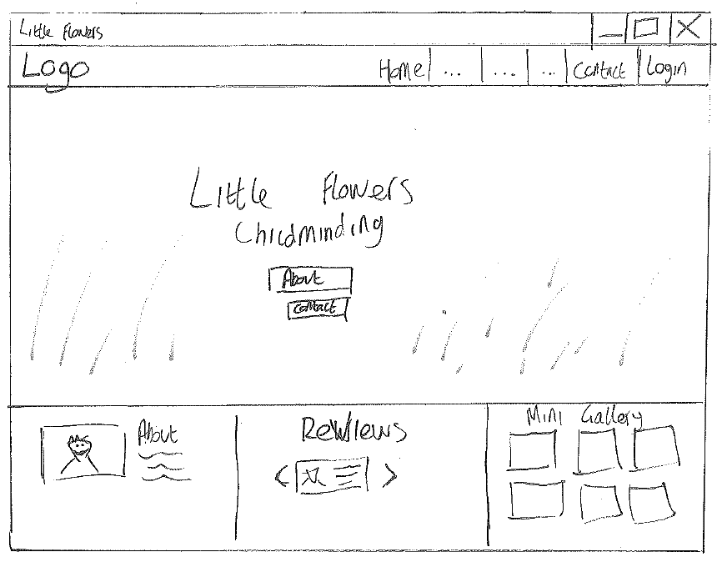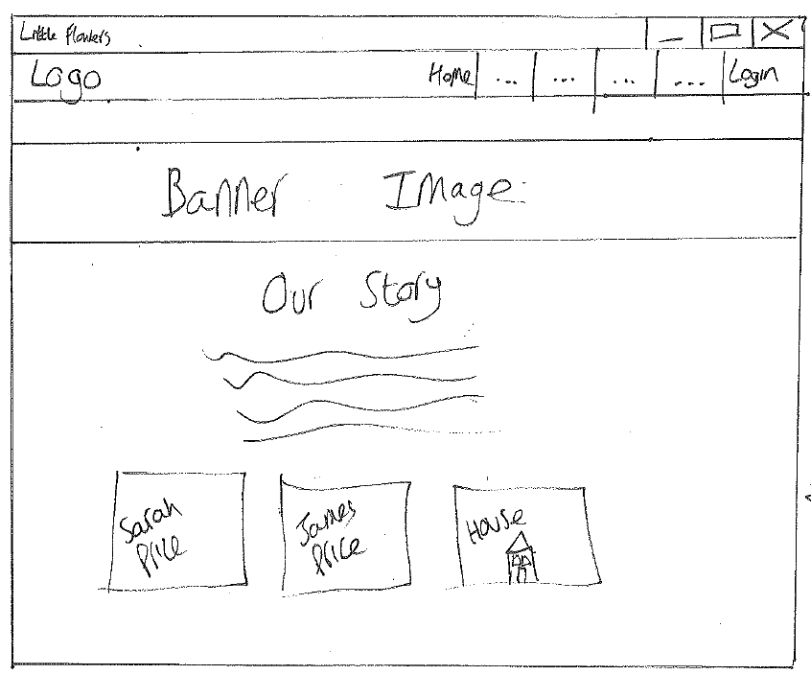
Home page | About page

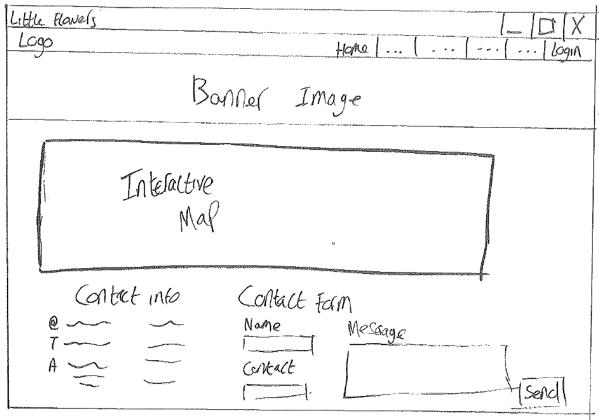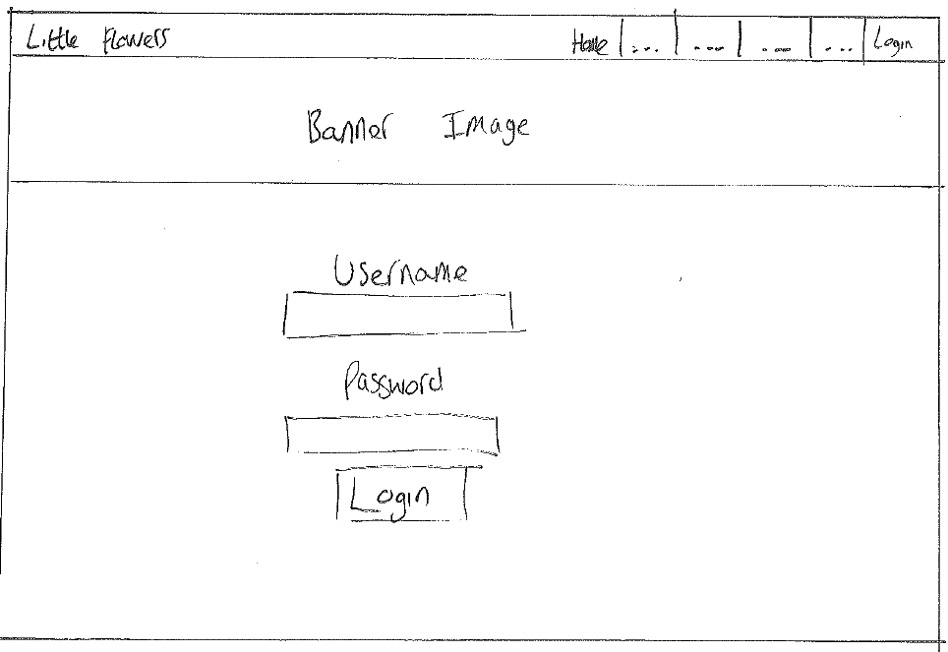
Contact page | Login page
Figures 14-17 – Wireframe designs.

4.2 Web Application
In contrast to the front end of the Little Flowers website which is designed to be attractive to visitors, the web app will be designed to be minimalistic and prioritise functionality in accordance with Nielsen’s Principle that an interface not be burdened with unnecessary information and options [95]. Staff and parents will both be able to gain access to system functionality through a single login point. Users will then be redirected and provided access to functions according to their user type and associated privileges.

4.2.1 Database design
To produce an effective database for the intended web app, consideration has been given to the business rules and practices currently in place at Little Flowers. The development of the database will be undertaken following the database lifecycle model, a visual representation of the stages involved in implementing a successful database.
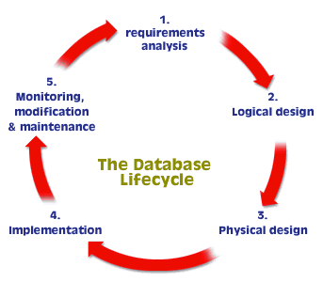
Figure 18 – Database Lifecycle. [97]
Following requirements analysis and consultation the following is a list of the entities that have been identified:
- Child
- Contact
- Log
- Accident
- Invoice
- Receipt
- User
- Document
- Rate
The following is a matrix that identifies where a relationship exists between two entities.
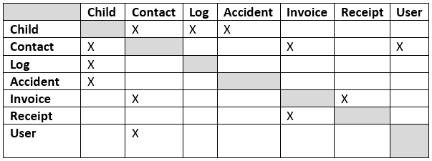
Figure 19 – Relationship matrix.
The following matrix identifies the type of relationship that may exist between two entities. These relationship types are:
- 1:1 – One to one relationship.
- 1:M – One to many relationship.
- M:M –Many to many relationship.
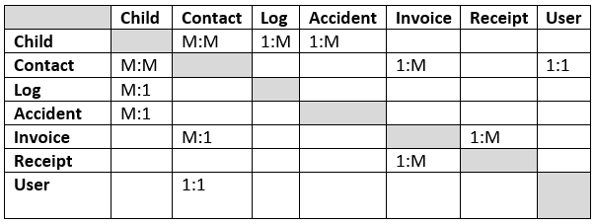
Figure 20 – Relationship type matrix.

Children may have many contacts and many contacts may be responsible for many children. (M:M)


A child may have many recorded logs but a log may only belong to only one child. (1:M)

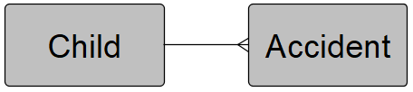
A child may have many recorded accidents but an accident may belong to only one child. (1:M)

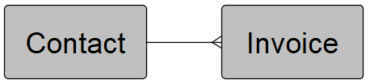
A contact may be issued many invoices but an invoice may belong to only one contact. (1:M)

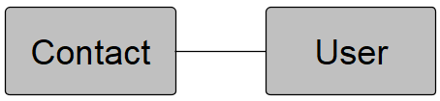
A contact may have only one user account and a user account may belong to only one account. (1:1)

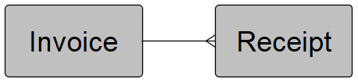
An invoice may have many receipts but a receipt may belong to only one invoice. (1:M)

Entity Relationship Diagrams
An entity relationship diagram (ERD) is a visual model that identifies the relationships that may exist between numerous entities in a given scenario [98]. ERDs are created to varying degrees of detail and fall under the following categories:
- Conceptual – Identifies entities, their relationships and the types of relationships that exist. Conceptual models may also indicate optionality – whether a relationship must exist or not.
- Logical – Logical models contain additional information such as attributes relating to the entity and primary and foreign keys. Logical models do not give all of the data required to build a database.
- Physical – A physical model is a high detailed model from which a database can be built. It should contain table names, keys, column names and data types.
[99-100]

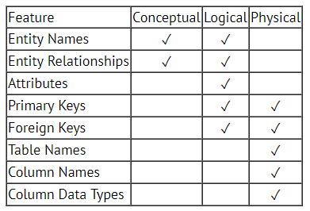
Table 12 – ERD model requirements. [101]
The following sequence of diagrams represents the progression of developing the database from a conceptual model through to a physical model.
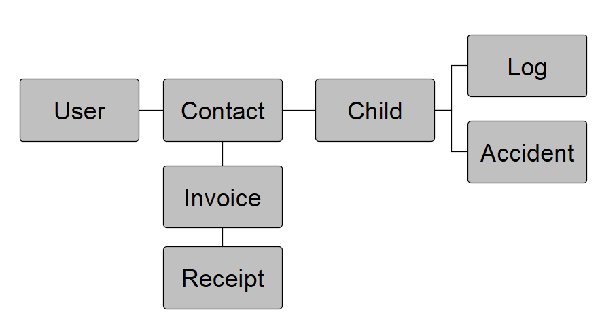
Figure 21 - Conceptual - Displaying entities and the existence of relationships.
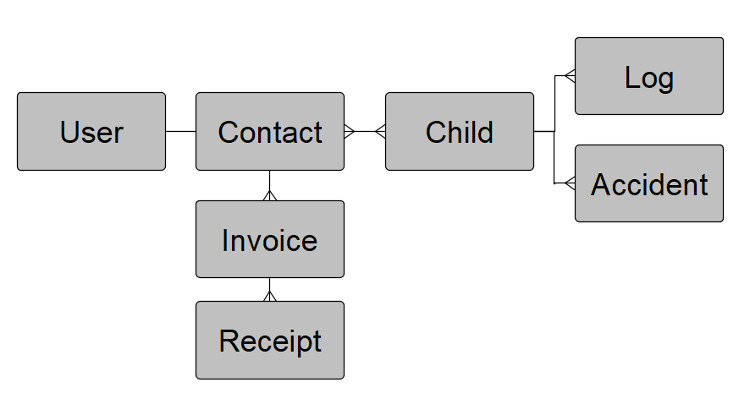
Figure 22 - Conceptual - Displaying relationships and relationship types.
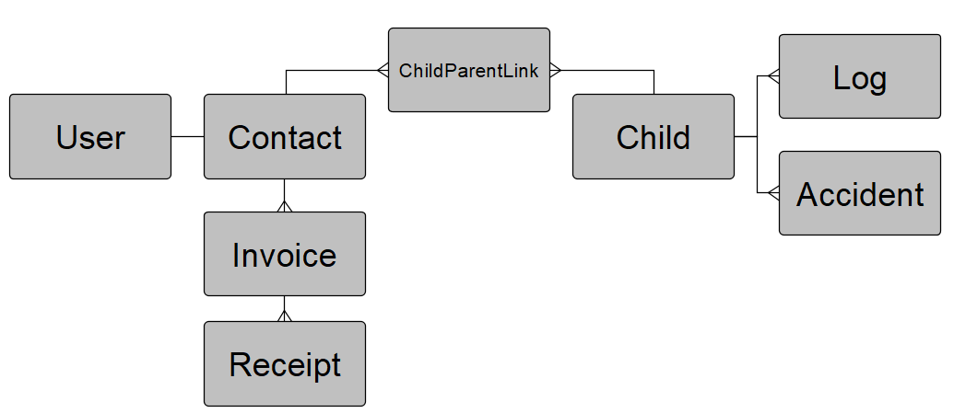
Figure 23 – Conceptual – Including link entity.

In database design, M:M relationships can result in redundant data and inaccurate query results. To resolve this issue a link entity should be placed in the M:M relationship [102]. In this scenario, many contacts may be responsible for many children and many children may belong to many contacts. This M:M relationships has been resolved with an entity entitled ChildParentLink.
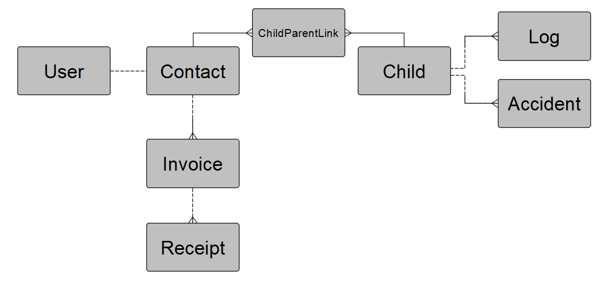
Figure 24 - Conceptual - Displaying the optionality of relationships.
A solid line indicates a relationship must exist and a dashed line indicates a relationship may exist but does not have to. For example, an invoice cannot exist without be addressed to a contact but a contact may exist without any attached invoices i.e. Emergency contacts will not receive invoices.
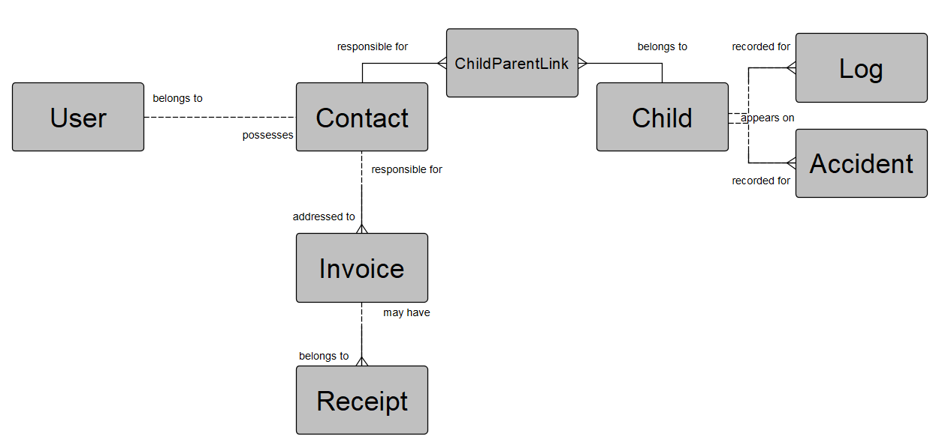
Figure 25 - Conceptual - With descriptor labels to describe the relationship between entities.

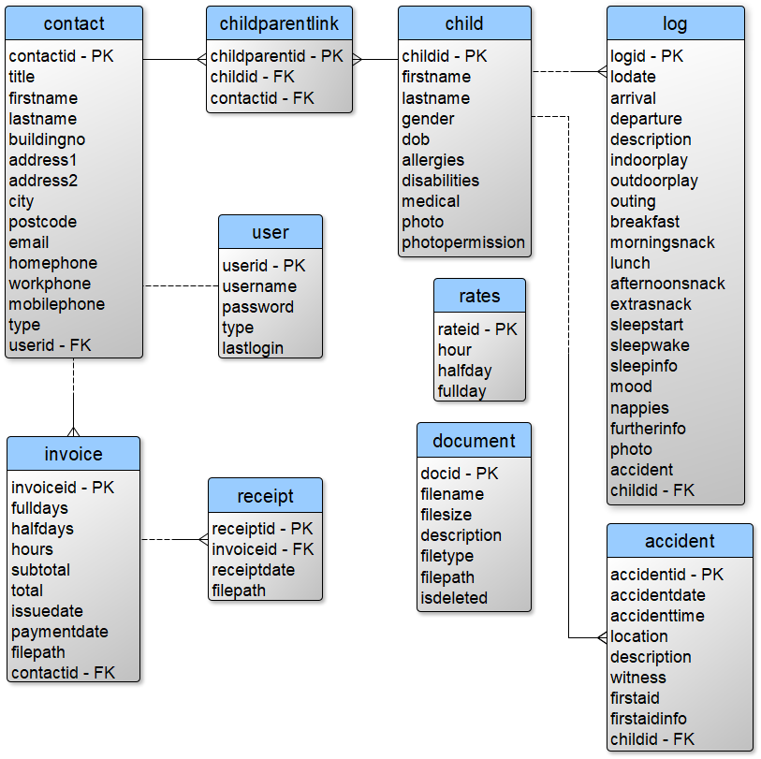
Figure 26 - Logical - Identifies entities, relationships attributes and keys.

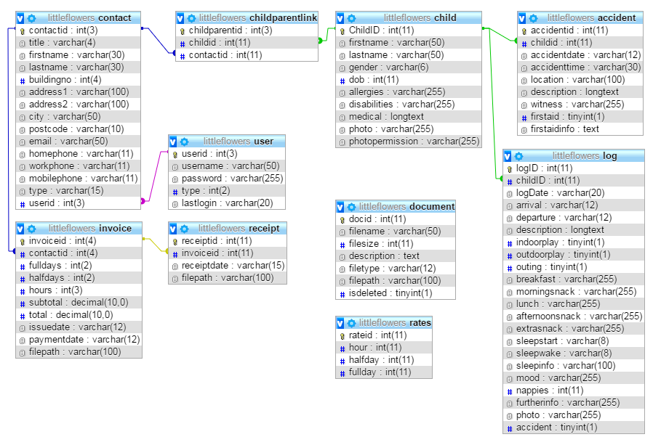
Figure 27 - Physical - Converts entities and attributes into database tables and columns. The physical model includes primary keys, foreign keys and data types for each column.
4.2.2 Database Design Decisions
Best practice in database design suggests that one to one relationships are not required and that the two entities can be merged [103]. In this physical database model a one to one relationship exists between the contact and the user tables. This intentional design decision has been made to allow the database to store user login details for users that are not contacts. For example, staff users are not technically contacts and are not associated with children. Merging the user attributes into the contact table would have resulted in a number of null fields where staff records exist.

An alternative solution considered was to attribute login details to each individual child. This, however, would be an inappropriate solution likely to negatively affect the user experience. For example, parents with multiple children would be required to login as each individual child to see related recordings rather than from a single account.

4.2.3 Wireframes
Staff
Staff users will arrive at a minimalistic dashboard providing immediate access to important information and tools. The main dashboard will include quick views that provide statistics such as the number of recorded children or contacts in the database. The quick actions panel will allow staff to quickly navigate to forms to create new records, daily diaries, invoices and more. In addition, the dashboard will also feature a table that displays emergency contact information for each child. The dashboard has been designed with Nielsen’s ‘Flexibility and efficiency of use’ Principle in mind that suggests frequent users benefit from easily accessible frequent actions [95].
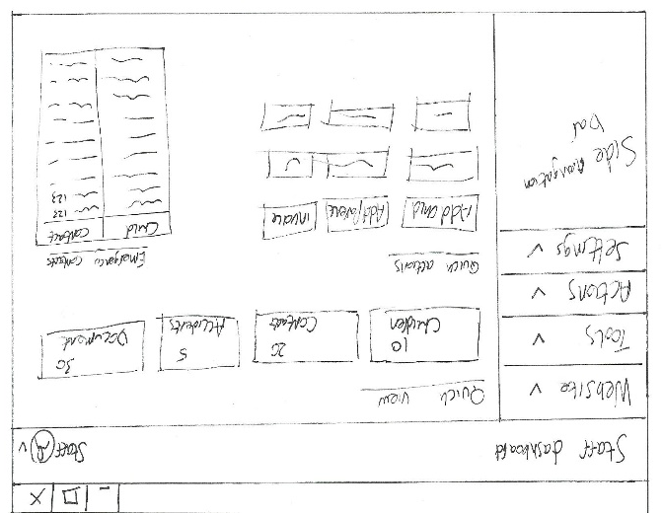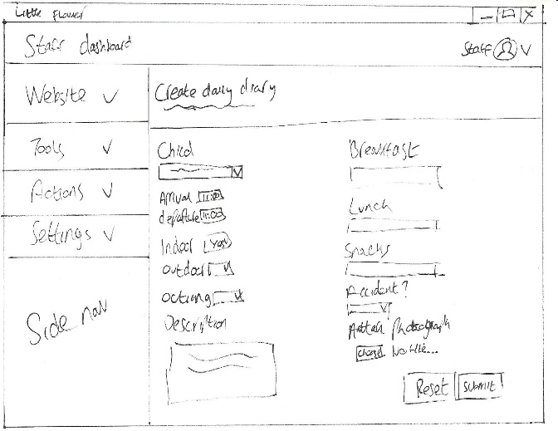
Staff dashboard | Daily diary creation form
Figure 28-29 – Wireframe designs.
Parent
Parent users are presented with a near identical dashboard entitled ‘Parent Zone’. The Parent Zone has also been designed to be minimalistic, functional and efficient and offers quick views to important information and quick action buttons allowing parents to view child information, daily diaries, invoices and more.
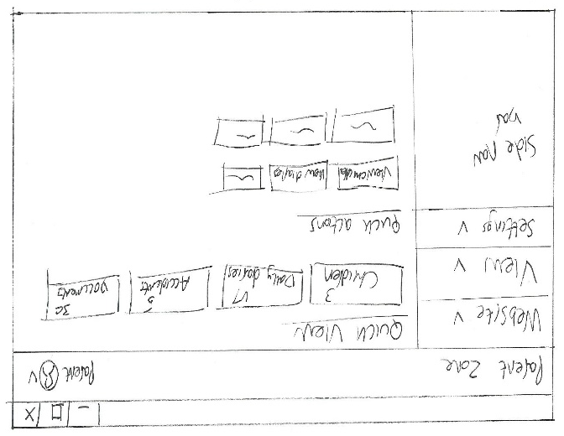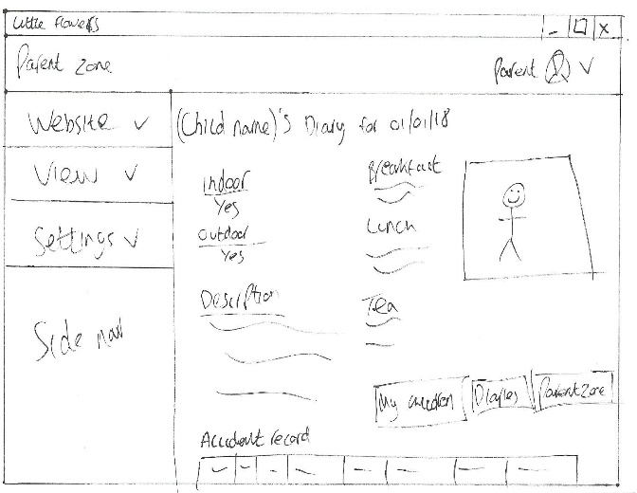
‘Parent Zone’ | Viewing daily diary entry
Figure 30-31 – Wireframe designs.

4.2.4 Functionality
In database and application design, functionality is often grouped into the CRUD acronym which stands for: Create, Read Update, Delete [104]. To perform CRUD operations the web app will need to generate and interpret SQL commands. Figure 32 is a Unified Modelling Language (UML) diagram that represents an example of programming logic that will be used to determine a user’s access rights and privileges when they login.
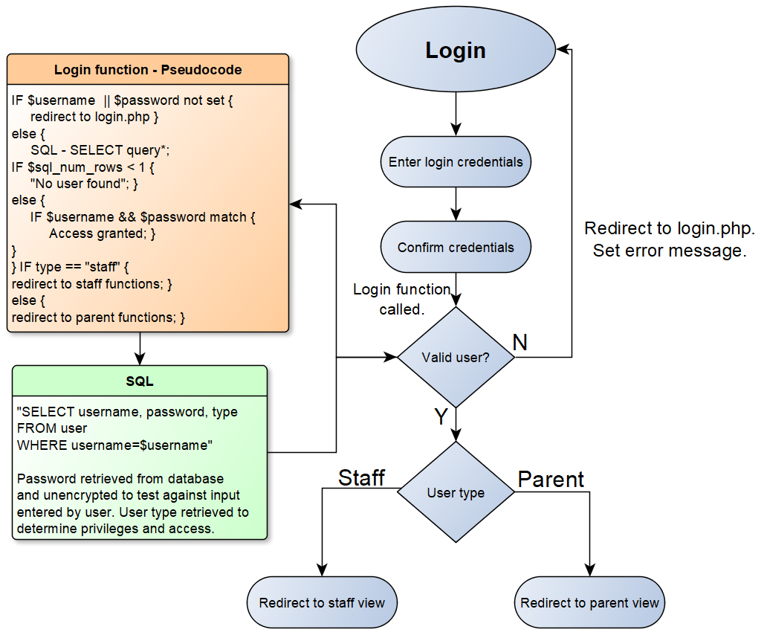
Figure 32 – Login UML.
UML and pseudocode are commonly used design methods to give detail of how an application is likely to function. Pseudocode uses English-like statements to describe a task or function but is not specific to a single programming language. UML utilises a number of symbols to depict processes and decisions and displays a direction and flow of information [105].

Figure 33 – Login code example.
Figure 33 displays how the login function and associated SQL will appear in development.

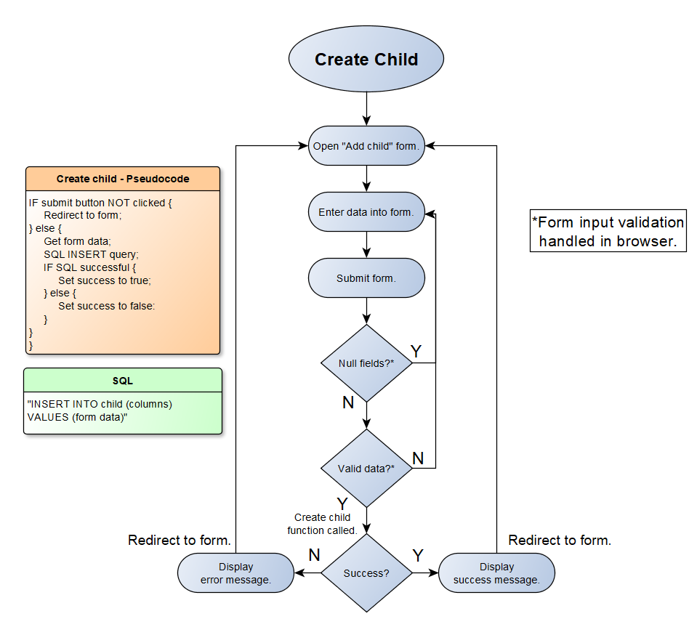
Figure 34 - Example of the programming logic required to create a record.
Parent Functionality
Parent users will not be afforded the same level of functionality that staff users have access to. When considering CRUD operations, functionality available to parents will largely fall into the Read category.
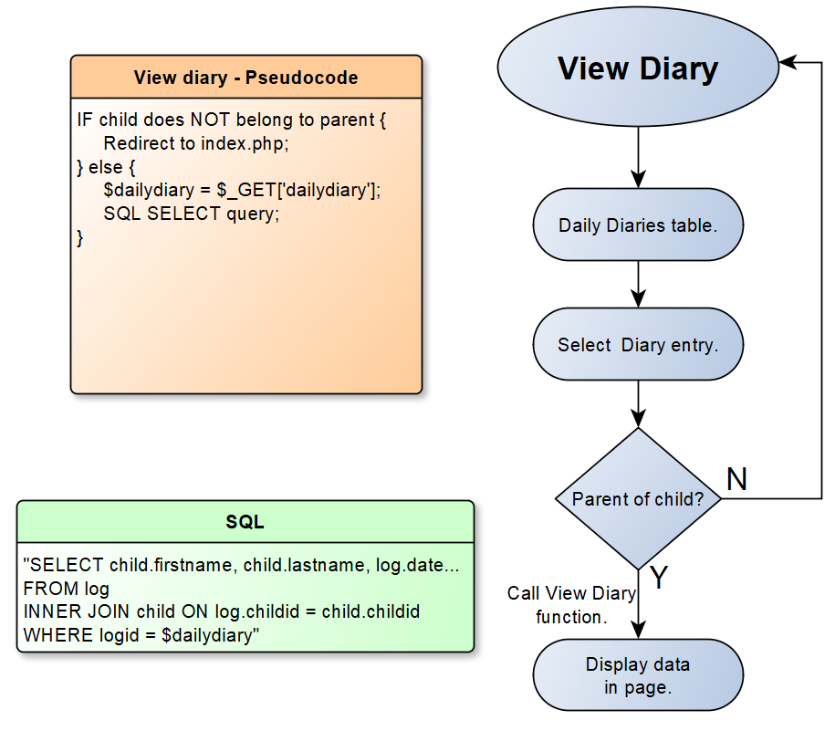
Figure 35 - Example of the programming logic required to view a diary.

4.3 Implementation
As this project follows the FDD methodology, the implementation stage began by developing a list of required features. The following is a summarised feature list where features have been categorised according to their role and in which section of the website and/or application they are implemented. A comprehensive list can be found in the appendices (see Appendix B):

Feature List
Website
Index page
Navigation bar
Navigation footer
About page
Childminding page
Contact page
Gallery page
Mobile crèche page
Services pages
Login page
Web App
Database
Conceptual model
Logical model
Physical model
Physical build
General
Config.php – Contains database connection
Functions.php – Contains frequently used functions.
Login – Login function including las login time recording.
Sessions
Navigation
Index – To hold page content.
Quick views
Quick actions
Change password function
Password check function (JavaScript)
Form validation
Staff Functionality
Add family form
Add child form
Add parent form
Add emergency contact form
Image upload function
Add user form
Manual invoice PDF
Auto invoice PDF
Receipt PDF
View all children table
View all accidents table
View all documents table
View all contacts table
Child profile page
Contact profile page
Add daily diary form
Add accident record form
Save invoice PDF to file
Save receipt PDF to file
Parent Functionality
Quick views
Quick actions
View all children table
View all daily diaries table
View all accident records table
View all documents table
Child profile page
Contact profile page
View invoices table
View receipts table
View daily diary

4.3.1 Website
The website has been developed using the Atom integrated development environment and utilises HTML5, CSS (Bootstrap library) and JavaScript. The website relies on HTML and CSS for structure and styling and JavaScript for interactive features such as the image gallery.

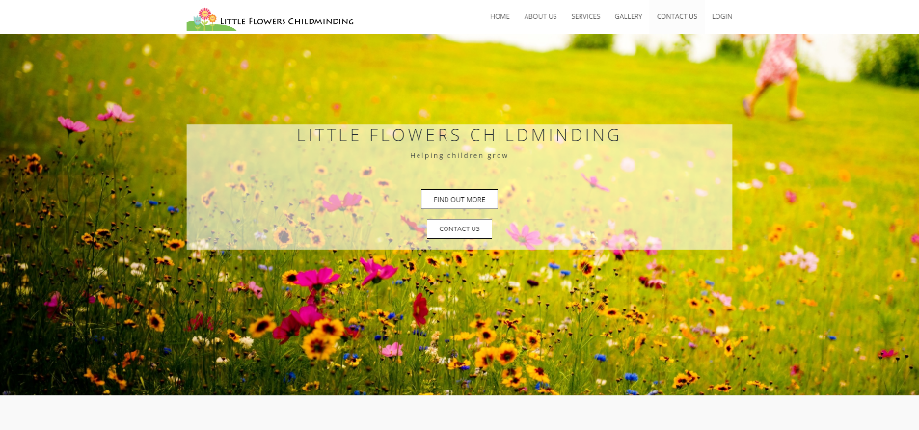
Figure 36 - Home page (index.php) as viewed on desktop PC.

Figure 37 - Gallery page (gallery.php) as viewed on desktop PC.
The Bootstrap CSS library allows developers to create responsive websites and web apps that are capable of resizing to fit the device on which they are viewed. The following images are of the same Contact page (contact.php) viewed on different devices.
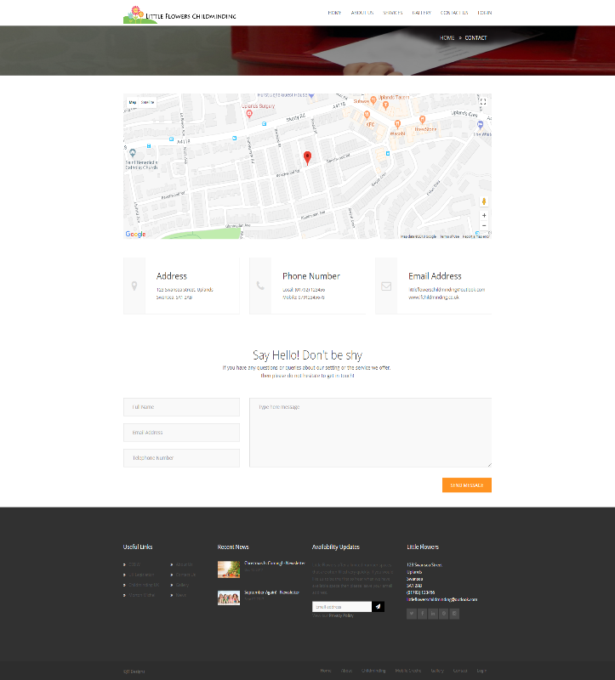 | 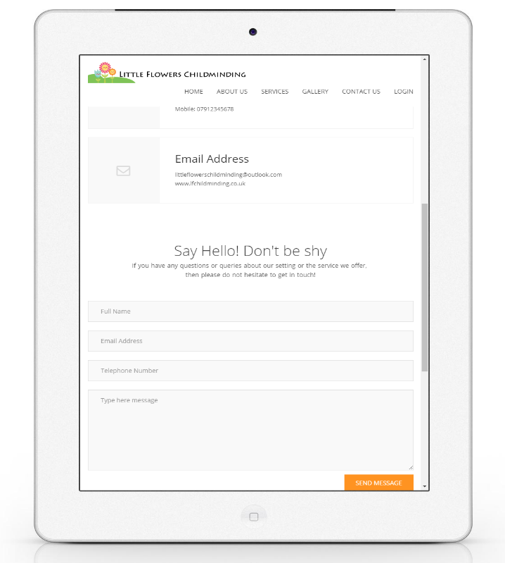
Figure 38 - Contact page on desktop PC. | Figure 39 - Contact page viewed on Apple iPad.

4.3.2 Web App
Database
The development of the database has benefitted from following the well-established database lifecycle model and by adopting other design tools such as conceptual, logical and physical design models. As a result, the database designed and implemented is fully functional and satisfies 3rd normal form [106].
When designing and developing the database great consideration was given to the most suitable approach to manage user accounts as discussed earlier. Consideration was given to creating a separate staff user table and amending the login process. For example, staff and parents may login through different pages. It was felt by Little Flowers that the single point of login was a valuable feature that appeared more professional and was less likely to result in confusion for potentially inexperienced web app users.

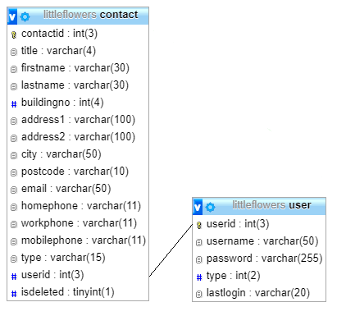
Figure 40 – Contact-user table relationship.
Having considered the alternative resolutions the developer feels that the adopted solution is most suitable.
Staff
Little Flowers consider a number of features to be highly valuable a number of which relating to the creation of recordings and documents. Among these valuable features was the ability to create digital invoices to increase their business efficiency.

Manual Invoices
The option to create a manual invoice has been developed to allow Little Flowers the freedom to generate an invoice as they require.

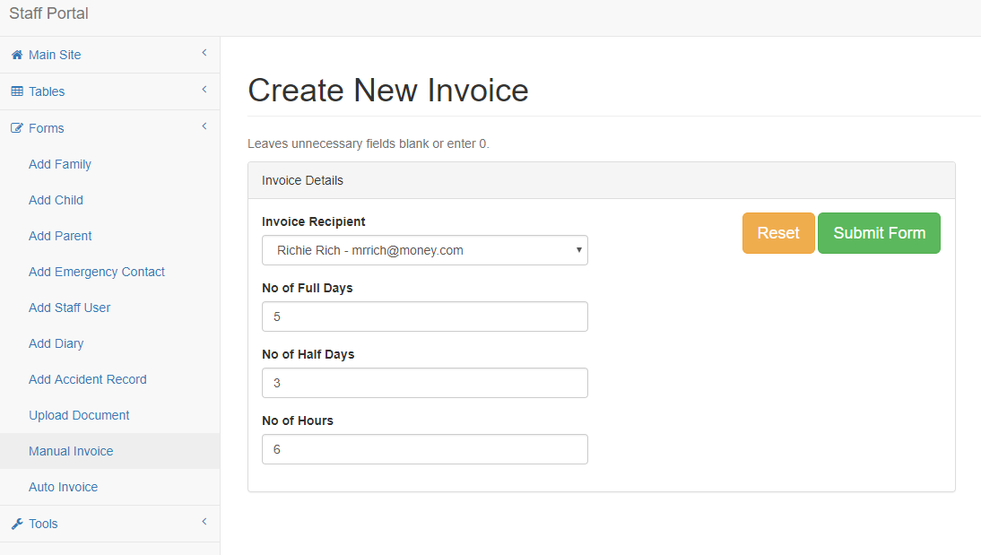
Figure 41 – Manual invoice form.
The manual invoice form (Figure 41) allows a member of staff choose a recipient and enter a value for the number of full days, half days and hours they wish to charge for.
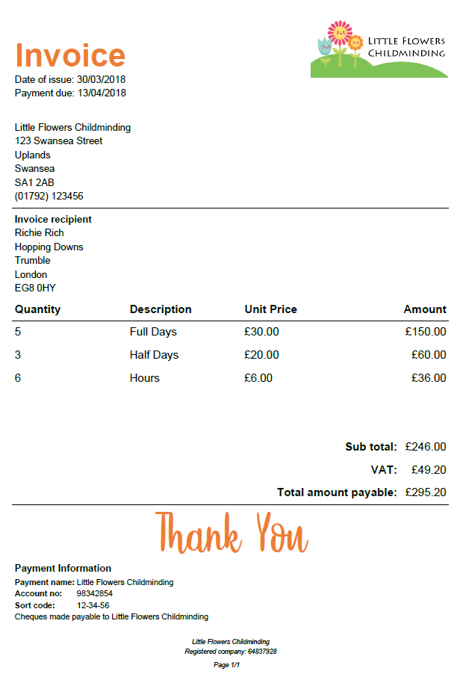

Figure 42 – Invoice PDF.
Using the provided information a professional quality PDF document (Figure 42) is generated with the recipient’s name and the date of issue as the filename.

Auto Invoice
The auto invoice feature utilises a simple form that requires staff to pick a child, an invoice recipient and a start and end date.
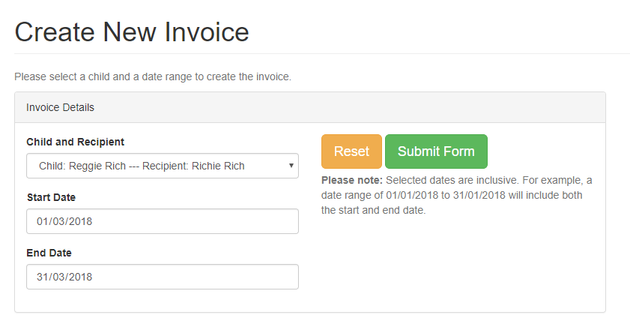
Figure 43 – Auto invoice form.
The auto invoice will use the selected parameters to query the database for daily diaries that have been recorded within the given date range.

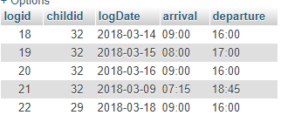
Figure 44 – Log table.
In this demonstration, Reggie Rich is the child selected who is represented in the database with a childid of 32. Reggie has four recorded daily diaries each of which with a recorded arrival and departure time. With the form data provided, SQL is generated and queries the database.

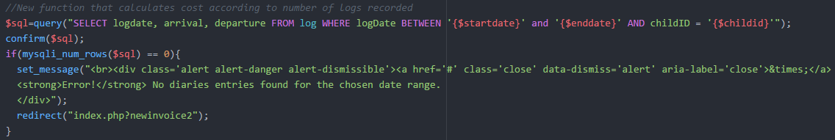
Figure 45 – SQL query code.
This section of the function forms the SQL query with the provided parameters. In the event that no daily diaries are found the user is returned to the invoice creation page with an appropriate warning message.

The auto invoice feature is able to determine the correct amount that a parent should be billed according to the time their child has spent in Little Flowers’ care. The rates are as follows:

Table 13 - Rates table.
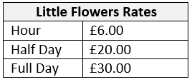

Following the SQL query, the algorithm created takes each row of the SQL result and converts the arrival and departure times into Unix timestamps and places them inside separate arrays. For each of the result rows the time difference between arrival and departure is calculated and according to its value is determined whether it is hourly, half day, full day or a combination. For example, on 15/03/2018 Reggie arrived at 08:00 and left at 17:00, a total of nine hours at Little Flowers. A full day at Little Flowers is considered to be eight hours, so on this particular day the recipient would be billed for a full day plus one hour.


Figure 46 – Code calculating invoice total.
When the invoice form has been submitted the staff user is returned to the invoice creation allowing them to continue generating invoices.
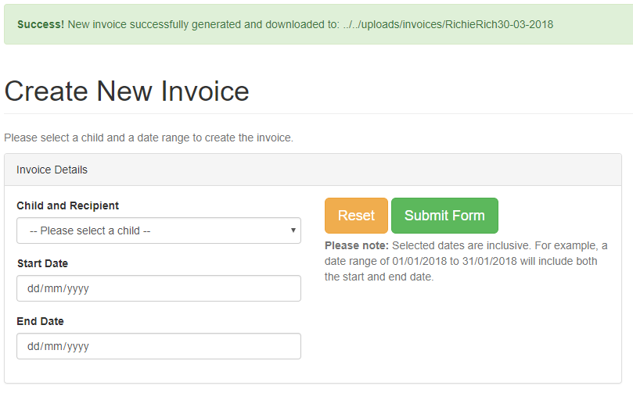
Figure 47 – Auto invoice form.
With the invoice successfully created the recipient is now able to view their invoice by logging into their account and clicking the View Invoice button (Figure 48). A record of this invoice creation is stored in the database (Figure 50) allowing Little Flowers to create receipts at a later stage.
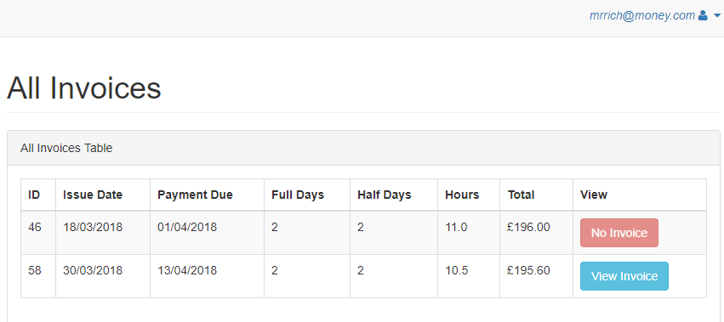
Figure 48 - Parent invoices table.
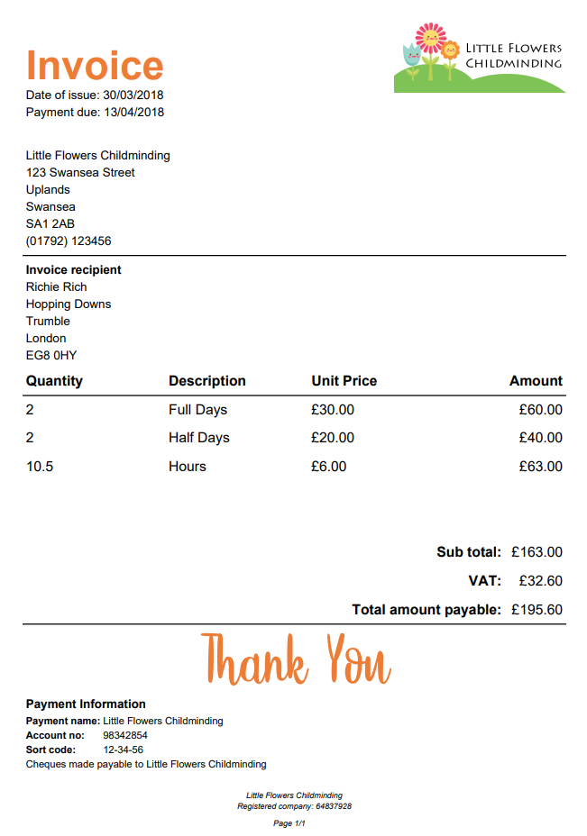
Figure 49 – PDF invoice.
Figure 50 – Database record.
This functionality was one of the most difficult to implement owing to the fact that it required knowledge in a number of areas. To produce the final invoice requires form data handling and conversion of data types in PHP, forming dynamic SQL commands and interpreting results to suitable formats and the creation of the PDF template using the FPDF PHP library. Subsequently, and largely in part to the business importance of financial documents, a great deal of time was spent ensuring this feature not only functioned correctly but produced a professional end result.

4.3.3 Responsive
One of the major benefits of creating a web app is its platform independence. As with the website, the web app is fully responsive and viewable on a wide range of devices as demonstrated below in desktop (Figure 51) and iPad (Figure 52) versions.

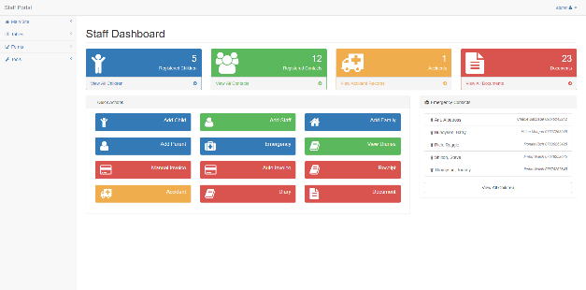
Figure 51 – Staff dashboard on PC.
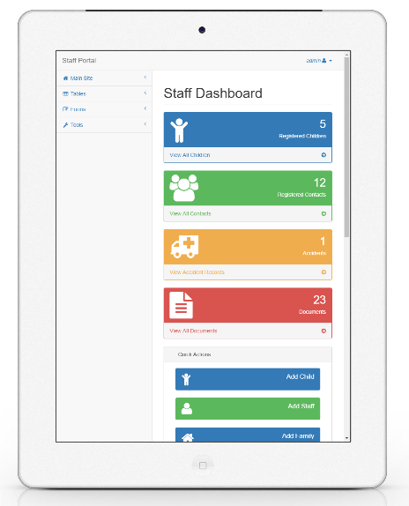
Figure 52 – Staff dashboard on Apple iPad.
Parents
The Parent Zone is also fully responsive as demonstrated below in desktop (Figure 53) and iPhone (Figure 54) versions.

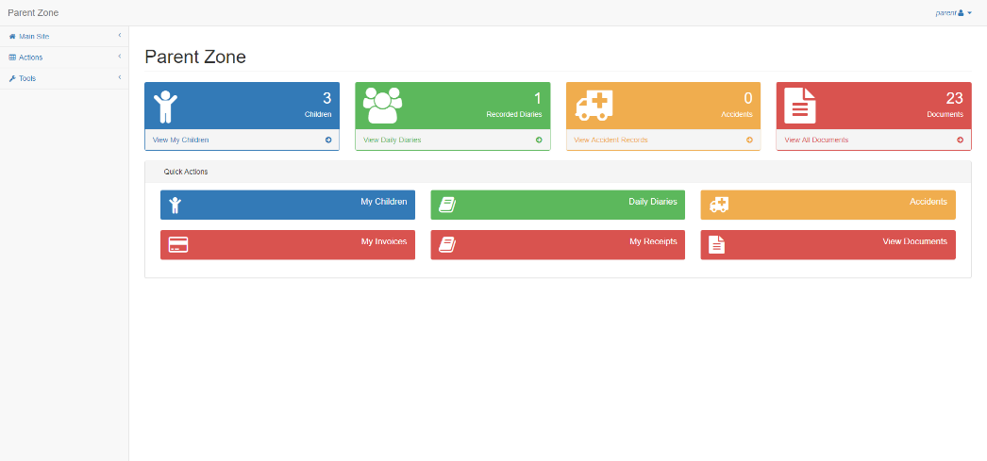
Figure 53 – Parent Zone on PC.
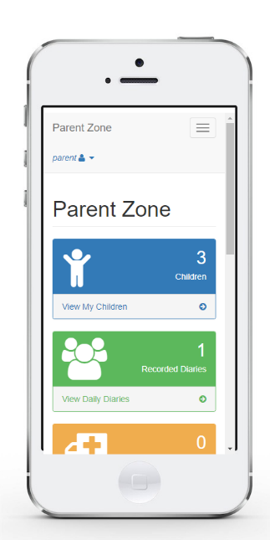
Figure 54 – Parent Zone on Apple iPhone.

To make the web app usable and efficient for parents the Parent Zone contains quick views and actions much like the staff web app. Parents are quickly able to access information important to them. For example, a parent wishing to view their children can do so in the All Children table.
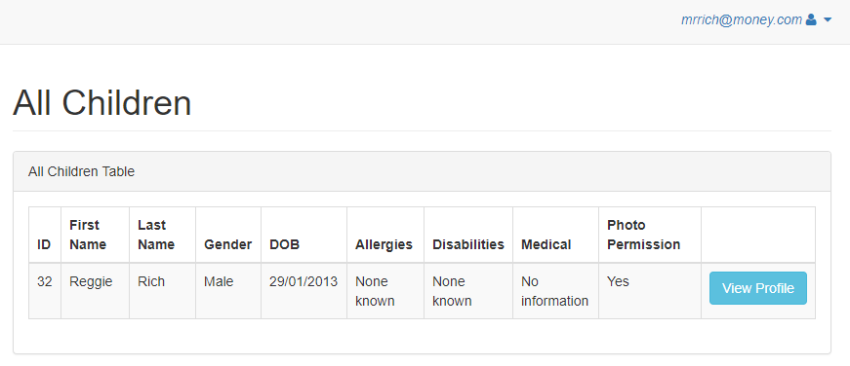
Figure 55 – All children table.
From the All Children table parents are able to view the profile of a selected child. With a profile selected parents are able to view all recorded information about that child and have buttons providing them quick access to other features.
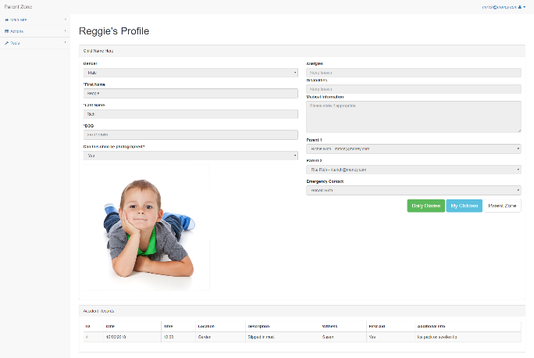
Figure 56 – Child’s profile.
Parents are able to move quickly from the child’s profile to the Children’s Diaries table which gives them access to all of the available diary entries. The table provides a quick view of important information of the ability to view the full diary entry.
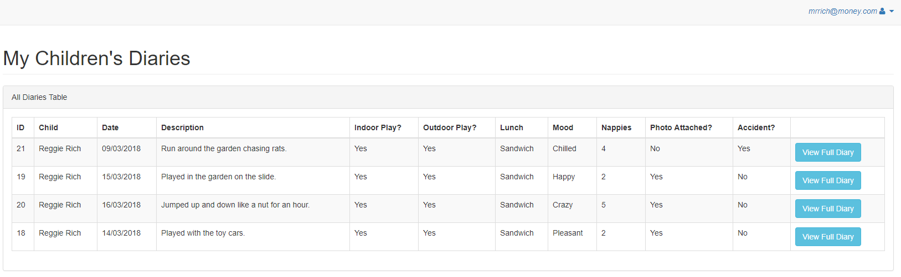
Figure 57 – Diaries table.
In this example, the diary entry selected is associated with an accident record. The diary page displays a clear message to parents that an accident record has been completed and it is available to view at the bottom of the page.
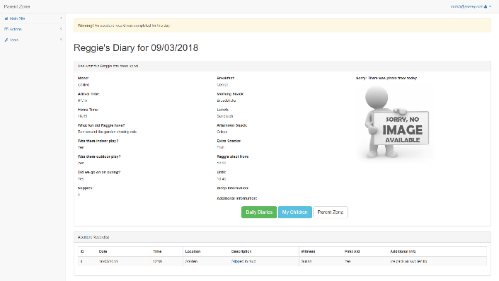
Figure 58 – Full diary.
Security
Parents must only allowed access to records that relate to them or their registered children to satisfy the Data Protection Act.

When a parent logs in to the web app their contact ID is stored in a session variable. By storing this data the web app is able to query the database and gather the ID numbers of related children. Children’s IDs are also stored in a session variable as an array. On each page that a parent visits a test takes place to confirm whether the page they are attempting to view belongs to a related child.

The code sample below takes the child profile value from the URL and compares it to the values stored in the session array of related child ID numbers. If the child’s ID is present in this array the parent is granted viewing permission. If not, they are redirected to the Parent Zone.

Figure 59 – URL with child profile value.
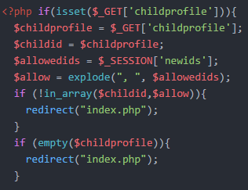
Figure 60 – Code managing access rights.
The Parent Zone utilises adaptations of many staff features which were developed first. As a result, there were no major obstacles that hindered the development of the Parent Zone.

4.4 Testing
Testing is a fundamental stage in development. It is the process of discovering whether a particular component and the solution as a whole satisfy the specified requirements [107]. A number of testing methodologies exist but those opted for in this project include:
- Unit Testing – Unit testing places a focus on validating that small components of a system meet their specified requirements [108].
- System Testing – Once all units of code have been tested the system as a whole will be tested.
- User Acceptance Testing (UAT) – UAT is a method of testing carried out prior to the deployment of a new application with the primary objective of ensuring the application performs as expected and meet the requirements of the business [109]. It is performed by those who represent the most likely user type.

4.4.1 Unit Testing
Throughout the development phase of the project unit testing was commonplace. Within the FDD methodology a feature is only deemed complete when it has been tested and considered fully functional. Unit testing is attributed with a number of benefits including:
- Faster development and debugging – Code written in small and manageable units is less likely to suffer from errors. Those errors that do exist are more easily recognised and rectified in a smaller unit of code.
- Better design – The developer is forced to consider how their unit of code is likely to be adopted throughout the system resulting in a better design and documentation.
- Reduced cost – Numerous studies indicate that bugs found in release cost far more to resolve than bugs found in development. Unit testing identifies bugs efficiently. [110]
Throughout the development process all features have been thoroughly tested to ensure performance and quality. At each iteration of the FDD methodology unit testing was performed to ensure a newly developed feature was complete before moving on to new developments. A comprehensive work log of features developed and important notes have been recorded (See Appendix B).

In this example test an invoice is generated for the time period between 01/04/18 and 12/04/18. The developer anticipates that once generated the invoice will be viewable by the corresponding recipient.
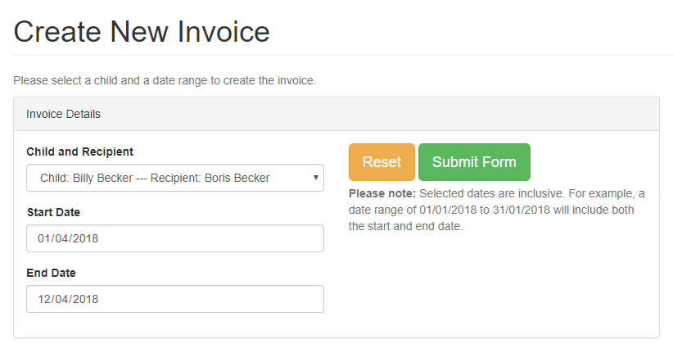
Figure 61 – Auto invoice form.
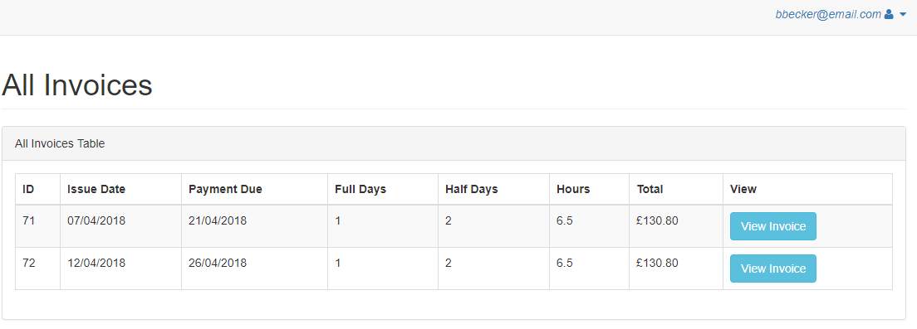
Figure 62 – Invoice table.
This test is successful as the recipient is able to view the newly created invoice.

4.4.2 System testing
When each of the required functions and features has been suitably designed, developed and passed through unit testing it is then appropriate to conduct testing on the project as a whole. System testing, as is the case in this instance, is most often performed by a developer who has good visibility and knowledge of the structure of the project [111]. System testing is undertaken to ensure that all of the requirements have been developed and that they perform their corresponding function without error [112].

System testing in this project was undertaken by the developer using a test data set. The developer, with the knowledge and insight into this project, was able to anticipate test results and determine whether or not the features being tested were performing correctly.

System testing proved to be successful with all staff and parent features performing as intended. Tests were performed on a desktop PC and using the latest available version of the Google Chrome internet browser. As a result of the positive test results the developer is confident that the system is ready for User Acceptance Testing.

4.4.3 User Acceptance Testing
As the client, Little Flowers have played an active role in the design and development of the website and web app and will be the eventual users of the system. Therefore, Sarah and James Price are the ideal individuals to perform UAT. UAT is a testing methodology where users are required to perform a number of tasks to validate the solution against its success criteria [113].

Sarah and James Price of Little Flowers were asked to complete the following tasks with no further guidance than what is provided below:

Parent Tasks
Acting as a parent, please complete the following:
- Find information relating to Little Flowers’ childminding services.
- Contact Little Flowers Childminding.
- Log in to the Parent Zone.
- View a daily diary for a registered child.
- View a created invoice.
- Log out.
Staff Tasks
Acting as a member of staff, please complete the following:
- Log in to the staff dashboard.
- Add a primary parent record to the database.
- Amend the name of a registered child.
- Delete a document.
- Generate an invoice for Reggie Rich for dates 01/03/2018 – 30/03/2018.
- Log out.
Following UAT, Sarah and James Price were asked to complete a questionnaire (See Appendix D).

5 Evaluation
Following design and development the solution created must be evaluated. To evaluate the success of the solution developed both criteria-based assessment and UAT have been adopted. Criteria-based assessment will determine whether or not the solution is successful while UAT will determine the perceived level of success.

5.1 Criteria-based
Criteria-based assessment is an evaluation method that analyses previously established success criteria and considers whether or not they have been satisfied [114]. To consider the developed solution a success it must satisfy all of the success criteria previously identified in this document.

Table 14 - Success criteria.
Success Criteria | Successful?
Website
Create an attractive and professional website which should include: | Determined by UAT.
‘About us’ information page.
‘Services’ page.
Interactive image gallery.
Contact information and contact form.
Single point of login for parents and staff.
Website should be responsive accounting for mobile, tablet and laptop/desktop viewers. | (UAT)
Staff functionality
Adding records of children, parents and emergency contacts to a database.
Accessing child, parent and contact information as required.
Amending child, parent and contact information as required.
Deletion of child, parent and contact information as required.
Add new staff users.
Creation of daily diaries including photo attachment.
Viewing historical daily diaries.
Creation of accident records.
Viewing historical accident records.
Manually create invoices.
Create automatically calculated invoices from daily diary recordings.
Distribute invoices in PDF format.
Manually create receipts.
Upload policies and procedures documentation.
Parent functionality
View ‘My children’ and stored information.
View completed daily diaries.
View completed accident records.
View created invoices.
View created receipts.
View policies and procedures documentation.
Project
Project follows adopts a suitable research methodology.
Project follows adopts a suitable development methodology.
Project is evaluated using appropriate methods.
Project identifies areas for future development.

The following is a summarised list of the success criteria and justification as to why these aspects have been deemed successful.

- The website is attractive and professional in appearance, easy to navigate and responsive. All specified pages are present.
Little Flowers required a website that achieved a balance of between being attractive and appearing professional. The success of this criteria will be determined through user acceptance testing.
By successfully adopting common web design principles and considering usability heuristics the website has been designed to be easily navigated. A consistently located navigation bar on each page provides access to all other pages. The website is fully responsive and resizes content to fit the screen of the device on which it is being viewed. All of the pages specified as requirements are present.

The website requirements have been satisfied and are considered successful.

- Staff are provided CRUD operations to manage child and contact information, daily diaries, accident records etc.
Staff have been provided with all of the functionality required to create, read, update and delete information and records as established in the success criteria.

The features and functionality afforded to staff have been designed, developed and tested to ensure they are suitable. Staff are able to perform all of the tasks deemed as valuable by Little Flowers which satisfies the success criteria.

- Professional invoices are created from the web app.
Little Flowers required invoice creation functionality to increase their business efficiency and reduce their dependence on physical resources. The web app provides staff the functionality to create:
- Manual invoices – Invoices created with manually entered values for a chosen recipient.
- Automatic invoices – Invoices automatically calculated and generated by selecting an invoice recipient, child and a period of time.
The ability to generate invoices both manually and automatically were considered to be valuable features to Little Flowers and will increase their business efficiency. These features fully satisfy the specified success criteria.

- Parents are only able to view information and records that relate to them or their children. Parents are able to access the web app from a range of devices.
Parent users are granted access to the Parent Zone which displays important information relating to their children in a quick and easily accessible way. The Parent Zone is responsive and fully functional across a range of devices.

Parents are able to access all of the information deemed important in the parent functionality requirements including:
- Child profiles.
- Completed daily diaries and accident records.
- Invoices and receipts
- Little Flower policies and procedures documentation.
Parents are only able to view information that relates to them or their children in accordance with the Data Protection Act. These restrictions have been suitably enforced which satisfies the success criteria.

5.2 User Acceptance Testing
Sarah and James Price were asked to perform a number of parent and staff tasks with no further guidance than the provided task list. Sarah and James successfully completed all of the tasks set and required no guidance or assistance at any stage.

Following UAT, Sarah and James provided positive feedback and valuable suggestions for improvements. Given the small sample size it is difficult to place too much value on the quantitative feedback but gives an indication that Little Flowers staff are generally pleased with the navigation, design and functionality of the website and app.

Table 15 - UAT feedback.
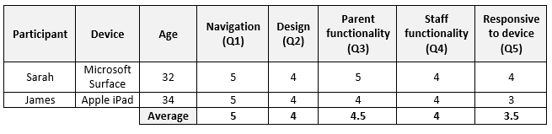

Comments provided by Sarah indicate that she was able to navigate the website and app with ease. It was noted however that the login page of the website lacks information that confirms who is able to login. Sarah said “It should probably make it clear to parents that this is where they login as well” – This is valuable insight that is likely to ease the parent experience. Viewing with a Microsoft Surface laptop, Sarah experienced the site and app in a full size desktop version.

Although James was largely positive in his evaluation, a score of three for responsiveness indicates a level of dissatisfaction. James commented “When completing the parent tasks, I noticed that the Children’s Diaries table extended too far to the right so some of the buttons were out of view”. This is a clear design flaw that appears to be present in a number of similar tables within the web app. This flaw should be rectified as a priority in future developments.

5.3 Conclusion
By direct comparison, it is fair to state that the final solution is more efficient than the current paper-based method of recording employed by Little Flowers. The website and web app both meet all of the success criteria and functionality requirements set out by Little Flowers. Commissioning this solution would certainly result in increased business operations efficiency and reduced dependency on physical resources.

UAT clearly indicated that Sarah and James felt that the website is suitably designed and portrays their business in the positive light they had hoped for. In addition, both were in agreement that the website and web app are easily navigable and that it successfully performs the functions they require. This success was exemplified by their own performance when asked to undertake a number of tasks which they were able to with no additional guidance.

By these measures of criteria-based assessment and the results of UAT, the design, development and implementation of this solution should be considered a success.

6 Conclusions and Recommendations

6.1 Conclusions
The rationale for this development project was to investigate and address the understanding that although certain recordings are a legal requirement for professional childminders, at present no industry standard means of doing so.

An in-depth literature review has provided a solid understanding and appreciation of the history of childcare in the UK and how a number of influential events and cultural shifts have led to the great demand for professional childcare services in the modern-day. In addition to this valuable insight, the literature review also considered a sample of currently available software solutions and analysed their advantages, disadvantages and suitably for meeting the needs of Little Flowers.
Having contacted a small number of local professional childcare settings it was quickly determined that producing recordings was done in various ways. The method of recording fell either under the scope of paper-based or digitally generated recordings, the latter more likely to be adopted by larger settings. It quickly became clear that no industry standard tool or method of creating or managing recordings is currently in place. None of which providing a wholly suitable solution for Little Flowers.
It was decided that a bespoke solution would be most suitable for Little Flowers and a number of development approaches were considered. When compared to locally installed software and mobile applications it was felt that developing a web application would most suitably meet the needs and requirements of Little Flowers. It would provide Little Flowers and parents the freedom to create and access information from a wider range of devices from any internet connected location.
The primary objective was to create a website for Little Flowers that was both aesthetically pleasing and professional in its design which would be accompanied by a web application that would perform CRUD operations for staff and parents as appropriate to their need.
The website and web app were successfully designed and developed by following a set of well-established industry methodologies including:
- Research Onion – Adopted as the research methodology.
- Feature Driven Development – Adopted as the development methodology.
- Database Lifecycle – Specifically utilised to develop a fully operational database.
  - Entity Relationship Diagrams – Used at a conceptual, logical and physical model level.
- Unified Modelling Language and Pseudocode – Used to visually represent the structure of an intended function.
- Wireframes – To provide a visual representation of the general structure of various web pages.
- Sitemap and Content Plan – Used to clearly identify required website content and represent the hierarchy of web pages and how they can be navigated.
In conclusion, by direct comparison against the success criteria, functionality requirements and the business requirements of Little Flowers the final solution is deemed successful. Little Flowers required a digital means of creating, managing and distributing important recordings which have been fully accounted for and provided in the developed web app. The web app created matches a great number of features offered by alternative existing solution and provides the additional freedom of access anywhere not provided by non-web applications. However, the web app developed does not provide some features that are available through iChildCare. Unlike iChildCare however, the web app developed is fully integrated into the Little Flowers website giving Little Flowers ownership over their data. By adopting this newly developed system Little Flowers would not be hindered by the possibility of an alternative provider, such as iChildCare, going out of business or no longer providing a competitive service.

6.2 Recommendations
Although the project may be considered a success, it is not without room for improvement and development. At the present time it is believed that the web app would benefit from giving further consideration to the following areas:

Responsive Design Testing
UAT and feedback identified that the web app suffered flaws with regards to responsive design. It was determined that tables did not always suitably resize when viewed on a small device such as a tablet or mobile phone. To ensure the web app is entirely suitable to the device on which it is being viewed, more comprehensive and rigorous testing of the responsive design must be undertaken.

Security Testing
Given the nature of the data created and stored by Little Flowers it is of utmost importance that data is secure. Principle seven of the Data Protection Act specifically states that appropriate technical measures be implemented to ensure the security of data. To ensure the web app is entirely secure it should be subject to penetration testing conducted by a qualified professional with a specific focus on protection against SQL injection attacks where malicious user input attempts to retrieve data from the database [115].

Further to developing and improving existing areas of the web app, the author feels that future developments should include the creation of additional features:

Email / SMS
The ability to send emails or SMS messages to parents from within the web app would allow Little Flowers to contact individuals or groups of parents easily without leaving the web app. This additional feature would further increase the efficiency of Little Flowers’ business operations. This feature was not developed due to the fact that the web app was developed in an offline test environment.

Contract Creation
Although not a specified requirement, the ability to generate and distribute contracts and terms of service with parents would be a valuable addition to the web app’s functionality. A contract is created for each child that is cared for by Little Flowers and signed by the parent(s) of said child. This was not discussed with Little Flowers but would be relatively straightforward to implement in future developments and would also increase business efficiency and further reduce their reliance on physical resources.

Additional features to be considered in future releases may also include:
  - Attendance register.
  - Interactive calendar.
  - Payment management system that records paid invoices and issues receipts automatically.
The web app developed meets all of the needs and requirements set out by Little Flowers yet still has a wide scope and range of areas for improvement. With greater time, financial backing and resources this project has the potential to become a cost-effective and efficient solution for professional childminders throughout Wales.

7 Reflection
To reflect on my own personal performance throughout this project and to consider ways in which I can improve, I will follow Gibb’s Reflective Cycle. Gibb’s Reflective Cycle is a model for reflection that consists of six stages that guides the author in their reflective writing [116].

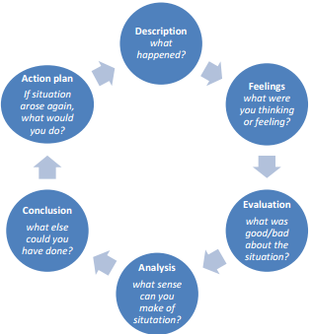
Figure 63 – Gibb’s Reflective Cycle. [116]
Description
I will be reflecting upon my own personal performance in this project and how the decisions made throughout have influenced progress. I will consider whether the methodologies and tools adopted for research, development and evaluation have been appropriate and whether they have contributed positively to the final solution.

Feelings
I approached this project with a mixture of trepidation and excitement. Having entered with little knowledge regarding the historical or modern state of professional childcare I was naturally wary. Conversely, I also held a great sense of excitement and eagerness to begin as I was confident that a good quality solution could become a valuable tool to Little Flowers.

Evaluation
I am pleased that throughout the research, design and development of this project I have found a wide range of opportunities to stretch and further my knowledge and experience. As the subject area was somewhat unfamiliar to me, a comprehensive literature review determined key historical factors and cultural shifts giving me valuable insight into the modern-day demand for professional childcare. Gaining an appreciation of its history and development in the UK placed modern-day professional childcare in its true context.

I am satisfied that the methodologies I identified and adopted have positively influenced this project. Choosing to follow the Research Onion and Feature Driven Development methodologies have guided the project naturally and made it easily manageable. Following such well-established methodologies gave me confidence in the process and allowed me to track progress and assess the amount of work still to be undertaken.

Although I am satisfied the project meets its aims, objectives and requirements, in hindsight I am disappointed that web app is missing features that would have immediately benefitted Little Flowers such as the aforementioned email/SMS functions and contract generation. Although not specified requirements, these features may have been easily implemented resulting in a more feature-rich solution and would have been welcome additions at this stage.

Also, I am disappointed that I did not utilise this opportunity to stretch my programming knowledge specifically by way of using a web application framework. A framework provides a structure that allows a developer to minimise the creation of repetitive code thus making them more efficient. Among the most popular PHP frameworks is Laravel which boasts greater performance in code execution than core PHP. CRUD functionality tests performed at Assam Downtown University have substantiated these claims as the Table 16 and Figure 64 depict:

Table 16 - Time (ms).
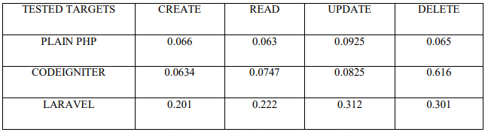
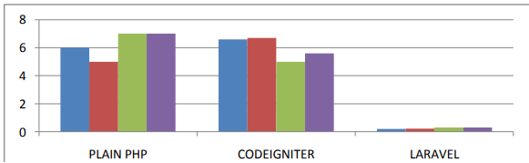
Figure 64 – Chart created from Table 16 data. [117]

In hindsight, this project may would have benefitted from the adoption of a PHP framework such as Laravel. Increasing my development efficiency would likely have afforded me more time to invest in additional features for the web app. This project presented a good opportunity to develop skills and knowledge in this area but was regretfully not grasped.

Having concluded development, I feel that more consideration may also have been given to the security of the application. While security has been considered and handled throughout such as enforcing user input validation in forms and restricting the viewing of data according to user account privileges, I am conscious that more stringent security measures may have been practiced. For example, it would have been better to use prepared statements to manage database connections and SQL queries. Prepared statements have two major benefits; Efficiency and protection against SQL injection [118]. To ensure the security of the developed solution I would insist on the use of prepared statements retrospectively and in future developments.

Analysis
Having reached a point of completion, I believe that the areas in which I am confident with my performance were supported by in-depth research and analysis. For example, I am pleased that choosing a web application was a suitable development method and that PHP was the most suitable programming language. These development decisions were a result of research and considered analysis into alternative available methods.

I am also pleased with the time and resource management of the project as a whole. This was in large part down to the selection of the FDD methodology which broke large tasks into manageable chunks. I chose to use FDD after analysing its benefits and drawbacks and considering its suitably to the project in question. It is a methodology I was previously unfamiliar with but certainly suitable and resulted in a positive experience.

As stated, I am disappointed that I did not adopt a web app framework for the development of the solution. Upon reflection, I believe this missed opportunity was a result of uncertainty towards learning a new development method while introducing myself to an unfamiliar topic in childcare. I chose to develop the solution in core PHP as I was already familiar and experienced with this method but I believe the project would have benefitted from developing within a framework.

Conclusion
In conclusion, the research, design and development of this project presented a range of challenges where I have been able to acquire new knowledge and experience while honing and furthering existing skills. I am pleased that the project has been well-managed and has been completed successfully. In light of this success, I am also aware that a broad scope for self-improvement and development exists and that this project is by no means without fault. Having reflected on the project from a stance of completion I am confident that future projects will provide an opportunity to continue developing personal performance and that the lessons learned in this project will be carried forward.

Action Plan
To continue my personal development I will actively seek opportunity to stretch my skills and knowledge in future projects. I will pursue the opportunity to undertake training in developing within a web app framework, such as Laravel. I will use the confidence I have gained from completing this project to push myself into unfamiliar territory to further my capabilities. I also wish to further my knowledge relating to web security and will study resources made available by reputable organisations such as OWASP [119].

8 Reference List

1. Foundation Phase Framework [Internet]. Cardiff: Welsh Government; 2015 [cited 19 April 2018]. Available from: http://learning.gov.wales/docs/learningwales/publications/150803-fp-framework-en.pdf
2. Victorian Children in Victorian Times and How They Lived [Internet]. Victorian Children. [cited 19 April 2018]. Available from: https://www.victorianchildren.org/victorian-children-in-victorian-times/
3. Schooling before the 19th Century [Internet]. UK Parliament. [cited 19 April 2018]. Available from: https://www.parliament.uk/about/living-heritage/transformingsociety/livinglearning/school/overview/before19thcentury/
4. The National Archives | Exhibitions | Citizenship | Struggle for democracy [Internet]. Nationalarchives.gov.uk. [cited 19 April 2018]. Available from: http://www.nationalarchives.gov.uk/pathways/citizenship/struggle_democracy/childlabour.htm
5. 1833 Factory Act - The National Archives [Internet]. The National Archives. [cited 19 April 2018]. Available from: http://www.nationalarchives.gov.uk/education/resources/1833-factory-act/
6. Hidden Lives Revealed - Ragged Schools, Industrial Schools and Reformatories [Internet]. Hiddenlives.org.uk. [cited 19 April 2018]. Available from: http://www.hiddenlives.org.uk/articles/raggedschool.html
7. Duckworth J. Fagin's children. London: Hambledon and London; 2002.
8. About us [Internet]. NSPCC. 2018 [cited 19 April 2018]. Available from: https://www.nspcc.org.uk/what-we-do/about-us/
9. Prevention of Cruelty to, and Protection of, Children Act 1889 [Internet]. Legislation.gov.uk. 1889 [cited 19 April 2018]. Available from: http://www.legislation.gov.uk/ukpga/1889/44/enacted
10. Convention on the Rights of the Child [Internet]. UNICEF; 1989 [cited 19 April 2018]. Available from: https://digitalcommons.ilr.cornell.edu/cgi/viewcontent.cgi?referer=https://scholar.google.co.uk/&httpsredir=1&article=1007&context=child
11. Ornstein A, Levine D, Gutek G, Vocke D. Foundations of education. Cengage Learning, Inc;.
12. Lawrence E. Friedrich Froebel and English education. London: Routledge; 2011.
13. Education in Robert Owen’s new society: the New Lanark institute and schools [Internet]. infed.org. [cited 19 April 2018]. Available from: http://infed.org/mobi/education-in-robert-owens-new-society-the-new-lanark-institute-and-schools/
14. May H, Kaur B, Prochner L. Empire, Education, and Indigenous Childhoods. London: Taylor and Francis; 2016.
15. Education Act 1944 [Internet]. UK Gov; 1944 [cited 19 April 2018]. Available from: http://www.legislation.gov.uk/ukpga/1944/31/pdfs/ukpga_19440031_en.pdf
16. Preschool Childcare: Past and Present [Internet]. History & Policy Parenting Forum Blog. [cited 19 April 2018]. Available from: https://arts.leeds.ac.uk/parentingforum/2016/01/26/preschool-childcare-past-and-present/
17. Soldiers in World War 2 | Breakdown of WW2 Soldiers by country [Internet]. Worldwar2.org.uk. 2018 [cited 19 April 2018]. Available from: https://worldwar2.org.uk/soldiers-world-war-2
18. The women of the Second World War - GOV.UK [Internet]. Gov.uk. 2015 [cited 19 April 2018]. Available from: https://www.gov.uk/government/news/the-women-of-the-second-world-war
19. Corn J. Britain since 1930. Dunstable: Folens; 1994.
20. Marwick A. Total war and social change. Basingstoke: Palgrave Macmillan; 2003.
21. Domenico D, Jones K. Career Aspirations of Women in the 20th Century [Internet]. Journal of Career and Technical Education; 2006 [cited 19 April 2018]. Available from: https://ejournals.lib.vt.edu/JCTE/article/view/430/574
22. A century of labour market change: 1900 to 2000 [Internet]. London: ONS; 2003 [cited 19 April 2018]. Available from: http://www.ons.gov.uk/ons/rel/lms/labour-market-trends--discontinued-/volume-111--no--3/a-century-of-labour-market-change--1900-to-2000.pdf?format=print
23. Female employment rate (aged 16 to 64, seasonally adjusted) - Office for National Statistics [Internet]. Ons.gov.uk. 2018 [cited 19 April 2018]. Available from: https://www.ons.gov.uk/employmentandlabourmarket/peopleinwork/employmentandemployeetypes/timeseries/lf25/lms
24. Gender roles An incomplete revolution? [Internet]. British Social Attitudes; [cited 19 April 2018]. Available from: http://www.bsa.natcen.ac.uk/media/38457/bsa30_gender_roles_final.pdf
25. Lamb M. The Role of the Father in Child Development [Internet]. 1981 [cited 19 April 2018]. Available from: https://www.researchgate.net/profile/Michael_Lamb/publication/31670039_The_Role_of_the_Father_in_Child_Development_M_R_Lamb/links/00b4952399d43485f1000000/The-Role-of-the-Father-in-Child-Development-M-R-Lamb.pdf
26. Lippa R. Gender, Nature, and Nurture. London: Taylor & Francis Ltd; 2014.
25. Barnett R, Rivers C. Role of fathers is changing for the better, science says - The Boston Globe [Internet]. BostonGlobe.com. 2015 [cited 19 April 2018]. Available from: https://www.bostonglobe.com/ideas/2015/06/18/role-fathers-changing-for-better-science-says/4eMmyMFrlF34G9arbL8FPN/story.html
28. Shared Parental Leave and Pay - GOV.UK [Internet]. Gov.uk. 2018 [cited 19 April 2018]. Available from: https://www.gov.uk/shared-parental-leave-and-pay
29. SHARED PARENTAL LEAVE: PUBLIC ATTITUDES [Internet]. London: UK Gov; 2015 [cited 19 April 2018]. Available from: https://www.gov.uk/government/uploads/system/uploads/attachment_data/file/394623/bis-15-32-shared-parenting-leave-public-attitudes.pdf
30. Kemp R. Why are only 1 in 100 men taking up shared parental leave? [Internet]. The Telegraph. 2016 [cited 19 April 2018]. Available from: https://www.telegraph.co.uk/men/the-filter/why-are-only-1-in-100-men-taking-up-shared-parental-leave/
31. The Modern Families Index 2017 [Internet]. Working Families; 2017 [cited 19 April 2018]. Available from: https://www.workingfamilies.org.uk/wp-content/uploads/2017/01/Modern-Families-Index_Full-Report.pdf
32. Families: the end or simply different? | Understanding Society [Internet]. Understandingsociety.ac.uk. [cited 19 April 2018]. Available from: https://www.understandingsociety.ac.uk/case-studies/families-the-end-or-simply-different
33. WHO’S BREADWINNING IN EUROPE? [Internet]. IPPR; 2015 [cited 19 April 2018]. Available from: https://www.ippr.org/files/publications/pdf/whos-breadwinning-in-europe-oct2015.pdf
34. University gender gap at record high as 30,000 more women accepted [Internet]. The Guardian. 2017 [cited 19 April 2018]. Available from: https://www.theguardian.com/education/2017/aug/28/university-gender-gap-at-record-high-as-30000-more-women-accepted
35. Review of the Childcare Sector in Wales [Internet]. CArdiff: Welsh Government; 2018 [cited 19 April 2018]. Available from: http://gov.wales/docs/caecd/research/2018/180110-review-childcare-sector-summary-en.pdf
36. National Minimum Standards for Regulated Childcare for children up to the age of 12 years [Internet]. Cardiff: Welsh Government; 2016 [cited 19 April 2018]. Available from: http://gov.wales/docs/dsjlg/publications/cyp/160411-regulated-child-care-en.pdf
37. Welsh Government|Childcare [Internet]. Gov.wales. 2017 [cited 19 April 2018]. Available from: http://gov.wales/topics/people-and-communities/people/children-and-young-people/childcare/?lang=en
38. Childcare Capacity in Wales [Internet]. Cardiff: Welsh Government; 2017 [cited 19 April 2018]. Available from: http://gov.wales/docs/caecd/research/2017/171031-childcare-capacity-summary-en.pdf
39. Childcare Survey 2017 [Internet]. Family and Childcare Trust. 2017 [cited 19 April 2018]. Available from: https://www.familyandchildcaretrust.org/childcare-survey-2017
40. Welsh Government|Talk childcare - The offer for Wales [Internet]. Gov.wales. 2017 [cited 19 April 2018]. Available from: http://gov.wales/topics/people-and-communities/people/children-and-young-people/childcare/talk-childcare/?lang=en
41. Welsh Government|The cost of childcare [Internet]. Gov.wales. 2017 [cited 19 April 2018]. Available from: http://gov.wales/topics/people-and-communities/people/children-and-young-people/childcare/talk-childcare/talkchildcare-campaign/cost-of-childcare/?lang=en
42. Welsh Government|Annual survey of hours and earnings [Internet]. Gov.wales. 2017 [cited 19 April 2018]. Available from: http://gov.wales/statistics-and-research/annual-survey-hours-earnings/?lang=en
43. Marano H. Daycare: Raising Baby [Internet]. Psychology Today. 2007 [cited 19 April 2018]. Available from: https://www.psychologytoday.com/articles/200704/daycare-raising-baby
44. Ahnert L, Lamb M. Child Care and Its Impact on Young Children (2-5) [Internet]. Encyclopedia on Early Childhood Development; 2011 [cited 19 April 2018]. Available from: http://www.child-encyclopedia.com/sites/default/files/textes-experts/en/857/child-care-and-its-impact-on-young-children-2-5.pdf
45. Melhuish E. THE IMPACT OF EARLY CHILDHOOD EDUCATION AND CARE ON IMPROVED WELLBEING [Internet]. 2018 [cited 19 April 2018]. Available from: https://www.britac.ac.uk/sites/default/files/Edward%20Melhuish%20-%20The%20Impact%20of%20Early%20Childhood%20Education%20and%20Care%20on%20Improved%20Wellbeing.pdf
46. Narea M. Does early centre-based care have an impact on child cognitive and socio-emotional development? Evidence from Chile [Internet]. London: Centre for Analysis of Social Exclusion; 2014 [cited 19 April 2018]. Available from: http://sticerd.lse.ac.uk/dps/case/cp/casepaper183.pdf
47. The Regulation of Child Minding and Day Care (Wales) Order 2016 [Internet]. London: UK Gov; 2016 [cited 19 April 2018]. Available from: http://www.legislation.gov.uk/wsi/2016/98/pdfs/wsi_20160098_mi.pdf
48. CHILDREN AND FAMILIES (WALES) MEASURE 2010 Application to Register as a Child Minder [Internet]. CSSIW; 2018 [cited 19 April 2018]. Available from: http://careinspectorate.wales/docs/cssiw/general/180201cmguidanceen.pdf
49. Chief Inspector’s Annual Report 2016–2017 [Internet]. CSSIW; 2017 [cited 19 April 2018]. Available from: http://cssiw.org.uk/docs/cssiw/report/171102annualreporten.pdf
50. Wales C. CIW | Care Inspectorate Wales [Internet]. Careinspectorate.wales. 2018 [cited 19 April 2018]. Available from: http://careinspectorate.wales/providingacareservice/our-inspections/?lang=en
51. Data Protection Act 1998 [Internet]. Legislation.gov.uk. 1998 [cited 19 April 2018]. Available from: https://www.legislation.gov.uk/ukpga/1998/29/contents
52. Data protection principles [Internet]. Ico.org.uk. 2018 [cited 19 April 2018]. Available from: https://ico.org.uk/for-organisations/guide-to-data-protection/data-protection-principles/
53. Nursery Genie – Nursery management software from Nursery Genie [Internet]. Nurserygenie.co.uk. 2018 [cited 19 April 2018]. Available from: http://www.nurserygenie.co.uk/
54. My Montessori Child [Internet]. Mymontessorichild.com. 2018 [cited 19 April 2018]. Available from: https://www.mymontessorichild.com
55. Starner T. Thick Clients for Personal Wireless Devices [Internet]. Georgia Institute of Technology; 2002 [cited 19 April 2018]. Available from: https://pdfs.semanticscholar.org/1eb5/bb6bc2b0ff81de5e7ba46e35670cdd090ef5.pdf
56. Get started with the .NET Framework [Internet]. Docs.microsoft.com. 2018 [cited 19 April 2018]. Available from: https://docs.microsoft.com/en-us/dotnet/framework/get-started/
57. Desktop Operating System Market Share Worldwide | StatCounter Global Stats [Internet]. StatCounter Global Stats. 2018 [cited 19 April 2018]. Available from: http://gs.statcounter.com/os-market-share/desktop/worldwide
58. Gosling J, Joy B, Steele G, Bracha G, Buckley A. The Java® Language Specification [Internet]. Oracle; 2015 [cited 19 April 2018]. Available from: https://docs.oracle.com/javase/specs/jls/se8/jls8.pdf
59. PYPL PopularitY of Programming Language index [Internet]. Pypl.github.io. 2018 [cited 19 April 2018]. Available from: https://pypl.github.io/PYPL.html
60. Apple & Samsung dominate UK smartphone Market in 3Q17 - Counterpoint Research [Internet]. Counterpoint Research. 2017 [cited 19 April 2018]. Available from: https://www.counterpointresearch.com/apple-leads-uk-smartphone-market-in-2017q3/
61. 2018 M. Tablet device vendors: market share 2012-2018 | UK [Internet]. Statista. 2018 [cited 19 April 2018]. Available from: https://www.statista.com/statistics/487815/market-share-tablet-device-vendors-uk/
62. Sunnebo D. Kantar - Sony and Samsung put Pressure on Huawei’s growth in Europe [Internet]. Uk.kantar.com. 2017 [cited 19 April 2018]. Available from: https://uk.kantar.com/tech/mobile/2017/september-great-britain-smartphone-data/
63. Develop - Apple Developer [Internet]. Developer.apple.com. 2018 [cited 19 April 2018]. Available from: https://developer.apple.com/develop/
64. Guthrie S. Microsoft to acquire Xamarin and empower more developers to build apps on any device - The Official Microsoft Blog [Internet]. The Official Microsoft Blog. 2016 [cited 19 April 2018]. Available from: https://blogs.microsoft.com/blog/2016/02/24/microsoft-to-acquire-xamarin-and-empower-more-developers-to-build-apps-on-any-device/
65. Download Android Studio and SDK Tools | Android Studio [Internet]. Developer.android.com. 2018 [cited 19 April 2018]. Available from: https://developer.android.com/studio/index.html
66. Getting Started - Xamarin [Internet]. Docs.microsoft.com. 2017 [cited 19 April 2018]. Available from: https://docs.microsoft.com/en-gb/xamarin/cross-platform/get-started/index
67. What is a Web-Based Application? - Definition from Techopedia [Internet]. Techopedia.com. [cited 19 April 2018]. Available from: https://www.techopedia.com/definition/26002/web-based-application
68. PHP: What is PHP? - Manual [Internet]. Secure.php.net. [cited 19 April 2018]. Available from: https://secure.php.net/manual/en/intro-whatis.php
69. Historical trends in the usage of server-side programming languages, April 2018 [Internet]. W3techs.com. 2018 [cited 19 April 2018]. Available from: https://w3techs.com/technologies/history_overview/programming_language
70. The Official Microsoft ASP.NET Site [Internet]. The Official Microsoft ASP.NET Site. 2018 [cited 19 April 2018]. Available from: https://www.asp.net/
71. HTML [Internet]. MDN Web Docs. 2018 [cited 19 April 2018]. Available from: https://developer.mozilla.org/en-US/docs/Web/HTML
72. CSS: Cascading Style Sheets [Internet]. MDN Web Docs. 2018 [cited 19 April 2018]. Available from: https://developer.mozilla.org/en-US/docs/Web/CSS
73. About JavaScript [Internet]. MDN Web Docs. 2018 [cited 19 April 2018]. Available from: https://developer.mozilla.org/en-US/docs/Web/JavaScript/About_JavaScript
74. Web Hosting | Cheap Website Hosting Services for the UK | 1&1 [Internet]. 1and1.co.uk. [cited 19 April 2018]. Available from: https://www.1and1.co.uk/web-hosting
75. Schifreen R. How to create Web sites and applications with HTML, CSS, Javascript, PHP and MySQL. [Internet]. [cited 19 April 2018]. Available from: http://www.itp.uzh.ch/~suzanne/ebooks/The%20Web%20Book-A4-HM.pdf
76. Sahay A. [Internet]. 2016 [cited 19 April 2018]. Available from: https://www.researchgate.net/publication/309488459_Peeling_Saunder's_Research_Onion
77. CHAPTER 3: RESEARCH METHODOLOGY [Internet]. Institut-numerique.org. [cited 19 April 2018]. Available from: http://www.institut-numerique.org/chapter-3-research-methodology-4ffbd6e5e3391
78. Research Methodology [Internet]. [cited 19 April 2018]. Available from: http://www.is.cityu.edu.hk/staff/isrobert/phd/ch3.pdf
79. Shirazi K. Strengths And Weaknesses of Positivist Paradigm [Internet]. [cited 19 April 2018]. Available from: http://www.academia.edu/8384477/Strengths_And_Weaknesses_of_Positivist_Paradigm
80. Soiferman L. Compare and Contrast Inductive and Deductive Research Approaches [Internet]. University of Manitoba; 2010 [cited 19 April 2018]. Available from: https://files.eric.ed.gov/fulltext/ED542066.pdf
81. Deductive Approach (Deductive Reasoning) - Research-Methodology [Internet]. Research-Methodology. [cited 19 April 2018]. Available from: https://research-methodology.net/research-methodology/research-approach/deductive-approach-2/
82. Alias A. ADVANTAGES AND DISADVANTAGES OF DEDUCTIVE AND INDUCTIVE APPROACHES [Internet]. Academia.edu. 2018 [cited 19 April 2018]. Available from: http://www.academia.edu/4110445/ADVANTAGES_AND_DISADVANTAGES_OF_DEDUCTIVE_AND_INDUCTIVE_APPROACHES
83. Case study as a research method [Internet]. Universiti Teknologi Malaysia; 2007 [cited 19 April 2018]. Available from: http://psyking.net/htmlobj-3837/case_study_as_a_research_method.pdf
84. Advantages and Disadvantages of Case-Control Studies [Internet]. Sphweb.bumc.bu.edu. [cited 19 April 2018]. Available from: http://sphweb.bumc.bu.edu/otlt/MPH-Modules/EP/EP713_Case-Control/EP713_Case-Control8.html
85. Saunders M, Tosey P. The Layers of Research Design [Internet]. 2012 [cited 19 April 2018]. Available from: https://anlp.org/files/research-onion-layers_42_357.pdf
86. Tashakkori A. Handbook of mixed methods in social & behavioral research. Thousand Oaks, Calif. [u.a.]: Sage;.
87. Khramtchenko S. Comparing eXtreme Programming and Feature Driven Development in academic and regulated environments [Internet]. Harvard University; 2004 [cited 19 April 2018]. Available from: http://www.featuredrivendevelopment.com/files/FDD_vs_XP.pdf
88. Coad P, Lefebvre E, De Luca J. Java modeling in color with UML. Upper Saddle River NJ: Prentice Hall PTR; 1999.
89. Early Aspects: Aspect-Oriented Requirements Engineering and Architecture Design [Internet]. Ris.utwente.nl. 2004 [cited 19 April 2018]. Available from: https://ris.utwente.nl/ws/portalfiles/portal/5128200
90. Tirumala S. A Hybrid Agile model using SCRUM and Feature Driven Development [Internet]. International Journal of Computer Applications; 2016 [cited 19 April 2018]. Available from: https://pdfs.semanticscholar.org/7171/ceedd2d549aa80d468004a3623591c02d2b9.pdf
91. Feature Driven Development & Empirical Modelling [Internet]. [cited 19 April 2018]. Available from: https://warwick.ac.uk/fac/sci/dcs/research/em/publications/web-em/04/featurelist.pdf
92. FDD - Agile - Feature Driven Development [Internet]. Sliitmscfdd.wikidot.com. [cited 19 April 2018]. Available from: http://sliitmscfdd.wikidot.com/introduction-to-fdd
93. Kaya N. Relationship between color and emotion: a study of college students [Internet]. [cited 19 April 2018]. Available from: http://irtel.uni-mannheim.de/lehre/expra/artikel/Kaya_Epps_2004b.pdf
94. Kalbach J. Designing Web Navigation [Internet]. O'Reilly; 2007 [cited 19 April 2018]. Available from: https://doc.lagout.org/Others/O%27Reilly%20Designing%20Series/O%27Reilly%20Designing%20Web%20Navigation.pdf
95. 10 Usability Heuristics for User Interface Design | Design Principles FTW [Internet]. Designprinciplesftw.com. 2018 [cited 19 April 2018]. Available from: https://www.designprinciplesftw.com/collections/10-usability-heuristics-for-user-interface-design
96. Wireframes [Internet]. Usability.gov; [cited 19 April 2018]. Available from: https://www.usability.gov/sites/default/files/creating-wireframes.pdf
97. DBLC Design Stages | Database Life Cycle for Relational Database Design [Internet]. Relationaldbdesign.com. [cited 19 April 2018]. Available from: https://www.relationaldbdesign.com/relational-database-design/module3/dblc-design-stages.php
98. Introduction to Databases E-R Data Modeling [Internet]. 2007 [cited 19 April 2018]. Available from: http://labe.felk.cvut.cz/~stepan/AE3B33OSD/Lesson08-IntroDatabases.pdf
99. DATABASE DESIGN [Internet]. [cited 19 April 2018]. Available from: http://cir.dcs.uni-pannon.hu/cikkek/conceptual_design.pdf
100. Everest G. Stages of Data Modeling [Internet]. University of Minnesota; 2016 [cited 19 April 2018]. Available from: http://www.dama-mn.org/resources/Documents/DAMA-MN%202016%20CvLvP%20stages.pdf
101. Data Modeling - Conceptual, Logical, and Physical Data Models [Internet]. 1keydata.com. [cited 19 April 2018]. Available from: https://www.1keydata.com/datawarehousing/data-modeling-levels.html
102. IBM Knowledge Center [Internet]. Ibm.com. [cited 19 April 2018]. Available from: https://www.ibm.com/support/knowledgecenter/en/SSGU8G_12.1.0/com.ibm.ddi.doc/ids_ddi_186.htm
103. One-to-One (1:1) [Internet]. Sqa.org.uk. [cited 19 April 2018]. Available from: https://www.sqa.org.uk/e-learning/MDBS01CD/page_10.htm
104. What is CRUD cycle (Create, Read, Update and Delete Cycle)? - Definition from WhatIs.com [Internet]. SearchDataManagement. 2018 [cited 19 April 2018]. Available from: http://searchdatamanagement.techtarget.com/definition/CRUD-cycle
105. [Internet]. Nku.edu. 2018 [cited 19 April 2018]. Available from: http://www.nku.edu/~sakaguch/ifs305/305-c1
106. Third Normal Form (3NF) - Database Normalization [Internet]. 1keydata.com. [cited 19 April 2018]. Available from: https://www.1keydata.com/database-normalization/third-normal-form-3nf.php
107. Software Testing [Internet]. TutorialsPoint; [cited 19 April 2018]. Available from: https://www.tutorialspoint.com/software_testing/software_testing_tutorial.pdf
108. Kua P. Unit Testing [Internet]. [cited 19 April 2018]. Available from: https://www.thekua.com/publications/AppsUnitTesting.pdf
109. Hambling B. USer Acceptance Testing [Internet]. Chartered Institute for IT; 2018 [cited 19 April 2018]. Available from: http://shop.bcs.org/resources/pdf/9781780171678.pdf
110. Jiménez O. Unit Testing [Internet]. 2008 [cited 19 April 2018]. Available from: https://web.stanford.edu/class/archive/cs/cs108/cs108.1092/handouts/06UnitTesting.pdf
111. Young M, Pezzè M. Integration & System Testing [Internet]. 1998 [cited 19 April 2018]. Available from: http://ix.cs.uoregon.edu/~michal/Classes/W98/LecNotes/10-Testing-system.pdf
112. Chapter Six: System Testing and Implementation [Internet]. [cited 19 April 2018]. Available from: http://repository.um.edu.my/362/8/8-ch6.pdf
113. [Internet]. Tutorialspoint.com. [cited 19 April 2018]. Available from: https://www.tutorialspoint.com/software_testing_dictionary/pdf/use_acceptance_testing.pdf
114. Jackson M. Software Evaluation: Criteria-based Assessment [Internet]. Software.ac.uk. 2011 [cited 19 April 2018]. Available from: https://software.ac.uk/sites/default/files/SSI-SoftwareEvaluationCriteria.pdf?_ga=2.190049384.2107475840.1522424079-1180251264.1522424079
115. SQL Injection - OWASP [Internet]. Owasp.org. 2018 [cited 19 April 2018]. Available from: https://www.owasp.org/index.php/SQL_Injection
116. Gibbs’ reflective cycle [Internet]. My.cumbria.ac.uk. [cited 19 April 2018]. Available from: https://my.cumbria.ac.uk/media/MyCumbria/Documents/ReflectiveCycleGibbs.pdf
117. Das R. Comparison of Procedural PHP with Codeigniter and Laravel Framework [Internet]. International Journal of Current Trends in Engineering & Research; 2016 [cited 19 April 2018]. Available from: http://www.ijcter.com/papers/volume-2/issue-6/comparison-of-procedural-php-with-codeigniter-and-laravel-framework.pdf
118. PHP: Prepared statements and stored procedures - Manual [Internet]. Secure.php.net. 2018 [cited 19 April 2018]. Available from: https://secure.php.net/manual/en/pdo.prepared-statements.php
119. OWASP [Internet]. Owasp.org. 2018 [cited 19 April 2018]. Available from: https://www.owasp.org/index.php/Main_Page
120. Welsh Government|Help paying for childcare [Internet]. Gov.wales. 2018 [cited 19 April 2018]. Available from: http://gov.wales/topics/people-and-communities/people/children-and-young-people/childcare/help-paying-for-childcare/?lang=en
121. Welsh Government change in guidance [Internet]. Pacey.org.uk. 2017 [cited 19 April 2018]. Available from: https://www.pacey.org.uk/news-and-views/news/welsh-government-change-in-guidance/
122. Health and Safety at Work etc. Act 1974 [Internet]. Legislation.gov.uk. 1974 [cited 19 April 2018]. Available from: http://www.legislation.gov.uk/ukpga/1974/37/contents
123. Wales C. CIW | Care Inspectorate Wales [Internet]. Careinspectorate.wales. [cited 19 April 2018]. Available from: http://careinspectorate.wales/providingacareservice/register/dbs/?lang=en
124. Safer food better business for childminders [Internet]. Food Standards Agency; [cited 19 April 2018]. Available from: https://www.food.gov.uk/sites/default/files/multimedia/pdfs/publication/sfbb-tagd-childminders-fullcol-pack0513.pdf
125. Special Educational Needs Code of Practice for Wales [Internet]. Cardiff: Welsh Government; 2004 [cited 19 April 2018]. Available from: http://gov.wales/docs/dcells/publications/131016-sen-code-of-practice-for-wales-en.pdf
126. Social Services and Well-being (Wales) Act 2014 [Internet]. Legislation.gov.uk. 2014 [cited 19 April 2018]. Available from: http://www.legislation.gov.uk/anaw/2014/4/part/1/enacted
127. GDPR Principles [Internet]. Ico.org.uk. 2018 [cited 19 April 2018]. Available from: https://ico.org.uk/for-organisations/guide-to-the-general-data-protection-regulation-gdpr/principles/

9 Appendices

Appendix A – Alternative Provision and Family Support
Alternative provisions are also in place to support parents paying for childcare with many companies offering salary sacrifice schemes where parents can purchase childcare vouchers directly from their salary before tax, effectively providing a discount of 20% on childcare costs [120]. Parents may also find themselves eligible for UK Government support including tax credits, universal credit or tax-free child schemes according to their individual circumstances and contributory factors. Although generally considered a welcome relief, Welsh Government have also been criticised for their backpedalling on family members being eligible to receive funding through the childcare offer. Original guidance provided by Welsh Government suggested that family members who offer formal childcare may receive funding which was considered to be leading the way in childcare sustainability. After consolation with their legal team Welsh Government have since retracted this offer [121]. In effect, many families with long term private childcare arrangements will now find themselves in a position where they are forced to consider moving their child to alternative provisions to receive the same benefits as other working parents.

Appendix B – Work Log
Feature | Date | Notes
Website
About page | 03/01/2018
Childminding page | 03/01/2018
Contact page | 04/01/2018
Gallery page | 05/01/2018
Index page | 07/01/2018
Mobile crèche page | 08/01/2018
Services pages | 10/01/2018
Login page | 14/01/2018
Web App
Database Design (initial) | 30/01/2018 | Began database design i.e. Established entities. ERD. Conceptual model.
Config.php | 30/01/2018 | Setup test database. Configured connection to database. Tested functionality.
Functions.php | 30/01/2018 | Created functions.php. Initial functions developed:  - set_message()  - display_message()  - redirect()  - login_user()  - logout_user()  - Helper functions
Sessions | 30/01/18 | Restricted access to parts of website according to the type of user logged in.
Password Hashing | 31/01/18 | Rewrote login_user() function to dehash passwords stored in database and test against user input.
Back Navigation | 31/01/18 | Made navigation uniform – All nav referred to same file. Single point of change.
Last login | 31/01/18 | Added record of last time user logged in.
Staff Dashboard | 31/01/18 | Information tiles changed.  Quick action panel created.
Page Content | 31/01/18 | Setup system of displaying content in single page. Content is reloading in the same page according to button clicked and value in URL
Add Family | 31/01/18 | Add family form designed and creation started.
Add family features | 31/01/18 | Disable 2nd parent (Javascript)  Copy address from parent 1 (Javascript)
Add family form | 02/02/18 | Form completed. All fields correctly named, given types, validated etc.
Family form test | 02/02/18 | Family form successfully passes variables to a test page. No errors found.  Resolved conversion of dates (being entered as dd/mm/yyyy but being returned as yyyy/mm/dd)
Image upload | 02/02/18 | Image upload script created.  - Uploads to folder (not DB)  - Specifies upload directory  - Basic validation implemented including:  - Filesize < 5MB  - File type JPG or PNG  - Files renamed to child’s name and DOB  - Option for unique filename also created but not implemented
Image upload cont. | 02/02/18 | Image upload function successfully implemented into Add Family form.  Success message generated following a successful upload.
Test Tables | 02/02/18 | Test Child table created. Successfully receives form input.
Database | 07/03/18 | Test database environment created.  Config amended to access new database.  Uploadchild() updates photo file destination in database.  Uploadparent1() created.
No parent 2 | 08/03/18 | Code check written to see if parent 2 ‘not applicable’ checkbox is checked. If checkbox is checked no record inserted.
Add User | 08/03/18 | Page and function created.  Success/error messages display correctly after attempting to add new user.
Password check | 08/03/18 | JavaScript function created to test users entering same password and that it matched password criteria.
Uploadparent2() | 09/03/18 | Function updated to add tests to see if N/A checked box was checked.
Add New Child |  | Page created. Drop downs populated with contacts from database.
Invoice PDF | 09/03/18  10/03/18  12/03/18 | Test PDF invoice successfully created using form data.  Drop down on page is populated with the contactid. The database is selecting record where contactid=$contactid.
Invoice table | 12/03/18 | Invoice table created to store details of generated invoices. Can be used at later time to retrieve information for parents and to generate receipts.
Bottom nav bar (Front) | 10/03/18 | Fixed minor error in fullfooter.php
Invoice form | 11/03/18 | Basic form created. Select box populated with parents from database. Invoice populated according to selection.
Parent 1 / Parent 2 | 12/03/18 | Add note on Add Family screen that parent 1 is primary contact etc.
Receipt PDF | 13/03/18 | Receipt PDFs created from stored invoice records.
New parent / New child forms | 14/03/18 | Forms and functions created to allow for new parents and children. Functions handle link table.
New emergency contact | 14/03/18 | As above
View All Tables | 14/03/18 | View all tables created for View All Children and View All Contacts
Default passwords | 14/03/18 | When New Parent created (on Add Parent and Add Family forms) their user account is created with email as username and ‘password’ as password.
Table to profile | 14/03/18 | Button added to each row to view child profile.
Profile page (Child) | 15/03/18 | -Page created  -Gets data from database  -Shows child photo  - Allows for updated image  - Linked accidents are shown in table below child profile.
Contact table | 15/03/18 | Contact table created with button to profile.
Profile page (Contact) | 16/03/18 | -Page created  -Gets database from database  -Records can be updated  -Displays table of children at bottom of page
Daily diary form | 16/03/18 | Form created. Handles information and image upload.
Document manager | 16/03/18 | Form created to upload document.  Staff can view all documents in table.  Staff can view individual documents.  Staff can delete documents.
Accident record form | 16/03/18 | Form created allowing staff to create new records of accidents.
Emergency Table | 16/03/18 | Emergency table visible in staff admin panel as quick view to emergency contact phone number
Success messages | 16/03/18 | Unnecessary success message removed.
Validation | 16/03/18 | “Required” condition added to:  - Add child  - Add staff  - Add family  - Add parent  - Add emergency  - Add accident  - Add diary  - Add document  Input fields given min and max values.
Accident table | 16/03/18 | View all accidents table created and populates
Change Password | 16/03/18 | Functionality created for staff to change password.
Invoicing | 17/03/18 | Staff are offered the functionality to:  - Create a manual invoice based on full days, half days and hours selected for a selected recipient.  - Date range invoice where a child and recipient are selected and then invoices are produced for the number amount of time attended in a given date range.
Auto invoice filepath | 18/03/18 | Auto invoice saves to uploads/invoice/$firstname.$lastname.date(“d-m-Y”).pdf
Upload created invoices | 18/03/18 | If saving to correct folder then INSERT record into database containing the information and the filepath.
Save created receipts | 19/03/18 | Generated receipts saved to uploads/receipts and record inserted to receipt table in DB
Parent Side Development
Redirects updated | 18/03/18 | Parent users successfully directed to appropriate pages.
Quick views | 18/03/18 | Quick views show correct counts according to child belonging to parent.
View my children | 18/03/18 | View my children table successfully displays children belonging to person signed in.
View all documents | 18/03/18 | Parent successfully able to view/download policies and documents
URL Changing | 18/03/18 | Inserted allowed children profile ids into array. Tested to see if URL id entered appeared in array. If so, the user can view.
Quick actions | 18/03/18 | Unnecessary action buttons removed.
View all diaries | 19/03/18 | Overview of daily diaries in table format
Child profile | 19/03/18 | Views profile. All fields read only. Does not display information relating to others. Buttons work correctly.
View accidents | 19/03/18 | Accidents only shown for appropriate children
Daily diary | 19/03/18 | Daily diary fetches all log data and displays warning if accident record was completed on that day.
View invoices | 19/03/18 | View all invoices in table and button to PDF
View receipts | 19/03/18 | View all receipts in table and button to PDF
View my profile | 19/03/18 | User able to view but not update information

Appendix C – Relevant Legislation
- Health and Safety at Work Act (HSWA) – The HSWA 1974 is the primary piece of legislation that covers occupational health and safety in Great Britain. The intended purpose of the Act is to ensure the provision of securing the health, safety and welfare of individuals in their place of work. Although Little Flowers operates out of a private residence, while it offers a professional service the home of Sarah and James Price becomes a recognised workplace [122].
- Disclosure and Barring Service (DBS) – It is compulsory for those in a position of responsibility over vulnerable individuals (including children) to be subject to a DBS check. The DBS is responsible for processing criminal record checks and deciding whether an individual should be placed on or removed from a barred list. The DBS will assess based on the information available to them whether an individual is a fit person for the position they wish to occupy [123].
- Environmental Health and Safety – Little Flowers provide breakfast, lunch and snacks to the children in their care as agreed on an individual basis. As food is prepared and served by Little Flowers the staff are required to undertake food hygiene training and register with the local authority. Little Flowers are subject to regular checks to ensure the food preparation environment is safe and that practices are in accordance with issued policies [124].
- Special Education Needs and Disability (SEND) – The Special Education Needs Code of Practice for Wales provides guidelines and practical advice to services that provide education or care to children in Wales. The code of practice exists to ensure that those with a recognised condition, disability or need are provided the same level of education or care as their peers and that equality and inclusion is promoted. An example of this code of practice in action would be the multilingual setting that Little Flowers have cultivated. Welsh Government state that “children’s progress will be hindered if they do not receive services in the language in which they are most comfortable” [125]. Little Flowers offer their services in the mediums of English, Welsh, French and British Sign Language.
- Safeguarding – Children, and their rights, are well-protected through a number of important Acts and pieces of legislation in Wales. Of the numerous Acts, the largest and most influential in Wales is the recent Social Services and Well-being Act 2014. The principles and intentions of this Act are to promote the well-being, rights and protection of children, young people and vulnerable adults across by Wales by enforcing a number of practices that lead to individuals receiving the level of care they require in a safe manner [126].
- Data Protection Act 1998 – On May 25th 2018 the longstanding Data Protection Act 1998 will cease to be enforced British law and will be superseded by the General Data Protection Regulation (GDPR) [127]. GDPR is an updated regulation that accounts more closely for the vast changes that have taken place in data collection and handling processes since the Data Protection Act 1998 was issued. GDPR is expected to remain largely in-line with the current principles set out in the Data Protection Act, but until such a time that GDPR is active in the UK Little Flowers must continue to adhere to the Data Protection Act. The Data Protection Act ensures that data collected on individuals shall be processed fairly, lawfully and in accordance with the grounds on which it was collected. It is inappropriate to keep more data on an individual than is necessary [52]. Principle seven of the Data Protection Act makes specific reference to appropriate technical and organisational measures being taken against the unauthorised access of data, a point that has been considered in greater detail earlier in this report.

Appendix D - UAT Questionnaire


